

Version Date: April 19, 2002

WinTR-55 User Manual

Table of Contents
Windows iii
Figures iv
Tables iv
Introduction 1
Historical Background 1
Program Description 1
Model Overview 1
Capabilities and Limitations 3
Model Input 3
Minimum Data Requirements 3
User Responsibility 4
Watershed Sub-areas and Reaches 4
Entry Window Features 5
Welcome to TR-55 Window 6
Purpose 7
Buttons 7
TR-55 Main Window 8
Purpose 8
Menu 8
Buttons 11
Identification Data Entry and Selection 13
Sub-area Entry and Selection 14
Status Bar 14
Land Use Details Window 15
Purpose 15
Data Entry and Selection 15
Summary Information 16
Buttons 16
Land Use Summary Window 17
Purpose 17
Data Selection 17
Custom CN Window 18
Purpose 18
Data Entry and Selection 18
Buttons 19
Time of Concentration Details Window 20
Purpose 20
Data Entry and Selection 21
Sheet Flow Length 21
Buttons 21
Reach Window 22
Purpose 22
Reach – Routing Element Concept 23
Data Entry and Selection 23
Selecting a Representative Cross Section 23
Buttons 24
Reach Schematic Window 25
Purpose 26
Buttons 26
Structure Data Window 27
Purpose 27
Alternate Outlet Sizes for Multiple Structures 27
Data Entry and Selection 28
Pipe Outlet 28
Full Pipe Flow Assumption 29
Weir Outlet 30
Buttons 31
Storm Data Window 33
Purpose 34
Data Entry and Selection 34
Buttons 37
Custom Rainfall Distributions Window 37
Purpose 38
Data Entry and Selection 38
Menu 38
Buttons 38
Dimensionless Unit Hydrographs Window 40
Purpose 40
Menu 40
Data Entry and Selection 40
Buttons 41
Plot Windows 42
Purpose and Description 42
Buttons 42
Running WinTR-55 43
Disclaimer 43
WinTR-55 Processes 43
Time of Concentration (T_{c}) 43
Land Use Parameters 44
Channel Rating Table 44
Structure Rating Table 44
TR-20 Processes 44
Generate Hydrographs 44
Combine Hydrographs 45
Channel Route 45
Structure Route 45
Viewing Output 45
File Display Window 45
Menu 47
Buttons 47
Output Definition Window 47
Available Reports 48
Buttons 50
Plotting and Viewing Hydrographs 50
Hydrographs or Output Graphics Window 50
Graphics Window 51
Appendix A - Examples 52
Example 1 – Determining Runoff from a Single Sub-area for the Existing and Developed Conditions and Sizing a Detention Basin 52
Background 52
Solution 52
Part A - Determine existing condition peak discharge and runoff volume 52
Part A - Results 57
Part B - Determine developed condition peak discharge and runoff volume 58
Part B - Results 62
Part C - Sizing the Detention Basin 63
Part C - Results 68
Example 2 – Evaluating Larger Watersheds and User Defined Storm Data 69
Background 69
Watershed Data 70
Rainfall Data 72
Results 73
Discussion of Results 74
Example 3 – Custom Dimensionless Unit Hydrograph 76
Background 76
Part 1 - Enter custom dimensionless unit hydrograph 76
Part 2 - Determine peak discharge and runoff volume for the present field tillage conditions. 80
Results 86
Part 3 - Determine peak discharge and runoff volume 'with crop residue management' condition 86
Results 89
Example 4 – Custom Rainfall Distribution 90
Background 90
Watershed and Basin Data 90
Existing Conditions – Type II Rainfall Distribution 91
Enter Historic Rainfall Distribution 95
Results 99
Appendix B - Equations 100
Runoff Equation 100
Composite CN (connected impervious area) 100
Composite CN (unconnected w/ <30% impervious) 100
Sheet Flow 100
Shallow Concentrated Flow 100
Channel Flow (Manning Equation) 101
Channel Rating Equations 101
Storage Rating Equations 102
Pipe Flow 102
Weir Flow 103
Appendix C - References 104

Windows
Window 1 - Welcome to TR-55 Window 6
Window 2. New User Help Window 7
Window 3 - TR-55 Main Window 8
Window 4 – TR-55 Main Window (File) 9
Window 5 - TR-55 Main Window (Options) 9
Window 6 - TR-55 Main Window (Run) 11
Window 7 - TR-55 Main Window (Help) 11
Window 8 - Land Use Details 15
Window 9 - Land Use Summary 17
Window 10 - Custom Curve Number 18
Window 11 - Land Use Details Window with Custom Curve Number 20
Window 12 - Time of Concentration Details 20
Window 13 - Reach Data 22
Window 14 - Channel Rating Plot 25
Window 15 - Reach Flow Path Definition 25
Window 16 - Structure Data (Pipe Outlet) 27
Window 17 - Structure Data (Weir Outlet) 31
Window 18 - Structure Rating (Pipe Outlet) 32
Window 19 - Structure Data Plot (Weir Outlet) 33
Window 20 – Storm Data 33
Window 21 - Watersheds Outside US 35
Window 22 - Storm Data Outside of US 35
Window 23 - Differing State/County and Storm Data Source Example 36
Window 24 - Custom Rainfall Distributions 37
Window 25 - Custom Rainfall Distributions (Edit) 38
Window 26 - Custom Rainfall Distributions Plot 39
Window 27 - Dimensionless Unit Hydrograph 40
Window 28 - Dimensionless Unit Hydrograph Plot 41
Window 29 - Typical Plot Window 42
Window 30 – File Display 46
Window 31 - Output Definition 48
Window 32 - Output Graphics 51
Window 33 - Output Plot 51

Figures
Figure 1. WinTR-55 System Schematic 2
Figure 2. Sample Watershed Schematic 4
Figure 3. Window Entry Terms 5
Figure 4. Additional Window Entry Terms 6
Figure 5. Pipe Outlet Schematics 29
Figure 6. Full-Pipe Flow Assumption Not Valid 30
Figure 7. Weir Outlet Schematic 30

Tables
Table 1. WinTR-55 Capabilities & Limitations 3
Table 2. Sample Watershed Flows 4
Table 3. TR-55 Reports 49

Introduction

Historical Background
Technical Release 55 (TR-55) Urban Hydrology for Small Watersheds was first issued in January 1975 as a simplified procedure to calculate the storm runoff volume, peak rate of discharge, hydrographs and storage volumes required for storm water management structures (SCS, 1975). The first issue involved manual methods and assumed the NRCS Type II rainfall distribution for all calculations.
In June 1986 major revisions were made in TR-55 by adding three rainfall distributions (Type I, IA and III) and programming the computations. Time of concentration was estimated by splitting the hydraulic flow path into separate flow phases (SCS, 1986). The computer program became a standard tool to analyze peak flow changes caused by urbanization in many locations. Its wide acceptance by public and private users has also indicated where improvements could be made in the procedures and the computer program.
A WinTR-55 work group was formed in the spring of 1998 to modernize and revise the Technical Release and the computer software. The current changes include: upgrade the source code to Visual Basic, change the philosophy of data input, develop a Windows interface and output post-processor, enhance the hydrograph-generation capability of the software and flood route hydrographs through stream reaches and reservoirs.
The availability and technical capabilities of the personal computer have significantly changed the philosophy of problem-solving for the engineer. Computer availability eliminated the need for TR-55 manual methods, thus the manual portions (graphs and tables) of the user document have been eliminated.
This user manual covers the procedures used in and the operation of the WinTR-55 computer program. Part 630 of the Natural Resources Conservation Service (NRCS) National Engineering Handbook provides detailed information on NRCS hydrology and is the technical reference for this document. Appendix C, which lists all the references, contains a list of the Part 630 chapters and their subjects. Users who are not familiar with NRCS hydrologic procedures should refer to the appropriate chapters for background information and the details of procedural techniques.

Program Description
WinTR-55 is a single-event rainfall-runoff small watershed hydrologic model. The model generates hydrographs from both urban and agricultural areas and at selected points along the stream system. Hydrographs are routed downstream through channels and/or reservoirs. Multiple sub-areas can be modeled within the watershed.

Model Overview
A watershed is composed of sub-areas (land areas) and reaches (major flow paths in the watershed). Each sub-area has a hydrograph generated from the land area based on the land and climate characteristics provided. Reaches can be designated as either channel reaches where hydrographs are routed based on physical reach characteristics or as storage reaches where hydrographs are routed through a reservoir based on temporary storage and outlet characteristics. Hydrographs from sub-areas and reaches are combined as needed to accumulate flow as water moves from the upland areas down through the watershed reach network. The accumulation of all runoff from the watershed is represented at the watershed Outlet. Up to ten sub-areas and ten reaches may be included in the watershed.
WinTR-55 uses the TR-20 (NRCS, 2002) model for all of the hydrograph procedures: generation, channel routing, storage routing, and addition.
Figure 1 is a diagram showing the WinTR-55 model, its relationship to TR-20, and the files associated with the model.

Figure 1. WinTR-55 System Schematic
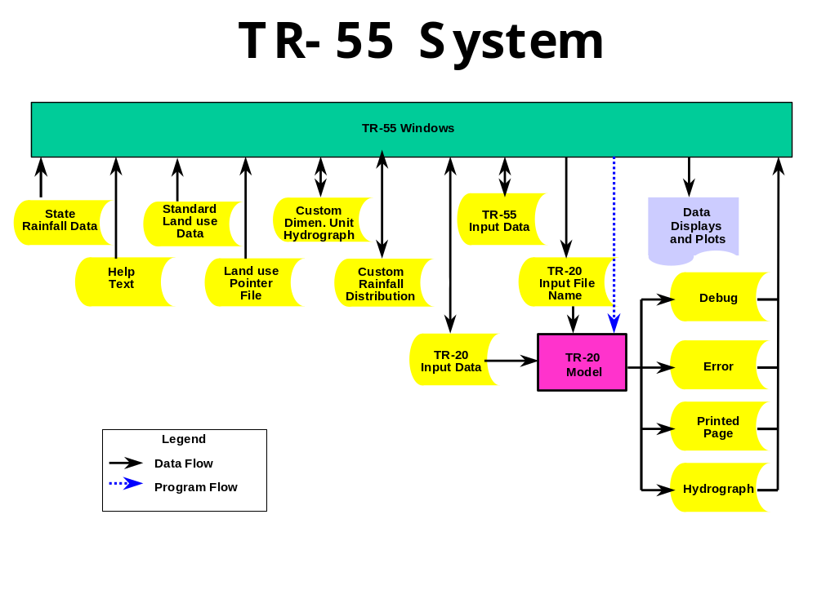

Capabilities and Limitations
WinTR-55 hydrology has the capacity to analyze watersheds that meet these criteria:

Table 1. WinTR-55 Capabilities & Limitations
Variable | Limits
Minimum area | No absolute minimum is included in the software. The user should carefully examine results from sub-areas less than 1 acre.
Maximum area | 25 square miles (6,500 hectares)
Number of Subwatersheds | 1-10
Time of concentration for any sub-area | 0.1 hour < T_{c} < 10 hour
Number of reaches | 0-10
Types of reaches | Channel or Structure
Reach Routing | Muskingum-Cunge
Structure Routing | Storage-Indication
Structure Types | Pipe or Weir
Structure Trial Sizes | 1-3
Rainfall Depth | Default or user-defined  0 – 50 inches (0-1,270 mm)
Rainfall Distributions | NRCS Type I, IA, II, III, NM60, NM65, NM70, NM75, or user-defined
Rainfall Duration | 24-hour
Dimensionless Unit Hydrograph | Standard peak rate factor 484, , or user-defined (e.g. Delmarva—see Example 3)
Antecedent Moisture Condition | 2 (average)

Model Input
The various data used in the WinTR-55 procedures are user entered via a series of input windows in the model. A description of each of the input windows follows the figure. Data entry is needed only on the windows that are applicable to the watershed being evaluated.

Minimum Data Requirements
While WinTR-55 can be used for watersheds with up to ten sub-areas and up to ten reaches, the simplest run involves only a single sub-area. Data required for a single sub-area run can be entered on the TR-55 Main Window. These data include: Identification Data-User, -State, -County, -Project, and -Subtitle; Dimensionless Unit Hydrograph; Storm Data; Rainfall Distribution; and Sub-area Data. The sub-area data can be entered directly into the Sub-area Entry and Summary table: Sub-area name, sub-area description, sub-area flows to reach/outlet, area, runoff curve number (RCN), and time of concentration (T_{c}). Detailed information for the sub-area RCN and T_{c} can be entered here or on other windows; if detailed information is entered elsewhere the computational results are displayed in this window.

User Responsibility
Results from the model can be sensitive to the input data. It is the user’s responsibility to ensure that all input data (whether it is actually entered or implied through default values for blank data fields) is appropriate for the watershed and watershed conditions being analyzed.

Watershed Sub-areas and Reaches
To properly route stream flow to the watershed outlet, the user must understand how WinTR-55 relates watershed sub-areas and stream reaches. Figure 2 and Table 2 show a typical watershed with multiple sub-areas and reaches.
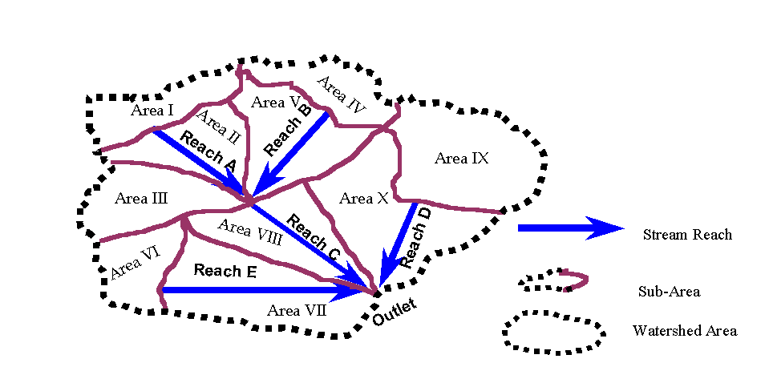

Figure 2. Sample Watershed Schematic

Table 2. Sample Watershed Flows
Sub-area | Flows into  Upstream End of |  | Reach | Flows into
Area I | Reach A |  | Reach A | Reach C
Area II | Reach C |  | Reach B | Reach C
Area III | Reach C |  | Reach C | OUTLET
Area IV | Reach B |  | Reach D | OUTLET
Area V | Reach C |  | Reach E | OUTLET
Area VI | Reach E
Area VII | OUTLET
Area VIII | OUTLET
Area IX | Reach D
Area X | OUTLET
Reaches define flow paths through the watershed to its outlet. Each sub-area and reach contribute flow to the upstream end of a receiving reach or to the Outlet. Accumulated runoff from all sub-areas routed through the watershed reach system, by definition, is flow at the watershed outlet.

Entry Window Features
Figures 2 and 3 show some of the features Windows uses, with the features labeled.

Figure 3. Window Entry Terms
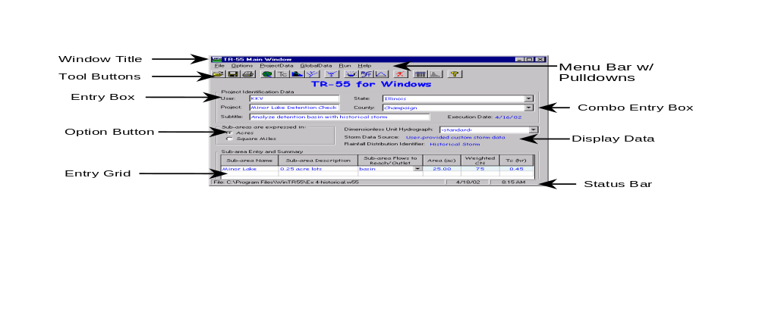

Feature | Function
Window Title | Displays title of the window
Tool Buttons | Quick access to functions or windows
Combo Entry Box | Select an entry or type in new data
Option Button | Select one option of several
Entry Grid | Enter data into cells
Menu Bar with Pulldowns | Select menu options with further sub-options
Entry Box | Enter data into box
Display Data | Display only, cannot enter data into a display area
Status Bar | Displays status information: filename, date, time

Figure 4. Additional Window Entry Terms
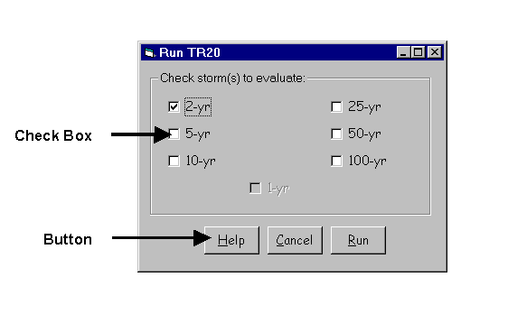

Feature | Function
Check box | Click on box to turn an option on or off
Button | Click to access named function

Welcome to TR-55 Window

Window 1 - Welcome to TR-55 Window
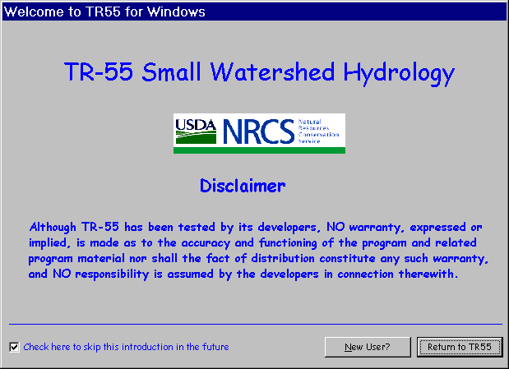

Purpose
This windows displays introductory information to the user.

Window 2. New User Help Window
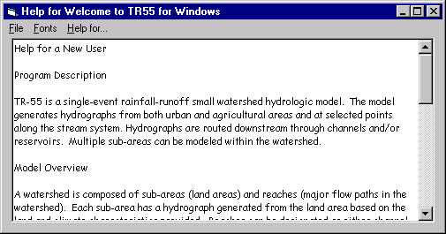
To skip this introduction in the future, click on the entry box in the lower left hand corner. The user may read additional help information or go directly to WinTR-55.

Buttons

New User?
Click New User to display introductory help text.

Return to TR55
Click Return to begin using WinTR-55 software.

TR-55 Main Window

Window 3 - TR-55 Main Window
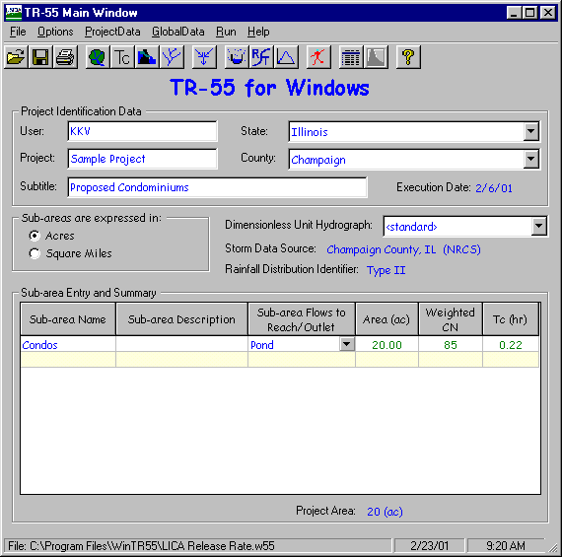

Purpose
The TR-55 Main Window allows the input of basic watershed data for a WinTR-55 watershed hydrology analysis. Other data and settings are accessible through the menus, buttons, and boxes on the window. WinTR-55 returns to this main window when other data input windows are closed.

Menu
The menu bar is located at the top of the TR-55 Main Window, just below the dark blue window title.

Window 4 – TR-55 Main Window (File)
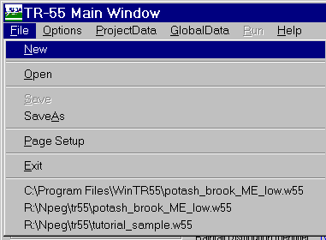

Menu Item | Pull-down Choice | Explanation
File | New | Create a new input file
File | Open | Open an existing input file
File | Save | Save current input data using current file name
File | Save As | Save current input data with different filename
File | Page Setup | Setup printer for page output
File | Exit | Exit software
File | List of Recent Files | List of recently accessed files tghat provides a shortcut to any of them
Window 5 - TR-55 Main Window (Options)
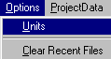

Menu Item | Pull-down Choice | Explanation
Options | Units | Declare measurement system: English or metric. Also choose watershed area display units: acres or square miles for English and hectares or square kilometers for metric.
Options | Clear Recent Files | Clear the list of recently opened files at the bottom of the File menu

Window 4 - TR-55 Main Window (Project Data)
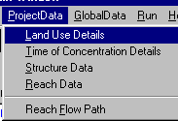

Menu Item | Pull-down Choice | Explanation
Project Data | Land Use Details | Open Land Use Details Window
Project Data | Time of Concentration Details | Open Time of Concentration Details Window
Project Data | Structure Data | Open Structure Data Window
Project Data | Reach Data | Open Reach Data Window
Project Data | Reach Flow Path | Display Reach Flow Path Schematic Window

Window 5 TR-55 Main Window (Global Data)
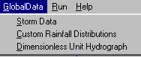
Menu Item | Pull-down Choice | Explanation
Global Data | Storm Data | Open Storm Data Window
Global Data | Custom Rainfall Distributions | Open Custom Rainfall Distributions Window
Global Data | Dimensionless Unit Hydrograph | Open Dimensionless Unit Hydrograph Window

Window 6 - TR-55 Main Window (Run)
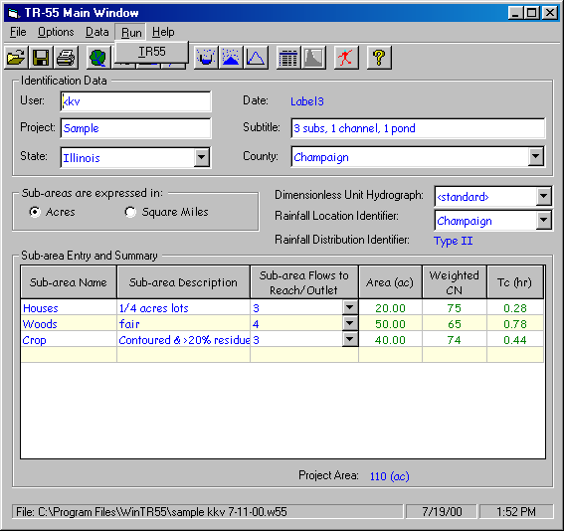
Menu Item | Pull-down Choice | Explanation
Run | Run TR-55 | Analyze watershed using currently entered data

Window 7 - TR-55 Main Window (Help)
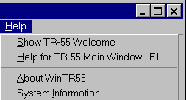

Menu Item | Pull-down Choice | Explanation
Help | Show WinTR-55 Welcome | Displays WinTR-55 Welcome Window
Help | Help for TR-55 Main Window F1 | Displays help
Help | About WinTR-55 | Display program version number and date
Help | System Information | Display System information, such as operating system

Buttons
The the button bar near the top of the TR-55 Main Window provides a graphical shortcut for some common functions described in the preceding menu section.

Open 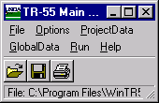
Opens a previously created and saved WinTR-55 input data file.

Save
Saves the current data in the file named on the status bar (bottom left corner of window). This button is not available until some data has been entered. If the current data does not have a filename associated with it, a box allowing entry of a filename is displayed when “Save” is clicked.

Input Data Printout
Prints a brief report of data on the TR-55 Main Window.

Land Use Details
Displays Land Use Description Window to enter or edit land use data by hydrologic soil group for any sub-area.

Time of Concentration
Displays Time of Concentration Window to enter or edit flow path information used to compute time of concentration for any sub-area.

Structure Data
Displays Structure Window to enter or edit data for storage ponds with either a pipe or weir outlet.

Reach Data
Displays Reach Window to enter or edit reach data for all reaches in the watershed.

Reach Flow Path 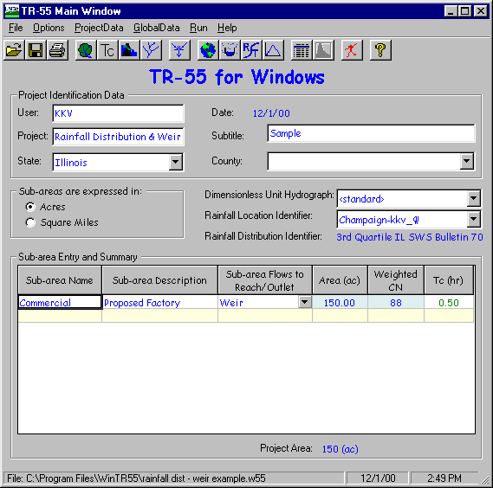

Displays Reach Flow Path Schematic

Storm Data
Displays Storm Data Window to view or edit rainfall depths and frequency. The associated rainfall distribution may be changed.

Custom Rainfall Distribution 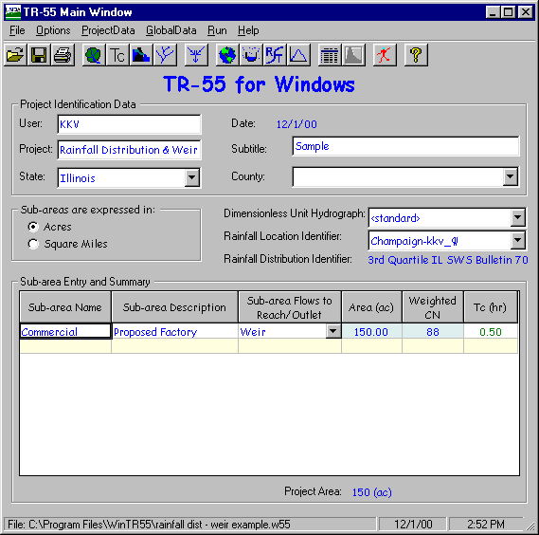
Displays Custom Rainfall Distribution Window to enter or edit custom rainfall distributions.

Dimensionless Unit Hydrograph
Displays Dimensionless Unit Hydrograph Window to enter or edit custom dimensionless unit hydrographs.

Run TR-55
Uses currently entered WinTR-55 data reformatted into TR-20 input to run the TR-20 model. Results from TR-20 are then available to the WinTR-55 program for output displays and/or reports. “Run TR-55 ” is not available until a minimum amount of data has been entered.

Summary Reports
Prints summary output reports. “Summary Reports” is not available until data has been entered and run.

Output Hydrographs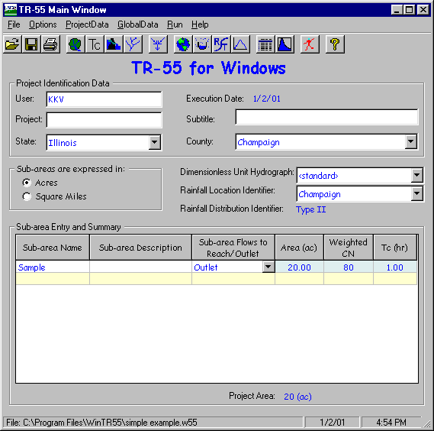
Views output hydrographs at various locations in the watershed. “Output Reports” is not available until a run has been completed.

Help - Context Sensitive 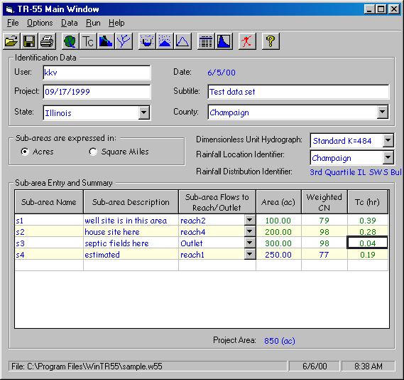
Once clicked, displays context-sensitive help for any data entry box on the TR-55 Main Window that is subsequently clicked. The help data is displayed below the data grid, at the bottom of the window. While in help mode, a question mark (?) is displayed next to the cursor. Clicking “?” a second time will return to the standard cursor.
Some help windows will not display completely with a 600x800 screen resolution. For better viewing, change the monitor’s screen resolution to a higher setting, such as 1024x768.

Identification Data Entry and Selection
Begin by entering the identification data: user, project name, and subtitle. The appropriate state and county (for locations within the U.S.) can be selected from the pull-down lists. For locations outside of the U.S., entering a name for the new 'state' causes the labels 'state' and 'county' to change to 'region' and 'locale'. State and county names supplied with the program cannot be edited, while user-entered names may be edited. Entering a single letter jumps to the first match in the list.
Next, click the sub-area units option button; English units of area are acres or square miles, metric units are either hectares or square kilometers. To change from English to metric or vice versa, select Units from the Options pull-down menu.
The default dimensionless unit hydrograph is the <standard> dimensionless NRCS unit hydrograph with a peak rate factor of 484 (NEH Part 630, Chapter 16). If a different dimensionless unit hydrograph is desired, select from the pull-down list or create a new one. To create a new dimensionless unit hydrograph, open the Dimensionless Unit Hydrograph Window.
Verify the Storm Data Source displayed. WinTR-55 supplies 24-hr rainfall amounts for many counties in the U.S. with the appropriate NRCS rainfall distribution. If needed, user may alter the storm data with different 24-hour rainfall amounts or a select a different rainfall distribution. Whenever, user-supplied data is used, the “user-provided storm data source” message is displayed on the TR-55 Main Window.
Note: changing the state and county locations on the TR-55 Main Window does not automatically change the Storm Data source. The user must verify that the storm data source is appropriate for the displayed location.
Verify the current rainfall distribution displayed. If a different rainfall distribution is desired, select a previously entered rainfall distribution or open the Rainfall Distribution Window and create a new distribution.

Sub-area Entry and Selection
Enter or edit sub-area information in the Sub-area Entry and Summary Table at the bottom of the TR-55 Main Window. Enter the Sub-area Name (1 to 10 characters) and if desired a Sub-area Description. Enter or select from the choice list the Reach Name (1 to 10 characters) or OUTLET (for the watershed outlet) into which the sub-area runoff flows in the Sub-area Flows to Reach/Outlet column. The sub-area flow always enters the reach at the upstream end. The network of sub-areas and reaches defined here and on the Reach Data window must be configured such that all flow eventually goes to the watershed Outlet. WinTR-55 will only run if all the flow is directed to “Outlet”.
The remaining columns in the table (Area, Weighted CN, and T_{c}) may be directly entered here or computed from more detailed information on other input windows. Details for computing Area and Weighted CN can be entered on the Land Use Description Window. Details for the T_{c} (time of concentration) can be entered on the Time of Concentration Window. Data entered directly in these columns is displayed in blue, and data WinTR-55 computes from other windows is displayed in green. Double-clicking on a column entry within the Sub-area Entry and Summary Table automatically displays the appropriate input window—Land Use Description, Time of Concentration, or Reach Window for additional data entry or editing.
The total project area is displayed below the Area column in the Sub-area Entry and Summary Table.

Status Bar
The path and filename of the current data is displayed on the left side of the status bar at the bottom of the window. If no file name has been assigned to the current data, <new file> appears in this location. The remainder of the status bar contains the current date and time. The same status bar appears on all other large size data entry windows.

Land Use Details Window

Window 8 - Land Use Details
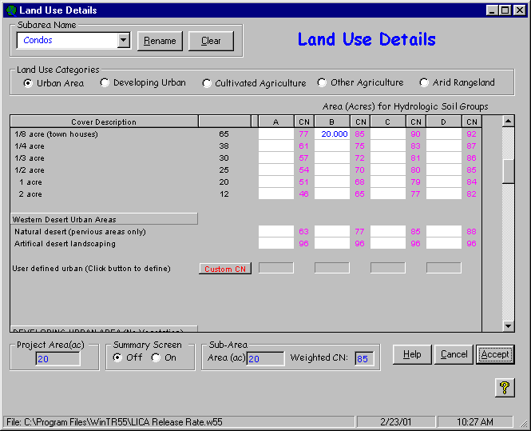

Purpose
The Land Use Description window allows the user to edit and view the land use description for sub-areas with detailed land use data.

Data Entry and Selection
There are two ways to find and view a specific Cover Description: the vertical scroll bar or Land Use category option buttons.
The vertical scroll bar on the right side of the window allows the user to make any portion of the land use list visible. Drag the scroll bar up or down to change the portion of the cover description list displayed. Scrolling from top to bottom may be time consuming since the table is long. Resizing the window to a larger window displays more lines of land cover.
Clicking any Land Use Categories option button causes the displayed portion of the Cover Description list to jump directly to the beginning of that category's cover descriptions. The complete list of the Cover Descriptions for the Land Use category may be too long to display at one time. If that is the case, use the vertical scroll bar to scroll down and view additional cover descriptions.
Once the desired cover description is in view in the table, enter the areas in the appropriate Hydrologic Soil Group columns (A, B, C, or D). Multiple hydrologic soil group entries can be made for a single cover description.
The average percent impervious areas shown for the Urban and Residential Districts were those used to develop the composite CN's given. Other assumptions made for urban and residential districts are: impervious areas are directly connected to the drainage system, impervious areas have a CN of 98, and pervious areas CN's are equivalent to Open Space in "good" hydrologic condition. Of these four assumptions, three may be changed. The impervious CN of 98 is the only constant.
If any other assumptions need to be changed to fit a particular project the user should go the Custom Curve Number Window and make the appropriate adjustments. See the Custom Curve Number documentation for more details.
Click on the sub-area name combo box in the upper left corner to select a previously named sub-area and display its data. To enter a new sub-area, click in the combo box and type in a new name.

Summary Information
The total watershed area accumulated from the sub-area information is displayed near the bottom left of the window. This total includes all sub-areas whether the data for each was entered in the detailed land use description above or as sub-area area on the TR-55 Main Window.
The Summary Screen buttons provide a toggle for display of the Land Use Summary for Sub-area Window. Click “On” to display the summary window and click “Off” to close the summary window. Information on the summary window is discussed after this current window discussion ends.
The accumulated sub-area area and associated weighted CN for the current sub-area are displayed in the two boxes at the bottom center of the window. As additional areas are entered or deleted, the summary values change. If both boxes are blank, no detailed land use description data has been entered for this sub-area.

Buttons

Rename
Rename allows the user to rename the sub-area.

Clear
Clear clears all the currently displayed sub-area land use details.

Help (See help comments on TR-55 Main Window)
Opens a new help-text window with an overview of window purpose and general data entry instructions.

Quick Help (?)
Click “?” to provide context-sensitive help for any data that is clicked on next. To replace the help question mark cursor with the standard cursor, click “?” again. Help is displayed at the bottom of the window.

Cancel
Click “Cancel” to lose all data entered or edited since this window was opened. The window is closed and the TR-55 Main Window redisplayed.

Accept
Click “Accept” to retain all data entered on the window, close the window, and to redisplay the TR-55 Main Window. The data is retained only in the computer memory and can be lost if the program is terminated prior to saving the data to a user file. To save data, use either the Save or Save As choices from the File menu or click the diskette icon on the TR-55 Main Window.

Land Use Summary Window

Window 9 - Land Use Summary
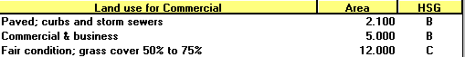

Purpose
The Land Use Summary window is for display only and shows the detailed land uses and associated areas by hydrologic soil group for a sub-area. The displayed sub-area is the selected sub-area on the Land Use description window. The window is activated or closed from the Land Use Description window. To move the summary window around, right click on the window and drag.

Data Selection
Click anywhere on a displayed land use line to jump to that entry on the Land Use Description window.

Custom CN Window

Window 10 - Custom Curve Number
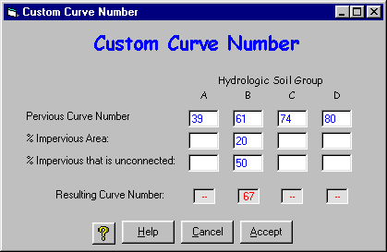

Purpose
The Custom CN window allows entry and editing of data to develop a custom urban curve number when the standard Cover Description assumptions on the Land Use Detail window do not apply. The pervious land use assumption of pasture in good hydrologic condition may not apply, so the user may change the pervious CN. The percent of impervious area in a sub-area may also be changed.
Impervious areas are connected impervious areas if its runoff flows directly into the drainage system or if its runoff flows as shallow concentrated flow over a pervious area and then into the drainage system. Shallow concentrated flow velocity is fast enough to allow little or no infiltration into the pervious area. An example of a connected impervious area is a residential rooftop where runoff flows from a roof downspout across a paved driveway, into the street gutter, and finally into to a storm sewer drainage system.
An impervious area is unconnected if runoff from it flows as sheet flow over a pervious area before entering the drainage system. The sheet flow is slow enough that some infiltration is presumed to occur in the pervious area. If the water from a roof downspout flows across a lawn as sheet flow, with opportunity to infiltrate the lawn, the rooftop is an unconnected impervious area. The user can enter appropriate numbers into the Custom Curve Number window to create a Custom CN to fit a specific land cover.

Data Entry and Selection
Scroll to the Custom CN line of the Cover Description and click “Custom CN” to create a custom urban curve number. The Custom Curve Number button is located at the bottom of the Urban Area land use section and just above the Developing Urban land use section.
Land use for setting custom curve numbers is divided into pervious and impervious areas. The impervious area is further identified as either connected impervious and unconnected impervious. Runoff from connected impervious areas flows directly into the drainage system or onto another impervious area and then into the drainage system. Runoff from unconnected impervious areas flows over some pervious area as sheet flow before entering the drainage system. The percent of impervious area that is unconnected is only available if the percent impervious area is less than or equal to 30 percent. The default Pervious Curve Number for each hydrologic soil group is for pasture in good condition. The user may change this default value, if needed.
Enter data for “Pervious Curve Number”, “% Impervious Area”, and “% Impervious that is unconnected” in the appropriate entry boxes. A composite curve number will be calculated using equations in Appendix B and displayed in the “Resulting Curve Number” box. The Hydrologic Soil Group entry indicates which CN column (Hydrologic Soil Group A, B, C or D) of the “User defined urban” Cover Description line (Land Use Details) window the computed curve number will be placed if the entered data is kept.

Buttons

Help (See help comments on TR-55 Main Window)
Opens a new help-text window with an overview of window purpose and general data entry instructions.

Quick Help (?)
Click “?” to provide context-sensitive help for any data that is clicked on next. To replace the help question mark cursor with the standard cursor, click “?” again. Help is displayed at the bottom of the window.

Accept
Click “Accept” to close the Custom CN Window and redisplay the Land Use Details Window with the newly defined custom curve numbers.
The window below shows the Land Use Window looks after the user has set a custom curve numbers for Hydrologic Soil Groups “B” then closed the Custom Curve Number window. In this example, the resulting custom curve number is 67, with 20% of the hydrologic soil group “B” area is impervious, and 50% of the impervious area is unconnected. A value of 61 for the pervious area was used. The user entered 22 acres of this curve number in the sub-area “Custom CN”.

Window 11 - Land Use Details Window with Custom Curve Number
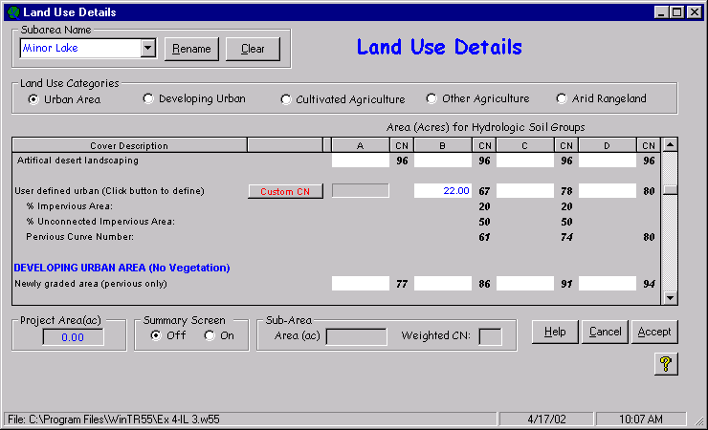

Cancel
Click “Cancel” to close the Custom CN Window and redisplay the Land Use Details Window, without incorporating the recently defined custom curve number data.

Time of Concentration Details Window

Window 12 - Time of Concentration Details
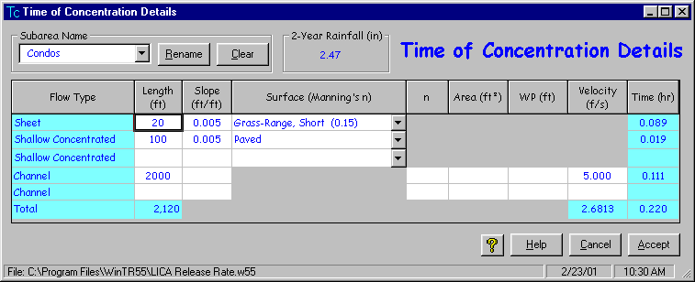

Purpose
The Time of Concentration Details window allows entry, editing, and/or viewing of sub-area flow path segment data and the resulting segment travel times and time of concentration for sub-areas in the watershed that have detailed time of concentration data. The computed sub-area time of concentration is displayed in the T_{c} column of the Sub-area Entry and Summary portion on the TR-55 Main Window. The sub-area time of concentration can also be entered directly on the TR-55 Main Window. Data computed from the Time of Concentration Window will override any prior time of concentration entries on the TR-55 Main Window. Blue boxes on the Time of Concentration Details window contain computed data while white boxes contain user-entered data.

Data Entry and Selection
Time of concentration is computed as per NRCS NEH Part 630.15, Chapter 15 and WinTR-55 (10/86).
After opening the Time of Concentration Details Window, select the sub-area in the sub-area combo box. The current 2-year, 24-hour rainfall depth is displayed. To change the 2-year, 24-hour rainfall depth, go to the storm data window.
Up to five flow segments may be entered: one for sheet, two for shallow concentrated, and two for channel flow. For sheet and shallow concentrated flow enter the length, slope, and surface. For channel flow, either enter length, slope, Manning n, flow area, and wetted perimeter or enter length and velocity directly.
The equations used for computing each segment’s travel time are in found in Appendix B.

Sheet Flow Length
Sheet flow length in the DOS version of WinTR-55 was limited to 300 feet (100 m). Sheet flow for 300 feet is very unusual because the surface and the corresponding flow would need to be extremely uniform. Generally, beyond 100 feet the flow becomes concentrated flow. Therefore, sheet flow length is limited to 100 feet (30 m) in this version of WinTR-55. For additional information see: USDA-SCS, Time of Concentration, Northeast Hydrology Technical Note No. N4, August 1986.

Buttons

Rename
Rename allows the user to rename the sub-area.

Clear
Clear clears all the currently displayed time of concentration details.

Help (See help comments on TR-55 Main Window)
Opens a new help-text window with an overview of window purpose and general data entry instructions.

Quick Help (?)
Click “?” to provide context-sensitive help for any data that is clicked on next. To replace the help question mark cursor with the standard cursor, click “?” again. Help is displayed at the bottom of the window.

Cancel (See Cancel comments on Land Use Details window)
Click “Cancel” to lose all data entry or revisions since this window was opened and redisplay the TR-55 Main Window.

Accept (See Accept comments on Land Use Details window)
Click “Accept” to retain all data entered or edited on the window, close the window, and redisplay the TR-55 Main Window. To save the data file, go to the TR-55 Main Window and click the diskette icon or “Save As” on the “File” menu.

Reach Window

Window 13 - Reach Data
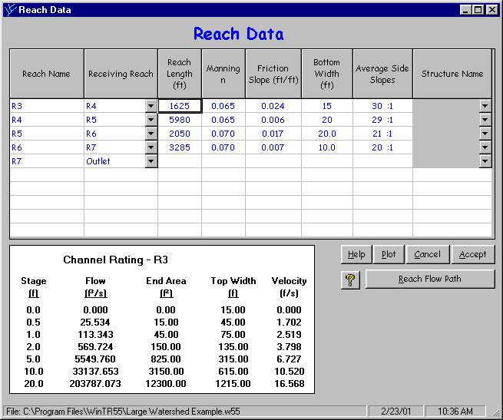

Purpose
The Reach window allows editing and viewing of the stream network, shows whether each reach is a channel reach or a storage (structure) reach, and provides information on creating a channel rating if the reach is a channel reach. No data is required in this window if all sub-areas flow directly to the watershed Outlet. Again, WinTR-55 will only run if all the flow is directed to “Outlet”.
If the watershed exceeds 10 reaches or the channel hydraulics require a complex rating relationship (for example, a principal spillway and an auxiliary spillway) another routing method should be used, such as TR-20 (NRCS, 2002) or SITES (NRCS, 2001).

Reach – Routing Element Concept
Reaches can be conceptualized as routing elements that exist in two types. The first type of routing element is a channel routing element, which is a stream reach. Data for a stream reach is entered on the Reach Data Window.
The second type of routing element is a storage routing element, which is a reservoir or structure. If the routing element is a structure, the structure name is entered on the Reach Data Window. The corresponding data for a structure, however, is entered on the Structure Data Window.

Data Entry and Selection
Each reach must have a unique “Reach Name” and a “Receiving Reach”. Reach names are 1 to 10 characters in length and may be entered here or previously entered as “Sub-area Flows to Reach/Outlet” on the TR-55 Main Window.
A downstream “Receiving Reach” is required for each reach. A pull-down choice list provides previously entered reach names to chose from along with the watershed “Outlet”. If a new name is entered into the Receiving Reach box, it will also be added to the Reach Name list as long as the current number of reaches is less than 10. If the current number of reaches is 10, then no new names are accepted in the Receiving Reach box.
When data is entered on the reach line for one type of routing, the box(es) for the other routing type will be grayed out. Data may still be entered in a gray box but will cause previously entered data on the line of the other routing type to be lost. Data for only one type of routing per line is retained.
To channel route, enter data for reach length, Manning n, friction slope, bottom width, and side slope. The reach length would be either the stream channel length or the floodplain length for the reach. Which length is used depends on whether expected flows are within bank or out of bank. The other parameters define a representative cross section for the reach. Based on the channel cross section information entered, a channel rating relationship for the reach is computed and displayed below the grid. The equations used in development of the channel rating are in Appendix B.
To storage route, enter a Structure Name or select from the choice list (if the structure has been previously described). To edit or view structure data, double-click the Structure Name to display the Structure Data Window.

Selecting a Representative Cross Section
A WinTR-55 reach cross section is either a rectangular, triangular, or trapezoidal channel. The cross section rating is based on the channel bottom width, side slope, Manning n, and friction slope data. The cross section rating includes Manning equation discharges for fixed depths at the cross section (0.5, 1.0, 2.0, 5.0, 10.0, and 20.0 feet).
The Muskingum-Cunge flood routing method estimates how the hydrograph changes as it flows through the reach utilizing this rating information. Typically, reach storage reduces and delays the peak discharge. In addition, the hydrograph peak becomes more rounded.
During a WinTR-55 run, all selected storms use one cross section rating for a reach. For this reason, selecting a representative cross section for the reach is extremely important. Generally, the channel has a capacity of a 5-year discharge or less (if the channel has a large capacity, the following discussion may not apply). If the peak discharge stays in the channel banks and the channel dimensions and roughness are entered, then the routing is reasonable. If the peak discharge flow overtops the channel banks, the reach routing is still based on the channel shape extending the side slopes up to 20 feet, which will not give a good representative stage-discharge relationship.
The user must judge if this is a reasonable approximation of the shape of the cross section above the channel banks. For example, the 2-year channel could be a 10-foot bottom width stream with 2:1 side slopes and 0.04 Manning n. However, the 100-year flow area might be represented by a 100-foot bottom width floodplain with 10:1 side slopes and 0.07 Manning n. However, WinTR-55 only accepts one set of data to represent the channel reach for all storms.
If the channel-only (no floodplain) approximation is unreasonable, one alternative is to enter a reach cross section representative of the floodplain (width, side slope, and Manning n). This alternative neglects the effect of the channel on the total cross section rating.
A second alternative is to use a hydraulic model, such as Corps of Engineers HEC-RAS, to develop the total cross section rating to include both the channel and floodplain. Then use NRCS TR-20 hydrologic model to develop and route the storm hydrographs. Using channel cross section data to represent the floodplain cross section will generally raise the peak discharge at the downstream end of the reach and translate it downstream sooner than if the floodplain and its storage are considered. The impact will vary with the floodplain width and its associated roughness.

Buttons

Help (See help comments on TR-55 Main Window)
Opens a new help-text window with an overview of window purpose and general data entry instructions. Close the help-text window to return to data entry.

Quick Help (?)
Click “?” to provide context-sensitive help for any data that is clicked on next. To replace the help question mark cursor with the standard cursor, click “?” again. Help is displayed at the bottom of the window.

Plot

Window 14 - Channel Rating Plot
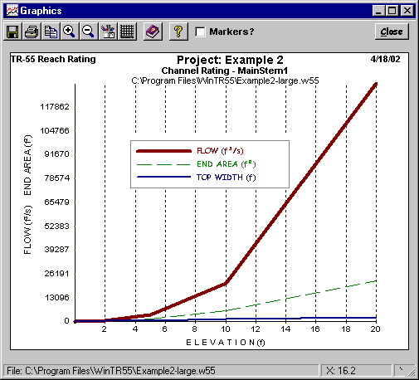
Click “Plot” to produce a graphical representation of the channel discharge and end area ratings from the data entered.

Cancel (See Cancel comments on Land Use Description window)
Click “Cancel” to lose all data entry or revisions since this window was opened and redisplay the TR-55 Main Window.

Accept (See Accept comments on Land Use Description window)
This button saves all data, closes the window, and returns to the TR-55 Main Window. To save the data file, go to the TR-55 Main Window and click on “Save” or select “File Save” from the menu.

Reach Flow Path
Click “Reach Flow Path” to display the Reach Flow Path window.

Reach Schematic Window

Window 15 - Reach Flow Path Definition
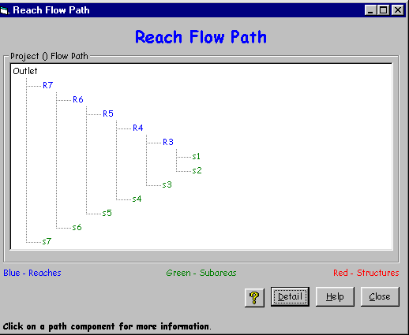

Purpose
This window displays a reach schematic of the currently entered reach, sub-area, and structure information.

Buttons

Detail
This button toggles between displaying detailed information with labels or displaying labels only in the schematic.

Help (See help comments on TR-55 Main Window)
Opens a new help-text window with an overview of window purpose and general data entry instructions. Close the help-text window to return to data entry.

Quick Help (?)
Click “?” to provide context-sensitive help for any data that is clicked on next. To replace the help question mark cursor with the standard cursor, click “?” again. Help is displayed at the bottom of the window.

Close
This button closes the reach flow path window and returns the user to the previously displayed window.

Structure Data Window

Window 16 - Structure Data (Pipe Outlet)
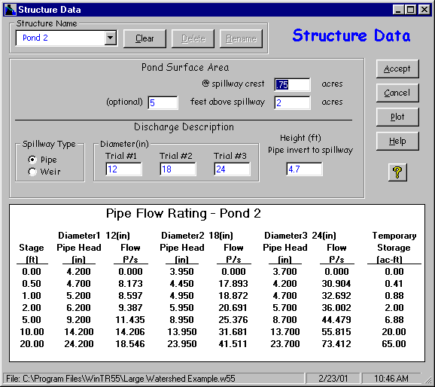

Purpose
The Structure Data window allows data editing for the pond’s surface area, structure outlet type and dimensions, and structure rating relationship for a structure. Three different outlet sizes (trials) may be defined for each structure. No data is required for this window if there are no structures in the watershed.
If the temporary ponding storage or structure hydraulics require a complex rating relationship another routing method should be used, such as TR-20 (NRCS, 2002) or SITES (NRCS, 2001).

Alternate Outlet Sizes for Multiple Structures
Three different outlet sizes may be entered for any structure. If the watershed has multiple structures and multiple outlet sizes, WinTR-55 will only compute up to three trials. Alternative one will combine the Trial #1 outlet sizes of each structure, alternative 2 will combine the Trial #2 outlet sizes of each structure, and alternative 3 the Trial #3 outlet sizes. Otherwise, the statistically possible number of alternatives with 10 structures and 3 outlet sizes is 3¹⁰ (greater than 59,000)! Since WinTR-55 only computes three trials, computation time is much faster and the user has only three alternatives to review and evaluate.

Data Entry and Selection
Enter the Structure Name (1 to 10 characters) or select from the choice list in the combo box. If data has been previously entered for the structure name, it will be displayed in the combo boxes in the window. If no data had been previously entered, all other entries will be blank. The first eight characters in structure names must be unique in each file. For example, Structure1 and Structure2 are invalid names because the first eight characters of the name are not unique. However, Struct1 and Struct2 are valid structure names.
Enter the Pond Surface Area @ Spillway Crest and optionally a height above the spillway crest and the pond surface area at that height. The pond area and height data are used to calculate the temporary storage for the ponded area. If only the surface area at the spillway crest is specified, the pond has vertical sides and the storage area remains constant as stage increases for the temporary storage calculation. If a height above the spillway crest and the pond surface area at that height are also provided, the pond cross section is trapezoidal and incremental storage varies with stage for the temporary storage calculation. The equations used to calculate the temporary storage are in Appendix B.
Select the Outlet Type (Pipe or Weir). The default is pipe.

Pipe Outlet
If Pipe is selected, one to three pipe diameters may be specified along with the Height (outlet to spillway). WinTR-55 will compute pipe head from the entered data. The minimum pipe diameter is 6 inches or 150 mm. The minimum Height (outlet to spillway) should be at least twice the smallest pipe diameter. The discharge equations used in the structure rating can be found in Appendix B. Once the first pipe diameter and the Height is entered, a pipe rating table will be displayed below the Outlet Description. The table is updated as additional information is entered or is revised.

Figure 5. Pipe Outlet Schematics
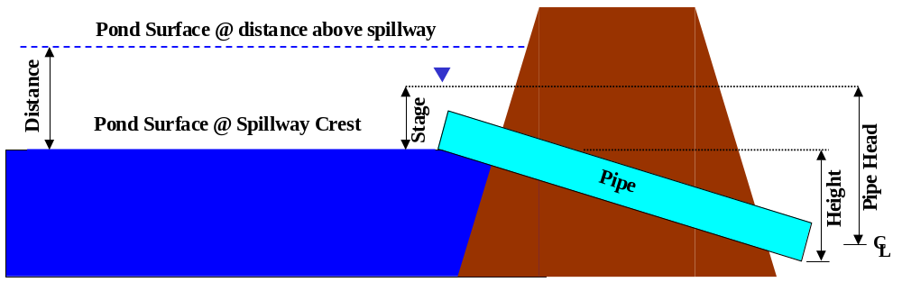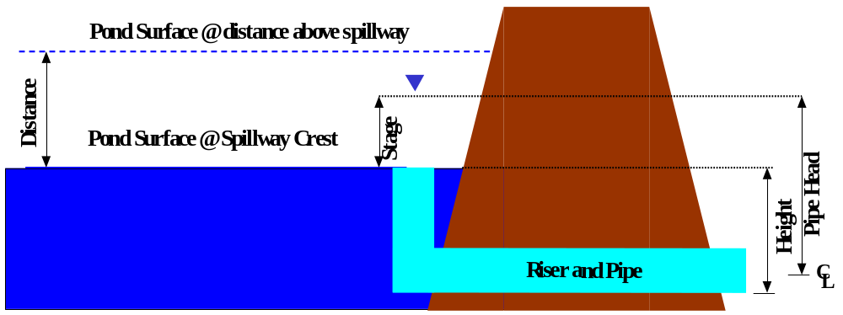

Full Pipe Flow Assumption
At any given stage, WinTR-55 assumes full-pipe flow for the computed pipe head. This is a reasonable assumption for the riser and pipe configuration (Figure 4 bottom schematic). However, this full pipe flow assumption may be unreasonable for large, straight pipes (Figure 4 top schematic).
For example, if the structure outlet is a 36-inch (1-m) diameter pipe culvert and the maximum computed stage is 1.5 feet (0.5 m), then the pipe has never been more than half-full (Figure 5). In this case, the full-pipe flow assumption has not been satisfied. Other routing software, such as SITES (NRCS, 2001), is necessary to analyze these cases.

Figure 6. Full-Pipe Flow Assumption Not Valid
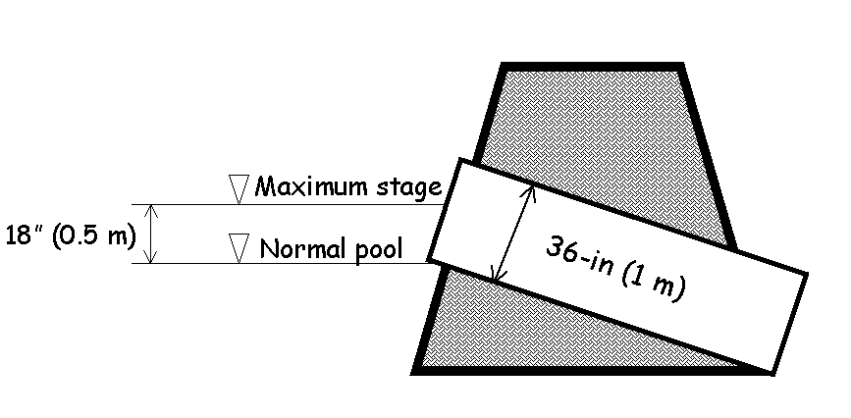

Weir Outlet
If Weir is selected, one to three weir lengths may be specified. The entry of a zero weir length indicates a V-notch weir while all other lengths are for rectangular broad-crested weirs. The weir discharge equations used in the structure rating are found in Appendix B. Once the first weir length is entered, a weir rating table will be displayed below the Outlet Description. The figure below shows the weir diagram.

Figure 7. Weir Outlet Schematic
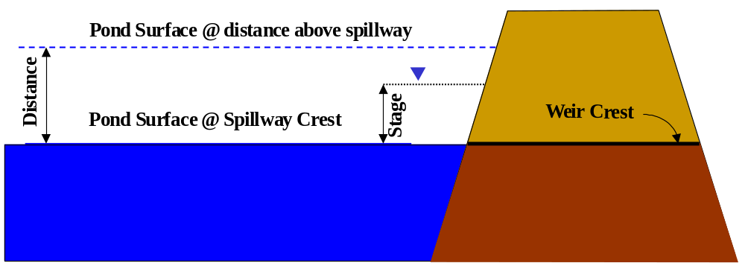
The table is updated as additional information is entered or is revised. The window for weir entry follows.

Window 17 - Structure Data (Weir Outlet)
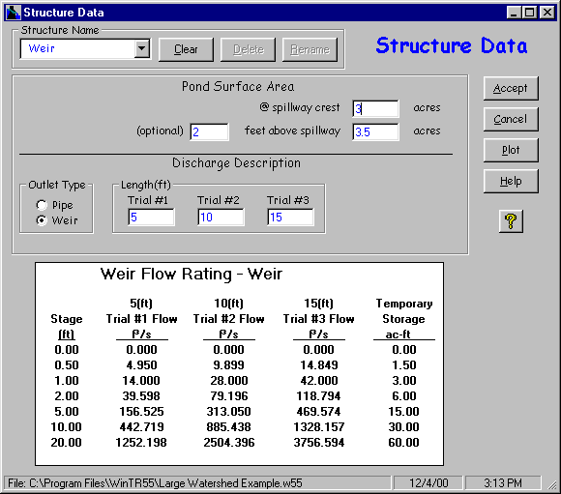
Additional items to note about entry on the Structure Data window are:
- Toggling between the two different outlet types clears the outlet dimension values.
- Minimum data for a valid run is surface area at the spillway crest, outlet type, and one outlet size. If the outlet is a pipe, height must also be entered.

Buttons

Clear
Clears all data for existing structure.

Delete
Deletes current structure data and name.

Rename

Renames current structure

Accept
Accept current data, closes the window, and returns to TR-55 Main Window.

Cancel
Click “Cancel” to lose all data entry or revisions since this window was opened and redisplay the TR-55 Main Window.

Plot
Click “Plot” to produce a graphical representation of the structure rating as shown in the following windows.

Window 18 - Structure Rating (Pipe Outlet)
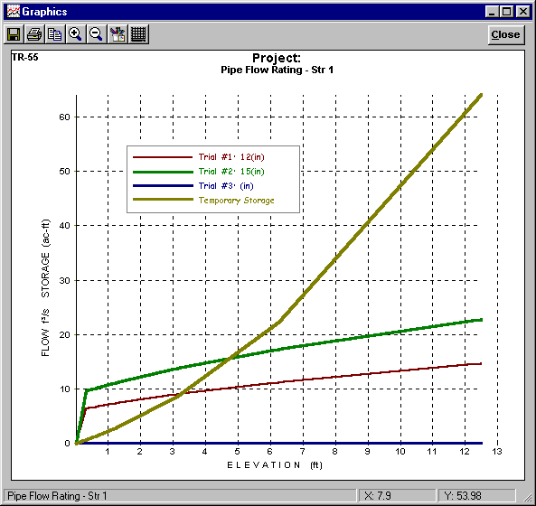

Window 19 - Structure Data Plot (Weir Outlet)
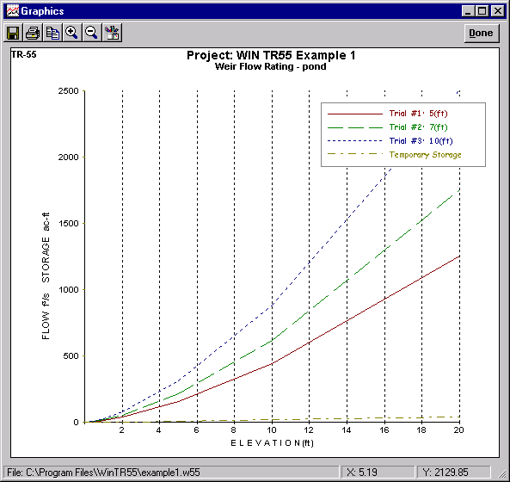

Help (See help comments on TR-55 Main Window)
Opens a new help-text window with an overview of window purpose and general data entry instructions. Close the help-text window to return to data entry.

Quick Help (?)
Click “?” to provide context-sensitive help for any data that is clicked on next. To replace the help question mark cursor with the standard cursor, click “?” again. Help is displayed at the bottom of the window.

Storm Data Window

Window 20 – Storm Data
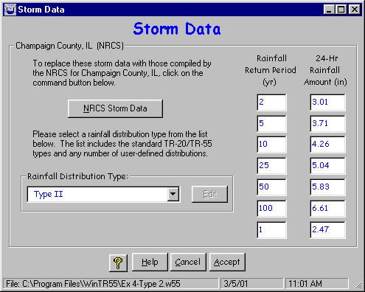

Purpose
The Storm Data window allows the user to select the NRCS-supplied rainfall data for the state and county or to enter custom rainfall depths and select a different rainfall distribution. Storm data consist of at least one rainfall amount / rainfall return period, and an associated rainfall distribution. The user may request NRCS storm data for the state and county specified. If such data exist, they will be displayed in the window entry boxes when the NRCS Storm Data button is clicked. The user can modify the NRCS storm data or may provide unique storm data. If NRCS storm data is altered or unique data is entered, the Storm Data Source on the TR-55 Main Window is listed as “User-provided custom source data”. NEH Part 630, Chapter 4 lists sources for rainfall data.

Data Entry and Selection

Watersheds Inside United States
Some counties have easily-defined rainfall data and this data is loaded into WinTR-55. However, other counties may vary in rainfall depths or appropriate distributions. These data are not supplied in WinTR-55. To select the NRCS-supplied storm data, click on the NRCS Storm Data button. If no data is available for the current state and county information entered on the TR-55 Main Window, this button is temporarily disabled. If this is the case, the user must enter the rainfall depths and select a rainfall distribution. The user must verify the appropriateness of all rainfall inputs, even if it is NRCS-provided. Local design requirements may supersede NRCS-provided storm data.

Watersheds Outside United States
No rainfall data is provided outside the United States. For example, if the watershed is in Durango, Mexico, the TR-55 Main Window combo box entry labels change from “State” and “County” to “Region” and “Locale” as shown in Window 20.

Window 21 - Watersheds Outside US
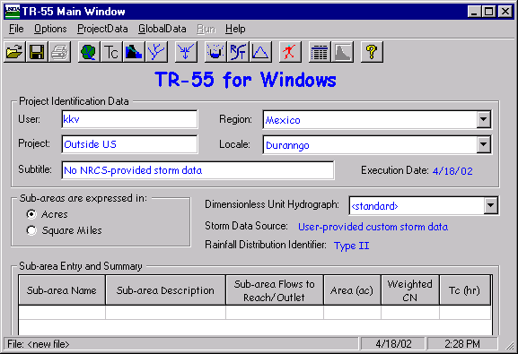
Therefore, all watersheds outside the United States require the user to enter all the rainfall return period data and 24-hour rainfall amount because the “NRCS Storm Data” button on the Storm Data Window is disabled. The user must also select a rainfall distribution from the “Rainfall Distribution Type” combo entry box.

Window 22 - Storm Data Outside of US
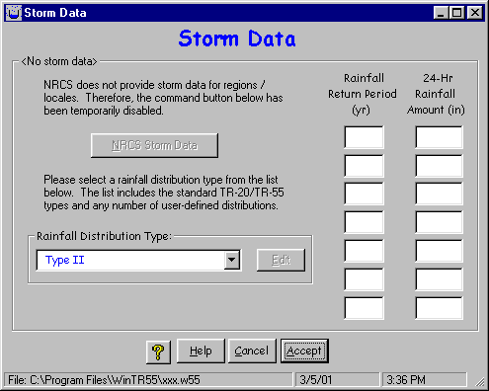

Rainfall Distribution
To change the associated rainfall distribution type displayed on this window, click on the pull-down list to select any previously entered distribution. To enter a new rainfall distribution, click Cancel to return to the TR-55 Main Window and select Custom Rainfall Distributions from the Global Data pull-down menu.

Creating a New File
When “File-New” is selected from the TR-55 Main Window, all the project data (Land Use, T_{c}, Structure, and Reach) is cleared. However, the global data (Storm Data, Rainfall Distribution, and Dimensionless Unit Hydrograph) are not changed. Furthermore, the global data is not changed even if the state and county are changed on the TR-55 Main Window.

Window 23 - Differing State/County and Storm Data Source Example
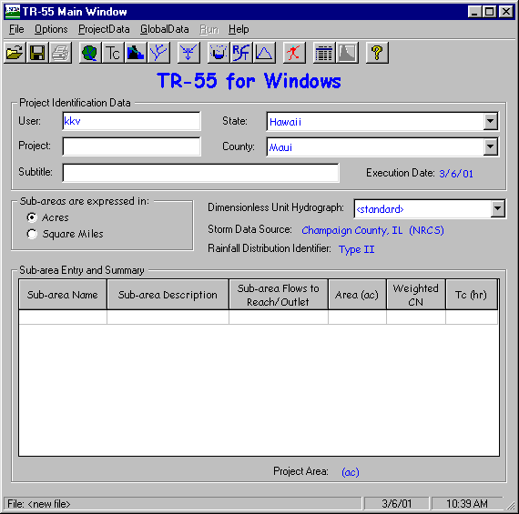
The window above shows that the Project Identification Data is Maui, Hawaii. However, the storm data source lists Champaign County, Illinois. Champaign Illinois storm data is not appropriate for Maui, Hawaii. Therefore, the user must go to the Storm Data window for each project and verify the accuracy of the storm data.

Template Files for Storm Data
Some users may use the same storm data set or sets repeatedly. If these data sets are not NRCS storm data sets, it would become tedious to re-enter the same rainfall data for each project. To create a template file, click “File- New” on the TR-55 Main Window to clear all the project data. Then enter the desired custom storm data. All the project data (Land Use, T_{c}, Structure, and Reach) has been cleared in the file. Save this file with a filename descriptive of the storm data.
To utilize this storm data for future projects, open this template file with the storm data first. Then proceed by entering project data (Land Use, T_{c}, Structure, and Reach). Make sure to save the project file as a different name so the template file isn’t overwritten.

Buttons

NRCS Storm Data
This button retrieves NRCS rainfall data, if it is available. If the button is not available, the rainfall is not available in the data base. Therefore, the user must supply all the rainfall data.

Help (See help comments on TR-55 Main Window)
Opens a new help-text window with an overview of window purpose and general data entry instructions. Close the help-text window to return to data entry.

Quick Help (?)
Click “?” to provide context-sensitive help for any data that is clicked on next. To replace the help question mark cursor with the standard cursor, click “?” again. Help is displayed at the bottom of the window.

Cancel
Click “Cancel” to lose all data entry or revisions since this window was opened and redisplay the Main TR-55 Window.

Accept
“Accept” applies all new data, closes the window, and returns to the Main TR-55 Window. To save the data file, go to the TR-55 Main Window and click “Save” or select “File Save” from the menu.

Custom Rainfall Distributions Window

Window 24 - Custom Rainfall Distributions
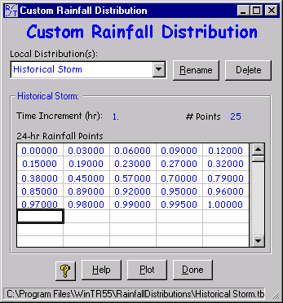

Purpose
This window allows the user to input and revise non-standard 24-hour rainfall distributions. The standard rainfall distributions in WinTR-55 may not be edited or deleted.
The first point of each distribution is 0.00000 and the last point should be 1.00000. No blank points are allowed. Each successive point must be equal to or larger than the previous one. Data is read left to right, starting at the top line and continuing to the bottom line.
For further information on rainfall distributions, see NRCS NEH Part 630, Chapter 4.

Data Entry and Selection
To enter a new distribution, type the name into the Local Distribution(s) entry box. To delete a distribution, select the distribution name from the pull-down list and then click “Delete”.
Once the distribution name is complete, begin entering distribution data points in the table. WinTR-55 automatically displays the time increment in hours and the number of data points as each point is entered.

Menu

Edit

Window 25 - Custom Rainfall Distributions (Edit)
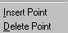
The Edit menu is a mouse right-click menu. The Edit menu allows the user to create and revise data points for the current rainfall distribution. “Insert Point” inserts a blank data point before the current point. “Delete Point” removes the current data point and moves successive points up. Click within a cell to edit the data in that cell.

Buttons

Rename
This button allows the user to rename the currently displayed rainfall distribution.

Delete
This button deletes the current distribution.

Plot
Clicking on plot produces a graphical representation of the current rainfall distribution. Only one distribution may be displayed at a time.

Window 26 - Custom Rainfall Distributions Plot
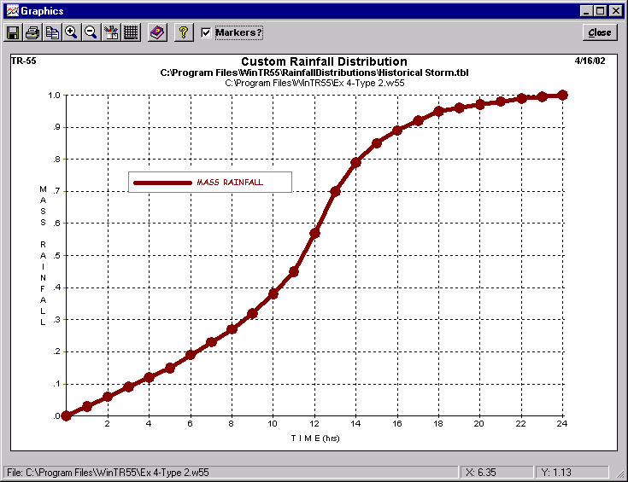

Done
“Done” on the Dimensionless Unit Hydrograph Window prompts WinTR-55 to save the distribution and return to the TR-55 Main Window. Note that this process is different than saving project-specific data such as Land Use Details, which only updates data in memory.

Dimensionless Unit Hydrographs Window

Window 27 - Dimensionless Unit Hydrograph
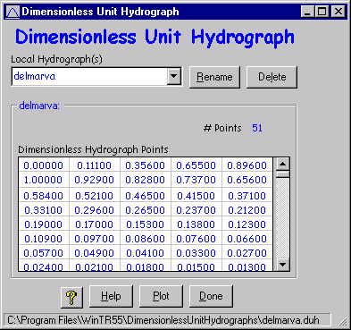

Purpose
This window allows the user to input and revise non-standard dimensionless unit hydrographs. The standard dimensionless unit hydrograph (peak rate factor = 484) in WinTR-55 may not be edited or deleted.
No blank points are allowed in the dimensionless unit hydrograph data table. Each point must increase from 0.00000 to 1.00000, then decrease to 0.00000. Data is read left to right, starting at the top line and continuing to the bottom.
For further information on dimensionless unit hydrographs, see NRCS NEH Part 630, Chapter 16.

Menu

Edit
The Edit menu is a mouse right-click menu. The Edit menu allows the user to create and revise data points for a user defined dimensionless unit hydrograph. “Insert Point” inserts a blank data point before the current point. “Delete Point” removes the current data point and moves successive points up. The user may also click within a cell to edit the data in that cell.

Data Entry and Selection
To enter a new dimensionless unit hydrograph, type the name into the local hydrograph(s) entry box.
Once the dimensionless unit hydrograph name is complete, begin entering the dimensionless unit hydrograph data points into the table. WinTR-55 automatically displays the number of data points as each point is entered. To delete a local dimensionless unit hydrograph, select the dimensionless unit hydrograph name from the pull-down list and then click “Delete”.

Buttons

Rename
This button allows the user to rename the displayed dimensionless unit hydrograph.

Delete
This button deletes the current dimensionless unit hydrograph.

Plot
Click “plot” to produce a graphical representation of the dimensionless unit hydrograph.

Window 28 - Dimensionless Unit Hydrograph Plot
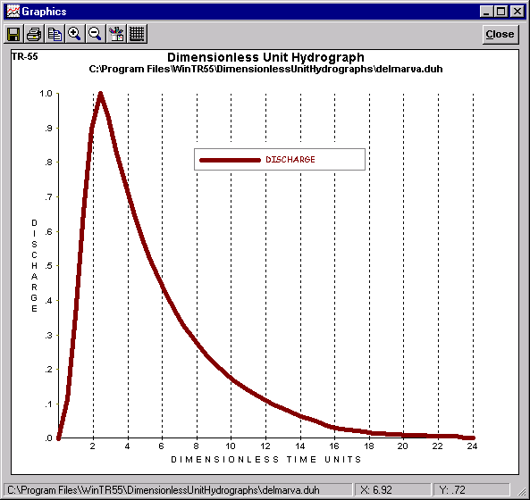

Done
Clicking “Done” prompts WinTR-55 to save the dimensionless unit hydrograph and return to the TR-55 Main Window. Note that this process is different than saving watershed-specific data such as Land Use Details, which only updates data in memory.

Plot Windows

Purpose and Description
The plot windows for various functions (dimensionless unit hydrograph, rainfall distribution, reach rating, output hydrograph, etc.) show graphically how two or more variables relate to one another. For example, the following plot shows how discharge and end area vary with elevation.

Window 29 - Typical Plot Window
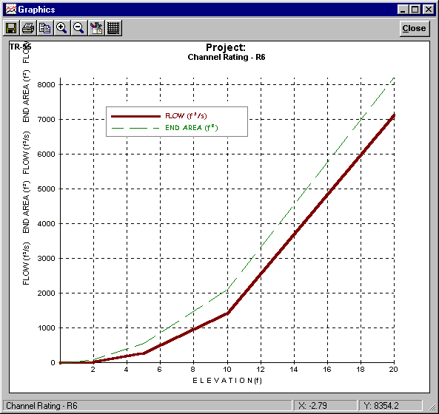

Buttons

Save As
Saves the current plot to a bitmap file.

Print
Prints the current plot to the user-selected printer.

Copy to Clipboard
Copies the plot to the system clipboard for later insertion into other software, such as word processors.

Zoom In
Allows the user to zoom into selected areas of the plot.

Zoom Out
Restores the view of the full plot.

Line Attributes
Allows the user to select various line widths, colors and types.

Grid Lines
Toggles between no grid lines, horizontal grid lines only, vertical grid lines only, and both horizontal and vertical grid lines.

Close
Closes the plot window and returns to the previous window.

Running WinTR-55
To run the WinTR-55 model, Click “Run” on the menu bar. The Run TR-55 window comes up, allowing the user to choose which frequencies to run. Click Run again. A TR-20 input data file is prepared and the TR-20 model is run producing hydrographs for all of the sub-areas, reaches (upstream and downstream), as well as the watershed outlet. If the run is successful, the Hydrograph Peak/ Peak Time Table will be displayed in the File Display window. If the run is unsuccessful, the Error file from TR-20 will be displayed in the File Display window. Any data errors identified will need to be corrected before re-running the watershed data.

Disclaimer
Although all pieces of the WinTR-55 system have been tested by the developers, NO warranty, expressed or implied, is made as to the accuracy and functioning of the programs and related program materials nor shall the fact of distribution constitute any such warranty, and NO responsibility is assumed by the developers in connection therewith.

WinTR-55 Processes
WinTR-55 preprocesses data, during data entry, for TR-20 hydrograph computations. The preprocessing computations are: Time of Concentration, land use parameters, channel rating table, and structure rating table.

Time of Concentration (T_{c})
The user may enter a sub-area T_{c} directly on the sub-area summary portion of the TR-55 Main Window or compute it from detailed flow path data entered on the TR-55 Time of Concentration Details window. Data entry and computations are sub-divided into three types of flow (sheet, shallow concentrated, and channel flow). While data for only one sheet flow segment can be entered, one or two segments of data can be entered for both the shallow concentrated and channel flows. The total computed travel times for each flow path segment are indicated on the entry window as is the T_{c} (sum of the travel times). The equations used to compute the various travel times for each segment type can be found in Appendix B. Green T_{c} values in the sub-area summary table indicate computed values, blue values indicate data entered directly.

Land Use Parameters
The user may enter a sub-area drainage area and weighted runoff curve number directly on the sub-area summary portion of the TR-55 Main Window or compute them from detailed land use data entered on the TR-55 Land Use Details window. Land use area amounts are entered on the Land Use Details window for each land use with the corresponding hydrologic soil group. The land use areas entered are summed to determine the sub-area drainage area. The land use areas are also used to weight the applicable runoff curve numbers for the land use hydrologic soil group combination to produce a sub–area weighted curve number. The equation used in the curve number weighting is in Appendix B. Green areas and weighted CN values in the sub-area summary table indicate computed values, blue values indicate data entered directly.
The optional custom CN in the Land Use Details table is under user control and is a weighted CN depending on an imperious area CN, the percent of the area that is impervious (CN = 98) and the amount of the impervious area not directly connected to the flow path.

Channel Rating Table
For each reach with channel information entered, a channel rating table is generated. The rating table consists of discharge, cross-section end area, and top width for depths from 0 to 20 feet (6.1 meters). This range should cover all WinTR-55 applications. The rating table data is displayed below the entry portion of the Reach data window when sufficient data is entered to perform the calculations. The equations used for each of the rating parameters are in Appendix B.

Structure Rating Table
For each reach that has structure information entered, a structure rating table is generated. The information contained in the rating table depends on the structure outlet type (pipe or weir). The pipe outlet rating table consists of stage, head on pipe, pipe flow, and temporary storage. The weir table consists of stage, weir flow and temporary storage. One to three pipe diameters or weir lengths can be entered. A set of 7 stages, based on either multiples of the smallest pipe diameter or 0 to 20 feet (6.1 meters), is computed for weirs. The rating table data is displayed below the entry portion of the Structure data window when sufficient data is entered to perform the calculations. The equations used for each of the rating parameters are in Appendix B.

TR-20 Processes
WinTR-55 relies on the TR-20 model for all hydrograph processes. These include: hydrograph generation, combining hydrographs, channel routing, and structure routing. A brief description of each of these processes follows.

Generate Hydrographs
Hydrographs are generated from sub-areas using the appropriate rainfall depth (for a specific frequency), rainfall distribution, sub-area drainage area, time of concentration (T_{c}), and curve number using the NRCS hydrograph generation technique. The sub-area T_{c} is used to establish the time interval for the spacing of points in the dimensionless unit hydrograph. This time interval defines the hydrograph time increment. The rainfall distribution is linearly interpolated to develop mass rainfall values to use at the time increment needed.

Combine Hydrographs
Two hydrographs are combined using the first hydrograph time increment and linearly interpolating the second hydrograph. Next, the two hydrographs are combined again using the time increment from the second and linearly interpolating the first. The combined hydrograph with the highest peak is the one retained along with the appropriate time increment.

Channel Route
The program uses a Muskingum-Cunge method of channel routing (Chow, Maidment, and Mays, 1988; Maidment, ed., 1993; or Ponce, 1989). The rating table generated by WinTR-55 for each reach is used to represent flow in that reach. The unique feature of the Muskingum-Cunge routing is the calculation of the length of a routing reach step based on inflow peak discharge and cross section information. If the routing reach step length is shorter than the reach length, the reach is sub-stepped. For example, if there are two steps, the routing is accomplished by solving the routing equation twice: the outflow hydrograph for the upper half of the reach becomes the inflow hydrograph for the lower half of the reach. If there are less than ten points from the beginning of the hydrograph to the peak of the inflow hydrograph, the inflow hydrograph is interpolated at a time interval to allow ten points, the routing computed, and the outflow hydrograph interpolated to return it to the original time increment.

Structure Route
The storage-indication method (NRCS NEH Part 630, Chapter 17) is used to route structure hydrographs. While the routed hydrograph time increment (downstream end of reach) is the same as the increment at the upstream end, the actual routing may sub-step the increment during the routing. The routing time step is based on the smallest time to empty the reservoir at each of the structure rating points. (The time to empty the reservoir is computed as the structure rating storage volume divided by the average outflow (rating outflow/2)). The hydrograph time increment is compared to a percentage (currently 50%) of the smallest emptying time to determine the number of time steps to use between hydrograph points.

Viewing Output

File Display Window
This window, also referred to as the Report Viewer, displays various TR-55 Reports.
This window opens after a WinTR-55 run. If there are any errors in the WinTR-55 run, this window opens with the title “Error File”. Carefully examine the error messages, and modify the input data to correct the errors.
If no errors are discovered in the data set, the WinTR-55 run is executed and the window opens with the reports selected from “Output Definition” window. If no reports were selected using the “Output Definition” window, the report viewer window opens with “Hydrograph Peak / Peak Time Table.”

Window 30 – File Display
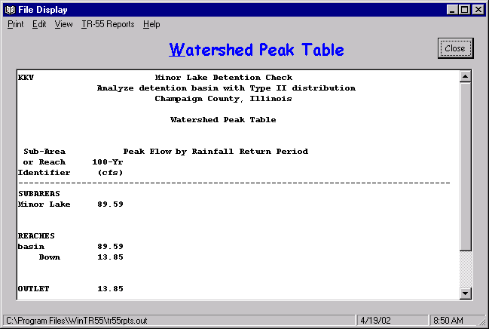
Click “Close” to close this window.
Scroll through the reports using the viewer or select individual reports on the File Display Window Menu. The following table contains a brief description of the File Display Window Menu.

Menu
Menu Item | Pull-down Choice | Explanation
Print | Print | Prints the displayed report(s)
Print | Page Setup | Define target printer, page size and orientation, margins.
Edit | Copy to Clipboard | Copies the displayed report(s) to the Windows system clipboard.
Edit | Find | Find a specific text or number. Helpful for navigating large output reports.
Edit | Find Next | Repeats a previously defined search.
View | Input File | View the TR-20 input file created from WinTR-55 input data.
View | TR-20 Printed Page File | View raw TR-20 output file.
View | Error File | View TR-20 error file. These error messages are found in the TR-20 user manual.
View | Debug File | View TR-20 debug file.
TR-55 Reports | See Table 3 for available reports.
Help | None | Displays File Display window help text.

Buttons

Close
Click “Close” to close the File Display window and return to the Output Definition window.

Output Definition Window
Once rainfall data is entered, the “Output Definition” button on the TR-55 Main Window is enabled. The user may select reports for viewing prior to executing a WinTR-55 run. However, some report options may be grayed-out, indicating that reports are not available for viewing until an error-free WinTR-55 run is executed.
Click the Output Definition icon to open the “Output Definition” window. Specify output by clicking the box to the left of the desired report. Output may be sent to a file or to the report viewer, depending on which option is selected.

Window 31 - Output Definition
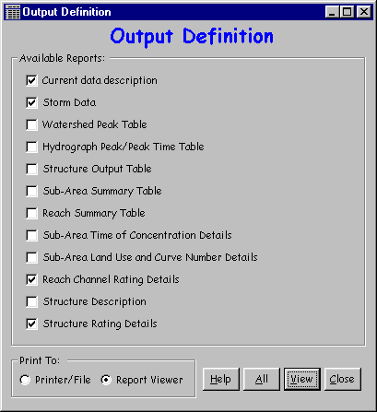

Available Reports
Available reports shown in the Output Definition window are summarized in the following table.

Table 3. TR-55 Reports
Report Name | Description
Current data description | Lists the current user-input data.
Storm Data | A listing of the Rainfall Depth by Rainfall Return Period information. Also shows Storm Data source, Rainfall Distribution and the Dimensionless Unit Hydrograph.
Watershed Peak Table | Watershed peak table is not available to the User until an error-free WinTR-55 run is executed. Upon completion of an error free WinTR-55 run, this option will give a listing of peak discharges, by reach, for each storm evaluated.
Hydrograph Peak / Peak Time Table | Hydrograph peak /peak time table is not available to the User until an error-free WinTR-55 run is executed. Upon completion of an error free WinTR-55 run, this option will give a listing of peak discharge and time of peak, by sub-area or reach identifier, for each storm evaluated.
Structure Output Table | Structure output table is not available to the User until an error-free WinTR-55 run is executed. Upon completion of an error-free WinTR-55 run, this option will give a list peak flow (PF), storage volume (SV), and maximum stage (STG) for structures included in the WinTR-55 run. If there are no structures in the run, this table will be blank, however, the headings will be shown.
Sub-area Summary Table | A listing, by sub-area of Drainage Area, Time of Concentration, Runoff Curve Number, Receiving Reach and Sub-area.
Reach Summary Table | Identifies, by reach, the receiving reach, reach length and routing method used.
Sub-area Time of Concentration Details | A listing, by sub-area, of flow length, slope, Manning “n” value, end area, wetted perimeter, velocity and travel time for time of concentration flow path segments along with the total time of concentration.
Sub-area Land Use and Curve Number Details | A listing, by sub-area, of Land Use, Hydrologic Soil Group and area for each particular land use in a sub-area. Also lists the total area and weighted curve number for each sub-area.
Reach Channel Rating Details | Identifies, by reach, the reach length, Manning “n” value used for that reach, friction slope, bottom width, and side slope. Also includes the computed channel rating for each reach. Channel ratings are the WinTR-55 input data format: Stage – Flow – End Area. Rating tables also include Top Width and Friction Slope.
Structure Description | Provides a summary of the user entered structure data by reach.
Structure Rating Tables | Provides a summary of the computed structure rating: stage, storage, and flow.

Buttons

Help (See help comments on TR-55 Main Window)
Opens a new help-text window with an overview of window purpose and general data entry instructions. Close the help-text window to return to data entry.

All/Reset
If no report boxes are checked, the button label is “All”. Click “All” to check all the reports. If all the report boxes are checked, the label toggles to “Reset”, which will clear all the check boxes.

View/Print
This button label toggles between View and Print, depending on which option button is selected, either Printer/File or Report Viewer.

Close
Click “Close” to close the Output Definition window and return to the TR-55 Main Window.

Plotting and Viewing Hydrographs

Hydrographs or Output Graphics Window
Click “Hydrographs” to open the Output Graphics Window and specify hydrographs to plot or view. Select either Sub-areas or Reaches and then check the box next to the name of the sub-area or reach for the desired hydrographs. For Reach hydrographs, the hydrograph may be viewed at the upstream or downstream or both ends of the reach. Select storm event hydrographs by checking the appropriate box.
It is possible to plot all the hydrographs for all the sub-areas or reaches for all of the available storm events on one plot. However, the User should be aware that selecting several hydrographs to view at once makes the hydrographs that much more difficult to read.

Plot
Once the desired hydrographs have been specified, click “Plot” and a Graphics Window opens showing the desired plot.

Close
Click “Close” to close this window and redisplay the Main Window.

Help (See help comments on TR-55 Main Window)
Opens a new help-text window with an overview of window purpose and general data entry instructions. Close the help-text window to return to data entry.

Quick Help (?)
Click “?” to provide context-sensitive help for any data that is clicked on next. To replace the help question mark cursor with the standard cursor, click “?” again. Help is displayed at the bottom of the window.

Window 32 - Output Graphics
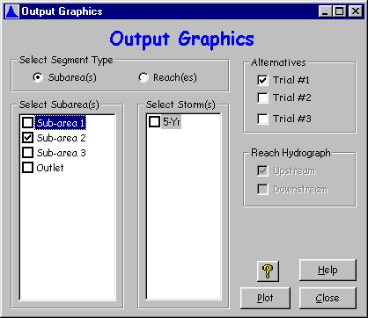

Graphics Window
Click “Plot” on the Output Graphics Window to plot selected hydrographs. Either save the plot to a file or print directly to a printer.

Window 33 - Output Plot
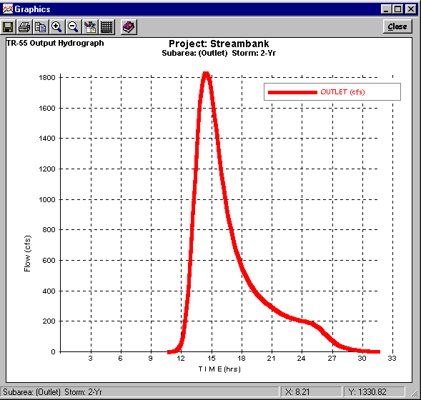
Click “Close” to close this window.

Appendix A - Examples

Example 1 – Determining Runoff from a Single Sub-area for the Existing and Developed Conditions and Sizing a Detention Basin

Background
An Industrial Development is planned on a 12.5 acre site in Franklin County, Missouri. The land is presently being used for corn production and is planted in straight rows. There are no special conservation practices being used and the vegetative cover is typically in good condition. The soils on this property are hydrologic soil group “B.”
There is no defined channel running through the property, but there is evidence of sheet flows and shallow concentrated flows. The sheet flow path has been determined to be 25 feet long at a slope of 0.8%. The shallow concentrated flow path has been determined to be 825 feet long at a slope of 0.8%.
It is desirable to limit peak discharge from a 25-year storm for the developed condition so that it does not exceed the peak discharge from a 50-year storm for the undeveloped condition. Therefore, it is necessary to design some type of stormwater detention structure to control the runoff.

Solution
The design of the stormwater detention structure will be handled in three parts. Part A will be to determine the peak discharge and runoff volume for the existing condition. Part B will be to determine the peak discharge and runoff volume for the developed condition. Part C will focus on sizing the stormwater detention structure and analyzing its effects.

Part A - Determine existing condition peak discharge and runoff volume
STEP 1: Start the WinTR-55 program and enter User I.D., Project Name, Subtitle, State and County. Specify sub-area units (default is acres). Use the Storm Data Source default values based on the State and County specified. To make certain the correct Storm Data Source and Rainfall Distribution Identifier are selected, the User MUST complete STEP 2.
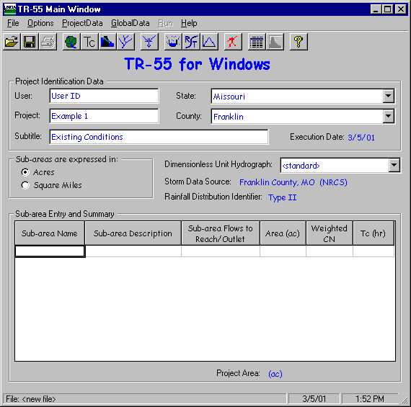
STEP 2: From the Main Window Menu, select “Global Data.” From that drop-down menu, select “Storm Data.” On the Storm Data Window, the User clicks the “NRCS Storm Data” Button and then the “Accept” Button to use the default database values for the county-state combination being modeled. Clicking the “Accept” Button accepts the data and returns the User to the Main Window.
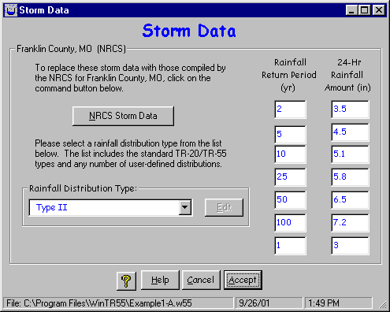
STEP 3: Enter Sub-area Name, Sub-area Description, and where the water leaving this sub-area flows in the “Sub-area Flows to Reach/Outlet” box.
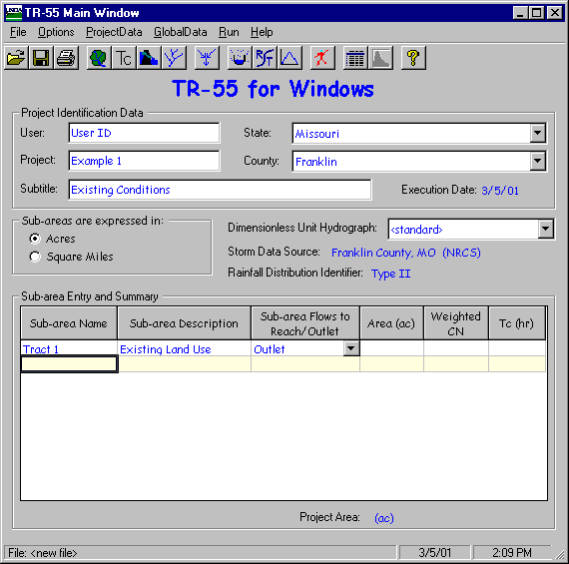
STEP 4: Click “Land Use Details” button to open the “Land Use Details” window. In the “Land Use Details” window, enter the area of the sub-area in the appropriate location. Click “Accept” to accept the data and return to “TR-55 Main Window.”
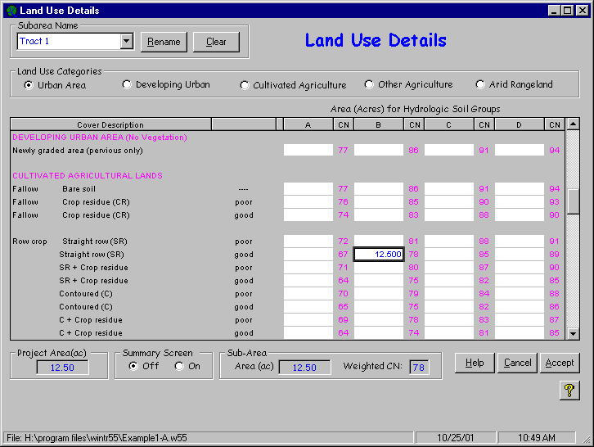
The sub-area area and runoff curve number now appear in the Sub-area Entry and Summary portion of the TR-55 Main Window.
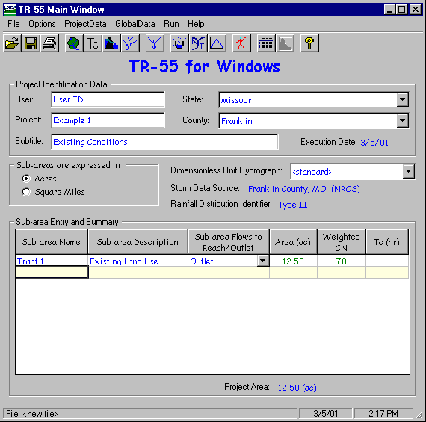
STEP 5: Click “Time of Concentration Details” button to open the “Time of Concentration Details” window. In the “Time of Concentration Details” window, enter the appropriate information to compute the sub-area time of concentration. Click “Accept” to accept the data and return to the “TR-55 Main Window.”
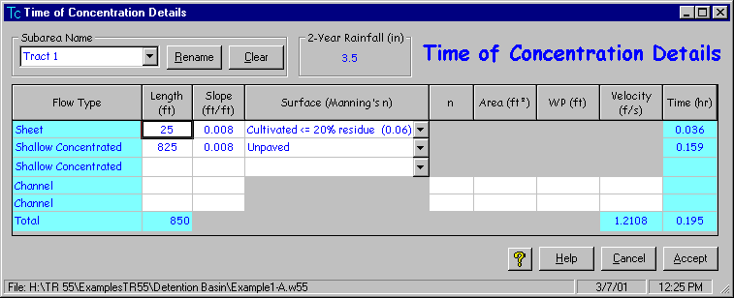
The sub-area time of concentration now appears in the Sub-area Entry and Summary portion of the TR-55 Main Window.
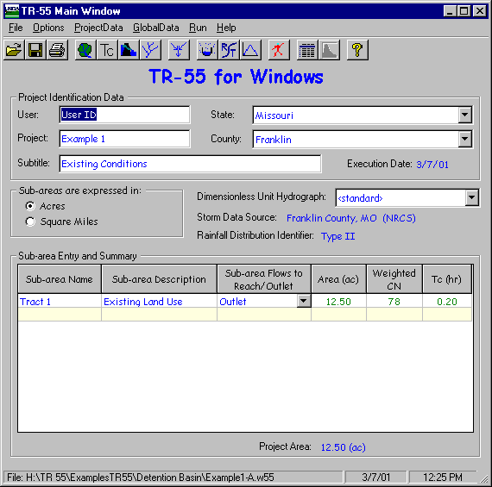
STEP 6: Click the “Run” button to open the “Run TR-55” window. Select the storm events for which output is desired. Once the storm events have been selected, click “Run” to execute the run.
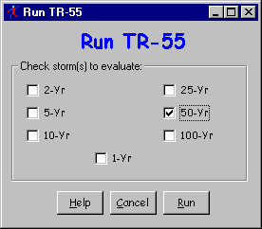
STEP 7: When the run is complete, the “File Display” window opens showing the “Hydrograph Peak / Peak Time Table.” To review other output, click “View” or “TR-55 Reports” and select the reports to view. When complete, click “Close” to close the “File Display” window and return to the TR-55 Main Window.
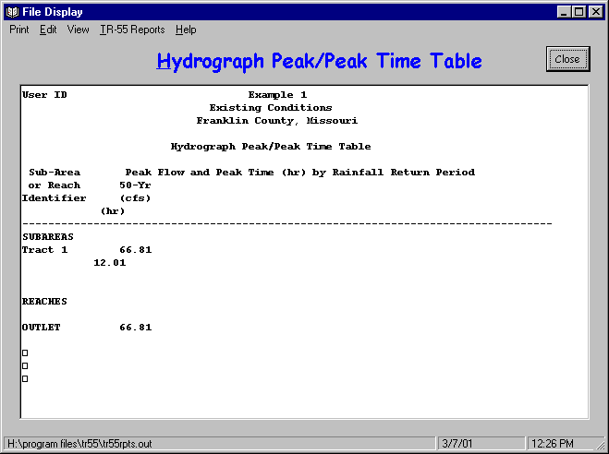
STEP 8: To save the data, click “File” and “SaveAs.” In the “Save a TR55 data file” popup window, specify a location and file name and click “Save.” The data is now saved, the popup window closes and TR-55 Main Window is redisplayed.
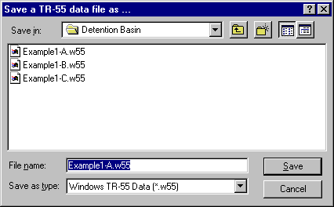

Part A - Results
50-year Pre-Development Discharge = 66.8 cfs

50-year Pre-Development Runoff Volume = 3.984 inches (watershed-inches) = 4.150 ac-ft
The Runoff Volume can be found from the “File Display Window” by selecting “View” and “TR-20 Printed Page File.”

Part B - Determine developed condition peak discharge and runoff volume
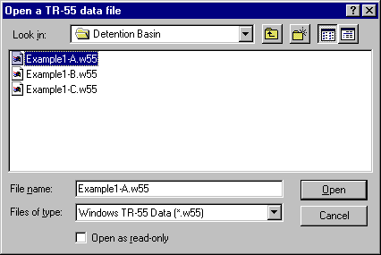
Rather than beginning with a new file to determine the peak discharge and runoff volume for the developed condition, it is possible to edit the existing condition file previously created.
STEP 1: Start the WinTR-55 Program and open the “Existing Conditions” file by selecting “Open” from the “File” menu and locating the file using the “Open a TR-55 data file” window.
STEP 2: Edit the User I.D., Project Name, and Subtitle as appropriate. Edit Sub-area Name, Sub-area Description, and where the water leaving this sub-are flows in the “Sub-area Flows to Reach/Outlet” box as appropriate. Since this example uses the same county-state combination established previously, there is no need to work through the “Global Data” selection process to change the Dimensionless Unit Hydrograph, Storm Data Source and Rainfall Distribution Identifier information.

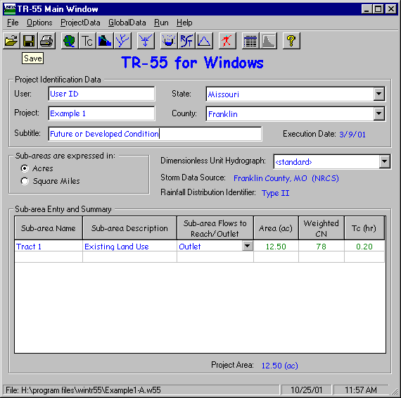
STEP 3: Click “Land Use Details” button to open the “Land Use Details” window. In the “Land Use Details” window, edit the land use as appropriate, and click “Accept” to accept the changes and return to “TR-55 Main Window.”
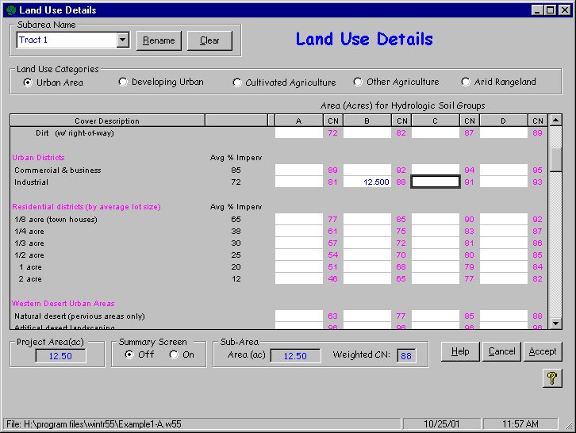
The sub-area area and runoff curve number now appear in the Sub-area Entry and Summary portion of the TR-55 Main Window.
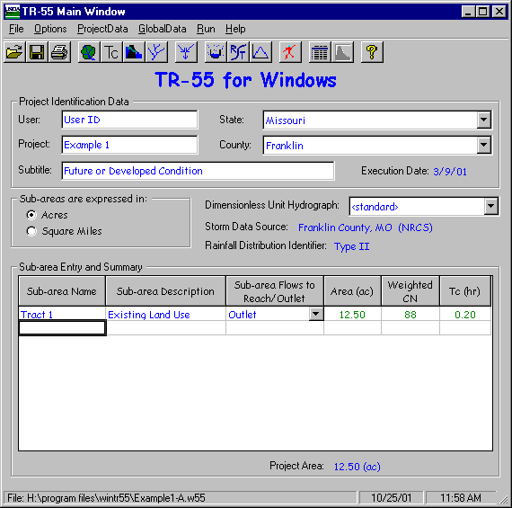
STEP 4: Click “Time of Concentration Details” button to open the “Time of Concentration Details” window. In the “Time of Concentration Details” window, edit the appropriate information to compute the developed condition sub-area time of concentration. Click “Accept” to accept the changes and return to the “TR-55 Main Window.”
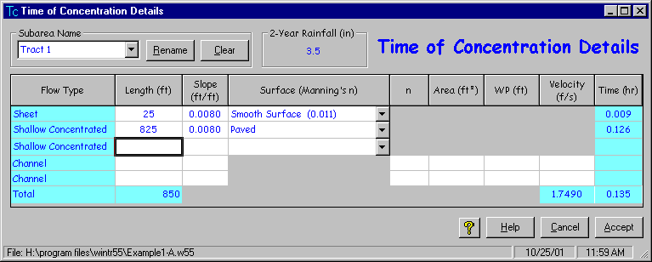
The sub-area time of concentration now appears in the Sub-area Entry and Summary portion of the TR-55 Main Window.
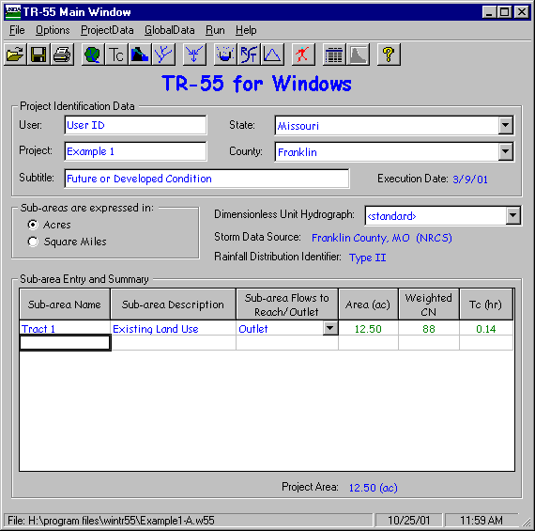
STEP 5: Click on the “Run” button to open the “Run TR-55” window. Select the storm events for which output is desired. Once the storm events have been selected, click “Run” to execute the run.
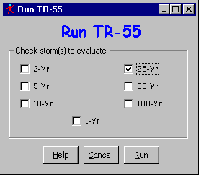
STEP 6: When the run is complete, the “File Display” window opens showing the “Hydrograph Peak / Peak Time Table.” To review other output, click “View” or “TR-55 Reports” and select the reports to view. When complete, click “Close” to close the “File Display” window and return to the TR-55 Main Window.
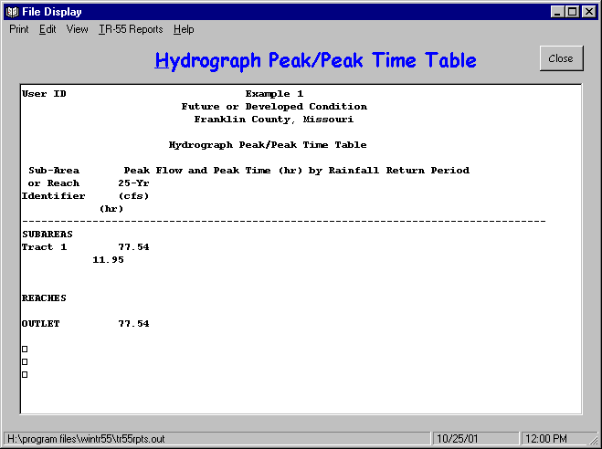
STEP 7: To save the data, click “File” and “SaveAs.” In the “Save a TR55 data file” popup window, specify a location and a NEW FILE NAME and click “Save.” The data is now saved, the popup window closes and the TR-55 Main Window is redisplayed.
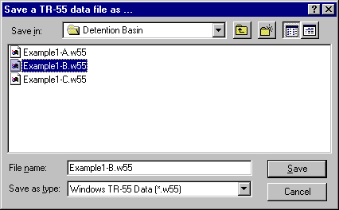

Part B - Results
25-year Post-Development Discharge = 77.5 cfs

25-year Post-Development Runoff Volume = 4.373 inches (watershed-inches) = 4.555 ac-ft
The Runoff Volume can be found from the “File Display Window” by selecting “View” and “TR-20 Printed Page File.”

Part C - Sizing the Detention Basin
There are two approaches to sizing the detention basin. The first approach is to maximize the storage volume while minimizing the pipe size. Using this approach, the entire runoff volume from the 25-year post-development storm would be stored and released at a slow rate over a long period of time using a small diameter pipe. The second approach is to minimize the storage volume while maximizing the pipe size. Using the second approach, water is released at the maximum rate possible (in this case the 50-year pre-development peak discharge) thereby minimizing the volume of water that must be stored.
The following table offers a summary of some of the advantages and disadvantages of each approach.
Method | Advantages | Disadvantages
Maximize Storage Volume  Minimize Pipe Size | Smaller diameter pipe is less expensive | Size of area required for detention basin is large
Maximize Storage Volume  Minimize Pipe Size | Storage benefits for more frequent storm events are realized because increased runoff for the smaller events is also stored. | Cost of constructing a large storage basin can be expensive.
Minimize Storage Volume  Maximize Pipe Size | Size of area required for detention basin is not as large | Larger Diameter pipe is more expensive
Minimize Storage Volume  Maximize Pipe Size | Lower construction costs for smaller storage basin | Because pipe diameter is so large, there may not be a reduction in peak discharge for more frequent storm events. Increased runoff volume from those more frequent events may pass through the basin without any portion of the increased runoff for those storms being stored.
Note that many stormwater management ordinances require a combination of storage volume and reduction in peak discharge. If that is the case, both requirements must be met. However, for this example, a minimum storage volume requirement does not apply. Therefore, in order to size the basin, one must look only at ways of reducing the peak discharge.
There was not a tremendous amount of increase in peak discharge, or storage volume for the developed condition. Peak discharge increased 16% from Q_{50pre} = 66.8 cfs to Q_{25post} = 77.5 cfs. Runoff volume increased 9.8% from Q_{50pre} = 3.984 in (4.150 ac-ft) to Q_{25post} = 4.375 in (4.555 ac-ft).
The chosen approach is to store only the increase in storage volume between the pre- and post-developed condition or:

Δ Storage Volume = 4.555 – 4.150 = 0.405 acre-feet
The detention basin will have a base area at the spillway crest elevation of 150’ on a side with side slopes of 3’ horizontal : 1’ vertical. This results in a base area of approximately 0.517 acres at the basin bottom. The depth required to store only the increase in runoff volume is approximately 0.77 feet. At 0.77’ above the spillway crest elevation, the surface area is approximately 0.549 acres.
Note: The WinTR-55 Structure Data Window uses only a standard riser / conduit configuration for evaluating detention basins with pipes. The only other option is a weir configuration. If either of these configurations is unacceptable, use another method to size the detention basin.
A standard riser configuration is chosen for the outlet device. Based upon the amount of control desired in the initial problem statement, it is necessary only to use a pipe of sufficient diameter to reduce the peak discharge from 77.5 cfs for the post-developed condition to 66.8 cfs for the pre-developed condition.
Again, rather than beginning with a new file, it is possible to edit the existing developed condition data file created in determining the future (or developed) condition discharge and volume.
STEP 1: Start the WinTR-55 Program and open the “Existing Conditions” file by selecting “Open” from the file menu and locating the file using the “Open a TR-55 data file” window.
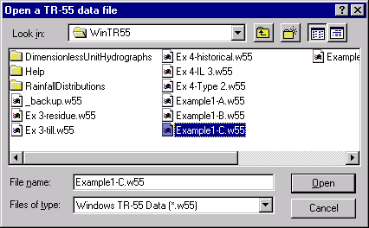
STEP 2: Edit the User I.D., Project Name, and Subtitle as appropriate. Edit Sub-area Name, Sub-area Description, and where the water leaving this sub-are flows in the “Sub-area Flows to Reach/Outlet” box as appropriate. In the situation where water flows into a detention basin, the name of the basin is entered in the “Sub-area Flows to Reach/Outlet” box. A reach name is entered here. The reach contains the structure.
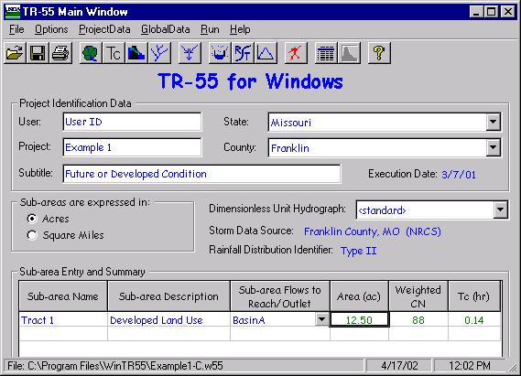
STEP 3: Click on the “Structure Data” button to open the “Structure Data” window. Enter the Structure Name, the surface area at the spillway crest elevation, and the surface area at an elevation above the spillway to define the storage characteristics of the basin. Note: If no surface area above the spillway is entered, the program assumes the basin has vertical sides. Enter the desired pipe sizes for initial evaluation of the structure ratings, and the Height in feet from the centerline of the outlet pipe to the spillway crest elevation. Note: For the standard riser configuration this height should be approximately ½ of the largest pipe diameter evaluated. As pipe diameters are entered, the structure ratings are computed and shown at the bottom of the “Structure Data” Window. Upon completion of this data, click “Accept” to accept the data and return to the TR-55 Main Window.
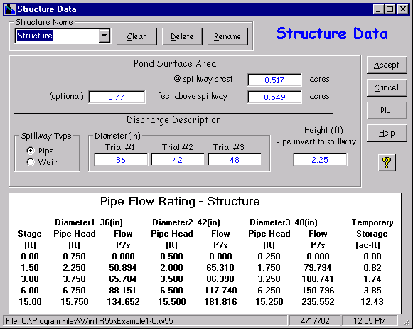
STEP 4: Click the “Reach Data” button to open the “Reach Data” window. The name of the “Sub-area Flows to Reach/Outlet” name as entered on the TR-55 Main Window is shown in the Reach Name column. In this case, the sub-area was defined to flow to “Structure.” Since the Structure is located at the outlet of the watershed, the receiving reach is Outlet. Also, since the sub-area flows through the structure, the Structure Name is entered instead of reach data. This tells the program that the water from the sub-area flows through the structure to the outlet. Click “Accept” to accept the data and return to the TR-55 Main Window.
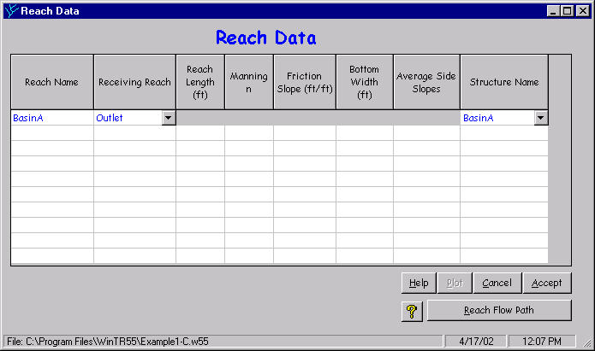
STEP 5: Click the “Run” button and select the storm to evaluate. Click “Run” to execute the run.
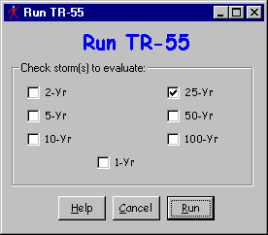
STEP 6: Upon successful execution of the run, the “File Display” window opens showing the “Hydrograph Peak / Peak Time Table” report. By scrolling down through the window, results of the runs for the different pipe sizes selected can be viewed. To review other output, click “View” or “TR-55 Reports” and select the reports to view. When complete, click “Close” to close the “File Display” window and return to the TR-55 Main Window.
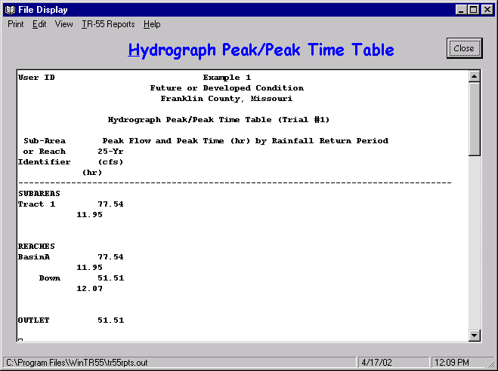
STEP 7: To save the data, click “File” and “SaveAs.” In the “Save a TR55 data file” window, specify a location and a NEW FILE NAME and click “Save.” The data is now saved and the user is returned to the “TR-55 Main Window.”
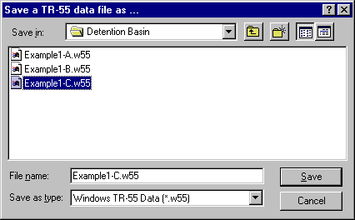

Part C - Results
Peak Discharges for the 3 different pipes evaluated are as follows:
36” diameter 52 cfs
42” diameter 58 cfs
48” diameter 61 cfs
Since the limiting discharge value is 66.8 cfs, the 48” diameter pipe may be used since the pipe discharge does not exceed the limiting value. (Note: It is possible, a larger pipe size may still meet the discharge criteria, but larger pipes were not evaluated for this example problem.)

Example 2 – Evaluating Larger Watersheds and User Defined Storm Data

Background
A small community in Any County, Some State has flooded multiple times in the last several years. The community wants to reduce flood damages and has requested assistance in evaluating peak discharges in the upper reaches of the watershed. A schematic of the watershed appears below.

Upper Main Creek Sub-area
(stream embedded in sub-area)
Lower Main Creek Sub-area
Main Stem 2 Reach
Middle Main Creek Sub-area
Main Stem 1 Reach
Lower East Trib Sub-area
East Reach
Upper East Trib Sub-area
(stream embedded in sub-area)
County Road Branch Sub-area
(stream embedded in sub-area)
Lower West Branch Sub-area
West Reach
Upper West Branch Sub-area (stream embedded in sub-area)

Watershed Data

Land Use Details
Sub-area | Land Use | Area by Hydrologic Soil Group (acres)
Sub-area | Land Use | A | B | C | D
Upper Main Creek | Residential Districts: 2 ac lots |  |  | 40
Upper Main Creek | Pasture; fair condition |  |  | 80
Upper Main Creek | Woods; fair condition |  |  | 55
County Road Branch | Residential Districts: 2 ac lots |  |  | 30
County Road Branch | Meadow |  |  | 60
County Road Branch | Woods; fair condition |  |  | 110
Middle Main Creek | Farmsteads |  | 10
Middle Main Creek | Pasture; good condition |  | 30 | 10
Middle Main Creek | Woods-Grass; fair condition |  | 20
Upper East Tributary | Residential Districts: 2 ac lots |  |  | 60
Upper East Tributary | Woods-Grass; fair condition |  |  | 40 | 10
Upper East Tributary | Woods; fair condition |  |  | 10 | 10
Lower East Tributary | Farmsteads |  | 10
Lower East Tributary | Pasture; fair condition |  | 25 | 5
Lower East Tributary | Woods-Grass; fair condition |  | 45 | 25
Upper West Branch | Industrial |  | 15
Upper West Branch | Pasture; fair condition |  | 10 |  | 20
Upper West Branch | Woods; fair condition |  | 15 |  | 5
Lower West Branch | Impervious; paved parking lots |  |  | 5
Lower West Branch | Industrial |  |  | 15
Lower West Branch | Residential Districts: 1 ac lots |  |  | 10
Lower West Branch | Pasture |  |  | 20
Lower West Branch | Woods; fair condition |  |  | 25
Lower Main Creek | Open Space, Lawns (fair cond.) |  | 15
Lower Main Creek | Impervious; paved parking lots |  | 15
Lower Main Creek | Commercial & Business |  | 15
Lower Main Creek | Residential Districts; ¼ ac lots |  | 85

Where do the “Land Use Details” data come from?
The land use data for the watershed may be derived using GIS, if GIS coverages exist for the watershed area, developed from current aerial photographs, or determined from a watershed site visit. The hydrologic soil group data may be obtained from the current soil survey for the county or counties in which the watershed is located.

Time of Concentration Details
Sub-area | Sheet Flow |  |  | Shallow Concentrated Flow |  |  | Open Channel Flow
Sub-area | Length (feet) | Slope (ft/ft) | Surface Description | Length (feet) | Slope (ft/ft) | Surface Description | Length (feet) | Velocity (ft/sec):
Upper Main Creek | 75 | 0.047 | Dense Grass | 425 | 0.047 | Unpaved | 2500 | 2.66
County Road Branch | 75 | 0.067 | Light Woods | 425 | 0.067 | Unpaved | 2100 | 2.30
Middle Main Creek | 65 | 0.052 | Short Grass | 385 | 0.052 | Unpaved | 925 | 2.40
Upper East Tributary | 50 | 0.110 | Smooth Surface | 285 | 0.110 | Unpaved | 1465 | 1.53
Lower East Tributary | 100 | 0.051 | Light Woods | 825 | 0.051 | Unpaved | 740 | 2.73
Upper West Branch | 60 | 0.092 | Smooth Surface | 340 | 0.092 | Unpaved | 1705 | 1.50
Lower West Branch | 100 | 0.045 | Smooth Surface | 1000 | 0.045 | Unpaved | 510 | 1.51
Lower Main Creek | 100 | 0.036 | Smooth Surface | 1465 | 0.036 | Unpaved | 1100 | 1.10

Where do the “Time of Concentration Details” data come from?
Time of concentration data should be carefully estimated for each sub-area. Length and slope for individual flow types (sheet, shallow concentrated and open channel) can be obtained from USGS topographical maps, aerial photographs, and field observation.
Sheet flow and shallow concentrated flow lengths may be difficult to develop. The best way to estimate these values is to visit the site and determine the actual flow paths. However, these values are generally estimated from topographical maps and aerial photos.
Open channel flow paths typically appear as a blue line on USGS topographical maps or as an obvious ditch or stream channel on aerial photographs and therefore are much easier to determine.
Surface codes for sheet flow are best determined by making a site visit. Carefully examine the land use along watershed divides.
Surface codes for shallow concentrated flow are simply paved or unpaved. This is the simplest to determine.
For open channel flows, it is necessary to determine a flow velocity. Either take bankfull velocity information from a previously developed water surface profile model or entering the Manning n value, use survey data to develop cross-sectional flow area, wetted perimeter, and slope for the stream length in question. Experienced users may simply estimate the flow velocity in the channel. Make certain that selected values are representative of the entire open channel flow length, and not just one segment of the open channel flow path.

Reach Data
Reach Name | Reach Length (feet) | Manning “n” | Slope (ft/ft) | Bottom Width (feet) | Side Slope (Z:1)
Main Stem 1 | 540 | 0.065 | 0.003 | 20 | 55
East Reach | 685 | 0.065 | 0.006 | 30 | 33
West Reach | 810 | 0.065 | 0.011 | 35 | 40
Main Stem 2 | 640 | 0.065 | 0.007 | 45 | 86

Where do the “Reach Data” come from?
Reach data must be derived for each stream segment that receives water from an upstream sub-area or another reach.
Rating curves are developed for the reaches which describe the flow characteristics of the reaches. A particular cross-section surveyed within the reach in question is picked to be representative of the entire reach and the data for that cross-section is used. That cross-section may be located anywhere within the reach, but will represent the entire length of that reach.
Ratings for the reach are developed using the Manning “n” values, slope, bottom width of the cross-section and side slopes. It is important to estimate these values for the overall valley cross-section and not just the channel section. These values may differ drastically between the channel and the valley. The goal is to estimate a rating curve that represents both.

Rainfall Data
Rainfall Data for the watershed in “Any County, Some State” is shown in the following table:
24-hour Precipitation Amount (inches) by Return Period
1-year | 2-year | 5-year | 10-year | 25-year | 50-year | 100-year
3.0 | 3.5 | 4.5 | 5.1 | 5.8 | 6.5 | 7.2

Entering Storm Data
Step 1: Select “Global Data” from the TR-55 Main Window Menu.
Step 2: Under “Global Data,” select “Storm Data.”
Step 3: When the “Storm Data” window opens, enter the rainfall amount by return frequency for the desired storms and select the appropriate rainfall distribution from the drop-down menu.
Step 4: Once the rainfall distribution type is selected and the rainfall amounts have been entered, click “Accept” to accept the data and return to the main window.
NOTE: The user should enter the state and county name on the Main Window, BEFORE going to the Storm Data window to enter the custom rainfall amount.
For this example problem, the Storm Data Window appears as follows upon completion of data entry. Press the “Accept” button to return to the main window.
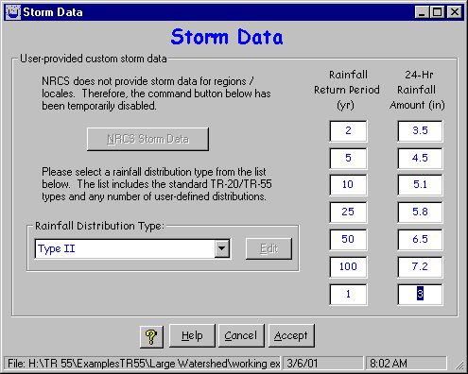

Results
Upon completion of data entry, the TR-55 Main Window should appear as follows:
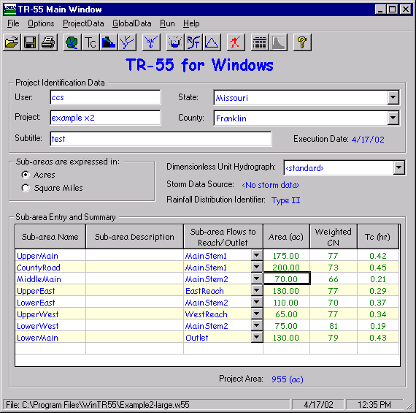
The 5-, 10-, 50-, and 100-year storm events were analyzed and peak discharges obtained for each sub-area and reach. The Watershed Peak Table contains a listing of peak discharges for each of the sub-areas and reaches.
WinTR-55 provides the following output data by sub-area and reach:
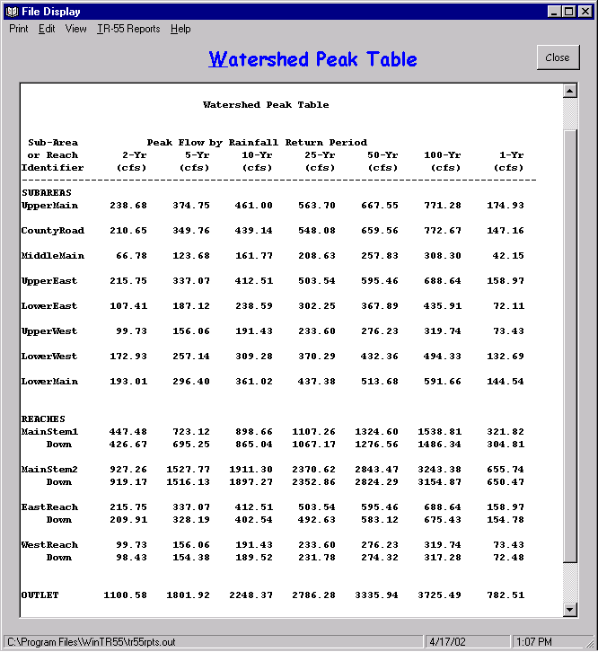

Discussion of Results
In order to evaluate the output results and make a judgement as to whether or not results are reasonable, an understanding of how WinTR-55 processes the data, and in particular, how the hydrographs are added in WinTR-55, is beneficial.
In the Watershed Peak Table, peak discharges are listed both by sub-area and by reach. The Sub-area Peak Discharges represent the peak discharge values obtained in determining the runoff contributed solely by a particular sub-area. So, for this example, the peak discharge for the UpperMain sub-area for the 5-year storm event is listed at 375 cfs. This peak is that obtained for the UpperMain sub-area SOLELY. Likewise, for the MiddleMain sub-area, the 5-year storm event peak discharge is 124 cfs. And again, this represents only the peak discharge produced by the rainfall falling on the MiddleMain sub-area. Obviously, the MiddleMain sub-area also receives water from the UpperMain and CountyBranch sub-areas; but the sub-area peak discharge, as listed in the Watershed Peak Table, is that produced by rainfall on the MiddleMain sub-area and to this point does not include waters coming from outside of that sub-area. In short, the sub-area peak discharges are independent peaks and have not been routed or added to produce any composite hydrographs.
The peak discharges by Reach are added and routed and represent composite hydrographs. However, it is necessary to take a close look at these peaks to understand how the WinTR-55 routing procedure works. As stated previously, the peak discharge for the UpperMain sub-area for the 5-year storm event is 375 cfs. The peak discharge for the CountyRoad sub-area for the same storm event is 350 cfs. Runoff from both of these hydrographs flow through the MiddleMain sub-area via MainStem1 reach. If we look at the peak for MainStem1reach in the Watershed Peak Table, we notice a value of 723 cfs. This peak represents the peak of the added hydrographs for the UpperMain and CountyRoad sub-areas. That is, the hydrographs for UpperMain and CountyRoad sub-areas added together produce a peak of 723 cfs for the 5-year storm event. Notice also that there is a Peak Discharge of 695 cfs listed on the Watershed Peak Table for the Downstream end of MainStem1 reach. This value represents the peak discharge for the routed hydrograph resulting from the runoff from the UpperMain and CountyRoad sub-areas. In summary, the runoff from UpperMain and CountyRoad produced hydrographs which when added together produced a peak of 723 cfs at the upper end of the MainStem1reach. When this hydrograph was routed through the MainStem1 reach, a hydrograph with a peak discharge of 695 cfs resulted. At this point, the runoff from the MiddleMain sub-area is not yet included.
For this example, the peaks listed for MainStem2 reach become somewhat more complicated because two tributaries enter the system. However, applying the concepts of adding the hydrographs and developing peaks as explained in the previous paragraph, it should be obvious to the user that the peak discharge at the upper end of the MainStem2 reach represents the combination of the following:
- Resultant hydrograph obtained from the runoff produced by the UpperMain and CountyBranch sub-areas routed through MainStem1 reach.
- Runoff hydrograph produced by MiddleMain sub-area.
- Runoff hydrograph produced by UpperWest sub-area routed through WestReach reach.
- Runoff hydrograph produced by LowerWest sub-area.
- Runoff hydrograph produced by UpperEast sub-area routed through EastReach.
- Runoff hydrograph produced by LowerEast sub-area.
From the Watershed Peak Table, the peak at this point for the 5-year storm event is 1,527 cfs. Notice at the downstream end of this reach that the peak is reduced to 1,516 cfs. The 1,516 cfs represents the peak of the hydrograph as it is routed downstream through MainStem2 reach. The only thing left at this point is to add the runoff produced by the LowerMain sub-area. The hydrograph for the LowerMain sub-area produces a peak discharge of 296 cfs. When these final two hydrographs are added, the resultant peak at the watershed outlet is 1,802 cfs.

Example 3 – Custom Dimensionless Unit Hydrograph
This example demonstrates the use of a Custom Dimensionless Unit Hydrograph (DUH) instead of the standard one preloaded in the program. In certain areas of the country different DUH's are applicable due to variations between geomorphic regions and differences in urbanization, channelization, and available storage (in wetlands, floodplains, and/or reservoirs) in watersheds. Users should contact the NRCS State Conservation Engineer if they have questions on whether or not to use the standard DUH in a location. This example uses the coastal Delmarva Dimensionless Unit Hydrograph named for Delaware, Maryland, and Virginia.

Background
Owen Davies owns a 12.5 acre site in Talbot County on Maryland's Eastern shore. Forest covers 1.5 acres of the property, and the remaining 11 acres are presently in Silver Queen sweet corn production, planted in straight rows. He uses conventional tillage with no special conservation practices and the vegetative cover is typically in good condition. The soils on the cropland portion of the property are hydrologic soil group C. Hydrologic soil group D soils underlie the wooded part.
His plot is almost rectangular, with the cropland located on higher ground and the wooded part in a forested stream corridor, although the stream itself lies outside of his property. There is no defined channel running through his property, but there is evidence of sheet flows and shallow concentrated flows. The sheet flow path is 100 feet long with a slope of 0.1%. The shallow concentrated flow path through the cornfield is 858 feet long, also at a slope of 0.1%. The path of the flow through the woods is 131 feet long at a slope of 0.095%.
Owen has considered leaving crop residues on his field to reduce erosion and pollutant discharge into the stream. His daughter Branwen wants to show him what a difference crop residues can make. She will use WinTR-55 to calculate the peak discharge from a range of storms for his land. She'll also use the Delmarva Unit Hydrograph (Welle, et al., 1980) which applies to the eastern shore of Maryland instead of the standard NRCS one. The Delmarva Unit Hydrograph was developed specifically for this area and reflects the discharge measured by USGS stream gages over years of monitoring.
Solution:
This analysis has three parts. First, enter the Delmarva dimensionless unit hydrograph into the data file. Second, determine the peak discharge and runoff volume for the present field tillage condition. Third, determine the peak discharge and runoff volume for the future condition with crop residue. Since the pollutants are carried by the runoff from the fields, a reducing runoff indicates a reduction in soluble pollutant load, if other factors are constant.

Part 1 - Enter custom dimensionless unit hydrograph
STEP 1: Branwen starts the WinTR-55 program and selects "new" from the pull down choice list for "File". She enters User ID, Project Name, Subtitle, State and County and specifies sub-area units as acres. The Dimensionless Unit Hydrograph, the Storm Data Source and the Rainfall Distribution identifier have default values given when the program starts up, based on the last file used. The default Dimensionless Unit hydrograph is the standard NRCS one, with a peak factor of 484.
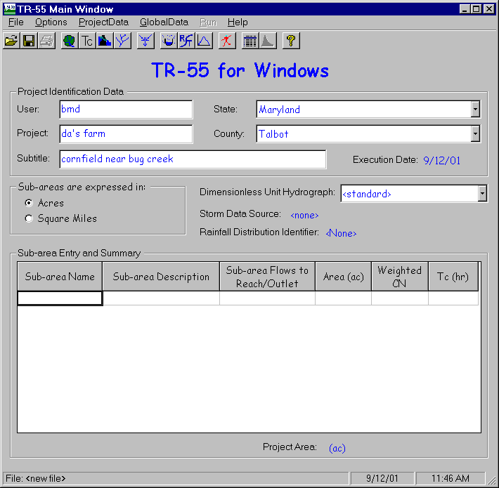
Branwen can click on Global Data in the TR-55 Main Window Menu Bar, and then on the Storm Data in the pull down choice list (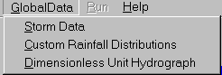), or on the storm data icon () on the button bar to bring up the Storm Data Window:

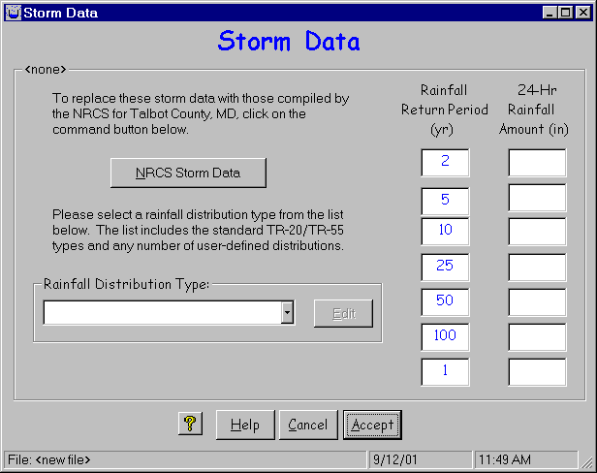
Clicking the NRCS Storm data button will fill in the data for Talbot County, Maryland:
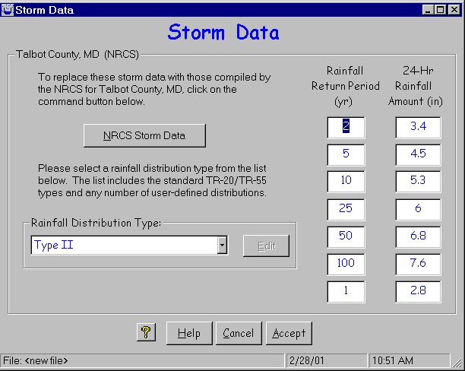
By clicking the Accept button, Branwen selects this as her Storm Data Source, which reflects on the TR-55 Main Window. She is ready to concentrate on the dimensionless unit hydrograph.
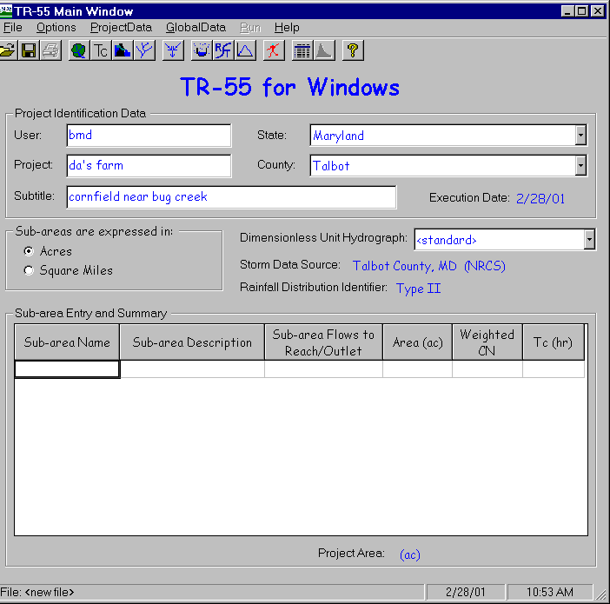
STEP 2: Branwen visited the Talbot County Agricultural Service Center and has a table with the values for the Delmarva DUH. She can click on Global Data in the TR-55 Main Window Menu Bar and then on Dimensionless Unit Hydrograph in the pull down choice list() or click on the icon for the dimensionless unit hydrograph () on the button bar to bring up the Dimensionless Unit Hydrograph Window:
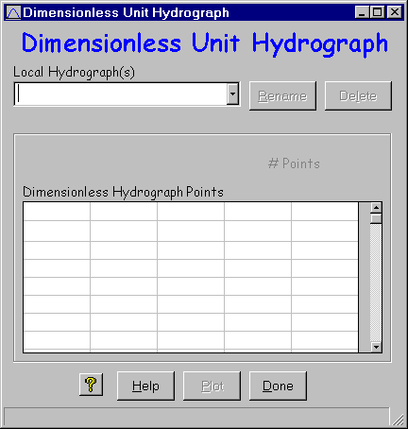
STEP 3: The Dimensionless Unit Hydrograph (DUH) Window allows entry of a custom DUH. Branwen enters Delmarva for the DUH in the Local Hydrograph combo entry box. She then enters the points that define the DUH in the Dimensionless Hydrograph Points Grid. The points should begin and end at 0.0 and should be no greater than 1.0. The program will calculate and show the number of points automatically.
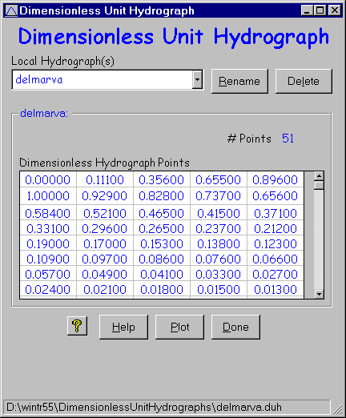

STEP 4: If she wants, she can click on the Plot button and plot the DUH. The second line of the Title gives the path where her work is located.
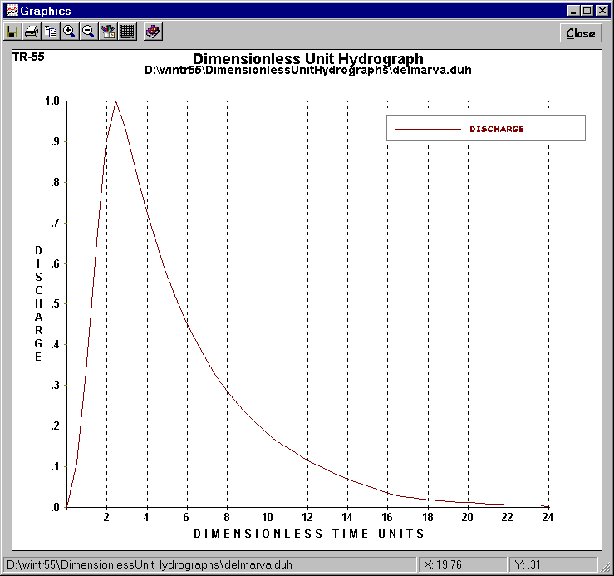
STEP 5: She must return to the Main Window and select the Delmarva Dimensionless Unit Hydrograph from the choices displayed by the DUH pulldown for the program to actually use the Delmarva hydrograph in its calculations. After highlighting Delmarva in the pull-down choice list, she double-clicks on it to enter it as her choice for use. If she wants to use this dimensionless unit hydrograph in another job, all she needs to do is click on its name in the hydrograph list.
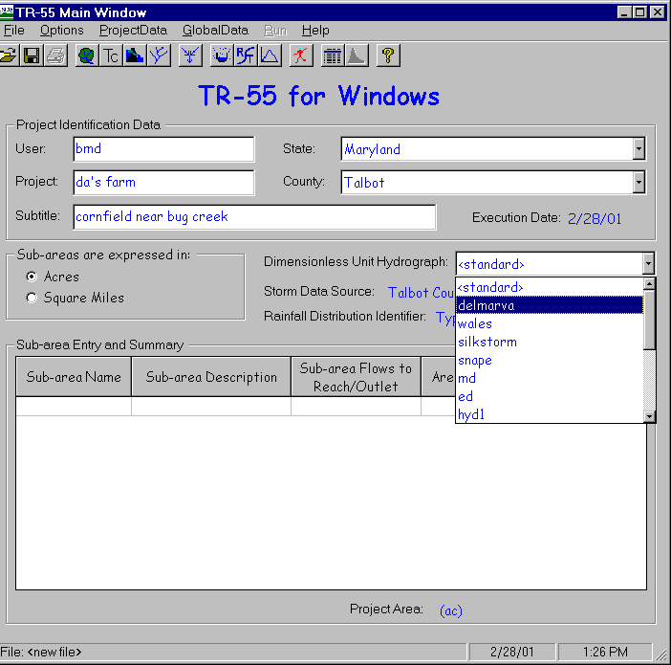
STEP 6: Branwen now enters the Sub-area Name, Sub-area Description, and where the water leaving this sub-area flows in the “Sub-area Flows to Reach/Outlet” box to set up her watershed, ready to do her land use and time of concentration calculations.
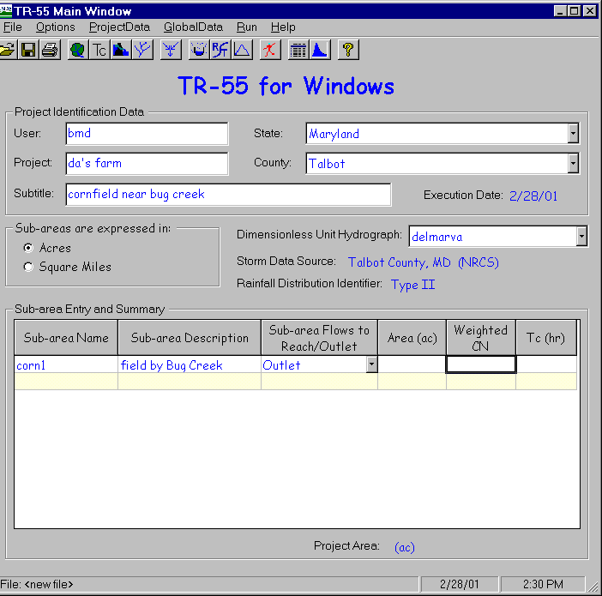

Part 2 - Determine peak discharge and runoff volume for the present field tillage conditions.
STEP 1: Branwen can double click on the 'Area (ac)' label, the 'Weighted CN' label, or on either of the two blank cells in the entry grid below them to open the “Land Use Details” window. In the “Land Use Details” window, for each land use she enters the area involved under the appropriate hydrologic soil group. She can click the Summary Screen “On” to see all her land use categories. Clicking “Accept” returns the program to the “TR-55 Main Window.”
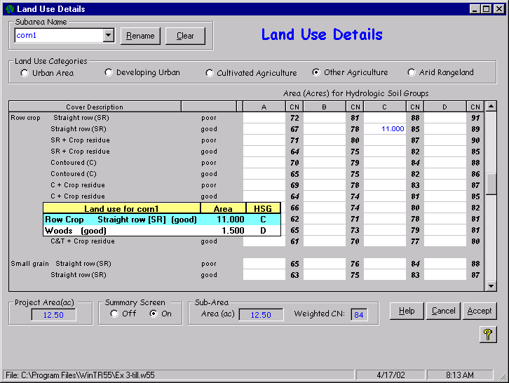

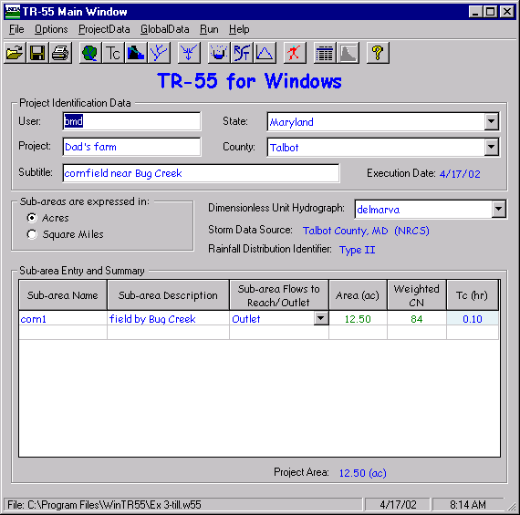

The sub-area area and runoff curve number now appear in the Sub-area Entry and Summary portion of the TR-55 Main Window.
STEP 2: Branwen opens the “Time of Concentration Details” window the same way as the "Land Use Details" window. She enters the appropriate information to compute the sub-area time of concentration and clicks “Accept” to return to the “TR-55 Main Window.”
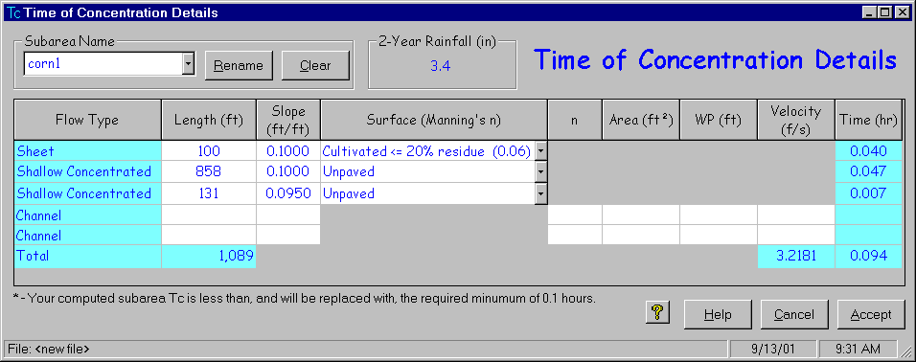
The sub-area time of concentration now appears in the Sub-area Entry and Summary portion of the TR- 55 Main window.

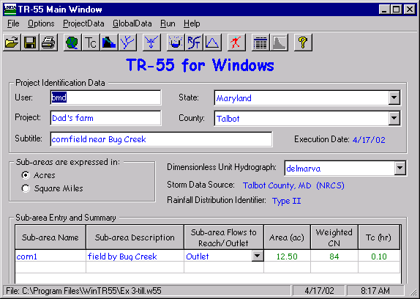
STEP 3: Branwen clicks the “Run TR-55 ” button or the 'Run' icon () to open the “Run TR-55 ” window and selects the storm events for which she would like output. Then she clicks the Run button to execute the run. While the program is running, a processing bar appears and displays the program's progress as a series of little blue rectangles that march from left to right over and over again. This reassures Branwen that something is happening, even if she's not sure what. The appearance of this processing bar excludes user entry of new data.
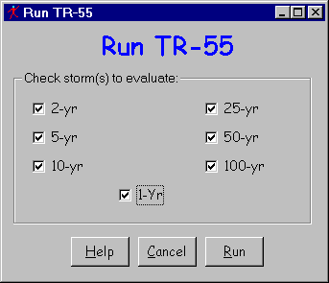
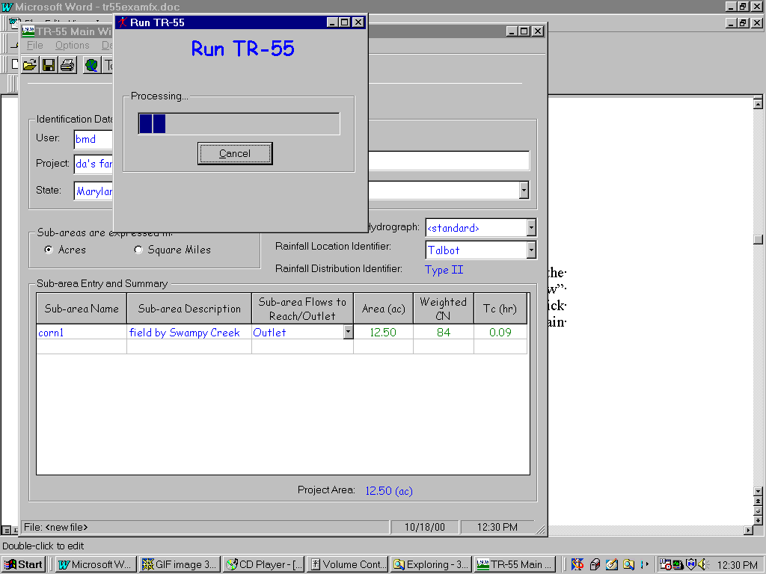
STEP 4: When the run is complete, the “File Display” window opens showing the “Hydrograph Peak / Peak Time Table.” Branwen can review other output by clicking “View” or “TR-55 Reports” and selecting the reports to view. She clicks “Close” to close the “File Display” window and return to the TR-55 Main Window.
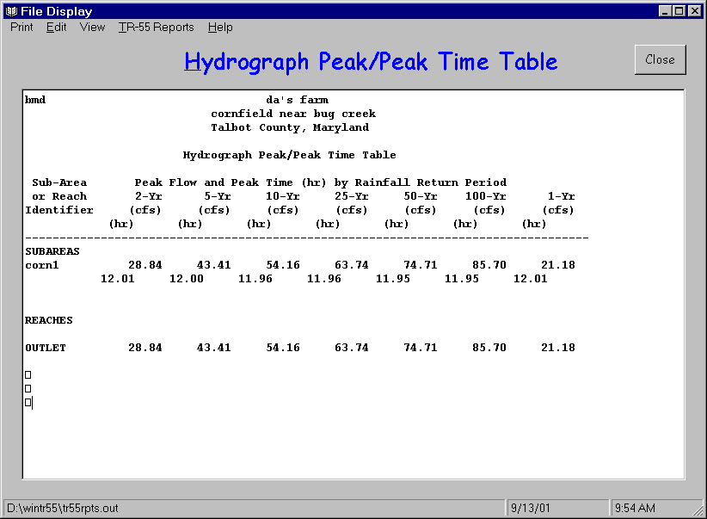
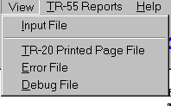
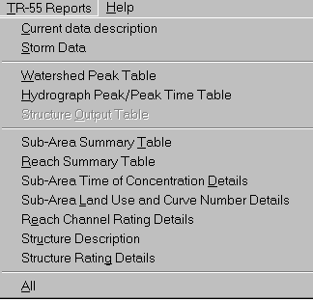
STEP 5: From the Main Window Branwen can click on the Output Definition icon () to get a list of output summary reports available for printing or viewing. She selects the Watershed Peak Table to show her Dad.
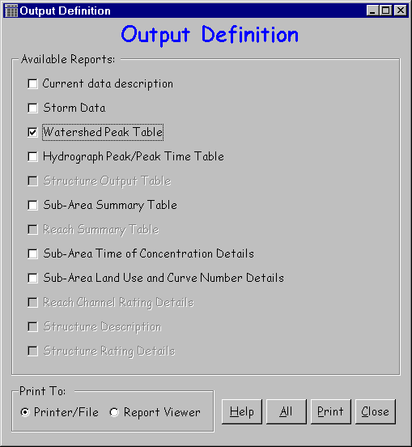
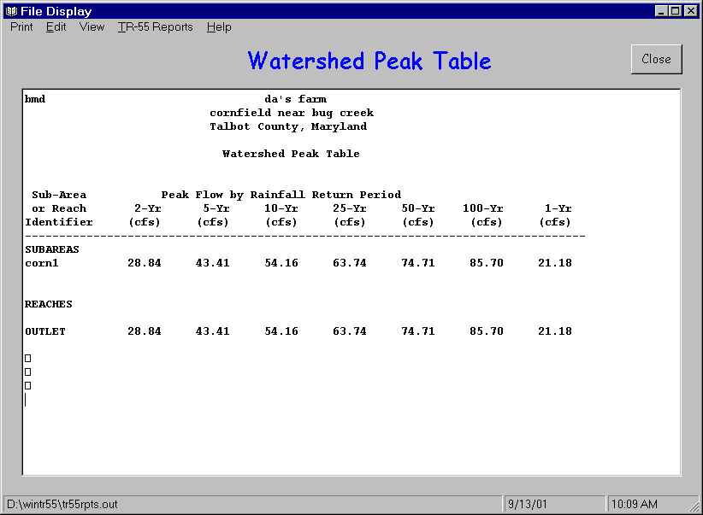

STEP 6: To save the data, she returns to the Main Window by clicking “Close” on the File Display Window and “Close” on the Output Definitions Summary Window. She then clicks “File” on the Menu Bar and “SaveAs.” In the “Save a TR-55 data file” popup window, she specifies a file name (Ex 3-till for corn, conventional tillage) and clicks “Save.” The data is now saved, the popup window closes and the “TR-55 Main Window” is redisplayed.
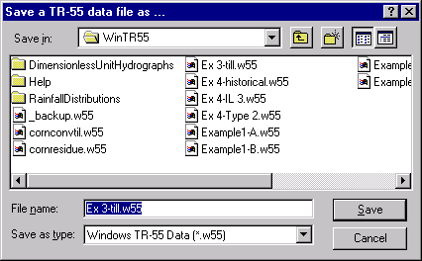

Results

Conventional Tillage Discharge
Frequency | 1-year | 2-year | 5-year | 10-year | 25-year | 50-year | 100-year
Discharge | 21.2 cfs | 28.8 cfs | 43.4 cfs | 54.2 cfs | 63.7 cfs | 74.7 cfs | 85.7 cfs
Volume* | 1.1” | 1.7” | 2.8” | 3.5” | 4.1” | 4.9” | 5.7”
*The Runoff Volume can be found from the “File Display Window” by selecting “View” and “TR-20 Printed Page File.”

Part 3 - Determine peak discharge and runoff volume 'with crop residue management' condition
Rather than beginning with a completely new file to determine the peak discharge and runoff volume for the crop residue condition, Branwen decides to edit the existing condition data file previously created and save it under a different name.
STEP 1: She starts the WinTR-55 Program and opens the “Existing Conditions” file by selecting “Open” from the “File” menu and locating the file using the “Open a WinTR-55 data file” popup window.
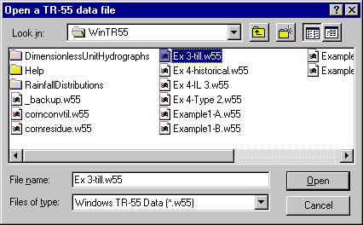
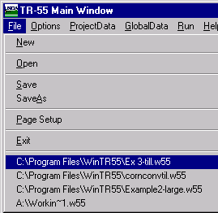
She may also go into the pull down choice list under File and select Ex 3-till.w55 from the last files used displayed in the history list.

STEP 2: Branwen edits the Subtitle, and the Sub-area Name, to reflect crop residue conditions. She will need to also edit the CN and Tc to account for the new practice. Clicking “Land Use Details” button opens the “Land Use Details” window in which she edits the land use and clicks “Accept” to return to “TR-55 Main Window.”
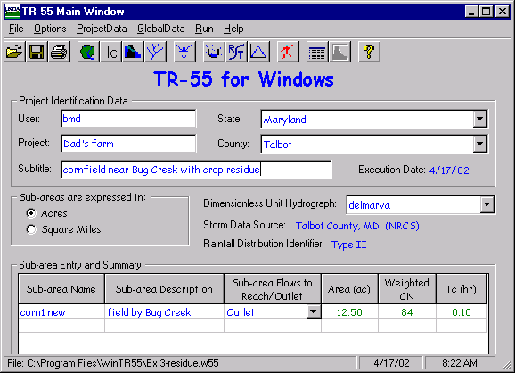
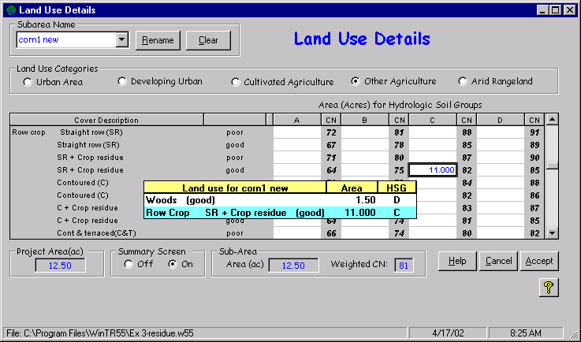
The sub-area area and the new runoff curve number now appear in the Sub-area Entry and Summary portion of the TR-55 Main Window.
STEP 3: Branwen opens the “Time of Concentration Details” window and edits the data (assuming her Dad will have greater than 20% residue) to compute the new sub-area time of concentration. Clicking “Accept” returns her to the “TR-55 Main Window.”
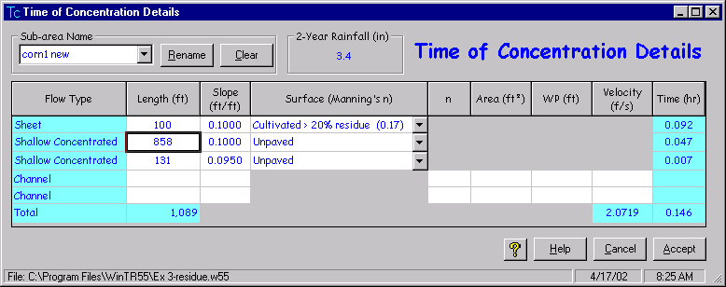
The sub-area time of concentration now appears in the Sub-area Entry and Summary portion of the TR-55 Main Window.
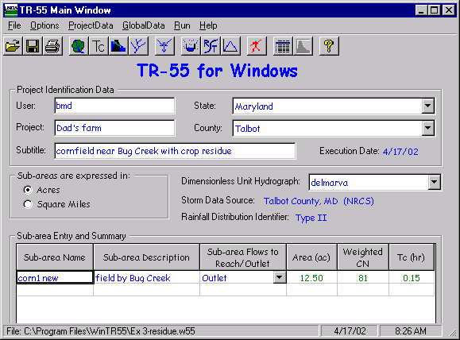
STEP 4: Branwen saves her data now using “SaveAs” to give it a new name (Ex3-residue), and then clicks “Run TR-55 ” button to open the “Run TR-55 ” window. The program saves the storm events for which the last run was made, so she can “Run” to execute the run. When the run is complete, the “File Display” window opens showing the “Hydrograph Peak / Peak Time Table.” She can click “View” or “TR-55 Reports” and select the reports to view. When complete, she clicks “Close” to close the “File Display” window and return to the TR-55 Main Window.
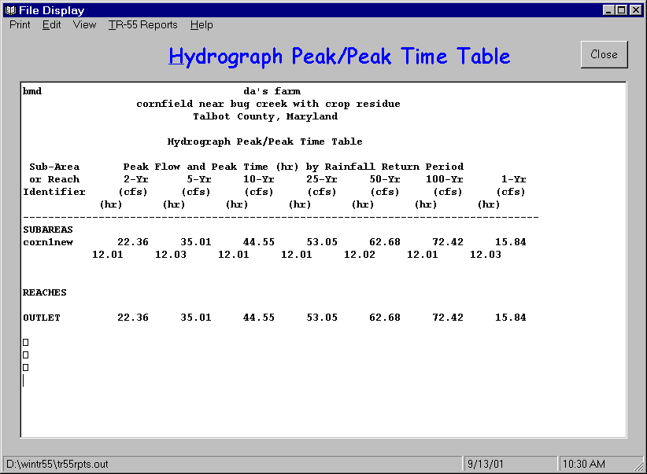

Results

Crop Residue Tillage Discharge
Frequency | 1-year | 2-year | 5-year | 10-year | 25-year | 50-year | 100-year
Discharge | 15.8 cfs | 22.4 cfs | 35.0 cfs | 44.6 cfs | 53.1 cfs | 62.7 cfs | 72.4 cfs
Volume* | 1.0” | 1.4” | 2.5” | 3.2” | 3.8” | 4.6” | 5.3”
*The Runoff Volume can be found from the “File Display Window” by selecting “View” and “TR-20 Printed Page File.”

STEP 5: Summary of Results
Crop Residue vs Conventional Tillage Discharge
Frequency | 1-year | 2-year | 5-year | 10-year | 25-year | 50-year | 100-year
Discharge (conv. tillage) | 21.2 cfs | 28.8 cfs | 43.4 cfs | 54.2 cfs | 63.7 cfs | 74.7 cfs | 85.7 cfs
Volume (conv. tillage) | 1.1” | 1.7” | 2.8” | 3.5” | 4.1” | 4.9” | 5.7”
Discharge (residue) | 15.8 cfs | 22.4 cfs | 35.0 cfs | 44.6 cfs | 53.1 cfs | 62.7 cfs | 72.4 cfs
Volume (residue) | 1.0” | 1.4” | 2.5” | 3.2” | 3.8” | 4.6” | 5.3”
Discharge decrease (w/residue) | 5.4 cfs | 6.4 cfs | 8.4 cfs | 9.6 cfs | 10.6 cfs | 12.0 cfs | 13.3 cfs
Volume decrease (w/residue) | 0.1” | 0.3” | 0.3” | 0.3” | 0.3” | 0.3” | 0.4”
Branwen can now carry these results to her Dad and demonstrate the advantages of residue in reducing flows from his corn field.

Example 4 – Custom Rainfall Distribution

Background
Minor Lake Subdivision in Champaign County, Illinois has an existing stormwater detention basin designed with 100-year Type II rainfall distribution. A nearby watershed recently experienced a 7-inch 24-hour storm for which hourly precipitation data is available. A local hydraulic engineer estimated the recurrence interval of this event to be 110 years.
The local homeowners want to know how their existing detention basin would perform during such an event. For comparison purposes, the engineer completed a 100-year Type II distribution design analysis first. The historical event was analyzed second.

Watershed and Basin Data
The existing hydrologic design listed the drainage area as 25 acres of ¼-acre residential lots on hydrologic soil group “B” soils – curve number 75. The time of concentration had been computed at 0.45 hours. The 100-year rainfall depth is 6.61”.
The existing detention basin has a surface area of 2.0 acres at the spillway crest. Three feet above the spillway crest the surface area is 2.4 acres. The inlet crest of the 15-inch diameter pipe is 3.5 feet above the outlet.

Existing Conditions – Type II Rainfall Distribution
Enter the existing data on the TR-55 Main Window, Structure window, and Reach window.
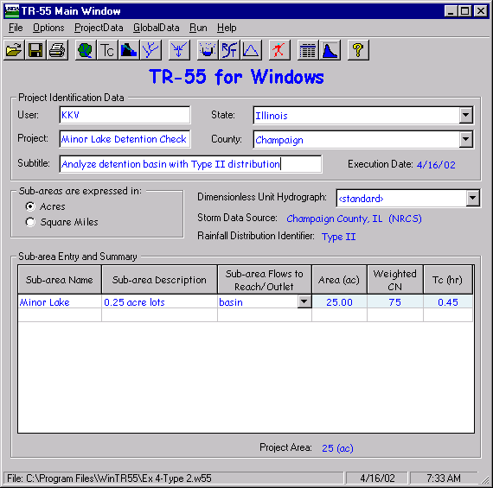
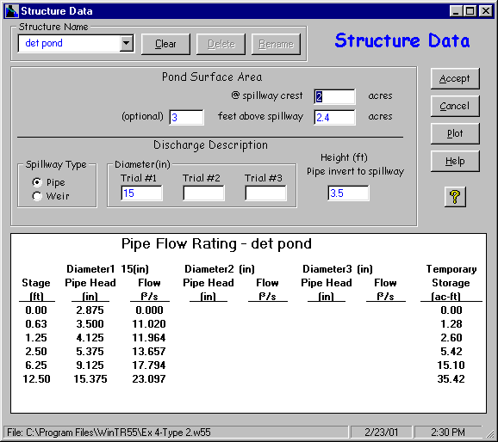
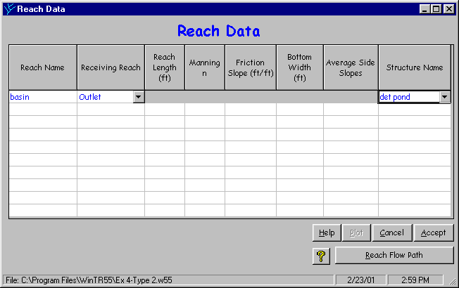
The resulting flow path schematic is shown below.
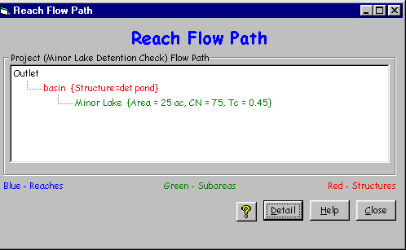
Go to the Global Data menu on the TR-55 Main Window and select Storm Data. On the Storm Data window, click NRCS Storm Data to choose the NRCS Champaign County rainfall data. Note that Type II rainfall distribution is the default distribution.
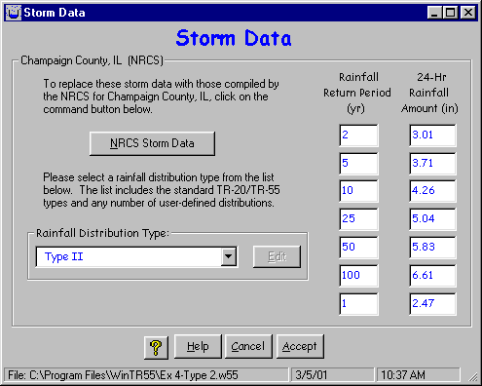
Click Accept to accept the data and return to the TR-55 Main Window. Save this data as “Ex 4 Type 2”. Run the 100-year design storm.
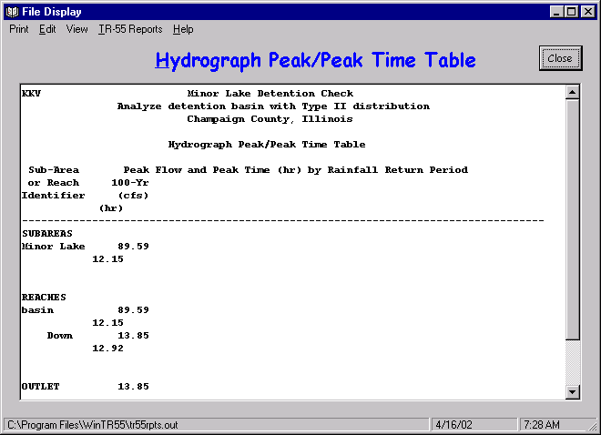
Using the Type II rainfall distribution, the peak flow from the Minor Lake watershed area is nearly 90 cfs into the basin. The flow out of the basin is approximately 14 cfs. To look at the respective 100-year design hydrographs, click the hydrographs button on the TR-55 Main Window.
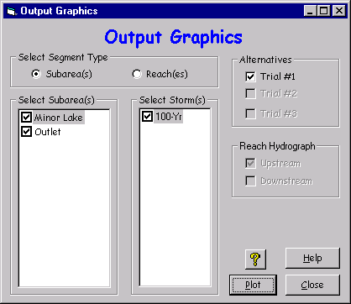
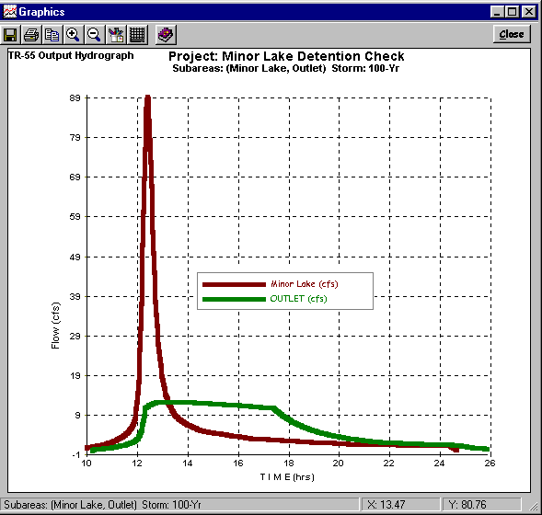
The short-duration highly-peaked line hydrograph is from subdivision houses and the long low line represents outflow from the basin.

Enter Historic Rainfall Distribution
From the TR-55 Main Window save the existing data file as “Ex 4-historical”. Click the custom rainfall distributions button on the TR-55 Main Window and enter the recorded hourly rainfall distribution as shown below. The values are a ratio of the total rainfall. For example, 0.21”of rain fell during the first hour, so the first data point after 0 is 0.03000 (0.21”/7” = 0.03).
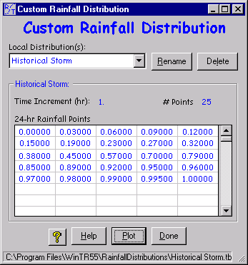
The plot below shows how the rainfall was distributed during the 24-hour storm.
Now that the custom rainfall distribution has been entered and saved, click on the Storm Data button on the TR-55 Main Window. Select the previously defined distribution, Historical Storm, from the pull-down list for distribution types. Make sure the 2-year rainfall is still 3.01” for time of concentration computations. Enter 7.00” for the 110-year rainfall on the right side of the window. Click “Accept” to return to the TR-55 Main Window.
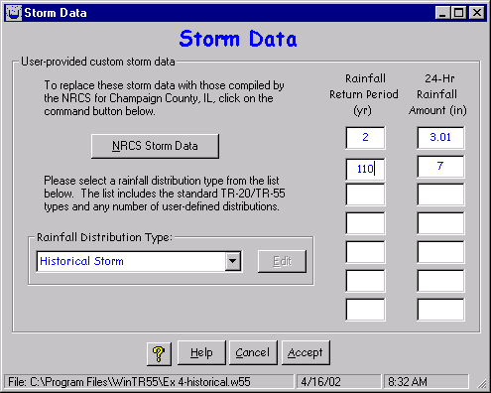
Click “Accept” to close the Storm Data window and return to the TR-55 Main Window.
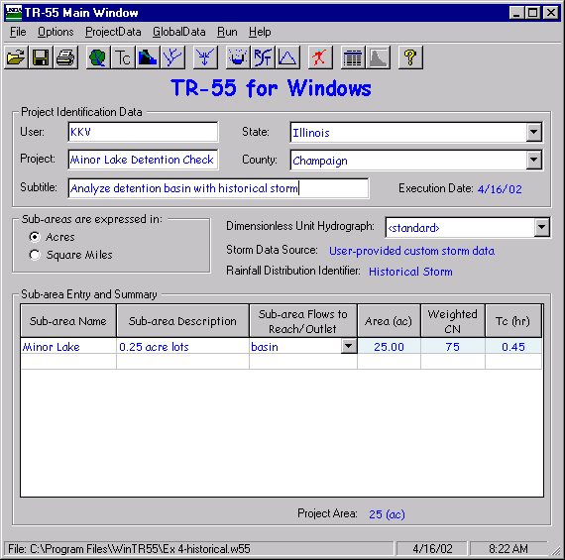
The storm data source now reads “User-provided custom storm data”. Click the run button to compute the hydrographs using the historical rainfall distribution and depth.
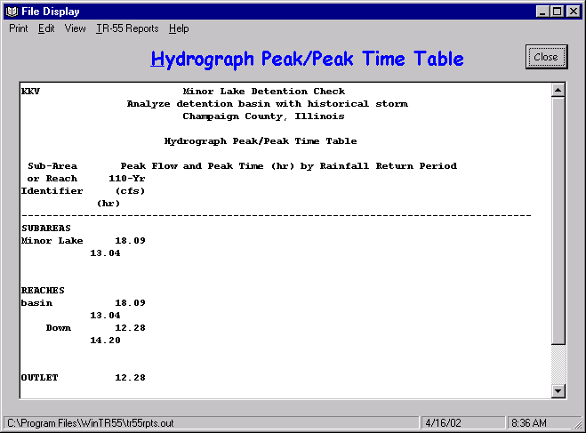
The historical peak is estimated at 18 cfs from Minor Lake sub-area. The detention basin lowers the peak to approximately 12 cfs. The hydrographs are plotted below.
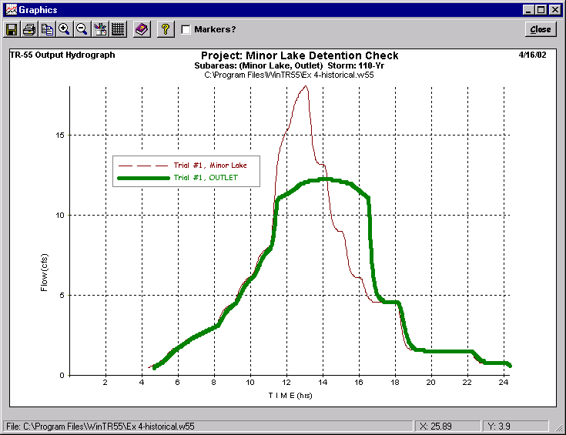
The thin, jagged line represents the flow from the subdivision and into the basin. The thicker line represents the estimated outflow from the detention basin during the historical rainfall event.
If detailed information is needed, such as a table of hydrograph points, go the the output definition window and view any report to open the file display window. Select View-TR-20 Printed Page File to see the following hydrograph.
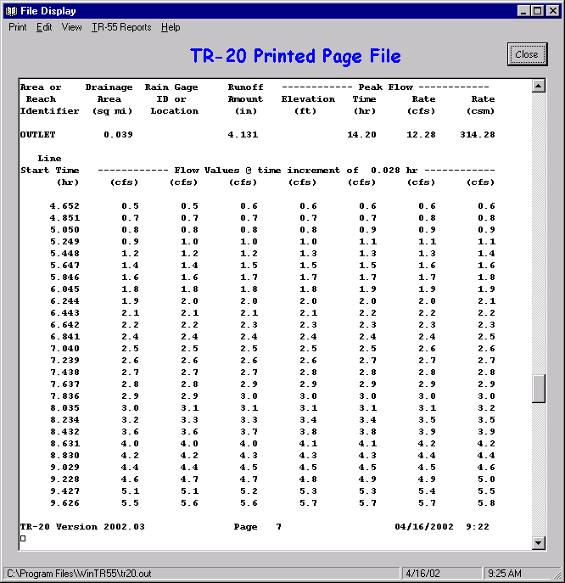
This TR-20 printed page report is a text file in the WinTR-55 subdirectory labeled “tr20.out”.

Results
The peak inflow to the existing stormwater detention basin was reduced from the 90 cfs (Type II) design value down to 12 cfs (historical storm). This dramatic peak flow reduction is due to the less-intense historical rainfall distribution. The peak discharge decreased even though the rainfall depth increased slightly from 6.61” design depth to 7” historical depth.
However, the peak outflow from the detention basin is reduced only slightly, from 13 cfs to 12 cfs. Therefore, this analysis demonstrates that the existing stormwater detention basin would performed adequately during the historical storm event that occurred in the nearby watershed.

Appendix B - Equations

Runoff Equation
Q = | [ | P – 0.2 | ( | 1000  CN | -10 | )] | 2
Q = |  | P + 0.8 | ( | 1000  CN | -10 | )
Where
Q = runoff (in)
P = rainfall (in), and
CN = runoff curve number

Composite CN (connected impervious area)
CN_{c} = CN_{p} + | ( | P_{im}  100 | ) | (98-CN_{p})
Where
CN_{c} = composite runoff curve number
CN_{p} = pervious runoff curve number, and
P_{im} = percent imperviousness

Composite CN (unconnected w/ <30% impervious)
CN_{c} = CN_{p} + | ( | P_{imp}  100 | ) | (98-CN_{p}) (1 –0.5 R)
Where
R = ratio of unconnected impervious area to total impervious area

Sheet Flow
T_{t} = | 0.007 (nL) ^{0.8}
T_{t} = | (P₂) ^{0.5} S ^{0.4}
Where
T_{t} = travel time (hr)
n = Manning roughness coefficient (for sheet flow)
L = flow length (ft)
P₂ = 2-year, 24-hour rainfall (in), and
s = slope of hydraulic grade line (land slope, ft/ft)

Shallow Concentrated Flow
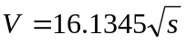 (Unpaved)
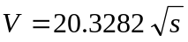 (Paved)
Where
V = average velocity (ft/s), and
s = slope of hydraulic grade line (watercourse slope, ft/ft)
These two equations are based on a solution of the Manning equation with different assumptions for n (Manning roughness coefficient) and r (hydraulic radius, ft). For unpaved areas, n is 0.05 and r is 0.4; for paved areas, n is 0.025 and r is 0.2.

Channel Flow (Manning Equation)
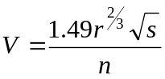
Where
V = average velocity (ft/s), and
r = hydraulic radius (ft) and is equal to a/p_{w}
a = cross sectional flow area (ft²)
p_{w} = wetted perimeter (ft)
s = slope of hydraulic grade line (channel slope, ft/ft)
n = Manning roughness coefficient (for open channel flow)

Channel Rating Equations
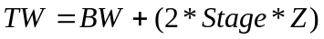
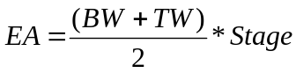
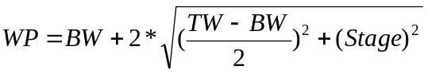
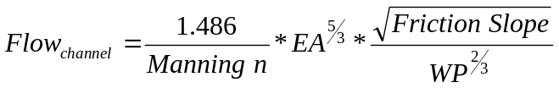
Where:
EA = End Area, square feet
Flow_{channel} = cfs
TW =Top Width, ft
BW = Bottom Width, ft
Stage = ft
WP = Wetted Perimeter, feet
Z = Side slope, dimensionless
Friction Slope = no units

Storage Rating Equations
Temporary storage
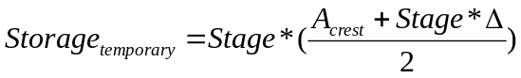
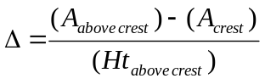
Where
Δ = delta, ft
Height_{above crest} = feet
Stage = feet
Area @ crest = acre
Area @ height above crest = acre
Storage_{temporary} = acre-feet

Pipe Flow

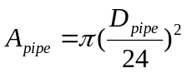
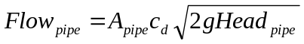
For g = gravity and C = 0.6
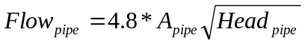
Where
Height = feet
Head_{pipe} = feet
Stage = feet
D_{pipe} = inches
A_{pipe} = square feet
Flow_{pipe} = cfs

Weir Flow
For L_{Weir} = 0
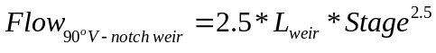
Where
L_{weir} = Weir Length, ft
Stage = feet
Flow_{weir} = cfs

Appendix C - References
United States Department of Agriculture, Soil Conservation Service. 1975. Urban Hydrology for Small Watersheds, Technical Release 55, 91 pp.
United States Department of Agriculture, Soil Conservation Service. 1986. Urban hydrology for Small Watersheds, Technical Release 55, 156 pp.
United States Department of Agriculture, Soil Conservation Service, Northeast National Technical Center. 1986. Time of Concentration, Hydrology Technical Note No. N4, 12 pp.
National Engineering Handbook, Part 630 HYDROLOGY (http://www.wcc.nrcs.usda.gov/water/quality/frame/hydrolog.html)
Preface: Preface (PDF 5kb) 2001
Chapter 1: Introduction (PDF 53kb) 1997
Chapter 2: Procedures (PDF 220kb) 1999
Chapter 3: Preliminary Investigations (PDF 77kb) 1999
Chapter 4: Storm Rainfall Data (PDF 159kb) 1993
Chapter 5: Streamflow Data (PDF 123kb) 1997
Chapter 6: Stream Reaches and Hydrologic Units (PDF 86kb) 1998
Chapter 7: Hydrologic Soils Groups
Chapter 8: Land Use and Treatment Classes (PDF 110kb) ?
Chapter 9: Hydrologic Soil-Cover Complexes (original) (PDF 557kb) 1969
Chapter 10: Estimation of Direct Runoff from Storm Rainfall (original) (PDF 1164kb) 1972
Chapter 11: Estimation of Direct Runoff from Snowmelt (original) (PDF 279kb) 1971
Chapter 12: Hydrologic Effects of Land Use and Treatment (PDF 247kb) 2002
Chapter 13: Stage-Inundation Relationships (original) (PDF 408kb) 1971
Chapter 14: Stage-Discharge Relationships (original) (PDF 3502kb) 1972
Chapter 15: Travel Time, Time of Concentration, and Lag (original) (PDF 882kb) 1972
Chapter 16: Hydrographs (original) (PDF 1040kb) 1972
Chapter 17: Flood Routing (original) (PDF 5661kb) 1972
Chapter 18: Selected Statistical Methods (PDF 359kb) ?
Chapter 19: Transmission Losses (original) (PDF 2304kb) 1983
Chapter 20: Watershed Yield (original) (PDF 862kb) 1971
Chapter 21: Design Hydrographs (original) (PDF 7668kb) 1972
Chapter 22: Glossary (original) (PDF 550kb) 1971
(The above documents requires a PDF reader, generally available free of charge.)

United States Department of Agriculture, Natural Resources Conservation Service. 2001 (draft). TR-20 System: User Documentation, 105 pp.
United States Department of Agriculture, Natural Resources Conservation Service. 2001 SITES Water Resource Site Analysis Computer Program User's Guide. 469 pp.
Maidment, D. R. (ed.), Handbook of Hydrology, McGraw-Hill, 1993, 1422 pages.
Chow, V. T., Maidment, D. R, and Mays, L. W., Applied Hydrology, McGraw-Hill, 1988, 586 pages.
U. S. Army Corps of Engineers, Hydrologic Engineering Center, HEC-RAS User's Manual, Version 2.0, April 1997,
Ponce, V.M., Engineering Hydrology, Prentice Hall, 1989, 640 pages.
Welle, P.I., Woodward, D. E., Fox Moody, H., A Dimensionless Unit Hydrograph for the Delmarva Peninsula, 1980. Paper No. 80-2013, ASAE 1980 Summer Meeting, 18 pp.

