4.4 Aerobatics:
Special nature of aerial application flying
Flight profile (G exposure, push-pull effect)
Spatial disorientation
Thermal stress
Crash survival and crash worthiness

Aerobatic flying, is a specialized form of flight, where the aircraft's performance and attitudes change rapidly. Aerobatics are governed by special aspect of FAR 91.303, which requires aerobatics to be performed in a specified box of air space, and requires that the aircraft be certified for acrobatic flight and a utility rating and that the pilot(s) wear parachutes. The flight profile is beyond normal operations for whatever class of aircraft and may involve rolls, loops, stalls and generation of smoke trails. Acrobatic flight has special hazards due to acceleration affects and orientation problems for the pilots as well as avoidable hazards for spectators. You will understand the risks involved in this aspect of aviation and be able to counsel pilots and airshow participants for safety issues.

Aerobatic flight is an intentional maneuver involving abrupt change in an aircraft's
attitude, an abnormal attitude, or abnormal acceleration, not necessary for normal flight. FAA Regulation Part 91 (General Operation and Flight Rules), Subpart D, section 303 regarding flight over inhabited areas or over people, requiring flight more than 1,500 feet above ground and governs acrobatic flight operations limiting flight to visual flight rule (VFR) conditions. Section 51 also requires the use of parachutes, and defines aerobatics as banks over 60º, pitch attitudes over 30º and prohibits carrying passengers. Aerobatics vary by aircraft type. A glider can perform aerobatics by a simple loop or roll, while a steep nose-high pitch-up constitutes acrobatics in a helicopter. Aerobatic maneuvers constitute normal operations in agricultural (Utility) aircraft but are virtually unknown in passenger jets (although a Boeing 707 was rolled in a 1959 flyby).

Basic maneuvers include the loop, roll and stall. A loop is simply flight where the nose of the aircraft is pitched up (or down in an outside loop) until the aircraft has completed 360º of rotation. Basic physics dictate that the aircraft will experience at least 2 Gz of acceleration on the bottom of the loop. Entrance speed must be significantly above stall speed so that as speed is lost during the climb, it does not drop below stall speed and maneuverability is maintained. In theory, the acceleration level can drop to 0 Gz at the apex of the loop, but no pilot does this in practice and normally a pilot will maintain excess speed and positive Gz will be experienced through the entire maneuver. Performed at high speed, the accelerations can be much higher in all aspects of the maneuver, pitch-up, over-the-top, pitch-over and pullout. If the speed is too high, the Gz can be excessive anywhere in the loop, but particularly during pullout with the possibility of loss of consciousness due to G-LOC (see Sustained Acceleration). The maneuver is accomplished entirely with horizontal elevator control changes and when performed properly, the entrance and exit altitudes are the same. In the outside loop, the nose is pitched down and negative Gz is maintained throughout; this is uncomfortable for the pilot and potentially dangerous if Gz forces are high enough.
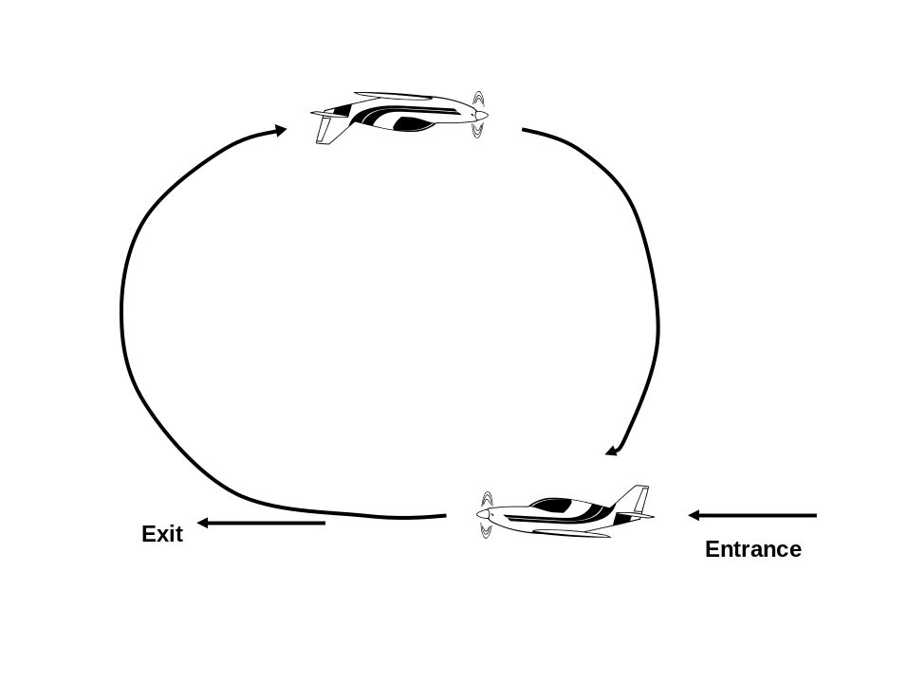

The Loop-360º of pitch change

The roll is an aileron maneuver. The ailerons are deflected to start the aircraft into a bank as in a turn, but no elevator or rudder is applied. The aircraft will roll about its longitudinal axis. However, there is always loss of altitude during this maneuver, as lift is lost when the wing is not parallel to the ground. Therefore the maneuver is started slightly nose high and ends slightly nose low. Use of rudder during the maneuver to keep the nose up also reduces loss of altitude. There is minimal speed change and accelerations vary from slightly above 1 Gx when horizontal to +1 Gz while at 90 º to -1 Gz while inverted and -1 Gz at 270º. However, the roll itself induces Gy accelertations. The direction of flight does not change.

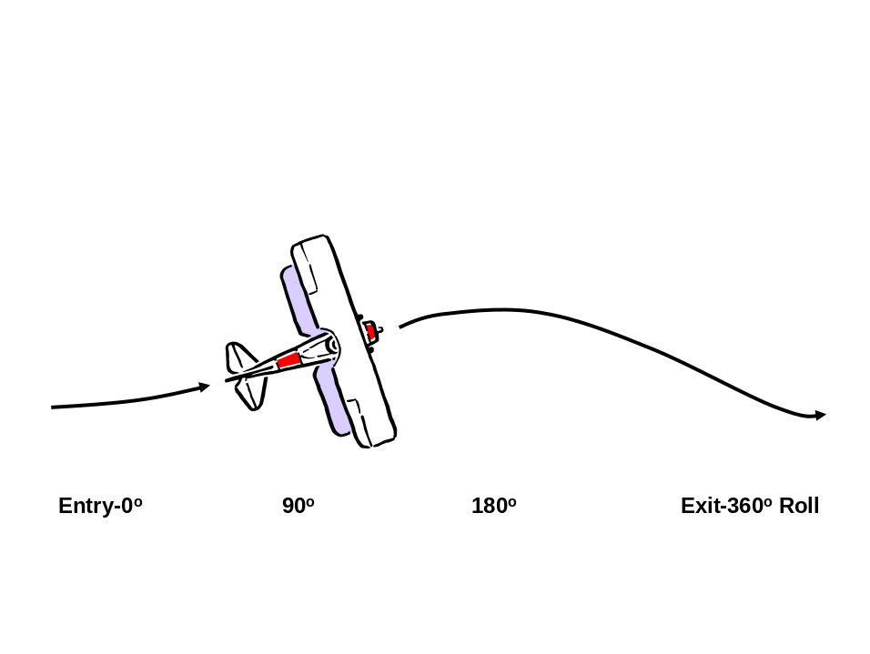

The Roll-360º of Bank Attitude Change

The Barrel Roll is a variation of the basic Roll. Here the pitch of the aircraft does change and nose describes an arc around a point. The pilot will initiate a roll with ailerons, but also pulls up the nose and maintains elevator pressure, resulting in nearly constant acceleration, typically +1.5 Gx, through the maneuver. The result is a full roll of 360º while describing a spiral path through space. No altitude is lost. Other variations on the Roll include 8-point or 16-point Rolls, where the pilot will pause the maneuver every 45º or 22º respectively. Snap Rolls are simply a roll performed very rapidly, and Slow Rolls are where the maneuver is drawn out.

Other maneuvers combine the Roll with a Loop to form figures in space such as an “8” or a cloverleaf. Still another acrobatic maneuver is the Stall, where the aircraft speed is slowed enough that lift is lost, usually by performing a near-vertical climb. The aircraft stops flying and falls, usually pitching nose over. This causes airspeed to increase to above stall speed and flight resumes. Obviously all these maneuvers require considerable skill and training, as failure to perform or recover from the maneuver will result in a crash. While the maneuvers described above can be performed with modest G profiles, most pilots vary this considerably. Their flight profile causes significant variation in G exposure, usually to high G during pullouts, as high as 6 Gs during some civilian maneuvers, although military aerobatics jets are capable of over 9 G maneuvers (see Sustained Acceleration).

Keep in mind, that this compares to a standard 30 degree bank turn of about 1.3 Gz, and a “steep” 60º level turn yields only +2 Gz. Maneuver variations can induce additional yaw with Gy loads, particularly during Snap Rolls, and a pilot who is not stabilized in the seat can strike their head against the canopy during these maneuvers. The high G exposure may cause stasis of blood flow and G-induced loss of consciousness (G-LOC). There is also a “push-pull effect”, where the pilot rapidly changes the loading from positive to negative Gs. This may induce spatial orientation problems which are inherent to aerobatics, as well as slowing the cardiovascular response to high G loads when returning from zero or negative Gs (See Spatial Orientation). Aerobatics training is required by a certified instructor, and rolls in performances during air shows are extremely strict.

In addition to spatial disorientation, thermal stress may occur, as many aerobatic aircraft have large glass canopies, and performances are often on hot summer days. The combination of greenhouse effect with the vigorous physical activity from flying and straining can produce a significant heat load, which in turn may produce mild dehydration and reduce G tolerance.

Aerobatics may not be performed over inhabited areas. During air shows acrobatics may not be performed over a crowd or flown towards a crowd. Failure to follow these rules led to massive spectator casualties during an air shows at Ramstein, Germany in 1989 and in the Ukraine in 2002 (below).

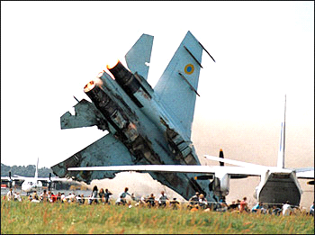

There has never been as fatality in an aerobatic competition, although accidents during air shows are unfortunately frequent, usually due to the tendency of a pilot to “over perform”, and misjudge their height above ground, or location relative to another aircraft. Additional permission must be obtained to use smoke generators. Some colored smokes include oils and volatiles that can drift down, coating buildings and onlookers, and cause skin and respiratory irritation.

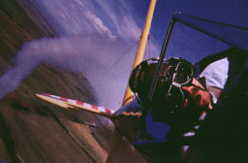

Aircraft and their engines must have certifications to withstand the increased loads and unusual attitude induced by aerobatic maneuvers. Certified acrobatic aircraft include Citabria, Cessna C150 Aerobat, Decathlon, and Pitts S-2A/B. Specialized acrobatic aircraft used for performances and competitions include the Extra and Sukhoi. Pilots only need appropriate certificates and medical certification for the aircraft they are flying. Performance for remuneration is usually a commercial activity and would require a commercial pilot’s license and a second-class medical certificate.

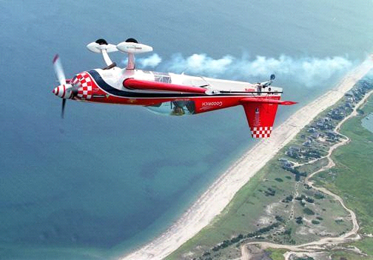
WORLD CHAMPION PATTY WAGSTAFF PERFORMING IN HER
EXTRA 300S

One characteristic of all aerobatic aircraft is a low wing load. This means that the weight per square foot of aircraft wing area is quite low, sometimes, on the order of 2 pounds per square foot, and often one-tenth that of a standard non-aerobatic aircraft. This effect permits the aircraft to make “sharp turns”, and greatly enhances performance.

In order to reduce the weight of the aircraft to meet some of these standards, however, some other safety features, such as a protective cage for the pilots is reduced to minimum. Due to the possibility of accidents during aerobatic flight, pilots are not only required to wear a parachute, but will frequently wear fire protective garments made of Nomex to enhance post crash survivability.

Reference: International Aerobatic Club and Experimental Aircraft Association.

