Copper Inclusion and Migration from the Back Contact in CdTe Solar Cells

C. R. Corwine, A. O. Pudov, M. Gloeckler, S. H. Demtsu, and J. R. Sites
Colorado State University
Department of Physics, Fort Collins, CO 80523
email: ccorwine@lamar.colostate.edu

ABSTRACT

Metallic back contacts to CdS/CdTe solar cells will in general form Schottky barriers. Better performance is achieved with the inclusion of Cu in the back contact. This study uses current-voltage, capacitance-voltage, and laser beam induced current measurements to analyze as-deposited CdS/CdTe solar cells prepared with varying back contact Cu amounts and to evaluate changes in cell performance following elevated-temperature stress. A simple model is proposed to explain both the observed differences in device behavior as copper is added or removed from the contact region, and how copper movement depends on electrical bias.

Keywords: CdTe solar cells, back contact, copper, stress, migration
1. Introduction
Copper is commonly used in the back contact to improve device performance of thin-film n-CdS/p-CdTe solar cells [1]. Since CdTe has a high electron affinity (χ) and band gap (E_{g}), many metals will form a Schottky barrier, resulting in a significant limitation to hole transport from the p-CdTe. In a circuit model, this barrier will form a diode of opposite polarity to the primary junction [2], which distorts the current-voltage (J-V) curves by limiting the total device current at higher voltage. The result is often referred to as the “roll-over” effect [3]. A second effect, “cross-over” of light and dark curves, is often explained by the photoconductivity in the CdS buffer layer of the typical CdS/CdTe device. In general, cross-over, which is primarily generated by a distortion of the dark curve, does not affect device efficiency. Roll-over, however, decreases device efficiency by reducing the fill factor and in extreme cases by limiting the V_{oc}.
During device preparation, it is common to chemically etch the CdTe layer after the CdCl₂ treatment but prior to the back contact process [4-7]. The etching creates a Te or Te-rich layer on the CdTe. The effect of the etching process is not well understood, but many benefits have been ascribed to it, including a change in the surface pinning of the Fermi level when metals are contacted to CdTe [4] and a decrease in the contact resistance when the contact is formed after etching [8]. During the subsequent back contact process, Cu from the contact can form a distinct Cu_{x}Te_{(1-x)} layer and/or it can locally increase the effective doping level in the CdTe at the back contact through interdiffusion [9]. The former lowers the back contact barrier while the latter narrows it. Most likely, both lowering and narrowing occur, as depicted schematically in Figure 1. In either case, the current through the back barrier should be less limited when copper is added, since the current transport is diffusion-limited based on the thermionic emission-diffusion theory [10,11] and depends therefore on the doping density at the contact. Conversely, removal of copper from the back contact region should progressively limit the current flow through the back diode.
The electrical activity of Cu is an important aspect to the model in Figure 1. Previous studies have shown that Cu can form donors (Cu_{i}), acceptors (Cu_{Cd}), and neutral complexes (Cu_{Cd}⁻-Cu_{i}⁺) in CdTe [12-14]. In the latter case, only a small percentage of Cu atoms would be electrically active in the crystal lattice. A study by Balcioglu et al. [15] explored the Cu-related impurities in polycrystalline CdTe/CdS solar cells. Optical deep-level transient spectroscopy (ODLTS) measurements on solar cells produced by the National Renewable Energy Laboratory (NREL) suggested that the most probable Cu-related defect is a deep donor and may be a doubly ionized Cu interstitial ion (Cu_{i}⁺⁺). The concentration of the Cu_{i}⁺⁺ defect (from ODLTS) corresponded to the Cu diffusion profile (from Secondary Ion Mass Spectroscopy, or SIMS), and the highest concentration was at the CdTe/CdS interface. The study also observed substitutional Cu impurities (acceptors), found only in the bulk of the CdTe. Both defects are believed to have originated from the Cu-containing back contact. The results indicate that at least part of the Cu in the back contact is electrically active: substitutional Cu will dope the CdTe, as discussed previously, and Cu_{i}⁺⁺ ions can migrate through the CdTe.
Figure 1 shows how the primary junction field might influence Cu movement. Cu is well known to be a fast diffuser. Most likely, the Cu moves along grain boundaries, since Cu has been reported to diffuse faster in polycrystalline CdTe than in single-crystal CdTe [16]. However, assuming that much of the Cu in the back contact is in the form of a positive ion, the primary junction field of the cell will resist the migration away from the contact. Hence, the rate of migration will depend on the bias across the cell. This argument was confirmed experimentally (Figure 2, reproduced from Ref. [17]), which shows efficiency changes in CdTe cells made by First Solar, Inc. that were held at 100°C for 20 days. The underlying assumption is that the major degradation mechanism originates from the back contact. The samples were stressed with elevated temperature under reverse bias (V < 0), under short circuit condition (SC), at the maximum power point (MP), using a load resistance equal to half (R_{MP}/2) and twice (2R_{MP}) the maximum power resistance, at open circuit (OC), and above open circuit voltage (J > 0). Both under illumination and in the dark, the change in efficiency becomes significantly larger in forward bias when the junction field is reduced. The changes in performance as a function of forward-bias stress condition (see Figure 2) can be explained by the model in Figure 1. Numerical modeling has shown that when cells are depleted through much of their width, the built-in potential reduces through the interaction of primary and secondary space charge regions, which are respectively located at the front and back of the device [18]. Additional loss of Cu-related acceptor levels through migration supports the depletion and the V_{bi} – limiting process, which results in lower open circuit voltage and fill factor.
Again referring to Figure 1, the CdS layer most likely acts as a Cu sink. Asher et al. [19] have monitored the Cu diffusion with SIMS measurements on CdS/CdTe solar cells under stress and found that a significant amount of copper diffuses through the CdTe into the CdS layer. Cu is a likely candidate for causing a stronger compensation of the shallow donor levels with deep acceptors in the CdS. Various groups have reported on CdS/CdTe device models that included a heavily compensated or even overcompensated, hence "photoconductive," CdS [20-22]. This can lead to a modulated barrier at the front of the device that flattens the dark J-V curves, but has little effect on the light J-V curves.

2. Device Preparation
The CdS/CdTe solar cells used in this study were fabricated at Colorado State University using an in-line Close-Space Sublimation (CSS) process [23]. The back contact of these devices is formed by the deposition of a copper compound onto CdTe followed by the application a graphite/nickel paste. The devices in this sample set were prepared with no intentional copper and with 0.5, 1, 2, and 4 minutes of Cu-compound deposition. The standard deposition time is 2 minutes, and is roughly equivalent to 2 nm of Cu. The amounts of Cu in the back contact will be referred to as no Cu and ¼, ½, 1, and 2 times the standard Cu.

3. J-V Variations
Figure 3(a) illustrates the typical variations seen in the CdTe current-voltage (J-V) curves when the amount of copper in the back contact is varied. Without intentional copper (circles), the fill factor is significantly reduced and the back barrier limits the current above V_{oc}. There are progressive improvements up to the standard amount, but additional copper makes little difference.
Figure 3(b) shows a highly suggestive reversal of the progression in Figure 3(a) when a cell with a standard amount of copper is stressed under illumination at short-circuit and elevated temperature (100°C) for increasing lengths of time [24]. In this case, the circles are for the as-deposited cell and the other curves correspond to stress times of 8 hrs, 8 days, and 24 days. At the latter two times, the current limitation, or roll-over, has clearly returned. One difference between Figure 3(a) and Figure 3(b) is found in the dark curves. Whereas the non-stressed cells with various copper amounts show reasonably well-behaved dark curves, the stressed cells have flatter dark curves, leading to greater cross-over of the light and dark J-V curves. This flattening is attributed to an additional front barrier that is generated or enlarged by Cu diffusion into the CdS. The J-V of the unstressed cells also exhibits flat dark curves at lower temperatures. Thus, the main effect of stress on the dark J-V, which may have little or no affect on the light curves, is to raise the additional front barrier and therefore the onset temperature of the cross-over effect.

4. Uniformity Variations
Figure 3 makes the argument that out-diffusion of copper affects the back barrier in the opposite direction as adding copper and possibly raises the front barrier. This is reinforced by laser beam induced current (LBIC) uniformity analysis, a small-spot measurement technique that uses a focused diode laser with intensity at the cell adjusted to approximately one sun [25]. Figure 4 shows photocurrent maps (expressed as the quantum efficiency at 638 nm) for select cells from this study. Figure 4(a) is from a cell fabricated with no intentional copper at the back contact, and Figure 4(b) is from a cell with the smallest intentional amount (¼ the standard Cu). The cell made without Cu shows both a substantial current variation across the cell. When the light-spot probe is focused to a smaller diameter, the contrast of the small features increases. The large-scale variations are presumably caused by manufacturing process non-uniformities, but seem to disappear if sufficient copper is present in the device. This can be seen from Figure 4(b), in which the device has only a small amount of Cu yet shows a very uniform response.
When a uniform cell similar to the one from Figure 4(b) was subjected to elevated-temperature stress (100°C for 2 days at open circuit and under illumination), its uniformity decreased, as illustrated in Figure 4(c). As with the cells that had no intentional copper, there is a substantial current variation across the cell. The behavior with stress supports the theory that Cu migrates away from the back contact, again making the process non-uniformities visible.

5. C-V Variations
The capacitance-voltage (C-V) response of CdTe solar cells also varies with the amount of copper used in back-contact fabrication. Figure 5 shows the typical progression for the same cells used in Figure 3. Prior to measuring the capacitance of each cell as a function of voltage, the capacitance vs. frequency was measured to assure that there was not significant frequency dispersion present. Figure 5 plots the capacitance data in the C⁻²-V format commonly used to deduce carrier density.
Without intentional copper, the capacitance of the cell was independent of voltage and has a value corresponding to complete depletion of the CdTe layer. As copper was added, the region near the back of the cell was no longer fully depleted, suggesting that Cu interdiffusion increased the carrier density in this region. The response of capacitance to elevated-temperature stress, as with J-V and uniformity, is highly suggestive of a reversal of copper addition. The post-stress C-V data, shown with open symbols in Figure 5, show that cells with the smaller amounts of copper (¼ and ½ the standard) revert to flat C-V curves very similar to those of the as-deposited cells with no intentional copper. Again the physical interpretation is that most of the CdTe is fully depleted since much of the copper has moved away from the back contact region.
The capacitance data shown with solid symbols in Figure 5 are converted to hole densities in Figure 6, assuming an one-sided junction. The horizontal dashed line in the mid-10¹⁴ cm⁻³ range is based on the authors' experience with a large number of CdS/CdTe solar cells and is consistent with the data in Figure 5. The other dashed lines are guides to the eye to complete the picture. Although the details of Figure 6 are speculative, the transition region widens as copper is added, and this trend reverses with temperature stress according to the open symbols in Figure 5, giving additional support to the thesis of barrier reduction due to increased carrier density.

6. Discussion
The Cu back contact model proposes explanations for several experimental observations: the need for Cu in the back contact, the role of Cu in device degradation under elevated-temperature stress, and the influence of applied forward bias during stress on device degradation. The model presented, however, is not complete. It does not address the possible effects of copper impurities in the CdTe layers, the reason (Figure 2) for reduced efficiency resulting from reverse-bias stress, details of the voltage loss alluded to in Section 1, or the reason why some Cu-containing back contacts show different behavior (e.g., ZnTe:Cu [26]). The model makes the assumption that at least part of the Cu is electrically active, which was previously shown for only one specific case of devices and may not always be true. Nevertheless, the Cu back contact model is both intuitively appealing and consistent with a large body of observed data. The implications of the model are that there needs to be sufficient Cu in the contact initially and that cells should be designed and operated so that the impact of Cu diffusion is minimal. Strategies to achieve the latter would include engineering polycrystalline CdTe so there is less surface migration, i.e., larger grain sizes, avoiding periods of time when these devices are at open-circuit voltage, and avoiding the exposure of devices to unnecessarily high temperatures.

7. Acknowledgements
The authors wish to thank W. Sampath, K. Barth, and R. A. Enzenroth of Colorado State University's Materials Engineering Department for fabricating the CdTe solar cells used in this study. They also thank many members of the National CdTe R&D Team, particularly T. A. Gessert of NREL and T. J. Nagle of Colorado State, for numerous helpful discussions. Financial assistance was provided by the U.S. National Renewable Energy Laboratory.

REFERENCES
[1] D. Bonnet and P. V. Meyers, J. Mater. Res. 13 (1998) 2740-2753.

[2] G. Stollwerck and J. R. Sites, Proc. 13th European PVSEC (Nice, France, 1995) 2020-2023.

[3] A. Niemegeers and M. Burgelman, J. Appl. Phys. 81, 6 (1997) 2881-2886.

[4] D. W. Niles, X. Li, D. Albin, D. Rose, T. Gessert, P. Sheldon, Prog. Photovolt. 4 (1996) 225-229.

[5] W. J. Danaher, L. E. Lyons, G. C. Morris, App. Surf. Sci. 22-23 (1985) 1083-1090.

[6] A. Rohatgi, R. Sudharsanan, S. A. Ringel, M. H. MacDougal, Sol. Cells 30 (1991) 109-122.

[7] D. H. Rose, F. S. Hassoon, R. G. Dhere, D. S. Albin, R. M. Ribelin, X. S. Li, Y. Mahathongdy, T. A. Gessert, P. Sheldon, Prog. Photovolt. 7 (1999) 331-340.

[8] D. W. Niles, X. Li, P. Sheldon, H. Hochst, J. Appl. Phys. 77, 9 (1995) 4489-4493.

[9] S. H. Wei, S. B. Zhang, A. Zunger, J. Appl. Phys. 87, 3 (2000) 1304-1311.

[10] S. M. Sze, Physics of Semiconductor Devices, 2nd ed. (Wiley, New York, 1981), 259.

[11] C. R. Crowell and S. M. Sze, Solid-State Electron. 9 (1966) 1035-1048.

[12] E. Kucys, J. Jerhot, K. Bertulis, V. Bariss, Phys. Stat. Sol. A59 (1980) 91-99.

[13] B. Monemar, E. Molva, L. S. Dang, Phys. Rev. B 33 (1986) 1134-1145.

[14] B. Bigligari, M. Samimi, M. Hage-Ali, J. M. Koebel, P. Siffert, J. Cryst. Growth 89 (1988) 428-434.

[15] A. Balcioglu, R. K. Ahrenkiel, F. Hasoon, J. App. Phys. 88, 12 (2000) 7175-7178.

[16] H. C. Chou, A. Rohatgi, N. M. Jokerst, S. Kamra, S. R. Stock, S. L. Lowrie, R. K. Ahrenkiel, D. H. Levi, Mater. Chem. Phys. 43, 2 (1996) 178-182.

[17] J. F. Hiltner and J. R. Sites, AIP Conf. Proc. 462 (1998) 170-175.

[18] T. J. McMahon and A.L. Fahrenbruch, Proc. 28th IEEE PV Spec. Conf. (Anchorage, AK, 2000) 539-542.

[19] S. E. Asher, F. S. Hasoon, T. A. Gessert, M. R. Young, P. Sheldon, J. Hiltner, J. Sites, Proc. 28th IEEE PV Spec. Conf. (Anchorage, AK, 2000) 479-482.

[20] G. Agostinelli, D. L. Bätzner, M. Burgelman, Thin Solid Films 431-432 (2003) 407-413.

[21] M. Köntges, R. Reineke-Koch, P. Nollet, J. Beier, R. Schäffler, J. Parisi, Thin Solid Films 403-404 (2002) 280-286.

[22] S. Hegedus, D. Ryan, K. Dobson, B. McCandless, D. Desai, Mater. Res. Soc. Symp. Proc. 763 (2003) B9.5.1-B9.5.6.

[23] K. L. Barth, R. A. Enzenroth, W. S. Sampath, Proc. 29th IEEE PV Spec. Conf. (New Orleans, LA, 2002) 551-554.

[24] A. O. Pudov, J. R. Sites, S. H. Demtsu, M. Gloeckler, K. L. Barth, R. A. Enzenroth, W. S. Sampath, Proc. 29th IEEE PV Spec. Conf. (New Orleans, LA, 2002) 760-763.

[25] J. F. Hiltner and J. R. Sites, Proc. 16th European PVSEC (Glasgow, 2000) 630-633.

[26] T. A. Gessert, P. Sheldon, X. Li, D. Dunlavy, D. Niles, R. Sasala, S. Albright, B. Zadler, Proc. 26th IEEE PV Spec. Conf. (Anaheim, CA, 1997) 419-422.

FIGURE LIST:

Figure 1. CdTe solar-cell band diagram showing possible effects due to variation in back-contact copper. The Cu addition trend assumes the formation of a Cu_{x}Te_{(1-x)} layer, which is not shown explicitly.

Figure 2. Efficiency changes as a function of biasing conditions during elevated-temperature stress.

Figure 3. Variations in J-V curves with (a) varying copper concentration and (b) stress time.

Figure 4. LBIC uniformity measurements: Cells with (a) no Cu, as deposited; (b) ¼ standard Cu, as deposited; (c) ¼ standard Cu, 2 days stress at 100ºC, V_{OC}.

Figure 5. Capacitance-Voltage Measurements: solid symbols represent variations in cell capacitance with different amounts of Cu and open symbols show flattening of capacitance curves with elevated-temperature stress.

Figure 6. Changes in hole density near back contact. Points deduced from Figure 5.

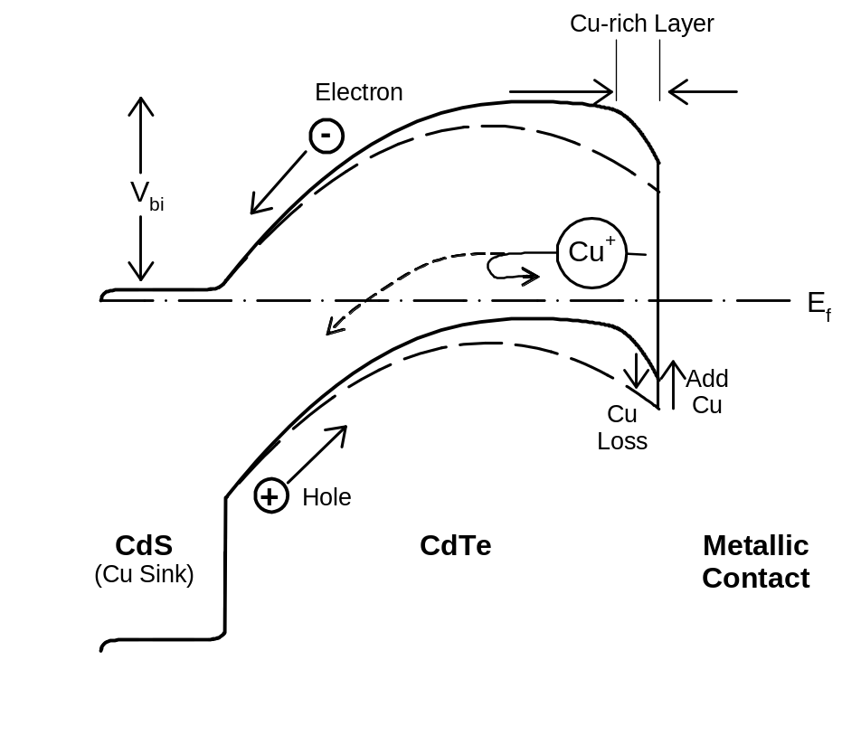

.
C. R. Corwine et al., Figure 1

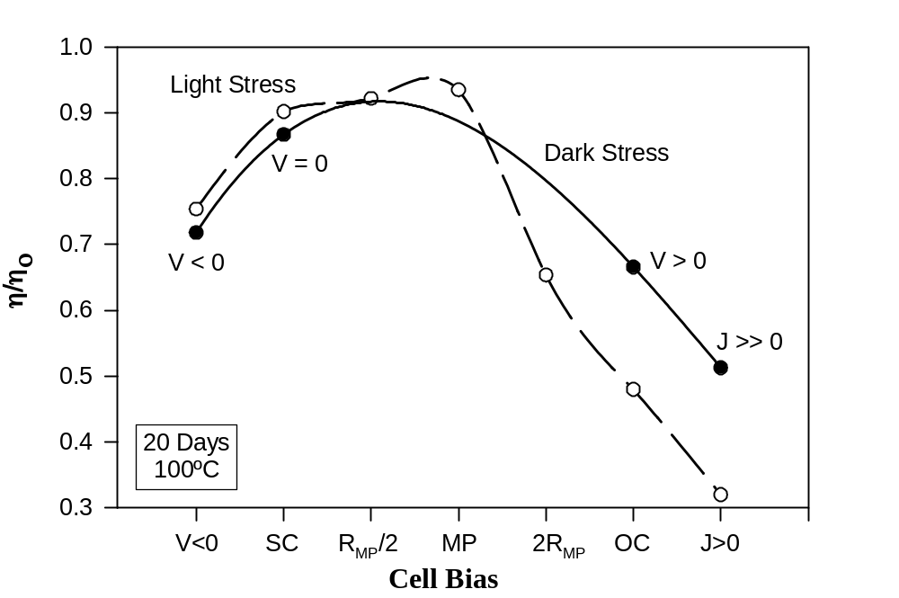

C. R. Corwine et al., Figure 2
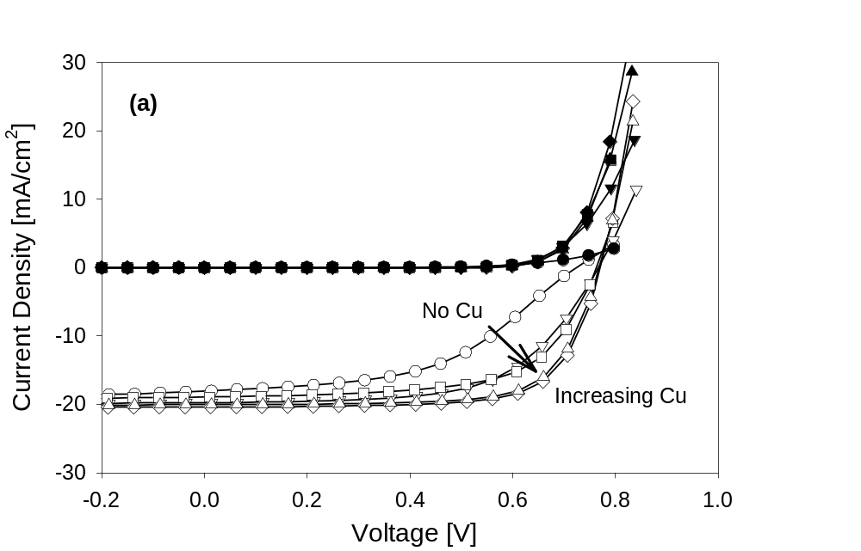
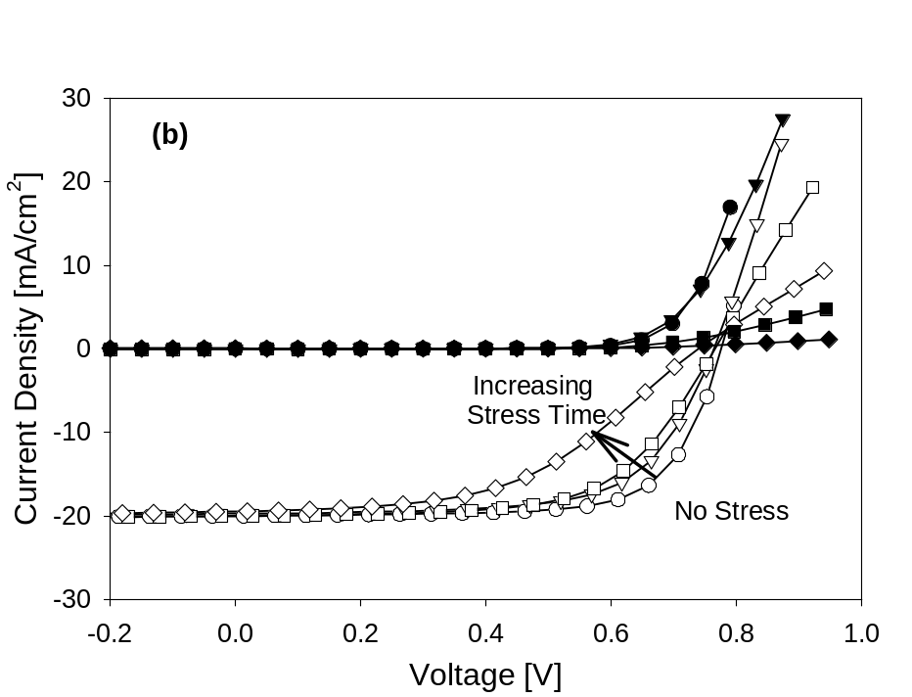

C. R. Corwine et al., Figure 3

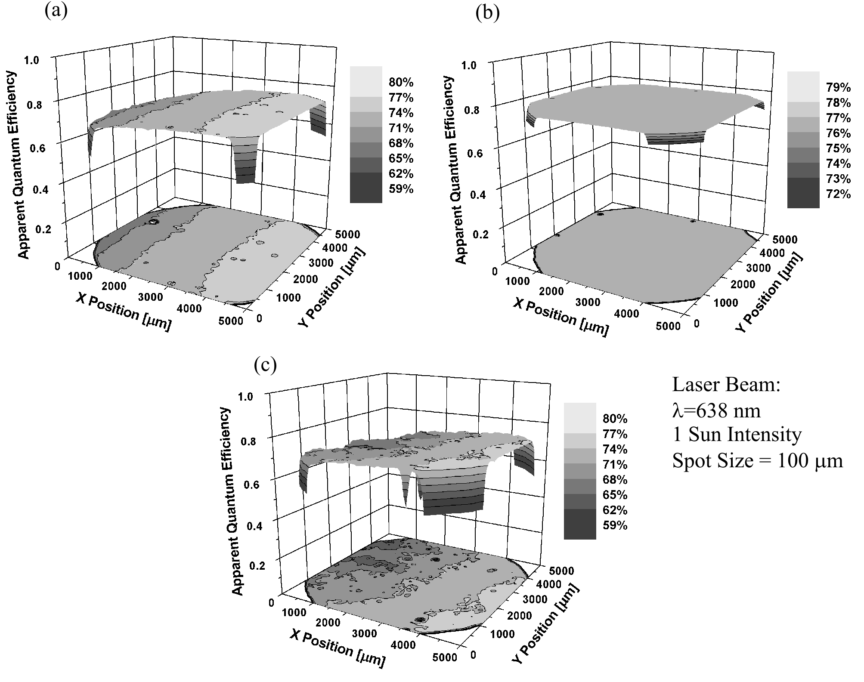

C. R. Corwine et al., Figure 4

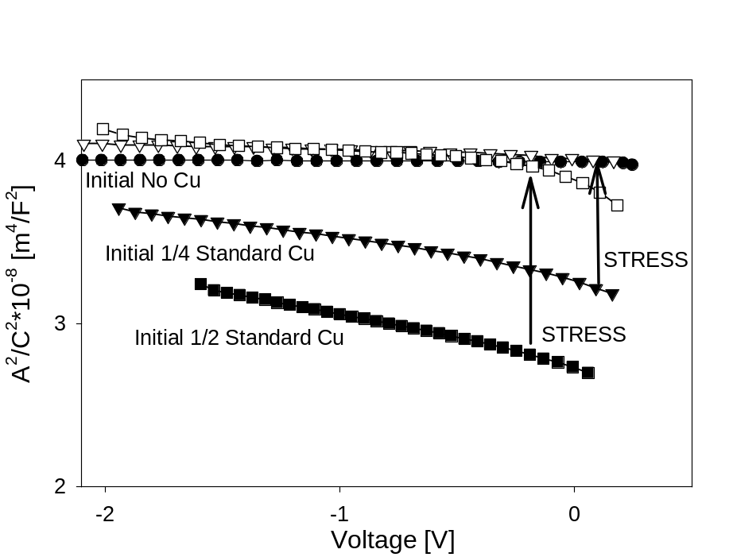

C. R. Corwine et al., Figure 5

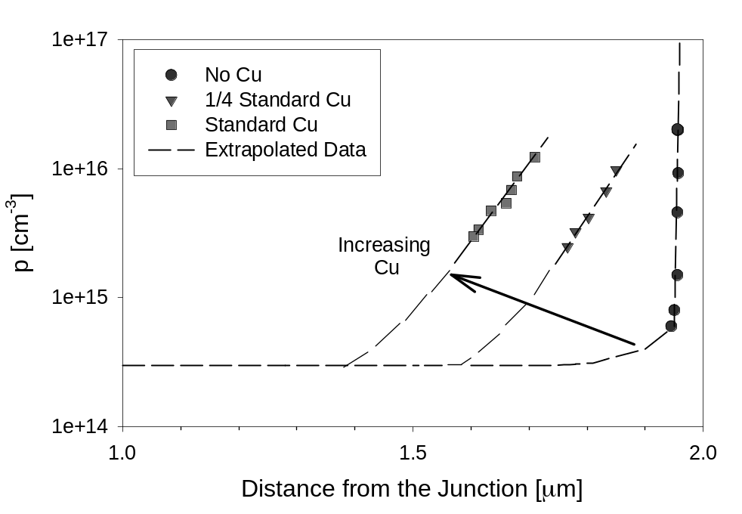

C. R. Corwine et al., Figure 6

