TAHOE YELLOW CRESS (Rorippa subumbellata) FIELD SURVEY FORM

Survey date¹:
Surveyor²: |  | Affiliation²:
Email²: |  | Telephone²:

LOCATION³(attach copy of quad map showing boundaries and pictures taken)

Site name:
USGS quad: S. Lake Tahoe Emerald Bay Meeks Bay Homewood Tahoe City Kings Beach Marlette Lake Glenbrook
County: El Dorado Placer Washoe Carson Douglas Site ownership: Private State Federal City/Local
Legal access:

TYC Present⁴? Yes No Actual Number of Plants⁵: _________ or Estimated Plants: _______

Amount of person minutes spent in search⁶?
Previous plant occurrence⁷? Yes No | Date Plant last observed⁸:
Cluster⁹ 1(individual clusters are equal to TYC that is within 13 m radius): (record additional clusters on back or on additional data sheets)
GPS Coordinates taken¹⁰: (UTM NAD 27, Zone 11) – be specific about where the coordinates are from (centroid, endpoints, etc.)
Easting: _______________________ Northing: ___________________________ Location: ________________________________________________
Easting: _______________________ Northing: ___________________________ Location: ________________________________________________
Easting: _______________________ Northing: ___________________________ Location: ________________________________________________
Easting: _______________________ Northing: ___________________________ Location: ________________________________________________

¹¹Number of plants within cluster_________ Actual Number or Estimated Percentage in each phenological stage (circle one)
Juvenile: ______ Senescent: ______ Flowering: ______ Fruiting (may also be flowering): ______
Min. Rosette Diameter (cm): ______ Max. Rosette Diameter (cm): ______

PHYSICAL ATTRIBUTES
substrate / soils (relative cover w/in 0.3 meter)¹⁵:
Elevation¹²: ______________ ___________ % sand (<2 mm)
Lake level on day of survey (USGS Station 10337000)¹²:______________ ___________ % fine gravel (>2-5 mm)
Distance to lake water line (meters)¹³: Shortest _______ Longest ________ ___________ % medium gravel (>5-20 mm)
Other waterbodies closer than lake¹³?________ How far________ ___________ % coarse gravel (>20-75 mm)
Sketch beach profile (use back paper additional space)¹⁴: ___________ % cobbles (>75-250 mm)
___________ % stones (>250-600 mm)
___________ % boulders (>600 mm)
___________ % other (silt, wrack, litter)

BIOLOGICAL ATTRIBUTES
Total Vegetation % cover¹⁶: ___________
Associated vegetation¹⁷: Common associates:
% Cover Name % Cover Name % Cover % Cover
___ TYC (R. subumbellata) ___ ____________________ __ Spike-rush (Eleocharis spp.) ___ Willow (Salix spp.)
___ ____________________ ___ ____________________ __ Sweet clover (Melilotus alba)* ___ Alder (Alnus incana)
___ ____________________ ___ ____________________ __ Clover (Lotus purshianus) ___ Epilobium spp.
___ ____________________ ___ ____________________ __ Mullein (Verbascum thapsus)* ___ Sedge (Carex spp.)
___ ____________________ ___ ____________________ __ Monkey flower (Mimulus primuloides) ___ Rush (Juncus spp.)
___ ____________________ ___ ____________________ __ W. yellow cress (Rorippa curvisiliqua) ___ Dock (Rumex spp.)
Non-native species in vicinity of TYC population¹⁸? Yes No (If YES, add to above species list and % cover and identify w/ an *)

LAND USES and IMPACTS¹⁹

Cover of footprints within patch²⁰: <5% 5-25% 26-50% 51-75% >75%
Note vegetation removal, trash, recreational impacts, vandalism and/or other impacts²⁰: _________________________________________ ______________________________________________________________________________________________________________
Enclosure effectiveness²¹: good fair poor Comment: _____________________________________________________
Possible management actions and other notes²²: _________________________________________________________________________
Cluster⁹ 2(individual clusters are equal to TYC that is within 13 m radius): (record additional clusters on back or on additional data sheets)
GPS Coordinates taken¹⁰: (UTM NAD 27, Zone 11) – be specific about where the coordinates are from (centroid, endpoints, etc.)
Easting: _______________________ Northing: ___________________________ Location: ________________________________________________
Easting: _______________________ Northing: ___________________________ Location: ________________________________________________
Easting: _______________________ Northing: ___________________________ Location: ________________________________________________
Easting: _______________________ Northing: ___________________________ Location: ________________________________________________

¹¹Number of plants within cluster_________ Actual Number or Estimated Percentage in each phenological stage (circle one)
Juvenile: ______ Senescent: ______ Flowering: ______ Fruiting (may also be flowering): ______
Min. Rosette Diameter (cm): ______ Max. Rosette Diameter (cm): ______

PHYSICAL ATTRIBUTES
Distance to lake water line (meters)¹³: Shortest _______ Longest ________ Other waterbodies closer than lake¹³?________ How far________
substrate / soils (relative cover w/in 0.3 meter)¹⁵:
___________ % sand (<2 mm) ___________ % coarse gravel (>20-75 mm) ___________ % boulders (>600 mm)
___________ % fine gravel (>2-5 mm) ___________ % cobbles (>75-250 mm) ___________ % other (silt, wrack, litter)
___________ % medium gravel (>5-20 mm) ___________ % stones (>250-600 mm)

BIOLOGICAL ATTRIBUTES
Total Vegetation % cover¹⁶: ___________
Associated vegetation¹⁷: Common associates:
% Cover Name % Cover Name % Cover % Cover
___ TYC (R. subumbellata) ___ ____________________ __ Spike-rush (Eleocharis spp.) ___ Willow (Salix spp.)
___ ____________________ ___ ____________________ __ Sweet clover (Melilotus alba)* ___ Alder (Alnus incana)
___ ____________________ ___ ____________________ __ Clover (Lotus purshianus) ___ Epilobium spp.
___ ____________________ ___ ____________________ __ Mullein (Verbascum thapsus)* ___ Sedge (Carex spp.)
___ ____________________ ___ ____________________ __ Monkey flower (Mimulus primuloides) ___ Rush (Juncus spp.)
___ ____________________ ___ ____________________ __ W. yellow cress (Rorippa curvisiliqua) ___ Dock (Rumex spp.)
Non-native species in vicinity of TYC population¹⁸? Yes No (If YES, add to above species list and % cover and identify w/ an *)

Cluster⁹ 3(individual clusters are equal to TYC that is within 13 m radius): (record additional clusters on back or on additional data sheets)
GPS Coordinates taken¹⁰: (UTM NAD 27, Zone 11) – be specific about where the coordinates are from (centroid, endpoints, etc.)
Easting: _______________________ Northing: ___________________________ Location: ________________________________________________
Easting: _______________________ Northing: ___________________________ Location: ________________________________________________
Easting: _______________________ Northing: ___________________________ Location: ________________________________________________
Easting: _______________________ Northing: ___________________________ Location: ________________________________________________

¹¹Number of plants within cluster_________ Actual Number or Estimated Percentage in each phenological stage (circle one)
Juvenile: ______ Senescent: ______ Flowering: ______ Fruiting (may also be flowering): ______
Min. Rosette Diameter (cm): ______ Max. Rosette Diameter (cm): ______

PHYSICAL ATTRIBUTES
Distance to lake water line (meters)¹³: Shortest _______ Longest ________ Other waterbodies closer than lake¹³?________ How far________
substrate / soils (relative cover w/in 0.3 meter)¹⁵:
___________ % sand (<2 mm) ___________ % coarse gravel (>20-75 mm) ___________ % boulders (>600 mm)
___________ % fine gravel (>2-5 mm) ___________ % cobbles (>75-250 mm) ___________ % other (silt, wrack, litter)
___________ % medium gravel (>5-20 mm) ___________ % stones (>250-600 mm)

BIOLOGICAL ATTRIBUTES

Total Vegetation % cover¹⁶: ___________
Associated vegetation¹⁷: Common associates:
% Cover Name % Cover Name % Cover % Cover
___ TYC (R. subumbellata) ___ ____________________ __ Spike-rush (Eleocharis spp.) ___ Willow (Salix spp.)
___ ____________________ ___ ____________________ __ Sweet clover (Melilotus alba)* ___ Alder (Alnus incana)
___ ____________________ ___ ____________________ __ Clover (Lotus purshianus) ___ Epilobium spp.
___ ____________________ ___ ____________________ __ Mullein (Verbascum thapsus)* ___ Sedge (Carex spp.)
___ ____________________ ___ ____________________ __ Monkey flower (Mimulus primuloides) ___ Rush (Juncus spp.)
___ ____________________ ___ ____________________ __ W. yellow cress (Rorippa curvisiliqua) ___ Dock (Rumex spp.)
Non-native species in vicinity of TYC population¹⁸? Yes No (If YES, add to above species list and % cover and identify w/ an *)

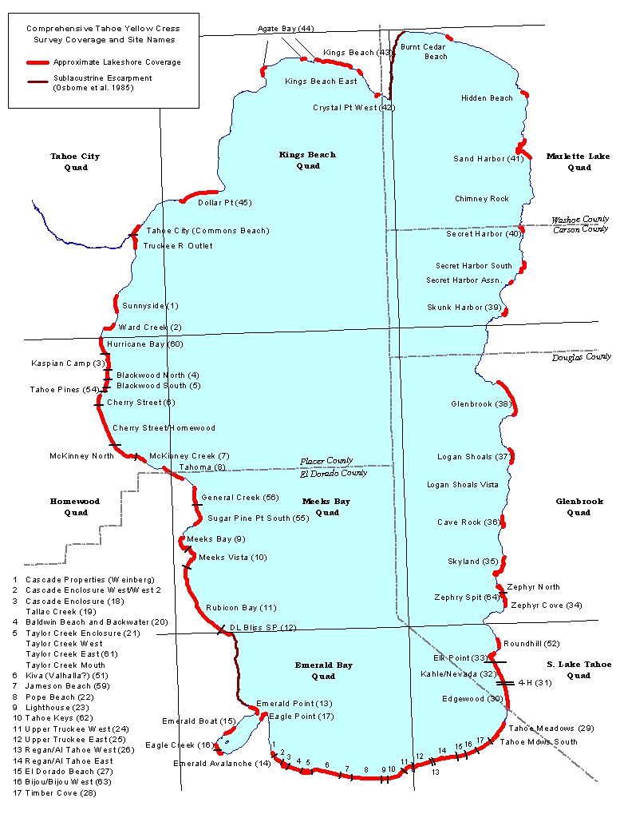

Site Name and Date of Survey__________________________________________________________________________________
Cluster⁹_______(individual clusters are equal to TYC that is within 13 m radius): (record additional clusters on back or on additional data sheets)
GPS Coordinates taken¹⁰: (UTM NAD 27, Zone 11) – be specific about where the coordinates are from (centroid, endpoints, etc.)
Easting: _______________________ Northing: ___________________________ Location: ________________________________________________
Easting: _______________________ Northing: ___________________________ Location: ________________________________________________
Easting: _______________________ Northing: ___________________________ Location: ________________________________________________
Easting: _______________________ Northing: ___________________________ Location: ________________________________________________

¹¹Number of plants within cluster_________ Actual Number or Estimated Percentage in each phenological stage (circle one)
Juvenile: ______ Senescent: ______ Flowering: ______ Fruiting (may also be flowering): ______
Min. Rosette Diameter (cm): ______ Max. Rosette Diameter (cm): ______

PHYSICAL ATTRIBUTES
Distance to lake water line (meters)¹³: Shortest _______ Longest ________ Other waterbodies closer than lake¹³?________ How far________
substrate / soils (relative cover w/in 0.3 meter)¹⁵:
___________ % sand (<2 mm) ___________ % coarse gravel (>20-75 mm) ___________ % boulders (>600 mm)
___________ % fine gravel (>2-5 mm) ___________ % cobbles (>75-250 mm) ___________ % other (silt, wrack, litter)
___________ % medium gravel (>5-20 mm) ___________ % stones (>250-600 mm)

BIOLOGICAL ATTRIBUTES
Total Vegetation % cover¹⁶: ___________
Associated vegetation¹⁷: Common associates:
% Cover Name % Cover Name % Cover % Cover
___ TYC (R. subumbellata) ___ ____________________ __ Spike-rush (Eleocharis spp.) ___ Willow (Salix spp.)
___ ____________________ ___ ____________________ __ Sweet clover (Melilotus alba)* ___ Alder (Alnus incana)
___ ____________________ ___ ____________________ __ Clover (Lotus purshianus) ___ Epilobium spp.
___ ____________________ ___ ____________________ __ Mullein (Verbascum thapsus)* ___ Sedge (Carex spp.)
___ ____________________ ___ ____________________ __ Monkey flower (Mimulus primuloides) ___ Rush (Juncus spp.)
___ ____________________ ___ ____________________ __ W. yellow cress (Rorippa curvisiliqua) ___ Dock (Rumex spp.)
Non-native species in vicinity of TYC population¹⁸? Yes No (If YES, add to above species list and % cover and identify w/ an *)

Cluster⁹_______(individual clusters are equal to TYC that is within 13 m radius): (record additional clusters on back or on additional data sheets)
GPS Coordinates taken¹⁰: (UTM NAD 27, Zone 11) – be specific about where the coordinates are from (centroid, endpoints, etc.)
Easting: _______________________ Northing: ___________________________ Location: ________________________________________________
Easting: _______________________ Northing: ___________________________ Location: ________________________________________________
Easting: _______________________ Northing: ___________________________ Location: ________________________________________________
Easting: _______________________ Northing: ___________________________ Location: ________________________________________________

¹¹Number of plants within cluster_________ Actual Number or Estimated Percentage in each phenological stage (circle one)
Juvenile: ______ Senescent: ______ Flowering: ______ Fruiting (may also be flowering): ______
Min. Rosette Diameter (cm): ______ Max. Rosette Diameter (cm): ______

PHYSICAL ATTRIBUTES
Distance to lake water line (meters)¹³: Shortest _______ Longest ________ Other waterbodies closer than lake¹³?________ How far________
substrate / soils (relative cover w/in 0.3 meter)¹⁵:
___________ % sand (<2 mm) ___________ % coarse gravel (>20-75 mm) ___________ % boulders (>600 mm)
___________ % fine gravel (>2-5 mm) ___________ % cobbles (>75-250 mm) ___________ % other (silt, wrack, litter)
___________ % medium gravel (>5-20 mm) ___________ % stones (>250-600 mm)

BIOLOGICAL ATTRIBUTES

Total Vegetation % cover¹⁶: ___________
Associated vegetation¹⁷: Common associates:
% Cover Name % Cover Name % Cover % Cover
___ TYC (R. subumbellata) ___ ____________________ __ Spike-rush (Eleocharis spp.) ___ Willow (Salix spp.)
___ ____________________ ___ ____________________ __ Sweet clover (Melilotus alba)* ___ Alder (Alnus incana)
___ ____________________ ___ ____________________ __ Clover (Lotus purshianus) ___ Epilobium spp.
___ ____________________ ___ ____________________ __ Mullein (Verbascum thapsus)* ___ Sedge (Carex spp.)
___ ____________________ ___ ____________________ __ Monkey flower (Mimulus primuloides) ___ Rush (Juncus spp.)
___ ____________________ ___ ____________________ __ W. yellow cress (Rorippa curvisiliqua) ___ Dock (Rumex spp.)
Non-native species in vicinity of TYC population¹⁸? Yes No (If YES, add to above species list and % cover and identify w/ an *)
Site Name and Date of Survey__________________________________________________________________________________
Cluster⁹_______(individual clusters are equal to TYC that is within 13 m radius): (record additional clusters on back or on additional data sheets)
GPS Coordinates taken¹⁰: (UTM NAD 27, Zone 11) – be specific about where the coordinates are from (centroid, endpoints, etc.)
Easting: _______________________ Northing: ___________________________ Location: ________________________________________________
Easting: _______________________ Northing: ___________________________ Location: ________________________________________________
Easting: _______________________ Northing: ___________________________ Location: ________________________________________________
Easting: _______________________ Northing: ___________________________ Location: ________________________________________________

¹¹Number of plants within cluster_________ Actual Number or Estimated Percentage in each phenological stage (circle one)
Juvenile: ______ Senescent: ______ Flowering: ______ Fruiting (may also be flowering): ______
Min. Rosette Diameter (cm): ______ Max. Rosette Diameter (cm): ______

PHYSICAL ATTRIBUTES
Distance to lake water line (meters)¹³: Shortest _______ Longest ________ Other waterbodies closer than lake¹³?________ How far________
substrate / soils (relative cover w/in 0.3 meter)¹⁵:
___________ % sand (<2 mm) ___________ % coarse gravel (>20-75 mm) ___________ % boulders (>600 mm)
___________ % fine gravel (>2-5 mm) ___________ % cobbles (>75-250 mm) ___________ % other (silt, wrack, litter)
___________ % medium gravel (>5-20 mm) ___________ % stones (>250-600 mm)

BIOLOGICAL ATTRIBUTES
Total Vegetation % cover¹⁶: ___________
Associated vegetation¹⁷: Common associates:
% Cover Name % Cover Name % Cover % Cover
___ TYC (R. subumbellata) ___ ____________________ __ Spike-rush (Eleocharis spp.) ___ Willow (Salix spp.)
___ ____________________ ___ ____________________ __ Sweet clover (Melilotus alba)* ___ Alder (Alnus incana)
___ ____________________ ___ ____________________ __ Clover (Lotus purshianus) ___ Epilobium spp.
___ ____________________ ___ ____________________ __ Mullein (Verbascum thapsus)* ___ Sedge (Carex spp.)
___ ____________________ ___ ____________________ __ Monkey flower (Mimulus primuloides) ___ Rush (Juncus spp.)
___ ____________________ ___ ____________________ __ W. yellow cress (Rorippa curvisiliqua) ___ Dock (Rumex spp.)
Non-native species in vicinity of TYC population¹⁸? Yes No (If YES, add to above species list and % cover and identify w/ an *)

Cluster⁹_______(individual clusters are equal to TYC that is within 13 m radius): (record additional clusters on back or on additional data sheets)
GPS Coordinates taken¹⁰: (UTM NAD 27, Zone 11) – be specific about where the coordinates are from (centroid, endpoints, etc.)
Easting: _______________________ Northing: ___________________________ Location: ________________________________________________
Easting: _______________________ Northing: ___________________________ Location: ________________________________________________
Easting: _______________________ Northing: ___________________________ Location: ________________________________________________
Easting: _______________________ Northing: ___________________________ Location: ________________________________________________

¹¹Number of plants within cluster_________ Actual Number or Estimated Percentage in each phenological stage (circle one)
Juvenile: ______ Senescent: ______ Flowering: ______ Fruiting (may also be flowering): ______
Min. Rosette Diameter (cm): ______ Max. Rosette Diameter (cm): ______

PHYSICAL ATTRIBUTES
Distance to lake water line (meters)¹³: Shortest _______ Longest ________ Other waterbodies closer than lake¹³?________ How far________
substrate / soils (relative cover w/in 0.3 meter)¹⁵:
___________ % sand (<2 mm) ___________ % coarse gravel (>20-75 mm) ___________ % boulders (>600 mm)
___________ % fine gravel (>2-5 mm) ___________ % cobbles (>75-250 mm) ___________ % other (silt, wrack, litter)
___________ % medium gravel (>5-20 mm) ___________ % stones (>250-600 mm)

BIOLOGICAL ATTRIBUTES

Total Vegetation % cover¹⁶: ___________
Associated vegetation¹⁷: Common associates:
% Cover Name % Cover Name % Cover % Cover
___ TYC (R. subumbellata) ___ ____________________ __ Spike-rush (Eleocharis spp.) ___ Willow (Salix spp.)
___ ____________________ ___ ____________________ __ Sweet clover (Melilotus alba)* ___ Alder (Alnus incana)
___ ____________________ ___ ____________________ __ Clover (Lotus purshianus) ___ Epilobium spp.
___ ____________________ ___ ____________________ __ Mullein (Verbascum thapsus)* ___ Sedge (Carex spp.)
___ ____________________ ___ ____________________ __ Monkey flower (Mimulus primuloides) ___ Rush (Juncus spp.)
___ ____________________ ___ ____________________ __ W. yellow cress (Rorippa curvisiliqua) ___ Dock (Rumex spp.)
Non-native species in vicinity of TYC population¹⁸? Yes No (If YES, add to above species list and % cover and identify w/ an *)

