Preliminary Report
2003 South Slough Coho Smolt Ultrasonic Telemetry Project
Michele Koehler, South Slough National Estuarine Research Reserve
Bruce Miller, Oregon Department of Fish and Wildlife
September, 2003

Estuaries are hypothesized as critical to survival for salmonids because of their role in rearing and emigration (Healey 1982). Estuaries provide foraging opportunity, habitat for the physiological transition from fresh to salt water, and refugia from predators. The decline of coho salmon (Oncorhynchus kisutch) populations along the Oregon Coast and a hypothesized link between rearing habitat and ocean survival make understanding these fish use estuarine habitats critical. Size, age at migration and diel timing are well described (see review by Sandercock 1998) but, the extent to which coho smolts use estuaries during rearing and seaward migration is still poorly understood. In the South Slough estuary, Coos Bay, OR, coho salmon have been found to use the estuary as juveniles during rearing periods and as smolts during seaward migration for an average of 12 days (Miller and Sadro 2003). While coho smolts spent the majority of their time holding throughout the estuary, smolt movement correlated with tidal currents (Miller and Sadro 2003). In Grays Harbor and the Chehalis River estuaries, WA, coho smolts used the estuary for one to six days (Moser et. al 1991). Moser et. al (1991) also described smolt movement as independent from changes in local salinity. Habitat use of emigrating smolts and physical attributes of these habitats were not described. This project was designed to further define estuarine habitat use of coho smolts in South Slough and to examine coho movement relative to tides, water temperature, and salinity. Coho salmon smolts were monitored using ultrasonic transmitters and a stationary receiver array. The project was conducted with the generous volunteer assistance of Bruce Miller, Oregon Department of Fish and Wildlife, Charleston, OR.
Three questions were addressed in this study:
1) How long do coho smolts spend in the South Slough estuary?
2) What movement patterns are exhibited through the estuary?
3) What physical characteristics of the estuary (tides, salinity, and temperature) affect coho smolt movement?
The hypotheses tested were that coho smolts would spend from one day to one week in the lower estuary and that movement would occur with tidal currents and be generally unrelated to water temperature or salinity. This report summarizes the techniques used in this study and highlights the preliminary results of the work.

Methods
We used ultrasonic telemetry to determine estuarine residence time and movement patterns of coho salmon in the South Slough estuary. Coho smolts, defined by visual evidence of silvering, were captured by beach seine in the stream/estuary ecotone (Miller and Sadro, 2003) during April and May, 2003 (Figure 1). Fish were anesthetized using MS-222 and fork length (FL) and weight were measured. Condition factor was calculated for each fish using the formula: [weight/(length)³]·10⁵.
Vemco, Ltd., Novia Scotia ultrasonic transmitters (8mm x 20mm, 3.1 g, Figure 2) were surgically implanted into the peritoneal cavity of each anesthetized fish immediately after capture (Figure 3). Five to six dissolvable surgical sutures were used to seal the incision (Figure 3). Twenty coho smolts were successfully implanted with transmitters, each emitting a unique acoustic code discernible by Vemco VR-2 receivers. The fish were placed in a live box at the seine site for recovery and held for 12 to 24 hours prior to release at the same site (Table 1).
We arranged twelve stationary receivers (Vemco VR-2) to define two large areas as the stream/ estuary ecotone (S/ E), the area between the upper limit of tidal influence downstream to incidence of tidal mudflat habitat along the channel (Miller and Sadro 2003), and the main estuary (ME), the downstream from the S/ E (Figure 1). In addition, five habitat types were delineated with receiver placement: upper tidewater, high density eelgrass, low density eelgrass, estuarine side channels and lower estuary (Table 2). Maximum receiver range was approximately 400m dia. (Figure 4). Estuarine exit was defined at the Charleston Bridge receiver for this study. The fish were monitored by the stationary receiver array for approximately two months.
During the monitoring period, the VR-2 receivers were monitored bi-weekly to check for failure and memory use. When possible, receivers were downloaded in the field once during the duration of the study. We also periodically cleaned the receivers of wrack and other debris that may have inhibited reception, although no receiver inhibition was detected during the study. At the end of the study, the receivers were removed from South Slough and downloaded into the Vemco VR-2 software program for analysis.
Temperature and salinity were measured at the sediment water interface by stationary YSI loggers at two stations in South Slough: Crown Point and in the S/ E (Figure 1). Temperature and salinity were also measured manually at each receiver site at low and high tides with different tidal exchanges at the water surface and bottom during the study (Figure 5).

Results
Twenty coho salmon smolts were implanted with ultrasonic tags and monitored throughout South Slough in April and May, 2003. The mean length of tagged fish was 155 mm FL; the mean weight of the fish was 42 g (Table 1). Of the twenty smolts, 19 were detected by at least one receiver. One fish was never detected and the fish was assumed dead post-release. The mean minimum residence time between the release site (stream/ estuary ecotone) and the Charleston Bridge was 18 d. Mean time spent in the S/E was 11.1 d, mean time spent in the ME was 5.8 d. Seventy-four percent of smolts (14 fish) were detected at Charleston Bridge, and 50% (seven fish) of those smolts went back to the lower estuary habitat where monitoring ceased. Two fish (11%) traveled into the ME and back to the S/ E at least once during the monitoring period. Three fish (16%) never left S/ E.
The coho smolts followed three general patterns of movement in the estuary: Q fish: quick (less than 10d total) movement from the stream/ estuary ecotone past the estuarine exit (3 total), S fish: greater time spent in the stream/ estuary ecotone than in the main estuary (12 total), or M fish: greater time spent in the main estuary than in the stream/ estuary ecotone (4 total, Table 1). Of these three groups, Q fish were the largest, with an average FL of 161 mm and weight of 45 g. M fish were the second largest, with an average FL of 156 mm and weight of 43 g, while S fish were the smallest, averaging 153 mm FL and 40 g.
Nine (47%) fish were recorded at the receivers located in the estuarine side channel habitat, Joe Ney and Sengstacken Sloughs. Two fish were recorded in both side channel habitats. While coho smolts spent a total average (summed average for each day of the study) of 0.44 d in low density eelgrass habitats and 0.54 d in high density eelgrass habitats, these differences must be further investigated to draw conclusions (Figure 6).
Generally, coho smolts were recorded intermittently at receivers frequently for long (>1 h) periods of time. However, fish were not often recorded consecutively at any receiver for >1 h time (defined as holding, HD). Individual movement patterns can be viewed in Appendix A.

Conclusion
Coho smolts in South Slough displayed movement patterns similar to those found by others. For example, coho were found to spend an average of six days in the main estuary, as Miller and Sadro (2003) and Moser et. al (1991) also found. The data from South Slough also correspond with hatchery coho in Yaquina Bay, OR, estimated to spend four to nine days (Myers and Horton 1982). Coho smolts were also found to hold in areas of South Slough as Moser et. al (1991) and Miller and Sadro (2003) described. Individual coho smolt movement in this study did not always correlate with the direction of tidal current (see individual fish movement maps, Appendix A), as reported in previous studies. This may indicate that the fish are moving to selected habitats, perhaps for foraging opportunity or predator avoidance.
In South Slough, different movement patterns (Q, S, and M) were displayed by fish of different mean sizes. While Moser et. al (1991) found no difference in movement patterns of coho smolts with different sizes, in South Slough, smaller fish stayed in the S/ E longer than larger fish. The largest fish moved directly out of the estuary. It is possible that in South Slough, larger fish are able to exploit food resources in the main estuary and ocean and move there quickly. Perhaps fish must remain in the S/ E until they reach a size where the benefits of abundant food in the main estuary outweigh the risk of predation there. This must be further investigated. Further analysis is also necessary to determine whether or not water temperature and salinity correlate with coho smolt movement in South Slough or if fish are attracted to areas with greater eelgrass densities.
Coho smolts were found to use all habitat types in the Slough, hold in certain areas of the Slough, and back-track from the ME to the S/ E at times. Whether these behaviors are the result of the need for predator refugia, habitat for physiological changes, or food, these results support the hypothesis that estuaries provide critical habitat for coho emigrants. Since the majority of Oregon’s estuaries have been dramatically modified for human uses, the challenge is to uncover the specific attributes of estuaries that coho smolts are drawn to and strive to provide those in all Oregon Coast coho bearing streams and rivers.
References

Healey, M.C. 1982. Juvenile Pacific salmon in estuaries: the life support system. In Estuarine Comparisons. Edited by V.S. Kennedy. Academic Press, Inc., New York. pp. 315-341.

Miller, B.A. and S. Sadro. 2003. Residence time and seasonal movements of juvenile coho salmon in the ecotone and lower estuary of Winchester Creek, South Slough, Oregon. Transactions of the American Fisheries Society. 132: 546-559.

Moser, M.L., A.F. Olson, and T.P. Quinn. 1991. Riverine and estuarine migratory behavior of coho salmon (Oncorhynchus kisutch) smolts. Canadian Journal of Fisheries and Aquatic Sciences. 48: 1670-1678.

Myers, K.W. and H.F. Horton. 1982. Temporal use of an Oregon estuary by hatchery and wild juvenile salmon. In Estuarine Comparisons. Edited by V.S. Kennedy. Academic Press, Inc., New York. pp. 377-391.

Sandercock, F.K. 1998. Life history of coho salmon (Oncorhynchus kisutch). In Pacific salmon life histories. Edited by C. Groot and L. Margolis. UBC Press, Vancouver, BC. pp. 396-445.

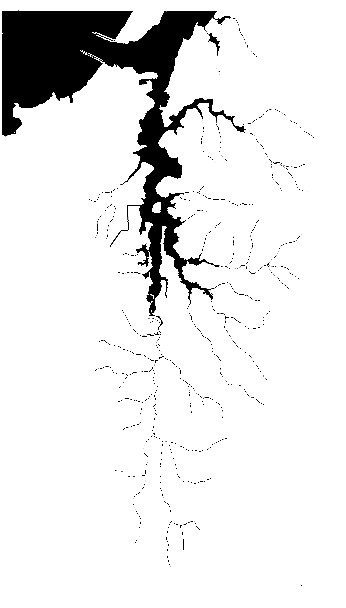
Charleston Bridge
Main estuary
(to Charleston Bridge)
Stream/Estuary ecotone
Capture and release site

Figure 1. Map of Coos Bay’s South Slough showing the stream/estuary ecotone, main estuary, and smolt capture and release site.
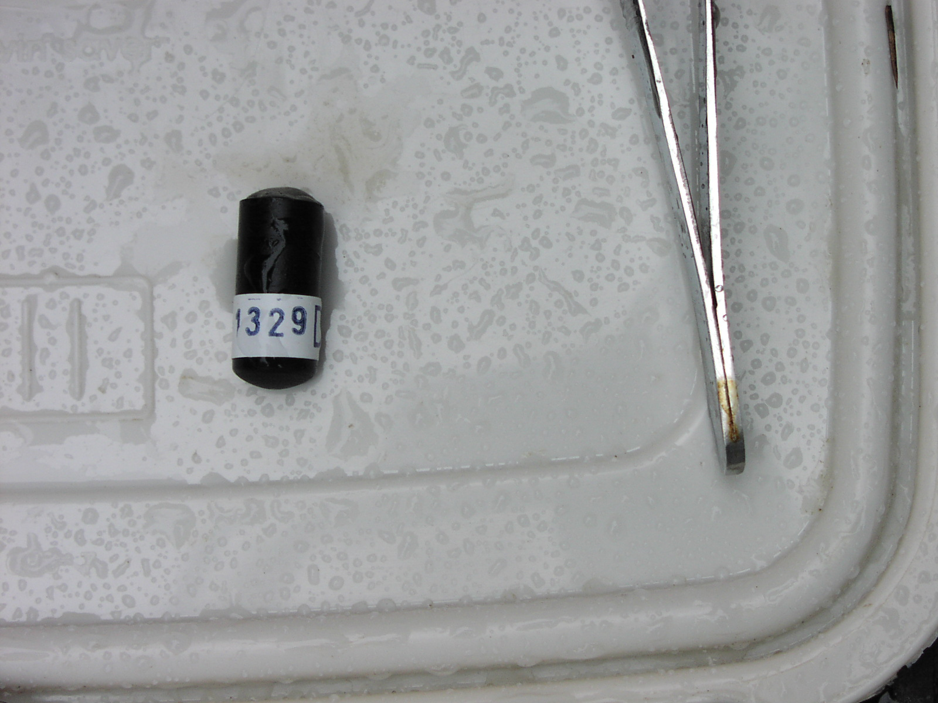

Figure 2. Vemco, Ltd., Novia Scotia ultrasonic transmitter (8mm x 20mm, 3.1 g) surgically implanted into smolts (shown next to forceps for scale).

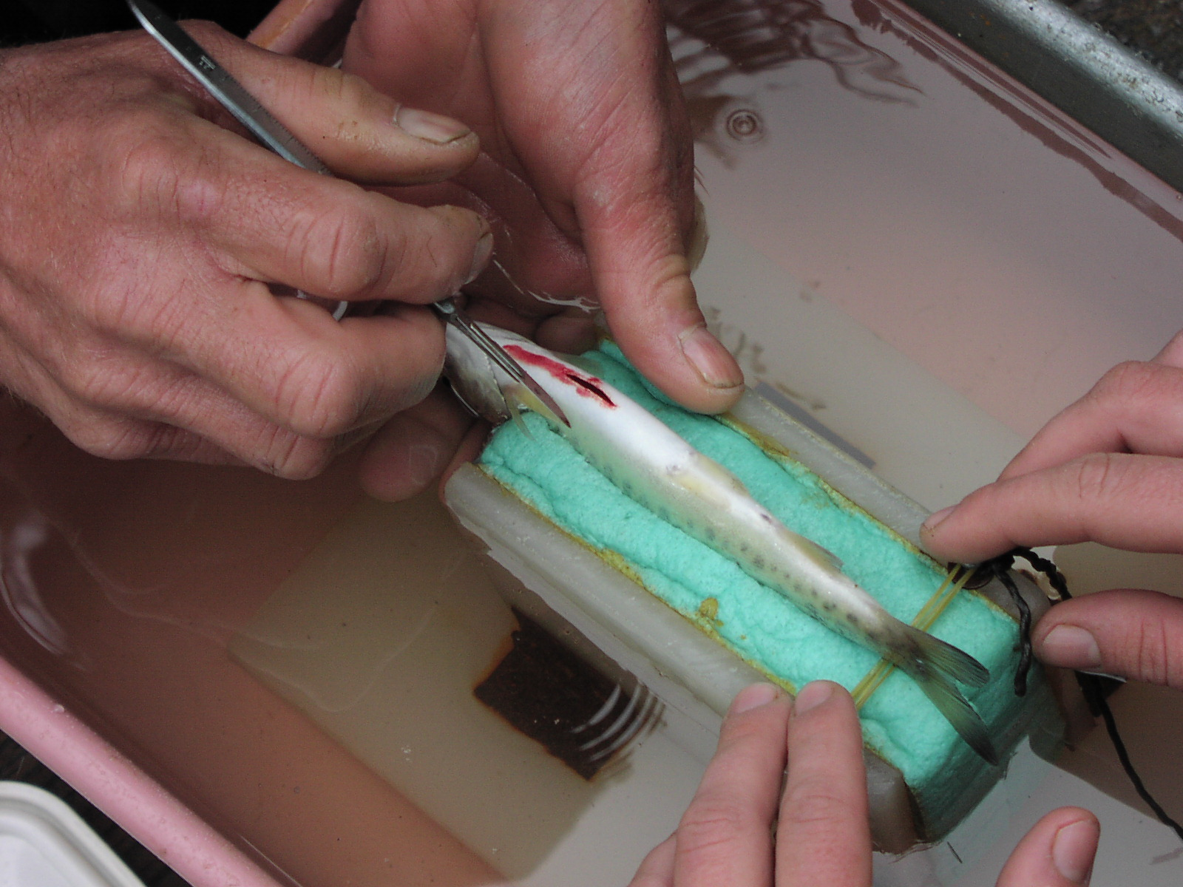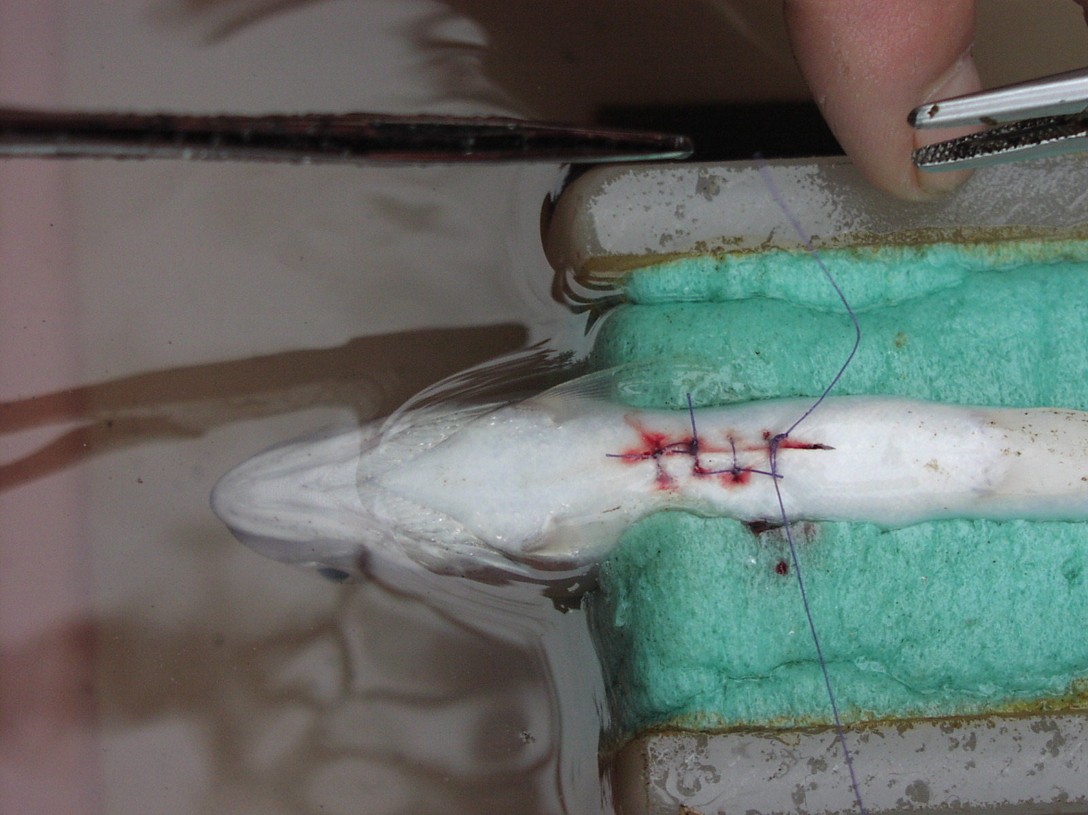

Figure 3. Belly incision (left photo) and sutures (post-transmitter implant, right photo) on coho smolt.
Charleston Bridge
Receivers
Figure 4. Map of South Slough estuary showing VR-2 receiver placement and approximate maximum range (400 m).
Figure5. Temperature and salinity at receiver sites in South Slough given for tides with different magnitudes.
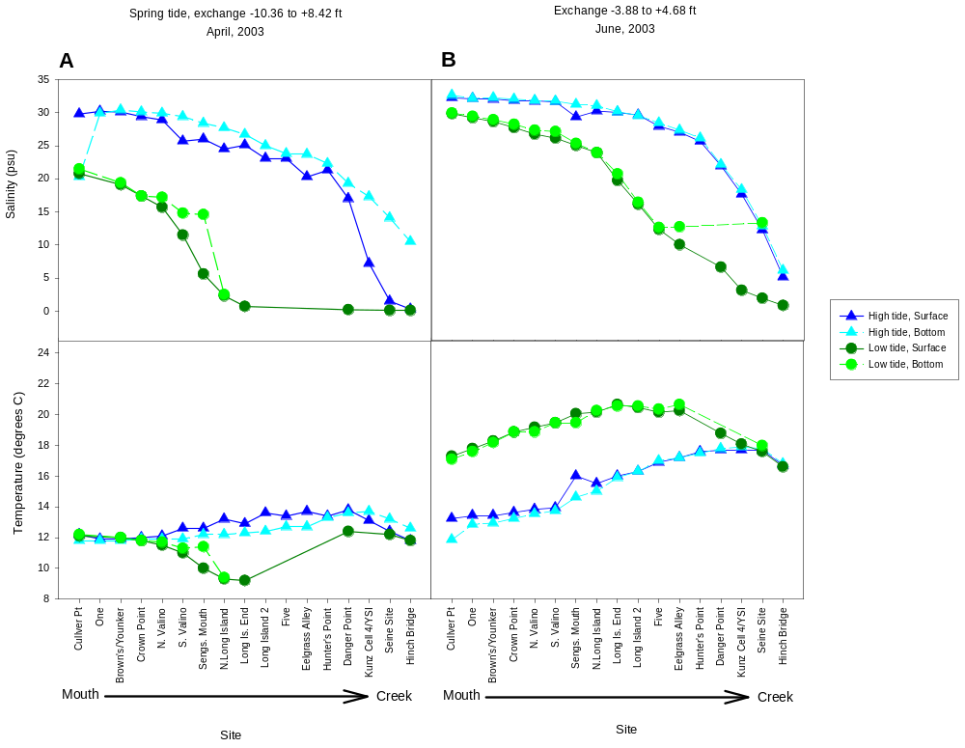
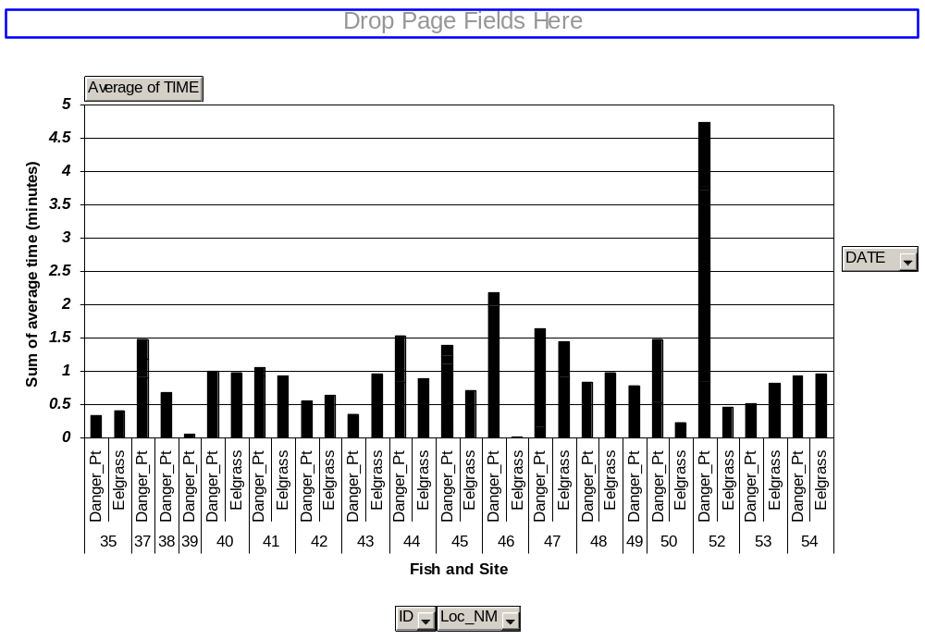
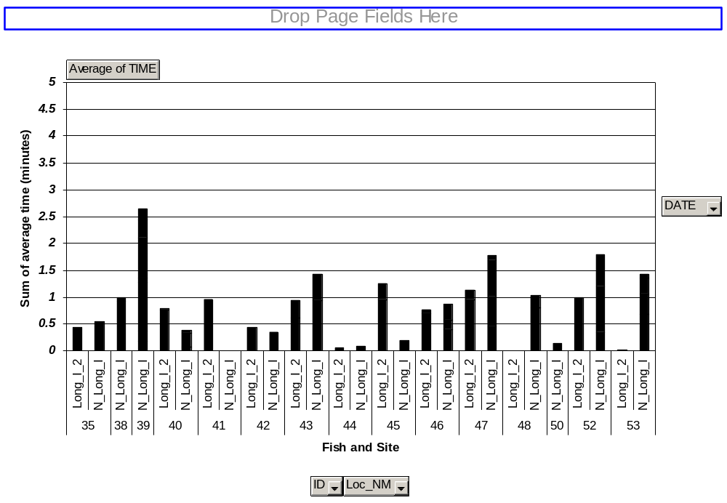
A
B

Figure 6. Graphs depicting total average daily time spent at high (A) and low (B) density eelgrass sites in South Slough.
Table 1. Individual fish data for coho salmon smolts. Lower estuary refers to all habitat downstream (north) of the stream/ estuary ecotone. See Figure 1 for locations: S/E = stream/ estuary ecotone, ME = main estuary, CB = Charleston Bridge.
 | Weight (g) | FL (mm) | Capture Date | Release Date | Condition Factor | Silvering | First Detection | Location | Last Detection | Location | Stream/ estuary ecotone or upstream (d) | Lower estuary* (d) | Movement Category | Monitor time (d)
Mean (all fish) | 41.8 | 155.2 | 9-Apr | 10-Apr | 1.1 |  | 11-Apr |  | 29-Apr |  | 11.1 | 5.8 |  | 17.0
 | 27.7 | 140 | 21-Apr | 22-Apr | 1.0 | silvered | NONE |  |  |  | 0 | 0 |  | 0
 | 44.6 | 145 | 9-Apr | 10-Apr | 1.5 | silvered | 10-Apr | S/E | 13-May | ME | 14 | 19 | M | 33
 | 34.4 | 146 | 9-Apr | 10-Apr | 1.1 | silvered | 11-Apr | S/E | 24-Apr | ME | 22 | 4 | S | 14
 | 36.1 | 146 | 10-Apr | 11-Apr | 1.2 | silvered | 12-Apr | S/E | 8-May | ME | 2 | 11 | M | 26
 | 33.1 | 147 | 9-Apr | 10-Apr | 1.0 | silvered | 10-Apr | S/E | 29-Apr | CB | 14 | 7 | S | 19
 | 35.3 | 147 | 9-Apr | 10-Apr | 1.1 | silvered | 11-Apr | S/E | 2-May | ME | 22 | 3 | S | 21
 | 35.9 | 147 | 9-Apr | 10-Apr | 1.1 | silvered | 11-Apr | S/E | 6-May | S/E | 14 | 5 | S | 25
 | 34.8 | 148 | 9-Apr | 10-Apr | 1.1 | silvered | 11-Apr | S/E | 30-Apr | SC | 12 | 7 | S | 19
 | 36.7 | 150 | 9-Apr | 10-Apr | 1.1 | silvered | 11-Apr | S/E | 4-May | ME | 17 | 0 | S | 23
 | 37.3 | 150 | 9-Apr | 10-Apr | 1.1 | silvered | 14-Apr | S/E | 1-May | S/E | 20 | 3 | S | 17
 | 39.4 | 152 | 10-Apr | 11-Apr | 1.1 | silvered | 11-Apr | S/E | 14-Apr | S/E | 3 | 0 | Q | 3
 | 39.8 | 153 | 10-Apr | 11-Apr | 1.1 | silvered | 13-Apr | S/E | 26-Apr | CB | 11 | 2 | S | 13
 | 42.9 | 154 | 9-Apr | 10-Apr | 1.2 | silvered | 11-Apr | S/E | 6-May | CB | 22 | 3 | S | 25
 | 40.1 | 156 | 9-Apr | 10-Apr | 1.1 | silvered | 11-Apr | S/E | 26-Apr | CB | 13 | 2 | S | 15
 | 44.3 | 162 | 10-Apr | 11-Apr | 1.0 | silvered | 13-Apr | S/E | 16-Apr | SC | 0 | 3 | Q | 3
 | 48.5 | 165 | 9-Apr | 10-Apr | 1.1 | silvered | 11-Apr | S/E | 28-Apr | CB | 13 | 4 | S | 17
 | 53.3 | 171 | 9-Apr | 10-Apr | 1.1 | silvered | 13-Apr | S/E | 2-May | CB | 13 | 6 | S | 19
 | 55 | 172 | 10-Apr | 11-Apr | 1.1 | silvered | 11-Apr | S/E | 18-Apr | CB | 0 | 7 | Q | 7
 | 54.6 | 175 | 9-Apr | 10-Apr | 1.0 | silvered | 11-Apr | S/E | 21-Apr | ME | 3 | 7 | M | 10
 | 62.8 | 177 | 9-Apr | 10-Apr | 1.1 | silvered | 10-Apr | S/E | 10-May | S/E | 7 | 23 | M | 30

Table 2. Habitat stratifications, locations, and descriptions in South Slough created to determine salmonid smolt use of the estuary.

Habitat | Location | Attributes
Stream/estuary ecotone | Hinch Bridge to Danger Point | meandering, narrow channel, small side channels, low salinity, in-channel woody debris, overhanging banks, very little habitat available at low tide
High density eelgrass | Danger Point to Long Island 2 | narrow, meandering channel, variable salinity, relatively high eelgrass density (average in April, 2003: 60 stems/ m2)
Low density eelgrass | Long Island 2 to North Long Island | straight, wide channel, variable salinity, relatively low eelgrass density (average in April ’03: 16 stems/ m2), some oyster culture
Estuarine side channels | Sengstacken and Joe Ney Sloughs | wide, meandering channel, salinity varies with tides, eelgrass variable, loss of habitat at low tide
Main estuary | north of Danger Point and below Sengstacken and Joe Ney Sloughs | wide channel, high salinity, variable eelgrass, oyster culture, deep water habitat

