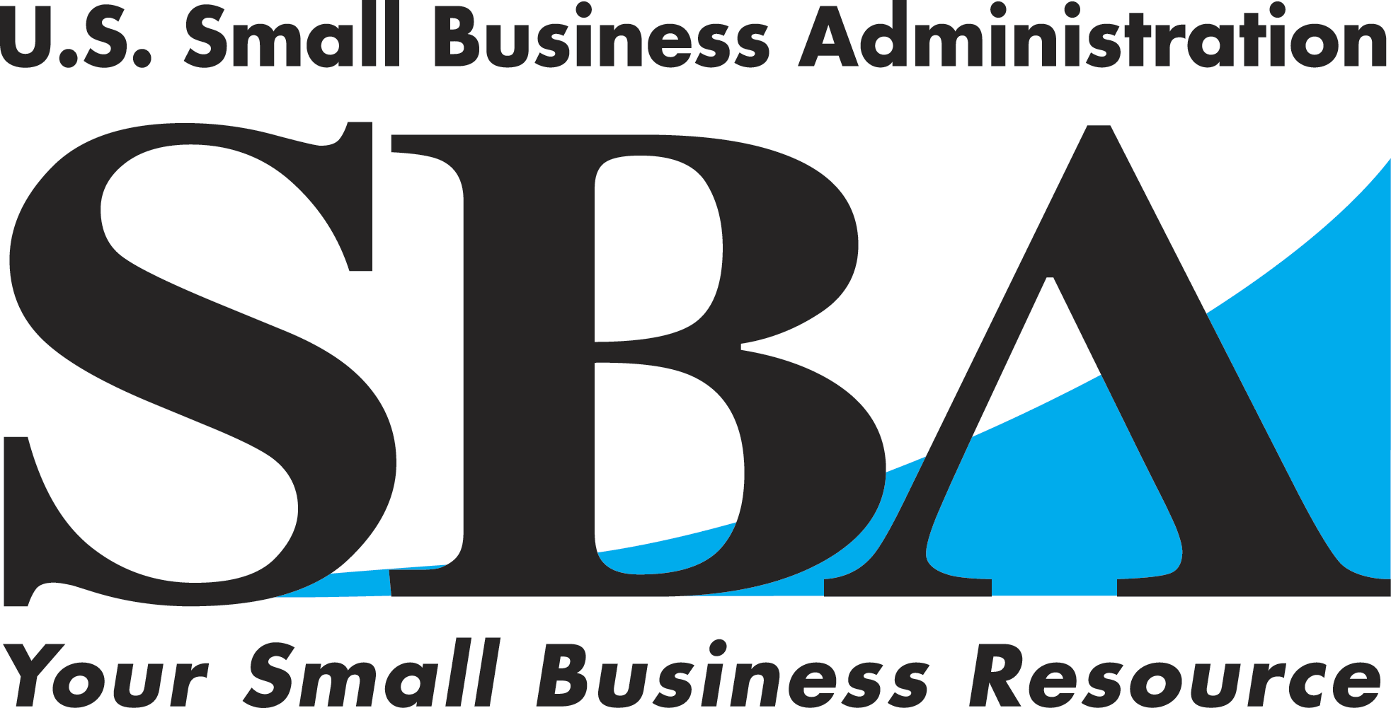
News Release
New York District Office

Release Date: January 12, 2005 Contact: John J. Miller (212) 264-7770
Release Number: NYDO-06-04 e-mail: john.miller@sba.gov

Bronx Cabinetmaker Making a Name for Itself
On Manhattan’s Fifth Avenue
With a Little Help from the SBA

Bronx, NY— With celebrities, high-flying business execs and the upper crust of New York
City society as clients, cabinetmaker Hendrickson Custom Cabinetry is proving that quality manufacturing can thrive in the resurgent Bronx.

The high-end product company owned by husband and wife team Felix and Lisa Hendrickson
is an example that with hard work, patience and pluck a small business can become successful
in the Bronx, provide both employment and life skills to local residents, and give back to the community.

The Hendricksons had been living in Austin, Texas when Felix decided he wanted to return home to New York City to be closer to family. Both Felix and Lisa took up corporate positions when they returned but Felix wanted to continue his 15-year career as a cabinetmaker. He had a vision of a custom-cabinetry company that provided high-end services for customers and a great work environment for employees. So Felix established Hendrickson Custom Cabinetry with five employees in a workspace sublet from his retiring former employer. Sales began to rise rapidly. Felix then asked Lisa, a business strategist at a professional services firm, to join the company and the two began building HCC into the business they envisioned--- a competitive, community-oriented company based on the “lean” manufacturing model. The Lean manufacturing method happens to be that commonly used by the Japanese automakers.

The for-the-trades-only business, at 134th Street and Saint Ann’s Avenue, had first-year sales of $333,000. Those sales numbers trebled in just three years with the company doing one-of-a-kind works for notable interior designers, contractors and architects like Peter Marino, and Beyer, Blinder and Belle, who were working for well-heeled clients residing at Manhattan’s most desirable addresses.

The company grew to twelve employees in the process but that growth created a problem. Specifically, the construction of high-end cabinets requires extensive and detailed communica-tion between all the craftsmen including the designer, cabinetmaker, finisher and installer. Yet half of HCC’s skilled and semi-skilled employees could either barely speak English or not speak it at all.
Page 1 of 2
Fortunately, HCC had been contacted by the Bronx Overall Economic Development Corpora-tion. HCC applied for and won a grant through the BOEDC in which Booz-Allen Hamilton engaged the Berlitz School to customize an employee training program focused on conversa-tional English as well as manufacturing and technology terminology. The program proved to be highly successful and resulted in reduced production errors and increased employee morale. The grateful students were recently feted with a “graduation ceremony” hosted by the Hendricksons and attended by their supportive English-speaking co-workers.

The company has also found an innovative way to both recycle and give back to the community. As one might imagine, there is a lot of waste, known as off-fall, generated by a woodworking operation. With the help of the non-profit Wastematch organization, HCC identified New York City’s Studio-in a-School Program to welcome the off-fall. Now, rather than fill the city’s landfills, that off-fall is shipped to 50 New York City elementary where artists teach kids how to build art projects using wood blocks. HHC has also constructed the off-fall into stage props which it donates to New York’s Desert Apple Theater Company.

Most recently, the company received a $100,000 working capital loan from Commerce Bank
that was guaranteed by the U.S. Small Business Administration. The loan was granted based upon a carefully detailed business plan and loan application that the couple compiled with the help of New York SCORE Counselor, Harry Lowenstein. SCORE is a business mentoring arm of the SBA. “We have the state-of-the-art design software, efficient new machine tools on order and the ability to increase our capacity,” said Lisa. “The working capital loan will now allow us to pull all the pieces together in an efficient operation and allow us to continue to grow here in the Bronx.”

As far as tips for other entrepreneurs and Bronx business owners in particular, Felix advises, “Training and education are imperative to the success of your business. The more you invest in your employees, the stronger they and your company will be.” Hendrickson Custom Cabinetry offers prove-positive that Bronx manufacturers can not only survive, they can thrive.

###
All of the SBA’s programs and services are provided to the public on a non-discriminatory basis. For more information about the SBA please visit www.sba.gov/ny/ny.

