APPLICATION FOR INCLUSION OF A PROPERTY
IN THE U.S. WORLD HERITAGE TENTATIVE LIST

"French Creole properties of the Mid-Mississippi Valley Corridor"

Prerequisites for U.S. World Heritage Nominations

Prerequisite 1 - Legal Requirements:

A. National Significance:

Has the property been formally determined to be nationally significant for its cultural values, natural values, or both (in other words, has it been formally designated as a National Historic Landmark, a National Natural Landmark, or as a Federal reserve of national importance, such as a National Park, National Monument, or National Wildlife Refuge)? If not, are there on-going processes to achieve any of the above designations and what is their status? (Listing in the National Register of Historic Places is not equivalent to National Historic Landmark status.)

YES: ___x______ NO: ________

Comment:__All of the properties included in the application are National Historic Landmarks.

B. Owner Concurrence:

Are all the property owners aware of this proposal for the inclusion of the property in the U.S. Tentative List and do all of the property owners agree that it should be considered? If any agreement is uncertain or tentative, or if the ownership situation is disputed, otherwise complicated, or unclear, please explain the issues briefly.

YES: ___x______ NO: ________

Comment:___The owners of all of the properties included in the application are aware that their properties are included , and agree that their properties should be included in the application.

C. Willingness to Discuss Protective Measures:

If the property is nominated to the World Heritage List, it will be necessary for all of the property owners to work with the Department of the Interior to document fully existing measures to protect the property and possibly to devise such additional measures as may be necessary to protect the property in perpetuity. Are all the property owners willing to enter into such discussions?

YES: __x_______ NO: ________

Comment: All of the owners are willing to enter into discussions to improve protection.

D. Scheduling:

If you wish a property to be nominated to the World Heritage List in a particular year during the period 2009-2019, please indicate the reason(s) why and the earliest year in which you feel it will be possible to meet all requirements for nomination

Preferred Year: ____No preferred year.________x____________

Reasons: ____________________________________________________________

Prerequisite 2 - Specific Requirements for Nomination of Certain Types of Properties:

E. Serial (multi-component) Properties:

If you are proposing a nomination that includes separate components that could be submitted separately over several years, do you believe that the first property proposed would qualify to be placed on the World Heritage List in its own right?

YES: ____x_____ NO: ________

Comment:__The application involves a serial nomination of six separate properties which we believe would qualify together for inscription on the World Heritage List. While we believe this proposal is complete in and of itself, we would not want to exclude the possibility of adding additional qualifying properties in future to more fully portray the outstanding universal value of this nomination
____________________________________________________________

F. Serial (multi-component) Properties:

Are you proposing this property as an extension of or a new component to an existing World Heritage Site?

YES: _______ NO ___x___

Name of Existing Site: _______________________________________________________

Prerequisite 3 - Other Requirements:

G. Support of Stakeholders

In addition to owners, please list other stakeholders and interested parties who support the property’s proposed inclusion in the Tentative List. Also note any known to be opposed.
Supporters:_
- Governor Rod Blagojevich, Illinois
- Senator Dick Durbin, Illinois
- Senator Barak Obama, Illinois
- 12th U.S. Congressional District Representative: Jerry Costello
- 58th District State Senator: David Luechtefeld
- 116th District State Representative: Dan Reitz
- Congressman Russ Carnahan who represents Ste.
Genevieve County in his Congressional District is an ardent supporter
and has attended events with us and the French Ambassador.
- Former Senator Jim Talent, defeated in the lections fall 2005, is another ardent supporter.
- Missouri's Secretary of State Robin Carnahan.
- French Ambassador Jean Levitte visited Ste. Gen. fall 2006 with Congressman Carnahan and promised full French support through his Cultural Attache.
- Missouri Preservation, a statewide organization
- The French Heritage Society through its East Coast liaison with Ste. Genevieve, Jane Bernback;
- St. Louis Convention and Visitors Commission;
- Missouri Tourism; Southwestern Illinois Tourism.
Opponents:_Not aware of any opponents.

Comment:This proposal has been discussed many times with elected officials and leaders in the two States, over several years, and has gained strong support. The project also has the strong support of the French Ambassador to the United States who has visited the properties.

Information Requested about Applicant Properties

1. IDENTIFICATION OF THE PROPERTY OR PROPERTIES

1.a. Country:

United States of America

1.b. State, Province or Region:

In what State(s) and/or Territories is the property located? Also note the locality and give a street address if one is available.

The application includes properties in both the States of Illinois and Missouri.

In Illinois:
- Fort de Chartres, R.R.2, Prairie du Rocher, Illinois. (Managed by the Illinois Historic Preservation Agency).
- Pierre Menard House, 4230 Kaskaskia Street,
Ellis Grove, Illinois. (Managed by the Illinois Historic Preservation Agency).
- Church of the Holy Family, 116 Church Street, Cahokia, Illinois. (Part of the
“Colonial Cahokia State Historic Sites”, four Cahokia historic sites which include the Cahokia Courthouse (1740, but relocated several times), the Martin Boisamenue House (about 1790), and the Jarrt Mansion (1810 – oldest brick building in Illinois) and the Church of the Holy Family Church (1799).

In Missouri:
- The Felix Valle Historic Site, owned by the State of
Missouri. (Missouri Dept. of Natural Resources) and which includes:
  - the Felix Valle House, 198 Merchant St., Ste Genevieve,
  - the Bauvais Amoureux House, Ste Genevieve, 327 St. Mary Road, Ste. Genevieve.
- The Guibord Valle House, , 4th & Merchant Streets Ste Genevieve. (Owned by the Foundation for the Restoration of Ste. Genevieve.)
- The Bolduc House, 123 S. Main St. Ste Genevieve. (Owned by the Missouri Society of the Colonial Dames of America. Ste Genevieve.).

1.c. Names of Property:

What is the preferred or proposed name of the property or properties proposed for nomination? If the site has multiple names, explain why you chose the primary choice or choices.

"French Creole properties of the Mid-Mississippi Valley Corridor"

Note: The Encyclopedia of Cajun Culture says that the word “Creole” “derives from the Latin creare, meaning "to beget" or "create." After the New World’s discovery, Portuguese colonists used the word crioulo to denote a New World slave of African descent. Eventually, the word was applied to all New World colonists, regardless of ethnic origin, living along the Gulf Coast, especially in Louisiana. There the Spanish introduced the word as criollo, and during Louisiana’s colonial period (1699-1803) the evolving word Creole generally referred to persons of African or European heritage born in the New World.”

Many of the properties included in this application are described locally as “creole” cottages, “creole buildings” or “creole architecture”. Here the word “creole” is being used to refer to those of French descent, born in the new World, although the suffix French is not being used. It is an important descriptor in this property name because it signifies the importance of what those in the New World added to, or modified of the French traditions that had travelled from France through Canada to the Illinois Country.

Naming of serial (multiple component) properties.

Group Name: "French Creole properties of the Mid-Mississippi Valley Corridor"
1.d.-e. Location, boundaries, and key features of the nominated property

Maps of individual properties are attached in an appendix at the end of this document.
All of the component properties are located on much larger secure properties controlled by public ownership (Fort de Chartres, Pierre Menard House), or situated in historic districts where development is carefully controlled (the case with the 4 Ste. Genevieve properties) or set in a much larger privately controlled and secure enclave (Holy Family Church). Hence the likelihood of adverse development negatively affecting these properties is very, very limited.

1.f. Area of nominated property (ha.)

Names and addresses of component properties.
In Illinois:
- Fort de Chartres, R.R.2, Prairie du Rocher, Illinois. (Managed by the Illinois Historic Preservation Agency).
- Pierre Menard House, 4230 Kaskaskia Street,
Ellis Grove, Illinois. (Managed by the Illinois Historic Preservation Agency).
Church of the Holy Family, 116 Church Street, Cahokia, Illinois.

In Missouri:
- The Felix Valle Historic Site, owned by the State of
Missouri. (Missouri Dept. of Natural Resources) and which includes:
  - the Felix Valle House, 198 Merchant St., Ste Genevieve,
  - the Bauvais Amoureux House, Ste Genevieve, 327 St. Mary Road, Ste. Genevieve.
- The Guibord Valle House, , 4th & Merchant Streets Ste Genevieve. (Owned by the Foundation for the Restoration of Ste. Genevieve.)
- The Bolduc House, 123 S. Main St. Ste Genevieve. (Owned by the Missouri Society of the Colonial Dames of America. Ste Genevieve.).

Approximate areas of component properties
Fort de Chartres: 1,100 acres
Pierre Menard House property:1.5 acres
Holy Family Church: 14 acres
Felix Valle House: 1.5 acres
Bauvais Amoureux House: 3.0 acres
Guibord Valle House: .5 acres
Bolduc House : .5 acres
Total – about 280 hectares

2. DESCRIPTION AND HISTORY OF THE PROPERTY

2.a. Description of the Property

Background: development of the region
The property which is the subject of this nomination application includes a number of component properties which together tell the story of early settlement in the Illinois-Missouri region by French settlers from Canada. The French administrators of New France by the early 1670s had begun to encourage western exploration intended to open up passageways to the Pacific, and trade with the native Americans. Joliet and Marquette’s expedition of 1672 brought the French to the Mississippi and established its southward course; within a decade the French led by the Sieur de la Salle had reached the Gulf of Mexico and claimed Louisiana territory (including the Mississippi and its tributaries) for the French. By the end of the 17th century, the French had set out to solidify their territorial claims as a means of confining the English to the eastern seaboard of the United States. This strategy involved establishing settlements at Biloxi in 1699, and Mobile in 1701 on the Gulf Coast and at Detroit at the northern end of the territory. In between, early settlements were established at Cahokia in 1699, and des Peres (within the confines of modern day St. Louis) in 1700, soon abandoned for the strategic mission outpost of Kaskaskia founded in 1703.

By 1718, a renegade Scotsman in the Court of France (John Law) had gained a royal patent for the Company of the West, soon to become the Company of the Indies, and had negotiated to wrest administrative control of the Illinois Country from Canadian hands. The Company’s officials established other settlements to enable them to further trade including New Orleans (1718) and Fort de Chartres (1719), which served as the administrative headquarters of French efforts to manage the Illinois Country for over 40 years. These settlements were soon joined by other villages on the eastern side of the Mississippi such as the mining community of St. Philippe (1720), and Prairie du Rocher, established in 1722.

The first settlement built on the west bank of the Mississippi was Ste Genevieve established in about 1750 near the site of a long used salt springs. The second settlement established west of the Mississippi was St. Louis, established in about 1763, in the midst of efforts to transfer control of the French Louisiana Territory (to the west of the Mississippi River) to the Spanish, in accord with the Treaty of Paris ending the Seven Years War. The fortunes of the Company of the Indies flagged and waned quickly, and by 1731, Louisiana had been passed back to the Royal Court. Also, at this time, the land to the east of the Mississippi (also part of what was loosely called Illinois Country) was passed from French control to British.

By 1787, Cahokia, had become one of the important permanent settlements in the region and in 1801, was named the seat of St. Clair County in the Northwest Territory, itself enlarged to extend to the Canadian border. By the early 19th century, Kaskaskia had become the capital of the Illinois Territory, (1809-1818) , and was later to become the first capital of the State of Illinois, (1818-1820).

Ste Genevieve residents, after devastating floods in the 1770s and 1780s moved their community to higher ground, and the new site had been legally established by the mid 1790s.

While the near century long occupation of the Illinois Country did not afford the French the trade profits they sought, they had indeed succeeded in their efforts to confine the English in the lands to the east for over a century, and had built a strong base for continuing settlement of the interior of the continent..

Relations of component properties to regional development and history
The component properties included in the application reflect key moments in the development of the French settlements in the Illinois country. The three properties in Illinois represent key stages in the development of the French occupation of the east bank of the river: the thrice re-built and partly reconstructed Fort de Chartres was once the administrative capital of the French lands; the Holy Family Church in Cahokia, also rebuilt. represents the early presence of the Catholic Church in the expanding French dominions; the Pierre Menard House, built in 1802 for Quebec born merchant Pierre Menard, who was to become the first Lieutenant Governor of the new State of Illinois in 1818, is a free standing outlying remnant of the original settlement of Kaskaskia village, built originally across the river on Kaskaskia Island, later to become the Capital of the Illinois Country, and in the late 19th century, fully inundated and destroyed by the Mississippi River.

The houses in Ste Genevieve reflect the later efforts of French settlers to build a strong community on the west bank of the Mississippi in the period after the Illinois country passed to the Spanish. This territory passed back to the French (1800) and finally under Jefferson to American ownership with the Louisiana Purchase (1803). The properties included in the application straddle these important transition years. These include the 1790s Bolduc House, which may include some fragments of an earlier Bolduc house built in 1770 in the first town site of Ste Genevieve near the agricultural lands of the community, the “Grand Champ”. The Bauvais Amoureux House also built facing the “Grand Champ”, once a part of the “breadbasket of the Illinois country”and still extant today, in 1792. In the heart of Ste Genevieve stand the Guibord Valle House built in 1806, after the Louisiana Purchase had passed Ste Genevieve to American hands, but still strongly reflecting French influences in its design form and unique Norman style truss, and the Felix Valle House, built in 1818 in an American “federal style” as both store and residence, but employing French masonry construction..

Which features or aspects of the property do you believe qualify it for the World Heritage List?

In simple terms, the individual properties which make up the property proposed for World Heritage nomination in this property, tell different aspects of the story of efforts by the French throughout the 18th century to develop and settle the interior of the North American continent. The properties selected well illustrate epochs and places important in both the mercantile and administrative development of what was initially called the Illinois Country and which today are located in modern day Illinois and Missouri. All of the structures chosen are accessible to the public, and all property owners are in full agreement with this proposal to nominate these individual properties within a single serial nomination to the USA World Heritage Tentative List.

What are the important present or proposed uses of the property and how do they compare with the traditional or historic uses of it?

Only the Holy Family Church in Cahokia serves the purposes for which it was built, that is, as a place of worship for its Roman Catholic parishioners. All of the other houses are no longer residences but today function essentially as “historic sites” managed and preserved to pass significant historic messages and stories to those who visit them.

2.b. History and Development of the Property

Note: Since section 2(a) includes an historical overview of the development of the region, this section will look at the details of the historical development of component properties.

Fort de Chartres,

The current Fort de Chartres, named after Louis, Duc de Chartres, son of the Regent of France, built in stone and enclosing 4 acres, is the third on the present site, and dates from the 1750s. The first two forts, built in 1720 and in 1725, were modest wooden palisades with flanking bastions at the four corners, enclosing a small number of buildings. In spite of the failure of the Company of the Indies, France felt it important to establish a permanent fort (in masonry) to help stabilize conditions for trade, and chose the site of the earlier wooden forts to do this rather to build in Kaskaskia, a location favoured by many. The British took control of the Fort in 1763 following the end of the Seven Years War, and renamed it Fort Cavendish, only to abandon it in the 1770s, following incursions by the Mississippi River.
By 1900, most of the building materials had been salvaged for use in other structures, but for the powder magazine, built in 1754 and which had survived relatively intact through more than a century of neglect. This may be the oldest standing building in Illinois.
The fort is an early example of publically funded reconstruction. Acquired by the State of Illinois in 1913 for its historical and archaeological importance, the WPA rebuilt the entrance gate to the fort in the 1920s, and slightly later (1928, 1934) two principal buildings in stone, as well as over time reconstructing various bastions, musket ports and embrasures in stone. A number of structures have more recently been framed in wood to suggest or “ghost” their earlier forms, without full rebuilding.
Pierre Menard House,

Sitting at the foot of the bluffs leading down from the remains of Fort Kaskaskia, the Pierre Menard Home is an excellent example of an early 19th century building employing French forms, construction techniques and details. Pierre Menard (1766-1844), born in St. Antoine sur Richelieu, in French Canada, had migrated to the region in 1791 from modern day Quebec, attracted to the Illinois Territory by the trading opportunities in place for a young entrepreneur. His house employs the French vernacular construction which had been in use throughout the 18th century in the Illinois country and whose use would continue into the 19th century for at least several decades. His structure is poteaux sur solle (post on sill), that is, timber frame construction employing closely spaced vertical uprights mortised and tenoned into plate above and sill below, and pegged in place. Interstices are filled with various forms of bousillage: insulating combinations of mud and twigs. The main house is accompanied with a number of outbuildings: a kitchen connected by a stone walkway to the main house, a spring house, a smoke house, and a carriage house, all still existing. It also included slave quarters built at the foot of the bluffs behind the house, but these have now all vanished.
Menard, as his house indicates, prospered quickly, and soon was seeking public office. By 1812, he had been elected President of the first Illinois territorial legislature. Later tasked with writing the Constitution for the new State of Illinois, in 1813, he became the State's first Lieutenant Governor – but only after the Constitution was amended to allow foreign born officers resident for at least two years.. Menard built his home across the river from the original village of Kaskaskia and his home is today one of the last tangible testimonies of the role played by Kaskaskia in the development of territorial government.
Church of the Holy Family,
The Holy Family Parish Log Church in Cahokia, Illinois was first established in 1699 by a French Catholic missionary from Quebec, Father St. Cosme. The first log church and its log successor, built in 1730, were both destroyed by fire. Construction of the present log church was begun immediately but the finished church was not dedicated until 1799. A number of religious objects which survived the fires have been preserved, among them a chalice used by Pope John Paul II during his visit to the site.

The church was built employing the typical French vernacular architectural structure of the era, poteaux-sur-solle (post-on-sill). The verticals are understood to be durable walnut posts fitted into grooved mortises in horizontal plates and sills. The roof structure consists of heavy oak rafters, covered over by cypress clapboards and sycamore shingles all pegged together, as are all the framed elements of the building. Clapboarded in 1913, memory of the log church was lost until 1949, when Father Joseph Mueller discovered what lay behind the clapboard; this discovery prompted a restoration project, carried out in time for the parish’s 250th anniversary.
Ste Genevieve, Missouri
The four houses included in the application and named below are set in Ste Genevieve, a small community which holds the greatest concentration of 18th and early 19th century French built vertical timber frame houses in the United States, indeed in all of North America, including the modern day province of Quebec.
The date of 1735 has been popularly associated with Ste. Genevieve's founding and while some structures may have existed at that time within the original townsite of Ste Genevieve in the Mississippi flood plain, the village of Ste. Genevieve was probably not established until 1750. Ste Genevieve was the first permanent European settlement established on the west bank of the Mississippi, set in what is now the state of Missouri. Originally established to function as a trading outpost, the hardy community survived increasing episodes of disastrous flooding as the 18th century wore on and by the 1780s, most residents were shifting their houses to higher ground. The new community of Ste Genevieve, formally established in the 1790s, thrived and attracted those involved with the mining of lead and farming as well as with trade. The French influence on building continued through the years of Spanish occupation which followed the Treaty of Paris and the cession of lands to the west of the Mississippi. With the Louisiana Purchase of 1803, ownership of these lands was acquired from the French (who had reacquired the lands from the Spanish in 1800), and from that point on, the century old influence of the French began to wane and new buildings were generally built in brick in various American styles.
As noted above, this application includes four buildings open to the public in modern day Ste Genevieve, and which represent the various phases of the transition from the French period through to the American. These four buildings are described below:
The Felix Valle House
The Felix Valle House was built in 1818 by Jacob Philipson, to accommodate a mercantile enterprise and associated residence. Marking the beginning of a departure from wood frame buildings of French style and construction, the structure was built in stone in a simple Federal style. The house passed to Jean Baptiste Vallé in 1824, and then to his son Felix in 1835, who occupied it throughout the 19th century with his wife Odile-Celeste Pratte (1805 - 1894).
The Bauvais Amoureux House
The Bauvais Amoureux House, facing le grand champ, the agricultural fields of colonial Ste. Genevieve, still in place, very much evokes the character of late 18th c. and early 19th century Ste Genevieve through its close connection to the surrounding landscape. The house, built in 1792, by Jean Baptiste Ste Gemme Bauvais provides a rare illustration of the poteaux en terre French vernacular construction, much rarer than the poteaux sur solle of most of the early houses included in this application. Here, employing a fairly crude construction technology, the upright timbers are set directly into an excavated earthen trench, rather than into a timber sill straddling a stone foundation. Some reports claim that only five such buildings are known in the United States (and variously that two - or three - of these are in Ste Genevieve).
The Guibord Valle House
The Guibord Valle House was built by Jacques Guibord, a French citizen who arrived in the Illinois Territory via St. Domingues. Espaping from an uprising there, he migrated north to Ste Genevieve. Acquiring the land on which the house sits in 1799 by virtue of a Spanish land grant, he married Ursule Barbeau, of Prairie du Rocher across the river in modern day Illinois, and by 1806 had begun the house which still stands today. The house is built in the local vernacular poteaux sur solle fashion, and includes an unusual example of a French medieval roof truss form. The house was acquired by Jules Felix Valle (a descendant of Francois Valle, first commandant of Ste Genevieve) in 1831. In time, the property came to include an enclosed garden of particular character and beauty.
The Bolduc House

It has long been claimed that the the Louis Bolduc House was built in 1770 within the original Ste Genevieve town site by Louis Bolduc, a Canadian merchant and businessman, and moved, at least in part, after the great flood of 1783 from the original townsite, then in the process of being abandoned, to the heart of the current site of Ste Genevieve , where it presently sits. The house is a restored example of the French vernacular construction methods already described: poteaux sur solle construction , and encircling hipped roof and galleries. The house was restored to its original appearance, including reinstatement of a surrounding wooden stockade, in 1956-57 with the support of the National Society of Colonial Dames. Investigations during the restoration work, and later dendrochronology testing suggest that the house dates to the early 1790s. .

It is worthy of note that the restoration of this house was directed by Dr. Ernest Allan Connelly, later an Associate Director of the National Park Service and the Secretary-General of ICOMOS when the World Heritage Convention was first being implemented in 1978. . This project is credited by many as being one of the first American efforts to restore a house for its architectural importance, rather than its historical importance.

2.c. Boundary Selection

The boundary of the property which is the subject of this application is the sum of the boundaries of the component properties of the proposed serial nomination. These individual component property boundaries correspond to the legal limits of ownership registered on title for each property, and which therefore provide assurance of control within the component properties. ________________________________________________________________________

Are all the elements and features that are related to the site’s significance included inside the proposed boundaries?

YES: __x_______ NO: ________

If no, please explain: Yes: The essential story of the French settlement of the Illinois Territory is well and completely told by the selected components of the proposed serial inscription. Other features could certainly be added in time to enrich and extend this story, but at present, as previously noted, this selection reflects the different phases of the French development of the territory set within all of the major French period settlements of modern day Illinois and Missouri , and accommodated within houses and structures accessible to the public, and whose owners are very much in support of the application and eventual nomination of the overall property to the World Heritage List.

Are there any enclaves or inholdings within the property and, if so, do they contain uses or potential uses contrary to the conservation or preservation of the site as a whole?

YES: _________ NO: __x______

If yes, please explain: ____________________________________________________

3. JUSTIFICATION FOR INSCRIPTION IN THE WORLD HERITAGE LIST

3.a. Criteria under which inscription is proposed

(ii)exhibit an important interchange of human values, over a span of time or within a cultural area of the world, on developments in architecture or technology, monumental arts, town-planning or landscape design;

_x___ This criterion applies to the property I am proposing

Reason:_The property which is the subject of this application exhibits the influence of French thinking and ideas in shaping the interior of the North American continent, and in turn demonstrates how French motifs and ideas were adapted to prevailing local conditions for about a century and emerged as Creole expression..

(iii)bear a unique or at least exceptional testimony to a cultural tradition or to a civilization which is living or which has disappeared;

__x__ This criterion applies to the property I am proposing

Reason:__The property which is the subject of the application_bears an exceptional testimony to the colonial traditions of France and associated efforts to bring French civilization to the interior of the North American continent.

(iv)be an outstanding example of a type of building, architectural or technological ensemble or landscape which illustrates (a) significant stage(s) in human history;

__x__ This criterion applies to the property I am proposing

Reason:_The structures included in the application are outstanding examples of French vernacular wood frame building construction technology in the New World, imported from France, generally through Canada, and adapted to local conditions, and reflective of the period during the 18th century when the French sought to establish dominion over the Louisiana and Illinois countries along the Mississippi and its tributaries for trading purposes, and the development of a continent.

3.b. Proposed statement of outstanding universal value

Statement of Outstanding Universal Value

This property embodies the bold and ambitious efforts of the French, working directly, and through their Canadian agents to develop the interior of the North American continent, open it up for trade and settlement, and to imprint French civilization over a vast extent of the then unknown and remote New World wilderness, over more than a century, from the 1670s through the early 19th century. The property illustrates the application of French know-how and technology to the solving of mercantile, military and administrative problems in the oversight of a continent, and how in turn, French approaches were adapted to local circumstances ultimately melding within, shaping and informing the development of American approaches to, and mechanisms for the management of the burgeoning continent. The Creole structures contained within the nominated serial property are outstanding examples of French vernacular wood frame building construction technology imported to the New World, from France, generally through Canada, and adapted to local conditions. Their forms, design and structure are reflective of a period (the 18th century) when the French sought to establish dominion over the Louisiana and Illinois countries along the Mississippi and its tributaries. The component properties of this nomination should be preserved in the authenticity of their materials, details, and spatial organization, and in the integrity of their setting to ensure that the imprint of this story of courage, foresight and endeavour in the New World can continue to be studied, and inspire present and future citizens of contemporary Missouri and Illinois, home to these remarkable and worthy early efforts. Their associations with the leaders of this century long effort (the Menards, the Valles, the Bolducs, and many others) to provide an organizing framework for the transplant of European (French) ideas to the New World, are important to recognize and maintain in all operations designed to preserve these properties and present them to the public.

Commentary
It has been stated on many occasions by regional scholars that the story of the French efforts to settle and command the development of the interior of a continent is told in a truly remarkable way by the surviving French structures of Ste Genevieve, unparalleled in their concentration, and in their quality elsewhere in North America. Linking many of the key structures of Ste Genevieve, with key French period structures in Illinois strengthens this application immensely, allowing the proposed nomination to link historic sites critical to understanding the development of two States, and to understand how these sites expose key themes in stimulating the growth, mercantile development and orderly administration of this immense territory.

Concerning the role of Ste Genevieve in telling the story of the French in this territory, Janet Snyder Matthews, Associate Director for Cultural Resources, National Park Service, Department of the Interior, in a statement made in hearings on the suitability of Bill S. 323 on April 2006, noted that the bill would authorize the Secretary to complete a study on the suitability and feasibility of designating the French Colonial Heritage Area as a unit of the National Park System. She noted that the area under consideration – which contains all of the properties included in this application – “contains some of the only existing examples of the French Colonial Period settlement, including two of the five poteaux-en-terre (post-in-the-ground) vertical log French buildings remaining in North America, dating from circa 1785, in addition to several other important historical resources. The Area is located within the expanded boundaries of Ste. Genevieve National Historic District (District), a National Historic Landmark. No current National Park System unit has comparable historic features providing the cultural backdrop required to adequately interpret the story of the early French in the New World.”
_____________________________________________________________________________________

3.c. Comparison of proposed property to similar or related properties (including state of preservation of similar properties)

There are many studies of the various forms of French architectural expression in the New World. (A number of works which touch these questions indirectly and directly are included below). It is necessary however before exploring these to be clear about the framework to be used for comparison.

The starting point for comparative analysis of this proposed nomination involves defining what the property represents. What is the set of similar expressions that we can usefully compare this property to? All examples of French building outside France? All French efforts at colonization globally? Or something more local? Given the primary focus of this proposed nomination, that is, the reflections of the efforts of the French to colonize the interior of the North American continent, the most useful comparisons are those with other French efforts and groups to achieve similar goals in North America. Hence the analysis below looks at comparable pockets of development of French buildings, within the same time span (approximately the 18th century), across North America (directed toward the development of a continent by a colonizing group, and employing the same general wood frame structural vernacular (poteaux sur sole, poteaux en terre) derived from precedent in Normandy, passed to Canada and beyond.

The heartland of the French efforts to settle North America is in Quebec province where seven million French speaking Quebecers today occupy land settled from the 1500s onward by those from France seeking opportunity in the New World. The cultural heritage of Quebec is remarkably distinct and very much the object of conscious and well supported preservation efforts. However only a very limited number of 18th century wooden vertical timber structures are known to exist at present in the entire province - probably less than half a dozen. The best known of these – the Lamontagne House in Rimouski – is illustrated herein. It seems in general, that the harsh winters in Quebec, combined with fears of fire quickly moved builders to a preference for building in masonry. And for reasons not so clear, when building in wood, the French soon evinced a preference for piece-sur-piece – the use of horizontal logs grooved into mortises in widely separated vertical posts. While this building technique – invented in the New World – was spread by the voyageurs across North America by the fur trade – and may be found in from New Brunswick to British Columbia, no such examples may be found in the lllinois Country.

French settlement was also very active in the part of the Canadian Maritimes known as Acadia (modern day Nova Scotia, and New Brunswick), prior to the so-called Acadian expulsion of 1751, which resulted in the forcible deportation of many thousand Acadians to New Orleans and its immediate the vicinity – the people today we call “cajuns”. Until recently, pre-Acadian architectural expression in Canada was thought to have been entirely lost. However in the past 20 years, a number of Maritime buildings or partial buildings have been “discovered” to have Acadian structures – usually vertical timber structures, covered up by horizontal wooden cladding. One of the best known of these is the Adams Ritchie House, in Annapolis Royal, (Nova Scotia), recently restored to its later 1785 two storey English Georgian appearance, but containing within it at ground level, a one storey 1710 vertical timber structure.

The numbers of surviving 18th c.timber frame buildings of French inspiration in Canada are dwarfed by the numbers of such structures to be found in the United States, in the area covered by this proposition (Illinois- Missouri), and to the south, in the former Louisiana territory. The concentration of such 18th c.- early 19th c. French structures in Ste Genevieve alone exceeds those to be found in Canada by a factor of 10 or more.

French buildings and structures were created as part of the efforts of France to develop trade in the interior of the North American continent. Most of these early structures have long since disappeared, been replaced in recent years by modern symbolic reconstructions or have lost their original historic context.
- The first French settlement in the Mississippi Valley was Fort Maurepas, a wooden palisaded fort, established in 1699, near modern day Ocean Springs, Mississippi, around which the early village of Biloxi grew up. The Fort was the first capital of French Louisiana for only two years, and was abandoned in 1702. A modern reconstruction of the Fort near the Bay of Biloxi is a tourist attraction and serves as a reminder of the first French settlement on the Mississippi.
- Present day Mobile which was the capital of French Louisiana for 9 years at the beginning of the 18th century contains little more than place names to recall its early history. A bicentennial reconstruction of mid 18th c. Fort Conde serves as a visitor centre for Mobile today.
- Fort Pontchartrain du Détroit, was founded by French officer Antoine de la Mothe Cadillacin 1701. The settlement, on the north bank of the Detroit River offered protection to French ships and traders on the Great Lakes, and .prospered for 60 years until surrendered to British Major Robert Rogers on November 29, 1760. In 1796, Detroit passed to the United States under the Jay Treaty but in 1805, fire destroyed most of the settlement and all structures from the period of its French origins.
- A full reconstruction of Fort Toulouse (1717) also in Alabama at the eastern extremity of the Louisiana Territory was created following excavation of the site in the 1970s.The 1751 rebuilding of this fort was planned by engineer Francis Saucier, also responsible for rebuilding Fort de Chartres.
- New Orleans has continuously developed since its founding in 1718 and continues to do so today, following the disastrous flooding associated with Hurricane Katrina in 2005. In spite of the continuous pace of urban intensification, a number of “Creole cottages” remain as testimonies of 18th century French building practices similar to those included within the proposed nomination. These are now relatively isolated within the Vieux Carre, and the adjacent Faubourg Marigny, but are still of high interest; these include the well known “Lafitte Blacksmith Shop” probably a residence of the 1770s, and “Madame John’s Legacy” at 632 Dumaine Street, also a late 18th c. structure, both in the Vieux Carre.

The historic town of Natchitoches, Louisiana has a legitimate claim however to early French origins and a great number of intact structures able to provide testimony to some of that early history. Natchitoches was founded in 1714 within a village inhabited by a group of Natchitoches Indians, as a bulwark against Spanish incursions into the territory. The village, set on the Red River, soon thrived as a trading centre, and eventually became after New Orleans the second busiest port in the Louisiana Territory. But when the Red River changed course in the early 19th century, the town lost its commercial vitality. The slow pace of development has allowed many of the town’s early historic structures to survive. Among structures recalling the 19th century period of French efforts to control the interior of the continent are the following:
- The Wells House (1776), a one story poteaux sur solle house, and certainly one of the oldest houses in the Louisiana Territory.
- The Chamard Dunahoe house, second half of the 18th century, with French vertical timber construction and some external American features – a house in transition.
- The mid 19th century Badin-Roque House, the only poteaux en terre structure in Louisiana.
- The Roque House, built in the early 19th century, in colombage with brick infill, moved to Natchitoches from Bermuda, several miles away, in 1967.
- The Prudhomme Roquier House of the early 19th century, an unusual two story bousillage house, later clothed in a Greek Revival exterior.
- A 1979 reconstruction of Fort St. Jean Baptiste first constructed in 1716,. This reconstruction is not on its original site.
In Natchitoches, the thirty-three block Historic District of Natchitoches, which includes more than fifty centuries-old buildings, has been designated a National Historic Landmark by the U.S. Department of the Interior. As well, the Cane River National Heritage Area (116,000 acres) contains many early French structures including later Creole plantations.

The Cajun French past of Louisiana is also present, in cities such as Lafayette, founded in the 1770s by the Acadians exiled from Canada, and settlements such as St. Martinville, founded before the Acadian arrvival. Much of the early French vernacular has been collected and moved to open air museums outside Lafayette. However this chapter of the French past is quite distinct from the efforts elsewhere to strengthen and solidify the French presence throughout the territory.

In conclusion, in comparing structures and settlements which tell the story of 18th c. and early 19th c, French presence and expansion through the interior of the North American continent, the properties selected for inclusion in this application comprise an exemplary set of buildings and structures capable of telling that story. It would be possible to consider adding additional structures to this proposal, particularly from New Orleans and Natchitoches but in general, even in Natchitoches which has a large concentration of French period buildings, such buildings do not represent those associated with the leadership of the French during this period to the same extent as those properties which form the subject of this nomination.

Also please make note of any major works that evaluate the property in comparison to similar properties anywhere else in the world.

The following references offer commentary which assist in making these comparisons. None of these however directly evaluate the property under consideration to other similar properties elsewhere in the world. The property under consideration is a serial nomination created for the purpose of possible World Heritage inscription and comprises a unique selection of component properties not previously assembled for purposes of comparison.

BELTING, Natalia Maree. Kaskaskia Under the French Regime. Southern Illinois University Press. 1948- 1976. 140 p.

BROWN, Margaret K. The Voyageur in the Illinois Country. Centre for French Colonial Studies, Number 3. 2002. 38 p.

Commission des biens culturels du Québec. Répertoire des motifs des biens classés et reconnus. Québec, 2003. s.p.
FOLEY, William E. The Genesis of Missouri: From Wilderness Outpost to Statehood. University of Missouri Press. Columbia and London. 1989. 367 p.

GAGNON, Paul. « Maison Lamontagne ». Commission des biens culturels du Québec. Les chemins de la mémoire. Monuments et sites historiques du Québec. Tome I. Québec, Les Publications du Québec, 1990, p. 512
.
LESSARD, Michel et Gilles VILANDRÉ.La maison traditionnelle au Québec. Construction, inventaire, restauration.Montréal, Les Éditions de l'Homme, 1974.493p.

LESSARD, Michel et.MARQUIS, Huguette. Encylopedie de la Maison Quebecoise.
Montréal, Les Éditions de l'Homme, 1972. 728p.

KATZ, Ron, French America. French Heritage Society. EDM, Singapore, 2004. 224 p
_
NAEGER, Bill and Patti, and EVANS, Mark L. Ste. Genevieve: A Leisurely Stroll Through History. Merchant Street Publishing. Ste Genevieve. 1999. 226 p.

PETERSON, Charles E. Colonial St. Louis. The Patrice Press: Tuscon. 2001.

RICHARDSON, A. J. H.. A Comparative Historical Study of Timber Building in Canada Bulletin of the Association for Preservation Technology, Vol. 5, No. 3. (1973), pp 77-102.

ROBITAILLE, Andre. Habiter La Nouvelle France. 1534-1648. MNH: Quebec. 1996.
THURMAN, Melvin D. Building a House in 18th Century Ste. Genevieve. 1984. Pendragon’s Press. Ste Genevieve. 28 p.

http://www.patrimoineculturel.gouv.qc.ca/RPCQ//recherche.do?methode=detailBien&bienId=92664 Repertoire du patrimoine culturel du Quebec. Maison Lamontagne, Rimouski, Bas-Saint-Laurent, Quebec.

3.d. Integrity and/or Authenticity

Authenticity: Does the property retain its original design, materials, workmanship and setting?_

YES: ____x_____ NO: ________

Comment:__The property in general retains its authenticity.

Authenticity is looked for in the World Heritage Operational Guidelines in terms of design, materials, workmanship and setting, use, tradition, language, spirit and other factors. It should also be noted that authenticity is not necessarily conceived by the World Heritage Committee to be linked exclusively to the original state of the heritage, rather to the degree to which the attributes associated with the property can be understood to faithfully (credibly, truthfully, honestly, genuinely, etc.) carry the identified values. “Attributes” may be understood to refer to those factors of design, materials, workmanship and setting, use, tradition, spirit referred to above. Authenticity does not need to reside in all attribute areas, but only in those which are significant carriers of a property’s outstanding universal value.

It is worth however looking at authenticity in relation to each of the component properties in turn. In general, as all the properties but one are historic sites of one kind or another, currently mandated to tell the story of French settlement in the Illinois territory, and the exception, the Holy Family Church, fully functional as a place of faith, also very consciously presents its history to visitors, authenticity analysis has something to do with measuring the degree to which the setting, the chosen design forms and surviving historic materials faithfully reflect the stories attributed to the properties.

Fort de Chartres. Fort de Chartres would be viewed by some as a reconstruction and hence ineligible for inclusion on the World Heritage List. (The Operational Guidelines note that “In relation to authenticity, the reconstruction of archaeological remains or historic buildings or districts is justifiable only in exceptional circumstances. Reconstruction is acceptable only on the basis of complete and detailed
documentation and to no extent on conjecture”). The development of the reconstructed portions of Fort de Chartres were however undertaken with extreme care. In situ remains were carefully stabilized and their identity preserved within reconstruction work; the early reconstruction work is itself of sufficient age (80 years or so) that it provides telling historic testimony of early efforts to recognize important history in the USA. Later reconstruction work has been in an indicative style providing building outlines to “suggest” earlier forms but not involving full recreation of vanished forms and materials. And all surviving 18th c. material including the single surviving building , the powder magazine, itself the oldest European built structure in Illinois, have been carefully preserved, stabilized and where necessary (as with the powder magazine) restored. In summary, I think the exceptional circumstances noted by the Operational Guidelines are sufficiently present here to justify the inclusion of this property within the nomination.

Pierre Menard House
The Pierre Menard House and the several outbuildings on the property have been very carefully restored by the State Of Illinois Historic Preservation Agency to portray the property as it was during the lifetime of Pierre Menard.

Church of the Holy Family,
The Church of the Holy Family was restored more than 50 years ago to expose the original construction techniques of the 1799 structure, and today offers an authentic image of the church when first constructed. Most of the original structural timber members of roof and walls are still in place.
The “Felix Valle Historic Site” owned by the State of
Missouri. and which includes:
The Felix Valle House,
This house has been restored to its appearance in about 1830, to the period when it was occupied by Jean Baptiste Vallé, during the period when he was in business with Pierre Menard, (builder and owner of the Pierre Menard House across the river in then-Kaskaskia). The restoration has been carefully carried out to incorporate significant amounts of original material, including the floor and ceiling of the original ground floor store, and responds to evidence uncovered during the research phase of work which helped restorers recreate store shelves and fittings. .
The Bauvais Amoureux House.
The Bauvais Amoureux House is one of the most authentic representations of a surviving late 18th century French house in the country. Occupied by the Bauvais family for about 60 years, it passed in 1852 to Benjamin Amoureux whose family held it for about 80 years. The Missouri Dept. of Natural Resources, over time, has carried out removal of some additions, and alteration of later changes to bring the property closer to its original appearance and layout, and to knit together surviving original materials including the poteaux en terre structure, the medieval “Norman” roof truss, and the ground floor beams spanning the full width of the house. All of this work has been carried out very carefully exposing the original to the extent possible, given the relative uniqueness of what the building portrays.

The Guibord Valle House
The Guibord Valle House has been carefully conserved to reflect both the French construction features of the original house including the so-called Norman truss roof, and some original casement windows, and also the period when it was occupied by the Jules Felix Valle family after 1831 when it was one of the most elegantly furnished houses in Ste Genevieve.
The Bolduc House
The Louis Bolduc House, built possibly in the 1770s and re-built in the 1780s in the second town of Ste Genevieve, was occupied by the same family until 1949. The restoration work carried out in 1956-57 by the National Society of Colonial Dames of America in the State of Missouri is often reported to be one of the best examples of restoration of a French colonial house in the Mississippi Valley, perhaps because of the hands on involvement of Dr. Ernest Allan Connally.. The house has been restored to its original appearance in the 1770s, and provides an authentic depiction of the appearance of French houses and their construction technologies in the original town of Ste Genevieve, and the early stages of the development of the relocated town. .
________________________________________________________

Integrity: Do the authentic material and spatial evidence inside the proposed boundaries remain in sufficient quantity to convey the full significance of the site? To tell the full story of why the site is outstanding? Is the integrity weakened by the intrusion of discordant and/or abundant elements or buildings that are unrelated to the significance and detract from the visual unity of the place?

YES: ____x_____ NO: ________

Comment:___The integrity of the property is generally well retained.

Integrity in relation to cultural heritage, as described in the Operational Guidelines may be understood to relate to” intactness” (is it in good condition?) and “wholeness” (are all the components necessary to convey significance of the property present?).

Wholeness:
Wholeness is best looked at for a serial inscription by looking at the relationship between the nominated property as a whole, and its component parts. The question here has to do with the degree to which the component properties can be understood together to tell the story of French efforts over a century, beginning from a base in Canada, to open up the central part of North America to trade, and colonization. The component properties have been chosen very carefully to represent different phases of those efforts – from the beginnings in Cahokia (Holy Family Church) and Fort de Chartres, to evidence of mercantile consolidation in the Pierre Menard House and the growth and development of Ste Genevieve. The properties selected also tell the story of the adaptation of French ways of building to New World circumstances, ranging from properties quite faithful to their architectural antecedents, to those which display galleries and roof forms intended to ameliorate the impact of warm and humid summers, to those in transition to American styles and ways of building, As well, the properties chosen all play roles or are linked to places (Fort de Chartres, Cahokia, Kaskaskia) which have played important roles in territorial administration. It would be possible to add other communities, places and landscapes which complement this story, but the selected properties described in this application all play key roles in illustrating that story.

Intactness:
Intactness is best looked at for the property by assessing the condition of the component properties. In this instance with all properties in public ownership or quasi-public ownership, it can be stated that that all are generally an exemplary state of repair and hence “intact”.
__________________________________________________________

How do authenticity and integrity compare for this property?

Both authenticity and integrity are strongly present for all of the properties which are the subject of this application. ______________________________________________________________________

Repairs: If repairs have been made, were they carried out using traditional materials and methods? If yes, please discuss. If not, please explain the methods used and why.

YES: ___x______ NO: ________

Comment:__Repairs have been continuously made in relation to the ongoing maintenance of all of the component properties. Given their recognized historic importance, and equally the recognized fragility of their constituent historic materials, repairs have been made with a very high degree of consciousness of the value of using traditional methods and skills to the extent possible. The traditional materials in all the properties (in particular the traditional timber in use) have been carefully studied, species ascertained, traditional working methods studied and to the extent possible, re-utilised going back half a century or more. . _____________________________________________________________

4. STATE OF PRESERVATION AND FACTORS AFFECTING THE PROPERTY

4.a. Present state of preservation of the property

What is the present state of preservation of the property (including its physical condition and preservation measures in place)?

The present state of preservation of the component properties is very high. All have maintenance budgets and access to skilled workers and craftsmen capable of repairing and stabilizing as required. ______________________________________________________________________

Are there any recent or forthcoming planned major repair projects? Are there any major repairs needed to buildings or structures that have not been planned or financed?

No “major” repair programmes are envisioned for component properties, nor at present would any seem necessary. All properties have been well looked after for some decades, and major projects for restoration, or upgrading long since carried out. _____________________________________________________________________

4b. Factors affecting the property

(i) Development Pressures (e.g., encroachment, modification, agriculture, mining)

Are there development pressures affecting the property? Or major changes in traditional land use? Or demographic shifts, especially in sites still in the hands of the descendants of their creators, or, for example, traditional ethnic communities.

YES: _________ NO: ___x_____

Comment:__Very little development pressure is currently affecting the subject properties. It is a local axiom that it is the lack of development pressures over a century that have permitted the survival of the French period heritage to the extent achieved. ___________________________________________________________

(ii) Environmental pressures (e.g., pollution, climate change, desertification)

Are there major sources of environmental deterioration currently affecting the property?

YES: _________ NO: ___x_____

Comment:_____________________________________________________________

(iii) Natural disasters and risk preparedness (earthquakes, floods, fires, etc.)

Are natural disasters likely to present a foreseeable threat to the property? If so, are there available background data (e.g., for a property in a seismic zone, give details of past seismic activity, or the precise location of the property in relation to the seismic zone, etc.)

YES: ___x______ NO: ________
Comment:__The flooding of the Mississippi has been a recurring fact of life for properties in Ste Genevieve, Fort de Chartres, for the Holy Family Church in Cahokia, and to a lesser extent the Pierre Menard House, (itself witness to the inexorable destruction of Kaskaskia by the River). The Army Corps of Engineers since the great floods of 1993 and the follow on flood of 1996 has been working to reduce risk to the most exposed communities along the Mississippi; the likelihood of the so-called “500 year flood”(which is how the flood of 1993 was described) again affecting these river side communities in a major way has been much reduced.

Are there contingency plans for dealing with disasters, whether by physical protection measures or staff training?

YES: __x_______ NO: ________

Comment:__Contingency risk preparedness measures have been in place for decades given the long time experience of Mississippi side communities in dealing with flooding. The 1993 flood devastated the Mississippi valley; flood waters rose to close to fifty feet above normal adjacent Ste Genevieve for example, given the impact of various nearby dams and levees which channeled flood waters toward Ste Genevieve. However the citizens of Ste Genevieve drawing very much on their own resources, were able to keep sufficiently far ahead of the rising waters with sand bags to protect the French heritage in their hands. Risk preparedness measures in place are substantially stronger than those in place in 1993.

(iv) Visitor/tourism pressures

If the property is open to visitors, is there an established or estimated "carrying capacity" of the property? Can it absorb or mitigate the current or an increased number of visitors without significant adverse effects?

YES: _________ NO: __x______

Comment:___A carrying capacity measure has not been established to manage tourism. Tourism agencies in both States are well aware of the attractiveness of the sites which are the subject of this application. Their efforts are at present directed at increasing tourism but are also aimed at increasing the quality of the visitor experience.
________________________________________________________

(v) Other

Are there any other risks or threats that could jeopardize the property’s Outstanding Universal Values?

YES: _________ NO: ____x____

Comment:_______No. ____________________________________________________

5. PROTECTION AND MANAGEMENT

5.a. Ownership

Provide the name(s) and addresses of all owners:

Fort de Chartres, R.R.2, Prairie du Rocher, Illinois.
Owner: Illinois Historic Preservation Agency
1 Old State Capitol Plaza
Springfield, Illinois 62701 – 1512.
Reference contact: Paula Cross
Superintendent, Historic Sites Division.
(217) 782-4836
Paula.Cross@Illinois.gov

Pierre Menard House, 4230 Kaskaskia Street,
Ellis Grove, Illinois.
Owner: Illinois Historic Preservation Agency
1 Old State Capitol Plaza
Springfield, Illinois 62701 – 1512..
Reference contact: Paula Cross
Superintendent, Historic Sites Division.
(217) 782-4836
Paula.Cross@Illinois.gov

Church of the Holy Family, 116 Church Street, Cahokia, Illinois 62006.
Owner – Diocese of Belleville
The Chancery
222 South Third Street
Belleville, IL 62220
phone: 618.277.8181
fax: 618.277.0387
email: info@diobelle.org
Reference contact : John Reed
Tel. 618-337-4548 Fax: 618-332-1699
hfamily1699@aol.com or
chaunceyreed@aol.com
618-332-8493

The Felix Valle Historic Site, Ste Genevieve, Missouri, includes
- The Felix Valle House, 198 Merchant St., Ste Genevieve, MO.
- The Bauvais Amoureux House, Ste Genevieve, 327 St. Mary Road, Ste. Genevieve MO.
Owner: Missouri Dept. of Natural Resources.
P.O. Box 176, Jefferson City, MO 65102
Reference contact: Doyle Childers, Director
Missouri Dept. of Natural Resources.
Reference contact: James Baker, Site Administrator
Felix Valle House State Historic Site
P.O. Box 89
Ste. Genevieve, MO 63670
(573) 883-7102
e-mail: felix.valle.state.historic.site@dnr.mo.gov

The Guibord Valle House, 4th & Merchant Streets Ste Genevieve, Mo.
Owner: The Foundation for the Restoration of Ste. Genevieve. Inc.
198 S. Second Street
P.O. Box 88
Ste. Genevieve, MO 63670.
Reference contact: Mickey Koetting, President; Robert Mueller, Vice President
Foundation for the Restoration of Ste. Genevieve
P.O. Box 88
Ste. Genevieve, MO 63670
(573) 883-9622 office or (573) 883-5850

The Bolduc House, 123 S. Main St. Ste Genevieve, MO 63670.
Owner: The National Society of the Colonial Dames of America, in the State of Missouri.
Reference contact: Lorraine Stange,
Director, Bolduc House Museum Properties, NSCDA-Mo.
c/o 125 South Main Street
Ste. Genevieve, MO 63670
(573) 883-3105 office or (573) 883-3359 Home
______________________________________________________________________

If any of these owners are corporations or other nongovernmental entities, identify which are public and which private. Identify any traditional or customary owners.
Private organization owners:_
Foundation for Restoration of Ste. Genevieve, Inc.
Established in 1967, the Foundation for Restoration of Ste. Genevieve, Inc. was created to insure the protection of the town's historic resources. While preservation of the community's historic properties is its primary goal, the organization also actively promotes interest in Ste. Genevieve's history.
While the Foundation has not attempted to accomplish its ends through direct property ownership, it recently acquired and restored the 1813 Kiel-Schwent House for its headquarters and office. It also owns the Guibourd-Valle House, which it operates as a museum.
The Foundation also sponsors the "Friends of the Cemetery," a group dedicated to repairing, preserving, and beautifying the 200-year-old Memorial Cemetery in Ste Genevieve.
The National Society of the Colonial Dames of America (in the State of Missouri)
The National Society of The Colonial Dames of America is dedicated to furthering an appreciation of our national heritage through historic preservation, patriotic service, and educational projects. The NSCDA, founded in 1891, is an unincorporated association of 44 Corporate Societies with over 15,000 members. The Society headquarters is located at Dumbarton House (pictured below), a Federal period museum in Washington, D.C.
The NSCDA in Missouri is involved with two historic properties in Ste. Genevieve: the Louis Bolduc House and the Bolduc-LeMeilleur House.__
The Belleville Diocese (Illinois, USA) of the Roman Catholic Church. ____________________________________________
For properties having multiple owners, is there any representative body or agent which speaks for all owners? If so, does that representative body or agent have authority to act on behalf of all the owners? If so, provide the name and address of that representative body or agent:

“Les Amis”
c/o Arts and Education Council, 3547 Olive, St. Louis, Mo. 63103.
Reference contact: Robert Fulstone – President
4 Buckhammon Place
St. Louis, MO 63124
e-mail: Bob Fulstone bfulstone@sbcglobal.net

Reference contact: Elizabeth Gentry Sayad – Chairman Emeritus
41 Westmoreland Place
St. Louis, MO 63108
. e-mail: Elizabeth Sayad esayad@aol.com (314)367-4030

Les Amis (“The Friends”), a Missouri not-for-profit corporation, was organized in 1994 as a permanent support group for the French heritage programs of the Missouri Department of Natural Resources. Its origins are rooted in the French Heritage Relief Committee formed during the Flood of 1993 for the preservation and support of the endangered historic resources of Ste. Genevieve and the surrounding historic French colonial corridor. Sparked by the Committee’s donation of the 18th century Bauvais Amoureux House to the state park system, Les Amis promotes the preservation, interpretation, and purchase of historic property in Missouri’s unique French colonial region.

Les Amis’ greatest achievement, and indeed its most daunting continuing task, is to bring the region’s notable French colonial history to the attention of the general public. Public interest and concern is vital to the continued preservation and further understanding of the region’s colonial past.

The statutes of Les Amis (ARTICLE IX - Corporate purpose and powers) note in Section 1 the following:
”Purpose: The Corporation is organized exclusively for charitable, educational, religious or scientific purposes within the meaning of Section 501(c)(3) of the Internal Revenue Code of 1954, and such other superseding sections thereof. The purpose of the Corporation is to support and contribute to state owned properties, both real and personal property, of French heritage in and around Ste. Genevieve, Missouri and to provide similar assistance and support to French heritage properties and activities beginning in St. Louis, in the Creole Corridor on both sides of the Mississippi River. The Corporation shall raise funds to help obtain, restore, operate and maintain such properties and to promote public interest in and appreciation of such properties with the assistance of the State of Missouri Department of Natural Resources, Division of Parks and other entities or organizations, including the City of Ste. Genevieve and other public and charitable bodies with similar goals, both in Missouri and Illinois”.

Les Amis has provided considerable financial support for preservation in the region. By 2006 the Les Amis Endowment Fund was over $400,000, which has allowed income for additional staffing and the extension of public viewing hours. During the Bicentennial of the Louisiana Purchase, Les Amis raised $150,000 to fund restoration of the Amoureux House.

In November, 2005, the Board approved a bylaw amendment to broaden responsibilities to include the entire Creole corridor on both sides of the Mississippi River. At that time, a committee of board members and elected officials began work to have the Creole Colonial District of Illinois and Missouri nominated a UNESCO World Heritage Site by the end of the decade.
The owners of the properties included in this nomination have delegated to Les Amis the authority to speak on their behalf in terms of developing and presenting this application for inclusion on the American tentative list of potential World Heritage properties to the National Park Service. ___________________________________________________________________

Are there any restrictions on public access to the property?

YES: _________ NO: ________

Comment:All of the properties are regularly open for public viewing at hours indicated in public information documents, web sites and brochures. ________________________________________________________

5.b. Protective designations

What are the principal existing (and pending) legal measures of protection that apply to the property?

Protection of these properties has been achieved primarily through the instrument of ownership. Four of the properties are owned by State authorities whose mandate is preservation of historic properties, these included. Two others are owned by private not for profit organizations whose purpose is to assure preservation of properties they acquire. The seventh property is owned by the Roman Catholic Church who have recognized in their actions for over 60 years the historic importance of the Church of the Holy Family. The present application also layers in the co-ordination activities of Les Amis, a not for profit organization set up following the floods of 1993, and who have assisted in raising funds to support conservation activity on these sites, and strengthened efforts to promote Creole heritage throughout the region.

List of measures:
- All of the component properties are National Historic Landmarks.

- Ste Genevieve National Historic Landmark District. The initial boundaries of this District Landmark were established by Dr. Ernest Allan Connally in 1970. These were later revised to exclude areas without contributing buildings, and extended to include areas with contributing resources, including the Comon Field, the Old Town located within the Common Field, the Delassus –Kern House and the site of New Bourbon, a Ste Genevieve satellite settlement. All of the Ste Genevieve properties included in the application are part of the Landmark District.

- National Historic District of Ste Genevieve (which includes the four properties included in this application).

- The historic core of Ste Genevieve is also recognized under a local Landmarks District designation. This provides protection for the properties as a result of the local Landmarks legislation which requires property owners to submit plans to a board for review, in order to receive a "certificate of appropriateness" prior to making any alterations to the exterior of buildings in the so-called "H-1" historic district. This includes the area in which may be found the four Ste Genevieve properties named in this application. Design Guidelines for change in this area have been established and published.

- Management by recognized public authorities:
  - Fort de Chartres, Pierre Menard House – Illinois State Historic Preservation Agency
  - Felix Valle Historic Site (including the Felix Valle House, Bauvais Amoureux House) – Missouri Dept. of Natural Resources

- Management by recognized private organizations
  - Guibord Valle House, Foundation for the Restoration of Ste Genevieve
  - Felix Valle House, National Society of Colonial Dames in the State of Missouri
___________________________________________________
Give the title and date of legal instruments and briefly summarize their main provisions. Provide the year of designation and the legislative act(s) under which the status is provided.

Titles, dates, and brief summaries of legal instruments:_

National landmark Status achieved:
Fort de Chartres 10/09/60
Pierre Menard House 04/15/70
Holy Family Church 04/15/70
Ste Genevieve Historic District 10/09/60
Includes Louis Bolduc House, Guibord Valle House, F. Valle House, Bauvais Amoureux House
Louis Bolduc House 04/15/70 (separate designation as individual property)

National Landmark Status is primarily about recognition. Owners of National Historic Landmarks agree to designation of their property and are free to privately manage their properties as they choose.

Are the protections in perpetuity or are there potential gaps in the protection?

YES: _________ NO: _____x___

Comment:___All of the component properties are fully protected, essentially in perpetuity. Perpetuity of course can never be understood as fully absolute and depends on the longevity of the Governments of Illinois and Missouri, of the Catholic Church, and of the Colonial Dames and the Foundation for the Restoration of Ste Genevieve, but this is as close to perpetuity as can reasonably be expected. ______________________________________________________

Are there any traditional ways in which custom safeguards the property?

YES: _________ NO: __x______

Comment: _____________________________________________________________

5.c. Means of implementing protective measures

Will the owner(s) be responsible for ensuring that the nominated property will be protected in perpetuity, whether by traditional and/or statutory agencies? If no, identify who will be responsible.

YES: __x_______ NO: ________

What is the adequacy of resources available for this purpose? Please briefly explain your reasoning.

All of the properties benefit from long established funding bases be they in public hands or private, and funding adequate to ensure reasonable annual maintenance expenditure levels appears secure.

In particular, it is worth noting that Les Amis acts as a support group for the Amoureux House, with commitment of $100,000 to an Endowment Fund for its maintenance. Les Amis has been partners with the State of Missouri since the property was given in 1994 to the State by the French Heritage Relief Committee, Les Amis’ predecessor .

Les Amis have also set a precedent for soliciting and managing funds for joint promotion of properties within the region, including those in this application, in preparing and printing a brochure on the historic sites contained within the “Creole Corridor”. Both the Southwestern Illinois Tourism and Convention Bureau and Missouri Tourism have just agreed to re-print 40,000 copies of this brochure.

5.d. Existing plans related to municipality and region in which the proposed property is located (e.g., regional or local plan, conservation plan, tourism development plan)

Concerning future efforts to strengthen preservation in Ste Genevieve: The “Ste. Genevieve County National Historic Site Study Act of 2005 (Enrolled as Agreed to or Passed by Both House and Senate, in Jan. 2006, authorized the Secretary of the Interior (acting through the Director of the National Park Service) to study the suitability and feasibility of designating portions of Ste. Genevieve County in the State of Missouri as a unit of the National Park System, and for other purposes. The study area is “Ste. Genevieve County, Missouri, which includes the Bequette-Ribault, St. Gemme-Amoureaux, and Wilhauk homes, and the related and supporting historical assets located in Ste. Genevieve County, Missouri”. Sucha study could lead to recommendations to include the area in question as a part of the National Park Service system, or to encourage its development as a National Heritage Area,

It is interesting to note that the Bauvais-Amoureux property includes 3 parcels acquired by the State has, as the house itself sat on a very, very small lot. The Missouri Department of Natural Resources plans eventually to remove the modern ”Jacob House”, adjacent to the Bauvais Amoureux House, in order to re-establish the viewshed between the Bauvais Amoureux House and the nearby Bequette-Ribault House, another late 18th or early 19th c. French house of great antiquity and architectural interest (privately owned). .

There is also growing co-operation in place among the state tourism organizations (Southwestern Illinois Tourism and Convention Bureau and Missouri Tourism) and others at the local level to strengthen the links between all the sites involved with French or Creole heritage in the two states and to present the shared experience as part of a plannedcultural itinerary. This diversifies and enriches interest for visitors but also spreads the tourism impacts around a greater number of deserving sites, rather than concentrating visitation at just a few places. Les Amis have played a large role in stimulating this co-ordinated approach to promoting and managing the properties concerned. This approach is best typified in the Creole Corridor brochure produced by Les Amis, 40,000 copies of which are currently being reprinted with financial support from Illinois and Missouri.

5.e. Property management plan or other management system

Is there a formal management plan or other management system for the property? If yes, when was it last updated? If not, is one in preparation and when will it be completed

YES: ____x_____ NO: ________

Comment:__Each of the component properties has a well developed and long implemented management system in place focused on sustainable transmission of the values of the property. In all cases but one, the properties comprising the application are operated as museums/ historic sites for public enjoyment, and in such cases the management objectives of the operators only reinforce the goal of communicating the essential values of the site. In the exceptional case, that of the Holy Family Church in Cahokia, concern for the historic character of the church has guided the parishioners for close to 60 years since restoration of the 1799 structure took place, and is very much a part of the efforts of the site’s managers to balance concern for the requirements of faith and the requirements of historic preservation.
At present, there is no formally co-ordinated management system linking these properties except their involvement in preparation of this application, but Les Amis, with the concurrence of the owners of the component properties have the capacity to provide an informal management framework cohering the management efforts of all partners around the shared desire to preserve and protect the attributed outstanding universal value of the nominated property. _____________________________________________________________

Is this management plan or other management system being effectively implemented?

YES: __x_______ NO: ________

Comment:___See above. _________________________________________________________

7. DOCUMENTATION

7.a Photographs, slides, and other audiovisual materials

Images being supplied and names of their authors:

Photos included in Appendix and (photo credits supplied). _________________________________________________________________________

8. CONTACT INFORMATION

8a. Preparer/Responsible Party for Contact:

Name: Herb Stovel. _____________________________________________________________

Title: Professor, School of Canadian Studies, Heritage Conservation Programme, Carleton University, Ottawa, Canada. ___________________________________________________________

Address:__36 Acacia Avenue, Ottawa, Ontario, Canada. ___________________________________________________________

City, State/Territory, Zip Code: _____K1M 0P4. ____________________________________

Telephone:__1.613.746.1834__________________________________________________________

Cellular phone: ________________________________________________________

Preferred Days/Hours for Contact: _any hours. _______________________________________

Fax: __1.613.520.3903. ________________________________________________________________

E-mail and/or website: ____hstovel@gmail.com._______________________________________________

8.b. Responsible Official or Local Institution/Agency

If different from the preparer above, provide the same information for the agency, museum, institution, community or manager locally responsible for the management of the property. In the case of public property, identify both the responsible official and the agency. If the normal reporting institution is a national agency, please also provide that contact information.

Name: Les Amis. (See above, under 5(a)).

Address:_ c/o Arts and Education Council, 3547 Olive,

City, State/Territory, Zip Code: St. Louis, Mo. 63103.

Reference contact: Robert Fulstone – President
4 Buckhammon Place
St. Louis, MO 63124
e-mail: Bob Fulstone bfulstone@sbcglobal.net

Reference contact: Elizabeth Gentry Sayad – Chairman Emeritus
41 Westmoreland Place
St. Louis, MO 63108
. e-mail: Elizabeth Sayad esayad@aol.com (314)367-4030

9. Signatures of All Owners of Private Properties or Authorizing Officials for Public Properties:

Note: Consent signatures are included in the Appendix.

___________________________________________________________________
Signature

Typed or Printed Name

____________________________________________________________________________
Title

Date
(Please attach as many additional signature pages as may be necessary.)
Application Document Appendix : Plans, Consent Signatures and Photographs

Plans

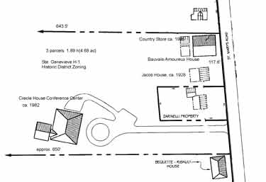

Plan of lot containing Bauvais Amoureux House, Ste. Genevieve, Missouri

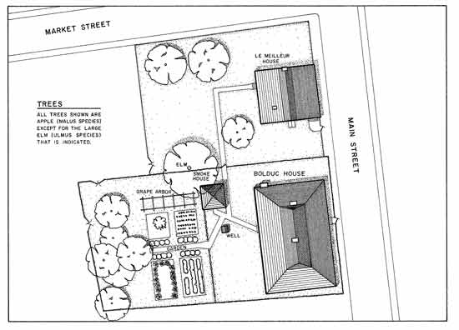

Plan of Bolduc House, Ste. Genevieve, Missouri

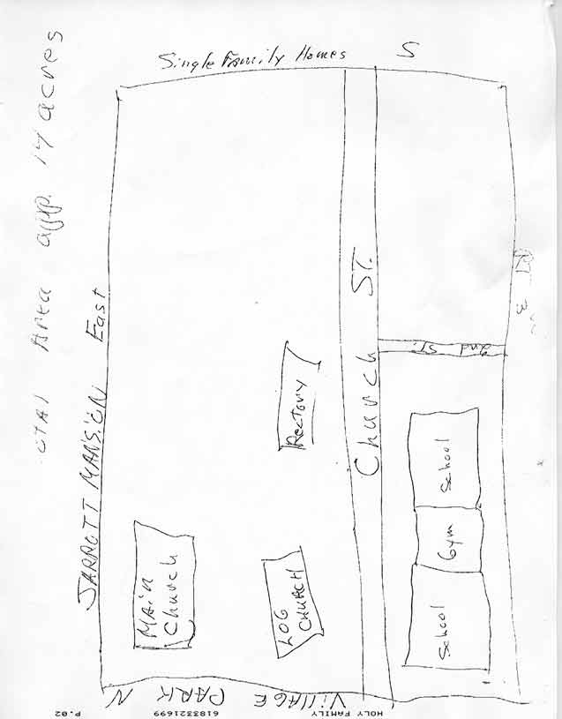

Plan of Holy Family Church, Cahokia, Illinois

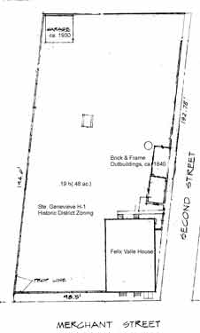

Plan of Felix Valle House, Ste. Genevieve, Missouri
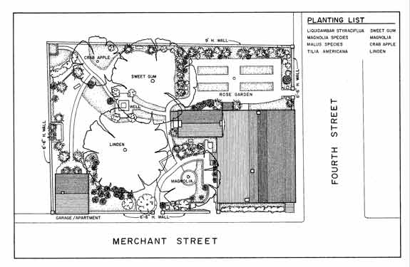

Plan of Guibord Valle House, Ste. Genevieve Missouri
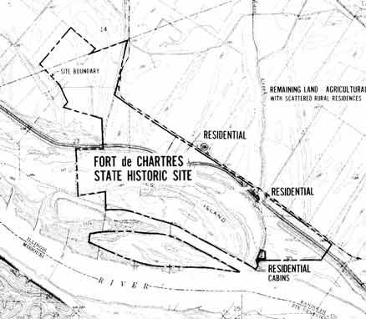

Overview plan of Fort de Chartres location, Illinois

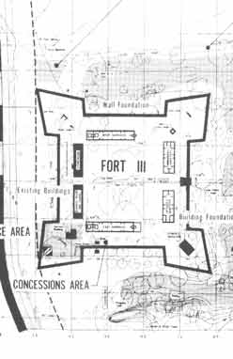

Plan of Fort de Chartres, Illinois
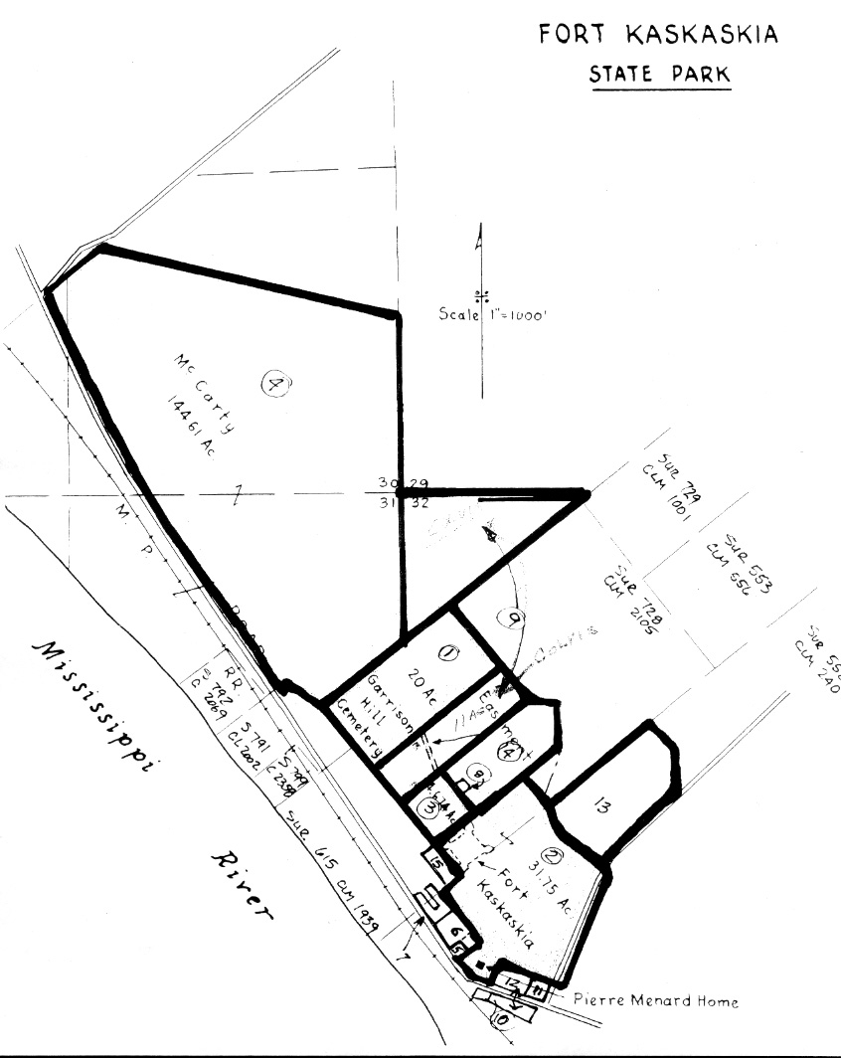

Plan of Pierre Menard House, Illinois

Consent Signatures

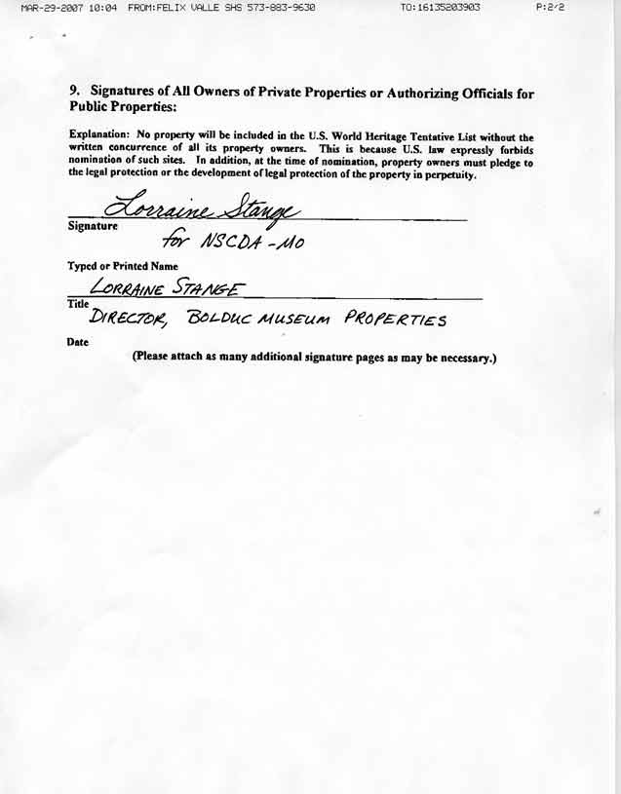

Consent signature, Bolduc House, Ste. Genevieve, Missouri
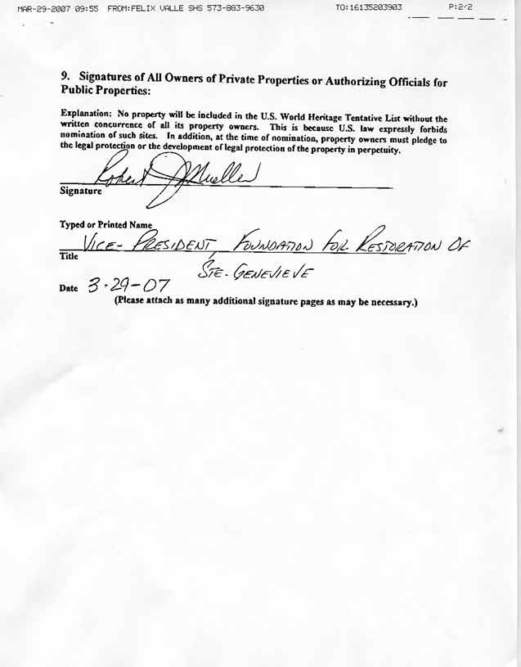

Consent signature, Guibord Valle House, Ste. Genevieve, Missouri
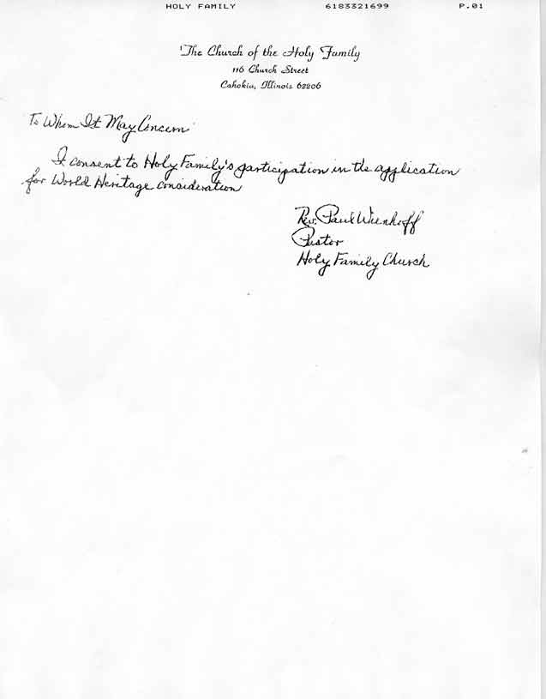

Consent Signature, Holy Family Church, Cahokia, Illinois
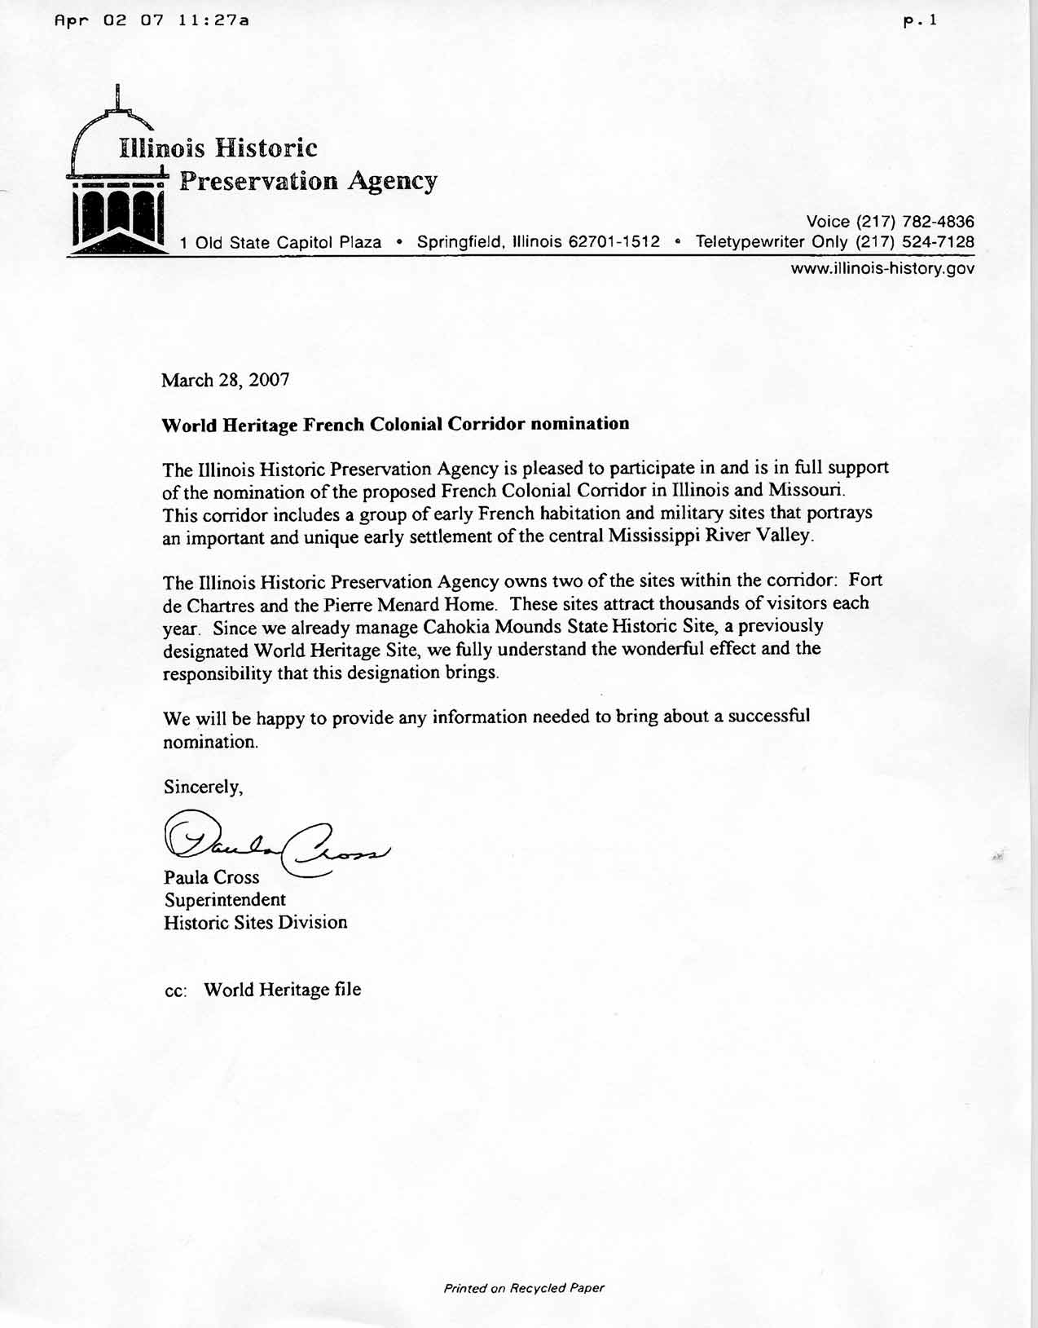

Consent signature, Illinois Historic Preservation Agency, for Fort de Chartres and Pierre Menard House, Illinois.
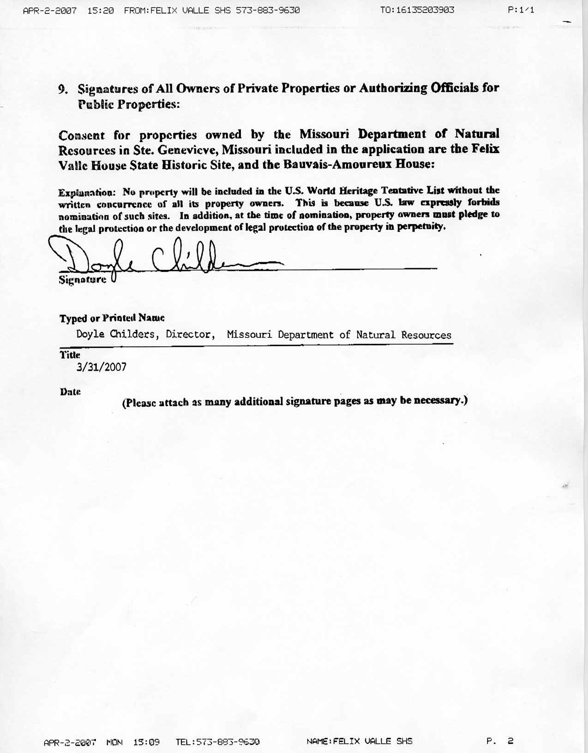

Consent signature, State of Missouri, Dept. of Natural Resources, for Felix Valle State Historic Site (Felix Valle House, Bauvais Amoureux House)
Photographs

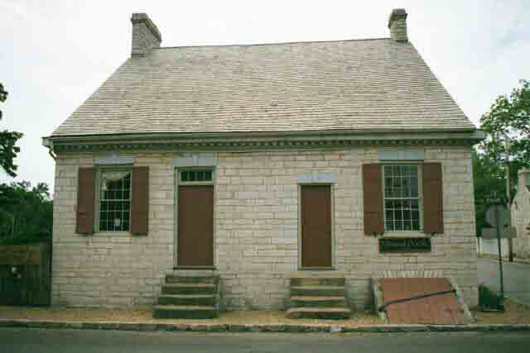

Felix Valle House, Ste. Genevieve, Missouri. Photo: http://www.genealogysource.com/stegenevieve.htm
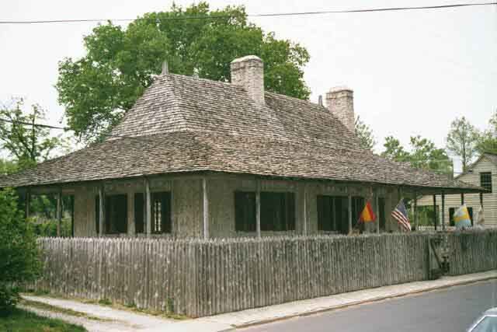

Bolduc House, Ste. Genevieve, Missouri. Photo: http://www.genealogysource.com/stegenevieve.htm

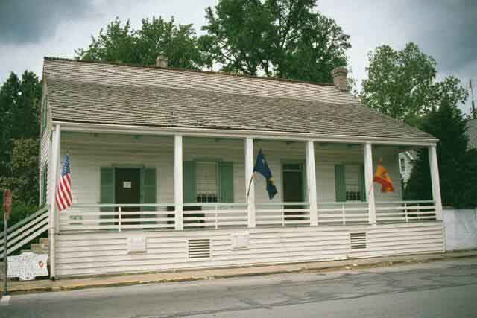

Guibord Valle House, Ste. Genevieve Missouri. Photo: http://www.genealogysource.com/stegenevieve.htm
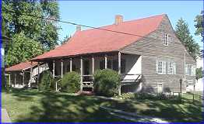

Bauvais Amoureux House, Ste. Genevieve, Missouri. Photo : http://www.ste-genevieve.com/histsite.htm
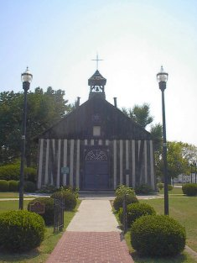

Holy Family Church, Cahokia, Illinois. Photo: http://www.greatriverroad.com/stegen/clair/logchurch.htm
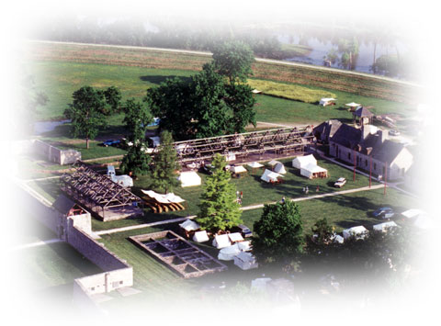

Fort de Chartes, Illinois. Photo: Illinois Historic Preservation Agency
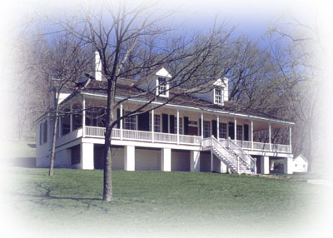

Pierre Menard House, Illinois. Photo: Illinois Historic Preservation Agency
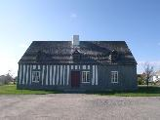

Lamontagne House, Rimouski Quebec. Photo: Repertoire du patrimoine culturel du Quebec

