PUBLIC NOTICE
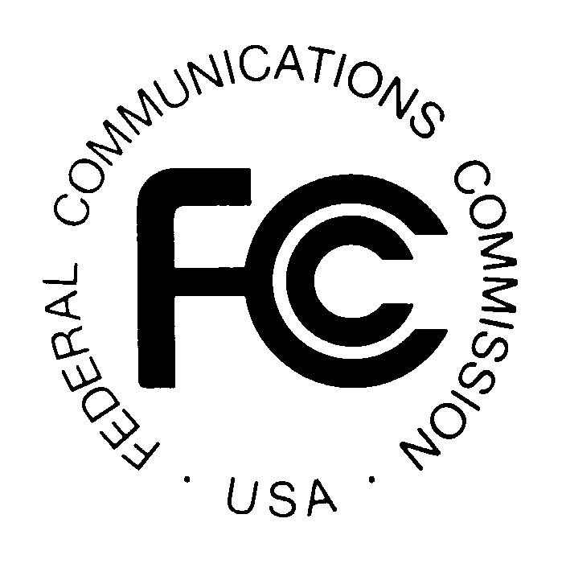
Federal Communications Commission
445 12th St., S.W.
News media information 202 / 418-0500
Fax-On-Demand 202 / 418-2830
TTY 202 / 418-2555
Internet: http://www.fcc.gov
ftp.fcc.gov
Washington, D.C. 20554

DA 04-3177

October 1, 2004

WIRELESS TELECOMUNICATIONS BUREAU ACTION

REGION 8 (NEW YORK – METROPOLITAN AREA) PUBLIC SAFETY

PLANNING COMMITTEES ANNOUNCE

700 MHz REGIONAL PUBLIC SAFETY PLANNING MEETING

AND

NPSPAC 800 MHz REGIONAL PUBLIC SAFETY PLANNING MEETING

The Region 8 (New York – Metropolitan area) Regional Planning Committees will hold two public safety planning meetings on November 3, 2004. The Region 8 700 MHz Regional Planning Committee meeting will convene at 11:00 a.m. at the Nassau County Police Headquarters, 1490 Franklin Avenue, Garden City, New York. The agenda for this meeting includes:

- Review and Approve Agenda
- Review and Approve June 22, 2004 Meeting Report
- Interoperability (SIEC Reports)
- New York State
- New Jersey
- Working Group Activities
- 700 MHz Working Group Activities – Sean O’Hara
- 4.9 GHz Working Group – Felix Melendez, WG Chair
1. Vendor Presentation – Felix Melendez
- Updates – Sean O’Hara
- 700 MHz Channel Availability (45 minutes)
- 5.9 GHz Incident scenario simulation and results (45 minutes)
- NPSTC (20 minutes)
- Region 19 Update
- 700 MHz Plan – Jerry Zarwanski/Peter Meade
- Dispute Resolution Process

- Old Business
- FCC approved petition to extend 4.9 GHz plan submission date
- New Business/Comments
- Schedule Next Meeting

Immediately following the adjournment of the 700 MHz Regional Planning Committee meeting, Region 8 will convene its 800 MHz NPSPAC Regional Planning Committee meeting. The agenda for this meeting includes:

- Review and Approve Meeting Agenda
- Review and Approve June 22, 2004 Meeting Report
- 800 MHz Rebanding – Sean O’Hara
- Application Approvals
  - NJ State Police – Mark Getsinger
  - Essex County – ITAC/ICALL Channels Use approval
- Old Business
a. Suffolk County Application Status – Vincent Stiles
- New Business/Comments
  - APCO Conference
1. Provide channel allotment information to coordinators
2. Coordinators to receive RPC approval for applications
7. Schedule Next Meeting

Both of the Region 8 Public Safety Planning Committee meetings are open to the public. All eligible public safety providers whose sole purpose or principal purpose is to protect the safety of life, health, or property in the New York – Metropolitan area would utilize these frequencies. It is essential that not only public safety, but all government, Native American Tribal, and non-governmental organizations eligible under Section 90.523 of the Commission’s Rules be represented in order to ensure that each agency’s future spectrum needs are considered in the allocation process. Administrators who are not oriented in the communications field should delegate someone with this knowledge to attend, participate and represent your agency’s needs.

All interested parties wishing to participate in the planning for the use of new public safety spectrum in the 764-776 and 744-806 MHz band, or the newly allocated 4.9 GHz band within Region 8 are encouraged to attend. For further information, please contact:

Peter W. Meade, Chairman
Region 8, 700 MHz Regional Planning
140 15th Street
Mineola, New York 11501
(516) 571-6400 (voice)
(516) 571-6407 (fax)
Email: NCFCFC1@aol.com

– FCC –

Region 8, the New York – Metropolitan area consists of Bronx, Kings, Nassau, New York, Orange, Putnam, Queens, Richmond, Rockland, Suffolk, Sullivan, Ulster, Dutchess, and Westchester Counties, New York; and Bergen, Essex, Hudson, Morris, Passaic, Sussex, Union, Warren, Middlesex, Somerset, Hunterdon, Mercer, and Monmouth Counties, New Jersey.

