CHAPTER 20

Administrative Procedures

CHAPTER 20 – ADMINISTRATIVE PROCEDURES

21 Ordering Channels/Cost Coding

All agencies have designated ordering procedures for incident and wildland fire support and services. These established ordering channels provide for: rapid movement of requests, agency review, efficient utilization of resources, and cost effectiveness.

21.1 Geographic Area Coordination Centers (GACCs)

The GACCs act as focal points for internal and external requests not filled at the local level. GACCs are located in the following Areas:

EASTERN – St. Paul, Minnesota:

Connecticut, Delaware, Illinois, Indiana, Iowa, Maine, Maryland, Massachusetts, Michigan, Minnesota, Missouri, New Hampshire, New Jersey, New York, Ohio, Pennsylvania, Rhode Island, Vermont, West Virginia, and Wisconsin.

SOUTHERN – Atlanta, Georgia:

Alabama, Arkansas, District of Columbia, East Texas (plus Texas State Forest Service in West Texas), Florida, Georgia, Kentucky, Louisiana, Mississippi, North Carolina, Oklahoma, South Carolina, Tennessee, Virginia, Puerto Rico, and the Virgin Islands.

SOUTHWEST – Albuquerque, New Mexico:

Arizona, New Mexico, and West Texas (west of the 100th Meridian).

ROCKY MOUNTAIN – Lakewood, Colorado:

Colorado, Kansas, Eastern Wyoming, Nebraska, and South Dakota.

NORTHERN ROCKIES – Missoula, Montana:

Montana, North Dakota, Northern Idaho, and Yellowstone National Park, Wyoming.

ALASKA – Fort Wainwright, Alaska:

Alaska.
NORTHWEST – Portland, Oregon:

Oregon and Washington.

NORTHERN CALIFORNIA OPERATIONS – Redding, California:

Northern California and Hawaii.

SOUTHERN CALIFORNIA OPERATIONS – Riverside, California:

Southern California and USA Pacific Islands.

EASTERN GREAT BASIN – Salt Lake City, Utah:

Southern Idaho, Western Wyoming, Utah, and a portion of Arizona north of the Colorado River.

WESTERN GREAT BASIN – Reno, Nevada:

Nevada.

21.2 Ordering Procedures

Resource order requests will be processed using the Resource Ordering and Status System (ROSS). Resource order requests as the result of an incident, preparedness, severity, and wildland and prescribed fire will follow the established ordering channel displayed below.

At the point in this flow when an order can be filled, reverse the process to insure proper notification back to the incident or requesting office. Local agency dispatch offices should use mutual aid agreements with cooperators whenever possible.
INCIDENT

DISPATCH CENTER

GEOGRAPHIC AREA COORDINATION CENTER

NATIONAL INTERAGENCY COORDINATION CENTER

GEOGRAPHIC AREA COORDINATION CENTER

DISPATCH CENTER

SENDING AGENCY
21.2.1 Support to Border Fires

Border fires are defined as a wildfire that has crossed the boundary from one (1) Geographic Area into another or where the fire is expected to cross the boundary within two (2) burning periods.

Whereas both Geographic Areas have a vested interest and authority to provide resource support to the incident, they may order directly from each other in support of the incident. The following protocols apply:

A. A single ordering point will be designated to ensure proper assignment and demobilization of resources. The incident will remain with the originating unit for situation reporting and prioritization.

B. The dispatch organization designated as the single ordering point may place orders to either GACC using established ordering channels, however only the GACC of the originating unit expanded dispatch is authorized to place orders with NICC.

C. Prior to initiating border fire support operations, concurrence and agreement must occur between the two GACCs and NICC. In order to maintain effective coordination and ensure that the appropriate resources are mobilized, daily conference calls will be conducted between both GACCs and the expanded dispatch organization for the duration of the incident.

21.2.2 Mobilization and Demobilization Information

Travel information for resources will be transmitted by using the ROSS Travel function. Each travel segment will identify mode of travel, carriers name with flight numbers, departure and arrival locations with estimated departure time and estimated arrival time (ETD/ETA) using the local time and time zone.

21.3 Non-Incident Related Ordering

Resource acquisition not related to an incident, preparedness, severity, and wildland or prescribed fire may also follow these ordering procedures. The use of appropriate cost coding procedures is required. Procedures for National Interagency Support Cache ordering are located within Chapter 23.3.

21.4 Cost Coding

Interagency Fire and Severity Activities

The five (5) Federal agencies with Wildland Fire Management funds (BLM, BIA, NPS, FWS, and USFS) have an Interagency Agreement for Fire Management which provides a basis for cooperation on all aspects of wildland fire activities. Included in this agreement is the direction to NOT bill for services rendered for emergency fire suppression, including severity activities.

All fire suppression orders are to have an interagency FireCode assigned by the ordering office. The BLM, FWS, NPS and BIA will use a four (4) digit interagency FireCode to track and compile costs for all severity activities; the ordering office must include the word “severity” within the resource order incident name. (Information on the interagency FireCode can be found at: https://www.firecode.gov/help/User_Guide.pdf)

All fire suppression orders are to have a four (4) digit interagency FireCode assigned by the ordering office. Interagency dispatch procedures have been established to incorporate assigning one FireCode per fire for use by all federal wildland fire agencies.

Orders processed through NICC must have at least one of the following federal agency cost codes assigned by the ordering office. Financial codes should be consistent with the Incident Type.

21.4.1 Bureau of Land Management (BLM)

The BLM wildland fire management cost coding is dived into ten (10) activities:

1. Wildland Fire Preparedness 2810
2. Fire Deferred Maintenance & Capital Improvement 2813
3. Suppression Operations 2821
4. Emergency Stabilization 2822
5. Hazardous Fuels Reduction 2823
6. Wildland Urban Interface 2824
7. Fire Program Reimbursement 2830
8. Rural Fire Assistance 2860
9. Burned Area Rehabilitation 2881
10. Joint Fire Science Program 2891

The use of 2813, 2821, 2822, 2823, 2824, 2830, and 2881 requires a project code.

The Fire and Aviation Directorate will use FireCode to assign project numbers for BLM severity activities. When the BLM assists other DOI agencies, the FireCode severity number provided by the requesting DOI agency will be used.

The Fire and Aviation Directorate will use the interagency FireCode system to assign one code annually for all severity assistance provided to the Forest Service by BLM.

As with all BLM fire operations activities (suppression, rehabilitation and fuels), a project number is required regardless of the subactivity code being used. The standard fund coding guidelines used for suppression, rehabilitation, and fuels activities apply. Also, note that the standard severity coding procedure of converting from the severity number to a fire number applies when dispatched to a specific fire. All fire severity numbers have been assigned under program 2821 HT.

21.4.2 Bureau of Indian Affairs (BIA)

The BIA wildland fire management funding has six (8) activities. Each activity has sub-activities with their respective cost code structures:

1. Wildland Fire Preparedness
Preparedness 92120 92120 P
Interagency Fair Share 9213 92130 R
National Programs 92140 92140 R

2. Construction & Deferred Maintenance 92800 92800 R

3. Self Governance 92900 92900 R

4. Emergency Suppression
Suppression 92310 92310 R
Emergency Stabilization 92320 92320 R
Severity 92350 92350 R

5. Hazardous Fuels Reduction-Non-WUI
Hazardous Fuels Reduction- 92630 92630 R
Fire Use

6. Burned Area Rehabilitation 92B00 92B00 R

7. Rural Fire Assistance 92R00 92R00 R
Training 92R10 92R10 R
Equipment 92R20 92R20 R
Prevention Activities 92R30 92R30 R

8. Wildland Urban Interface 92W00 92W00 R

The sub-activity, Fire – Construction & Deferred Maintenance (92800R), requires approval by the BIA Fire Management Office at NIFC. The job code is mandatory as it tracks costs for approved projects. All sub-activities, with the exception of Suppression (92310R), require funding approval by the BIA Fire Management Office at NIFC. These are noted above with an “R” after the program code. The sub-activity, Severity (92350R) will be considered on an interagency basis.

The interagency FireCode will be used by the Bureau of Indian Affairs for tracking and compiling costs for wildland fire suppression and for severity activities.

21.4.3 National Park Service (NPS)

The NPS wildland fire management cost coding is divided into seven (7) activities and twenty-five (25) sub-activities:

1. Wildland Fire Preparedness 8500
Readiness P11
Facilities, Construction, and Maintenance P12
Research and Technology P13
Fire Plans P14

2. Fire Suppression Operations 8530
Suppression E11
Fire Use E12
Emergency Stabilization E13

3. Burned Area Rehabilitation 8540
Burned Area Rehabilitation B11
Burned Area Monitoring B14

4. Hazardous Fuels Reduction – Non-WUI 8550
Fuels Management H11
Hazardous Fuels Projects – Prescribed Fire H12
Hazardous Fuels Compliance H13
Fire Effects H14
Hazardous Fuels Projects – Mechanical H22
Hazardous Fuels Projects – Other H32

5. Wildland Urban Interface - WUI 8560
Wildland Urban Interface Management W11
Wildland Urban Interface Projects –
Prescribed Fire W12
Wildland Urban Interface Compliance W13
Wildland Urban Interface Monitoring W14
Wildland Urban Interface Community Assistance W15
Wildland Urban Interface Project – Mechanical W22
Wildland Urban Interface Projects – Other W32

6. Rural Fire Assistance 8570
Rural Fire Assistance R11

7. Fire Protection Assistance 8520
National Income Account F11
Expenditure Account – Preparedness F12
Expenditure Account – Operations F13

The interagency FireCode will be used by the National Park Service for tracking and compiling costs for wildland fire suppression and for severity activities.

21.4.4 Fish and Wildlife Service (FWS)

The FWS wildland fire management cost coding is divided into seven (7) activities:

1. Wildland Fire Preparedness 9131
2. Suppression Operations 9141
3. Emergency Stabilization 9142
4. Burned Area Rehabilitation 9262
5. Hazardous Fuels Reduction Operations 9263
6. Wildland Urban Interface Projects 9264
7. Rural Fire Assistance 9265

All cost codes require a five-digit organization code, five (5) numbers starting with the Region (1-9), then the sub-activity, and finally the interagency FireCode or project number. The interagency FireCode will be used with the 9141 sub-activity. The use of 9262, 9263, 9264, and 9265 sub-activities requires a project number.

The interagency FireCode will be used by the Fish and Wildlife Service for tracking and compiling costs for wildland fire suppression and for severity activities.

21.4.5 Forest Service (FS)

The FS wildland fire management cost coding falls under five (5) activities. The interagency FireCode Program will be used to generate a four (4) character code that will be used to track and compile costs.

1. “P” codes represent wildland fires.

2. “G” codes represent wildland fire use for resource benefits.

3. “T” codes represent prescribed fires.

4. “S” codes represent severity requests. Each Region/Forest will have two S-codes for severity. One code for Washington Office (National) approved severity and a second code for Regional Office approved severity. Region/Unit overrides will be used.

S (region number) 1111-Short duration severity, approved at the Regional level. Each Region/Forest should use their own override.

S (region number) 9999-Longer duration, approved at the National level. Each Region/Forest should use their own override.

Four (4) national standard codes have been established to track interagency severity assists:

S70001-FS resource used on BIA fire
S70002-FS resource used on BLM fire
S70003-FS resource used on FWS fire
S70004-FS resource used on NPS fire

5. “F” codes indicate FEMA supported incidents. An “F” code will be assigned by the Forest Service Regional Office that is within the affected FEMA Region. All units providing support will use the “F” code assigned for all charges by the ordering office. Under the National Response Framework (NRF), overtime, travel, and per diem are reimbursable. Base salary costs are not reimbursed in most cases. (See Chapter 12.1.1)

22 Overhead/Crews

Personnel must be requested by the description found in the Fireline Handbook, NWCG Handbook 3, PMS 410-1, NFES 0065 (March 2004) and in the National Interagency Incident Management System (NIIMS) Wildland Fire Qualification System Guide, PMS 310-1, NFES 1414 (April 2006). All requests will be in one of these categories:

C = Crews by type
O = Overhead by position title
IA = Initial Attack Rappelers and Smokejumpers

22.1 Overhead Mobilization and Demobilization

Units filling requests for personnel are responsible for ensuring all performance criteria are met. Requests will be processed as "fully qualified" unless "Trainee Acceptable" is selected as an inclusion in ROSS. The sending unit must designate a Flight Manager when two (2) or more personnel travel together to the same incident via non-commercial air transport. Refer to Chapter 62.8 for Flight Manager responsibilities.

NICC will not accept requests for clerical, driver, or laborer positions. It is not cost effective to hire and transport such personnel when they are normally available from local sources.

If a request requires individuals to be self sufficient for the duration of the assignment, they must be able to procure food, lodging, and local transportation.

Name requests for suppression or all-hazard incidents should be rare and are appropriate only for highly specialized positions or to meet specific agency objectives (for example, name requests between state agencies). The ordering unit must confirm availability for the individual being requested prior to placing the request.

Severity requests often involve strategic movement of resources from areas with lower fire potential. In these cases, name requests may be appropriate and are typically directed by agency managers.

Name requests charged to budgeted/programmed, non-suppression funds are acceptable and will be processed without delay.

All name requests not filled by the sending unit will be returned to the requesting unit by NICC as UTF.

Unless specified “agency only”, ADs and private contractors will be accepted for suppression and severity orders.

During demobilization of resources, emphasis will be placed on having personnel home no later than 2200 hours local time. Occasionally, the availability of large transport aircraft will dictate timeframes during demobilization.

22.2 Crews

Crews will be ordered by a standard type. Four (4) types exist for National or interagency assignments. They are; Type 1, Type 2, Type 2 with IA (initial attack) capability, and Type 3. Refer to Chapter 62.2 for minimum crew standards for national mobilization.

NIFC Forest Service has contracted nationally for T-2IA crews (National Contract Resources, or NCR). National Contract Resources (NCR) are hosted by local units (Host Unit Coordination Centers, or HUCC) which are contractually required to utilize dispatch priorities when mobilizing crews, as outlined in section C.7 of the 2007 National Type-2IA Firefighter Crew Contract. See the following web-site for further details:
http://www.fs.fed.us/fire/contracting/crews/crews.htm

Type 1 Crews:

Crews that meet minimum standards identified within the Fireline Handbook, NWCG Handbook 3, PMS 410-1, NFES 0065 (March 2004). Interagency Hotshot Crews (IHC) are a Type 1 crew that exceeds the Type 1 Standards as required by the National IHC Operations Guide (revised 2004). Interagency Hotshot Crews require appropriate Federal or State agency sponsorship and a recommendation by their respective Geographic Area Coordinating Group for inclusion into the National Interagency Mobilization Guide. NICC will maintain availability status of Type 1 Crews, but will not recognize internal Geographic Area rotations of these crews.

Type 1 Crews attempting to transport chain saws on other than NIFC contract jets should be prepared to ship their chain saws via an alternative method should loading be refused. Type 1 Crews normally come equipped with hand tools. There may be occasions when Type 1 Crews transported by air do not arrive with hand tools. If tools are needed, they should be ordered separately as supply items.

When Type 1 Crews are transported by aircraft, the receiving unit should be prepared to provide the following:

A. Crew transportation.
B. Vehicle to transport saws, fuel, and hand tools separate from crew transportation.
C. Fire equipment (minimum two (2) cases of fuses).
D. Chain saws (four (4) kits).
E. Saw fuel (ten (10) gallons, unmixed).
F. Bar oil (five (5) gallons).

Type 2, Type 2 IA and Type 3 Crews:

Crews that meet minimum standards identified within the Fireline Handbook, NWCG Handbook 3, PMS 410-1, NFES 0065 (March 2004). Type 2 Crews will be ordered as Type 2 or Type 2 IA. In addition to the Type 2 minimum standards, Type 2 IA Crews can be broken up into squads and have three (3) qualified sawyers.

Type 2, Type 2IA and Type 3 Crews ordered through NICC DO NOT come with chain saws or hand tools when transported by air. If chain saws or hand tools are needed, they should be ordered separately as supply items. Crews on the National T2IA contract are self sufficient.

Units sending Type 2, Type 2 IA, and Type 3 crews will determine the ratio of crews to Crew Representatives (CREP) needed for a given assignment. Depending on the assignment, ratios of 1:1 to 1:4 may be appropriate. These responsibilities can be met by an Interagency Resource Representative (IARR) as well. A CREP assigned to Type 2, Type 2 IA, and Type 3 crews will remain with the crew from the initial dispatch until the crew is released to home unit. CREPs are not required for agency regular crews.

Standard crew size is twenty (20) people maximum and eighteen (18) people minimum (including Crew Boss, Crew Representative, and trainees).

All equipment will be inspected and weighed at time of mobilization to ensure adherence to safe transportation procedures.

All crew personnel mobilized and demobilized outside the local unit through NICC will be identified on a crew manifest form. Crew supervisors or will maintain a minimum of four (4) accurate copies of this form at all times. Crew weights will be manifested separate from personal gear and equipment weights. The crew supervisor or CREP will ensure compliance with weight limitations. See Chapter 13.8 for standard weight and gear policy.

Anytime a Geographic Area or State has committed four (4) or more crews, an Interagency Resource Representative (IARR) can be sent by the sending unit or the receiving unit can request them. For each IARR sent, it is the responsibility of the sending GACC to mobilize, demobilize, and ensure proper notification is made to the receiving GACC. An IARR mobilized to incident assignments away from their home unit should have the ability to be fiscally self-sufficient. If the IARR is not self-sufficient, the receiving unit must be notified in advance so they can be prepared to support them.

22.3 Interagency Fire Use Modules

Orders for Interagency Fire Use Modules will be placed through established ordering channels in ROSS using an Overhead Group Request (Module, Fire Use) and configured according to Chapter 62.3.1.

Interagency Fire Use Modules provide skilled and mobile personnel for prescribed fire management and Wildland Fire Use (WFU) in the areas of planning, fire behavior monitoring, ignition, and holding. Secondary priorities follow in the order below:

A. Support burn unit preparation.
B. Support mechanical hazardous fuel reduction projects.
C. Assist with fire effects plot work.

22.4 Smokejumpers

Smokejumpers primary mission is initial attack. While most effective at providing rapid initial response, smokejumpers are well equipped to respond to extended attack incidents and short-term critical need missions on large fires. Smokejumpers are normally configured by planeload, with each load ranging from 2 to 20 smokejumpers depending on aircraft type and smokejumper availability. Smokejumpers may be configured as crews (hand crew, engine crew, or helitack crew), as wildland fire use modules, or as single-resource overhead for Incident Command System positions. Concurrence with NICC must be obtained prior to configuring smokejumpers as crews or modules for extended attack operations.

NICC must be notified when a Geographic Area has internally committed or mobilized 50% of their smokejumpers. Geographic Areas will inform NICC prior to the establishment of smokejumper spike bases.

When requesting a booster load or when pre-positioning individual smokejumpers they will be ordered by individual Overhead requests. Requests may specify a desired delivery system (round or square parachutes). If needed, the requesting base may specify that a spotter be included among the booster load. Smokejumper aircraft must be ordered separately if needed.

The following are included as standard items for each reinforcement smokejumper:

A. Two (2) main parachutes (BLM or FS).
B. Rigging kit (for booster load).
C. Smokejumper gear.
D. Firefighting gear.

Any additional requirements or equipment should be requested at the time of ordering. When smokejumpers are needed jump-ready for initial attack with aircraft, they are to be requested in ROSS as “Load, Smokejumper, Initial Attack” on an Aircraft request. Specifying the delivery system is not permitted. The sending unit will fill the request with a roster in ROSS or by forwarding a manifest form, with name and agency identification, through the established ordering channels. Any intent to retain Smokejumpers which have not been utilized as an IA load will be negotiated between the sending GACC and NICC.

Smokejumpers held as boosters after release from the first IA assignment will be placed on an Overhead order using individual “O” requests. Smokejumpers recovered and mobilized to another assignment, internally or across Geographic Area boundaries, will also be placed on an Overhead order.

Aircraft delivering Initial Attack smokejumpers will return to the sending base or a designated airport before the end of the pilot’s daily flight or duty limitations. Any intent or necessity to retain the aircraft will be negotiated between NICC and the sending GACC. If the aircraft is retained past the first operational period, it will be placed on an Aircraft request through established ordering channels.

22.5 Helicopter Module

Call-When-Needed (CWN) helicopters will be managed by a qualified Helicopter Manager (HELM) and qualified Helicopter Crew Members (HECM); when combined they function as a helicopter module.

TYPE  HELICOPTER | FAA STANDARD / TRANSPORT  CATEGORY | FAA Standard Category Temporarily Designated for Limited Use | FAA Standard Category Permanently Designated for Limited Use* or FAA Restricted Category
1 | Manager plus Four (4) Helicopter Crewmembers | Manager only | Manager only
2 | Manager plus Three (3) Helicopter Crewmembers | Manager only | Manager only
3 | Manager plus Two (2) Helicopter Crewmembers | Manager only | Manager only
CWN Helicopter and Module must meet up away from Incident(s) or Fire Operations. The minimum required staffing levels must be filled with fully qualified personnel. Trainees may be ordered in addition to the standard module configuration.

Units requesting helicopter modules for Call-When-Needed helicopters will do so using an Overhead (O) support request for each position. Helicopter module requests should be coordinated with anticipated helicopter delivery time and location. Ordering a helicopter module for a CWN helicopter is not automatic. Ordering units should attempt to fill helicopter module positions internally first.

If the intended use is for initial attack, the HELM request must specify that a fitness level of arduous is required. Any other qualification requirements (ICT4, etc.) must also be specified.

If helicopter personnel/modules are required to arrive with special needed items (flight helmets, radios, etc.), it must be specified at the time of request.

22.6 Communications Coordinator (COMC)

A Communications Coordinator must be assigned when a second 4390 Starter System is assigned to any incident within a one hundred (100) mile radius of the first assigned 4390 Starter System.

It is important that this position be ordered as early as possible to alleviate the possibility of frequency conflicts during multi-incident situations. See Chapter 62.7 for additional information.

22.7 Incident Meteorologist (IMET)

Whenever a Geographic Area mobilizes a Type 1 Interagency Incident Management Team, the Geographic Area will provide an IMET who will be assigned to the incident. Certain situations could develop where an IMET is not needed for each incident, such as when two (2) or more incidents are in close proximity to each other. In these cases, one (1) or more IMETs could be shared by the incidents. Incident Commanders must ensure sufficient weather information is available to ensure safety and minimize the risk to incident personnel.

IMET status will be maintained by the respective Geographic Area in ROSS. Status will include updated contact information, the home jet port, individual qualifications, and current availability.

When an IMET is needed for an incident, the request will be placed with the local National Weather Service (NWS) Forecast Office within the local fire weather district in which the incident is located.

If the IMET request is not filled by the NWS Forecast Office or if the National Preparedness Level is at 4 or higher, the request will be placed up to the GACC. The GACC will contact the NWS National Fire Weather Operations Coordinator (NFWOC) (Larry Van Bussum or acting) in Boise, Idaho by calling the NWS Incident Response Division at 877-323-IMET (4638).

The NFWOC will then identify the name and location of the available IMET to fill the ordering incidents IMET request. If the available IMET is located within the Geographic Area where the incident is located, the IMET will be ordered by name request and internally mobilized using established procedures. If the available IMET is located in another Geographic Area, the IMET request will be placed to the National Interagency Coordination Center (NICC) as a name request using established procedures. NICC will place the IMET request to the appropriate Geographic Area to be filled.

When the NWS cannot provide transportation, the sending dispatch office is responsible for arranging and providing mobilization needed for the IMET and any required equipment to the incident. The incident or incidents host agency is responsible for arranging and providing demobilization needed for the release of the IMET and required equipment back to the home unit.

The IMET is a single resource covered under a reimbursable agreement between the Wildland Fire Agencies and the Department of Commerce, NOAA-NWS. Standard NWS equipment that is essential to on-site meteorological support is mobilized with each IMET, no additional resource order requests are necessary. Standard NWS equipment does not require additional ordering by the incident. Basic standard NWS equipment includes:

- Laptop computer
- Printer
- Mobile satellite setup and setup tools
- Cellular telephone
- All terrain rental vehicle
- Miscellaneous office supply

Reimbursement of costs associated with utilization of Standard NWS equipment such as cell phone usage charges and satellite communication charges is authorized under section V., part B item 4 of the Interagency Agreement for Meteorological and Other Technical Services. Damages, failure, and daily wear incurred to standard equipment during an assignment are also eligible for reimbursement.

During an assignment, an IMET may place a resource order for a NWS Atmospheric Theodolilte Meteorological Unit (ATMU). All associated items (helium, setup tools and related supplies) are provided under the ATMU resource order request, no additional resource order requests are necessary. Costs associated with an ATMU are reimbursable.

  - Cache Support Positions

These positions are available to assist fire caches during periods of high activity or when shortages of locally trained personnel hinder cache operations.
22.9 National Incident Management Teams

22.9.1 Interagency Incident Management Teams (IMT)

Incident Management Teams will be ordered by type (Type 1, Type 2 and NIMO). National Type 1 IMTs and NIMO will be mobilized according to the National call-out procedures from the National rotation managed by NICC. Geographic Area Type 2 IMTs will be mobilized according to Geographic Area policy, with the following exception: Geographic Area Type 2 IMTs that have been ordered through NICC for staging within a Geographic Area will be prioritized and assigned to any new Federal Type 2 incident within that Area, or when a replacement team is needed within that Area.
.
IMTs will be requested through established ordering channels configured as identified in Chapter 63.1.1. Incident Commanders shall make notification to the receiving Geographic Area through established ordering channels of any position shortages, or when their team configuration differs from the standard configuration.

The primary mission of IMTs is wildfire incident management. IMTs may respond to all-hazard incidents under the following guidelines:

A. Planned events should be managed internally by the respective agency.

B. The planned length of assignment should not exceed fourteen (14) days without negotiated approval from the sending Geographic Area and NICC.

A Federal Emergency Management Agency (FEMA) mobilization under the National Response Framework will be accomplished according to the National call-out procedures identified in Chapter 63.1. For additional information on the National Response Framework, see Chapter 12.1.1.

A. The standard length of assignment of fourteen (14) days may be extended up to thirty (30) days after negotiated approval between the Incident Commander and FEMA.

B. Base hours for Federal employees, in most cases, are not reimbursed by FEMA. Overtime, premium pay, and travel expenses may be paid by FEMA.

22.9.2 National Area Command Team

National Area Command Teams will be mobilized according to the National call-out procedures from the National Area Command Team rotation managed by NICC. Orders for National Area Command Teams will be placed through established ordering channels using an Overhead Group Request to NICC, configured as identified in Chapter 63.2.1.

22.9.3 Fire Use Management Team (FUMT)

Fire Use Management Teams will be mobilized according to the National call-out procedures from the FUMTs Rotation managed by NICC. Orders for FUMTs will be placed through established ordering channels using an Overhead Group Request, configured as identified in Chapter 63.3.1.

The primary mission of the FUMTs is to provide land managers with skilled and mobile personnel to assist with the management of Wildland Fire Use (WFU) and prescribed fires. Each FUMT offers the full range of appropriate management responses to wildland fire occurrence and large complex prescribed fire applications.

22.9.4 National Park Service All-Hazard Incident Management Team

Orders for National Park Service All-Hazard Incident Management Teams will be placed through established ordering channels in ROSS using an Overhead Group Request to NICC configured as identified in Chapter 63.4.1.

The primary mission of this team is to manage planned and unplanned non-wildland fire incidents on an interagency basis.

22.9.5 National Incident Management Organization Teams (NIMO)

Orders for National Incident Management Organization Teams will be placed through established ordering channels using an Overhead Group Request and configured as identified in Chapter 63.1.1.

The primary mission of NIMO Teams is to manage wildland fires and/or fire use incidents.

22.10 Incident Support Teams

22.10.1 National Interagency Buying Teams (BUYT)

National Interagency Buying Teams will be mobilized according to the National call-out procedures from the National Interagency BUYT Rotation managed by NICC. Orders for BUYTs will be placed through established ordering channels using an Overhead Group Request and configured as identified in Chapter 64.1.1.

The primary mission of a BUYT is to support the local administrative staff with incident acquisition. In addition, the BUYT Leader has the responsibility for coordinating property accountability with the Supply Unit Leader. Responsibilities and coordination of BUYTs can be found in the Interagency Incident Business Management Handbook, Chapter 20, Section 20.04, and in Chapter 40, Section 43.

BUYTs should not be utilized as defacto payment teams. Incident host agencies should order an Administrative Payment Team if the situation warrants.

BUYTs are ordered by the incident host agency and report to the agency administrator or designated position, and work with the local administrative staff to support the incident acquisition effort. Geographic Areas will internally mobilize their National Buying Teams, local Geographic Area buying teams, or ad-hoc buying teams before requesting a National Interagency Buying Team from NICC. National BUYTs are mobilized according to National Call-Out Procedures; (See Chapter 60, Section 64.1.2)

22.10.2 Administrative Payment Teams (APTs)

The National Park Service provides Administrative Payment Teams for incident support. The purpose of the APT is to expedite payment of financial obligations incurred as a result of an emergency incident and relieve the local administrative unit of additional work generated by the incident. After receiving written delegation of authority from the agency administrator, the team is responsible for payment of all financial obligations incurred during the incident.

Requests for APTs will be placed through established ordering channels using an Overhead Group Request to NICC, configured according to Chapter 64.2.1. APTs will be mobilized according to the National call-out procedures from the APTs Rotation managed by NICC.

APTs can make a full range of vendor payments. The following should be considered before requesting an APT:

A. Is the incident expected to last for more than fourteen (14) days?

B. The incident host agency is unable to process the payments during and after the incident due to regular workload demands.

C. The community near the incident is providing support and cannot replenish stock without financial hardship and must be reimbursed fairly quickly.

22.10.3 Burned Area Emergency Response Team (BAER)

Burned Area Emergency Response is an integral part of wildfire incidents. All wildland fire management agencies are responsible for taking immediate and effective post wildfire site and resource stabilization actions designed to protect life and property and prevent further natural and cultural resource degradation while ensuring all environmental and legal mandates are met.

BAER team personnel meet training and PPE standards necessary to make non-escorted IC approved fireline visits. Orders for BAER teams will be placed through established ordering channels in ROSS using an Overhead Group Request and configured according to Chapter 64.3.

22.10.4 Critical Incident Stress Debriefing Teams

Stress debriefing personnel and teams are usually provided internally or through locally contracted services. The National Park Service has two (2) Critical Incident Stress Debriefing Teams available for interagency use. Requests will be placed through established ordering channels using individual overhead requests.

22.10.5 National Fire Prevention and Education Teams (NFPET)

Requests for National Fire Prevention and Education Teams will be placed through established ordering channels in ROSS using an Overhead Group Request to NICC and configured according to Chapter 64.4.1.

National Fire Prevention Education Teams provide skilled and mobile personnel for fire prevention and education activities. They can be ordered to support a variety of situations affecting a large or small area. Teams are effective with the reduction of unwanted human-caused wildland ignitions, when wildland fire severity conditions are imminent, when unusually high fire occurrence is anticipated due to human activity, weather conditions, or hazardous fuels, and when an above normal incidence of human caused fires exists. NFPETs are designed to supplement local prevention and education program efforts on a short term basis. Working with local agencies and resources, NFPETs are equipped to complete on-site prevention assessments and plans, initiate the implementation of the plans, and begin immediate public outreach and information dissemination. See Chapter 64.4 for additional information.

22.10.6 Wildland Fire and Aviation Safety Teams (FAST)

Wildland Fire and Aviation Safety Teams assist Agency Administrators during periods of high fire activity by assessing policy, rules, regulations, and management oversight relating to operational issues. They can also provide the following:

A. Guidance to ensure fire and aviation programs are conducted safely.

B. Review compliance with Occupational Safety and Health Administration (OSHA) abatement plans, reports, reviews, and evaluations.

C. Review compliance with Interagency Standards for Fire and Aviation Operations.

Wildland FASTs can be requested to conduct reviews at the local, state, and regional level. If a more comprehensive review is required, a National FAST can be ordered through established ordering channels to NICC using an Overhead Group request and configured according to Chapter 64.5.1.

Wildland FASTs will be chartered by their respective Geographic Area Multi-Agency Coordinating Group (GMAC), with a delegation of authority, and report back to the GMAC.

The team’s report includes an executive summary, purpose, objectives, methods and procedures, findings, recommendations, follow-up actions (immediate, long-term, and national issues), and a letter delegating authority for the review. As follow-up, the team will gather and review all reports prior to the end of the calendar year to ensure identified corrective actions have been taken. FAST reports should be submitted to the Geographic Area, with a copy to the Federal Fire and Aviation Safety Team (FFAST) within thirty (30) days.

22.10.7 Aviation Safety Assistance Team (ASAT)

Aviation Safety Assistance Teams enhance safe, efficient, and effective aviation operations. An ASAT provides assistance to unit and aviation managers, flight crews, and incident management teams for increasing, ongoing or declining incident aviation activity.

If an ASAT cannot be filled internally, the request may be placed with NICC through established ordering channels using individual overhead requests configured according to Chapter 64.6.1.

ASATs receive an assignment briefing with management concerns and/or issues identified in a letter delegating authority, which establishes the roles of the team and its expectations. The teams will provide daily feedback to the person(s) identified in the delegation of authority. Teams will conduct an exit briefing and will provide a written report prior to demobilization.

THIS PAGE INTENTIONALLY LEFT BLANK
23 Equipment/Supplies

All Equipment and Supply Orders will follow established ordering procedures (Type1, 2, 3 incidents), except for the redistribution of supplies within the National Fire Equipment System (NFES). Redistribution of excess supply items will be coordinated by the designated NFES Cache Manager(s). Cache orders will be filled to meet timeframes specified, using the most economical service. All NFES cache items are shipped ready for fireline use.

23.1 Equipment/Supplies Mobilization

All Equipment requests will be processed using ROSS.
Examples of Equipment resources are:

A. National Contract Mobile Food Services (Caterers).
B. National Contract Mobile Shower Facilities.
C. Rolling Stock – engines, water tenders, dozers, etc.
D. Telecommunications items (NIRSC systems and kits)

Supplies will be requested on a Supply Order. Supplies are identified as materials or goods not defined in any other resource or service category.

Examples of Supplies resources are:

A. NFES items (other than NIRSC systems and kits).
B. Mobile Cache Vans.
C. Local Purchase.

23.2 Equipment/Supplies Demobilization

Equipment and accountable supply release information must be promptly relayed using ROSS.

23.3 National Interagency Support Cache Ordering Procedures

A. Orders from caches to supplier (including GSA – General Services Administration) for procurement of non-consumable supplies (i.e., pumps, saws, generators, high cost reusable items) in support of incidents must be coordinated through the NFES Representative at NIFC.

B. Other large replacement supply orders will be coordinated by the NFES Representative at NIFC to avoid overstocking the system.

C. Orders for cache restock and incident support will be placed directly between National Interagency Support Caches until the National Interagency Supply Cache Coordinator (NISCC) position is activated at NICC. The NISCC is normally activated at PL4 but can be activated at lower planning levels due to significant circumstances.

D. When the NISCC is activated at NICC, all cache restock and incident support orders from National Interagency Support Caches will be placed with NICC. Based on national priorities, the NISCC will forward requests to the appropriate National Interagency Support Cache(s) for processing. The Resource Order Form will be used when ordering supplies through the NISCC at NICC. Travel information will be relayed using the Shipping Status Form.

23.3.1 NFES Items in Short Supply

A. NICC, in cooperation with NFES, will advise all incident support agencies of those items in high demand and limited quantities and distribute this information through the NFES Managed Items List.

B. Identified items on the NFES Managed Items List will be requested through established ordering channels and will be coordinated through the NFES Representative at NIFC.

23.3.2 Field Office Replenishment During Fire Season

Agencies will place orders to their servicing National Interagency Support Cache. Replenishment orders must be the result of fire management activities and must be accompanied with the appropriate cost code.

23.3.3 Field Office Replenishment Outside of Fire Season

Whenever possible, field offices must order directly from GSA for those items stocked in the Federal Supply System.

All other items will be ordered directly from suppliers unless individual agency instructions prevail.

23.3.4 Incident Replacement of NFES Items

Prior to release from an incident, personnel may request replacement of equipment and supplies that were lost, consumed, or worn out during the incident.

IMTs will approve all requests for replacement of equipment and supplies. If the requested equipment and supplies are not available at the incident, the Supply Unit Leader may forward requests to their servicing cache through established ordering channels. Replacement items will be shipped to the Supply Unit at the incident. If there is insufficient time for the Supply Unit to obtain replacement requests before demobilization of the resource, an Incident Replacement Requisition (NFES #1300) will be completed and forwarded to the servicing cache, who will then forward it to the requesting unit’s servicing cache for processing. Replacement items will be filled and shipped to the requestor’s home unit.

23.3.5 Local Unit Incident Replacement: Type 3 and Type 4 Incidents

The hosting units’ Agency Administrator or authorized representative must approve all replacement requests. Follow procedures for incident replacement, Chapter 23.3.4.

23.3.6 Incident to Incident Transfer of Equipment and Supplies

Transfer of equipment and supplies between incidents, including those operating under Area Command authority, may occur only with proper documentation so accountability is maintained. Transfer of communications equipment creates safety concerns by increasing the risk of frequency conflict and the possibility of damaged equipment or equipment not tuned being utilized. This may only be done with approval of the NIRSC Communications Duty Officer (CDO).

23.4 National Incident Radio Support Cache (NIRSC)

NIRSC is a National Resource composed of multi-channel radio systems and kits available for complex incident communications. The priority use of NIRSC radio systems and kits is for active incidents. All radio systems and kits must be returned to NIRSC as soon as the incident has demobilized. A National Communications Duty Officer (CDO) is available at NIRSC throughout the year. Geographic Area Frequency Managers, Communication Coordinators (COMC), and Incident Communication Unit Leaders (COML) will coordinate with NICC, the Geographic Area, and the NIRSC CDO on all telecommunication issues.

NIRSC stocks NFES #4390 Starter Systems, which will provide the Command/Tactical, Air Operations, and Logistical communications requirements of a single incident. Individual kits are available to supplement Starter Systems or to provide support for smaller incidents.

NIRSC radios are synthesized and contain both FS and DOI frequencies. FS and DOI frequencies are not “cleared” nationally. Other agencies use these frequencies and, in some cases, in very critical and sensitive areas. All frequencies must be approved for the areas where they will be used. Any of the national frequencies (FS or DOI) are not to be used without prior coordination with the NIRSC CDO.
NIRSC issues dedicated FM frequencies in conjunction with communication equipment assigned to incidents. NIRSC will order additional FM frequencies from DOI and FS – WO as conditions warrant. Government users may not use Family Radio Service (FRS) for communications in any planned or ongoing incident.

23.4.1 Radio Mobilization

Requests for NIRSC radio systems and kits will be placed with NICC through established ordering channels. To insure proper frequency coordination, the ordering office must include the Latitude and Longitude of the incident on the resource order. Radios will be used as received without modification. Defective radio equipment will be immediately returned to NIRSC for maintenance. To maintain quality and quantity for the field, each Starter System or kit will be returned to NIRSC for rehabilitation immediately after each assignment. The incident or unit charged with custody of the radio equipment is responsible for a complete inventory of that equipment upon return from the incident.

Each Geographic Area may order up to four (4) Starter Systems for preposition during their established fire season. The NIRSC CDO must be contacted at 208-387-5644 when an order for a Starter System is received for an incident. The CDO will identify which prepositioned Starter System will be assigned to the incident. A replacement Starter System may be requested after commitment of a prepositioned Starter System.

Typically, Starter Systems should remain intact. However, individual kits may be utilized for smaller incidents that do not require the entire Starter System. GACCs will notify NICC of the commitment of individual kits from a Starter System and will reorder kits needed to complete the prepositioned Starter System. Any kit committed or assigned to an incident that was originally prepositioned to a Geographic Area must follow the same transfer process as outlined above.

Prepositioned radio systems and kits will be returned to NIRSC as soon as the need has diminished or annually for preventative maintenance. Prepositioning NIRSC radio systems and kits longer than six (6) months requires NIRSC approval.

23.4.2 Radio Demobilization

NIRSC radio systems and kits should be inventoried, sealed, and returned promptly to NIRSC/NIFC. Do not stockpile kits. Spare seals are supplied in each box. Incidents are responsible for ensuring all radio systems or kits are returned or accounted for on a Property Loss Statement.

23.5 Atmospheric Theodolite Meteorological Unit (ATMU) NFES #1836

ATMUs will be mobilized only upon request from the Incident Meteorologist (IMET). Mobilizations of ATMUs are not automatic. Geographic Areas unable to fill ATMU requests internally will place requests with NICC. NICC coordinates filling the request with the National Weather Service (NWS) in Boise, ID by calling the NWS Incident Response Division at 1-877-323-IMET (4638).

ATMUs are National Resources. At National Preparedness Levels 4 and 5, all requests for ATMUs will be placed with NICC through established ordering channels.

23.6 Fire Remote Automatic Weather Stations, (FRAWS) NFES #5869

Requests for FRAWs will be placed with NICC through established ordering channels. Any necessary FRAWS technicians, vehicles, or air transportation required for mobilization and demobilization will be coordinated through NIFC. Upon release from the incident, the FRAWS will be returned to NIFC.

If the requesting unit has agency qualified personnel to install and maintain the FRAWS units, then this information must be documented in the special needs portion of ROSS. Technicians will not be dispatched from NIFC when a request has such documentation.

23.7 Project Remote Automatic Weather Stations, (PRAWS) NFES #5870

Requests for PRAWs will be placed with NICC through established ordering channels. PRAWS will be configured for the specific project prior to the mobilization. The requesting agency must contact the NIFC Remote Sensing Fire Weather Support Office at (208) 387-5726 prior to ordering to determine the PRAWS configuration. Any necessary PRAWS technicians, vehicles, or air transportation required for mobilization and demobilization will be coordinated through NIFC. Upon release from the project, the PRAWS will be returned to NIFC.

23.8 National Contract Mobile Food Services and National Contract Mobile Shower Facilities

National Contract Mobile Food Service Units

When the use of a National Mobile Food Service Unit is needed for Federal wildland fire suppression activities in the western United States and Alaska (food boxes only for AK), the Federal Government is obligated to purchase such quantities as may be needed from the National Mobile Food Service Contractor(s), any time, (1) the number of people to be fed is at or above 150 persons per meal and (2) the headcount is estimated to remain at those numbers or greater for at least seventy-two (72) hours from when the headcount first reaches 150 per meal, provided they can meet the incident’s needs and required time frames. National Contract Mobile Food Service Contractors will be given the opportunity to provide three (3) meals per day unless other arrangements are mutually agreed to with the Contracting Officer Representative (COR). When the use of mobile food service is needed for other types of activities, the Federal Government may use the National Contract Mobile Food Service Contractor(s) at its option and the contractor may elect to accept or not accept the order. For additional contract information, refer to the National Mobile Food Services Contract publication or on the web at: http://www.fs.fed.us/fire/contracting/food/food.htm.

National Contract Mobile Shower Facilities Units

Any time contract mobile shower services are needed for Federal wildland fire incidents in the western United States, the Federal Government is obligated to purchase services from the National Mobile Shower Facilities Contractor(s), provided that the contractor can reasonably meet the incident’s needs and required time frames. When the use of a Mobile Shower Facility is needed for other types of incidents, the Federal Government may use a National Contract Shower Facilities Contractor at its option, and the contractor may elect to perform or not perform the work. For additional contract information, refer to the National Mobile Shower Facilities Contract publication or on the web at: http://www.fs.fed.us/fire/contracting/shower/shower.htm.

23.8.1 National Contract Mobile Food Services and Shower Facilities Mobilization

All National Contract and CWN (Call When Needed) Mobile Food Service Units and Mobile Shower Facility Units in the lower 48 States are ordered through and mobilized by NICC through established ordering channels. The National Contract Mobile Food Service Unit located in Alaska (food boxes only) is ordered through and mobilized by the Cache Manager at the Alaska Fire Service Warehouse in Fairbanks, Alaska.

A. Mobile Food Service Unit requests require a completed Food Service Request Form at the time of request. (See Chapter 28.2.)

B. Shower Facilities requests require the approximate number of personnel to service, estimated duration, and date and time the showering is to begin.

If an incident has a need for additional mobile food service units or shower facilities units, the request will be placed with NICC through established ordering channels. NICC will determine and assign the appropriate units to all Federal wildland fire incidents.

When necessary, as determined by the incident, a Contracting Officer’s Technical Representative (COTR) may be ordered through the appropriate Geographic Area. If the Geographic Area is unable to provide a COTR, the order will be placed through NICC. Once the unit is operating smoothly, the COTR may be demobilized from the incident through the appropriate dispatch channels.

23.8.2 National Contract Mobile Food Services and Shower Facilities Reassignments

All requests to reassign National Contract Mobile Food Services or Shower Facilities units will be placed with NICC through established ordering channels. All reassignments of National Contract Mobile Food Services and Shower Facilities units will be communicated to the vendor by NICC.

23.8.3 National Contract Mobile Food Services and Shower Facilities Demobilization

All release information will be entered into ROSS within fifteen (15) minutes of demobilization. Contractors may take twenty-four (24) hours to rest and replenish supplies within the local area after release. After 24 hours, contractors must return to the unit’s designated dispatch point.

23.9 National Contract Mobile Commissary Services

National contract for mobile commissary services are not available for 2008.

THIS PAGE INTENTIONALLY LEFT BLANK

24 Aircraft

NICC is the sole source for large transport aircraft holding Federal Aviation Regulations (FAR) Part 121 Certificates and for Type 1 and 2 Call-When-Needed (CWN) Helicopters. (See Chapters 24.8 or 24.9)

Cooperator aircraft (State contracted, State owned, State managed National Guard aircraft, county, city, or other) may be used on federal fires under the following conditions:

A. The pilot has been approved in writing for the aircraft and the mission by either the FS or the DOI’s Aviation Management Directorate (AMD).

B. The aircraft has been approved in writing for the mission by either the FS or AMD.

C. There exists a written MOU (Memorandum of Understanding), Interagency Agreement, or other document that authorizes this use and payment for this use.

D. The cooperator aircraft will be operated within any limits on its use established in the written approval.

E. The cooperator aircraft will be used only in situations where federal aircraft are not reasonably available.

F. The cooperator aircraft will be released when federal aircraft become reasonably available.

G. Use of cooperator-owned aircraft prior to exhausting contracted resources must involve a “significant and imminent threat to life or property.”

24.1 Aircraft Mobilization

When a Geographic Area has depleted local and available aircraft resources, request(s) will be placed with NICC. Aircraft assigned will become the receiving Area’s resource until released. The following terminology will be used when requesting aircraft through NICC:

A. Knots (kts) will be the standard term used to reference airspeed.

B. VORs (Very High Frequency Omni-directional Range) will be used to reference direction.

C. Latitude and longitude must be provided in degrees and minutes.

D. Aircraft registration numbers will be used when referencing helicopters, lead planes, and air attack aircraft. Airtankers will be referenced by the airtanker number; e.g., T-00.

The following selection factors will be used when ordering aircraft:

A. Airtankers: Loaded or empty (two (2) hour maximum flight when loaded, except for the P3A airtanker).

B. Timeliness.

C. Cost effectiveness.

D. Performance specifications for density/high altitude operations.

E. Appropriately carded.

F. Special applications such as special-use flights, tundra pads, float, etc.

24.2 Aircraft Demobilization

Flight Following will be performed on all Government or exclusive use contract aircraft being demobilized. NICC will release charter and CWN aircraft to the vendor without flight following provided no Government personnel or cargo is on board. All aircraft release information will be entered in to ROSS.

24.3 Flight Management Procedures

Types of flights:
- Point-to-Point. Point-to-point flights originate at one developed airport or permanent helibase, with a direct flight to another developed airport or permanent helibase. These types of flights are often referred to as "administrative" flights. These flights require point-to-point approved pilots and aircraft. A point-to-point flight is conducted higher than 500 feet above ground level (AGL) except for take off and landing.

- Mission Flights. Mission flights are those flights that do not meet the definition of a point-to-point flight. These types of flights are often referred to as “tactical” flights. A mission flight requires work to be performed in the air (such as retardant or water delivery, reconnaissance, smokejumper delivery, sketch mapping), or through a combination of ground and aerial work (such as delivery of personnel and/or cargo from a helibase to an unimproved landing site, rappelling, cargo let-down, or wild horse herding). The pilot and aircraft must be agency approved (carded) for the mission being performed.
Flight Plans and Flight Following. Agency flight plans are the responsibility of the originating dispatch office and documented on a Flight Request/Flight Schedule or an Aircraft Resource order for mission flights. Flight following is the responsibility of the originating dispatch office and will remain so until transferred through a documented, positive handoff. The flight following dispatch office shall be continually staffed while an aircraft is airborne. Confirmation of an aircraft’s arrival at a specified destination is required to ensure that a flight has been completed safely. It is the pilot’s responsibility to close out a flight plan. If an aircraft is overdue, it is the receiving dispatcher’s responsibility to initiate aircraft search and rescue actions. Flights following problems are documented through the SAFECOM system.

- FAA Flight Plans and Flight Following. All flights conducted under FAA Instrument Flight Rules (IFR) are automatically provided FAA flight following. Administrative flights conducted under Visual Flight Rules (VFR) flight plans require the pilot to file a flight plan with the appropriate FAA facility. The pilot must request FAA flight following. Air Traffic Control (ATC) may or may not provide it. It is the pilot’s responsibility to confirm with dispatch which type of FAA flight plan will be used. The pilot shall close out the flight plan with the FAA once the flight is completed. FAA flight plans and flight following are generally used for point-to-point flights and the pilot or flight manager will contact dispatch with an estimated time of departure, estimated time en route and close out with dispatch once the aircraft is on the ground to accomplish resource tracking.

- Agency Flight Plans and Flight Following. For mission flights, there are two types of Agency flight following: Automated Flight Following (AFF), and Radio Check-in. AFF is the preferred method of agency flight following. If the aircraft and flight following office have AFF capability, it shall be utilized. Periodic radio transmissions are acceptable when utilizing AFF. See AFF procedures section, for more detailed information. Radio Check-in / Check-out flight following requires verbal communication via radio every 15 minutes. The dispatcher will log the aircraft call sign, latitude, longitude and heading. Agency flight following is used for all mission flights. Helicopters conducting Mission Flights shall check-in prior to and immediately after each takeoff/landing per IHOG 4.II.E.2.

For point-to-point flights, AFF flight following may be used as well. The pilot or flight manager will, as a minimum, contact dispatch prior to the flight with an estimated time of departure, estimated time en route, souls and fuel on board and will close out with dispatch once the aircraft is on the ground.

NICC will Resource Track all aircraft crossing Geographic Area boundaries, which have been ordered through NICC, on:

A. Aircraft Orders.
B. Flight Requests.
C. IA Smokejumper Orders.

Notification of the commitment of National Resources applies to non-tactical flights.

SENDING UNIT – The Sending Unit is the dispatch unit which sends the aircraft from the vendor or Government aviation unit.

RECEIVING UNIT – The Receiving Unit is the dispatch unit which is receiving the resource.

A. Responsibilities of the Sending Unit:

1. Obtain actual time of departure (ATD) and estimated time of arrival (ETA) from the initial departure airport from pilot/vendor.

2. Relay the ATD, ETA, and method of Flight Following (agency or FAA) to the Sending Unit’s GACC via established ordering channels.

3. Notify the GACC of any route changes, and of any delay or advances of a flight plan exceeding thirty (30) minutes.

4. Assist with search procedures for overdue aircraft. Utilize agency aircraft search/rescue guides, as appropriate.

5. On any flight requiring stops en route to a destination, instruct the Pilot-In-Command or Flight Manager to contact NICC at (800) 994-6312. Aircraft support vehicles should contact NICC at fuel stops.
(Flight Manager Responsibilities are located in 62.8)

B. Responsibilities of Sending GACC:

1. Sending GACC will relay the flight itinerary to NICC via email or fax.

2. Notify NICC of any route changes, and of any delay or advances of a flight plan exceeding thirty (30) minutes.

3. Assist with search procedures for overdue aircraft. Utilize agency aircraft search and rescue guides, as appropriate.

C. Responsibilities of NICC:

1. Relay flight itinerary to the receiving GACC by email or fax.

2. Notify receiving GACC of any route changes, and of any delay or advances of a flight plan exceeding thirty (30) minutes.

3. Resource track tactical aircraft to specified destinations.

4. Monitor flight plans for additional utilization.

D. Responsibilities of Receiving GACC:

1. Relay flight itinerary to the Receiving Unit by email or fax.

2. Notify Receiving Unit of known delays/advances of a flight plan exceeding thirty (30) minutes.

3. Confirm arrival of all tactical aircraft to NICC by telephone; notify NICC of any aircraft overdue by more than thirty (30) minutes.

4. Assist with search procedures for overdue aircraft. Utilize agency aircraft search and rescue guides, as appropriate.

E. Responsibilities of Receiving Unit:

1. Confirm arrival of all tactical aircraft by telephone to Receiving GACC.

2. Notify Receiving GACC of any delays of a flight plan exceeding thirty (30) minutes; notify Receiving GACC of any aircraft overdue by more than thirty (30) minutes.

3. Initiate/assist with search procedures for overdue aircraft. Utilize agency aircraft search and rescue guides, as appropriate.

    - Automated Flight Following (AFF) Requirements and Procedures

AFF reduces the requirement to “check in” via radio every 15 minutes, and provides the dispatcher with a wide range of information on the flight, airspace, and other data that may be pertinent to the flight. This reduces pilot workload, clears congested radio frequencies, and provides the dispatcher with much greater detail and accuracy on aircraft location and flight history.

A. Requirements to Utilize AFF:

1. Automated flight following does NOT reduce or eliminate the requirement for aircraft on mission flights to have FM radio capability, and for the aircraft to be monitoring appropriate radio frequencies during the flight.

2. Procedures for flight requests, ordering aircraft, requirement for a Flight Manager, etc., are the same as radio check-in procedures.

3. The aircraft must be equipped with the necessary hardware (transmitter and antenna).

4. The dispatch office responsible for the flight following must have a computer connected to the Internet immediately available to them in the dispatch office. Dispatch office(s) responsible for flight following shall be staffed for the duration of the flight.

5. Training: The flight following dispatcher must have a working knowledge of the automated flight following program (Webtracker) and must have a current username and password for the automated flight following system.

B. Procedures for Utilizing AFF:

1. When an aircraft is ordered, or a user requests flight following from a dispatch office, and the above listed requirements are met automated flight following shall be utilized.

2. The dispatch office will log on to the automated flight following web site, verify that the aircraft icon is visible on the screen, and be able to quickly monitor this page at any time during the flight.

3. The dispatch office will provide the pilot with FM frequencies and tones that will be monitored for the duration of the flight.

4. The pilot will relay the flight itinerary, ETD, ETA and fuel on board to the dispatch center.

5. When aircraft is initially airborne, and outside of sterile cockpit environment, the pilot will contact the dispatch office via radio stating “Nxxxx off (airport or helibase name), ATD, SOB, FOB and ETE on AFF”. Dispatch office shall respond “Nxxxx, (dispatch call sign) AFF.” This is required to positively verify that both the aircraft and the dispatch office are utilizing AFF, radios are operational, and that the dispatcher can “see” the aircraft on the computer screen. If there is a problem at this point, change to radio 15-minute check-in procedures until the problem is resolved.

If radio contact cannot be established the pilot will abort the mission and return to the airport/helibase.

6. If there is a deviation from the planned and briefed flight route, the pilot will contact the dispatch office via radio with the changed information.

7. The dispatch office will keep the AFF system running on a computer for the entire flight and will set a 15-minute timer and monitor the computer at a minimum and document, for the duration of the flight.

8. If the aircraft icon turns RED, it means the signal has been lost. Immediately attempt contact with the aircraft via radio and follow normal lost communication, missing aircraft, or downed aircraft procedures as appropriate. If radio contact is made after a lost signal, flight may continue utilizing 15-minute radio check-ins for flight following. (During tactical operations below 500’ a periodic red indication is normal and does not necessitate an ‘immediate’ contact especially if flight following has been established with the incident. This should be addressed during the pre-flight briefing.)

9. When the aircraft has completed the flight and landed, the pilot or flight manager (passenger, observer, Flight Manager, ATGS, etc.) shall contact the dispatch office via radio or telephone informing them that they are on the ground.

10. If the flight will cross “traditional dispatch boundaries,” the originating dispatch office must coordinate with affected units, and establish if the aircraft will be flight followed for the duration of the flight from the originating office or handed off when the border is crossed. Either option is acceptable but must be communicated and understood between dispatch offices and pilots/flight managers.

Additional information about AFF can be found at: https://www.aff.gov/

24.4 Airborne Thermal Infrared (IR) Fire Mapping

Infrared equipment and aircraft are National Resources. All requests for infrared flights will be placed with NICC through established ordering channels. All requests for infrared services or other types of IR technology will be on an Aircraft Order. Requests for infrared flights will be made at the National Infrared Operations (NIROPS) website at: http://nirops.fs.fed.us/rcr/scanner/index.php. User accounts can be requested by contacting NIROPS directly. If the website is unavailable, a faxed Infrared Aircraft Scanner Request Form (See Chapter 28.5) will be submitted for each request. A qualified Infrared Interpreter (IRIN) must be confirmed or in place at the time of the infrared flight.

NICC may assign these resources to a Geographic Area during lower Preparedness Levels. When assigned to a Geographic Area, the GACC will provide a qualified IR Coordinator and provide for Flight Following of assigned aircraft. NICC will flight follow between Geographic Areas.

NICC will maintain the flight scheduling and priority setting for infrared aircraft when competition exists.

Flight crews, when assigned to a Geographic Area, will coordinate with the using agency’s IR Liaison and IR Coordinator. The IR Coordinator will keep informed of mission priorities, flight times, etc.

Users of Infrared Services should be familiar with the contents of the Infrared (IR) Thermal Mapping Operations Manual, available from the Infrared Operations Specialist at NIFC, (208) 387-5647.

The objectives of the Infrared Program are:

A. Primary: Provide infrared support and services to all agencies engaged in wildland fire activities.

B. Secondary: Provide infrared support for other resource projects as priorities, time, and capabilities allow.

24.5 Lead Planes

Lead Planes are National Resources. Areas administering these aircraft will make them available for wildland fire assignments when ordered by NICC, if not currently committed to fires. Requests for lead planes may be filled with an ASM1. (See Chapter 24.6)

24.6 Aerial Supervision Modules (ASM1)

The ASM1 is a fixed wing platform that utilizes two (2) crew members to perform the functions of traditional air attack and low-level lead operations. The ASM1 requires both crew members to be trained to work as a team, utilizing Crew Resource Management (CRM) skills and techniques to enhance safety, efficiency, and effectiveness. ASM1s are National Resources. Areas administering these aircraft will make them available for wildland fire assignments when ordered by NICC.

24.7 Air Tactical and Reconnaissance Aircraft

Air attack and reconnaissance aircraft are on Aircraft Rental Agreements (ARAs) and Exclusive Use Contracts solicited and inspected by the AMD and other federal agencies. They are available for interagency use and will be requested through established ordering channels. The ordering office may request the aircraft with specific avionics equipment. (See Chapter 82.2)

24.8 Large Transport Aircraft

Large transport aircraft are National Resources and will be requested through NICC.

A. Scheduling

Large transport aircraft arranged by NICC are requested on a per mission basis. Flight Following ATD/ETE will be relayed by the NICC Aircraft Desk for each flight leg.

B. Requests for Large Transport

When requesting a large transport aircraft, the following information is required:

1. Number of passengers and/or cargo weight per destination, and combined total weight for the flight.

2. Pick-up point at jetport and time passengers and/or cargo are available to load. NICC requires 48 hour lead time to plan and schedule aircraft.

3. Pick-up point at the jetport is the Fixed Base Operator (FBO) or gate at the airport terminal where the aircraft will park.

4. Passengers must be weighed and manifested prior to boarding the aircraft.
5. Government or contractor support available at each airport, including contact person and telephone number.

6. All personnel listed on the manifest and flight crew members should be provided at least one sack lunch.

24.9 Helicopters: Call-When-Needed (CWN)

A. Type 3 and 4 helicopters are solicited and inspected by the AMD and FS Regional Aviation Officers.

B. Type 1 and 2 helicopters are solicited and inspected by NIFC. With the exception of Alaska, all Type 1 and 2 helicopters will be dispatched by NICC.

There are two (2) categories of helicopters:

1. Limited: No passenger transport, lift only. See Interagency Helicopter Operations Guide, NFES 1885 for additional information.

2. Standard: Passenger and cargo hauling.

C. Helicopter Modules

When processing requests for helicopters, NICC will inform the requesting GACC of the contract type of the assigned resource: Exclusive Use or CWN. Exclusive Use Contract helicopters are mobilized complete with an assigned module. If the request is filled with a CWN helicopter, the requesting Area must provide a module or order a module through NICC. A helicopter manager must be confirmed before NICC assigns a CWN helicopter, with the exception of Alaska, due to the extended mobilization time of the aircraft from the Lower 48 to Alaska. CWN helicopter managers and/or modules will meet with their assigned helicopter off-site from the incident prior to performing work. A specific meeting place should be identified on the Resource Order, such as a Fixed Base Operator (FBO) or other easily located site. For information regarding mobilization of helicopter modules, see Chapter 22.5.

D. GACCs will obtain approval from NICC prior to reassigning Type 1 or 2 Helicopters to another incident.

24.9.1 Exclusive Use Contract Helicopters

A. All FS Exclusive Use Type 1 and 2 Helicopters are
contracted by NIFC.
B. All FS Exclusive Use Type 3 and 4 Helicopters are contracted by FS Regional Offices.

C. All Exclusive Use Contract Helicopters for DOI Agencies are solicited, inspected, and contracted by AMD.

D. Exclusive Use Contract Helicopters are dispatched locally by the Administrative Unit.

Periodically, Forest Service Type 1 and Type 2 Exclusive Use Helicopters not within their Mandatory Availability Period (MAP) are hired under their Exclusive Use Contract for optional use periods for incidents or projects. A modification to the Exclusive Use Contract is required for the duration of the incident assignment. The Exclusive Use Contract designates the COR and the Exclusive Use Helicopter Manager. If, the designated FS Exclusive Use Helicopter Manager is not immediately available, the requesting Geographic Area will assign an available Exclusive Use Helicopter Manager to the helicopter until the designated Exclusive Use Helicopter Manager arrives at the incident. The designated Helicopter Manager will then manage the helicopter thereafter. The COR will be notified that the Exclusive Use Helicopter is being dispatched.

24.10 Airtankers

Airtankers are National Resources. Geographic Areas administering these aircraft will make them available for wildland fire assignments when ordered by NICC. There are four (4) types of airtankers:

Type Capacity (Minimum)

1 3,000 gallons
2 1,800 to 2,999 gallons
3 800 to 1,799 gallons
4 Up to 799 gallons

24.10.1 Airtanker Use In Optional and Post Season Periods

Post Season and Optional Use airtanker activations are processed by the Contracting Officer (CO), through the Designated Administrative Contracting Officers (ACO).

The following chart indicates the different contract periods

Optional  Use |  | Mandatory  Availability (MAP) | 30 Day  Post-Season

The following process is used to activate airtankers during the Post Season and Optional Use periods:

1. The requesting GACC will place request(s) for airtankers with NICC.

2. NICC will notify the CO or designated representative of request(s).

3. The CO or designated representative and NICC will determine the availability of airtankers and will notify the national airtanker inspector(s), if needed. The CO or designated representative will notify the ACO of the contract item to be activated.

4. NICC will notify the GACC of the airtanker activation.

5. NICC will request the airtanker from the appropriate vendor.

24.10.2 Modular Airborne Firefighting Systems (MAFFS)

A. Objectives

MAFFS provides emergency capability to supplement commercial Airtankers on wildland fires.

B. Policy

MAFFS are National Resources and are used as a reinforcement measure when contract Airtankers are committed or not readily available. MAFFS will be made available to assist foreign governments when requested through the Department of State or other diplomatic Memorandum of Understanding (MOU).

C. Responsibility

Geographic Areas are responsible for ascertaining all suitable commercial Airtankers. All Airtankers must be assigned to wildland fires or committed to initial attack before placing a request for a MAFFS Mission to NIFC. For additional information, see the MAFFS Operating Plan.

D. NIFC Responsibility

NIFC is responsible for ascertaining that all suitable commercial contract Airtankers nationally are committed to wildland fires, initial attack, or cannot meet timeframes of requesting units. When this occurs, the Duty Coordinator will notify the FS Director, NIFC. The FS Director, NIFC, or in his/her absence, the FS National Aviation Officer or Fire & Aviation Management, Washington Office, or their Acting is responsible for initiating a MAFFS Mission. Once approval is given, the NICC Manager activates the request through proper DOD channels.

After the initial contact has been made, the NICC Aircraft Dispatcher will process the request. The Governors of California, Wyoming, and North Carolina may activate the appropriate Air National Guard Unit having MAFFS equipment and qualified crews for State-controlled fires. Approval for use of MAFFS equipment must be obtained from the FS Director, NIFC, prior to this activation.

When MAFFS are activated by a governor, the FS Regional Office for that State will assign an accounting code for the incident.

E. Ordering Criteria

1. FS domestic requests will be placed through established ordering channels to NICC.

2. NICC will, place a Request for Assistance (RFA) to the NIFC Defense Coordinating Officer (DCO). The DCO places the RFA concurrently with the US Northern Command and the Joint Directorate of Military Support for approvals.

3. The requesting Geographic Area needs to order the following support:

a. 1 each MAFFS Liaison Officer (MLO aka MAFF) and 1 each MLO trainee

b. 1 each MAFFS Base Station Radio Kit (no NFES number assigned)

c. 1 each NIICD FAA Certified Avionics Technician (THSP)
d. 1 each Assistant MAFFS Liaison Officer.

e. 1 each MAFFS Airtanker Base Manager (MABM) and 1 each MABM trainee

f. Logistics, Finance, and Information personnel

4. MAFFS Operations must also include a MAFFs qualified Lead Plane.

The Receiving Unit must be prepared to provide administrative support (procurement, motel rooms, phones, office space, clerical and timekeeping support, transportation) to accommodate as many as 55 people per two (2) aircraft. Refer to the current MAFFS Operating Plan for specifics.

24.10.3 Single Engine Airtankers (SEATs)

Single Engine Airtankers (SEATs) are under an On-Call or an Exclusive Use Contract are solicited and inspected by AMD and other federal agencies. The SEAT module includes a support vehicle with batch mixing capability for wet and dry retardant. They are available for interagency use and will be requested through established ordering channels. If the ordering office cannot provide a SEAT Manager for a SEAT, the SEAT Manager will be requested on an Overhead order. For additional information, see the Interagency SEAT Operations Guide (ISOG), NFES 1844.

24.11 Temporary Flight Restrictions, FAR 91.137 (TFR)

Temporary airspace restrictions will be established when incident related Aviation activities present potential conflict with other Aviation activities. The FAA requires that latitude/longitude information for TFRs (Temporary Flight Restrictions) must be provided in degrees, minutes, and seconds, including reference to north latitude and west longitude. If seconds’ information is not available, add two (2) zeros to the description. Do not use spaces, commas, or other symbols in the description. Example: ddmmssN/dddmmssW or 450700N/1175005W. The corner points should be listed in a clockwise sequence around the requested TFR to avoid “bow tie” depictions. The Interagency Airspace Coordination Guide describes further how flight restrictions are requested and implemented.

24.12 Military Training Routes and Special Use Airspace

Military Training Routes and Special Use Airspace presenting conflicts with incident related Aviation activities will be identified by local units. The source for this information is AP-1B, Flight Information Publication, “Military Training Routes” and the AP/1A FLIP, “Special Use Airspace.” Each office should maintain a current edition of these documents. Special Use Airspace information should be organized for easy and rapid utilization; i.e., displayed on dispatching maps, with conversions for legal description to latitude/longitude prepared. Further direction may be obtained in the Interagency Airspace Coordination Guide.

24.13 Airspace Conflicts

Consult the Interagency Airspace Coordination Guide.

24.14 FAA Temporary Control Tower Operations

The FAA may be requested to provide air traffic control support (consisting of two (2) FAA Air Traffic Controllers) when Air Operations in support of an incident becomes complex or unsafe at uncontrolled airports. FAA Temporary Control Towers are ordered on an Aircraft Order. It is advisable for GACCs to make agreements with local FAA Regions. A lead time of eight (8) hours is desirable when ordering. If the FAA cannot supply radios, the incident COML will order radios as an Equipment Request through established ordering channels.

The FAA has requested additional information be provided when requesting FAA Temporary Control Towers. (See FAA Temporary Tower Request Form, Chapter 28.6.) This form, in addition to the Checklist Form in Chapter 11 of the Interagency Airspace Coordination Guide, must accompany FAA Temporary Control Tower requests.

24.15 Dedicated Radio Frequencies

FM, VHF, and UHF Frequencies:

NIRSC issues dedicated FM frequencies in conjunction with communication equipment assigned to incidents. NIRSC will order additional FM frequencies from DOI and FS, Washington Office, as conditions warrant. To insure proper frequency coordination, the ordering office must include the Latitude and Longitude of the incident on the resource order.
AM Frequencies:

At the start of each season, NIRSC will order AM frequencies from the FAA for all Geographic Areas. Additional AM frequencies will be ordered by NIRSC as conditions warrant. The NIRSC National Communications Duty Officer (CDO) is the only point of contact for ordering AM frequencies from the FAA.

Incident requests for the use of dedicated Air-to-Air and Air-to-Ground frequencies will be made through established ordering channels to NICC and are filled by the NIRSC CDO. The CDO coordinates all National Cache FS and DOI frequencies as well as any additional frequencies released by other agencies for wildland fire support. Aviation frequencies are to be ordered on an Aircraft order as an “A” request.

All Air Tanker bases will monitor 123.975 VHF AM for aircraft contact. This frequency is for air traffic control and is not to be used for tactical or Flight Following purposes.

24.16 Interagency Interim Flight and Duty Limitations

A. Phase 1 – Standard Flight and Duty Limitations (Abbreviated Summary)

1. Fourteen (14) hour maximum duty day.

2. Eight (8) hours maximum daily flight time for mission flights.

3. Ten (10) hours for point-to-point, with a two (2) pilot crew.

4. Maximum cumulative flight hours of thirty-six (36) hours, up to forty-two (42) hours in six (6) days.

5. Minimum of ten (10) hours uninterrupted time off (rest) between duty periods.

This does not diminish the authority or obligation of any individual COR (Contracting Officer Representative) or Aviation Manager to impose shorter duty days or additional days off at any time for any flight crew members for fatigue at their discretion, as is currently provided for in agency direction and contract specifications.

B. Interim Flight and Duty Limitations Implementation

During extended periods of a high level of flight activity or maximum 14-hour days, fatigue factors must be taken into consideration by Fire and Aviation Managers. Phase 2 and/or Phase 3 Duty Limitations will be implemented for specific Geographic Area’s Aviation resources. The minimum scope of operation should be by Geographic Area, i.e., Northwest, Great Basin, etc.
Implementation decisions will be made on a coordinated, interagency basis, involving the GACC, NICC, NMAC, and National Aviation Representatives at NIFC.

Official notification of implementation should be made by the FS Regional Aviation Officer (RAO) and DOI Aviation Managers through the GACC and, for broader scope implementations, by National Aviation Management through NIFC.

C. Interim Flight and Duty Limitations

1. Phase 2 – Interim Duty Limitations

When Phase 2 is activated, pilots shall adhere to the flight and day-off limitations prescribed in Phase 1 and the duty limitations defined under Phase 2.

a. Each flight crew member shall be given an additional day off each fourteen (14) day period. Crews on a twelve (12) and two (2) schedule shall have three (3) consecutive days off (11 and 3). Flight crews on six (6) and one (1) schedules shall work an alternating weekly schedule of five (5) days on, two (2) days off, then six (6) days on and one (1) day off.

b. Aircraft fixed daily rates and special rates, when applicable, shall continue to accrue during the extra day off. Contractors may provide additional approved crews to maximize utilization of their aircraft. All costs associated with providing the additional crew will be at the contractor’s expense, unless the additional crew is requested by the Government.

2. Phase 3 – Interim Duty Limitations

When Phase 3 is activated, pilots shall adhere to the flight limitations of Phase 1 (standard), the additional day off of Phase 2, and the limitations defined under Phase 3.

a. Flight crew members shall have a minimum of twelve (12) consecutive hours of uninterrupted rest (off duty) during each duty day cycle. The standard duty day shall be no longer than twelve (12) hours, except a crew duty day extension shall not exceed a cumulative fourteen (14) hour duty day. The next flight crew rest period shall then be adjusted to equal the extended duty day, i.e., thirteen (13) hour duty day, thirteen (13) hours rest; fourteen (14) hour duty day, fourteen (14) hours rest. Extended duty day applies only to completion of a mission. In no case may standby be extended beyond the twelve (12) hour duty day.

b. Double crews (two (2) complete flight crews assigned to an aircraft), augmented flight crews (an additional pilot-in-command assigned to an aircraft), and aircraft crews that work a rotating schedule, i.e., two (2) days on, one (1) day off, seven (7) days on, seven (7) days off, or twelve (12) days on, twelve (12) days off, may be exempted from Phase 2 Limitations upon verification that their scheduling and duty cycles meet or exceed the provisions of Paragraph a. of Phase 2 and Phase 1 Limitations.

c. Exemptions of Phase 3 provisions may be requested through the local Aviation Manager or COR, but must be approved by the FS RAO or DOI Area Aviation Manager.

25 Predictive Services

The GACC Predictive Services units are responsible for preparing and submitting data and reports to NICC regarding current and projected information on wildland fire, weather, fuels, fire danger, and resource status. This information is used by NICC to prepare and distribute the Incident Management Situation Report, National Wildland Fire Outlook, and other reports and products.

The Predictive Services Handbook provides guidance and direction to the National Interagency Coordination Center (NICC) and the Geographic Area Coordination Centers (GACC). This handbook details:

• Program management and organization
• Roles and responsibilities
• Products and services
• Communication, training, and support requirements

This document is to be the standard by which the Predictive Services program operates.
The Predictive Services Handbook can be viewed or downloaded at:
http://www.nifc.gov/nicc/predictive/NPSG/npsg_pdf/PSHandbook_Web.pdf

25.1 Incident Status Summary (ICS-209)

The Incident Status Summary (ICS-209) submitted to the GACC is used to report large wildfires, Wildland Fire Use (WFU) events, and any other significant events on lands under federal protection or federal ownership. Lands administered by states and other federal cooperators may also report in this manner.

The ICS-209 form is a Fire and Aviation Management Web (FAMWEB) application known as the 209 Program. The ICS-209 is submitted by the agency that has protection responsibility for the incident regardless of who administers the land. If the protection agency is non-federal and chooses not to meet federal reporting standards, then the federal agency which has administrative jurisdiction will submit the ICS-209. Geographic Area Coordination Centers will ensure that their dispatch centers have submitted complete and accurate ICS-209 reports at the times specified in their Mobilization Guide. (See Chapter 20, Section 28.8 for the ICS-209 Form.) Specific instructions for entering ICS-209 information using the 209 Program are located in the User’s Guide at: http://www.fs.fed.us/fire/planning/nist/209.htm. The ICS-209 Program is located at: http://fam.nwcg.gov/fam-web/.

A. Wildfires

The National Interagency Coordination Center classifies large fires as 100 acres or larger in timber fuel types, 300 acres or larger in grass or brush fuel types, or when a Type 1 or 2 IMT is assigned. An ICS-209 will be submitted daily until the incident is contained. Refer to GACC Mobilization Guide or agency policy for reporting requirements once containment is achieved.

B. Wildland Fire Use (WFU) Events and Wildfires in Confinement Strategy

An ICS-209 will be submitted to the GACC for WFU fires and for wildfires where confine/contain or monitor is the strategy employed as the appropriate management response, when the event exceeds 100 acres in timber fuel types, or 300 acres in grass or brush fuel types. Subsequent reports are required whenever a WFU, confine/contain or monitor fire reaches 1,000 acres in size and every time the fire doubles in size thereafter, unless significant activity occurs (e.g. resource commitment or resource loss) or as determined by the GACC Mobilization Guide. An ICS-209 shall be submitted when a WFU fire moves from Stage I to Stage II as defined in the Wildland Fire Implementation Plan (WFIP).

C. Other Incidents

An ICS-209 will be submitted for other significant events in which a significant commitment of wildland fire resources has occurred or when a Type 1 or 2 Interagency Incident Management Team has been assigned.

D. Complex Reporting

Incidents within a complex should be aggregated and included on one (1) ICS-209. A complex is two (2) or more individual incidents located in the same general proximity, which are assigned to a single Incident Commander or unified command. Individual incidents within the complex, including acreage, should be listed in the Remarks Section.

25.2 Interagency Situation Report

Daily: At National Preparedness Level 2 and above, whenever significant wildland fire activity occurs, or when the following condition is met:

A. All fires that meet large fire criteria (see 25.1), including WFUs, prescribed fires, and when an incident or event experiences significant commitment of wildland fire resources.

The Interagency Situation Report is a (FAMWEB) application known as the Sit Report Program. GACCs will ensure that all of their dispatch centers have submitted completed Situation Reports as outlined above, and as outlined in each GACC’s Mobilization Guide. The reporting period for this report is 0001 to 2400. NICC will retrieve the reports from FAMWEB by 0200 MDT. Fires and acres
shall be reported by ownership. Reporting is required for all prescribed fire activity year-round according to the schedule listed above. The Interagency Situation Report application is divided into seven (7) sections:

A. Daily Fire Statistics
B. Resource Information
C. Planned Prescribed Fires
D. Remarks
E. Year-to-Date Statistics
F. ICS-209 Entry
G. Incident Priority

The Sit Report Program shares certain incident information with the 209 Program for summaries and reports. Specific reporting requirements and program instructions are located in the Sit Report User’s Guide located at:
http://www.fs.fed.us/fire/planning/nist/sit.htm.

The Sit Report Program is located at http://fam.nwcg.gov/fam-web/

25.3 Incident Management Situation Report

Daily: At National Preparedness Level 2 and above, or when significant
activity occurs.

Weekly: At National Preparedness Level 1.

The Incident Management Situation Report (IMSR) is prepared by NICC Predictive Services from information and data derived from the Interagency Situation Report and 209 Program through the FAMWEB reporting system.

A brief national weather/fire potential outlook will be prepared by a NICC meteorologist for inclusion in the Predictive Services Discussion section of the IMSR.

Large fires are typically reported in the IMSR until the incident is contained. Wildland Fire Use events and wildfires in confinement strategy will initially be reported in the IMSR when the event exceeds 100 acres in timber fuel types or 300 acres in grass or brush fuel types. Confine/contain and WFU events will be reported again in the IMSR when they reach 1,000 acres in size, double in size thereafter, or when significant activity occurs (such as resource commitment or resource loss). Large, long term fires will be reported in the IMSR until activity diminishes, and thereafter when significant activity occurs until the incident is contained as outlined above for confine/contain fires.

25.4 7 Day Significant Fire Potential Outlook

Daily: 7 Day Significant Fire Potential is posted daily to the GACC web site by
1100 MT during significant wildland fire potential and/or fire activity.

This product contains projected fire weather, fire potential and resource information. The national 7 day significant fire potential map can be found at:
http://199.141.1.21/predictive/index.html

25.5 National Wildland Significant Fire Potential Outlook

Monthly: issued the first business day of the month.

The National Wildland Significant Fire Potential Outlook is prepared and distributed by NICC on the first business day of each month. This report consists of a national monthly map (delineating areas of below-normal, normal, and above-normal significant fire potential), as well as a seasonal map covering months 2-4 that is a trend off of the monthly map (delineating areas of persisting, increasing to, or decreasing from above normal significant fire potential). A brief synopsis of the current and predicted national situation is included in the report. National Wildland Significant Fire Potential Outlooks will utilize information from individual GACC Predictive Services units, as well as other sources of climate, weather, and fire danger data. This product is updated and produced each month of the year as a collaborative effort by all personnel in the NICC Predictive Service unit.

25.6 GACC Monthly and Seasonal Wildland Significant Fire Potential Outlooks

GACC monthly and seasonal outlooks are optional, but strongly encouraged as they provide greater depth of detail than the national outlook issued by NICC. GACC monthly or seasonal outlook products will adhere to the following protocols:

a. GACC and NICC outlooks are required to align.

b. GACC websites are required to link to either Geographic Area or national outlooks.

c. GACCs are strongly encouraged to provide draft forecast maps as well as narrative highlights of monthly and seasonal significant fire potential on a monthly basis to NICC.

d. GACC monthly and seasonal outlooks will be issued and posted to their websites on the first business day of each month. The monthly maps will delineate areas of below-normal, normal, and above-normal significant fire potential. Seasonal map covering months 2-4 will trend off the monthly map and delineate areas of persisting, increasing to, or decreasing from above normal significant fire potential. A discussion of fuel conditions, climate outlooks and other pertinent information will be included in the outlooks.

  - Fuel and Fire Behavior Advisories

Predictive Services and Coordination staff at all levels should be involved with the issuance of any fuels/fire behavior advisories covering a large percentage of their Geographic Area(s) so they can carefully consider both the content and intended audience of the messages. When a situation arises that warrants an advisory message:

1. Determine area of extent

a. If local area only (single agency unit or county) – Local area should issue advisory or safety message (Use of Standard Template strongly recommended). No other GACC action needed.

b. If geographic in scope (multiple units, counties, or significant portion of geographic area):

i. Involve and coordinate with Predictive Services unit staff to get their input/feedback

ii. Discuss message on 09:30 Coordinators call to determine if other GACCs are facing same issue.

iii. Review & tailor message for content, accuracy, suitability and distribution (Predictive Services staffs at Geographic and/or National levels, as appropriate, will coordinate to ensure message is appropriate for entire area of concern).

2. Post advisory according to protocols listed below.

Posting Protocols

1. Use Standard Template (available from NICC).

2. Post Fuels/Fire Behavior Advisories on the Fuels/Fire Danger Web page.

3. Once advisories are finalized, send a copy and the URL link to NICC. Include detailed description of area affected.
4. NICC will post to a national map and archive messages.

5. It is recommended that URLs and email messages posted or sent out by the GACCs informing users about the advisory contain a link to the NICC Fuels/Fire Behavior web page and national map (this will inform users about other fuels/fire behavior advisories that are posted across the country).

a. GACC web pages may include “thumbnails” of national map.

6. GACCs will determine when the advisory message is no longer valid and contact NICC to remove the advisory link off the webpage and map.

25.8 Wildland Fire Entrapment/Fatality

Entrapment: A situation where personnel are unexpectedly caught in a fire behavior-related, life-threatening position, where planned escape routes or safety zones are absent, inadequate, or have been compromised. An entrapment may or may not include deployment of a fire shelter for its intended purpose. This situation may or may not result in injury. They include “near misses.”

In the event that a wildland fire entrapment or fatality occurs, it should be reported immediately to NICC. A Wildland Fire Entrapment/Fatality Initial Report should be completed and mailed to NICC electronically or by fax machine within twenty-four (24) hours. Submit this report even if some data is missing. (See Chapter 20, Section 28.10.) Form is located at the following web site: http://www.nifc.gov/nicc/logistics/coord_forms.htm. Subsequent to the Initial Report, the investigation and review shall be conducted following agency specific policies and NWCG Guidelines.

26 National Fire Preparedness Plan

National Preparedness Levels are established by the NMAC at NIFC throughout the calendar year. Preparedness Levels are dictated by burning conditions, fire activity, and resource availability. Resource availability is the Area of most concern. Situations and activities described within the Preparedness Levels consider wildland fires and prescribed fires. At any preparedness level, NMAC may request that proposed new Wildland Fire Use (WFU) or prescribed fire (Rx) applications be curtailed to meet national resource needs for emergency operations.

26.1 Why Preparedness Levels are Established

The purpose of established Preparedness Levels is:

A. To identify the level of wildland fire activity, severity, and resource commitment nationally.

B. To identify actions to be taken by NIFC and Geographic Areas to ensure an appropriate level of preparedness/readiness for the existing and potential situation.

C. To guide and direct Geographic Area Fire Management activities when essential to ensure national preparedness or in response to the National situation.

The NICC Coordinator will monitor the national wildland fire activity and Geographic Area Preparedness Levels and will recommend to the NMAC a National Preparedness Level. Response and support to non-fire incidents requiring a significant commitment of resources may also affect National Preparedness Levels. National Preparedness Levels will be responsive to the Homeland Security Advisory System.

National Preparedness Levels are determined from the ground up and may influence resource allocations within Geographic Areas not experiencing significant activity to ensure sufficient resources are available for the national situation.

26.2 Geographic Area Preparedness Levels

Geographic Area Preparedness Plans should be prepared in accordance with Agency Directives. Copies of Geographic Area Plans should be forwarded to NICC.

26.3 Preparedness Level Descriptions

26.3.1 Preparedness Level 1

Description: Minimal large fire activity nationally. National Response Framework (NRF). Most Geographic Areas have low to moderate fire danger. There is little or no commitment of National Resources.

A. Management Direction/Consideration:
Agency/Geographic Areas will determine appropriate actions.

Responsibility:
Agency Administrators within Geographic Areas.

26.3.2 Preparedness Level 2

Description: Several Geographic Areas are experiencing high to extreme fire danger. Wildland fire activity is increasing, and support to the NRF and/or large fires are occurring in one (1) or more Geographic Areas. Minimal mobilization of resources from other Geographic Areas is occurring. There is moderate commitment of National Resources with the potential to mobilize additional resources from other Geographic Areas.
.
A. Management Direction/Consideration:
Agency/Geographic Areas will determine appropriate actions.

Responsibility:
Agency Administrators within Geographic Areas.

B. Management Direction/Consideration:
Daily morning briefings conducted for the NIFC Directorate.

Responsibility:
NICC Coordinator.

C. Management Direction/Consideration:
Monitor Geographic Area wildland and prescribed fire status, resource commitments, and preparedness levels.

Responsibility:
NICC Coordinator, Geographic Area Coordinators.

26.3.3 Preparedness Level 3

Description: Two (2) or more Geographic Areas are experiencing wildland or prescribed fire activities or support to the NRF requiring a major commitment of National Resources. Additional resources are being ordered and mobilized through NICC. Type 1 and 2 IMTs are committed in two (2) or more Geographic Areas and crew commitment nationally is at 50%.

A. Management Direction/Consideration:
Agency/Geographic Areas monitor WFU, prescribed fire activities, and suppression requirements to maximize efficient resource utilization for identified priorities.

Responsibility:
Agency Administrators within Geographic Areas.

B. Management Direction/Consideration:
Ensure agency fire qualified personnel are available for fire assignments.

Responsibility:
Agency Administrators within Geographic Areas.

C. Management Direction/Consideration:
Daily morning briefings conducted for the NIFC Directorate.

Responsibility:
NICC Coordinator.

D. Management Direction/Consideration:
Coordinate the prepositioning of National Resources, as appropriate.

Responsibility:
NICC Coordinator.

E. Management Direction/Consideration:
Consider requesting Severity Funds to strengthen fire preparedness capability (scarce National Resources).

Responsibility:
NICC Coordinator.

F. Management Direction/Consideration:
Assess resource availability from Canada.

Responsibility:
NMAC.

G. Management Direction/Consideration:
Monitor critical Fire Cache Supply Inventories and provide appropriate direction to Geographic Areas.

Responsibility:
NMAC.

H. Management Direction/Consideration:
Geographic Areas provide NICC with timely intelligence on existing and emerging situations.

Responsibility:
Geographic Area Coordinators.

I. Management Direction/Consideration:
AMD and FS Aviation inspect all Type 1 and Type 2 Helicopters.

Responsibility:
National Aviation Officer, FS, and Director, AMD.

J. Management Direction/Consideration:
Advise the military of the need for a Defense Coordinating Officer (DCO) to be assigned to NIFC.

Responsibility:
NICC Coordinator.

K. Management Direction/Consideration:
Evaluate the need to activate the National Interagency Support Cache Coordinator at NICC.

Responsibility:
NICC Coordinator and National Interagency Support Cache Managers.

26.3.4 Preparedness Level 4

Description: Three (3) or more Geographic Areas are experiencing
incidents requiring Type 1 and 2 IMTs. Competition exists for resources between Geographic Areas. Nationally, 60% of Type 1 and 2 IMTs and crews are committed.

A. Management Direction/Consideration:
Establish MAC Group at NIFC and conduct MAC Group Meetings daily.

Responsibility:
NMAC.

B. Management Direction/Consideration:
WFU and prescribed fire application can be continued or be initiated if the proposed action is approved by an agency at the Regional or State Office level. This approval must be based on an assessment of risk, impacts of the proposed actions on Area resources and activities, and include feedback from the GMAC. The GMAC provides information or perspectives to agencies wishing to proceed with or implement a WFU or prescribed fire application. The final decision to implement resides with the implementing agency.

Responsibility:
Agency Administrators and Regional and State Offices.

C. Management Direction/Consideration:
Establish IR Coordinator position at NICC, as appropriate.

Responsibility:
NICC Coordinator.

D. Management Direction/Consideration:
Allocate/preposition National Resources.

Responsibility:
NMAC.

E. Management Direction/Consideration:
Train additional emergency firefighters as may be appropriate.

Responsibility:
Agency Administrators within Geographic Areas.

F. Management Direction/Consideration:
Coordinate “off-site” training of emergency firefighters with Geographic Areas.

Responsibility:
NMAC Coordinator.

G. Management Direction/Consideration:
Encourage: (1) Assignment of Communications Frequency Managers and Aviation Specialists to all complex multiple incidents; and (2) Activation of MAC Group as may be appropriate.

Responsibility:
Agency Administrators within Geographic Areas.

H. Management Direction/Consideration:
Geographic Areas provide NICC with fire priorities and other pertinent information at [0300 and 1700 daily].

Responsibility:
Agency Administrators within Geographic Areas.

I. Management Direction/Consideration:
Implement Military Training Plan. Assemble Training Cadre for training military.

Responsibility:
NMAC Coordinator.

J. Management Direction/Consideration:
AMD and FS Aviation contract, award, and inspect additional CWN Type 1 and Type 2 Helicopters.

Responsibility:
National Aviation Officer, FS

K. Management Direction/Consideration:
Activate the National Interagency Aviation Coordinator position.

Responsibility:
National Agency Aviation Offices – FS, BLM, and AMD.

L. Management Direction/Consideration:
Activate the National Interagency Support Cache Coordinator position at NICC.

Responsibility:
NICC Coordinator.

26.3.5 Preparedness Level 5

Description: Geographic Areas are experiencing major incidents which
have the potential to exhaust all agency fire resources. Eighty percent
(80%) of Type 1 and Type 2 IMTs and crews are committed, as well as
the majority of other National Resources.

A. Management Direction/Consideration:
Continue with National Preparedness Level 4 activities.

Responsibility:
NMAC Coordinator.

B. Management Direction/Consideration:
Request Canadian Liaison for the NMAC.

Responsibility:
NMAC Coordinator

C. Management Direction/Consideration:
Access the need for International assistance.

Responsibility:
NMAC

D. Management Direction/Consideration:
Add Coordinator position at NICC to coordinate military mobilizations.

Responsibility:
NMAC Coordinator.

E. Management Direction/Consideration:
WFU and Rx applications can be initiated or continued if the proposed action is approved by an agency at the Regional or State Office level and local resources are available to carry out the application without additional outside resource needs. This approval must be based on an assessment of risk, impacts of the proposed actions on Area resources and activities, and include feedback from the GMAC. The GMAC provides information or perspectives to agencies wishing to proceed with or implement a WFU or Rx application. For WFU or Rx applications to be initiated or continued that requires additional support of resources from outside the local unit or require resource ordering of an IMT or FUMT, a National MAC representative must assess risk and impacts of the proposed action and present to NMAC for review prior to proceeding. The final decision to implement resides with the implementing agency.

Responsibility:
Agency Administrators, Regional and State Office Fire Staff, NIFC Staff, and NMAC.

F. Management Direction/Consideration:
Prepare Geographic Area evaluation/assessment of current and projected fire situation when requested by the NMAC.

Responsibility:
GMACs.

G. Management Direction/Consideration:
When requested by the NMAC, make available and incorporate project equipment into the NFES Fire Cache System.

Responsibility:
GMACs.

26.3.6 Preparedness Level 5 to 4

Description: Competition for resources has significantly decreased. No critical fire weather events are forecasted for the next twenty-four (24) hours, and moderating weather conditions are forecasted for the next three (3) to five (5) days.

26.3.7 Preparedness Level 4 to 3

Description: Significant demobilization is occurring. Crews are being released daily and sent to home units. Fifty percent (50%) of total crew capability is available for new fires. All ground DoD resources have been released. Moderating conditions are forecasted for the next twenty-four (24) hours, and higher humidity and lower temperatures are forecasted for the major fire areas.

26.3.8 Preparedness Level 3 to 2

Description: The majority of large fires are contained. Initial attack resources are again available. Geographic Area Crew availability is at or above the 50% level. There is no competition for resources between Geographic Areas. Large fire areas are expected to receive precipitation, with associated higher humidity and lower temperatures.

26.4 National Multi-Agency Coordinating Group (NMAC) Decisions

All NMAC Decisions affecting Geographic Areas and/or providing management guidance will be documented on the NICC web page, located at the following web site: http://www.nifc.gov/news/nmac2/index.html. Additional information may be required from Geographic Areas and Coordinating Groups in order to effectively develop strategy.
26.5 Follow-Up Evaluation

The NMAC Coordinator will document decisions and their results and will report to the NMAC during subsequent meetings.

THIS PAGE INTENTIONALLY LEFT BLANK

27 Mobilization Procedures for Military Assets and International Assignments

It is advisable that units and field level users intending to order and utilize military resources obtain copies of the Military Use Handbook, NFES #2175. The short term use of trained DoD assets should be considered until civilian or wildland fire agency resources become available to replace DoD assets. For long term use/assignments, the following process will be followed:

27.1 Established Resource Ordering Process

The established resource ordering process will be utilized, including standard resource order format.

A. NICC will determine if all available civilian resources are committed.

B. The Resource Order will be passed back to the Geographic Area indicating that military assets are the only available resources and estimated time frames for delivery.

C. The Resource Order will be passed back from the Geographic Area to the ordering unit dispatch center, indicating military assets are the only available resources and estimated timeframes for delivery.

D. The Resource Order will be passed back from the ordering unit dispatch center to the incident indicating military assets are the only available resource and estimate timeframes for delivery. It may be necessary for the unit dispatcher to redeploy civilian crews to insure military units are kept intact by deploying a minimum of one (1) battalion to the same incident.

E. The incident must reorder the military assets on a Resource Order in the following manner:

1. Crews: Will be ordered by battalion (25 crews). Each battalion will have one (1) “C” request number. Each battalion will initially be deployed to the same incident.

2. Each Resource Order for crews will be accompanied by “O” requests for:

a) One (1) Battalion Military Liaison (BNML).
b) One (1) Deputy BNML.
c) Four (4) Strike Team Leaders – Military (STLM).
d) Twenty-eight (28) Military Crew Advisors (MCAD) (Minimum Crew Boss qualified).
Overhead personnel will remain committed throughout the assignment (30–33 days).

3. Aviation: Aviation support will be ordered by required missions. It should be noted that military Aviation resources, when compared to civilian resources, are restricted in mission capability.

Each group of missions will have its own “A” request number. Each Resource Order will specify the following information:

a. Pounds of external cargo per day.
b. Number of passengers (PAX) per day.
c. Hours of water bucket missions per day.
d. Pounds of internal cargo per day.
e. Estimation of aircraft needed.
f. Aviation communication needs.

4. Helicopter Modules/Managers

a. Refer to Military Use Handbook, NFES 2175, July 2006, Chapter 70.4.1.

5. Vehicles: Vehicles will be ordered by required missions. Each group of missions will have its own “E” request number.

Each Resource Order will specify the following information:

a. Number of passengers per day.
b. Pounds of cargo per day.

F. The Resource Order will then be passed from the incident through established ordering channels to NICC. NICC will certify no civilian assets are available, and then forward the Resource Order to the appropriate Continental United States Military Headquarters.

G. NICC will provide the following items:

1. Air transportation, if needed, from installation to the jetport closest to the incident.

2. Five (5) kits of programmable handheld radios, which will be mobilized with the battalion.

H. The incident, on a separate request number, must order enough support equipment, caterers, showers, transportation, and hand tools to equip the military (500-600 firefighters and support personnel). The incident will need to supply diesel fuel for ground vehicles, and fuel for Aviation assets. All firefighting personnel will come equipped with PPE.

27.2 Civilian Support

All other civilian support requested specifically by the military at the incident will follow the established ordering procedures.

27.3 Demobilization Procedures

Procedures will be reversed. However, a lead time of seventy-two (72) hours will be needed to release military firefighters. NICC will release assets to the military and normally provide air transport from the nearest airport. The incident should be prepared to provide ground transportation to the airport. All tools, PPE, and other firefighting issued equipment need to be collected at the incident prior to demobilization.

27.4 International Operations

27.4.1 Canada Support

Mobilizations involving the United States of America (USA) and Canada are governed and directed by the diplomatic note, Reciprocal Forest Fire Fighting Arrangement Operational Guidelines, and by local initial attack agreements.

Requests to Canadian agencies will normally be made after USA resources are depleted, shortages are projected, or reasonable timeframes cannot be met. All requests for use of Canadian Resources must be ordered through NICC, except for local mutual aid that does not include provisions for any reimbursement. The USA may request airtankers from Canada only after all available contract, add-on, and MAFFS aircraft have been mobilized. The USA may request helicopters from Canada after all available contract and CWN helicopters have been mobilized.

27.4.2 Australia and New Zealand Support

Mobilizations involving the United States, Australia, and New Zealand are coordinated through NICC, and are defined in the Wildfire Arrangements between the Department of the Interior and Department of Agriculture of the United States and the Australian and New Zealand
Participating Agencies and in the Annual Operating Plan for these Arrangements. Request to Australian and New Zealand Participating Agencies will normally be made after USA resources are depleted, shortages are projected, or reasonable timeframes cannot be met.

27.4.3 Mexico Support

Mobilizations involving the United States and Mexico for fires within ten (10) miles either side of the U.S. – Mexico border are defined in the Wildfire Protection Agreement between the Department of the Interior and the Department of Agriculture of the United States and the Secretariat of Environment, Natural Resources, and Fisheries of the United Mexican States for the Common Border.

Mobilizing USA resources for suppression assistance within Mexico beyond the ten (10) mile zone must be approved and coordinated by NICC, be authorized for reimbursement by the U.S. Agency for International Development’s Office of Foreign Disaster Assistance, and be received by NICC through a request from the U.S. Forest Service’s Disaster Assistance Support Program. (See Chapter 10, Section 12.1.2.)

27.4.4 Other Nations Support for Large Scale Mobilizations

Large scale mobilizations for reimbursable direct support to disasters (fires or all-hazard) in other nations are based on requests received through the Forest Service International Program’s Disaster Assistance Support Program (DASP). DASP responds to requests from the U.S. Agency for International Development’s Office of Foreign Disaster Assistance (OFDA). OFDA works closely with U.S. Ambassadors in foreign countries, who must determine if an incident in a foreign country warrants U.S. involvement. If the Ambassador does feel the incident is beyond the capability of the affected government, the affected government has requested the assistance, and it is in the best interest of the U.S. Government to assist, the Ambassador can “declare” a disaster. That declaration is the activation mechanism for U.S. support. If that support would include resources available through the land management agencies, OFDA would go to DASP, who would place requests through NICC.

Small scale requests for disaster assistance or technical assistance are coordinated directly by DASP through the home units of the requested individuals.

More information concerning the mission of OFDA and how it organizes and responds to international disasters can be found in OFDA’s Field Operations Guide for Disaster Assessment and Response (FOG). The FOG can be located at the following web site:
http://www.usaid.gov/hum_response/ofda.

More information on DASP is located at: http://www.fs.fed.us/global.

THIS PAGE INTENTIONALLY LEFT BLANK

28 Dispatch Forms

28.1 Resource Order Form

28.2 Food Service Request Form

28.3 Passenger and Cargo Manifest Form

28.4 Aircraft Flight Request/Schedule Form

28.5 Infrared Aircraft Scanner Request Form

28.6 FAA Temporary Tower Request Form

28.7 Preparedness/Detail Request Form

28.8 Incident Status Summary (ICS-209) Form

28.9 Monthly Wildland Fire Weather/Fire Danger Outlook Form

28.10 Wildland Fire Entrapment/Fatality Form

28.11 Documentation of Length of Assignment Extension Requirements Form

THIS PAGE INTENTIONALLY LEFT BLANK

28.1 Resource Order Form

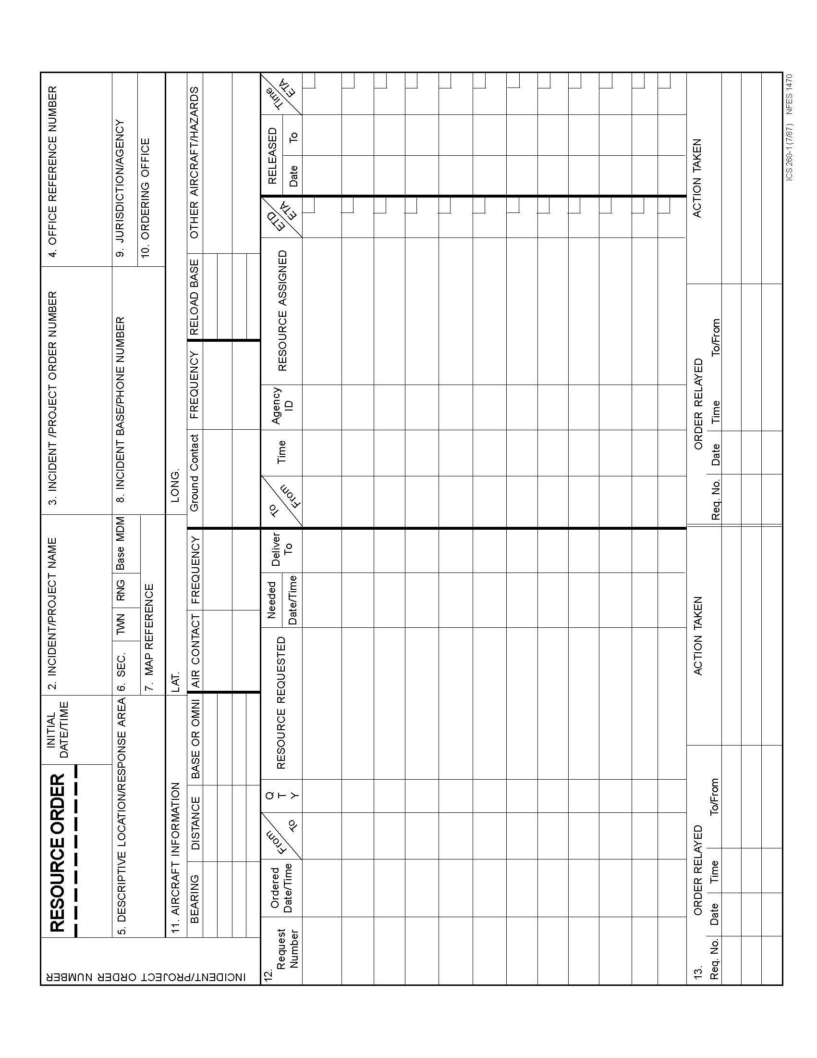

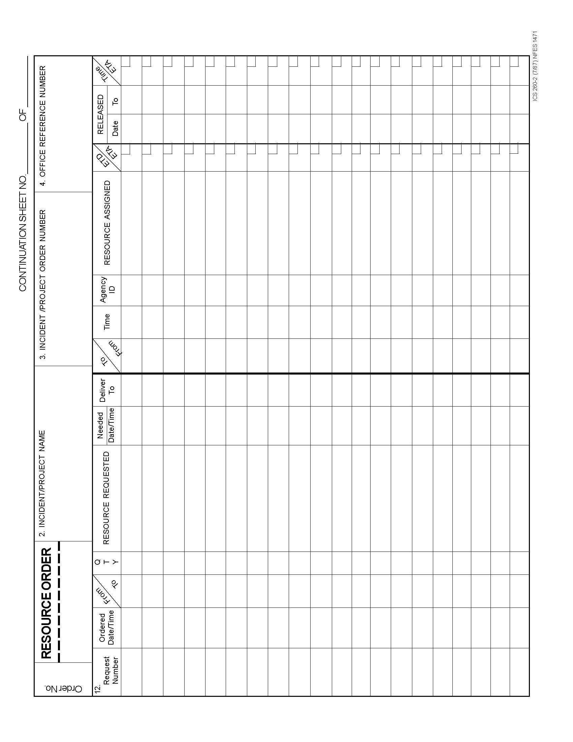

28.2 Food Service Request Form

FOOD SERVICE REQUEST FORM
Incident Name: Management/Fiscal Code:
Resource Order No. Request No. Date:
I. Requested Date, Time, Meal Types, and Number of Meals
1. Requested Date and Time for first meal, Date: Time:
2. Estimated numbers for the first three meals
1st meal: [ ] Hot Breakfast [ ] Sack Lunches [ ] Dinner
2nd meal: [ ] Hot Breakfast [ ] Sack Lunches [ ] Dinner
3rd meal: [ ] Hot Breakfast [ ] Sack Lunches [ ] Dinner
3. Fresh Food Boxes (Alaska Only):

This Block for NICC / AICC Use Only.
Actual agreed upon Date/Time first meals are to be served: Date: Time:
(Minimum guaranteed payment is based on these estimates, see Section G2.2):
1st meal: [ ] Hot Breakfast [ ] Sack Lunches [ ] Dinner
2nd meal: [ ] Hot Breakfast [ ] Sack Lunches [ ] Dinner
3rd meal: [ ] Hot Breakfast [ ] Sack Lunches [ ] Dinner
II. Location
Reporting location:
Incident Contact person:
Contracting Officer's Technical Representative:
Food Unit Leader:
III. Support Information for Contractors
Nearest authorized potable water source:
The benefiting unit is responsible for providing the following services:
1. Gray water removal 3. Department of Health notified (optional)
2. Potable water
Incidents requesting additional potable water tenders, gray water tenders, handwash stations, or refrigerated units must assign new request No. for each additional resource ordered.
IV. Estimated Incident Duration and Needs
1. Anticipated Duration of Incident:
2. Anticipated Peak Number of Personnel at Incident:
3. Spike Camps? [ ] Yes [ ] No, Number: , No. of meals per camp per day:
V. For Additional Information
Contact: Telephone:
GACC: Telephone: _______

National Interagency Coordination Center – (208) 387-5400

THIS PAGE INTENTIONALLY LEFT BLANK

28.3 Passenger and Cargo Manifest Form

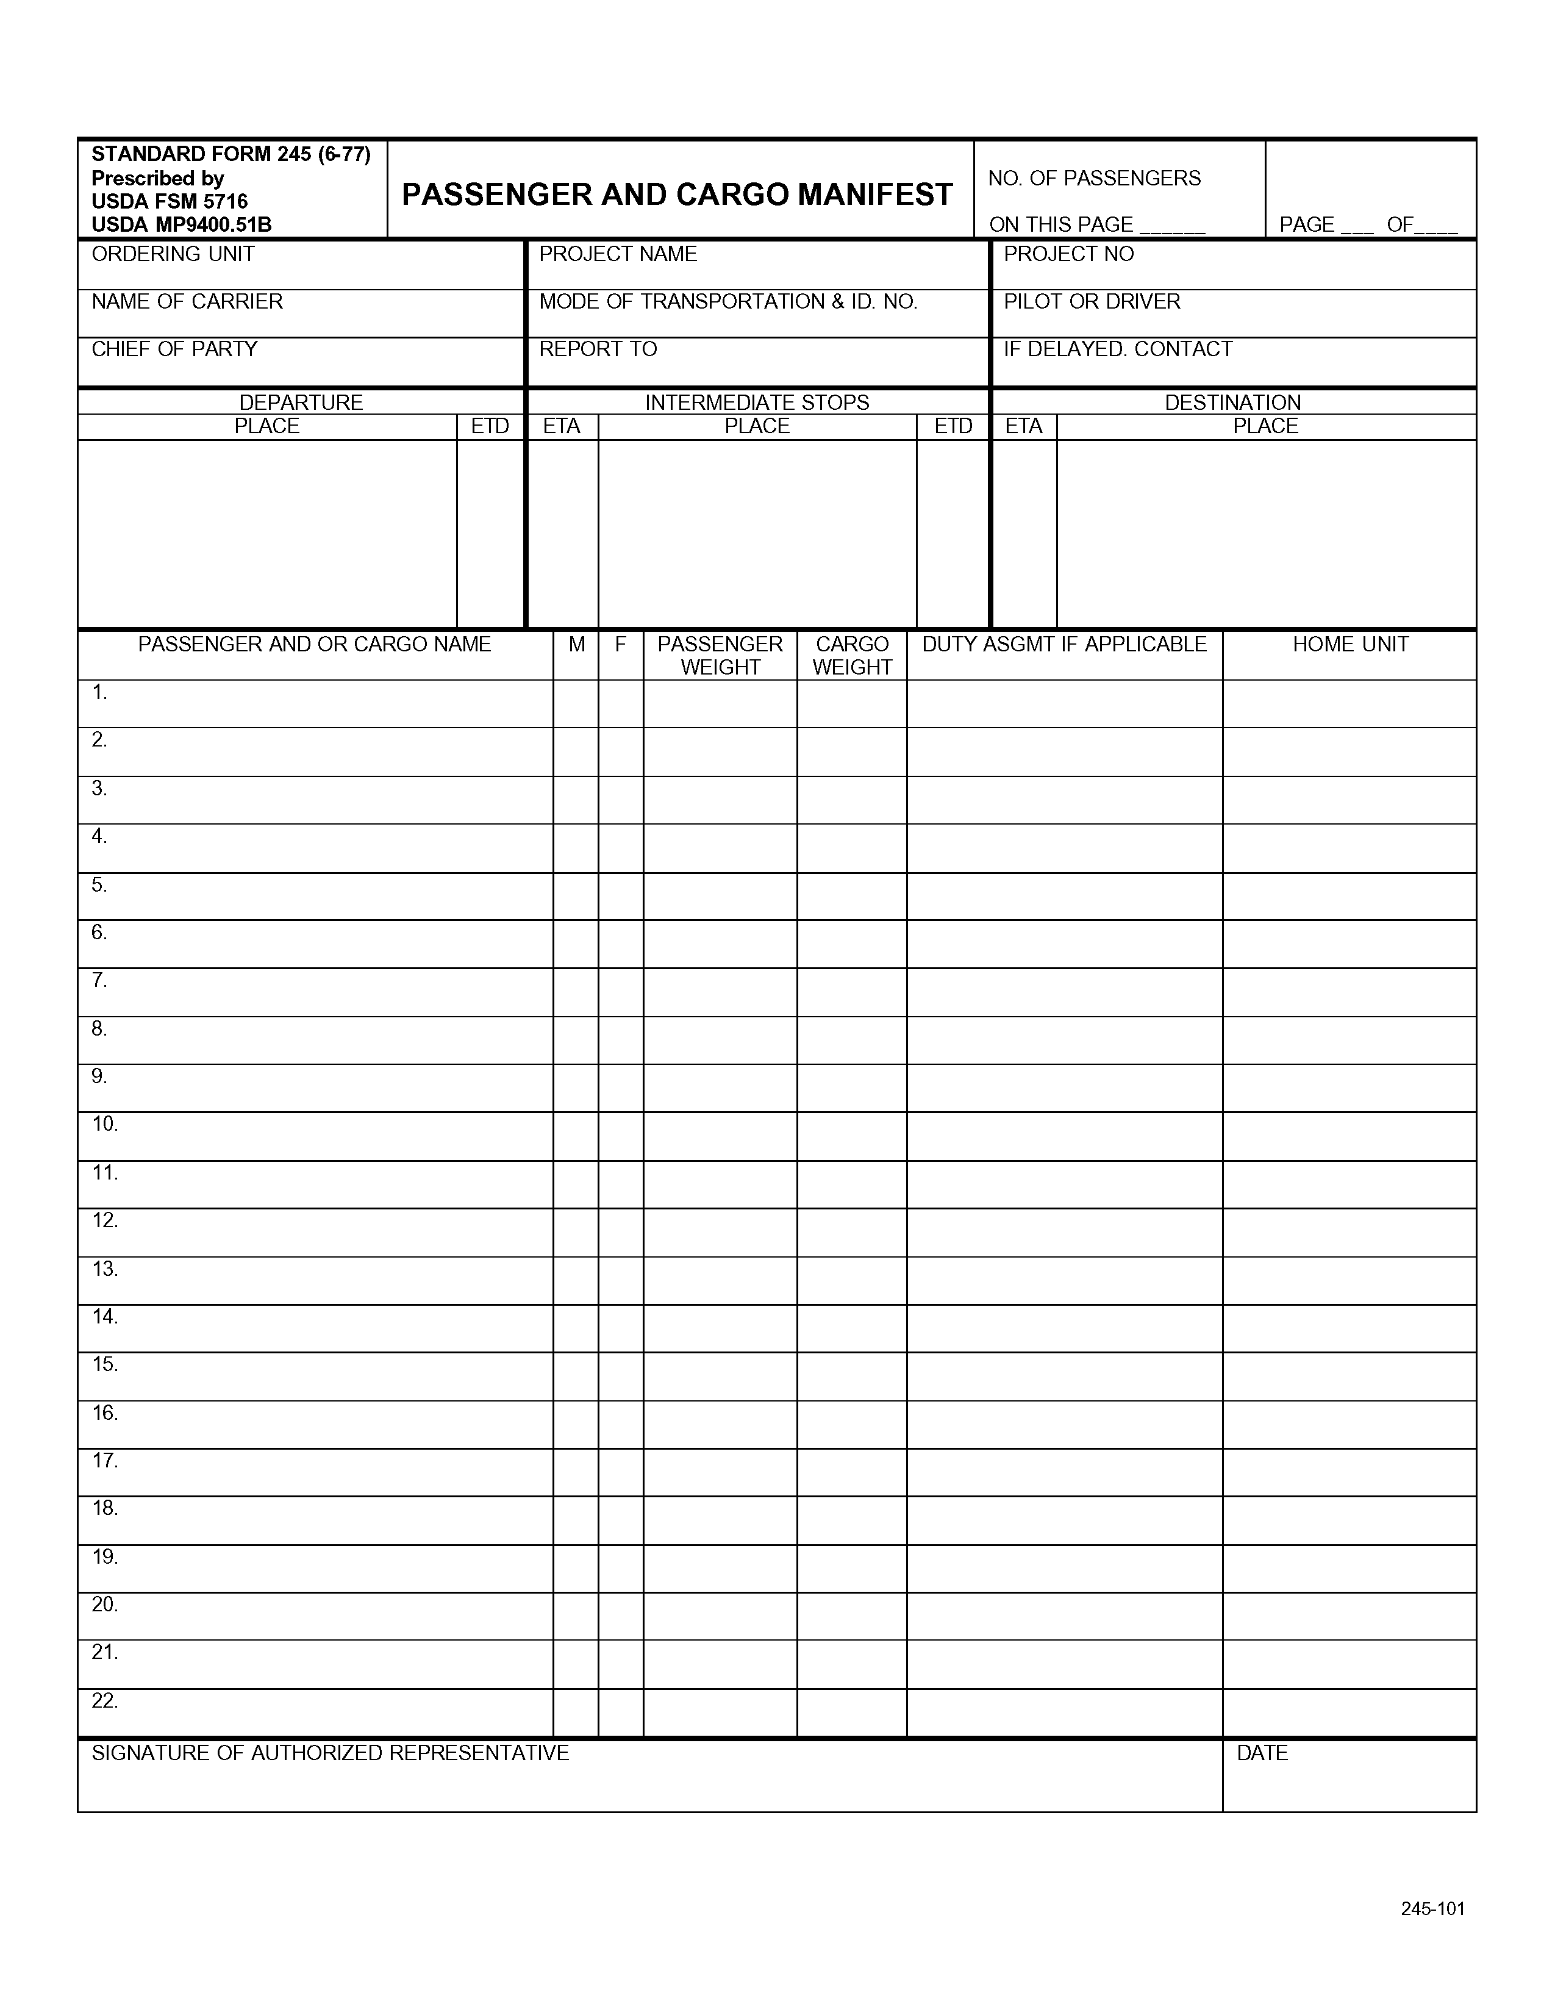

THIS PAGE INTENTIONALLY LEFT BLANK

28.4 Aircraft Flight Request/Schedule Form

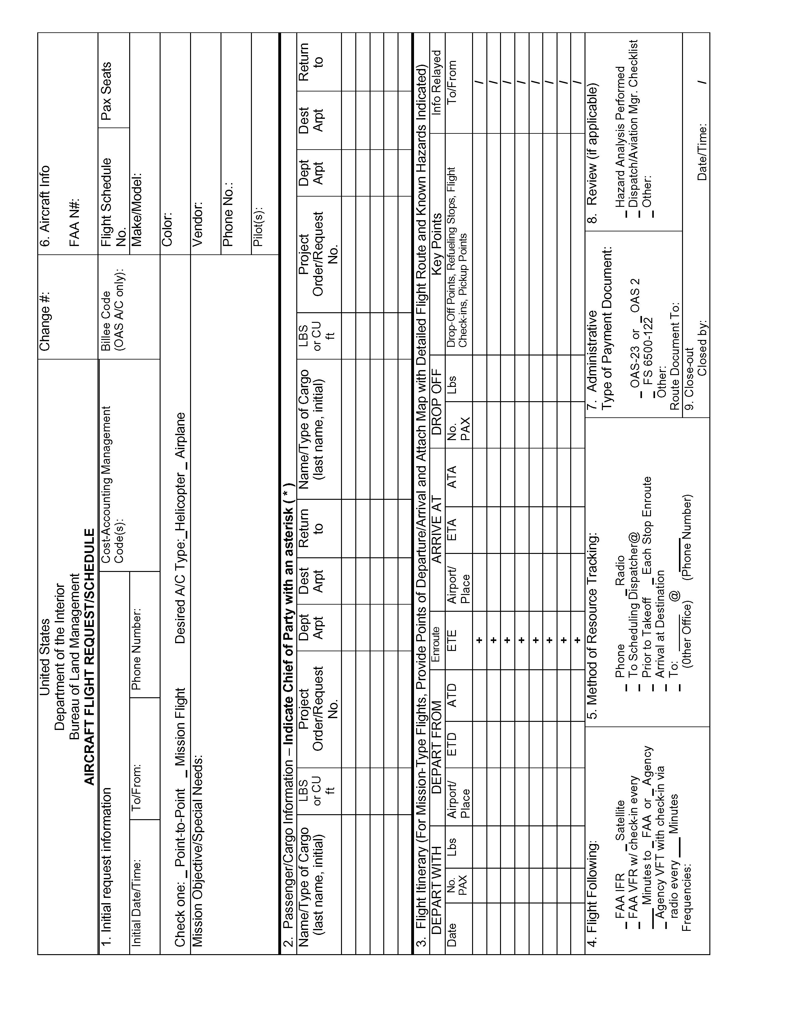

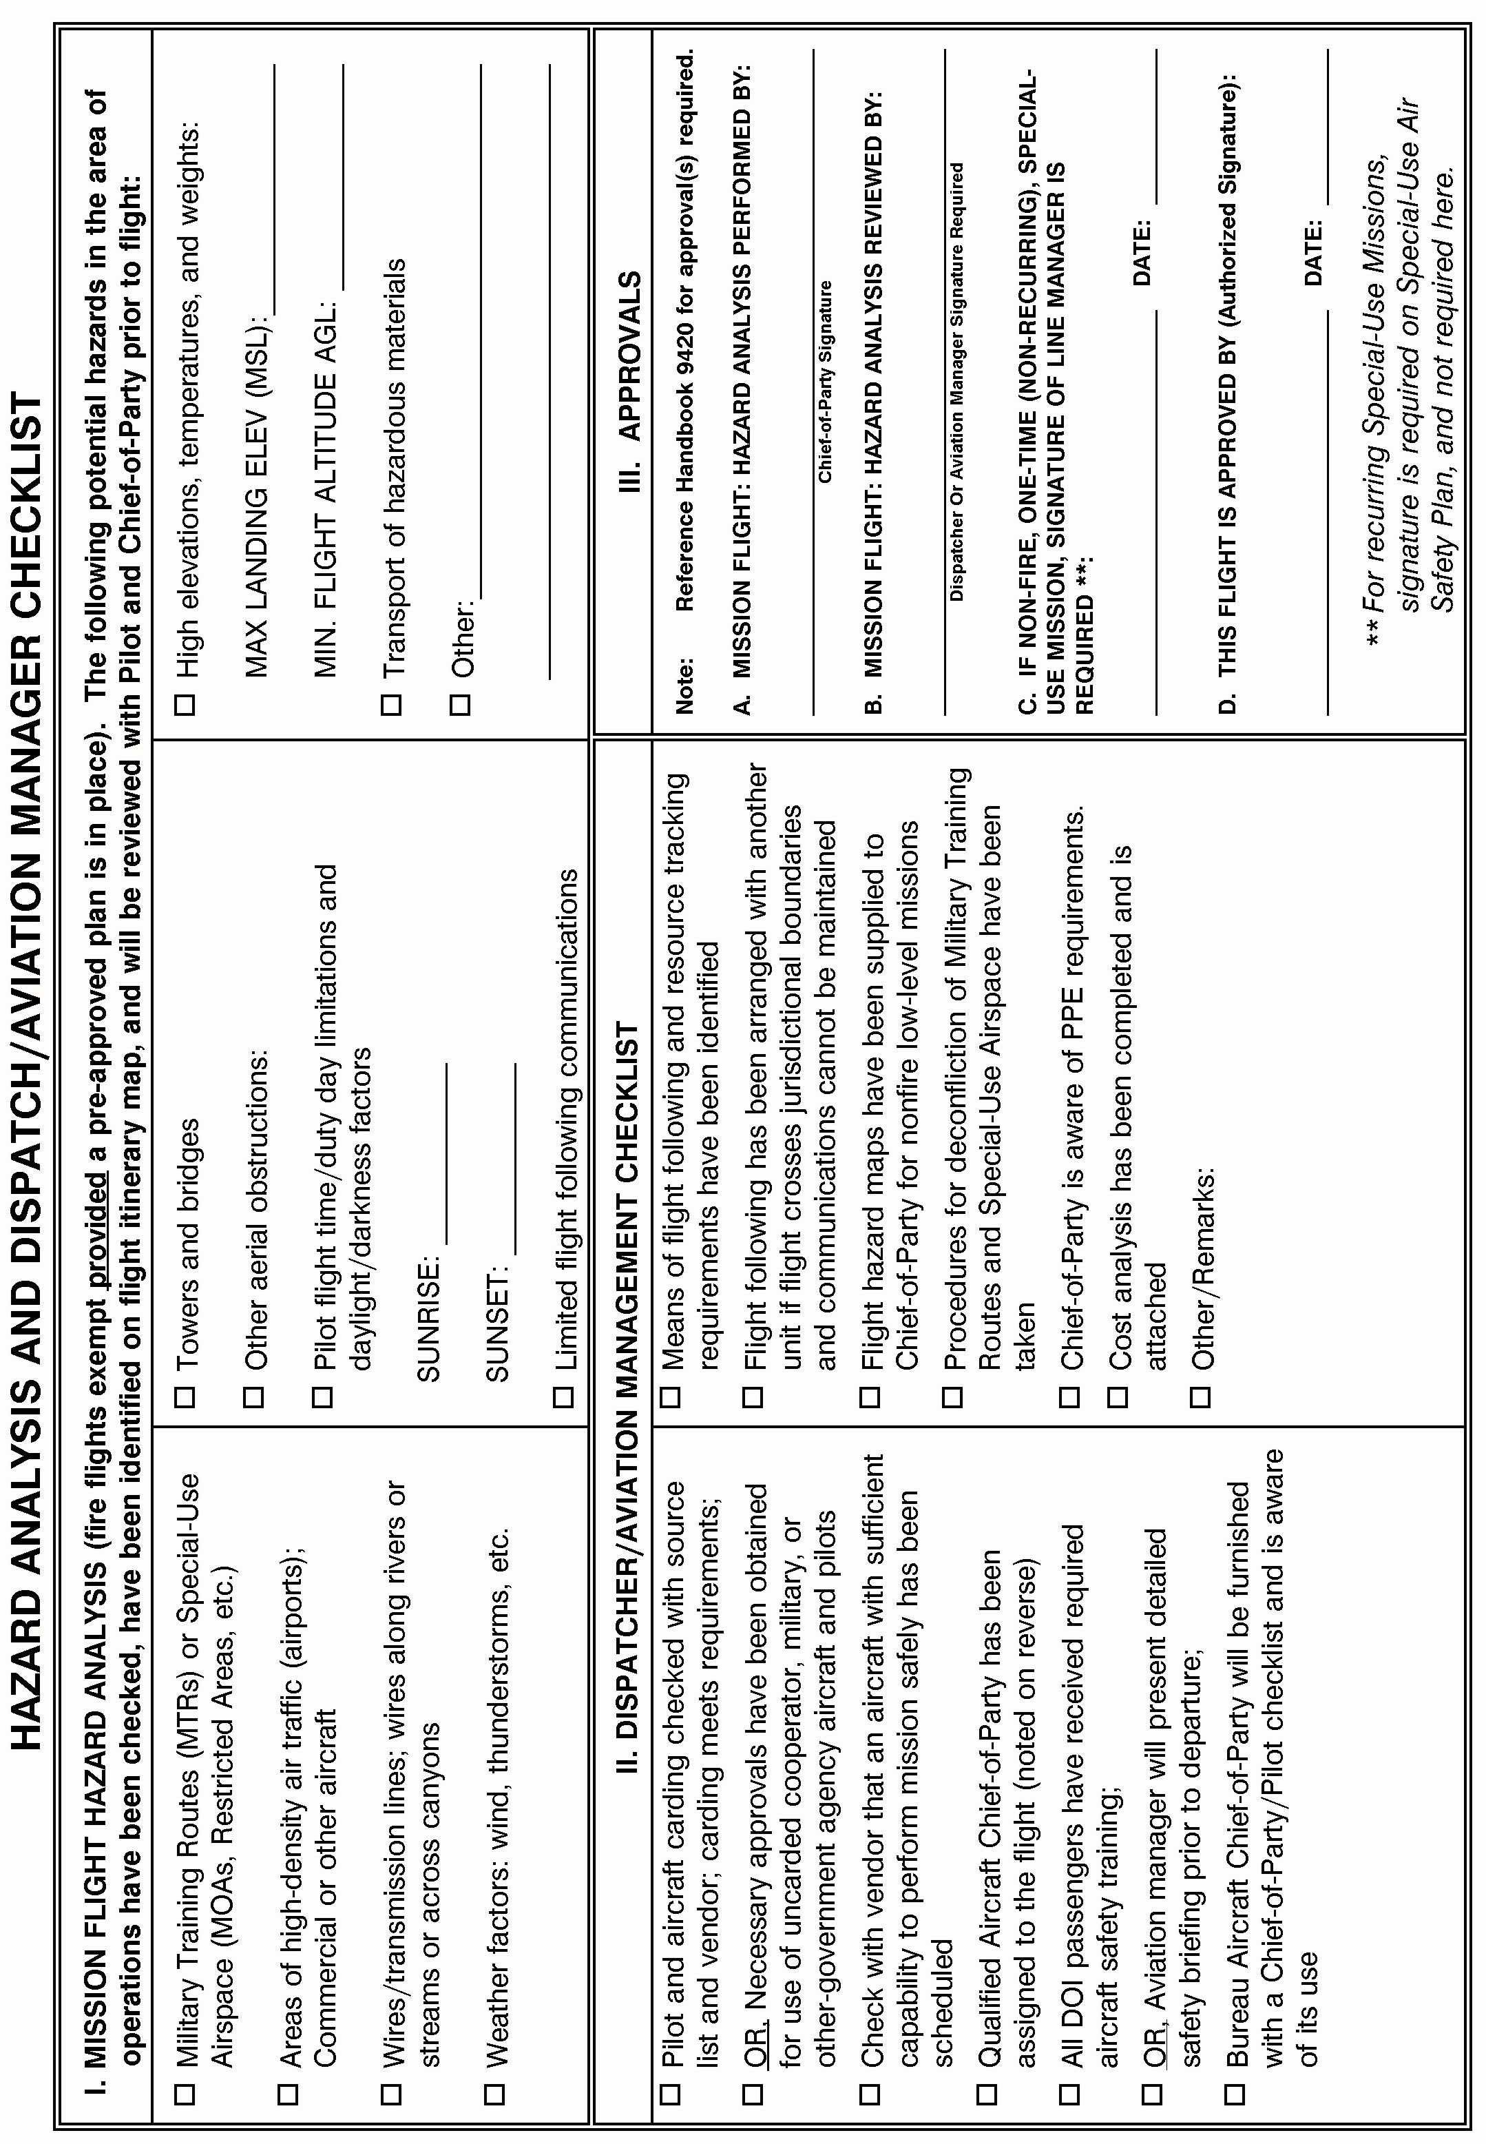

28.5 Infrared Aircraft Scanner Request Form

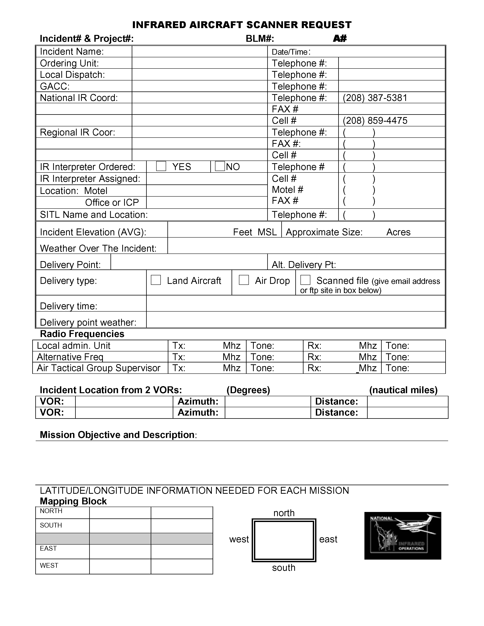

THIS PAGE INTENTIONALLY LEFT BLANK

28.6 FAA Temporary Tower Request Form

TEMPORARY TOWER REQUEST FORM

(Note - this form should be used in conjunction with the checklists located in Chapter 11 of the Interagency Airspace Coordination Guide (www.fs.fed.us/r6/fire/aviation/airspace)
Please attach this form to the Resource Order and forward both forms to the appropriate FAA Regional Operations Center (ROC), through established ordering channels.

I. GENERAL INFORMATION:
Incident Name ________________________ Management/Fiscal Code ____________________
Resource Order Number ________________ Request Number ________ Date_________________

II. POINTS OF CONTACT
Name/Agency Telephone
Ordering Unit __________________________________ ________________________
Air Ops/Air Support _____________________________ ________________________
Local or Expanded Dispatch _______________________ ________________________
Geographic Area Coordination Ctr__________________ ________________________
National Interagency Coordination Ctr_______________ ________________________
FAA POC at ROC ____________________________ ________________________
Name / Phone Number of Airport Owner / Operator ___________________________________
Has the Airport Owner been notified? YES NO
Requested Operational Hours: ____________________________
Estimated Length of Duration: ____________________________

III. SUPPORT INFORMATION
Closest City/Town ____________________________________ State ___________________

Where is the proposed location of the temporary tower (Select one or explain):
Airport Name & FAA Code__________________________ Helibase_______________
Incident Command Post ___________________________ Other__________________
Is a facility available on site for use as a tower (Select one or explain)?
FBO Site/Room rental/etc__________________ Rental Trailer ____________________
Facility to be built on site___________________ Other __________________________
Conditions to expect for overnight at site: Camp ________________ Hotel _________________

Is a vehicle (Gov’t or rental) available for tower personnel? YES NO
Please attach detailed driving directions to the reporting site
Note: Road closures, hazardous conditions, easiest route of travel, etc

IV. EQUIPMENT SURVEY - Refer to Chapter 11 checklist / Interagency Airspace Coordination Guide
What equipment do you currently have (radios, etc) for use by tower personnel?
_____________________________________________________________________________
_____________________________________________________________________________

What equipment do you need? (radios, etc)
__________________________________________________________________________________________________________________________________________________________

Have you completed an inventory of equipment?
_____________________________________________________________________________

THIS PAGE INTENTIONALLY LEFT BLANK

28.7 Preparedness/Detail Request Form

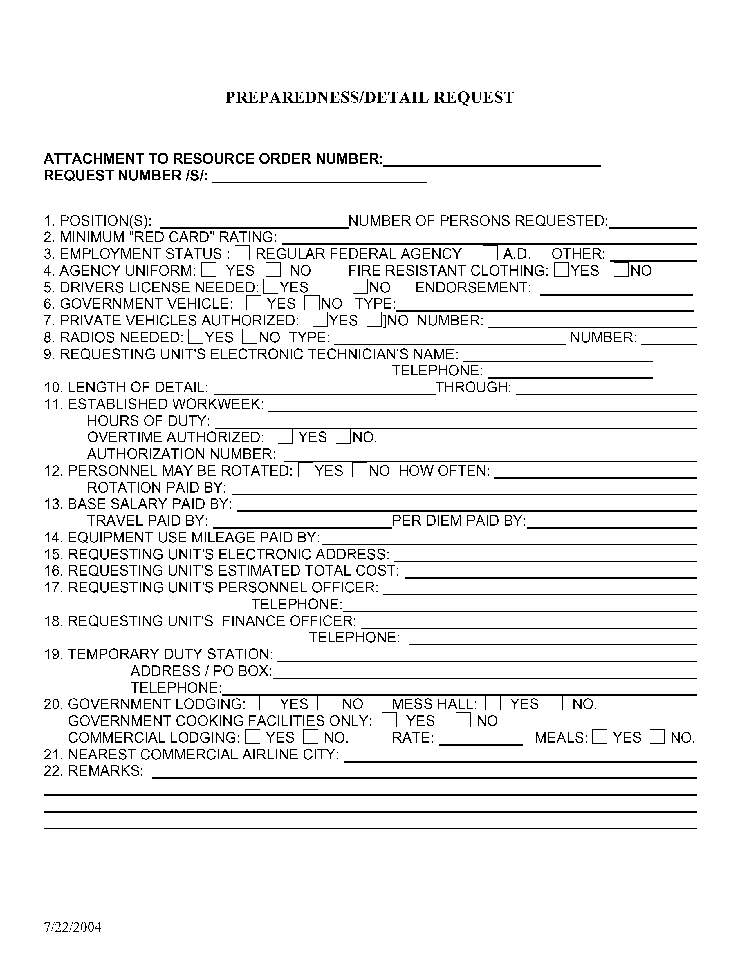

THIS PAGE INTENTIONALLY LEFT BLANK

28.8 Incident Status Summary (ICS-209) Form

Incident Status Summary (ICS-209)

1: Date | 2: Time | 3: Initial | Update | Final  | | | 4: Incident Number | 5: Incident Name

6: Incident Kind | 7: Start Date Time | 8: Cause | 9: Incident Commander | 10: IMT Type | 11: State-Unit

12: County | 13: Latitude and Longitude  Lat:  Long:  Ownership: | 14: Short Location Description (in reference to nearest town):

Current Situation

15: Size/Area  Involved | 16: % Contained or  MMA | 17: Expected Containment  Date:  Time: | 18: Line to Build | 19: Costs  to Date | 20: Declared Controlled  Date:  Time:

21: Injuries this  Reporting Period: | 22: Injuries  to Date: | 23: Fatalities | 24: Structure Information
 |  |  | Type of Structure | # Threatened | # Damaged | # Destroyed
25: Threat to Human Life/Safety:  Evacuation(s) in progress ----  No evacuation(s) imminent --  Potential future threat --------  No likely threat --------------- |  |  | Residence
 |  |  | Commercial Property
 |  |  | Outbuilding/Other

26: Communities/Critical Infrastructure Threatened (in 12, 24, 48 and 72 hour time frames):
12 hours:
24 hours:
48 hours:
72 hours:

27: Critical Resource Needs (kind & amount, in priority order):
1.
2.
3.

28: Major problems and concerns (control problems, social/political/economic concerns or impacts, etc.) Relate critical resources needs identified above to the Incident Action Plan.

29: Resources threatened (kind(s) and value/significance):

30: Current Weather Conditions  Wind Speed: mph Temperature:  Wind Direction: Relative Humidity: | 31: Resource benefits/objectives (for prescribed/wildland fire use only):

32: Fuels/Materials Involved: A drop down box with the 13 Fire Behavior Fuel Models has been added. The incident would select the predominant fuel model with the option to include additional fuels information in the text box.

33: Today's observed fire behavior (leave blank for non-fire events):

34: Significant events today (closures, evacuations, significant progress made, etc.):

Outlook

35: Estimated Control  Date and Time: | 36: Projected Final Size: | 37: Estimated Final Cost: | 38: Tomorrow's Forecasted Weather  Wind Speed: mph Temperature:  Wind Direction: Relative Humidity:

39: Actions planned for next operational period:

40: Projected incident movement/spread during next operational period:

41: For fire incidents, describe resistance to control in terms of:
1. Growth Potential -
2. Difficulty of Terrain -

42: How likely is it that containment/control targets will be met, given the current resources and suppression/control strategy?

43: Projected demobilization start date:

44: Remarks:

45: Committed Resources

Agency | CRW1 |  | CRW2 |  | HEL1 | HEL2 | HEL3 | ENGS |  | DOZR |  | WTDR | OVHD | Camp  Crews | Total  Personnel
Agency | SR | ST | SR | ST | SR | SR | SR | SR | ST | SR | ST | SR | SR | Camp  Crews | Total  Personnel
Total

46: Cooperating and Assisting Agencies Not Listed Above:

Approval Information

47: Prepared by: | 48: Approved by: | 49: Sent to: By:  Date: Time:

THIS PAGE INTENTIONALLY LEFT BLANK

28.9 Monthly Wildland Fire Weather/Fire Danger Outlook Form

MONTHLY WILDLAND FIRE WEATHER/FIRE DANGER OUTLOOK

1. Reporting Unit: _______________________________________________________

2. Date: ____________________________

3. Potential for Serious/Critical Fire Problems:

This Coming Month | Below Normal |  | Normal |  | Above Normal
This Season | Below Normal |  | Normal |  | Above Normal

Comments: ___________________________________________________________________

4. Fire Weather Outlook: (Addresses the following factors)

Drought Conditions: ________________________________________________________
Precipitation Anomalies and Outlook: _________________________________________
Temperature Anomalies and Outlook: _________________________________________

5. Fuels:

Fine – Grass Stage | Green |  | Cured
New Growth | Sparse |  | Normal |  | Above Normal

Live Fuel Moisture (sage, deciduous, conifer): ___________________________________
1000 Hour Dead Fuel Moisture: _______________________________________________
Normal/Average Fuel Moisture for this Time of Year: ____________________________

6. Average Fire Occurrence/Acres Burned (to date, 5 year average): ______________________________________________________________________________

7. Actual Occurrence/Acres Burned (to date, this year): ______________________________

8 Written Summary (The text from this summary will be used in the National Wildland Fire Outlook). (Attach to this form.)

9. Fire Outlook Map (Attach to this form.)

A Geographic Area outline map showing Areas of below normal, normal, and above normal fire potential shall be submitted, along with the Monthly Fire Weather/Fire Danger Outlook Report. The map template can be found at:
http://www.nifc.gov/news/intell_predserv_forms/national_map.html

THIS PAGE INTENTIONALLY LEFT BLANK

  - Wildland Fire Entrapment/Fatality Initial Report Form

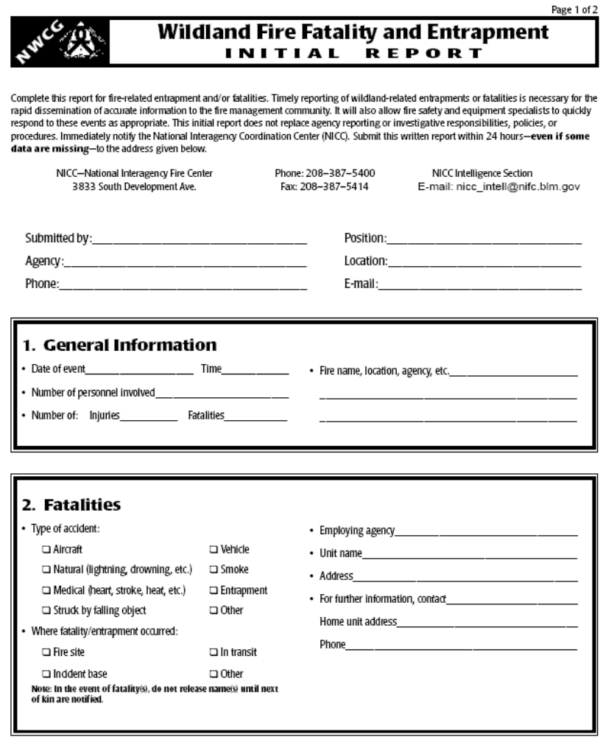

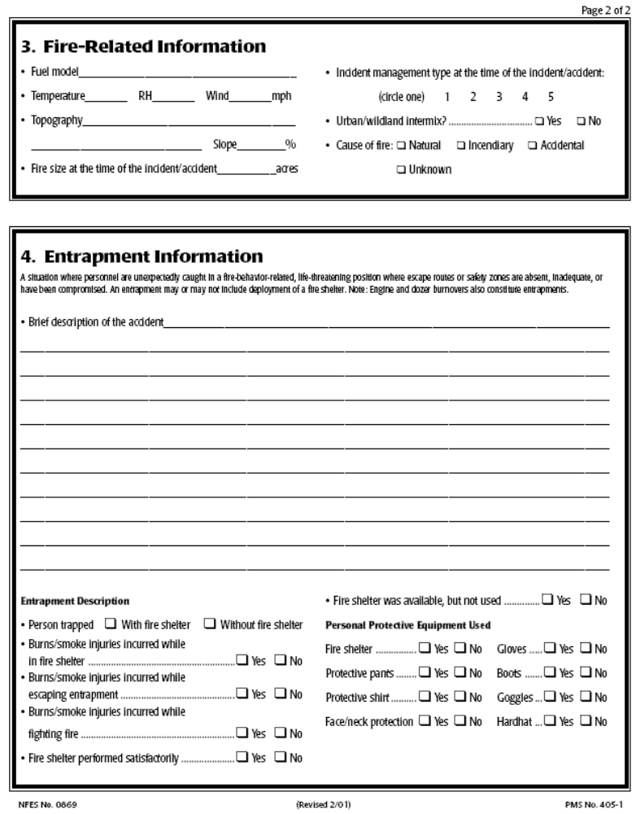

28.11 Documentation of Length of Assignment Extension Requirements Form

DOCUMENTATION OF LENGTH OF
ASSIGNMENT EXTENSION REQUIREMENTS

Documentation of any type of assignment extension should include the following:

I. Resource Name: __________________________________________

Position/Type of Resource: __________________________________

- Length of Extension: _______________________________________

- Rationale for Extension (Circle all that apply):

Life and property threatened.
Suppression objective(s) are close to being met.
Replacement Resources are not available (Unable to Fill)
Other: ________________________________________
______________________________________________

- Recommendation

Incident Supervisor (of resource to be extended), Title, and Signature

____________________________________________________________

- Approval Signatures / Date

Resource (to be extended): ______________________________________
Incident/Area Commander: _____________________________________
Hosting GACC: ______________________________________________
Home Unit Supervisor: ________________________________________
Sending GACC: _____________________________________________
NICC (if National Resource):____________________________________

THIS PAGE INTENTIONALLY LEFT BLANK

