POLICY DIRECTIVE 01 - 186

TO: ALL JUSTICES OF THE PEACE
ALL CIVIL COURT MANAGERS

FROM: PATRICIA W. GRIFFIN
CHIEF MAGISTRATE

RE: INTERPLEADERS

DATE: FEBRUARY 14, 2001

________________________________________________________________________

ISSUE

Red Riding Hood Realtors holds a deposit in escrow which has been paid by a Mr. Wolf, who was planning to purchase the home of Mrs. F. Tale. At the pre-settlement inspection, water was found in the basement. Mr. Wolf has refused to go ahead with the purchase and claims that he should receive his deposit back from Red Riding Hood. The would-be seller, Mrs. F. Tale, disputes Mr. Wolf’s claim to the deposit, arguing that any problem with water in the basement has been corrected. Mrs. Tale claims that the deposit belongs to her and is demanding it from Red Riding Hood. May Red Riding Hood Realty initiate a suit in the Justice of the Peace Court to determine to whom it should pay the money?

SHORT ANSWER

Yes. Such a suit would bring in Mr. Wolf and Mrs. Tale as defendants by way of interpleader. This is permitted under Justice of the Peace Court Civil Rule 22. Cases involving interpleaders which are within the Justice of the Peace Court’s jurisdiction should be accepted.

DISCUSSION

1. What is interpleader?

Interpleader is a procedure, provided for in Justice of the Peace Court Rule 22, by which a person or entity holding money or property which is claimed by two or more other parties may seek to avoid liability by joining the other parties and letting the court determine ownership of the money or property. (The person or entity holding the money or property makes no claim to ownership.) Examples of such situations would include a bank holding money in trust, an insurance company holding payment of a claim, or as in the example above, a real estate firm holding a deposit in escrow.

Woolley states regarding interpleader:

Where two or more persons, whose titles are connected by reason of one thing derived from a common source, claim the same thing, debt or duty, by different or separate interests, from a third person, he not knowing to which of the claimants he ought of right to render the debt or duty, or to deliver the thing, and fearing he may be hurt by some of them, may maintain against them the remedy of interpleader. The object of this remedy is that the conflicting claimants may litigate the matter among themselves, without involving the stake-holder in their controversy with which he has no concern.

Woolley on Delaware Practice § 424.

While Red Riding Hood’s case involves the use of interpleader in the initiation of the suit, Rule 22 also provides for interpleader to be used by a defendant. For example, if Mr. Wolf sued Red Riding Hood for the return of his deposit, Red Riding Hood could interplead Mrs. Tale so that the court could determine to whom Red Riding Hood should pay the deposit.

2. Does the Justice of the Peace Court have jurisdiction over interpleaders?

The Justice of the Peace Court has authority to handle interpleaders under Civil Rule 22. However, interpleader is a procedural device not a substantive claim. Thus, the question of whether the Court has jurisdiction depends upon whether it has jurisdiction over the underlying action. In the Red Riding Hood case, the Court would have jurisdiction over the case as a debt action, similar to the bringing of a debt action for the return of a rental security deposit. Red Riding Hood may use the procedural device of interpleader to bring the two persons claiming the deposit into court.

3. I thought Justice of the Peace Court Civil Rule 22 only permitted a defendant to bring another defendant into court. Does Rule 22 really permit the person holding the money (or other property) to bring the two claimants into court as defendants?

Yes. Rule 22 clearly makes provision for the holder of the deposit (or other money or property) to join claimants to the deposit as defendants. Rule 22 states:

Persons having claims against the plaintiff may be joined as defendants and required to interplead when their claims are such that the plaintiff is or may be exposed to double or multiple liability. It is not ground for objection to the joinder that the claims of the several claimants or the titles on which their claims depend do not have a common origin or are not identical but are adverse to and independent of one another, or that the plaintiff avers that the plaintiff is not liable in whole or in part to any or all of the claimants. A defendant exposed to similar liability may obtain such interpleader by way of cross-claim or counterclaims. The provisions of this rule supplement and do not in any way limit the joinder of parties permitted in Rule 20.

The underlined first sentence of Rule 22 states that the plaintiff may join persons having claims against him or her which would expose the plaintiff to double or multiple liability. In the Red Riding Hood case, if Red Riding Hood pays the deposit to Mr. Wolf, Red Riding Hood could be subject to liability for failing to pay it to Mrs. Tale. Thus, Red Riding Hood qualifies as one who may interplead the two claimants, Mr. Wolf, and Mrs. Tale, so that it can avoid double liability.

This is further explained in the discussion of Rule 22 of the Federal Rules of Civil Procedure in Moore’s Federal Practice. (Justice of the Peace Court Civil Rule 22 mirrors Rule 22 of the Federal Rules. Thus, the discussion of Federal Rule 22 in Moore’s is directly applicable to Justice of the Peace Court Civil Rule 22.) Moore’s states:

Interpleader is a procedural device used to resolve conflicting claims to money or property. It enables a person or entity in possession of a tangible res or fund of money (“the stakeholder”) to join in a single suit two or more “claimants” asserting mutually exclusive claims to that stake. The stakeholder institutes interpleader, usually as an initial proceeding, by filing a complaint and joining the claimants. A stakeholder who has already been sued, however, can institute interpleader defensively, by filing a counterclaim or cross-claim to which it joins the additional claimants….a many-sided dispute can be resolved economically and expeditiously in a single proceeding and the stakeholder can be relieved from the obligation of determining who has the rightful claim to the money or property. In addition, the stakeholder avoids possible multiple liability resulting from inconsistent judgments for different claimants in different suits.

Moore’s Federal Practice § 22.02[1].

In this case, because Red Riding Hood wishes to initiate the action, Red Riding Hood would be the plaintiff and would join as defendants Mr. Wolf and Mrs. Tale, both of whom have claims against it for the deposit.

- How would a clerk process an interpleader action?

It would be entered as a specific type of debt action (“debti”) and the plaintiff interpleader would deposit the money in question with the court that will maintain that money in the court’s checking account under “IP Escrow” funds (see attached Fiscal Procedure for Interpleader Funds). When the Court determines which of the interpleader defendants should receive the money, the judgment type entered will be “AGREE” for that defendant. (Given the nature of an interpleader case, we do not want a judgment of any type to appear on any party’s credit report so this procedure should be followed.) The case should be rescheduled for 16 days (allowing full 15 days for appeal). When the 16 days have passed and the case appears on the court docket, the clerk will pull the case, give it to the judge on duty, and the judge will direct the court manager to disburse the appropriate funds, dismiss the case, and include notes on the docket concerning the nature of the action taken (for future reference). A detailed explanation (dated 2/15/01) in bottom left corner of document) of clerical procedures for handling interpleader actions is attached. This is a 31 page document (with “print shots” of processing screens) which clerks should print but judges would most likelyDel.C. § not use or need to print.

PWG/crm

cc: Hon. E. Norman Veasey
Hon. Joseph T. Walsh
Hon. Henry duPont Ridgely
Hon. Alex J. Smalls
Hon. Vincent J. Poppiti
Hon. Alicia Howard
Thomas W. Nagle
Anna A. Lewis
H. John Betts
Larry Sipple
All Justice of the Peace Courts
Law Libraries: New Castle County, Kent County, Sussex County,
Widener University School of Law

February 14, 2001

Interpleader Funds – Fiscal Procedure

- Add a column to your Civil Activity journal and to your checkbook journal entitled “IP Escrow” funds.

- When the IP Escrow funds are received, go to the case’s automated docket screen and record the date, amount, payer, and check no. Then record the same info. on the Cash Activity journal and provide the payer a receipt. When the deposit is made, post the IP funds amount under “IP Escrow” in your checkbook journal.

- When the disbursement is ordered, post the check particulars to the checkbook journal (as a subtraction) under the column entitled “IP Escrow”, recording the same disbursement information (date, check no. amount and recipient) to the automated docket screen.

- Prepare a list of IP Escrow funds on hand at the end of each month for accounting purposes (receipt date, case no., payer, and amount), as we do for appeal bonds.

Justice of the Peace Court
INTERPLEADERS
How to file and how to dispose of the case
________________________________________________________________________

In June 2000, the new Civil Rules introduced to the Justice of the Peace Court the concept of INTERPLEADERS

Rule 22. Interpleaders.

(a) Use. Persons having claims against the plaintiff may be joined as defendants and required to interplead when their claims are such that the plaintiff is or may be exposed to double or multiple liability. It is not ground for objection to the joinder that the claims of the several claimants or the titles on which their claims depend do not have a common origin or are not identical but are adverse to and independent of one another, or that the plaintiff avers that the plaintiff is not liable in whole or in part to any or all of the claimants. A defendant exposed to similar liability may obtain such interpleader by way of cross-claim or counterclaims. The provisions of this rule supplement and do not in any way limit the joinder of parties permitted in Rule 20.

- Remedy in Addition to Statute. The remedy herein provided is in addition to and in no way supersedes or limits the remedy provided by the statute but actions thereunder shall be conducted in accordance with these Rules.

An example of a case that would follow interpleading procedure is where a real estate company has a deposit, but the sale falls through. The real estate company then wishes to have the court determine to whom the escrow money is returned.
Interpleader Plaintiff: Real Estate Company
Interpleader Defendant 1: Seller
Interpleader Defendant 2: Prospective buyer and depositor

For Case Initiation (CS, CC)
The case type is DEBTI for Debt Interpleader
When entering the case the clerk marks the salutation field on both plaintiff and defendants and when the window appears, puts Interpleader plaintiff and Interpleader defendant. This would carry over to the docket and heading for forms

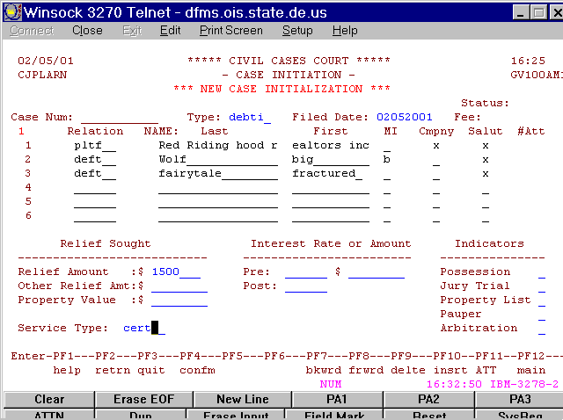

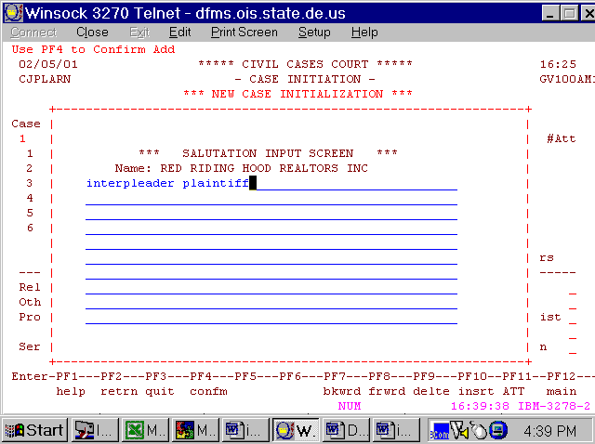

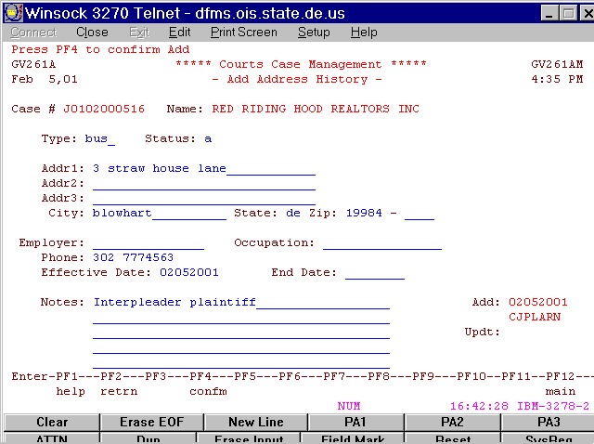

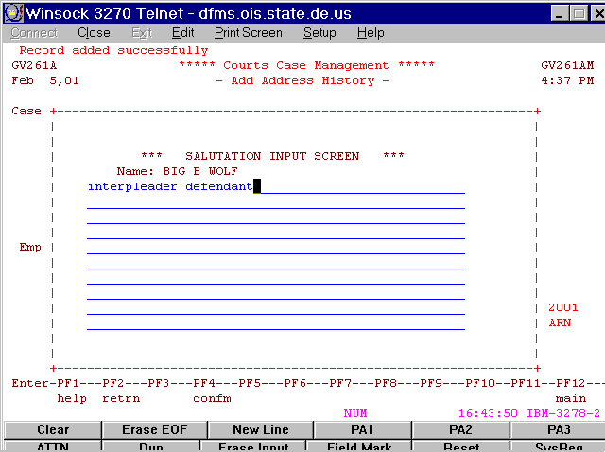

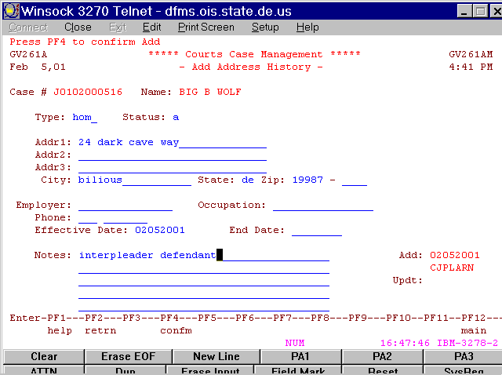

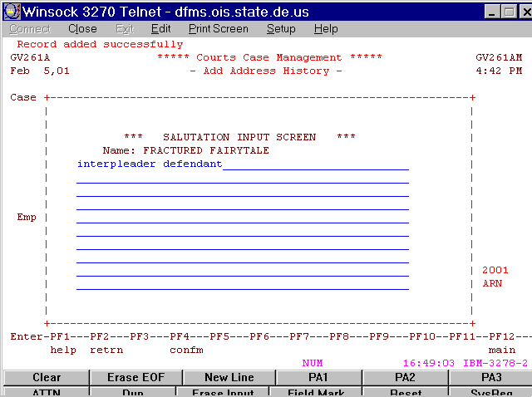

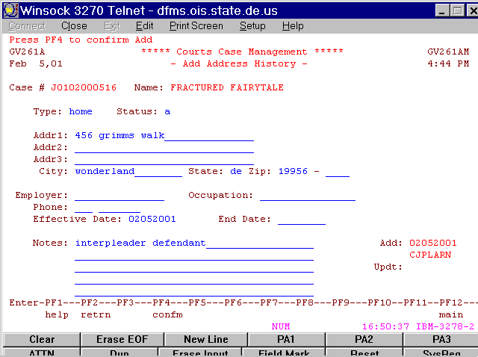

Docket entry with an explanation of the case.

Please put more than canned docket text on the case.

You must get the money from the Interpleader Plaintiff for the court to hold until the appeal time is over. Contact the Fiscal Administrative Officer for the correct account to deposit the money and any accompanying procedures.
You will want to note the check #, Amount on the docket

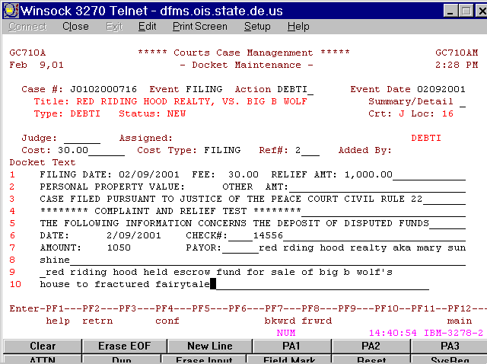

Schedule the trial
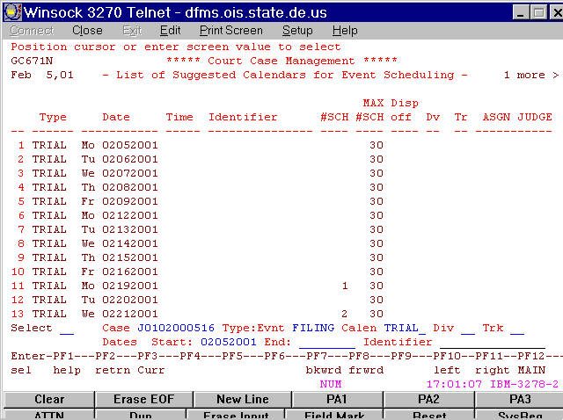

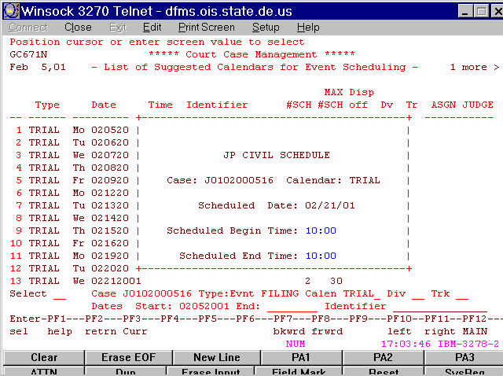

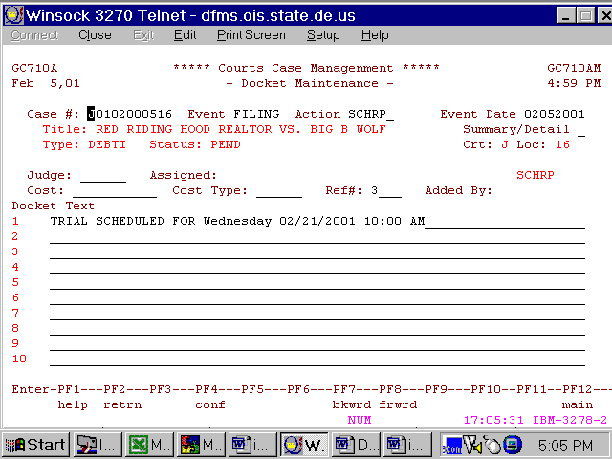

Notice screen
Select the plaintiffs and the defendants
Remember to select the correct printer
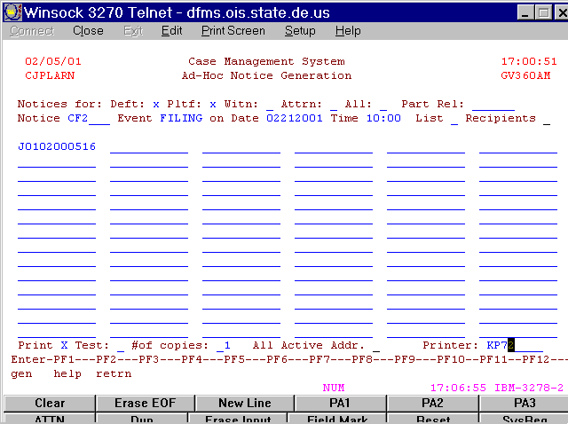

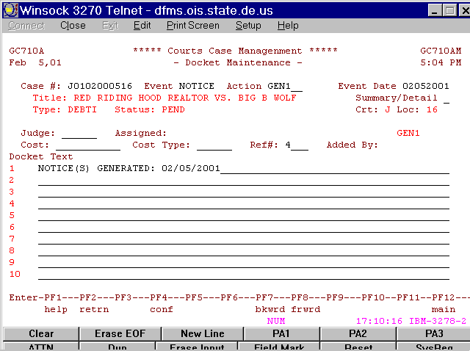

Key the Certified mail numbers
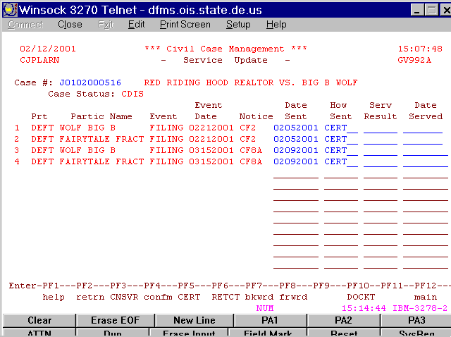

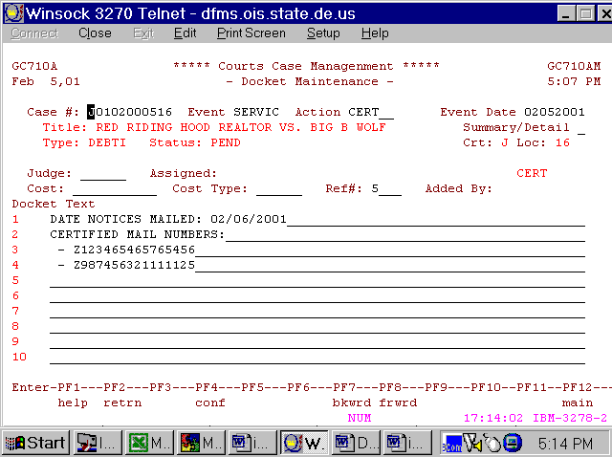

Return of service as usual- SRU1

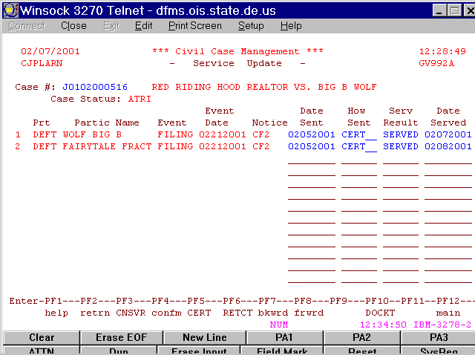

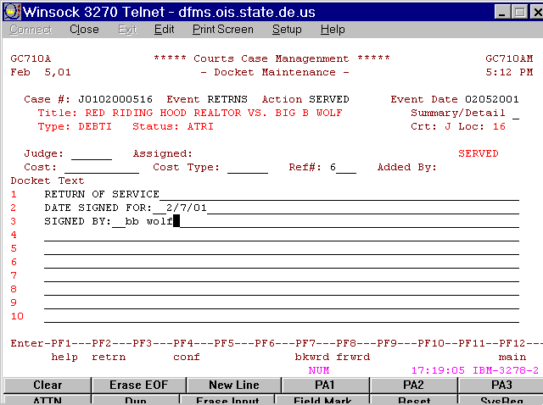

Enter second service

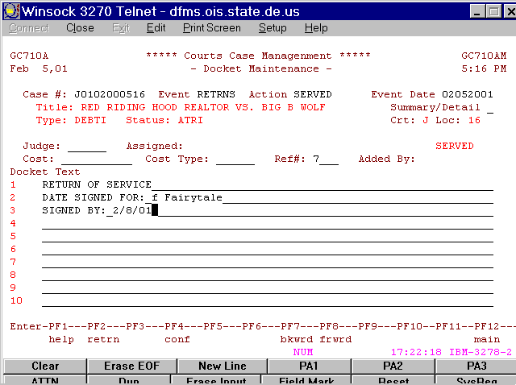

Enter Judgment after the trial

This will be entered as an agreement AGREE on the trial calendar CEDM

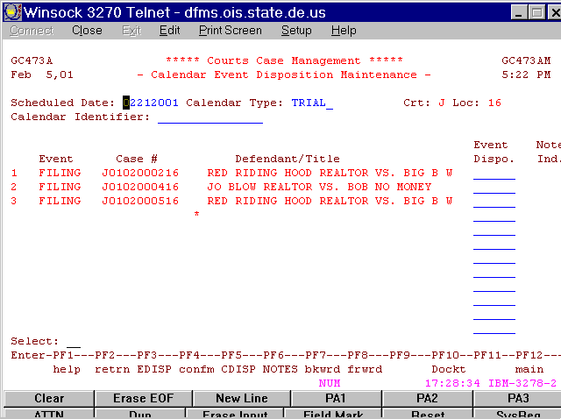

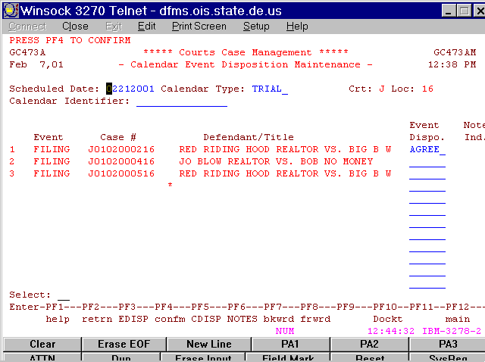

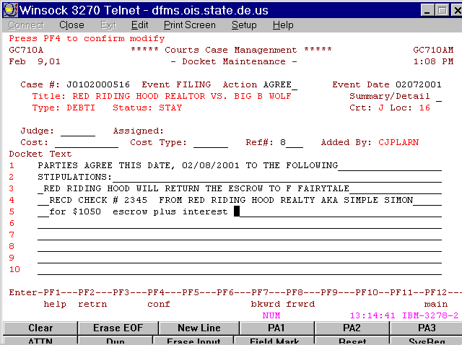

Now reschedule for 15 + 1 days
to allow time for appeal.

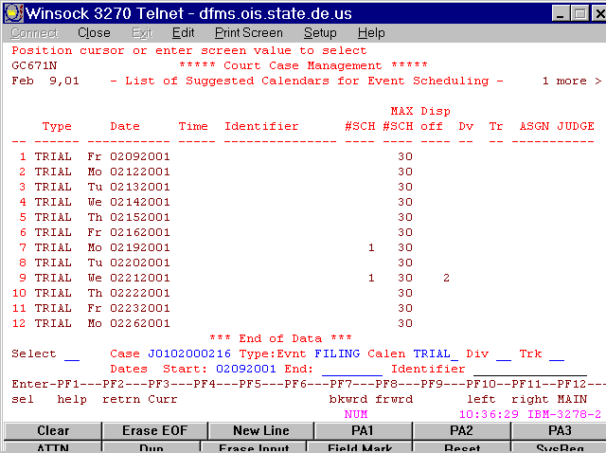

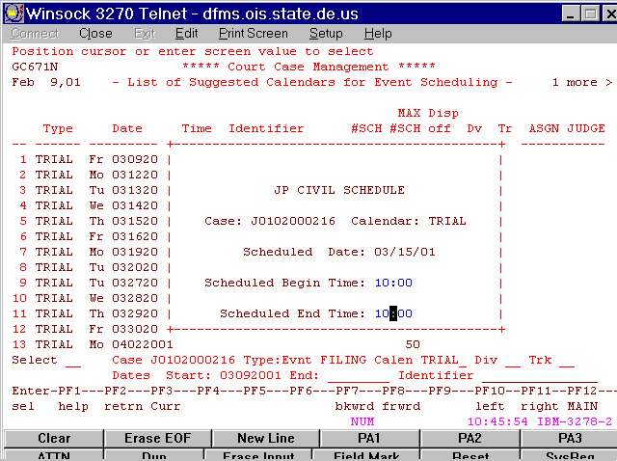

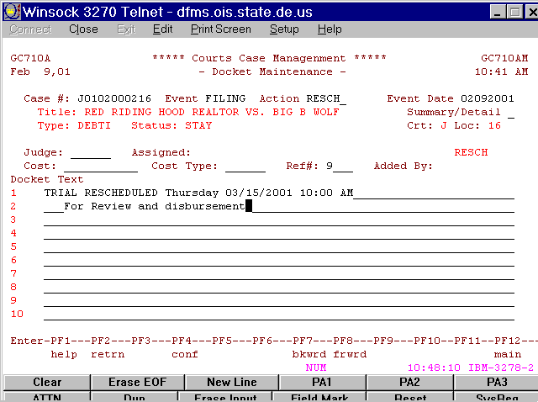

You will want to mark the docket
so you know why this case is coming up again

Notices of new trial date
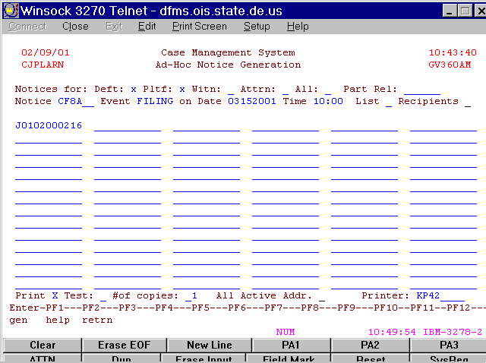

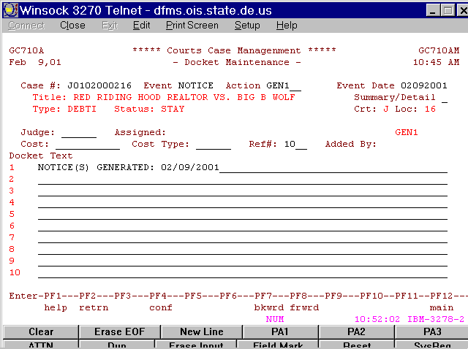

Remember to put the agreement on the other Interpleader Defendant

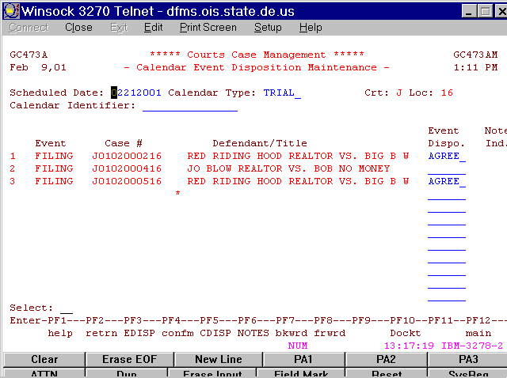

Reschedule

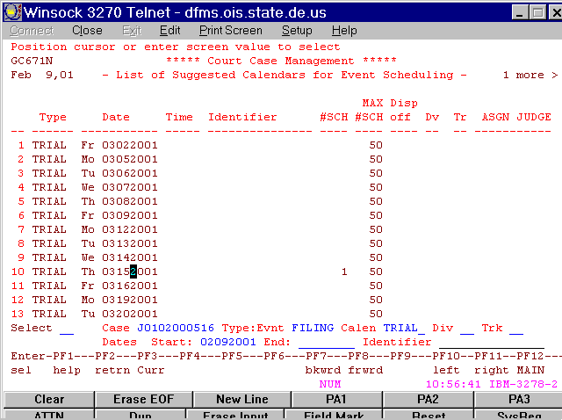

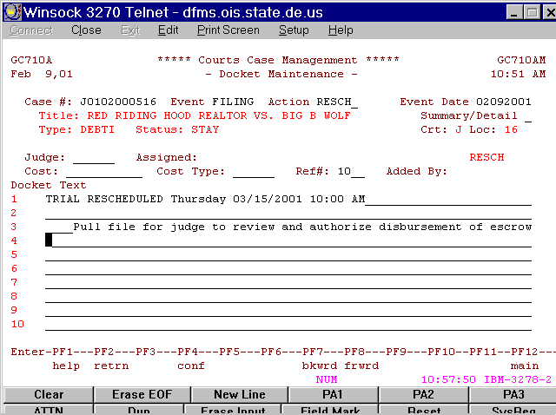

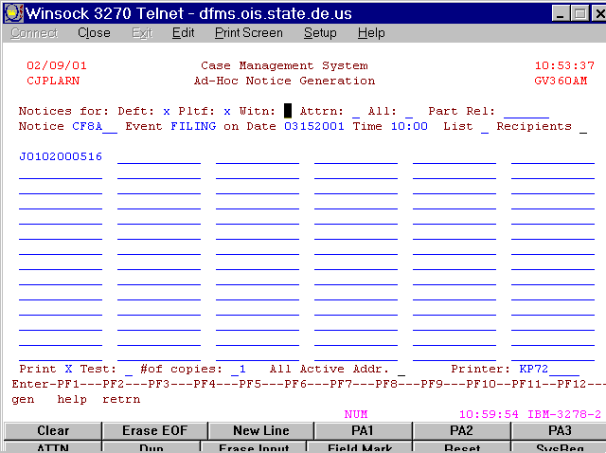

Type your agreement/judgment in Word™.

At the time of the new trial, if no appeal has been filed, the judge will direct the clerk to disburse funds to the appropriate party and satisfy the case. Remember to consult with the Fiscal Administrative Officer for the proper procedures for returning escrow money.

Use CEDM to enter the disposition that will be DISM

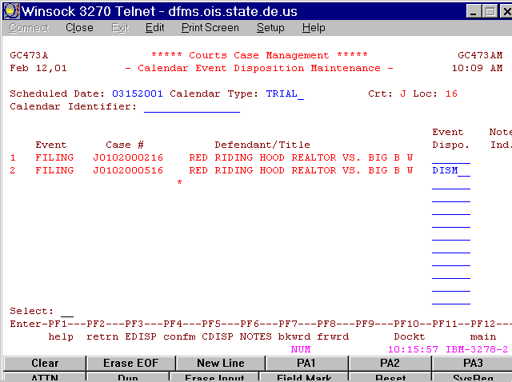

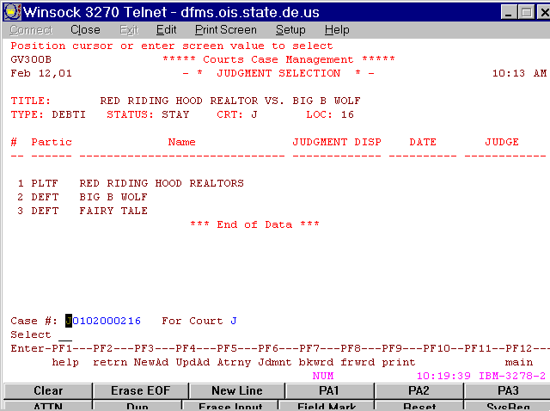

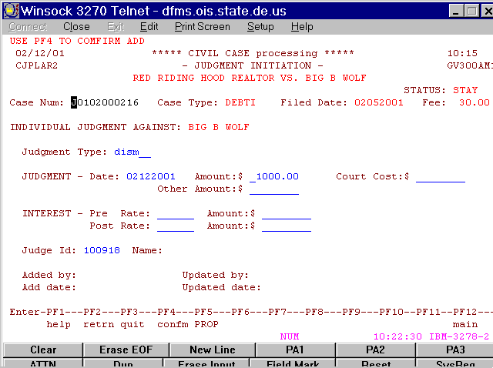

Enter the Judgment code DISM

Enter the Judge ID

DOCKET
Clearly explain
Check #
Amount
Recipient

Also state dismissed against and list both defendants

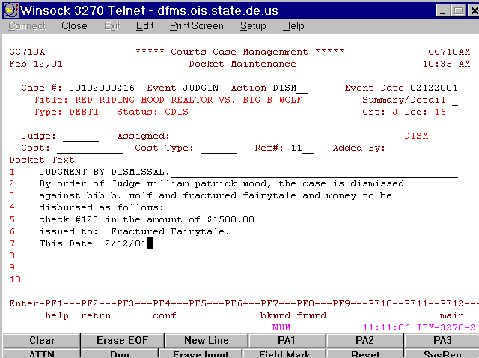
Judgment Notices after the 15-day appeal period
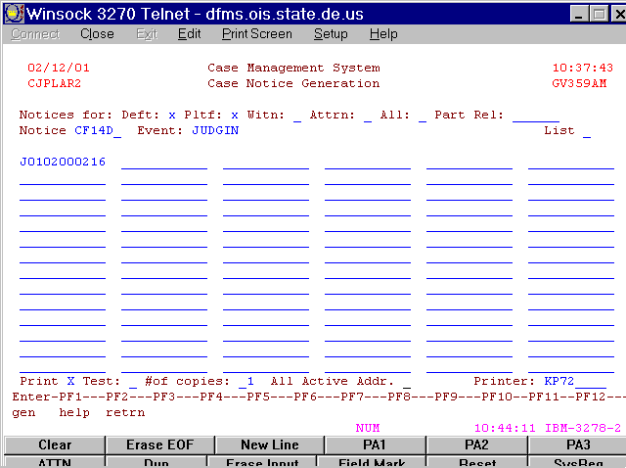

Fill in the window just as the docket reads
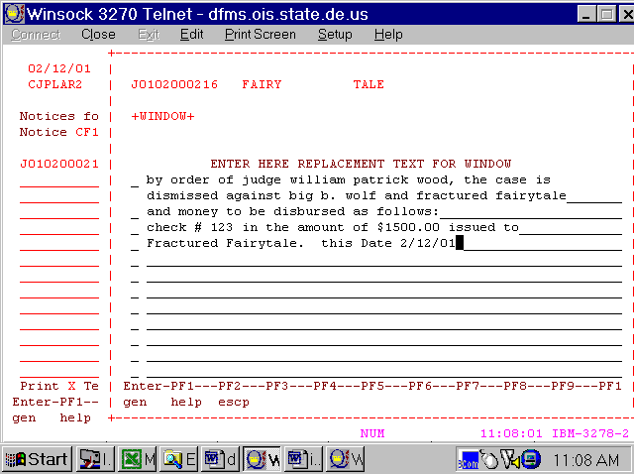

There will be a window for each participant

You may choose not to select plaintiff
which will save you a window

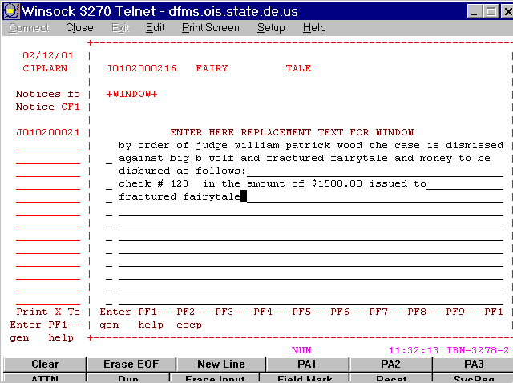
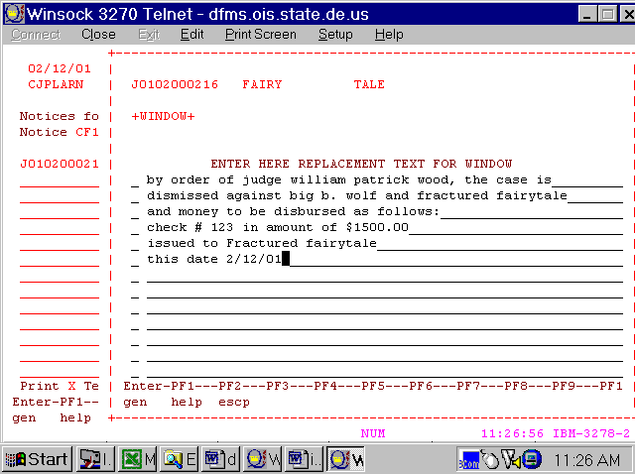

Second Interpleader defendant
Enter Dismissal
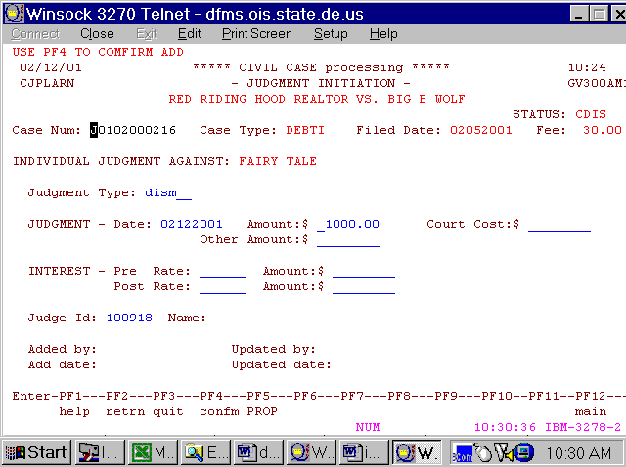

Dism

Judge ID

Put the judgment on the other defendant and skip the notices and several of the docket entries because they will be duplicated

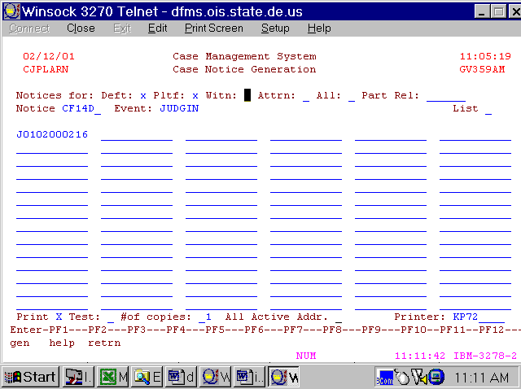

Notices

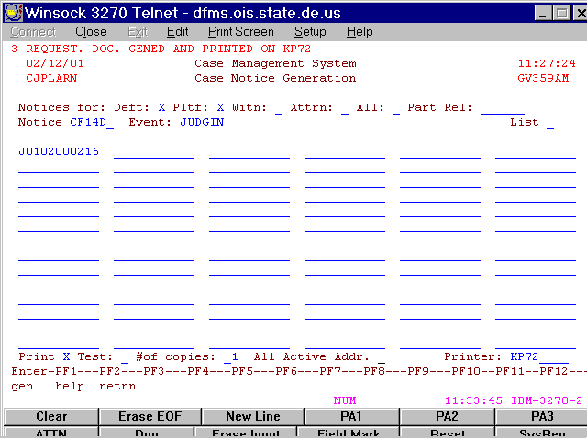

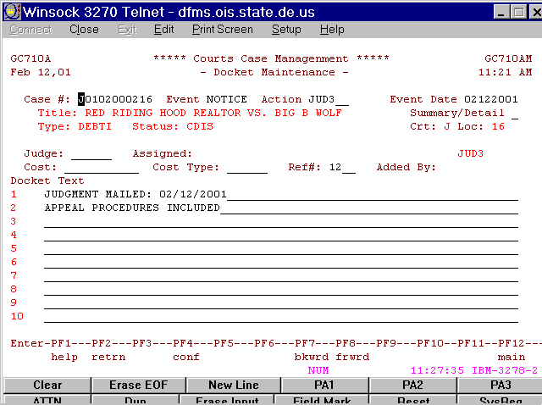
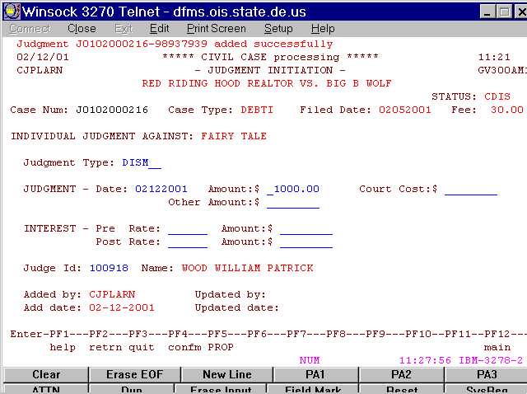

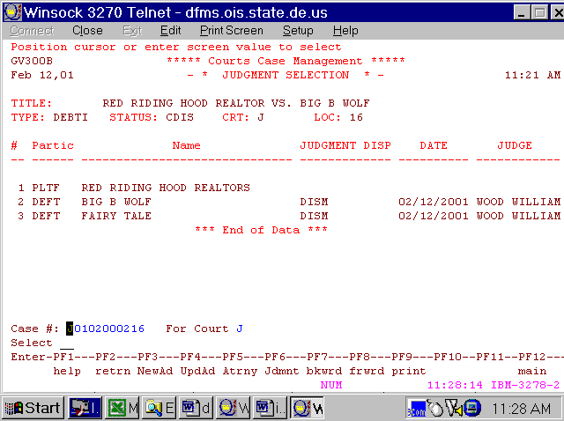
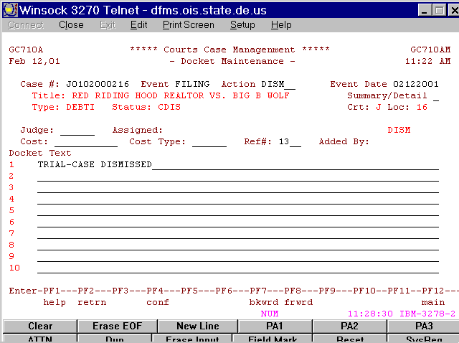

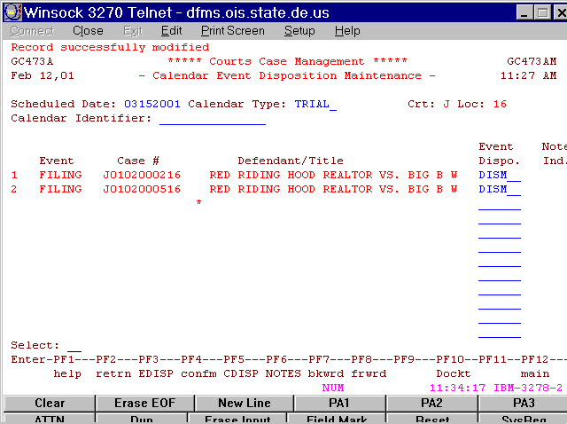
You are finished with the case

