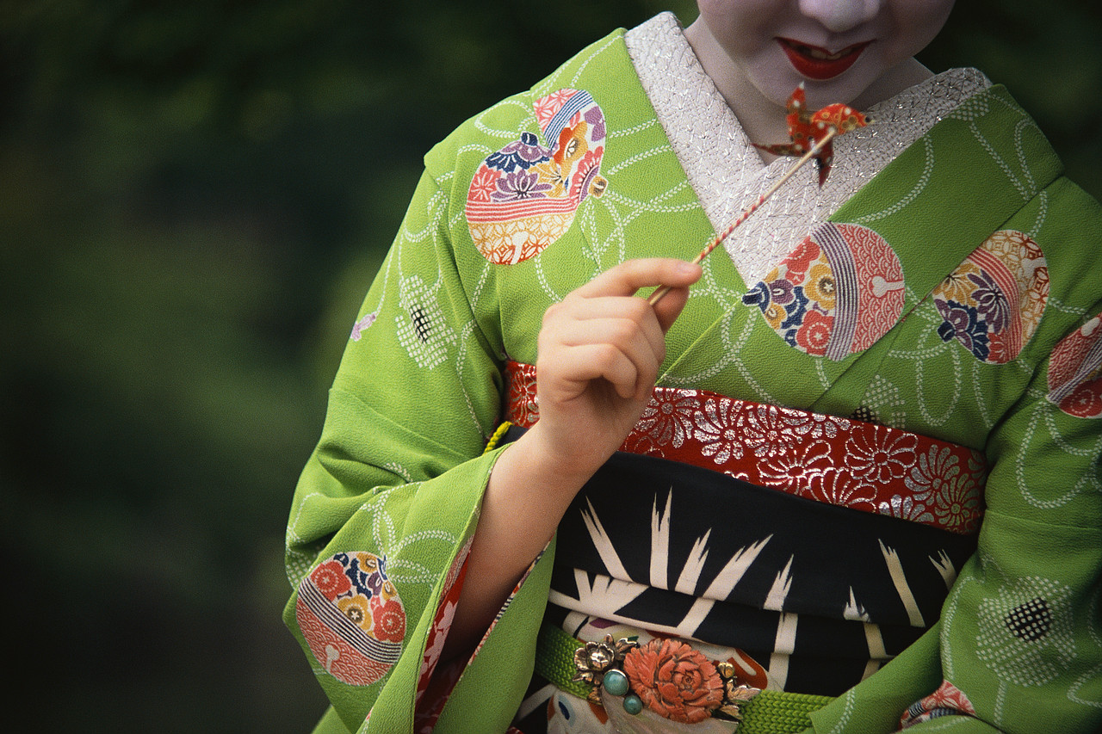
IF YOU LIKED
MEMOIRS OF A GEISHA
TRY…

Fiction:

Buck, Pearl S - The Good Earth.
A poor farmer and his wife rise to great wealth and position in pre-communist China. Winner of the 1932 Pulitzer Prize.

Clavell, James - Gai-Jin; Shogun; Tai-Pan.
Historical adventures about early relations between Japan and the West.

Dalby, Liza - The Tale of Murasaki
A fictionalized account of the life of the 11th Century author of The Tale of Genji.

Hoobler, Dorothy - The Demon in the Teahouse; The Ghost in the Tokaido Inn.
Young Adult mysteries set in 18th Century Japan.

Johnson, Kij - The Fox Woman
In this blend of fantasy and Japanese folklore, a husband is bewitched by a woman who is in fact a fox.

Lee, Chang-Rae - A Gesture Life
A Korean immigrant in a small New York town reflects on the tragic events that shaped him while serving in the Japanese army during World War II.

Liu, Aimee - Cloud Mountain
An American teacher marries one of her students, a Chinese revolutionary, in early 20th Century San Francisco.

Loh, Vyvyanne - Breaking the Tongue
As the Japanese prepare to invade Singapore, an Anglophile Chinese family struggles to survive and preserve its dignity in the face of shifting loyalties of spies, expatriates, and nationalists.

Minatoya, Lydia - The Strangeness of Beauty
In the 1920’s, an orphaned Japanese-American girl is taken by her aunt to Japan to receive an education in Samurai life.

Mirakami, Haruki - Wind-up Bird Chronicle
The collapse of a marriage is superimposed on an investigation of recovered war memories and a man's search for his own identity.

Murasaki Shikibu - The Tale of Genji
Written and set in 11th Century Japan, this is considered the world’s first novel. This story of an emperor’s son is full of strong female characters.

Parker, I.J. - The Dragon Scroll; The Hell Screen; Rashomon Gate
Mysteries set in 11th Century Japan.

Rowland, Laura - Black Lotus; The Pillow Book of Lady Wisteria; The Samurai’s Wife. Mysteries set in 17th Century Japan.

Shigekuni, Julie - The Bridge Between Us
The story of four generations of Japanese-American women in 1930’s San Francisco.

Tan, Amy - The Hundred Secret Senses; The Joy Luck Club; The Kitchen God’s Wife
Bestsellers about Chinese-American women learning their personal and cultural heritages from their immigrant mothers.

Tsukiyama, Gail - Women of the Silk and The Language of Threads
The life of a young girl in early 20th Century China and Hong Kong.

Yoshimoto, Banana - Asleep; Amrita; Goodbye Tsugumi.
Stories of contemporary Japanese women.

Zeldis, Chayym - The Geisha’s Granddaughter
The son of a geisha joins the U.S. army in World War II so his American daughter can be free.

Non-fiction:

Dalby, Liza Crihfield- Geisha
306.74 D137

Cobb, Jodi - Geisha
306.742 Cobb

Downer, Lesley - Madame Sadayakko, the Geisha Who Bewitched the West
Biography Kawakami

Gallagher, John - Geisha: A Unique World of Tradition, Elegance and Art
792.7028 Gallagher

Iwasaki, Mineko - Geisha: a Life
792.70952 Iwasaki

Masuda, Sayo - Autobiography of a Geisha
792.70280952 Masuda

