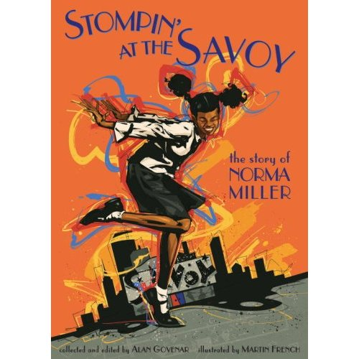
Norma knew from being a little girl that all she ever wanted to do was dance. Growing up in Harlem, life was tough - her father died before she was born and her mother worked long hours to keep the family together.
Norma's desire to be a dancer never faltered, inspiring her to overcome racism and poverty and become a world famous dancer and choreographer.
This inspiring children’s tale is brought vividly to life by black and white illustrations by prize-winning artist Martin French.

To order copies of this book or the 73 minute DVD “Queen of Swing”, please call Collins Productions at (651) 231-7718.

