White Mountain for the Family Tour
4- Day
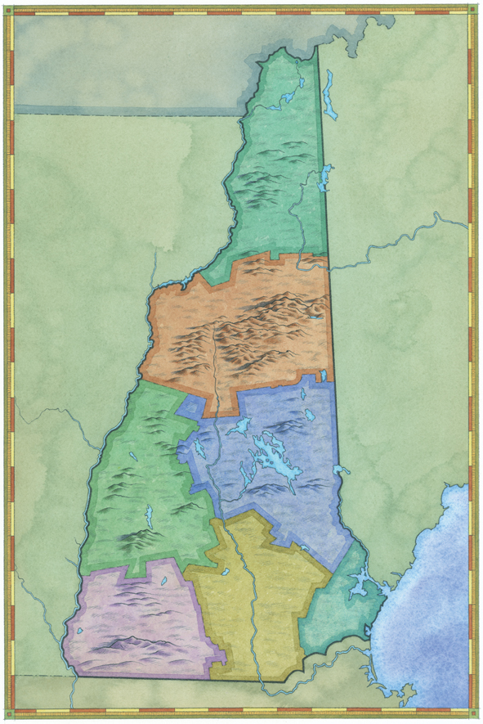
Day 1 –
- Polar Caves Park, Plymouth
- Stop in at the White Mountains Attractions Visitor Center , Lincoln
- Ride the Hobo in Lincoln and have lunch on the train
- Hike the Flume Gorge or ride the Cannon Aerial Tramway at Franconia Notch State Park
- Possible overnight options:
- Mountain Club on Loon, Lincoln
- Indian Head Resort, Lincoln
- The Beacon Resort, Lincoln
- Woodward’s Resort, Lincoln
- Rivergreen Resort, Lincoln
Day 2 –
- Clark's Trading Post, Lincoln
- Whale's Tale Waterpark, Lincoln

Day 3 –
- Ride the Mount Washington Cog Railway, Bretton Woods
- Picnic in Crawford Notch State Park
- Continue to Attitash Bear Peak in Bartlett to ride the Alpine Slides
- Possible overnight options:
- Attitash Grand Summit Lodge, Bartlett
- Eagle Mountain House, Jackson
- AMC Highland Center, Crawford Notch or AMC Joe Dodge Lodge at Pinkham Notch
- North Conway Grand Hotel, North Conway
- Red Jacket Mountain View, North Conway
- Braircliff Motel, North Conway
Day 4 –
- Story Land, Glen
- Ride the Conway Scenic Railroad, North Conway
- Take the Kancamagus Highway back to Lincoln

Next time you visit, don’t miss:
- Santa's Village, Jefferson
- Six Gun City, Jefferson
- Mount Washington Auto Road, Pinkham Notch
- Loon Mountain Gondola, Lincoln
- Littleton Coin Company
- Chutters Candy, Littleton

