

Land Use Change and Effects on Water Quality and Ecosystem Health in the Lake Tahoe Basin, Nevada and California: Year-1 Progress

By William Forney¹, Christian Raumann¹, Timothy B. Minor ², J. LaRue Smith ³, John Vogel ¹, and Robert Vitales¹

Open-File Report 02-014

2002

Any use of trade, product, or firm names is for descriptive purposes only and does not imply endorsement by the U.S. Government.

U.S. Department of the Interior
U.S. Geological Survey

___________________________
¹U.S. Geological Survey, Menlo Park, California
²Desert Research Institute, University and Community College System of Nevada, Reno, Nevada
³U.S. Geological Survey, Carson City, Nevada

ABSTRACT
As part of the requirements for the Geographic Research and Applications Prospectus grants, this Open-File Report is the second of two that resulted from the first year of the project. The first Open-File Report (OFR 01–418) introduced the project, reviewed the existing body of literature, and outlined the research approach. This document will present an update of the research approach and offer some preliminary results from multiple efforts, specifically, the production of historical digital orthophoto quadrangles, the development of the land use/land cover (LULC) classification system, the development of a temporal transportation layer, the classification of anthropogenic cover types from the IKONOS imagery, a preliminary evaluation of landscape ecology metrics (quantification of spatial and temporal patterns of ecosystem structure and function with appropriate indices) and their utility in comparing two LULC systems, and a new initiative in community-based science and facilitation.

INTRODUCTION
This paper updates the previous Open-File Report (OFR 01–418) by focusing on specific results and accomplishments that have occurred over fiscal year (FY) 2001. The only item that is repeated from OFR 01–418 is Chart 1. This is meant to refresh the memory of any reader that has read the other OFR, and—for those that have not—to put the body of the text in context. For further discussion of the elements and particulars of Chart 1, please refer to OFR 01–418.

Chart 1. Schematic of research approach.

IKONOS (25 km² scene) | HDOQs (pilot watersheds) | Fieldwork
- Obtain imagery.  - Classify impervious cover.  - Classify natural cover. | - Produce HDOQs.  - Produce temporal LULC datasets.  - Create temporal transp. layer | - Define LULC classes.  - Do accuracy assessments.  - Clarify mixed pixel problems.

ANALYSIS

Landscape Structure
Investigate and define metrics.
Assess the integrity of landscape.
Water Quality | Ecosystem Health
- Assess the change in two hydrographs.  - Perform SCS Curve Number analysis.  - Do export coefficient model.  - Regress class metrics to water quality parameters. | - Change in class and landscape metrics, fractal dimension.  - Change in SEZs and riparian patches.  - Metapopulation dynamics and corridors.  - Human and naturally induced disturbance regimes.

The progress to be discussed in this OFR is the production of historical digital orthophoto quadrangles (HDOQ), the development of the land use/land cover (LULC) classification system, the development of the temporal transportation layer, the classification of anthropogenic cover types from the IKONOS imagery, a preliminary evaluation of landscape ecology metrics (quantification of spatial and temporal patterns of ecosystem structure and function with appropriate indices), and the utility of landscape ecology metrics in comparing two LULC systems: the California Gap Analysis and the Multi-Resolution Land Characteristics (MRLC), and a new initiative in community-based science and facilitation.

PROGRESS AND RESULTS

Historical Digital Orthophoto Quadrangle Production
The production of HDOQs was the second project of its kind undertaken by the U.S. Geological Survey’s (USGS) Western Geographic Science Center Data Applications & Integration Section (DAIS). The first part of the project required image rectification of 22 natural color 3.75-minute DOQs. The 3.75-minute HDOQs are within the Emerald Bay, South Lake Tahoe, Echo Lake, Freel Peak, Caples Lake, and Carson Pass, Calif., 7.5-minute quadrangles, which encompass the pilot watersheds. Only 14 of the 22 HDOQs were ingested into the DOQ database, as 8 HDOQs did not have complete image coverage within the 3.75-minute cell.
Challenges facing this particular project that are inherent characteristics of many HDOQ projects included the use of non-National Aerial Photography Program (NAPP) source imagery (nonstandard flight heights/scale), the use of image photography not quarter-quad centered, and the absence of traditional ground control and aerotriangulation.
Materials for the project that were researched and acquired included existing first-generation DOQs (produced from 1992 NAPP photographs), digital elevation models (DEM), published quadrangle maps, flight line diagrams, camera calibration reports, and the natural color 1987 U.S. Forest Service (USFS) aerial photographs. Forty-four image diapositives were required to make the twenty-two 3.75-minute HDOQs in the project; four to six image “chips” per HDOQ. The photograph centers and extents were plotted on 7.5-minute topographic quadrangle maps to determine optimum image coverage for the 3.75-minute DOQ cells.
The image diapositives were digitally captured with a scanning aperture of 30 microns. During the scanning phase, two representative images with clear fiducial marks were selected for measurement. The coordinates of the fiducial marks were measured on the scanner as input to transformation software that generated a camera calibration file, with additional processing that calculated an approximate photographic scale.
In lieu of control or aerotriangulation, the existing 1992 DOQs were used to control each scanned image. Control points that were selected had to be visible on both the existing DOQ and on the scanned image of the 1987 photograph. Using a split screen, we selected at least nine distributed points of common, well-defined, photoidentifiable image features and measured them to control each image. At least two points were selected on each image edge, for commonality with two or more adjoining overlap and side images. The relative closeness of the photograph acquisition dates between the historical image photographs, and the source image photographs of the existing DOQs facilitated selection and accurate reading of the control points.
With the camera and derived control files, DEMs, and source images as input, the Digital Orthophoto Processing System (DOPS) was used to perform image rectification and HDOQ creation. A parameter file (.par) was generated, with relevant information about the project. Each aerial photograph or image chip was entered into the .par file to ensure the proper interaction between inputs and to be used for subsequent program execution. Image chips falling within Universal Transverse Mercator (UTM) Zone 11 were initially rectified in UTM Zone 10, as requested by the project staff. Using the requisite control, DEMs, and raw image files, the DOPS software rectified the image chips.
Once the individual image chips were rectified, they required mosaicking to construct the final HDOQ. Many of the image chips were used repeatedly where chip coverage extended into multiple HDOQs. Re-rectification of image chips occurred when chips did not extend to areas of estimated coverage. This was remedied by adjusting the corner coordinate determining domain size in the .par file and then reprocessing. The mosaic program locally adjusted the brightness values at join lines to minimize tonal variations between image chip join areas. After the mosaic of the chips was completed, the HDOQ overedge was calculated and trimmed, and the HDOQ datum quadrangle corner crosses were embedded. Finally, the standard USGS keyword header for the HDOQ was edited, which included recording the photographic source information of the image chips contained within.
Final quality assurance/quality control (QA/QC) measures consisted of HDOQ header verification, thorough image inspection of each individual HDOQ, and a comprehensive check of all HDOQs within the project, checking image adjacency geometry and general image radiometry. Tone matching was not performed on the HDOQs. After the chips that resided in UTM Zone 11 were re-rectified, the 14 HDOQs with complete image coverage met DOQ acceptance criteria and were ingested into the DOQ database.

Temporal Land Use/Land Cover Mapping
The two primary considerations in defining a classification system for the Lake Tahoe Basin are (1) the techniques of LULC mapping and (2) the intended use of the resulting temporal LULC coverages.
To maintain consistency with other LULC mapping activities of the USGS National Mapping Program, we developed a modified-Anderson hierarchical classification system with definitions (Appendix B) for the Tahoe Basin; this is a subset of the system developed for the MRLC 2000 National Land Cover Data (NLCD) mapping effort (Anderson, 1976). Additional models for defining classes were provided by classification systems developed by a group at the USGS Rocky Mountain Mapping Center for use in large-scale regional temporal LULC mapping projects in the Middle Rio Grande Basin, Colorado Front Range, and Brazos, Texas (Stier, 1999). This approach allows the capture of high-resolution features from the HDOQs in a system that can be aggregated and compared on a regional basis. The system developed for the Tahoe Basin allows classification of major land use types (2000-series Developed) and land cover types (1000 Water, 2000 Bare, 4000 Vegetated), as well as estimation of impervious surface cover for developed lands (fig. 1).
For this project, Aerial Information Systems, Inc. (AIS) in Redlands, Calif., was chosen to compile the temporal LULC coverages under the direction of the USGS. AIS uses traditional aerial photography interpretation techniques to create vector LULC coverages by onscreen (or “heads up”) digitizing of LULC polygons over a DOQ/HDOQ base layer. Also, stereopairs of the original aerial photographs from which the DOQs were produced are viewed through a stereoscope to assist in the LULC mapping. Areas of similar LULC are detected and grouped on the basis of color, tone, texture, size, shape, and context of features shown on the imagery, as well as information gained from ancillary data sources, such as parcel, vegetation, elevation, and NLCD data layers. The minimum mapping unit (MMU) used will be 1 acre. These techniques yield a spatial resolution that allows a classification system up to Level IV.
The intended use and analysis of the temporal LULC coverages were considered in determining classes and defining their extent. Since the impact of anthropogenic impervious surfaces on water quality is the basis for much of the future analysis, the LULC coverages must include an estimation of impervious cover. LULC classification systems used in previous water quality studies have assigned a single percentage of impervious surface coverage for each land use class. However, a more accurate assessment of impervious cover is possible with more precise and rigorous photographic interpretation and use of ancillary data. With this in mind, AIS will estimate anthropogenic impervious surface cover from 0-100 percent in 5-percent increments for each developed parcel (2000-series) and will include this value as a separate attribute in each coverage.

Temporal Transportation Layer Development
The HDOQs produced for this project, as well as existing Tahoe Basin DOQs for 1992 and 1998, will serve as the primary source for developing temporal transportation layers. These geographic information system (GIS) layers will be used to provide quantitative information on landscape structure, to estimate impervious surface coverage, and to assist in the interpretation of land cover classes.
A 1998 transportation layer for the pilot watersheds was developed for this project on the basis of the best available vector-based transportation dataset, which was obtained from the USFS, and then modified using 1998 DOQs and data obtained from the field (fig.2). The original USFS transportation layer incorporated USGS DLG data with USFS global positioning system (GPS) corrections obtained in 1998. However, even with the GPS corrections, this layer contained many horizontal inaccuracies of up to 20 meters that had to be reduced to make the data useful in later analysis and derivation of temporal layers.
The USFS layer was modified by displaying the data onscreen at a scale of 1:4,000, with the 1998 DOQs as a reference for editing. All road segments that did not lie within the width of a road as shown on the DOQ were moved to fall within the width of the road. However, the modified road segments do not necessarily represent the centerlines of the roads. Also, if a line existed in the layer but a coinciding road was not visible on the 1998 DOQ, the line was deleted. This process removed many trails that the USFS has identified but that are not visible on the 1998 DOQs. Trails cannot be accurately identified in compiling

Level I | Level II | Level III | Level IV
1000 Water | 1100 Open Water | 1110 Stream/River
 |  | 1120 Canal/Ditch
 |  | 1130 Lake/Pond
 |  | 1140 Reservoir
 |  | 1150 Bay/Estuary
 | 1200 Perennial Ice/Snow
2000 Developed | 2100 Residential | 2110 Single-family Residential
 |  | 2120 Multi-family Residential
 | 2200 Nonresidential Developed | 2210 Commercial | 2211 Major Retail
 |  |  | 2212 Mixed/Minor Retail
 |  |  | 2213 Office
 |  |  | 2214 Light Industry
 |  | 2220 Communication/Utilities
 |  | 2230 Institutional | 2231 Schools
 |  |  | 2232 Cemeteries
 |  | 2240 Agriculture/Livestock
 |  | 2250 Transportation | 2251 Primary Road
 |  |  | 2252 Railroad
 |  |  | 2253 Airport
 |  | 2260 Recreation/Open Space | 2261 Golf Course
 |  |  | 2262 Urban Park
 |  |  | 2263 Ski Runs
 |  |  | 2264 Campground/Picnic Area
 |  |  | 2265 Marina/Boat Launch
 |  |  | 2266 Swimming Beaches
 | 2300 Mixed Urban
3000 Bare | 3100 Transitional
 | 3200 Quarries/Strip Mines/Gravel Pits
 | 3300 Rock Faces, Rock Slides, Cliffs
 | 3400 Exposed Rock
 | 3500 Disposal
 | 3600 Mixed Bare
4000 Vegetated | 4100 Forest | 4110 Coniferous | 4111 Coniferous (10-50% Crown Closure)
 |  |  | 4112 Coniferous (>50% Crown Closure)
 |  | 4120 Deciduous | 4121 Deciduous (10-50% Crown Closure)
 |  |  | 4122 Deciduous (>50% Crown Closure)
 |  | 4130 Coniferous/Decid. Mixed | 4131 Con./Decid. Mixed (10-50% Crown Closure)
Level I | Level II | Level III | Level IV
 |  |  | 4132 Con./Decid. Mixed (>50% Crown Closure)
 |  | 4140 Brush/Shrubland
 |  | 4150 Mixed Forest/Shrub
 |  | 4160 Planted/Cultivated
 | 4200 Herbaceous | 4210 Natural Herbaceous
 |  | 4220 Planted/Cultivated Herb.
 | 4300 Wetlands | 4310 Wooded Wetlands
 |  | 4320 Brush/Shrub Wetlands
 |  | 4330 Herbaceous Wetlands
 | 4400 Severely Burned Upland Vegetation
Figure 1. Land Use/Land Cover Classification System for the Lake Tahoe Basin.

the temporal transportation layers if trails are not visible in the HDOQs. In other cases, if a road was visible in the 1998 DOQs but not present in the USFS layer, the road was added to the layer.
Once line editing was completed, the attributes of the layer were modified. Road width and accessibility attributes were added, both of which required field measurements in addition to DOQ interpretation. The three transportation attributes and their descriptors are as follows:

- Surface: paved, unpaved, railroad, trail
- Width: actual width of the road in feet
- Access: unlimited, limited, controlled

The accuracy of this initial transportation layer is crucial for preserving vertical integration, because this layer will be used as a base to derive the older transportation layers. As the HDOQs from 1987, 1969, and 1940 become available, lines will then be edited or deleted from this completed 1998 transportation layer, and new temporal layers will be created.

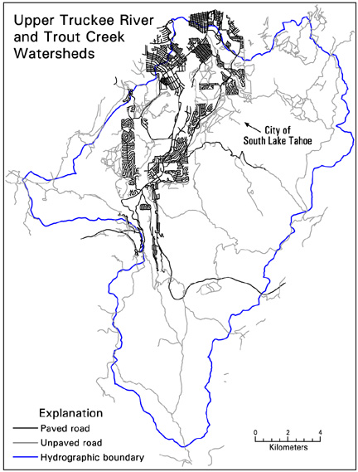
Figure 2. Extent and detail of the edited 1998 transportation layer for the pilot
watersheds.

Anthropogenic Cover: Impervious Surfaces
Remotely sensed data offer the advantage of synoptic, large-area analyses but have limitations in an environment such as the Lake Tahoe Basin. Analysis of airborne and/or spaceborne data for impervious cover is complicated by high variability in extended forest canopy density throughout the Basin. Some commercial areas near the “Y,” as shown in figure 3 for example, have very little or no canopy cover. Rural residential areas such as those shown in figure 4, on the other hand, have canopy densities approaching 90 percent or higher, essentially obscuring the surface features underneath the canopy. With high canopy closure, conventional manual interpretation of aerial photographs and/or satellite imagery will not provide accurate estimates of impervious cover, because understory features, such as driveways or roofs, cannot be detected below the canopy.

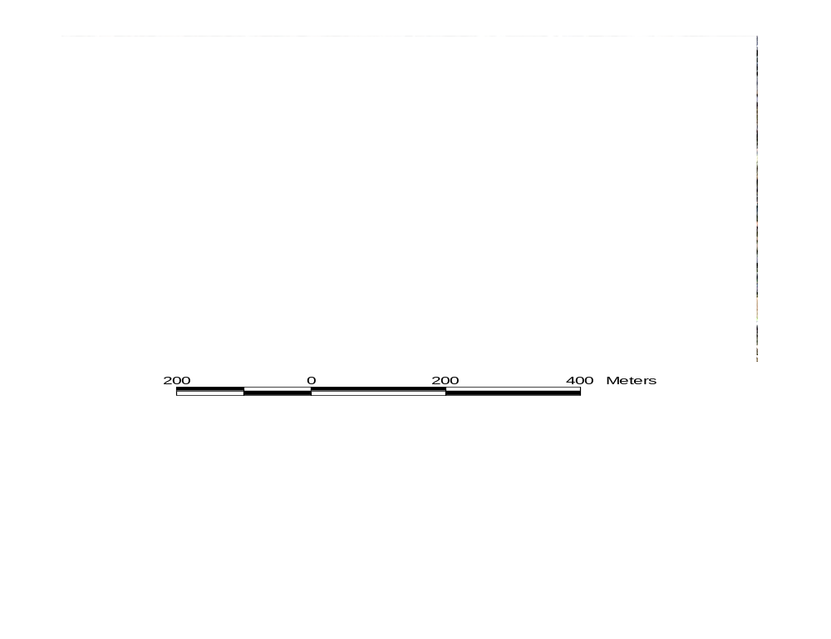
Figure 3. Portion of IKONOS imagery showing commercial development
with little or no canopy cover at the South Lake Tahoe “Y.”

Despite this difficulty, remotely sensed imagery has been used to derive accurate impervious cover estimates by using methods that integrate ancillary data sources. Image classification methods have been tailored to combine both imagery and ancillary spatial data, such as parcel descriptions, transportation, and other demographic and physical data. It is critical in these applications that the ancillary spatial data (especially parcel data, if being used) have a high level of accuracy. These methods produce a raster-based surface of impervious cover density. The raster-based surfaces represent local probabilities of impervious cover density ranging from high to low (Harris and Ventura, 1995; Mesev, 1998). These probability data can then be converted to percentage of impervious cover estimates by unit. Ji and Jensen (1999) used Landsat thematic mapper (TM) data with a layered classification approach, along with a subpixel classifier, to derive eight levels of urban imperviousness in parts of Charleston, S.C. Although, these methods result in some measure of impervious cover, they do not measure it directly. That is, the result is not a discrete number but rather a categorical range or associated value, such as low, medium, or high.
New satellite data collected by the IKONOS instrument may allow direct estimates of impervious cover, where canopy closure does not obscure the direct sensing of features. IKONOS also provides a means of

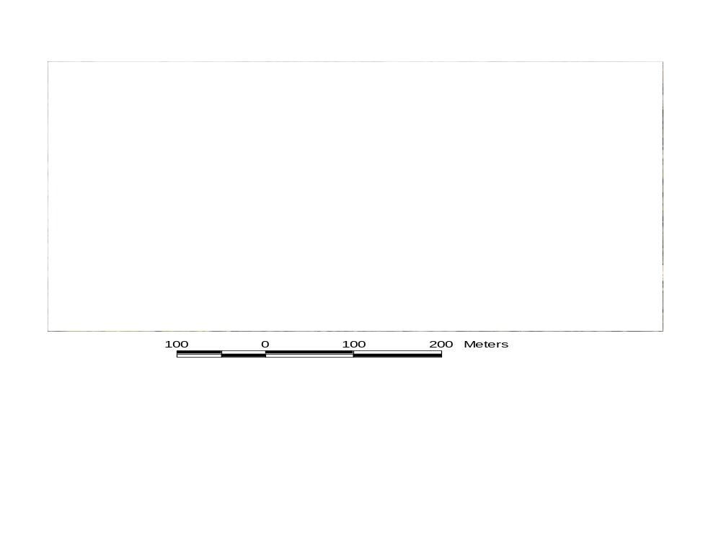
Figure 4. Portion of IKONOS imagery showing residential development obscured
by canopy cover in the Black Bart neighborhood of South Lake Tahoe.

discriminating different urban land cover types and their relationship to impervious cover classes. The results from Cablk and Minor (in press) indicate that impervious cover can be accurately and directly mapped with IKONOS imagery. The method for impervious cover mapping involved multiple image processing steps, ranging from masking to image transformation with thresholding, to applying morphological filters. A modeling approach was proposed because the IKONOS data were expected to have the same difficulties that other air- and space-borne sensors have with dense canopies. The results were contrary to this assumption; it was found that sub-canopy and subshadow surfaces were not only detectable, but also discernible with respect to the underlying surface cover, when image processing methods were combined with spatial modeling tools (fig. 5). An image processing/spatial modeling method based on principal components analysis and spatial morphological operators was developed using image processing software and a GIS. On the basis of an accuracy assessment using 170 ground verification points selected throughout the study area, an overall classification accuracy of 92.94 percent was obtained, with an even higher user or “reliability” accuracy of 95.83 percent. Impervious cover estimates for the entire 9.65-square-mile (25-square-kilometer) area were calculated at 1.6 square miles (4.15 square kilometers), or 16 percent of the total surface area.
The investigation described in this report expands on the work presented by Cablk and Minor (in press) to determine if contemporary urban land use classes can be generated using the impervious cover results. These use types include commercial, residential, infrastructure, and industrial. These distinctions depend primarily upon the availability of a good GIS parcel layer, which the El Dorado County Assessor’s office is in the process of producing. Natural land cover types will be identified as well, particularly those associated with relevant ecosystem processes. Investigators will determine if IKONOS data can allow finer distinctions between classes than other types of multispectral imagery (such as Landsat TM or SPOT) and the HDOQs. An accuracy assessment of the IKONOS classification results will be conducted using ground truthing to validate the accuracy of the results and examine heterogeneous pixel issues.

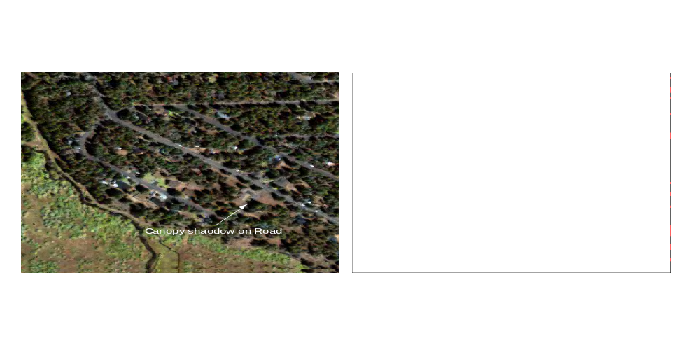
Figure 5. Results of principal component analysis with morphological operators to detect
impervious cover under tree canopy shadow; Black Bart neighborhood of South Lake Tahoe.

Assessment of LULC Systems and Landscape Ecology Metrics
One of the goals of this research is to assess alternative LULC data sources for their ability to provide useful classification systems and landscape metrics. As such, the California Gap Analysis and the MRLC systems were examined, and their GIS coverages were analyzed.
The Gap Analysis is an ecoregional assessment with a scale of 1:100,000 and a 100-hectare MMU. Gap Analysis data are intended for identifying landscapes that contain large numbers of potentially unprotected vegetation types and vertebrate species (California Gap Analysis Program, 2001). It applies the California Wildlife-Habitat Relation (WHR) System as its dominant LULC classification system to determine preferred and likely habitat of 455 native terrestrial vertebrate species. Figure 6 presents the GIS coverage and LULC of the Gap Analysis for the four-quadrangle area of South Lake Tahoe (Freel Peak, South Lake Tahoe, Echo Lake, and Emerald Bay).
The MRLC is a consortium of the USGS (National Mapping, Biological Resources, Geologic, and Water Resources Disciplines), U.S. Environmental Protection Agency, USFS, and National Oceanic and Atmospheric Administration, and its goal is to produce a consistent land cover data layer for the conterminous United States based on 30-meter (0.09 ha) Landsat TM data (Lake Tahoe Data Clearinghouse, 2001). Figure 6 presents the NLCD GIS coverage that is a result of the consortium’s efforts for the same four-quadrangle area that was represented in Figure 7.
After obtaining the two coverages and clipping them to the same spatial extent, we used the software package FRAGSTATS*ARC to produce a suite of patch, class, and landscape metrics. Although the software produces a total of 59 metrics, certain simple ones were selected to elucidate the consistency between systems and assess the utility of the data. Tables 1 and 2 present select class and landscape metrics from the two coverages.
In table 1, the two metrics presented provide valuable information about a class or a particular land cover type in a landscape. According to the MRLC, over 32,000 ha or almost 60 percent of the four-quadrangle area in South Lake Tahoe is considered to be evergreen forest. These metrics are useful for getting a sense of the composition of a landscape. As for the two LULC classification systems, table 1 gives a good indication of the problems associated with using multiple systems. When comparing the two systems, the nomenclature assigned to the same or similar cover types can confound analyses or applications of the data. For example, the distinction between barren versus rock/sand/clay can be significant. If one were trying to establish hydrologic infiltration rates or ground-water recharge sites, neither of these land cover types would offer much guidance in parameterizing a water balance model or determining locations in which to prohibit certain land uses. Consequently, as this research moves

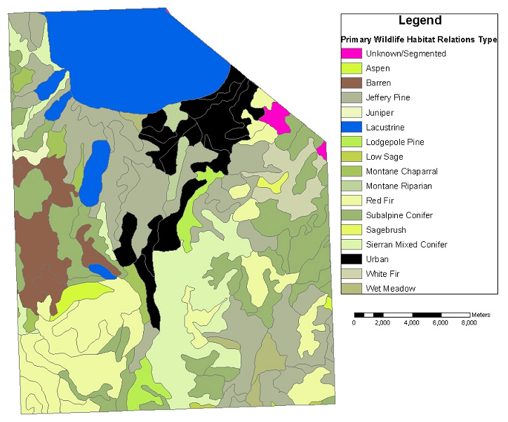

Figure 6. California Gap Analysis Program land cover data for the pilot watersheds.

Table 1. Class metrics of two LULC classification systems (regular text signifies the Gap Analysis metrics, and italicized text signifies the MRLC/NLCD metrics)
Gap and MRLC/NLCD Classifications | Area (ha) | % Landscape
Barren | 2,907 | 5.2
Rock/Sand/Clay | 539 | 1.0
Wet meadow | 767 | 1.4
Emergent herbaceous wetland | 100 | 0.2
Subalpine conifer | 8,440 | 15.4
Evergreen forest | 32,715 | 59.5
Urban | 4,512 | 8.2
Low-intensity residential | 1,877 | 3.4

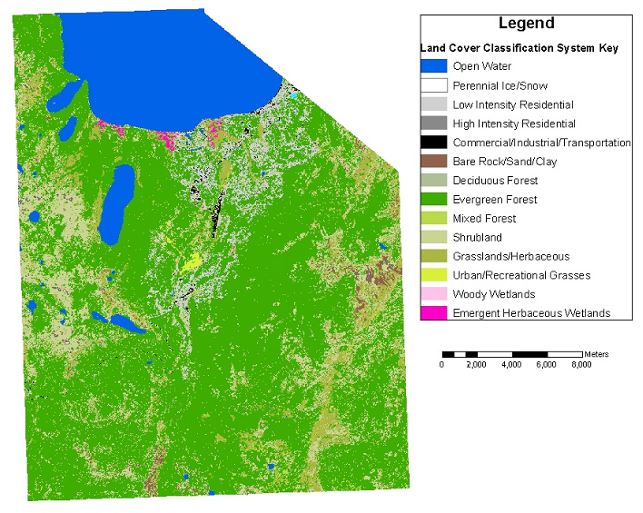

Figure 7. The National Land Cover Dataset for the pilot watersheds.

forward, it is essential that a consistent and hierarchical LULC system be adopted and used for all data sources and locations. This will provide for analyses and applications at multiple scales and regions.
Table 2 shows that the landscape metrics that aggregate across all land cover types within the specified region are very useful in quantifying the visually apparent differences in the LULC datasets. As suggested in figure 5, the Gap Analysis data have large patches compared with the NLCD, as a result of their relatively coarse resolution. Table 2 supports this assertion as the mean patch size of the Gap Analysis is 337 ha, whereas for the NLCD it is 1.3 ha. Furthermore, the NLCD is derived from raster Landsat data, which will tend to make the class designations more intermittent and interspersed. This assertion is supported by the fact that although the NLCD has a lower patch richness (or diversity of land cover types), it has a higher number of patches (table 2). Overall, the NLCD data appear to be more useful than the Gap Analysis data for this study, so future comparisons will be made using the NLCD. As this research moves forward, the consistency of scale, resolution, and source of data needs to be maintained. This will become a challenge when comparing LULC datasets derived from the HDOQs with ones derived from IKONOS imagery.

Community-Based Science
At the May 2001 meeting of the Upper Truckee Watershed Focus Group, the USGS and Desert Research Institute project scientists presented an overview of this USGS research effort in the Tahoe Basin

Table 2. Landscape metrics of two LULC classification systems
Classification System | Patch Richness | # of Patches | Mean Patch Size (ha)
Gap analysis | 17 | 163 | 337
MRLC/NLCD | 14 | 41,901 | 1.3

to other scientists, regional administrators, and local landowners. Following that meeting, project researchers approached the landowners and asked for their input on the project; specifically, the project team wanted to know if the research being conducted addressed the landowners’ questions and concerns. As a result of those discussions, the authors are now exploring the impact of beaver populations in the watershed (Busher and Dzieciolowski, 1999), and they were asked to facilitate future meetings that focus on issues important to the landowners. In August 2001, Christian Raumann and John Vogel presented project information and facilitated a meeting of landowners, Tahoe Regional Planning Agency officials, El Dorado County government personnel, and USGS researchers.

Summary and Work Plan
As the tasks described in this report are completed, work in 2002 will build upon these accomplishments. Production of HDOQs for the pilot area will be completed, and then temporal LULC coverages with impervious cover estimates will be derived from the HDOQs. The temporal transportation datasets in the pilot area will also be completed using the HDOQs. Once IKONOS imagery is obtained for the entire Tahoe Basin (summer 2002) all impervious cover in the pilot watersheds will be classified. When these datasets have been created, the hypotheses stated in OFR 01–418 can be tested. An ArcIMS-based Web site will also be created to allow improved data dissemination and analysis by all potential data users.

Acknowledgments
Thank you to those who also contributed to the progress of this project and the writing of this report, including Timothy Rowe, Ken Adams, Mike Campagna, and Leila Gass.

REFERENCES
Anderson, James, Hardy, Ernest, Roach, John, and Witmer, Richard, 1976,. A land use and land cover classification system for use with remote sensor data: U.S. Geological Survey Professional Paper 964.

Busher, P.E., and Dzieciolowski, R.M., 1999, Beaver protection, management, and utilization in Europe and North America: New York, Kluwer Academic/Plenum Publishers, p. 182.

Cablk, M.E., and Minor T.B., in press, Detecting and discriminating impervious cover with high resolution IKONOS data using principal components analysis and morphological operators: International Journal of Remote Sensing.

California Gap Analysis Program, September 2001, http://www.biogeog.ucsb.edu/projects/gap/gap_proj.html.

Harris, P.M., and Ventura, S.J., 1995, The integration of geographic data with remotely sensed imagery to improve classification in urban areas: Photogrammetric Engineering and Remote Sensing, v. 61, no. 8, p. 993–998.

Ji, M., and Jensen, J.R., 1999, Effectiveness of subpixel analysis in detecting and quantifying urban imperviousness from Landsat thematic mapper Imagery: Geocarto International, v. 14, no. 4, p. 31–39.

Lake Tahoe Data Clearinghouse, September 2001, http://tahoe.usgs.gov/files/nlcd_meta_ca.txt.

Mesev, T.V., 1998, The use of census data in urban image classification: Photogrammetric Engineering and Remote Sensing, v. 64, no. 5, p. 431–438.

Stier, M.P., 1999, Temporal land use and land cover mapping, in Bartolino, J.R., ed., U.S. Geological Survey Middle Rio Grande Basin Study—Proceedings of the Third Annual Workshop, February 24–25, 1999, Albuquerque, N. Mex.: U.S. Geological Survey Open File Report 99–203.

APPENDIX A

Lake Tahoe Basin Land Use/Land Cover Classification System Definitions

1000 WATER—Area covered by water, snow, or ice with less than 25-percent vegetated or developed cover, unless specifically included in another category.
1100 Open Water—All areas of open water with less than 25-percent vegetative or developed cover.
1110 Stream/River—A natural body of flowing water. Includes streams and rivers that have been channelized to control flooding or erosion or to maintain flow for navigation.
1120 Canal/Ditch—A manmade open waterway constructed to transport water, to irrigate or drain land, to connect two or more bodies of water, or to serve as a waterway for watercraft. Collection should include the rights-of-way and associated dikes and levees.
1130 Lake/Pond—A nonflowing, naturally existing body of water. Includes water impounded by natural occurrences and artificially regulated natural lakes. The delineation of a lake is based on the areal extent of water at the time the imagery was acquired.
1140 Reservoir—Any artificial body of water, unless specifically included in another category. It can lie in a natural basin or a manmade basin. The delineation of a reservoir is based on the areal extent of water at the time the imagery was acquired. (The water control structures are classified as Communications/Utilities)
1150 Bay/Estuary—The inlets or arms of the sea that extend inland.
1200 Perennial Ice/Snow—Areas covered year-round with snow and ice.

2000 DEVELOPED—Areas that have been improved by human activity. Includes all built-up and urban areas of the landscape. Does not include mining lands, croplands, or waste-disposal areas. This land use category takes precedence over a land cover category when the criteria for more than one category are met.
2100 Residential—Lands containing structures used for human habitation.
2110 Single-Family Residential—Lands used for housing residents in single-family dwelling units. Includes trailer parks, mobile home parks, and entire farmsteads when there is a home in the complex. Single-family residential buildings located within another category should be identified in this category.
2120 Multi-Family Residential—All lands devoted to housing more than one family on a permanent or semipermanent basis, group living situations, and their associated grounds. Includes apartments, apartment complexes, duplexes, triplexes, attached row houses, condominiums, retirement homes, nursing homes, and residential hotels. Residential buildings located within another category, such as barracks and dormitories, should be identified in this category when possible.
2200 Nonresidential Developed—Any developed area or feature that is used for a purpose other than habitation.
2210 Commercial—Structures and associated grounds used for the sale of products and services, for business, or for light industrial activities. Includes all retail and wholesale operations. Includes “industrial parks” and other features that cannot be clearly classified as either a retail service or light industry, such as heavy equipment yards, machinery repair, and junkyards.
2211 Major Retail—Includes shopping malls, retail “outlet centers,” and “superstores” that draw clientele from a regional area. Major retail centers consist of extremely large single buildings or a complex of large buildings and their parking lots. Malls usually house one or two major department stores and numerous small retail stores. Includes outlet centers, “superstores,” multiplex movie theaters, warehouse-type stores, hotels, and casinos. The structures themselves are often several acres in size and have extensive parking lots.
2212 Mixed/Minor Retail and Services—Includes individual stores and services of various sizes and associated grounds and parking. Includes neighborhood strip malls and shopping centers, veterinarian services, small movie theaters, gas stations and auto repair shops, garden centers, motels, small auto dealerships, public parking lots, lumber yards, art galleries, farm supply stores, flea markets, bars and restaurants, grocery stores, and commercial truck stops. Many small office buildings will have no features to distinguish them from retail stores and will fall in this category.
2213 Office—Structures (and their associated grounds and parking) that provide financial, professional, administrative, and informational services. Includes administrative government offices (for example, IRS and State Motor Vehicles offices), trade schools, professional medical office complexes, research facilities/centers, and banks. Usually only office buildings in office complexes or in downtown areas will be distinguishable as offices. Small, single-story office buildings may blend in with minor retail.
2214 Light Industry—Structures and their associated grounds and facilities that are used primarily to produce or process some finished product, or that are used as a wholesale distribution center. Activities include the design, assembly, finishing, packaging, warehousing, or shipping of products rather than the processing of raw materials. The materials used in light industry have generally been processed at least once. They are generally “clean” industries that do not produce large amounts of waste materials. Use this category as a default for those facilities with semi-truck and trailer activity around loading docks, but that cannot be classified as either retail services or heavy industry. Includes electronic firms, clothing and furniture manufacture, grain elevators, printing plants, commercial bakeries, shipping and distribution centers, sand/gravel sorting facilities, secondary buildings associated with a mining or quarrying site, and generic warehouses.
2220 Communications/Utilities—Structures or facilities and associated grounds used for the generation of power and communications, the treatment or storage of drinking water, waste management, flood control, or the distribution and storage of gas and oil not associated with a unique feature. Includes pumping stations (oil, gas, or water), tank farms, power plants, electric substations, sewage treatment facilities and ponds, garbage collection facilities (not the final dumping ground; these are included in Bare), dams, levees, and spillways of appropriate dimensions, filtration plants, and heavy concentrations of antennas or satellite dishes, along with the related operational buildings.
2230 Institutional—Specialized government or private features that meet the educational, religious, medical, governmental, protective, and correctional needs of the public. Parking lots and associated grounds are included with these features. Includes public and private schools, city halls, courthouses, libraries, churches, convents, monasteries, hospitals and training hospitals, post offices, police and fire departments, prisons, and military bases.
2231 Schools—Public and private schools, seminaries, university campuses, and associated lands, including the entire “core campus” area, along with athletic fields and vegetated areas. This category does not include daycare centers or commercial trade schools, both of which are commercial uses.
2232 Cemeteries—Structures and lands devoted to burial of the dead. Includes mausoleums, service areas, and parking lots.
2240 Agriculture/Livestock—Structures and all associated grounds used for raising plants or animals for food or fiber. Includes fish farms and hatcheries, feedlots, poultry farms, dairy farms, temporary shipping and holding pens, animal breeding or training facilities, and greenhouses. (Farmsteads including a dwelling are classified as residential, not Agricultural Business.)
2250 Transportation—Roads, railroads, airports, port facilities, and their associated lands. Category includes bus stations, highway maintenance yards, school bus parking and service yards, and park-and-ride lots. Port facilities include loading and unloading facilities, docks, locks, and temporary storage areas. Associated warehousing and transfer stations for truck or rail are included only if they appear to be an integral part of the airport or port facility. Nearby but separate warehouses will be classified as light industry.
2251 Primary Road—Roads include rights-of-way, interchanges, and median
strips.
2252 Railroad—Railroads include rights-of-way, interchanges, and median strips. Category also includes railroad stations and railroad yards.
2253 Airport—Includes the maintained active and overrun areas of the runways, landing strips, and taxiways, with the intervening land; also includes the plane tie-down areas, terminals, hangers, related fuel-storage facilities, service buildings, parking lots, navigation aids, and airport offices. Rental car lots integrated with the airport should be included with the airport.
2260 Recreation/Open space—Areas and structures used predominantly for athletic or artistic events, or for leisure activities, and all associated lands and developed parking areas. Includes outdoor amphitheaters, drive-in theaters, campgrounds, zoos, sports arenas (including indoor arenas), developed parks and playgrounds, community recreation centers, museums, amusement parks, public swimming pools, fairgrounds, and ski complexes (not the ski slopes). Marinas with over 25 percent of water surface covered by docks and boats are included here.
2261 Golf Course—All par 3 courses and above are included, both public and private. Courses can be identified by greens, fairways, sand traps, water hazards, clubhouses, and parking areas. Additional facilities often associated with golf courses, such as tennis courts, pools, parking, and so on, are not identified separately but are included in the 2261 category. Ponds, wetlands, and other water bodies are, however, identified separately under the appropriate category if they meet minimum polygon size.
2262 Urban Parks—Designated open space in urban settings used for outdoor recreation. Category includes grass fields and associated structures, parking lots, and facilities. Includes city parks, “green-belt” urban parks, and athletic fields not associated with a school. Does not include undeveloped “open space” on the periphery of urban areas or undeveloped regional, state, or national park areas.
2263 Ski Runs—Areas that have been cleared of vegetation for the purpose of downhill skiing and related activities.
2264 Campground/Picnic Area—This category includes areas that are set aside for picnicking and camping specifically and for associated activities (hiking, and so on). Commercial and private tent and trailer campgrounds are included, unless they are part of a resort complex. Any open areas associated with either picnicking or camping areas that exceed 1 acre are mapped out under category 2264. Supplemental information may be needed to identify picnic or camping areas in forested regions.
2265 Marina/Boat Launch—Public and private facilities consisting of docks, storage, storage buildings, boat ramps, jetties, piers, and parking areas are included in this category. Boats may or may not be visible because of photographic scale. Small, primarily State-owned launching sites will generally not be visible on the small-scale air photographs.
2266 Swimming Beaches—These areas are specifically manmade beaches that are adjacent to lakes or ponds and have been developed for recreational activities. Parking areas are included, but the water is identified under the appropriate water category.
2300 Mixed Urban—Developed areas with a mixture of residential and nonresidential features where no single feature meets the minimum mapping unit specification. This category is used when more than one-third of the features in an area do not fit into a single category. Often applicable in the central urban-core area of cities.

3000 BARE—Undeveloped areas of Earth not covered by water that exhibit less than 25-percent vegetative cover or less than 5-percent vegetative cover if in an arid area. Earth’s surface may be composed of bare soil, rock, sand, gravel, salt deposits, or mud.
3100 Transitional—Areas dynamically changing from one land cover/land use to another, often because of land use activities. Includes all construction areas, areas undergoing transition between forest and agricultural land, and urban renewal areas that are in a state of transition.
3200 Quarries/Strip Mines/Gravel Pits—Areas of extractive mining activities with significant surface disturbance. Vegetative cover and overburden are removed for the extraction of deposits such as coal, iron ore, limestone, copper, sand and gravel, or building and decorative stone. Current mining activity does not need to be identifiable. Inactive or unreclaimed mines and pits are included in this category until another land cover or land use has been established. Includes strip mines, open-pit mines, quarries, borrow pits, oil and gas drilling sites, and gravel pits, all with their associated structures, waste dumps, and stockpiles.
3300 Rock Faces, Rock Slides, Cliffs—Includes rock faces on mountains, rock slides, talus cones, and cliffs that are sparsely vegetated. These exposed types have a large vertical component.
3400 Exposed Rock—Includes bare bedrock, natural sand beaches, sand bars, deserts, desert pavement, lava, and glacial debris. Areas consisting of exposed bedrock or other accumulation of rocks lacking vegetative cover are included. These areas have a small vertical component compared with 3300.
3500 Disposal—Designated areas where refuse is dumped or exists, such as landfills, trash dumps, or hazardous-waste disposal sites. Reclaimed disposal areas or those covered with vegetation do not qualify.
3600 Mixed Bare—Any mixture of substrates making up a bare area, such as bare rock, soil, and/or sand, where the individual units do not meet the minimum mapping unit or do not fit in another 3000-series class.

4000 VEGETATED—Areas having generally 10 percent or more of the land or water with vegetation. Arid or semiarid areas may have as little as 5-percent vegetation cover.
4100 Forest—Land with at least 10-percent tree and/or brush/shrub canopy cover.
4110 Coniferous—Land where natural coniferous (evergreen) stands form at least 10-percent canopy cover. Species include pine (such as ponderosa, Jeffery, lodgepole, sugar, western white, whitebark), fir (white, red), mountain hemlock, incense-cedar, and juniper.
4111 Coniferous, 10- to 50-Percent Crown Closure—Natural coniferous stands with crown closure of at least 10 percent but les than 50 percent.
4112 Coniferous, >50-Percent Crown Closure—Natural coniferous stands with crown closure greater than 50 percent.
4120 Deciduous—Land where natural deciduous stands form at least 10-percent canopy cover. Species include willow, quaking aspen, and cottonwood.
4121 Deciduous, 10- to 50-Percent Crown Closure—Natural deciduous stands with crown closure of at least 10 percent but less than 50 percent.
4122 Deciduous, >50-Percent Crown Closure—Natural deciduous stands with crown closure greater than 50 percent.
4130 Coniferous/Deciduous Mixed—Land where natural forest stands form at least
10-percent canopy cover and are dominated by coniferous species and mixed with deciduous species (such as aspen, alder, willow, maple, and cottonwood).
4131 Coniferous/Deciduous Mixed, 10- to 50-Percent Crown Closure—Natural forest stands dominated by coniferous species and mixed with deciduous species with crown closure of at least 10 percent but less than 50 percent.
4132 Coniferous/Deciduous Mixed, >50-Percent Crown Closure—Natural forest stands dominated by coniferous species and mixed with deciduous species with crown closure greater than 50 percent.
4140 Brush/Shrubland—Forested areas dominated by woody vegetation predominately less than 20 feet in height (with large trees composing less than 10-percent crown closure). Vegetative communities in these areas may range from early successional species that are only a few years old, to climax or subclimax communities that are many years old. Clear-cut areas will exhibit a stage of shrub cover during the regrowth cycle. Also included in this category are old fields that are covered primarily by grasses and some shrubs. Includes evergreen and deciduous species of true shrubs, trees that are small or stunted because of environmental conditions (that is, krummholz), desert scrub, and chaparral. Common species include mountain sagebrush, manzanita, chinquapin, rabbit brush, bitterbrush, desert peach, willow, mountain mahogany, cream bush, huckleberry oak, tobacco brush, Ceanothus, and whitebark pine.
4150 Mixed Forest/Shrub—Areas characterized by large coniferous and deciduous trees (taller than 20 feet) and shrubs, where neither trees nor shrubs dominate.
4160 Planted/Cultivated—Areas containing plantings of evenly spaced trees, shrubs, bushes, or other cultivated climbing plants usually supported and arranged evenly in rows. Includes orchards, groves, vineyards, cranberry bogs, berry vines, and hops. Includes tree plantations planted for the production of fruit and nuts, Christmas tree farms, and commercial tree nurseries. Excludes pine plantations and other lumber or pulp wood plantings that are classified as 4110 Coniferous.
4200 Herbaceous—Areas dominated by nonwoody plants, such as grasses, forbs, ferns, and weeds, either native, naturalized, or planted. Trees must account for less than 10-percent crown cover, and herbaceous plants dominate all existing vegetation.
4210 Natural Herbaceous—Areas dominated by native or naturalized grasses, forbs, ferns, and weeds. Areas can be managed, maintained, or improved for ecological purposes, such as weed/brush control or soil erosion. Includes vegetated vacant lots and areas where it cannot be determined whether the vegetation was planted or cultivated, such as in areas of dispersed grazing by feral or domesticated animals. Includes landscapes dominated by natural grasses and grass-like plants, such as bunch grasses and tundra vegetation.
4220 Planted/Cultivated Herbaceous—Areas of herbaceous vegetation planted and/or cultivated by humans for agronomic purposes in developed settings. Most of the vegetation in these areas is planted and/or maintained for the production of food, feed, fiber, pasture, or seed. Includes perennial grasses, legumes, or grass-legume mixtures that are planted by humans and used for erosion control, for seed or hay crops, for grazing animals, or for landscaping purposes. Temporarily flooded areas are included in this category.
4300 Wetland—Areas where the water table is at, near, or above the land surface for a significant part of most years and vegetation indicative of this covers more than 25 percent of the land surface. Wetlands can include marshes; swamps situated on the shallow margins of bays, lakes, ponds, streams, or reservoirs; wet meadows or perched bogs in high mountain valleys; or seasonally wet or flooded low spots or basins. Do not include agricultural land flooded for cultivation purposes. Wetlands that have been modified for recreation, agriculture, or industry will not be included here but described under the specific use category.
4310 Wooded Wetland—Wetlands dominated by coniferous and deciduous trees. In this category are seasonally flooded bottomland and wooded swamps, including those around bogs. Dominating species include willow, cottonwood, alder, aspen, and pine.
4320 Brush/Shrub Wetland—Wetlands dominated by woody species that are less than 20 feet tall. These areas may be an early successionary stage to wetland dominated by canopy species or a shrub-dominated community associated with marshes, isolated wetlands, or bogs. Brush and shrub species are similar to those in 4130.
4330 Herbaceous Wetland—Wetlands dominated by herbaceous vegetation, including fresh-water and brackish-water marshes, mountain meadows, and open bogs. Includes grass, sedge, rush, and cattail.
4400 Severely Burned Upland Vegetation—Naturally vegetated upland areas that have been altered by intense burning. These burned areas have not revegetated sufficiently on the photographs, or at the time of any field inspection undertaken to support a mapping effort, to make a determination of the type of vegetation that will reappear in the burned area. The preburn cover type may be any of those listed above in the 4000 series. Where sufficient re-vegetation has occurred to determine a postburn cover type, the burned area is given the appropriate land cover code. However, where the revegetation has been insufficient, the 4500 code has been applied. Note that many different upland forest types may be included in this category.

5000 UNMAPPED

