R2VEG USER GUIDE – DRAFT 4/15/2003
Table of Contents
Delineation
Attributing
Maintenance Requirements
Generic GeoDataBase Editing Setup
Specific Instructions to Edit R2Veg
Creating a Subset of Data to Edit
Sample Query of the R2Veg Database
Other Tables R2Veg Links To
Calculated Tables
Delineating Vegetation (R2VEG) Polygons
Overview
This chapter describes the process for mapping existing vegetation (current as of the inventory or change date). Existing vegetation is what currently exists on a site as compared to potential natural vegetation (PNV) that exists when successional sequences are completed (climax). If successional sequences are complete on a particular site, potential and existing vegetation are the same.
Existing vegetation is mapped and attributed in R2VEG as individual vegetation polygons. The Vegetation Unit layer is a map of existing vegetation data in a geographic information system. Individual polygons are generally homogeneous in dominant lifeform, species composition, percent crown cover, size, vertical and horizontal structure, and tree condition and occassionaly other features indicative of vegetation change such as a major break in slope.
Objective of the Vegetation Layer
The vegetation unit layer is corporate geodatabase, which was made to meet the following objectives:
• Existing vegetation and other ground cover is described on the landscape.
• Basic information on existing vegetation is provided in a common format using standard terms, definitions, and measurements. The vegetation unit layer is consistent throughout the Rocky Mountain Region and is compatible with Forest Service National systems.
• Guidelines, hierarchy, and structure for mapping all existing vegetation and ground cover is provided.
• The geodatabase and associated tools can be exported to a personal geodatabase for distribution to others.
Desired Product
The vegetation unit layer shall be developed at a 1:24,000 map scale following minimum standards that:
1. Delineate existing vegetation as it actually occurs on the landscape irrespective of non-vegetative boundaries such as ownership or administrative boundaries.
2. Contains polygons that accurately describe the existing vegetation resource and other ground cover current as of the date of survey.
3. Stores both the vegetation spatial and tabular data in a geodatabase.
- Delineations cover 104/14/20030% of the project area.
There are hierarchical levels of map information. The vegetation layer is composed of basic vegetation information mapped at 1:24,000 scale.
By definition, the vegetation unit layer is dynamic. Existing vegetation characteristics are constantly changing due to successional processes and disturbance events. Both natural and artificial disturbance events influence changes in vegetation. The vegetation unit layer is updated periodically as management activities and natural processes occur and as new information becomes available.
Steps for Developing the Vegetation Unit Layer
The following list outlines the steps to follow in developing the vegetation unit map layer. It is not traditional to create the map first, and then attribute as a second step, but is much more efficient and consistent.
- The first step is photo delineation of polygons. Existing maps, aerial photographs, and local knowledge of the area are combined in an effort to accurately delineate polygons representing uniform conditions with respect to existing lifeform, dominant species, crown cover, size, vertical and horizontal structure, and tree condition. If the available photo set does not have effective area delineated on it, this must be done prior to delineating polygons.
- The polygons are transferred to a registered map base that is ready for scanning or transferred to registered Digital Ortho Quads using on screen digitizing.
- The maps are scanned, edited and a coverage is assembled; or in the case of screen digitizing, a coverage is assembled and edited. Additional integration with watersheds or other partitions is done in the GIS environment. When the final gis map is complete, all polygons are numbered within watersheds or other partitions using an automated numbering system.
- Once a final GIS map has been prepared and polygons have been identified, vegetation polygons are interpreted. Each polygon is attributed by one of more lines describing lifeform, species, layer, size, and cover percent. This information is entered into the corporate data base.
Quality Control
The purpose of quality control is to maintain consistent and accurate polygon delineations that are as homogeneus as practical. These are some steps used to insure quality in the photo delineation:
Photo interpreters are expected to be adequately trained, experienced with photos and photo interpretation procedures, and knowledgeable of the vegetation in the area that will be delineated.
An initial field overview shall be done as each interpreter encounters new vegetation characteristics or areas. Interpreters visit the area to visually recognize delineation criteria as it appears on the photo.
Photo interpreters shall work closely together and review each others polygon delineations to calibrate to each other. Prior to completion of each quad map, delineations are reviewed by the project leader. Areas where interpreters disagree are redelineated or settled by consensus.

Vegetation Unit Delineation Procedures
Vegetation unit polygons depict existing vegetation covering a specified area in a specific period of time. The polygon is generally uniform in vegetation characteristics (delineation criteria) and is based on physical, observable, largely quantifiable, features and attributes. Some polygons may be void of vegetation but should still be homogeneous in terms of rock outcrops or other physical characteristics observable via stereoscopic interpretation. Non-vegetated polygons are identified by their ground surface (GSC) cover type. Some examples of non-vegetated polygons are rock slides, quarries, glaciers, and wide roads. Water polygons are also mapped (Note that when possible water polygons are concident with the NRIS water polygon coverage which was derived from the CFF coverage). Where non-vegetated areas (all GSCs, including water areas) are less than the minimum mapping size, they are considered inclusions within the polygon and are assigned a cover percent. The initial delineation will delineate 100% of the area within the project boundary with polygons covered by vegetation, polygons covered by some other ground surface characteristic or polygons covered by water. The integration of any other lines such as watersheds or other partitions will automated as part of the GIS work. Attributing will not start until the final map has been prepared and numbered.
Delineation Criteria
Vegetation polygons are delineated based on identifiable changes in vegetation characteristics as seen on project imagery, generally 1:24,000 scale natural color aerial photos. Aerial photos are interpreted using tonal contrasts or colors, texture, and patterns. Polygon boundaries are drawn around homogenous vegetation conditions and obvious changes in the delineation criteria. Delineation criteria can be subtle, but most often are readily seen on a stereo view of the photo. Occasionally, a major break in slope or other subtle factor can indicate a vegetation change dependant on knowledge of the area.
The vegetation characteristics always used for delineation criteria are lifeform, species, percent crown cover, size, vertical structure and tree condition. For a particular polygon, each criterion may be the dominant condition, may be the only condition, or may occur more than once. A description of the delineation criteria in the order that they are generally used follows below.
Lifeform
This is the growth habit of the vegetation according to shape and structure (usually Family). The lifeforms used are trees, shrubs, forbs, and grasses. For the purposes of IRI, grasses include members of the family Poaceae (Gramineae) and grass-like plants. Grass-like plants are members of the Cyperaceae (sedge) and Juncaceae (rush) families that vegetatively resemble a true grass of the Gramineae family. Within this Guide, when the term grass is used, it also refers to these grass-like plants. Vegetation of similar lifeforms are delineated as a group. For example, an area with a mixture of treeland and shrubland would generally be delineated into separate polygons if each group meets the minimum polygon size criteria and the the two lifeforms were not well integrated. Areas not covered by vegetation are delineated based on their ground surface cover.
Species
Distinct changes in species composition require further delineation. Species determination is optional for shrubs, grasses, and forbs; since, species identification for these species are difficult to determine from aerial photos. However, additional information and field calibration can be used to determine species, especially for shrub species. Common and abundant shrubs with a taller growth form should be identified by species.
Crown Cover
Significant, easily observable differences in crown cover require additional polygon delineation. Generally, this is about a 20 percent difference. Delineations are based on groupings of similar crown cover patterns or density patterns.
Size
Changes in vegetation size require delineating a new polygon for tree and shrub lifeforms. The size classes for trees are established (seedling), small, medium, large, and very large, based on diameter of the stem at breast height. The size classes for shrubs are small, medium, and large, based on height. The size of shrubs is often difficult to observe from aerial photos; therefore, the size of shrubs must be obvious to be used as a delineation factor.
Vertical Structure
This is the layering of vegetation occurring in tree and shrub lifeforms. Where both lifeforms exist, layering is considered separately. A layer should generally have 10 percent or more crown cover within a horizontal component in order to be recognized. Layering is difficult to see on aerial photographs for grass and forb lifeforms and is not a delineator for those lifeforms.
Tree Condition
For tree stands, tree condition is a delineator for tree lifeforms and may be an indicator of stand maturity. It consists of two classes, the presence or absence of declining crowns or standing dead trees. Declining crowns are those that have dead or dying, flattened, or unusually large branched tops. In some tree species these conditions are easily recognized, but in other they are more obscure; so this factor is used when the condition is very obvious. To delineate a separate polygon, 15 percent or more of the trees in the polygon must be affected. For example, an isolated tree or two with declining crowns or a few scattered standing dead trees does not require a new polygon to be delineated.
Delineation Standards
The minimum standards are based on the scale of photography that is generally used for initial project planning and Forest Planning (1:24,000 scale). Minimum standards imply that differences within the criteria must be broken out at least to these standards. For example, it is not acceptable to not delineate a 5 acre tree polygon within the center of a 30 acre grass polygon. However, sometimes it is useful to delineate a polygon smaller than the minimum standard recognizing that one acre or a 1 mm width is about the smallest unit that is reasonable at 1:24000 scale. Experience has demonstrated that a properly delineated diverse National Forest of about 2 million acres in size will be represented by approximately 50,000 existing vegetation polygons.
The minimum standards for delineating vegetation polygons are:
1. Polygons are generally homogeneous in lifeform, species, crown cover, size, vertical structure, and tree condition.
- The minimum size for non-riparian vegetation polygons is five acres and at least 160 feet wide (2 mm at 1:24,000).
- A two acre minimum and 80 foot width (1mm at 1:24,000) is applied to polygons with riparian vegetation along streams or wet areas. Any change in delineation standards that is equal to or larger than these minimum sizes determines when a separate polygon is delineated. Vegetation unit polygons that are designated as riparian (eg. riparian polygons) must have riparian vegetation species that contribute 50% or more of the total crown cover for the polygon.
- A one acre minimum and 80 foot width (1mm at 1:24,000) is applied to water polygons. Water polygons have relatively permanent water cover, not marshes, and are to be delineated at the high water mark.
- Vegetation unit polygons can generally be located on the ground.
- Polygons, at a minimum, should logically close past the project boundary. The project boundary must be completely within the vegetation unit mapping area.
- Political boundaries are never used for delineation criteria.

Attributing Vegetation (R2VEG) Polygons

The R2VEG Polygon Data form and corresponding instructions specify how to attribute R2VEG polygons either in the field or in the office. There are two general levels of data quality (EVENT TYPE);

PI (Photo Interpretion in the Office)
FV (Field Verification)

Field Collected Data (FV)

When collecting Field Data and using the crown method, crown cover percent should add up to 100% for the polygon. The intent of the polygon survey is to not collect the same level of detail as you would with a point survey such as a range cover/frequency or ocular plot, but to describe the general “makeup” of the polygon. This means to code all of the tree species and the major shrub species. The dominant grass or forb species depending on the need and the standard set for the Forest. Any species used to identify cover type or habitat type should also be coded. For “CROWN” cover methods 100% of the cover must be accounted for with “FV” surveys but not all of the cover for shrubs, grass and forbs has to be identified by species.

Photo Interpreted Data (PI)

When collecting data from photo interpretation in the office, only the total crown cover of the what you can see needs to be accounted for. The “CROWN” cover method is always used for photo surveys and what you can see may not add up to 100%. However, it must never exceed 100%. For example, if the life form is trees then the total crown of trees needs to be accounted for. If it is not such important calculated items as wildlife habitat structural stage will be in error. With Photo Interpretation, it is ok to assign the dominant species to that total lifeform crown cover if that is all you can see. What you can see generally amounts to enough to “throw” the polygon into the correct cover type, size class, and density class.

When doing photo interpretation and using R2Veg you can only record what can be seen on the photo. For example, you cannot see under the top layer of trees unless the trees are sparse in the top layer. You may be able to make a good guess of what is under the top layer based on local knowledge and that is ok.

The IRI-CVU experience has been for people to estimate more cover data than what can be reasonably estimated using PI. What you can enter using photo interpretation is limited to what you can see on the photo. The flexibility is there because when in the field you can get a more complete description of the polygon.

Filling out the R2Veg species form is not difficult. Most people are used to photo interpreting cover type, size class and density and it does not have to be any harder than that. The following is a guide for interpreting these same items using the R2Veg species form. This guide is an example of entering the information in its most simplistic form. If you can realistically see more on the photo, then what you can see should be entered.

Sample Guide to Photo Interpretation Shortcuts

Data to Enter for R2Veg Species Table
Sample  Poly | Description | LF_GSC | LAYER | SPECIES | SIZE  CLASS | COVER %
1 | Ponderosa Pine, Large, 60% crown cover | T | 1 | PIPOS | L | 60
2 | Aspen, Mediun, 75% crown cover | T | 1 | POTR5 | M | 75
3 | Ponderosa, very large and open 40% crown with regeneration of seed saps 20% crown | T  T | 1  2 | PIPOS  PIPOS | V  S | 40  20
4 | Ponderosa pine, very large 50% with patches of oak (not sure on size) amounting to 30% cover | T  S | 1  1 | PIPOS  QUGA | V  M | 50  30
5 | Spruce/fir, very large dominated by spruce, 80% cover | T | 1 | PIEN | V | 80
6 | Spruce/fir, large dominated by fir, 70% tree cover. I.E. since photo interp, labeled all of the tree cover by the dominant species. This is OK since all we can really see is cover type and either ABLA or PIEN will calculate to a Spruce/fir cover type. | T | 1 | ABLA | L | 70
7 | Grass/Forb meadow, 90%. Note the assumption used is that most of our grass/forb stands are dominated by Forb. We cannot see the other 10% so only account for 90% of the cover. | F |  |  |  | 90
8 | Bare ground 100% | B |  |  |  | 100
9 | Large Spruce/fir dominated by spruce but with patches of Medium Aspen. Total tree cover is 80%, aspen patches amount to 20%. Note the flexibility in this example . . . we do not have a cover type code for Spruce with Aspen, but if you can see it, you can describe it with very little extra effort. | T  T | 1  1 | PIEN  POTR5 | L  M | 60  20
10 | A pond | W |  |  |  | 100
11 | Gambel Oak, think its medium or average size with 60% cover. | S | 1 | QUGA | M | 60
12 | A cut over ponderosa stand that is now 90% grass/forb Note that in RMRIS this would be coded as ponderosa pine, nonstocked. To reflect the nonstocked condition code previously trees as Y for yes in the polygon table. | F |  |  |  | 90

R2VEG GeoDataBase Data Sheet

Only two R2Veg tables (R2Veg_poly and R2Veg_species) are populated by the user. Optionally, R2Veg_local may be entered by the user. The remaining tables are calculated by the R2Veg system.

It the data has been verified based on field collected data, then it should be flagged as a FV. If not, then it should be coded PI. The method used for field verification may vary, but the distinction is an important break for determining the accuracy of the data.

The polygon data sheet is used to evaluate the polygon cover by species and other attributes. The individual polygons are attributed as continuous or patchy. Each polygon is attributed by lifeform, species, size, layer, and cover percent. The method for determining the cover percent is documented in the cover method field. For example a pine/oak stand might have the following composition using the “CROWN” cover method:

Species Attributes
Lifeform/  GSC | Layer | Species | Size | % Cover
T | 1 | PIPO | L | 70
T | 2 | PIPO | E | 5
S | 1 | QUGA | S | 18
G |  |  |  | 5
RS |  |  |  | 2

The horizontal diversity of the polygon must be determined as a measure of patchy or continuous. A patch is generally a significant homogeneous component at least 1/4 of an acre in individual size. Twenty percent or more of this polygon is not in patches, so it is considered “continuous” (code C).

When collectiong the R2VEG data in the field, the procedure for completing the form is consistent with the office photo interpretation procedure with the exception that you have more information when on the ground. Once the composition of the vegetation has been observed in the field this form is filled out by using a field stereoscope and photo interpreting the polygon with field notes in hand. When using the “CROWN” method, the total crown cover percent must add to 100. Record the following information for each polygon:

Field Name | Description and Action to be Taken
POLYGON IDENTIFICATION
Veg_link | This is the unique ID for each polygon. When entering data with the Visual Basic form, the user will not have to code this. When editing using the table editor, the user will have to code this. This field needs to be exactly 22 digits long with the partition number or name left justified and spaces between the polygon id which is right justified. This is difficult to type in correctly so best to use the visual basic form when editing R2Veg data.
Partition Type | Valid Codes for Partition Type are:  WATERSHED, ALLOTMENT, LOCATION, COMPARTMENT,  DISTRICT, FOREST, and GRASSLAND. When using the table editor must only be filled in on the r2veg_poly table. This will be filled in on the other tables by calculation.
Partition Number or Name | Record the appropriate R2VEG watershed alias or other partition identification (16 characters maximum). When using the table editor must only be filled in on the r2veg_poly table. This will be filled in on the other tables by calculation.
Poly_ID | Record the unique up to six-digit sequential number of the polygon within the watershed. Please recognize that currently only a 4 digit number will work with FSVEG_LINK. When using the table editor must only be filled in on the r2veg_poly table. This will be filled in on the other tables by calculation.
DATA RECORDER
Recorder | A simple unique name. Use the pull down menu to select the proper name such as “Sally Zwisler”.
Entered_by, Entered_date, Modified_By, and Modified_date are all calculated items using system names and dates when using the visual basic form. | However, if using the table editor, these items must be entered once and only in the R2Veg_poly table. These will be calculated (by the veg coordinator) for the other tables. Entered_by uses the same domain ad recorder.
SAMPLE FOR POLYGON
Event Type | PI – Data collected primarily using photos  FV – Data based on field ancillary data or field visit
Sample Date | Record the month,day, and year of the attribute data collection in the format MM/DD/YYYY. For example, October 9,1996 is recorded as "10/09/1996". This is recorded in the sample date field in IDS.
Delineation Source | Record the main source that was used to delineate the polygon. This will generally be "PH" for photograph.
Attribute Source | Record the main source that was used to attribute the polygon.
Cover Method Tree (method_t)  Cover Method Shrub (method_s)  Cover Method Grass/Forb (method_g_f). All must be filled. | Record the appropriate cover method:  CROWN = Crown Cover Percent, CANOPY = Canopy Cover PC  COMP = Percent Composition, FREQ = Frequency Method. Only Crown and Canopy are valid for Cover Method Tree.
PHOTO COVERAGE ID
Photo Project (Required) | Record the symbol or code for the mission, flight, or project when the photos were taken. This will be consistent for the entire photo flight.
Photo Roll (Optional) | Enter the number that identifies the roll.
Photo Frame (Optional) | Enter the number that identifies the exposure or print of the photo with the majority of the polygon delineation on it.
Photo Date (Optional) | Record the Date that the photo was taken. Sample format = 04/14/2003
POLYGON ATTRIBUTES
Horizontal Diversity | Record a “P” if 20% or more of the polygon area is in patches. Otherwise record a “C”. Refer to the diagrams below for examples.
Tree Condition | Record a tree crown condition for the polygon:  P – Signs of declining crowns or scattered dead trees present. At least 15 percent of the polygon area has declining live trees with dead tops, broken tops, or flat crowns.  A – Signs of declining crowns are absent.  S – Significanty amount of dead trees present (over 50%)  D – Dead present in 15- 50% of trees
FSVeg Link (Optional) | 12 character full field linking to FSVeg Data where it exists
Terra Link (Optional) | The link to a classification or a point sample id or cn in Terra is recoreded later as an office proceedure.
Formerly_Range | Y (or Null) Rangeland/shrubland polygons that are currently dominated by trees, or are undergoing shrub or softwood conversion, or should be included in the capable or suitable rangeland base.

Formerly_Trees | Y (or Null) If the polygon does not currently have a total of 25% crown cover of trees, but was previously tree cover but is currently not stocked due to a recent harvest or burns, enter “Y” for yes. Otherwise leave blank. These polygons are included in the capable timber base.
Field Habitat Structural Stage | Record the habitat structural stage as observed in the Field  1T Grass-Forb, Previously Trees  1M Grass-Forb, Not Previously Trees (Natural Meadow)  2T Shrub-Seedling, Previously Trees  2S Shrub-Seedling, Not Previously Trees  3A Sapling-Pole, Crown cover percent < 40  3B Sapling-Pole, Crown cover percent >= 40 and < 70  3C Sapling-Pole, Crown cover percent >= 70  4A Mature and Over Mature, Crown cover percent < 40  4B Mature and Over Mature, Crown cover percent >= 40 and < 70  4C Mature and Over Mature, Crown cover percent >= 70  5 Old Growth, Forest Criteria and Documentation usually determined by a scoring system

Recording Delineation Source
Use one of the following codes to indicate the primary source of the polygon delineation.

CODE | DESCRIPTION
AM | Activity map
CF | Cartographic Features File (CFF)
ED | Ecodata
FM | Fire map
LC | Landsat image, classified
LU | Landsat image, unclassified
OS | Other source
PH | Aerial photograph
RM | Range analysis map
RS | RIS map
SC | SPOT or other digital image, classified
SE | Stand exam point layer
SM | Sale area map (timber/other wood products)
SU | SPOT or other digital image, unclassified
WM | Wetland/riparian map

If there are identified riparian polygons within the R2VEG coverage be sure to code this WM.

Recording Attribute Source

Use one of the following codes to indicate the primary source of the polygon attributes. If the data was based on field information the code should be in sync with the code for event type. For example, a code here of TD would indicate that the event type should have been FV. The percentage of FV compared to PI should give us an indication of how accurate the R2VEG data is.

Code | Description
AM | Attributed from Activity map
CF | Attributed from Cartographic Features Files
ED | Attributed from Ecodata plot data
FM | Attributed from Fire map
FV | Attributed from field verification
LC | Attributed from Landsat, classified
LU | Attributed from Landsat, unclassified
OC | Attributed from ocular estimate
OS | Attributed from other source
PI | Attributed from aerial photo
RD | Attributed from range data
RM | Attributed from range map cover types
RS | Attributed from RMRIS photo interpreted cover types
SC | Attributed from SPOT or other digital image, classified
SM | Attributed from sale area map
SU | Attributed from SPOT or other digital image, unclassified
TD | Attributed from timber stand exam and regeneration exams
WD | Attributed from riparian data
WM | Attributed from wetland/riparian data

Recording Horizontal Diversity

Vegetation information is attributed to a site based on a delineated polygon which is homogeneous as possible given the size constraints of 1:24000 resource photography. Some polygons represent natural mosiacs consisting of patchy polygons. If the patches make up at least 20 percent of the polygon, then the polygon is considered to be patchy and not continuous.

Continuous

The continuous polygon has vegetation or other cover that is uniformly or consistently distributed throughout. An example of a continuous (C) polygon composed of two tree species, such as spruce and fir as shown in the figure on the left below. Both species are evenly distributed throughout the stand.

The figure on the left below shows a polygon with spruce-fir continuously distributed throughout the stand.
Patchy
A patchy polygon has vegetation that is discontinuous throughout the stand, occurring in clumps that may or may not vary in size. An example of a patchy (P) polygon is shown below. The stand is dominated by one species, lodgepole pine, but contains patches of aspen. For the polygon to be coded as patchy, at least 20 percent of the area must be in patches. Patchiness may sometimes be linear such as a powerline too small to delineate that goes across the polygon.

The figure on the right below shows a polygon with lodgepole pine continuously distributed throughout the stand and containing patches of aspen.

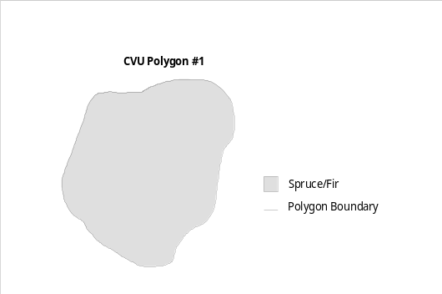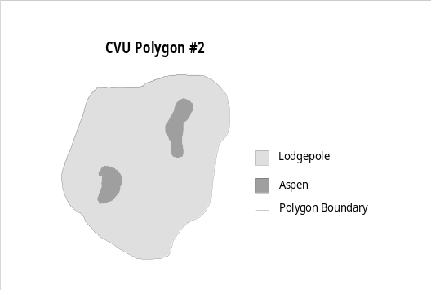
CONTINUOUS PATCHY

Recording Species Attribute Information

Each polygon is described based on existing vegetation observed in the field (at the time the site was visited). The following table shows the required attributes for each polygon, based on lifeform or ground surface cover type, as required for photo interpretation.

Attributes | Lifeform/Ground Surface Cover
 | Tree | Shrub | Grass | Forb | Ground Surface
Lifeform/GSC | r | r | r | r | r
Layer | r | r
Species | r | r | o | o
Cover % | r | r | r | r | r
Size | r | r
r = required field o = optional field

Lifeform Subtype. This item is calculated – do not enter when using the table editor. You will not see it when using the visual basic form.
Lifeform/Ground Surface Cover. You can record more than one lifeform for each polygon. At a minimum, record the dominant lifeform or ground surface cover, using one of the codes listed in the following Table in the lifeform/GSC field. Use those lifeform codes for vegetation lifeforms and nonvegetated ground surface cover types. For nonvegetated ground surface types, record the ground surface cover to the level that can be accurately interpreted. Codes listed under Barren are specific barren types.

Lifeform/GSC Codes | Description
T | Trees are woody plants possessing at maturity a well-developed stem, are generally at least 3 inches in diameter at DBH or DRC, a definite formed crown of foliage, and generally a height of at least 16 feet. Examples are lodgepole pine and aspen.
S | Shrubs are plants with persistent woody stems, a relatively low growth habit, and generally produce several basal shoots instead of a single well developed stem. Shrubs also differ from trees by their low stature and nonarborescent form, and are usually less than 16 feet tall at maturity. Examples are big sagebrush and Gamble oak.
G | A member of the family Poaceae (Gramineae). For the purposes of IRI, this code also refers to grass-like plants, such as sedge or rush.
F | Any herbaceous plant other than those in the Poaceae (grass), Cyperaceae (sedge), and Juncaceae (rush) families.
W | Water
B | Barren areas with unknown composition, lacks vegetation
BS | Bare soil
RS | Rock and soil, soil with significant surface rock(not distinguishable from one another on photo)
RO | Rock, all sizes
LD | Litter/duff
WO | Wood
IC | Permanent ice/snow

Layer. Determine the number of canopy layers present within the lifeform (eg. layers within all trees and/or layers within all shrubs); then record the layer number that the line entry of trees or shrubs falls in. Use codes in the table below. Tree and shrub lifeforms must have a minimum of one layer and not more than three layers. A layer must contain at least 10 percent of the crown cover within the component. (eg, If three layers are visible and the trees in the middle layer do not equal 10 percent crown cover, the middle height trees should be placed in the layer that is closest to its height.) If there is less than 10 percent crown cover for a tree species and no other layers of that same species, record information for that layer.
Code | Layer
0 | Unknown (SHRUBS ONLY)
1 | Top layer
2 | Middle layer
3 | Bottom layer

Species. Record the NRCS plant species code for each species. Use codes in NRIS-TERRA or NRIS-FSVEG.

Record all shrub species with unobscured crown cover (this refers to shrubs which occur in openings and would be visible from an aerial photo, not understory species). All species must be accurately identified on the data sheet. If species is unknown, identify to genus. Grass and forb species are not required to be listed. The field observer should include all grasses which occur into one data entry coded by lifeform (G) and all forbs into a separate line entry coded by lifeform (F). Cover percent must add up to 100 percent for the polygon when the cover method is specified to be “CROWN”.

Cover Percent. Record a cover percent for each line based on the cover method used.

Size. Record the sizes of tree and shrub lifeforms, using either the tree or shrub lifeform size classes in the Table below. The diameters associated with each size class are interpreted from the height and crown structure, unless measured in the field. Shrub size classes are based on actual heights. Do not include seedlings unless they are the dominant vegetation or make up a significant portion of the crown cover. The diameter of woodland tree species, including pinyon pine and juniper is estimated at root collar. Size class U (unknown) for shrubs should not be used for new surveys.

Tree Size Class |  | Description
E |  | Established seedlings. Mostly comprised of individuals 0.0 - 0.9 inches in diameter at ground level or root collar.
S |  | Small. Individuals 1.0 - 4.9 inches in diameter measured at diameter at breast height. Woodland species are measured at the root collar (DRC).
M |  | Medium. Individuals are 5.0 - 8.9 inches in diameter measured at diameter at breast height. Woodland species are measured at the root collar.
L |  | Large. Individuals are 9.0-15.9 inches in diameter measured at diameter at breast height. Woodland species are measured at the root collar.
V |  | Very Large. Individuals are 16.0 inches and larger in diameter measured at diameter at breast height. Woodland species are measured at the root collar.
 | Shrub Size Class |  | Description
 | S |  | Small. Shrubs are less than 2.5 feet tall.
 | M |  | Medium. Shrubs are 2.5-6.4 feet tall.
 | L |  | Large. Shrubs are greater then 6.4 feet tall.
R2VEG Polygon Data Sheet
Polygon Identification Sample Information
Partition  Type | Partition  (Watershed) | Poly  # | Event  Type | Survey Date  mm/dd/yyyy | Delin.  Source | Attrib.  Source | Tree  Cover  Meth | Shrub  Cover  Meth | G/F  Cover  Meth
Data Recorder Photo ID
Name | Photo  Project | Photo Roll | Photo  Frame | Photo  Year

Polygon Attributes and Links
Horiz  Div | Tree  Cond | Formerly  Range | Formerely  Trees | Fsveg Link | Terra Link | Hab  Stage

Cover Attributes
Lifeform/  GSC | Layer | Species | Size  Class | Percent  Cover

Draft R2VEG Form 11/12/2002

Maintenance Requirements

Policy

The Forest R2Veg GeoDataBase shall be maintained regularly and consistently so that it reflects the most recent sample of existing vegetation type and condition available. It is the responsibility of users of vegetation data to participate in updating the database and/or coverage when they become aware of either actual changes on the ground or errors in the data. At a minimum, field personnel shall complete R2Veg-FV forms during field vegetation surveys for input of more accurate data. It is expected that the majority of users will participate in the tabular and spatial maintenance processes. Since R2Veg is a GeoDataBase, the tabular and spatial are generally edited together and the system maintains the 1:1 correspondence.

Forests shall establish an R2Veg maintenance team, consisting of a GIS coordinator/team member and a R2Veg data steward or stewards who are responsible for coverage and database maintenance, delegating the work as necessary. Other personnel who use R2Veg information must be aware of the process involved in layer maintenance, data collection and updating. The Regional Office will develop and provide R2Veg maintenance training. All R2Veg users will keep management apprised of the need and value of timely, consistent, accurate data maintenance.

The GIS data manager on each Forest will be responsible for developing appropriate security procedures, so that only assigned individuals will have the ability to make changes to the ArcSde feature class. Privileges for updating the ArcSde Oracle Database will be assigned by the Forest GIS Coordinator or delegate.

The R2Veg inventory contains basic data and summary calculations from the basic data. Each supplemental R2Veg data collection will also consist of basic data and summary calculations, whether from an activity or a field inventory. The R2Veg coverage must be updated annually as a minimum, and may be updated more frequently if necessary for specific projects or circumstances. Updates should reflect changes due to vegetation treatment, natural changes, or new inventories, and may include such items as timber harvests, fires, insect and disease effects, blow down, etc. Updates include field verified information, and may simply result in changes in the polygon attributing, as opposed to polygon boundary changes.

The intent is to maintain R2Veg within the bounds of the delineating and attributing specifications. R2Veg is intended to be current and applicable to the Forest-wide analysis scale and project scale. Updates, at a minimum, will be commensurate with the Forest-wide scale of resolution. Forests shall make updates at a finer scale for individual project resolution. Minimum acreage parameters are listed in the delineation chapter of the R2Veg User Guide. The way that water polygons or riparian polygons were implemented may vary somewhat across the Region.

As a minimum, an archive copy of the R2Veg will be made:
- when completed and released on the Forest or Grassland
- annually.

Initially the R2Veg geodatabase may be archived to a personal geodatabase (MDB). Eventually we will probably deal with history as a “version” in ArcSde. The MDB will include all of the Oracle tabular and spatial data and can be created via a drag and drop from ArcCatalog.

Coincidence

The specifications for R2Veg require, tracking coincidence with water polygons 2 acres and larger. This is tracked in the Delineation Source field. Coincidence with water polygons is important since we do not expect trees to grow in the bottom of a lake. The delineation source field may be used to indicate other concidence that should be maintained such as riparian.

Polygon Shape Updates

GIS changes are designed to incorporate new polygon boundaries in the existing polygon set. Updating the R2Veg polygon feature class means deciding which lines to keep or replace and how to number the resulting polygons. In most cases, it will be best to have a unique temporary coverage to represent the polygons that will be used to update R2Veg, unless those polygons are on another GIS coverage, such as RMACT_A. The temporary coverage could have, for example, delineations from fires or corrected delineations from field verification.

Close coordination between the GIS coordinator and R2Veg data steward will be essential for synchronizing the updates in the geodatabase. The Forest GIS coordinator will assign version names to be used for updating. The GIS coordinator and R2Veg data steward will resolve any conflicts when reconciling a version.

There are certain rules that pertain to the R2Veg coverage:
- Maintain existing delineation and attributing source codes related to coincidence
- Coincidence to the partitions used to number polygons must be maintained
- Coincidence to water polygons must be maintained at the level initially implemented
- There may not be duplicate poly_ids within a watershed
- There may not be polygons numbered as “0”
- Data is always checked/edited whenever a polygon shape is altered or a new polygon is created
Refer to the R2Veg geodatabase chapter for details on editing your data. Refer to Exhibit 1 for generalized flowchart related to maintenance of R2Veg.

EXHIBIT 1– R2VEG MAINTENANCE FLOWCHART

The following events create a new to update R2Veg polygons, data or both:

ACTIVITIES NEW DATA COLLECTION CHANGE DETECTION
Harvest Cuts 5 acres or larger would generally require the creation of new polygons. | Stand Exam, FSVEG fuel surveys, range surveys, or any survey requiring a R2Veg FV form to be completed will result in an update to the Oracle database. | Periodically (every 5 or 10 years), the Forest will receive new resource photos or new DOQs. These should be reviewed for changes in the vegetation not picked up by activity tracking systems.
Activities less than 5 acres would not necessarily create new polygons, but would require the polygon data to be updated. | All of the activities in the left column that cause a polygon change will also need a corresponding update to the Oracle database. | New Forest inventories will require a review of the existing delineations and data.
Natural burns, prescribed burns or other similar activites may cause polygon updates if they change the character of the vegetation according to the R2Veg delineation standards. | R2Veg polygon delineation should be checked prior to collecting field data. Any needed changes in polygon delineation should be done prior to field data collection. The end result of field data collection could require both polygon and data updates | New Forest Plans will require a review of the existing delineations and data.
Tornados, windstorms, and other events can result in R2Veg polygons needing updates.
Any recorded activity in RMACT or other systems that has an accurate spatial boundary may be used for R2Veg updates.

Generic GeoDataBase Editing Setup

Qualifier – This general setup for editing geodatabases has been copied from the Noxious Weed User Guide training example prepared by Mark Applequist, San Juan NF. The steps in this guide are geared towards editing a personal geodatabase but are also applicable to a versioned SDE geodatabase.

Introduction. Before you begin editing your own personal project work, be sure that you make a backup copy of the theme(s) you are going to edit. This will give you a safety net in case you make mistakes while editing, or if you need to compare your editing work with the original, or the electricity goes off for a while. Also, remember that ArcMap is a PC program meaning that all of your work exists only on your desk, and you will be storing your work in the GIS directory structure on your PC. You need to make backup copies of your important GIS work on the server (or write them to a CD) so that you will not lose anything if your computer crashes.

Additionally, www.esri.com has a vast store of information about problems and issues regarding ESRI products. It is a safe bet that any problem you have has been encountered before and recorded on the ESRI web page. Sometimes, when we encounter problems with ESRI software, we are timid about explaining the problem to other GIS folks or the ESRI support team. We all need to get over this shyness and seek answers, because some of the problems are not user error, but rather software bugs which may be fixed in future versions. The search engine (SEARCH THE KNOWLEDGE BASE) does a good job of locating resourceS in the discussion forums, technical articles, ArcScripts, and downloads of fixes or additional tools.

ArcMap Features. For ArcView users, the transition to ArcMap will entail learning to look for the same functionality you enjoyed in ArcView, but in different places. Some of the functionality of ArcView now resides in ArcCatalog, the sister module of ArcMap within the ArcGIS suite of modules. It is best to run ArcMap by itself, and open ArcCatalogue only when necessary to perform certain operations.

A lot of the functionality that was contained in dropdown menus in ArcView is now located in right click menus in ArcMap. During your edit session, if you are having a hard time finding some functionality, try the right click. If you are working in ArcGIS, and do not know what a button does, place your mouse pointer over the button, and it will tell you. Like ArcView, these hints will also be found at the bottom left corner of the ArcMap session. Many of the functions of ArcGIS appear in more than one place, usually buttons and dropdown menus.

Editing Concepts. ArcMap allows you to edit coverages, shapefiles, geodatabases, and CAD products. We do not deal with CAD products, and experience has taught us that ArcMap is not a good editor for coverages. ESRI is evolving the coverage into the geodatabase, and this replacement is not too far in the future. Geodatabases can be either personal, on your PC, or corporate, meaning that they will reside on the server in the SDE environment. Personal geodatabases can be exported into the SDE environment, and vice versa.

WARNING: ArcMap is NOT recommended for editing coverages.

Getting Setup for Editing

Activate the Editor toolbar.
- Start ArcMap.
2. Under Tools on the Main menu, select the top choice to activate the tool bar. You will immediately see a new tool bar on your ArcMap interfact with the Editor menu at one end.

TECH TIP You can also activate the Editor toolbar by clicking the third button from the right end on the top row of buttons. You can also go to Tools Customize on the main menu.
REFERENCE You can edit in either the Data view or the Layout view, but we will do all of your editing in the Data view to prevent confusion. See Diagram 1 for the location of those buttons.

Docking the Editor toolbar.

4. Dock the Editor toolbar where you find it the most convenient to use. It is recommended to
dock it right above the mapped area. To dock, you need to grab the toolbar by the small ridge on the end of the toolbar and drag it to where you want. It will change from vertical to horizontal depending on where you put it. See Diagram 1 below for one configuration.

Diagram 1
UNDO(LEFT)/ REDO(RIGHT)
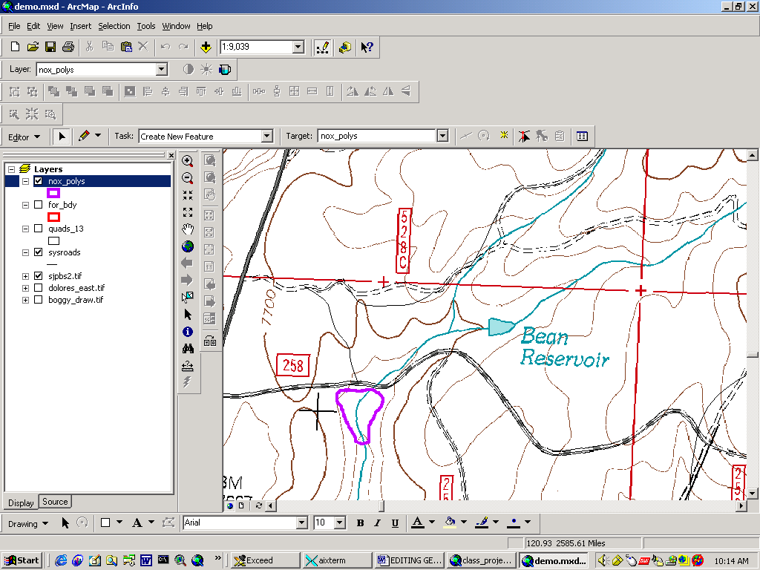
DATA VIEW (LEFT)/LAYOUT VIEW BUTTONS (RIGHT)
TOOLS TOOLBAR
LAYOUT TOOLBAR

EDITOR TOOLBAR
REFERENCE: Everybody makes mistakes, encounters unexpected results, or needs to go back to the preceding step. In Diagram 1 above, the Undo and Redo buttons are circled, and you can also find these at the top of the menu under Edit on the main menu.

Selecting the edit layers.

5. Under Editor on the Edit toolbar, choose Start Editing. You will get a menu of choices indicating which of the directories or geodatabases in which your are going to edit. By highlighting each directory on the top half, you can see which layers are included.
- Select the geodatabase to edit (MDB).
- Select the Target feature class to edit within the geodatabase. Set your project to select features from the theme you are editing. On the Selection dropdown menu on the Main menu, select the Set Selectable Layers and uncheck everything but the theme you are editing.

WARNING:
If your selectable layer is not set to your Target edit theme, you can accidentally select features from multiple layers. If you hit the delete button, you are deleting features in layers you did not intend to edit. Future versions of ArcMap may correct this.

Familiarize yourself with edit Tasks and the Edit Select tool.

9. Left click on the arrow at the right of the Task window. You will see the following options for
tasks you can select for your Editing and what those tasks accomplish.

Create New Feature | Create a new point, polygon or line
Auto Complete Polygon | Create a new polygon using an existing edge.
Select Features using a line | Select features by drawing a line through them, using Sketch tool.
Select Features using an Area | Select features by drawing a line around them, using Sketch tool.
Extend/Trim Features | Extend or Trim lines based on a line you draw with the Sketch tool.
Mirror Features | Mirror selected features based on a line you draw with the Sketch tool.
Modify Features | Modify features by dragging line or polygon vertices.
Reshape Features | Reshape features based on a line you draw with the Sketch tool.
Cut Polygon Features | Cut polygon features based on a line you draw with the Sketch tool.

- Select a feature using the Select Edit button (the black arrowhead). This select tool is for editing only. Diagram 2 below shows the location of all three select tools. The Select Features button is used to select features when not editing. The Select Elements button is used to select map objects during map making.

WARNING: Only use the “Auto Complete Polygon” tool tool for R2Veg edits. You may also use “Merge” off of the edit toolbar menu. You may split polygons using autocomplete. Never use any of the other tools or you will damage polygon topology. Be very careful to not move polygons.

Diagram 2 Location of the three different Select Tools.

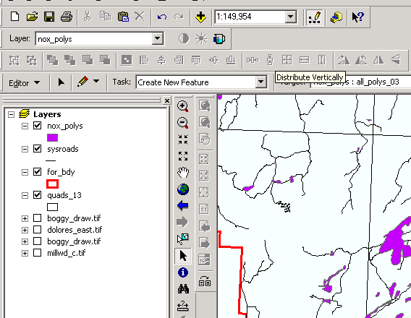
SELECT FEATURES

SELECT ELEMENTS
SELECT
EDIT
TOOLS TOOLBAR

Setting Snapping Tolerance

When you are editing, the snapping environment is very important, and can greatly increase your efficiency. Snapping tolerance refers to your ability to create features which snap to existing vertices, ends, or edges if it is within a certain distance of that feature. The best way to become comfortable with how snapping tolerances act in the real world, is to play around with different settings.

- Under Editor on the Edit toolbar, select Options.
- In the Editing Options window, change the Snapping Tolerance from 5 Map Units to 3 meters.
- Click OK to apply this setting and close the window.
- Under Editor on the Edit toolbar, select Snapping.
- In the Snapping Environment window, which appears, check Vertex, and Edge for nox_poly.
- Drag nox_poly to the top of the list so it is in first priority for snapping. Compare to Diagram 3.
- Click the “X” in the upper right hand corner to close and apply these settings.

Diagram 3 – Snapping Environment
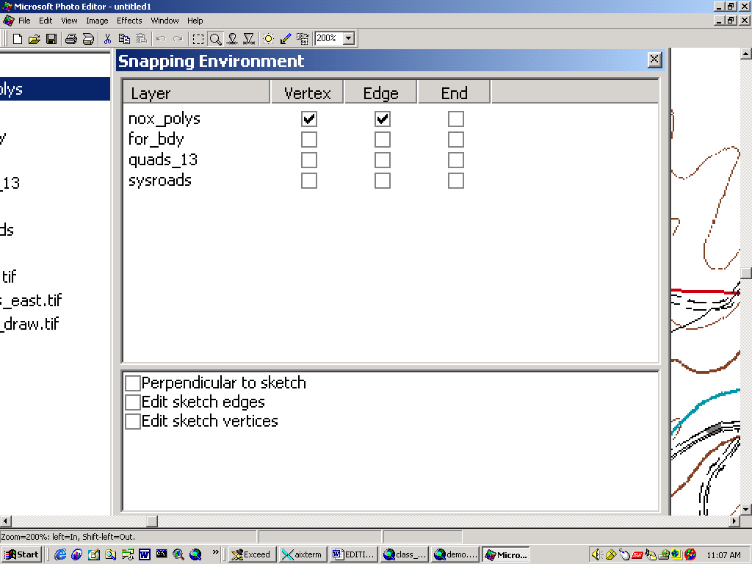

Calculate Acres

After adding activity polygons or changing the shapes of any existing polygons it will be necessary to update the Area (ACRES) field required for some reports. The following is the procedure to populate the acres field of the R2Veg feature class table.

  - open the table in ArcMap and start editing
  - right click on the acres column title and select calculate values
  - say yes to the prompt asking about clearing space for new calcs
  - type in or load the acre calculation from a file and click OK
  - (the acre calculation from meters is
[shapearea] * .000247105
  - after acres are calculated for each GIS feature save your editssto
  - stop editing

Specific Instructions to Edit R2Veg

This section assumes that all editing is done using a personal geodatabase on the PC. All background covers must reside on the PC for this to be efficient (see the recommended PC structure for doing GIS work) or they must reside in ArcSde.

Since the R2Veg cover contains 100% coverage of adjacent polygons it is very important to maintain topology. The best way to do this is by sticking to the correct editing tools.

- Only use two editing tools:
  - autocomplete polygon (split polygons and create new polygons)
  - merge
- Never use any of the other available editing tools.
- Never move a polygon. This can easily happen by accident when you have a polygon selected. If it does happen do not try to move it back. Use edit/undo.
- When merging a polygon, the one selected first will retain the data. The first one selected also show in the table editor if that is open. This is a good double check.
- When splitting a polygon, both polygons will end up with the same data that the original polygon had. There are some choices to make after splitting:
  - Do you want to redo the polygon and species data
a) Before opening any links with the table editor, change the polygon identity. This will delete the linked data. If it does not, perform a save and this will clear the links.
  - Do you want to retain the polygon and species data and edit it for the “new” polygon
    - Open the links to the polygon and species data
    - Change the veg_links to the new one in all 3 tables; feature class, polygon and species (only the species records you want to change).
    - Save your changes
    - Alter the remaining data
    - Never delete a species or polygon record with the original number as it will be deleted for the original link (the other polygon). Think!
  - Do you want to retain and alter the polygon and species data for the one polygon that keeps the identity of the original polygon?
    - Simply edit the polygon and species records leaving the veg_link alone.
    - Delete species records that no longer apply.
- Do not cross partition boundaries
- New polygon numbers should be obtained using the following method.
  - stop editing (or don’t be in an editing session)
  - open the R2veg feature class table
  - use the options tab to select the partition that the polygon lies in
    - Such as [veg_link] like ‘WDOLXX*’
    - Right click on veg_link and select summarize
    - Be sure to check the box to use only selected.
    - Add the resulting table to your project, open and review the list
    - You may pick a number larger than the largest number or one in-between that is not being used.
    - Note that the count should never exceed 1 which would indicate you have duplicate polygons.
- Always consider using the following for background when editing R2Veg:
    - DOQs resident on the PC or in ArcSde
    - Dissolved Partitions (can create on the fly)
    - Activity layer

- Never point to a layer that resides on the server directly (i.e. the j: drive). This will bottleneck the entire process. If a layer is used that resides on the server, it must be accessed via ArcSde so that the performance will be adequate.
- Always make a copy of your MDB prior to editing and after a series of major change.
- Your edits should be performed on a subset of the geodatabase (ideally a “checked out” version from ArcSde).
- Always use the TABLE editor to make changes to the data. Never open the tables any other way to edit them.

If the above rules are followed your editing experience with R2Veg should be positive. When you make a mistake that is difficult to correct use the undo or stop editing without saving.

Polygon Split using Autocomplete Polygon.

Note: When splitting always start outside the desired polygon to split and end outside.

Before –
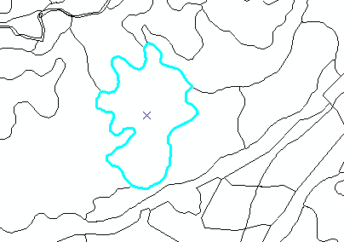

After –
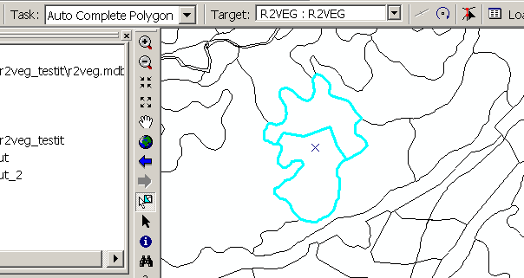

Data After – everything is the same except for the object id
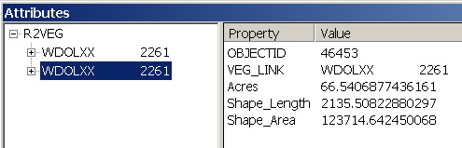

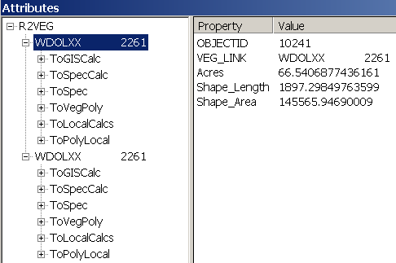

Objective – Keep data for one highlighted and re-enter for other one
Notice that when you click on the veg_link that the polygon highlights.
There is a group of ID’s available from 2531-2681.

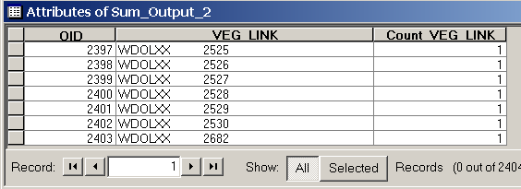

Change the poly_id portion of the veg_link ID to 2531 (carefully keeping the number right justified in the field).

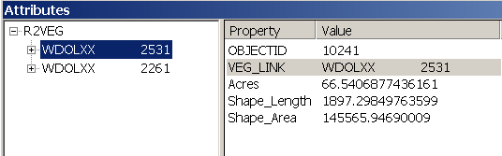

Now when opened, there are no related tables (no plus signs)

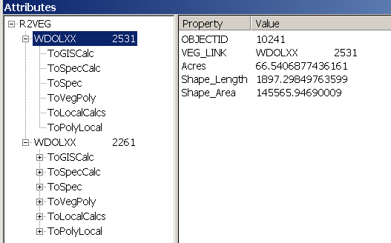

The user must create the related data for the polygon table and then the species table (the ToVegPoly and ToSpec relationship classes. Some Forests may have optional data in the local table (ToPolyLocal) that may also have to be entered. Do not change data in the other tables since those are for calculated data only.

Right click on ToVegPoly and select add new and notice the new object id of 46454.

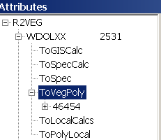

Click on the object id to see the empty table and start entering data via the pulldown selections (i.e. click on Nul to see a list of valid selections for most items). Type in partition and poly_id to match the appropriate portions of the veg_link field.

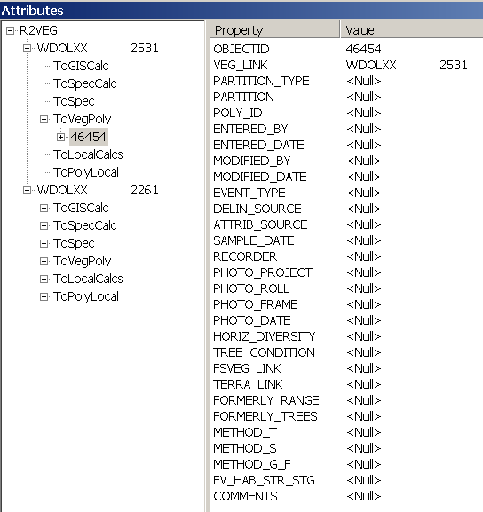

All required items are filled in:

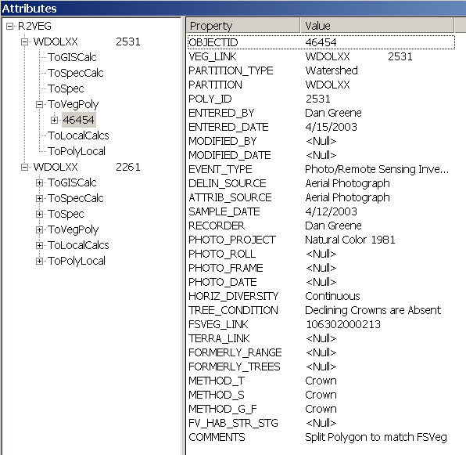

This is a new data set, so the modified_by and modified_date are left blank. The photo Project can be more specific to identify an individual photo, or can identify a GIS layer of photo centers for a spatial reference. In this example, the layer is identified and the individual photo information is left blank.

The FSVeg link must be filled in if it exists. The number in this case is based on the RIS data for older surveys since the old and new boundaries are reasonably matched. It may be based on the watershed alias and R2Veg polygon number for new surveys (ie, in this case WDOLXX253113 if there was a new survey). Remember that there is only one polygon record and do not add a second for the same polygon.

Next Fill in the species data. There may be several species records for the same polygon. In this case, the CROWN cover method is used and the cover percents should add to 100% or less. Since this is a photo survey, less than 100% may be accounted for as long as 100% of the dominant life form is accounted for.

Now code the species records. We have two lines to record, so right click on the ToSpec relationship class and select add new twice.

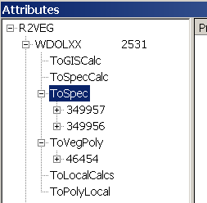

Complete the data for each species record using the pull down menus.

Do not fill in partition_type, partition, poly_id, entered_by, entered_date, modified_by, or modified_date since this will be calculated by the coordinator based on the information you entered for the polygon prior to merging with the master data set.

Do not fill in distribution percent as this is just a carry over field from CVU. The first record looks like the following:

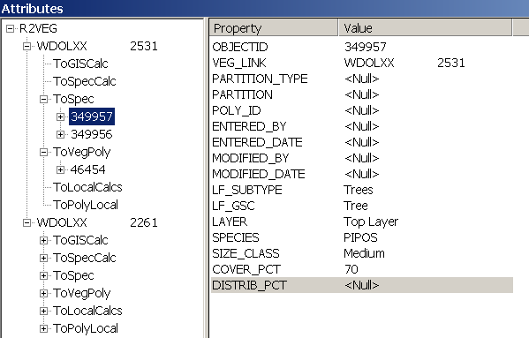

Now complete the 2nd record following the rules in the attributing section of this guide:

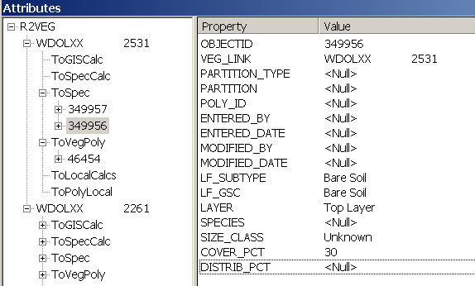

Lifeform_Subtype is redundant, but necessary if using the table editor rather than the VB form. There are some advantages of ArcGis subtypes but they have to be defined as numeric fields. Thus in the background, LF_SUBTYPE is just a conversion of LF_GSC to a numeric subtype code that takes place in the background.

The other polygons would also need to be edited and corrected. The key is to always leave the original number with the polygon that matches the original data best. For this polygon, add the modified_by and modified_date to the polygon table. Modify any values in the polygon table as appropriate. Delete any species records that are not needed (right click, delete) and modify the data for the remaining species records as needed.

Save your edits!

Polygon Merge

First determine which polygon that you want to delete the species and polygon data. In this case select polygon 2531, right click on the data for the ToVegPoly relationship and delete it. Do the same for the two records in the ToSpec relationship. If you do not do this it could be cleaned up later since there will be records in the polygon and species table that do not have a match in the feature class table. R2Veg defines “simple” relationship classes to allow easy use of the ArcCatalog data loader tool, but “composite” relationships could have been defined which would have resolved this minor inconvenience.

For this example, lets merge the two polygons that we just created by splitting back to the original polygon. The data for the merge is dependant on which polygon was selected first so in this case we want to select the polygon with the original veg_link identity first. Select polygon 2261 first.

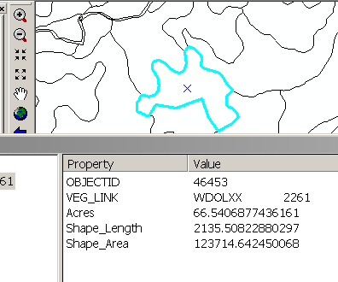

The hold the shift key and select polygon 2531.

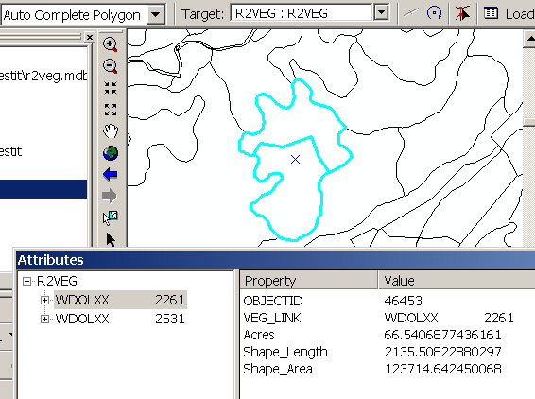

Be sure that the one with the data is shown on top of the list with the table editor (2261).

Right click on the editor and select merge.

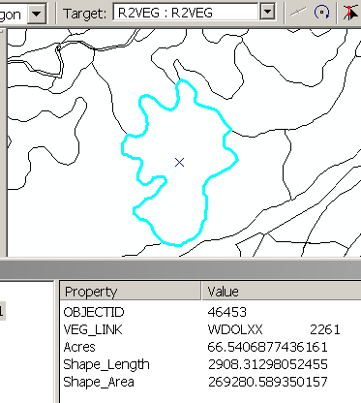

Save Edits.

Note: Do not combine polygons from two different Partitions. The partition boundaries are firm unless changed by Forest decision.

Adding a New Polygon coincident to a Watershed.

Note: When adding a new polygon, always start inside an existing polygon boundary and end inside an existing polygon boundary.

Since the Existing Vegetation cover always consists of contiguous polygons, adding a new polygon means adding a polygon to the outside boundary. When doing this, the watershed boundary, or whatever is being used for partitions becomes important since it is not obvious from the numbering system where the boundaries are.

The example R2Veg feature class used huc5 and huc6 boundaries to define the partitions (blue being the HUC6 background).

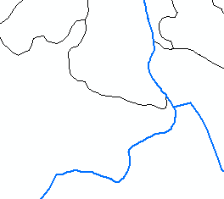

Start Editing and set snapping to both huc6 Vertex and Edge.

For the watershed edge only, set the snapping tolerance to 30 meters (reset this back to 3 meters when done with polygons next to the watershed boundary. Zoom in close.

Start from inside an existing R2Veg polygon, draw your line to the watershed boundary, carefully follow that boundary past the edge of the existing R2Veg polygon and double click inside the existing R2Veg polygon to close. Note how the line will snap to the HUC6 line. Below is the new polygon perfectly coincident to the watershed line.

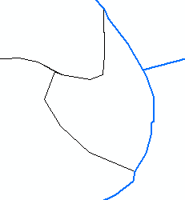

Add your data for the new polygon as in the previous example. Be sure to reduce your snapping distance for creation of the inside polygons.

Creating a Subset of Data to Edit

Versioning to a personal geodatabase will not be available until ArcGis 8.3 is releaased for Forest Service use. In lieu of that, a procedure is described in this chapter that enables the coordinator to set up a subset of the data for an individual to edit. It is not good to give out a copy of the entire R2Veg database to edit since errors can be made that extend beyond the scope of the area to be edited.

To follow this procedure requires that you have a populated R2Veg Master dataset and an empty R2Veg geodatabase. Both much match in terms of domains and relationship classes. If created from the original R2Veg repository, it becomes necessary to re-type the local domains.

Step 1

Create a project boundary that covers the extent of the area you want to edit.

Step 2

Make a copy of the empty R2Veg geodatabase and rename it to something meaningful such as the person’s name who will be doing the edits such as:

r2veg_scott.mdb

Step 3

Open ArcMap and add the project boundary and then a copy of the master R2Veg. This could also be the master ArcSde version of R2Veg accessed from the fs_public connection. Note that the project boundary (for the purposes of editing) should be a single polygon (not multiple polygons).

Step 4

Select by location

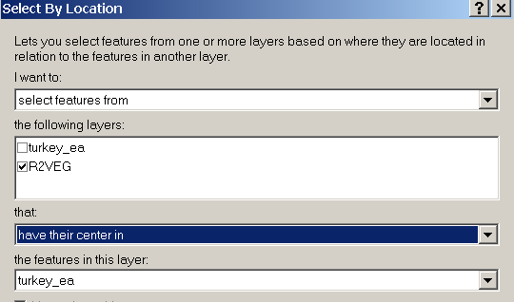

You must use a method of spatial selection that results in whole polygons. The outside boundary of the edit polygon data set must not be changed at all so that it can be merged into the master. Therefore you may want to buffer.

After selecting the polygons, open up the table for the r2veg_feature class and bring the selected records to the top. Under options, open both the polygon and species tables for the related records and bring the selected to the top. The related tables are identified by “ToVegPoly” and “ToSpecies”.

Step 5

Export the layer, the poly table, and the species table into the r2veg_scott.mdb geodatabase and call the layer temp_veg, the polytable temp_poly and the species table temp_species. Export only the selected records.

The working MDB should look like:

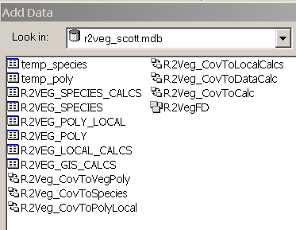

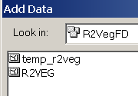

Step 6

Open up ArcCatalog and navigate to r2veg_scott.mdb

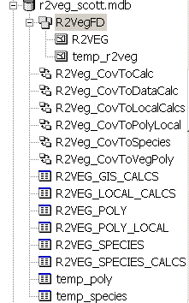

Right click on the R2Veg feature class and select load data
Next
Navigate to temp_r2veg and add it
Next all the way to the finish screen.

Step 7

Do the same for the R2Veg Poly table (loading the data from temp_poly) and for the R2Veg_Species table loading the data from temp_species. Loading should proceed smoothly since there is an exact match between tables.

Step 8

Right click on the TEMP layer and 2 tables in ArcCatalog and delete them.

Step 9

Confirm that all looks ok by querying up the edit area in ArcMap

Step 10

Distribute the MDB for editing. Log that a version of an area has been checked out to Scott Wagner in this example for editing. Be sure that the editor knows not to alter the outside boundary of edit area. The coordinator will be deleting the polygons from a copy of the master for the same area when bringing the data back in and reversing the process used to export to a subset MDB. The coordinator will also need to update the Acres and fill in the missing fields at the top of the species table via calculation from the R2Veg Poly data.

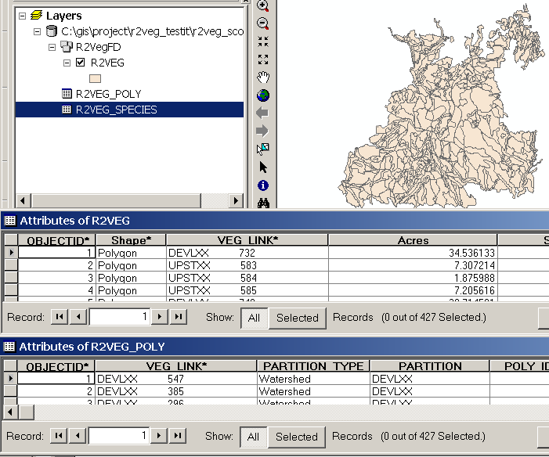

Notice that there are the same number of records in the polygon table as in the R2Veg feature class. There are 3054 records in the species table or about 7 species records per polygon. If you start editing the pull down menus should still exist (domains). Polygon and species relationship classes should still work. The calculated tables may be ignored for the editing process.

Sample Query of the R2Veg GeoDataBase

For this example we will perform a query that could not be done (easily) using the old IDS-CVU system. We would like to query all polygons that have OAK coded in the species table.

Open the species table to where you can see the species column.

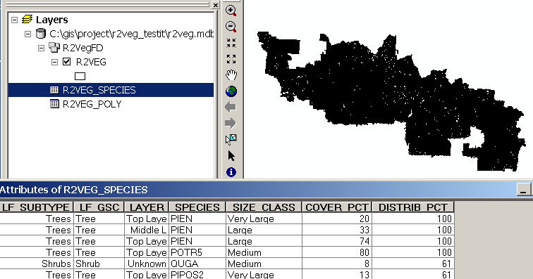

Under options select by attribute and apply.

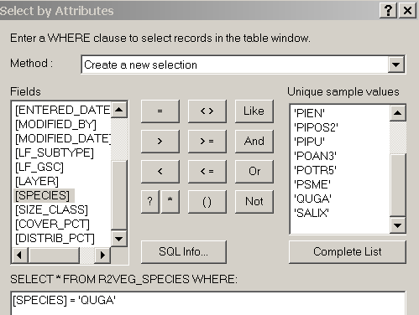

Show selected and you will note there are 16,530 records. But also note that no polygons show as selected on the polygon map. Under options, related tables, select the ToPCov relate (to polygon coverage).

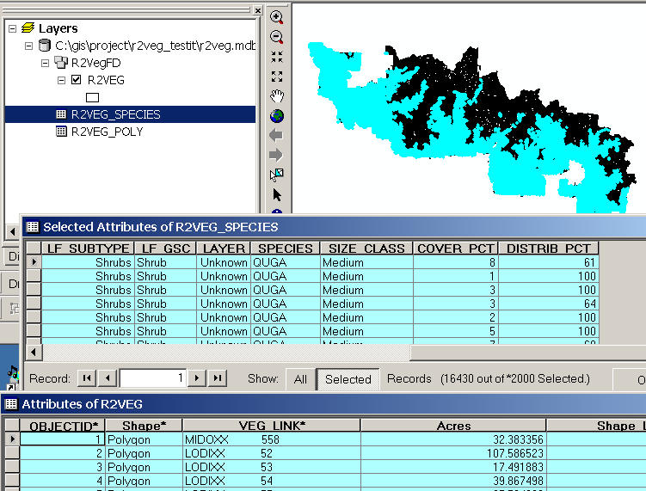

Other Tables R2Veg Links To
Need to add info on how to link to the RMSTAND_POLY_SUMMARY table once that has been fixed.

Calculated Tables

Two draft chapters currently exist for R2Veg GIS calculations (slope, aspect and elevation) and for the species calculations (cover type, hab struct stage, etc) and those will be included once the Visual Basic routines are complete. The calculations work by selecting a data set to calculate and then pushing the calc button.

For edit projects, it will be important to be able to reproduce the selection that produced the subset for editing.

