 | 
 | Bildiri Özetleri
Ana Sayfaya Dönüş

Back To The Main List

Overgrazing Effect on Rangeland Soil Properties
Mudahir Ozgul, Taskin Oztas
Ataturk University, Faculty of Agriculture, Department of Soil Science, Erzurum, Turkey

Abstract
Overgrazing is one of the main factors causing range degradation by leading erosion, reducing biodiversity, and altering soil properties. The objective of this study was to evaluate soil properties of an overgrazed range site with those of a protected range site. Two study sites had similar grazing history until 1990. But the protected site has never been grazed since after then. Soils of both sites formed from calcareous parent material on similar topography. In both sites, morphological description of the soil profiles was defined, and some physical and chemical properties including particle size distribution, bulk density, moisture content, aggregate stability, penetration resistance, soil pH, organic matter content, plant- available P, and CaCO3 content were determined. Canopy coverage rate of soil surface was also measured. Results were indicated that the protected site; had at least four times biomass, higher amounts of clay content, low penetration resistance and bulk density, higher moisture and organic matter content, and more water stable aggregates than those of uncontrolled range site.
Introduction
Rangelands have special importance in resource management. About 80 % of land under erosion risk in the world consists of rangelands (Thurow, 1991). Grazing is the most economical way of evaluating rangeland vegetation. But, overgrazing or uncontrolled grazing always reduces plant cover that protects the soil and finally causes soil erosion and compaction (Oztas et al. 2000). Overgrazing and its attendant effect of depletion of plant cover and litter and trampling of the soil is the most important factor contributing to erosion (Branson et al. 1981), which threats about 85 % of our lands in Turkey. The grazing lands of Turkey are subject to quite heavy, uncontrolled grazing pressure and the forage production capacities of these lands are gradually decreasing, therefore, ultimately reflecting typical examples of land degradation all over Turkey (Tukel&Hatipoglu, 1996). Overgrazing which led to deterioration of plant cover on rangelands was initiated in 1950s and has been continued up until today (Koc et al. 2000). As a result of increasing grazing pressure, Turkey's rangelands has lost about 90 % of their climax vegetation (Genckan et al. 1990). Koc (1995) emphasized that rangelands in our country were in poor and moderate categories with a canopy cover rate of 20 % on the average, and the degradation was too severe in lower altitudes. The objective of this study was to evaluate soil properties of an overgrazed range site with those of a protected range site.
Material and Methods
An overgrazed rangeland and a rangeland protected from grazing for ten years were selected to determine changes in some soil properties and biomass. The study sites are located in Tuzcu village, which is about 5 km southwest of Erzurum. Soils of both sites formed from calcareous parent material on similar topography. Sheep fescue was the dominant species in both sites. The study sites have never been cultivated. Average slope gradient in the study sites was about 15 %. Both sites had similar grazing history until 1990. In the region farmers tend to graze range lands as long as climatic conditions are favorable for grazing. Grazing starts with the melt of snow in spring and continues until the snowfall in autumn (approximately 9 months). The study area has a semi-arid moisture regime with a mean annual precipitation of 446.2 mm and a mean annual temperature of 5.9 oC. The mean annual evaporation and relative humidity are 1059 mm and 63 % respectively (Anon., 1997).
After searching for typical profiles to represent overgrazed and protected sites, two soil profiles were dug. The profile I was located in overgrazed range site, and the profile II in protected site. There was only 500 m distance between two range sites. The range sites on which profile II was dug, was surrounded by wire about ten years ago, and it has never been grazed since 1990. Morphological description of the soil profiles was performed according to the Soil Survey Division Staff (1993) and presented in Tablo1 & 2. Observation on topography of the site, the extent of erosion, and the degree of drainage and soil moisture status were reported. Disturbed and undisturbed soil samples were collected from different horizons, and analyzed for some physical and chemical soil properties including particle size distribution, bulk density, moisture content, aggregate stability, soil pH, organic matter content, plant- available P, and CaCO3 content. Penetration resistance of soils was determined using field-type penetrometer.
Results and Discussion
Measured physical and chemical properties of soils are given in Table 3. Clay content of different horizons in Profile I was almost constant, except the surface horizon which had about 20 % less clay content than those of the lower horizons. This may due to erosion losses. Although the profile II had greater amounts of clay content (around 30 %, except the deepest horizon) than the profile I, there was no changes in clay contents between the top horizon and the lower horizons. This clearly indicated that erosion losses were minimized in protected range site by keeping plant cover on soil surface, which reduces raindrop impact and run-off.
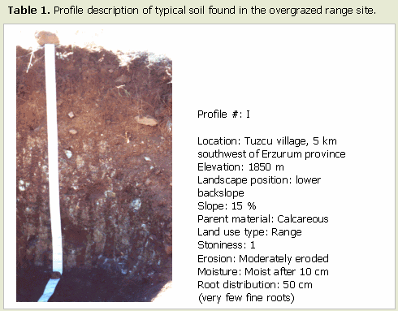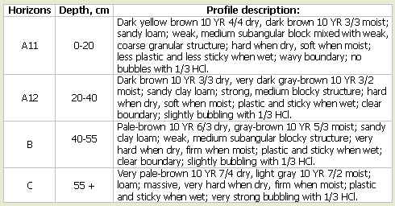

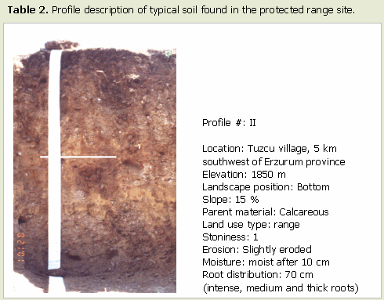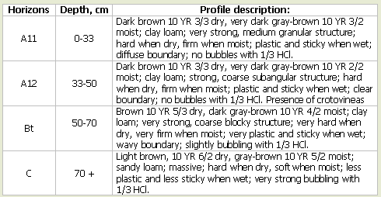
Soil bulk density values of the samples representing the profile I were higher than those of the profile II. This may be related to soil texture. The profile I had around 50 % sand that may cause high bulk density values. Although bulk density values were almost constant and changed around 1.04 g cm-3 through the soil profile dug in the protected site, there was no such situation in the soil profile of overgrazed range site. High bulk density of the top horizon in the overgrazed range site may be resulted from soil compaction due to extreme pressure by heavy grazing.
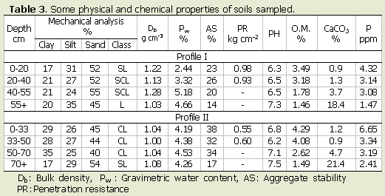
Soil water percentages at the time of sampling showed significant differences between two sites. The overgrazed site was drier than the protected site. Soil water percentages were respectively constant throughout the soil profile at the protected site. However, soil moisture content decreased down to 2.44 % in the surface horizon of the profile at the overgrazed site. It could be concluded that soil water losses from the profile were higher in the overgrazed site because of lack of plant cover on soil surface. Aggregate stability of soils, which affects soil's resistance against erosive forces, was higher in samples from the protected site. This means that a higher amount of aggregates in soil at the protected site was water-stable as compared to that of soil at the overgrazed site. This may be a result of high amounts of clay and organic matter content in soil at the protected range site. On the other hand, penetration resistance that also effect water movement into soil as related to runoff losses was higher in soils at the overgrazed range site. It was almost twice in overgrazed site than the protected site had. Organic matter content of soils at the overgrazed site was less than 3.5 % in the upper two horizons, but it was higher than 4 % at the protected site soils. This may be directly related to higher surface cover rate in the protected site.
CaCO3 contents of the range site soils were quite similar in both sites. It increased with depth and reached the highest value at the deepest horizon. Low CaCO3 values at the upper horizons were resulted from leaching. Similar to the variation of organic matter content, plant-available-P content was the highest at the surface horizon of both sites. There were no significant differences in plant available P contents of soil between lower horizons. However, surface horizon at the protected site had significantly higher amount of available P than that of the overgrazed site soil had. On the other hand, it was determined that while the rate of canopy coverage at the overgrazed site was lower than 20 %, it was higher that 80 % at the protected range site. Results were indicated that the protected site had at least four times biomass, higher amounts of clay content, low penetration resistance and bulk density, higher moisture and organic matter content, higher amounts of plant available P, and more water stable aggregates than those of the overgrazed range site. In conclusion, the results of this study support the idea that overgrazing causes low level of vegetation and poor soil properties.
References
. Anonymous. 1997. Weather Forecasting Sub-Directory Bulletin. General Directorate of Government Meteorological Works. Ankara (In Turkish).
. Branson, F.A., Gifford, G.F., Renard, K.G. & Hadley, R.F. 1981. Rangeland hydrology. 2nd ed. E.H. Reid (ed). Soc. Range Manage. Kendull/Hund Publ. Com. Iowa.
. Genckan M.S., Avcıoglu R., Soya H. & Dogan O. 1990. Türkiye mer'alarının kullanımı, korunması ve geliştirilmesine ilişkin sorunlar ve çözüm yolları. Türkiye Ziraat Mühendisliği 3. Teknik Kongresi, 8-12 Ocak 1990, Ankara s. 53-61.
. Koc A. 1995. Topografya ile toprak nem ve sıcaklığının mer'a bitki örtülerinin bazı özelliklerine etkileri (Doktora Tezi). Atatürk Üniv. Fen Bil. Enst., Tarla Bit. Anabilim Dalı, Erzurum.
. Koc, A., Oztas, T. & Tahtacıoglu, T. 2000. Rangeland-livestock interaction in our near history: Problems and recommendations p. 293-298 13-17 June 2000. Konya-Turkey.
. Oztas, T., Koc, A. & Comakli, B. 2000. Changes in vegetation and soil properties along a slope. Proceedings of International Symposium on Desertification, Konya, pp 57-61.
. Soil Survey Division Staff. 1993. Soil Survey Manual. Soil Conservation Service. USDA. Handbook 18.
. Thurow, T.L. 1991. Hydrology and erosion. p. 141-159. In Grazing management an ecological perspective (Ed) R.K. Heitschmidt & J.W. Stuth. Timber Press, Inc.,
. Tukel, T. & R. Hatipoglu. 1996. Turkish grazing lands; Causes for misuse and likely measures of preventing degradation. Int. Conference on Land Degradation. June 10-14, Adana - Turkey p, 53.

Sayfa Başı

