WIP

Working With DEAR

Guide to the DOI Enterprise Architecture Repository

Prepared by: Northrop Grumman Mission Systems

Contact: Michael Schievelbein

Original Content Date: January 27, 2004

Table of Contents
Table of Contents 2
Advanced Guide 3
1 Open Large Diagram 3
2 View Object Properties 6
3 Perform a "Referenced By" Query 10
4 Create a New Diagram 12
5 Create a New Encyclopedia 18
6 Extract From and Merge to an Encyclopedia 18
7 Create a New Diagram and Copy and Paste Objects from one Diagram to Another 18
8 Rearrange the Children in a Hierarchical Model 23
9 Check Out and Check In an Encyclopedia Object 25
10 Work with a Matrix 28
11 Export Data to a CSV File 33
12 Import Definitions from a File into the SA Encyclopedia 35

Advanced Guide

Open Large Diagram
The following steps show you how to zoom in and zoom out so you can read a large diagram.
Step | Do this… | Notice this…
1 | In the Encyclopedia Browser, expand “Diagrams”, then expand “TECHNICAL-REFERENCE-MODEL”, then right-click on “Technical Reference Model”, and select “Open”. | 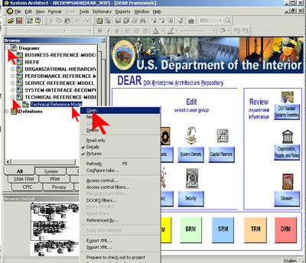
2 | Click “Yes” in the warning window. | 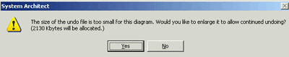
3 | If you get a message that the diagram is in use by someone else, click “OK”. | Only the first person with the diagram open can write to it—everyone else sees it in read-only mode. (It will say “READ ONLY” in the window’s blue title bar.)
4 | Select the magnifying glass in the toolbar. | 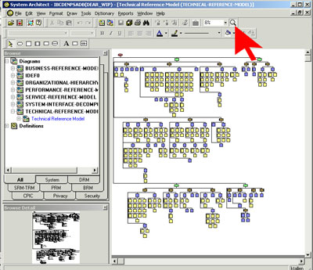
5 | Zoom in on part of the diagram by drawing a box around that part (hold down the left mouse button while pulling the cursor diagonally across the area to be magnified.)  When you release the mouse button, the diagram zooms in on that area. | 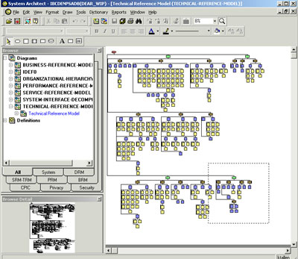
6 | Left-click to zoom in one level. Keep clicking until the symbol’s text is easy to read. | 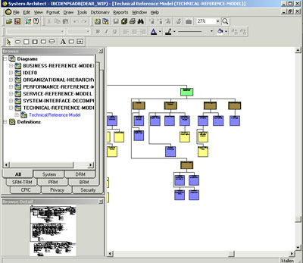
7 | Right-click to zoom out one level.
8 | Get out of zoom mode by  - pressing the Esc key on the keyboard,  - clicking the cursor icon on the toolbar, or  - clicking the magnifying icon again to turn it off. | 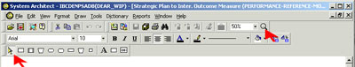

View Object Properties
The following steps show you how to find an object, look at its properties, and change them.
Step | Do this… | Notice this…
1 | Click on the binoculars in the toolbar. In the Find Symbol window that comes up, enter “D” in the text box. | 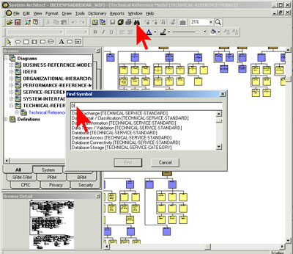
 |  | The text will automatically scroll to the part of the list that starts with “D”.
2 | Select “Database-Storage (TECHNICAL SERVICE CATEGORY)” and click “Find”. | 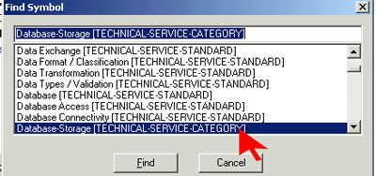
The symbol will show up with little black boxes around it, meaning it is selected. (If you can’t see it clearly, zoom in until you can.)
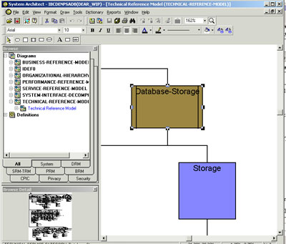
3 | Open the symbol’s definition dialog in one of these ways:  - From the menu bar, select “Edit”, then “TECHNICAL_SERVICE_CATEGORY”  - Right-click on the symbol itself and select “Edit” from the floating menu. | 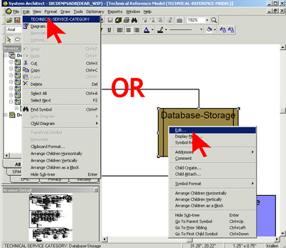
4 | Click through the tabs in the definition dialog to get familiar with them, then click “Cancel”, so as not to save any accidental changes. | 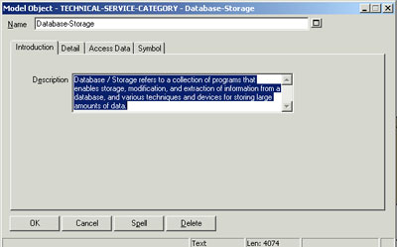
5 | Use the binoculars again, to select “Change Control (TECHNICAL-SERVICE-STANDARD)”; then open the definition dialog for that symbol. | 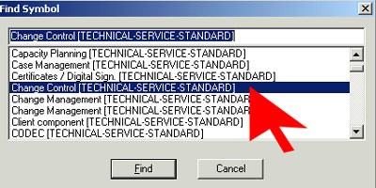
6 | If you are in read-only mode, get out and start over when you have write access, because the next steps cannot be done in read-only mode.
7 | Change the name in the definition dialog to “XXX-Change Control”, where XXX is your initials.  In the Description box, type “Now is the time for all good men to come to the aid of their country.” | 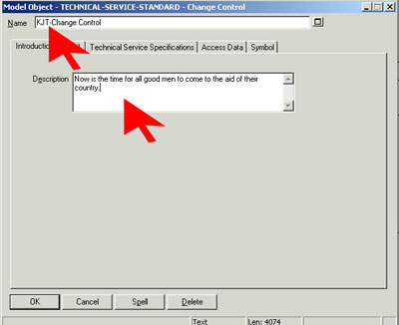
8 | Click “OK”. | 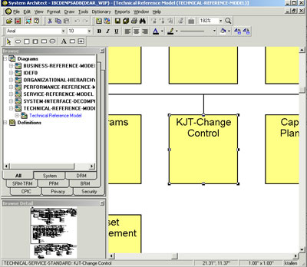
9 | Close the diagram from the keyboard with CTRL-W, or from the menu bar with “Files / Close Diagram”.  Click “Yes” on the window asking whether to save.

Perform a "Referenced By" Query
These steps show you how definitions reference each other. You will discover the way to a definition dialog through a set of Referenced By windows.
Step | Do this… | Notice this…
1 | In the Encyclopedia Browser, expand “Definitions”. Scroll down to “TECHNICAL-SERVICE-AREA” and expand that. | 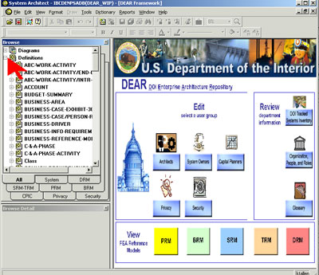
2 | Right-click on “Component Framework” and select “Referenced By” from the floating menu. | 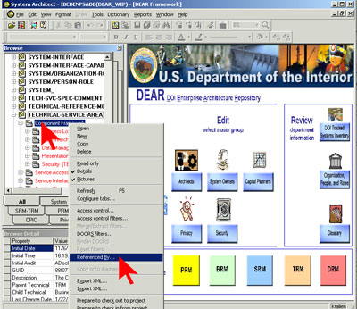
3 | In the Referenced By window that comes up, right-click “Business Logic” and select “Referenced By” from the floating menu. | 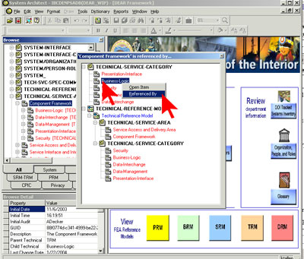
4 | In the second Referenced By window, right-click the first item under “SERVICE-COMPONENT/TECH-SVC-STD”, and select “Open Item” from the floating menu. | 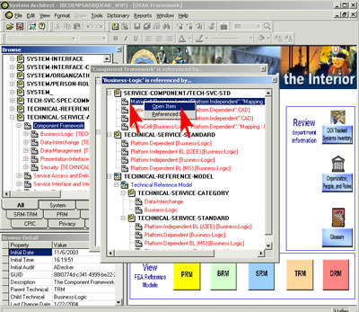
5 | When you are finished looking at the definition dialog that comes up, click “Cancel”. | 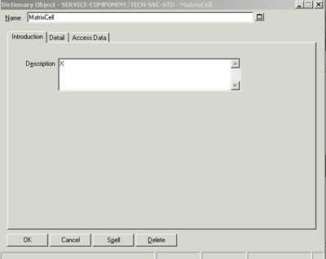

Create a New Diagram
These steps show you how to create a new diagram and add symbols to it.
Step | Do this… | Notice this…
1 | From the menu bar, select “Tools / Preferences”. In the window that comes up, make sure all the preferences are set as shown at right.  Don’t miss the Save checkbox (by the red arrow)!  Click “OK”. | 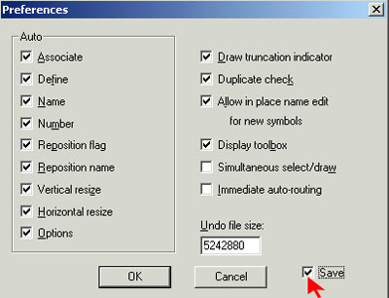
2 | From the menu bar, select “File / New Diagram”.  In the window that comes up, select “BUSINESS-REFERENCE-MODEL”, and click “OK”. | 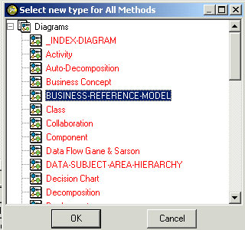
3 | In the naming dialog that comes up, give the new diagram the name “XXX-Wild Fire Management”, where XXX is your initials.  Click “OK”. | 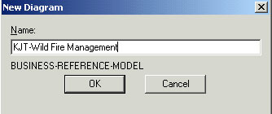
4 |  | You will get a blank window for your new diagram, and a draw toolbar. Each type of diagram has its own draw toolbar; this is the one for Business Reference Model diagrams. It has five icon types; if you forget which is which, mousing over each will show its name.  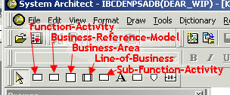  To put one of these symbols in the diagram, just click on that symbol in the toolbar, then click the spot in the diagram where you want it.  As long as your cursor is shaped like a pen, you are in draw mode and every time you click it will add another symbol of that type to the diagram. Use the Esc key as the “undo” function to erase any symbols you draw accidentally.
5 | Add a BUSINESS-AREA to the diagram. | 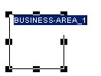
6 | In the Model Object window that comes up, change the name to “XXX-Manage Wildfires” where XXX is your initials.  Click “OK”. | 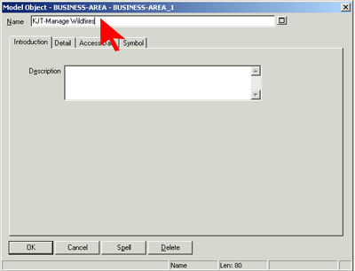
7 | Add a LINE-OF-BUSINESS under “XXX-Manage Wildfires”.  Name it “XXX-Provide Infrastructure”. | To get the connecting line, start with your pen on the BUSINESS-AREA and drag the pen downwards before releasing the mouse button.  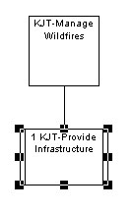
8 | Add three FUNCTION-ACTIVITY symbols under “XXX-Provide Infrastructure”.  Name them  “XXX-Educate Personnel”,  “XXX-Assess Wildfire Threat”, and  “XXX-Review Lessons Learned”. | Note that each level of the diagram is automatically numbered.  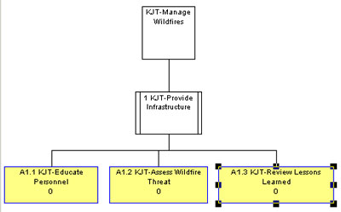
9 | Add a Doc Block to the lower left corner of the diagram. | A Doc Block is an identification box, showing the name of the diagram, when it was created, and any comments. The Doc Block tool is also on the draw toolbar.  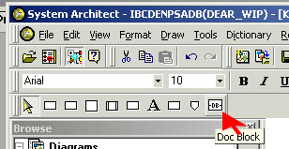
 |  | 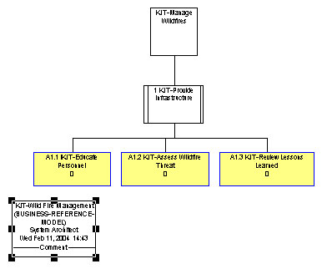
10 | Right-click in an open area of the diagram, and select “Save Diagram” from the floating menu. | 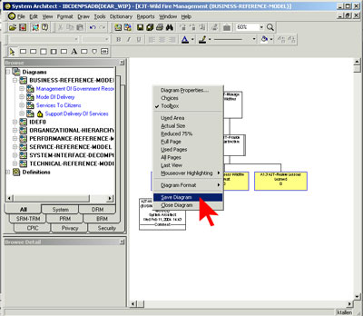
11 | From the menu bar, select “File / Save Diagram As”  Click “Yes” if asked if you want to save changes to the diagram.  Name the new diagram “XXX-Wild Fire Management – ToBe”  Click on “BUSINESS-REFERENCE-MODEL”.  Click “OK”. | 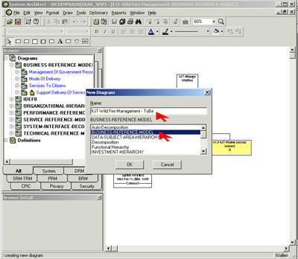
12 | Refresh the window, either by F5 on the keyboard, or right-clicking in the Encyclopedia Browser on “BUSINESS-REFERENCE-MODEL” and selecting “Refresh” from the floating menu. | You should see your two diagrams in the menu.  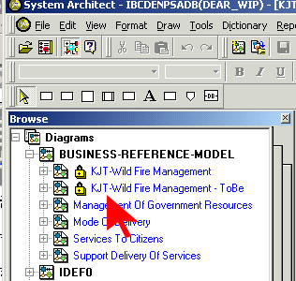
13 | From the menu bar, select “Window / Close All” to close all the diagrams.

Create a New Encyclopedia
Creating a new encyclopedia is an administrative function. Your system administrator will know where and how to create a new encyclopedia. If you need a new encyclopedia, put in a help ticket.

Extract From and Merge to an Encyclopedia
Extracting from and merging to an encyclopedia are administrative functions. Your system administrator will know how to extract and merge. If you need extracting or merging done, put in a help ticket.

Create a New Diagram and Copy and Paste Objects from one Diagram to Another
These steps show you how to build a new diagram from an old one and add symbols to it.
Step | Do this… | Notice this…
1 | In the Encyclopedia Browser, expand “Diagrams”, then “ORGANIZATIONAL-HIERARCHY”, then right-click on “DOI Org Chart” and select “Open” from the floating menu. | 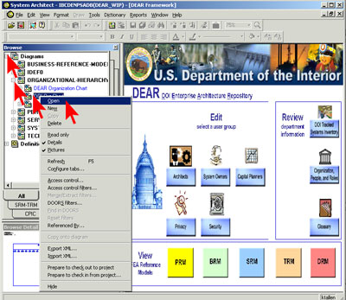
2 | Right-click on “ORGANIZATIONAL-HIERARCHY” and select “New” from the floating menu. | 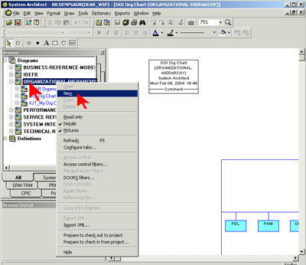
3 | In the New Diagram window, enter “XXX-My Org Chart” where XXX is your initials.  Click “OK”. | 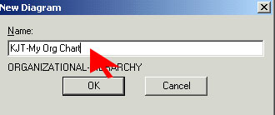
4 | Tile the windows (from the menu bar, select “Window / Tile Horizontally”.)  If you still have the framework window open, close it, then tile the remaining windows again.  Adjust the size of the diagrams so you can see the overall structure. | 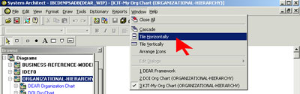
5 | Select part of the DOI org chart by drawing a box around it with the cursor (drag the cursor diagonally across the area you want the box to cover.) | The selected symbols are each outlined with little black boxes. 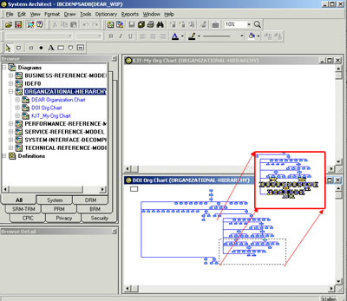
6 | Copy and paste the section into the XXX-My Org Chart window. (You can do this from the keyboard with CTRL-C and CTRL-V, or from the toolbar with the Copy and Paste buttons pointed out bythe red arrows.)  If you get a warning window about having selected unconnected parts of the hierarchy, just click “OK”.  When you paste, it doesn’t put the symbols in immediately; it gives you a box the size of your selection, with the cursor shown as a hand “holding” the box. Move this box around to wherever you want the symbols to be, then click, and the symbols will appear. | 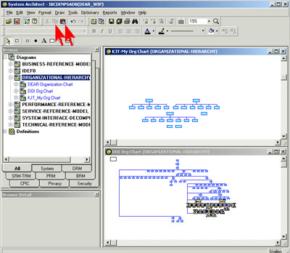
7 | Click on the Organization box on the toolbar to get the symbol-drawing pen. | 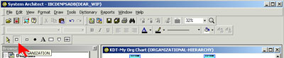
8 | Connect the new symbol to an existing symbol, by clicking where the red arrow points, and pulling the pen downward. | 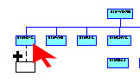
 |  | If you don’t start by clicking on an existing symbol, the new symbol will be on its own, unconnected to any other. If you click on an existing symbol that has already has a symbol attached, the attached symbol will automatically move over to make space for the new one.
9 | In some situations, you get the symbol with the name field selected, in other situations you get a window for typing the name in. Either way, name the symbol “XXX-ABC”, where XXX is your initials. | 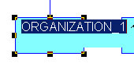  OR  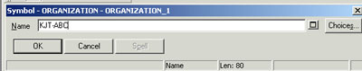
 |  | Your added symbols may be a different color than the turquoise ones shown.
10 | In the Model Object window that then comes up, just click “OK”; no need to add more information at this point. | 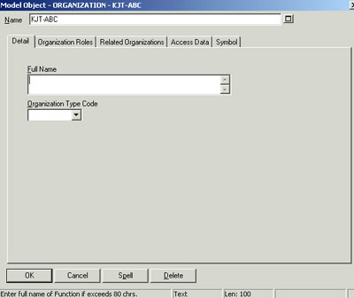
11 | Make some more new symbols the same way, and name them  “XXX-DEF”,  “XXX-GHI”,  “XXX-JKL”, and  “XXX-MNO”. | 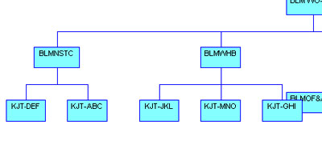
12 | From the menu bar, select “File / Save Diagram”.  Close the two diagram windows. | 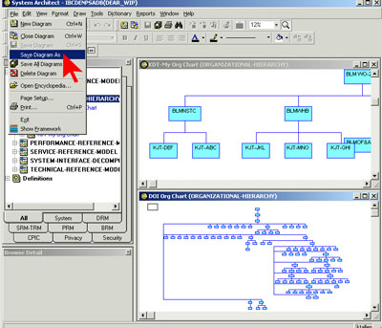

Rearrange the Children in a Hierarchical Model
These steps show how to make a diagram easier to read by changing horizontal layout to vertical layout.
Step | Do this… | Notice this…
1 | In the Encyclopedia Browser, expand “Diagrams”, then “BUSINESS-REFERENCE-MODEL”, then right-click on “Support Delivery of Services” and select “Open” from the floating menu.  If you don’t see “Support Delivery of Services”, open any diagram under “BUSINESS-REFERENCE-MODEL” that doesn’t look too big. (You can get an idea of the size from the Browse Detail window below the browser.) | 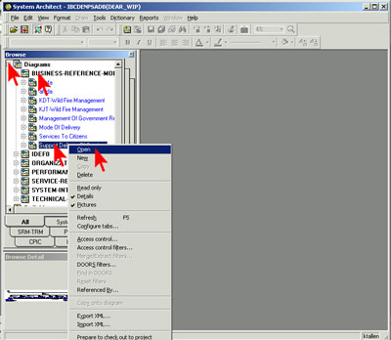
2 | Adjust the diagram size to be big enough to click on individual symbols (probably at least 10% actual size).
3 | Right-click on a symbol that has symbols under it and select “Arrange Children Vertically” from the floating menu. | 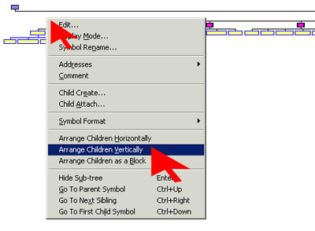
4 | Do the same for every level except the top level. | Your diagram should go from looking something like the left picture to something like the right picture.  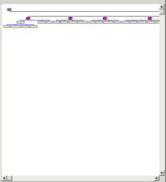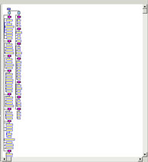
5 | Save and close the diagram: from the menu bar select “File / Save Diagram” and “Window / Close All”. | 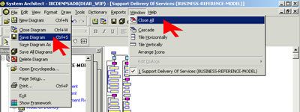

Check Out and Check In an Encyclopedia Object
These steps show you how to check out an object and how to know when an object is checked out.

Step | Do this… | Notice this…
1 | In the Encyclopedia Browser, expand “Definitions”, then “BUSINESS-AREA”, then right-click on “Mode of Delivery – Financial Vehicles” and select “Access Control” from the floating menu. | 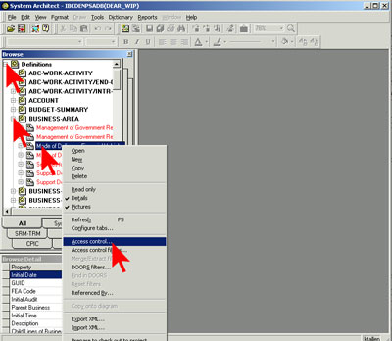
2 | If you get a message that someone else has that definition checked out, select a different definition under “BUSINESS-AREA”. | You should see “Check out” as the only action permitted, in the Access Control window.
3 | Make sure the Subordinate definitions box is checked, then click “OK”. | 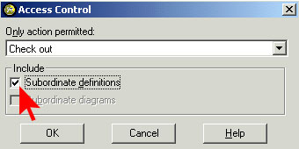
4 | Close the information window that comes up, when you are done reading it. | 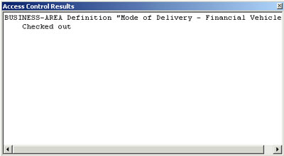
5 | Refresh the window, either by F5 on the keyboard, or by right-clicking on a definition and selecting “Refresh” from the floating menu. | If you don’t refresh the screen after checking out, the screen won’t let you check in the definition.  The check beside the definition shows that it is checked out.  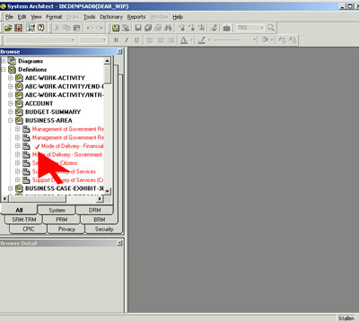
6 | Right-click on the checked-out definition and select “Access Control” again from the floating menu.  Again make sure the Subordinate definitions box is checked, then click “OK”. | Notice that now “Check in” is the only action permitted. 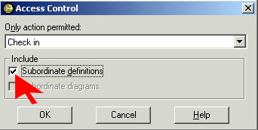
7 | Again close the information window that comes up, when you are done reading it. | 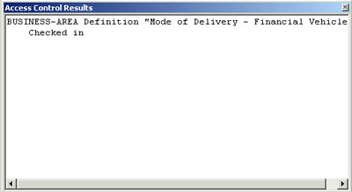
8 | Refresh the window again. | The checkmark beside the definition should disappear. You have now checked the definition out and in.

Work with a Matrix
These steps show you how to use the Matrix Editor in mapping activities to systems.

Step | Do this… | Notice this…
1 | From the menu bar, select “View / Matrix Browser”.  In the Matrix browser that appears, click on the DOI Matrices tab. | 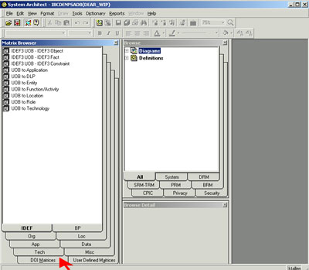
2 | Double-click on “04_Function Activity to Sub-System”. | 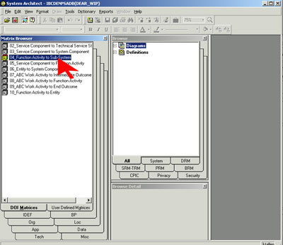
3 | Click “Next” on the Specify Filters screen that appears. | 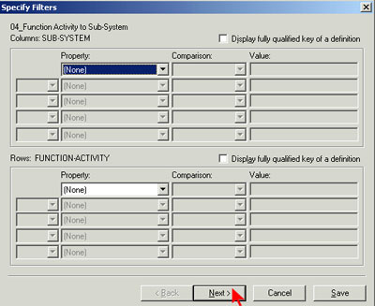
4 | Click “Finish” on the Choose Matrix Contents window. | 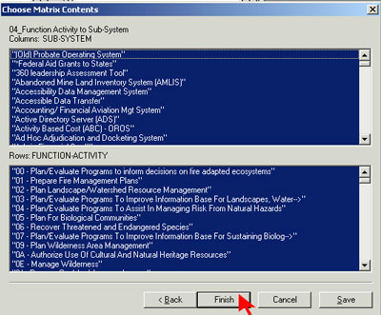
 |  | Be patient—it may take several minutes for the Matrix Editor to load the matrices.
5 | Scroll down (it may be a long way!) in the Matrix Editor window until you see some X’s. | 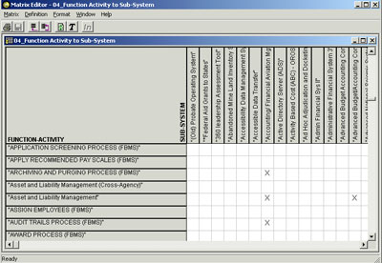
6 | Right-click on a row that has an X, and select “Modify Row Definition” from the floating menu. | 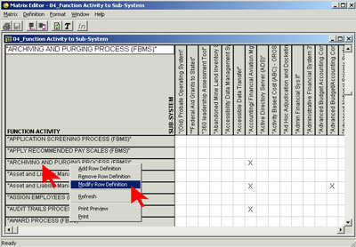
7 | Click on the “Relationships” tab of the Dictionary Object window that comes up.  Notice the name shown in the Sub Systems box. This is the column that the X shows intersecting with the row you picked.  When you finish looking at the Dictionary Object window, click “Cancel” to return to the matrix. | 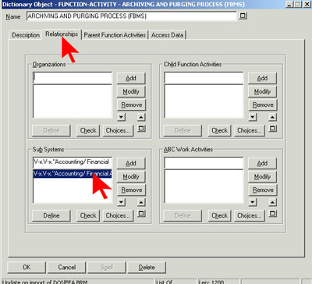
8 | From the Matrix Editor menu bar, select “Matrix / Save As” to save the matrix. | 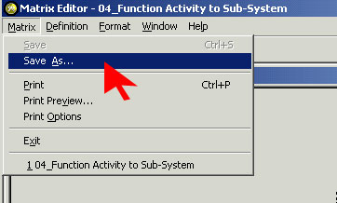
9 | Open the O drive (the one that says something like “xxx on ‘Ibcdenpsadb\Data\Output’ (O)”  Save the matrix on this drive, with the name “XXX-BRM Tier to Sub-System”, where XXX is your initials. | 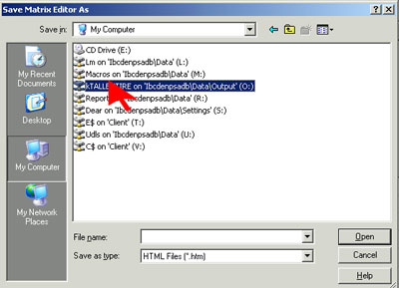
10 | From the Matrix Browser menu bar, select “Matrix / Exit”, to close the browser. | 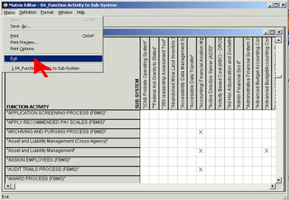

Export Data to a CSV File
These steps show you how to export data, and how to find and open the exported file.
Step | Do this… | Notice this…
1 | From the menu bar, select “Dictionary / Export Definitions”.  Click on the Browse button. | 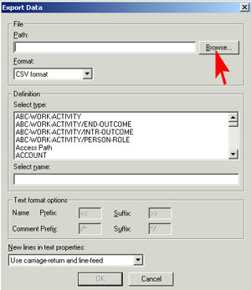
2 | Go to the drive marked “Client”, which is probably “C$ on ‘Client’ (V:)”  Open (or create) a folder called “tmp”.  In the File name box, enter “XXX_Business_Area.CSV”, where XXX is your initials.  Click “Open”. | 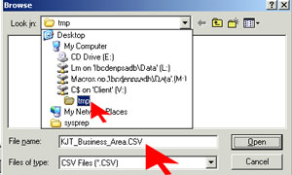
 |  | Entering this address will send the output file to your local machine.
3 | In the Definition text box, select “BUSINESS-AREA”.  Click “OK”. | 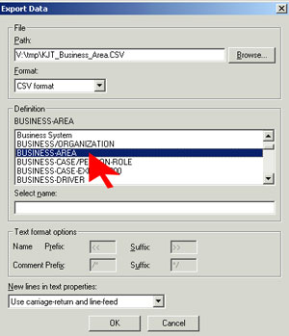
4 | Close the report window that comes up, when you are done reading it. | 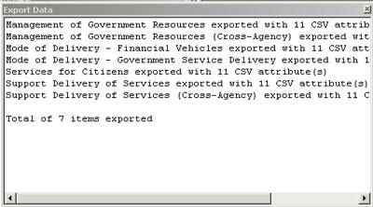
5 | Open Excel, and from Excel, open the CSV file you just extracted to your local machine. | Note that it is a .csv file, not an .xls file.
6 | Each line is a definition. On each line, change the name to start with “XXX-“, where XXX is your initials. | 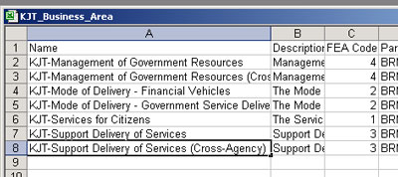
7 | Save the file and close it. | Make sure you are saving it as a .csv file, not a .xls file. The name should not change.

Import Definitions from a File into the SA Encyclopedia
These steps show you how to bring data into DEAR from an external file. On production encyclopedias, be sure to back up the encyclopedia before importing. For this exercise, however, a backup is not necessary.
Step | Do this… | Notice this…
1 | From the menu bar, select “Dictionary / Import Definitions”.  Click on the Browse button. | 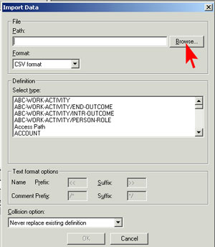
2 | Find the file you made in the previous exercise, named “XXX_Business_Area.CSV”, where XXX is your initials.  In the Definition text box, select “BUSINESS-AREA”.  Make sure the Collision option box shows “Never replace existing definition”.  Click “OK”. | 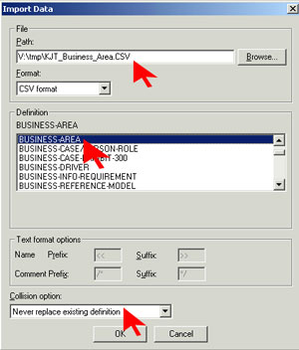
3 | The report window that comes up should look similar to this. Close it when you are done reading it. | 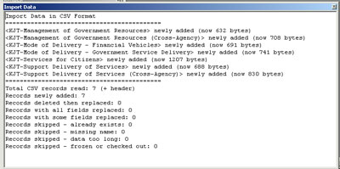
4 | In the Encyclopedia Browser, expand “Definitions”, then “BUSINESS-AREA”, and check that the definitions you just imported are there. | 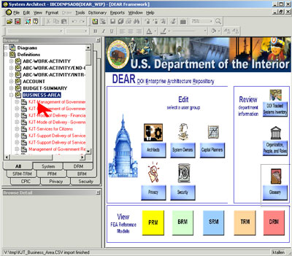

Document Abstract

FEAF Area:  Subject Function Code: | Architecture Management  1230 | Contract Number:  Task number: | NBD020221  8
This is an advanced guide to using DEAR. The guide is for use at the bureau and the department level..

Revision History

Doc Status | Content as of Date | Author | Description of edit | Filename/lineage

