DART Data Acquisition System

Data, Permit & Trigger Link
Interface Specification

John Anderson & Ed Barsotti

June 5, 1995

Version 3.11

Document # ESE-DART-950511

DRAFT DOCUMENT

Table Of Contents

1. Data & Permit Link Interface
1.1. Overview
1.1.1. Physical Medium of the Data Link
1.1.2. Physical Medium of the Permit Link
1.1.3. Example Implementation of the Permit Link
1.1.4. Data Format
1.2. Data Flow Control Mechanisms
1.3. Initiating Readout From The First Data Source in a Chain
1.4. Connectors ... Types, Alignment, Pin Assignments & Signal Polarities
1.5. Data & Permit Link Signal Timing (At Source & Destination Connectors ... Normal Operation & Source To Source)
1.6. RS-485 Drivers & Receivers ... Mandatory Types, Artwork Stub Lengths & Supply & Component Bypassing
1.7. Removal Of Obsolete Signals
1.8. Grounding (At One End) Of Unused Signal Lines
1.9. Driving WAIT
1.10. Driving EOR
1.11. Differential Driver Input & Tri-State Enable/Disable Timing
1.12. Front-Panel Indicators & Test Points
2. Trigger Link Interface
2.1. Overview
2.2. Physical Medium of the Trigger Link
2.3. Connectors ... Types, Alignment, Pin Assignments & Signal Polarities
2.4. Trigger Link Timing (At Source & Destination Connectors) ... Pre & Post Triggering
2.5. RS-485 Drivers & Receivers ... Mandatory Types, Artwork Stub Lengths & Supply Bypassing
2.6. Grounding (At One End) Of Unused Signal Lines
2.7. Front-Panel Indicators & Test Points
3. Implementations & Component Selection To Minimize Temperature Effects On Timing
4. Module & Cable Insertion & Extraction Under Powered Conditions
5. Appendix A ... External Termination, DC Biasing & Component Protection Networks A-
5.1. Data, Data Control and Trigger Links A-
5.2. Permit Links A-

Data & Permit Link Interface

Overview

Data Sources and Destinations are connected to each other in the DART system by DART Data Links, which carry data from the Data Sources to the Data Destination. A second cabling scheme, the Permit Link, interconnects only Data Sources and is used to control which Data Source is the current driver of data on the Data Link. Both links are described here.

Terminology is necessary to provide a common frame of reference. In this document, the term “Upstream” refers to that end of a cable which is farthest away from the destination. “Downstream” refers to the closest point on a cable to the eventual destination. Both terms are stated in reference to the flow of the data and the associated data strobe, and are used in this way to describe both the Data Link and the Trigger Link. The Data Destination(s) should all be placed near each other at one end of the Data Link cable. Special care must be taken when Repeater modules are used such that all Data Destinations are located Downstream of all Repeaters.

Physical Medium of the Data Link

The DART Data Link consists of two parallel twisted-pair ribbon cables, one of 34 pins and a second of 50 pins, carrying both data and control signals. The organization of the cables is as follows:

- Low 16 data bits plus control signals on the 50-pin connector.
- High 16 data bits on the 34-pin connector.

The control signals defined are as follows:

- DSTROBE (Data Strobe) is pulsed once per data word sent from Data Source to Data Destination.
- EOR (End of Record) is pulsed once per block of data words sent from one or more Data Sources to the Data Destination, and is used to delineate ‘events’ or ‘blocks’ of data.
- WAIT is asserted by the Data Destination to signal the Data Sources that transmission of data should be halted. The WAIT signal propagates backwards along the cable with respect to Data, DSTROBE and EOR.

The Data Link shall be carried differentially upon multipair twisted flat cable such as 3M series 1700 or any other with equivalent or better signal transmission characteristics. The nominal characteristic impedance of the Data Link shall be 120 ohms for balanced transmission.

Data Links shall connect through the use of standard insulation-displacement ribbon cable connectors. Matching headers on Data Sources, Repeaters and Data Destinations shall be shrouded on a minimum of three sides and use latch & eject ears of sufficient length to allow the use of on-cable strain relief to insure mechanical stability of the connection. Cable connections shall also employ strain relief.
Rule 1

Physical Medium of the Permit Link

The Permit Link consists of a single coaxial cable which carries a single NIM signal from one Data Source to the next. A Data Source issues a Permit Out signal which is connected to the Permit In of the next Data Source to inform the next Data Source that it should now drive the bus. The current Data Source must cease driving the bus with the leading edge of the Permit Out signal. The next Data Source may not enable its data drivers until it has seen the trailing edge of Permit In.

The Permit Link shall be carried as a NIM-level signal on standard coaxial cable with a characteristic impedance between 45 and 55 ohms. The Permit Out signal of each Data Source shall be driven using a current driver which is capable of pulling no less than 16 mA of current through a 50 ohm resistance to ground, such that a voltage of at least -0.8 V DC is developed across the resistor when the driver is active.

Data Sources and Repeaters shall employ a 50 ohm resistor to ground at their Permit In connector to eliminate reflections and correctly terminate the coaxial cable. Permit In receivers shall respond to the voltage developed across the 50 ohm resistorin accordance with Sections 5.9.1 and 5.9.2 of the NIM Specification, DOE/ER-0457T (May 1990. The shield wall of the Permit In connector shall be connected to module ground.

Permit Out drivers shall be of the current type such as 75LS110, MC10192 or 75LS112 so long as the implementation supplies the 16mA required by NIM specifications. If 75LS110 drivers are used, two drivers in parallel shall be employed to supply the required current.

Permit Links shall be interconnected by single-contact plus shield coaxial cable latching connectors such as LEMO S series. Connectors used for the Permit Link must contain a latching mechanism to insure positive connection and must provide strain relief for the coaxial cable.

Permit In and Permit Out connectors shall each be clearly labeled as such to minimize the possibility of improperly connecting Permit Links between Data Sources.

Timing of the Permit In and Permit Out signals shall be in accordance with Figure 6. The Permit Out pulse shall have a duration of no less than 200 nanoseconds and no more than 400 nanoseconds. The leading edge of the Permit Out pulse may occur no earlier than the later of 100 nanoseconds after the completion of the last data cycle or the trailing edge of EOR to guarantee that the Permit Out occurs after all RS-485 data drivers have reached the high-impedance state.
Rule 2

Example Implementation of the Permit Link

For user reference a typical Permit Link implementation of driver and receiver circuit is given in Figure 1.

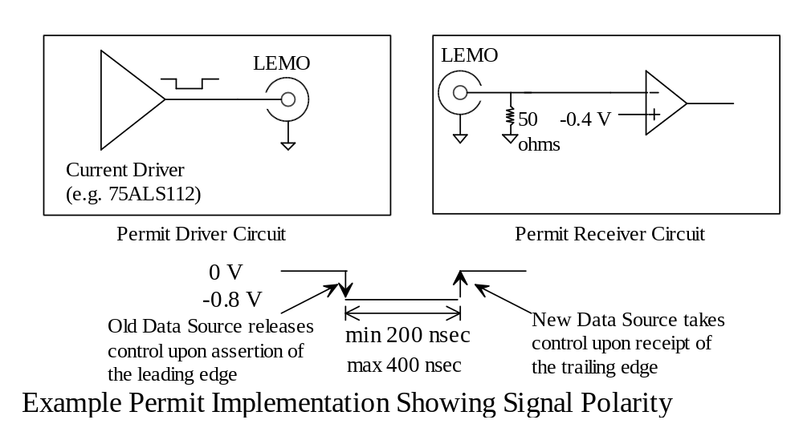
Figure 1

Data Format

Data is sent as blocks of indeterminate length terminated by the End-Of-Record (EOR) signal. A Data Source may optionally provide as the first data word a header which contains an inclusive word count for the event (number of data words in packet, including the header in the count), but no requirement exists upon the Data Destination to interpret or use the information contained in any such header.

At the discretion of the user, the first word of every data block may be interpreted by the Data Destination as an address which is used to select between multiple Data Destinations on the same cable. If addressing is used, bits 12-15 of the header are compared against four bits in an internal register (or four bits set by DIPswitch) located within the Data Destination. If a match is found, the Data Destination will store the matching header word and all data received after that point up to and including the EOR strobe. The comparison is re-evaluated on the first data word following each EOR, which is by definition the header of the next event.

An EOR strobe is not used to carry any data, and the 32 bits of data present during the EOR pulse are ignored by the Data Destination. The EOR pulse is also used by the Data Destination to perform any internal housekeeping such as pointer updates in preparation for the next event.

Every data word shall be accompanied by a single Data Strobe pulse. Logical blocks of data shall be delineated by an End-of-Record (EOR) pulse which occurs outside of the data transfer.

The Data Destination may treat the first word after reset and the first word after each EOR as a special header word used to select between multiple Data Destinations. If this selection process is used, bits 12-15 of the header word shall contain a four-bit address which is used to uniquely select one Data Destination, and bits 16-19 shall be interpreted as four ‘group bits’ which individually are compared against bits in the Data Destination to allow selection of user-defined groups of Data Destinations.
Rule 3

Data Flow Control Mechanisms

The DART Data Link may have multiple Data Sources which feed data to either a single Data Destination or a group of Data Destinations. As there is no handshaking, the general description of data transfer is ‘ship-and-pray’; that is, Data Sources need to communicate among themselves for control of the data bus but the Data Sources receive no information concerning the number or state of the Data Destinations.

Data overrun is controlled by the Data Destination which asserts a WAIT signal when data input threatens to overrun the internal buffering of the Data Destination. The WAIT signal is asserted asynchronous to the Data Strobe and may persist for an arbitrary length of time. When WAIT is asserted the Data Sources cease sending data until WAIT is released.

Data Sources on the DART Data Link are designated as being ‘first’, ‘middle’ or ‘last’. There must be one and only one ‘first’ and one ‘last’ Data Source on a DART Data Link, but any number of ‘middles’ is allowed, including zero. In the simplest case, a single Data Source is both ‘first’ and ‘last’. Each type of Data Source follows certain rules:

1. The ‘last’ Data Source is the only one which is allowed to drive the EOR signal. All other Data Sources in a group must disable (tri-state) their EOR driver at all times.

2. Any ‘middle’ or ‘last’ Data Source must wait to receive a Permit In signal before it may take control of the data bus and send data. After transmitting its group of data words, any ‘middle’ or ‘last’ Data Source issues a Permit Out signal which is connected to the Permit In of the next device in the readout chain. Upon power-up or reset, all ‘middle’ or ‘last’ Data Sources are disabled.

3. The ‘first’ Data Source acts identically to the ‘middle’ save for the exception that, in response to power-up or reset, the ‘first’ Data Source not only enables its data drivers but also assumes that a Permit In signal has been received. Thus, when the system is initialized, the ‘first’ will ship data as soon as it has some to send.

Each Data Source on the same Data Link shall be identified as being ‘first’, ‘middle’ or ‘last’ in the set. There shall be one and only one ‘first’ source, one and only one ‘last’ source. Any number of ‘middle’ sources is allowed, as limited by cable length and loading and pulse rise/fall time restrictions. In the case where only one Data Source is present on a link, that one source is both ‘first’ and ‘last’.

The ‘last’ Data Source shall be the sole driver of the EOR signal. All other Data Sources in a group must disable (tri-state) their EOR driver at all times such that that EOR signal is always actively asserted either high or low, only by the ‘last’ data source.

Any ‘middle’ or ‘last’ Data Source must wait to receive a Permit In signal before it may take control of the data bus and send data. After transmitting its set of data words any ‘middle’ or ‘last’ Data Source issues a Permit Out signal which is connected to the Permit In of the next device in the readout chain. Upon power-up or reset, all ‘middle’ or ‘last’ Data Sources are disabled.
Rule 4

Initiating Readout From The First Data Source in a Chain

As noted in the previous section, the ‘first’ data source begins with control of the bus, either from a power-up state or due to a command sent via software during the initialization period. As soon as data is available, it will be sent. In the second and all subsequent events, the Permit Out of the ‘last’ Data Source drives the Permit In of the ‘first’ Data Source, re-enabling the ‘first’ to again take control of the data bus.

Independent of the Permit logic, Data Sources in general require that a trigger signal of some form be sent to initiate data transfer. Dependent upon the particular Data Source being used, that trigger signal is either a command to go and fetch the data (e.g., FSCC Trigger In) or a second enable which allows the Data Source to pass on data that has been previously pushed into the Data Source (e.g., DYC+ End-Of-Event input). In both cases, the Trigger Strobe has a one-to-one correspondence with the system Master Trigger such that each Trigger Strobe is uniquely identified with one and only one Master Trigger. Upon receipt of the Trigger Strobe, the Data Source begins the process that will send one event’s worth of data up the DART Data Link.

The ‘first’ data source shall assume it has control of the Data Link bus upon reset, software initialization or power-up. In the second and subsequent events, the ‘first’ Data Source shall wait for the receipt of Permit In before sending data.
Rule 5

Connectors ... Types, Alignment, Pin Assignments & Signal Polarities

The DART Data Link is carried on a 50-pin and a 34-pin cable as shown here:

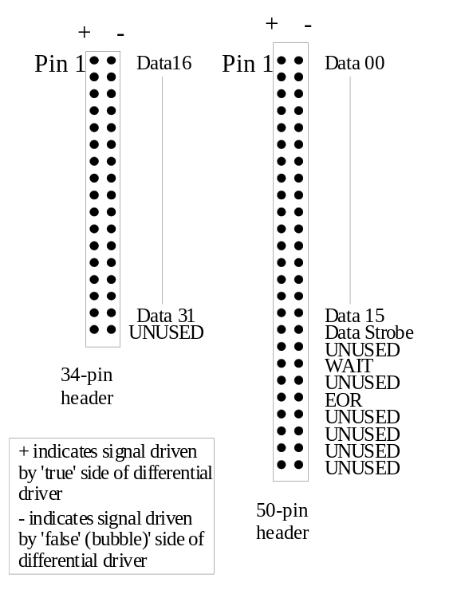

Figure 2

Signals connected to the DART Data Link shall be connected to its two connectors as is shown in Figure 2. Signals labeled UNUSED’ shall be left unconnected at the DART Data Link connectors in all Data Sources, Data Destinations and Upstream Termination Networks.
Rule 6

Data Strobe, EOR and WAIT signals shall all have the polarity as shown in Figures 3 and 4. Each signalÕs input to its RS-485 driver and output of its RS-485 receiver shall be the low-true state of the signal. The ‘inactive’ state of each signalÕs driver input and receiver output shall be a TTL ‘high’ (> 2.0 V) and the ‘active’ state a TTL ‘low’ (< 0.8 V). The Data Strobe and EOR shall both be EDGE-sensitive signals where the active edge shall be the one in which driver input and the receiver output transitions high-to-low. WAIT is a LEVEL-sensitive signal.

Data shall have the polarity as shown in Figure 5. Each data signalÕs input to its RS-485 driver and output of its RS-485 receiver shall be the high-true state of the signal. The ‘inactive’ state of the data signalÕs drivers input and receivers output shall be a TTL ‘low’ (< 0.8 V) and the ‘active’ state a TTL ‘high’ (> 2.0 V).
Rule 7

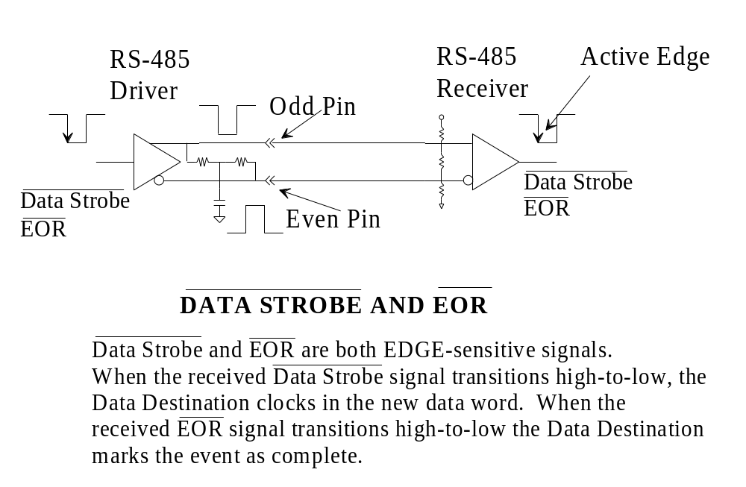
Figure 3
Figure 4
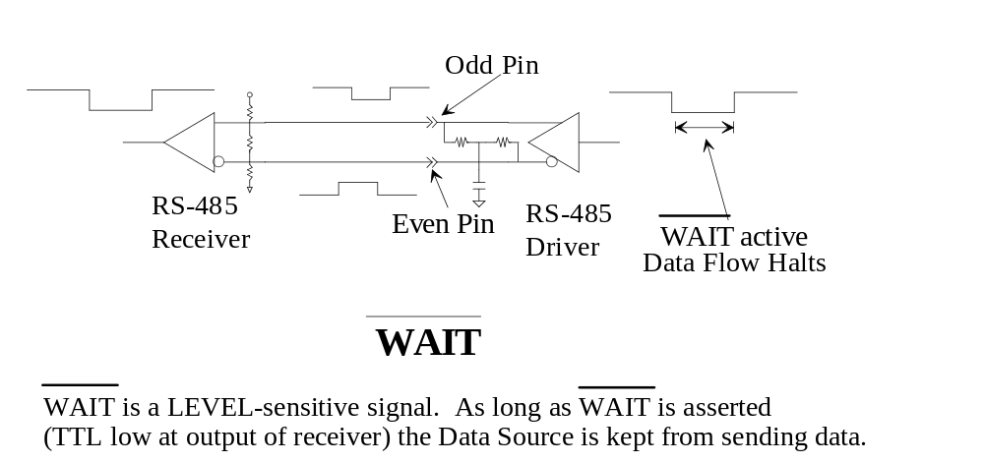

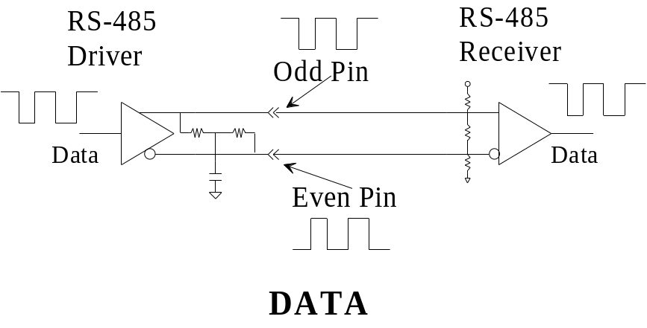
Figure 5

Data & Permit Link Signal Timing (At Source & Destination Connectors ... Normal Operation & Source To Source)

Data is nominally driven in 100 nanosecond long cycles. The Data Source waits for the receipt of Permit In, at which point it enables its drivers for Data Strobe and, after a short delay, the data bits. After an internal delay period to allow for the drivers to be fully enabled, the data cycles begin. When all data is transferred the Data Source disables its data drivers, followed by disabling the Data Strobe driver, and finally issues the Permit Out pulse to the next Data Source, as shown in Figure 6.

Data Sources and Repeaters shall be designed such that the data is presented at the output connector with timing and polarity matching Figure 6 of this document. Data may optionally be presented at rates slower than one word per 100 nanoseconds so long as the setup and hold timing is not violated by doing so.

The RS-485 drivers for the Data Strobe shall be enabled a minimum of 50 nanoseconds before the RS-485 drivers for data bits are enabled, as shown in Figure 6. Further, the RS-485 drivers for the Data Strobe shall be disabled a minimum of 50 nanoseconds after the RS-485 drivers for data bits are disabled. This insures that the Data Strobe line is always in a relatively low impedance state when the data bit drivers are enabled or disabled to eliminate false Data Strobes caused by crosstalk or reflections.

Cable lengths and the number and distribution of loads shall be maintained such that the presentation of Data and Data Strobe at the Data Destination connector provides a minimum of 20 nanoseconds setup time and 20 nanoseconds hold time as shown in Figure 7.
Rule 8
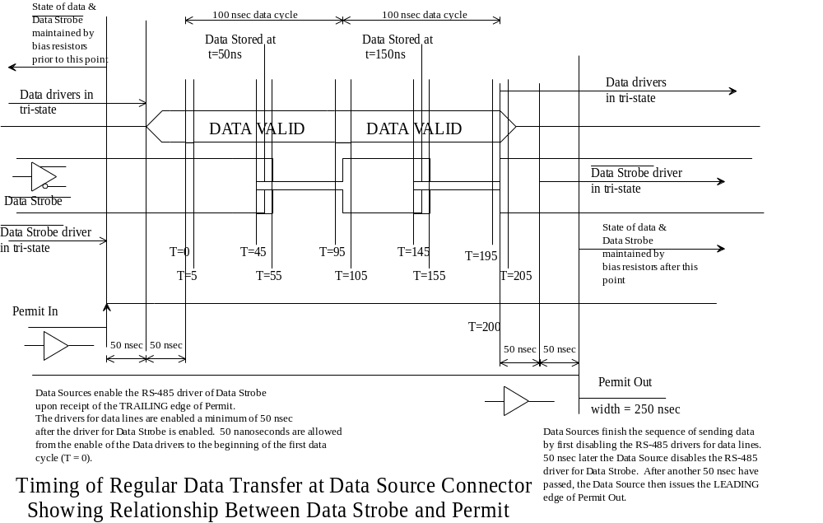
Figure 6
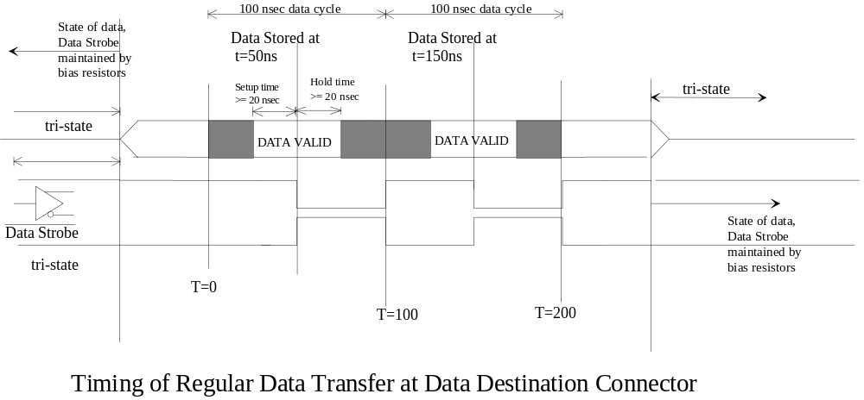
Figure 7

Note that minimum setup and hold times of 20 nanoseconds each is required at the Data Destination. Some skew of the data bits with respect to the Data Strobe is inevitable over long cable lengths. If, at the end of a cable length, the minimum setup and hold times are not being observed, a Repeater is required or a shorter cable must be used to maintain the setup and hold times.

RS-485 Drivers & Receivers ... Mandatory Types, Artwork Stub Lengths & Supply & Component Bypassing

The correct selection of RS-485 driver and receiver parts is critical to the correct operation of the system. Use of parts which are too slow will result in errors due to slew rate limitations or violation of setup and hold times.

New Modules being built for the DART system shall only use the following RS-485 components to connect to DARTÕs Data & Trigger Links:

RS-485 drivers: DS96F172
DS96F174
RS-485 receiver: DS96F173 or DS96F175
RS-485 transceiver: DS36F95

Modules being redesigned or upgraded for use with DART shall only use the following RS-485 components to connect to DART’s Data & Trigger Links:

RS-485 drivers: DS96F172 DS96172
TI75ALS172A DS96F174
DS96174 TI75ALS174A
RS-485 receiver: DS96F173 DS96173
TI75ALS173 DS96175
RS-485 transceiver: DS36F95 TI75ALS1178

Modules such as a point-to-point cable extender which do not participate in any form of Permit logic (and, therefore, always have drivers enabled) may in addition use LTC487 drivers and LTC489 receivers.
Rule 9
All drivers, receivers, transceivers, bias resistors and termination resistors must be kept as close as possible to the connector to minimize reflections and capacitive loading.

Artwork trace lengths from all RS-485 drivers, receivers and transceivers to their respective connector pin shall not exceed 2 inches.
Rule 10

Power supply voltages supplying power to RS-485 ICs connected to DARTÕs Data, Permit and/or Trigger Links must be bypassed properly very near the ICs to insure reliable operation.

The DC steady-state current load of all RS-485 drivers in the DART Data Link is significant. Total current in the steady-state condition approaches 2 Amperes, and increases when data bits or control signals are switching states. This generates a significant load on the power supply which must be properly bypassed to avoid introducing noise in to the rest of the system.

Each RS-485 driver, receiver and transceiver shall have its power pin bypassed to its ground pin with a high-frequency 0.1µF capacitor. Through-hole decoupling capacitors must be connected directly to the +5 volt power and ground planes. Surface-mount decoupling capacitors must be connected directly to the +5 volt power and ground planes with minimal trace stubs. All decoupling capacitors shall be as close as physically possible to each driver. Capacitor leads are to be clipped as short as practical.

PC board traces carrying RS-485 differential signals shall be laid out such that differential pairs are carried on traces whose balanced, differential-mode characteristic impedance matches that of the DART Data Link cable. In addition, trace pairs for differential signals should match each other in length as closely as possible.

In addition, for every six driver, receiver or transceiver ICs in close proximity on a PC board, there shall be a 4.7 µF tantalum capacitor, placed in the rough geographic center of the ICs, connected to the ICsÕ +5 volt power and ground planes in the same manner as the 0.1µF decoupling capacitor.
Rule 11

Removal Of Obsolete Signals

Various lines left over from previous similar cables but not used in DART are explicitly removed from the cable specification. These include the FILL_EVEN, 16/32, SSTROBE, SPARE0, SPARE1, SPARE2 signal lines. In addition, the RSBAF and ASTROBE lines present in the original conception of DART but now known to be irrelevant are also removed.

Connections from Data Source and Data Destination logic previously used to connect FILL_EVEN, 16/32, SSTROBE, SPARE0, SPARE1, SPARE2, RSBAF and/or ASTROBE signals to the Data Link connectors shall be disconnected thus disconnecting these now unused connector pins from the logic. Stub lengths at the connector shall be minimized.
Rule 12

Grounding (At One End) Of Unused Signal Lines

Unused lines, including those listed in Section 1.7 above, shall be tied to ground by the Downstream Terminator Network and Repeater (at Downstream side) only. This insures that these signal lines are grounded to avoid noise pickup, but that no ground loops are formed by multiple grounding points.

Data Sources & Data Destinations shall leave unused lines unconnected at their connectors.
Rule 13

Driving WAIT

Each Data Destination must be able to drive the WAIT signal in order to control data flow and insure that internal buffers are not overrun. Each Data Destination will normally leave the WAIT driver in the tri-state (disabled) condition, allowing external bias resistors found in the Termination Networks to maintain WAIT in the ‘transfer enabled’, or high (not true), state.

A Data Destination shall enable its WAIT driver and assert the WAIT signal whenever internal data buffering FIFOs are at least half full. A pulse-stretching circuit shall be implemented such that the minimum duration of the WAIT signal is 500 nanoseconds. The WAIT signal shall continue to be asserted until the half-full flag of the FIFO is no longer asserted and the 500 nanosecond minimum pulse width requirement is met, at which time the WAIT shall be de-asserted and the WAIT driver disabled. The RS-485 driver’s output enable may be connected to the input signal WAIT (by wire or inverter as required) to accomplish this logic.

Data Sources shall continuously monitor WAIT and shall cease sending data whenever WAIT is asserted. Data Sources shall sample the WAIT signal with the same clock as used for the state machine that controls data transfer such that response to WAIT is synchronized to the data transfer in progress and no data transfer cycles are shortened or lengthened by the receipt of WAIT.
Rule 14

Driving EOR

As stated in Rule 4, each Data Source shall have the optional ability to drive the EOR signal if that Data Source is configured as the ‘last’ data source of a set The EOR signal is used to delineate a block of data and is issued after all data in that block has been sent to signal the Data Destination that the block is complete.

The ‘last’ Data Source shall drive the EOR line actively at all times and shall issue, when needed, a 150 nanosecond minimum, 300 nanosecond maximum wide EOR pulse. The EOR signal shall be separated from any transitions in the Data Strobe by a minimum of 100 nsec as shown in Figure 8.
Rule 15
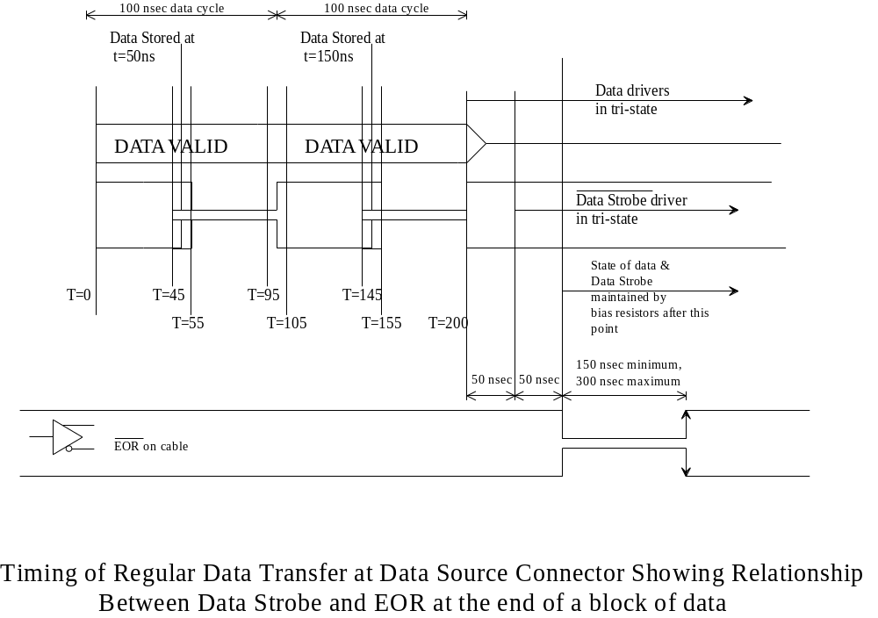
Figure 8

Differential Driver Input & Tri-State Enable/Disable Timing

Careful control of tri-state conditions is essential to proper system operation. Most important, RS-485 driver enable and disable times must be taken in to account when designing modules such that drivers of Data Strobe and Data are guaranteed to be either fully enabled or fully disabled before their data inputs are allowed to change.

RS-485 drivers for the Data Strobe and all data lines shall be enabled at least 50 nanoseconds before any change may occur to the input pin of the driver, and all signals shall reach their final state before the driver is disabled. Upon disable, the input to the driver shall be maintained for a minimum of 50 nsec before any input changes are allowed.
Rule 16

Front-Panel Indicators & Test Points

To make system integration easier, DART Data Sources, Repeaters and Data Destinations should provide visual indicators and test points to allow experimental users and field technicians ready access to the operational state of each piece of hardware.

It is recommended that all DART Data Sources implement, at minimum, the following front panel Data Link, Permit Link and miscellaneous indicators:

POWER OK (lit if power is applied and fuse is not blown)
ON BUS (lit when holding the Permit token, pulse-stretched to 50 milliseconds min. duration)
DSTRB (lit whenever the Data Source is asserting the Data Strobe signal, pulse-stretched to 50 milliseconds minimum duration)
EOR (lit whenever the Data Source is asserting the EOR signal, pulse-stretched for at least 50 milliseconds with each EOR sent)

The DART Data Destination shall implement, at minimum, the following front panel indicators:

POWER OK (lit if power is applied and fuse is not blown)
ON BUS (lit if addressed, pulse-stretched to 50 milliseconds minimum duration)
DSTRB (lit if Data Strobe is asserted, blinks for at least 50 milliseconds with every Data Strobe received)
EOR (lit if EOR is asserted, blinks for at least 50 milliseconds with every EOR received)
WAIT (lit if WAIT is asserted,, pulse-stretched to 50 milliseconds minimum duration)
Rule 17

Trigger Link Interface

Overview

Trigger information is sent from experiment-specific trigger logic to the DART system in order to perform two functions:

1. Synchronize the data transfer amongst all the Data Sources; and, optionally,
2. Provide routing information (Trigger ID bits) from the trigger system in order to direct data corresponding to different trigger conditions to different Data Destinations.

A single Trigger Strobe sent to all Data Sources is used to provide the data synchronization function, and this same Trigger Strobe is also used to latch in Trigger ID bits which may be used as the routing information. Various trigger holdoff (flow control) signals run in the opposite direction of Trigger Strobe (and Trigger ID bits), from Data Source or Data Destination to Trigger System. A schematic view of the relationship between DART and the Trigger System is shown in Figure 9. The Buffer Almost Full signal from the Data Destination is another signal which indicates that system conditions require triggers to temporarily halt, and so in the trigger system this is another form of trigger holdoff.

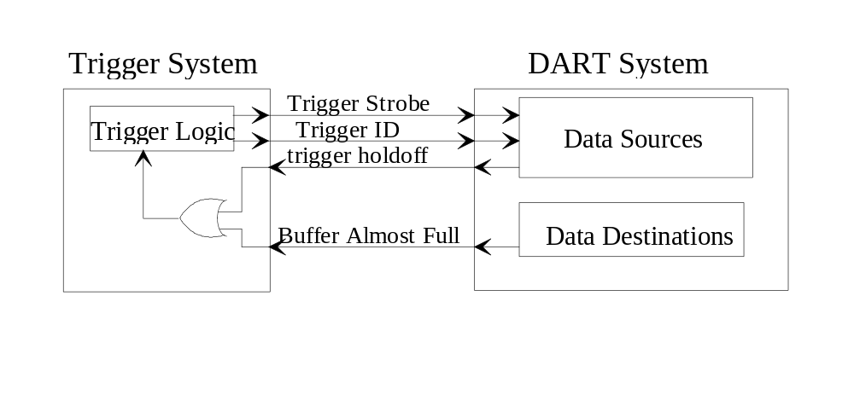
Figure 9

Physical Medium of the Trigger Link

The Trigger Link is carried on a variety of media. Combinations of current-source and differential logic are used to carry the Trigger Strobe, the Trigger ID and the trigger holdoff dependent upon the unique installation.

Each Data Source shall implement the Trigger Link signal Trigger Strobe and a signal or signals, collectively referred to as the trigger holdoff, that indicates to the trigger system that triggers should be temporarily halted. The trigger holdoff signal(s) shall be implemented as NIM.

The Trigger Strobe shall, at minimum, be implemented as a NIM signal which must be properly terminated. If the signal is internally terminated in a particular module visual indication of that termination should be provided on the front panel. If no internal termination is provided the module shall implement two connectors for each unterminated NIM signal, with a visual indication that the two connectors are bridged and unterminated. The implementation of the Trigger Strobe as a NIM signal, and any NIM trigger holdoff signals, shall be collectively referred to as the ‘NIM Trigger Link ’.

NIM Trigger Link signals shall be carried as NIM-level signals on coaxial cable with a characteristic impedance of from 45 to 55 ohms, and shall be interfaced to the modules using LEMO S series coaxial connectors.

Data Sources may implement an additional set of inputs collectively referred to as the Trigger ID (or, in some cases, the Event Synchronization Number). If furnished, the Trigger ID shall be implemented using a 10-pin header which provides for the input of four Trigger ID bits on pins 1-8 as shown in Figure 11. Pins 9 and 10 of the 10-pin header may be used to implement an RS-485 version of the Trigger Strobe. If the RS-485 Trigger Strobe is not implemented, then pins 9 and 10 of the 10-pin header shall be left unconnected.

The Trigger ID bits, and the differential Trigger Strobe, if implemented, shall be carried on mass-terminated twist-n-flat ribbon cable with a balanced-mode characteristic impedance of from 110 to 130 ohms as RS-485 differential signals. The group of RS-485 Trigger Strobe and RS-485 Trigger ID shall be referred to as the ‘RS-485 Trigger Link’ as opposed to the ‘NIM Trigger Link’.

The Downstream Termination Network shall supply a 10-pin header for terminating the RS-485 Trigger Link at its source. If the Downstream Termination Network is not physically close to the Trigger System this termination shall be implemented within the Trigger System.

RS-485 Trigger Link signals shall be interfaced to modules using mass-termination headers which are shrouded on a minimum of three sides and shall be strain-relieved using latch & eject hardware on each header.
Rule 18

Connectors ... Types, Alignment, Pin Assignments & Signal Polarities

In a NIM Trigger Link implementation the signals are transmitted as single-ended current-mode NIM signals as shown in Figure 10. In an RS-485 Trigger Link implementation the signals are transmitted differentially with the ‘+’ side of the driver and receiver connected to the odd-numbered pin of the pair, as shown here in Figure 11 and Figure 12.
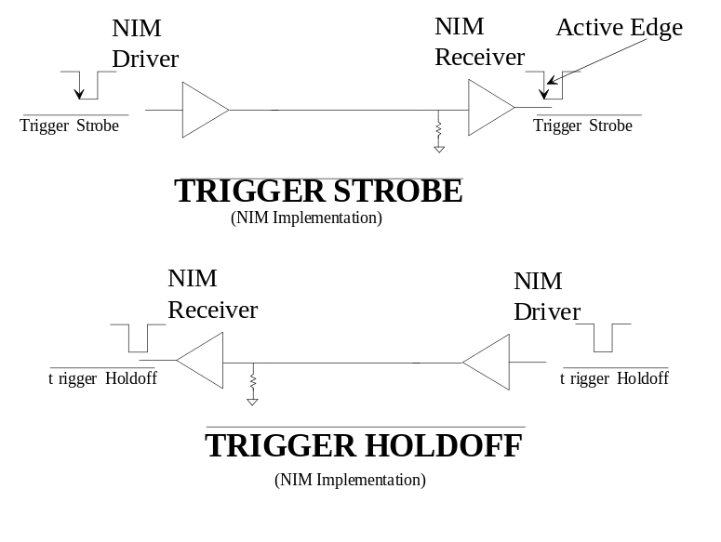

Figure 10
Polarity for NIM Trigger Link Signals
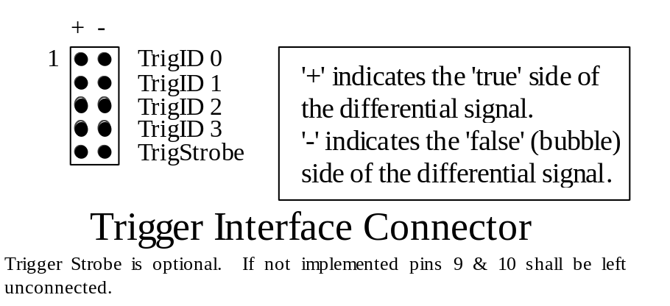
Figure 11
RS-485 Trigger Link Connector
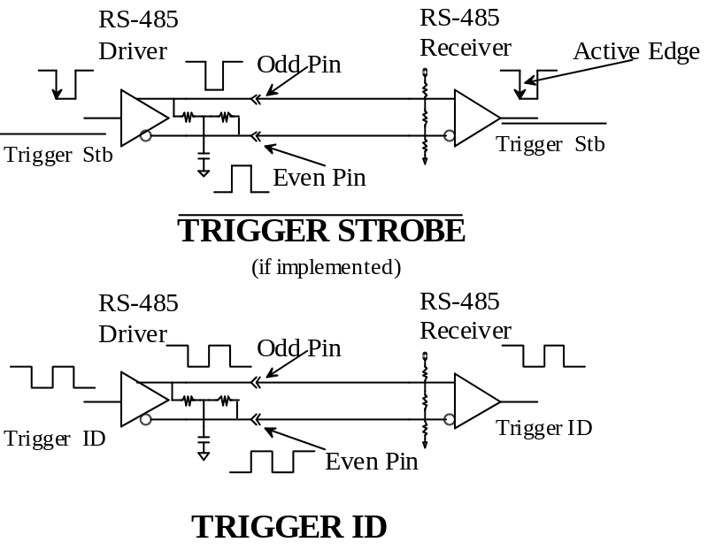

Figure 12
Polarity for RS-485 Trigger Link Signals

Trigger Link Timing (At Source & Destination Connectors) ... Pre & Post Triggering

The Trigger Strobe is synchronized with a ‘gate’ or ‘stop’ signal applied to the data converters which are read out by the Data Sources. Logic in the Trigger System generates the ‘gate’ or ‘stop’, and, after some calculational delay, either issues a ‘Fast Clear’ to the converters (indicative of an event with no useful data) or a Trigger Strobe (indicative of an event with possibly useful data). The Trigger Strobe may either be ‘pre-conversion’ or ‘post-conversion’. In the former case, upon the receipt of the Trigger Strobe, the Data Source begins to poll the converters to see if data is ready. In the latter case, the Trigger Strobe indicates ‘end of event’ and signals the Data Source that the converters are done and data is ready for further shipment across the DART Data Link.

The criteria by which any event is deemed ‘not useful’ or ‘possibly useful’ is entirely application-dependent. Rates of triggers vary widely and some form of flow control is required to hold off triggers when the Data Sources are in danger of being overrun. The immediate technique is to provide a local trigger holdoff output (or outputs) in each Data Source which, if active, inhibits further triggers. To allow manual control or to accommodate later obstructions in the data flow, other trigger holdoff or Trigger Veto signals may be driven by the Data Destination or later computational devices. The trigger holdoff signals from all Data Sources are combined in the Trigger System by logic of the experiment’s design, and the design and implementation of this logic is outside the bounds of this specification document. If the Trigger ID is implemented the ID bits must be presented to the Data Source with sufficient setup and hold time with respect to the active edge of the Trigger Strobe to guarantee that they are correctly stored.

Data Sources shall not collect data until they either have received a Trigger Strobe signal from external trigger electronics or have determined that data is present by polling an internal register or external status bit(s) of the data conversion electronics. Trigger ID bits, if implemented, shall be sent synchronous with Trigger Strobe. If the Trigger ID is implemented, upon receipt of the Trigger Strobe, the Data Source shall latch the Trigger ID, and use that ID value as bits 12-15 of the first data word sent out over the DART Data Link cable in response to Permit In or any other ‘initiate readout’ command..

The Trigger System shall provide a Trigger Strobe pulse of minimum 50 nanoseconds duration to the Data Sources. The Trigger ID, if implemented, shall be set up a minimum of 100 nsec before the active edge of the Trigger Strobe and shall provide, at minimum, a 100 nsec hold time after the active edge of the Trigger Strobe, as detailed in Figure 13.

Trigger holdoff signals may be driven asynchronously with respect to the Trigger Strobe.

If a readout controller is forced to read out an event which overflows its internal data buffer the readout controller shall assert a trigger holdoff signal continuously until such time as a manual or external reset is applied to clear the internal data buffer and the conversion units associated with that readout controller, even though the normal data link transfer to the Data Destination may result in the internal buffer becoming less than half full.
Rule 19

Figure 13
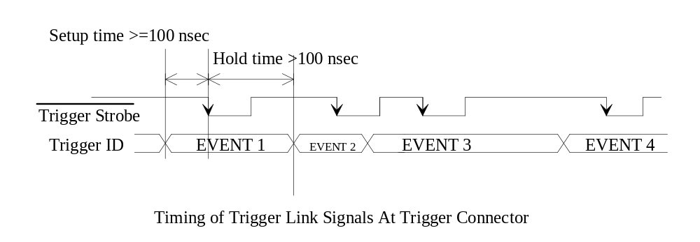

Note that no explicit relationship is defined between the ‘gate’ or ‘stop’ applied to the data conversion electronics and the Trigger Strobe. Dependent upon the timing and interface of the conversion modules, the Trigger Strobe may occur either before, during or after the ‘gate’ or ‘stop’ signal, so long as each Trigger Strobe is uniquely associated with a single ‘gate’ or ‘stop’.

RS-485 Drivers & Receivers ... Mandatory Types, Artwork Stub Lengths & Supply Bypassing

RS-485 drivers for Trigger Strobe and Trigger ID are identical to those used for the DART Data Link as described in Rule 9, repeated here:

New Modules being built for the DART system shall only use the following RS-485 components to connect to DARTÕs Data & Trigger Links:

RS-485 drivers: DS96F172
DS96F174
RS-485 receiver: DS96F173 or DS96F175
RS-485 transceiver: DS36F95

Modules being redesigned or upgraded for use with DART shall only use the following RS-485 components to connect to DART’s Data & Trigger Links:

RS-485 drivers: DS96F172 DS96172
TI75ALS172A DS96F174
DS96174 TI75ALS174A
RS-485 receiver: DS96F173 DS96173
TI75ALS173 DS96175
RS-485 transceiver: DS36F95 TI75ALS1178
Rule 20

Grounding (At One End) Of Unused Signal Lines

Pins 9 and 10 of the RS-485 Trigger Link Connector shall be connected to ground at the Trigger System end of the link only, and only if the RS-485 Trigger Link implementation does not use pins 9 and 10 for the RS-485 Trigger Strobe.
Rule 21

Front-Panel Indicators & Test Points

To make system integration easier, DART Data Sources, Repeaters and Data Destinations should provide visual indicators and test points to allow experimental users and field technicians ready access to the operational state of each piece of hardware.

All DART Data Sources shall implement, at minimum, the following front panel Trigger Link indicators in addition to those required for the Data Link in Rule 17:

TSTRB (lit whenever the receivedTrigger Strobe is asserted, pulse-stretched to at least 50 milliseconds)

Trigger holdoff indicators, one for each trigger holdoff signal implemented in the module (lit when any trigger holdoff signal is asserted, pulse-stretched to 50 milliseconds minimum)

If the Data Source does not drive any form of trigger holdoff signal no indicator for trigger holdoff is required.
Rule 22

Implementations & Component Selection To Minimize Temperature Effects On Timing

Variation in timing caused by temperature change can adversely affect data transfer. DART data systems should avoid the use of R-C time constant delays in favor of clocked systems or delay lines wherever practical.

Any timing elements used in the control, reception or generation of the Data Strobe, data, EOR and Permit signals shall exhibit no more than +/- 10% variation in timing over a 0 to 70 degrees Celsius operational range. Any timing elements used in the control, reception or generation of the Trigger Strobe, Trigger ID, trigger holdoff or WAIT signals shall exhibit no more than +/- 20% variation in timing over a 0 to 70 degrees Celsius operational range.
Rule 23

Module & Cable Insertion & Extraction Under Powered Conditions

Power supply transients caused by insertion or extraction of cables or devices under powered conditions significantly increase the number of component failures in the system. Live insertion or extraction is not supported in the DART system.

Appendix A ... External Termination, DC Biasing & Component Protection Networks

This section has been added for information only. All termination and DC bias networks are supplied by the Computing Division in external components such as Upstream and Downstream Terminator Networks and Repeaters. These termination networks are designed to provide both AC terminations at one end and AC terminations and DC biasing on all signals at the signal receiving end. The DC biasing network also helps protect receiver inputs against electrostatic discharge damage to RS-485 receivers. The DC bias networks are designed such that all signals float to their ÔinactiveÕ state (receiver output = TTL high for Data Strobe, EOR and WAIT signals and receiver output =TTL low for data signals). Very short cable runs may allow pass-through AC termination-only cards at Data Source output and Data Destination input connectors in some experiment installations.

Data Sources & Data Destinations shall not contain any AC termination and/or DC bias networks.
Rule 24

Data, Data Control and Trigger Links

The Upstream Terminator Network provides AC termination of all Data signals, the Data Strobe and the EOR signal, plus DC bias/termination of the WAIT signal. Similarly, the Downstream Termination Network provides DC bias/termination of Data, Data Strobe and EOR, but only AC termination of the WAIT signal. As specified earlier, the Downstream Terminator Network or the upstream {input} end of a Repeater connects all unused signal lines to ground.

Allowed topologies using the Repeater module are discussed in the specification for that module, document # ESE-DART-950308-A.

All RS-485 links (DART Data and Trigger Links) shall be AC-terminated at the most upstream (farthest from the receiver) end and both AC-terminated and DC-biased at the most downstream (closest to the receiver) end as shown in Figures 3,4,5,13,15 and 16 by external termination modules.

The Repeater shall implement a resistor network identical to that of the Downstream Terminator Network on its Upstream (input) side.

Unused signals on the DART Data and Trigger Links shall be grounded at the downstream end of the cable by either a Downstream Terminator Network or a Repeater (at its upstream {input} end) and shall be left floating at the other end of the cable.
Rule 25

The Upstream Terminator Network shall terminate the Data and EOR signals of the Data Link with the network as shown in Figure 14 and terminate the WAIT signal with the network as shown in Figure 15. The Upstream Terminator Network shall terminate the Trigger Strobe and Trigger ID bits of the RS-485 Trigger Link with the network as shown in Figure 15. Internal 50 ohm termination of the NIM Trigger Strobe shall be provided by the Upstream Terminator Network. The Upstream Terminator Network shall terminate the Data Strobe signal of the Data Link with the network as shown in Figure 16.

The Downstream Terminator Network shall terminate the Data Strobe, Data and EOR signals of the Data Link with the network as shown in Figure 15 and terminate the WAIT signal with the network as shown in Figure 14.

The Repeater shall terminate the Data and EOR signals of the Data Link with the network as shown in Figure 15 on the Upstream (input) side of the Repeater only. The Repeater shall terminate the Data Strobe signal of the Data Link with the network as shown in Figure 16. The Repeater shall terminate the WAIT signal of the Data Link with the network as shown in Figure 14 on the Upstream side only. The Repeater shall terminate the Trigger Strobe and Trigger ID bits of the RS-485 Trigger Link with the network as shown in Figure 15 on the Downstream (output) side of the Repeater only. The Repeater shall provide internal 50 ohm termination of the NIM Trigger Strobe on the Downstream side and shall provide internal 50 ohm termination of at least two trigger holdoff signals on the Upstream side.
Rule 26

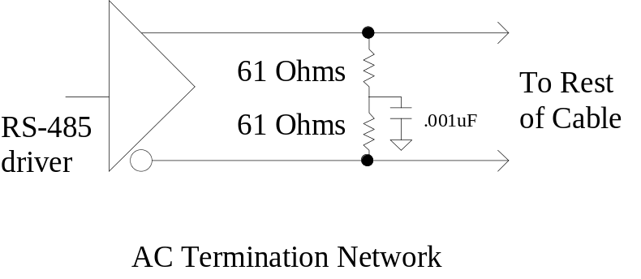

Figure 14

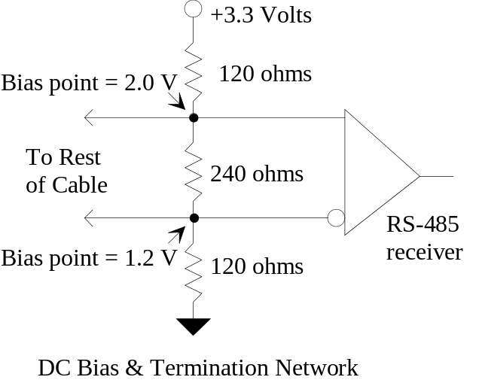

Figure 15

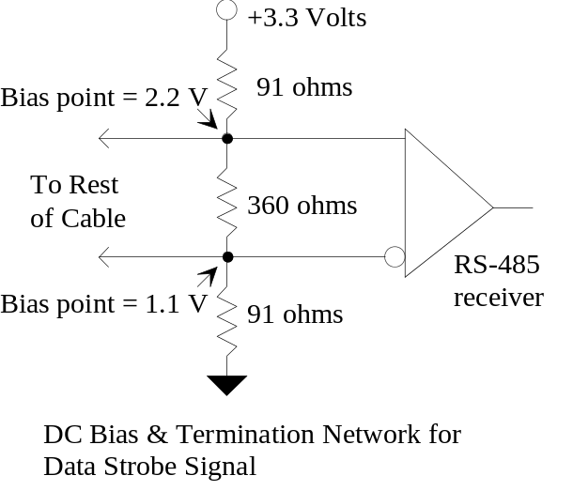

Figure 16

Permit Links

As noted in Section 1, the Permit signal is a NIM signal, requiring normal NIM termination.

Permit signals routed between Data Sources shall be terminated in a single 50 ohm resistance to ground, at the receiving (Permit In) end only.

The Repeater shall terminate the Permit In signal on both the Upstream and Downstream sides with an internal 50 ohm resistance.
Rule 27

Available from Denise Bumbar, Computing Division, FNAL, (708) 840-8277.

