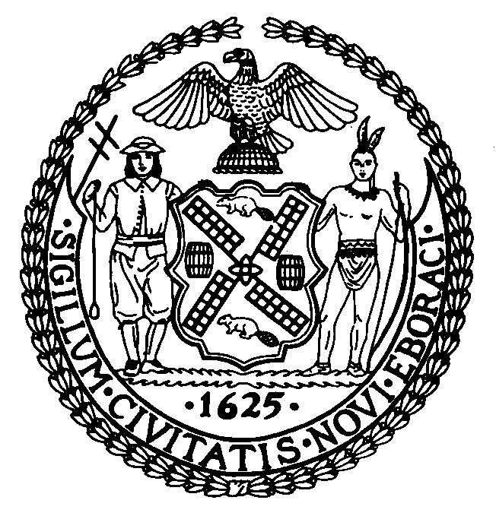
THE COUNCIL OF THE CITY OF NEW YORK

OFFICE OF COUNCILMAN THOMAS WHITE, JR.

145-40 Rockaway Blvd
South Ozone Park, NY 11436
(718) 843-0792

**For Immediate Release**

December 9, 2008

Contact: 212-788-6850

COUNCILMAN WHITE INTRODUCES LEGISLATION TO HELP SAVE OVER 500 JOBS IN SOUTHEAST QUEENS

December 9, 2008, City Hall, New York City - Councilman Thomas White Jr. introduced legislation to assist Flying Food Group (FFG) to obtain Regionally Significant Project (RSP) status within the South Jamaica Empire Zone. The FFG is a food processing and packaging company that serves over 85 airlines and nationally known retail companies, including, minority, women-owned, union shops with over 500 employees. FFG’s Jamaica facility is looking to expand and relocate their production facility to building 146 at JFK Airport. Key to these efforts is the Greater Jamaica Development Corporation which is currently assisting the Flying Food Group to attain RSP designation, as well as working with the Empire State Development Corporation to secure the necessary approvals.

“During a severe economic downturn, we must take the necessary steps to assure that strategic businesses remain in our communities and continue to provide well paid jobs,” Councilman White said, “this legislation will allow the Flying Food Group to pursue Regionally Significant Project status, allow Southeast Queens to retain one of its largest employers, expand and support the airport industry which is vital to the area, and enable the company to retain over 500 jobs, while creating over 200 new, good paying positions with benefits.”

“Greater Jamaica Development Corporation is particularly interested in supporting the airline industry and strengthening airport-related economic activity. This work is consistent with our efforts to boost the aviation business in Jamaica and the surrounding community,” said Carlisle Towery, President of the Greater Jamaica Development Corporation, which administers the State Empire Zone Program for Jamaica. “Thanks to the Empire State Development Corporation, which is offering tax credits for retention and expansion and Councilman Thomas White Jr. of the New York City Council who is working to secure Regionally Significant Project status via legislation, which would allow the Flying Food Group obtain Empire Zone Benefits and further enhance the companies ability to thrive and create jobs for area residents.”

“These tax credits are important to making this project a success. The support of the City Council and Councilman White's leadership as Chair of the Economic Development Committee represent a giant step toward qualifying our company for these incentives as we grow and invest in Southeast Queens,” said David Cotton, CFO of the Flying Food Group.

In order to make the Jamaica location attractive to FFG, as well as retain the 500 plus positions, create over 200 new jobs and invest over $20 million in capital improvements to the property at JFK Airport, FFG is seeking Regionally Significant project status and will be following in the footsteps of Bimmy’s LLC and the Bronx-Westchester Tempering Corporation which received such designations as Regionally Significant Projects earlier in the year. Designation as an RSP entitles a company to New York State Empire Zone benefits which may include the following:
Wage, employment, tax reduction, real property, investment and capital tax credits, as well as sales tax exemptions and refunds.

FFG has been approved for regionally significant status by the South Jamaica Empire Zone Administrative Board, and the Empire State Development Corporation, which oversees the Empire Zone Program at the State level. The next step is for the Council to pass a local law granting RSP status to the Flying Food Group.

