ON CORONAL STREAMER CHANGES

N. Gopalswamy¹, M. Shimojo², W. Lu¹, S. Yashiro³, K. Shibasaki²,
and R. A. Howard⁴

¹NASA Goddard Space Flight Center, Greenbelt, MD 20771, USA
²Nobeyama Radio Observatory, Minamimaki, Minamisaku, Nagano, 384-1305, Japan
³The Catholic University of America, Washington DC 20064, USA
⁴Naval Research Laboratory, Washington DC 20064, USA

ABSTRACT

Coronal streamer represents one of the pre-eruption configurations of coronal mass ejections (CMEs), because they overlie prominences and often possess all the substructures of CMEs. In this paper, we report on a study of streamer changes associated with prominence eruptions. The prominence eruptions and streamer changes were observed by the Nobeyama radioheliograph and Solar and Heliospheric Observatory (SOHO), respectively. Multiwavelength data showed that at least one of the streamer events involved heating and small-scale material ejection that subsequently stalled. After presenting illustrative examples, we compare the properties of the streamer-related events with those of general population of prominence events. We find that the properties of streamer-related prominence events are closer to those of prominence eruptions with transverse trajectories.

INTRODUCTION

It has been known for a long time that coronal streamers visible in eclipse pictures often overlie prominences and coronal cavities (Saito and Tandberg Hanssen, 1973). At least in one class of coronal mass ejections (CMEs), prominence core, cavity and frontal structure are observed similar to what is seen in streamers. If we associate the outer structure of CMEs with the white light streamers (see, e.g., Hundhausen, 1988), we can conclude that the streamers represent the pre-eruption state of at least some CMEs. How the pre-eruption configurations evolve may hold clues to the understanding of the eruption. In one such scenario, slow addition of mass to the closed field regions of the streamer may result in its subsequent eruption (Wolfson et al., 1987) seen as “bugles” (Howard et al., 1985; Hundhausen 1993). Another aspect of this configuration is that the mass in the streamer restrains the cavity, and hence allows for the build up of sufficient energy to produce eruptions (Wolfson and Saran, 1998). In this paper, we discuss another kind of evolution in which the eruption is partial and results in streamer changes. Full eruptions would correspond to the streamer blowout events first described by Howard et al., (1985) using Solwind data. The events presented in this paper were noticed among the prominence eruption events observed by the Nobeyama radioheliograph while studying their association with white-light CMEs (Gopalswamy et al., 2003).

ILLUSTRATIVE EXAMPLES

The streamer-related prominence events were identified in the sample of prominence eruptions in microwaves obtained by the Nobeyama radioheliograph at 17 GHz. The Solar and Heliospheric Observatory (SOHO) mission’s Large Angle and Spectrometric Coronagraph (LASCO) images were used to observe the streamer changes. During 1996-2001, a total of 226 prominence eruptions were identified from the daily images using an automatic detection software (see, Gopalswamy et al., 2003 for details). Out of these, 186 events overlapped with SOHO observations. Some 52 prominence eruptions lacked white-light CMEs, out of which 11 were streamer changes (see Table 1 for the list). We study these 11 events in this paper.

2000 January 18 Event
The microwave images of the Sun (southeast quadrant is shown) in Figure 1 show the 2000 January 18 prominence event. The prominence mainly moved in the transverse direction (parallel to the limb), with no significant radial motion. However, the overall height of the prominence increased slightly. From the height-time measurements, we found the average speed to be only ~ 5.2 km/s. Although the Nobeyama observations ended by 06:11 UT, we were able to track the prominence using the Pic du Midi H-alpha coronagraph data (see Fig 1b). By 14:32, the prominence had completely erupted. In white light, the streamer overlying the prominence showed some change during the Nobeyama observations, but did not erupt. Figure 2 shows the streamer as observed by LASCO corresponding to the period of the Nobeyama observations. Note that the streamer increased in height and width slowly. Figure 2b shows the subsequent evolution of the streamer. The streamer was also slightly perturbed (deflected to the south) by a nearby CME. After continued swelling, the streamer finally erupted as a slow CME in association with the prominence eruption observed in H-alpha by the Pic du Midi coronagraph. The average speed within the coronagraph field of view was only 143 km/s and showed significant acceleration. The activation of the filament started at 01:41 UT, and it took about 11 hours for the onset of the CME. The response of the streamer to the prominence activation or small-scale eruption seems to be the slow swelling. It must be noted that the streamer change is much more than the changes one would expect from solar rotation.

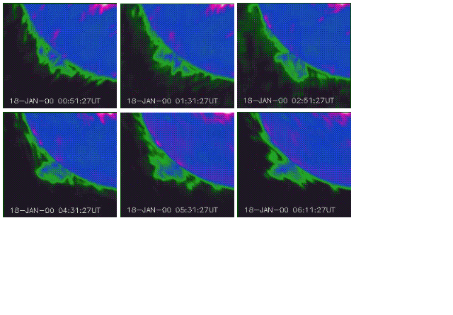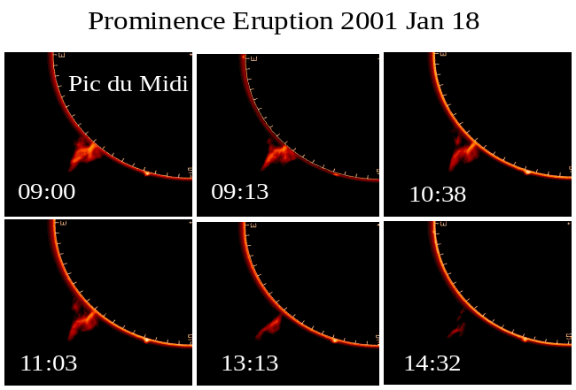

Fig. 1a (left). A series of microwave (17 GHz) images (southeast quadrant) showing the 2000 January 18 prominence event and, b (right) subsequent evolution of the prominence in H-alpha as observed by the Pic du Midi coronagraph (images courtesy: SOHO summary data base).

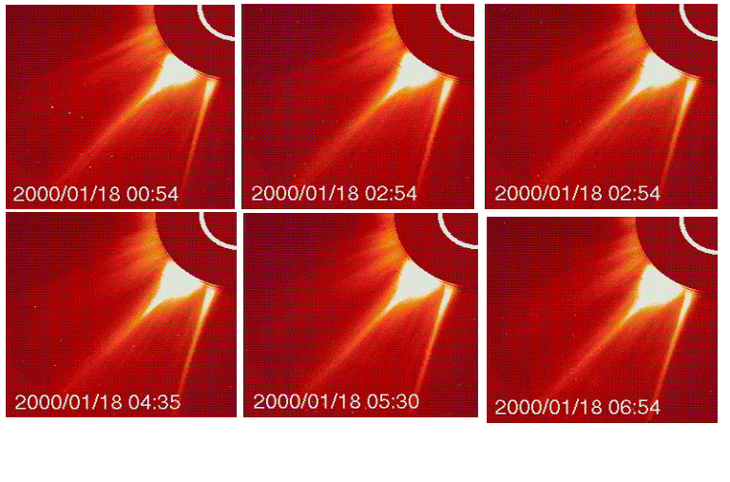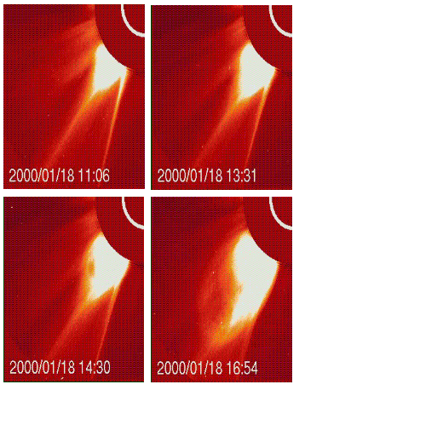

Fig. 2a (left). SOHO/LASCO images (southeast quadrant of the corona) from the C2 telescope showing the swelling of the streamer; 2b (right) Subsequent evolution and the eruption as a CME. The white arc represents the solar disk superposed on the occulting disk.
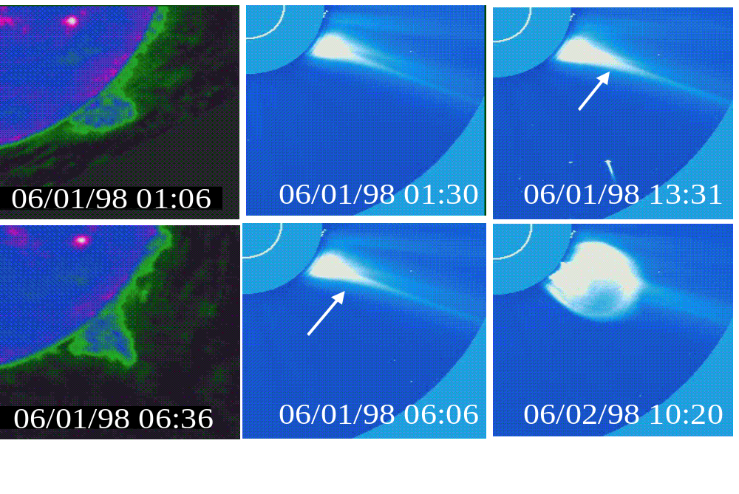

Fig. 3. Microwave (two leftmost panels) and SOHO/LASCO images showing the prominence eruption, streamer swelling (arrows) and the subsequent eruption of the streamer as a spectacular CME (four right panels).

The 1998 June 01 Event
The 1998 June 1 prominence event occurred from the southwest limb. Figure 3 shows the prominence eruption along with the streamer changes. The microwave image at 01:06 UT shows the pre-eruption position of the prominence. The image at 06:36 shows that the leading edge is at a larger height. The prominence motion was again slow with an average speed of 8 km/s. The streamer had corresponding increase in the height of its helmet (compare the 01:30 and 06:06 LASCO images in Fig. 3). The apex of the streamer continued to increase (see the 13:31 UT image in Fig. 3) and finally resulted in a CME the next day at 08:08 UT. The fully formed CME can be seen in the 10:30 UT image in Fig. 3. The Nobeyama radioheliograph stopped observations for the day around 06:30 UT. Fortunately, the filament was also observed by SOHO’s extreme-ultraviolet imaging telescope (EIT), which showed indications of a EUV eruption from the northern part of the filament. The EUV eruption started at 05:00 and reached its maximum height of ~ 0.3 Rs above the surface. After reaching the maximum height, the
EUV ejecta started fading away until about 06:56 UT. Movies of EUV images clearly showed that it was a “failed eruption.” It appears as though the EUV ejecta hit a barrier and was stopped. The whole prominence was also seen in absorption by EIT and showed some activation, similar to what was seen in microwaves. A large coronal cavity was observed in the pre-eruption phase, which might have acted as the barrier (Plunkett et al., 2000). The EUV ejecta was seen in emission which means that part of the prominence must have been heated to coronal temperatures even in this small-scale eruption. Figure 4 shows a superposition of microwave contours on an EIT difference image when the eruption reached its maximum height (darkest features corresponds to brightest EUV emission in the reverse color table). Note that there were two regions with enhanced EUV emission: one is the ejecta and the other near the southern leg of the prominence in projection. This suggests the overall participation of the prominence as is also evident from the microwave prominence. The EUV ejecta corresponds to the thin upper part of the microwave prominence.

Carrington Maps
In order to look at the long-term evolution of the 1998 June 01 streamer event, we examined the Carrington maps of the corona obtained from the LASCO C2 images (Rich et al., 2000). Figure 5 is a Carrington map constructed from the west limb images at three different radial distances (2.5, 3.0 and 4.5 Rs) for the rotation 1936. The feature we are interested in is the bugle roughly at the center of the map (pointed by arrow). The feature can be on maps of all heights with a narrower width at larger heights. Note that this streamer was the brightest in the Carrington map. The streamer first appeared on 1998 May 28 and slowly evolved as a bugle until
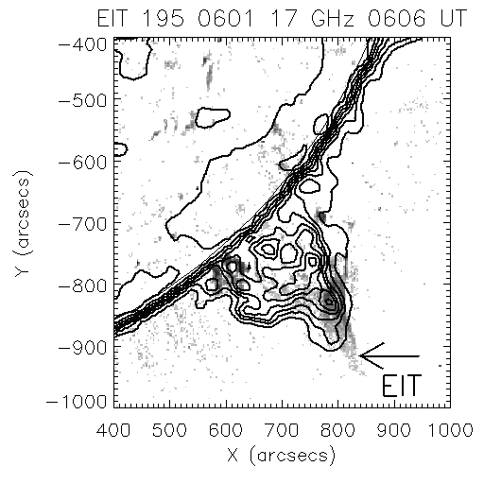

Fig.4. Overlay of the microwave (17 GHz) Contours on an EIT difference image.

the beginning of June 2, when it erupted as a spectacular CME with a heavily structured prominence core (see Plunkett et al 2000 for details). The vertical feature at the wider end of the bugle corresponds to the CME. The measurements were made starting from 08:08 UT on 1998 June 02 from a height of about 3.3 Rs. Note that the

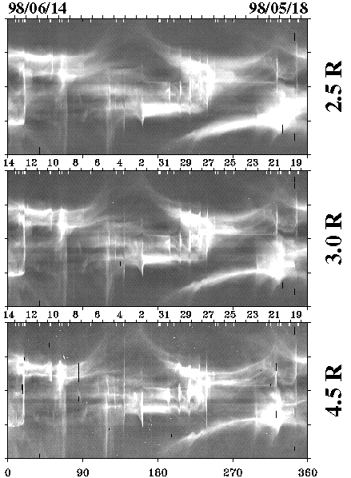

Fig. 5. Carrington maps for the period 1998 May 19 to June 14 showing the streamer event of 1998 June 1. The maps were constructed by assembling strips of the coronal images at a given height (marked at the right side of the maps). Typical resolution on the maps is ~0.5 degrees in longitude and 1 degree in latitude. At the bottom, the Carrington longitudes are given.
streamer was completely destroyed due to the CME eruption. The Carrington map shows many CMEs (indicated by the sharp vertical features), but there are not many bugle-type events. The CME had a significant acceleration and CME took almost eight hours to cross the field of view of LASCO. It attained a speed of 1278 km/s when it left the LASCO field of view, though the average speed was only 750 km/s. The prominence observed in microwaves and EUV became the highly-structured core of the CME.

Table 1. List of prominence eruption events

Prominence Event  (Date & UT) | P-Angle  (deg) | Speed  km/s | Height  (Rs) | Subsequent  CME (UT)
1996 Aug 30 22:49 | 74 | 7.5 | 1.16 T | ?
1996 Sep. 05 03:00 | 268 | -12.7 | 1.12 T | ?
1996 Sep. 18 01:05 | 85 | 34.3 | 1.32 R | ?
1997 Dec 24 04:26 | 130 | 20.8 | 1.24 R | ?
1998 Jun. 01 06:06 | 222 | 8.0 | 1.29 R | 08:08n
1999 Jun. 15 01:01 | 178 | 5.1 | 1.14 T | 14:55
1999 Aug 14 02:41 | 48 | -1.3 | 1.17 T | 06:30
2000 Jan. 18 01:41 | 146 | 5.2 | 1.25 T | 11:54
2000 Sep. 09 22:46 | 312 | 12.9 | 1.15 T | 07:15n
2001 May 28 22:50 | 175 | -12.8 | 1.21 R | ?
2001 Dec 11 00:55 | 130 | -8.0 | 1.09 T | 18:30n

STATISTICAL RESULTS

Table 1 gives list of streamer-related prominence events we studied. The position angle of occurrence, the speed and the largest height attained (in units of solar radii, Rs) are listed for each prominence event. The negative speeds correspond to events in which only the descending phase could be measured. In the last column we have also noted the direction of the trajectory (R and T). Gopalswamy et al. (2003) found that the prominence trajectories could be classified as radial (R) or transverse (T) to denote the predominant direction of motion of the prominence. The T events generally correspond to prominence activation events while the R events correspond to prominence eruption events. The R events generally acquired larger final heights and moved faster on the average. On the other hand the T events were confined to lower heights and never left the field of view of the radioheliograph. Most of the R events were associated with white-light CMEs while only a small fraction of the T events had CME association. In the preceding sections, we described two events: the T event of 2000 January 18 and the R event of 1998 June 01. Note, however, the later eruption of the 2000 January 18 event was radial because the prominence had erupted. Table 2 compares the speed and final heights of the streamer-related events with those of the R and T events in general. It is clear that the streamer-related prominence events had properties intermediate between the R and T events, but closer to the T events because a majority of the streamer events (7/11 = 64%) had transverse trajectories. Even those with the radial trajectories had a final height much smaller than the average final height of all the R events (see Table 2).

Table 2. Comparison of the streamer-related prominence
events with the R and T events (Gopalswamy et al. 2003)
Property | Streamer  events | Transverse  events | Radial  events
Average speed (km/s) | 13 | 10 | 65
Final height (Rs) | 1.19 | 1.16 | 1.4

We tracked the streamers beyond the prominence event and found that more than half of them subsequently erupted along with an associated CME. The times of the subsequent CMEs are given in the last column of Table 1 (with the suffix ‘n’ denoting that the time corresponds to the next day). Note that the subsequent CMEs occurred 4 – 42 hr later, with an average delay time of ~17.3 hr. In some events the streamers distended and faded out gradually, so it was difficult to say whether there was a CME. These events are marked by a ‘?’ in the last column of Table 1. With the small number of CMEs it is difficult to say whether the prominence events discussed in this paper can be treated as a precursor to the subsequent eruption. It is possible that these streamer events represent an intermediate level of activity between the prominence eruptions and very slow evolution.

SUMMARY

We performed case studies of two prominence events and the associated streamer events to show that the two phenomena are related similarly to the CME-prominence core. We also performed a statistical analysis of a set of 11 such events and found that they correspond to eruptions less energetic than typical prominence eruption events, which invariably end up in the cores of white light CMEs. The prominence motion is horizontal for a majority of the cases, which will be normally classified as prominence activation events. There was also a sizable number of radial events, in which the prominence seems to be stalled after an initial radial motion. In the radial event we discussed, we know that there was a huge cavity (flux rope) overlying the filament. It is possible that the flux rope prevented the prominence from escaping. Since streamer changes are closely associated with prominence activations or partial eruptions, this may have important implications for understanding the CME initiation process. Very slow evolution of streamers in brightness and size has been linked to changes in photospheric magnetic flux. In particular, increase in brightness is known to be correlated with decrease in photospheric flux, which was interpreted as opening of flux tubes under the streamer (Poland and MacQueen, 1981). In this sense, we think that the prominence activations produce a similar effect of opening some field lines. Unfortunately, we cannot verify this because it is difficult to observe the photospheric magnetic field changes for limb events. Prolonged coronal dimming associated with some eruptions may also correspond to these field openings (Gopalswamy et al., 1999). We need a reverse study to look at a large number of streamers as they evolve to arrive at firm conclusions regarding the connection between the small-scale prominence eruptions and activations on the one hand and the stability of the streamers on the other.

ACKNOWLEDGMENTS

This work was supported by United States NASA (Living with a Star), Air Force Office of Scientific Research, and NSF/SHINE (ATM 02045880).

REFERENCES

Gopalswamy, N., M. L. Kaiser, R. J. MacDowall, et al., Dynamical phenomena associated with a coronal mass ejection, in Solar Wind Nine, Proceedings of the Ninth International Solar Wind Conference, edited by S. R. Habbal, R. Esser, J. V. Hollweg, and P. A. Isenberg, AIP Conf. Proceedings, Vol. 471, pp.641-645, 1999.
Gopalswamy, N., M. Shimojo, W. Lu, et al., Prominence eruptions and coronal mass ejection: A statistical study using microwave observations, Astrophys. J., 586, 562-578, 2003.
Howard, R. A., N. R. Sheeley, D. J. Michels et al., Coronal mass ejections - 1979-1981, J. Geophys. Res., 90, 8173-8191, 1985
Hundhausen, A. J., Sizes and locations of coronal mass ejections - SMM observations from 1980 and 1984-1989, J . Geophys. Res., 98, 13177-13200, 1993.
Poland, A. I. and R. M. MacQueen, The evolution of a coronal streamer and the photospheric magnetic field, Solar Phys., 71, 361-379, 1981.
Plunkett, S. P., A. Vourlidas, S. Simberova et al., Simultaneous SOHO and ground-based observations of a large eruptive prominence and coronal mass ejection, Solar Phys., 194, 371-391, 2000.
Rich, N., K. P. Dere, and R. A. Howard, Synoptic maps from the LASCO experiment on SOHO, AGU abstract, SH51A-06, 2000 (http://lasco-www.nrl.navy.mil/carr_maps).
Saito, K., and E. Tandberg-Hanssen, The arch systems, cavities, and prominences in the helmet streamer
observed at the solar eclipse, November 12, 1966, Solar Phys., 31, 105-121, 1973.
Wolfson, R., R. M. E. Illing, and C. Conover, The evolution of a coronal streamer prior to mass ejection , J. Geophys. Res., 92, 13641, 1987.
Wolfson, R., and S. Saran, Energetics of coronal mass ejections: Role of the streamer cavity, Astrophys. J., 499, 466, 1998.

