SNS/ORNL Note-draft 07/22/2001

Note on Different Schemes of Laser Wire Technique Implementation for SNS.

A.V.Aleksandrov.

- Introduction.
Laser wire technique for beam profile measurements was proposed for SNS [1] and is being experimentally tested at BNL [2]. Current implementation makes use of pulsed Q-switched Nd-YAG laser for photo-detachment of electrons from H⁻ ions. Wide band measurements downstream of the laser are used to detect reduction of the beam current due to photo neutralization. While this scheme has certain advantage of use of the cheapest way to obtain highest instant power thus providing largest instant degree of photo-neutralization, there are some disadvantages. First, efficiency of laser power use is quite low because more than 99% of photons of 10ns laser pulse pass by H⁻ bunch of 20 ps duration. Second, extremely high power laser beam requires more complicated and expensive optics to handle it. Third, wide band measurements are required to detect neutralization notch on the beam current.
Note that choice of laser system is mainly dictated by signal detector properties. Indeed, energy (i.e. number of photons) delivered for 1ms by 1mJ pulsed Nd-YAG, mode locked 1W Nd-YAG or 1W diode laser is the same therefore total number of neutralized ions is the same. Beam current sag produced by the pulsed laser has large amplitude over short time easily observable by naked eye on an oscilloscope therefore this scheme is well suited for initial “prove of principle” experiments. In contrast, CW light sources produce photo neutralization of very small amplitude over long time and require special tools for detection. Netherless CW mode sources can provide significant advantages: possibility to measure longitudinal profile in case of short pulse mode locked laser, low cost and mechanical simplicity in case of laser diode. Photo-neutralization yield for CW and mode locked laser wire is estimated and possible detection schemes are discussed in this paper.

- Pulsed laser.
Short pulse (  10 ns) Nd-YAG laser ( = 1.064m) can deliver light beam of very high instant power (250mJ energy at 10Hz repetition rate). Such a beam when intercepting H- beam can neutralize substantial part of ions. The result of neutralization can be observed on downstream current monitor as sag in the current profile following shape of the laser beam. BCM must have wide bandwidth (100 MHz) to measure narrow peak of neutralization. Time windowing can help to reduce low frequency noise but if BCM is located far downstream from laser wire, it can be difficult to determine initial position of the window. Dependence of estimated signal amplitude upon ion beam energy is shown in fig.1

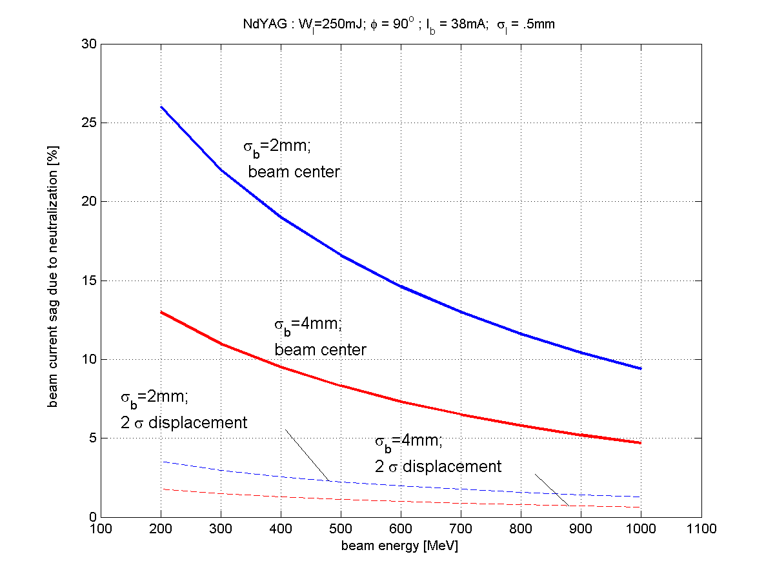
Figure 1. Dependence of H- beam neutralization upon beam energy

3. Mode locked CW laser. Output of mode locked CW laser consists of continues stream of short light pulses. Typical parameters of readily available commercial laser used for further calculations are 2W of average power, <1ps pulse width, 50 MHz repetition rate at 1064 nm wavelength. These parameters are flexible and its variation by order of magnitude up or down doesn’t affects price of the laser significantly (for fixed wavelength, of course). The main advantage of this laser is that light pulse can be shorter than ion pulse thus overlapping it completely and providing 100% use of available laser power. Moreover by scanning relative phase of light pulses relative to ion bunches one can measure longitudinal distribution in the H⁻ micro bunch. Relative instant photo-neutralization degree is shown in Table 1 for different beam energies. It is rather small in comparison with possible 100% for 10ns pulsed laser but lasts for all beam pulse duration, therefore laser output intensity can be modulated internally or by external optical modulator and narrow band receiver used to detect modulation of the beam current. Note that not only wide band current transformers can be used in this case but also sum signal from BPM because spectral line of the signal can be placed inside BPM receiver bandwidth around harmonic of fundamental beam frequency by proper choice of laser repetition rate and modulation frequency [3]. Electron detection as being discussed below can make implementation of this diagnostics much simpler.

Table 1. Photo-neutralization output at different laser wire locations
(mode locked laser, τ<1ps, P=2W, f=50MHz, λ=1064 nm, I_{b}=38mA, )
Beam energy, MeV | 2.5 | 7.5 | 86 | 186 | 379 | 1000
Instant neutralization degree | 3.5⋅10⁻⁵ | 2⋅10⁻⁵ | 6.4⋅10⁻⁶ | 4.6⋅10⁻⁶ | 3.3⋅10⁻⁶ | 1.9⋅10⁻⁶
Number of detached e⁻ for 2.5 ns | 2e4 | 1.2e4 | 3.8e3 | 2.7e3 | 2e3 | 1.1e3
Number of detached e⁻ for 945 ns | 5.6⋅10⁶ | 3.3⋅10⁶ | 1.1⋅10⁶ | 7.5⋅10⁵ | 5.6⋅10⁵ | 3.1⋅10⁵
Number of detached e⁻ for 1.0 ms | 8⋅10⁹ | 5⋅10⁹ | 2⋅10⁹ | 1⋅10⁹ | 8⋅10⁸ | 5⋅10⁸

- Diode Laser.
Output of diode laser is continues light flax, which can be easily modulated by modulation of applied current. Typical DC output power of several watts combined with large beam divergence results in much smaller amplitude of instant photo-neutralization degree than for mode locked laser as shown in Table 2. Problems associated with reliable detection of so small signal can easily outweigh any other advantages of this type of laser if modulation of beam current is used as observable. But low cost and mechanical robustness of diode laser can justify use of direct detection of photo-detached electrons as shown in fig.2.

Table 2. Photo-neutralization output at different laser wire locations
(diode laser, P=10W, λ=900 nm, I_{b}=38mA, )
Beam energy, MeV | 2.5 | 7.5 | 86 | 186 | 379 | 1000
Instant neutralization degree | 2⋅10⁻⁶ | 1⋅10⁻⁶ | 3⋅10⁻⁷ | 2⋅10⁻⁷ | 1⋅10⁻⁷ | 8⋅10⁻⁸
Number of detached e⁻ for 2.5 ns | 1⋅10³ | 7⋅10² | 2⋅10² | 166 | 120 | 68
Number of detached e⁻ for 945 ns | 3⋅10⁵ | 2⋅10⁵ | 6⋅10⁴ | 4⋅10⁴ | 3⋅10⁴ | 2⋅10⁴
Number of detached e⁻ for 1.0 ms | 4⋅10⁸ | 2⋅10⁸ | 6⋅10⁷ | 4⋅10⁷ | 3⋅10⁷ | 2⋅10⁷

Electrons released in the process of photo-detachment have well defined velocity along the beam. They can be easily deflected by uniform magnetic field and collected. Bending radius for electrons in uniform magnetic field is

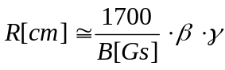

For example in the MEBT 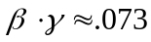 and magnetic field required to turn electrons with radius R is

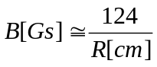
It is useful to take 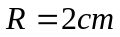 to guide stripped electrons just outside the aperture of 1.5 cm. Then 62Gs magnetic field is appropriate and total longitudinal size of the profilometer can be about 3cm, which fits to the current MEBT wire scanner box. Note that quality of magnetic field is not important and stray magnetic field of surrounding quads is not an issue in contrast to beam imaging devices such as IPM. Single detector can be used for horizontal, vertical etc. measurements. Stripped electrons have energy of 1.25keV therefore no additional accelerating voltage is needed inside the vacuum chamber. If phosphor screen is placed at the exit of 90⁰ magnet then emitted light can be collected by photomultiplier outside of the vacuum chamber.

H- beam
Laser beam
Phosfor screen
Photodetector
Photoelectrons
Background
electrons
Bending
magnet
Fig.2. Schematic view of electron collection detector.

References.
- B.Shafer, Laser Wire Profile Measurement Simulation.
- R. Connolly, et al., private communication.
- Proposed by T. Shea in private communication.

