Feb 10, 2001
G. W. Foster

Section 5.1.3 Corrector Magnet System Requirements - Phase I
***THIS SECTION HAS SOME WRONG NUMBERS BUT THE IDEAS ARE OK**

Introduction

The LF magnet system has a complete set of dipole, quadrupole, and multipole correctors distributed throughout the arcs. The magnets are independently powered with short cables from power supply modules located at each half-cell boundary. This provides maximum flexibility for diagnosis and manipulations of the beam optics. All correctors are factory installed, aligned, pre-cabled and tested on the 65m magnet assembly. There are on average ~3.5 corrector magnets in each half-cell for each bore of the machine, for a total of 12,000 corrector magnets in the ring. The aperture requirements for correctors are discussed in section [***vacuum].

Reliability

A large machine can typically function properly with a number of broken correctors. However, corrector failures during a collider store often cause the store to be lost. Thus the Phase I corrector power supplies (sect ***) will be fully redundant, with a “hot spare” supply for all loads either ready to take over or actively involved in load sharing. This redundancy increases the (relatively small) direct hardware cost of the power supplies and does not affect the cabling or power dissipation requirements. The increased reliability from redundancy is desirable and appropriate given the scale of the machine. Corrector reliability is not a machine safety issue since the long fall time (milliseconds to seconds) of the magnetic field in the corrector allows the beam to be safely aborted.

The power distribution to each module is also doubly redundant as described in section ***. Each supply module can accept input power in either direction in the tunnel from loop feeders with remote disconnects. Thus any single power feeder can fail (open or short circuit) without a loss of input power to any supply module. We expect this redundancy to provide an appropriately reliable corrector system.

Technology Choice: Superconducting or Warm Correctors

Both superconducting and warm (copper/iron) corrector designs were developed and evaluated in the course of this study. Warm correctors were chosen for reasons of simplicity, flexibility, and cost.

Superconducting Corrector Option
The main advantage of a superconducting corrector is that very strong correctors can be made in relatively compact packages. The cold corrector can share the insulating vacuum with the transmission line, and be clamped directly onto the transmission line without large cold-to-warm forces. If a cold-bore corrector design is chosen, its cryopumping will reduce the number of ion pumps needed to remove CH4 from the beam pipe vacuum. The overhead paid for this includes current leads, leak checking, quench protection, thermal shields and intercepts, warm bore or extra gate valves on the beam pipe, vacuum feedthroughs, and so on. The estimated heat leak and cold mass of the first-pass corrector design (see fig --) would approximately double that of the main transmission line.

Fig 1 – Superconducting Corrector Option [ref ***] Developed for Design Study.

Normal Conducting Corrector Magnets
The chosen correctors are classical room temperature, air cooled, iron dominated magnets with copper coils. The design parameters benefit from the small aperture requirements of the Phase I machine. The design fits well with the vacuum system of the Phase I magnet. These are well developed technologically, with a good experience base for projecting costs, reliability, and power consumption. Collaboration with industry is straightforward with these magnets. Magnet details are given in section ***.
Warm correctors with large iron yokes cannot easily coexist with the 100kA transmission line current. The best solution is to re-route the transmission line downwards towards in a 20-30cm chicane as it passes the corrector magnet. See fig.2.

Fig 2 – Normal conducting Corrector Option Chosen for Design Study.

ORBIT CORRECTOR DIPOLE REQUIREMENTS

Location of Orbit Correctors
The Phase I machine follows the canonical approach of having one Horizontal (or Vertical) dipole corrector at each Focusing (or Defocusing) “quad location” in the lattice. Correctors are identical in the straight sections and the arcs. Approximately 20 locations have both H and V correctors to provide complete orbit control for injection, extraction, beam cleaning, IR’s, etc. These require no special spool pieces or special integration since the correctors are “C-magnets” clamped over unoccupied beam pipe in the straight sections.

Strength of Orbit Correctors
The parts cost and power dissipation of a warm corrector increases linearly with its strength. Thus there is incentive to provide the minimum strength necessary to get the job done. The orbit corrector strength must satisfy several requirements. The most stringent by far is the requirement to regulate the orbit at full energy, in the presence of installation misalignments, bend strength errors, and geological settling of the tunnel. The final requirement (discussed below) is that a single corrector must be able to “bump the orbit at the next corrector” by at least 3mm TBD at top energy of 20 TeV. This requires a corrector of 0.5 TBD Tesla-meter.

1. During commissioning, correctors must have sufficient strength to thread the orbit
from BPM to BPM to establish a closed orbit, in the presence of both routine field and alignment errors and occasional (several mm) alignment blunders. The corrector strength should not limit initial beam threading as long as there is physical aperture between BPM/corrector locations. This is automatically satisfied at injection energy where the maximum orbit bump is 20x the high field bump or ~60mm TBD. This is far outside the range of expected misalignments.

2. Full aperture scans are necessary to verify the clear beam path and identify alignment problems. Again, the corrector strength necessary for orbit correction at 20 TeV energy is sufficient to perform full aperture scans in the +/-10mm beam pipe at any energy up to 5 TeV. (Note there is no particular problem with magnet quenches while performing aperture scans in the warm-iron transmission line magnet. Preserving this capability is an additional argument in favor of normal conducting correctors.)

3. High-field orbit corr. - [insert Hiroshi Simulation Words leading to 0.5-1 T-m]
input assumptions:
- alignment offsets
- rolls
- bend strength errors
- ground motion
- number of magnets moved
results:
- closed orbit distortions & corrector strength distributions

DIPOLE CORRECTORS |  |  | Phase I
 | Location (one per half-cell each bore) | (H/V) at (F/D) quad locs
 | Number per Ring (both bores) | 3420
 | Magnet Type | Warm Iron/Copper
 | Configuration | C-Magnet
 | Bend Field (max) | 0.7 |  | T
 | Magnetic Length | 0.7 |  | m
 | Physical (slot) Length | 1 |  | m
 | Integrated Bend Strength | 0.5 |  | T-m
 | Bore | warm aluminum pipe
 | Magnetic Aperture (magnet gap/coil diam) | 20 x 30 |  | mm
 | Physical Aperture | 18x28 |  | mm
 | Max Bend Angle
 | at injection | 158.3 |  | urad
 | at max energy | 7.4 |  | urad
 | Max Orbit Deflection (2-bump)
 | at injection | 65.2 |  | mm
 | at max energy | 3.1 |  | mm
 | Equivalent Quad Displacement
 | at injection | 14.7 |  | mm
 | at max energy | 0.7 |  | mm
 | Magnet Weight | 300? |  | kG
 | Coil Weight | 150? |  | kG
 | Operating Current (max) | 10 |  | Amp
 | Coil Resistance incl. Leads | 10 |  | Ohm
 | Ohmic Voltage (max) | 100 |  | V
 | Ohmic Power (max) incl. Leads | 1000 |  | W
 | Ohmic Power (average for ring) | 200 |  | W
 | Coil Inductance | 1 |  | H
 | Min Ramping Time 0-100% | 20 |  | sec
 | Max Inductive Voltage | 0.5 |  | V
 | Inductive Stored Energy | 50 |  | J
 | Overheating Protection | Series Klixon
 | Coolant | Air
 | Power Supply Location | Each Quad location

QUADRUPOLE CORRECTOR REQUIREMENTS

Location and Number of Quad Correctors
The Phase I machine has an independently powered quadrupole corrector at each “quad location” in the arcs, and at locations of straight section quads which are not independently powered. The main function of the correctors is to locally compensate for the gradient shifts that occur near 2 Tesla due to iron saturation in the combined-function arc magnets. The situation is analogous to separated-function machines having quads and dipoles on a common bus, and which therefore require quad correctors to account fo r the differential saturation of quads and dipoles [ref SSC: 2% allowance for quad:dipole tracking].

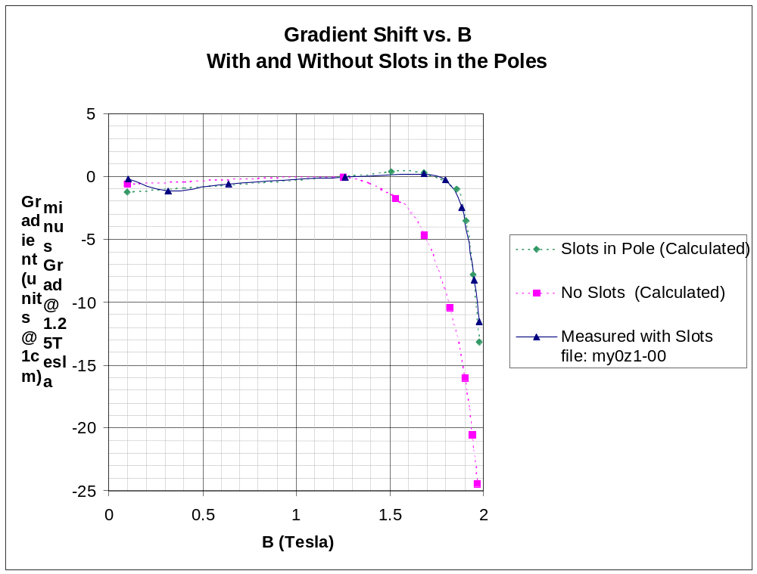
Individual correctors at each quad allow the beta functions to be measured (via the tune shift vs. corrector current) at each quad location. Thus beta waves can be detected and corrected at each cell. This compensates for both systematic and random quadrupole errors, as well as avoiding loss of aperture due to beta waves.

Strength of Quad Correctors
The strength of the quad correctors must exceed the gradient shift of the combined-function magnets. The gradient drops by ~10 units TBD as the steel saturates differentially on the high-field side of the pole tip. To preserve the optics and phase advance, this must be compensated for by an increased gradient from the quad corrector. The integrated strength required by the quad corrector is about 25% less than the integrated strength of the field defect in the arc magnets since it operates near beta-max in the cell.
To minimize corrector strength, the design gradient of the combined-function magnet is increased by one-half of the gradient drop at full field. This results in a bipolar corrector current program which swings to +/- 1/2 of the full gradient shift in the magnet.

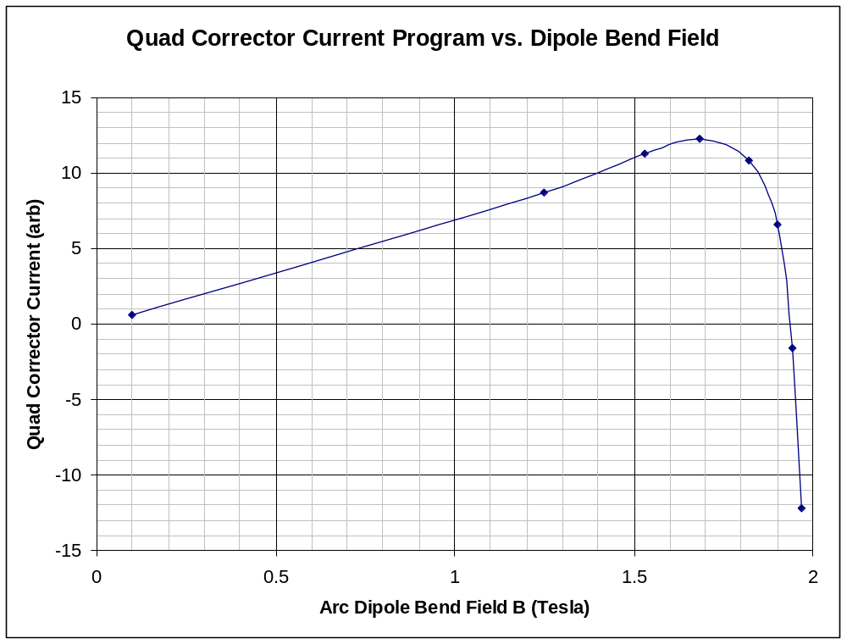

QUADRUPOLE CORRECTORS |  |  | Phase I
 | Location | each halfcell in arcs
 | Number per halfcell | 1 |  | per bore
 | Number per Ring (both bores) | 3136
 | Magnet Type | Warm Iron/Copper
 | Gradient | 25.0 |  | T/m
 | Magnetic Length | 0.75 |  | m
 | Physical (slot) Length | 1 |  | m
 | Integrated Quad Strength | 18.8 |  | T-m/m
 | Bore | warm aluminum pipe
 | Magnetic Aperture (magnet gap/coil diam) | 20 x 30 |  | mm
 | Physical Aperture | 18x28 |  | mm
 | Tune Adjustment (single corrector)
 | at injection | 0.197 |  | nu
 | at max energy | 0.009 |  | nu
 | Tune Adjustment (all correctors in ring)
 | at injection | 154.1 |  | nu
 | at max energy | 7.2 |  | nu
 | Beta Wave Generation/Trim (per corrector, fractional tune 0.3)
 | at injection | 131 |  | %
 | at max energy | 6 |  | %
 | Maximum Correctable Gradient Error in Dipoles
 | at injection | 194 |  | units@1cm
 | at max energy | 9 |  | units@1cm
 | Magnet Weight | 300? |  | kG
 | Coil Weight | 150? |  | kG
 | Operating Current (max) | 10 |  | Amp
 | Coil Resistance incl. Leads | 10 |  | Ohm
 | Ohmic Voltage (max) | 100 |  | V
 | Ohmic Power (max) incl. Leads | 1000 |  | W
 | Ohmic Power (average for ring) | 200 |  | W
 | Coil Inductance | 1 |  | H
 | Min Ramping Time 0-100% | 20 |  | sec
 | Max Inductive Voltage | 0.5 |  | V
 | Inductive Stored Energy | 50 |  | J
 | Coolant | Tunnel Air Flow
 | Overheating Protection | Klixon Interlock
 | Power Supply Location | Each Quad location

SEXTUPOLE CORRECTOR REQUIREMENTS

Location of Sextupole Correctors
The Phase I machine has an independently powered sextupole corrector at each “quad location” in the arcs, and (optionally, TBD) at the ¼ cell point. Their main function is to correct as necessary the saturation sextupole defect that occurs at full field in the transmission line magnet. If desirable, the independently powered sextupoles can be programmed to correct the individual (random) sextupole component of the arc magnets in each cell. Sextupole correctors can be grouped into software-defined “virtual families” for chromaticity & resonance control as well.
Tracking studies [sect ***] studied the extent to which a sextupole body field error can be compensated by one or more correctors in each half-cell. A point of reference is the Fermilab Main Injector, which compensates more than ~20 units of saturation sextupole without difficulties.

Sextupole Corrector Strength
The arc magnet pole tip design and “holes in the poles” (sect ***) have been optimize to reduce the required sextupole corrector strength. The resulting current program is shown in fig. ** .

[plot of arc sextupole vs bend field, and corrector current vs. bend field]

ALIGNMENT AND APERTURE REQUIREMENTS FOR CORRECTORS

(Maybe this should be moved to vacuum system)
Horizontal correctors 3x2cm
Vert correctors: 2x3cm
Quad and 6-pole correctors: 2.5cm pole tip radius

Most demanding alignment: vertical alignment of horizontal corrector.
Alignment keyed to end of laminations at either magnet end.

SEXTUPOLE CORRECTORS |  |  | Phase I
 | Location | each halfcell in arcs
 | Number per halfcell | 1 |  | per bore
 | Number per Ring (both bores) | 3136
 | Magnet Type | Warm Iron/Copper
 | Sextupole Strength | 0.15 |  | T @1cm
 | d2By/dy2 | 3000 |  | T/m^2
 | Magnetic Length | 0.8 |  | m
 | Physical (slot) Length | 1.0 |  | m
 | Integrated Sextupole Strength | 0.12 |  | T-m@1cm
 | Bore | warm aluminum pipe
 | Magnetic Aperture (pole tip/coil diam) | 25.0 |  | mm
 | Physical Aperture (diameter) | 23.0 |  | mm
 | Chromaticity Adjustment (single corrector)
 | at injection
 | at max energy
 | Maximum Correctable Sextupole Error in Dipoles
 | at injection | 99 |  | units@1cm
 | at max energy | 5 |  | units@1cm
 | Magnet Weight | 250.0 |  | kG
 | Coil Weight | 100.0 |  | kG
 | Operating Current (max) | 1 |  | Amp
 | Coil Resistance incl. Leads | 340 |  | Ohm
 | Ohmic Voltage (max) | 340 |  | V
 | Ohmic Power (max) incl. Leads | 340 |  | W
 | Ohmic Power (average for ring) | 255 |  | W
 | Coil Inductance | 1 |  | H
 | Min Ramping Time 0-100% | 20 |  | sec
 | Max Inductive Voltage | 0.05 |  | V
 | Inductive Stored Energy | 0.5 |  | J
 | Coolant | Tunnel Air Flow
 | Overheating Protection | Klixon Interlock
 | Power Supply Location | Each Quad location

