Procedure for setting up the transfer lines for the sns*

D. Raparia, Y. Y. Lee W. T. Weng, and J. Wei,
Brookhaven National Laboratory, Upton, NY 11973

Abstract
This paper describes the procedures for setting up the transfer lines for the Spallation Neutron Source (SNS). The High Energy Beam Transfer (HEBT) is about 170 meters long and has two achromat sections, an energy corrector cavity, energy spreader cavity, and transverse and longitudinal collimators. The Ring to Target Beam Transfer (RTBT) line is about 150 meters long has an achromat, transverse collimators and a beam spreader section. It will be shown that with the available diagnostics one can first characterize the incoming beam in both lines and then, with types and locations of the diagnostics and beam tuning “knobs”, set up to deliver an output beam with the desired properties.

1 Introduction
The 1.4 MW Spallation Neutron Source (SNS) [1], under construction in Oak Ridge National Laboratory, is an order of magnitude higher power than any other existing machines. The commissioning of the HEBT, RING will start Dec. 22, 2004 and should end on June 17, 2005. The commissioning of RTBT will start Dec. 1 , 2005 and should finish on Dec. 30, 2005. The primary goal of commissioning is to reach 10E13 protons/pulse on the target. Secondary goals include more detailed understanding of the machine: linear optics, HEBT/Ring/RTBT optics matching, chromaticity, resonance structure, beam stability, dynamic RF tuning, impedance, and space charge in the machine. Setting the transfer lines for the SNS will be done at low power, (100 μs, 0.2 Hz).

2 High Energy Beam Transfer (HEBT) Line
HEBT is about 180 meter long and transports H⁻ ion with peak average current of 38 mA in 1 ms long pulses at the rate of 60 Hz. The HEBT not only transports the H⁻ ions but also optically matches linac and ring, corrects the energy jitter from the linac, increases the energy spread of beam to avoid beam instability in the ring, cleans the transverse and longitudinal halo coming from the linac, characterizes the beam from linac, and protects ring from fault conditions. [2]

We assume here that linac has been commissioned and beam properties have been measured. Magnet polarities and transfer function have been checked and all the diagnostics are working as specified.

*SNS is managed by UT-Battelle, LLC, under contract DE-AC05-00OR22725 for U.S. Department of Energy. SNS is a partnership of six national labs: Argonne, Brookhaven, Jefferson, Lawrence Berkeley, Los Alamos and Oak Ridge.

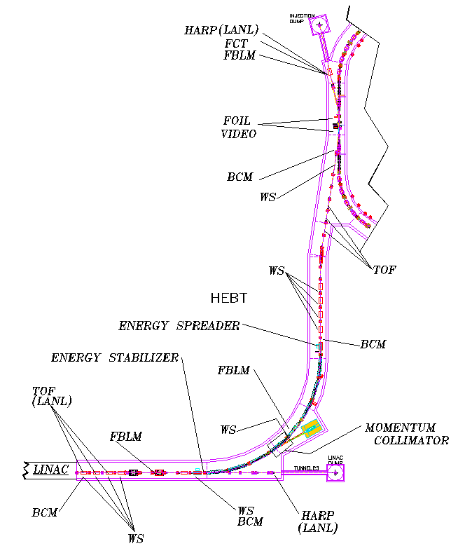

Figure 1: Layout and diagnostics of the HEBT.

Figure 1 shows the diagnostics in the HEBT and as well as the layout of the HEBT with respect to linac and ring, Other diagnostics which are not shown in the Fig. 1are the BPMs. There are 31 BPMs and 18 corrector magnets in the HEBT, located such that with help of corrector magnets one can align the beam at all narrow apertures. A layout of corrector magnets and BPMs is shown in Figure 2.
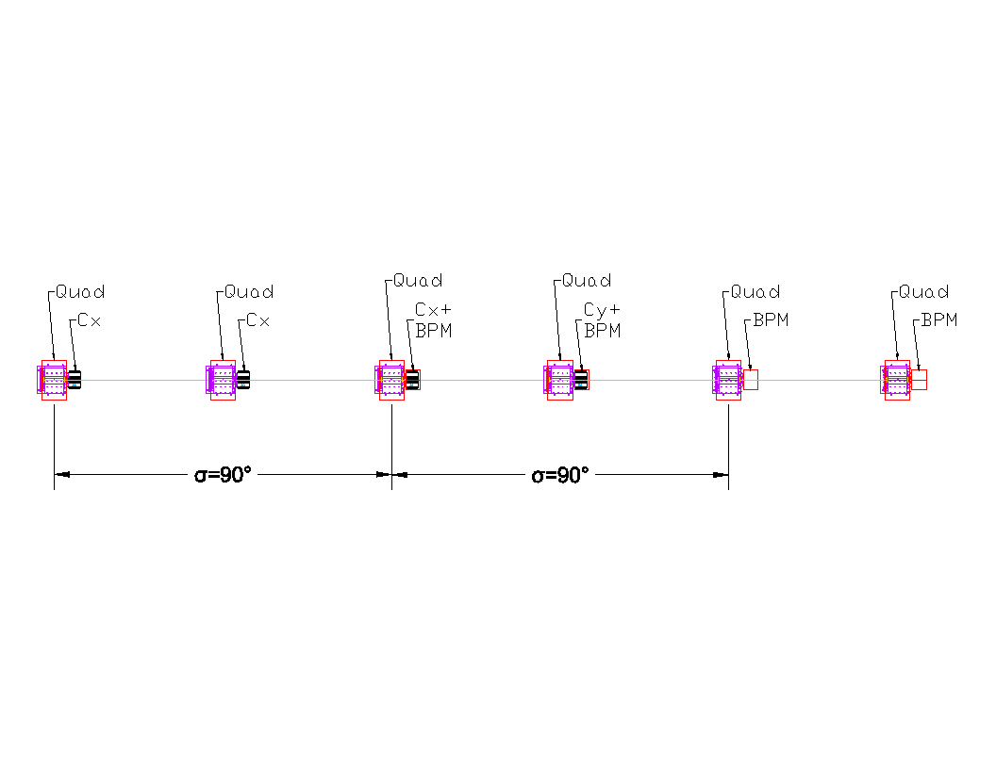

Figure 2: Corrector magnet -BPM unit.

Simulations show the expected maximum beam misalignment in the HEBT is 0.75 mm with all the BPMs working and 1.1 and 1.5mm with one and two BPM failures respectively. Once beam is delivered to the injection dump with minimum losses, one can start setting up the HEBT. The sequence for setting the HEBT is the following: (1) match the beam into HEBT, (2) measure the emittance with wire scanner (3) set up the achromat (4) measure the emittance after second achromat (5) match the beam into the ring (6) set up the energy corrector and energy spreader cavity.

2.1 Matching to HEBT

There are six independent quadrupoles in the last part of the linac, which will be used to match the beam into the HEBT by measuring the Twiss functions with the help of the wire scanners [3] which are located in the first part of the HEBT [4]

2.2 Emittance Measurement

The emittance measurements using profiles will have some uncertainty because the longitudinal emittance will not be not known (there is no longitudinal measurement planned). Simulations show that even if the longitudinal beam size is off by a factor of two, the uncertainty in the emittance measurement will less than 10%.

The other error in the emittance measurement comes from the resolution of the wire scanner. The specification for the resolution is 0.1 mm, giving an error in the emittance of less than 10%.

2.3 Achromat Set Up

If the achromat is not set correctly the beam centroid after the achromat will move with an energy change. The achromat is set up by (1) scanning quadrupoles and measuring the centroid after the achromat with a BPM, (2) measuring the phase advance. There are two families of quadrupoles in the 1st achromat which are varied, and the centroid displacement is measured by a BPM. Figure 3 shows such a scan. By measuring the scan one can set up the achromat.
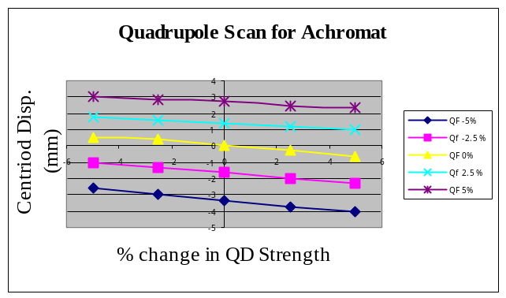Figure 3: Quadrupole scan for the achromat.

(2) The measurement of R12 by kicking the beam with the corrector and measuring the beam centroid and beam profiles gives the phase advance for the achromat. R12 is given by
R12=√(β₁ β₂)sin (ΔΦ)
where β₁ and β₂ are beta function at locations 1 and 2. Location 1 is the after HEBT quadrupole number 10, where the wire scanner is located, and location 2 is the after quadrupole number 20, where another wire scanner is used to measure the beam profile. Both methods give less than 10% error in setting up the achromat. Finally, to check the achromat the emittance is measured after the achromat with wire scanners, which are located after quadrupoles number 20 through 23. If the achromat is not correctly set up the horizontal emittance measurements will show an increase. The 2nd achromat is set up using same techniques.

2.4 Matching into the Ring

Once the 2nd achromat is set up, then by measuring the Twiss parameters with wire scanners and adjusting them between the 1st and 2nd achromat, one can match beam to the ring. To confirm the match, beam size is measured at the foil location with a phosphorus screen which is located in one of the slots of the foil changer.

2.5 Setting up the Energy Corrector Cavity

The energy corrector cavity (ECC) set up is done in the following way: (1) phase lock the ECC with the last linac cavity, (2) change the linac energy by 1 or 2 MeV, (3) measure the energy by Time of flight and (4) then switch on/off the cavity for different cavity gradients and measure the centroid motion at the middle of achromat. Figure 4 shows the centroid displacement at the middle of achromat versus cavity voltage (E0T) for 1 MeV energy offset. The energy spreader cavity (ESC), which operates about 100 kHz away from the linac frequency, will be tuned based on the ring energy spread requirement.

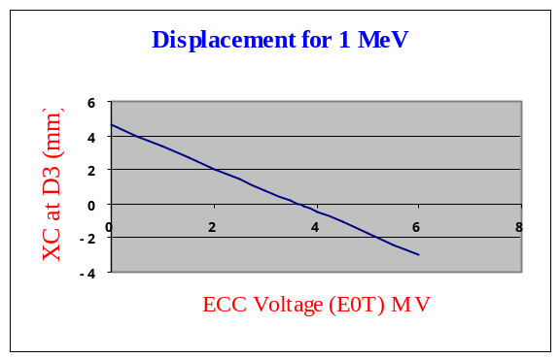

Figure 4: ECC voltage versus beam displacement at the middle of the achromat for 1 MeV energy offset.

3 RING TO TARGET BEAM TRANSFER (RTBT) LINE

The Ring to Target Beam Transfer (RTBT) line is about 150 meter long and transports the beam from the ring extraction region to the target and provides the desired footprint for the accelerator complex. The general features of this line are, the line is immune to one kicker failure and the ratio of acceptance to rms emittance is more than 20[5].

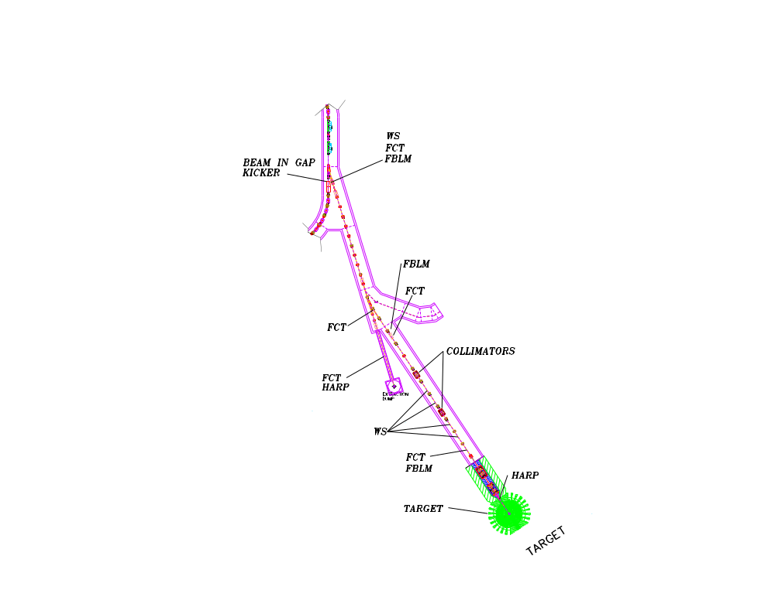

Figure 5: Layout and diagnostics of RTBT.
Figure 5 shows the diagnostics and the RTBT layout. There are 17 BPMs and 19 corrector magnets located such that one can center the beam in all narrow apertures such as collimator, fast gate valve etc. The corrector magnet and BPM layout is same as shown in Figure 2. Simulation shows that the maximum beam displacement will be about 1.1, 1.5 and 2.5 mm with no, one and two BPM failures. The sequence for the RTBT set up is the following, (1) set up the achromat, (2) match the beam in transport by measuring the Twiss parameters and (3) obtain beam size and current density at the target harp.

3.1 Lambertson Dipole Achromat

The Lambertson and 16.8 degree achromat will be set using the quadrupoles scans describe in the HEBT section, the only difference being instead of two quadrupoles knobs we have four quadrupoles knobs.

3.2 Matching to Transport and Emittance Measurement

After the dipoles there are four wire scanners to measure the emittance and match beam to the 6 cell long transport. The expected error in the emittance, given the 0.1 mm resolution for the wire scanner, is less than 5%.

3.3 Beam Spreader

The beam spreader consists of five radiation hard quadrupoles near the end of the RTBT. Due to target lifetime considerations, the beam current density on the target must remain below 0.25 A/m². This requirement results in a non-Gaussian beam distribution in space (with un-normalized rms emittance of 24 π mm mrad) with beam size of 20 x 7 cm**2. The beam size and current density will be measured using the harp . Figure 6 shows the change in beam area at the target due to quadrupole gradient deviations in the spreader section.

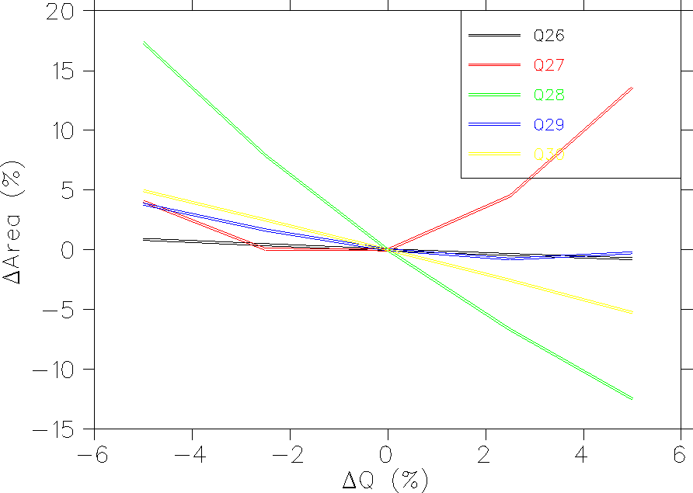
Figure 6: Beam area at the target versus quadrupole gradient deviations .

4 ACKNOWLEDGEMENTS

We would like to thank BNL/SNS and SNS accelerator physics and diagnostics team for useful discussions.

5 Reference

[1] N. Holkamp, “The SNS linac and Storage Ring: Challenges and Progress Towards Meeting them” EPAC 2002.
[2] D. Raparia, et al, “ The SNS High Energy Beam Transport Line”, Proc 1997 Particle Accelerator conference, p 162.
[3]G. Arduini et at, “Measurement of the Optical Parameters of a Transfer Line Using Multi-Profile Analysis”, EPAC 1998, Page 891
[4]Dong-o Jeon, “Improve Matching Between SCL and HEBT” SNS Tech. Note 18, April 3,2002
[5] D. Raparia, et al, “The SNS Ring to Target Beam Transport Line”, Proc. 1999 Particle accelerator conference, p 1297.

