Abstract—A luminosity upgrade of the CERN Large Hadron Collider (LHC) is planned to coincide with the expected end of life of the existing inner triplet quadrupole magnets. The upgraded inner triplet will have much larger heat loads to be removed from the magnets by the cryogenics system. As part of the LHC Accelerator Research Program (LARP), a design study has been completed to investigate the required characteristics of the cold mass cooling system within the framework of a design temperature profile. These characteristics are the beam pipe annulus, collar radial cooling channels, yoke radial cooling channels, yoke longitudinal cooling channels, and heat exchanger connecting pipe. Using these parameters in conjunction with energy deposition calculations, longitudinal and radial temperature profiles for an entire inner triplet are calculated and presented.
Cold Mass Cooling Design Studies for an LHC Inner Triplet Upgrade
Roger J. Rabehl

Index Terms—accelerator magnets, cooling, cryogenics, helium

Introduction
The inner triplets of the CERN Large Hadron Collider (LHC) are expected to reach their end of life after several years of operation due to radiation damage. Subsequent replacement of the inner triplets it expected to coincide with a luminosity upgrade of the accelerator. Such an upgrade would result in increased heat loads to the inner triplet magnets, requiring a new design instead of simply replacing them with another identical triplet. A number of possible upgrade scenarios are being considered: Nb₃Sn coil magnets [1], NbTi coil magnets [2], and ‘slim’ quadrupole magnets placed very close to the interaction point (IP).
Cold mass cooling studies are required to ensure the heat load deposited by the beams can be removed from the cold mass within acceptable temperature limits. Inadequate cooling of the magnet coil would result in quenching when operating at high luminosity.
One such cold mass cooling study is presented here for a luminosity of 10³⁵/cm²-s, a factor of 10 higher than the nominal luminosity of the LHC. This paper details the cooling study of an inner triplet consisting for four main quadrupoles and four correctors. The four main quadrupoles are Q1 (closest to the IP), Q2a, Q2b, and Q3 (farthest from the IP). The four corrector magnets are MCBX-1 (a nested horizontal and vertical dipole orbit corrector at the non-IP end of Q1), MCBX-2 (a nested horizontal and vertical dipole orbit corrector between Q2a and Q2b), MQSXA (a skew quadrupole in line with nested skew octupole, octupole, and skew sextupole coils at the Q3 IP end), and MCBXA (an MCBX package with nested sextupole and dodecapole coils at the Q3 non-IP end). This inner triplet would be placed on either side of the IP at the position of the existing inner triplet. The cold mass magnetic lengths are 6.3 m for Q1 and Q3, and 5.5 m for Q2a and Q2b. The coil aperture is 90 mm. The beam pipe is made of the tungsten-rhenium alloy W-25 Re with a thickness of 11.5 mm in the Q1 and 2.5 mm elsewhere. The inner triplet operates in a stagnant bath of He II that is cooled by a He II heat exchanger located outside the cold mass. The external heat exchanger currently used in the inner triplet is described elsewhere [3]-[4], as are initial heat exchanger studies for the upgraded inner triplet [5].
This paper presents the methodology used to calculate the values for the critical cooling parameters for this particular configuration. Radial and longitudinal temperature profiles are then calculated for single magnets and the entire inner triplet from the beam pipe annulus to the magnet heat exchanger.

Design Temperature Profile
A design temperature profile was established as a starting point for the cold mass cooling studies. The design temperature profile takes the total temperature drop in the cryogenic system, from the magnet beam pipe to the cryoplant cold compressors, and partitions it into segments with the ultimate goal of ensuring the magnet coil remains in He II.
There were several considerations in arriving at the design temperature profile. An initial study examined the thermal limitations of the existing inner triplet and identified thermal bottlenecks as the heat load is increased [6]. These bottlenecks were then allocated a relatively larger temperature drop.
Another consideration is possible upgrades to the LHC cryogenics system. For example, upgrading the cold compressors and moving them closer to the inner triplets would increase the available temperature drop and reduce the pressure drop in the piping between the inner triplets and cold compressors.
Finally, CERN work in the Next European Dipole (NED) program and interaction region upgrade studies also provided input for the design temperature profile [7]-[8].
The design temperature profile used for this design study allocates a 150 mK temperature drop (2.15-2.00 K) from the beam pipe annulus to the heat exchanger connecting pipe, and a 50 mK temperature drop (2.00-1.95 K) within the heat exchanger connecting pipe. The envisioned heat exchanger connecting pipes are illustrated in Fig. 1.

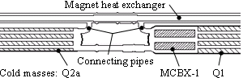

Fig. 1. Illustration of heat exchanger connecting pipes, which transfer heat from the cold mass He II volume to an annular He II volume around the heat exchanger pipe. Results presented here assume a connecting pipe at each end of each cold mass, as shown.

The existing inner triplet has one connecting pipe per interconnect, whereas it is assumed the upgraded inner triplet will have a connecting pipe at each end of each main cold mass.

Heat Deposition
A required input to calculate temperature profiles is the longitudinal heat deposition. Fig. 2 shows the calculated dynamic heat load to the He II as a function of distance from the IP [9]. The locations of the four main quadrupole cold masses are indicated. The four corrector magnets are also shown, each indicated by a single vertical bar outside the brackets of the main quadrupoles. The heat is assumed to be deposited equally in the horizontal and vertical planes. Radial variations in heat deposition are also not taken into account. Whether heat is deposited in the beam pipe, the inner coil, or the outer coil, it is assumed that all heat reaches the He II of the beam pipe annulus.
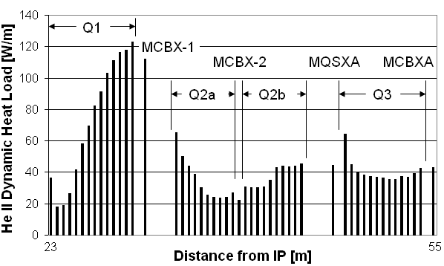
Fig. 2. Dynamic heat loads to the He II system of the upgraded inner triplet. Increasing the LHC luminosity would substantially increase the He II heat loads, requiring careful design of the cold mass cooling system.

Thermal Center And Heat Removal Distribution
The thermal center is the longitudinal position where there is a change in the direction of heat flow. On the IP side of the thermal center, heat flows toward the IP. On the non-IP side of the thermal center, heat flows away from the IP. The thermal center provides a zero heat flux boundary condition for subsequent calculations.
A first estimate of the longitudinal position of the thermal center of a cold mass is calculated by (1), where q(x) is the heat flow at a given position, L is the length of the cold mass, and x_{TC} is the longitudinal position of the thermal center. The cubic exponent is characteristic of He II heat transfer. Equation (1) assumes the longitudinal temperature drops from the thermal center to each end of the cold mass are equal.
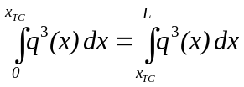 (1)

Based on the calculated location of the thermal center of each main quadrupole cold mass, Fig. 3 shows the amount of heat to be removed from each end of each cold mass. The numbers in parentheses are the heat loads deposited in the corrector magnets. The numbers without parentheses are the heat loads deposited in the main quadrupoles.
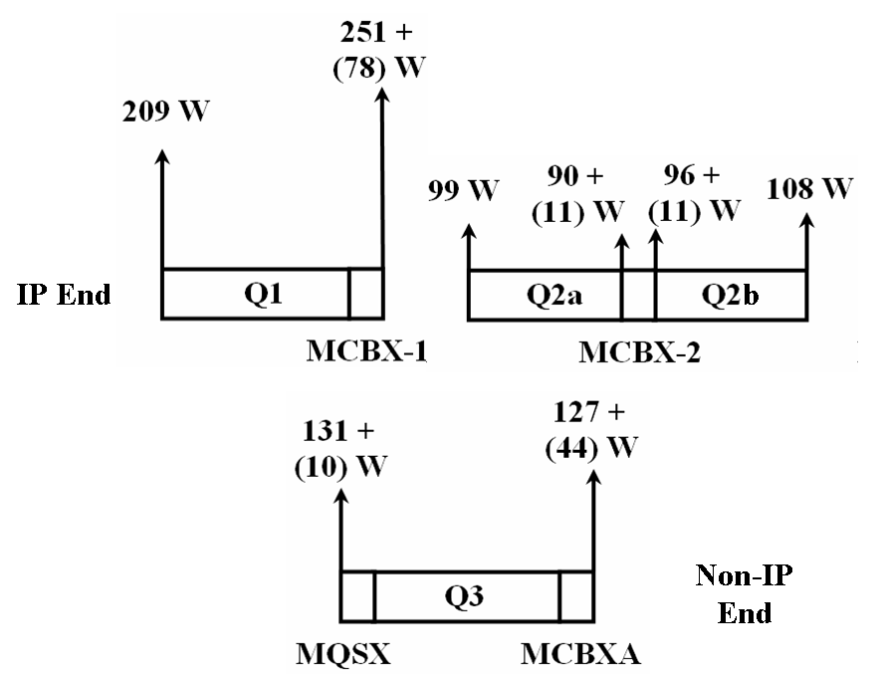

Fig. 3. Heat loads to be removed from each end of each inner triplet quadrupole. These values result from estimating the locations of the cold mass thermal centers using (1).

Design Parameters
There are a number of critical design features that must be specified in order to adequately remove heat from the cold mass coils: beam pipe annulus, collar radial cooling channels, yoke radial cooling channels, yoke longitudinal cooling channels, and heat exchanger connecting pipe. The sensitivity and effect of each individual parameter can be studied using (2), where q’’ is the heat flux, L is the cooling channel length, f ⁻¹(T,P) is the He II thermal conductivity function, and T is temperature.
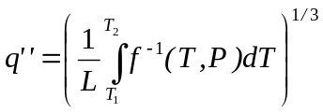 (2)

Heat exchanger connecting pipes transfer heat from the ends of the cold masses to the external heat exchanger. Each inner triplet now has five connecting pipes: one at the IP end of Q1, one between each pair of cold masses, and one at the non-IP end of Q3. Those at the Q1 IP end and at the Q3 non-IP end have an inner diameter of 82.8 mm. Those in the interconnects have an inner diameter of 95.2 mm. The maximum size of this connecting pipe is limited by the geometries of the cold mass and cryostat piping. The cooling scheme presented here uses pipes having a 168.3 mm (6.625 in) outer diameter and a 3.4 mm (0.134 in) wall thickness.
For the Nb₃Sn magnets being studied here, [1] has specified 400 cm² of yoke longitudinal cooling channels. The existing inner triplet magnets have 113 cm².
Yoke radial cooling channels are required to transfer heat from the yoke lamination inner diameter to the yoke longitudinal cooling holes. These cooling channels may be created by removing a small portion of the full thickness of the yoke lamination at the parting plane or by machining cooling channels into the surface of the laminations. Whichever method is used, it must be ensured that the heat load is able to be distributed among the yoke longitudinal cooling holes. The cooling scheme described here considers 2.4% of the yoke inner diameter open for cooling channels.
Collar radial cooling channels are required to transfer heat from the beam pipe annulus to the iron yoke. Collar cooling channel size is expressed as a percentage of the collar pole tip open for He II heat transfer. The current LHC Q2 quadrupole magnets have a cooling channel equivalent to 4% of the inner pole tip area, or one missing 1.5 mm thick collar lamination in each quadrant per 38 mm of length. If the second generation magnets are constructed similarly to the first generation magnets, it is recommended to have a collar cooling channel area equivalent to 7% of the pole tip area, or one missing 1.5 mm thick lamination in each quadrant per 21 mm of length.
A heat load due to secondary particles produced by the proton-proton collisions at each IP is deposited in the beam pipe and the coils, concentrated in the horizontal and vertical planes. This heat is transferred to the He II and is conducted 45º circumferentially through the beam pipe annulus to the collar pole tips. The existing inner triplet has a 1 mm annular gap between the beam pipe and the coils. The same 1 mm annular gap is used here.
This is one possible combination of parameters and is summarized in Table I. The value of each parameter is noted along with the calculated radial temperature drop near the non-IP end of Q1, where the heat loads are largest. The maximum calculated temperature is 2.089 K, leaving a significant temperature drop available from the coil to the He II bath.

TABLE I Cold mass cooling system parameters
Design parameter | Value | Calculated temperature range [K]
Beam pipe annular gap | 1 mm | 2.089 - 2.061
Collar radial cooling channels | 7% of collar pole tip open | 2.061 - 2.008
Yoke radial cooling channels | 2.4% of yoke inner diameter open | 2.008 – 2.000
Yoke longitudinal cooling channels | 400 cm² | 2.000
Heat exchanger connecting pipe | 161.5 mm (6.357 in) inner diameter | 2.000 - 1.971

Magnet Temperature Profile
Once these parameters have been specified, the longitudinal and radial temperature distribution of one half of the cold mass (from the thermal center to the cold mass end) can be calculated. A finite difference model using temperature-dependent properties of He II was constructed to calculate the temperature profiles. Fig. 4 shows the resulting temperature map of the non-IP half of Q1 where the heat loads are the highest, resulting in substantial temperature gradients.
It was assumed that all heat transfer is radial, except in the yoke longitudinal cooling holes. The beam pipe annulus allows a slight redistribution of the heat load, permitting it to find a path of least resistance through the cold mass cooling channels. The result would be a slight smoothing of the calculated magnet temperature profiles. Neglecting this effect is therefore conservative in that a larger temperature range is calculated. This redistribution of the heat load has been calculated to be 3 W/m or less, which is small compared to the dynamic heat loads presented in Fig. 2.

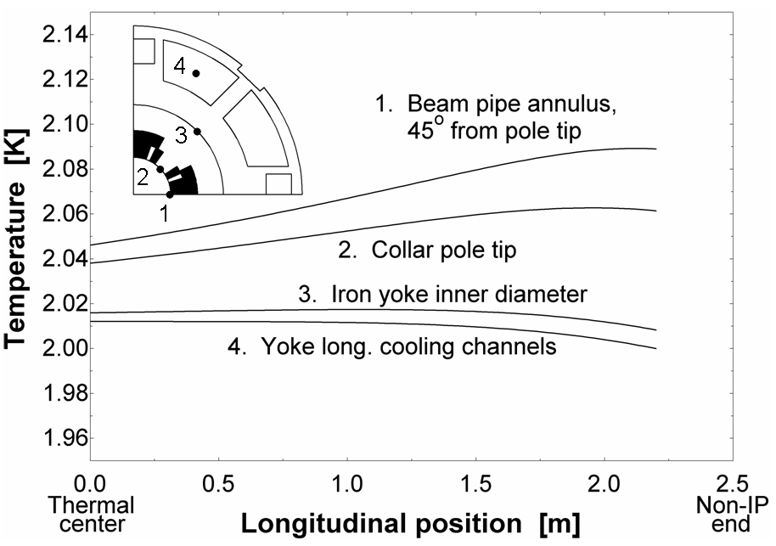

Fig. 4. Temperature profile of the non-IP half of Q1. All locations within the magnet remain in He II, below the lambda point of 2.17 K. The yoke longitudinal cooling channels are 2.00 K at the non-IP end of the cold mass as specified by the design temperature profile. At the thermal center, the temperature gradient in the yoke longitudinal cooling channels is zero. Positions where temperatures are calculated are specified in the magnet cross-section inset.

Triplet Temperature Profile
These calculations can be extended to calculate the radial and longitudinal temperature profiles of the entire inner triplet. The finite difference model was applied to each half of each cold mass to calculate the temperature profiles after additional iterations to more precisely locate the cold mass thermal centers and generate better curve fits of the longitudinal heat load distribution. This and the temperature-dependent properties of He II account for the difference at the non-IP end of Q1 between Fig. 4 and Fig. 5, which presents the calculated temperature profile of the specific inner triplet configuration considered here. Discontinuities in the temperature curves are the result of small errors in determining the exact thermal centers of the magnets.

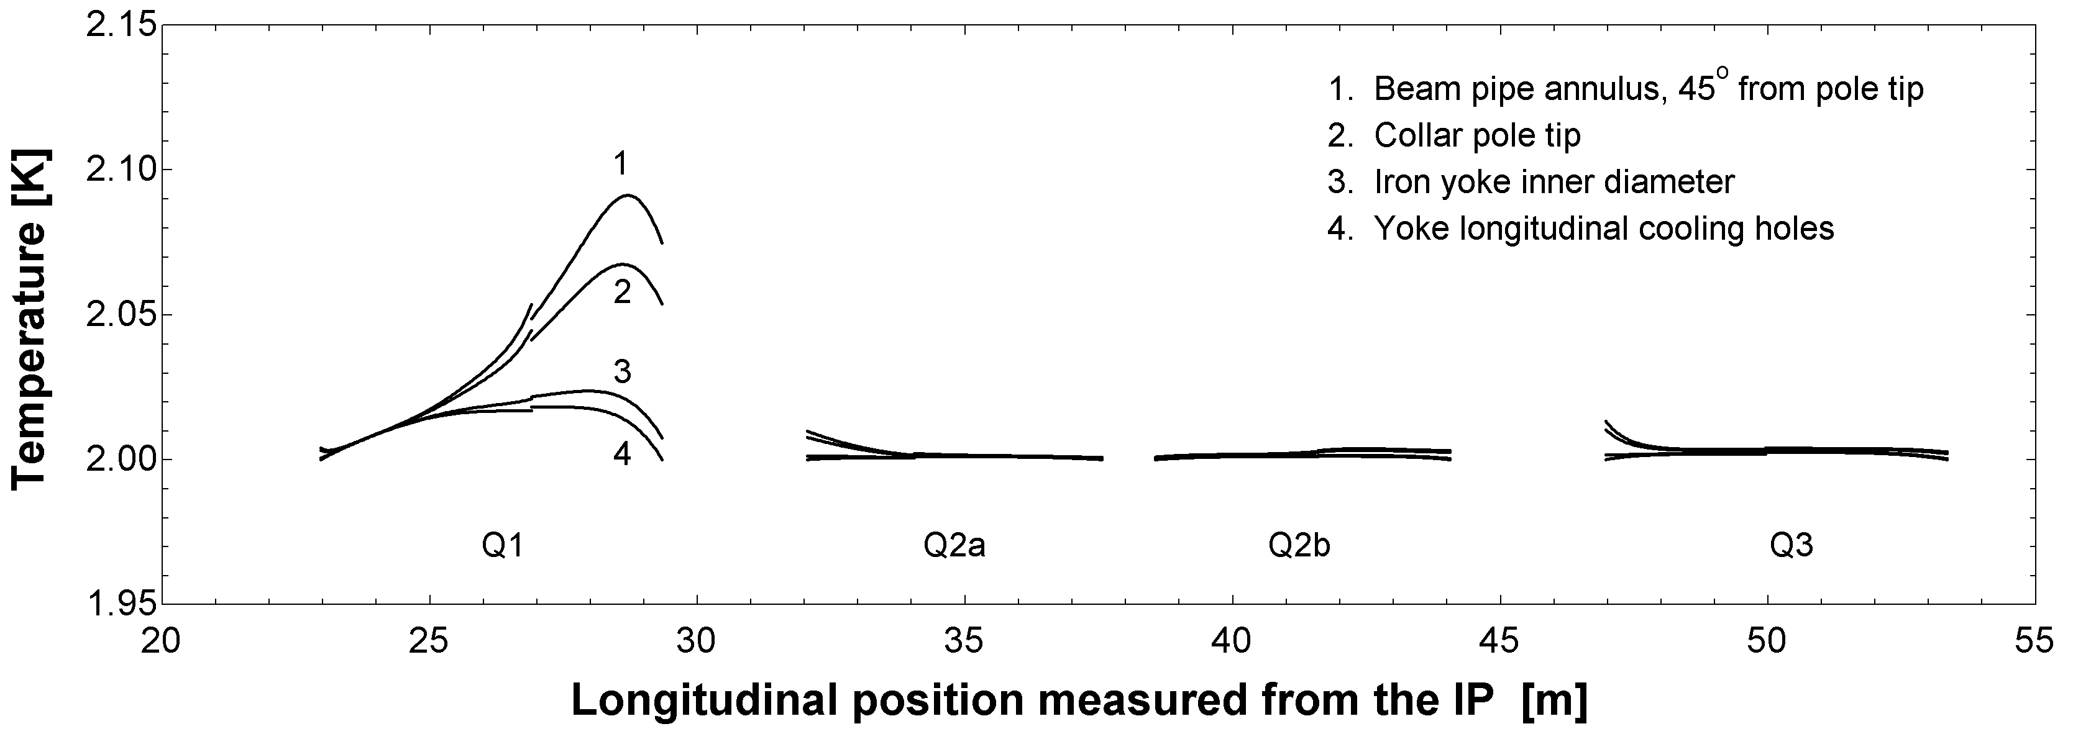

Fig. 5. Calculated longitudinal and radial temperature profiles of the inner triplet. The cooling system presented here would result in sizable temperature drops in the Q1 cold mass but very small temperature drops in the other cold masses. The positions where temperatures are calculated are the same as those identified in the Fig. 4 inset.

Conclusion
A methodology for calculating longitudinal and radial temperature profiles of an inner triplet has been presented. A complete thermal analysis also requires consideration of the heat exchanger and heat transfer between the coil and the He II.
While results for one specific inner triplet configuration and cold mass geometry are detailed here, this approach can be used to investigate other inner triplet configurations. One such alternate configuration is the use of heat exchanger tubes internal to the cold mass [10].
Convergence on a magnet design will ultimately require iteration on both thermal and mechanical analyses.
References
- A. V. Zlobin et al., “Conceptual Design Study of Nb3Sn Low-beta Quadrupoles for 2nd Generations LHC IRs,” IEEE Trans. Applied Superconductivity, vol. 13, pp. 1266-1269, June 2003.
- O. Brüning, R. De Maria, R. Ostojic, “Low Gradient, Large Aperture IR Upgrade Options for the LHC compatible with Nb-Ti Magnet Technology,” CERN LHC Project Report 1008, May 2007. Available: http://cdsweb.cern.ch
- P. Lebrun, L. Serio, L. Tavian, and R. Van Weelderen, “Cooling Strings of Superconducting Devices below 2 K: the Helium II Bayonet Heat Exchanger,” Adv. in Cryogenic Engineering, vol. 43A, pp. 419-426, 1998.
- R. Byrns et al., “The Cryogenics of the LHC Interaction Region Final Focus Superconducting Magnets,” Proceedings of the Seventeenth International Cryogenic Engineering Conference 14-17 July 1998, pp. 743-746, 1998.
- R. Rabehl and Y. Huang, “Heat Exchanger Design Studies for an LHC Inner Triplet Upgrade,” Adv. in Cryogenic Engineering, vol. 53, submitted for publication.
- R. Rabehl, “LARP IR Cryogenics: Scaling of LHC I IR Cryogenics Model,” Document LARP-doc-15. Available: http://larpdocs.fnal.gov
- R. van Weelderen, “He II Heat Transfer in Superconducting Magnets,” Next European Dipole (NED) project, February 2005.
- R. van Weelderen, “Heat Transfer in Superconducting Magnets,” Accelerator Magnet Technology (AMT) – Beam Generated Heat Deposition and Quench Levels for LHC Magnets, March 2005. Available: http://indico.cern.ch/contributionListDisplay.py?confId=0516
- N. Mokhov and I. Rakhno, Fermi National Accelerator Laboratory, Batavia, IL, private communication, January 2006.
- R. Rabehl, “LARP IR Cryogenics: Inner Triplet Heat Transfer Studies,” Document LARP-doc-364. Available: http://larpdocs.fnal.gov

 Manuscript received August 24, 2007. This work was supported by the U.S. Department of Energy under contract DE-AC02-76CH03000. R. J. Rabehl is with the Fermi National Accelerator Laboratory, Batavia, IL 60510 USA (phone: 630-840-8855; fax: 630-840-6724; e-mail: rabehl@fnal.gov).

