Proton Plan

11/09/04

Accelerator Division
Fermi National Accelerator Laboratory

Editors: Bruce Baller, Eric Prebys, Jeff Spalding

Executive Summary 3
1. Introduction 4
1.1 Motivation 4
1.2 Present Operational Limitations 5
1.3 Strategy 6
2. Elements of the Plan 8
2.1 Work Breakdown Structure 8
2.2 Subprojects 9
WBS 1.1 – Linac Upgrades 9
WBS 1.1.1 – Linac PA Vulnerability 9
WBS 1.1.2 – Linac Quad Power Supplies 10
WBS 1.1.3 – Linac Instrumentation Upgrade 10
WBS 1.2 – Booster Upgrades 11
WBS 1.2.1 – Determination of Booster Repetition Rate Limit 11
WBS 1.2.2 – ORBUMP System 11
WBS 1.2.3 – Corrector System 12
WBS 1.2.4 – 30 Hz Harmonic Upgrade 13
WBS 1.2.5 – Gamma-t System 14
WBS 1.2.6 – Alignment Improvements 14
WBS 1.2.7 – Drift Tube Cooling 15
WBS 1.2.8 – Booster RF Cavity #20 15
WBS 1.2.9 – Solid State RF Power Amplifiers 15
WBS 1.2.10 – Booster Instrumentation Upgrade 16
WBS 1.3 – Main Injector Upgrades 16
WBS 1.3.1 – Large Aperture Quadrupoles 17
WBS 1.3.2 - Main Injector Collimator 17
WBS 1.3.3 – NuMI Multi-batch Operation 17
WBS 1.3.4 – Main Injector RF Upgrade 18
3. Cost and Schedule 20
3.1 Methodology 20
3.2 Cost Estimate 20
3.3 Schedule 22
3.4 Future Updates to the Plan 22
4. Performance Projection 24
4.1 Operating Modes 24
4.2 Booster Radiation Limit 25
4.3 PoT Projection 28
References 32

Executive Summary
Fermilab is poised to significantly improve our understanding of neutrino oscillation. The MiniBooNE experiment [1] using the Booster Neutrino Beam (BNB) will confront the puzzling ν_{e} oscillation results from LSND within the next year. The MINOS experiment [2] will detect neutrinos produced by the NuMI facility in early 2005 to confirm the presumed ν_{μ} → ν_{τ} oscillation results from Super-Kamiokande, and to make precision measurements of the mixing parameters. The proposed NOνA experiment will use off-axis neutrinos from the NuMI facility to detect ν_{μ} → ν_{e} oscillations. The investment in accelerator upgrades described in this document will maximize the physics reach of these experiments.
We present a three-year plan for increasing the proton intensity delivered to the 120 GeV and 8 GeV neutrino beams, with upgrades to the Linac, Booster and Main Injector. Once the elements of this plan are completed, NuMI will accumulate approximately 3.4E20 protons per year. The 8 GeV beamline will receive approximately 2.2E20 protons per year. This latter estimate is highly dependent on the performance of the Booster and other efficiency factors.
The preliminary estimate for the total cost of this plan, including 46% contingency, is $34M ($23M M&S, $10M labor SWF). The labor cost estimate includes technical, physicist and project management effort. Overhead is not included in these estimates.
The plan includes tasks and milestones to address the serious vulnerability issue with Linac amplifier tubes. Costs are included for alleviating concerns for the availability of these tubes in the short-term, and for developing a plan for the long-term. Similarly, costs are included to determine the repetition rate limitation in the Booster and to develop a plan to exceed this limit, if appropriate. These two long-term plans, when accepted, will require significant addition to the present scope.
1. Introduction

1.1 Motivation
With the startup of NuMI in early 2005, the Fermilab program will include two neutrino beamlines, the NuMI beam at 120 GeV from the Main Injector and the 8 GeV beam from the Booster which currently supports the MiniBooNE experiment. For the purpose of this document we refer to this beam as Booster Neutrino Beam (BNB). The goal of the Accelerator Division Proton Plan is to maximize the number of protons delivered on target (PoT) to these two neutrino beamlines in the period up to the replacement of the present Linac and Booster by the Proton Driver. This is assumed for the purposes of this document to be in 2015 or later. The plan includes a series of upgrades in the next three years to increase intensity and reliability for 10 or more years of operation.
Throughout this period the Linac, Booster and Main Injector will continue to support the production of antiprotons for Tevatron collider operation. The Main Injector will continue to play a central role in collider shot setup and will transfer antiprotons between the Accumulator and the Recycler. The proton intensity delivered for antiproton production will be doubled in 2005 using a technique called slip stacking (described in section 2.2 below). The Proton Plan will maintain operational compatibility with this antiproton production and collider operation.
The basis for this plan is the Proton Committee Report of October 2003 [3]. This report includes a discussion of the proton demands from the neutrino, collider and fixed-target programs, and a set of recommendations and suggestions for increasing proton supply in short, medium and long time frames. To a large extent the recommendations for the short time frame have been implemented since the date of the report, or are currently being implemented. These include the installation of a collimation system in the Booster to reduce radiation levels, the installation of one of two large aperture RF cavities (the second is included in this plan), rearrangement of the Booster doglegs, the development of slip stacking and cogging between the Booster and Main Injector (being developed under the Run II Upgrade Plan [4]), and the commissioning of longitudinal and transverse dampers in the Main Injector (also under the Run II Upgrade Plan). Upgrades to the Beam Position Monitor (BPM) and Beam Loss Monitor (BLM) systems in the Main Injector, and the BLM system in the Booster are planned for 2005 in the Run II Upgrade Plan.
The plan outlined here will implement a specific set of upgrades for the mid- to long-term time frames, to increase the Booster repetition rate and the maximum beam intensity in the Booster and Main Injector.

1.2 Present Operational Limitations
The current bottlenecks in proton delivery are due to (1) radiation levels in Booster operation, (2) the repetition rate of the Booster, and (3) intensity limitation in the Main Injector.
Proton losses in the Booster, leading to radiation damage, activation, and above ground radiation, have limited the total rate at which protons can be delivered. This has been the primary limitation since MiniBooNE began running in 2002. With recent improvements, including the installation of a collimation system [5] and rearrangement of the extraction chicanes (the “doglegs”) [6], a maximum of 8E16 protons per hour has now been achieved. The improvements in this plan will provide a further increase by almost an additional factor of two.
The Linac and Booster together deliver “batches” of protons at a nominal intensity of 5E12 protons/batch and at an instantaneous rate of 15 Hz. However, the Booster must be conditioned by two “pre-pulses” prior to a beam loaded pulse, so it is operationally advantageous to deliver protons in 15 Hz “batch trains” following each pair of pre-pulses. The maximum average repetition rate of the Booster is currently limited to 7.5 Hz by magnet cooling. The upgrades included in this plan will themselves operate at up to 15 Hz, however it is expected that power limitations in the RF system will limit Booster operation to 8-9 Hz. This limit is not well determined. The plan includes an engineering study to identify limiting components in the RF system or power distribution system and to propose a scope addition to address them. We assume a 9 Hz operational limit for the present plan.
The PoT delivered to NuMI will be limited primarily by the amount of beam that can be loaded into the Main Injector, and the time it takes to accelerate that beam. The Main Injector has six usable “slots” in which to load booster batches. One slot is dedicated to antiproton production, and five to NuMI. Starting in early 2005, slip stacking will be used to load two Booster batches into one slot for antiproton production. In this plan, slip stacking will be further developed to load a total of nine batches for NuMI.
The higher intensity in the Main Injector requires more RF power for acceleration. The existing RF system can accelerate up to 4E13 protons [7] by modifying the shape of the RF ramp. This will allow five-batch operation for NuMI, but the plan for slip stacking will require a major upgrade to the RF system.
Larger batch intensities will result in increased beam loss at the limiting apertures at the injection and extraction regions of the Main Injector. These apertures are defined by the Lambertson septa magnets and nearby quadrupole magnets. This plan includes an upgrade to larger quadrupole magnets in these regions to keep the losses at acceptable levels, and the installation of a collimation system.
Other operations concerns focus on reliability rather than performance limitations. In particular the first stage of the Linac is now 35 years old, while the second stage was rebuilt in 1993. A reliable Linac is essential for the entire Fermilab program, and must be assured for another 10 or more years. Two components are identified as presenting serious vulnerabilities in the low energy Linac: the RF amplifier tubes and the quadrupole power supplies. Availability of the amplifier tubes has been a reliability concern for several years, and presents a very high risk for maintaining operations. The plan includes effort and M&S costs in the short- to medium-term to alleviate this concern. Several proposals have been made to solve this issue for the long-term. This plan includes an engineering study to recommend a specific course of action that will then be added to the scope. The quadrupole power supplies will be replaced in the present plan with supplies based on those used in the second stage Linac.

1.3 Strategy
The subprojects in this plan address three major objectives:
- Increasing the proton delivery from the Booster to NuMI and BNB
This is principally achieved by increasing the Booster repetition rate (ORBUMP replacement and drift tube cooling upgrade), by increasing acceptance, and by improving orbit control.
- Increasing the beam intensity in the Main Injector for NuMI
This is principally achieved by developing multi batch operation, and slip stacking in the Main Injector, increasing the acceptance in the Main Injector to maintain acceptable losses (large aperture quads), and increasing the RF power to allow acceleration of the increased intensity in the Main Injector.
- Improving operational reliability and radiation limitations
In the present scope this includes replacing the quadrupole power supplies in the first stage of the Linac, replacing the Booster RF drivers, and improving instrumentation in both the Linac and Booster. The plan also includes two engineering studies that will define new projects to be added to the scope of the plan: the Linac power amplifier tubes and the power limitation on Booster repetition rate.
The completion of the projects leads to three main phases in the operation.
Phase 1: January 2005 – December 2005
The NuMI beamline will be commissioned. Slip stacking will be commissioned for antiproton production. The Main Injector will operate with a “2+5” cycle (two batches slip stacked for the collider program and five batches for NuMI). The Booster will operate at an average rate of 7.5 Hz.
Phase 2: December 2005 – December 2006
Following the ORBUMP replacement and drift tube cooling upgrade, the Booster can operate at up to 9 Hz, increasing the beam delivered to BNB.

Phase 3: starting December 2006
With completion of the RF upgrade in the Main Injector, slip stacking will be commissioned for NuMI, and the Main Injector will operate with a “2+9” cycle.
The performance in terms of PoT for each of these phases will be discussed in section 4 below.

In the following section the Work Breakdown Structure (WBS) for organizing the work on the subprojects in this plan will be described. A brief description will follow for each of the key elements of the plan, including motivation and description of the work. Section 3 will describe the methodology for estimating the cost in M&S and labor and the schedule for the work, tabulate the costs, and identify major milestones. Section 4 will describe the model for operational performance and present predictions for each phase of the upgrade plan.

2. Elements of the Plan

2.1 Work Breakdown Structure
Personnel in the Linac, Booster and Main Injector departments will manage and accomplish the programmatic goals outlined in this plan. The following WBS structure is constructed to reflect the presence of this existing Division organization.

WBS | Description
1 | Proton Plan
1.1 | Linac Upgrades
1.1.1 | Linac PA Vulnerability
1.1.2 | Linac Quad Power Supplies
1.1.3 | Linac Instrumentation Upgrade
1.2 | Booster Upgrades
1.2.1 | Determination of Rep Rate Limit
1.2.2 | ORBUMP System
1.2.3 | Corrector System
1.2.4 | 30 Hz Harmonic Upgrade
1.2.5 | Gamma-t System
1.2.6 | Alignment Improvements
1.2.7 | Drift Tube Cooling
1.2.8 | Booster RF Cavity #20
1.2.9 | Booster Solid State RF PA’s
1.2.10 | Booster Instrumentation Upgrade
1.3 | Main Injector Upgrades
1.3.1 | Large Aperture Quads
1.3.2 | Main Injector Collimator
1.3.3 | NuMI Multi-batch Operation
1.3.4 | Main Injector RF Upgrade
1.4 | Management

Table 1: Work Breakdown Structure at Level 3
We anticipate that Level 2 managers will be designated by the Department Head for each accelerator. The Level 2 managers are charged with developing and maintaining a cost and schedule plan that is consistent with the resources available. A subproject manager will be assigned to each WBS element at Level 3. The Level 3 manager is responsible for providing an operating system that meets agreed upon specifications. The Level 3 manager is responsible for cost and schedule control over design, procurement, fabrication, installation, and commissioning.
A radiation shielding assessment is conducted prior to approving a new mode of operations for the complex, including the operation of the Booster and Main Injector as described in section 4. It is not expected that significant work will required but this cannot be guaranteed until the assessment is performed. No work for shielding improvements is included in this plan.
In order to accomplish the Proton Plan goals, specific Run II Upgrade subprojects must be completed. We rely on existing management systems in the Run II Upgrade project to accomplish these tasks. They include:
- Cogging (timing of the Booster and Main Injector) - expected to be achieved by January 2005.
- The Main Injector BPM system and Main Injector and Booster BLM systems - to be upgraded in 2005.

2.2 Subprojects
This section includes a brief description of the motivation and technical scope for each element of the plan, and the basis for the cost and schedule estimates. The cost and schedule themselves are compiled together in the next section.

WBS 1.1 – Linac Upgrades
The performance of the Linac is not a significant bottleneck to proton delivery. Linac projects focus on improving reliability, addressing vulnerabilities where equipment failure would curtail operations for a significant period of time, and improving instrumentation to allow better characterization of the machine.

WBS 1.1.1 – Linac PA Vulnerability
The first stage of the Linac uses five power amplifier tubes. These tubes fail at a rate of 6-8 tubes per year. Typically about 2/3 of the failed tubes can be rebuilt by the vendor; the others must be replaced with new tubes. The availability of replacement tubes has remained critical since the start of Run II. This lack of spares is a serious vulnerability, both in the immediate future and for the long term viability of the experimental program. It is essential that Fermilab work with the vendor to increase tube production and testing, and build up an inventory of spare tubes. The scope of work may include improvements to the operating environment of the tubes at Fermilab, moving the acceptance testing to the production facility, and working with the vendor to address any bottlenecks in the production process.
Solutions have been proposed for the longer term. The timescale for their implementation is of order three years, and the total cost is likely in the range $20-40M. A determination of the optimum solution requires balancing technical merit, cost, reliability and the horizon posed by the Proton Driver.
This WBS element includes funds to build up an inventory in the mid-term, and a study to recommend a specific plan of action for the long term. The scope of work for both of these time scales will be defined by a task force with expertise in technical, planning and procurement areas. A report on the mid-term plan will be reviewed by the Level 1 manager and presented to the Accelerator Division Head by February 2005 and on the long-term plan by July 2005. The cost included for the mid-term plan has 100% contingency assigned. The estimates will be updated in the February report. Once the recommendation presented in the July report is accepted, the long-term plan may require a significant increase in scope to the present plan.

WBS 1.1.2 – Linac Quad Power Supplies
The five tanks in the first stage of the Linac, the 200 MHz Drift Tube Linac (DTL), contain 120 drift tubes, each with an internal quadrupole magnet. Because of the high current required by these magnets, they are pulsed at 15 Hz to avoid excessive heat. The pulsed supplies are original to the Linac. While they have operated fairly reliably for the last 35 years, it is believed that we risk significant downtime in the next ten years.
We plan to replace the existing supplies with newer, more reliable supplies, modeled on the pulsed supplies used for the quadrupoles in the second stage, the High Energy Linac (HEL).
The cost of the project was determined starting with the actual part cost of the HEL supplies, corrected by 30% for ten years of inflation. Labor costs were based on the HEL experience. It is planned to build a prototype station in FY05 to test and develop the controls interface, then go into full production in FY06 with the goal of installing the new supplies in the Fall 2006 shutdown.

WBS 1.1.3 – Linac Instrumentation Upgrade
The Linac instrumentation provides insufficient information to diagnose common problems. In addition, only roughly one third of the BPM’s in the Linac are currently digitized. During the summer of 2000, the MiniBooNE experiment experienced a reduction of roughly 20% in average weekly protons, over a period of three months. This was due largely to stability problems in the Linac. The goal of this instrumentation upgrade is to eliminate similar extended performance degradation in the future.
The instrumentation upgrade began during 2004 with the addition of 10 MHz digitizers to several channels on the pre-accelerator and each RF station in the Low Energy Linac. These particular digitizers are not compatible with the voltage levels in the High Energy Linac, so the plan is to move the current BPM digitizers to the High Energy Linac, and then digitize all of the BPM’s with the 10 MHz digitizers. This involves a total of 72 channels of digitization arranged in nine eight-channel digitizer modules, and requires an additional 33 RF modules for the BPM’s that are not currently instrumented.
The cost estimate for this project is based on the established cost of building the standard components involved. The goal is to have the upgraded instrumentation in place by the end of FY05.

WBS 1.2 – Booster Upgrades
A set of upgrades are needed to increase the delivery of protons from the Booster. The most direct improvements are achieved by reducing beam losses, and increasing the repetition rate. Reliability is improved by upgrading the RF power amplifiers.

WBS 1.2.1 – Determination of Booster Repetition Rate Limit
It is believed that the RF system in the Booster will limit operation to an average repetition rate of 8-9 Hz. The nature of the limitation and the actual value of the maximum sustainable rate are not well determined. This WBS element includes an engineering review, documenting and measuring the present system, and identifying components that limit the rate. This review will be summarized in a report, along with a recommendation and cost estimate for increasing the repetition rate beyond the limit. This report will be reviewed by the Level 1 manager and presented to the Accelerator Division Head by July 2005. If accepted, the recommendations will be developed into a project and incorporated into the Proton Plan.

WBS 1.2.2 – ORBUMP System
The Booster uses H- ion injection so that beam can be injected over several revolutions. A system of four pulsed magnets forms a chicane that moves the circulating and injected beams radially, such that they lie on top of one another at injection. The two then pass through a foil to strip the electrons from the ions, after which they circulate together. This system is referred to as “ORBUMP”.
There are two problems to be addressed with the ORBUMP system:
- Both the magnets and the power supply suffer from internal heating, limiting the total average repetition rate to roughly 7.5 Hz.
- The system is not powerful enough to fully align the circulating beam with the injected beam. This results in horizontal mismatch of approximately 1 cm, which significantly increases beam loss at injection.
Approximately half of the beam loss in the Booster occurs very early in the cycle. This is due largely to beam slewing caused by the ORBUMP system. Improving this situation is a crucial part of the plan.
Technical Division has begun the design of new magnets with water-cooled conductors and a ferrite core. EE support is designing and building a new power supply. The magnets and power supply together will be capable of sustained 15 Hz operation with a field strong enough to fully align the circulating and injected beam.
The design and fabrication of the magnets and power supply is well underway. Technical Division has performed a detailed cost estimate. Construction of the power supply has started. The cost estimate for this work is based on essentially identical charging supplies.
The goal is for the magnets and power supply to be ready by mid 2005, so that they can be thoroughly tested and installed during the 2005 shutdown.

WBS 1.2.3 – Corrector System
The Booster has a corrector system comprised of horizontal and vertical trim dipoles as well as regular and skew quadrupoles in each of the 48 sub-periods. Unfortunately, this system has never been powerful enough to control either the beam position or tune at high field. Figure 1 shows the beam motion during the acceleration cycle.
This motion leads to beam loss throughout the cycle. By having a corrector system capable of fully controlling the orbit, we will be able to reduce this loss significantly. This requires a corrector system capable of approximately 1 cm of beam motion at all energies

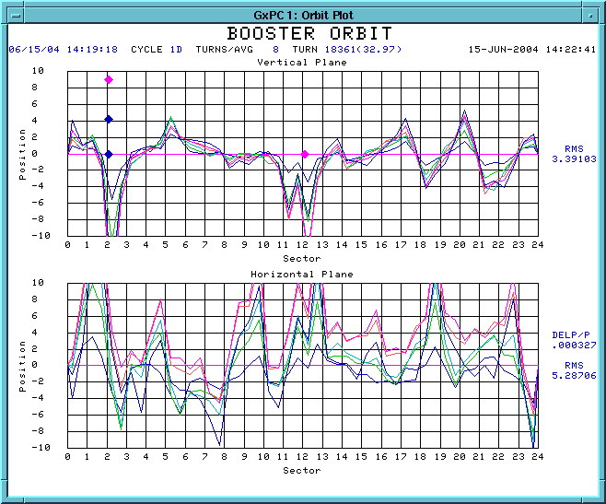
(a)

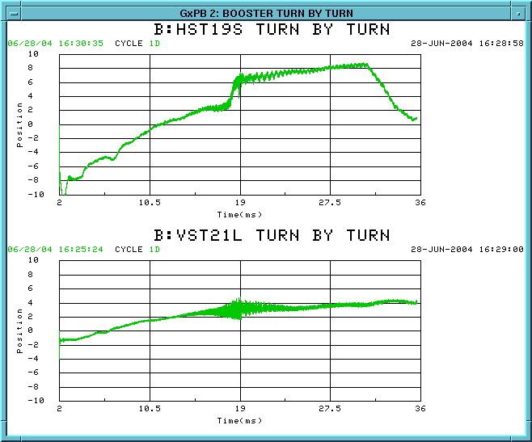
(b)

FIGURE 1: Beam position (mm) through the Booster cycle: (a) the orbit around the ring at several times in the cycle, relative to the injected orbit, (b) two selected locations as a function of time throughout the cycle. This beam motion was used to specify the new corrector packages.
Specifications in terms of field strength and slew rate have been defined [8] and the Technical Division is currently working on a design for the corrector packages. The final choice of dipole, quadrupole, skew-quad and sextupole components is not yet finalized. However, it is clear that a factor of four increase in field is needed, so new power supplies will be required.
Because this system is in the early stages of design, 100% contingency is assigned to the cost estimates. The estimate for the correctors themselves is based on the required field and estimated volume of copper, rules of thumb for estimating cooling lines and insulation and good faith estimates of the tooling costs. The cost of the power supplies is based on the estimated power requirements of the magnets under the assumption that standard power supplies will work. Cabling will be significant, and this has been included in the cost estimate.
Similarly the schedule estimate is not yet final. The goal is to refine the cost estimate, complete the design, build a prototype, and begin procurement for the entire system in FY05. System fabrication would then be complete by the end of 2006. It is not yet clear if installation can be completed in the presently scheduled shutdown in summer 2006.

WBS 1.2.4 – 30 Hz Harmonic Upgrade
Simulations and studies have shown that the Booster intensity is limited by longitudinal bucket area. This will be accomplished by increasing RF voltage (WBS 1.2.8) and by decreasing the maximum acceleration rate.
The booster lattice magnets are not ramped in the usual sense. They are connected with a system of capacitors and inductors that form an offset 15Hz resonant circuit. The maximum dE/dt of the beam is fixed by the resonant frequency and the total acceleration, so reducing the maximum dE/dt will allow more beam to be accelerated. Modifying the circuit to add a properly phased 30 Hz component to the resonance [9] will extend the acceleration portion of the curve and reduce the maximum dE/dt. Figure 2 shows a potential reduction of 35% in the maximum acceleration.
The result of the 30 Hz harmonic will be an increase in the amount of beam that we can get through transition. We conservatively estimate an extra 0.5E12 per cycle.
The extra capacitors and inductors required will fit onto the existing magnet girders without significant modification. The gradient magnet power supplies (GMPS) will require some modification to allow the voltage to go negative, and the regulation software will require significant upgrade to properly control the two phases.
The cost estimate is determined from quotes for the choke and by general rules for the capacitors, based on their energy. Labor costs are included for prototyping, testing, final design, and a significant amount for installation. Estimates have been made for the cost of the GMPS modification and regulator software upgrade.
The plan is to prototype a complete girder during FY05, and to proceed with procurement as soon the design is finalized. The modification will be installed during the 2006 shutdown.

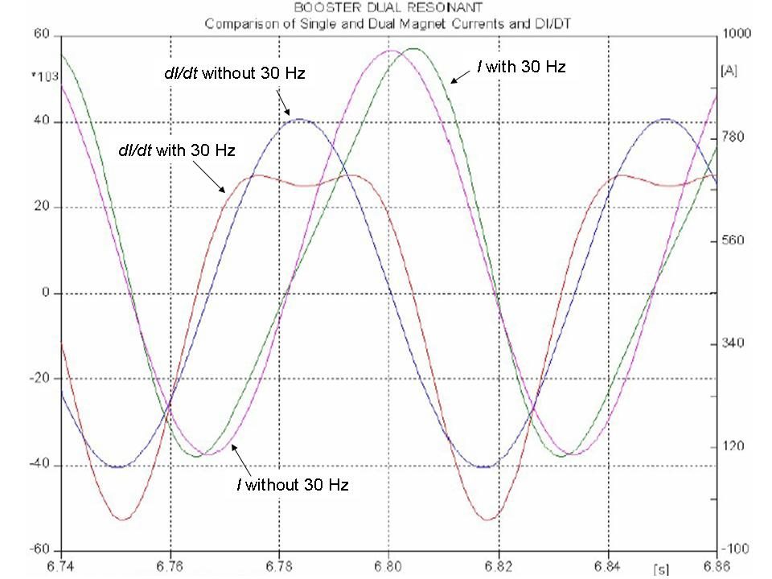

FIGURE 2: Effect of 30Hz component on the bend field in the Booster. Both the existing and modified waves are shown.

WBS 1.2.5 – Gamma-t System
The Booster “gamma-t” system [10] consists of 12 quadrupole magnets that can be pulsed when the beam is just below transition energy. The effect is to lower the transition energy below the energy of the beam so that longitudinal emittance blow-up is minimized.
This system has been in place for some time, but it suffers from two problems:
- The reduced longitudinal emittance exacerbates coupled-bunch oscillations after transition.
- The quadrupoles are not properly aligned, which causes significant closed orbit distortions when they are pulsed.
The first problem can now be ameliorated using the recently commissioned longitudinal damping system. The quadrupole misalignments can be calculated and corrected by studying the induced closed orbit distortions. No hardware upgrades are required to make this system operational, but study time will be needed and effort in studies and analysis.
It is expected that the gamma-t system will be required to maximize the benefit of the RF increase and 30 Hz harmonic upgrades. The goal is to commission the gamma-t system by the end of 2005.

WBS 1.2.6 – Alignment Improvements
There have been significant alignment problems in the Booster since it was built, which result in aperture restrictions and high field orbit distortions. Properly aligning the Booster is critical to achieving its maximum performance potential. In the 2004 shutdown a 3D laser-tracker network was completed and as-found measurements were made of the magnets. This will be used to calculate a series of magnet moves over the next year, which should maximize the beam aperture and stabilize the orbit.
Since beam motion is responsible for a significant amount of beam loss, it is expected that better alignment will contribute to a significant improvement.

WBS 1.2.7 – Drift Tube Cooling
The original installation of the Booster RF drift tubes (DT) included stainless steel cooling lines connected to brazed copper tubing on the inner DT surface. The cooling lines were found not to be necessary at low repetition rates and were disconnected. Inadequate cooling at high repetition rate (> 7.5 Hz) could cause failure of the custom ceramic blocking capacitors. We have started re-commissioning the cooling system with two stations completed in the 2004 shutdown and will incorporate this upgrade work into the cavity maintenance schedule. In the event that the 30+ year-old copper cooling lines leak, we will install a chill plate that serves the same function.

WBS 1.2.8 – Booster RF Cavity #20
Until recently the Booster operated with 18 RF stations installed, although there is space for 20 cavities. An R&D project in 2003-2004 built two large aperture cavities and installed the first in the 19th location to determine the benefit in lowering losses. While the reduction in losses does not warrant increasing the aperture of the standard cavities, studies have shown a benefit from extra RF voltage. It is therefore planned to install the second prototype in the 20th location in fall 2005.
These two new cavities will in principle allow the acceleration of an additional 0.5E12 protons and will also make the Booster performance more robust against the failure of the drivers on any one or two cavities.
The 20th cavity exists and much of the preparatory work for its installation is done. The major costs over the next year are for the required modulator, power amplifiers, sold state drivers and bias supply. These are standard Fermilab technology so the estimate is considered reliable.

WBS 1.2.9 – Solid State RF Power Amplifiers
Traditionally, the highest maintenance components in the Booster are tubes in the cascode amplifier in the RF system. These are located in the tunnel, so servicing them is a problem, particularly given that the RF cavities can become activated. The PA’s will be replaced with a new system with only the power tube in the tunnel; the driver amplifier will be similar to those used in the Main Injector and situated outside the tunnel.
The benefits are threefold:
- The solid state PA’s have a mean time between failures that is three to four times longer than the current PA’s, so down time will be reduced.
- The cost of the upgrade will be offset by reduced repair costs. At the very least, we can eliminate the $400k/year currently spent on replacing tubes.
- The RF technicians who work the PA’s typically receive 100-150 mRem per quarter, which is high by Fermilab standards. The new PA’s would reduce this dose by at least a factor of three.
The upgraded PA’s are already in place on two of the Booster cavities. The remaining upgrade is to be coordinated with the Main Injector RF upgrade, discussed in the next section. Because these PA’s are already in use, the costs are well established. The Booster RF upgrade will proceed after the Main Injector Upgrade, with the final installation during the 2007 shutdown.

WBS 1.2.10 – Booster Instrumentation Upgrade
The existing Booster instrumentation is based on the Fermilab MADC system. This limits the number of channels that can be monitored on a particular Booster cycle. Booster reliability could be increased if more channels could be regularly monitored.
The Hotlink Rack Monitor (HRM) system, developed by the Fermilab Controls Department [11], is well suited to this need. In the initial phase, this instrumentation upgrade will involve four of these digitization chassis controlled by two VME processors. This will allow for 512 channels of digitization, enough for all of the ramped controller cards, plus a large number of other devices.
Additionally, the BPM readout system will be replaced with a modified version of the HRM system that is compatible with a turn-by-turn position digitization. This configuration, which is currently under development, will be able to digitize 16 channels per crate. Seven HRM crates will be required to digitize all of the BPM’s in the Booster.
This is based on an existing instrumentation system, so the parts and labor costs are well established.

WBS 1.3 – Main Injector Upgrades
The focus of the Proton Plan is to increase beam intensity in the Main Injector by developing multi-batch operation and increasing RF power for acceleration. The beam size will be larger, resulting in unacceptably high losses in the injection and extraction regions unless apertures are increased. Radiation surveys of the Main Injector and beam loss studies indicate that the major sources of beam loss occur at injection, at transition and at extraction. Losses at transition are thought to be small compared to the injection and extraction losses. WBS elements 1.3.1 and 1.3.2 will increase the aperture in specific places and reduce beam tails to reduce these losses.
The existing Beam Position Monitor system will not provide batch-by-batch information in NuMI multi-batch operation, and the Beam Loss Monitor system does not allow data-logging for an individual cycle. These instrumentation systems will be replaced as part of the Run II Upgrade Plan.

WBS 1.3.1 – Large Aperture Quadrupoles
With large batch intensities delivered from the Booster and particularly with the advent of slip stacking for NuMI that will result in increased longitudinal emittance, beam loss and activation become an issue in the Main Injector. The most critical locations for this loss are at the quadrupoles near each of the extraction transfer lines, specifically the NuMI, A1, P1, and abort extraction lines, and the transfer lines to and from the Recycler.
The aperture will be increased at these locations by replacing the present quadrupoles with large aperture magnets. The design for these magnets is complete, and materials have been procured. It is planned that they will be completed in time for the fall 2005 shutdown.

WBS 1.3.2 - Main Injector Collimator
A collimation system will be designed and installed for the Main Injector to reduce losses around the ring.
The design of this system has not yet begun, but it is estimated that the cost will be similar to the system recently installed in the Booster.

WBS 1.3.3 – NuMI Multi-batch Operation
This WBS encompasses on-going work in the Main Injector to achieve multi-batch mixed mode operation. This work includes studies of extraction kicker rise and fall times, revised sequencer timing for NuMI, orbit studies of the NuMI extraction region, potential orbit distortions due to the NuMI Lambertson magnets, and slip stacking for NuMI.
The circumference of the Main Injector provides six “slots” for loading Booster batches. One slot is required for antiproton production, leaving five available for NuMI. Both programs will rely on schemes that allow more than one Booster batch to be loaded into a single slot. The baseline proposal is to use the technique called slip stacking that has been extensively developed for antiproton production. In this scheme, two batches are injected into the Main Injector at slightly different momenta, and therefore different velocities. This causes them to “slip” together, at which point they are captured by the RF. This allows two batches to be loaded into a single slot, at the cost of increased longitudinal emittance. Figure 3 illustrates slip stacking during studies for antiproton production.

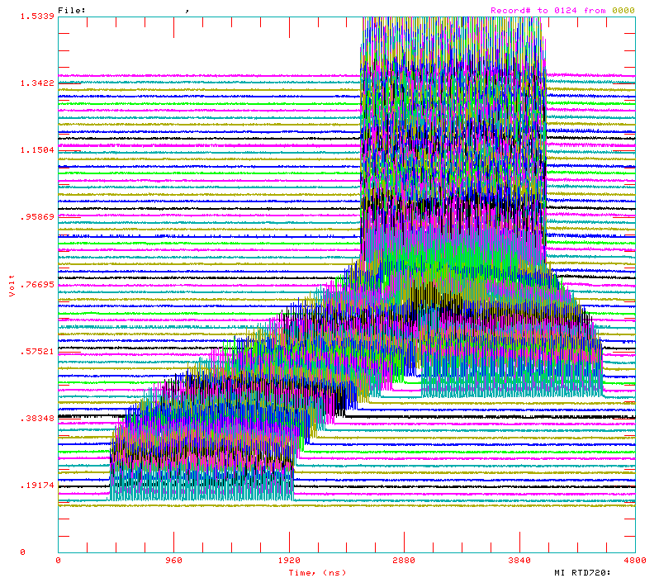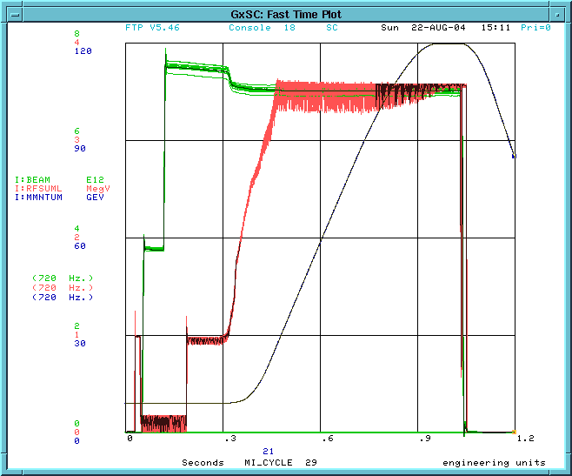
1st Booster Batch in MI
2nd Booster Batch in MI
Merged bunch train

Figure 3: (Left) Mountain range picture showing merging of two Booster batches of protons in the Main Injector. The horizontal axis is the time for one orbit. The vertical axis is the number of orbits. (Right) Fast time plot during slip stacking – the green trace is the beam intensity (scale 0 to 8E12 protons), the red trace is the 53 MHz RF voltage and the black curve shows the beam momentum for acceleration from 8 to 120 GeV.
During initial operation, we plan to slip stack two batches for antiproton production, and then load five batches for NuMI, for a total of seven batches to be accelerated in the Main Injector. It is expected that this mode will be operational by April 2005. At this point, the intensity will be near the limit for the Main Injector RF power, until WBS 1.3.4 is completed.
During this time studies will continue to develop slip stacking for NuMI operation.
Once the RF upgrade is completed, nine batches will be slip stacked into the five NuMI slots. Under this scheme, it will take 12 Booster cycles to load and slip a total of 11 batches [12], two batches for antiproton production and nine for NuMI. The total intensity accelerated in the Main Injector will then be over 5.5E13 per cycle.
The estimated effort and time required for the development of slip stacking is based on the experience with antiproton production.

WBS 1.3.4 – Main Injector RF Upgrade
The existing Main Injector RF system is capable of accelerating 4E13 protons to 120 GeV [7], sufficient for initial NuMI operation. With slip stacking for NuMI, five additional Booster batches will be loaded, and additional RF power will be required. The goal for this upgrade is to allow the acceleration of up to 7E13 (providing about 20% headroom over expected operation).
The Main Injector RF system was designed with two power amplifier ports, of which only one is used at present. In order to meet the ultimate needs of NuMI, we plan to build and install a power amplifier for the second port. This involves a new PA and solid-state driver for each of the 18 cavities, a new modulator capable of driving the pair, and an upgrade to the anode supply transformer.
The plan includes a prototype of the upgrade using a spare cavity to demonstrate that specifications are met, before proceeding with upgrading the operational stations. This prototype will determine whether any modifications to the cavities themselves are required. The prototype phase be completed by mid 2005, and the full upgrade staged a station at a time through 2006.
The cost and schedule estimates are based on experience building similar systems. The present modulators will be used as part of the Booster solid-state upgrade (WBS 1.2.9), and offset the cost of that WBS element.

3. Cost and Schedule

3.1 Methodology
The cost and schedule estimates are derived from information provided by senior engineers, group leaders and department heads. Labor needs are estimated in terms of effort, and converted to an estimate of salary with fringe (SWF) by assuming an average cost per technician, engineer and physicist.
The information is typically tabulated at the component or task level where an assessment of the technical uncertainty and schedule risk is used to assign M&S and labor contingency. The contingency assigned is chosen according to three general categories:
20% “off the shelf” procurements, accounts for vendor uncertainties
50% systems for which a conceptual design exists
100% systems that are not yet fully specified
All costs are escalated to then-year dollars using 3% escalation per year. No G&A overhead is included.

3.2 Cost Estimate
The costs are rolled up to Level 3 and presented in table 2.

WBS | Description | M&S Base | M&S Cont | M&S Total | SWF Base | SWF Cont | SWF Total
1 | Proton Plan | 16,513 | 42% | 23,486 | 6,648 | 57% | 10,419
1.1 | Linac Upgrades | 2,705 | 86% | 5,039 | 981 | 65% | 1,622
1.1.1 | Linac PA Vulnerability | 2,000 | 100% | 4,000 | 300 | 100% | 600
1.1.2 | Linac Quad Power Supplies | 617 | 50% | 925 | 628 | 50% | 942
1.1.3 | Linac Instrumentation Upgrade | 88 | 30% | 114 | 53 | 50% | 80
1.2 | Booster Upgrades | 6,499 | 35% | 8,765 | 2,777 | 54% | 4,262
1.2.1 | Determine Rep Rate Limit | 0 | 0 | 0 | 110 | 50% | 165
1.2.2 | ORBUMP System | 256 | 42% | 364 | 231 | 47% | 338
1.2.3 | Corrector System | 629 | 58% | 995 | 715 | 57% | 1,124
1.2.4 | 30 Hz Harmonic | 1,031 | 35% | 1,388 | 279 | 60% | 447
1.2.5 | Gamma-t System | 0 | 0 | 0 | 50 | 100% | 100
1.2.6 | Alignment Improvements | 0 | 0 | 0 | 60 | 50% | 90
1.2.7 | Drift Tube Cooling | 10 | 50% | 15 | 10 | 50% | 15
1.2.8 | Booster RF Cavity #20 | 300 | 50% | 450 | 120 | 50% | 180
1.2.9 | Booster Solid State RF PA's | 4,200 | 30% | 5,460 | 960 | 50% | 1,440
1.2.10 | Booster Instrumentation | 73 | 27% | 93 | 242 | 50% | 363
1.3 | Main Injector Upgrades | 7,294 | 32% | 9,661 | 2,026 | 60% | 3,239
1.3.1 | Large Aperture Quads | 194 | 50% | 291 | 406 | 50% | 609
1.3.2 | Main Injector Collimator | 200 | 100% | 400 | 150 | 100% | 300
1.3.3 | NUMI Multi-batch Operation | 0 | 0 | 0 | 250 | 100% | 500
1.3.4 | Main Injector RF Upgrade | 6,900 | 30% | 8,970 | 1,220 | 50% | 1,830
1.4 | Management | 15 | 32% | 20 | 864 | 50% | 1,296
TABLE 2: M&S and SWF in $K at Level 3
The total M&S and SWF cost is shown by fiscal year in table 3.

WBS | Description | Base Estimate:  M&S and SWF |  |  |  | Total with Contingency
 |  | FY05 | FY06 | FY07 | Total
1 | Proton Plan | 8,341 | 10,965 | 3,854 | 23,161 | 33,904
1.1 | Linac Upgrades | 1,039 | 2,097 | 550 | 3,686 | 6,661
1.1.1 | Linac PA Vulnerability | 650 | 1,100 | 550 | 2,300 | 4,600
1.1.2 | Linac Quad Power Supplies | 248 | 997 | 0 | 1,245 | 1,867
1.1.3 | Linac Instrumentation Upgrade | 141 | 0 | 0 | 141 | 194
1.2 | Booster Upgrades | 1,945 | 4,718 | 2,613 | 9,276 | 13,027
1.2.1 | Determine Rep Rate Limit | 110 | 0 | 0 | 110 | 165
1.2.2 | ORBUMP System | 486 | 0 | 0 | 486 | 702
1.2.3 | Corrector System | 583 | 761 | 0 | 1,344 | 2,119
1.2.4 | 30 Hz Harmonic | 146 | 1,165 | 0 | 1,310 | 1,835
1.2.5 | Gamma-t System | 50 | 0 | 0 | 50 | 100
1.2.6 | Alignment Improvements | 30 | 30 | 0 | 60 | 90
1.2.7 | Drift Tube Cooling | 20 | 0 | 0 | 20 | 30
1.2.8 | Booster RF Cavity #20 | 420 | 0 | 0 | 420 | 630
1.2.9 | Booster Solid State RF PA's | 0 | 2,680 | 2,480 | 5,160 | 6,900
1.2.10 | Booster Instrumentation | 100 | 82 | 133 | 315 | 456
1.3 | Main Injector Upgrades | 5,010 | 3,860 | 450 | 9,320 | 12,900
1.3.1 | Large Aperture Quads | 600 | 0 | 0 | 600 | 900
1.3.2 | Main Injector Collimator | 250 | 100 | 0 | 350 | 700
1.3.3 | NUMI Multi-batch Operation | 50 | 150 | 50 | 250 | 500
1.3.4 | Main Injector RF Upgrade | 4,110 | 3,610 | 400 | 8,120 | 10,800
1.4 | Management | 348 | 290 | 241 | 879 | 1,316
TABLE 3: Total cost (M&S and SWF) by fiscal year.
Some of the costs in this plan will be offset by savings elsewhere. These include:
- WBS 1.1.1 Linac PA Vulnerability – a short-term plan is currently within the scope of the Run II Upgrades, with $500K M&S and $150K labor included for FY05 and FY06 each. These funds will be transferred to the Proton Plan.
- WBS 1.2.2 ORBUMP System – $160K M&S and $300K labor for replacing the magnets themselves are included in the Run II Upgrade Plan. These funds will be transferred to the Proton Plan.
- WBS 1.2.9 Booster Solid State PA’s – maintenance costs for the present system are $400K M&S and $100K labor per year. After installation of the new system, a further eight years of operation through 2015 will result in a savings of over $3M.
The total cost offset is then of order $1.7M transferred from the Run II Upgrades and $3M savings in maintenance costs.

3.3 Schedule
The schedule is summarized at Level 2 in figure 4, including dates for major milestones. Lower level milestones will be established for technical reviews of the major upgrades and to facilitate monitoring progress.
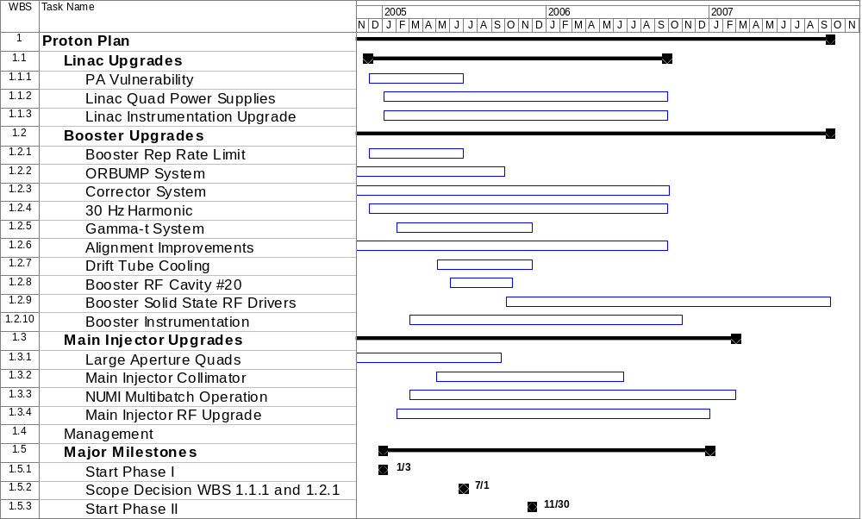
FIGURE 4: Schedule at Level 3
Many of the upgrades planned can be implemented incrementally, without significantly impacting the laboratory operating schedule. Others require installation during shutdowns. The plan assumes the current Fermilab schedule with shutdowns each summer/fall typically of eight weeks duration. No additional shutdowns are required.
These cost and schedule estimates are preliminary. For each Level 2 subproject the next stage will be to develop a detailed work plan and bottom-up estimates for cost, labor and schedule, which will then be compiled into an integrated work plan. Labor is largely provided from Accelerator and Technical Divisions. Physicist labor is included in the costs.
The schedule is subject to labor availability and funding profile. We show the effect of schedule delay in the performance projections in section 4.

3.4 Future Updates to the Plan
This plan will remain flexible as the subprojects progress from concept through design. In particular, WBS 1.1.1 will lead to a specific plan for reducing the operational risk associated with the Linac amplifier tubes which will be incorporated into the Proton Plan. Similarly WBS 1.2.1 will investigate and document the repetition rate limitations in the Booster and propose a course of action to extend this limit. The present scope of these subprojects is to deliver reports with specific recommendations and cost estimates. These two subprojects may lead to significant increase in scope in terms of cost and timeframe.
The importance of mitigating the risk associated with the availability of Linac tubes cannot be overstated. The entire experimental program at Fermilab through 2015 or beyond is dependent on these tubes.

4. Performance Projection

4.1 Operating Modes
The proton delivery cycle encompasses the loading and acceleration cycle of the Main Injector. In this cycle two pre-pulses in the Booster are followed by a series of batches injected into the Main Injector. Once loaded and slip stacked these batches are accelerated. During Main Injector acceleration, the Booster is available to deliver batches to BNB, subject to the average repetition rate and radiation limits.
At present, it takes 1.37 seconds for the Main Injector to ramp from 8 to 120 GeV and back again. We count cycle time in units of Booster cycles, a cycle being 1/15 of a second, so the Main Injector ramp requires 21 cycles. The minimum Main Injector cycle time is then given by:
(21+nBatches+nSlip)/15
Where nBatches is the number of Booster batches loaded and nSlip represents any additional cycles required to slip stack batches together. Antiproton production for the collider requires a minimum cycle time of about two seconds.

As described in the introduction, the Proton Plan has three distinct phases of operation:
- Phase I: This phase begins at the start of 2005. During this phase the Booster will be limited by the ORBUMP system to an average repetition rate of 7.5 Hz, and the Main Injector will have a capacity to accelerate 4E13 protons. This phase will culminate in “2+5” operation, in which two Booster batches are slip stacked for antiproton production, followed by five for NuMI. The loading timeline for this phase of operation is shown in Figure 6a.
- Phase II: This phase follows the ORBUMP and RF cooling upgrades in the Booster, which should increase the repetition rate limit to about nine Hz. Because there will be no increase in the Main Injector capacity, there will be no change to NuMI operation, but the higher Booster repetition rate will allow more protons to be available for BNB. This phase begins after the 2005 shutdown.
- Phase III: Following the completion of the Main Injector RF upgrade the Main Injector will have the capacity to accelerate up to 7E13 protons, enabling “2+9” operation, in which two batches are slipped together for antiproton production, and a total of nine batches for NuMI. The loading timeline for this scheme is shown in Figure 6b. During this period, Booster radiation continues to limit the total proton delivery to BNB. Phase III will begin in late 2006.
During Phase III operation 11 batches are loaded into the Main Injector in a total of 12 Booster cycles. Assuming the same ramp time for the Main Injector, this results in a total Main Injector cycle time of 2.2 seconds. We are investigating the feasibility of reducing the cycle time by up to 10%, but will use 2.2 seconds for the purpose of this document.

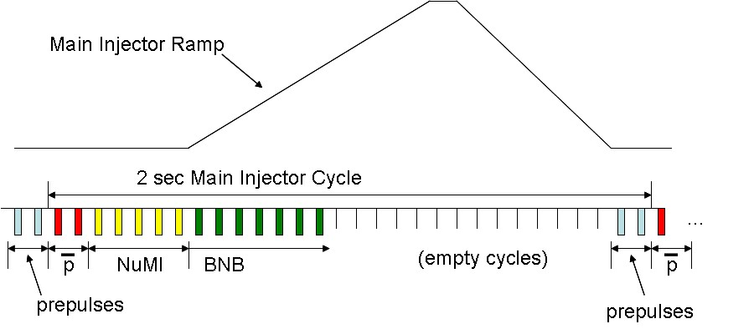
(a)

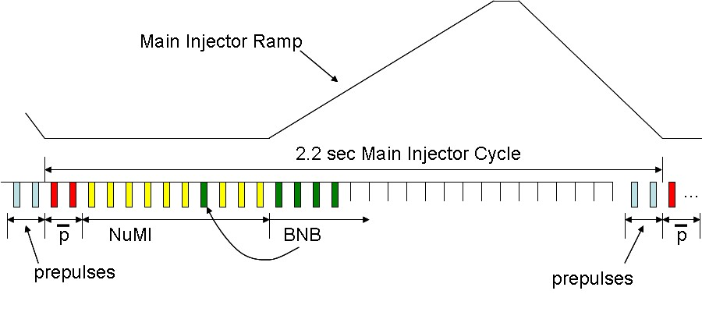
(b)

FIGURE 6: Proton timelines. The tick marks represent 15 Hz Booster cycles. The Phase I and II loading schemes are shown in (a). After two pre-pulses, two antiproton and five NuMI batches are sent to the Main Injector. While these are accelerating as many batches as possible are sent to BNB, subject to the limits of average repetition rate and Booster losses. Phase III running is shown in (b). The number of NuMI batches is increased to nine. In addition to the regular BNB batches, some BNB batches may be inserted during NuMI loading if slipping time is needed.
The time available for delivering beam to BNB is set by the Main Injector ramp cycle. The amount of beam delivered in this time is determined by the limitation on the average Booster repetition rate and radiation limits.

4.2 Booster Radiation Limit
In addition to the increase in repetition rate, it is expected that the improvements in longitudinal bucket area will allow us to gradually increase the Booster batch intensity to 5.5E12 over the next two years. The scale of this increase is based on conservative estimates of the effects of the RF increase and the 30 Hz harmonic upgrade. It is expected that with the increase in repetition rate and batch intensity, beam losses in the Booster will continue to limit the proton output. This will limit the PoT delivered to BNB.

One of the goals of this plan is to steadily reduce uncontrolled losses in the Booster, allowing a higher operational limit for proton throughput. We have not yet taken full advantage of the Booster collimators. Prior to the 2004 shutdown, the Booster had demonstrated 8E16 protons per hour and was regularly operating at 7E16 protons per hour, so we set this as our starting point at the beginning of 2005. However, even at these rates, we were still seeing a significant reduction in activation around the Booster. Figure 7 shows the change in activation around the Booster, relative to the levels before the collimators were installed. There is a 40% reduction around most of the ring. Based on this, we are confident that after a reasonable period of optimization, the Booster can deliver 1E17 protons per hour without exceeding the activation which was seen prior to the collimators.
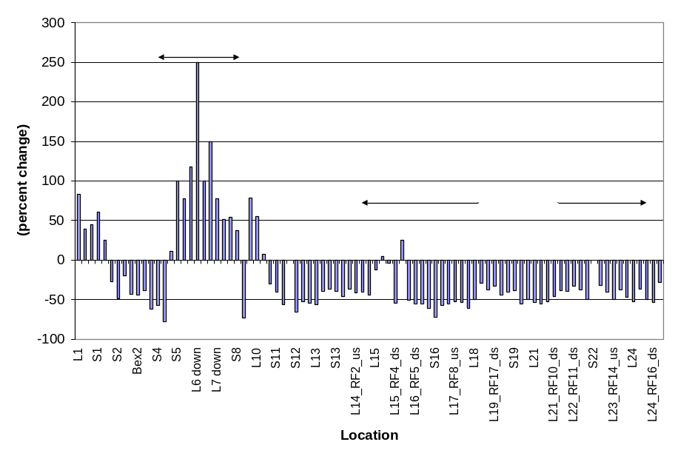
FIGURE 7: The effect of collimator system on activation around the Booster ring.

In order to estimate the benefit of various improvements, we will calculate the relative increase in acceptance due to each of them. We will focus on the horizontal plane. The aperture needed by the beam is:
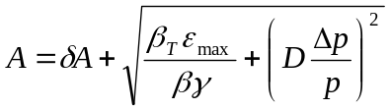
where δA represents aperture loss from all causes and the other variables have their usual meaning, and the second term represents the beam size due to transverse and longitudinal emittance. This can be used to calculate the acceptance as:
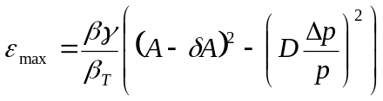
We use the fractional change in acceptance as an estimate of increased beam capacity for each of the proposed improvements.

For our purposes, the following remain fixed:
- 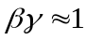
- 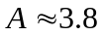 cm (the physical aperture at high beta and dispersion point)
- 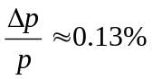 (measured)
The aperture reduction is currently about one centimeter at injection, due to (1) ORBUMP slewing, (2) alignment problems, and (3) inadequate beam control.
In addition to the aperture reduction, acceptance has been reduced because of the parasitic focusing due to the extraction chicanes (“dogleg effect”) [13], which increases the maximum beta function and dispersion in the horizontal plane. One of the extraction regions was modified in 2003 and the second in the 2004 shutdown.
Table 4 shows the calculated improvement in acceptance for each of planned upgrades.

Condition | Date | δA | max D | max beta | Acceptance | Cumulative
 | Completed | (mm) | (m) | (m) | (π-mm-mr) | Increase (%)
Start of MiniBooNE | --- | 10 | 6.2 | 45.8 | 15.7 | -15
Dogleg 3 Fix | Oct-03 | 10 | 4.5 | 40.8 | 18.4 | 0
Dogleg 13 Fix | Oct-04 | 10 | 3.8 | 36.1 | 21.0 | 14
Alignment | Oct-05 | 8 | 3.8 | 36.1 | 24.3 | 32
ORBUMP | Oct-05 | 5 | 3.8 | 36.1 | 29.5 | 60
correctors | Oct-06 | 2 | 3.8 | 36.1 | 35.2 | 92
Ideal | --- | 0 | 3.19 | 33.7 | 42.3 | 130
TABLE 4: The effect of various improvements on acceptance. The last column shows the cumulative effect relative to the state of the machine prior to the 2004 shutdown.
In the following section, we project proton delivery for each of the beamlines. In the “Design Projection” we assume (1) a base performance of 1E17 protons per hour prior to these improvements, (2) that actual improvements are degraded by a factor of two from these calculated values, and (3) that it takes a year to gain the maximum benefit from each improvement. A “Fallback Projection” is also presented using a base of 9E16 and assuming that each improvement has only 25% of the calculated effect. This leads to the intensity limits shown in Table 5.

Date | “Design” Limit  (1E16 p/hr) | “Fallback”  Limit  (1E16 p/hr) | Comment
1/2006 | 10.7 | 9.3 | Effect of collimators, dogleg fix, plus some alignment
1/2007 | 13.0 | 10.4 | Alignment and ORBUMP
1/2008 | 14.6 | 11.0 | New corrector system
TABLE 5: Intensity Limits reached at the end of each year for the Design and Fallback Projections.
The Booster intensity limit is linearly interpolated between these yearly values, as shown in figure 8.
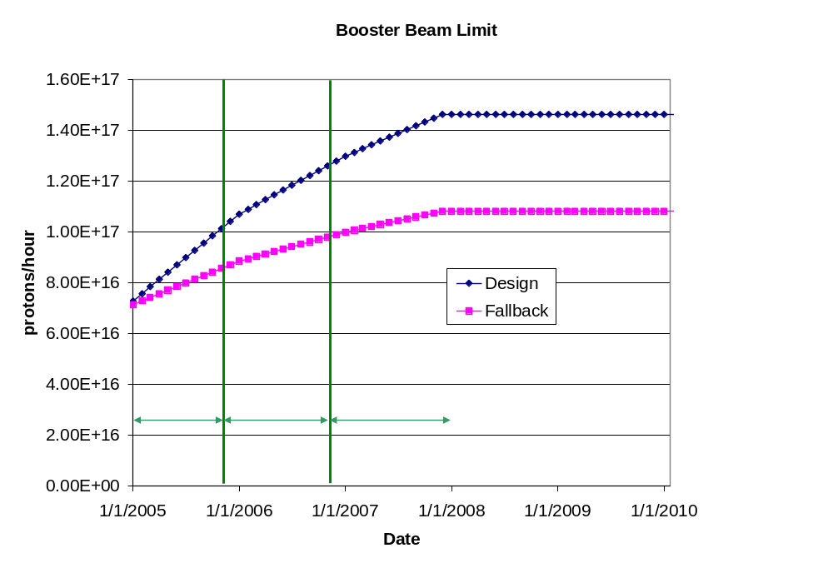
FIGURE 8: Booster output limit which is used as a basis for proton projections.

4.3 PoT Projection
A model for projecting the PoT delivered to each of the neutrino beamlines has been developed. The model incorporates the phased approach outlined above, the Fermilab operating schedule with shutdowns each summer, and learning curves for the introduction of each operating phase.
We present here a model that delivers the planned intensity for antiproton production and maximizes the PoT for NuMI. BNB then receives the residual capacity of the proton source. Reducing the PoT for NuMI and providing additional protons to BNB is an option within the overall program.
We are assuming a 2 month shutdown during August and September of each year. Beyond that, we are using an overall up time factor of 81%, as measured for BNB operation from December 2003 to July 2004. The same factor is applied to both BNB and NuMI.
There is no performance history for extended multi-batch operation, but it is reasonable to assume that there will occasionally be some problems. We are therefore including a 90% factor in the NuMI projections, to allow for operational difficulties. There is also a 90% efficiency applied to slip stacking for NuMI.
BNB projections are less certain. Under the model described in the last subsection, we are confident that the radiation limit in the Booster will allow sufficient protons for antiproton production and NuMI operation. The beam available to BNB will then be determined by the excess Booster capacity beyond these needs. The projection for BNB is therefore extremely sensitive to the Booster output limit and fluctuations in losses.
Our discussion in the last subsection focused on the peak capacity of the Booster. For our projections, we use average proton rates based on operating experience during the period of mid June to mid July 2004. During this time, the Booster consistently reached peak outputs of 7.5E16 protons/hr for all users. The total beam up time for the period was 90%, so the projected total for that intensity would be 4.9E17 protons. In fact, 4.2E19 protons were delivered, resulting in an average/peak factor of 4.2/4.9≈85%. After applying this factor, the protons needed for antiproton production and NuMI are subtracted to determine the PoT for BNB.
Additionally, 10% down time for NuMI is included for collider shot setup. During this time all available protons are sent to BNB. We have also applied a 5% reduction for NuMI to allow for antiproton transfers from the Accumulator to the Recycler. This does not affect BNB operation. Finally, for 2005, a 5% downtime is applied to both beamlines to allow for potential interference from electron cooling commissioning in the Main Injector tunnel.
Table 6 shows the final performance parameters for each phase of operation. On completion of the present scope of this plan at the end of Phase III, it is estimated that 3.4E20 protons will be delivered annually to NuMI and 2.2E20 to BNB.
For reference, parameters are included for typical running in July 2004. An 11 Hz scenario in which 2+9 Booster batches are delivered to NuMI and BNB is then supplied at 5Hz is also included. This would require the Booster to operate at an average repetition rate over 11 Hz, and is beyond the scope of the present plan.

 | Booster  Batch Size | Main Injector Load | Cycle Time | MI Intensity | Booster Rate* | Total Proton Rate | Annual Rate at end of Phase
 |  | (AP + NuMI) | (sec) | (protons) | (Hz) | (p/hr) | NuMI | BNB
Actual Operation
July, 04 | 5.0E+12 | 1+0 | 2.0 | 0.5E+13 | 5.1 | 0.8E+17 | 0 | 3.3E+20
Proton Plan
Phase I | 5.10E+12 | 2+1→2+5 | 2.0 | 3.6E+13 | 6.3 | 1.0E+17 | 2.0E+20 | 1.5E+20
Phase II | 5.3E+12 | 2+5 | 2.0 | 3.7E+13 | 7.5 | 1.2E+17 | 2.2E+20 | 2.8E+20
Phase III | 5.50E+12 | 2+9 | 2.2 | 6.0E+13 | 8.3 | 1.5E+17 | 3.4E+20 | 2.2E+20
Beyond Scope of Present Plan
11 Hz | 5.50E+12 | 2+9 | 2.2 | 6.1E+13 | 11.0 | 2.0E+17 | 3.4E+20 | 5.0E+20
TABLE 6: Performance parameters at the completion of each phase of operation.
* Booster rate is limited by radiation levels, except for the 11 Hz case

Individual machine performance projections are shown in figure 9. The cumulative totals through the beginning of 2010 are shown in figure 10 for both NuMI and BNB.

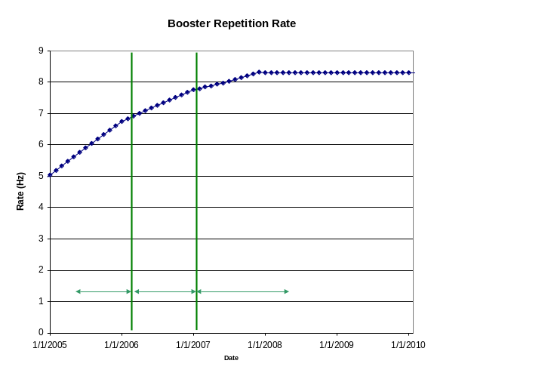
(a)
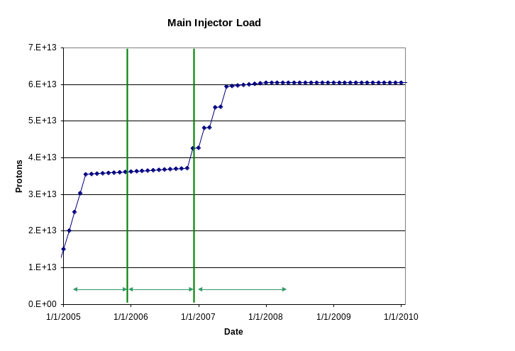
(b)

FIGURE 9: Projected performance in terms of (a) the average Booster repetition rate, and (b) Main Injector intensity.

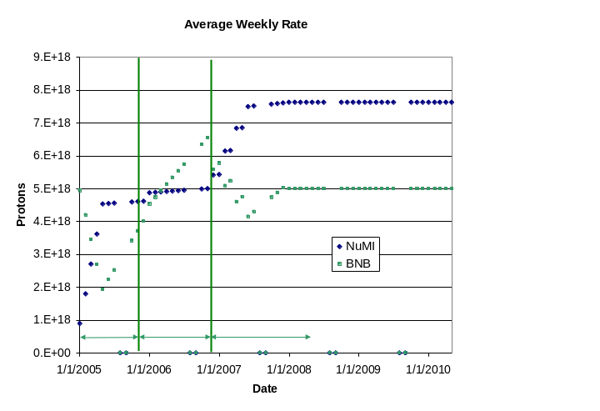
(a)
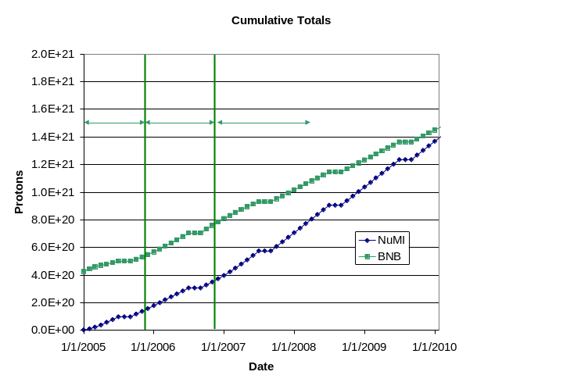
(b)

FIGURE 10: (a) weekly and (b) cumulative total PoT for BNB and NuMI in the Design Projection.
The performance risk in this plan is quite different for the two beamlines. For NuMI the risk is that slip stacking proves problematic or the Main Injector RF upgrade fails to allow the acceleration of the full beam intensity. The scenario for NuMI without slip stacking is shown in figure 11(a). In this case the maximum annual PoT rate to NuMI would be 2.2E20. It should be noted, however, that slip stacking has been successfully developed for antiproton production, and development for NuMI will be demonstrated by early 2006. Similarly the RF upgrade will be demonstrated on a test station by the end of 2005.
For BNB the main uncertainty is due to the radiation limit in the Booster. Using the fall-back projection for the radiation limit described in section 4.2, and the methodology described at the beginning of this section, the scenario for BNB is shown in figure 11(b). Under these assumptions, the beam available for BNB is severely limited with slip stacking for NuMI.
Figure 11 also shows the effect of a delay for the Design Projections in completion of the Booster Corrector System (WBS 1.2.3) and the Main Injector RF Upgrade (WBS 1.3.4) by one year each. With the delay in the RF upgrade, NUMI takes less beam in 2007, allowing more protons to be provided to BNB.

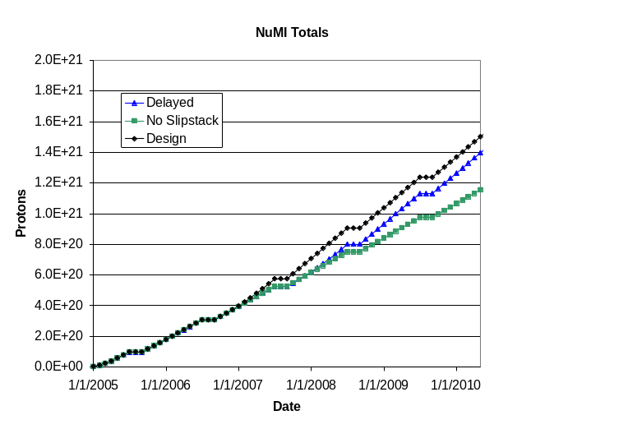
(a)
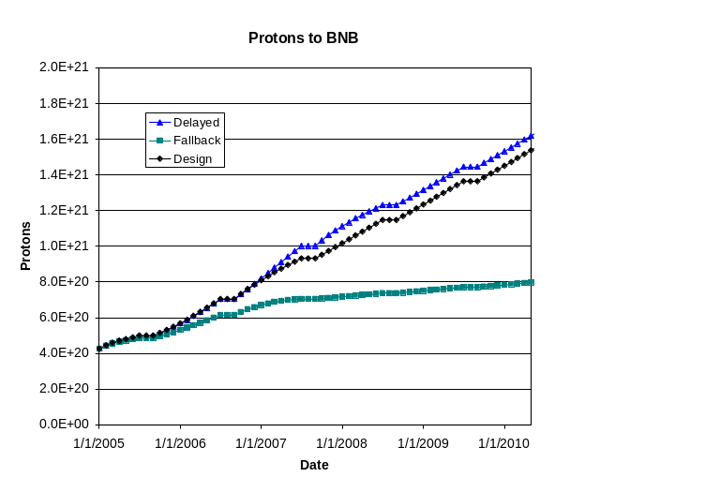
(b)

FIGURE 11: (a) Design and fall-back (without slip stacking) projections for NuMI (b) Design and fall-back (conservative improvement to Booster radiation limit) projections for BNB
It should be noted that the BNB projection is highly dependent on the assumptions made regarding the improvement to the radiation limits in the Booster. The Design Projection assumes that 50% of the optimal improvement is actually achieved and the Fall-Back Projection assumes 25%. Once slip stacking for NuMI starts in phase III, the delivery of useful intensity to BNB is dependent on the success of these upgrades. The accuracy of the projections will improve as progress is made on the Booster subprojects.

References
- http://www-boone.fnal.gov/
- http://www-numi.fnal.gov/
- D. Finley, et al, “Report to the Fermilab Director”, Oct. 2003. http://www.fnal.gov/directorate/program_planning/studies/ProtonReport.pdf
- “The Run II Luminosity Upgrade v2.0”, Jan. 2003.
http://www-bdnew.fnal.gov/doereview04/RunII_Upgrade_Plan_v2.0.pdf
- N. Mokhov, et al, “Fermilab Beam Collimation and Shielding”, 2004 PAC, TPAG033 (2003).
- J. Lackey, “New Dogleg Layout”, Booster Space Charge Meeting, May, 2003. http://www-bd.fnal.gov/pdriver/booster/meetings2/22may_layout_new.pdf
- W.Chou, “Revised RF Power Calculations”, Booster Space Charge Meeting, Sep. 2004. http://www-bd.fnal.gov/pdriver/meetings3/chou_16sept04_rev.pdf . Limit can be raised to 4E13 by modifying acceleration ramp (I. Kourbanis, private communication).
- D. Harding, J. Lackey, E. Prebys, Fermilab/BEAMS-DOC-1430. Oct. 2004.
- D. Wolff, “Booster Dual Resonance”, Booster Space Charge Meeting, Jan. 2004. http://www-bd.fnal.gov/pdriver/booster/meetings8/wolff_29jan04.pdf
- W. Merz, C. Ankenbrandt, and K. Koepke, “Transition Jump System for the Fermilab Booster”, FERMILAB-TM-1473, Sep. 1987.
- A.R. Franck, et al, FERMILAB-CONF-01/342/E. Dec. 2003.
- K. Koba, Fermilab/BEAMS-DOC-1432. Oct. 2004.
- A. Drozhdin, et al, “Evaluation of Fringe Field Effect…”, Booster Space Charge Meeting, Aug. 2003.
http://www-bd.fnal.gov/pdriver/booster/meetings4/fringe_field.pdf

