LARP IR Cryogenics: Scaling of LHC I IR Cryogenics Model

Roger Rabehl
June 27, 2005
Rev. October 7, 2005
Version 2: March 24, 2006

Introduction

A spreadsheet-based model was written during the design phase of the LHC I interaction region (IR) cryogenics system [1]. This model calculates temperature drops from the magnet center at the cold mass cooling holes out to the cold compressors. This paper documents the equations used in this model and the predicted temperature profiles resulting from scaling up the IR dynamic heat load.

Temperature drops within the pressurized He II system are based on static and dynamic heat loads of the inner triplet. The dynamic heat load (heat deposition rate) is greatest at the Q1/Q2a end of the Q1 magnet, and therefore this interconnect is the basis for the model. Figure 1 is a cutaway of the Q1 and Q2a magnets, showing the cold masses, interconnect piping, TAS absorber, and a corrector magnet. The locations of the calculated temperatures and temperature drops are indicated in Figures 1 and 2, respectively. Each temperature drop is described in Table 1.

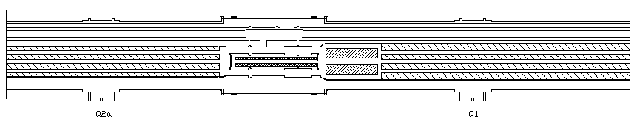
T₁
T₆
T₅
T₄
T₃
T₂

Figure 1 Temperatures in the Q1 and Q2a magnets and the associated interconnect.

ΔT₁
ΔT₂
ΔT₃
ΔT₄
ΔT₅

Figure 2 Temperature drops in the Q1 and Q2a magnets and the associated interconnect.

Table 1 Temperature drops within the pressurized He II system.

Temperature drop | Description
ΔT₁ | From the cold mass thermal center to the cold mass end via the cooling holes
ΔT₂ | Through the interconnect piping to the crossover pipe
ΔT₃ | Through the crossover pipe
ΔT₄ | Through the pressurized He II in the annular volume outside the corrugated magnet heat exchanger tube
ΔT₅ | Across the corrugated magnet heat exchanger tube wall

There are additional temperature drops to consider in the subatmospheric He system. These are equivalent temperature drops resulting from pressure drops as the saturated He II vapor generated in the magnet heat exchanger corrugated tube returns to the cold compressors. Figure 3 shows the locations of the equivalent temperatures and temperature drops in the subatmospheric He system, and Table 2 describes these equivalent temperature drops.
ΔT₈ + ΔT₉
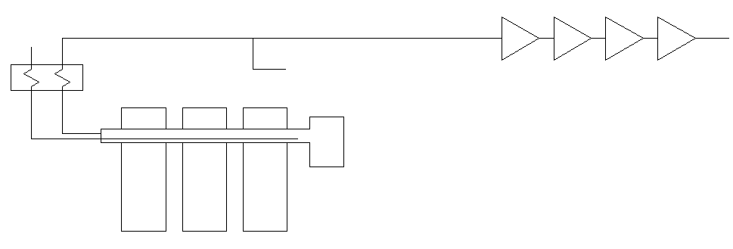
Q1
Q2
Q3
From octant arc
J-T heat
exchanger
Cold compressors
T₆
T₇
T₈
T₁₀
ΔT₆
ΔT₇

Figure 3 Equivalent temperature and temperature drops in the subatmospheric He system.

Table 2 Equivalent temperature drops within the subatmospheric He system.

Pressure/ temperature drop | Description
ΔP₁/ΔT₆ | Along the length of the inner triplet corrugated magnet heat exchanger tube
ΔP₂/ΔT₇ | Through the shell side of J-T heat exchanger
ΔP₃/ΔT₈ | Through the octant transfer line elevation change
ΔP₄/ΔT₉ | Through the octant transfer line to the cold compressor station

Inputs to the model include the inner triplet system heat load, geometric parameters of the cold mass and external heat exchanger, and pipe sizes.

The model also includes a scaling factor for the inner triplet dynamic heat load. A scaling factor of 0.5 corresponds to the LHC I nominal luminosity; a scaling factor of 1 corresponds to the LHC I ultimate luminosity.

ΔT₁ – ΔT₄: Temperature drops through pressurized He II

The first four temperature drops considered occur within the pressurized He II and are governed by the superfluid steady-state heat transport equation of Equation 1 [2]:

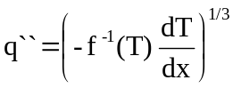 (1)

where q`` is the heat flux [W/cm²], -f⁻¹(T) [W³/cm⁵-K] is the He II heat conductivity function, and dT/dx [K/cm] is the temperature gradient.

ΔT₅: Temperature drop across the external heat exchanger tube wall

The temperature drop across the heat exchanger tube wall is calculated with three heat transfer resistances in series. These resistances are based on the Kapitza conductance on the outside of the tube wall, the thermal conductivity of the wall material (copper), and the Kapitza conductance on the inside of the tube wall. The Kapitza coefficient for this material is Ch_{K} = 892.8 W/m²-K⁴ [3].

ΔT₆: Temperature drop along the inner triplet magnet heat exchanger tube

The pressure drop in the inner triplet magnet heat exchanger tube is calculated piecewise along its length using the standard, single-phase pressure drop equation. A factor of 4 is added for the corrugations, and another factor of 1.5 is included based on experience with the Heat Exchanger Test Unit (HXTU).

The calculated pressure drop is converted to a temperature drop with Equation 2:

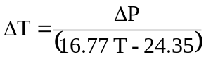 (2)

where T is the temperature [K], ΔP is the calculated pressure drop [Pa], and ΔT is the corresponding temperature drop [mK].

ΔT₇: Temperature drop through the shell side of the J-T heat exchanger

The vapor produced in the magnet heat exchanger goes through the shell side of the J-T heat exchanger and passes over finned tubes to precool the 4.6 K/3 bar supercritical helium supply.

To scale the vapor pressure drop as it passes over the finned tubes, Equations 3 [4] and 4 are used:

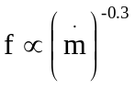 (3)

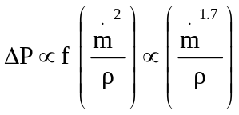 (4)

where f is the friction factor for flow over finned tube banks, is the mass flow rate, ρ is the vapor density, and ΔP is the calculated pressure drop. The system parameters for a scaling factor of 1 – Q = 205.5 W, T = 1.863 K – are used as a baseline for scaling to a new operating point.

The temperature drop corresponding to this pressure drop is calculated with Equation 2.

ΔT₈: Temperature drop due to octant elevation change

The pressure drop due to elevation change in the octant is constant at 62 Pa, the value included in the original inner triplet model. The corresponding equivalent temperature drop decreases slightly as the inner triplet heat load increases.

ΔT₉: Temperature drop through the octant transfer line

Pressure drop through the octant transfer line is calculated by Equation 5:

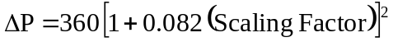 (5)

where ΔP is the pressure drop [Pa] and the Scaling Factor has a value of 0.5 for LHC I nominal luminosity, a value of 1 for LHC I ultimate luminosity, etc. This equation indicates that at LHC I ultimate luminosity, the return flow due to the inner triplet dynamic heat load is 8.2% of the flow returning from the rest of the octant. This percentage increases proportionally as the dynamic heat load increases, and the pressure drop increases with the square of the total mass flow rate.

The temperature drop corresponding to this pressure drop is calculated with Equation 2.

T₁₀: Temperature at the cold compressors

The cold compressors are able to reach a minimum pressure of 15 mbar, or an equivalent saturation temperature of 1.775 K.

At ultimate luminosity (scaling factor of 1), the existing model indicates that the inner triplet dynamic heat load is about 8% of the octant heat load. Scaling up the inner triplet dynamic heat load by a factor of six, for example, would then mean the inner triplet dynamic heat load is about 50% of the octant heat load. It is assumed that the 15 mbar cold compressor inlet pressure could be maintained if the 1.9 K system heat load increases by 50%.

Scaling Results

To run the model, a scaling factor is provided. Temperature drops through the cryogenics system are then calculated. Figure 4 is a plot of calculated system temperatures vs. inner triplet total (static + dynamic) heat load to 1.9 K.

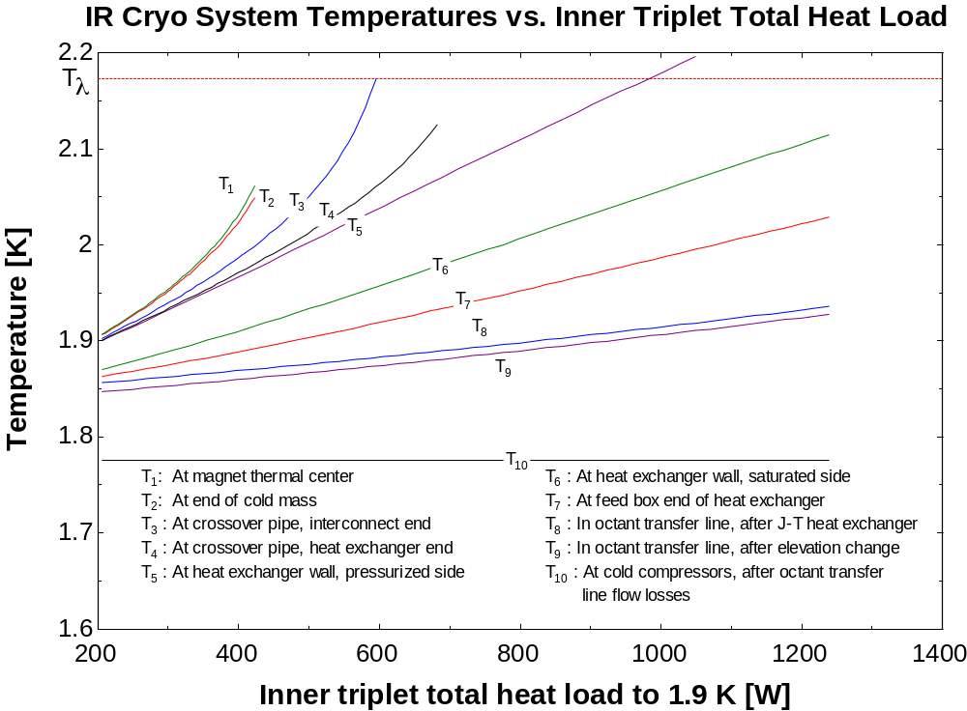

Figure 4 Calculated system temperatures vs. inner triplet total heat load to 1.9 K.

At a total heat load of about 400 W, the calculated temperature at the magnet thermal center begins to increase rapidly and presents an operating limit to the LHC I inner triplet cryogenics system. It is important to note that Figure 4 presents temperatures from the cold mass cooling holes to the cold compressors. Additional temperature drops from the magnet coils to the cold mass cooling holes must also be considered and could present additional limitations.

Limits of the inner triplet design versus limits of the LHC cryogenics system can also be differentiated. Temperatures T₇-T₁₀ are dictated by characteristics of the LHC cryogenics system: cold compressor capacity, QRL return line size and elevation change, and QRL service module J-T heat exchanger. These factors are considered fixed for the purposes of this document. These characteristics dictate the available inner triplet cooling temperature margin in order for the magnets to remain in superfluid at a given inner triplet total heat load. This temperature margin, defined as T_{λ} – T₇, is plotted as a function of inner triplet heat load in Figure 5.

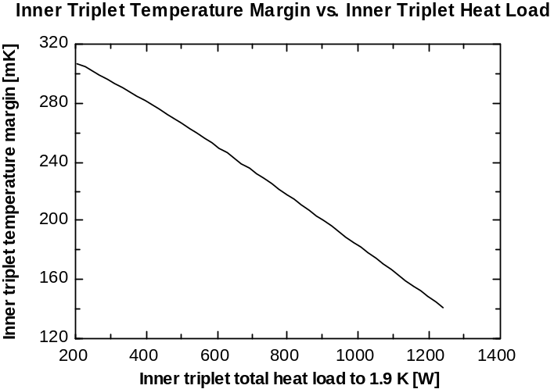

Figure 5 Inner triplet temperature margin vs. inner triplet heat load.

Comparing temperature drops can point to limitations in the LHC I inner triplet cryogenics system. Figure 6 plots temperature drops in the pressurized He II system as a function of the inner triplet total heat load. All of these temperature drops begin to grow exponentially at heat loads of 400-600 W. Any magnet design for an upgraded inner triplet must therefore address issues such as cooling hole sizing, interconnect pipe sizing, crossover pipe sizing and frequency, and heat exchanger annulus sizing.

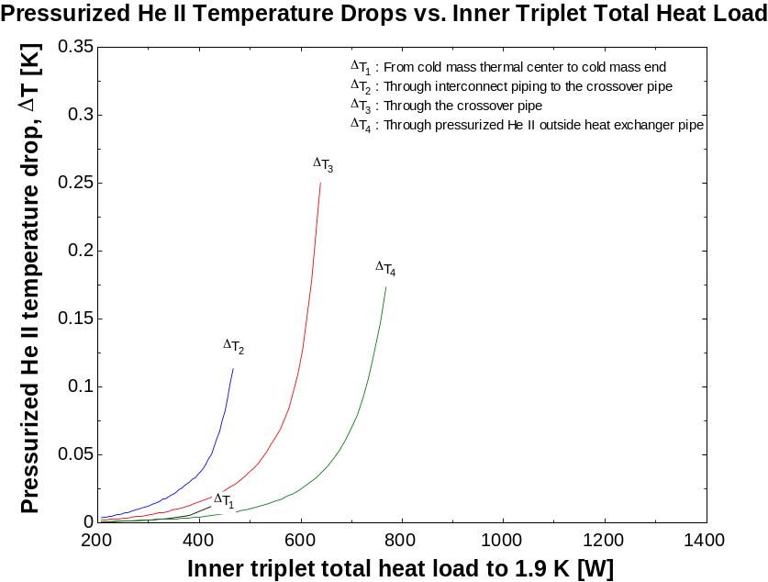

Figure 6 Pressurized He II temperature drop vs. inner triplet total heat load to 1.9 K.

Similarly, Figure 7 plots temperature drops in the subatmospheric He system as a function of the inner triplet total heat load. The largest equivalent temperature drop is due to flow losses in the QRL transfer line return to the cold compressors. As was stated previously, any upgrades of the cryogenics system beyond the inner triplet is considered outside the scope of this document. The second largest temperature drop is across the heat exchanger corrugated tube wall. An upgraded inner triplet could address this using extended surfaces (fins) or using a larger fraction of the tube wall for heat transfer from the pressurized liquid He II to the saturated liquid He II. The fourth largest temperature drop is along the length of the inner triplet heat exchanger. This could be improved through heat exchanger pipe sizing and design (e.g., corrugated tube vs. straight tube).

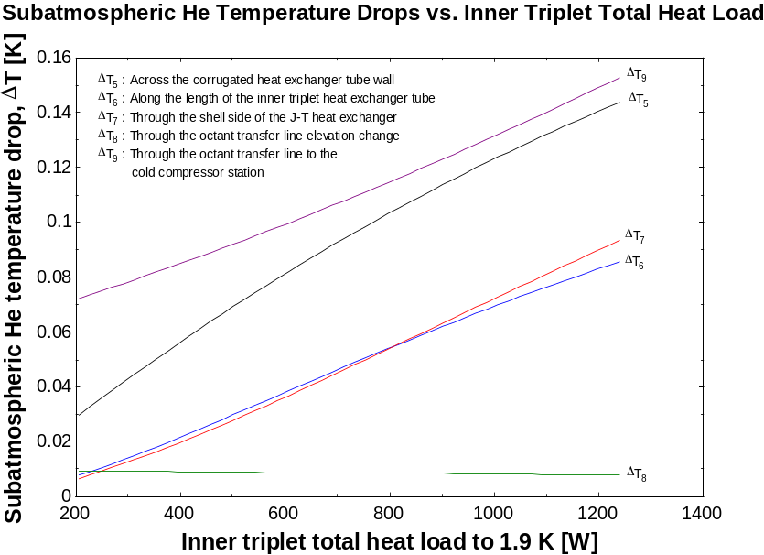

Figure 7 Subatmospheric He temperature drop vs. inner triplet total heat load to 1.9 K.

Conclusions

Heat load scaling of the LHC I inner triplet cryogenics model has been completed. The resulting system temperature profile shows that for any given inner triplet total heat load, the LHC cryogenics system presents a temperature margin within which the magnets must operate.

The calculated temperature drops point toward areas of further study. The entire pressurized He II system will require careful analysis. Temperature drop across the magnet heat exchanger pipe wall will also need to be investigated, as will pressure drop along the heat exchanger pipe.

References

[1] T. Peterson, FNAL (2002).
[2] S. Van Sciver, Helium Cryogenics, Plenum Press (1986), p. 145.
[3] C. Darve, Y. Huang, T. Nicol, and T. Peterson, “He II Heat transfer through a Corrugated Tube – Test Report,” Fermilab Technical Division Note TD-99-064 (1999).
[4] W. Rohsenow, J. Hartnett, and Y. Cho, Handbook of Heat Transfer, McGraw-Hill (1998), p. 17.87.

