VMSNA Website — Technical Design Document

Application: Vokkaliga Mahajana Sangam North America (VMSNA) community website
Repository path: tvsna-website-dark-hero-fullsite/
Firebase project: vmsna-e9bd0 · Hosting site: vmsna
Public URLs referenced in code: https://vmsna.org, https://www.vmsna.org, https://vmsna.web.app
Document status: Baseline — reverse-engineered from the code at commit 194287b
Last updated: 2026-09-21

Contents
1. Purpose and Scope 4
2. System Overview 5
3. Architecture 6
3.1 Architectural characteristics 6
4. Component Inventory 7
4.1 Firebase / Google Cloud components 7
4.2 Third-party and external integrations 7
4.3 Repository-level components 8
5. Frontend Design 9
5.1 Page inventory 9
5.2 Shared page shell 9
5.3 SDK usage inconsistency 10
6. Data Model 11
6.1 membershipApplications — the core collection 11
6.2 helpRequests 12
6.3 contactMessages 12
6.4 members 12
6.5 Composite indexes 13
7. Security Design 14
7.1 Trust boundaries 14
7.2 Admin identity 14
7.3 Rules summary (firestore.rules, rules_version = '2') 14
7.4 Authentication controls 15
8. Backend Design — Cloud Functions 16
8.1 Why three paths send the same admin email 16
8.2 Idempotency 16
9. End-to-End Flows 18
9.1 Registration → verification → admin notification 18
9.2 Admin approval 18
9.3 Member dashboard load 19
9.4 Member directory construction 20
9.5 Profile edit and account deletion 20
9.6 Unauthenticated help / contact submission 20
10. Configuration Reference 21
10.1 firebase.json 21
10.2 .firebaserc 21
10.3 Secrets and environment 21
10.4 Hardcoded values worth knowing 21
11. Build and Deploy 23
12. Observability 24
13. Non-functional Characteristics 25
14. Operational Runbooks 26
14.1 One-time migration (already executed) 26
14.2 Incident tooling 26
14.3 Existing documentation 26
15. Known Issues and Risk Register 27
Critical 27
High 27
Medium 28
Low / hygiene 28
16. Recommended Sequence 30
Appendix A — File Map 31
Appendix B — External Endpoints 32
Appendix C — Glossary 33

1. Purpose and Scope
This document describes the architecture of the VMSNA website: every component it is built from, every external service it integrates with, the data it stores, the security model that protects that data, and the end-to-end flows that tie them together.
It is written to be sufficient for a new engineer to reason about a change without first reading all 6,400 lines of source. Section 15 records the defects and risks that exist in the current implementation, so the document describes the system as built, not as idealised.
In scope: the static frontend, Firestore data model, Firebase Authentication usage, Cloud Functions, the email notification subsystem, security rules, build/deploy, and the operational one-off tooling committed to the repo.
Out of scope: the legacy vokkaligasangam Firebase project (referenced only by the migration scripts), DNS/domain configuration, and the Gmail account's own administration.

2. System Overview
VMSNA is a volunteer-run non-profit. The site serves three audiences:
Audience | Needs | Surface
Public visitors | Learn about the org, find a local chapter, see events, donate, request welfare assistance, contact the org | index, about, chapters, events, media, donate, help, contact
Members | Apply for membership, verify email, view/edit their profile, search the member directory | membership, dashboard
Admins (13–14 named emails) | Review, approve or reject membership applications | admin, plus one-off operational pages

The defining workflow is gated membership: anyone may apply, but a member cannot see the member directory until (a) they verify their email address and (b) an admin approves their application. Almost everything else in the system exists to support, notify, or audit that gate.
There is no application server and no build step for the frontend. Every page is a self-contained HTML file that talks directly to Firebase from the browser. The only server-side code is a small set of Cloud Functions whose sole job is sending email.

3. Architecture
All pages are plain static files served by Firebase Hosting, and every dynamic page loads the Firebase JS SDK 10.7.1 from gstatic.com. Those two edges are omitted below so the data flows stay legible.
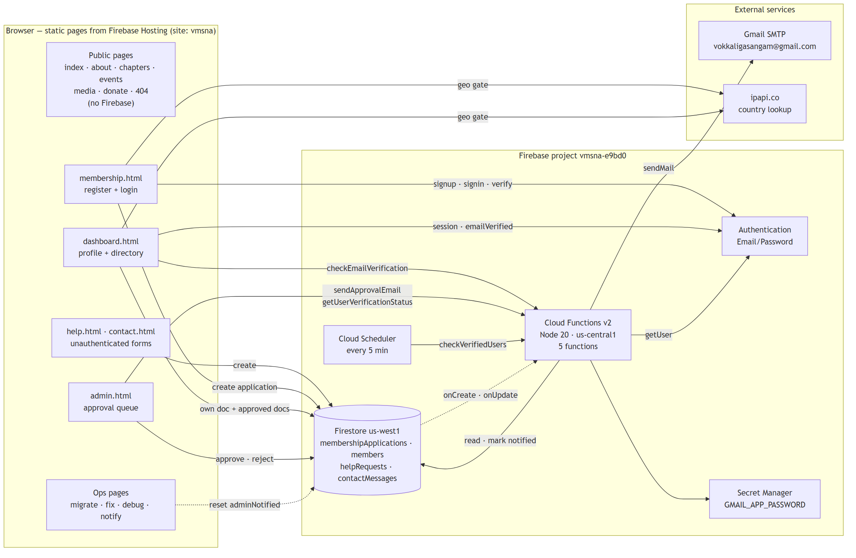
Figure 1 — System architecture and integrated components

3.1 Architectural characteristics
- Serverless / BaaS. The browser is a first-class client of Firestore and Auth. There is no API tier, so Firestore Security Rules are the only authorization boundary for data access.
- No shared frontend code. Each page repeats the nav, footer, Firebase config object and menu-toggle script inline. There is no shared JS module, no template engine, and no firebase-config.js. Changing the Firebase config or the nav requires editing every page.
- Email is the only server-side concern. Cloud Functions exist because an SMTP password and the Admin SDK cannot be exposed to a browser.
- Idempotency by flag. All admin notifications converge on one boolean (adminNotified) guarded by a Firestore transaction, because three independent code paths can trigger the same email.

4. Component Inventory
Every component integrated with the application, why it is there, and where it is configured.

4.1 Firebase / Google Cloud components
Component | Role in the app | Configured in | Notes
Firebase Hosting | Serves the entire public/ directory as static files | firebase.json → hosting, .firebaserc → target main | Site vmsna. No rewrites, no custom headers, no SPA fallback. 404.html is served by Hosting convention.
Cloud Firestore | Primary datastore for applications, help requests, contact messages | firebase.json, firestore.rules, firestore.indexes.json | Database (default), location us-west1.
Firebase Authentication | Identity: email/password sign-up, sign-in, email verification, password reset | Firebase console (not in repo) | Email/Password is the only provider used. No federated login, no MFA (see §15).
Cloud Functions (2nd gen) | Email notification subsystem; privileged Auth lookups | functions/src/index.ts, functions/package.json, firebase.json | Node 20, TypeScript, maxInstances: 10 globally, region us-central1.
Cloud Scheduler | Fires checkVerifiedUsers every 5 minutes | onSchedule in functions/src/index.ts | Timezone America/Los_Angeles. Provisioned implicitly by the onSchedule trigger.
Secret Manager | Stores the Gmail app password | secrets: ["GMAIL_APP_PASSWORD"] on each function | Set via firebase functions:secrets:set GMAIL_APP_PASSWORD.
Firebase Realtime Database | Not used. | database.rules.json (.read/.write = false) | No database block in firebase.json, so these rules are never deployed. Vestigial.
Firebase Data Connect | Not used. | dataconnect/dataconnect.yaml, dataconnect/schema/schema.gql | Unmodified scaffold for a music library app (Artist, Album, Track, Playlist). Targets Cloud SQL …-fdc / fdcdb in us-east4. Should be deleted or implemented.
Google Analytics | Not active. | measurementId: "G-GW1V7MS84J" in every page's config | No firebase-analytics SDK is loaded, so no events are collected.

4.2 Third-party and external integrations
Integration | Purpose | Called from | Failure behaviour
Gmail SMTP (nodemailer, service: "gmail") | Sends all outbound mail: member approval emails and admin new-application alerts, from vokkaligasangam@gmail.com | All Cloud Functions | Errors are logged; the triggering operation is not rolled back. The admin UI shows a "email could not be sent, please email manually" fallback.
ipapi.co (GET https://ipapi.co/json/) | Client-side country check; access intended to be limited to US and CA | membership.html login, dashboard.html load | Fails open — any error or timeout grants access. Purely advisory (see §15).
gstatic.com | Delivers Firebase JS SDK 10.7.1 | Every dynamic page | Hard dependency; no local vendored copy, no SRI hashes.
Facebook group / WhatsApp invite | Community links | contact.html | Static outbound links.

4.3 Repository-level components
Path | Type | Purpose
public/ | Static site | 16 HTML pages + CSS + images. The Hosting root.
public/assets/css/style.css | CSS | Base theme: dark navy/teal/amber design tokens, nav, hero, tiles, buttons, footer.
public/responsive.css | CSS | Mobile layer: box-sizing reset, fluid media, clamp() typography, .row/.col-* grid, nav hamburger behaviour, breakpoints at 576/768/992px.
functions/src/index.ts | TypeScript | The deployed backend. 5 functions.
functions/index.js | JavaScript | Dead code. Legacy v1 custom-verification-email function; not loaded (main is lib/index.js) and incompatible with firebase-functions v7.
scripts/make.responsive.js | Node codemod | Idempotently injects the viewport meta tag, responsive.css link, and menu-toggle script into every public/*.html.
mobile.patch | Patch artifact | The original diff that introduced responsive.css. Historical.
export-firestore.js, browser-export.js | Node / browser-console scripts | One-time export of the legacy vokkaligasangam project's collections (members, help_requests, contact_messages, education_help, medical_help, employment_help, other_services_help).
trigger-notification.js | Node script | Manual admin-notification send for one hardcoded email, using a service-account key file that is not in the repo.
users.json | Data | Broken 13-byte stub ({"users": [) from a failed firebase auth:export. Dead file.
*.md (6 files) | Docs | Setup and incident runbooks — see §14.3.

5. Frontend Design

5.1 Page inventory
Page | Auth required | Firebase SDKs loaded | Writes | Reads
index.html | No | none | — | —
about.html | No | none | — | —
chapters.html | No | none | — | —
events.html | No | none | — | —
media.html | No | none | — | —
donate.html | No | none | — | —
help.html | No | app, firestore | helpRequests | —
contact.html | No | app, firestore | contactMessages | —
membership.html | No (creates auth) | app, firestore, auth | membershipApplications | —
dashboard.html | Yes + verified | app, firestore, auth, functions | membershipApplications (own doc) | own doc + all approved docs
admin.html | Yes + admin allowlist | app, firestore, auth, functions | membershipApplications (status) | all pending docs
migrate-approve-existing.html | Yes (any user!) | app, firestore, auth | batch-updates all pending docs | all pending docs
manual-notify.html | Yes (implicit) | app, functions | via function | —
fix-hasini.html | Yes + admin allowlist | modular SDK | one doc's adminNotified | one doc
debug-hasini.html | Yes + admin allowlist | modular SDK | one doc's adminNotified | one doc
404.html | No | none | — | Unmodified Firebase CLI default page.

5.2 Shared page shell
Every page repeats, inline:
- <meta name="viewport">, assets/css/style.css, responsive.css.
- A sticky <header> with the logo (assets/img/vokkaligasangam.png), the org name, a .toggle hamburger button, and a 9-item .menu nav list.
- A four-column <footer> plus a copyright line whose year is set by inline JS.
- A DOMContentLoaded handler that toggles .nav .menu { display } — generated by scripts/make.responsive.js.

Styling is a hybrid: design tokens and structural classes live in the two stylesheets, but almost all page-level styling is written as inline style attributes. This is the dominant maintainability cost in the frontend.

5.3 SDK usage inconsistency
Most pages use the compat namespace API (firebase.firestore(), firebase.auth()). fix-hasini.html and debug-hasini.html use the modular v9+ API (import { getFirestore } from '…/firebase-firestore.js'). Both styles coexist; new work should standardise on one (modular preferred).
The Firebase web config — including the API key — is duplicated verbatim in 7 pages. This is expected for Firebase web apps (the key is a project identifier, not a secret), but the duplication means a project migration requires 7 coordinated edits.

6. Data Model

6.1 membershipApplications — the core collection
One document per application. Created by membership.html, then mutated by the member (dashboard), admins (admin panel), and Cloud Functions.
Field | Type | Written by | Notes
userId | string | membership.html | Firebase Auth UID. The join key to Auth.
name | string | membership.html, dashboard | Required.
email | string | membership.html | Required. Immutable after creation — the dashboard edit form renders it read-only. Also the de-duplication key for the directory.
phone | string | membership.html, dashboard
street, city, state, zip | string | membership.html, dashboard | All required at signup.
nativePlaceSelf | string | membership.html, dashboard | e.g. "Odaipatti, Theni District".
profession | string | membership.html, dashboard | Profession and community services offered.
profileUrl | string | membership.html, dashboard | Free text; may hold multiple URLs separated by commas/spaces. Parsed at render time.
spouseName, spouseEmail, spousePhone, spouseProfession, spouseProfileUrl, nativePlaceSpouse | string | membership.html, dashboard | Spouse mirror of the above. Drives synthetic directory rows (§9.4).
childrenDetails | string | membership.html, dashboard | Free text.
privacyLevel | 'full' | 'limited' | membership.html, dashboard | full = all fields visible in directory; limited = name + state only. Default full.
status | 'pending' | 'approved' | 'rejected' | membership.html (pending), admin.html, migration page | The access gate.
adminNotified | boolean | membership.html (false), 3 functions (true) | Idempotency flag for admin alerts.
submittedAt | Timestamp | membership.html | serverTimestamp(). Directory de-dup tiebreaker.
approvedAt, approvedBy | Timestamp, string | admin.html / migration page | approvedBy is the admin's email, or the literal 'migration-script'.
rejectedAt, rejectedBy, rejectionReason | Timestamp, string, string | admin.html | rejectionReason defaults to 'Not specified'.

Lifecycle:
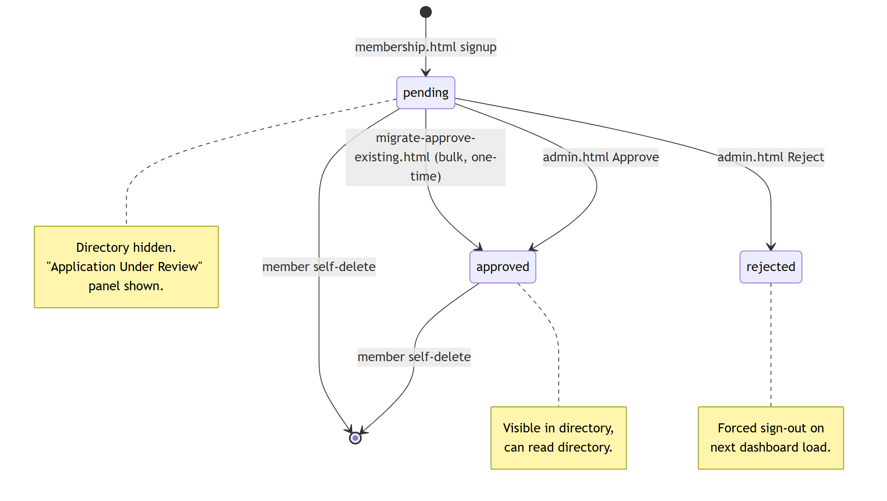
Figure 2 — Membership application lifecycle

6.2 helpRequests
Written unauthenticated by the four forms on help.html. Fields are collected generically (formData.forEach), so the shape varies by requestType.
requestType | Fields beyond name, email
Education | program, statement
Medical | urgency (Immediate / Within 1 month / General), summary
Employment | situation, field, experience, details
Other Services | service, details

Plus submittedAt (serverTimestamp) and status: 'pending'.
The requestType is derived from the form's DOM index (requestTypes[index]). Reordering the forms in help.html silently mislabels every subsequent submission.

6.3 contactMessages
Written unauthenticated by contact.html: name, email, subject, message, submittedAt, status: 'unread'.

6.4 members
Has security rules but no reader or writer anywhere in public/. It is a leftover from the legacy project (whose export script reads a members collection). Either migrate it into membershipApplications or remove its rules.

6.5 Composite indexes
firestore.indexes.json declares exactly two, both on membershipApplications:
Fields | Required by
status ASC, submittedAt DESC | admin.html → where('status','==','pending').orderBy('submittedAt','desc')
status ASC, adminNotified ASC | checkVerifiedUsers and checkEmailVerification

Single-field indexes (automatic) cover the remaining queries: userId ==, status == 'approved', and email ==.

7. Security Design

7.1 Trust boundaries
Boundary | Enforced by | Strength
Anonymous → Firestore write | firestore.rules (allow create: if true for help/contact) | Intentionally open; unrated and unthrottled (§15).
Member → own data | firestore.rules (request.auth.uid == resource.data.userId) | Sound for identity, but unrestricted on fields (§15).
Member → directory | status == 'approved' filter in the client query | Client-side only; the rules do not express it (§15).
Member → admin UI | ADMIN_EMAILS array in admin.html | Client-side only — cosmetic. The real gate is the rules' isAdmin().
Admin → other members' data | isAdmin() in firestore.rules (email allowlist read from the auth token) | Server-enforced. Correct mechanism.
Caller → Cloud Function | Per-function invoker setting + in-function request.auth check | Inconsistent; two functions are fully public (§15).
Function → Gmail | Secret Manager | Correct.

7.2 Admin identity
Admin status is an email allowlist duplicated in two places:
Location | Count | Comparison
firestore.rules → isAdmin() | 13 | request.auth.token.email in [...] — exact, case-sensitive
public/admin.html → ADMIN_EMAILS | 14 | ADMIN_EMAILS.includes(user.email.toLowerCase())

sivasrees@gmail.com appears only in admin.html. There are no custom claims and no roles collection; adding or removing an admin requires editing and redeploying both the rules and the HTML.

7.3 Rules summary (firestore.rules, rules_version = '2')
Collection | create | read | update | delete
membershipApplications | authed, uid == resource.userId | own doc or admin | own doc or admin | own doc only
members | authed, own userId | any authed user | own or admin | own only
helpRequests | anyone | any authed user | any authed user | any authed user
contactMessages | anyone | any authed user | any authed user | any authed user

The rules' own comments claim help requests and contact messages are admin-only for read; the rules as written grant them to every authenticated member. See §15.

7.4 Authentication controls
- Provider: Email/Password only.
- Email verification: required to pass the dashboard.html gate, and required by the functions before an admin is notified. Sent with Firebase's default template via the client-side sendEmailVerification().
- Password reset: sendPasswordResetEmail, triggered from the login form.
- Re-authentication: account deletion surfaces auth/requires-recent-login and asks the user to sign in again.
- Geo restriction: client-side ipapi.co lookup limiting to US/CA — advisory only.
- MFA: not implemented, despite MFA_IMPLEMENTATION.md (§15).

8. Backend Design — Cloud Functions
All five deployed functions live in functions/src/index.ts, share one module-scope nodemailer transporter, and read GMAIL_APP_PASSWORD from Secret Manager with GMAIL_USER falling back to vokkaligasangam@gmail.com.
Function | Type | Trigger | Region / invoker | Auth check | What it does
sendApprovalEmail | Callable | admin.html after an approval write | us-central1, invoker: "public" | Commented out | Emails the member "your membership has been approved".
sendApprovalEmailOnStatusChange | Firestore | onDocumentUpdated membershipApplications/{docId} | default | n/a (trusted) | Detects the status transition !approved → approved and sends the same approval email.
notifyAdminNewApplication | Firestore | onDocumentCreated membershipApplications/{docId} | default | n/a (trusted) | Emails the admin inbox about a new application — only if Auth already reports the email verified.
checkEmailVerification | Callable | dashboard.html on load; manual-notify.html | default | request.auth.uid required | Checks the caller's verification flag, finds their pending un-notified application, sends the admin alert, sets adminNotified.
getUserVerificationStatus | Callable | admin.html, once per pending row | us-central1, invoker: "public" | None | Returns { emailVerified, email } for an arbitrary userId.
checkVerifiedUsers | Scheduled | every 5 minutes, America/Los_Angeles | us-central1 | n/a | The reconciliation loop: scans status == 'pending' && adminNotified == false, checks each user's Auth verification flag, sends and marks.

8.1 Why three paths send the same admin email
Because the member's email verification happens outside the app (they click a link in their inbox), there is no reliable in-app moment to detect it:
- notifyAdminNewApplication fires on document creation — at which point the email is essentially never verified yet, so this path almost always returns early. It is effectively a no-op retained for the edge case of a pre-verified account.
- checkEmailVerification fires when the member next loads the dashboard — fast, but only if they log in. The original production incident (documented in FIX_HASINI_GUIDE.md) was a member who verified but never logged in, so no admin was ever notified.
- checkVerifiedUsers is the fix: a 5-minute poll that needs no member action. This is the primary path in practice, bounding admin notification latency to roughly 5 minutes after verification.

8.2 Idempotency
All three paths guard on adminNotified and perform the send inside db.runTransaction, re-reading the document to re-check the flag before sending, then transaction.update(ref, { adminNotified: true }). This is what prevents duplicate alerts when two paths race.
Two caveats are inherent to the design:
- The email send is an external side effect inside a transaction. If the transaction retries after sendMail has already succeeded, a duplicate email goes out.
- The queries filter adminNotified == false, so documents where the field is missing (created before the field was introduced) are invisible to every path. That was the root cause of the fix-hasini / debug-hasini incident, and those tools exist purely to set the flag explicitly.

9. End-to-End Flows

9.1 Registration → verification → admin notification
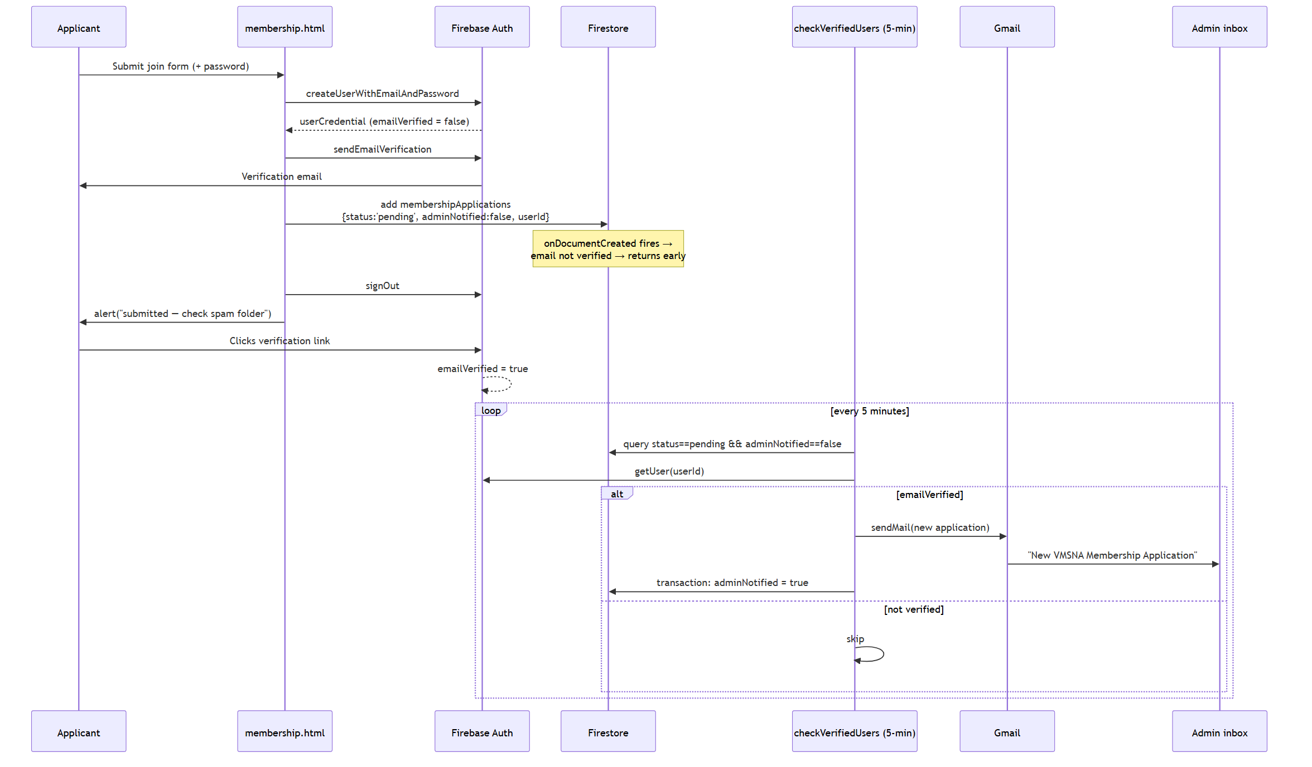
Figure 3 — Registration, verification and admin notification

9.2 Admin approval
- Admin loads admin.html; the client allowlist check runs, then the page queries status == 'pending' ordered by submittedAt desc.
- For each row the page calls getUserVerificationStatus(userId) to render a ✓ Verified / ⚠ Not Verified badge. This is N sequential callable invocations, awaited in a for loop — the page's dominant latency cost.
- Admin clicks Approve → confirm dialog → card fades → Firestore update { status: 'approved', approvedAt, approvedBy }.
- Two things then race to email the member: the explicit sendApprovalEmail callable from the page, and the sendApprovalEmailOnStatusChange Firestore trigger. Neither knows about the other, so an approved member can receive two identical approval emails. Unlike the admin-notification path, there is no idempotency flag here.
- Reject writes { status: 'rejected', rejectedAt, rejectedBy, rejectionReason } and sends no email at all — the member only learns on their next dashboard load, via an alert() and a forced sign-out.

9.3 Member dashboard load
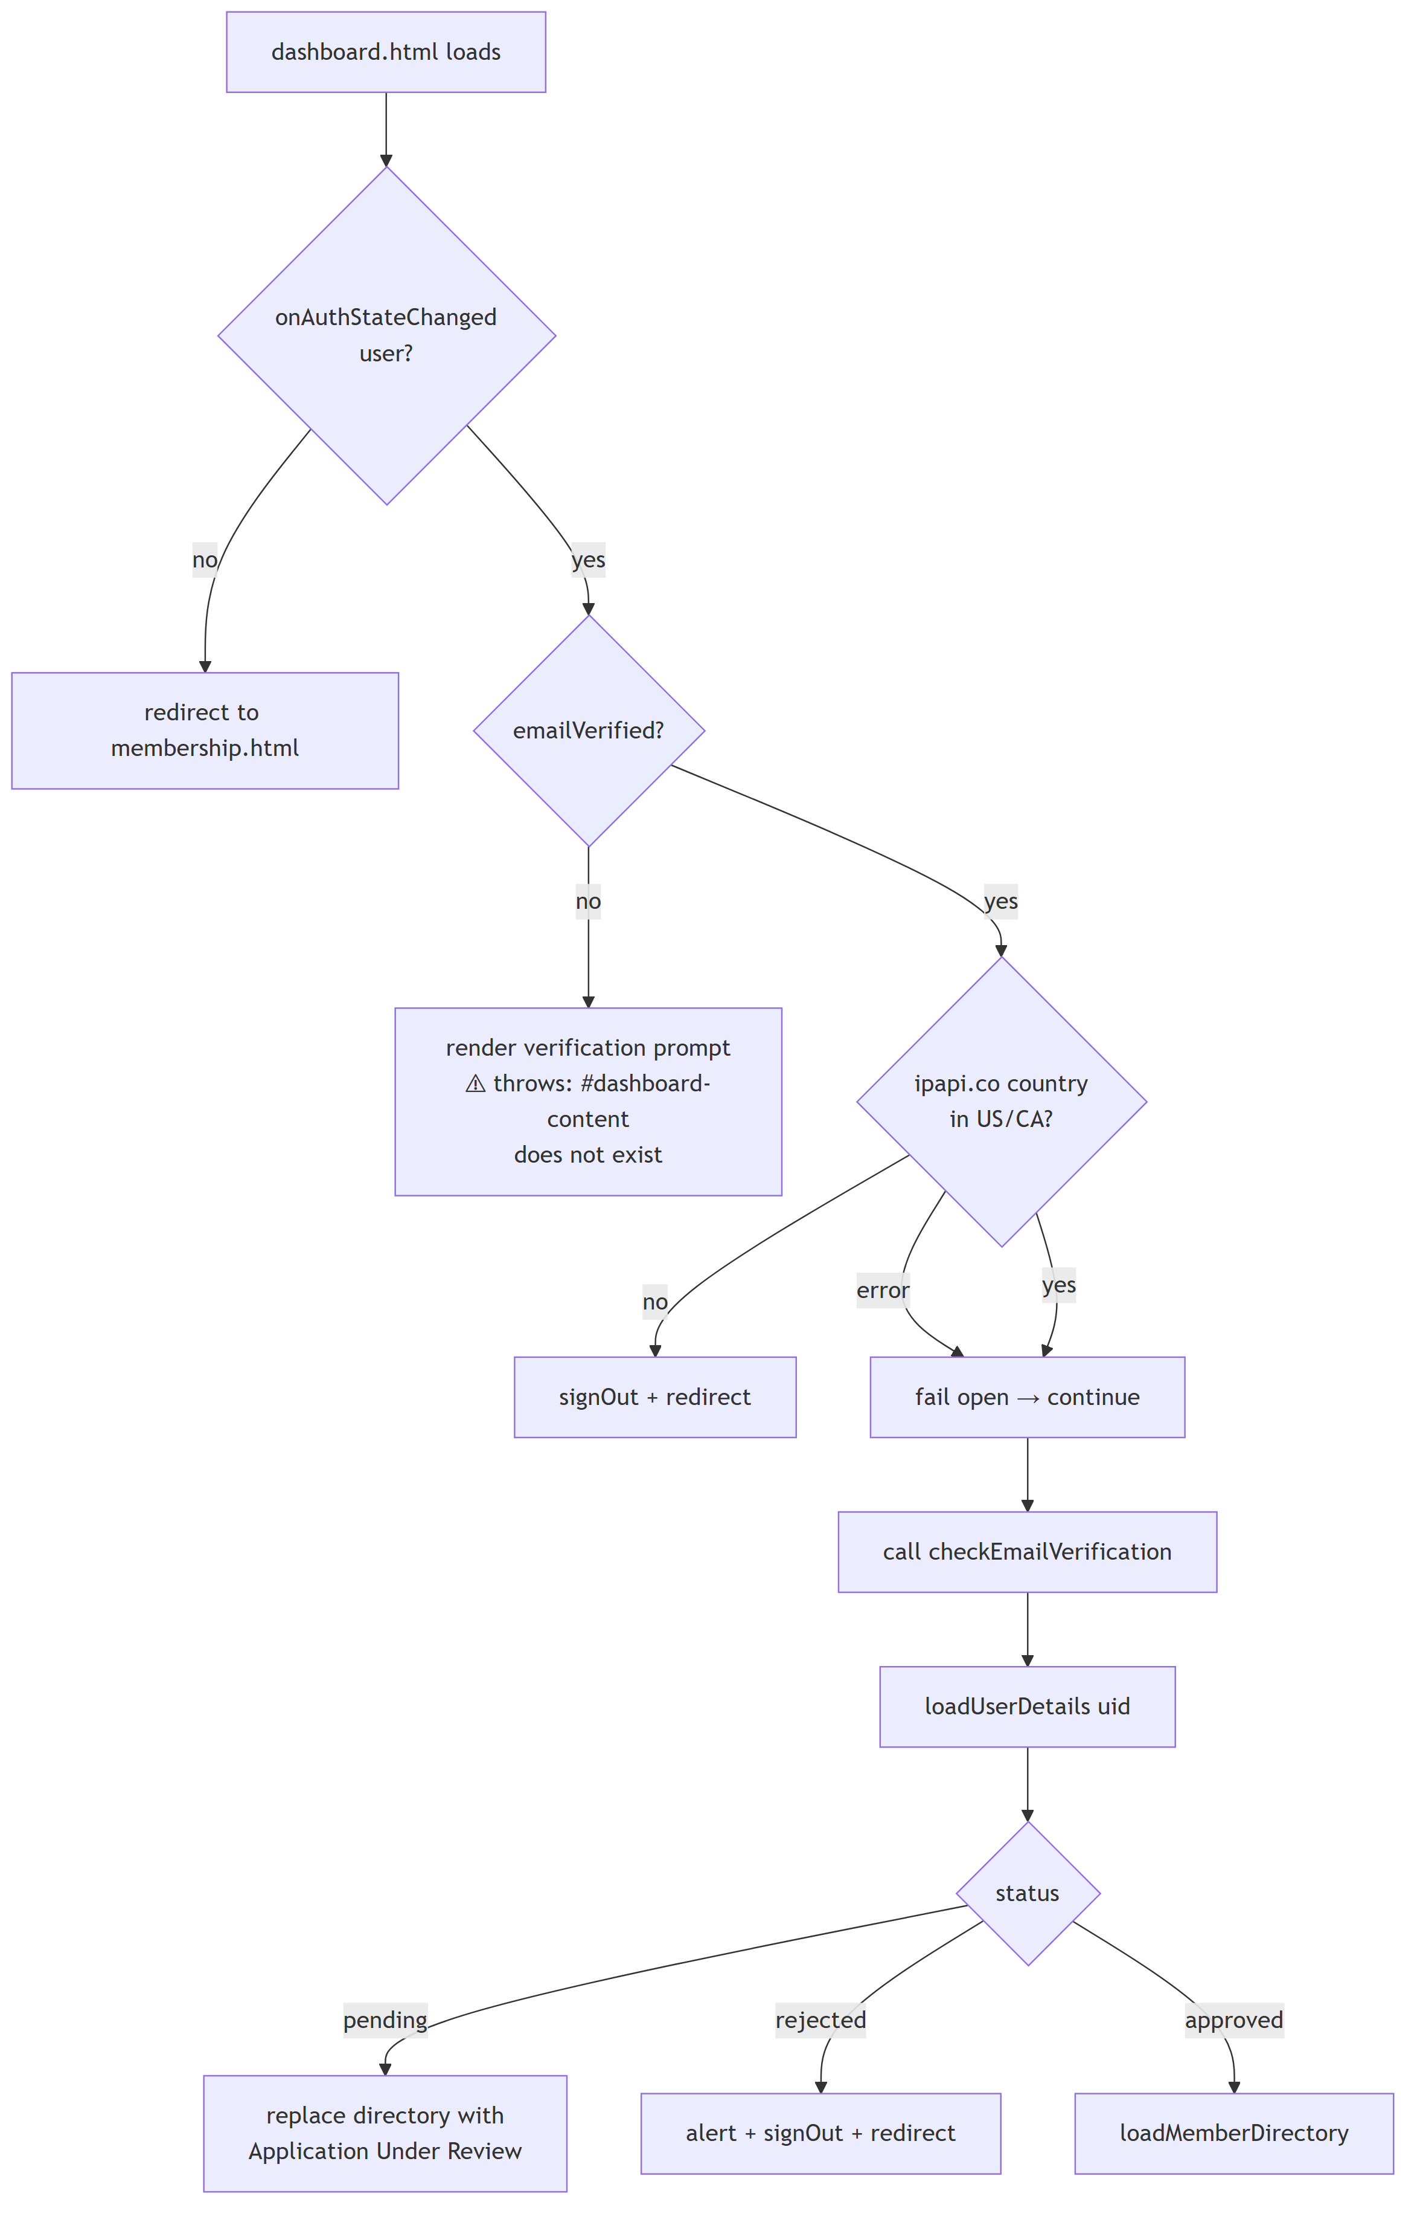
Figure 4 — Member dashboard load sequence

9.4 Member directory construction
loadMemberDirectory() in dashboard.html:
- Query all membershipApplications where status == 'approved'.
- De-duplicate by lowercased, trimmed email, keeping the document with the newest submittedAt — defensive handling of members who applied more than once.
- Synthesize spouse rows. If a member has a spouseEmail that is not itself a registered member email, a pseudo-member row is appended with id <docId>_spouse, mapping spouseName → name, nativePlaceSpouse → nativePlaceSelf, etc., inheriting the primary member's privacyLevel and address, plus a linkedToMember back-reference. This is how couples appear as two searchable people from one application.
- Sort by name (localeCompare).
- Render. Rows with privacyLevel === 'limited' show only name + state, with every other cell replaced by "Private". Rows with full show location, native place, profession, parsed profile links, and a mailto: + phone contact cell.
- Filtering is entirely in memory over the allMembers array, on input events, across name / state / profession / native place.

formatUrls() extracts URLs with /(https?:\/\/[^\s,]+|www\.[^\s,]+)/g, prefixes a bare www. with https://, and renders them as Link 1, Link 2, … opening in a new tab.

9.5 Profile edit and account deletion
- Edit: the page caches window.currentUserDocId / window.currentUserData from the initial load, pre-populates the edit form, and on submit writes a whole-object update() to that doc. email is deliberately excluded (it is the directory's identity key and the verified Auth identifier). It then reloads both the profile and the directory.
- Delete: double confirmation (confirm + typing DELETE), then delete the Firestore document, then user.delete() on the Auth record, then redirect home. Order matters: if user.delete() fails (e.g. requires-recent-login), the Firestore document is already gone while the Auth account survives — leaving an orphaned login with no profile.

9.6 Unauthenticated help / contact submission
help.html attaches one submit handler per form.req, derives requestType from the form's index, collects all fields generically, and writes to helpRequests. contact.html writes a fixed four-field shape to contactMessages with button disable/restore around the await. Neither sends any notification — there is no email, no Cloud Function trigger, and no admin UI for either collection. Submissions are visible only in the Firebase console.

10. Configuration Reference

10.1 firebase.json
Block | Value
firestore.database | (default)
firestore.location | us-west1
firestore.rules | firestore.rules
firestore.indexes | firestore.indexes.json
functions.source | functions
functions.runtime | nodejs20
hosting.site | vmsna
hosting.public | public
hosting.ignore | firebase.json, **/.*, **/node_modules/**

No database, dataconnect, storage, emulators, rewrites or headers blocks.

10.2 .firebaserc
default project : vmsna-e9bd0
hosting target : main → [vmsna]

10.3 Secrets and environment
Name | Mechanism | Used by
GMAIL_APP_PASSWORD | Secret Manager, declared per function | All 5 functions
GMAIL_USER | process.env, defaults to vokkaligasangam@gmail.com | Transporter
gmail.password | Legacy functions.config() | Dead functions/index.js only

10.4 Hardcoded values worth knowing
Value | Where
Admin notification inbox vokkaligasangam@gmail.com | 3 places in functions/src/index.ts, plus trigger-notification.js
Firebase web config (7 copies) | membership, dashboard, admin, help, contact, manual-notify, migrate-approve-existing (+ the two modular ops pages)
Admin allowlist (2 copies, divergent) | firestore.rules, admin.html
Dashboard link in emails https://vmsna.web.app/dashboard.html | Approval emails
Admin link in emails https://vmsna.web.app/admin.html | Notification emails
Support address info@vmsna.org | Approval email footers
Individual member emails | fix-hasini.html, debug-hasini.html, trigger-notification.js

Note the email templates link to vmsna.web.app while membership.html's verification redirect targets vmsna.org — the two domains are used inconsistently.

11. Build and Deploy
There is no frontend build. public/ is deployed as-is.
# Functions only (requires a TypeScript compile)
cd functions && npm install && npm run build # tsc → functions/lib
firebase deploy --only functions

# Hosting only
firebase deploy --only hosting

# Rules / indexes
firebase deploy --only firestore:rules
firebase deploy --only firestore:indexes

# Secret rotation
firebase functions:secrets:set GMAIL_APP_PASSWORD
firebase deploy --only functions # required: functions pin secret versions
Concern | Setting
TS target / module | es2017 / NodeNext, strict: true, noUnusedLocals, outDir: lib
Lint | ESLint 9 flat config (functions/eslint.config.mjs), TS-aware, ignores lib/
Tests | None. firebase-functions-test is a devDependency but no test files or test script exist.
CI/CD | None. No GitHub Actions, no firebase.json predeploy hooks. All deploys are manual.
Unused deps | express, genkit, genkit-cli, tsx are declared but never imported.

12. Observability
Signal | Mechanism | Gap
Function logs | firebase-functions/logger — logger.info on each send, logger.error on failure | Reasonably thorough; the scheduled run logs a per-cycle count.
Client logs | console.log / console.error throughout; admin.html dumps 7 fields of an email error | Dev-only; not collected anywhere.
User-facing errors | alert() / prompt() / confirm() exclusively | No toasts, no inline validation, no error boundary.
Email delivery | None | A sendMail failure is logged but never surfaced to an admin and never retried. Silent failure of the primary notification channel.
Metrics / alerting | None | No uptime check, no error-rate alert, no dashboard.
Analytics | measurementId present but SDK not loaded | No traffic data.

13. Non-functional Characteristics
Aspect | Current state
Scale | The directory does a full collection read of all approved members (~500 per APPROVAL_SYSTEM_SETUP.md) on every dashboard load, then filters client-side. Fine at hundreds; degrades at thousands.
Cost | Dominated by that full read per dashboard load, plus the 5-minute scheduler (~8,640 invocations/month) and N callables per admin page load. Comfortably inside free-tier limits at current size.
Latency | Admin notification ≤ ~5 min after verification. Admin panel load is O(N) sequential callables.
Availability | Fully dependent on Firebase + gstatic; no offline support, no service worker.
Accessibility | Only aria-label on the menu toggle. No skip links, no focus management, contrast unverified, tables lack captions/scope.
Browser support | Modern evergreen only (:has() selector used in dashboard.html, optional chaining, ES modules on two pages).
i18n | English only, lang="en", despite a stated mission of preserving Tamil Nadu Vokkaliga language.
SEO / social | No <meta name="description">, no Open Graph tags, no sitemap, no robots.txt.

14. Operational Runbooks

14.1 One-time migration (already executed)
migrate-approve-existing.html bulk-sets every pending application to approved / approvedBy: 'migration-script' in a single WriteBatch. It existed so that ~500 pre-existing members would not lose directory access when the approval gate shipped. It is idempotent in the sense that it only touches pending docs — which is exactly why it is now dangerous: re-running it silently approves every genuine pending applicant, bypassing review. Its only access check is "is anyone signed in".
Recommendation: delete this page from public/.

14.2 Incident tooling
fix-hasini.html, debug-hasini.html, manual-notify.html and trigger-notification.js were built for one incident: a member verified her email but never logged in, so no notification fired. debug-hasini.html prints the Firestore document plus a diagnosis of the adminNotified field; fix-hasini.html resets the flag so the scheduler picks it up.
Note that debug-hasini.html is titled and labelled "Hasini" but actually queries babejascorp28@gmail.com — it was copy-edited for a second case and the labels were never updated.
These four artifacts are now superseded by checkVerifiedUsers and should be removed; debug-hasini.html's diagnostic view is the only part worth generalising (into the admin panel, keyed on an email input).

14.3 Existing documentation
Doc | Content | Accuracy
APPROVAL_SYSTEM_SETUP.md | Pre-deployment checklist for the approval gate: migration, admin allowlist, Gmail SMTP | Accurate; references admin.html line numbers that have since shifted
AUTOMATIC_NOTIFICATION_SYSTEM.md | Design of the 5-minute scheduled notification | Accurate
FIREBASE_SETUP.md | Greenfield Firebase project setup | Generic; still says "VSNA" and shows placeholder config
GMAIL_PASSWORD_SETUP.md | Secret migration steps | Contains a live-looking Gmail app password in plaintext (§15)
FIX_HASINI_GUIDE.md | The incident runbook above | Historical
MFA_IMPLEMENTATION.md | Describes SMS-based MFA as implemented | Fiction — no MFA code exists anywhere

15. Known Issues and Risk Register
Ordered by severity. Every item was verified against the source.

Critical
# | Issue | Detail | Fix direction
C1 | sendApprovalEmail is an open email relay | invoker: "public" and the request.auth check is commented out with "temporarily disabled for testing". Anyone with the URL can send VMSNA-branded mail to any address with any display name, from the org's Gmail. Risks phishing-by-proxy and Gmail account suspension. | Restore the auth check, verify the caller is an admin, drop invoker: "public".
C2 | Gmail app password committed in plaintext | GMAIL_PASSWORD_SETUP.md contains the literal 16-character app password (redacted here: hlmz…tphq) and instructs the reader to revoke it. It remains in git history regardless. | Confirm revocation, redact that doc, rotate the secret, consider a history rewrite.
C3 | A pending member can self-approve | The rules allow a member to update their own membershipApplications doc with no field restrictions, including status, approvedBy and adminNotified. | Constrain updates to the member-editable field set via request.resource.data.diff(resource.data).affectedKeys().
C4 | getUserVerificationStatus leaks any user's email | Public callable, no auth check; given any UID it returns that user's email and verification state. UIDs are readable from any document the caller can read. | Require auth + admin.

High
# | Issue | Detail | Fix direction
H1 | The committed rules cannot serve the member directory | The dashboard queries where('status','==','approved'), but the read rule requires userId == auth.uid || isAdmin(). Firestore rejects a list query it cannot prove satisfies the rule, so this query fails for every non-admin. Either the deployed rules differ from the repo (a drift hazard) or the directory is admin-only in practice. | Add an explicit allow list path for approved docs and re-align the repo with production.
H2 | Welfare and contact data readable by every member | helpRequests and contactMessages grant read/update/delete to any authenticated user, while the comments claim admin-only. Medical and employment hardship disclosures are among the most sensitive data the org holds. | Change to isAdmin().
H3 | Stored XSS in the directory and admin panel | Member-supplied strings are interpolated into innerHTML unescaped in renderMembers() and createApplicationCard(). A profession containing a <script> / <img onerror> payload executes in every member's and admin's browser. | Escape on render, or build nodes with textContent.
H4 | Unauthenticated, unthrottled public writes | helpRequests and contactMessages allow create: if true with no App Check, no CAPTCHA and no rate limit. Trivially spammable, and each write costs money. | Enable App Check; add a reCAPTCHA gate.
H5 | Help and contact submissions notify nobody | Both write to Firestore and stop. No function, no email, no admin UI. Genuine medical-assistance requests can sit unseen indefinitely. | Add onDocumentCreated notification triggers and an admin view.

Medium
# | Issue
M1 | Duplicate approval emails. sendApprovalEmail (called by the page) and sendApprovalEmailOnStatusChange (Firestore trigger) both fire on one approval, with no shared idempotency flag. Drop the explicit call, or add an approvalEmailSent flag.
M2 | The verification prompt is broken. dashboard.html references #dashboard-content, which does not exist in the document. An unverified user hits a TypeError and sees a blank dashboard instead of the "verify your email" prompt and resend button.
M3 | migrate-approve-existing.html is live and near-unguarded. Any signed-in user can bulk-approve every pending application. Delete it.
M4 | Admin allowlists have drifted. sivasrees@gmail.com is in admin.html but not in the rules; the page loads and then every privileged read fails. Single-source it via custom claims.
M5 | Admin panel is O(N) sequential round-trips. One awaited callable per pending row. Return verification status in a single batch call.
M6 | approveApplication breaks on apostrophes. The button is built as onclick="approveApplication('${docId}','${data.email}','${data.name}')". A name like O'Brien breaks the handler — and is an injection vector (see H3). Attach listeners instead of inlining data.
M7 | Rejection is silent. No email is sent; the member discovers it via an alert() and a forced sign-out on next login.
M8 | Account deletion can orphan an Auth user. The Firestore doc is deleted before user.delete(); a requires-recent-login failure leaves a login with no profile. Reverse the order, or do it in a function.
M9 | requestType derived from DOM order. Reordering help.html's forms silently mislabels submissions. Use an explicit data-request-type attribute.
M10 | Service-account keys are not gitignored. trigger-notification.js requires ./vmsna-e9bd0-firebase-adminsdk-*.json; nothing in .gitignore prevents committing it. Add *firebase-adminsdk*.json.
M11 | Email sends inside Firestore transactions. A transaction retry after a successful sendMail produces a duplicate email. Send after the transaction commits, driven by the flag flip.

Low / hygiene
# | Issue
L1 | Geo-restriction via ipapi.co is client-side and fails open — it is not a security control and should not be described as one.
L2 | MFA_IMPLEMENTATION.md documents SMS 2FA that does not exist. Delete or implement.
L3 | functions/index.js is dead (main is lib/index.js) and would crash if loaded — it uses v1 functions.config(), removed in firebase-functions v7.
L4 | dataconnect/schema/schema.gql is unmodified music-app boilerplate (Artist/Album/Track/Playlist); dataconnect.yaml points at a Cloud SQL instance. Delete or implement.
L5 | database.rules.json is never deployed (no database block in firebase.json).
L6 | users.json is a broken 13-byte stub from a failed auth export.
L7 | The members collection has rules but no code.
L8 | Firebase config duplicated in 7+ pages; nav, footer and toggle script duplicated in all 16. Extract shared partials or a small include step.
L9 | Two SDK styles (compat vs modular) coexist.
L10 | measurementId present but no Analytics SDK loaded.
L11 | 404.html is the unbranded Firebase CLI default.
L12 | Unused function dependencies: express, genkit, genkit-cli, tsx.
L13 | Placeholder content shipped to production: about.html office bearers are "Name Placeholder"; donate.html and media.html links are #; donate.html shows the developer note "Replace links with Stripe/PayPal".
L14 | Domain inconsistency: emails link to vmsna.web.app, signup redirects to vmsna.org.
L15 | No tests, no CI, no emulator config. firebase-functions-test is installed but unused.
L16 | No <meta name="description">, Open Graph tags, sitemap or robots.txt.
L17 | Mojibake in contact.html — the WhatsApp emoji is a corrupted byte sequence.
L18 | Incident tooling (fix-hasini, debug-hasini, manual-notify) is publicly reachable and hardcodes individual members' email addresses.

16. Recommended Sequence
Roughly ordered by risk reduced ÷ effort:
- Close C1 and C4 — restore the auth checks on both callables and remove invoker: "public". Small diff, removes the two worst exposures.
- Rotate the Gmail secret (C2) and redact GMAIL_PASSWORD_SETUP.md.
- Harden the rules (C3, H1, H2) — field-restricted member updates, an explicit approved-directory list rule, admin-only welfare/contact reads. Verify with the emulator before deploying.
- Delete the live footguns (M3, L18) — migrate-approve-existing.html and the three incident pages.
- Escape rendered member data (H3, M6).
- Notify on welfare/contact submissions (H5) and enable App Check (H4).
- Fix the verification prompt (M2) and de-duplicate the approval email (M1).
- Single-source admin identity onto Firebase custom claims (M4) — this removes the drift class of bug permanently.
- Prune the dead weight (L3–L7, L12) and extract shared page partials (L8).
- Add an emulator config and a rules test suite, so items 3 and 8 stay fixed.

Appendix A — File Map
tvsna-website-dark-hero-fullsite/
├── firebase.json Hosting + Firestore + Functions config
├── .firebaserc Project vmsna-e9bd0, hosting target main→vmsna
├── firestore.rules Authorization model (4 collections, isAdmin allowlist)
├── firestore.indexes.json 2 composite indexes on membershipApplications
├── database.rules.json RTDB lockdown — NOT deployed
├── dataconnect/ Unused music-app scaffold
│ ├── dataconnect.yaml
│ └── schema/schema.gql
├── functions/
│ ├── src/index.ts * The deployed backend: 5 functions
│ ├── index.js Dead v1 legacy function
│ ├── package.json Node 20, main=lib/index.js
│ ├── tsconfig.json / tsconfig.dev.json
│ └── eslint.config.mjs / .eslintrc.js
├── public/ * Hosting root
│ ├── index.html about.html chapters.html events.html
│ ├── media.html donate.html 404.html
│ ├── help.html 4 unauthenticated welfare forms → helpRequests
│ ├── contact.html → contactMessages
│ ├── membership.html Registration + login
│ ├── dashboard.html * Largest file: profile + directory
│ ├── admin.html Approval queue
│ ├── migrate-approve-existing.html One-time bulk approval (remove)
│ ├── fix-hasini.html Incident tool (remove)
│ ├── debug-hasini.html Incident tool (remove)
│ ├── manual-notify.html Incident tool (remove)
│ ├── responsive.css Mobile layer
│ └── assets/
│ ├── css/style.css Base theme + design tokens
│ └── img/ Logo variants, temple, cardamom hero images
├── scripts/make.responsive.js Codemod: viewport + responsive.css + menu toggle
├── mobile.patch Historical diff
├── export-firestore.js Legacy-project export (Admin SDK)
├── browser-export.js Legacy-project export (browser console)
├── trigger-notification.js Manual notification for one hardcoded email
├── users.json Broken 13-byte stub
└── *.md 6 setup/runbook docs + this document

Appendix B — External Endpoints
Endpoint | Direction | Purpose
www.gstatic.com/firebasejs/10.7.1/* | outbound, browser | Firebase SDK delivery
ipapi.co/json/ | outbound, browser | Country lookup (fails open)
smtp.gmail.com (via nodemailer service: "gmail") | outbound, functions | All transactional email
firestore.googleapis.com | outbound, browser + functions | Data plane
identitytoolkit.googleapis.com | outbound, browser | Auth
us-central1-vmsna-e9bd0.cloudfunctions.net | outbound, browser | Callable functions
facebook.com/groups/tnvokkaligagowdasinusa | link | Community
chat.whatsapp.com/JwIIRMDXq0NALtyJd9Cwe7 | link | Community

Appendix C — Glossary
Term | Meaning
VMSNA | Vokkaliga Mahajana Sangam North America
TN Vokkaliga | Tamil Nadu Vokkaliga (also Gowda) — the community the org serves
Application | A membershipApplications document; both the signup record and the living member profile
adminNotified | Idempotency flag preventing duplicate admin alerts
privacyLevel | full or limited — how much of a member's profile the directory reveals
Chapter | One of six regional groupings (East/NE, Southeast, Midwest, West, South, Canada)

