Zillow Capstone Project 1: Milestone Report

**Project Summary**

Zillow, one of the largest real estate informational website. One of its most highly sought after service is providing real estate valuations for potential home buyers and sellers. These valuations are often the only means of price comparison of many consumers; often times preceding the importance of traditional real estate valuations. According to Zillow, their real valuations, called Zestimates have been as accurate to be within 5% of the actual transaction pricing. This is a considerable seeing that their initial valuations produced a 14% prediction error. Even with a 5% error rate, this could mean a fairly large variance from the actual sales price of home. For a home whose initial valuation estimate of $300,000, this could mean a difference of the selling price of almost $15,000. These inaccuracies of 5% have actually lead to lawsuits brought upon buyers and sellers of homes. In both cases, the alleged parties alleged that the inaccurate price predictions have caused economic harm to the respective parties. It is of strategic importance for Zillow to constantly try to improve their prediction algorithms not only for the sake of reliability and trust among their user base but to also avoid potentially expensive lawsuits.

**Data Limitations**

The data provided by Zillow for their competitions seem to have all features related to the physicality of the home. Some of these features are of course vital to the actual pricing of the home. The difficulty in in predicting the target features comes from trying to find the sources of volatility and whether that volatility is direction specific, i.e. over valuations versus under valuations.

The biggest limitation to the current dataset relates to real estate’s “golden rule” of “location, location, location.” Though the latitude and longitude coordinates are provided, we can only make limited location valuation assessment; whether a clump of homes have better or worse log error rates. The assessment of a property’s location value will require other features such as quality of schools, crime rate, parks, etc.

The challenge summary mention an error of 5%. After running our machine learning algorithms, we may or may not be able to achieve this 5% in this stage of the data challenge. There is mention of a second round where presumably these other features relating to location is released.

**Section I Data Exploration**  
  
The properties dataset consists of 2985217 samples indexed by parcelid. The index provides little information since it is describe in the data dictionary as “Unique identifier for parcels (lots)”; with no reference to how the unique identifier was determined. The training dataset consist of 90811 also indexed by parceled. This dataset contains our response variable, the logError estimates, that we are trying to minimize.

Key Highlights from the Data exploration part:

* There are 57 distinct features (not including parcelid) in the properties dataset and 2 distinct features in the training data set. Since the total number of combined features is still relatively small, we do not need to worry about false positive created by the curse of dimensionality.
* 53 of the features are float 64, 5 are object, 1 date/time and 1 integer 64. We may have to encode the 5 object features since most ML algorithms cannot correctly process these features. The ways of encoding and the difference among them will be discussed later on.
* There are many missing values in the dataset. Some features have 99% of their values missing. This fact shows that Zillow’s data may not be as highly processed and friendly to use as most other Zillow competitions.
* The current strategy to deal with the missing values is to average the values that are currently available and substitute them into the missing fields, imputing the values. Though this solution holds for most of the values missing in the features, certain features can not take advantage of this strategy. These features often have values that are descriptive in nature and can not be mathematically averaged.
* Some of the float 64 features are really categorical. Features such as Architectural type and Air conditioning type are really labels of categories. We will need to process these feature correctly in order for the Machine Learning algorithms to work.
* The target feature has been preemptively converted to the log normal of the error between the actual selling price and the Zillow estimate of the selling price (Zestimate)
* The target feature is normal distributed but also has some outlier values.
* Some of the features contain extremely outliers. Coincidently, many of these features which have these extremely outliers are correlated. This correlation makes perfect sense since some of the features are in essences physical components of the others. For example, increase the number of bedroom and bathrooms automatically means you increase the square footage and cost of the home. If you an extreme number of either of these features, this will in turn create outlier values for the latter features. We correlation matrix shows all the related features. Unfortunately, this will mean that we have multicollinearity in our dataset. This is lessen the predictive power of the linear

**Evaluation Method**

Since this projects serves as the first major capstone, we will used Root Mean Square error as a means of evaluating the different models. As are optimizing for model performance, we will not focus so much on model interpretability. Thus we did not emphasize on various Feature Selection techniques such as the Filter Method, Wrapper Method or Embedded method. We instead put our emphasis on Feature Extraction techniques; Principal Component Analysis.

**Section II Feature Selection**

***Correlation Matrix***

From the result of the correlation matrix below, we see that the “regionzip” had the highest correlation with the target feature. We also noticed that “calculated finished square feet ”and finished square feet12” also made it to the top ten correlated features. Unfortunately, those two features are also correlated with each other. This makes intuitive sense and therefore one of the variable will need to be eliminated for our final model. The R –squared of running only those significant features produced using the Ordinary Least Squares and Correlation matrix produced a model with an R squared of less than 1%. Though we expected a larger R –square due to the fact that the dataset did not have many important feature that would be normally added into a model for predicting home prices, a value of less than 1% is still surprising low. Hopefully, we will produce a better model using different methods of feature selection as well as running machine learning algorithm such as Neural Network.

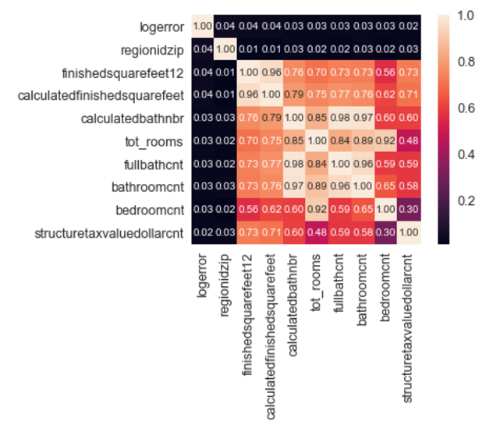

***OLS Regressions***

Even though we are aware that the features were not independent, we ran Ordinary Least Square regression with the target feature just to get a baseline of which features were important. There were 10 categorical variables that were statistically significant with a p-value less than 0.05 and 8 continuous variable with 8 statistically significant variables.

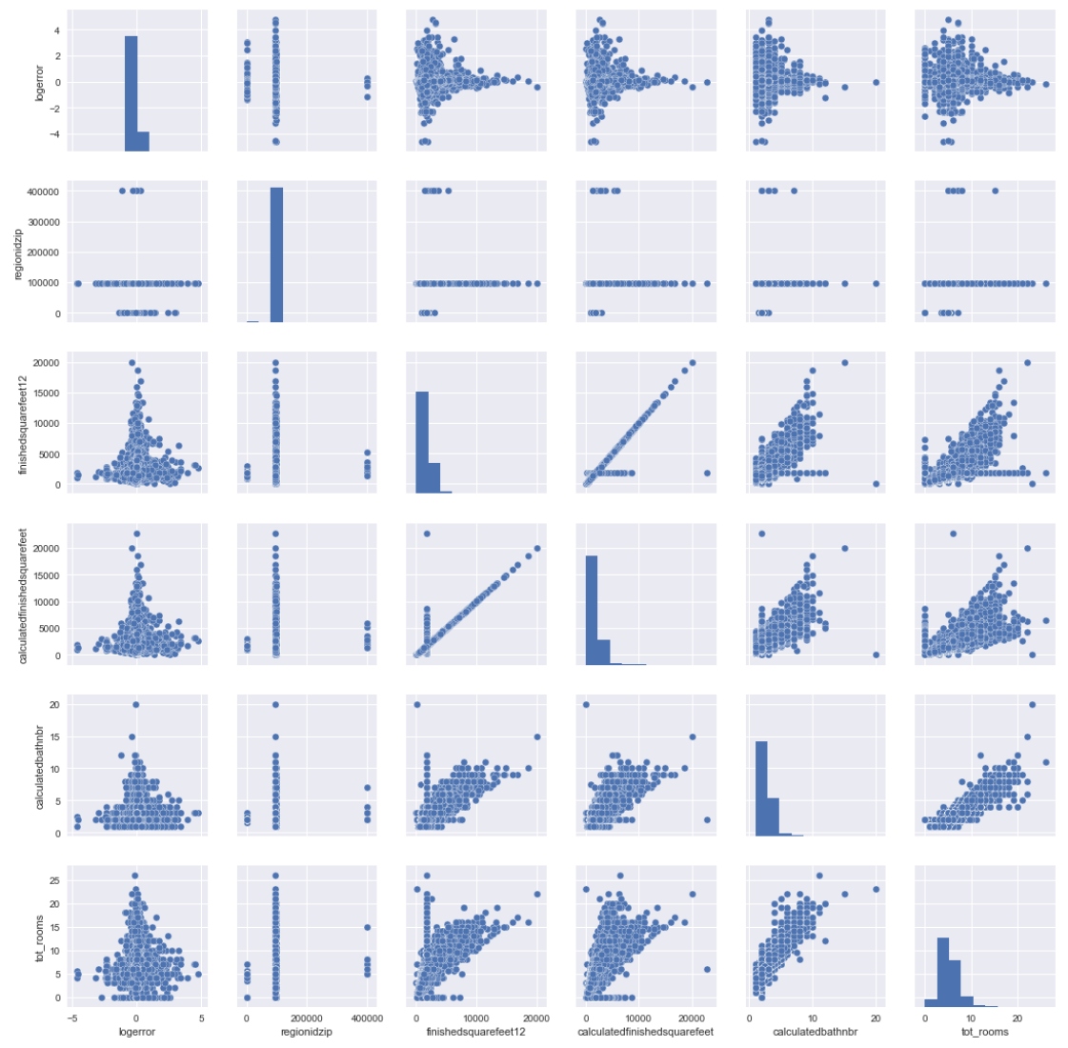

***Feature Selection Results***

When we ran Ordinary Least squares independently on all the features we saw that there were a handful of features that seem to be statistically significant to the model. However, when we took the features most correlated to our response variables we produced a model whose R-squared was less than 1%. Since we are more focus on producing a model that has the most accuracy prediction, we are not as worried about the interpretability of our model.

**Section III Feature Extraction and Regression**

We originally planned on doing Feature Extraction using Principal Component Analysis (PCA), Linear Discriminant Analysis and Kernel Principal Component Analysis. Even after setting up a desktop to run computations using the GPU, the desktop was not able to handle the computational needs of the later two feature extraction techniques and we were left to run just PCA on our model.

***Principal Component Analysis***

Before using the various regression models, we had to do use a feature extraction technique due to the limited computer power available. After creating dummy variables for our categorical features, we were left with a dataset with over 3000 features. Unlike Feature selections techniques, we will not be able to interpret the features extracted. We will leverage using the features extracted using PCA and feed it into our regression models. We will vary the number of Principal components needed; using 10, 20, and 50 respectively. We will then feed these number of component into our various regression models to see if choosing a number of principal component as any significant effect on the model performance.

***Multiple Linear Regression***

We use the multiple linear regression as our baseline model to compare the other regression models. Ideally, we would like to feed our entire list of features into our multiple regression model, but due to computational constraints we will only feed it the principal components we selected from earlier.

***Support Vector Regression***

We will use a Support Vector regression to check for non-linear models. Before we can use our Support Vector Regression we have to make sure our features are all scaled. Some regression classes include a feature scaling algorithm, like the multiple regression above, but our Support Vector Regression does not. We had to fit transform both the feature and response variables before we produce our predictions. For our Support Vector Regression, we chose a Gaussian kernel. For our Support Vector Regression, we chose a Gaussian kernel. If we were to use the linear kernel, our results would be similar to a multiple linear regression.

***Decision Tree Regression***

Using another non linear regression on the dataset. The Decision tree regression to the one use for classification in that it uses entropy as a metric of determining whether certain features provide added information to the model. The Decision tree builds regression model by breaking down a dataset into smaller and smaller subsets while at the same time an associated decision tree is incrementally developed. The overall structure of a decision tree includes a decision node and a leaf node. The decision has two or more branches that each represent the value of the feature tested while the leaf node represents the decision target. Decision trees can handle both numerical and categorical data.

***Random Forest Regressions***

Similar to the Decision Tree, the first step of a Random forest is to first find the feature that gives the most information gain when splitting on a given value of that feature. The second step is to find the next feature that gives the most information gain. Unlike a Decision tree that continuously add branches by adding features, a Random forest will randomly choose a feature and start another tree with a different combinations of features to start the tree. This will help counter the tendency to overfitting.

**Section IV Artificial Neural Network**

We were able to have access to a computer that had an Nvidia Graphics GeForce 770 graphics card. Even though we can access the GPU to run the neural network, we will standard scale the features variables to help run the computations. For our Neural Network, we ran it with two hidden layers, with 6 nodes in each layer. We chose a batch size of 10 and an epoch of 50. We would have normally chosen a epoch or 100, but we wanted to optimal solution with computational constraints. We ran this Neural Network multiple times. The first we included our entire feature set into the neural network. Later we first ran principal component analysis and then used those components as input features/nodes for our artificial neural network. To minimize the problem of overfitting we included a 10% drop out between each hidden layer.

**Section V XgBoost**

XgBoost is one of the most popular model in machine learning. It is also the most powerful implementation of gradient boosting. One of the major advantages of Xgboost besides having high performance and fast execution speed, you can keep the interpretation of the original problem. This also means you do not need to do feature scaling. We will still do a train and test split to check our model. Even though it is even better to do a K-fold cross validation, we are restricted by the our computational power of our desktop.

**Section III Results**

|  |  |  |  |  |  |  |
| --- | --- | --- | --- | --- | --- | --- |
| **Section II Feature Selection (RMSE)** | |  |  |  |  |  |
| Baseline: |  |  |  |  |  |  |
| *Multiple Linear Regression* |  |  |  |  |  |  |
|  | **PCA ( n= 10)** | | **PCA ( n= 20)** | | **PCA ( n= 50)** | |
| **Section III Regressions** | **Train/Test** | **K-Fold** | **Train/Test** | **K-Fold** | **Train/Test** | **K-Fold** |
| *\*Multiple Linear Regression* | 0.07618 | 0.07619 | 0.07615 | 0.07619 | 0.07612 | 0.07619 |
| *Support Vector Regression* | 0.99868 | 1.00591 | 0.99688 | 1.00698 | 0.99686 | 1.00627 |
| *Decision Tree Regression* | 0.11113 | 0.11198 | 0.11188 | 0.11371 | 0.11284 | 0.11406 |
| *Random Forest Regressions* | 0.08066 | 0.08234 | 0.08058 | 0.08266 | 0.08058 | 0.08308 |
|  |  |  |  |  |  |  |
| **Section IV Deep Learning** | **All** | **PCA ( n= 10)** | **PCA ( n= 20)** | **PCA ( n= 50)** |  |  |
| *Artificial Neural Network* | 0.07071 | 0.07248 | 0.07241 | 0.07252 |  |  |
| *\*Train/Test split only* |  |  |  |  |  |  |
| **Section V Gradient Boost** | **All** |  |  |  |  |  |
| *XgBoost* | 0.08884 |  |  |  |  |  |
| *\*Train/Test split only* |  |  |  |  |  |  |

***Results Summary***

From the results above, we see that the Artificial Neural Network performed the best out of all the algorithms. Since were able to use the GPU to run the Neural Network, we were able use our entire feature set in our algorithm. Unfortunately, the regression algorithms utilizes the less powerful CPU to process the data and as result we could not run our models with all the features without running into “memory errors.” For a better comparison we ran all the algorithms after we did a Principal Component Analysis; varying the number of principal components from 10 to 50. After running the models through this procedure we see that Neural Networks produced the lowest root mean square error. The second best result came from a Multivariate Linear Regression. This could mean that the model is more linear than non-linear.

**Section IV Conclusions**

The response variable is the log of the errors between the actual selling price and the estimated selling price of the home. This is different than the more traditional model that predicts the price of a home and compares it to the actually selling price. Under this model assumption, variables such as size of the home and number of bedrooms have a significant correlation with the sales price. Since we are dealing with the log of the errors, the question now becomes which variable, size of home or number of bedrooms, makes our guess more accurate. This log error model has no natural intuition. As such we must treat each feature provided as potentially important model feature.

Another questionable concern about our result is the fact that the Root Mean Square Error is an order of magnitude higher than the mean log errors. We can account for this discrepancy since the root mean square error will cumulatively add both the positive and negative values together while the mean of log errors would have the positive and negative values negating each other, thereby reducing the magnitude.

We were not surprised that a deep learning model produced the best result. We were a little surprised that a simple multivariate linear regression produced the second best result.

***Improving the model***

The simplest way to improve our model is to run the algorithms on more powerful computers. This would improve the results of our Artificial Neural Network since we could utilize Grid Search to tune our Hyper Parameters. We could also increase the batch size, number of hidden layers, number of nodes in each hidden layer as well as the number of epochs ran. A more powerful computer would also allow to try other feature extraction algorithms such as Linear Discriminant Analysis and Kernel PCA. Even though the results may be similar, it helps to further verify the potency of the models.

For the first round of the competition, Zillow provided a sample of their full dataset. We can assume more features would be provided in the second round. Common real estate related variables such as average household income, quality of schools and crime rate were not included in the first dataset. These variables should improve our current models and reduce our root mean square error of our predictions even further

***Alternative Strategies***

One alternative strategy for this project could be to take the absolute value of the log error as a new response variable. Though this method helps simplify things by focusing on just the magnitude of the errors, it would probably not increase our prediction accuracy in the actual use case. We could narrow the absolute error rate, but because we do not know the direction of the error, positive or negative, we could make our predictions twice as bad if we had the incorrect sign.

We could have also spent more time engineering different features. For this project we created two new features, “age of home” and “total number of rooms.” These new features probably did contribute to the accuracy of the model, but since the baseline model including both new features, we will not be able to detect the importance of adding these new features.