Key Discussion Points and Decisions
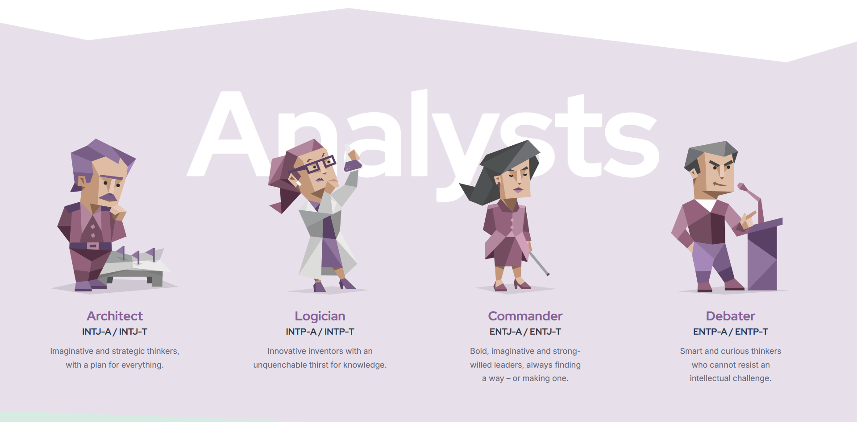
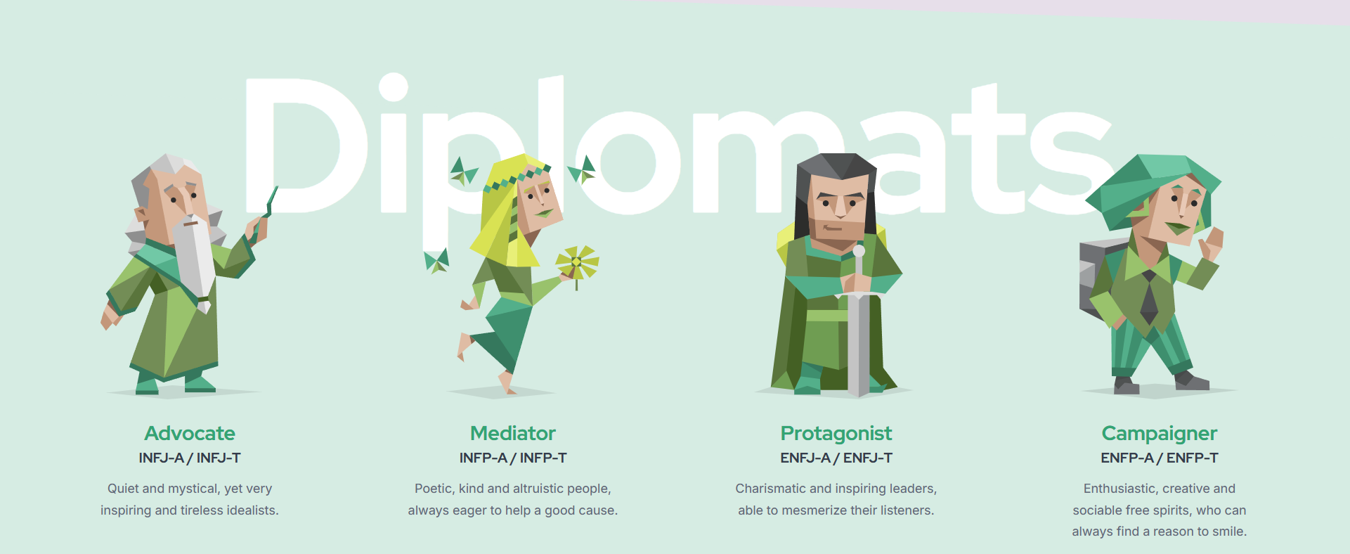
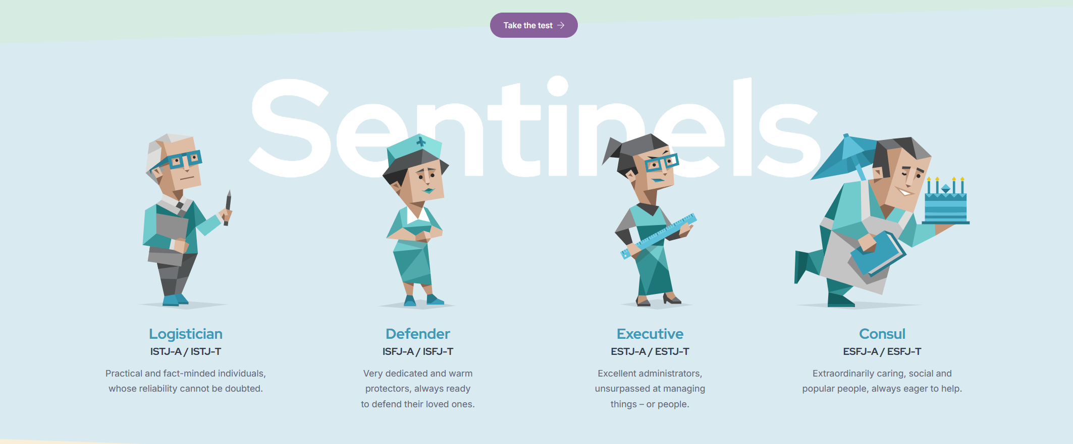
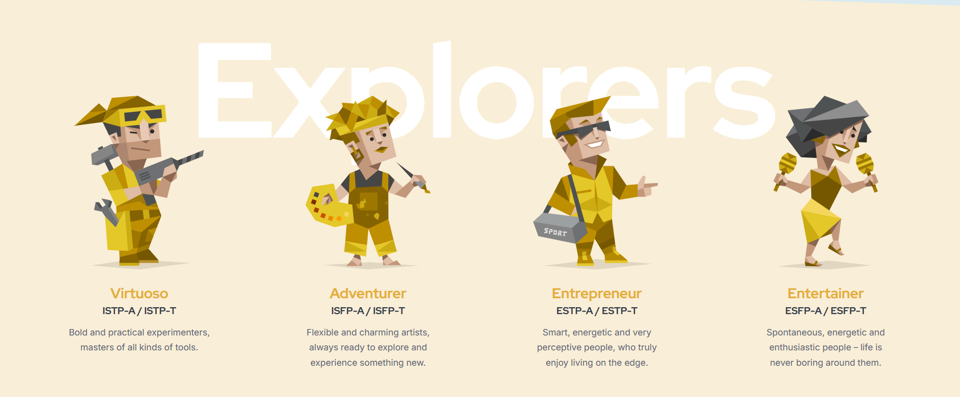
Myer Briggs Archetypes

- 8-16 User Archetypes like in Briggs Myer’s test
- ~ 20 questions, we can add more later
4 base metrics (example taken from Briggs Myer):
Extraversion (E) vs. Introversion (I): Where you direct and receive your energy. Sensing (S) vs. Intuition (N): How you take in and process information. Thinking (T) vs. Feeling (F): How you make choices and conclusions. Judging (J) vs. Perceiving (P): How you deal with the outer world.

Onboarding and Personality System
- Initial ~20 question during user login to help understand the user’s MBTI spectrum (E/I, S/N, T/F, J/P).
- Archetype and 12 labours mapping. Quiz results assign the user one of 12 Archetypes linked directly to one of the 12 Labors of Heracles.
- Align to the user’s goal. For example, do they want to be a “productive introvert” or become an “extrovert”?
- FOCUS ON ONLY E/I FOR PROTOTYPE

Core Progression Loop
Users will be given a progression loop to follow:
- Story / main questline, which should be created based on the user’s onboarding quiz.
- Challenges (please someone clarify what this means better).
- Daily Engagement Cap: Users receive 1 daily quest to prevent burnout and encourage habitual return.
TERMINOLIGY
- Quests: Full Heracles narrative arc, challenge, and reflection
- Dailies: Global daily quests shared by MBTI type?
- Tasks: Daily micro actions that contribute to the full story/ labour of heracles.
It was either dailies or task completion that contributed to a player’s login streak
FEATURES
Streaks, badges, friend progress feeds, and a Radar Chart visualizer to track development and personality traits over time
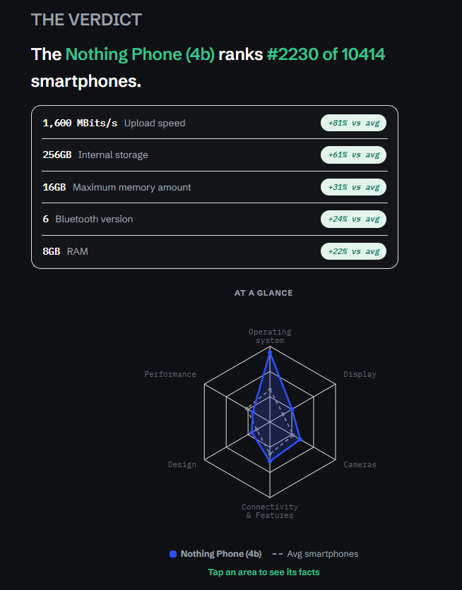

AI personalisation
Ai will personalise you

System Architecture
Frontend: JavaFX, low-fidelity and high-fidelity concepts
Backend: Java, JDBC, SQLite, possibly yaml

Miscellaneous Discussion
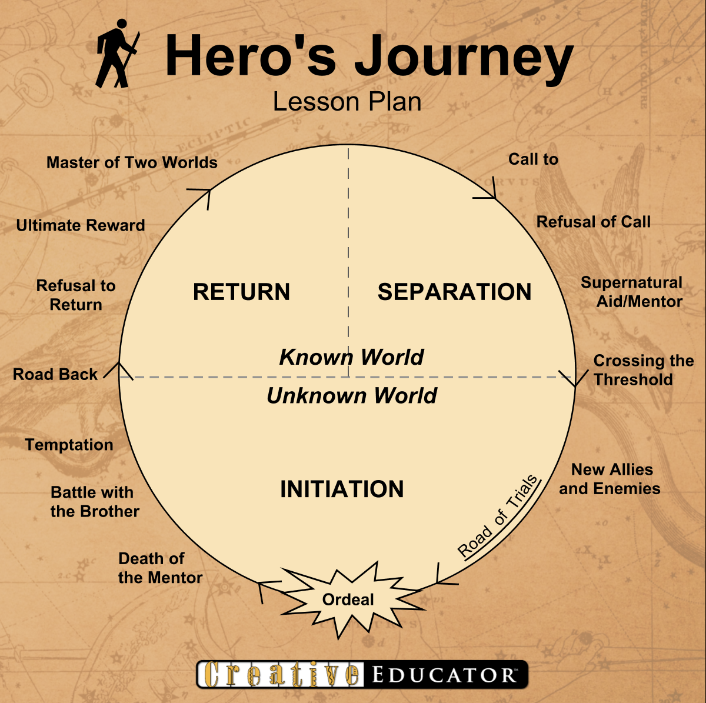
- The Innocent — Capture the Ceryneian Hind Challenge: There's something you genuinely want (a person, a spot on a team, a creative goal) that can't be rushed or forced. Spend the week showing up for it consistently without demanding a result. Reflection: What are you chasing that needs steady patience instead of one big grand gesture? The Sage — Slay the Lernaean Hydra Challenge: Pick the assignment or problem that keeps multiplying every time you touch it. Stop, figure out the actual root, and solve that instead of firefighting symptoms. Reflection: Where are you working hard on the wrong part of the problem? The Explorer — Steal the Cattle of Geryon Challenge: Go somewhere unfamiliar alone this week — a society you've never tried, a part of the city, a class outside your degree. Reflection: What's stopping you from stepping outside your usual circle? The Outlaw — Steal the Mares of Diomedes Challenge: Push back on something unfair — a dodgy landlord clause, a group project freeloader, a rule that doesn't make sense. Challenge it properly, not just in the group chat. Reflection: What do you complain about but never actually confront?
- The Magician — Clean the Augean Stables Challenge: Tackle the backlog you've been avoiding (inbox, laundry, overdue admin) by setting up a system that clears it, not just a one-off blitz. Reflection: What could you set up once so the mess stops rebuilding? The Hero — Capture the Cretan Bull Challenge: Face the thing you've been dreading head-on this week — the hard conversation, the exam, the gym session you keep skipping. Reflection: What have you been avoiding because it feels too big? The Lover — Obtain the Girdle of Hippolyta Challenge: Repair or deepen one relationship through honesty rather than avoidance — reach out to someone you've drifted from, or have the vulnerable conversation. Reflection: Where would openness work better than pride? The Jester — Slay the Stymphalian Birds Challenge: Break a stale routine that's dragging you down. Do something playful and disruptive that shakes you out of the rut. Reflection: What are you taking too seriously right now?
- The Everyman — Capture the Erymanthian Boar Challenge: Solve a problem using what you already have — no new app, no expensive fix. Use your existing resources and the people around you. Reflection: What simple, unglamorous approach have you been overlooking? The Caregiver — Slay the Nemean Lion Challenge: Get through a tough stretch (deadlines, homesickness, burnout) and then share what you learned with someone going through the same thing. Reflection: How can something hard you survived become useful to someone else? The Ruler — Steal the Golden Apples of the Hesperides Challenge: Stop doing everything yourself. Delegate part of a group project or ask for help — but know which piece you have to own. Reflection: When should you carry it, and when should you let someone else? The Creator — Capture Cerberus Challenge: Finish and actually share something you've made — post the track, submit the piece, show the project. Face the fear of it being seen. Reflection: What are you keeping hidden because you're scared of the response?
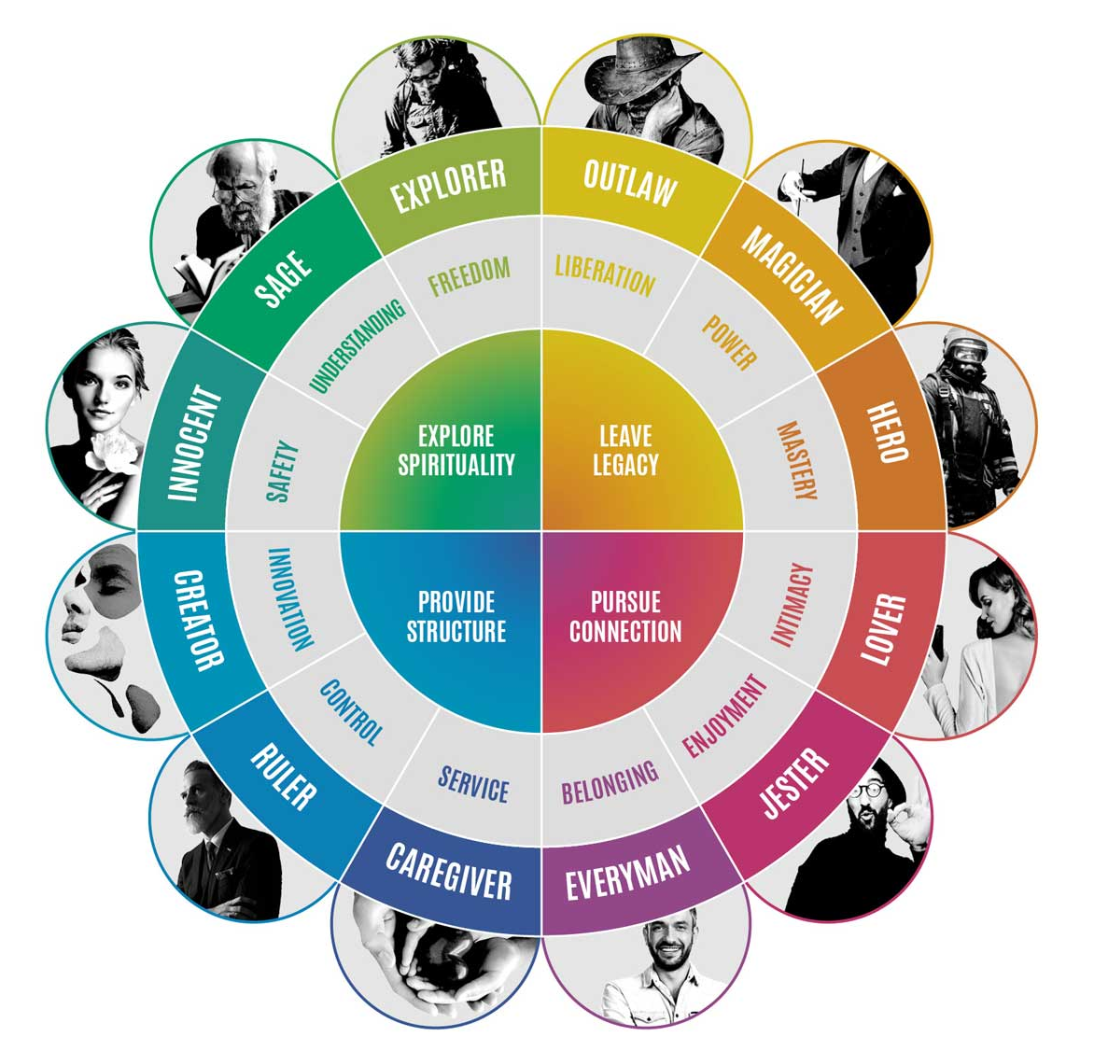
- User Takes A Quiz which will link to one of the twelve labours
- From this you will be given daily tasks that match the labour
- From these quests gain rewards (e.g. Badges, Streaks, Progress, Personality Values)

