


{{TITLE}}
{{SUBJECT}}
[Publish Date] • Version {0.1 DRAFT}
Prepared For: {{COMPANY}}
💡The Published Date field is a static value, i.e. you must manually select the date from the drop down calendar that appears when you click on the selector:
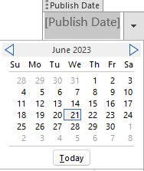


Prepared and Delivered by:
[Consultant 1], [Title]
[Sales Associate 1], [Title]

Change Record
Date | Author(s) | Version | Change Reference
99/99/9999 | [Associate] | 0.1 | Initial review
99/99/9999 | [Associate] | 1.0 | Published

Peer Reviewers
Date | Reviewer(s) | Version | Change Reference
99/99/9999 | [Reviewer] | 0.1 | Initial Recommendations
💡To exclude a header from the Table of Contents, select the title > References > Add Text > Check Do Not Show in Table of Contents:

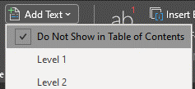

Go to the Table of Contents and hit [F9] or click on
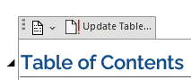

Select Update Entire Table
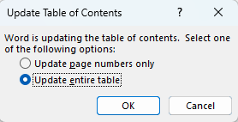

Table of Contents
💡The TOC is in a dedicated section, following a different page numbering sequence.
Change Record i
Peer Reviewers i
Table of Contents i
1 About 1
2 How do I use this Template? 1
3 Headings and Styles 2
1.1 [CTRL] + [ALT] + [2] for Heading 2 2
3.1.1 [CTRL] + [ALT] + [3] for Heading 3 2
4 Tables 3
5 Decision Records, Limitations and Notes Blocks 4
6 Adding Code to Word Documents 5
1.2 HowTo: apply Syntax Highlighted Code to existing text 5
1.3 HowTo: paste Syntax Highlighted Code from VS Code 5
7 HowTo: Use this template to an existing document 6
1.4 Only copy the styles from this document to another 6
8 Keyboard Shortcuts 7
9 HANDY SECTION: Next Steps 8
10 Contact Information 9

About
This document template (Style-Template_2306.dotx) is a style accelerator – it includes various styles, tables, images, and other elements as a starting point for new documents that require brand and style consistency.

How do I use this Template?

Instructions
This document template (File: Document3) is a style accelerator – it includes various styles, tables, images, and other elements as a starting point for new documents that require brand and style consistency.

How do I use this template?
- Generate a document from this Document3 template by either the [DOUBLE-CLICK] or [RIGHT-CLICK] > Open actions.
- Understand the legend of elements throughout the document.
- Take note of some handy-dandy custom Quick Parts and AutoText content available (Insert > Quick Parts).
- Personalize for the customer or project, e.g. update the logo on the cover page, update the document properties (File > Info > Properties), etc. You can also delete the LinkId* and ContentType properties.
- Collect the required data and build on the Summary and Next Steps sections (if applicable).
- Delete this section before submitting for review and finalization.

Style Revision: v2306

Headings and Styles
💡 You can reveal spaces, tabs, page breaks and section breaks with [CTRL+SHIFT+8]

🧠 PrinterLogic also uses the same shortcut to display its dialog. Just click on the Shutdown button.

Category | Value

[CTRL] + [ALT] + [2] for Heading 2
💡 Layouts (portrait, landscape, etc.) can be customized by sections. You can change the layout of this section in the ribbon (Layout > Orientation >) and see that it doesn’t affect the other sections.

Create new sections in the ribbon: Layout > Breaks > Section Breaks
[CTRL]

[CTRL] + [ALT] + [3] for Heading 3
Text

Tables
Feature | Notes
💡To ensure that table headers span between page breaks, select the header row > right-click > Table Properties > turn on the following settings:

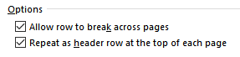

Decision Records, Limitations and Notes Blocks

Aside from the Decision Records, Limitations and Notes styles, icons are included with the corresponding Quick Parts, which are accessible from the Insert > Quick Parts () menu items:


Decision Blocks indicate recommendations and architectural design decisions for this document. Recommended, but optional, details include:
- The context must precede each decision record.
- After the document is published and approved, updates to the decisions recorded in this document must be dated, and prior decisions must be marked Amended with a date.
- Optionally, all design records should include Status (Accepted | Rejected | Proposed), a Date, Consequences, and Compliance (Process | Automation) details.
You can insert this text using the AutoCorrect feature. Just type “{{DecisionBlock}}”


Limitation Blocks identify limitations of the platform, tooling, or software.
- Bullet 1
- Bullet 2
💡 You can insert this text using the AutoCorrect feature. Just type “{{LimitationBlock}}”


Note Blocks identify information that is important, but not directly related to the design.
- Bullet 1
- Bullet 2
💡 You can insert this text using the AutoCorrect feature. Just type “{{NoteBlock}}”

Adding Code to Word Documents
This is the “Code” style from the Style Gallery.
Best used for:
- Code snippets
- Reporting output from console applications and script hosts
- Contents of text files like general scripts, .txt, .reg, .csv, etc.
- Font should be a monospace one, e.g. Consolas, Cascadia Code, Lucida Console, etc.

️This style does not have a language specified, so it will be excluded from Word’s
Spell Check feature


If bullets negatively affect the spacing of text within cells, an alternative method is to use the [Alt] + [Num 7] to insert a bullet character.

HowTo: apply Syntax Highlighted Code to existing text
Syntax Highlighter vs Code Formatter
Tip: If you require Syntax Highlighting, consider installing the Easy Syntax Highlighter
Office Add-On.

TIP: Want to get rid of those spell/grammar checks and suggested corrections on code blocks? You still need to select the text and disable {{whatever}}. Unfortunately, the API to do so is not available. Go figure.

HowTo: paste Syntax Highlighted Code from VS Code
{{In Progress}}

HowTo: Use this template to an existing document
Follow the steps below to add the features of this template to subsequent documents, e.g., Auto Text, Note blocks, Styles, and pre-built sections.
- File > Options > Add-Ins > Templates > Go
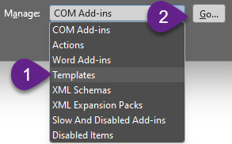
- Add button, then select the full path to this template file:
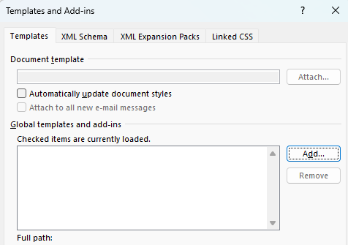

Only copy the styles from this document to another
{{In Progress}}

Keyboard Shortcuts
This table doesn’t need an introduction. These aren’t the most commonly used, but handy when needed:
To do this | Windows | MacOS
Reveal document markers, and reveal hidden text | [CTRL] + [SHIFT] + [8]
Insert a Page Break | [CTRL] + [ENTER]
Align Text to Center | [CTRL] +[E]
Apply Heading # Style | [CTRL] + [ALT] + [Number]
Apply the Normal Style | [CTRL] + [ALT] + [N]

HANDY SECTION: Next Steps
The Next Steps section is a critical part of most assessment reports and can contain potential sales and engagement opportunities. Discuss this section with your Sales Executive.
The following table contains the consolidated list of recommendations based on findings during the effort.
Recommendation | Timeline | Urgency | Importance
Recommendation 1 | Long | High | High
Recommendation 2 | Medium | Medium | Medium
Recommendation 3 | Short | Low | Low

For each item, the risk is detailed and complemented with a recommendation for remediation. In addition, the recommended timelines for the remediation, as well as the perceived urgency and importance of remediation are indicated. The designations for Timeline, Urgency and Importance are defined as follows:
Timeline: Defines recommended implementation time range.
- Short Term: Immediately actionable and could be completed within a 6 week duration.
- Mid Term: Immediately actionable and could take upwards of 6 months to complete.
- Long Term: Not immediately actionable. Requirements or prerequisistes are undefined or require additional consideration.
Urgency: Defines the risk to the stability and on-going function of the VCW environment.
- High: Significant impact to the environment stability, security, or user productivity. Immediate attention recommended.
- Medium: Impact to environment stability, security, manageability, or user experience, but tolerable to the business. Remediation plan recommended.
- Low: Cosmetic, or consideration for long term planning. No immediate action required.
Importance: Defines the anticipated positive impact on the stability, security, scalability, and/or manageability of the VCW environment.
- High: Represents factors critical to the ongoing support and future expansion of the environment, and could seriously affect the business.
- Medium: Represents importance in the long-term, but poses little risk in the immediate future.
- Low: Not critical to short-term or long-term success, poses little if any risk.
Please note that all recommendations should be tested and approved by the appropriate change management.

Contact Information
Project Information
Client Name | [Client Name] | Document Author
Project Name | [Project Name] | Date | XXX 0, 0000

Customer Contact |  |  | Coretek Contact
Name |  |  | Name
Title |  |  | Title
E-mail |  |  | E-mail
Phone |  |  | Phone
 |  |  | Delivery Engineer
 |  |  | E-Mail
 |  |  | Phone

