


{{TITLE}}
{{SUBJECT}}
[Publish Date] • Version {0.1 DRAFT}
💡The Published Date field is a static value, i.e. you must manually select the date from the drop down calendar that appears when you click on the selector:
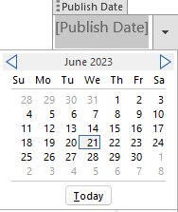
You can modify the format through the Developer menu.
Prepared For: {{COMPANY}}

Prepared and Delivered by:
[Consultant 1], [Title]
[Sales Associate 1], [Title]

Change Record
Date | Author(s) | Version | Change Reference
99/99/9999 | [Associate] | 0.1 | Initial review
99/99/9999 | [Associate] | 1.0 | Published

Peer Reviewers
Date | Reviewer(s) | Version | Change Reference
99/99/9999 | [Reviewer] | 0.1 | Initial Recommendations

💡The TOC is in a dedicated section, following a different page numbering sequence.
Table of Contents
Change Record i
1 About 1
1.1 How do I use this template? 1
2 Headings and Styles 2
2.1 [CTRL] + [ALT] + [2] for Heading 2 2
1.1.1 [CTRL] + [ALT] + [3] for Heading 3 2
3 Tables 3
4 Section Boxes 4
5 Adding Code to Word Documents 5
5.1 The “Easy” Button: Visual Studio Code 5
5.2 “I’m to l33t for that. I write code directly in a Word doc” 6
6 HowTo: Use this template for an existing document 7
7 Tips 8
7.1 Keyboard Shortcuts 8
7.2 Create an Autocorrect string to automate Call-Outs 8
8 Next Steps 10
9 How to start a document from this template? 13
9.1 How to start a blank document from this template? 13

💡We don’t want the Change Record in the Table of Contents. To exclude a header from the Table of Contents, go to the section and select the heading, then References > Add Text > Check Do Not Show in Table of Contents:
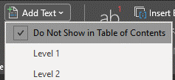

Go to the Table of Contents and hit [F9] or click on
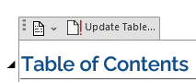

Select Update Entire Table
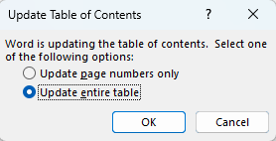

About
This document template (Technical_Doc_2307.dotx) is a style accelerator – it includes custom styles, tables, images, and other elements as a starting point for new documents that require brand and style consistency.
Style Revision: 2308

How do I use this template?
- Generate a document from this Document3 template by either the [DOUBLE-CLICK] or [RIGHT-CLICK] > Open actions.
- Understand the legend of elements throughout the document.
- Take note of some handy-dandy custom Quick Parts and AutoText content available (Insert > Quick Parts).
- Personalize for the customer or project, e.g. update the logo on the cover page, update the document properties (File > Info > Properties), etc. You can also delete the LinkId* and ContentType properties.
- Collect the required data and build on the Summary and Next Steps sections (if applicable).
- Delete this section before submitting for review and finalization.
💡Notice the page numbers don’t always exist for all the pages, particularly the cover page, TOC, and other unrelated pages in the document.

This is achieved through the use of Section Breaks and the Link to Previous features.
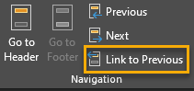

Hit [CTRL]+[SHIFT]+[8] to toggle the visibility of formatting marks. Take note of the ----- Section Break ---- units.

Headings and Styles
💡 You can reveal spaces, tabs, page breaks and section breaks with [CTRL+SHIFT+8]

🧠 PrinterLogic also uses the same shortcut to display its dialog. Just click on the Shutdown button.

Category | Value

[CTRL] + [ALT] + [2] for Heading 2
💡 Layouts (portrait, landscape, etc.) can be customized by sections. You can change the layout of this section in the ribbon (Layout > Orientation >) and see that it doesn’t affect the other sections.

Create new sections in the ribbon: Layout > Breaks > Section Breaks
[CTRL]

[CTRL] + [ALT] + [3] for Heading 3
Text

Tables
Feature | Notes
💡To ensure that table headers span between page breaks, select the header row > right-click > Table Properties > turn on the following settings:

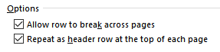

Section Boxes
Aside from the Decision Records, Limitations and Notes styles, icons are included with the corresponding Quick Parts, which are accessible from the Insert > Quick Parts menu items:

DESIGN DECISION
Design Decisions indicate a design decision, including any details related to the design and configuration of such supporting services.


NOTE
Notes identify information that is important, but not directly related to the design. These are often used to classify out-of-scope sections which will be provided in the documentation.


LIMITATION
Limitation Boxes identify potential limitations for the current or future deployments of the note’s resources.


SECURITY
Security Boxes are used to call out items that are related to the security of the environment.


RECOMMENDATION
Recommendations are suggestions and preferred approaches based on industry standards and field observations. While recommendations are not mandatory, incorporating them typically improves results and user experiences.

💡 If bullets negatively affect the spacing of text within cells, an alternative method is to use the [Alt] + [Num 7] to insert a bullet character.

Adding Code to Word Documents

The “Easy” Button: Visual Studio Code
Using VSCode, you can simply copy and paste code from the application’s Editor and paste them into your Word document. When you do, the contents of the clipboard will include the formatting and theme used in VSCode, including the syntax highlights.
The “trick” comes down to one VSCode setting, Copy With Syntax Highlighting
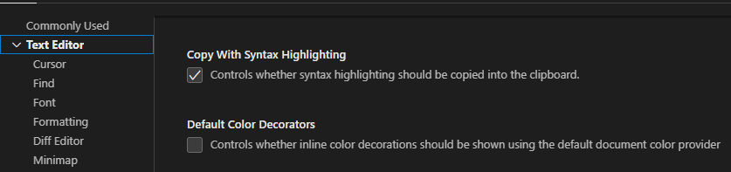
Or just add the highlighted text from the sample below into your settings.json:
{
"terminal.integrated.fontFamily": "'Hack Nerd Font Mono', 'CaskaydiaCove Nerd Font', Consolas",
"editor.fontLigatures": true,
"editor.fontFamily": "'Hack Nerd Font Mono', 'CaskaydiaCove Nerd Font', Consolas",
"editor.copyWithSyntaxHighlighting": true,
"git.autofetch": true,
"explorer.confirmDragAndDrop": false,
"git.enableSmartCommit": true
}

“I’m to l33t for that. I write code directly in a Word doc”
Umm… okay… well, that’s always an option.
There are a couple of free Word Add-Ons to try. Easy Code Formatter has a unique feature of including line numbers.
1. private static int MAX = 5;
2.
3. public void TestMethod()
4. {
5. // Try highlighting the line below.
6. // We will try to highlight using your highlighting preference.
7. Console.WriteLine("Select this line and click Highlight line button");
8. }
9.

And another would be Easy Syntax Highlighter, with support for themes out of the box.
private static int MAX = 5;
public void TestMethod()
{
// Try highlighting the line below.
// We will try to highlight using your highlighting preference.
Console.WriteLine("Select this line and click Highlight line button");
}

HowTo: Use this template for an existing document
Follow the steps below to add the features of this template to subsequent documents, e.g., Auto Text, Note blocks, Styles, and pre-built sections.
- File > Options > Add-Ins > Templates > Go
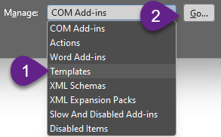
- Add button, then select the full path to this template file:
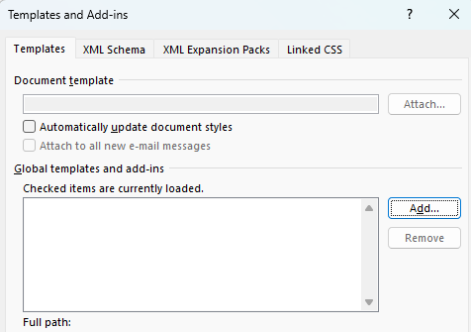

Tips

Keyboard Shortcuts
This table doesn’t need an introduction. This audience is expected to know how to perform basic formatting tasks, like Bolding text or adding a hyperlink. If you center text by mashing the space bar until it “looks center enough”, please close this document, turn off your laptop and leave the room.
These aren’t the most used, but handy when needed:
To do this | Windows | MacOS
Reveal markers and hidden text | [CTRL] + [SHIFT] + [8] | {procrastinating}
Insert a Page Break | [CTRL] + [ENTER]
Apply Heading # Style | [CTRL] + [ALT] + [Number]
Apply the Normal Style | [CTRL] + [SHIFT] + [N]
Toggle Upper/Lower/Mixed Case | [SHIFT] + [F3}
Insert a Hyperlink | [CTRL] + [K]
Align Text to Center | [CTRL] +[E]
Align Text to Left | [CTRL] + [L]
Align Test to Right | [CTRL] + [R]

Create an Autocorrect String to Automate Callouts
You can set an Autocorrect string to automatically replace it with almost anything. In this example, we’ll create one with one of the Callout Boxes (aka Admonition boxes).
NOTE
Autocorrect and proofing data is stored within your profile’s custom dictionary and cannot be included with a document or document template without embedding code.

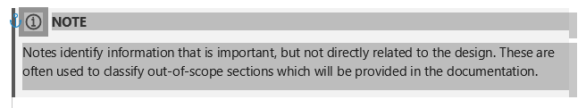
- Select a Call-Out and the “hidden” Line Feed below it, shown by the faint gray line at the bottom of the image.
- Hit [CTRL] + [C] to copy the selected objects.

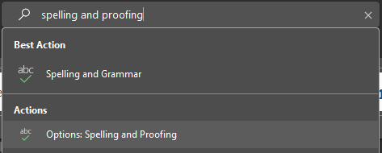
- In the Word search bar, type “Spelling and Proofing” and select “Options: Spelling and Proofing”

- Click on the “Autocorrect Options” button
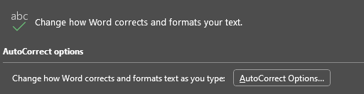

- Specify the unique string you would want to use for Autocorrect to detect and replace. In this example, we’re using the string {{Note}}. Click the “Add” button to save it.
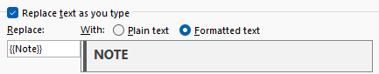

- You can test the string right below this line:

Next Steps
The Next Steps section is a critical part of most assessment reports and can contain potential sales and engagement opportunities. Discuss this section with your Sales Executive.

💡This section is also available as a Quick Part. Insert it through the ribbon: Insert > Quick Parts > .NextSteps.
The following table contains the consolidated list of recommendations based on findings during the effort.
Backup and Disaster Recovery
Backup and DR Recommendation | Timeframe | Impact | Priority
Azure Backup: consider the different backup types (GRS/ZRS/LRS) for each resource; default is the most expensive GRS | Long | Medium | High

Governance
Governance Recommendation | Timeframe | Impact | Priority
Enforce and/or append resource tags through Azure Policy
Enforce an organizational policy to make sure that resource owners are aware of their roles and responsibilities around regularly performing access reviews, budget reviews, budget reviews, and remediate policy compliance when necessary. | Ongoing | High
Enforce a process for cost management, including a regular review of Coretek Insights and Advisor recommendations, enforcing the use of purchased Reserved Instance and Savings Plan for Compute. | Ongoing | High
  
  Reserved Instances and Savings Plans can be purchased through Coretek’s CSP team. Please contact your Coretek Customer Success Manager for more details.
Regularly review assigned policies for non-compliance. Some policies are assigned but “disabled” until needed. | Ongoing | High
Incorporate MDU standard alerts into the Knife River tenant and Azure subscription(s). | Short | Medium | Medium

Cost Management
Cost Management Recommendation | Timeframe | Impact | Priority
Deploy and use Coretek Insights | Short | Medium | High
Continually review Reserved Instances for long-standing production workloads. Add these reviews as part of the decommissioning process | Long | Medium | High
Review Log Analytics SKU. Current deployment of Log Analytics Workspace is using the most cost-efficient SKU for light workloads and new environments – Pay-as-you-Go. As the environment matures, the data ingested will increase. Please refer to the Azure Pricing Guide and review.

Reliability
Reliability Recommendation | Timeframe | Impact | Priority

Security
Security Recommendation | Timeframe | Impact | Priority
Deploy a Break Glass account | Short | Low | Low
Regularly review all Public IP resources and assess their necessity | Medium | Medium | Medium
Mitigate Azure Monitor and Microsoft for Defender security score and recommendations | Long | High | High
Limit Global Administrators to a maximum of 3 (however, Microsoft recommends “less than 5”)

Manageability
Recommendation | Timeframe | Impact | Priority
Consider using Azure DevOps/GitHub and CI/CD pipelines to manage the state of the Azure environment:  - Leverage automation.  - Enable drift detection to detect unsanctioned or inadvertent changes to the environment.  - Ensure that any changes to production are all tested in the development and/or QC environments. | Long | Medium | High

For each item, the risk is detailed and complemented with a recommendation for remediation. In addition, the recommended timelines for the remediation, as well as the perceived urgency and importance of remediation are indicated. The designations for Timeline, Urgency and Importance are defined as follows:
Timeframe: Defines recommended implementation time range.
- Short Term: Immediately actionable and could be completed within a 6 week duration.
- Mid Term: Immediately actionable and could take upwards of 6 months to complete.
- Long Term: Not immediately actionable. Requirements or prerequisistes are undefined or require additional consideration.
- Ongoing: Associated with guidance around operational processes and policies. Requirements are organizationally unique and may require multiple approvals and extensive communications.
Impact: Defines the risk to the stability and on-going function of the solution or environment.
- High: Significant impact to the environment stability, security, or user productivity. Immediate attention recommended.
- Medium: Impact to environment stability, security, manageability, or user experience, but tolerable to the business. Remediation plan recommended.
- Low: Cosmetic, or consideration for long term planning. No immediate action required.
Priority: Defines the anticipated positive impact on the stability, security, scalability, and/or manageability of the solution or environment.
- High: Represents factors critical to the ongoing support and future expansion of the environment, and could seriously affect the business.
- Medium: Represents importance in the long-term, but poses little risk in the immediate future.
- Low: Not critical to short-term or long-term success, poses little if any risk.
Please note that all recommendations should be tested and approved by the appropriate change management.

How to start a document from this template?
Unless you opened this template in Edit mode, you already did it!
Look at the title bar of this window. If it says, Document <number>, then you’re looking at a brand-new document! Just go ahead and delete the instructions text from the sections above and have at it.

How to start a blank document from this template?
It’s quite likely you’ll find a NewNormal.dotx file in the same folder where you found this document. You can create a blank document off that. Here’s some steps to get things going:
- Double-click on the .DOTX file to create a new document.
- Start with the cover page:
  - Hit [CTRL]+[SHIFT]+[8] to reveal the hidden markers
  - Insert the Cover Page you want.
  - Replace the Page Break with a Section Break
- Insert a Table of Contents
  - Insert the custom Table of Contents
  - Insert another Section Break
- Insert the custom Footer in the new section
- Update the document properties, and optionally, the published date on the cover page.
- Update all field codes

