**Logitech G502 X**





**F15**

**F17**

**F13**

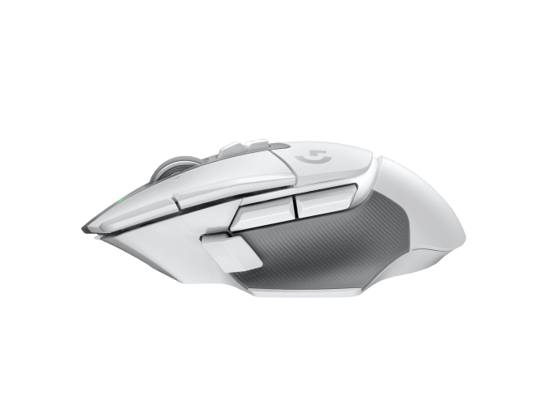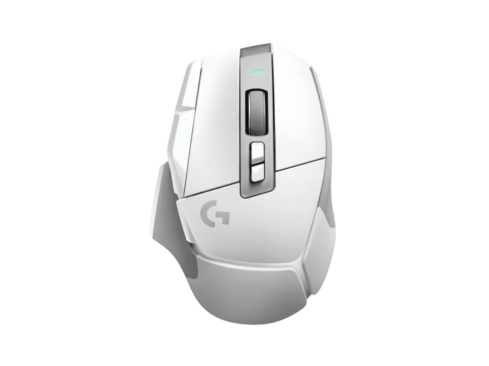

**F23**

**F18**



**F14**



**F19**

**F22**

**F24**

**F21**



**F16**

**F20**

**Forward**

**Back**

