GraSP Instrument Recognition
2026-10-06
Objective
Find and label every surgical instrument in a video frame, and know when a label is likely to be wrong. Given a frame and the box around each instrument, the system returns the instrument's mask and class. When it is unsure, it checks neighbouring frames to correct the class. The goal is to match or beat the published TAPIS results on mIoU, IoU and mcIoU.
Challenges and how we addressed them
- Few annotated frames. We start from pretrained models (SAM2, SAM3 and pretrained classifier backbones) and fine-tune only a small part of them. We also train the classifier on crops of the same instrument taken from neighbouring frames, so it sees the kind of crop it will get at test time.
- Class imbalance. The rarest instrument has about 25 times fewer examples than the most common. Every instrument is classified on its own crop, and results are judged with class-averaged metrics (mcIoU, macro-F1) so rare classes count as much as common ones. Tracking helps the rare classes most.
- Occlusion. Instruments are partly hidden, and some look alike from certain angles. Each crop is masked to the single instrument so neighbours do not leak in. Uncertain instruments are followed across neighbouring frames, where a clearer view often exists, and the per-frame predictions are combined weighted by confidence.
Pipeline
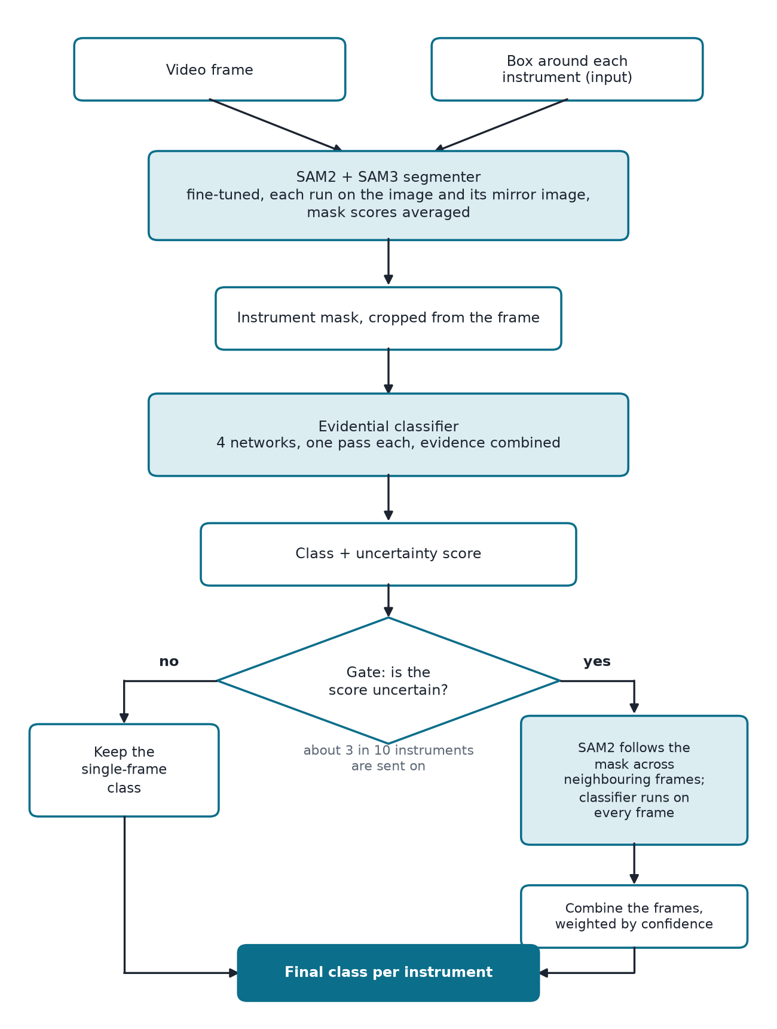
Results
Method | mIoU | IoU | mcIoU
Final pipeline (SAM2 + SAM3 segmenter, SAM2 evidential tracking) | 87.37 ± 0.33 | 86.22 ± 0.46 | 78.33 ± 1.28
TAPIS (Mask2Former Swin-L + video transformer) | 86.61 | 83.38 | 77.42

± is the spread over 3 training runs of the classifier. In the chart, the whisker shows the likely range of the score on a different set of test cases.
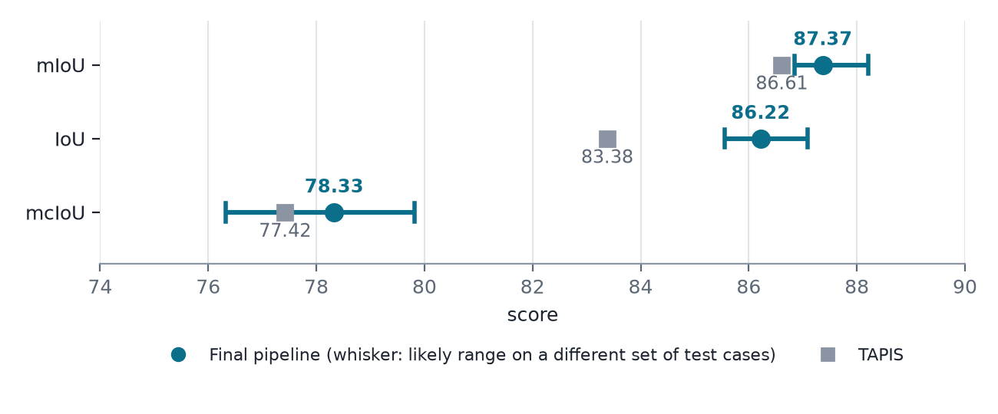
IoU is clearly above TAPIS, mIoU is modestly above, and mcIoU is comparable.
What each step added
Step | mIoU | IoU | mcIoU
SAM2 fine-tuned segmenter | 86.34 | 85.31 | 77.59
+ SAM3 added to the segmenter | 86.78 | 85.72 | 77.90
+ classifier trained on tracker-style crops | 87.11 | 85.97 | 78.19
Final pipeline (segmenters trained on all training data) | 87.37 | 86.22 | 78.33

Per class (IoU, final pipeline)
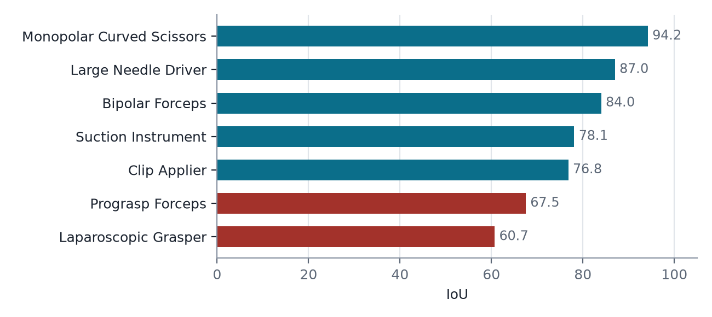
Laparoscopic Grasper is the weak class: with closed jaws it looks like a suction tube in a single frame, and tracking cannot separate them.
Classifier history
Configuration | accuracy | macro-F1
Whole-frame label (exact match) | 0.359 | 0.708
Single MobileNetV3-small | 0.867 | 0.834
Single ResNet-50, 320 px | 0.915 | 0.865
4-model ensemble | 0.927 | 0.890
+ uncertainty-gated SAM2 tracking | 0.962 | 0.935

The uncertainty method is now a single-pass evidential ensemble instead of 80 stochastic votes: 1/80 of the cost, 0.3 to 0.5 points lower accuracy over 3 seeds.
Uncertainty: MC dropout vs Evidential
Two ways to score how likely a prediction is wrong, compared on a held-out fold (3 seeds) and the test set. We chose evidential: it finds errors at least as well at 1/80 of the cost, and it also catches errors where every network agrees on the wrong class.
 | MC dropout | Evidential
AUROC, held-out fold | 0.912 ± 0.010 | 0.927 ± 0.004
AUROC, test set | 0.896 | 0.922
Errors caught when 20% of instruments are reviewed | 83.5% | 89.3%
Errors flagged when all networks agree on the wrong class | 0% | 74%
Forward passes per instrument | 80 | 1

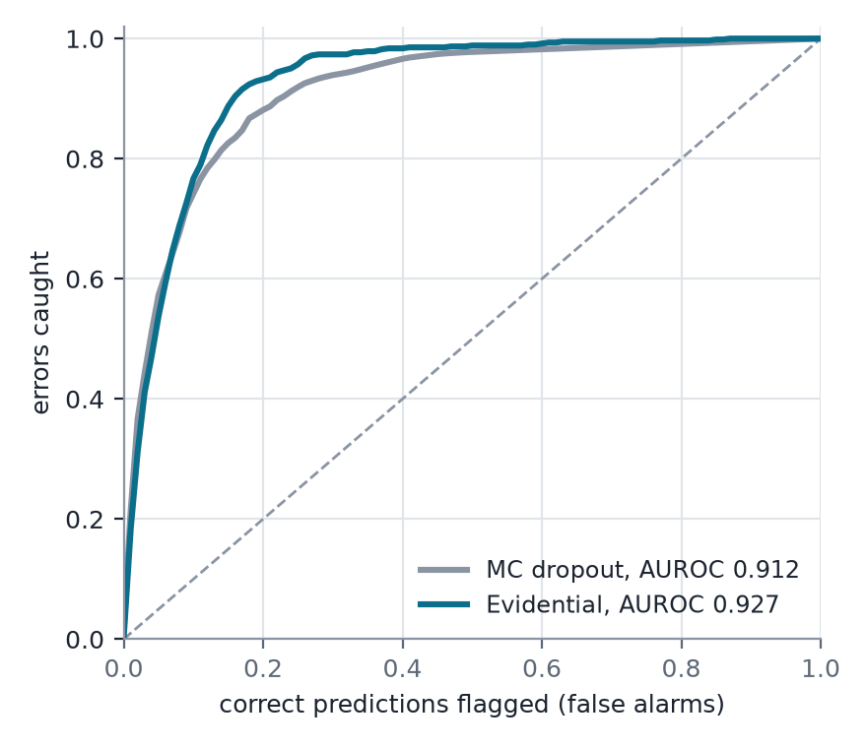
AUROC: 0.5 is chance, 1.0 ranks every wrong prediction above every right one. Curves are the mean of 3 seeds on the held-out fold. When all networks agree on the wrong class, a vote shows no disagreement, so only the evidential score can flag it.
How the gate was chosen
The gate decides which instruments are sent to tracking. The threshold was swept on a held-out fold, and we took the best accuracy, then the cheapest gate within 0.001 of it. Accuracy is flat beyond about 15% tracked, so the exact threshold matters little.
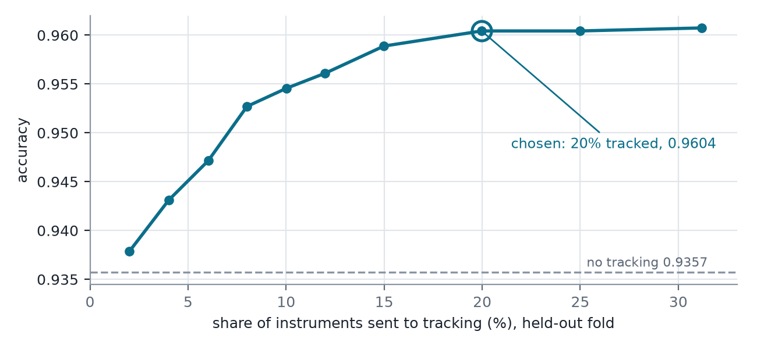

Latency
Measured on one Titan Xp, one frame at a time, with 2.5 instruments per frame on average.
Stage | ms
Segmenter (SAM2 + SAM3, with mirror pass), per frame | 3,423
Classifier, no tracking, per frame | 96
Tracking + classifier (SAM2 tracking, 21 frames), per tracked instrument | 12,812
End to end, best case (no instrument tracked), per frame | 3,519
End to end, average, per frame | 13,006
End to end, worst case (5 instruments, all tracked), per frame | 67,579
TAPIS, for reference, per keyframe | 484

Average assumes 29% of instruments are tracked. Worst case is the busiest frame in the test split with every instrument tracked in turn. End-to-end figures are computed from the measured stage times.
Real-time version
Uses past frames only, at one frame per second, with a smaller segmenter (SAM2.1-tiny) and a causal tracker.
Pipeline | mIoU | IoU | mcIoU | End to end, avg (ms)
Real-time: SAM2-tiny segmenter + causal EdgeTAM tracking (recommended) | 84.22 | 82.30 | 71.89 | 853
Real-time: SAM2-tiny segmenter + causal YOLO26s tracking | 83.23 | 81.32 | 70.28 | 370
Real-time: SAM2-tiny segmenter, no tracking | 82.13 | 79.55 | 67.93 | 306
Final pipeline (offline above) | 87.37 | 86.22 | 78.33 | 13,006
TAPIS | 86.61 | 83.38 | 77.42 | 484

Real-time rows track the 539 most uncertain instruments (about 19%). Latencies are estimated from measured stage times on one Titan Xp; the EdgeTAM tracking delay comes from a streaming replay.

Latency of the recommended real-time pipeline (SAM2-tiny + causal EdgeTAM)
Stage | ms
Segmenter (SAM2-tiny, with mirror pass), per frame | 207
Classifier, no tracking, per frame | 98
Tracking + classifier (EdgeTAM, 21 frames), per tracked instrument | 2,907
End to end, best case (no instrument tracked) | 306
End to end, average | 853
End to end, worst case (slowest tracked instrument in the replay) | 10,037

The label from segmentation and classification arrives within the best-case time; tracked instruments get a corrected label later, after the tracking time.
Tried and not adopted
- Mask refinement network
- SAM3 on its own (zero-shot and fine-tuned)
- Mask post-processing (hole filling, largest component, polygon fit, erosion)
- Clipping the mask to its box (only helps with ground-truth boxes)
- Perturbed-mask training of the classifier
- Tight crops with masking and lighting augmentation
- ResNet-101 as an ensemble member
- INT8 quantization
- Fusing evidence across frames by matching boxes, without a tracker
Release
- Code: github.com/volcanictv/grasp-instrument-classifier
- Weights: huggingface.co/AryanB005/grasp-instrument-pipeline
Limits and open items
- Ground-truth boxes. Results use ground-truth boxes, so detection errors are not included. Next step: run on a trained detector's boxes or TAPIS's own boxes.
- Segmenter seed variance. Each segmenter was trained once, so the spread shown covers the classifier only.

