- Do you have a GitHub account already? If yes, go to step #3. If no, continue to step #2.
- Go to https://github.com/ and click “Sign up”. Then follow the instructions to sign up for a free account.
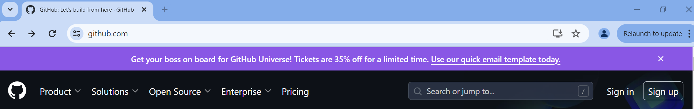
- Once you have a GitHub account, go to: https://victor.ldeo.columbia.edu/

- Click “Sign up”

- Fill in the form

