Medical Practice Database

Contents
1. Chen ERD 3
2. Data Dictionary 4
3. Crow’s Foor ERD 4
4. RDM 5
5. Business Domain Summary 7
6. Business Requirements Analysis 7
7. System Context Diagram (Textual Description) 9
8. Functional Requirements 9
9. Summary 11
10. Approval / Sign-off: 11

- Chen ERD
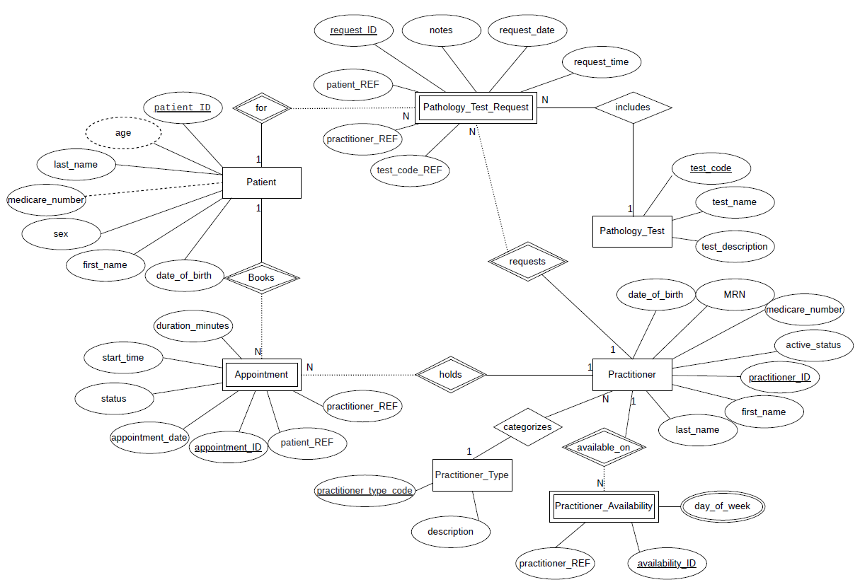

- Data Dictionary
The file is also included in the “Client Requirements Report” folder.
- Crow’s Foor ERD
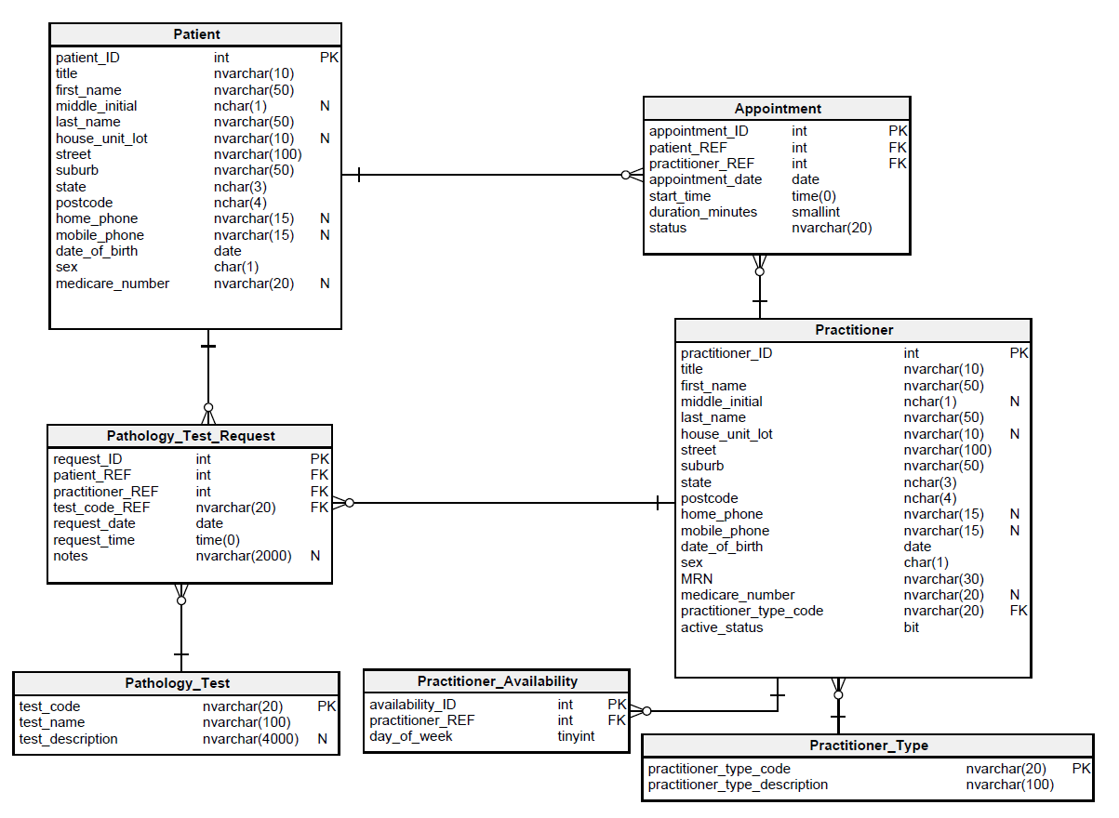

- RDM
Patient
- PK: patient_ID
- AK: medicare_number (unique when present)
- Columns: title, first_name, middle_initial, last_name, house_unit_lot, street, suburb, state, postcode, home_phone, mobile_phone, date_of_birth, sex
- Notes: sex constrained to M/F/O; only current details stored.
Practitioner_Type
- PK: practitioner_type_code
- Columns: practitioner_type_description
- Notes: Defines valid practitioner categories. Such as NUR as a Nurse.
Practitioner
- PK: practitioner_ID
- AKs: MRN (unique, required), medicare_number (unique)
- FK: practitioner_type_code → Practitioner_Type
- Columns: title, first_name, middle_initial, last_name, address fields, phones, date_of_birth, sex, active_status
- Notes: Practitioners can be marked inactive.
Practitioner_Availability
- PK: availability_ID
- FK: practitioner_REF → Practitioner
- Columns: day_of_week
- AK: (practitioner_REF, day_of_week)
- Notes: Stores which days each practitioner is available.
Days of the week: Monday = 1, Tuesday = 2, … Sunday = 7.
Pathology_Test
- PK: test_code
- Columns: test_name, test_description
- Notes: Catalogue of test types.

Appointment
- PK: appointment_ID
- FKs: patient_REF → Patient; practitioner_REF → Practitioner
- Columns: appointment_date, start_time, duration_minutes, status
- AKs: (patient_REF, appointment_date, start_time); (practitioner_REF, appointment_date, start_time)
Notes: Prevents double-booking; enforces 15-minute increments. If the duration_minutes was requested for more than 15-minutes, the system will automatically count it as 2 bookings in a row which will fill out 2 appointment_IDs or so more for the longer appointments. The system will also check for the Practitioner_Availability to prevent from double bookings.
Pathology_Test_Request
- PK: request_ID
- FKs: patient_REF → Patient; practitioner_REF → Practitioner; test_code_REF → Pathology_Test
- Columns: request_date, request_time, notes
- AK: (practitioner_REF, patient_REF, request_date, request_time)
- Notes: Prevents duplicate requests at same date/time.
Normalisation:
- All tables are in 4NF. Multi-valued attributes (e.g., practitioner availability) are separated into their own table. No repeating groups, no partial or transitive dependencies. Each non-key attribute depends only on the whole key.
- Business Domain Summary
Medical Practice’s Business Rules:
The Medical Practice provides healthcare services through a range of practitioners, including doctors, nurses, physiotherapists, podiatrists, optometrists, and others. Patients may book appointments with practitioners for consultations, health checks, or general services.
The practice operates Monday to Friday, 8:00 am to 6:00 pm, with each practitioner available on specific days of the week. Appointments are managed by the receptionist, and the system must also track pathology test requests ordered by practitioners for patients.
The new relational database will centralise patient, practitioner, appointment, and pathology test data, ensuring:
- Secure storage of personal and medical information
- Accurate tracking of appointments and practitioner availability
- Prevention of double-bookings for patients and practitioners
- Recording and retrieval of pathology test requests
- Consistency and integrity of data across all records
- Business Requirements Analysis
After reviewing the Medical Practice Business Rules, the following entities and rules were identified and confirmed in the ERD:
Core Entities
- Patient — demographic and contact details, Medicare number.
- Practitioner — practitioner details, type, and active status.
- Practitioner_Type — catalogue of practitioner roles (Doctor, Nurse, Physiotherapist, etc.).
- Practitioner_Availability — days and times each practitioner is available.
- Appointment — scheduled meeting between a patient and a practitioner.
- Pathology_Test — catalogue of available pathology tests.
- Pathology_Test_Request — requests made by practitioners for patients.
Key Business Rules
- Patients and practitioners must exist in the system before appointments can be made.
- Appointments are in 15-minute increments, starting on the quarter hour.
- Patients and practitioners cannot be double-booked.
- Practitioners are only available on specific days/times as defined in their availability records.
- Pathology test requests must record the patient, practitioner, date, and time.
- A practitioner cannot request two identical pathology tests for the same patient at the same date/time.
- Patient records are never deleted, only updated. Practitioner records are marked inactive when no longer current.
Operational Goals
- Improve efficiency of appointment scheduling.
- Provide accurate reporting of appointments, practitioner schedules, and pathology test requests.
- Ensure compliance with healthcare data management standards.
- System Context Diagram (Textual Description)
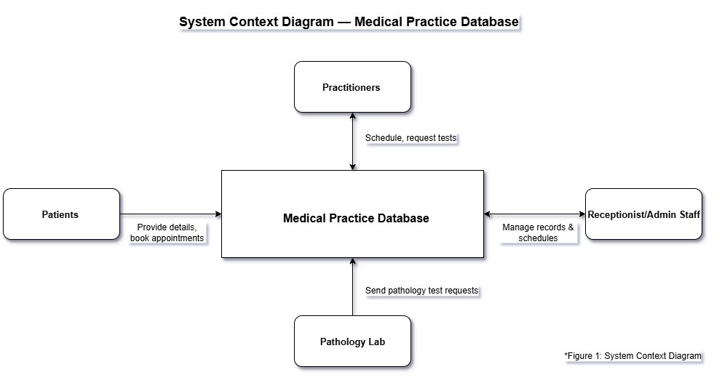
Actors:
- Patients — provide personal details and attend appointments.
- Practitioners — provide healthcare services and request pathology tests.
- Receptionist/Admin Staff — manage patient records, practitioner schedules, and appointments.
- Pathology Lab — receives and processes pathology test requests.
System:
- Medical Practice Database — manages patient data, practitioner data, practitioner availability, appointment scheduling, and pathology test requests.
- Functional Requirements
The database will perform the following operations and outputs:
Function
  Description / Purpose
Record Patient Details | Store and update patient demographic and contact info.
Record Practitioner Details | Maintain practitioner details, type, and active status.
Record Practitioner Availability | Store days and times practitioners are available.
Schedule Appointments | Create appointments linking patients and practitioners.
Update / Cancel Appointments | Modify or cancel appointments as required.
Retrieve Appointments | List appointments for a patient, or for a practitioner on a given date.
Enforce Appointment Rules | Prevent double booking of patients or practitioners and enforce 15-minute slots.
Manage Pathology Test Catalogue | Maintain list of available pathology tests.
- Summary
The Medical Practice Database will streamline operations by integrating patient management, practitioner management, availability tracking, appointment scheduling, and pathology test request handling into one secure system.
This will reduce administrative workload, improve accuracy of records, and ensure compliance with healthcare data management standards. The design ensures data integrity, prevents scheduling conflicts, and supports efficient reporting for both clinical and administrative needs.
- Approval / Sign-off:
Name:
Signature:
Date:

