Hooks
Hooks
Run commands at specific points in Claude Code’s lifecycle. Unlike everything else, hooks are deterministic - they always run. Use them to format, log, notify, or block, guaranteed.
Deterministic · settings.json · Events, matchers & handlers
IN THIS GUIDE
From the first auto-format hook to the full configuration reference:
- Why hooks are deterministic - and the everyday use cases
- Configuring them in settings.json, the events you can hook, and the /hooks command
- Blocking tool calls with PreToolUse, and sharing hooks with your team
- The full lifecycle, a step-by-step resolve walkthrough, and hook locations
- Matcher patterns and the five hook handler types

ON THIS PAGE
› 1. Why Use Hooks
› 2. How Hooks Work
› 3. A Practical Example: Auto-format
› 4. Blocking with PreToolUse
› 5. Sharing Hooks with Your Team
› 6. The Hook Lifecycle
› 7. How a Hook Resolves
› 8. Configuration & Hook Locations
› 9. Matcher Patterns
› 10. Hook Handler Types

01 Why Use Hooks
You can tell Claude in your CLAUDE.md to run Prettier after every file edit. Most of the time it will - but sometimes it won’t. A hook makes it happen every single time, no exceptions. That determinism is the whole point.
Common use cases include:
- Auto-formatting after file edits
- Logging all executed commands for compliance
- Blocking dangerous operations like modifying production files
- Sending yourself notifications when Claude finishes a task

02 How Hooks Work
Hooks are configured in your settings.json. You pick an event, optionally set a matcher for which tools it applies to, and provide a command to run. The everyday events are:
Event | When it fires
PreToolUse | Before a tool call - can block it.
PostToolUse | After a tool call completes.
UserPromptSubmit | When you submit a prompt, before Claude processes it.
Stop | When Claude finishes responding.
Notification | When Claude sends a notification.
Configure them through the /hooks command inside Claude Code, or by editing settings.json directly.
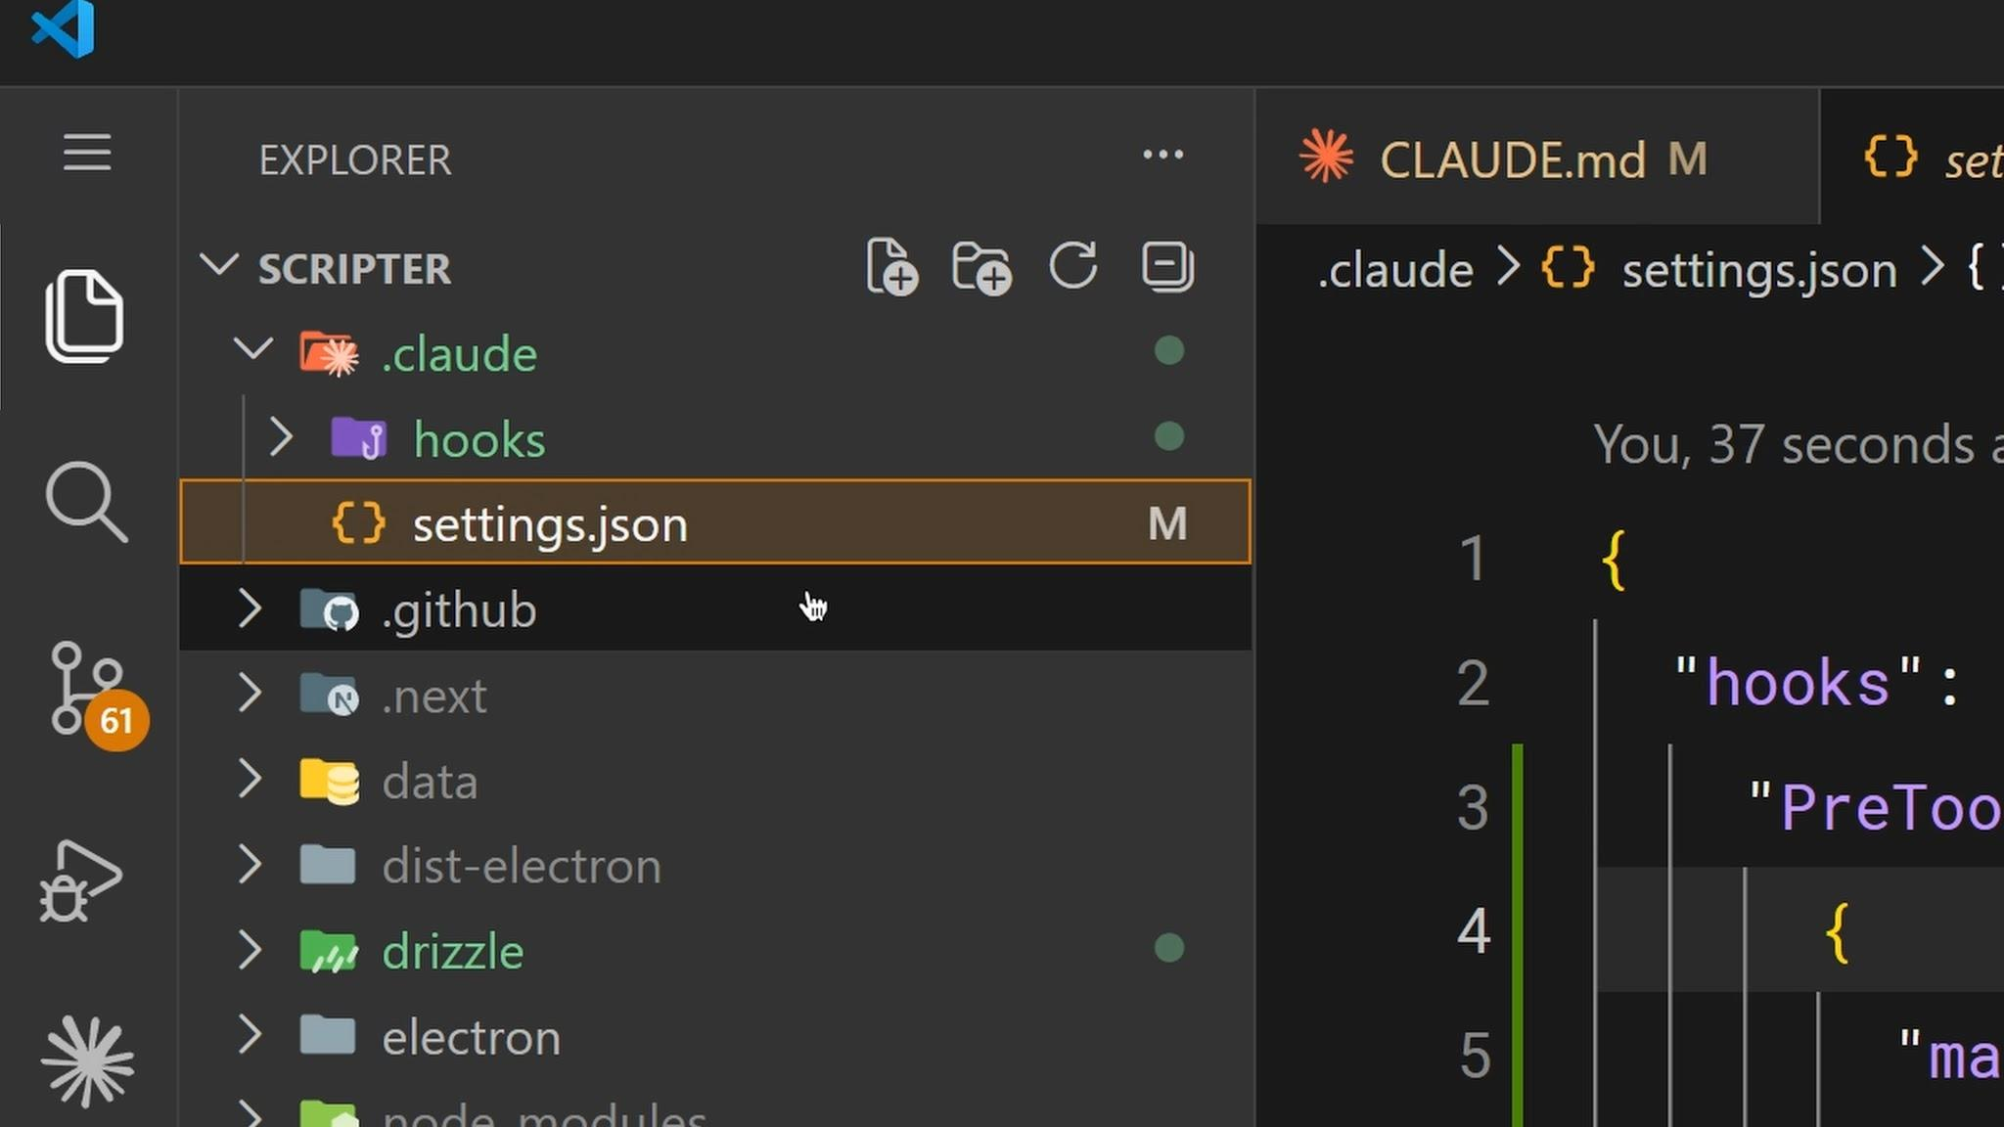
Configure hooks with the /hooks command inside Claude Code - or edit settings.json directly.

03 A Practical Example: Auto-format
The most common hook is auto-formatting after edits. Set a PostToolUse hook with a matcher of Edit|MultiEdit|Write so it fires whenever Claude modifies a file. The command checks the file extension and runs the appropriate formatter - Prettier for TypeScript, gofmt for Go, whatever your project uses.
SETTINGS.JSON
{
"hooks": {
"PostToolUse": [
{
"matcher": "Edit|MultiEdit|Write",
"hooks": [
{ "type": "command", "command": "/path/to/format.sh" }
]
}
]
}
}

04 Blocking with PreToolUse
PreToolUse hooks can block tool calls before they execute. Your hook receives the tool name and input as JSON on stdin, and its exit code determines the behavior:
Exit code | Behavior
0 | Proceed normally.
2 | Block the action. The stderr message is fed back to Claude as feedback, so it knows why and can adjust.
Any other | A non-blocking error - shown to you, but nothing stops.
This is how you enforce hard rules: block writes to a production config directory, block bash commands containing rm -rf, block commits to main - whatever your team needs to be guaranteed, not suggested.
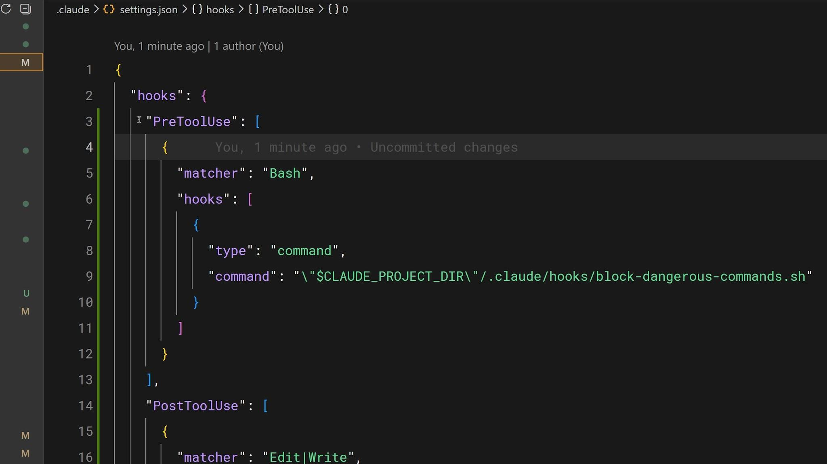
A PreToolUse hook blocking a tool call before it runs - guaranteed, not suggested.

05 Sharing Hooks with Your Team
Hooks configured in .claude/settings.json are project-level and can be checked into your repo, so your entire team gets the same hooks automatically. Use the CLAUDE_PROJECT_DIR environment variable in your commands to reference scripts stored in your project, so they work regardless of Claude’s current working directory.

06 The Hook Lifecycle
Hooks fire at specific points during a session. When an event fires and a matcher matches, Claude Code passes JSON context to your handler - on stdin for command hooks, or as the POST body for HTTP hooks. Your handler inspects the input, takes action, and optionally returns a decision. Events fall into three cadences:
- Once per session - SessionStart, SessionEnd.
- Once per turn - UserPromptSubmit, Stop, StopFailure.
- Every tool call in the agentic loop - PreToolUse, PostToolUse.
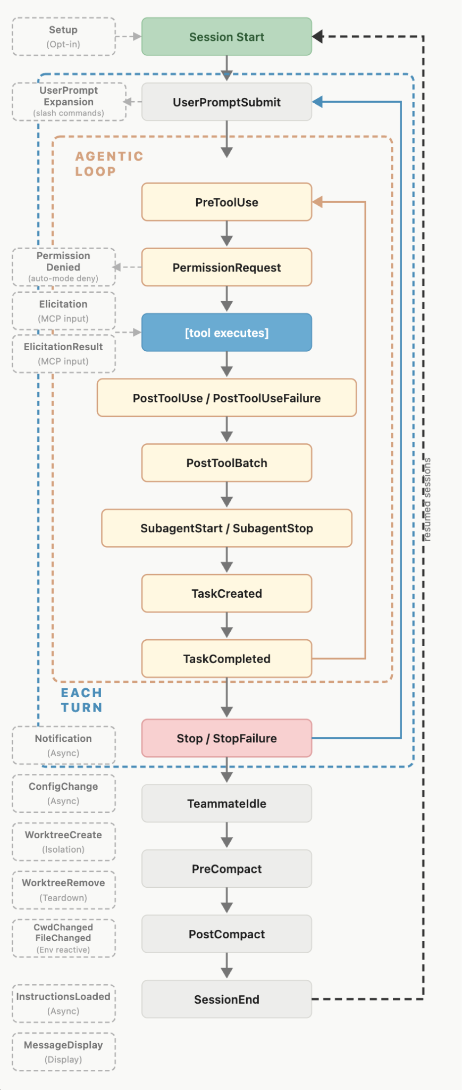

Complete event reference
Every event you can hook, and when it fires:
Event | When it fires
SessionStart | A session begins or resumes.
Setup | Starting with --init-only, or --init / --maintenance in -p mode - for one-time prep in CI or scripts.
UserPromptSubmit | You submit a prompt, before Claude processes it.
UserPromptExpansion | A typed command expands into a prompt, before it reaches Claude. Can block the expansion.
PreToolUse | Before a tool call executes. Can block it.
PermissionRequest | A permission dialog appears.
PermissionDenied | A tool call is denied by the auto-mode classifier. Return {retry: true} to allow a retry.
PostToolUse | After a tool call succeeds.
PostToolUseFailure | After a tool call fails.
PostToolBatch | After a batch of parallel tool calls resolves, before the next model call.
Notification | Claude Code sends a notification.
MessageDisplay | While assistant message text is displayed.
SubagentStart | A subagent is spawned.
SubagentStop | A subagent finishes.
TaskCreated | A task is being created via TaskCreate.
TaskCompleted | A task is being marked completed.
Stop | Claude finishes responding.
StopFailure | The turn ends due to an API error. Output and exit code are ignored.
TeammateIdle | An agent-team teammate is about to go idle.
InstructionsLoaded | A CLAUDE.md or .claude/rules/*.md file loads into context (session start and lazy loads).
ConfigChange | A configuration file changes during a session.
CwdChanged | The working directory changes (e.g. a cd command). Useful with direnv.
FileChanged | A watched file changes on disk. The matcher specifies which filenames to watch.
WorktreeCreate | A worktree is being created via --worktree or isolation: "worktree". Replaces default git behavior.
WorktreeRemove | A worktree is being removed (session exit or subagent finish).
PreCompact | Before context compaction.
PostCompact | After context compaction completes.
Elicitation | An MCP server requests user input during a tool call.
ElicitationResult | After a user responds to an MCP elicitation, before the response is sent back.
SessionEnd | A session terminates.

07 How a Hook Resolves
Consider a PreToolUse hook that blocks destructive shell commands. The matcher narrows to Bash tool calls, and the if condition narrows further to subcommands matching rm *, so block-rm.sh only spawns when both filters match:
SETTINGS.JSON
{
"hooks": {
"PreToolUse": [{
"matcher": "Bash",
"hooks": [{
"type": "command",
"if": "Bash(rm *)",
"command": "${CLAUDE_PROJECT_DIR}/.claude/hooks/block-rm.sh",
"args": []
}]
}]
}
}
The script reads the JSON from stdin, extracts the command, and returns a permissionDecision of "deny" if it contains rm -rf:
BLOCK-RM.SH
#!/bin/bash
# .claude/hooks/block-rm.sh
COMMAND=$(jq -r '.tool_input.command')
if echo "$COMMAND" | grep -q 'rm -rf'; then
jq -n '{
hookSpecificOutput: {
hookEventName: "PreToolUse",
permissionDecision: "deny",
permissionDecisionReason: "Destructive command blocked by hook"
}
}'
else
exit 0 # no decision; normal permission flow applies
fi

Now suppose Claude decides to run Bash "rm -rf /tmp/build". Here’s what happens, step by step:
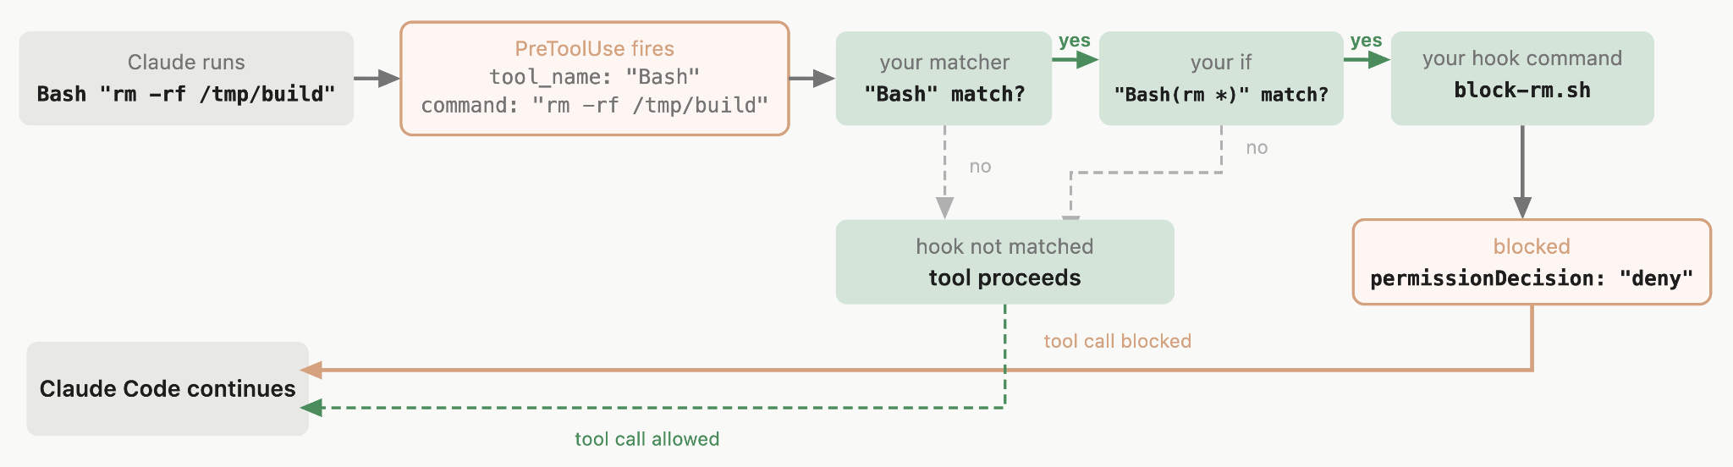
- 1 · Event fires. The PreToolUse event fires; Claude Code sends the tool input as JSON on stdin: { "tool_name": "Bash", "tool_input": { "command": "rm -rf /tmp/build" } }.
- 2 · Matcher checks. The matcher "Bash" matches the tool name, so the group activates. Omitting the matcher (or "*") activates on every occurrence.
- 3 · If-condition checks. The if "Bash(rm *)" matches, so the handler spawns. Had the command been npm test, the check would fail and the script would never run - avoiding the spawn. The if field is optional.
- 4 · Handler runs. The script finds rm -rf and prints a "deny" decision to stdout. A safer rm file.txt would hit exit 0 instead - no decision, so the call continues through the normal permission flow. The hook can deny, but silence doesn’t approve.
- 5 · Claude Code acts. It reads the JSON decision, blocks the tool call, and shows Claude the reason.

08 Configuration & Hook Locations
Hooks are defined in JSON settings files, with three levels of nesting:
- Choose a hook event to respond to, like PreToolUse or Stop.
- Add a matcher group to filter when it fires, like “only for the Bash tool.”
- Define one or more hook handlers to run when matched.
Throughout, hook event is the lifecycle point, matcher group is the filter, and hook handler is the shell command, HTTP endpoint, MCP tool, prompt, or agent that runs. “Hook” on its own refers to the general feature.

Where you define a hook sets its scope
Location | Scope | Shareable
[object Object] | All your projects | No - local to your machine
[object Object] | Single project | Yes - commit to the repo
[object Object] | Single project | No - gitignored by default
Managed policy settings | Organization-wide | Yes - admin-controlled
Plugin hooks/hooks.json | When plugin is enabled | Yes - bundled with the plugin
Skill / agent frontmatter | While the component is active | Yes - defined in the component
Enterprise administrators can use allowManagedHooksOnly to block user, project, and plugin hooks; hooks from plugins force-enabled in managed enabledPlugins are exempt, so admins can distribute vetted hooks through an organization marketplace.

09 Matcher Patterns
The matcher field filters when hooks fire. How it’s evaluated depends on the characters it contains:
Matcher value | Evaluated as | Example
"*", "", or omitted | Match all | Fires on every occurrence of the event
Only letters, digits, _, | | Exact string, or |-separated list | Bash matches only Bash; Edit|Write matches either
Any other character | JavaScript regular expression | ^Notebook matches tools starting with Notebook
Each event type matches on a different field. For tool events that field is tool_name:
Event(s) | Matcher filters | Example values
PreToolUse, PostToolUse, PostToolUseFailure, PermissionRequest, PermissionDenied | Tool name | Bash, Edit|Write, mcp__.*
SessionStart | How the session started | startup, resume, clear, compact
Setup | Which CLI flag triggered setup | init, maintenance
SessionEnd | Why the session ended | clear, resume, logout, …
Notification | Notification type | permission_prompt, idle_prompt, …
SubagentStart / SubagentStop | Agent type | general-purpose, Explore, Plan, custom
PreCompact / PostCompact | What triggered compaction | manual, auto
ConfigChange | Configuration source | user_settings, project_settings, …
FileChanged | Literal filenames to watch | .envrc|.env
StopFailure | Error type | rate_limit, overloaded, …
InstructionsLoaded | Load reason | session_start, include, compact, …
UserPromptExpansion | Command name | Your skill / command names
Elicitation / ElicitationResult | MCP server name | Your configured server names
UserPromptSubmit, PostToolBatch, Stop, CwdChanged, and others | No matcher support | Always fires on every occurrence

Filtering further with if
For tool events you can filter more narrowly with the if field on a handler. It uses permission-rule syntax to match the tool name and arguments together: "Bash(git *)" runs when any subcommand matches git *, and "Edit(*.ts)" runs only for TypeScript files.

Matching MCP tools
MCP tools appear as regular tools and follow the pattern mcp__<server>__<tool>. To match every tool from a server, append .* - it’s required, since mcp__memory (letters and underscores only) is compared as an exact string and matches nothing. So mcp__memory__.* matches all memory-server tools, and mcp__.*__write.* matches any write tool from any server.

10 Hook Handler Types
Each object in the inner hooks array is a hook handler - the thing that runs when the matcher matches. There are five types:
- command - runs a shell command. Your script gets the JSON input on stdin and replies via exit codes and stdout.
- http - sends the JSON input as an HTTP POST; the response body uses the same output format.
- mcp_tool - calls a tool on an already-connected MCP server; its text output is treated like command stdout.
- prompt - sends a prompt to a Claude model for a single-turn yes/no decision.
- agent - spawns a subagent that can use tools like Read, Grep, and Glob to verify conditions (experimental).

Common fields
These apply to all handler types:
Field | Req? | Description
[object Object] | Yes | "command", "http", "mcp_tool", "prompt", or "agent"
[object Object] | No | Permission-rule filter (tool events only), e.g. "Bash(git *)". Holds exactly one rule - no && / ||.
[object Object] | No | Seconds before canceling. Defaults: 600 (command/http/mcp_tool), 30 (prompt), 60 (agent).
[object Object] | No | Custom spinner message shown while the hook runs.
[object Object] | No | Run once per session then remove. Only honored in skill frontmatter.

Command hooks: exec form vs shell form
A command hook runs in exec form when args is set - command is resolved as an executable and spawned directly, with each args element passed as one argument and no shell involved. Use it whenever the hook references a path placeholder. Omit args for shell form, which passes the string to a shell so you can use pipes, &&, and globs.
SETTINGS.JSON
// exec form - path passed as one argument, no quoting
{ "type": "command", "command": "node",
"args": ["${CLAUDE_PLUGIN_ROOT}/scripts/format.js", "--fix"] }

// shell form - needs quoting for paths with spaces
{ "type": "command",
"command": "node \"${CLAUDE_PLUGIN_ROOT}\"/scripts/format.js --fix" }
ON WINDOWS
Exec form needs a real executable (a .exe). The .cmd/.bat shims that npm and friends install aren’t executables - invoke the underlying script with node directly, or use shell form.

Type-specific fields
Command hooks add command (required), args, async, asyncRewake, and shell ("bash" or "powershell").
HTTP field | Req? | Description
[object Object] | Yes | URL to send the POST request to.
[object Object] | No | Extra headers; values support $VAR interpolation for listed vars only.
[object Object] | No | Env-var names that may be interpolated into headers. Required for any interpolation.
HTTP error handling differs: non-2xx responses, connection failures, and timeouts are all non-blocking. To block, return a 2xx with a JSON body containing decision: "block" or a permissionDecision: "deny".
MCP-tool field | Req? | Description
[object Object] | Yes | Name of an already-connected MCP server (never triggers a connection flow).
[object Object] | Yes | Name of the tool to call on that server.
[object Object] | No | Arguments; string values support ${path} substitution, e.g. "${tool_input.file_path}"
Prompt and agent hooks add prompt (required; use $ARGUMENTS for the input JSON) and an optional model. All matching hooks run in parallel, and identical handlers are deduplicated automatically.

- Recap
KEY TAKEAWAYS
- Hooks run commands at lifecycle points and are deterministic - they always run.
- Configure them in settings.json: an event, an optional matcher, and a handler.
- PreToolUse can block a call (exit 2 / a deny decision); PostToolUse reacts after.
- Commit project hooks in .claude/settings.json so the whole team gets them.
- Handlers come in five types - command, http, mcp_tool, prompt, agent.

When it has to happen every time, make it a hook - guaranteed, not suggested.

Demo
Hooks in Claude Code
Intercepting and Controlling Tool Calls
Hooks in Claude Code allow you to intercept and control tool calls before or after they execute. This gives you fine-grained control over what Claude can and cannot do in your development environment.
PreToolUse · PostToolUse · Exit codes · Security

ON THIS PAGE
› 1. Building a Hook
› 2. Available Tools
› 3. Tool Call Data Structure
› 4. Exit Codes and Control Flow
› 5. Example Use Case
› 6. Building the .env Read Hook
› 7. TypeScript Type Checking Hook
› 8. Query Duplication Prevention Hook
› 9. Implementation Considerations
› 10. Extending These Concepts
› 11. Other Hook Types
01 Building a Hook
Creating a hook involves four main steps:
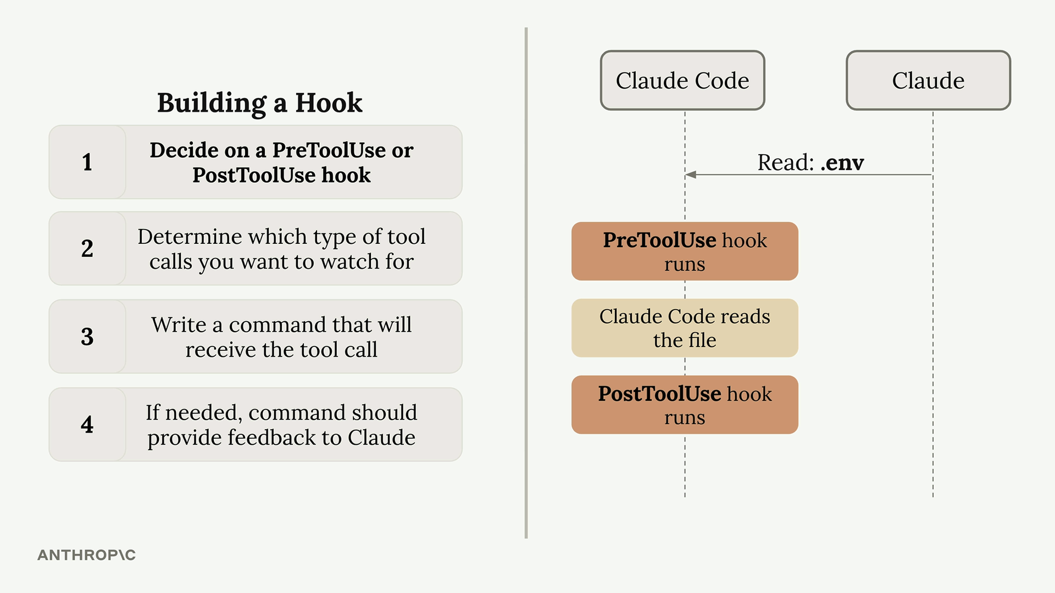

- Decide on a PreToolUse or PostToolUse hook - PreToolUse hooks can prevent tool calls from executing, while PostToolUse hooks run after the tool has already been used.
- Determine which type of tool calls you want to watch for - you need to specify exactly which tools should trigger your hook.
- Write a command that will receive the tool call - this command gets JSON data about the proposed tool call via standard input.
- If needed, the command should provide feedback to Claude - your command’s exit code tells Claude whether to allow or block the operation.
02 Available Tools
Claude Code provides several built-in tools that you can monitor with hooks:
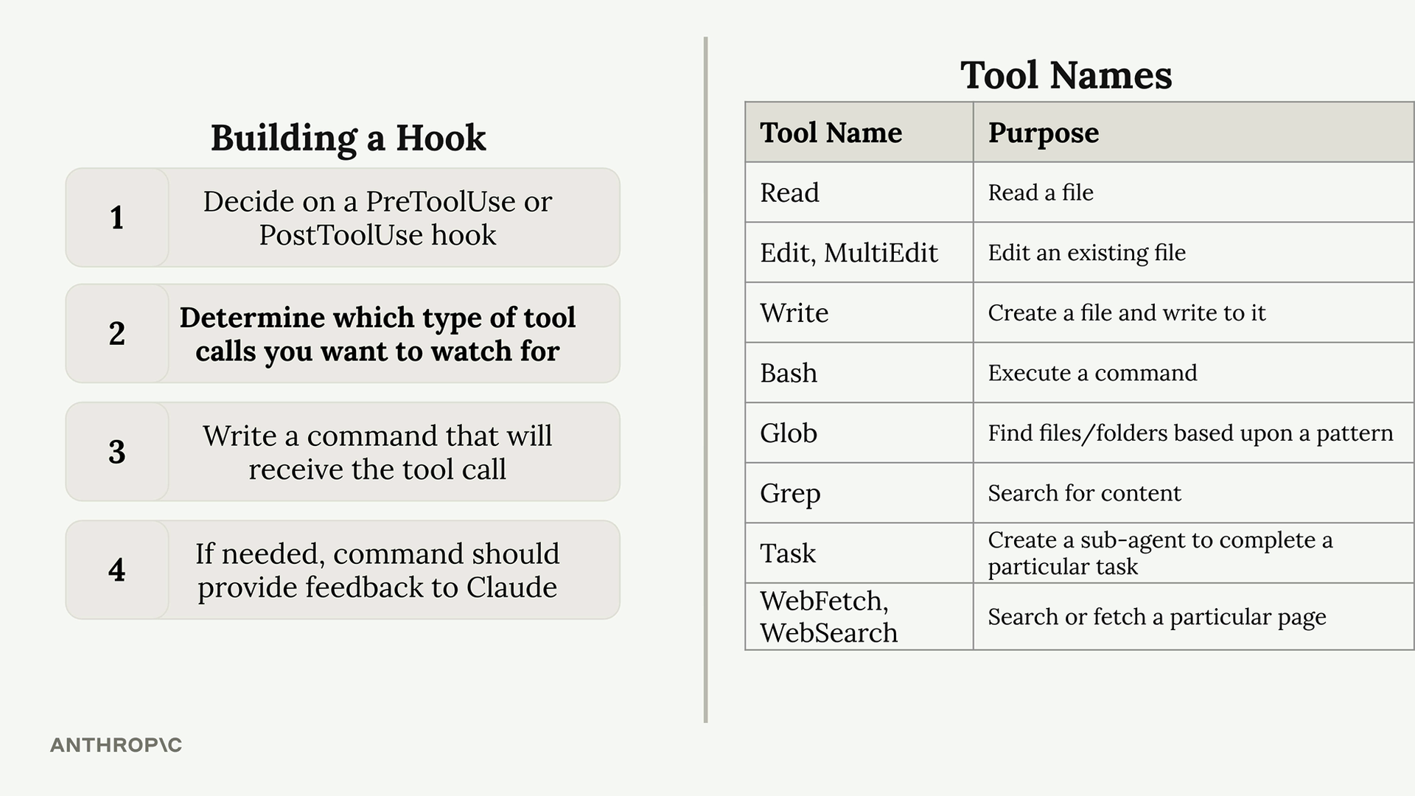

To see exactly which tools are available in your current setup, you can ask Claude directly for a list. This is especially useful since the available tools can change when you add custom MCP servers.
03 Tool Call Data Structure
When your hook command executes, Claude sends JSON data through standard input containing details about the proposed tool call:
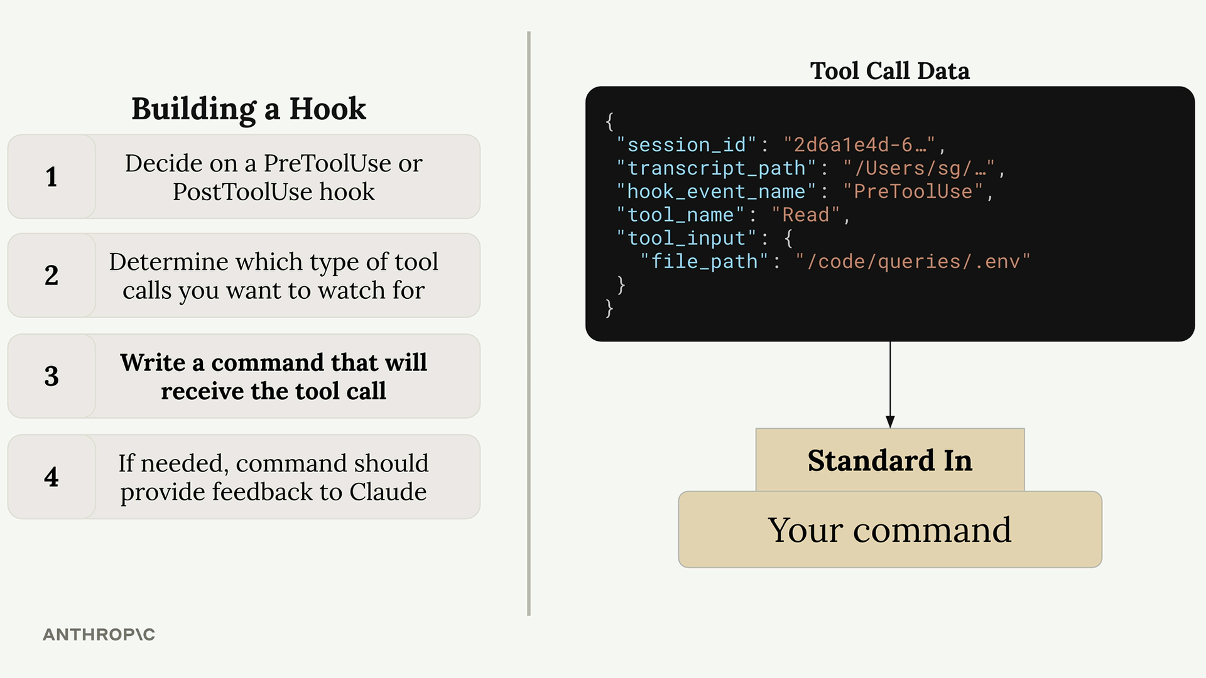

{
"session_id": "2d6a1e4d-6...",
"transcript_path": "/Users/sg/...",
"hook_event_name": "PreToolUse",
"tool_name": "Read",
"tool_input": {
"file_path": "/code/queries/.env"
}
}
Your command reads this JSON from standard input, parses it, and then decides whether to allow or block the operation based on the tool name and input parameters.
04 Exit Codes and Control Flow
Your hook command communicates back to Claude through exit codes:
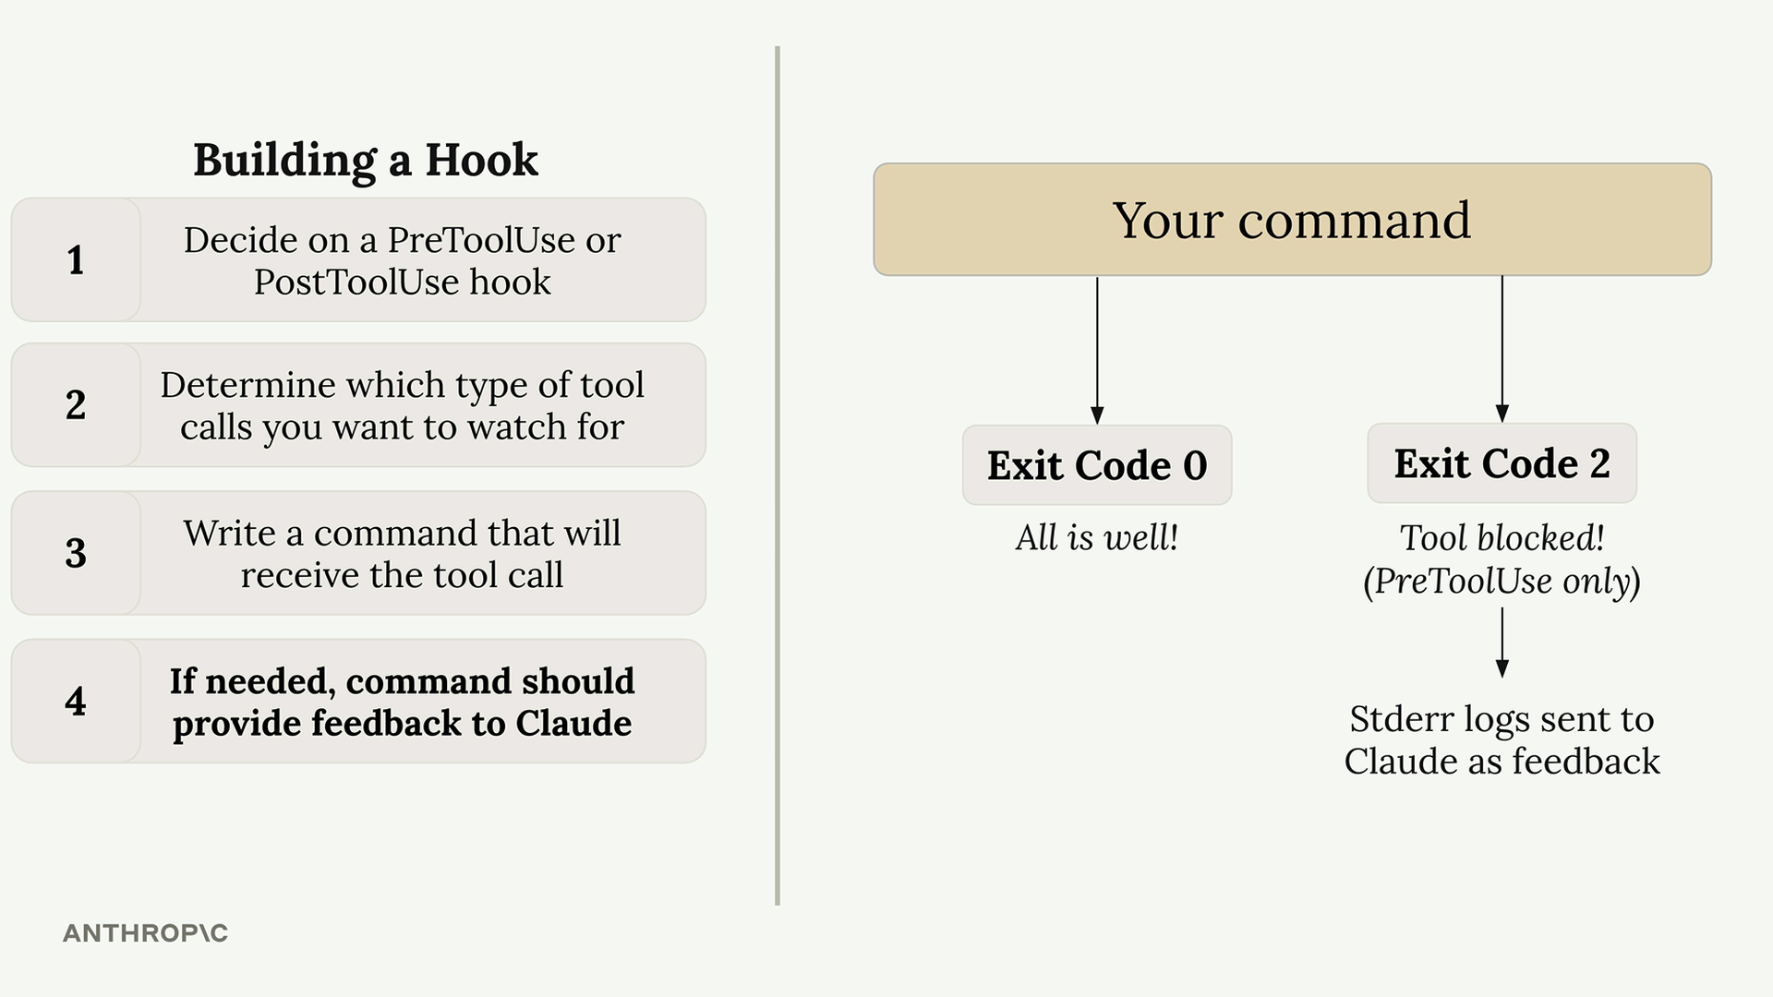

- Exit Code 0 - everything is fine, allow the tool call to proceed.
- Exit Code 2 - block the tool call (PreToolUse hooks only).
When you exit with code 2 in a PreToolUse hook, any error messages you write to standard error will be sent to Claude as feedback, explaining why the operation was blocked.
05 Example Use Case
A common use case is preventing Claude from reading sensitive files like .env files. Since both the Read and Grep tools can access file contents, you’d want to monitor both tool types and check if they’re trying to access restricted file paths.
This approach gives you complete control over Claude’s file system access while providing clear feedback about why certain operations are restricted.
Let’s build a hook that prevents Claude from reading sensitive files. This is a practical example of how a PreToolUse hook can intercept tool calls before they run.
06 Building the .env Read Hook
6.1 What This Exercise Covers
You’ll write a hook that blocks the Read tool from opening .env. This protects your environment variables during a session.
SCOPE
This hook covers Read only. Blocking Grep or Bash from reaching the same file requires checking each tool’s input shape separately, since each tool sends different fields. For comprehensive file protection, combine a hook with a permissions.deny rule like "Read(**/.env)".
6.2 Configure the Hook
Open .claude/settings.local.json and add a PreToolUse hook that matches the Read tool:
{
"hooks": {
"PreToolUse": [
{
"matcher": "Read",
"hooks": [
{ "type": "command", "command": "node $PWD/hooks/read_hook.js" }
]
}
]
}
}
6.3 Write the Hook Script
Create hooks/read_hook.js:
process.stdin.setEncoding("utf8");
let input = "";
process.stdin.on("data", (d) => (input += d));
process.stdin.on("end", () => {
const toolArgs = JSON.parse(input);
const readPath = toolArgs.tool_input?.file_path || "";
if (readPath.includes(".env")) {
console.error("You cannot read the .env file");
process.exit(2);
}
process.exit(0);
});
The hook reads the tool call from stdin as JSON, checks tool_input.file_path, and exits with code 2 to block the call (anything written to stderr becomes the message Claude sees).
6.4 Test It
In a Claude Code session, ask Claude to read your .env file. You should see:
You cannot read the .env file
That’s the hook blocking the Read call. Ask Claude to read a different file and it works normally.
6.5 Why Read Only?
Each tool sends a different input shape. Read sends {"file_path": "..."}; Grep sends {"pattern": "...", "path": "..."} where path is a search directory, not a file; Bash sends {"command": "..."}. A check on file_path catches Read but won’t catch a project-wide grep for API_KEY or a cat .env in Bash. To cover those, you’d write separate matchers per tool and inspect each one’s specific fields - or use permissions.deny rules, which apply uniformly across tools.
6.6 Sharing Settings Across Machines
You may notice that after running the npm run setup command there are two settings.json files in the .claude directory. Let me explain what’s going on there.
The Claude Code documentation lists some recommendations around hooks security:
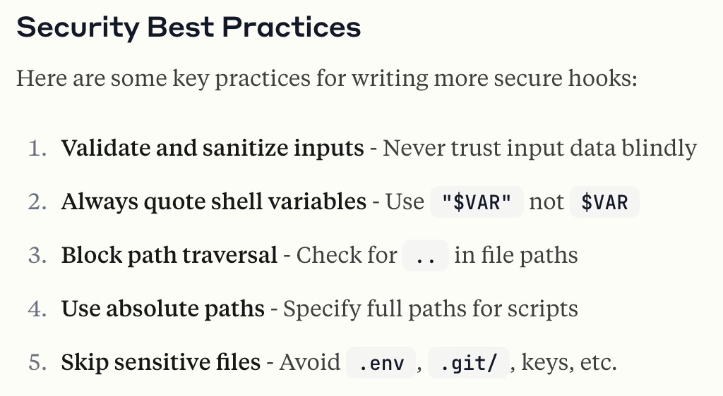
One of the recommendations is to use absolute paths (rather than relative paths) for scripts. This helps mitigate path interception and binary planting attacks.
This recommendation also makes it much more challenging to share settings.json files. The reason is simple: the absolute path to any of the hook scripts on your machine will likely be different from the absolute path on my machine, simply because we will probably place the project in separate directories.
To solve this problem, our project has a settings.example.json file. Inside of it, the script references contain a $PWD placeholder. When we run npm run setup, some dependencies are installed, but it also runs an init-claude.js script placed inside the scripts directory. This script will replace those $PWD placeholders with the absolute path to the project on your machine, copy the settings.example.json file, and rename it to settings.local.json.
This script allows us to share settings.json files but still use the recommended absolute paths.
07 TypeScript Type Checking Hook
One of the most useful hooks addresses a fundamental problem: when Claude modifies a function signature, it often doesn’t update all the places where that function is called throughout your project.
For example, if you ask Claude to add a verbose parameter to a function in schema.ts, it will successfully update the function definition but miss the call site in main.ts. This creates type errors that Claude doesn’t immediately catch.
The solution is a post-tool-use hook that runs the TypeScript compiler after every file edit:
- Runs tsc --noEmit to check for type errors.
- Captures any errors found.
- Feeds the errors back to Claude immediately.
- Prompts Claude to fix the issues in other files.
This hook works for any typed language where you can run a type checker. For untyped languages, you could implement similar functionality using automated tests instead.
08 Query Duplication Prevention Hook
In larger projects with many database queries, Claude sometimes creates duplicate functionality instead of reusing existing code. This is especially problematic when you give Claude complex, multi-step tasks that include database operations as just one component.
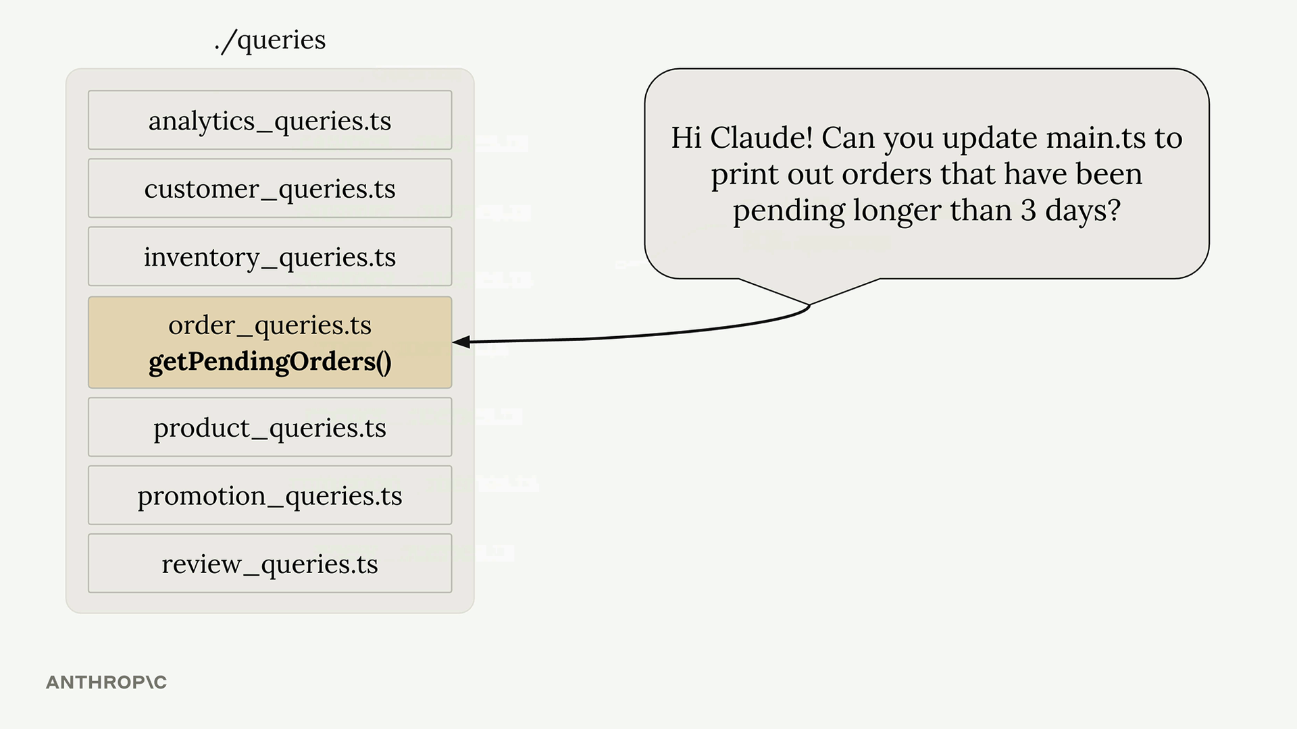
Consider a project structure with multiple query files, each containing many SQL functions. When you ask Claude to “create a Slack integration that alerts about orders pending longer than 3 days,” it might write a new query instead of using the existing getPendingOrders() function.
The query duplication hook addresses this by implementing a review process:
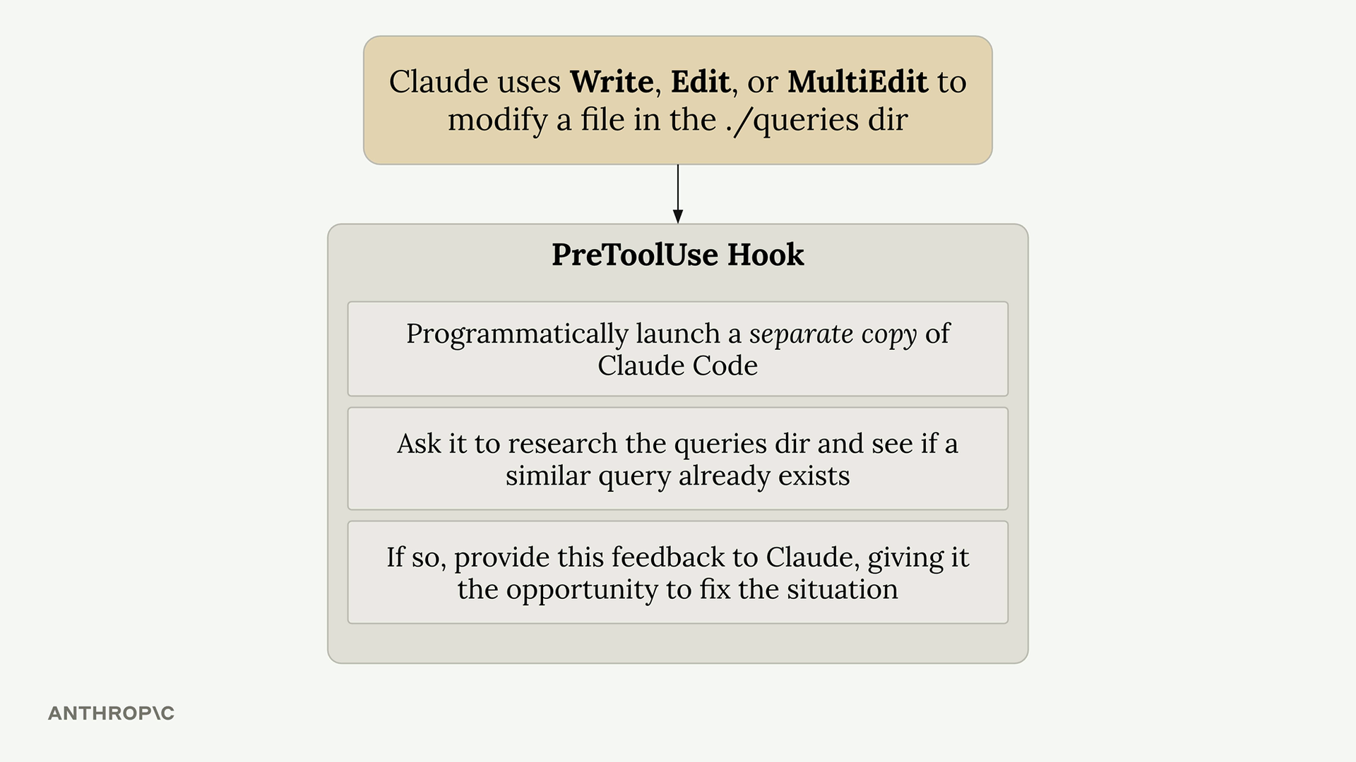
Here’s how it works:
- Triggers when Claude modifies files in the ./queries directory.
- Launches a separate instance of Claude Code programmatically.
- Asks the second instance to review the changes and check for similar existing queries.
- If duplicates are found, provides feedback to the original Claude instance.
- Prompts Claude to remove the duplicate and use the existing functionality.
09 Implementation Considerations
Both hooks use the pre-tool-use or post-tool-use hook system. The TypeScript hook is relatively lightweight and runs quickly. The query duplication hook requires more resources since it launches a separate Claude instance for each review.
For the query hook, consider these trade-offs:
- Benefits - a cleaner codebase with less duplication.
- Costs - additional time and API usage for each query directory edit.
- Recommendation - only monitor critical directories to minimize overhead.
The hooks use Claude’s Agent SDK to programmatically interact with the AI. This allows you to create sophisticated workflows where one Claude instance can review and provide feedback on another’s work.
10 Extending These Concepts
These hooks demonstrate broader principles you can apply to your own projects:
- Use compiler/linter output to provide immediate feedback.
- Implement code review processes using separate AI instances.
- Focus monitoring on high-value directories where consistency matters most.
- Balance automation benefits against performance costs.
The key is identifying the specific pain points in your development workflow and creating targeted hooks that address those issues automatically.
11 Other Hook Types
There are more hooks beyond the PreToolUse and PostToolUse hooks discussed in this course. There are also:
- Notification - runs when Claude Code sends a notification, which occurs when Claude needs permission to use a tool, or after Claude Code has been idle for 60 seconds.
- Stop - runs when Claude Code has finished responding.
- SubagentStop - runs when a subagent (displayed as a “Task” in the UI) has finished.
- PreCompact - runs before a compact operation occurs, either manual or automatic.
- UserPromptSubmit - runs when the user submits a prompt, before Claude processes it.
- SessionStart - runs when starting or resuming a session.
- SessionEnd - runs when a session ends.
THE CONFUSING PART
The stdin input to your commands will change based on the type of hook being executed (PreToolUse, PostToolUse, Notification, etc.).
The tool_input contained in that will differ based on the tool that was called (in the case of PreToolUse and PostToolUse hooks).
For example, here’s a sample of some stdin input to a hook, where the hook is a PostToolUse that was watching for uses of the TodoWrite tool. For reference, that is the tool that Claude uses to keep track of to-do items.
{
"session_id": "9ecf22fa-edf8-4332-ae85-b6d5456eda64",
"transcript_path": "<path_to_transcript>",
"hook_event_name": "PostToolUse",
"tool_name": "TodoWrite",
"tool_input": {
"todos": [{ "content": "write a readme", "status": "pending", "id": "1" }]
},
"tool_response": {
"oldTodos": [],
"newTodos": [{ "content": "write a readme", "status": "pending", "id": "1" }]
}
}
And for comparison, here’s an example of the input to a Stop hook:
{
"session_id": "af9f50b6-f042-4773-b3e2-c3a4814765ce",
"transcript_path": "<path_to_transcript>",
"hook_event_name": "Stop",
"stop_hook_active": false
}
As you can see, the stdin input to your command will differ significantly based on the hook (PreToolUse, PostToolUse, Stop, etc.) and the matcher used. This can make writing hooks challenging - you might not know the exact structure of the input to your command.
To handle this challenge, try making a helper hook like this:
"PostToolUse": [ // Or "PreToolUse" or "Stop", etc
{
"matcher": "*",
"hooks": [
{
"type": "command",
"command": "jq . > post-log.json"
}
]
},
]
Notice the provided command. It will write the input to this hook to the post-log.json file, which lets you inspect exactly what would have been fed into your command. This makes it a lot easier to understand what data your command should inspect.

Hooks turn Claude Code into a programmable, guard-railed teammate - intercept what matters, and let everything else run.

Demo Files/Link
Drive Folder - Link
https://github.com/ANI-IN/ecommerce-query-utils

