**Squashing:**

There are total 3 commits in our project. After doing latest commit in github, run these commands:

1. **git rebase –i HEAD~3**

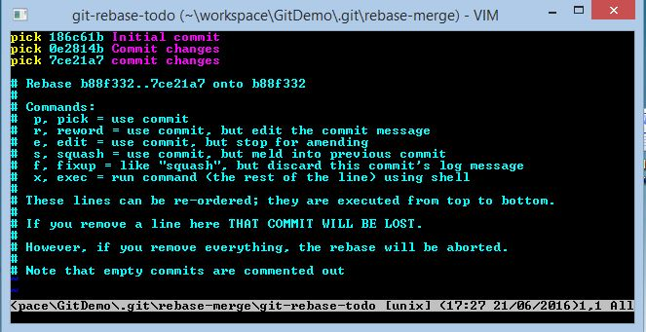

1. Pick the intial commit and squash the remaining commits.

pick 186c61b Initial commit

**squash** 0e2814b Commit changes

**squash** 7ce21a7 commit changes

1. Save the file using :wq

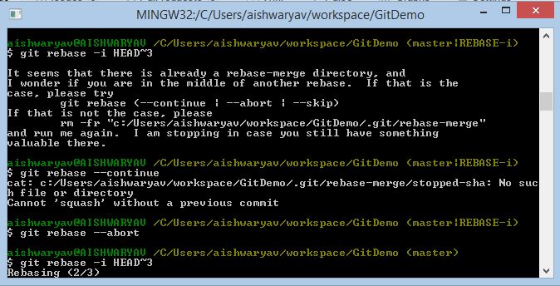

1. After rebasing,

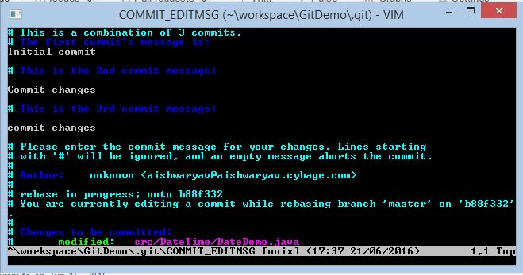

1. Check the commits. Press Esc button. Write “:wq”

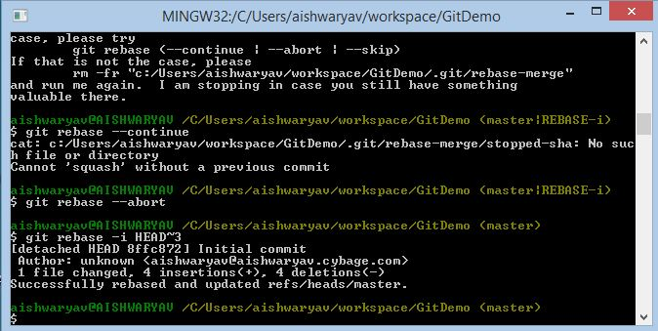

1. It will be rebased and updated in local machine.
2. We need to push it in github.

cmd : git push –f origin master