- JOIN METHODS

  - TASK 1: NESTED LOOP JOIN

Two tables were created test_joins_a and test_joins_b and filled in with data. After execution the query with a condition a.id1 > b.id1 below:
EXPLAIN ANALYZE
SELECT * FROM test_joins_a a, test_joins_b b WHERE a.id1 > b.id1;

Query planner chose Nested Loop Join because the condition a.id1 > b.id1 is an inequality predicate. Hash Join and Merge Join require an equality condition (=) to work — they cannot be used here. For every row in test_joins_a (outer loop, 10 000 rows), PostgreSQL performs a full Sequential Scan of test_joins_b (inner loop, 10 000 rows). Result: ~49 995 000 rows (roughly half of all pairs satisfy a.id1 > b.id1).

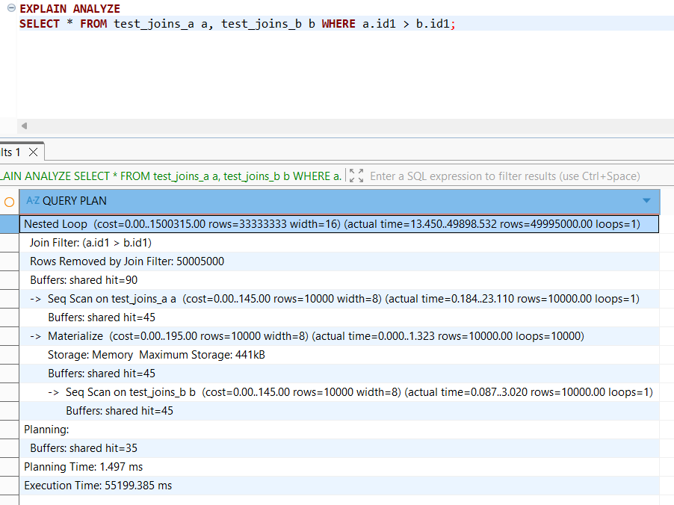
After execution the second query with CROSS JOIN below:
EXPLAIN ANALYZE
SELECT * FROM test_joins_a a CROSS JOIN test_joins_b b;
Query planner chose Nested Loop Join because CROSS JOIN has no join condition at all — it is a Cartesian product of both tables. There is nothing to hash or sort on, so Hash Join and Merge Join are not applicable. Every row from test_joins_a is paired with every row from test_joins_b — all pairs are emitted as results. Result: exactly 100 000 000 rows — every possible pair is a match.
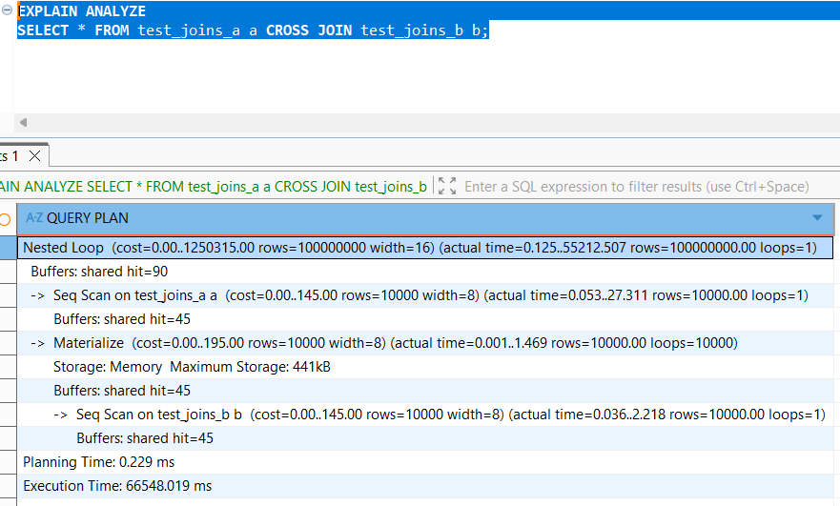
Both queries force Nested Loop Join, but for different reasons — one has an inequality condition that other algorithms cannot handle, and the other has no condition at all.
1.2 TASK 2: HASH JOIN

To force Query planner chose Hash Join, the condition to equality was passed and other methods(Merge join and Nested loop) were disabled:
SET enable_nestloop = off;
SET enable_mergejoin = off;
EXPLAIN ANALYZE
SELECT * FROM test_joins_a a, test_joins_b b
WHERE a.id1 = b.id1;
Hash Join was ~40% faster here because it skipped sorting entirely — it just built a hash table once and probed it. Only 1 batch was created so everything fit in RAM — no disk spill. Result:
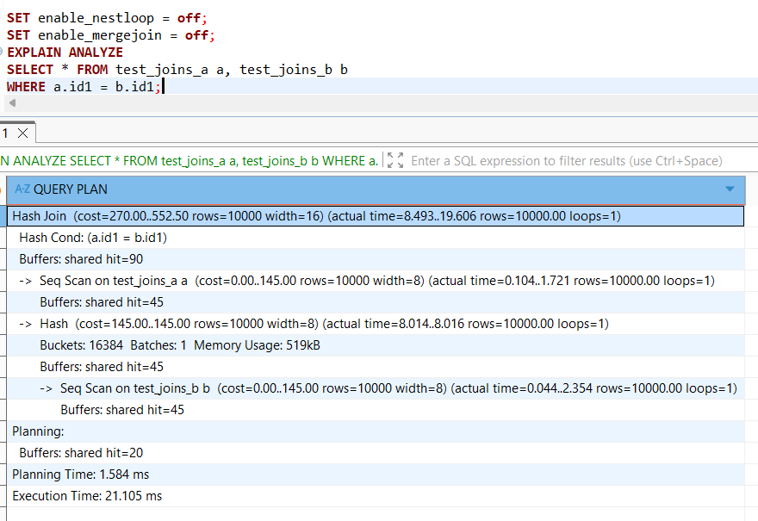
Regular JOIN returns all matching pairs. Semi Join only asks whether a match exists. This makes Semi Join more efficient when only the existence of a match matters, not the actual matched values from table. It is expressed in SQL using EXISTS or IN subqueries:
EXPLAIN ANALYZE
SELECT * FROM test_joins_a
WHERE id1 IN (SELECT id1 FROM test_joins_b);
The result of a transaction:
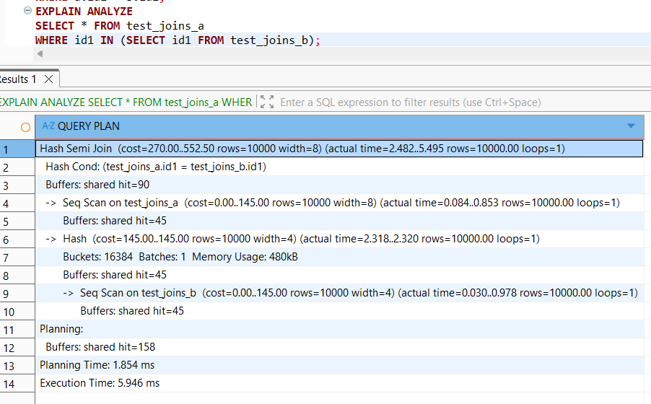
Hash Semi Join was ~3.5× faster than regular Hash Join because it stopped probing the hash table as soon as the first match was found per outer row, avoiding unnecessary extra work.

After setting enable_hashjoin off, query planner chose Merge Semi Join, which required sorting both tables first using quicksort — adding extra time and memory overhead. Hash Semi Join was faster because it built a hash table in a single pass with no sorting needed:
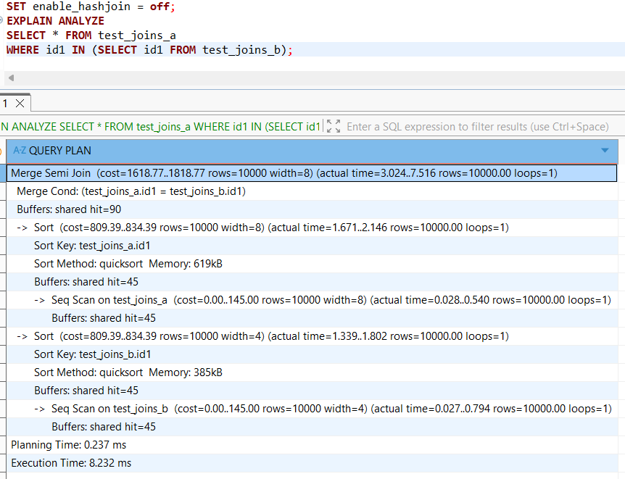
After re-enabling Hash Join with SET enable_hashjoin = on, the planner returns to Hash Semi Join as the optimal choice.

1.3 TASK 3: MERGE JOIN

To force Query planner chose Merge Join, indexes on id were created and the query was ORDERed BY a.id1. By creating B-tree indexes on id1 in both tables, the data is already stored in sorted order. PostgreSQL reads both tables through Index Scans which return rows in ascending order by nature of the B-tree structure — no explicit sort step is needed before merging.
With Nested Loop and Hash Join disabled, the planner chose Merge Join as the only remaining option. It sorted both tables by id1 using quicksort and then merged them in a single linear pass. Despite requiring two sorts upfront, Merge Join was the fastest method for this equality join — completing in just 6.799 ms compared to 21.105 ms for Hash Join — because both sorted streams could be walked simultaneously with minimal memory overhead and no hash table construction:
CREATE INDEX idx_a_id1 ON test_joins_a(id1);
CREATE INDEX idx_b_id1 ON test_joins_b(id1);
ANALYZE;
EXPLAIN ANALYZE
SELECT * FROM test_joins_a a
JOIN test_joins_b b ON a.id1 = b.id1
ORDER BY a.id1;
Merge Join was achieved by creating indexes on the join key id1 and adding ORDER BY a.id1 to guide the planner. The indexes eliminated the need for an explicit sort phase — the most expensive part of Merge Join — allowing PostgreSQL to merge both streams directly in a single linear pass. This resulted in an execution time of just 5.184 ms with no additional memory needed for sorting:
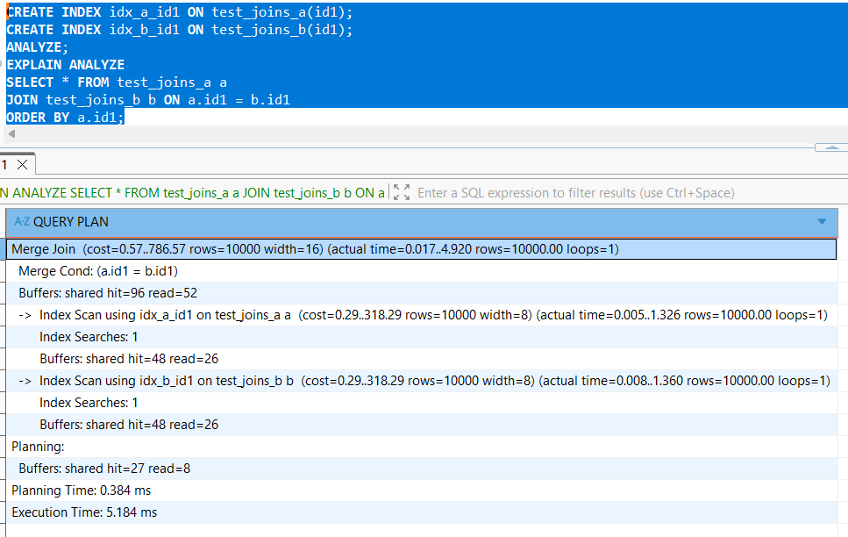
With Merge Join disabled, the planner fell back to Hash Join — but since the query still requires ORDER BY a.id1, PostgreSQL had to add an explicit Sort step on top of the Hash Join result costing an extra 697kB of memory and increasing execution time from 5.184 ms to 8.841 ms. This demonstrates that Merge Join with indexes is the most efficient method for sorted equality joins — it produces sorted output naturally through Index Scans, avoiding both hash table construction and explicit sorting. 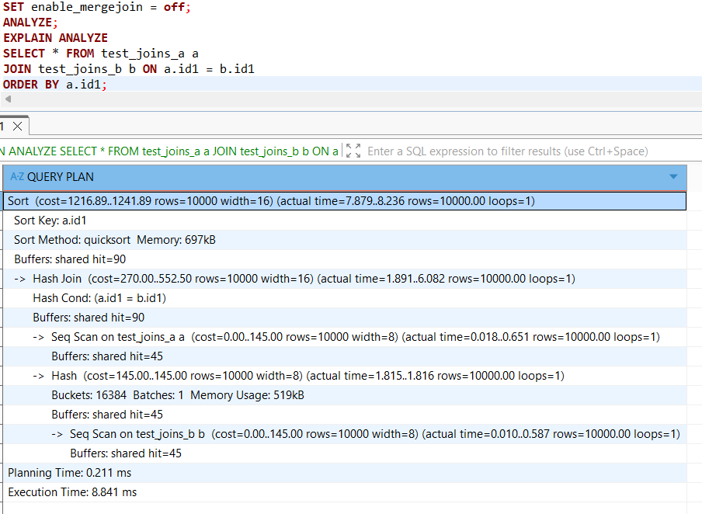

2. JOIN ORDER AND LATERAL JOIN

2.1 TASK 4: CHANGING JOIN ORDER

The 3 table test_joins_c was created and filled in with data. PostgreSQL optimized the join order by processing the two small tables (test_joins_a and test_joins_b) first via a regular Hash Join, producing a compact 10 000 row intermediate result. It then joined that result against the large test_joins_c table using Hash Right Join — scanning the large table as the outer probe side rather than building a hash table from it. The LEFT JOIN was internally rewritten as a RIGHT JOIN to allow the smaller result set to be on the hash build side, minimizing memory usage.
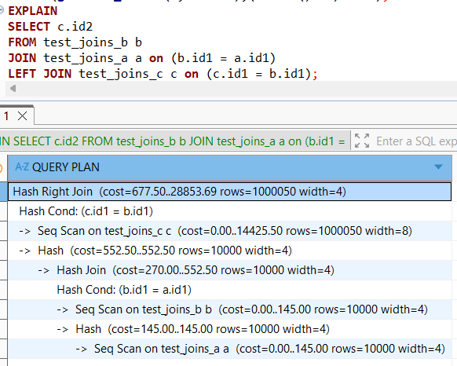
join_collapse_limit = 1 prevents the planner from reordering tables — it must join them strictly in the order they appear in the query. However, in this case the order written in the SQL already matches the order the planner would have chosen on its own. Since the optimal join order already matched the written order, the restriction had no effect and the plan remained unchanged:
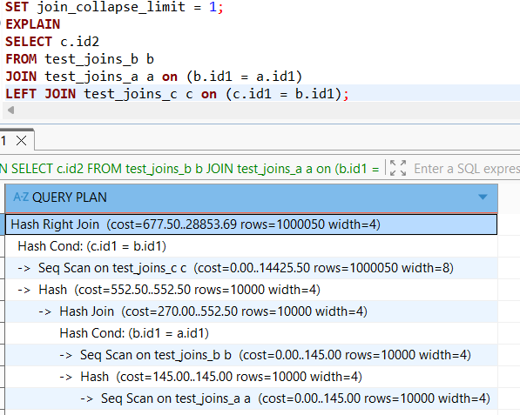

2.2 TASK 5: LATERAL JOIN

SELECT
s.store_id,
s.store_name,
s.max_order_cost,
o.order_id,
o.order_cost,
o.order_num
FROM stores s
JOIN LATERAL (
SELECT order_id, order_cost, order_num
FROM orders
WHERE order_cost < s.max_order_cost
ORDER BY order_cost DESC
LIMIT 10) o ON true
Total 29 rows were returned — up to 10 orders per store, each with order_cost strictly below the store's max_order_cost:
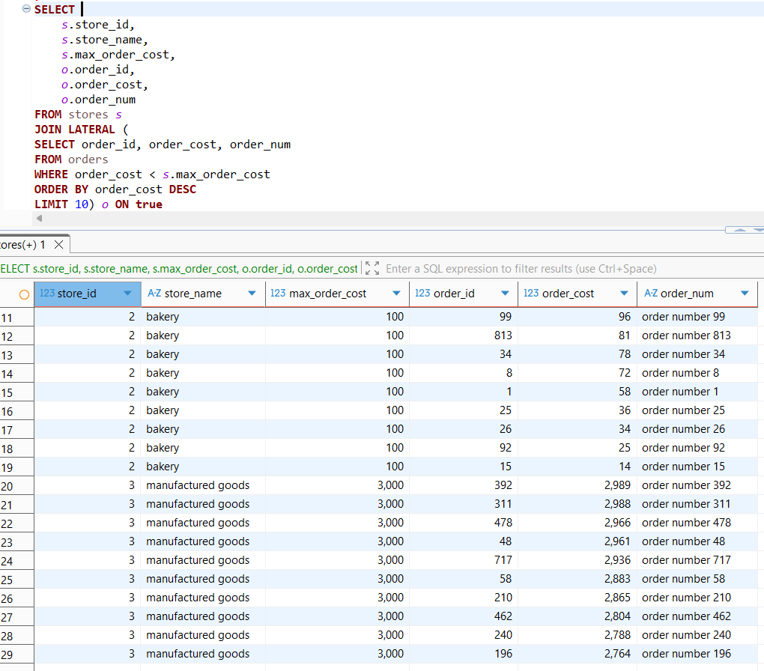
3. CTES
3.1 TASK 6: RECURSIVE CTE

The query:
SELECT * FROM emp;
WITH maneger as (SELECT empno, ename FROM emp)
SELECT e.empno, e.mgr, e.ename,m.ename AS mngname,
CASE
WHEN e.mgr IS NULL THEN 1
ELSE NTILE(4) OVER (ORDER BY e.mgr DESC) + 1
END AS lvl
FROM emp e
LEFT JOIN maneger m ON
e.mgr = m.empno
ORDER BY e.empno
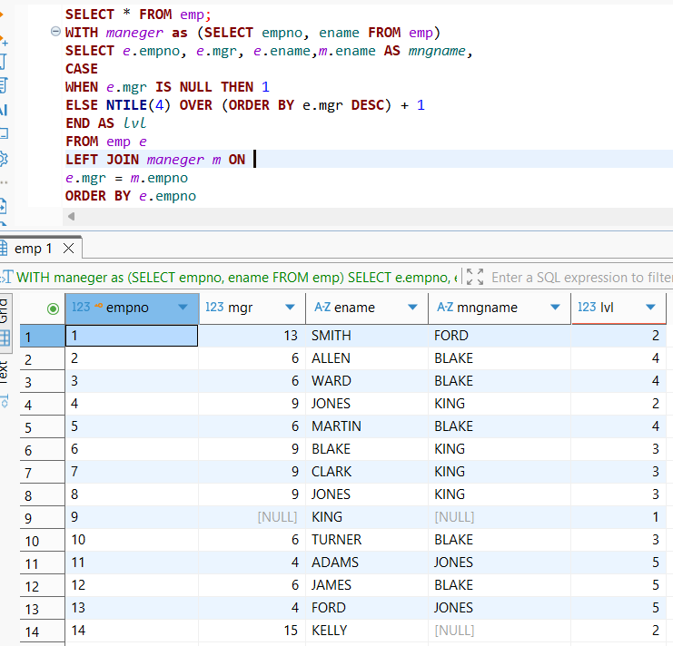
3.2 TASK 7: CHANGING DATA CTE
The query:
WITH
deleted AS
(DELETE FROM orders
WHERE order_cost<50
RETURNING order_id, order_cost, order_num, 'D' AS action_type
),
updated AS (
UPDATE orders
SET order_cost = order_cost / 2
WHERE order_cost BETWEEN 100 AND 1000
RETURNING order_id, order_cost, order_num, 'U' AS action_type
),
log_insert AS (
INSERT INTO order_log (order_id, order_cost, order_num, action_type)
SELECT order_id, order_cost, order_num, action_type FROM deleted
union ALL
SELECT order_id, order_cost, order_num, action_type FROM updated
RETURNING * )
SELECT * FROM log_insert;
