PL/pgSQL. Loading DM dimensions
To ensure that the transition from 3NF to Star Schema is repeatable, historically accurate (SCD2), and fully auditable the implementation stored procedures were added to the script. It transforms the Data Mart from a static set of tables into a dynamic, self-logging, and error-resistant ETL system.
Before the data load, USAGE, SELECT, INSERT, and UPDATE permissions were granted to the BL_CL . This ensures the ETL user has the necessary privileges to manipulate data. Also UNIQUE constraints were added to source ID columns in dimension tables. It enables the ON CONFLICT (UPSERT) logic used in the procedures.
DIM_DATES_DAY table
The date dimension is static and generative — its data doesn't come from a source system but is mathematically made via generate_series(). There is no source table to join, no updates to apply, and no conflicts to resolve. A plain INSERT with a NOT EXISTS subquery on date_id is sufficient: if the date range is already loaded, the procedure does nothing. The procedure LOAD_DIM_DATES_DAY exists to make the table idempotent and loggable:
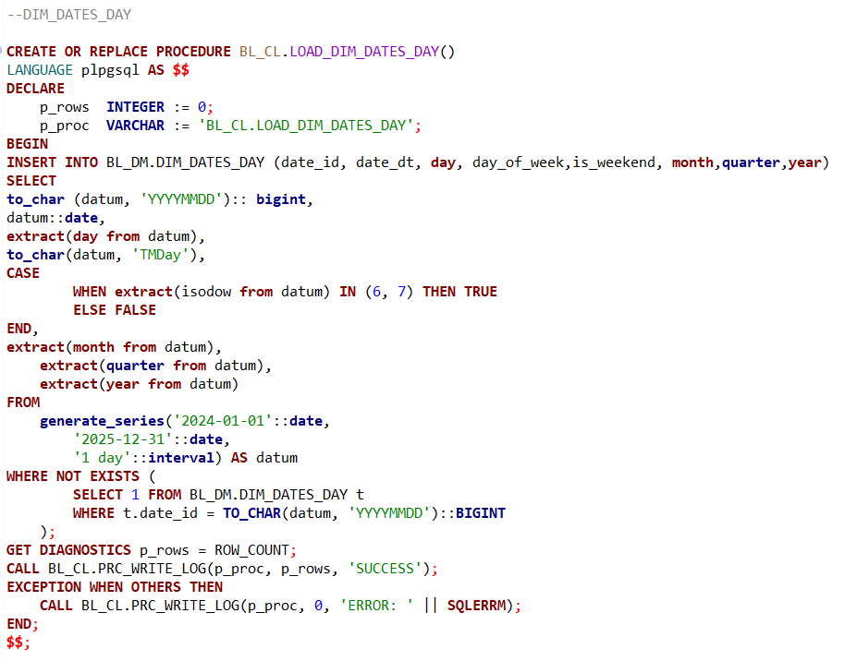
DIM_VENDORS table
To load data to DIM_VENDORS table the LOAD_DIM_VENDORS procedure with Composite Type and a Cursor-like Loop were designed.
Composite type was used to increase data integrity, composite type acts as a template, ensuring that every time vendor data is moved within the BL_CL layer, it follows the exact same format and constraints, it was created using the following logic:
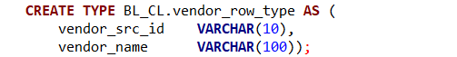
Cursor-like Loop acts as a row-by-row synchronization engine that migrates vendor data from the 3NF source to the Data Mart dimension. For each record, it applies data cleaning (handling nulls via the Composite Type) and performs an UPSERT, ensuring that new vendors are inserted and existing ones are updated only if their information has changed. it was implemented following :
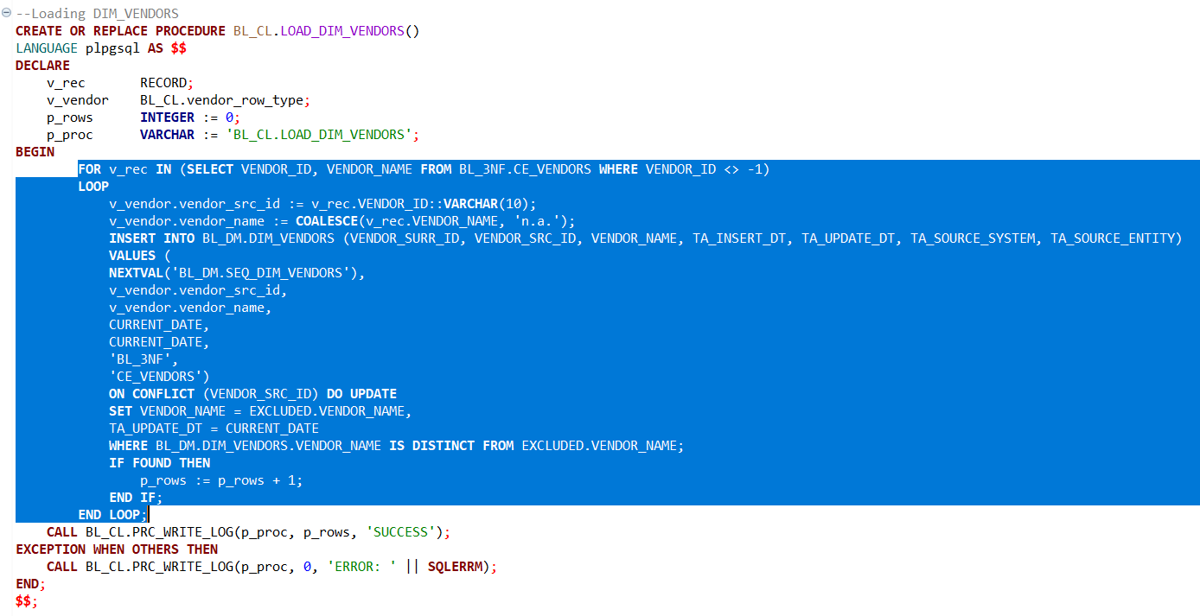
Also, error handling and logging are implemented in the end providing full visibility into both successful data loads and critical failures.
DIM_PROMOTIONS table
Unlike the vendor loading process, LOAD_DIM_PROMOTIONS procedure avoids loops and instead uses a single INSERT ... SELECT statement to optimize speed. Processing 10,000 rows in one statement is significantly faster than executing 10,000 individual insert commands inside a loop. It ensures that if a promotion's discount changes in the source system, the Data Mart reflects that change immediately for accurate sales analysis.
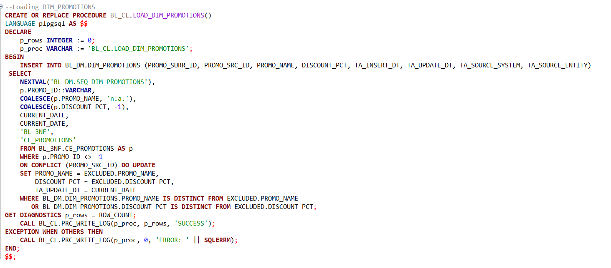
Error handling and logging are implemented in the end providing full visibility into both successful data loads and critical failures.
DIM_STORES
The LOAD_DIM_STORES is implemented with REFCURSOR combined with the FETCH command. The cursor is used to "wrap" the heavy SQL logic required to flatten the geographic hierarchy. This separates the extraction logic (selecting and joining data) from the loading logic (performing the UPSERT), making the procedure significantly easier to debug and maintain. LOOP and FETCH structure provides absolute control over every iteration. This allows for precise auditing and making it easy to add future business rules or row-level validations without rewriting the entire query.
Procedure defines a REFCURSOR (cur_stores) that executes a complex LEFT JOIN between CE_STORES, CE_ADDRESSES, CE_CITIES, and CE_COUNTIES. It iterates through this cursor using a LOOP, fetching records that include the store name, type, house number, city, zip code, and county name. For each fetched record, it performs an UPSERT (INSERT ... ON CONFLICT).
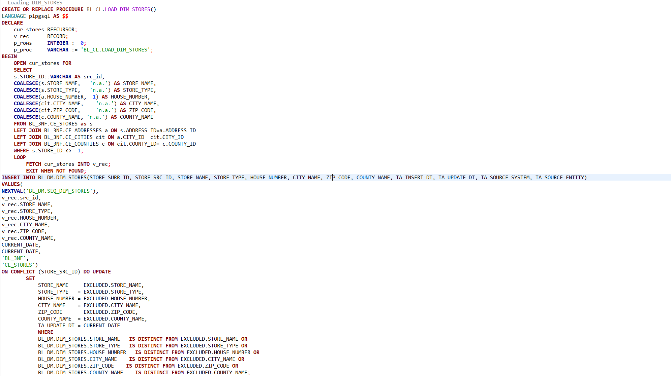
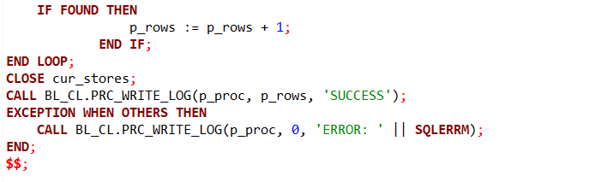
DIM_ITEMS_SCD table
LOAD_DIM_ITEMS_SCD procedure uses a simple mechanism. The procedure first performs an UPDATE on existing records in the Data Mart where TA_IS_ACTIVE = 'Y'. It sets the TA_END_DT to the previous day and changes the status to 'N' if the source system (BL_3NF) indicates that a newer version has been created. It then executes an INSERT to bring in the new active records from BL_3NF.CE_ITEMS_SCD. These records are marked with TA_IS_ACTIVE =’Y”. This approach allows the business to report on sales using the attributes that were valid at the time of the sale. By preserving every version of an item, the Data Mart enables analysts to track how changes in packaging or pricing affect sales performance over time. The procedure uses GET DIAGNOSTICS twice to capture the count of "closed" records and "newly opened" records. It then sums them up to provide a total row count in the MTA_LOGS table.
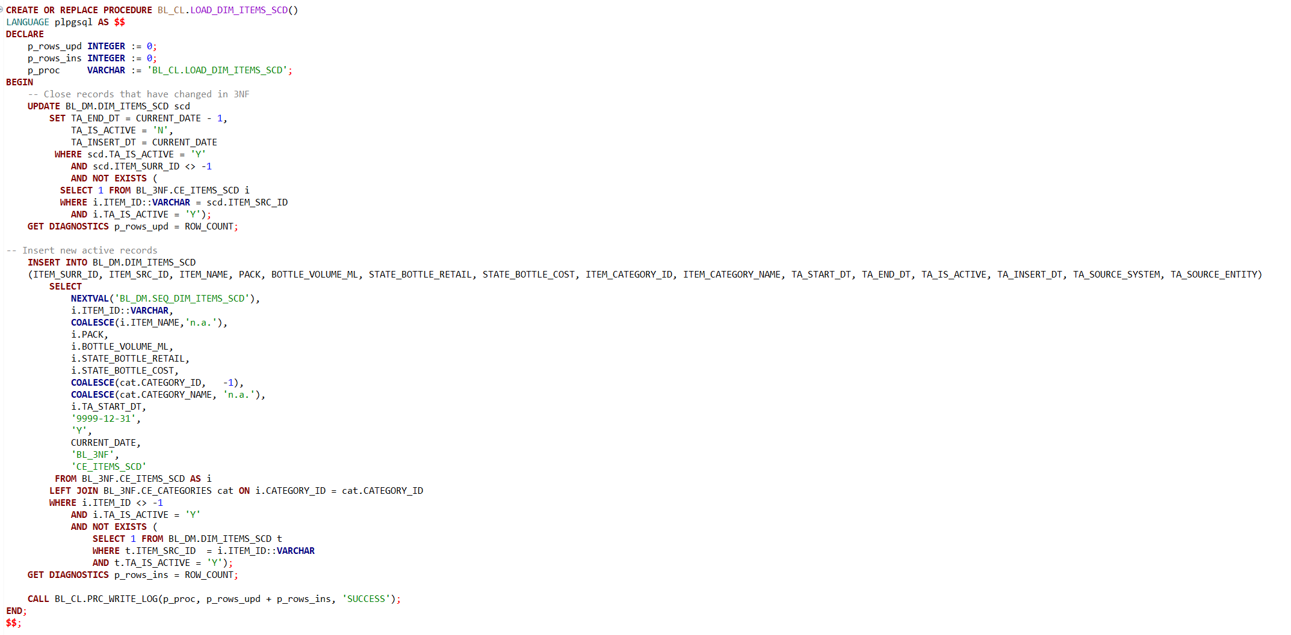
FCT_SALES_DD
The LOAD_FCT_SALES_DD procedure is implemented through Dynamic Execution. As fact table grow daily, static plans can become outdated. Dynamic execution ensures the optimizer chooses the most efficient path—such as the correct index scan—based on the most recent data distribution. Also, it helps to improve code readability. The procedure builds the logic into a v_sql text string and runs it via EXECUTE:
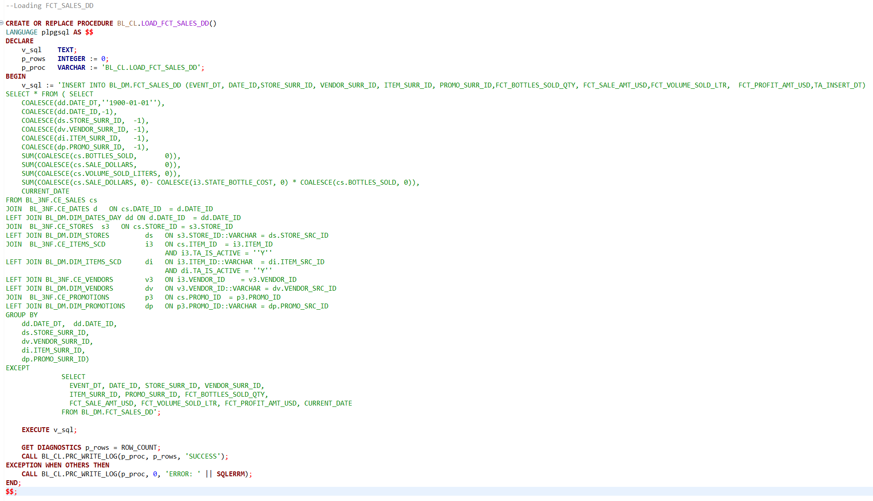
Also, error handling and logging are implemented in the end providing full visibility into both successful data loads and critical failures.
LOAD_ALL_DM_DATA (Master Procedure)
LOAD_ALL_DM_DATA procedure orchestrates the entire DM loading process. The dependency management is critical: the Fact table cannot be loaded until the Dimensions are ready to provide surrogate keys. It calls each sub-procedure in a specific order (Dimensions first, Fact last) and logs the results into MTA_LOGS.
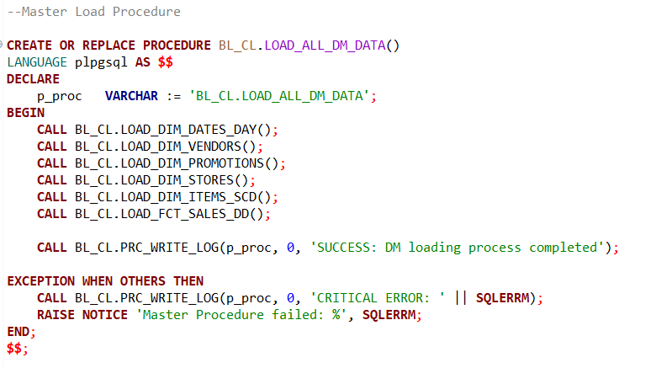
As the data have been already uploaded to DM layer the result of LOAD_ALL_DM_DATA procedure has 0 rows_affected results:
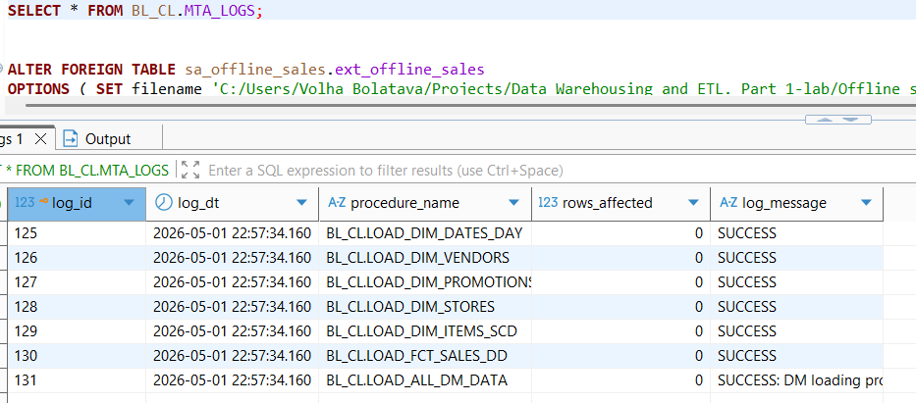
After executing all procedures BL_DM test was performed successfully , which means that all data is correctly and sufficient transferred from 3NF to DM:
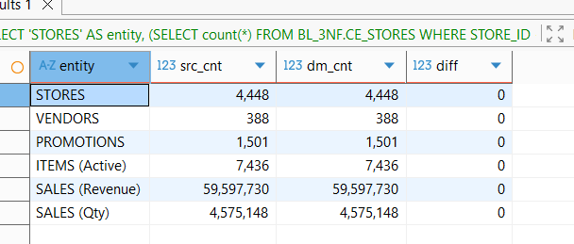
Testing loading SCD2 dimension
The item with item_id = ‘322’ was chosen for the test :
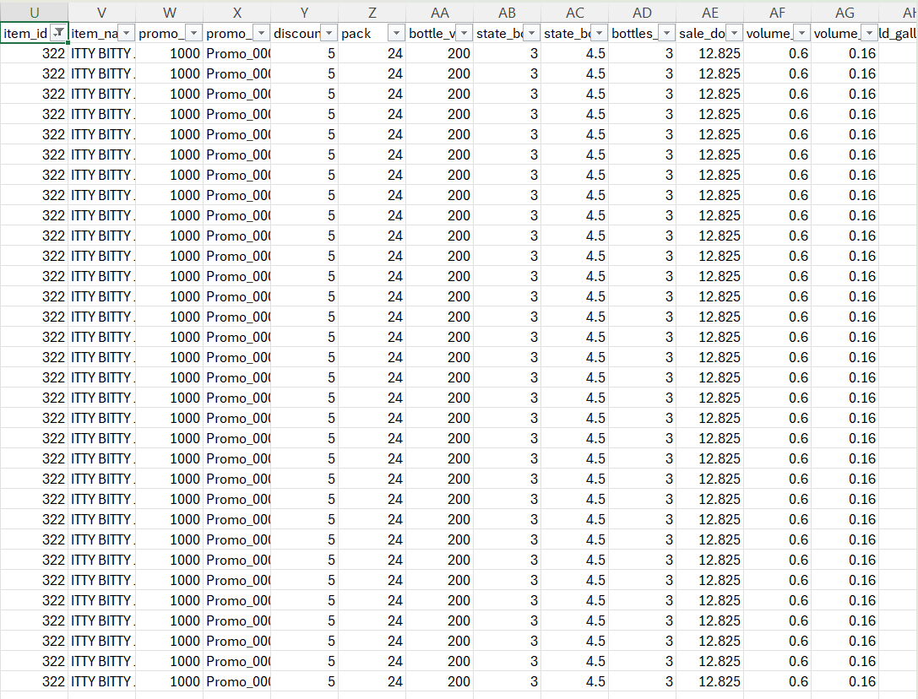
Item before changings in 3NF layer :
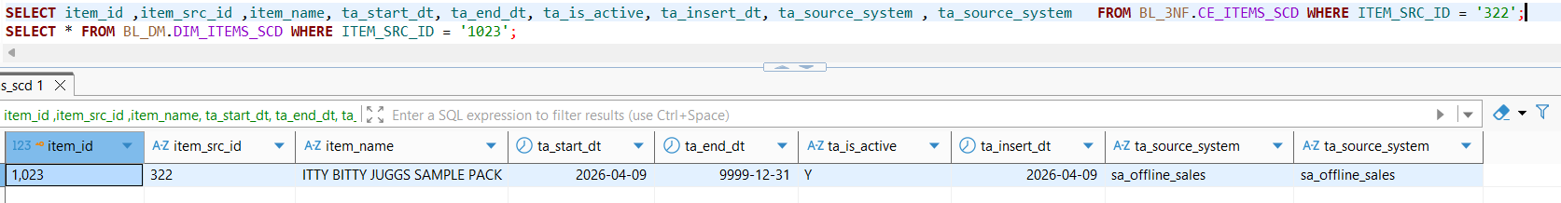
Item before changings in DM layer :
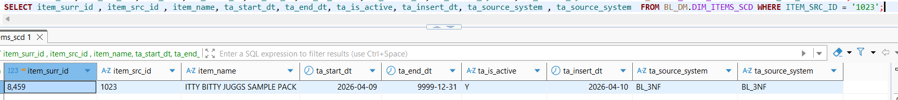
For iten_id = ‘322’ name was changed to ‘JUGGS’, state_bottle_retail was changed from 4.5 to 5 and bottles_sold from 3 to 4. Sale_dollars has changed accordingly taking into account discount percentage = 5%(discount_p).
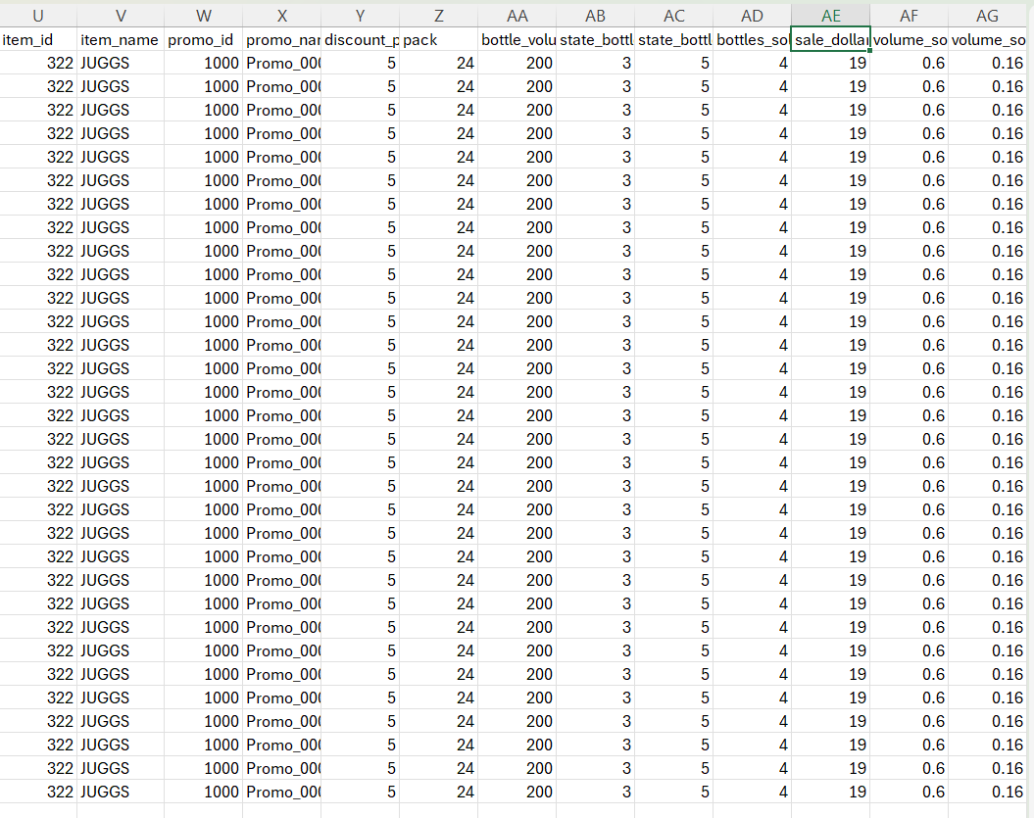
After loading new csv file with changed data to staging_layer:
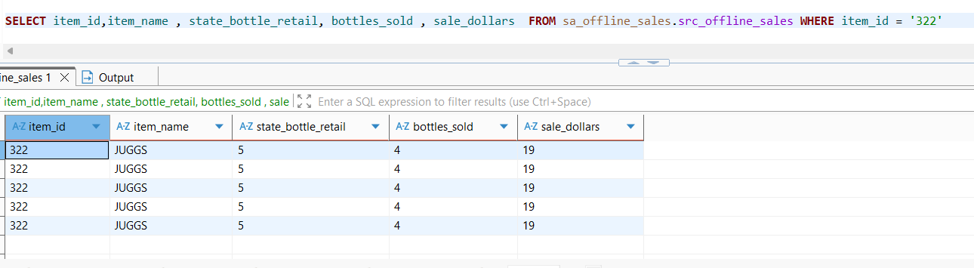
The procedure BL_CL.LOAD_CE_ITEMS_SCD executed successfully loading data from staging layer to 3NF. The log shows 2 rows affected, which correctly corresponds to closing the old historical record and inserting the new active one.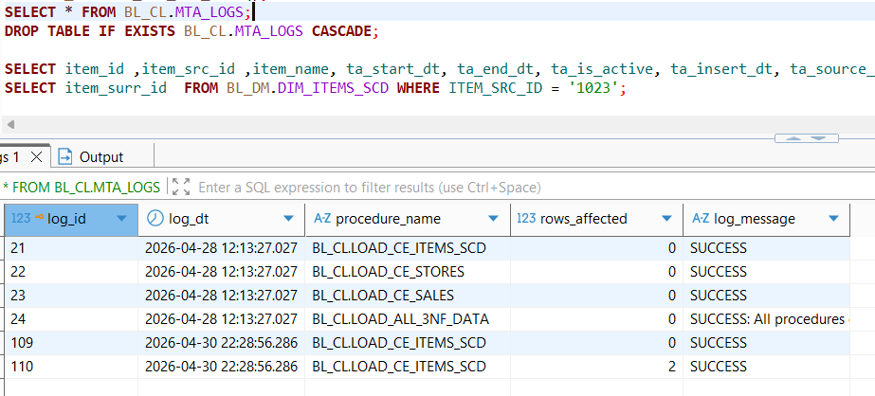
The query results for ITEM_SRC_ID = '322' in 3NF. Item with name "ITTY BITTY JUGGS SAMPLE PACK" marked with ta_is_active = 'N', indicating it is no longer the current version and the record was valid from 2026-04-09 to 2026-04-29. Current Active Record is with the name "JUGGS".This version became active on 2026-04-30. It is marked with ta_is_active = 'Y' and has a future-proof end date of 9999-12-31: 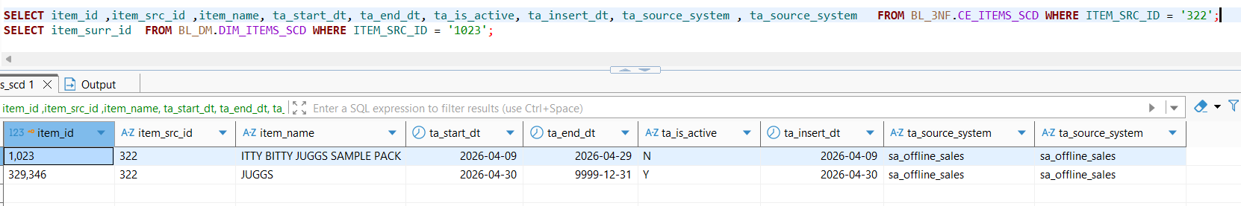
The procedure BL_CL.LOAD_DIM_ITEMS_SCD executed successfully loading data from 3NF to DM. The log shows 2 rows affected, which correctly corresponds to closing the old historical record and inserting the new active one.
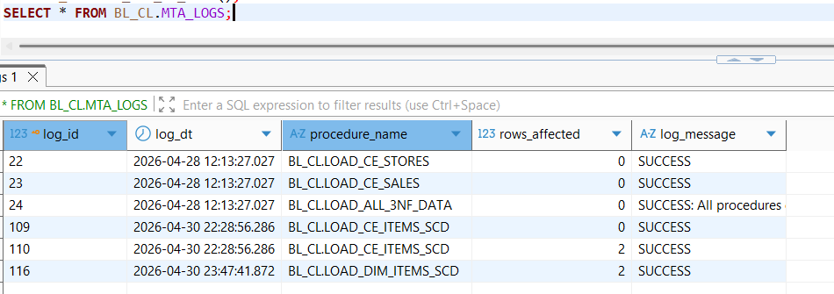
Item with name "ITTY BITTY JUGGS SAMPLE PACK" marked with ta_is_active = 'N', indicating it is no longer the current version and the record was valid from 2026-04-09 to 2026-04-29 (state_bottle_retail=4.5). Current Active Record is with the name "JUGGS".This version became active on 2026-04-30. It is marked with ta_is_active = 'Y' and has a future-proof end date of 9999-12-31(state_bottle_retail=5) :
