PL/pgSQL. Loading fact on 3NF / DM
Loading fact on 3NF
The LOAD_CE_SALES procedure is implemented using incremental load strategy. Shifting from a full refresh to an Incremental Load was made to optimize the ETL pipeline and handle high-frequency data updates each new load the system only processes "new" transactions, significantly reducing CPU and I/O overhead. The procedure first calculates v_last_load_dt by finding the maximum date already present in the target table. It uses the WHERE src.raw_date > v_last_load_dt clause. This ensures that the procedure only looks at sales records that occurred after the last successful load.
Also, procedure is merging data from both Online and Offline source systems using a UNION ALL. This helps to apply the same transformation rules (like handling the #VALUE! error and comma removal) to both sources simultaneously. It uses a NOT EXISTS subquery to remove duplicates and in the end of subquery the logging logic and error handling is implemented tracking all loads through the MTA_LOGS table. It provides a historical timeline, showing which procedures ran, when they ran, and how much data they moved.
Since the data is already in database, the v_last_load_dt set to the latest date found in source. Therefore, the filter raw_date > v_last_load_dt finds no new records.So, an incremental load to returned 0 as no new transactions have occurred in the source systems since the last run. It prevents the creation of duplicate sales records:
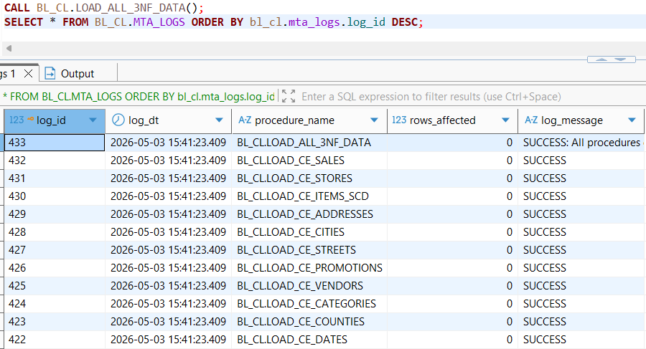
The query itself:
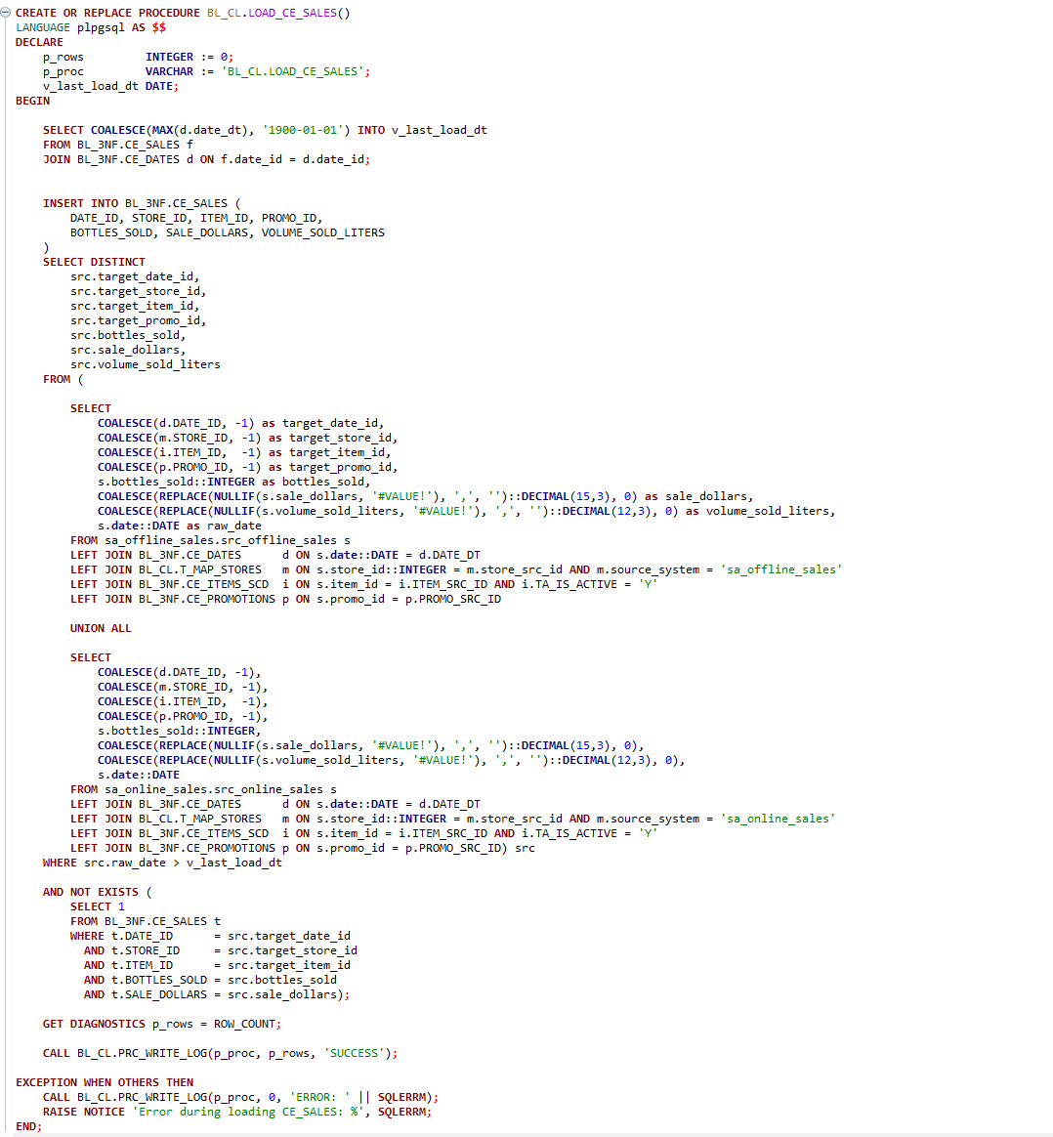
To check data consistency and integrity 6 data quality checks were implemented:
- TEST 1: Scans the CE_SALES table for duplicates. The test passed successfully with the 0 result of redundant data records.
- TEST 2: Ensures that all Foreign Keys in the Fact table are populated and contain no NULL values. The test passed successfully with the 0 result ensuring strict relational integrity constraints.
- TEST 3 & 4: Verifies that every store_id present in the source systems has a corresponding mapping in the T_MAP_STORES table. The test passed successfully with the 0 result - all source stores have been correctly identified and registered in the mapping layer before the final sales load, ensuring no revenue is "lost" due to unknown locations.
- TEST 5: Cross-references all item IDs from the source files against the CE_ITEMS_SCD table to ensure every product is recognized and Active. The test passed successfully with the 0 result. The Item Dimension was fully synchronized with the 3NF layer before the sales transaction load began. Every item found in the sales data has a valid, active master record.
- TEST 6: Checks for "garbage" rows where all dimension keys are equal to the default value (-1). This would indicate a complete failure in record resolution. The test passed successfully with the 0 result - there are no records where the system failed to identify every single attribute. This confirms the high reliability of the transformation logic.
The occurrence of 0 errors across all six tests confirms the robustness of the Incremental Load and Mapping logic. It proves that the 3NF layer maintains high data integrity, with no duplicates, full referential alignment with source systems, and effective handling of mandatory attributes:
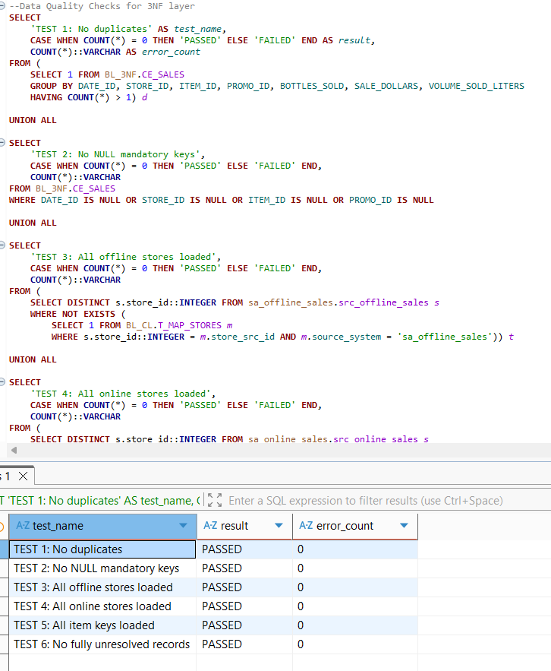

Loading fact on DM
The LOAD_FCT_SALES_DD procedure is implemented using attaching/detaching PARTITION clause and logic of load for rolling window period. This strategy enables Partition Pruning, allowing the database engine to skip irrelevant data segments during queries. This significantly accelerates reporting for specific time periods (e.g., monthly or yearly sales analysis). t facilitates easier data lifecycle management, such as archiving or dropping old historical data without affecting the performance of the active partitions.
Firstly, to divide Fact table into smaller, manageable pieces based on the EVENT_DT procedure MAINTAIN_FCT_PARTITIONS was used. This procedure implements Dynamic Partitioning to ensure the Data Mart is always ready to receive data without manual intervention. It identifies the date range within 3NF data and automatically creates monthly partitions. It has DEFAULT partition to catch any records that fall outside the defined monthly ranges, preventing the ETL process from failing due to "missing partition" errors ( for example technical row). By using ATTACH PARTITION, it registers these tables into the master FCT_SALES_DD table, allowing the database to perform Partition Pruning for faster query execution.
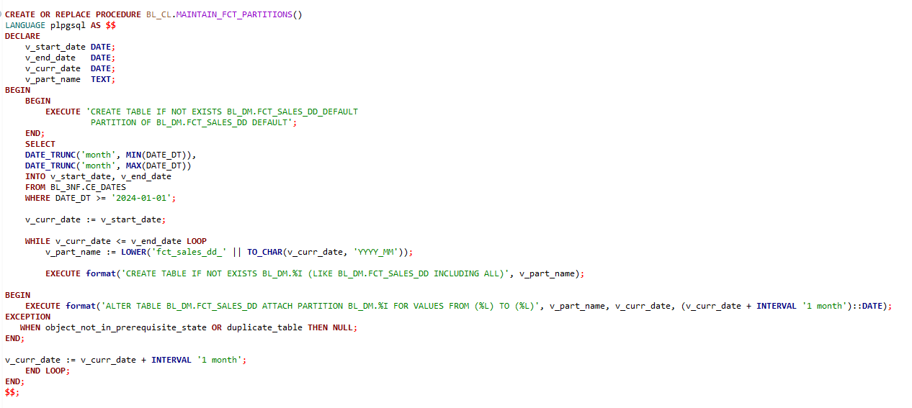
LOAD_FCT_SALES_DD is implemented using attaching/detaching PARTITION and window. The procedure scans BL_3NF.CE_DATES to identify the full date range of sales data available in the 3NF layer. The code finds the MIN and MAX dates in your 3NF layer to determine exactly which months need to be loaded. It sets a processing window starting from 2024-01-01 up to the latest available record, ensuring the ETL focuses only on relevant historical data. For every month in the range, the procedure identifies the corresponding partition. It uses ALTER TABLE ... DETACH PARTITION to temporarily remove the partition from the main table. This "unplugs" the month from the main Fact table, allowing the system to perform maintenance on that specific segment without locking the entire table for users. TRUNCATE is used to instantly clear all old data from that specific month. It is the fastest way to prepare the table for a fresh start without the overhead of heavy logging. Insert command ensures that freshly aggregated data together with the old inserted into the empty monthly table. With the help of ALTER TABLE ... ATTACH PARTITION the updated monthly table is "plugged" back into the master FCT_SALES_DD table. This makes the new data instantly visible to the end-users and reporting tools. Because it is attached as a partition, the database knows exactly which dates are inside it, allowing for Partition Pruning—which makes queries much faster by only scanning the relevant monthly tables.
While the loading of CE_SALES in 3NF is incremental (using a date watermark), this Data Mart procedure is designed as a monthly full-refresh. For every month in data set, it truncates the existing partition and re-inserts the data. So the result of the first execution of the query is 426,953. The number 426,953 represents the total count of unique, aggregated combinations of Date, Store, Vendor, Item, and Promotion in 3NF dataset.
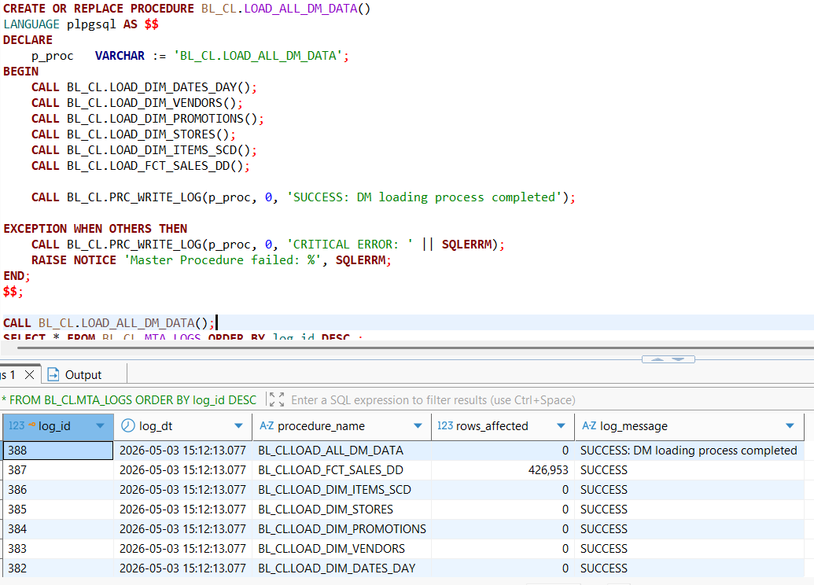
Second execution gives the same resalts as it is refreshing of the entire historical window, the sum of all monthly re-loads will always equal this full dataset count:
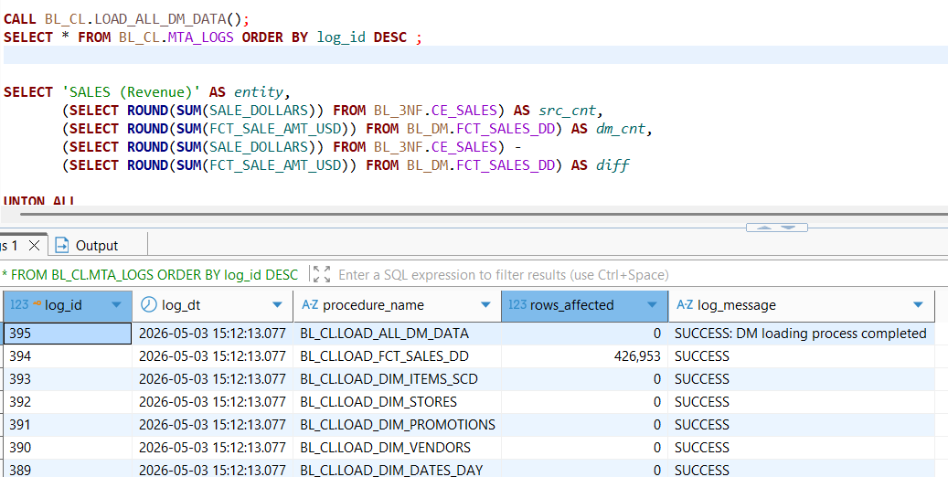
Nevertheless, total revenue and total bottles sold quantity stays equal in 3NF and DM layers.

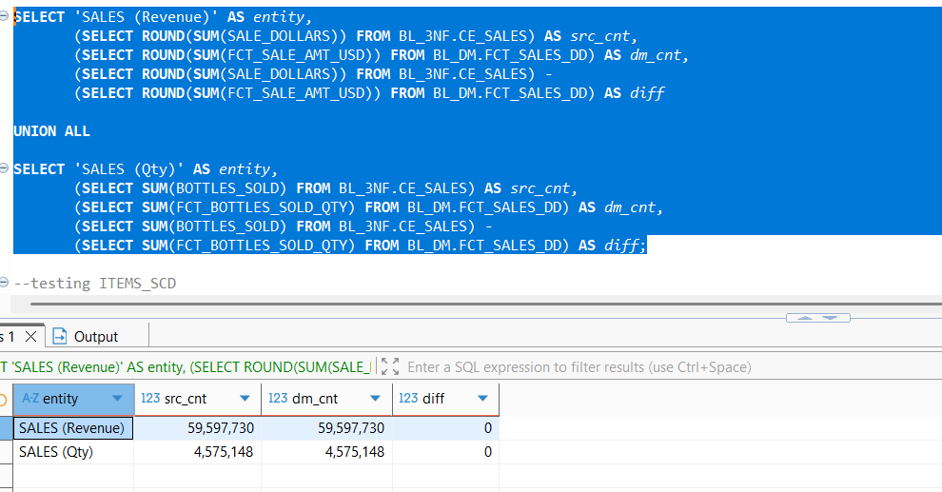
To check data consistency and integrity 6 data quality checks were implemented:
- TEST 1: Checks for duplicate rows based on the grain of the Fact table. The test passed successfully with the 0 result of redundant data records.
- TEST 2: Compares the total count of unique business keys in the 3NF source against the total number of records in the Data Mart. The test passed successfully with the 0 result. It confirms that no data was lost or double-counted during the multi-source merge and aggregation process
- TEST 3: Verifies that every store used in a sales transaction has a corresponding record in the DIM_STORES table. The test passed successfully with the 0 result. This confirms that the dimension mapping was successfully completed before the Fact table load.
- TEST 4: Cross-references the active items in the 3NF layer against the DIM_ITEMS_SCD table to ensure master data synchronization. The test passed successfully with the 0 result. It proves that every product sold has an active version in the Data Mart, allowing for accurate historical price and category tracking.
- TEST 5: Ensures that all mandatory foreign keys (Surrogate Keys) and the partition key (EVENT_DT) are fully populated. The test passed successfully with the 0 result - this maintains strict referential integrity.
- TEST 6: Checks for "empty" records where all dimension keys are set to the default -1, indicating a total failure to resolve business keys. A result of 0 proves the transformation logic is highly reliable.
The 0 error results across all integrity tests validate the robustness of the Partition-Exchange strategy. These tests confirm that the Data Mart is synchronized with the 3NF layer:
