DB Services
TASK 1. RDS MYSQL
The database instance was created directly through the AWS RDS console. On the Create database screen, the MySQL engine type was selected, and the Easy create method was chosen, since this is a sandbox/development environment that did not require fine-grained control over every configuration option. The MySQL Community edition was used together with the Sandbox instance size (db.t4g.micro, 2 vCPUs, 1 GB RAM, 20 GB storage), which is sufficient for practice purposes while keeping cost minimal.
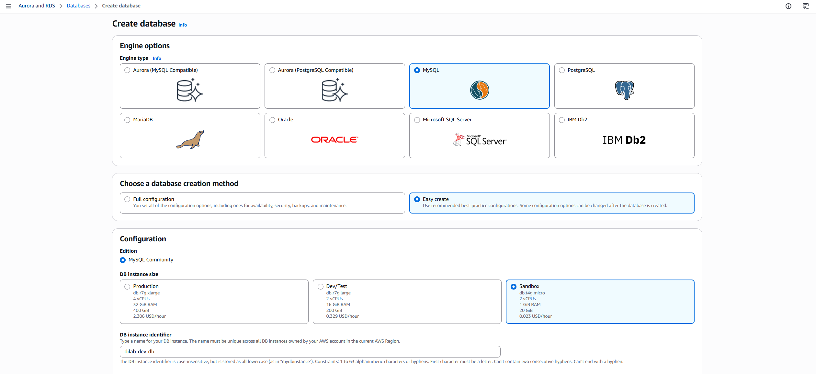
The DB instance identifier was set to dilab-dev-db, and the master username was set to admin. For credentials management, Self managed was selected instead of AWS Secrets Manager, since direct knowledge of the password was needed for connecting from an external SQL client.
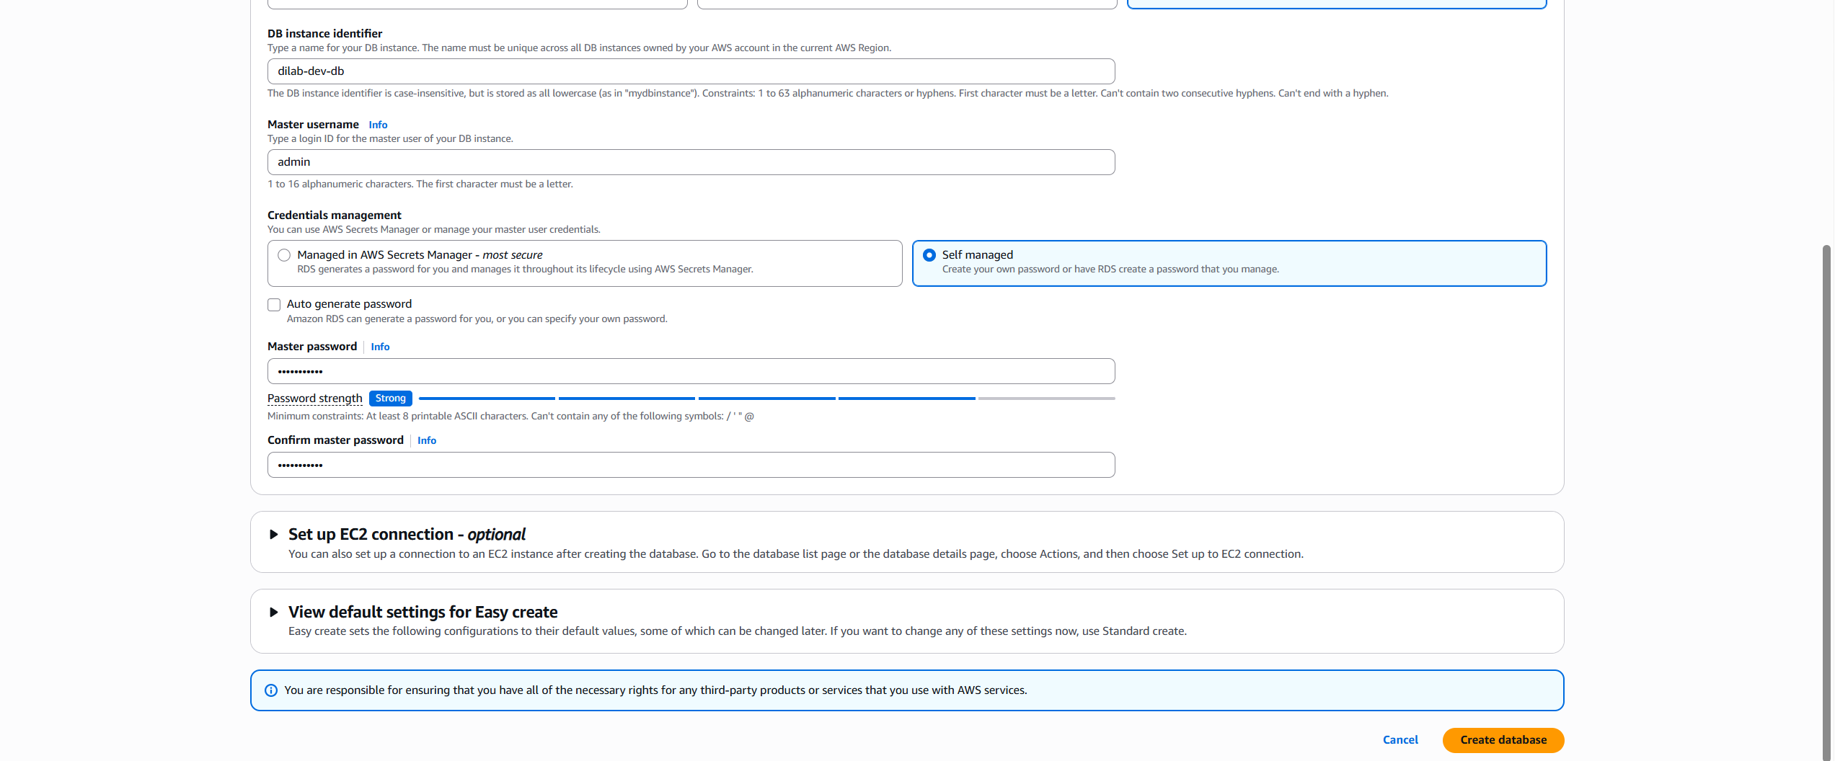
After creation, the Databases list confirmed that dilab-dev-db reached the Available status, running the MySQL engine with role Instance, indicating the instance was ready to accept connections.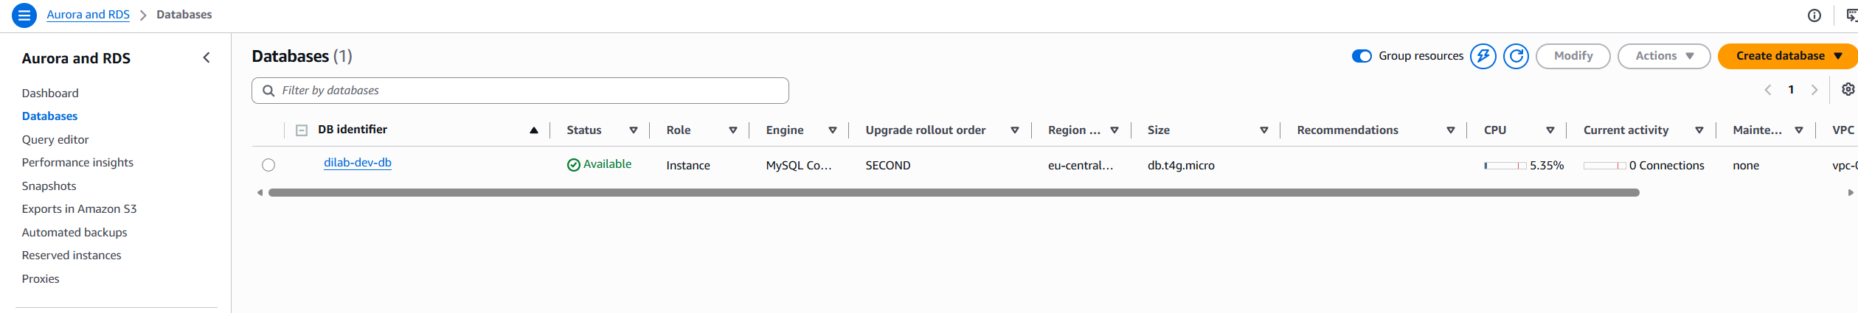
Because the database needed to be reachable from a local machine rather than only from within the VPC, Publicly accessible was enabled under Additional configuration. This causes RDS to assign a public IP address to the instance so that external clients can connect to it.
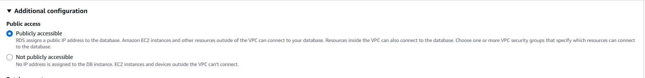
To actually permit inbound traffic, the security group attached to the instance was edited. An inbound rule for MySQL/Aurora (TCP port 3306) was added with the source restricted to My IP, so that only the current IP address could reach the instance — balancing external accessibility with basic security.
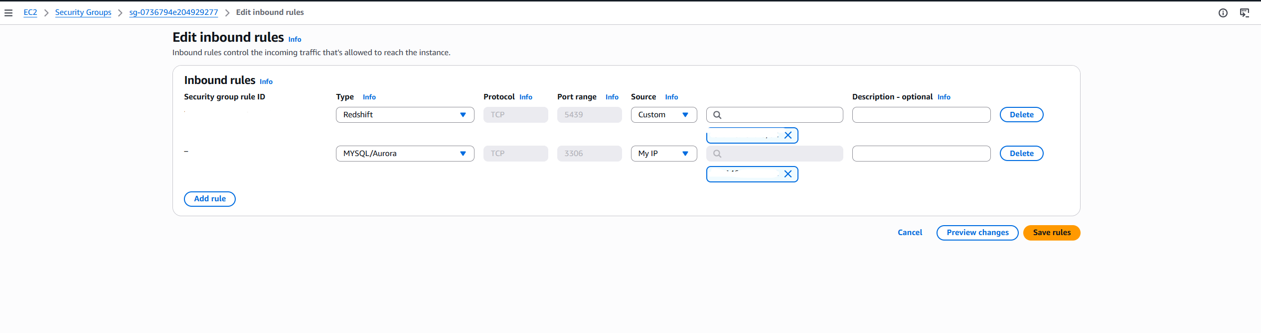
Since public accessibility was not part of the initial Easy Create flow, it was applied afterward through the Modify action, with Apply immediately selected under "Schedule modifications" so the change would take effect right away instead of waiting for the next maintenance window.
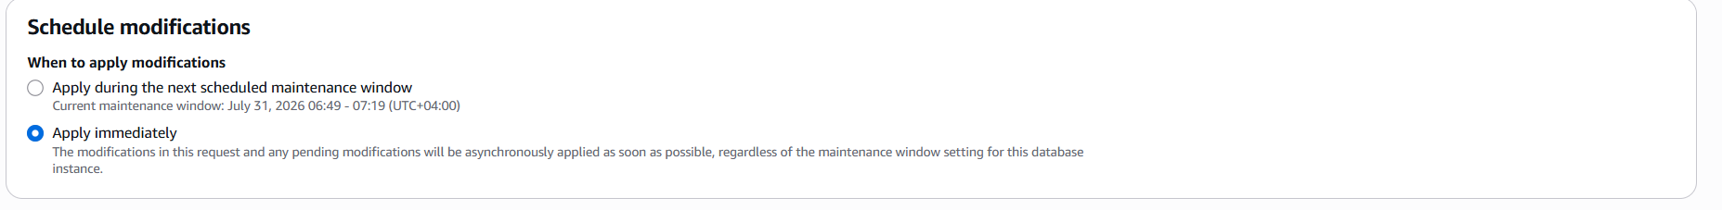
A connection to the instance was established using a MySQL client (DBeaver), using the RDS endpoint, port 3306, and the admin master credentials configured during creation.
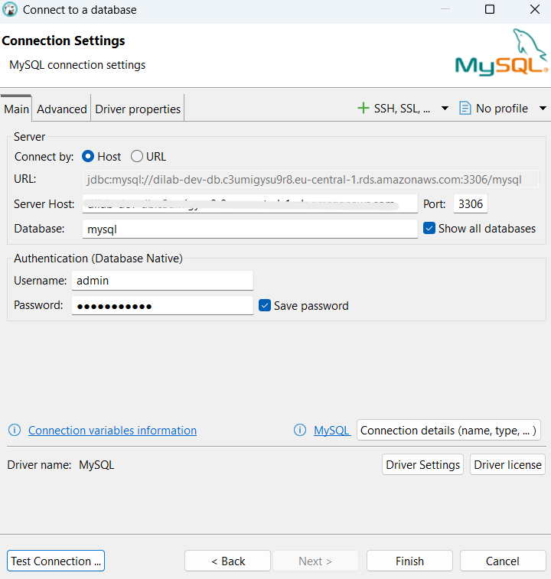
One configuration detail was required at the driver level: allowPublicKeyRetrieval had to be set to TRUE. This is necessary because MySQL 8's default authentication plugin (caching_sha2_password) requires the client to retrieve the server's RSA public key in order to securely exchange the password over a non-SSL connection; without this setting, authentication fails.

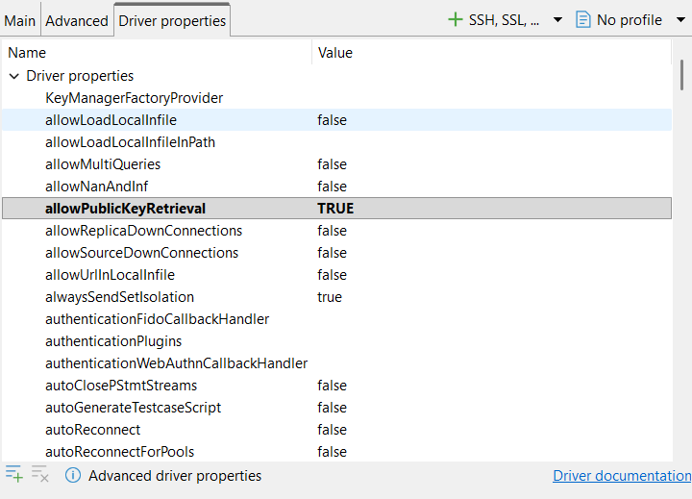
The Test Connection confirmed success, connecting in about 2 seconds to server version MySQL 8.4.9 via MySQL Connector/J 8.2.0 — validating that networking, security group rules, and credentials were all correctly configured.
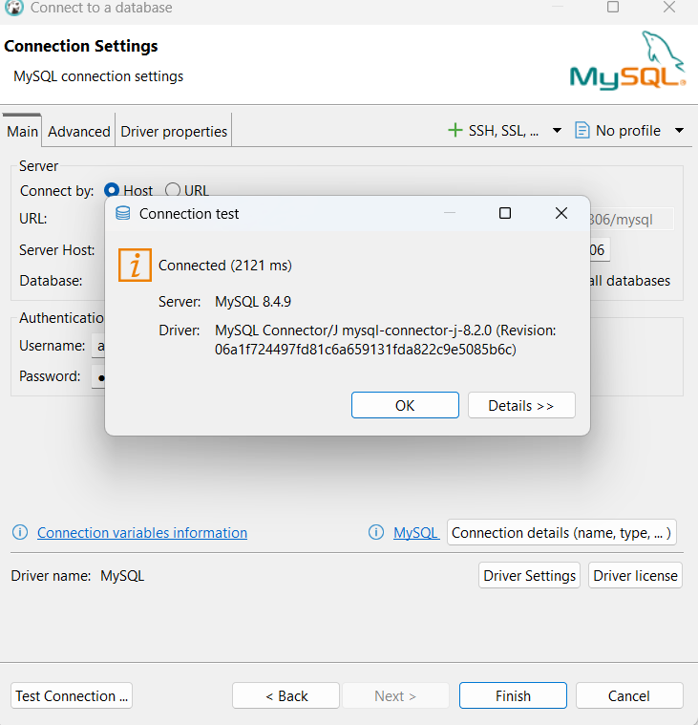
Once connected, the default database structure was reviewed, showing only the standard built-in sys schema (with its sys_config table, views, indexes, procedures, triggers and events) along with the default Users, Administer, and System Info sections. This confirmed the instance was a clean, freshly provisioned MySQL server containing no personal schema yet, which was the expected starting point before creating a personal user and schema.
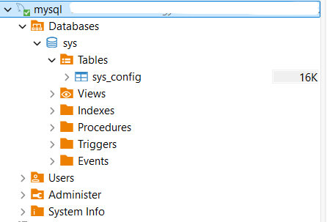
Schema and Object Creation
Following the connection setup, the schema and database objects were created using the personal user, continuing directly from the initial script prepared for the task.
The schema was created with CREATE SCHEMA IF NOT EXISTS dilab_dev;, which returned 1 updated row on first execution, confirming the schema was newly created. The context was then switched into this schema with USE dilab_dev;. Both statements use the idempotent IF NOT EXISTS pattern, so re-running the script on an already-initialized database does not raise errors.
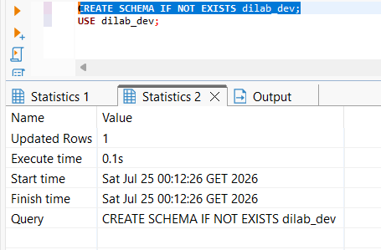
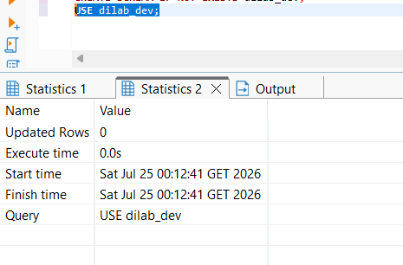
A table named sales_staging was created with CREATE TABLE IF NOT EXISTS, containing an auto-incrementing primary key (sale_id), along with product_name, category, amount, sale_date, and a created_at timestamp defaulting to CURRENT_TIMESTAMP. The IF NOT EXISTS clause ensures the script remains restartable:

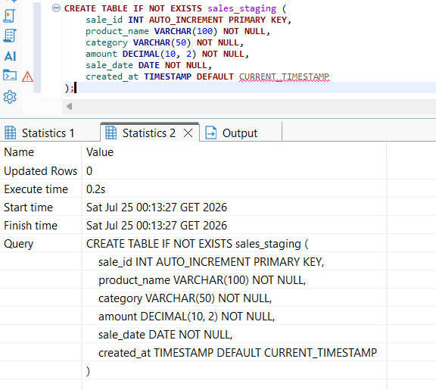
Sample data was then inserted using INSERT INTO ... VALUES ... ON DUPLICATE KEY UPDATE amount = VALUES(amount);, which is the MySQL-specific idempotency mechanism for DML: if a row with a conflicting key already exists, the statement updates it instead of failing, which is why this pattern (rather than a plain INSERT) was chosen for the seed data.
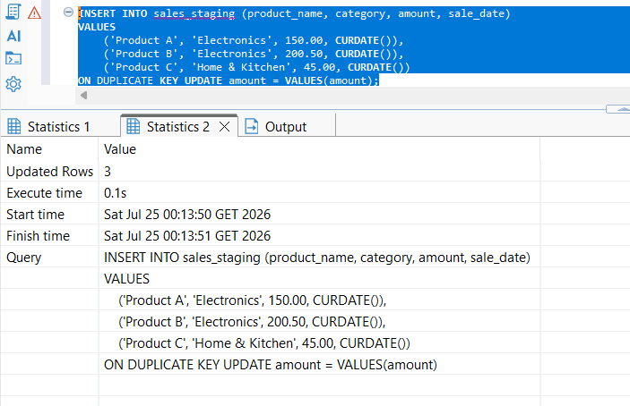
Three rows were inserted successfully, and a subsequent SELECT * FROM sales_staging; confirmed the data was stored correctly, with the expected product names, categories, amounts, and sale dates.
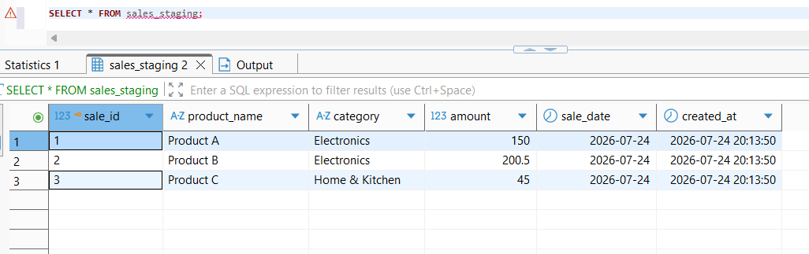
A view named v_daily_sales_summary was created using CREATE OR REPLACE VIEW, which aggregates the staging table by category, returning the count of transactions, total revenue, and average check (transaction value) per category. CREATE OR REPLACE was used specifically because MySQL does not support CREATE VIEW IF NOT EXISTS; OR REPLACE achieves the same restartability goal by overwriting the view definition on each run instead of failing if it already exists:
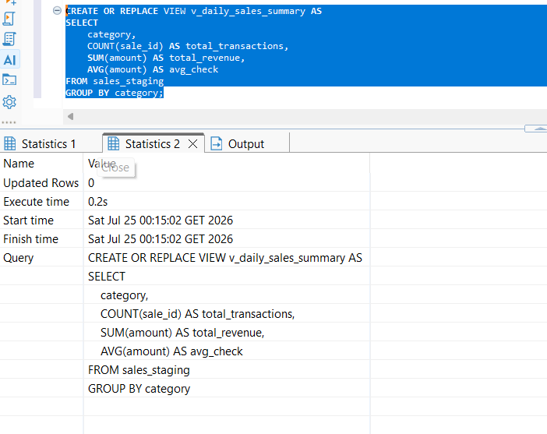
Querying the view with SELECT * FROM v_daily_sales_summary; returned correctly aggregated results — two categories, "Electronics" and "Home & Kitchen" — with transaction counts, revenue totals, and average check values matching the underlying staged data, confirming the view logic was correct.
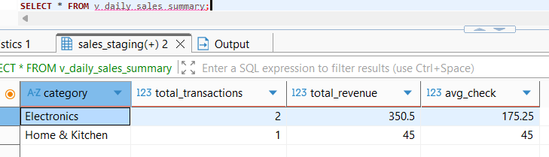
A procedure sp_add_new_sale was created to insert a new sale record. It accepts four input parameters (p_product_name, p_category, p_amount, p_sale_date) and performs a single INSERT into sales_staging using those parameters. Hiding table details behind a simple procedure is standard practice. It keeps the table structure private and lets developers update logic or add data checks in the future without breaking outside code.

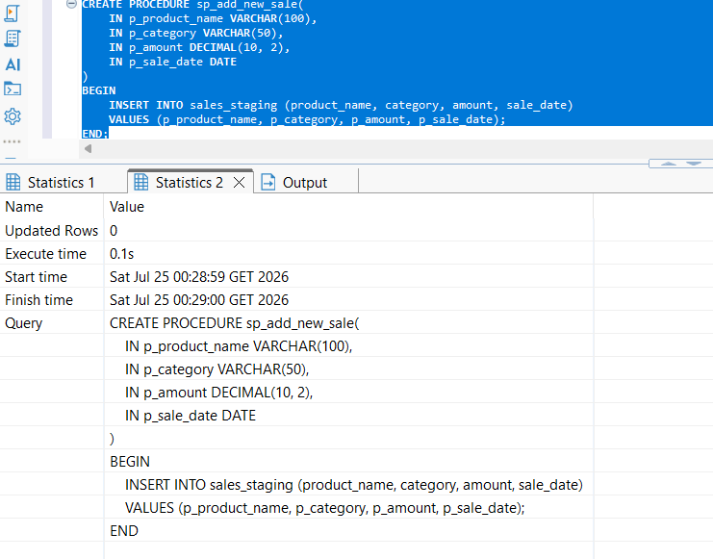
The procedure was tested by calling CALL sp_add_new_sale('Product D', 'Home & Kitchen', 89.99, CURDATE());, followed by re-querying v_daily_sales_summary. The results correctly reflected the new sale — the "Home & Kitchen" category updated from 1 to 2 transactions, with total revenue increasing from 45 to 134.99 and the average check adjusting to 67.495 — confirming that the table, view, and procedure were all working together correctly.
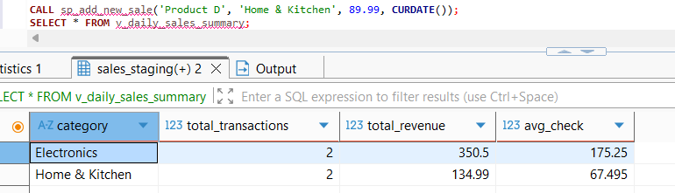\
TASK 2. RDS AURORA
RDS Data API works only with Aurora (MySQL-compatible) databases. So, a new Aurora MySQL database was created. Aurora (MySQL Compatible) was selected as the engine type. Unlike the previous task, Full configuration was chosen instead of Easy create, since more granular control was needed over connectivity settings — specifically, enabling the RDS Data API, which is not exposed through the Easy create flow. The Dev/Test template was selected under Templates, as this is a non-production learning environment, and Aurora Serverless was chosen as the cluster scalability type:
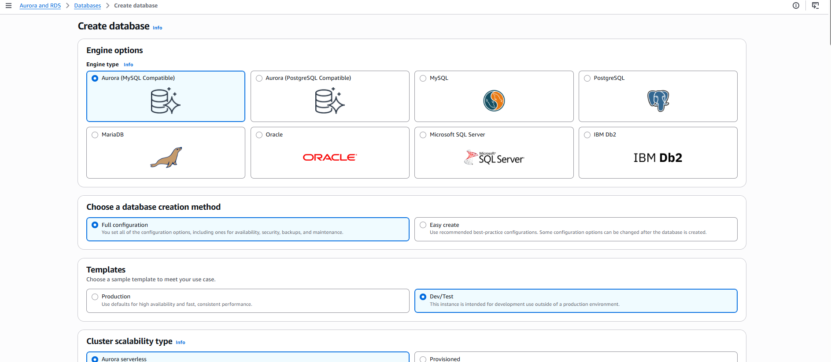
For the Aurora Serverless capacity range, the minimum capacity was set to 0 ACUs (0 GiB) and the maximum to 1 ACU (2 GiB). Setting the minimum to 0 allows the cluster to pause automatically during inactivity, which reduces cost for a database that is only used intermittently for practice queries. The "Pause after inactivity" setting was left at its default of 5 minutes, meaning the cluster automatically pauses shortly after queries stop being run.
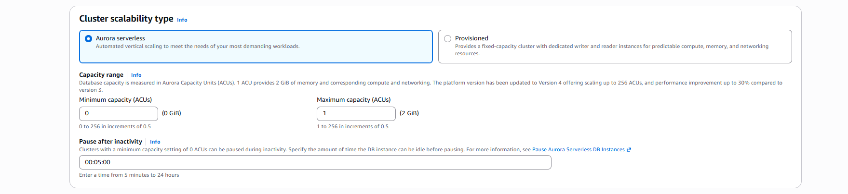
The engine version selected was Aurora MySQL 3.10.3 (compatible with MySQL 8.0.42). The DB cluster identifier was left as database-1, and the master username was set to admin, with Self managed credentials chosen (rather than Secrets Manager) so the password would be directly known for use in the Query editor login prompt.
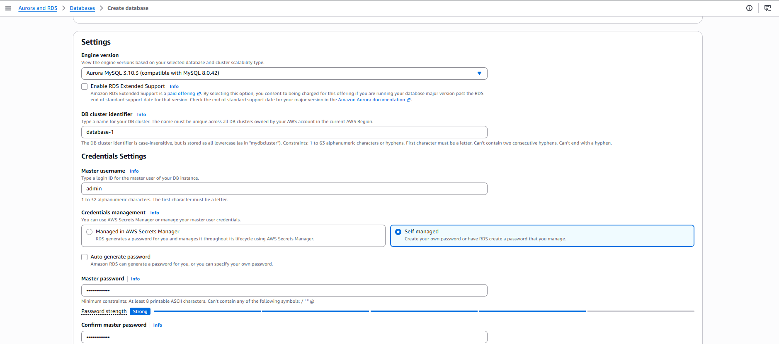
Aurora Standard storage was selected over Aurora I/O-Optimized, since the workload for this exercise involves a moderate, low volume of queries rather than I/O-intensive operations, making the standard pay-per-request I/O pricing more cost-effective. Under Availability & durability, "Don't create an Aurora Replica" was chosen, as high availability and failover were not required for a single-user test environment.
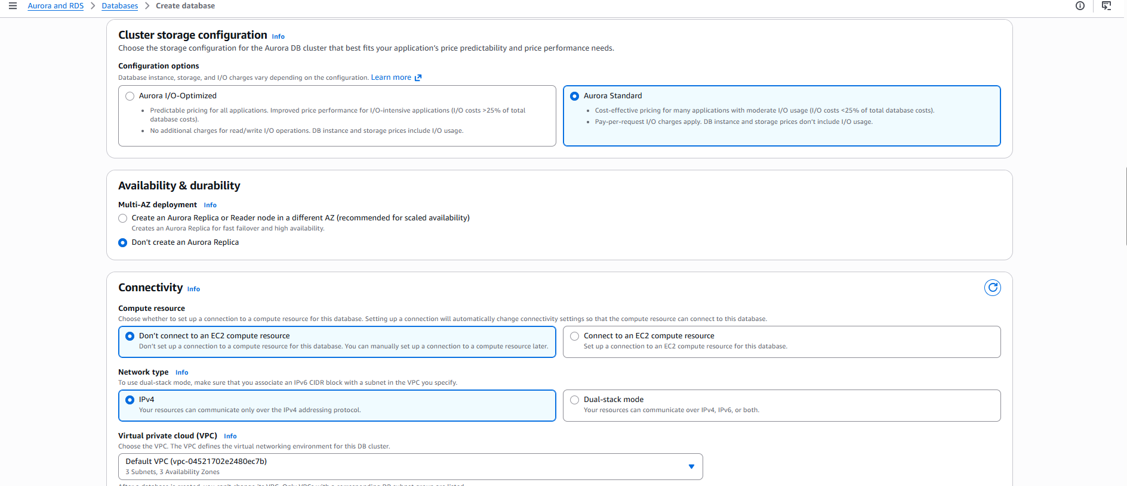
For connectivity, "Don't connect to an EC2 compute resource" was selected, since no application server needed to reach the database directly — all interaction would happen through the AWS Console's Query editor. The default VPC and its associated DB subnet group were used. The existing default VPC security group was selected rather than creating a new one, since no custom inbound rules were required for this access pattern.
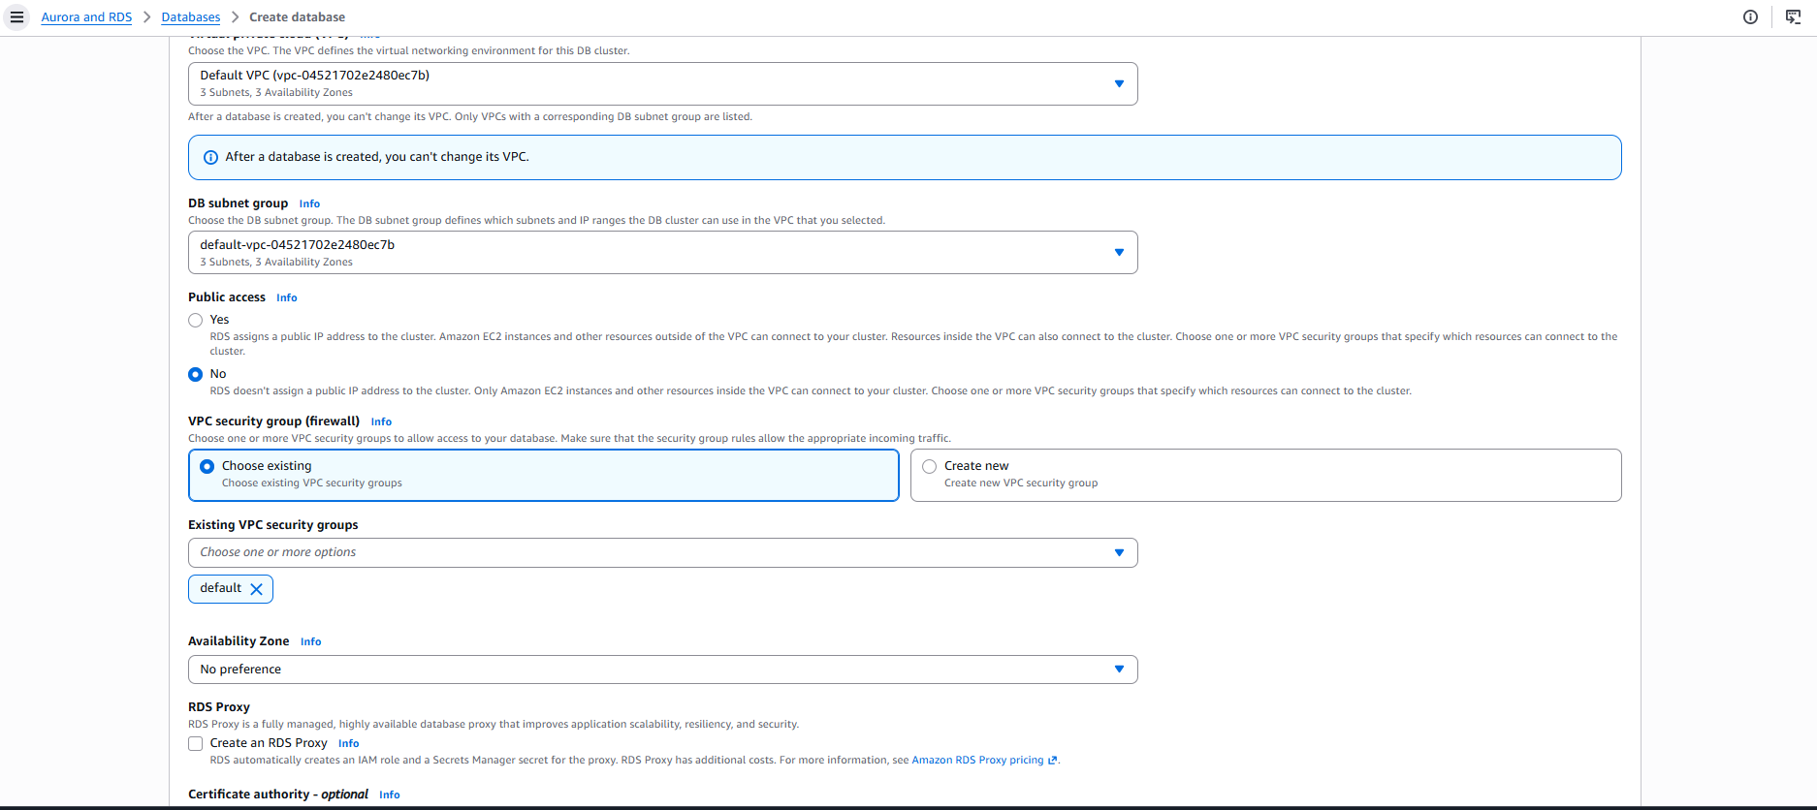
The key configuration step specific to this task was enabling the RDS Data API, found under the connectivity settings. This option exposes a SQL-over-HTTP endpoint for the database, which is what allows the AWS Console's Query editor to run SQL statements without needing a direct TCP connection, a local SQL client, or VPC-level network access. This checkbox was enabled, since without it the Query editor cannot connect to the cluster at all.
Under Monitoring, Database Insights - Standard was kept as the default (rather than the Advanced tier), since Advanced retains a much longer performance history (15 months vs. 7 days) and is intended for production fleet monitoring, which was unnecessary for this short-lived test cluster. Performance Insights and Enhanced Monitoring were left disabled, and no additional CloudWatch log exports (audit, error, general, slow query, etc.) were selected.

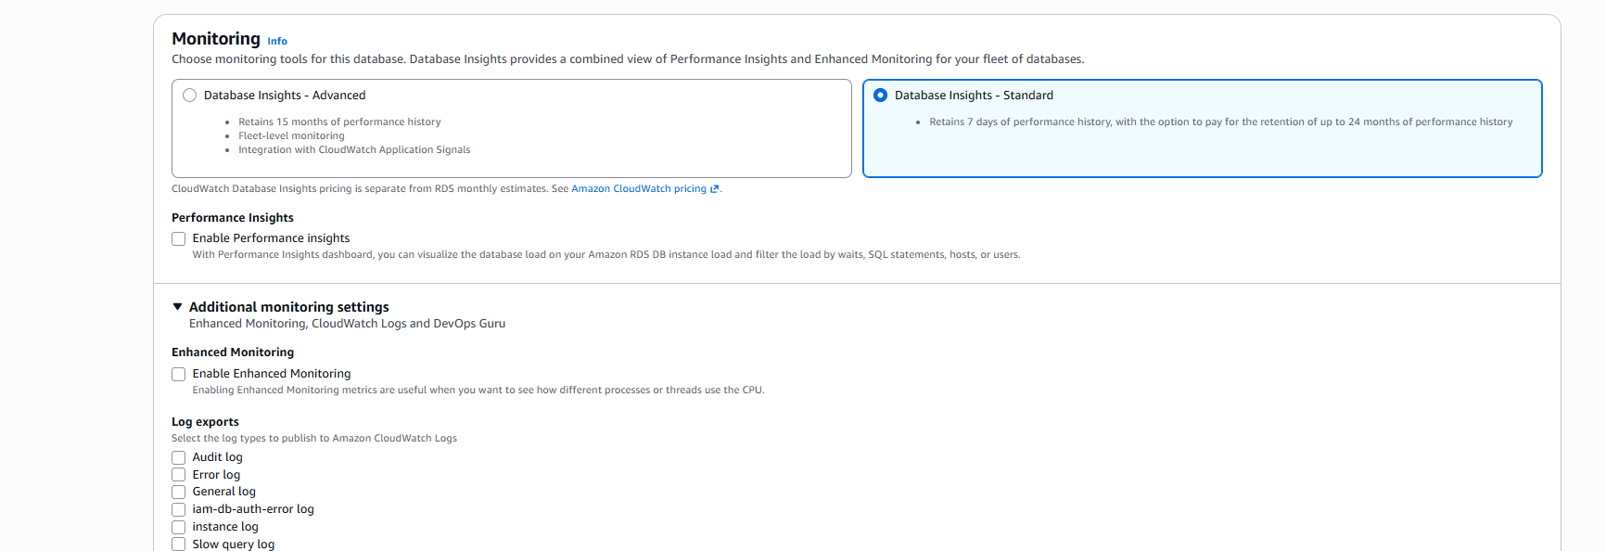
The database was created:
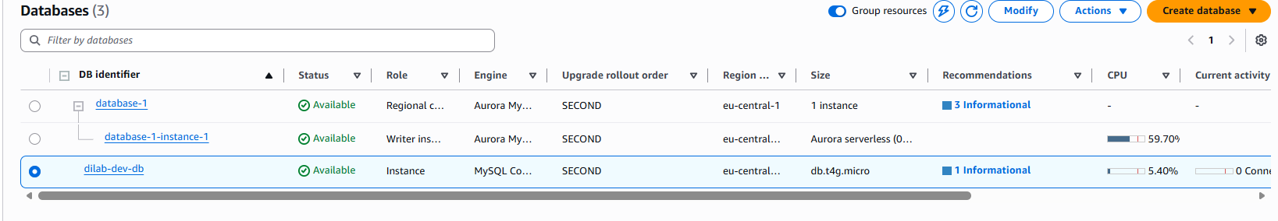
To connect to the Aurora cluster through the AWS Console's Query editor, a new database credential was configured under Connect to database. The database-1 cluster was selected as the target instance, and a dedicated database username (sakila) and password were entered:
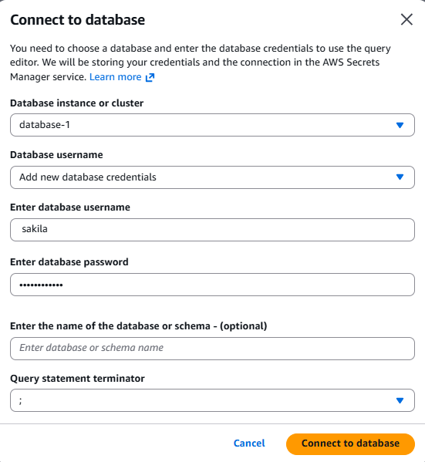
Rather than building a custom schema from scratch, the pre-built Sakila sample database was used, as suggested by the task as an alternative to a self-created schema. The official Sakila installation files (sakila-schema.sql and sakila-data.sql) were obtained from the MySQL documentation, which explains that the schema file contains all CREATE statements needed to build the database structure — tables, views, stored procedures, and triggers — while the data file contains the corresponding INSERT statements to populate that structure, along with the triggers that must be created only after the initial data load:

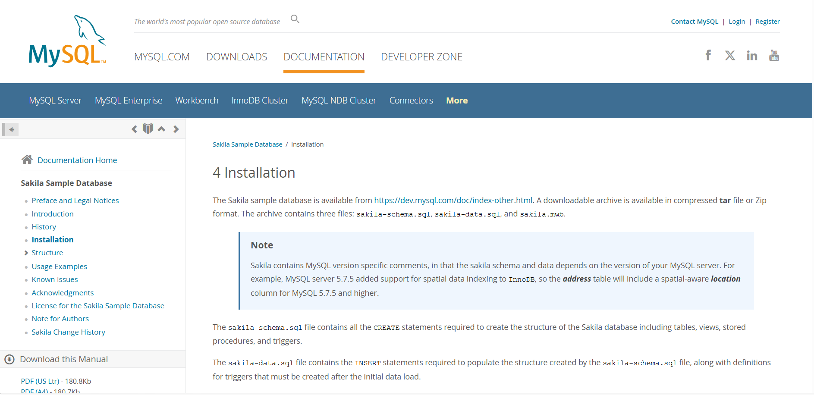
In the Query editor, a first statement block was run to create the target database and switch into it: CREATE DATABASE IF NOT EXISTS sakila; followed by USE sakila;. The Output panel confirmed all four underlying statements (including the implicit transaction begin/commit that the Query editor wraps around each run) completed successfully: the database was created (1 row updated) and the session context switched to it (no rows changed, as expected for a USE statement).
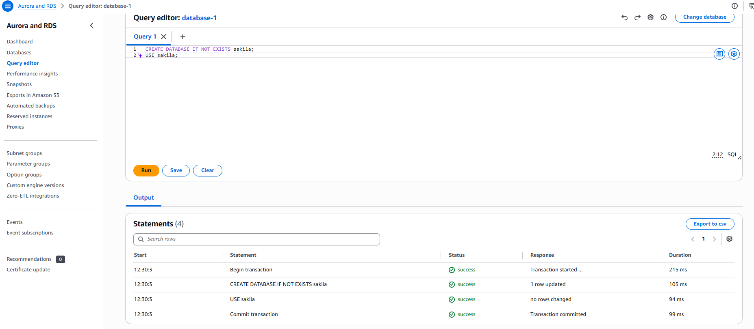
The sakila-schema.sql script was then executed against this database to create all of Sakila's tables, views, procedures, and triggers in a single batch, establishing the full relational structure (actors, films, customers, rentals, payments, stores, staff, etc.) needed to write meaningful, non-trivial queries later.
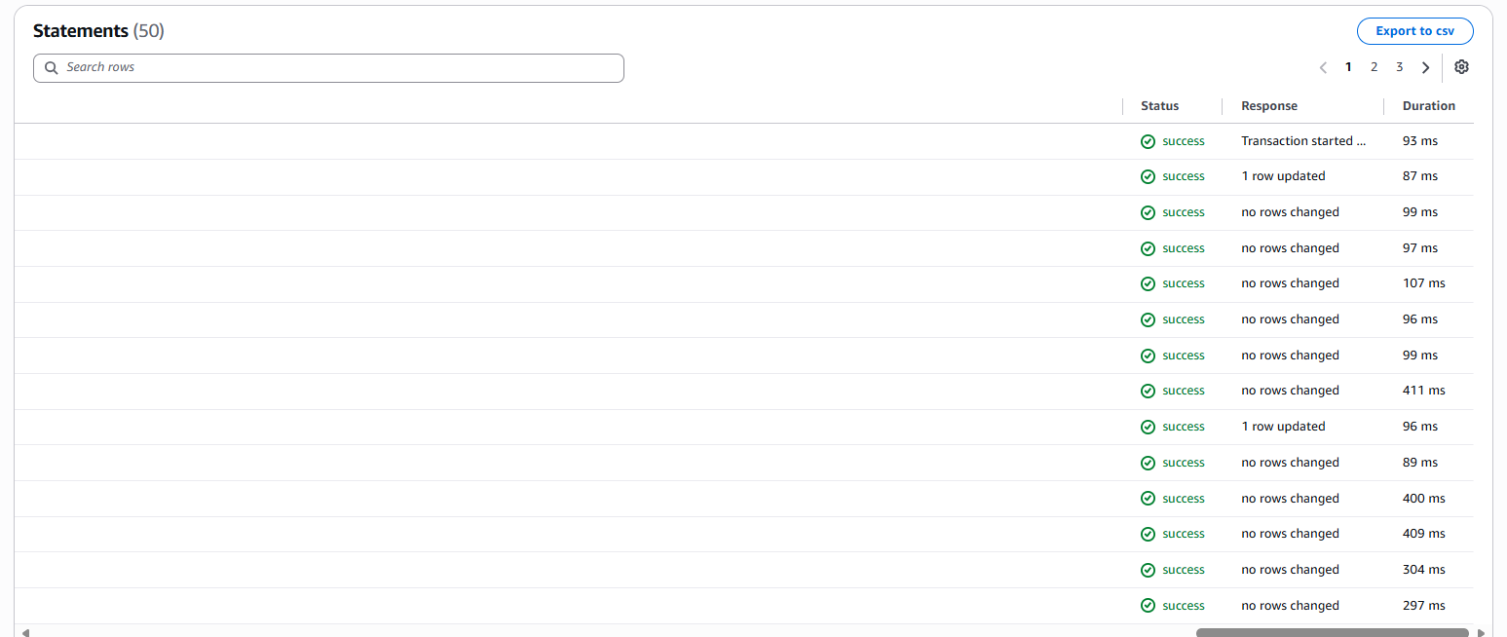
After the schema scripts finished executing, a SHOW TABLES; statement was run against the sakila database to confirm that the full object structure had been created correctly. The query returned a Result set listing all 23 objects present in the schema:

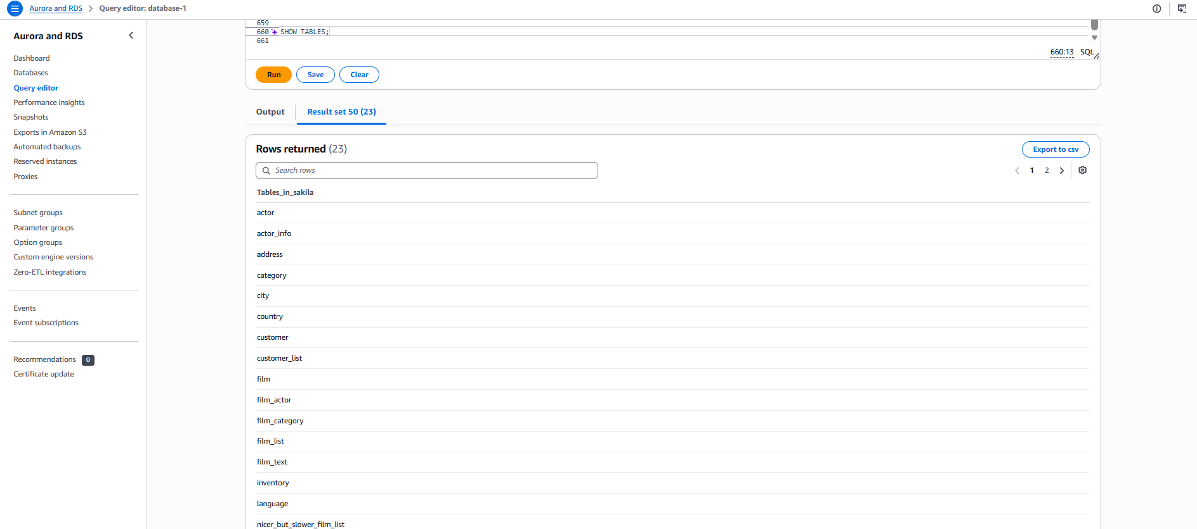
While the sakila-schema.sql script executed without issue directly in the AWS Console's Query editor, the accompanying sakila-data.sql file proved too large for the console to handle reliably — it contains a very high number of INSERT statements, and the browser-based Query editor is not designed for bulk-loading scripts of this size. Rather than continuing to fight timeouts and console limitations, the data load was performed instead through DBeaver, connecting directly to the Aurora cluster's endpoint as an external MySQL client, the same tool and approach used in the previous MySQL RDS task. The connection was tested and confirmed successful. his confirmed that direct network access to the cluster was correctly configured and that DBeaver could authenticate using the sakila database credentials created earlier.

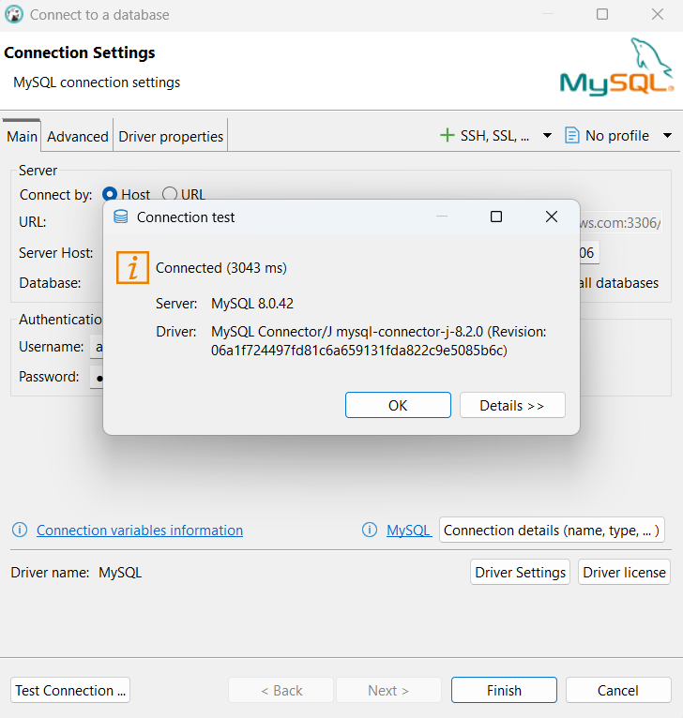
With the connection established, the full sakila-data.sql script was executed as a batch through DBeaver rather than the Query editor. DBeaver's execution log confirmed the load completed successfully: 52 queries were run, affecting a total of 44,335 updated rows, with a total execution time of 16 seconds.
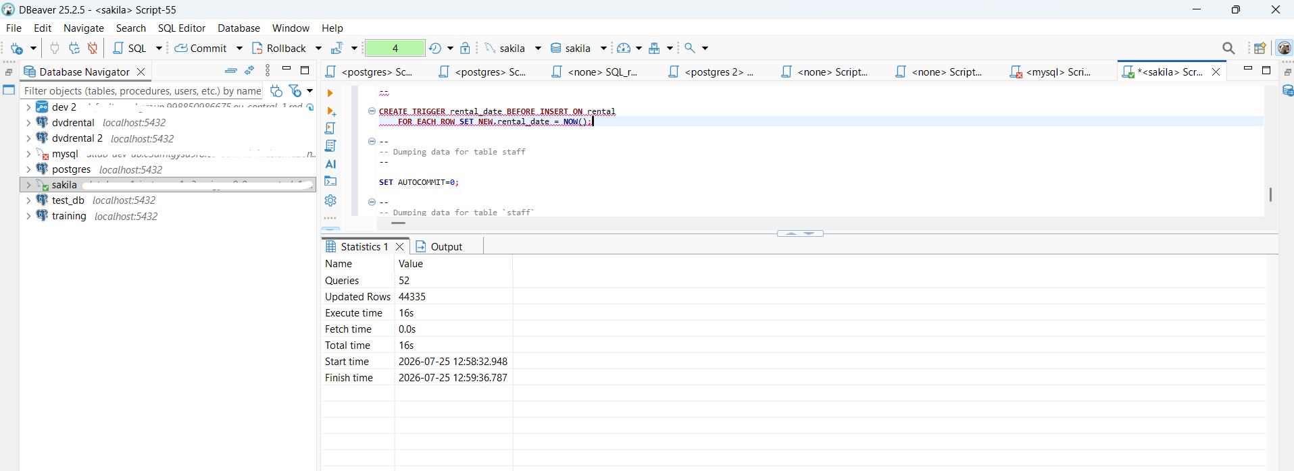
To confirm the data had loaded correctly, execution returned to the AWS Console's Query editor, where a verification query was run to count rows across the key tables in a single result set:
SELECT
(SELECT COUNT(*) FROM sakila.actor) AS total_actors,
(SELECT COUNT(*) FROM sakila.film) AS total_films,
(SELECT COUNT(*) FROM sakila.customer) AS total_customers,
(SELECT COUNT(*) FROM sakila.rental) AS total_rentals,
(SELECT COUNT(*) FROM sakila.payment) AS total_payments;
The result confirmed the dataset was fully and correctly loaded, matching the well-known standard row counts for the Sakila sample database: 200 actors, 1000 films, 599 customers, 16,044 rentals, and 16,044 payments:
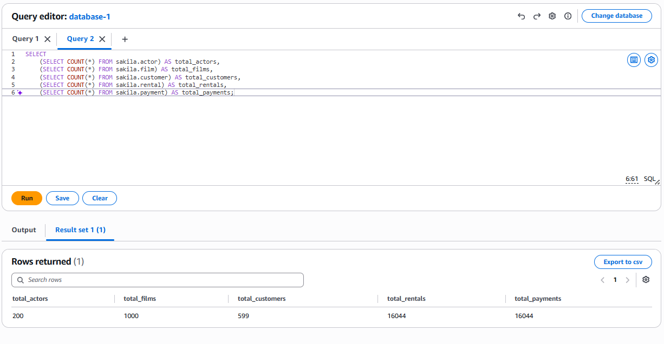
The first query was a top customers by revenue query.
SELECT
c.customer_id,
CONCAT(c.first_name, ' ', c.last_name) AS customer_name,
COUNT(r.rental_id) AS total_rentals,
SUM(p.amount) AS total_spent,
ROUND(AVG(p.amount), 2) AS avg_payment
FROM customer c
JOIN rental r ON r.customer_id = c.customer_id
JOIN payment p ON p.rental_id = r.rental_id
GROUP BY c.customer_id, customer_name
ORDER BY total_spent DESC
LIMIT 10;
This query gives a ranked list of the most valuable customers by actual money spent, not just by how often they rented — which matters because a customer who rents frequently isn't necessarily the one generating the most revenue. The result identified Karl Seal as the top customer, with 45 rentals totaling $221.55, followed closely by Eleanor Hunt and Clara Shaw. This kind of query is directly useful for a real business, since it could feed a loyalty program, targeted marketing, or VIP customer identification.
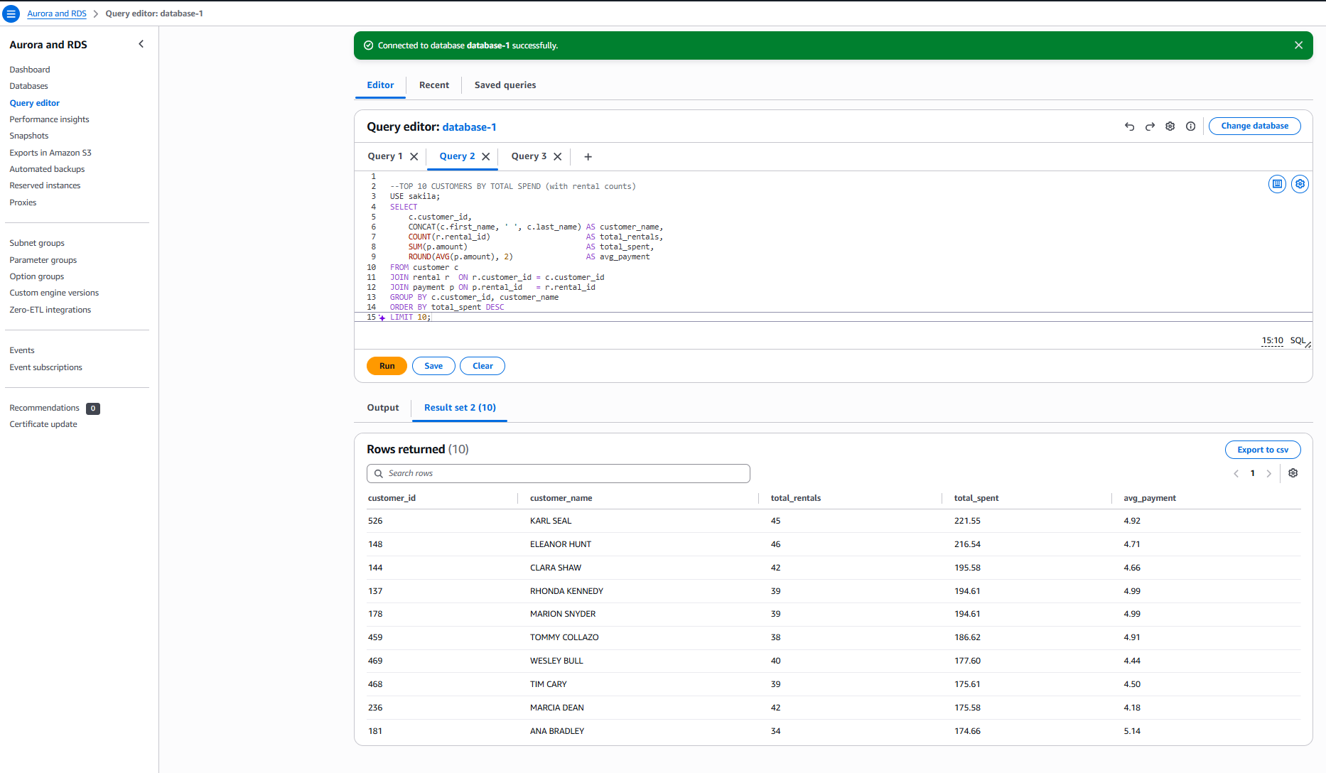
The second query gives a store performance comparison over time:
SELECT
s.store_id,
DATE_FORMAT(p.payment_date, '%Y-%m') AS revenue_month,
COUNT(DISTINCT p.payment_id) AS num_payments,
SUM(p.amount) AS monthly_revenue
FROM payment p
JOIN staff s ON s.staff_id = p.staff_id
GROUP BY s.store_id, revenue_month
ORDER BY s.store_id, revenue_month;
This query gives a way to compare how each store branch is performing against the other for the same period, rather than looking at revenue in isolation. The result showed that for July 2026, Store 2 generated slightly more revenue ($33,924.06 from 7,990 payments) than Store 1 ($33,482.50 from 8,054 payments) — meaning Store 1 processed more transactions but Store 2 earned more per transaction, an insight that would be invisible without combining transaction counts and revenue side by side.
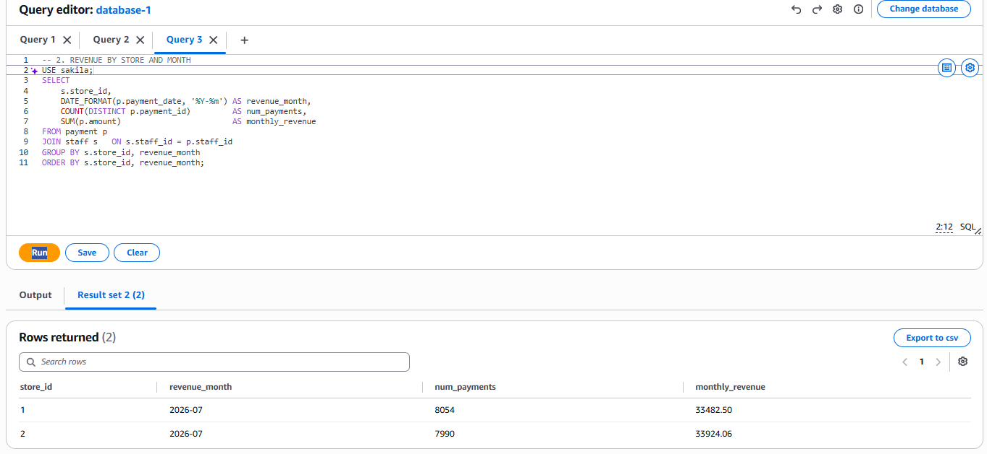
The third query gives a films never rented report:
SELECT
f.film_id,
f.title,
f.rental_rate,
f.replacement_cost
FROM film f
LEFT JOIN inventory i ON i.film_id = f.film_id
LEFT JOIN rental r ON r.inventory_id = i.inventory_id
WHERE r.rental_id IS NULL
ORDER BY f.replacement_cost DESC;
This query gives visibility into inventory that is tying up capital without generating any return, which is a genuinely useful operational question a business would ask (should we discount, promote, or remove these titles?). The result returned 43 such films, topped by "Floats Garden" at a $29.99 replacement cost, meaning that's the single most expensive unused copy sitting on the shelf.
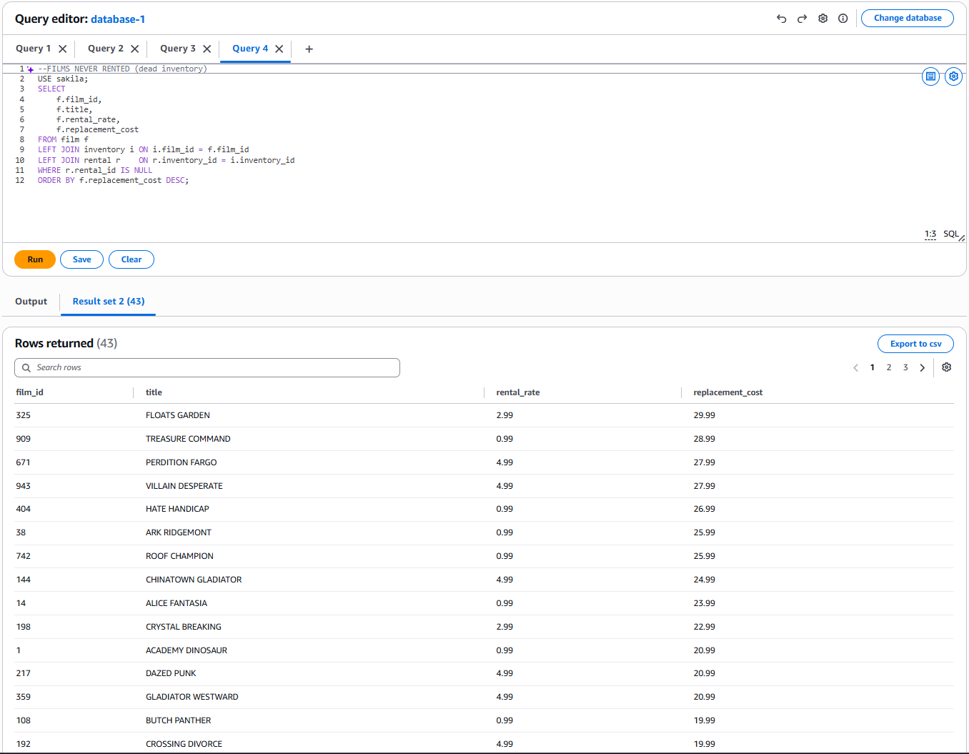
The fourth query gives a category profitability ranking.
SELECT
cat.name AS category,
COUNT(r.rental_id) AS times_rented,
SUM(p.amount) AS total_revenue,
ROUND(SUM(p.amount) / COUNT(r.rental_id), 2) AS revenue_per_rental
FROM category cat
JOIN film_category fc ON fc.category_id = cat.category_id
JOIN film f ON f.film_id = fc.film_id
JOIN inventory i ON i.film_id = f.film_id
JOIN rental r ON r.inventory_id = i.inventory_id
JOIN payment p ON p.rental_id = r.rental_id
GROUP BY cat.name
ORDER BY total_revenue DESC
LIMIT 5;
This query gives insight into which genres are both popular and profitable, and specifically separates volume from profitability per rental, which don't always align. The result showed Sports as the clear leader in both total rentals (1,179) and total revenue ($5,314.21), but interestingly, Comedy — despite ranking only 5th in total revenue — had the highest revenue per rental at $4.66, meaning each comedy rental was, on average, more profitable than each Sports rental, even though Sports moved more volume overall:
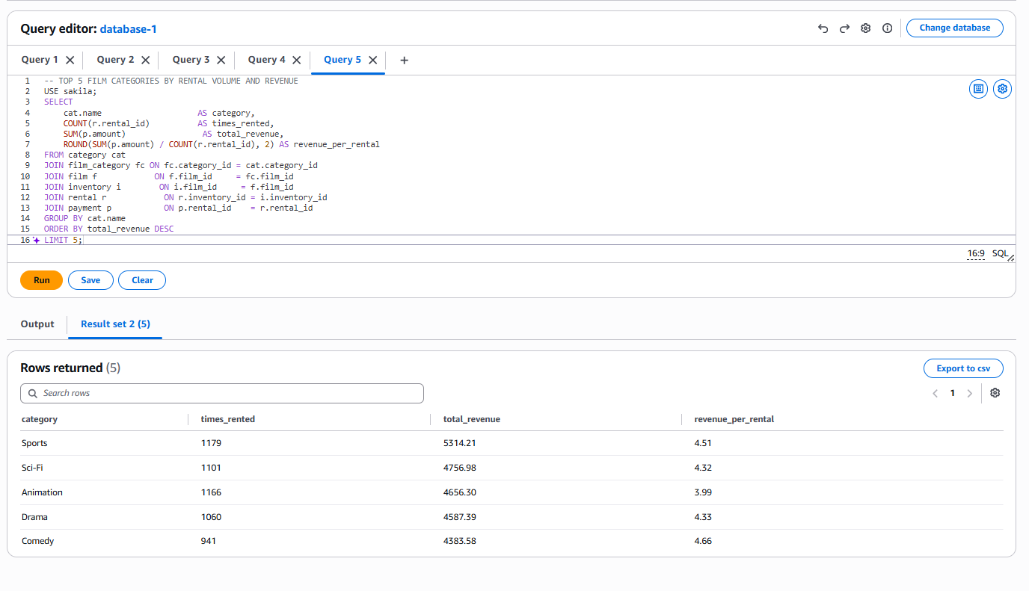
TASK 3
A table named Students_Manual was created through the DynamoDB console's Create table screen. Unlike relational databases, DynamoDB is schemaless and only requires defining the table name and its primary key at creation time — all other attributes are added freely per item without a fixed schema.
For the primary key, a composite key was chosen: student_id (String) as the partition key, and enrollment_date (String) as the sort key.
The choice of student_id as the partition key was based on the guidance that a good partition key should have high cardinality and distribute access evenly across the table's underlying partitions. A student ID is a natural, unique-per-entity identifier.
enrollment_date was added as a sort key rather than making student_id a simple (single-attribute) primary key, because this allows multiple records to exist under the same student_id (for example, if a student enrolls in multiple programs or re-enrolls at different dates) while still guaranteeing overall item uniqueness through the combination of partition key + sort key. It also enables efficient range queries within a single partition — such as retrieving a specific student's records sorted or filtered by enrollment date — which a single-attribute key could not support.
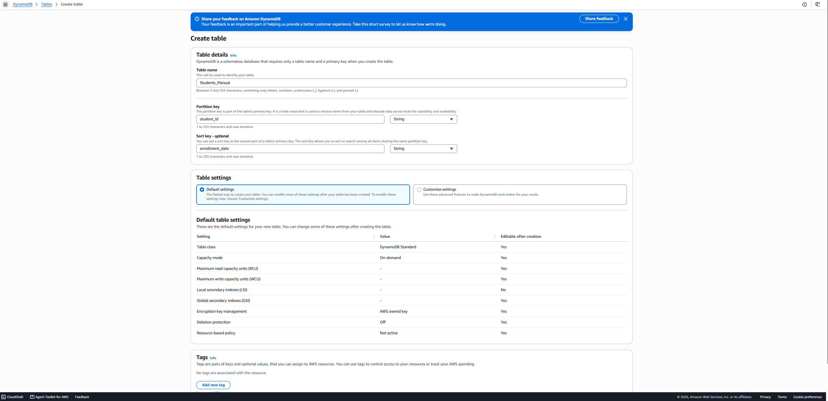
The table was created successfully and confirmed in the Tables list with status Active, an on-demand capacity mode, and the expected partition key (student_id) and sort key (enrollment_date) displayed.
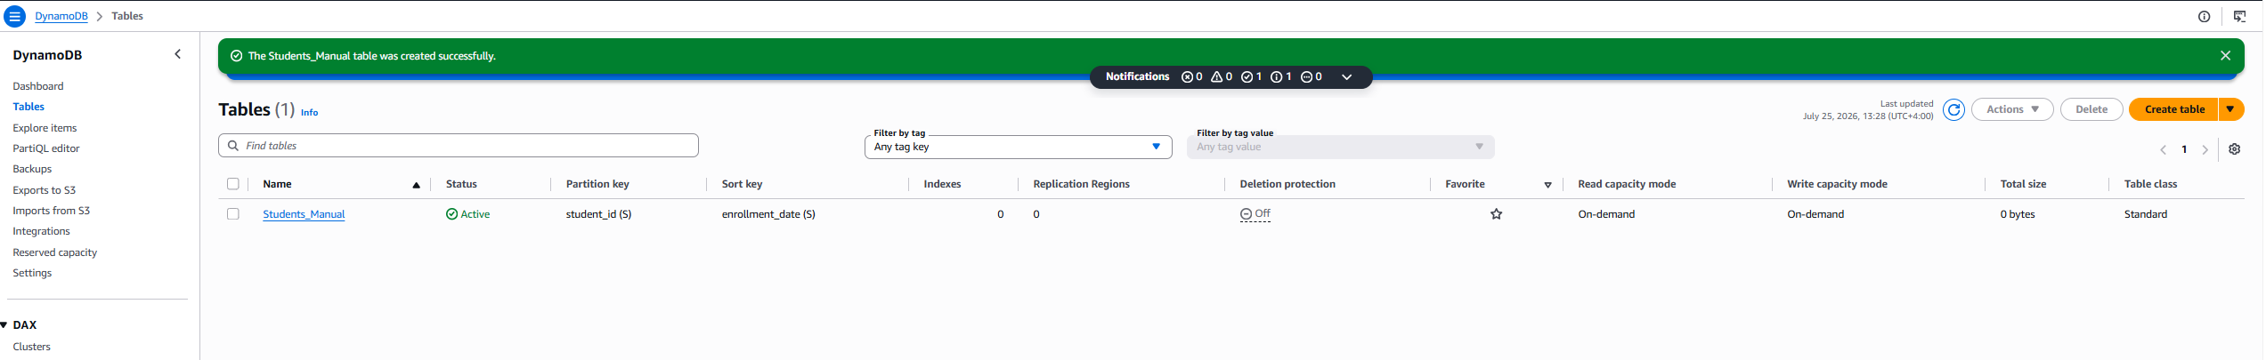
Using the Explore items view, a Query operation was first run against the empty table (specifying the partition key attribute with no value entered) to confirm the table was reachable and correctly returned zero items:

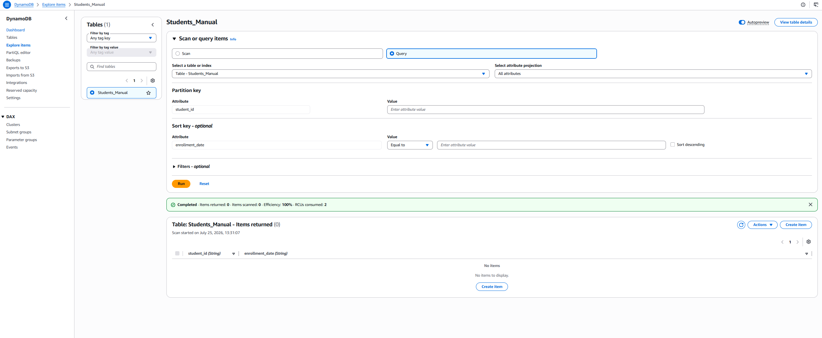
An item was then added manually through the console's Create item form, which displays the primary key attributes (student_id, enrollment_date) as required fields and allows arbitrary additional attributes to be added freely, demonstrating DynamoDB's schemaless nature:
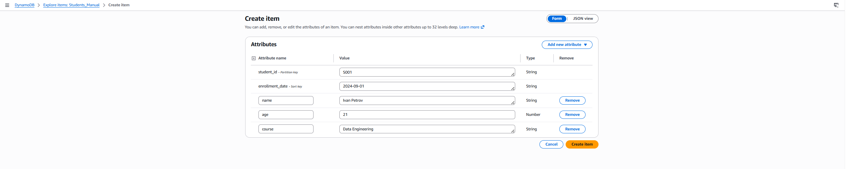
After creation, a re-scan of the table confirmed the item was successfully stored and retrievable, correctly returning all five attributes with their proper types (student_id and enrollment_date as strings forming the key, plus the freeform age, course, and name attributes) exactly as entered:
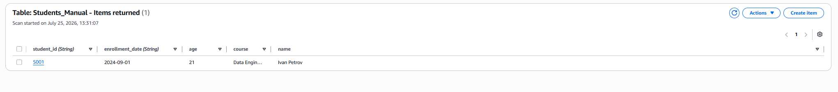
Once the manual creation, population, and retrieval steps were verified through the console, the table was deleted as required by the task:
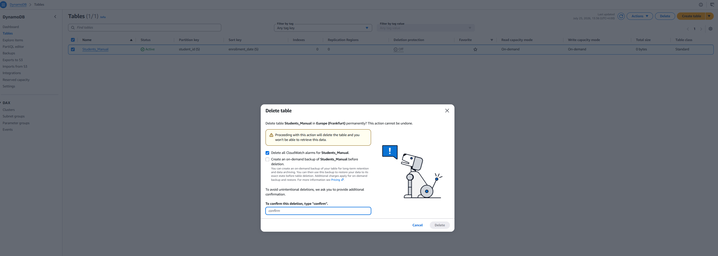
Before any CLI-based DynamoDB operations could be run, the AWS CLI was configured with credentials using aws configure, entering the Access Key ID, Secret Access Key, session token, and setting the default region to eu-central-1 to match the region used for the earlier console-based work. The configuration was verified with aws sts get-caller-identity, which returned the authenticated UserId, Account, and Arn, confirming the CLI was correctly authenticated against the intended AWS account before proceeding with any table operations.
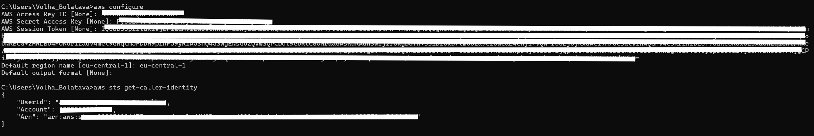
he table Orders was created using aws dynamodb create-table, defining customer_id as the partition key (HASH) and order_id as the sort key (RANGE), both of type String, with --billing-mode PAY_PER_REQUEST used instead of provisioning fixed capacity units.
The choice of customer_id as the partition key follows the same reasoning applied in the manual console task: a good partition key needs high cardinality and even access distribution, and since orders naturally belong to many different customers, using customer_id spreads write and read traffic across many partitions rather than concentrating it. order_id was added as the sort key because a single customer can place multiple orders, so the partition key alone would not be unique — the composite key (customer_id + order_id) guarantees each order is uniquely identifiable while also enabling efficient queries such as "retrieve all orders for a given customer," since DynamoDB stores and indexes items with the same partition key together, sorted by the sort key.
PAY_PER_REQUEST (on-demand) billing mode was chosen over provisioned throughput because the workload for this exercise is small, irregular, and exploratory rather than a predictable, sustained production load — on-demand billing avoids the need to estimate and provision fixed read/write capacity units in advance and simply charges per actual request.
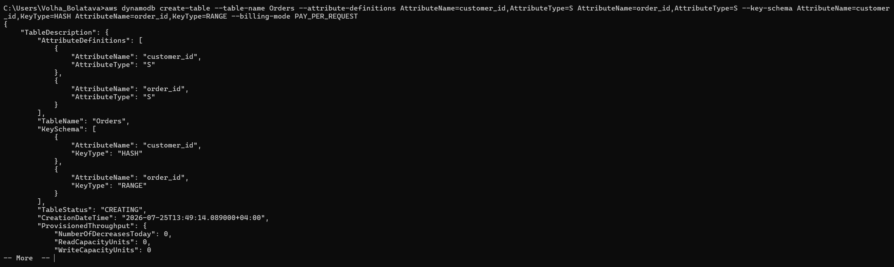
The CLI output confirmed the table was created with the correct attribute definitions and key schema, initially in CREATING status, and this was cross-verified in the DynamoDB console, where the Orders table subsequently appeared as Active with the expected partition key (customer_id) and sort key (order_id), on-demand capacity mode, and no additional indexes — matching exactly what was specified in the CLI command.
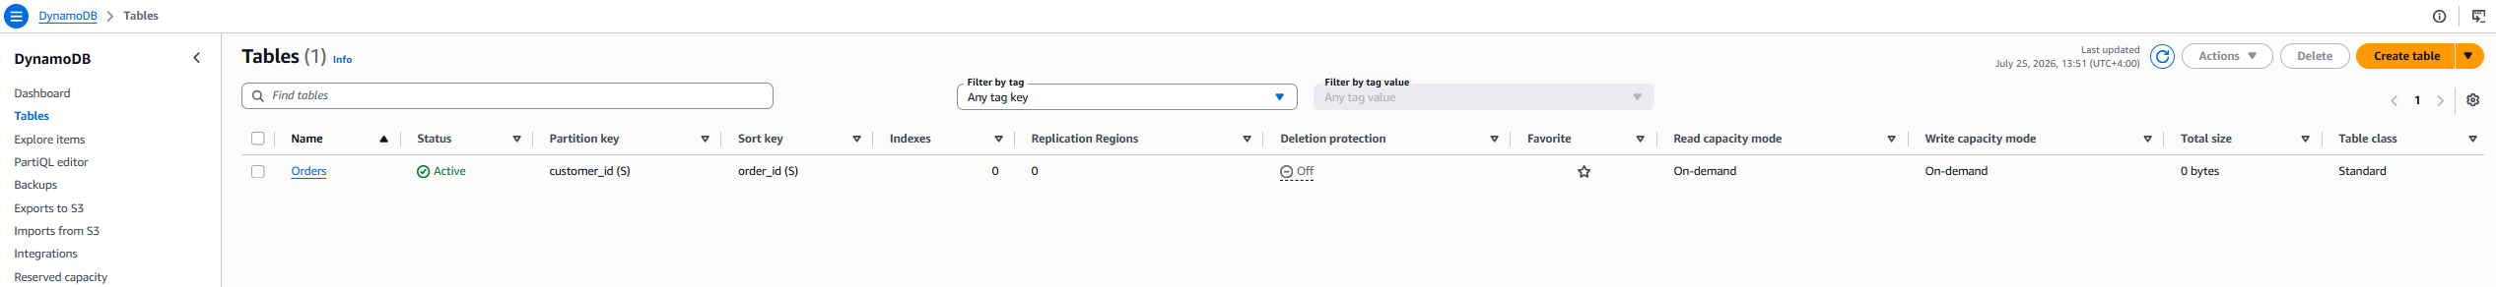
A batch approach was chosen to populating the table with 20+ Rows. A JSON file (items.json) was prepared containing a PutRequest for each item under the Orders table key, with each item specifying customer_id, order_id, amount (Number), status (String), and order_date (String) attributes in DynamoDB's native JSON attribute-value format (e.g., {"S": "C001"}, {"N": "150.50"}). The file contained 25 such items spread across multiple distinct customers (C001–C009), with varying order statuses (pending, shipped, delivered, cancelled) and dates, so that the later query/filter examples would have realistic, varied data to work against.
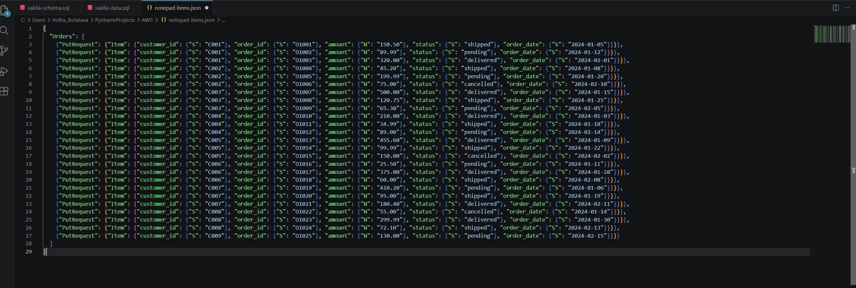
This batch was loaded in a single command using aws dynamodb batch-write-item --request-items file://items.json, which is the CLI equivalent of a bulk insert — batch-write-item allows up to 25 put/delete operations to be submitted in one API call, which is far more efficient than issuing 25 separate put-item calls both in terms of command count and API request overhead. The command returned an empty UnprocessedItems: {} object, confirming that all items in the batch were successfully written with none left unprocessed or throttled:
To confirm all rows were correctly inserted, aws dynamodb scan --table-name Orders --select COUNT was run, which performs a full table scan but returns only the item count rather than the actual data. The result confirmed 25 items were present :
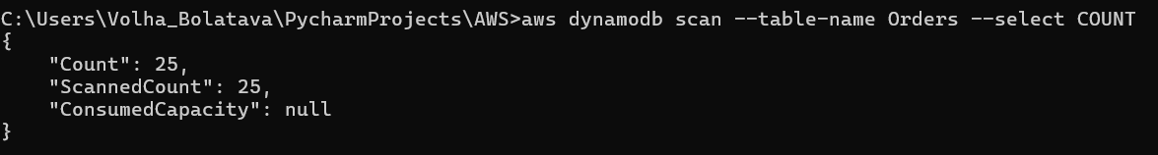
To retrieve 5+ rows by key, get-item was used 5 times, each time giving the full key (customer_id + order_id):
aws dynamodb get-item --table-name Orders --key "{\"customer_id\": {\"S\": \"C001\"}, \"order_id\": {\"S\": \"O1001\"}}"
--table-name specifies which table to read from. --key must contain the item's full primary key — since Orders uses a composite key (partition key customer_id + sort key order_id), both values have to be provided together, or DynamoDB can't uniquely identify the item.
The key is written in DynamoDB JSON format, where each value is paired with its data type ("S" for String, "N" for Number, etc.), because DynamoDB is schemaless and doesn't know attribute types in advance — they have to be specified explicitly in every request.
The backslash-escaped quotes (\") are just a Windows command-line requirement, since the whole --key value is a JSON object wrapped in an outer string; the inner quotes need escaping so the shell doesn't mistake them for the end of the string. On Linux/macOS this is usually avoided by wrapping the JSON in single quotes instead.
This was repeated for C002/O1004, C003/O1007, C005/O1013, C008/O1023. Each call returned exactly one item with all its attributes — for example C001/O1001 returned amount 150.5, status "shipped". get-item works this way because it's a direct lookup by full primary key, so it's fast and returns exactly one item, no scanning involved.
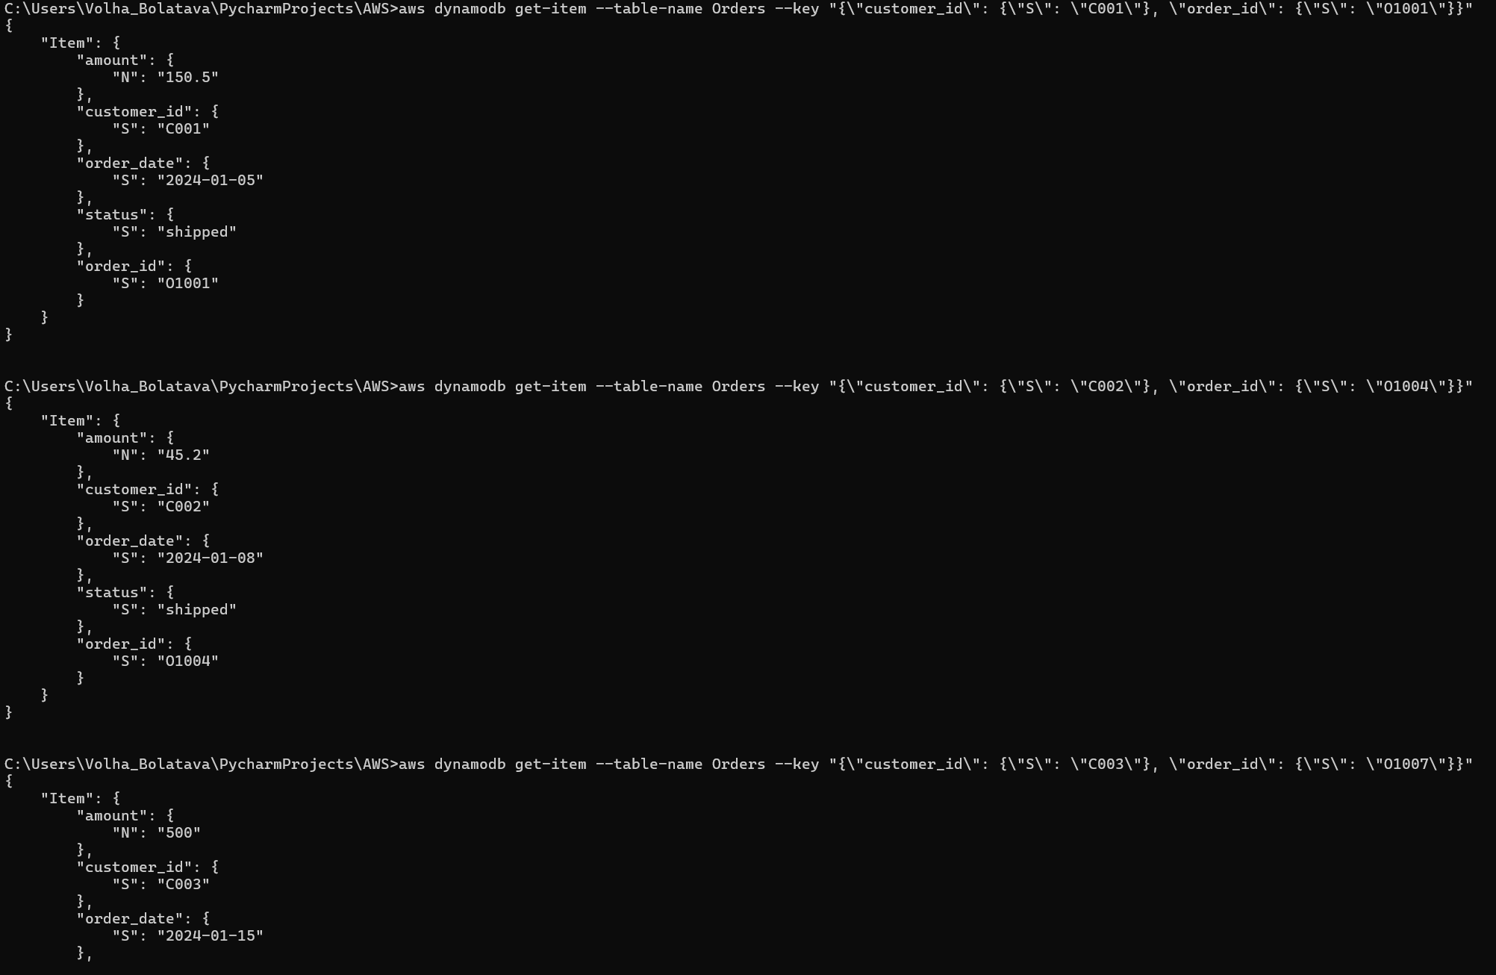

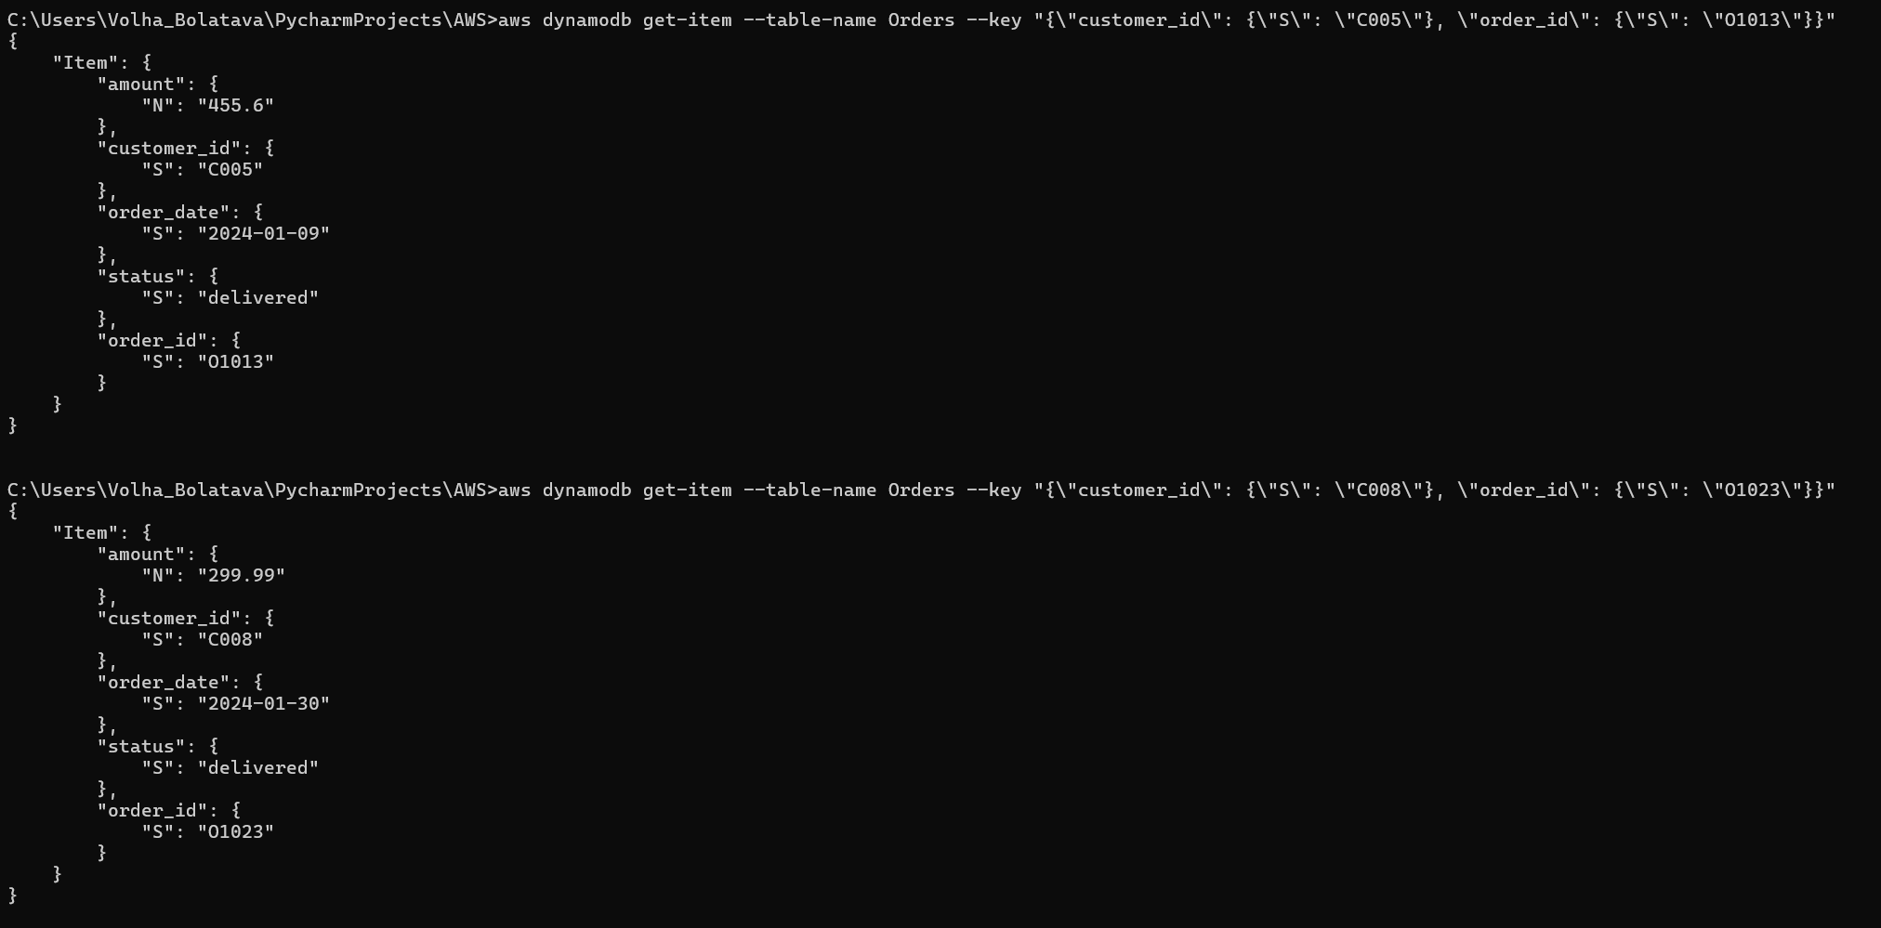
Query by partition key:
aws dynamodb query --table-name Orders --key-condition-expression "customer_id = :cid" --expression-attribute-values "{\":cid\": {\"S\": \"C001\"}}"
--key-condition-expression specifies the condition used to search the table — here it says "find all items where customer_id equals a given value." The actual value isn't hardcoded into the expression; instead a placeholder :cid is used, and its real value is supplied separately through --expression-attribute-values, again in DynamoDB JSON format ({"S": "C001"}). This separation between placeholder and value is required syntax for query and scan expressions in the CLI.
Unlike get-item, this only requires the partition key, not the full composite key — because query is designed to retrieve every item that shares the same partition key, regardless of their sort key value. The result returned all 3 orders belonging to C001 (O1001, O1002, O1003), plus a "Count": 3 field confirming how many items matched. This works efficiently because DynamoDB physically groups items with the same partition key together, so a query only reads that one group instead of scanning the whole table:
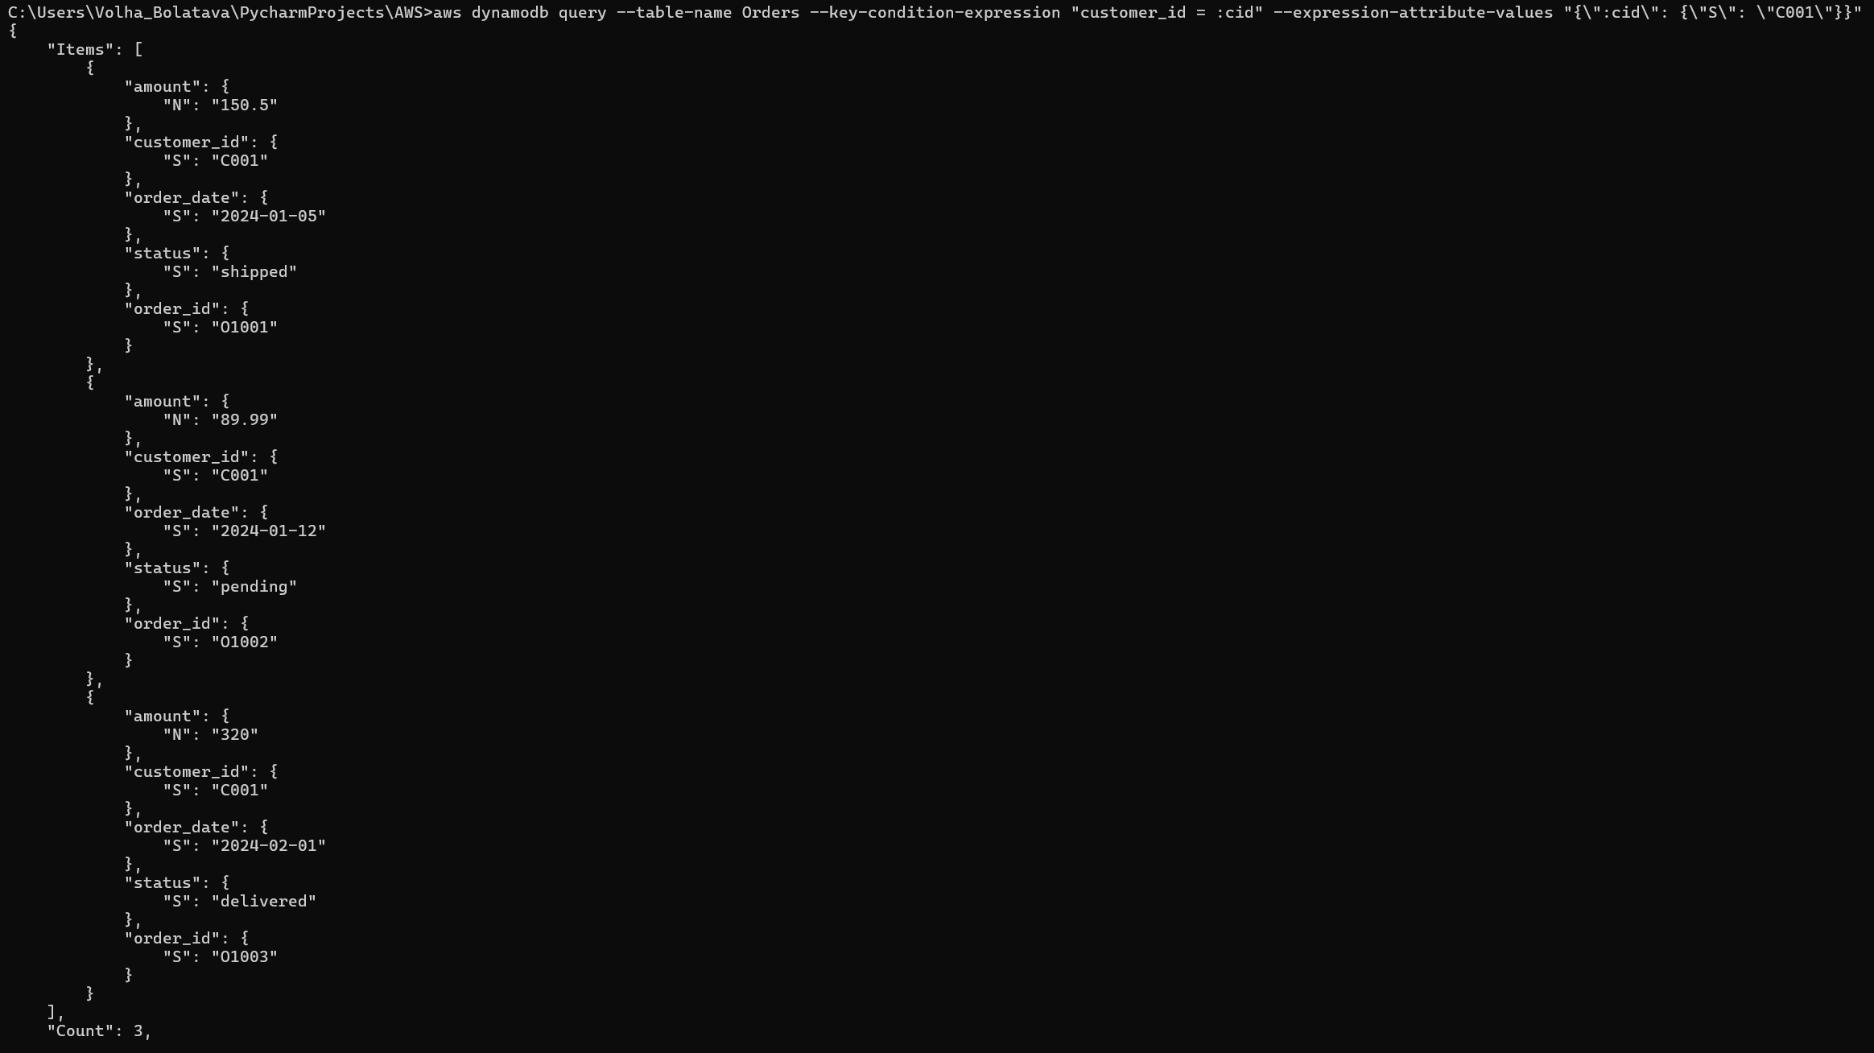
Query with a filter expression:
aws dynamodb query --table-name Orders --key-condition-expression "customer_id = :cid" --filter-expression "#s = :st" --expression-attribute-names "{\"#s\": \"status\"}" --expression-attribute-values "{\":cid\": {\"S\": \"C005\"}, \":st\": {\"S\": \"delivered\"}}"
Here two extra pieces are added on top of the basic query. --filter-expression "#s = :st" applies an additional condition on top of the key condition — in this case, only keep items where status equals a given value. Since status is a reserved word in DynamoDB's expression language, it can't be used directly in the expression; instead --expression-attribute-names maps a placeholder (#s) to the real attribute name (status). Both placeholders (:cid for the key and :st for the filter) get their real values from --expression-attribute-values.
The result returned just 1 item (the delivered order for C005), but "ScannedCount": 3 shows that all 3 orders for that customer were first read by the key condition, and only afterward filtered down to 1 by the status check — showing that a filter expression doesn't reduce what gets read, only what gets returned:
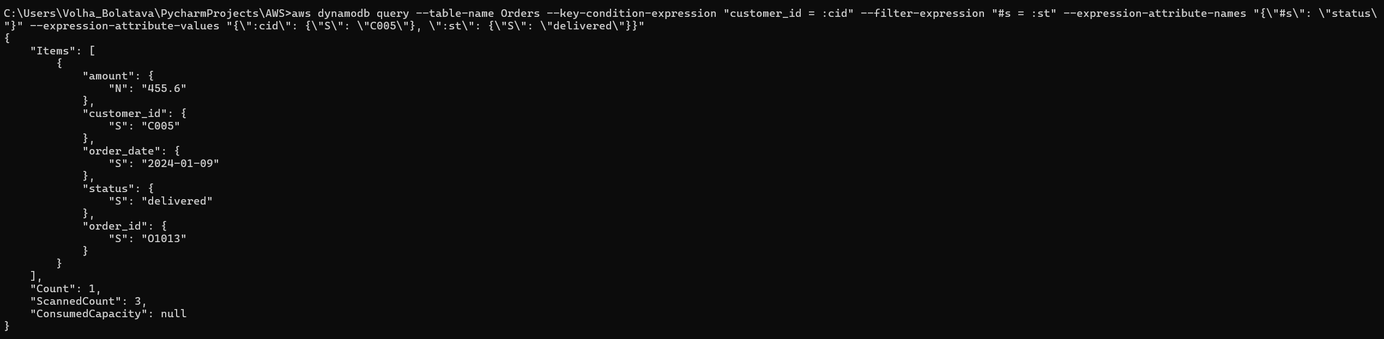
Scan with a numeric filter:
aws dynamodb scan --table-name Orders --filter-expression "amount > :amt" --expression-attribute-values "{\":amt\": {\"N\": \"200\"}}"
This uses scan instead of query because the condition (amount > 200) isn't based on the partition key — it applies across all customers, not just one. scan reads every item in the table and then applies the filter expression to each one, which is why it can answer this kind of table-wide question that query cannot. The result returned all orders with an amount above 200, spanning multiple different customers (C001, C003, C005, C006, C007, C008).
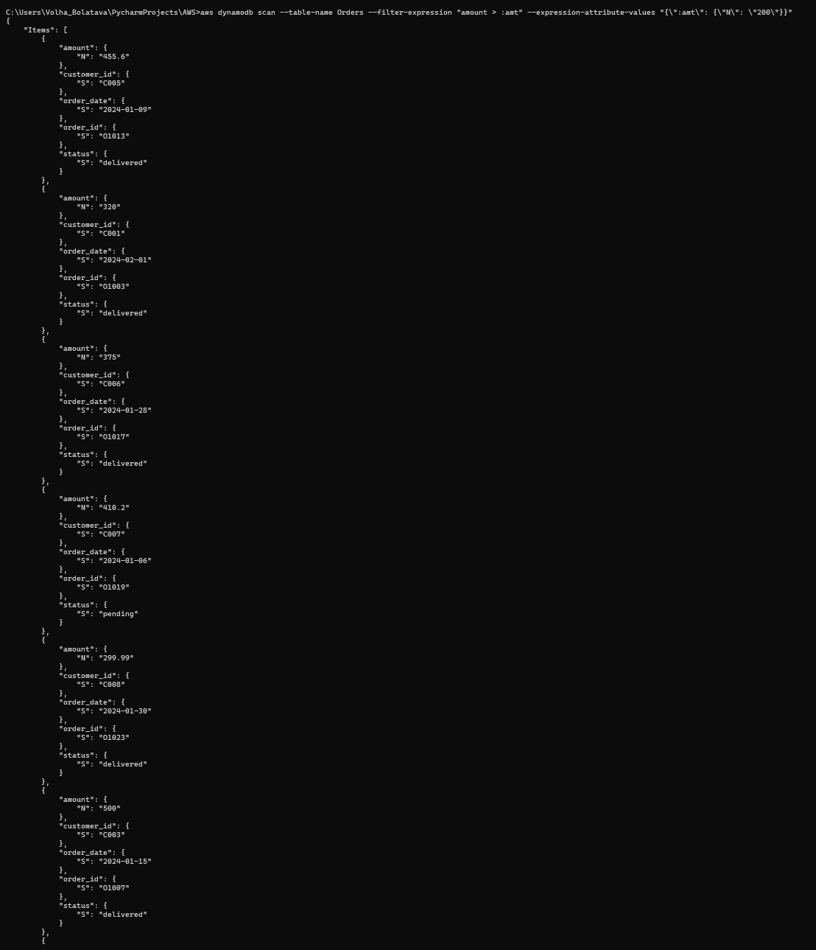
Scan filtering by status:
aws dynamodb scan --table-name Orders --filter-expression "#s = :st" --expression-attribute-names "{\"#s\": \"status\"}" --expression-attribute-values "{\":st\": {\"S\": \"cancelled\"}}"
Same pattern as before — #s maps to status because it's reserved, and :st holds the actual value ("cancelled"). The result returned 3 cancelled orders, but "ScannedCount": 25 confirms that scan read through all 25 items in the table before filtering down to those 3 matches. This is the key practical difference from query: query only ever reads inside one partition, while scan always reads the entire table, making it less efficient as the table grows larger.
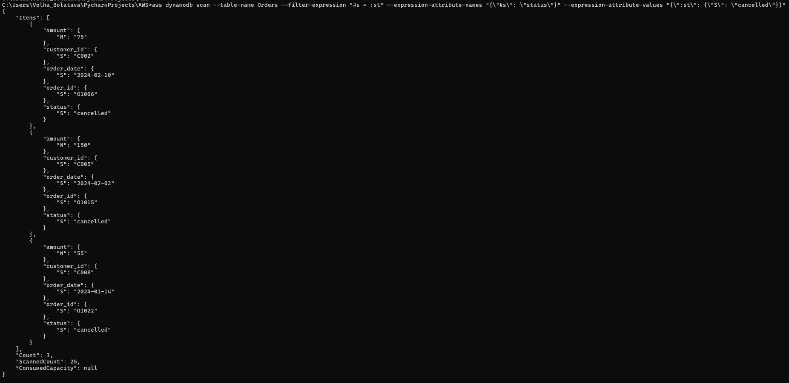
Two rows were deleted using delete-item with the full key:
Deleting O1002 , client C001:
aws dynamodb delete-item --table-name Orders --key "{\"customer_id\": {\"S\": \"C001\"}, \"order_id\": {\"S\": \"O1002\"}}"
Deleting O1016 client C006
aws dynamodb delete-item --table-name Orders --key "{\"customer_id\": {\"S\": \"C006\"}, \"order_id\": {\"S\": \"O1016\"}}"
Each transaction is specifying the full composite key of the item to remove: customer_id = C001, order_id = O1002, and customer_id = C006, order_id = O1016. As with get-item, deletion by full primary key is a direct, efficient operation rather than requiring a scan to locate the item first.
To confirm the deletions took effect, aws dynamodb scan --table-name Orders --select COUNT was run again afterward, and the count dropped from the original 25 items down to 23, correctly reflecting that exactly 2 items had been removed from the table:
