1.
a. Creating an EC2
A new Amazon EC2 virtual machine instance was created within the AWS Management Console to establish a cost-effective and lightweight relational database hosting environment in the cloud. The instance was designated with the recognizable identifier EC2_PostgreSQL_Server to host the database engine and maintain full administrative root control over the operating system.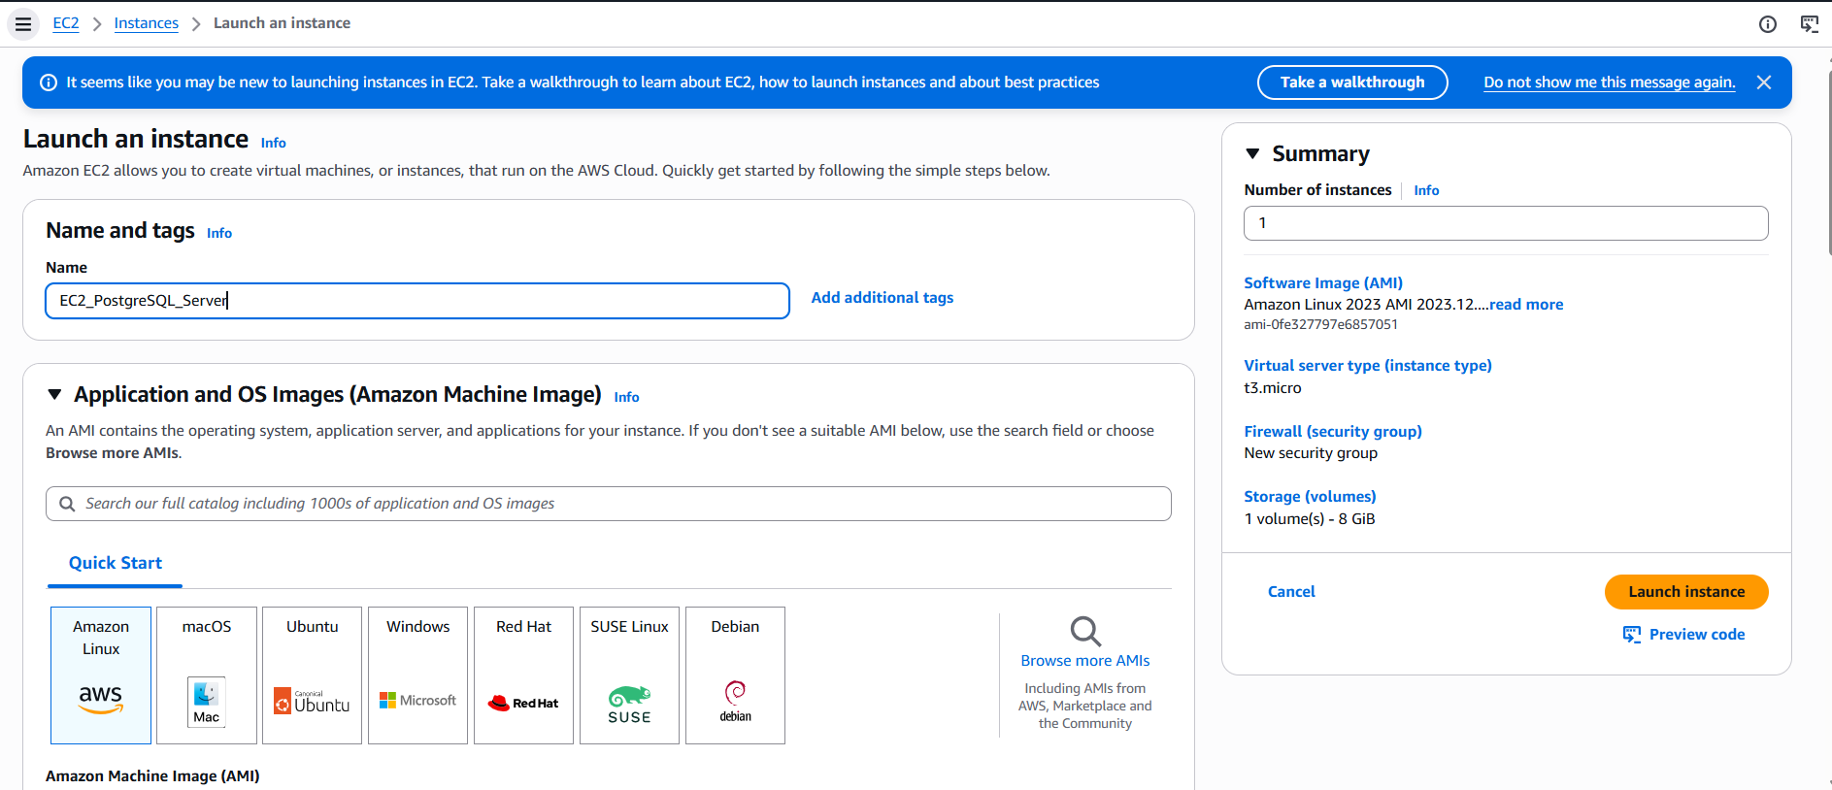
To optimize operational compute expenses while providing sufficient burstable performance for development workloads, the deployment was targeted directly to the Amazon Linux 2023 AMI platform running on a standard t2.micro instance specification with an initial 8 GiB root volume.
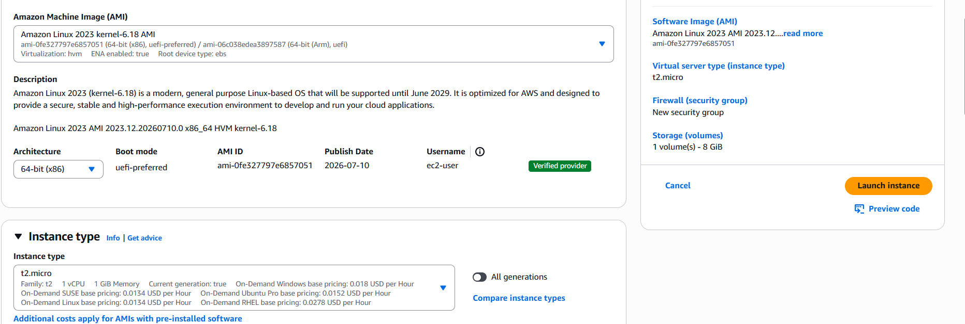
A new cryptographic SSH key pair was explicitly generated within the EC2 instance creation wizard to secure administrative access to the virtual database host without relying on vulnerable password-based authentication. The key pair was assigned the matching name EC2_PG_Server to align credentials directly with the underlying database host. For maximum system compatibility and compliance with standard OpenSSH protocols, the key was configured using the RSA encryption algorithm and saved in the standard .pem private key file format.

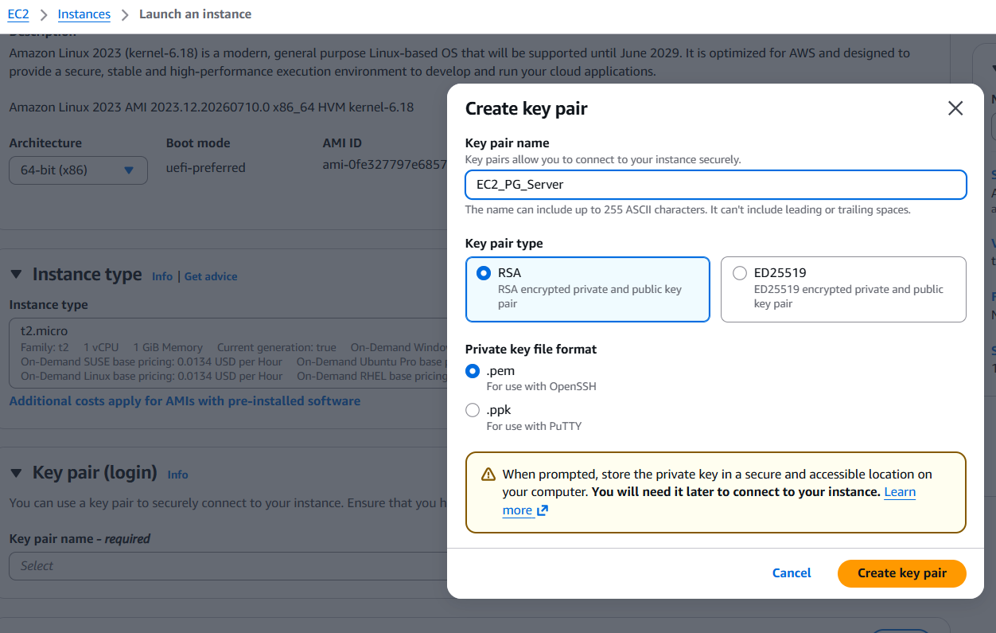
Standard .pem was downloaded to the local host workstation's secure storage directory to enable encrypted CLI connectivity and prevent unauthorized remote login attempts.
To establish inbound network perimeter controls and guarantee reachable administrative connectivity, the EC2 instance was assigned to the default VPC (vpc-04521702e2480ec7b) with public IP auto-assignment explicitly enabled. To isolate incoming operational traffic, a virtual firewall security group was configured to permit inbound SSH connections exclusively. To restrict administrative entry points and prevent brute-force exposure from unauthorized networks, the SSH ingress rule was limited directly to the specific source IP address:

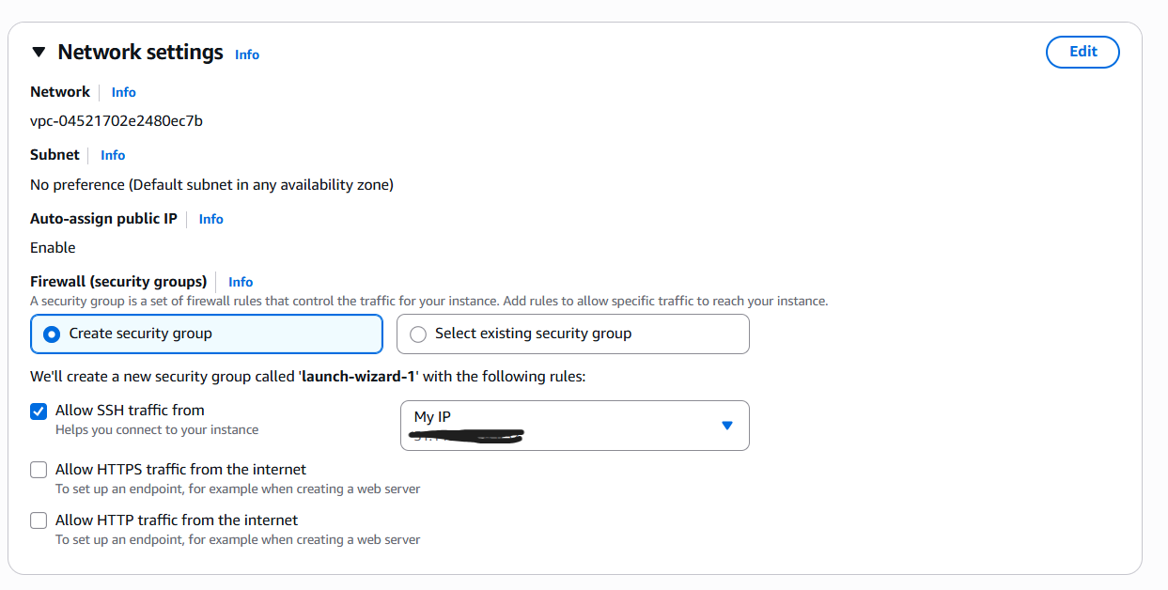
A partitioned storage architecture was configured directly within the EC2 instance launch settings to separate system operations from database data. A primary Root volume was allocated at 8 GiB using the general-purpose gp3 specification to host the operating system files and core utilities. An additional 10 GiB gp3 secondary EBS volume was attached to accommodate the relational database engine and prevent system failure from disk overflow, maintaining a cost-effective storage footprint without subscribing to external network file systems:
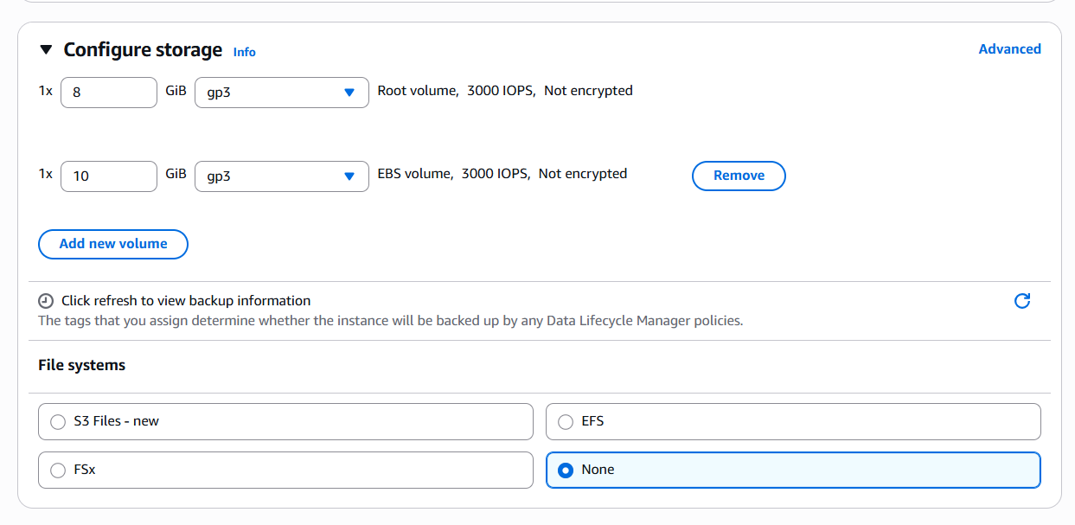
A dedicated IAM role setup was initiated to grant the virtual server secure permission to interact with cloud storage without hardcoding access keys. The trusted entity type was configured as an AWS service, with EC2 explicitly selected as the target use case.:
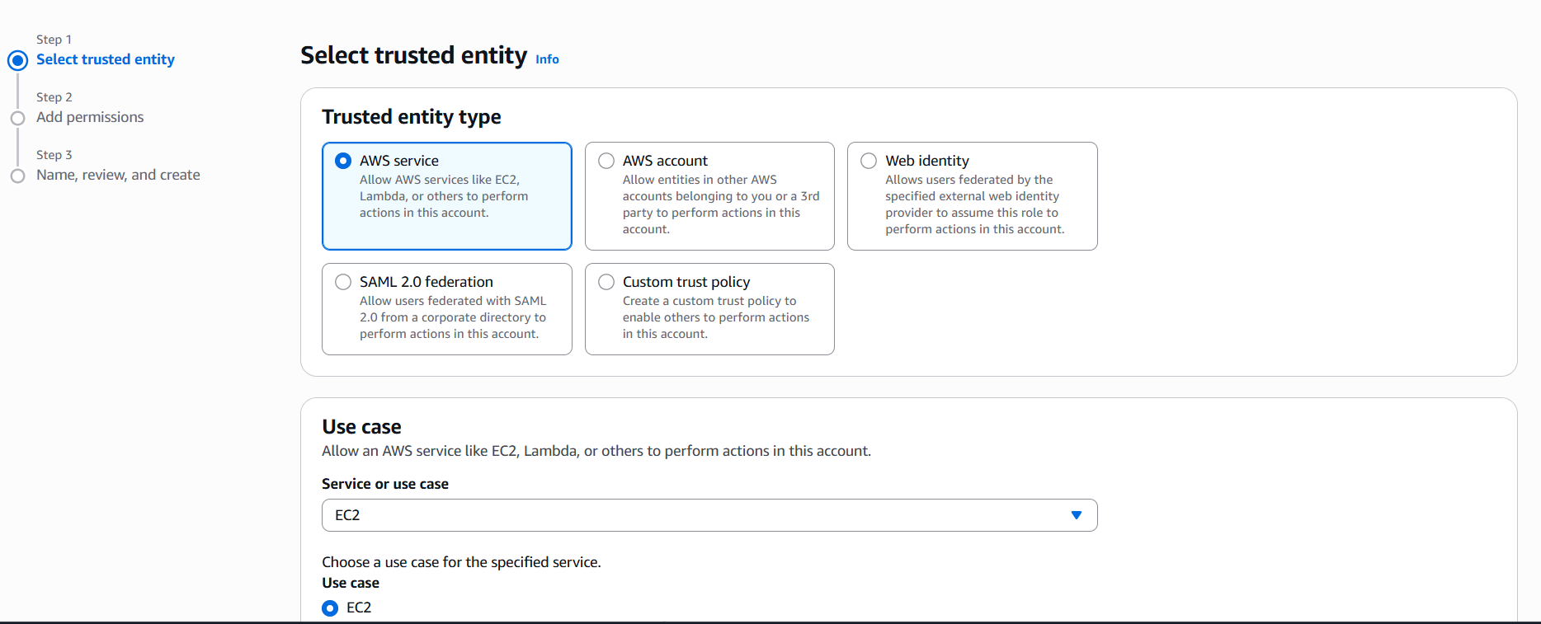
To define the operational scope of the identity, an existing AWS-managed policy was attached to the role. The AmazonS3FullAccess policy was selected from the policy repository to enable complete read, write, and administrative access to Amazon S3 buckets directly from the EC2 instance:
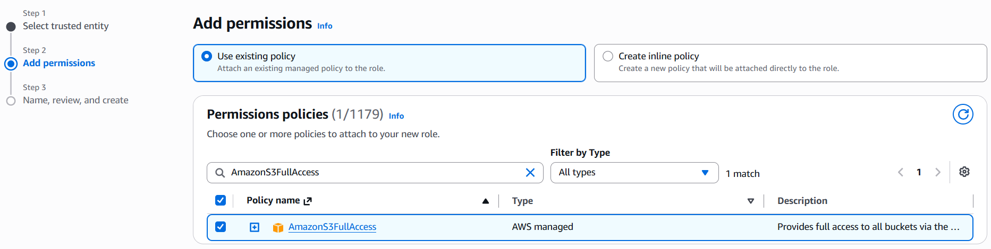
To finish configuring the IAM identity, the role was named AWS_EC2_full_access_S3 to clearly signal its associated service and granted permissions:

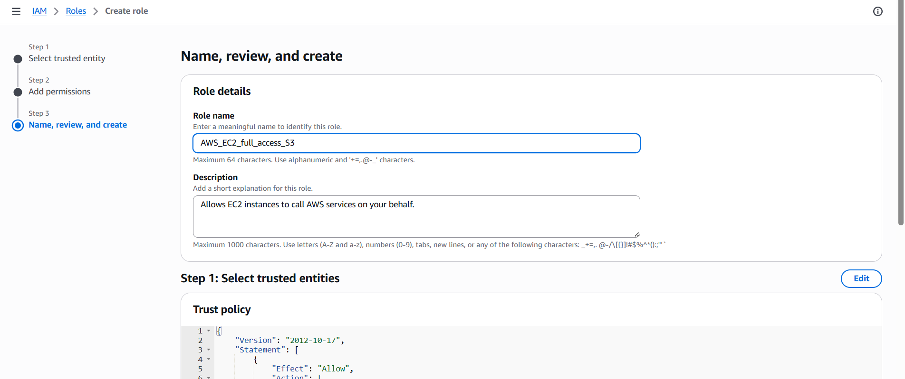
The role AWS_EC2_full_access_S3 was successfully created:
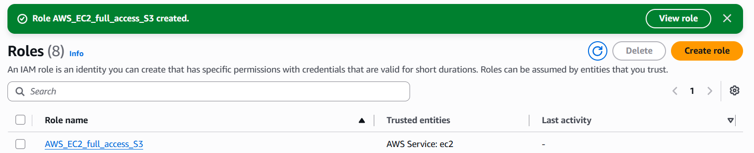
To grant the virtual machine permissions for Amazon S3 the newly generated IAM role was attached:
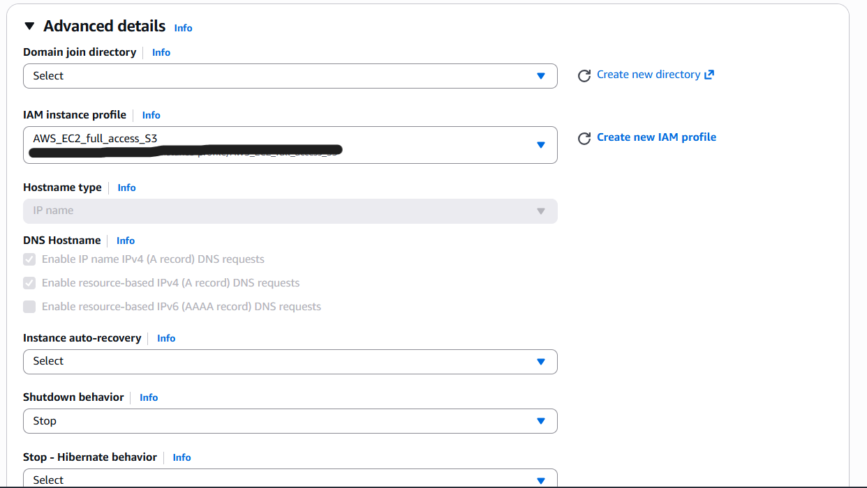
To finalize the setup, the launch process was successfully initiated for the new EC2 instance. The system validated all initial requests, configured the security group rules, and successfully launched the virtual server. This confirms that the EC2 environment for PostgreSQL is now live and running in the cloud:
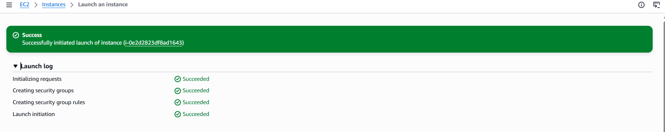

After launching, the EC2 instance status was verified in the AWS Management Console. The instance EC2_PostgreSQL is in the Running state with a 2/2 checks passed status, deployed as a t2.micro instance type in the eu-central-1b Availability Zone. This confirms that the virtual server is fully active and ready for connection.
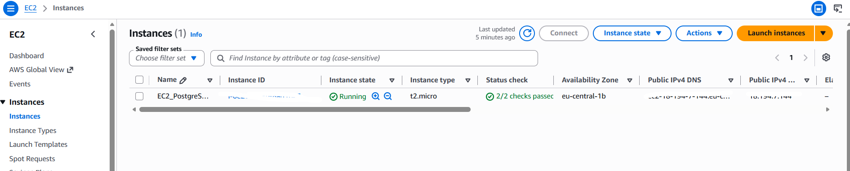
b. Installing PostgreSQL
Inbound network access was restricted to ensure secure connectivity to the instance. The SSH rule was configured on port 22 to allow remote administrative access exclusively from My IP. Similarly, the PostgreSQL rule was enabled on default port 5432, restricting database connections strictly to the administrator's current IP address for enhanced security:
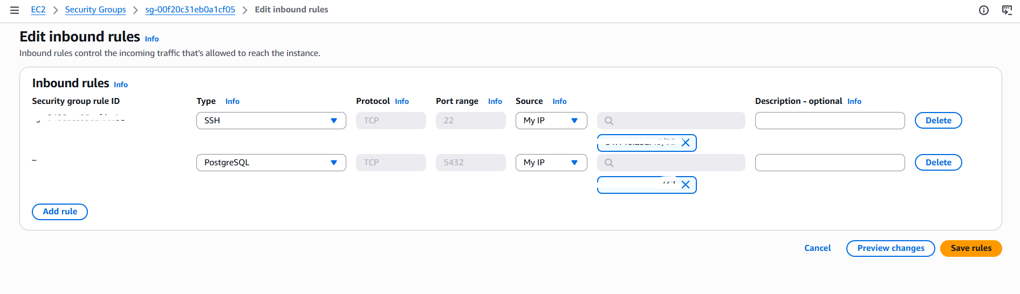
The original OpenSSH private key file (.pem) downloaded from the AWS Management Console was imported into PuTTYgen (PuTTY Key Generator) to transform it into the .ppk (PuTTY Private Key) format. This conversion was necessary because Windows PuTTY clients do not natively support raw .pem keys for SSH authentication. The RSA key parameters (2048-bit) were preserved during the import, and the resulting .ppk file was saved locally for session configuration. A new SSH session was configured in PuTTY targeting the EC2 instance's public IPv4 address on standard Port 22. Under the Connection > SSH > Auth > Credentials panel, the converted .ppk key was attached as the authentication file. Upon initiating the connection, the system automatically logged in as the default Amazon Linux administrative user (ec2-user) and authenticated against the public key stored in the instance's authorized_keys file.
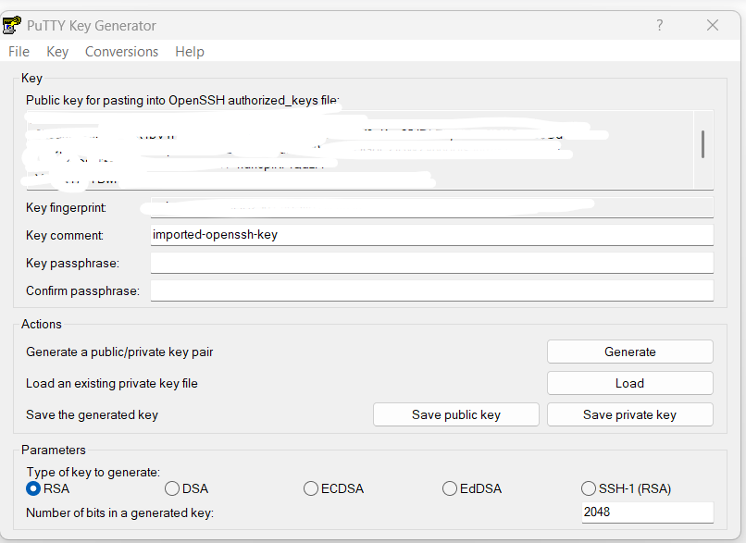
The terminal successfully rendered the Amazon Linux 2023 ASCII banner and opened a functional interactive bash prompt This confirmed that the network security group rules (Port 22 open to My IP), the elastic infrastructure, and the cryptographic identity setup were all operating correctly, giving full command-line control over the virtual server.
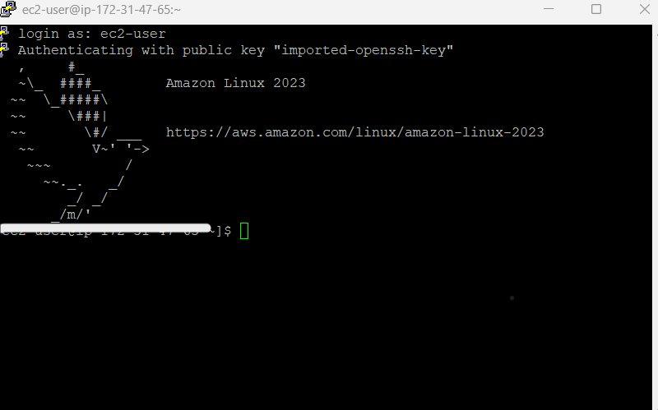
The postgresql15-server package along with its core dependencies (libicu, postgresql15, and postgresql15-private-libs) was installed via the dnf package manager (sudo dnf install -y postgresql15-server). This deployed the essential database binaries and libraries directly onto the Amazon Linux 2023 environment.
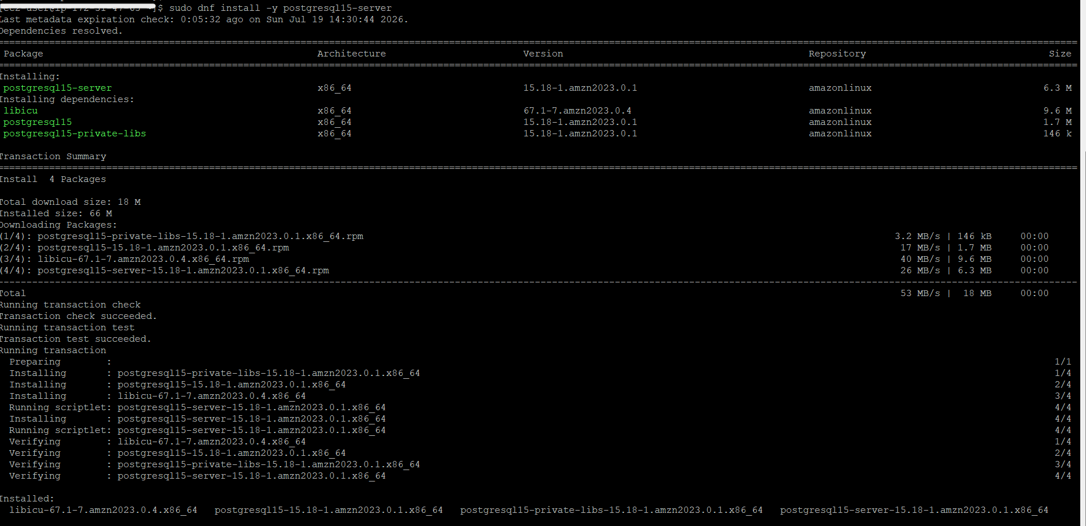

c. Connecting to database with DBeaver
The primary database cluster was initialized in /var/lib/pgsql/data using the postgresql-setup --initdb utility. This command generated the core system catalogs, configuration files (postgresql.conf, pg_hba.conf), and default database structures required for runtime operations.
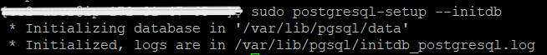

The PostgreSQL background daemon was started and configured for automatic boot persistence using systemctl (sudo systemctl start postgresql and sudo systemctl enable postgresql). Verification via sudo systemctl status postgresql confirmed that the service was active, running under PID 27974, and managing standard background workers (logger, checkpointer, autovacuum launcher).
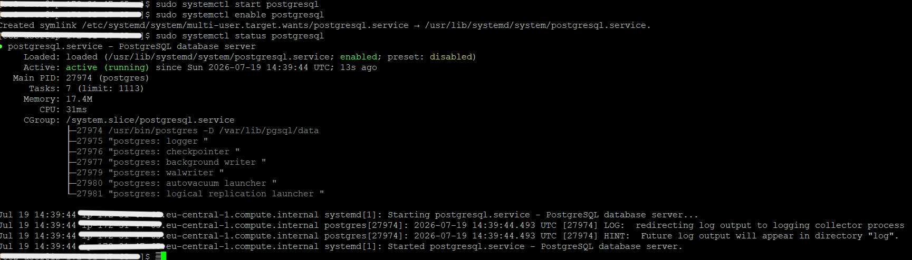

Superuser privileges were configured by switching to the system postgres user and setting a secure master password via SQL CLI (psql -c "alter user postgres with password '...'"). Additionally, Midnight Commander (mc) was installed (sudo dnf install -y mc) to provide a convenient two-panel file manager for navigating system directories and editing cluster configuration files.
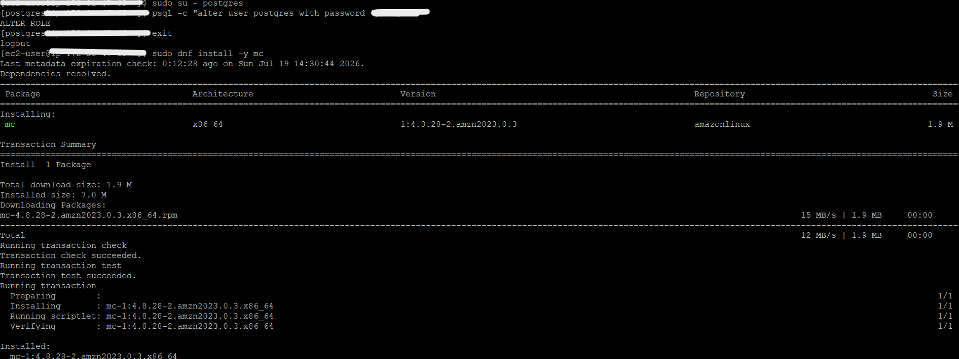
Network binding was verified using the socket statistics command (sudo ss -tulpin). The output confirmed that PostgreSQL (postgres process) is actively listening on standard Port 5432 across all network interfaces (0.0.0.0:5432 and [::]:5432), ready to accept incoming connections alongside the SSH service on Port 22.
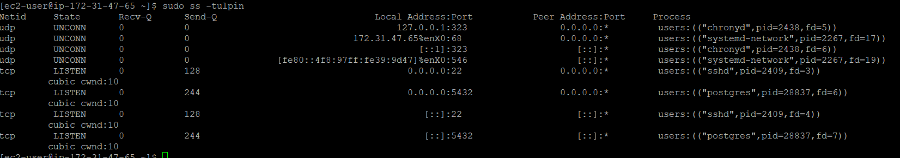
To verify external database connectivity, a new PostgreSQL connection profile named postgres 2 was configured in DBeaver. The target Host was set to the EC2 instance's public DNS endpoint on standard PostgreSQL Port 5432, pointing to the default postgres system database.
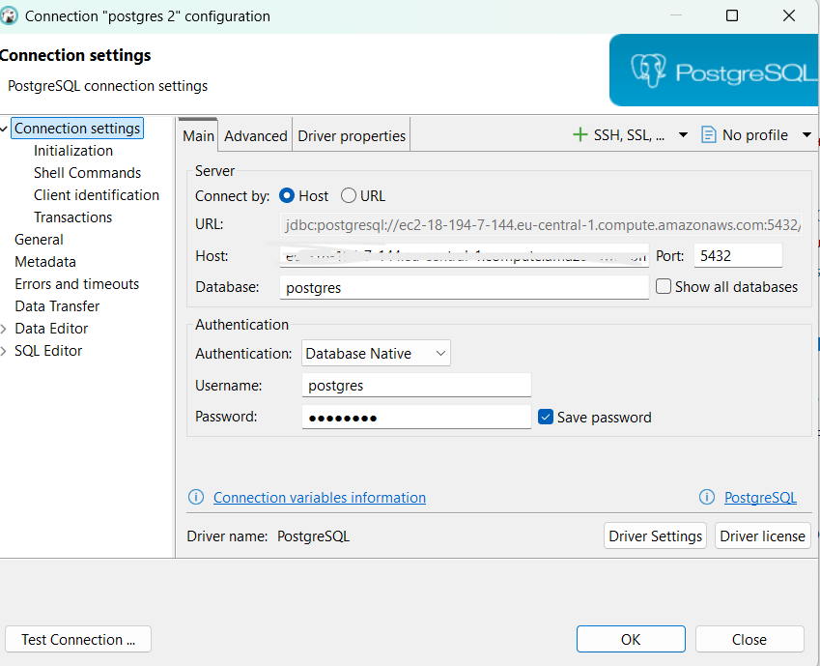
The database was successfully connected. The output confirmed that the target host is running PostgreSQL 15.18 on x86_64-amazon-linux-gnu using the PostgreSQL JDBC Driver 42.7.2, proving that end-to-end network traffic, user authentication, and database readiness are fully operational:

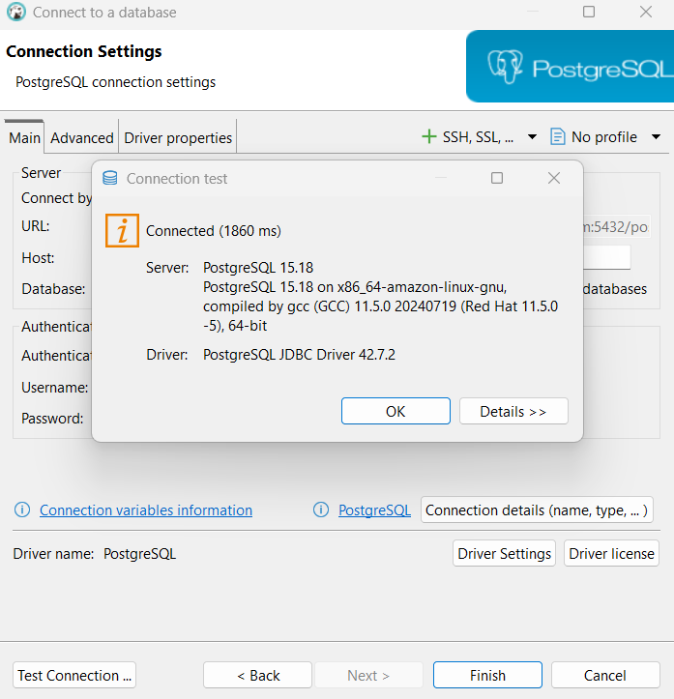
The active database session was established in DBeaver's Database Navigator panel. The expanded connection tree for postgres 2 displays the default postgres database along with its child administrative components, including Schemas, Event Triggers, Extensions, Storage, System Info, and Roles. This active hierarchy view confirms full administrative access and object visibility over the remote PostgreSQL cluster:
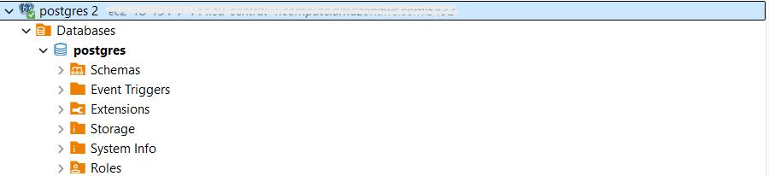
e. Crating objects in DB
Using the DBeaver SQL Editor connected to the remote PostgreSQL database, a series of DDL and DML operations were executed. The script defined a core employees table with column constraints, populated it with initial record sets, created a relational view named high_paid_employees, and declared a PL/pgSQL stored procedure raise_salary for automated salary updates.
-- Table creation
CREATE TABLE employees (
id SERIAL PRIMARY KEY,
first_name VARCHAR(50),
last_name VARCHAR(50),
salary NUMERIC(10, 2),
hire_date DATE DEFAULT CURRENT_DATE
);

-- Inserting values
INSERT INTO employees (first_name, last_name, salary) VALUES
('Pavel', 'Sidorov', 5500.00),
('Anna', 'Sidorova', 7500.00),
('Ivan', 'Ivanov', 3200.00);

-- Creating view
CREATE VIEW high_paid_employees AS
SELECT id, first_name, last_name, salary
FROM employees
WHERE salary > 4000.00;

-- Creating procedure
CREATE OR REPLACE PROCEDURE raise_salary(emp_id INT, amount NUMERIC)
LANGUAGE plpgsql
AS $$
BEGIN
UPDATE employees
SET salary = salary + amount
WHERE id = emp_id;
END;
$$;
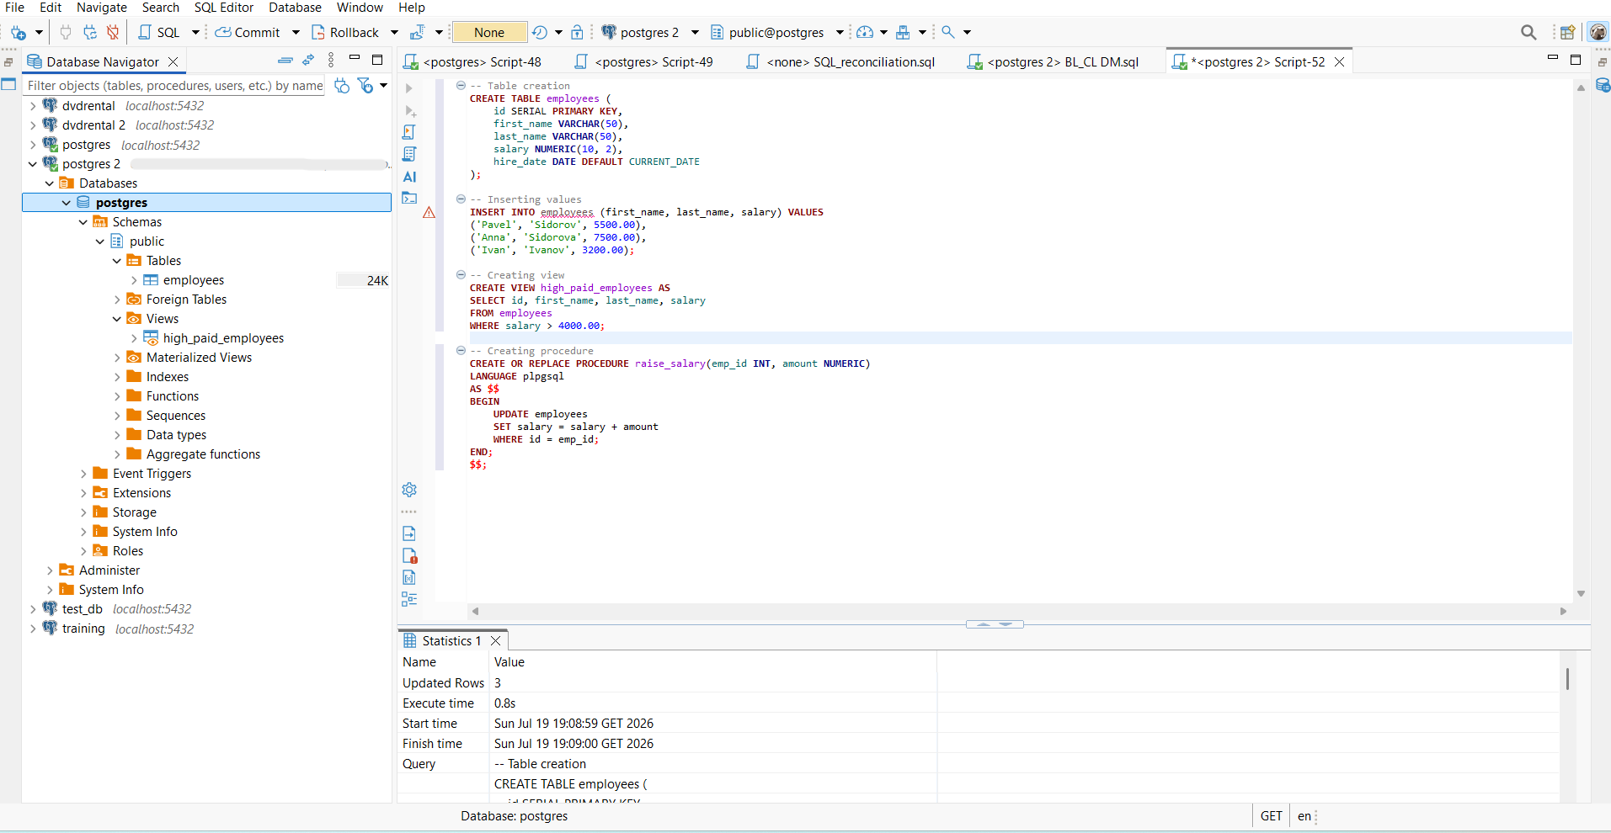
To verify database object persistence directly on the EC2 host, an interactive psql session was launched as the postgres superuser. Meta-commands \dt and \dv confirmed the physical creation of the employees table and high_paid_employees view within the public schema. A direct SQL query (SELECT * FROM employees;) validated that all inserted records were correctly committed and stored in the database engine.
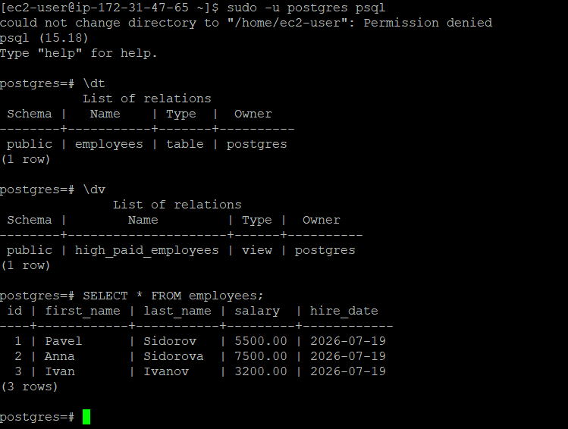
2.
Data integration capabilities were tested using the AWS Command Line Interface. A target dataset (dim_stores.csv) was copied from an Amazon S3 storage bucket (s3://s3bucketvolha/dwh_database/...) to the EC2 local filesystem using aws s3 cp. Directory verification (ls -la) confirmed the successful download of the dim_stores.csv file (~500 KB) into the home directory, preparing it for subsequent bulk-loading into PostgreSQL.
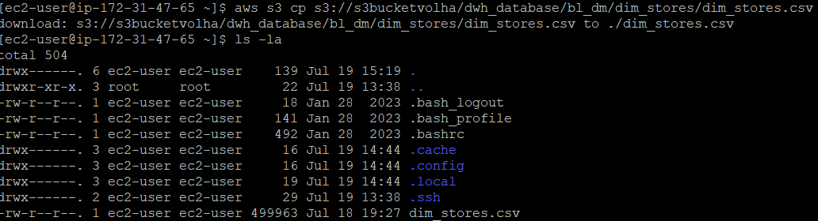
3.
The 10 GB EBS volume (vol-06fdf9c090434d61b) attached to the EC2 instance was selected in the AWS Console, and the Create snapshot option was executed. A snapshot is created to serve as a point-in-time backup of the disk. This step was necessary to safely preserve all current data, installed software (such as PostgreSQL), and system configurations, protecting the work against data loss.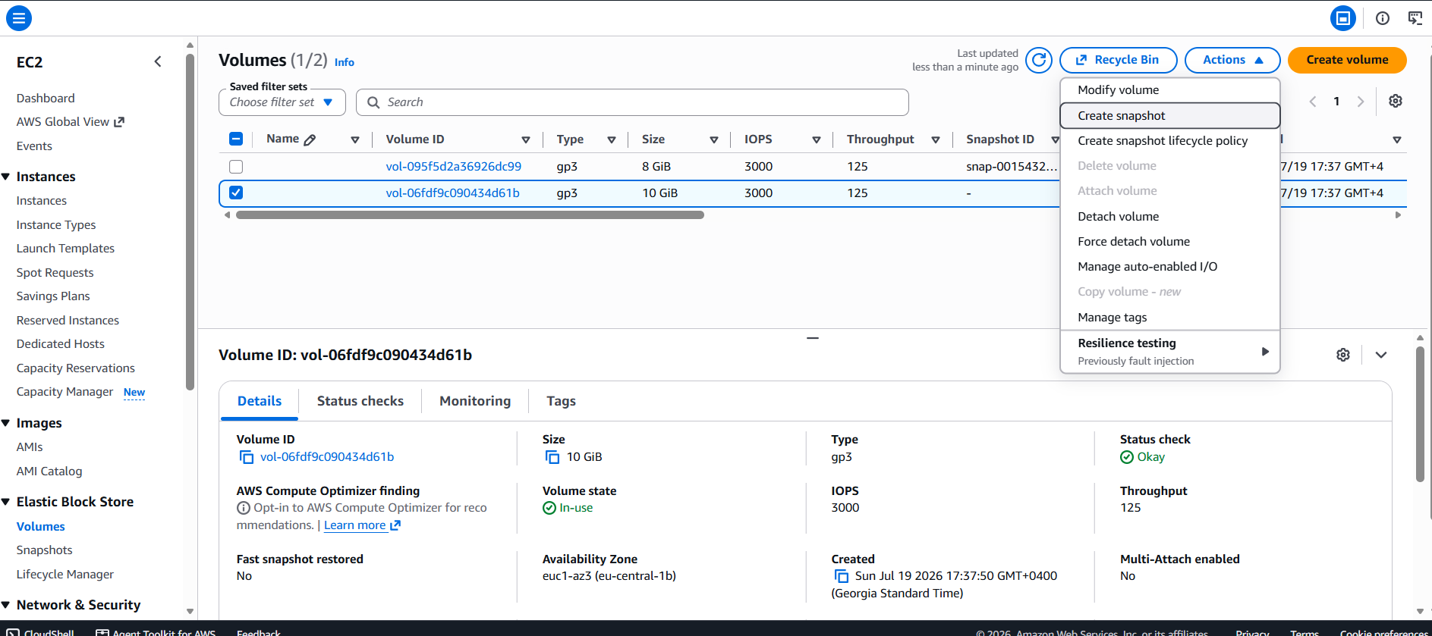
The snapshot was named volha-ebs-snapshot with an added owner: student tag for identification.
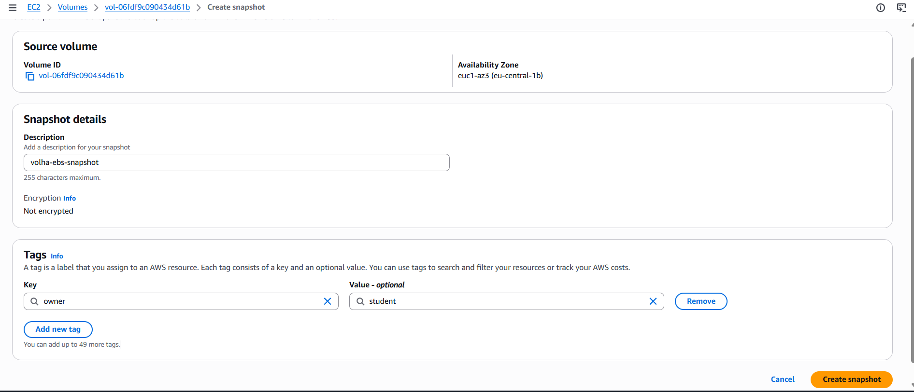
Using the completed snapshot (snap-05bb258da1896548c), a custom Amazon Machine Image (AMI) was generated via the Create image from snapshot option. The image was configured with the x86_64 architecture and a 10 GB root volume. While a snapshot only stores raw disk data, an AMI acts as a fully bootable virtual machine template. The AMI was created so that identical copies (clones) of the original EC2 instance can be launched quickly in the future without needing to reinstall the operating system or manually configure the database from scratch.
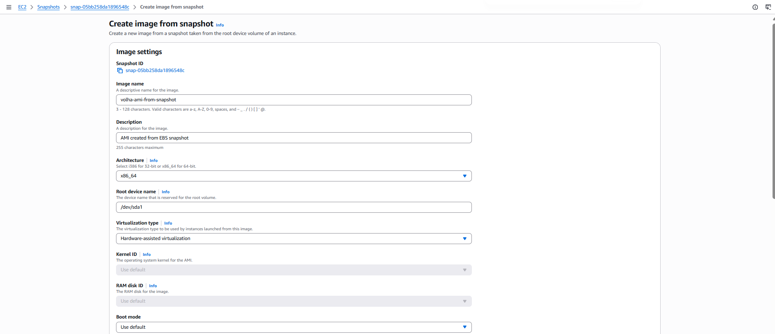
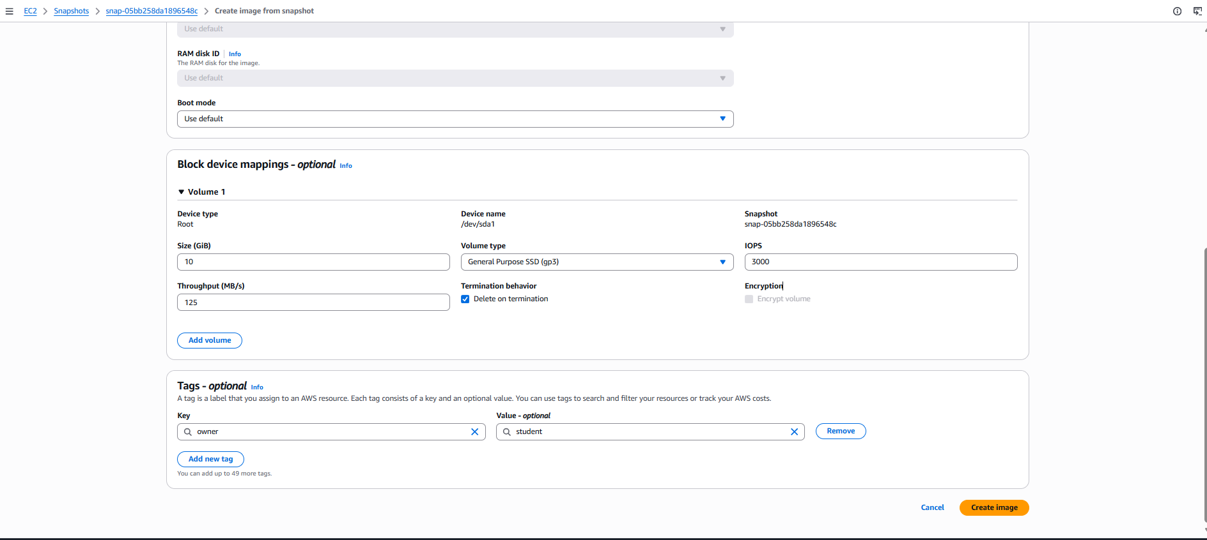To confirm the process was successful, the AMIs page in the EC2 Console was checked. The new image (ami-09dce8abd7122dee4) appeared with an Available status. This verifies that the backup is complete and the template is ready for future deployments.
4.
A new EC2 instance named PG_Server_from_AMI was launched using the previously created custom image EC2_PG_Server_Image (ami-083f26c6b824c41c0). During configuration, standard parameters were selected: t2.micro instance type, existing key pair EC2_PG_Server, and security group launch-wizard-1. Using a custom AMI ensures that the newly created instance is an exact clone of the original server with all system state, configurations, and files preserved.
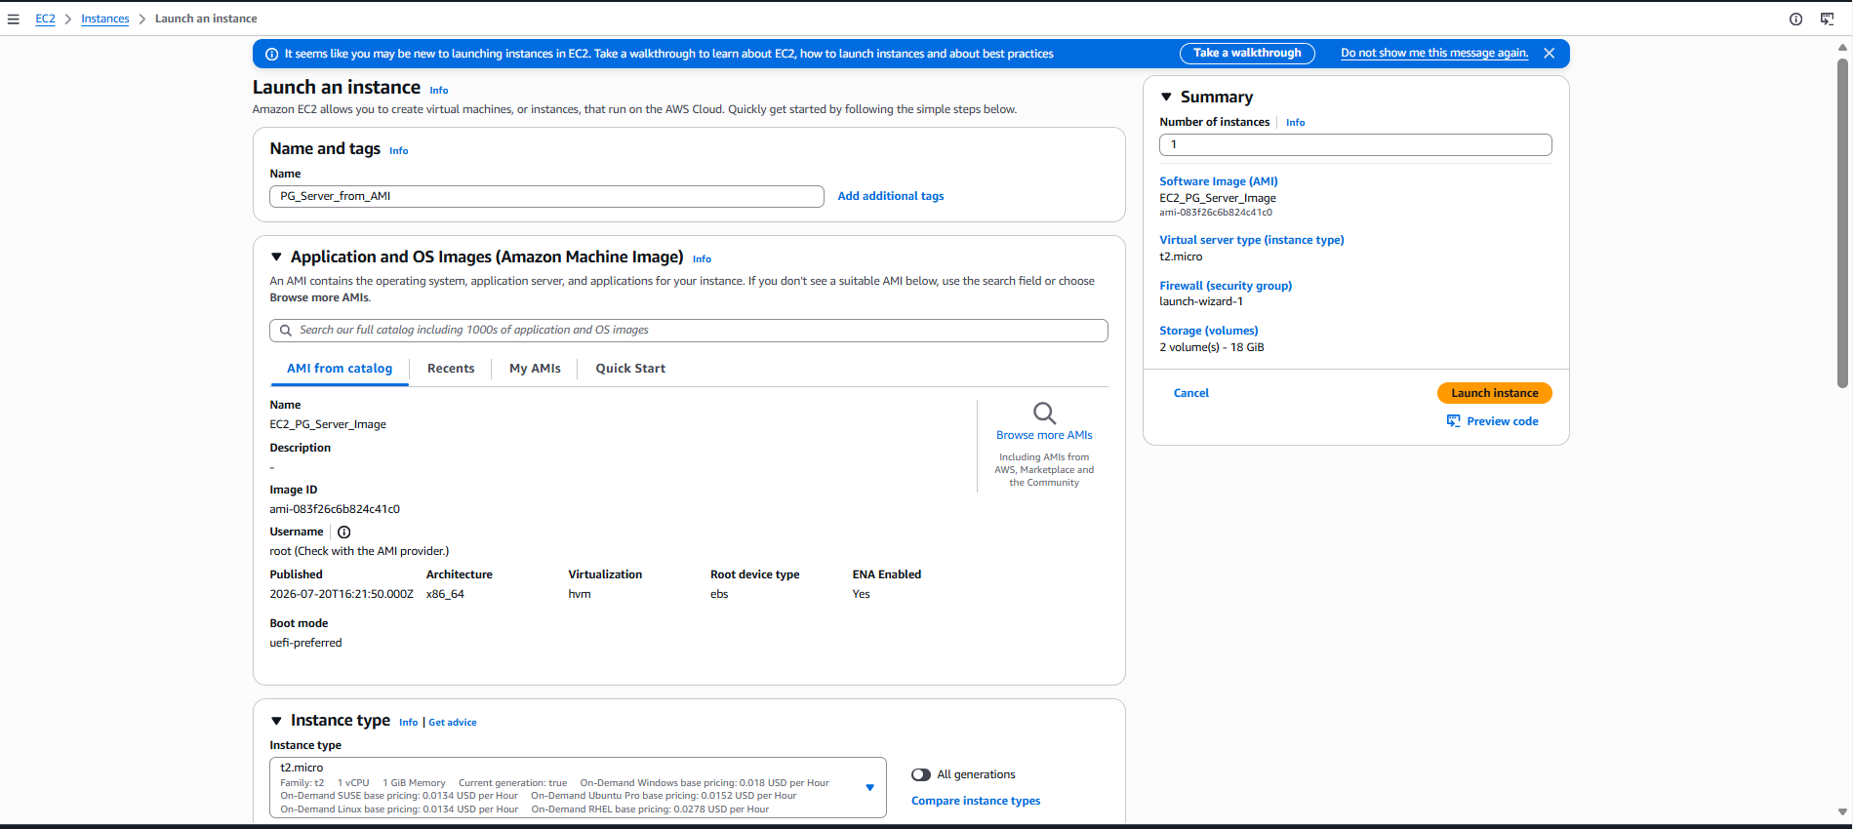
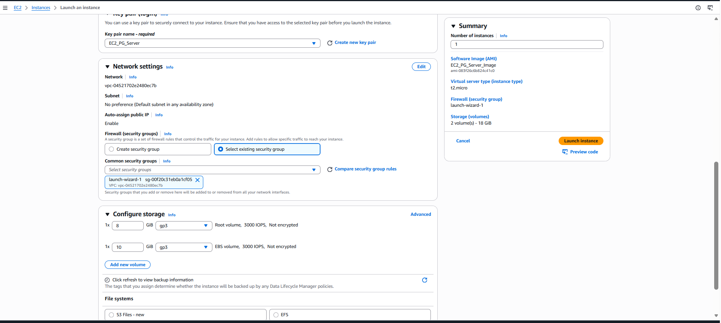
Under the Advanced details section on the launch page, Instance Metadata Service parameters were configured: Metadata accessible was set to Enabled, and Metadata version was explicitly set to V2 only (token required). Enforcing IMDSv2 (Instance Metadata Service Version 2) is a critical security best practice. Unlike IMDSv1, Version 2 requires session-oriented authentication (tokens), protecting the server against potential SSRF (Server-Side Request Forgery) vulnerabilities.

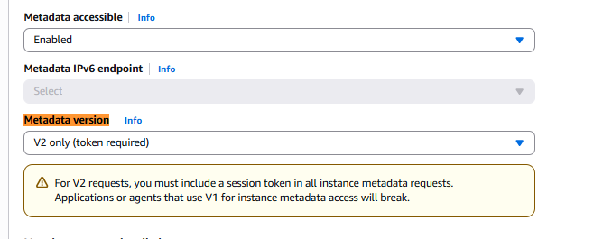
The AWS EC2 console confirms that both virtual instances—the original EC2_PostgreSQL_Server (i-0e2d2823df8ad1643) and the newly created clone PG_Server_from_AMI (i-043f687679eadccc6)—are in the Running state with 2/2 status checks passed in the eu-central-1b availability zone:
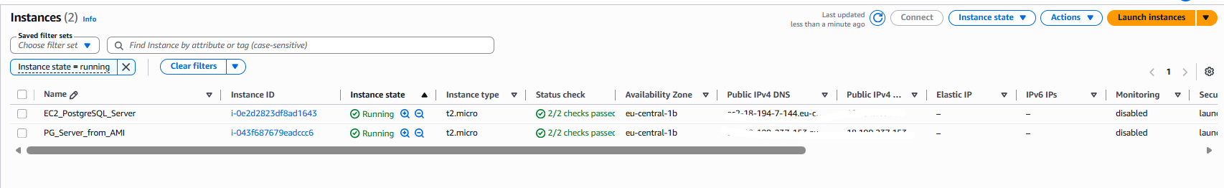
Upon establishing a successful SSH connection to the newly deployed EC2 instance (PG_Server_from_AMI) as ec2-user, executing the ls -la command verified the successful preservation of the system directory state. The terminal output confirms the presence of the dataset dim_stores.csv (size: 499963 bytes) within the home directory, retaining its original permissions and metadata. This demonstrates that deploying a server from a custom AMI fully clones the underlying EBS volume, ensuring complete data consistency and operational readiness without requiring manual data re-uploading.
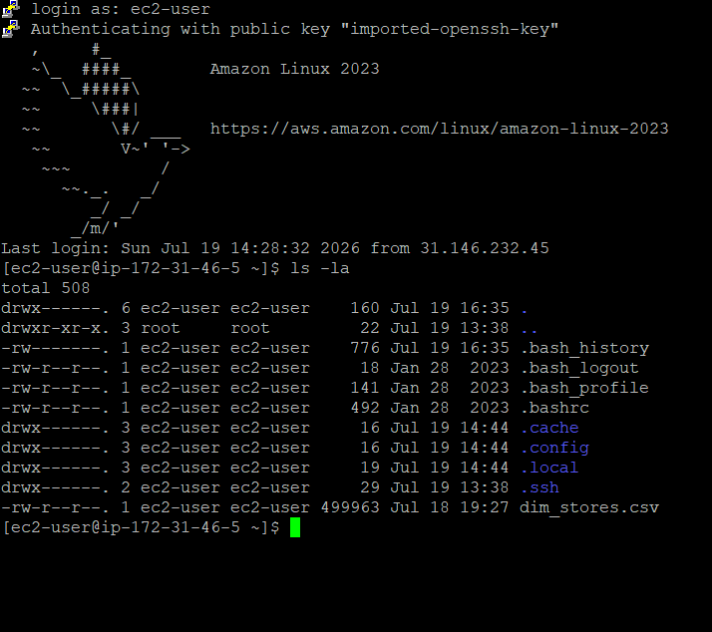
5.
The Apache Web Server (httpd-2.4.60) and its required dependencies were successfully installed on the EC2 instance using the package manager (dnf/yum). The terminal output confirms that all 13 RPM packages were downloaded, verified, and installed without transaction errors, preparing the server environment to host static web content from the standard /var/www/html directory and expose it over HTTP.
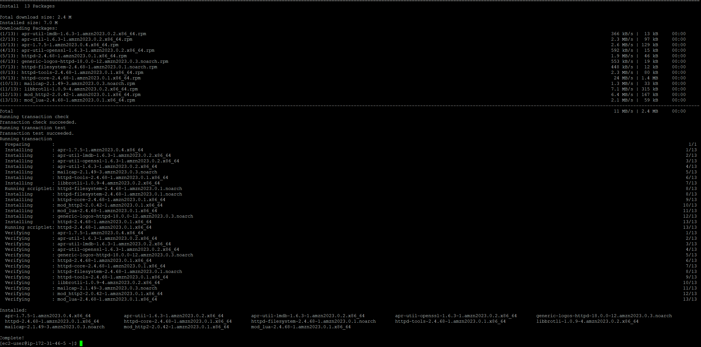
To enable external access to the Apache web server while maintaining network isolation, an inbound HTTP rule (Port 80, TCP) was added to the security group alongside the existing SSH (Port 22) and PostgreSQL (Port 5432) rules. Restricting the source IP to 31.146.232.45/32 applies the principle of least privilege, allowing web traffic specifically from authorized client networks while blocking unrestricted public access to the hosted web application:
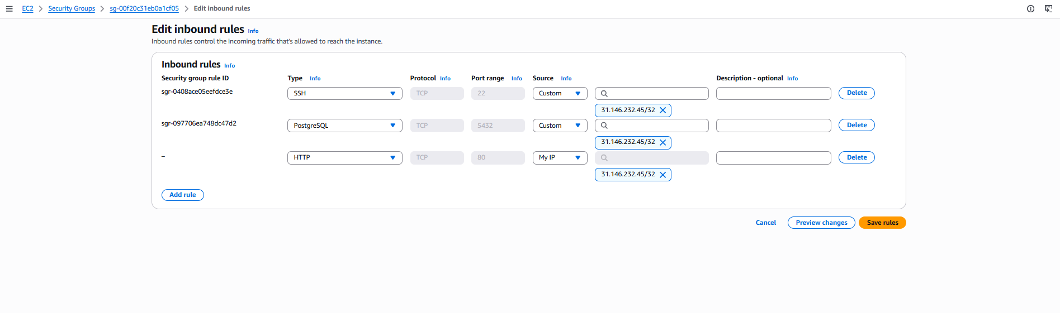
The Apache web service (httpd) was initiated and configured for persistent execution across system reboots using systemctl start httpd and systemctl enable httpd. A detailed service inspection via systemctl status httpd confirmed an active, healthy process state (PID 3105) actively listening on port 80.
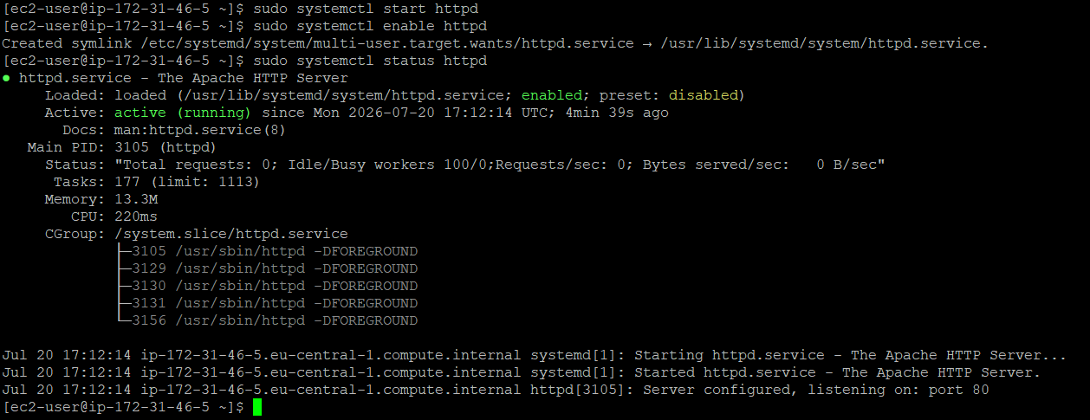
Subsequent verification in a web browser by navigating to the instance's public IP address ([http://18.199.237.153/](http://18.199.237.153/)) successfully rendered the custom index.html page displaying "It works!". This end-to-end test conclusively validates proper HTTP daemon initialization, correct file placement within /var/www/html, and appropriate security group inbound rule routing.
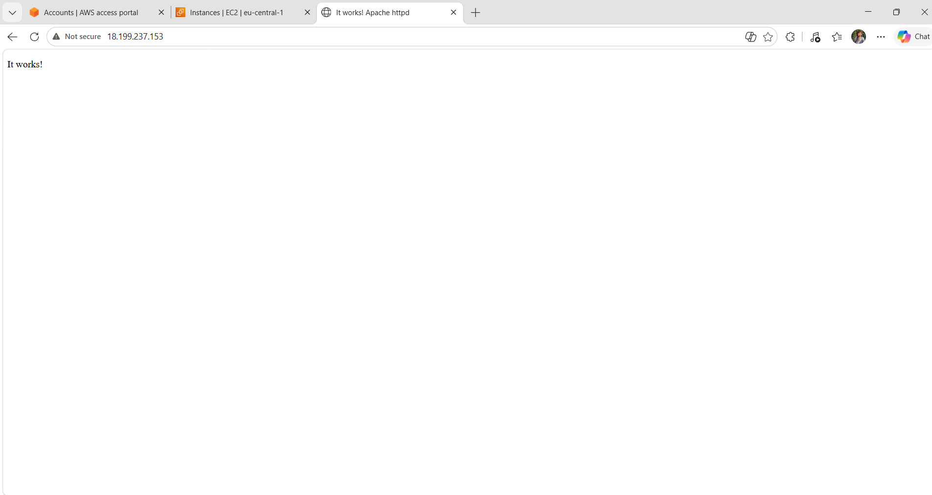
WEB page ( Please note that following completion of all laboratory tasks, all AWS services and EC2 instances were intentionally stopped to prevent unnecessary cloud resource consumption and manage costs effectively):
http://18.199.237.153/
6.
An Amazon SNS topic named ec2-alerts-topic was created as a Standard topic type in the AWS Management Console to handle automated infrastructure alerts. The Standard type was selected because it supports email endpoint subscriptions and provides high-throughput, at-least-once message delivery. This topic serves as the centralized notification channel that receives alert triggers from CloudWatch Alarms and dispatches operational notifications directly to specified email recipients.
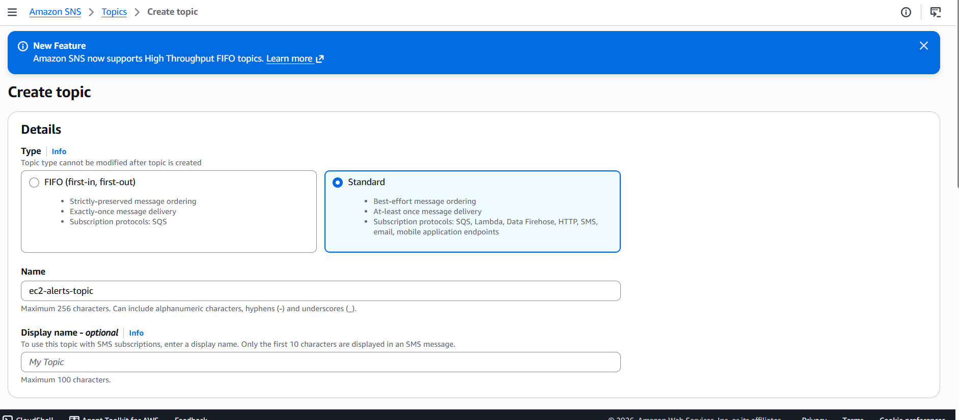
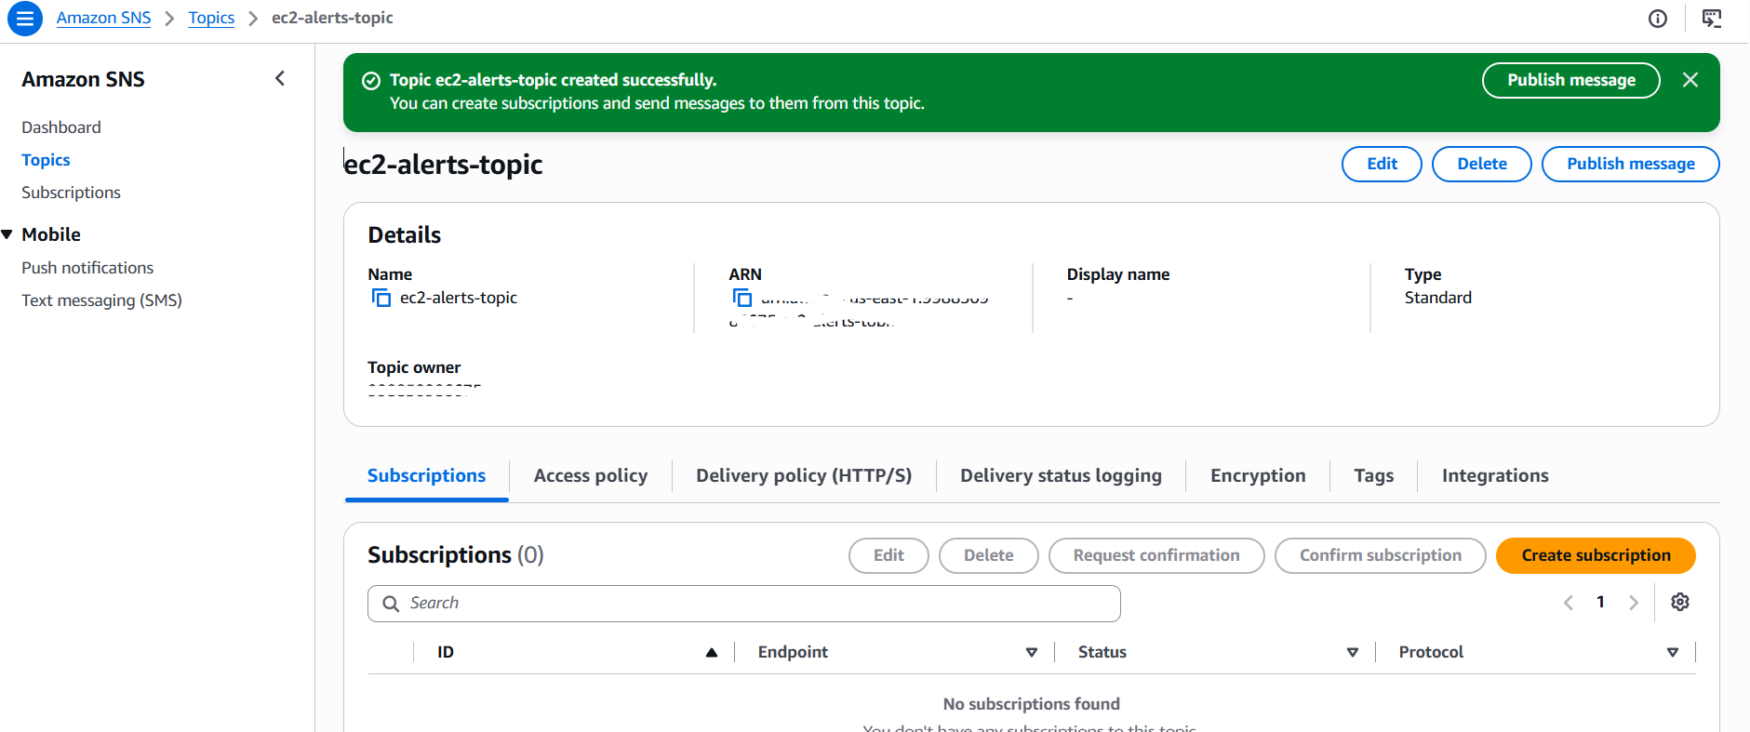
A subscription was configured for the ec2-alerts-topic SNS topic using the Email protocol with the specified recipient endpoint:
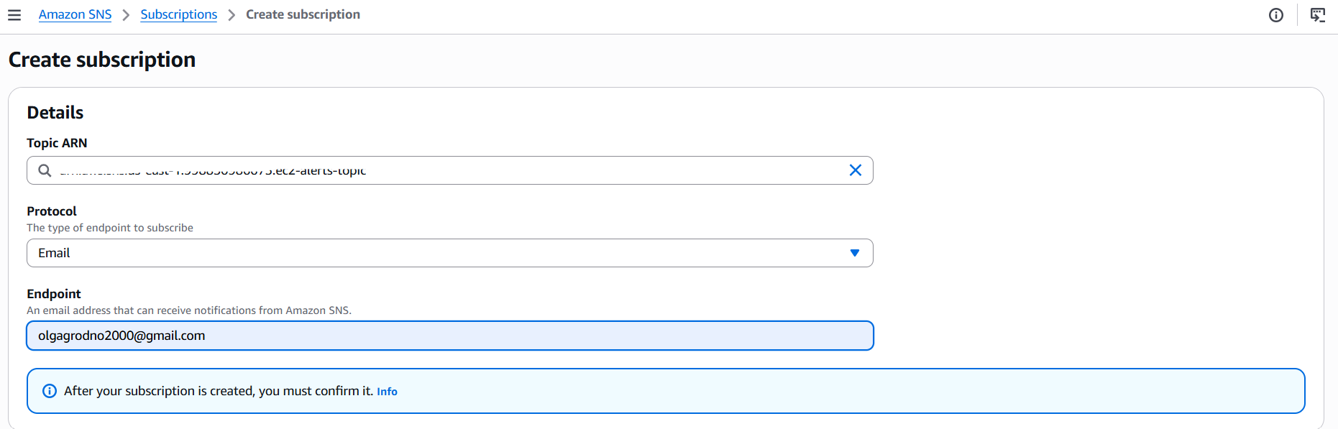
Following subscription creation, AWS sent an automated verification link to the target inbox, which was accessed to complete the handshake. The confirmation page ("Subscription confirmed!") validates that the email address is successfully linked to the SNS topic and ready to receive real-time alarm notifications from CloudWatch.
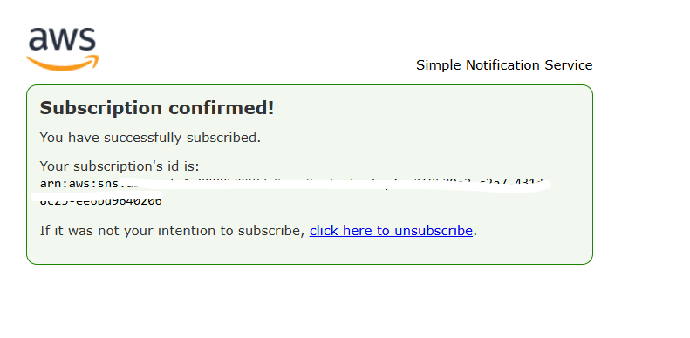
In Amazon CloudWatch, a new alarm was initiated under the Specify metric and conditions wizard step to monitor EC2 resource utilization. The CPUUtilization metric from the AWS/EC2 namespace was selected for the specific target instance. The evaluation statistic was set to Average over a standard time window, establishing a baseline to detect abnormal processor workloads that exceed regular operational thresholds.
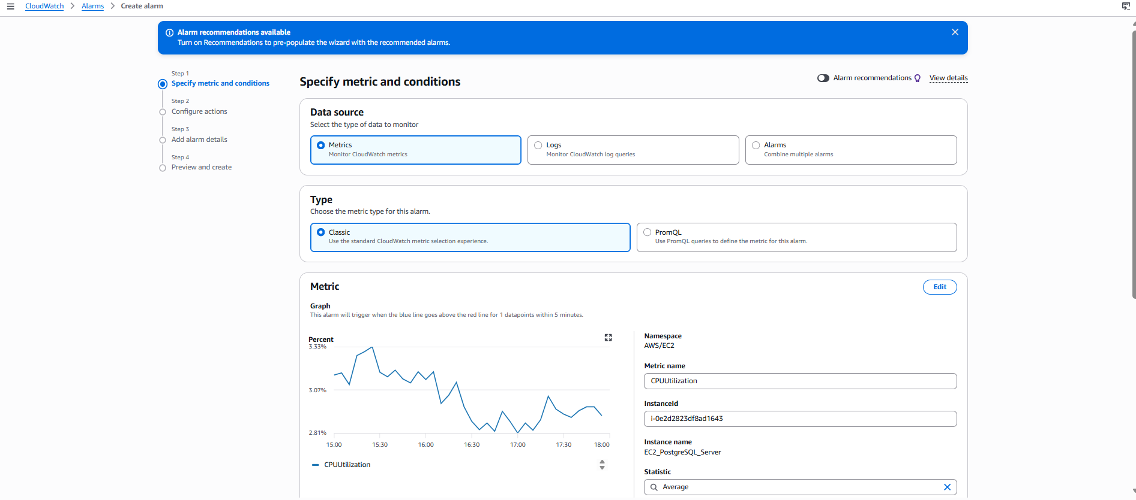
The evaluation logic for the CloudWatch alarm was configured using a Static threshold type applied to the average CPU utilization over a 5-minute period. The condition was set to Greater/Equal (>= threshold) with a threshold value of 80%. Under this rule, if the server's CPU load reaches or exceeds 80% for a single 5-minute evaluation period, the alarm state will transition to ALARM and immediately trigger the associated SNS notification topic.
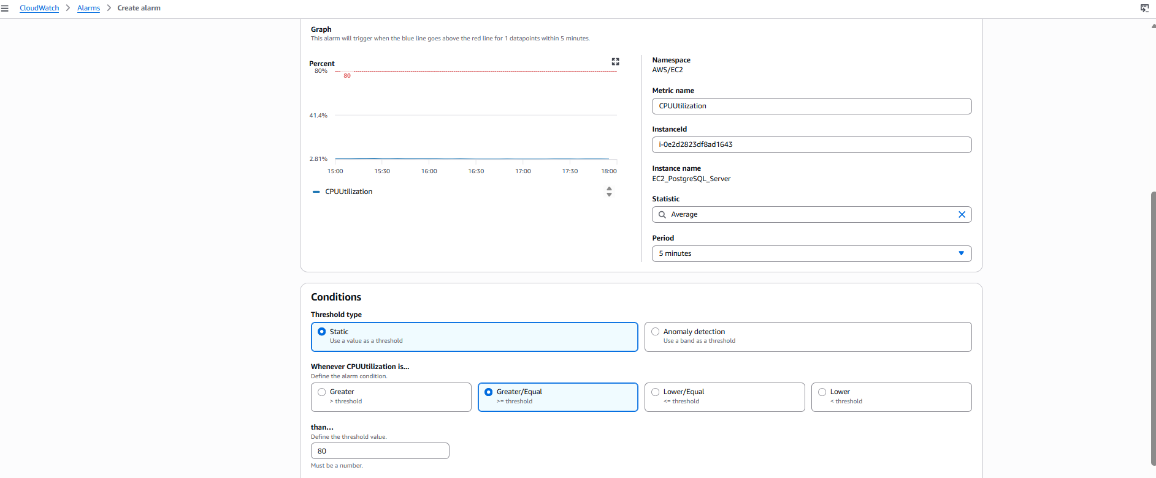
Under the Configure actions wizard step, notification rules were configured to link the CloudWatch alarm with the notification pipeline. The alarm state trigger was set to In alarm, ensuring that an action executes as soon as CPU utilization breaches the defined threshold. The existing Amazon SNS topic ec2-alerts-topic was selected as the destination, which automatically maps to the confirmed email endpoint to deliver real-time alert messages upon threshold breaches.
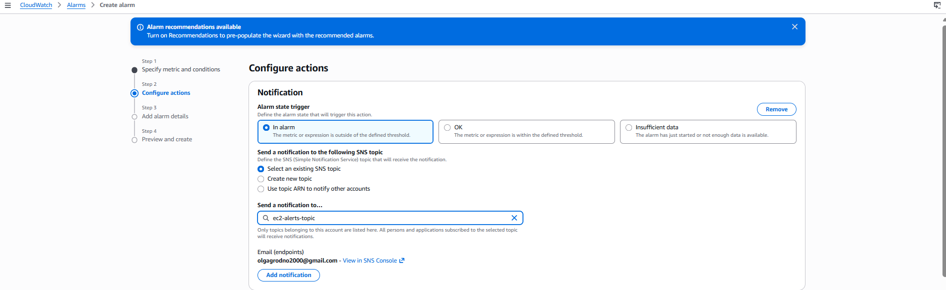
In the Add alarm details step, the alarm was assigned the descriptive name High-CPU-EC2-Alarm to clearly identify its monitoring purpose across the AWS environment. Specifying a meaningful name ensures quick recognition during incident response when alert messages are dispatched to the operations team via SNS.
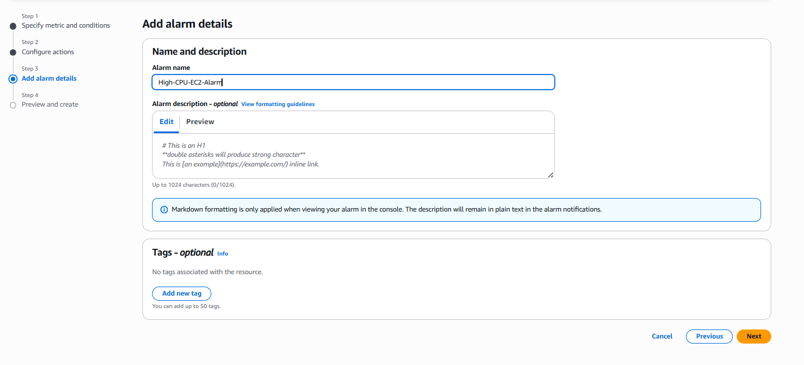
The alarm creation process was completed successfully, as confirmed by the banner message in the CloudWatch console:
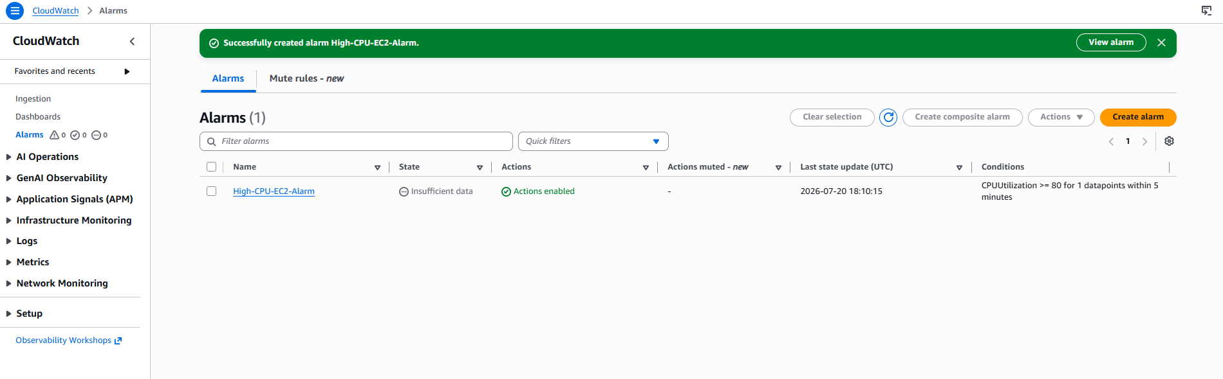
7.
To automate infrastructure deployment, the template was first authored in a plain text editor (Notepad) and saved with a .yaml extension (ec2_template.yaml). The code utilizes the standard 2010-09-09 AWS template format and defines two main sections: Parameters and Resources. The Parameters section dynamically resolves the latest Amazon Linux 2023 AMI via the AWS Systems Manager Parameter Store (/aws/service/ami-amazon-linux-latest/al2023-ami-kernel-default-x86_64), ensuring the deployment always uses an up-to-date base image without hardcoding region-specific IDs. Under Resources, an AWS::EC2::Instance (MyLabEC2Instance) is declared with a t2.micro instance type and tagged with the name EC2-from-CloudFormation, completing a lightweight, declarative Infrastructure as Code (IaC) configuration.
AWSTemplateFormatVersion: '2010-09-09'
Description: 'Universal CloudFormation script to deploy an EC2 instance'
Parameters:
LatestAmiId:
Type: 'AWS::SSM::Parameter::Value<AWS::EC2::Image::Id>'
Default: '/aws/service/ami-amazon-linux-latest/al2023-ami-kernel-default-x86_64'
Resources:
MyLabEC2Instance:
Type: 'AWS::EC2::Instance'
Properties:
InstanceType: t2.micro
ImageId: !Ref LatestAmiId
Tags:
- Key: Name
Value: EC2-from-CloudFormation

To automate the deployment of the EC2 instance using Infrastructure as Code (IaC), the AWS CloudFormation Create stack wizard was initiated. Under the Prepare template section, Choose an existing template was selected, and the local template file ec2_template.yaml was uploaded via the Upload a template file option.
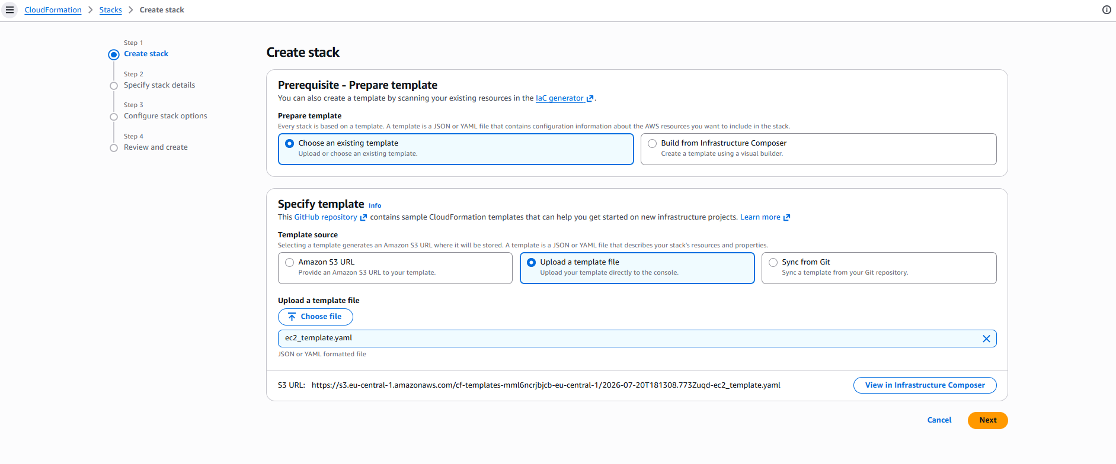
The deployment execution of the CloudFormation stack (MyEC2Stack) was monitored and confirmed directly within the AWS Management Console. The Stack info tab indicates a successful provisioning cycle, showing a final status of CREATE_COMPLETE. The stack overview displays the description defined in the YAML template ("Universal CloudFormation script to deploy an EC2 instance") along with the unique Stack ID and creation timestamp.

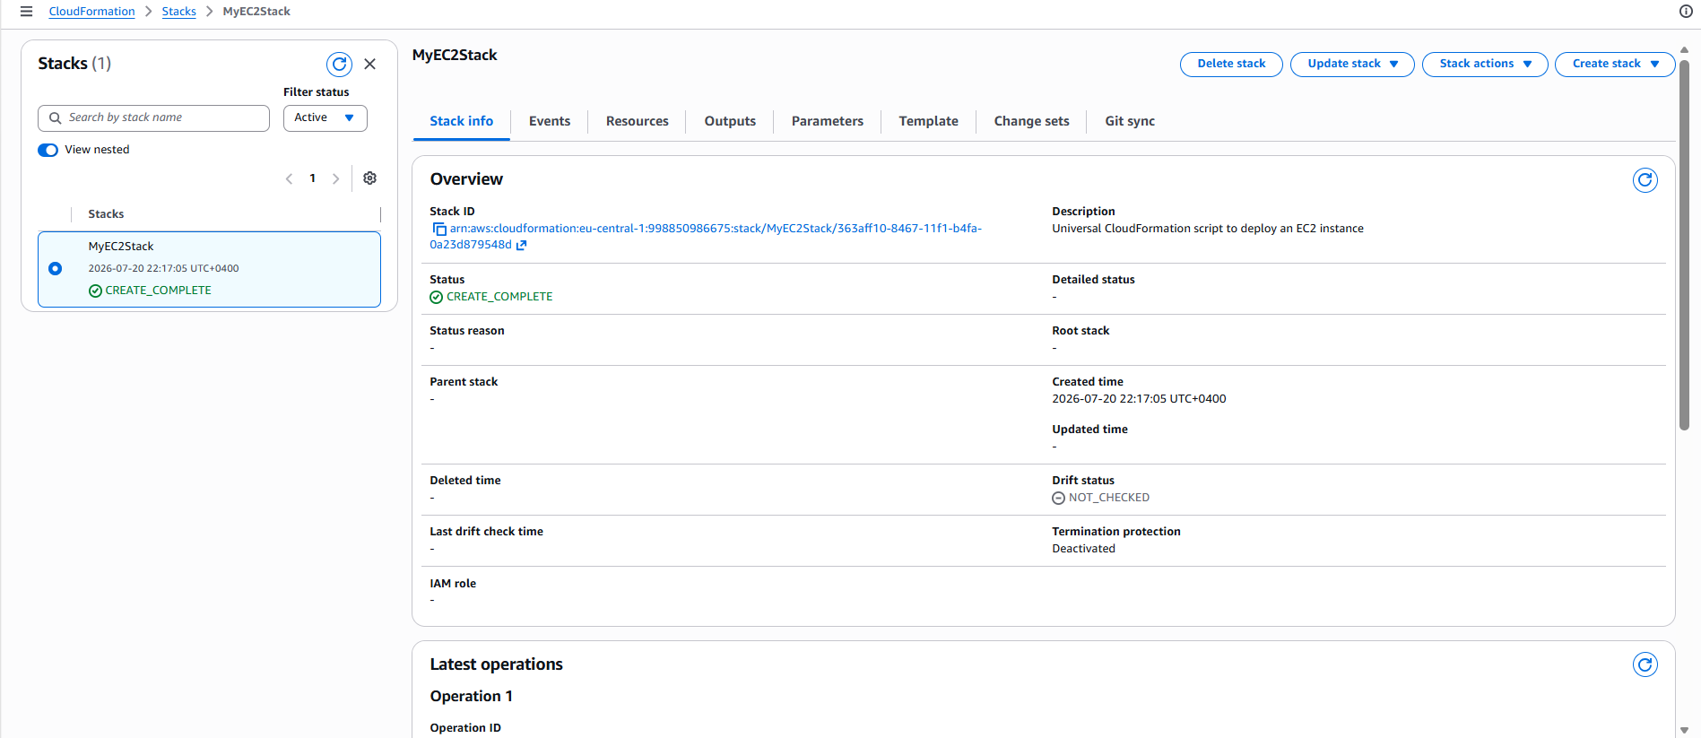
The Events timeline view tracks the lifecycle of the declared resource (MyLabEC2Instance). It illustrates the progression from initial instantiation (In progress) to full provisioning (Complete), verifying that the underlying AWS::EC2::Instance was successfully initialized and integrated without deployment errors.
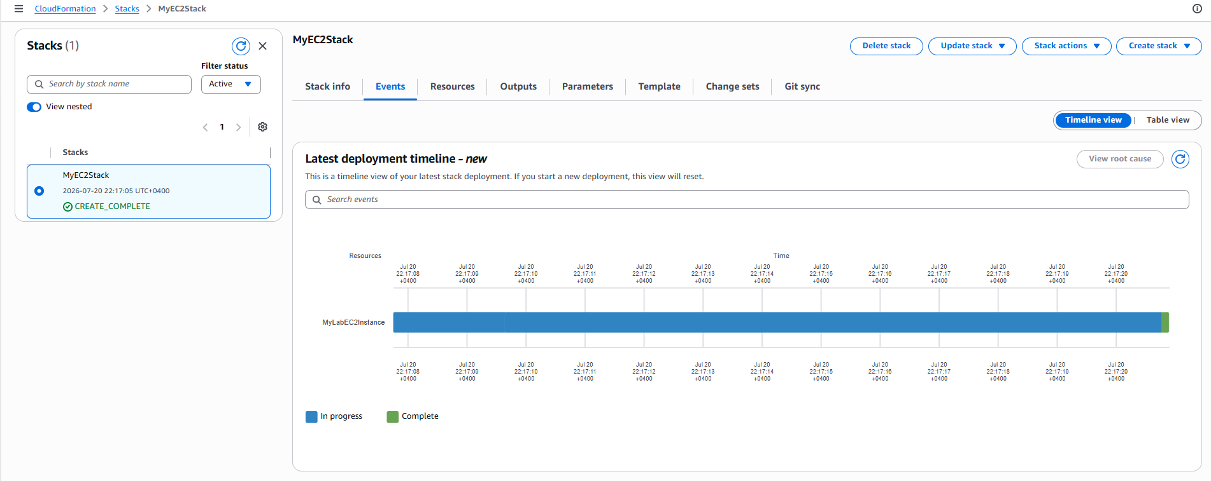
Please note that following the completion of all laboratory tasks, all AWS services and EC2 instances were intentionally stopped to prevent unnecessary cloud resource consumption and manage costs effectively

