1. Connection to test_db and lab schema was done. Table labs.person was created with 3 rows.

2.1 PERFOMANCE WITH UNLLOGED TABLES
Two tables (regular table labs.test_simple and unlogged table test_unlogged) were created.
Inserting 1 million rows into the regular table labs.test_simple took 3.4 seconds, and inserting 5 million rows took 20 seconds.
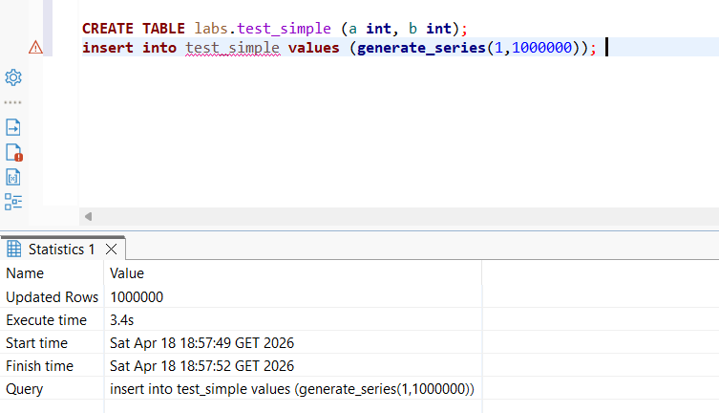
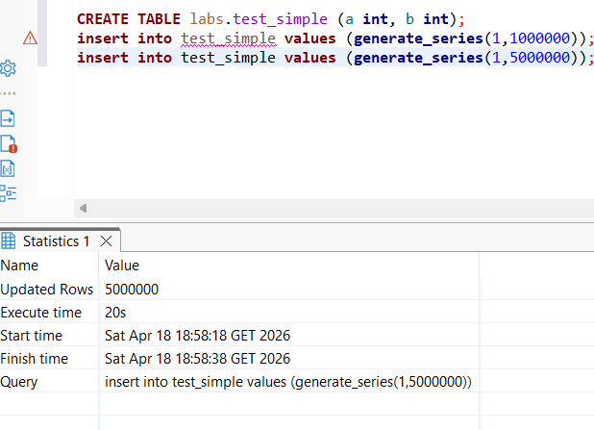
Inserting 1 million rows into the unlogged table test_unlogged took 2.4 seconds, while inserting 5 million rows took only 9.5 seconds.
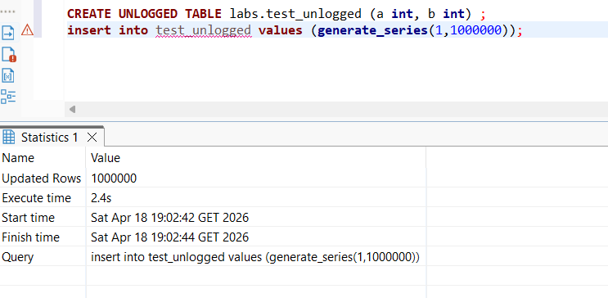
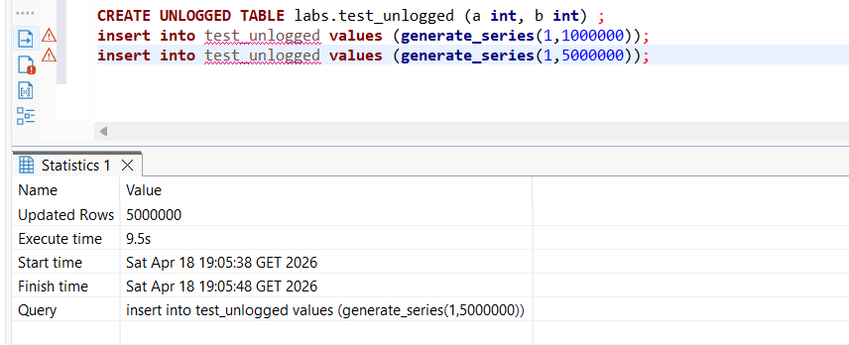
This difference is due to the fact that regular tables write every change to the WAL (Write-Ahead Log) to ensure crash recovery, which adds significant performance overhead. UNLOGGED tables skip this step entirely, making writes faster — but the data is lost in case of a crash.
2.2 UNDERSTANDING INHERITED TABLES
The inherited table labs.users was created for person. 2 rows (id=1 "new Bob", id=999 "TestUser") were inserted into the table labs.users.
SELECT * FROM users returned 2 rows (id=1 "new Bob", id=999 "TestUser") — only the child table data.
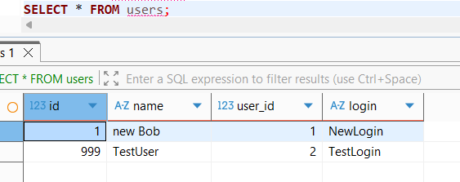
SELECT * FROM person returned 5 rows — it included both the original person records (Bob, Alice, Robert) and the inherited rows from users, because inheritance makes the parent query all child tables by default.
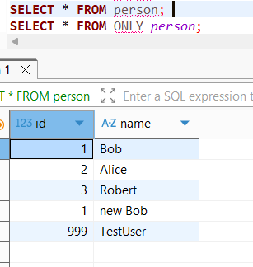
SELECT * FROM ONLY person returned only 3 rows (Bob, Alice, Robert) — the ONLY keyword restricts the query to the parent table exclusively, excluding inherited data.
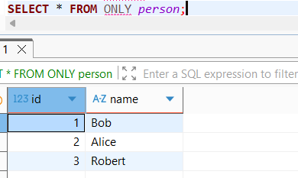
UPDATE person SET name = 'not Bob' WHERE id = 1 affected both tables — it updated the row in users as well, since the update propagates to child tables.
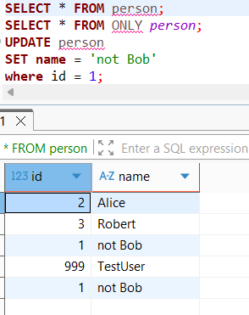
To update only the parent, UPDATE ONLY labs.person was used, which successfully changed only the person row back to 'Bob', leaving the users row untouched.
UPDATE ONLY labs.person
SET name = 'Bob'
WHERE id = 1;

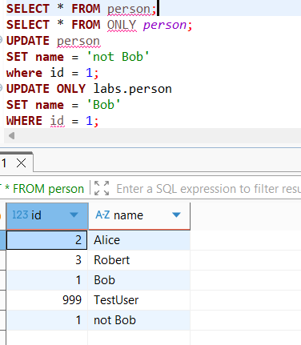
By adding a new column “status” with default value 0 to a parent table person (ALTER TABLE person ADD COLUMN status integer DEFAULT 0) — the new column was inherited by the users child table as well. This is because in PostgreSQL, adding a column to a parent table automatically propagates it to all child tables that inherit from it.
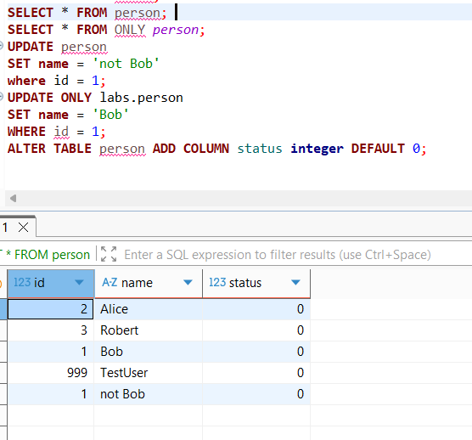
ALTER TABLE person ADD CONSTRAINT status CHECK (status in (0,1)) NO INHERIT — this constraint was applied only to the parent person table and was not inherited by users. This is due to the NO INHERIT keyword, which explicitly prevents the constraint from propagating to child tables. The check was made by trying to insert a row with status = 2. In person table an error arises, while in child users table the line was inserted:
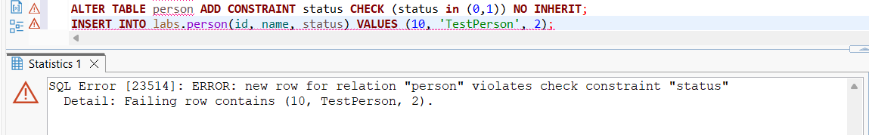
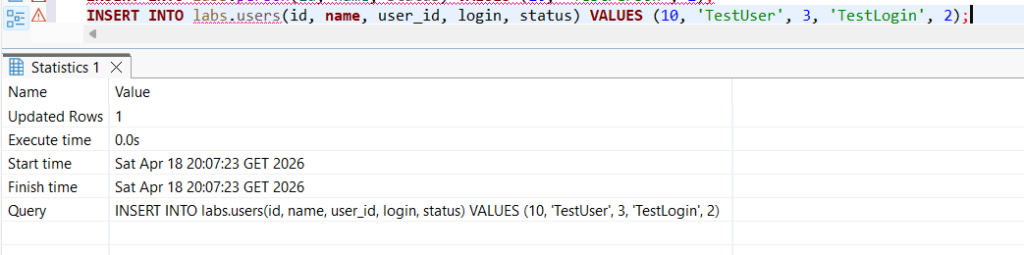
Users table after inserting the row with status = 2:
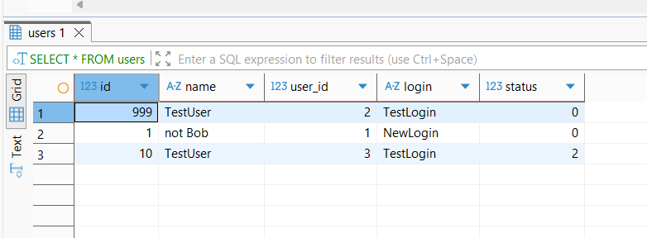
ALTER TABLE person ADD CONSTRAINT id UNIQUE (id, name) — this constraint was also applied only to the parent person table. This is because UNIQUE and PRIMARY KEY constraints are never inherited in PostgreSQL by default — child tables do not receive them regardless of whether NO INHERIT is specified or not. The check was made by trying to insert a duplicated row( same id and name) . In person table an error arises, while in child users table the line was inserted:
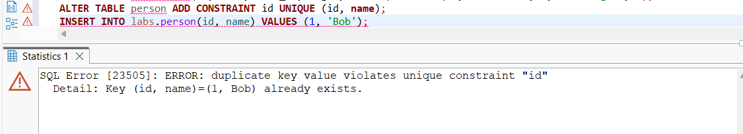
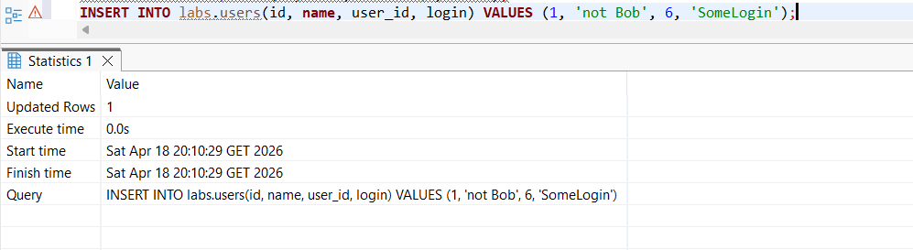
Users table after inserting the duplicated row( same id and name): 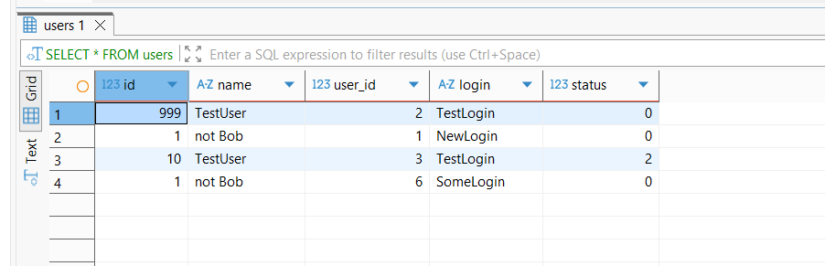
3.1 BRIN VS B-TREE
The table labs.test_index was created and filled with 15,776,640 rows (data from 2017 to 2021 with 10-second intervals). The INSERT took 29 seconds. Table size: 666 MB.
Amount of the rows and insert transaction execute time of the table :
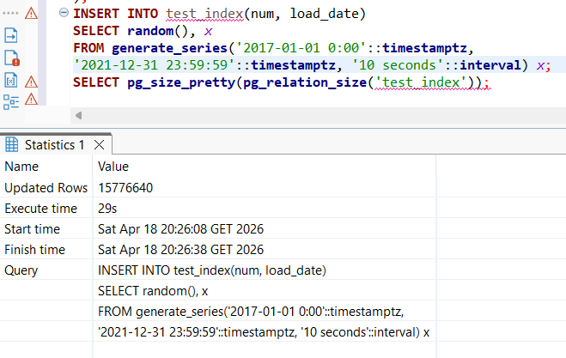
Table size:
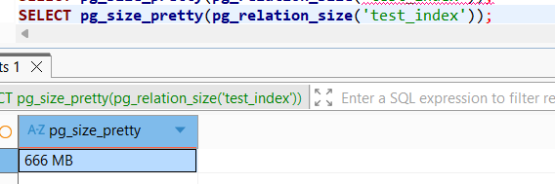
Without index the query planner performed a full scan — it had to read every single row in the table to find matching dates. Execution time: 251 ms.
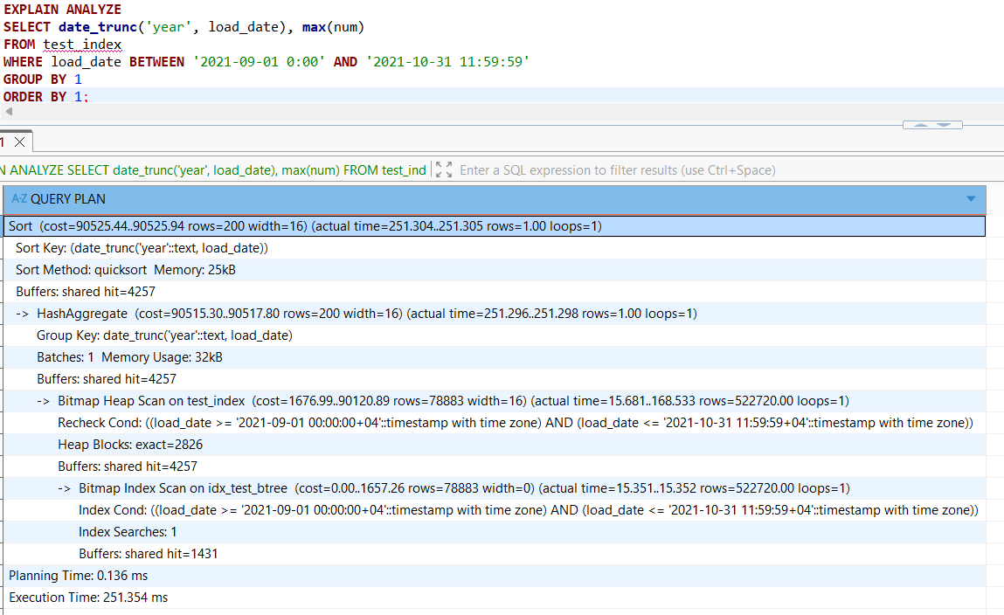
B-Tree index (idx_test_btree) was created in 7.4 seconds. Index size: 338 MB — half the table size, because B-Tree builds a balanced tree structure storing every individual indexed value in sorted order.
Execute time:
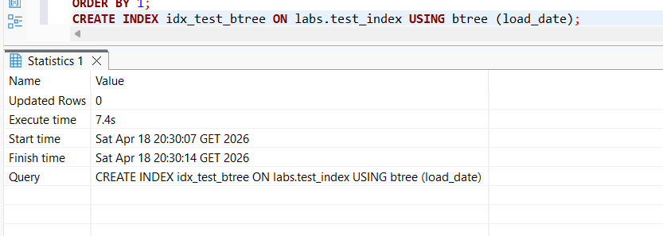
Index size:
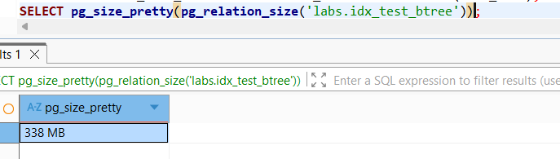
After creation, the query planner switched to a Bitmap Index Scan, reducing execution time to 196 ms:
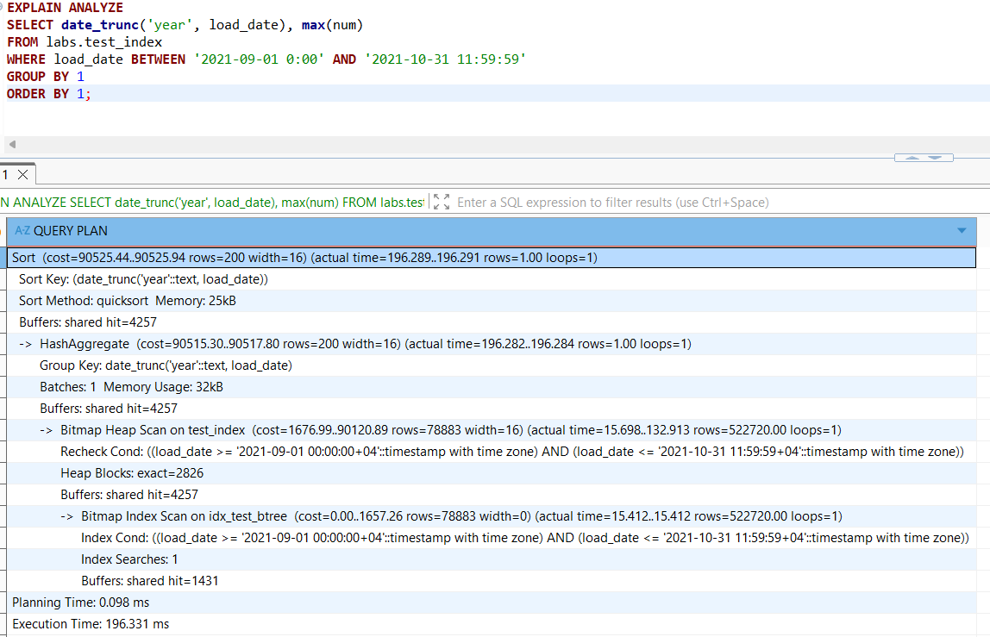
BRIN index (idx_test_brin) was created in just 0.8 seconds. Index size: only 40 kB — because BRIN does not store individual values. Instead, it divides the table into block ranges and stores only the min/max values per range. This makes it extremely lightweight and fast to build.
Execute time:
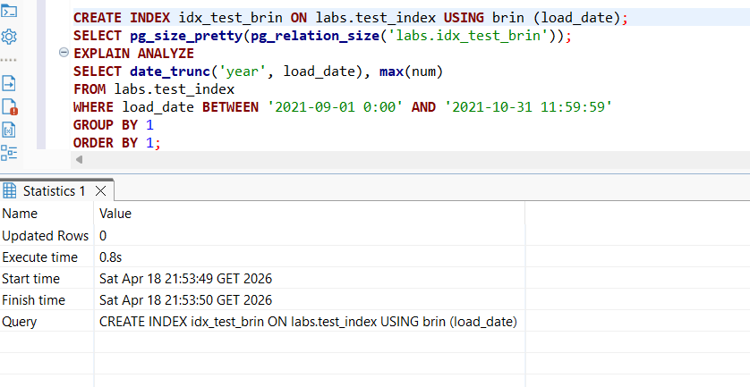
Index size:
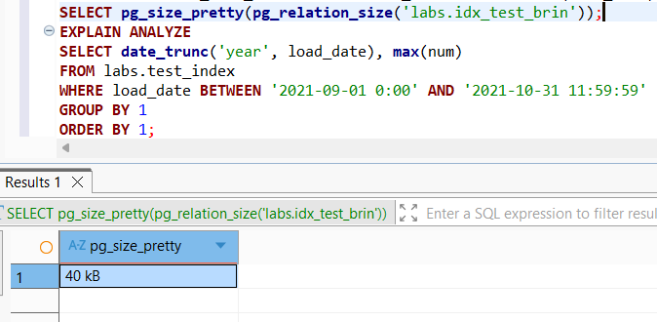
The query still used a Bitmap Index Scan, but execution time was 231 ms — slightly slower than B-Tree. While B-Tree precisely locates only the matching rows by navigating a sorted tree structure — reading buffer pages — BRIN had to load full blocks and recheck extra rows just to filter out non-matching data.
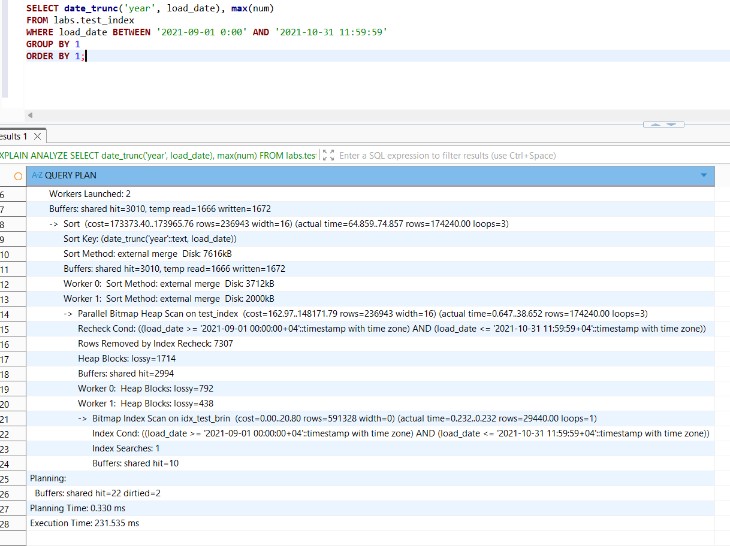
B-Tree wins on query speed, BRIN wins on size and creation time. For large append-only tables with naturally ordered columns (like timestamps in ETL pipelines), BRIN is often the better practical choice — near-zero storage overhead with acceptable query performance.
3.2 GIN VS GIST
The table test_index was created with 10,000,000 rows (id + md5 hash). Table size: 652 MB: 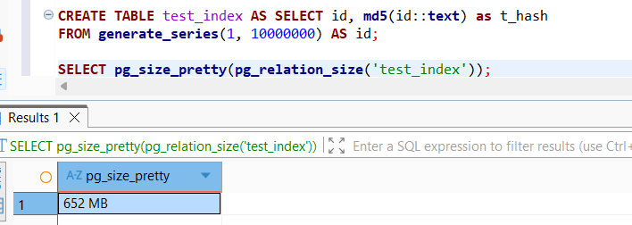
Without index: the query planner used a Parallel Sequential Scan, it scanned 10M rows, removing 3,333,333 non-matching rows by filter. Execution time: 570 ms: 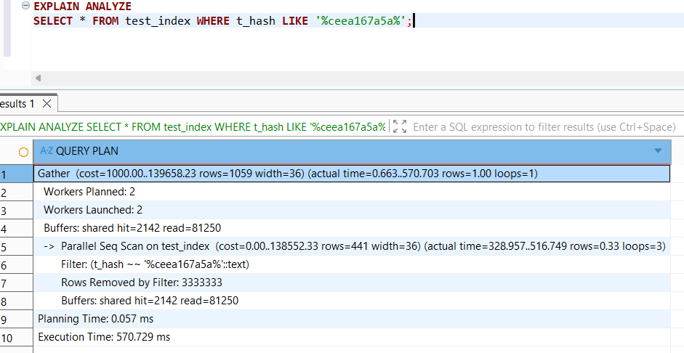
GiST index (idx_text_index_gist) was created in 5 minutes 21 seconds. Index size: 1770 MB — larger than the table itself, because GiST with pg_trgm breaks every string into trigrams (overlapping 3-character chunks) and builds a tree structure storing all possible trigram combinations for each value:
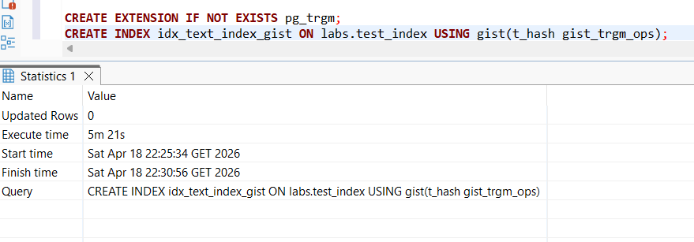
Index size:
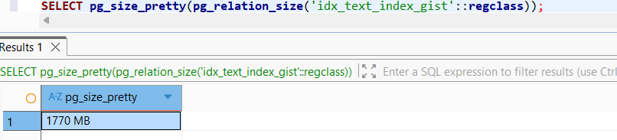
After creation, the query planner switched to a Bitmap Index Scan, but execution time was 1136 ms —slower than without an index. This happened because the index had to read 77,152 buffers from disk, and GiST is not the most efficient structure for trigram lookups on large datasets.
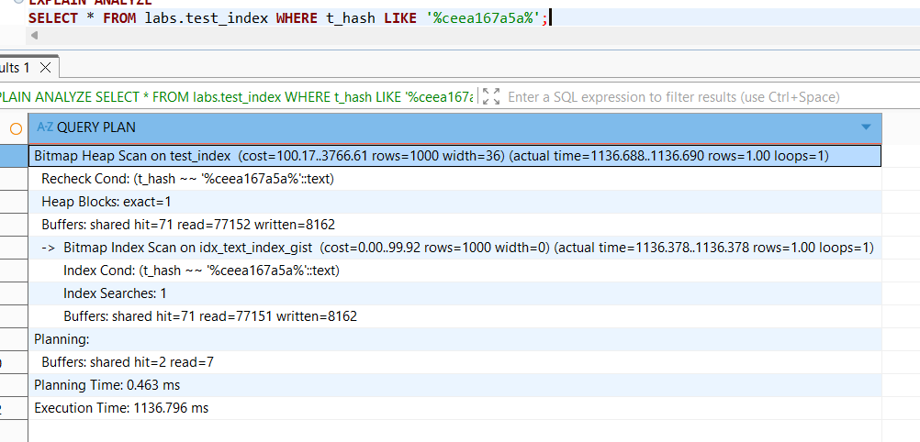
GIN index (idx_text_index_gin) was created in 1 minute 10 seconds — much faster than GiST. Index size: 600 MB — significantly smaller than GiST, because GIN stores an inverted index: each unique trigram points to a list of row IDs that contain it, avoiding redundant storage.

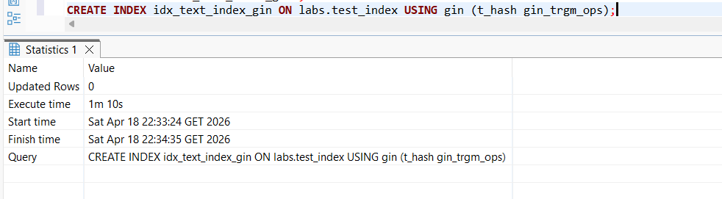
Index size:
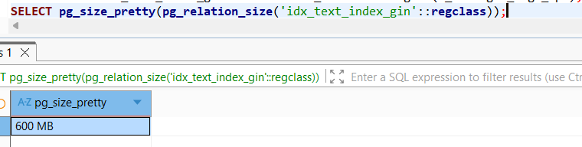
After creation, execution time dropped to just 15 ms — a 38x speedup compared to no index. GIN is far more efficient for LIKE pattern matching because it directly maps trigrams to matching rows with minimal buffer reads:
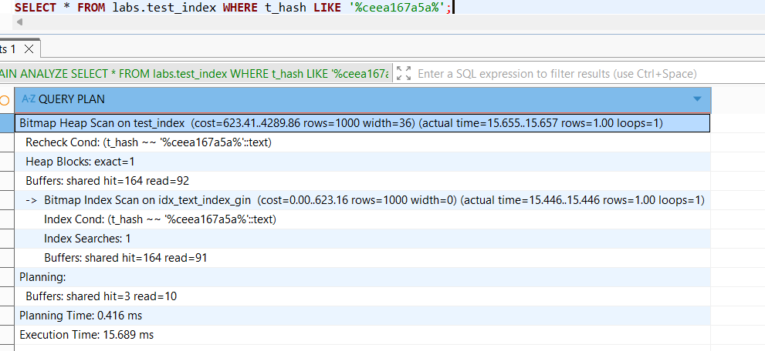
For LIKE pattern matching on text columns, GIN with pg_trgm is the more efficient choice. It is smaller in size, faster to build, and provides dramatically lower query execution time. GiST is better suited for geometric or spatial data, which makes it less effective for text search scenarios.
4. CSV FILE AS A TABLE
A file_fdw extension was installed and a foreign server test_import was created. A foreign table labs.test_foreign_table was created pointing to the local CSV file cities_list.csv. SELECT count(*) FROM test_foreign_table returned 128 rows — the data was read directly from the CSV file without importing it into the database:
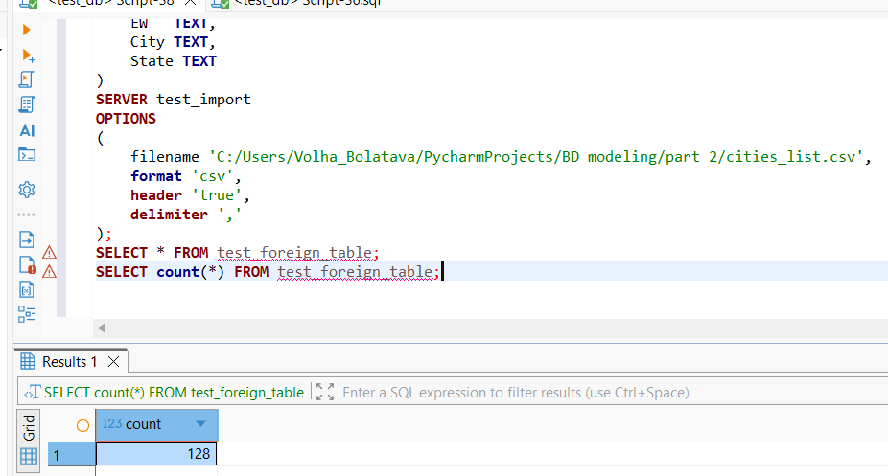
A Materialized View labs.mview_cities was created based on the table labs.test_foreign_table. SELECT statement returned 128 rows — the data was physically snapshot into the materialized view at the moment of creation:
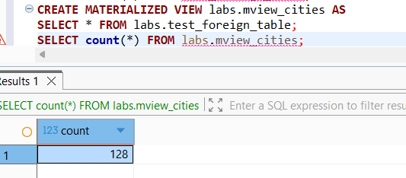
After deleting some rows from the CSV file, SELECT statement from the table returned returned 111 rows — the foreign table always reads directly from the file, so it immediately reflected the change:
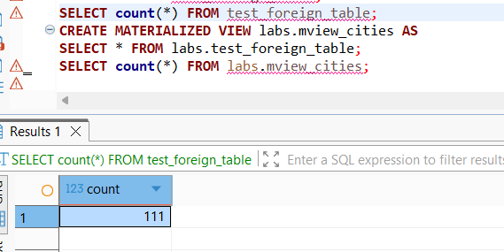
However, SELECT statement from materialized view returned 128 rows — because a materialized view stores a physical snapshot of the data at the time it was last refreshed and does not automatically reflect changes in the source:
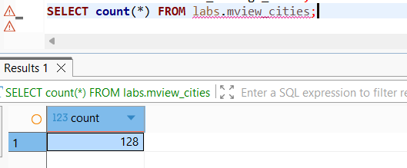
After refreshing materialized view with statement:
REFRESH MATERIALIZED VIEW labs.mview_cities;
SELECT statement from materialized view returned 111 rows — now matching the updated CSV file.
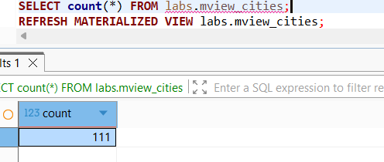
This demonstrates the key difference: a foreign table always reads live data from the source, while a materialized view holds a static snapshot that must be manually refreshed to reflect source changes.

