Transaction
2.1. The first transaction performs an INSERT of new rows into the employee table. Simultaneously, a second transaction reads the table but does not initially see these new rows, as the database is operating under the Read Committed isolation level. Once the first transaction commits, the second transaction performs another read and the new data becomes visible. This discrepancy between two reads within the same active session confirms the occurrence of the Non-Repeatable Read anomaly, demonstrating that snapshots are taken at the statement level rather than the transaction level.
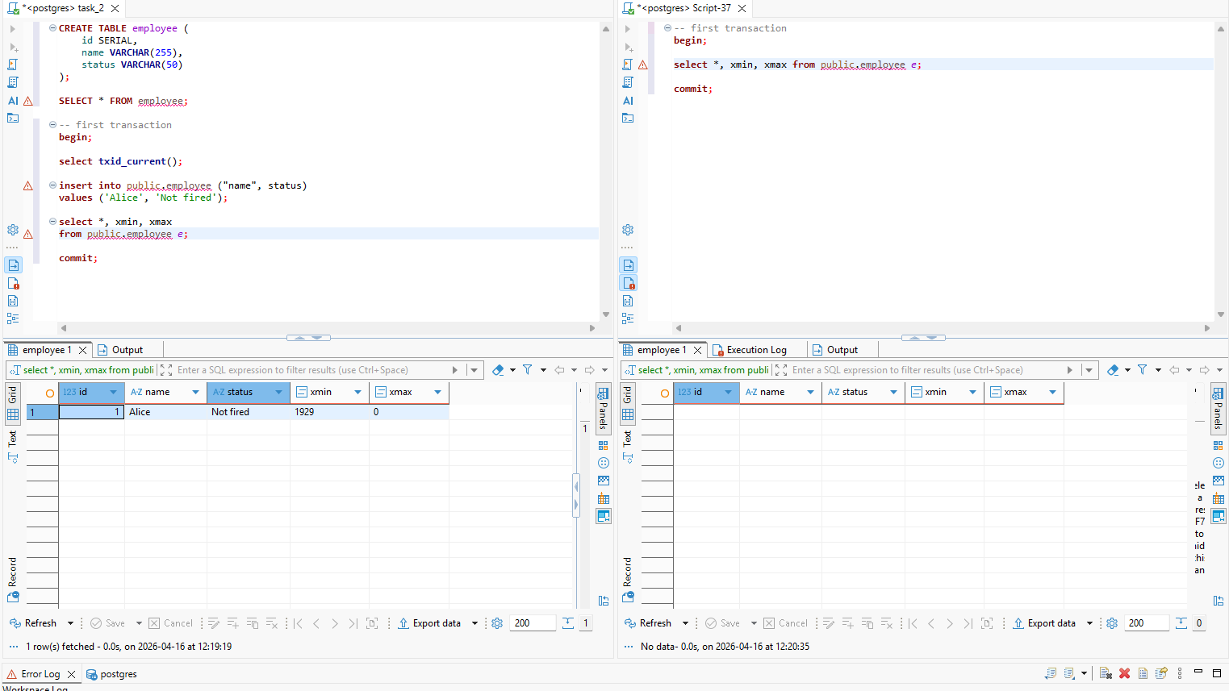
2.2 The experiment demonstrates the Phantom Read anomaly using two concurrent transactions. While the first transaction is active, a second transaction performs a DELETE on a row but does not commit immediately. During this time, the first transaction can still see the row, though the xmax column is updated with the ID of the deleting transaction (1932), signaling a pending change.
Once the second transaction executes a COMMIT, the row is permanently removed from the database. When the first transaction performs a subsequent SELECT, the row is no longer returned. This change in result sets within a single, continuous transaction confirms the Non-repeatable read anomaly. It proves that under the Read Committed isolation level, each statement sees the latest committed snapshot of the data, meaning the "repeatability" of the initial read is not guaranteed.
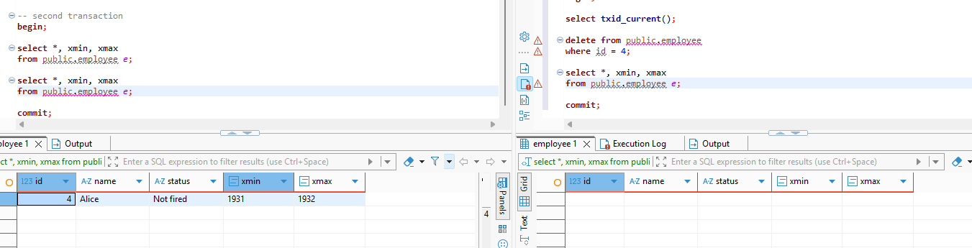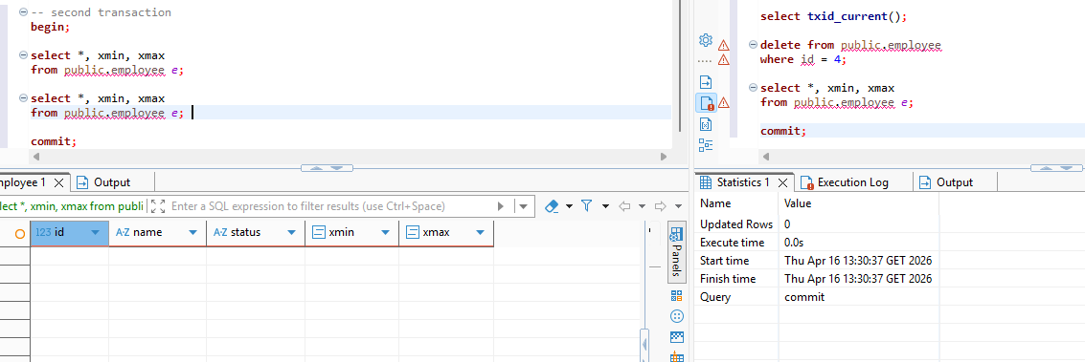
2.3 The experiment demonstrates the Non-repeatable read anomaly using two concurrent transactions. While the first transaction is active, a second transaction performs an UPDATE on a row. Under the MVCC (Multi-Version Concurrency Control) architecture, this UPDATE effectively "deletes" the old version of the row by setting its xmax (1934) and creates a brand-new row version with a new xmin.
During the process, the first transaction still sees the original data until the second transaction executes a COMMIT. Once committed, the old version is rendered obsolete, and the new version becomes global. When the first transaction performs a subsequent SELECT, the updated status is returned.
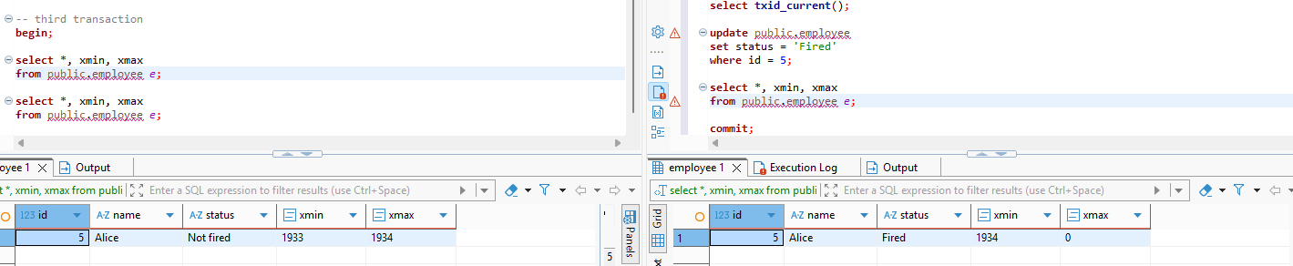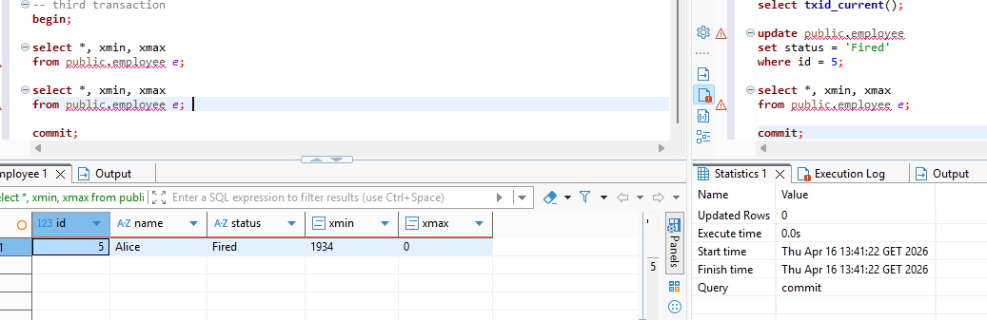
3. The command “SET session characteristics as transaction isolation level repeatable read” ; was executed to standardize the isolation level across all subsequent transactions in the current session.
4. Сurrent isolation level was checked in each session:
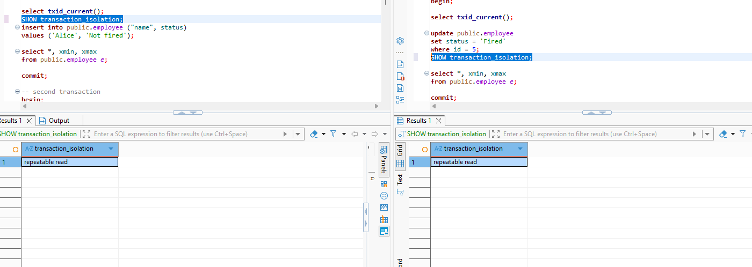
5.1 The first transaction performs an INSERT into the employee table. Simultaneously, a second transaction reads the table but does not see the new rows because the first transaction is uncommitted.
Even after the first transaction commits, the second transaction continues to see the same original data upon re-reading. This behavior confirms the prevention of the Non-Repeatable Read anomaly, demonstrating that under the Repeatable Read level, snapshots are taken at the transaction level. The session maintains a consistent view of the data as it existed when the transaction first began. The values of cmin and cmax both remain 0, which is expected since only a single modifying command was issued within the inserting transaction, meaning no intra-transaction command sequencing occurred.

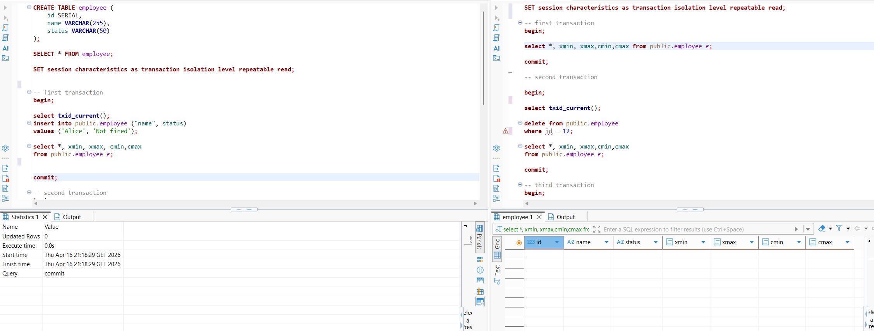
5.2 The experiment demonstrates the prevention of the Phantom Read anomaly under the Repeatable Read isolation level. The second transaction performed a DELETE on the row with id = 13 and committed the change. However, when the first transaction executed a subsequent SELECT, the deleted row was still visible in the result set — the row with id = 13 (Alice, Not Fired) continued to appear with its original xmin (1951) and xmax (1952) values. Only after committing the first transaction , the row is disappeared from the select query result.
This behavior confirms that under Repeatable Read, the snapshot is taken at the transaction level — specifically at the moment the first transaction issues its initial read. As a result, preventing the Phantom Read anomaly. The values of cmin and cmax both remain 0, which is expected since only a single modifying command was issued within the inserting transaction, meaning no intra-transaction command sequencing occurred.
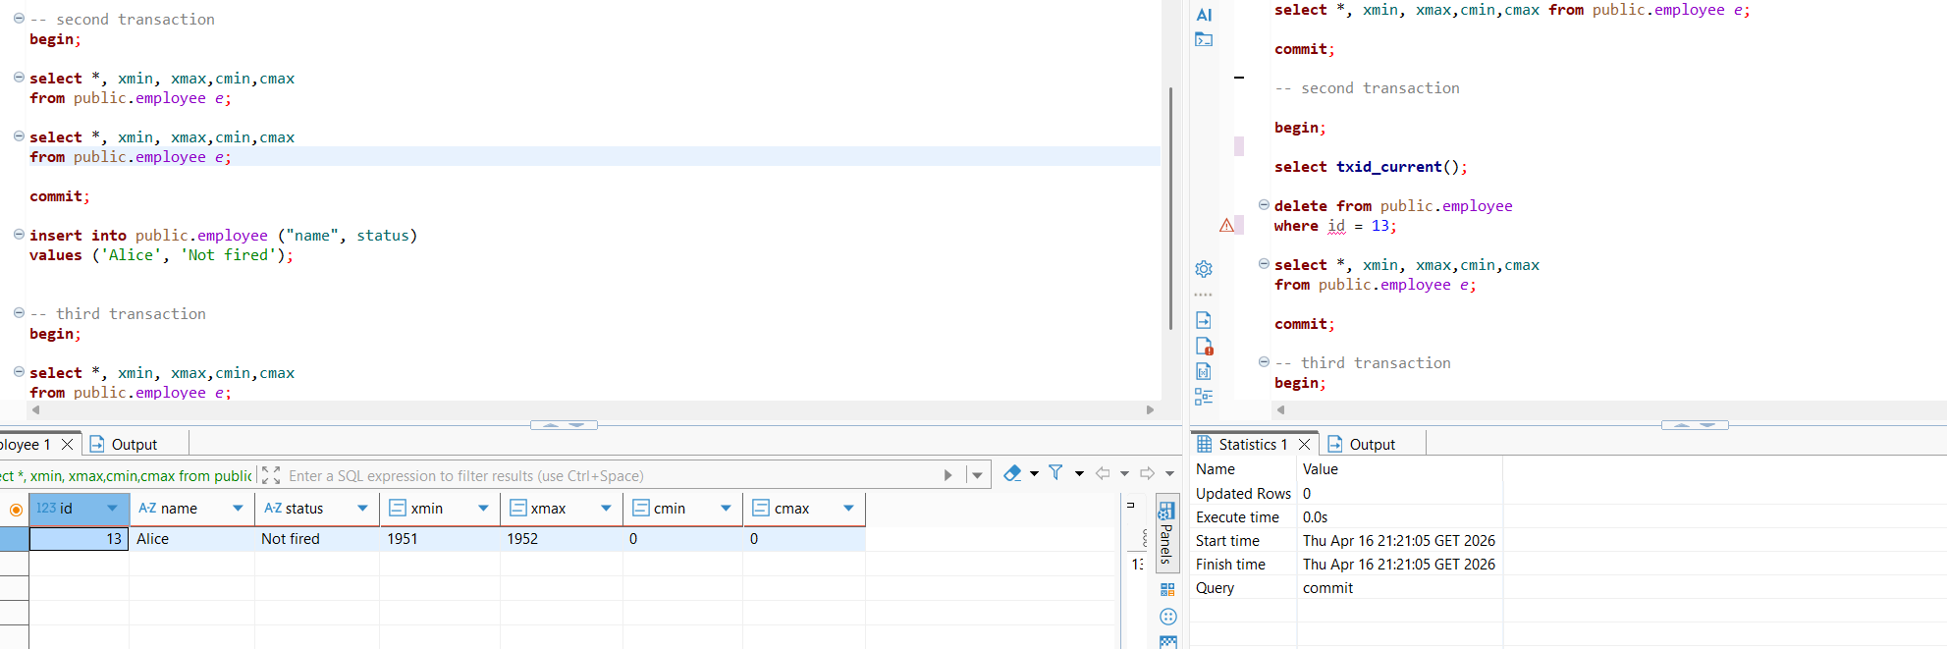
5.3 The experiment demonstrates the prevention of the Non-Repeatable Read anomaly under the Repeatable Read isolation level. The second transaction performed an UPDATE on the row with id = 5, setting its status to 'Fired', and committed the change. However, when the first transaction executed a subsequent SELECT, the updated value was not reflected — the result set remained identical to the initial read taken at the start of the transaction.
The system columns further confirm this behavior. The visible row shows xmin = 1953, xmax = 0, indicating that the row version was created by transaction 1953 and has not been deleted or superseded from the perspective of the current snapshot. The values of cmin and cmax both remain 0, which is expected since only a single modifying command was issued within the inserting transaction, meaning no intra-transaction command sequencing occurred.
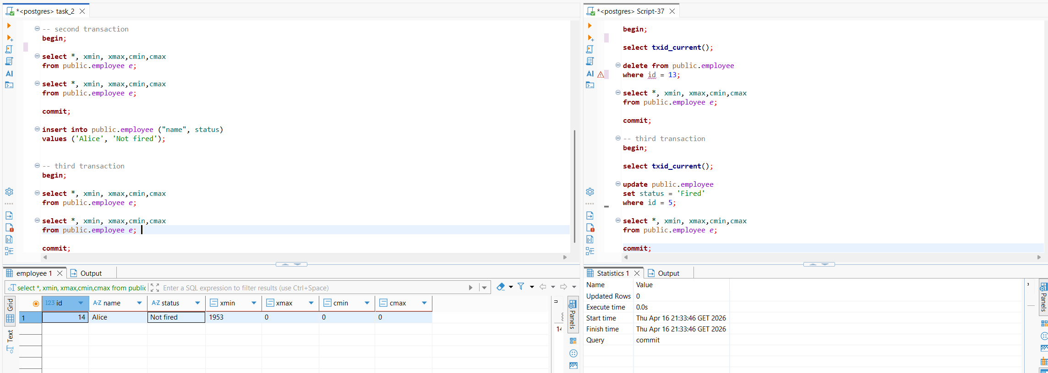
6.1 Repeatable Read (anomaly occurs)
Under the Repeatable Read isolation level two concurrent transactions were executed. Transaction 1 read the total count (or sum) of rows in the employee table and then inserted a new row based on that result. Simultaneously, Transaction 2 performed the same read and inserted its own row based on the same snapshot.
Since both transactions took their snapshots independently at the start, each saw the same initial state of the table. Both proceeded with their inserts based on stale data, and both successfully committed. The final state of the table reflected both insertions. This confirms the Serialization Anomaly: the outcome is inconsistent with any serial (one-after-another) execution of the two transactions.
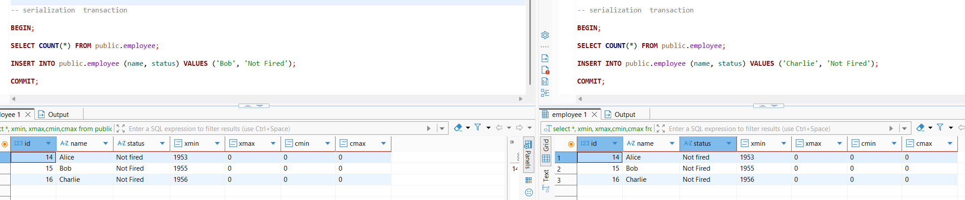
6.2 Serializable (anomaly prevented)
After switching the isolation level to Serializable when both transactions attempted to commit, PostgreSQL detected a read-write conflict between them — each transaction's result depended on data that the other transaction was concurrently modifying.
As a result, one of the transactions was aborted with the error:
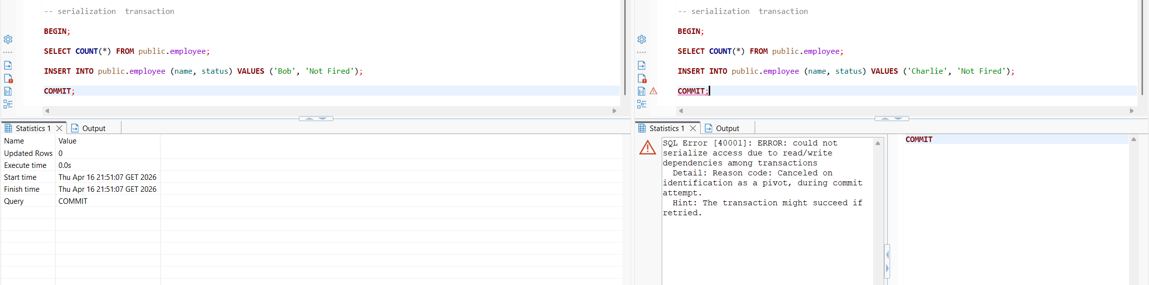
Only one transaction was allowed to commit. Anomaly was prevented.
7. Under the READ COMMITTED isolation level two concurrent transactions were executed. Both transactions read the same row (id = 14, Alice, Not Fired) and attempted to update it concurrently. Session 1 set the status to 'Fired' and committed successfully. Session 2, which attempted to set the status to 'Promoted', was blocked and forced to wait ("Execute query — 1m 12s" indicator) until Session 1 commit.

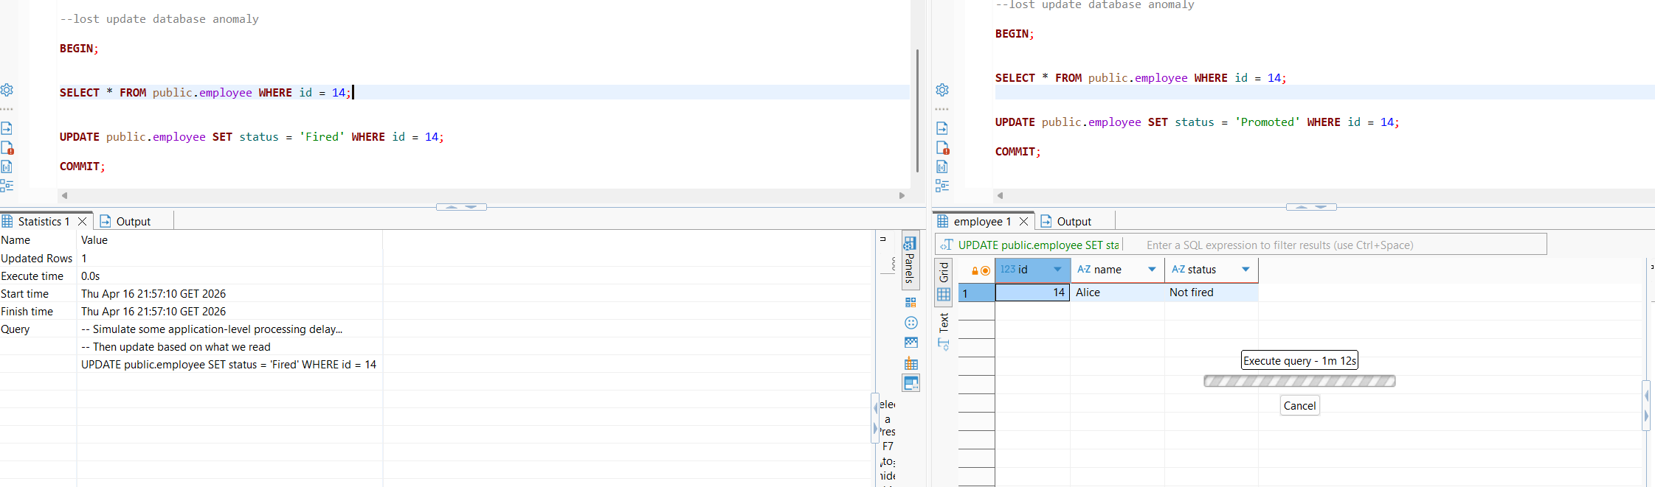
Once Session 1 commits, Session 2 will re-read the row in its updated state and apply its own UPDATE on top, resulting in the final value of 'Promoted'. This means Session 1's update will be effectively overwritten, which is the essence of the Lost Update — the last writer wins regardless of the original read order.
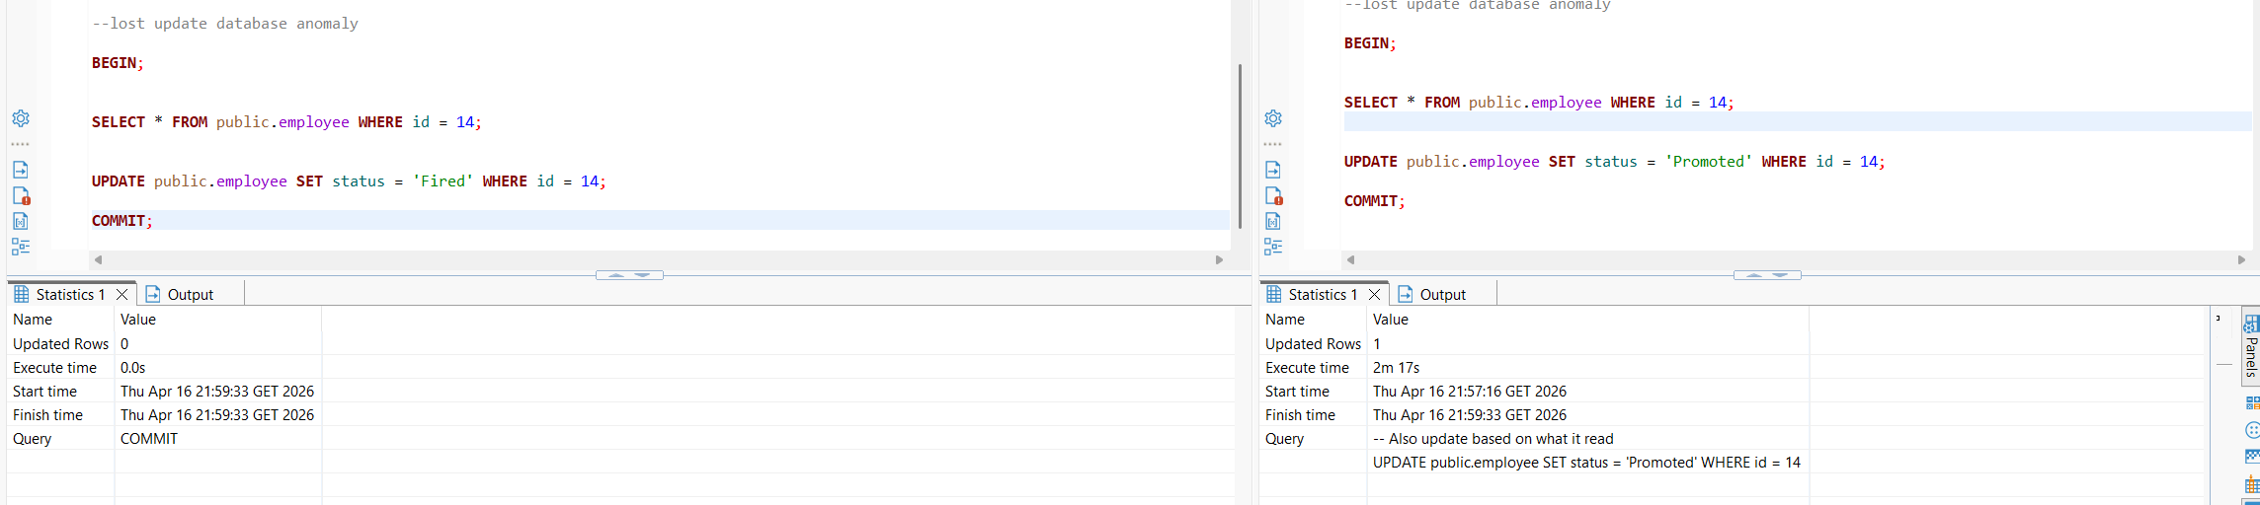
Downsides:
1. Reduced concurrency — row-level locking forces transactions to wait for each other
2. Silent logic errors — Session 2's UPDATE was based on a stale read (the value before Session 1's commit). PostgreSQL executes it anyway without warning the application. The business logic is effectively broken, but no error is raised.
3. Application unawareness — the application believes it made a decision based on current data, but it actually acted on outdated information.

