AWS CLOUD FOR DATA ENGINEERING
- CREATING THE REPORT

EC2 instance was created in AWS console and runned following the same steps as in the lab 2. An EC2 instance running Amazon Linux 2023 was provisioned and accessed via SSH as the default ec2-user, authenticated using an imported OpenSSH public key rather than the default AWS-generated key pair — this approach is commonly used when a user already manages their own SSH key pair locally and wants to reuse it across multiple instances instead of tracking a separate .pem file per instance. Immediately after login, sudo dnf update was run to refresh the package repository metadata and apply any pending OS-level updates before installing new software. In this case the output showed "Nothing to do" — the AMI was already current, so no packages needed upgrading, but running this step first is standard practice to avoid dependency conflicts during subsequent installs.
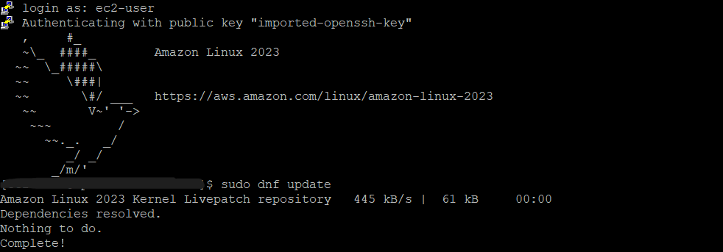

The command sudo dnf install postgresql15.x86_64 postgresql15-server was used to install both the PostgreSQL 15 client and server packages. This pulled in two dependencies automatically. The purpose of installing PostgreSQL locally on the EC2 instance was to have a local psql client and a local PostgreSQL server available on the instance, independent of the Redshift cluster itself — useful as a lightweight SQL client for connecting to Redshift.

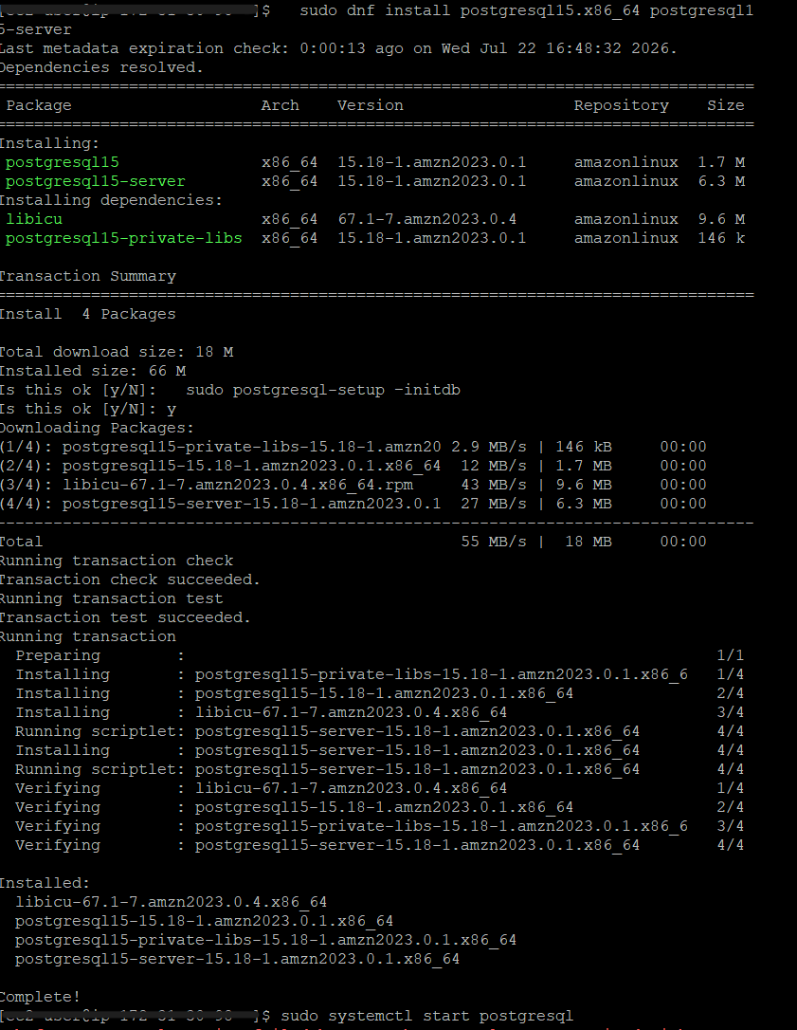

The install process prompted sudo postgresql-setup --initdb, which was confirmed (y). This step creates the initial PostgreSQL data directory (/var/lib/pgsql/data) and system catalogs — a required one-time step before the PostgreSQL server can start, since a freshly installed package only provides the binaries, not an initialized database cluster. sudo systemctl status postgresql confirmed the service was active (running), showing the main PostgreSQL process (PID 27527) along with its child processes. This confirmed the server was fully operational and ready to accept connections.
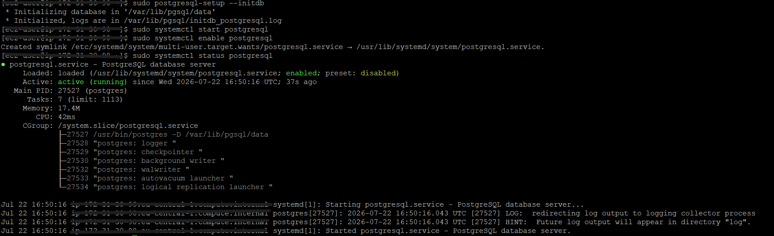
Redshift Serverless with basic auto settings and 300 points for free usage was created and runned. Redshift Serverless was selected instead of a traditional provisioned cluster because it removes the need to size, launch, and manage a fixed-capacity cluster (node type, node count) ahead of time. Compute capacity scales automatically based on workload demand and is billed per RPU-second of actual usage, which is well suited to a learning environment with unpredictable query activity rather than a constant production workload. The Serverless dashboard confirmed a default namespace (default-namespace) and workgroup (default-workgroup), both showing an "Available" status, with zero snapshots and no datashares configured — indicating a clean, freshly provisioned environment with no inherited configuration from other projects.
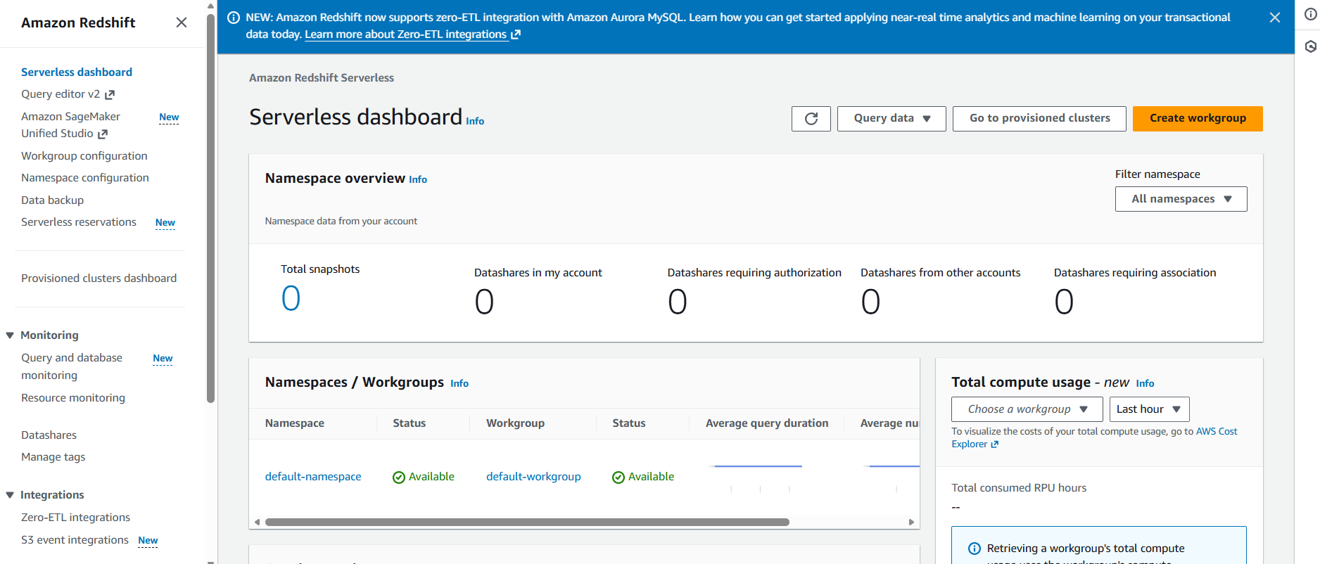
Before configuring a full GUI client, connectivity to the newly created Serverless workgroup was first validated directly from the EC2 instance using the psql command-line client that had already been installed. The connection string pointed to the workgroup's public endpoint with sslmode=require enforced, since Redshift Serverless requires encrypted connections. This step served as a quick sanity check — confirming the endpoint was reachable, the credentials were valid, and the workgroup was actually serving queries — before investing time in setting up a heavier desktop client. A simple SELECT * FROM information_schema.tables LIMIT 5 confirmed the connection was fully functional, returning system catalog tables.
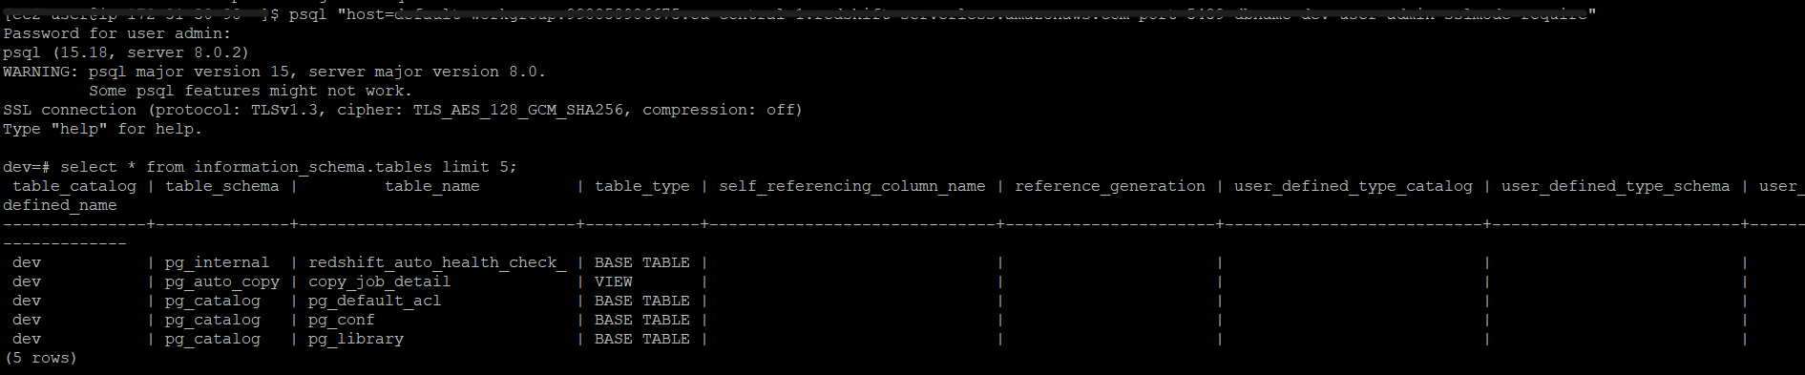
With connectivity confirmed, the next step was to set up a persistent connection in DBeaver for ongoing query work, since a desktop SQL client offers a far better experience than a terminal psql session for iterative development — syntax highlighting, result grids, query history, and multiple open script tabs. The connection was configured directly on the Main tab, using the workgroup's JDBC endpoint, database dev, and native database authentication with the admin user and password, plus SSH tunnel pointing at the EC2 instance's public DNS as a potential jump host, authenticating with the same private key used for the EC2 SSH session.
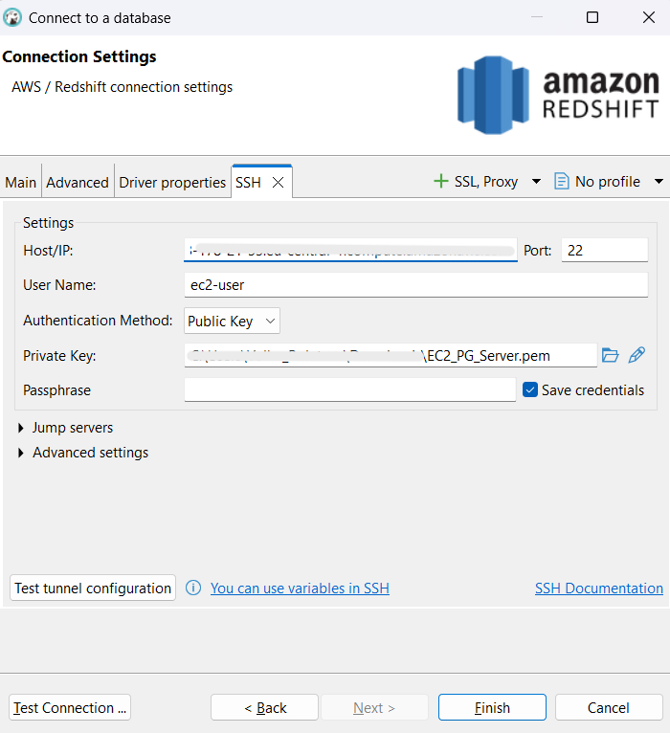

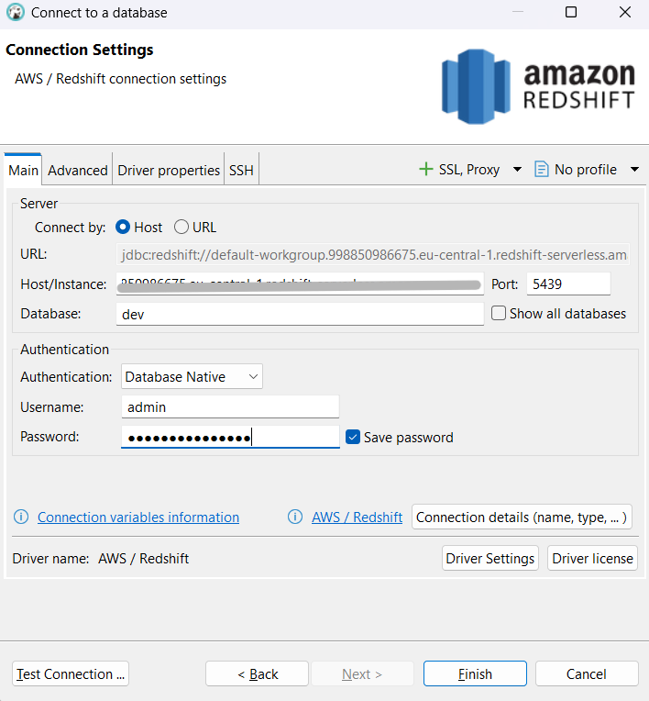
When first testing the connection, DBeaver's default Redshift driver was outdated. To fix this, the official Amazon Redshift JDBC driver was downloaded directly from AWS's official distribution and manually added to the driver's library list in DBeaver's driver editor. This manual approach ensured the exact, current driver version and all its transitive dependencies were present, avoiding version-mismatch errors during authentication or query execution.
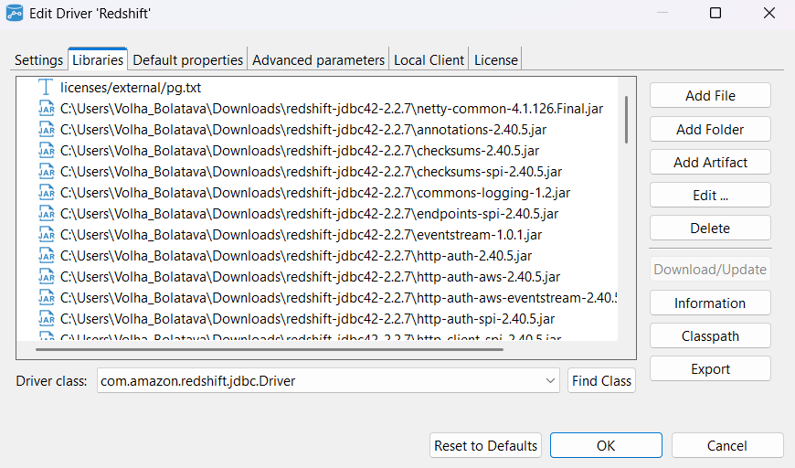
After updating the driver libraries, the connection test succeeded, reporting a successful connection in 3,574 ms, identifying the server as Redshift 8.0.2 (PostgreSQL 8.0.2-compatible protocol) and the driver as Redshift JDBC Driver 2.2.7. This confirmed the DBeaver client was correctly configured end-to-end and ready to be used for all subsequent schema creation, data loading, and query work in the lab.
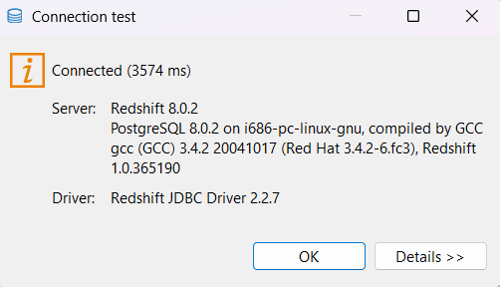
The database dev 2 appeared in the Database Navigator tab with a fully expandable tree structure - confirming that DBeaver had not only authenticated successfully but had also retrieved the full catalog metadata needed to browse the workgroup interactively.
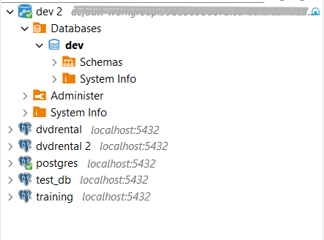

Since this lab is being completed independently, without a assigned group, the decision was made to substitute a dataset that was already fully under this account's control and had already been validated end-to-end in an earlier module of the same lab: the DIM_STORES, DIM_VENDORS, and FCT_SALES_DD tables loaded from the personal S3 bucket (s3bucketvolha), using the same IAM role and COPY mechanics the task description asks for.
The schema user_dilab was created, along with three tables designed to support a sales-reporting use case: DIM_STORES (store dimension), DIM_VENDORS (vendor dimension), and FCT_SALES_DD (the daily sales fact table, referencing both dimensions via surrogate keys and holding transactional measures). These three tables were deliberately chosen — rather than loading every table available in the data lake — because together they are sufficient to build a meaningful sales-performance report joining facts to both the "where it was sold" and "who supplied it" dimensions, satisfying the requirement of using at least three related tables while keeping resource usage limited, as instructed.
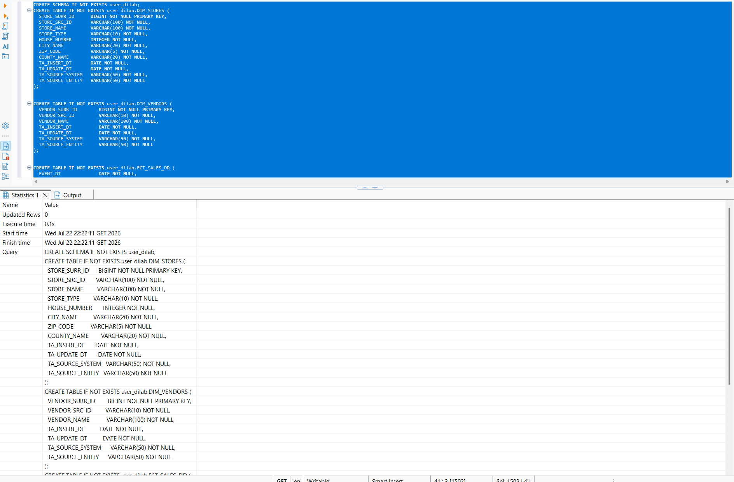
All three tables were loaded from S3 using the COPY command, authenticating through the assigned IAM role (AmazonRedshift-CommandsAccessRole) rather than static credentials — this is the AWS-recommended approach, since it avoids embedding long-lived access keys in SQL scripts and scopes access strictly to what the role permits. Each COPY pointed to a distinct S3 prefix for its respective table, used CSV IGNOREHEADER 1 to skip the header row, and a comma delimiter matching the source file format. The load completed successfully for all three tables, confirmed by Redshift's own load summary: 4,448 records into dim_stores, 388 into dim_vendors, and 427,182 into fct_sales_dd.
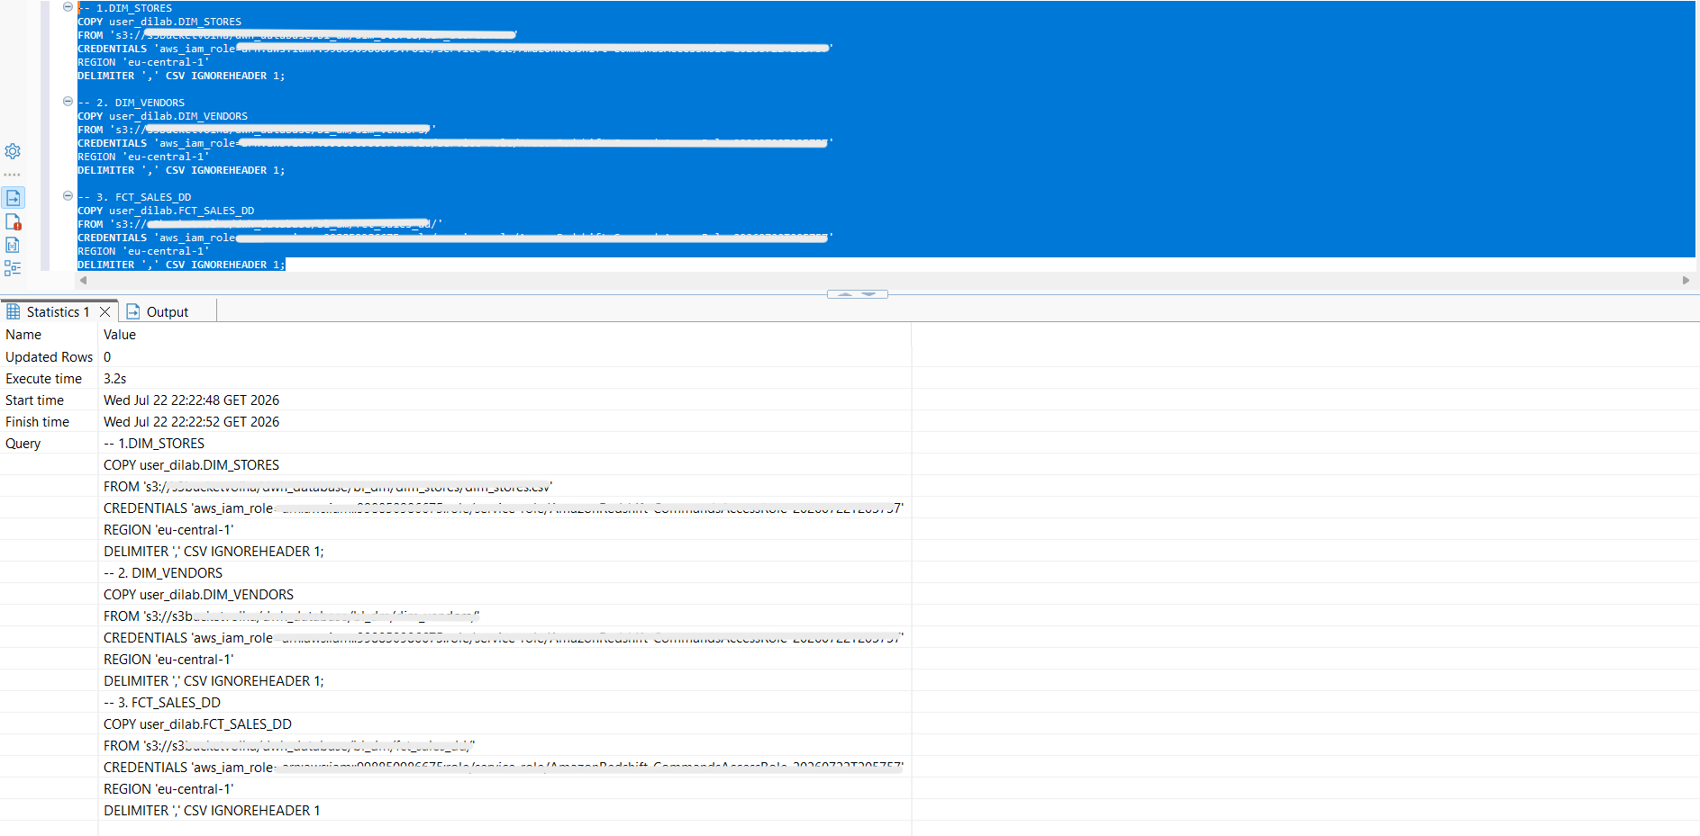

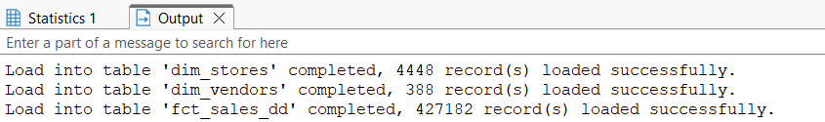
After loading, pg_table_def was queried (with search_path explicitly set to user_dilab to ensure the catalog view resolved correctly) to inspect the encoding automatically applied to each column. The result showed Redshift had assigned lzo encoding to nearly all VARCHAR/text columns (city_name, county_name, store_name, store_src_id, store_type, zip_code, source-system/entity tracking columns) and az64 encoding to numeric and date columns (house_number, store_surr_id, ta_insert_dt, ta_update_dt) — consistent with Redshift's default COPY-time behavior of auto-selecting a compression algorithm suited to each column's data type and value distribution, without any encoding being explicitly specified in the DDL. sortkey was 0 (unset) for every column in both dimension tables, confirming no explicit sort order had been defined.
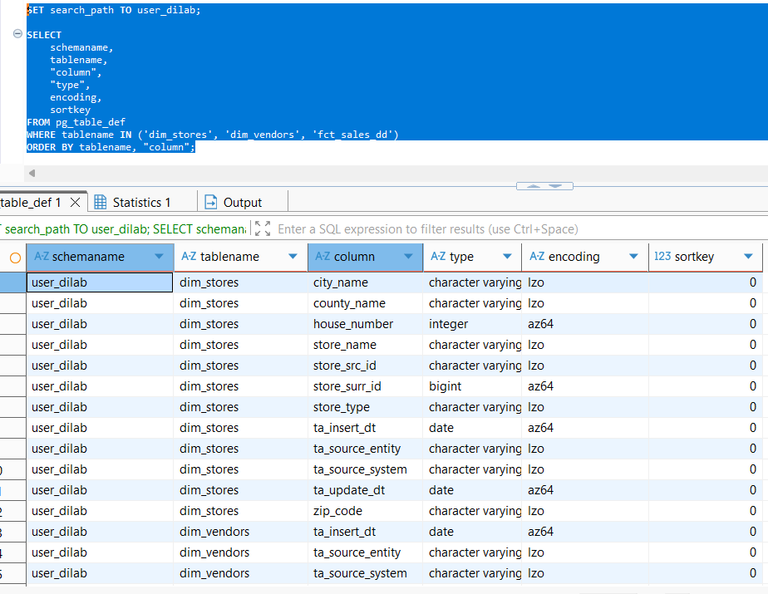
Separately, svv_table_info was queried to capture distribution style alongside table size and row counts. This showed dim_vendors and dim_stores were both auto-assigned AUTO(ALL) distribution — Redshift's automatic choice to replicate small dimension tables fully across all nodes — while fct_sales_dd, the much larger fact table, was assigned AUTO(EVEN), distributing its 427,182 rows evenly across cluster slices rather than replicating them. All three tables showed AUTO(SORTKEY), meaning Redshift had not yet committed to a specific sort key and reserved the right to choose one automatically as the table grows and query patterns emerge. This automatic behavior — correctly differentiating a small, frequently-joined lookup table (ALL) from a large fact table (EVEN) without any manual intervention.
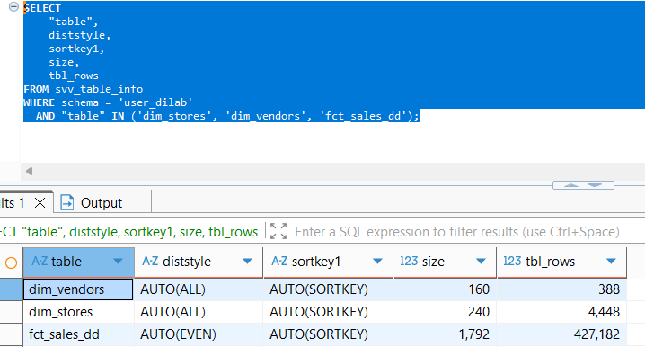
3.
fct_sales_dd was chosen as the subject table for the deeper compression exercise, since as the largest and most frequently queried table it best demonstrates the practical impact of compression choices. A reference copy, fct_sales_dd_defaultcomp, was created via CREATE TABLE ... AS SELECT * FROM fct_sales_dd to freeze a stable snapshot for comparison. fct_sales_dd was queried to inspect the encoding automatically applied to each column. The result showed Redshift had assigned az64 encoding to numeric and date columns:
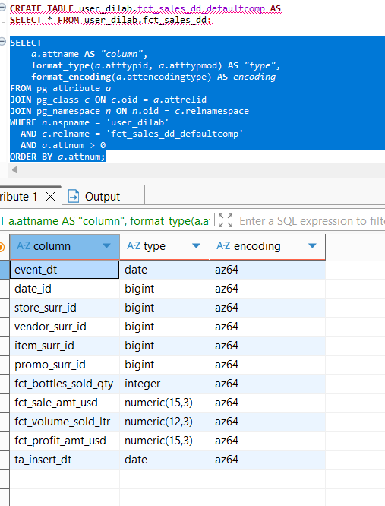
fct_sales_dd_withoutcomp was created with ENCODE RAW explicitly specified on every column, guaranteeing zero compression — this is the correct way to force "no encoding" in Redshift, since simply omitting ENCODE in a CREATE TABLE ... AS SELECT would let Redshift auto-select encodings again rather than leaving the table genuinely uncompressed. All 427,182 rows were then copied in from fct_sales_dd_defaultcomp via INSERT INTO ... SELECT:
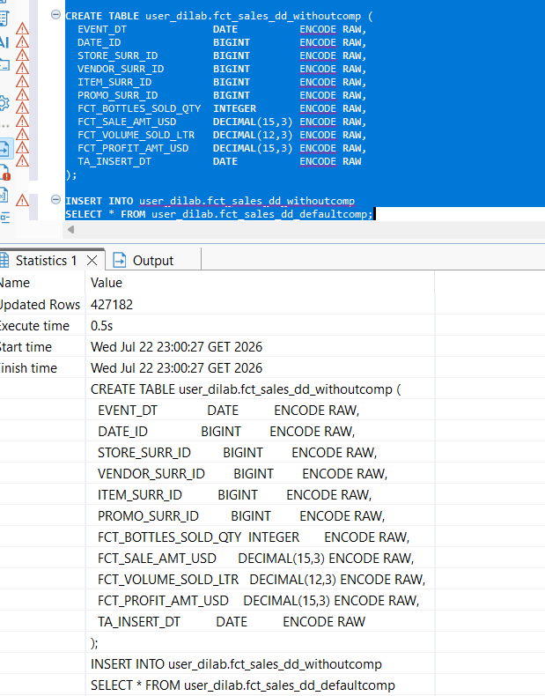
The load was verified against pg_table_def, which reported encoding none (the pg_table_def display equivalent of ENCODE RAW) for all 10 data columns — confirming the uncompressed baseline was built correctly:
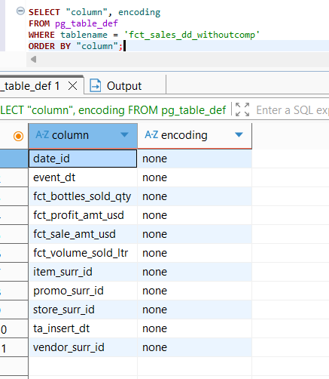
ANALYZE COMPRESSION was run against fct_sales_dd_withoutcomp to obtain Redshift's own encoding recommendations based on an actual sample of the uncompressed data. Rather than recommending typical byte-oriented encodings, Redshift returned raw for every column with an estimated size reduction of 0.00% across the board. This outcome is explained by two factors specific to this dataset: the fact table's columns are dominated by high-cardinality surrogate keys and monetary values, which limit the effectiveness of sequence-dependent algorithms like delta, and the rows in withoutcomp were not physically sorted (having been inserted via a plain SELECT * with no ORDER BY), which further reduces the benefit of any position-dependent compression scheme.
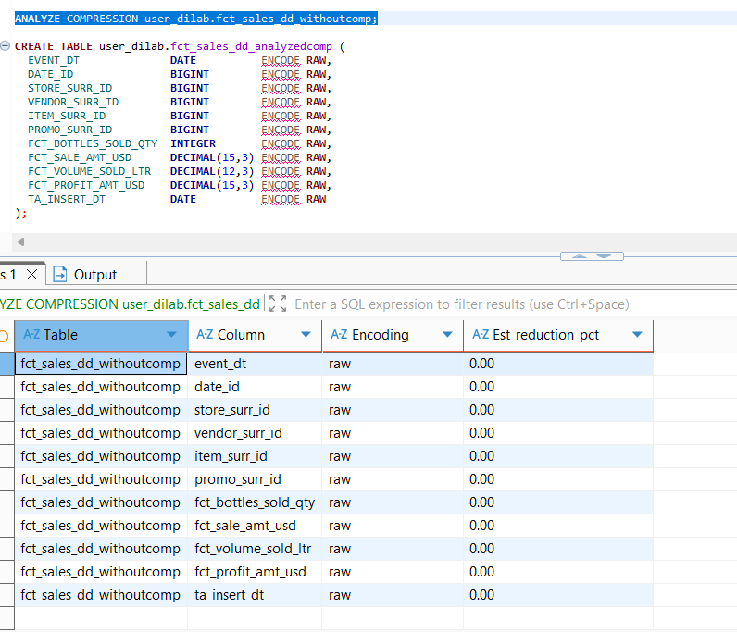
Since the recommendation was uniformly raw, fct_sales_dd_analyzedcomp was created with ENCODE RAW on all columns as well — an identical structure to withoutcomp — and populated from fct_sales_dd_defaultcomp, with pg_table_def again confirming none encoding across all 10 columns.
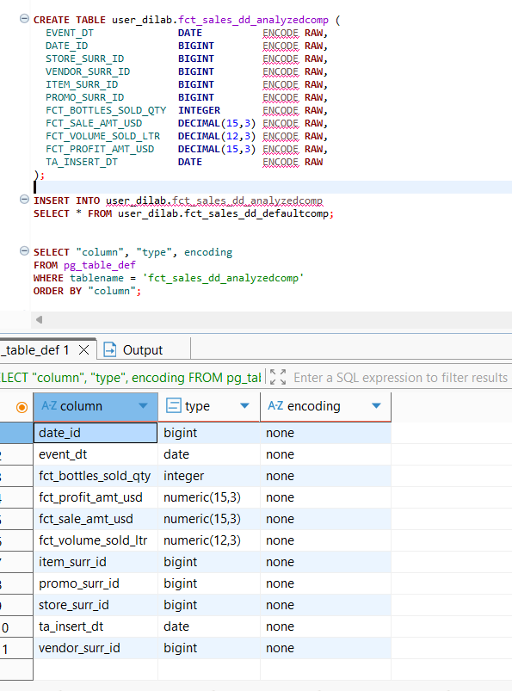
svv_table_info was queried for all three tables (fct_sales_dd_defaultcomp, fct_sales_dd_withoutcomp, fct_sales_dd_analyzedcomp), each holding the identical 427,182 rows, allowing a clean size-only comparison. The results were unambiguous: fct_sales_dd_defaultcomp (auto-encoded at COPY time, az64 throughout) occupied 952 MB, while both fct_sales_dd_withoutcomp and fct_sales_dd_analyzedcomp (both RAW, since ANALYZE COMPRESSION recommended no change) occupied 1,708 MB each — a ~44% storage reduction attributable entirely to Redshift's automatic COPY-time compression.
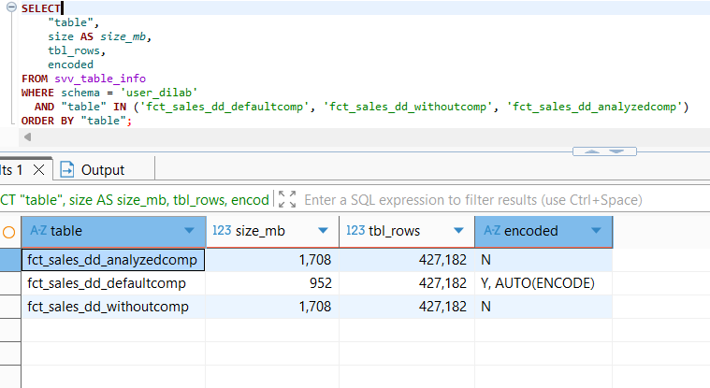
Main conclusion: This shows that Redshift's COPY-time auto-encoding — which samples the raw source data directly from S3 before any rows are written — was more effective at compressing this dataset than ANALYZE COMPRESSION, which evaluates an already-loaded, unsorted, uncompressed table and in this case found no encoding worth recommending. The practical conclusion: for this dataset (high-cardinality surrogate keys and monetary fields, physically unsorted), the best compression outcome came from simply loading data the normal way via COPY into a table with no ENCODE specified, rather than from a manual ANALYZE COMPRESSION pass — the two mechanisms are not guaranteed to produce the same result, and relying on one instead of the other can materially change storage efficiency.
4.
A stored procedure, sp_load_sales_report, was written to encapsulate the report-building logic end-to-end: it drops any prior version of the output table, then rebuilds it via CREATE TABLE ... AS SELECT, joining all three tables required by the task — fct_sales_dd (fact) to dim_stores and dim_vendors (both dimensions) — on their respective surrogate keys, aggregating bottles sold, sale amount, volume, and profit, grouped by date, store, city, county, and vendor. Wrapping this in a procedure makes the report refreshable with a single CALL, which matters directly for the performance-testing methodology used next, since the same logic needed to be re-executed multiple times to distinguish a cold run from a stable, cacheable one. Calling the procedure and spot-checking the output (SELECT COUNT(*) and a LIMIT 20 sample) confirmed the join and aggregation logic was correct before moving to performance measurement.

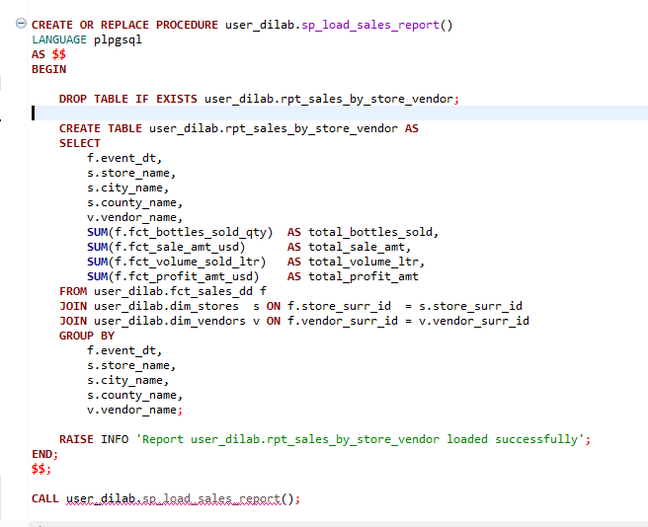
Result of the procesdure:
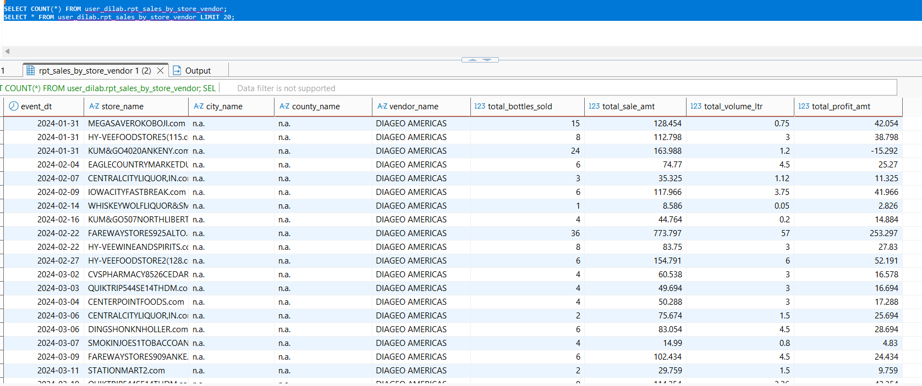
Before any timing was recorded, SET enable_result_cache_for_session TO OFF was executed. Redshift's result cache can return a previously computed result set almost instantly for a repeated identical query, which would make every run after the first appear artificially fast and mask the actual cost of re-executing the join and aggregation — invalidating any before/after comparison. Disabling it for the session ensured every subsequent CALL genuinely re-executed the full query plan against the underlying tables.
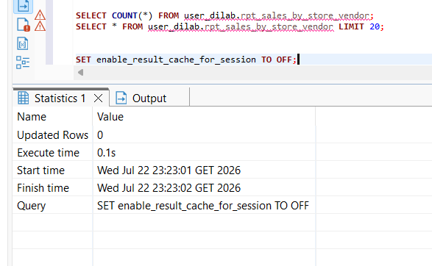
EXPLAIN was run against the report's SELECT before any distribution/sort key changes. The plan showed two XN Hash Join nodes, both flagged DS_DIST_ALL_NONE, joining fct_sales_dd (427,182 rows, XN Seq Scan) to dim_stores (4,448 rows) and dim_vendors (388 rows) via hashed lookups on store_surr_id and vendor_surr_id, followed by an XN HashAggregate (cost 16489.92..20761.74) to compute the grouped sums. The DS_DIST_ALL_NONE tag on both joins was the key detail: it indicated no network redistribution of rows was required for either join, because Redshift had already auto-selected ALL distribution for the small dimension tables (confirmed independently via svv_table_info), so both dimensions were already present in full on every node — the join could execute entirely locally per slice.
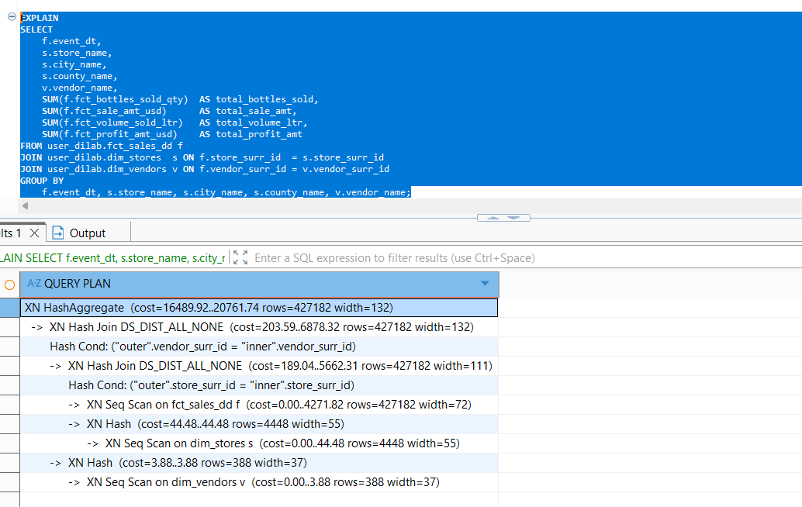
The execution time was measured using sys_query_history by tracking the procedure's internal CREATE TABLE statement and calculating the duration from start_time and end_time. The procedure was run four times. The execution times were 1,288 ms, 911 ms, 477 ms, and 489 ms.
The first run was much slower because Amazon Redshift had to compile and prepare the query for execution. It also had to load the required metadata and data into cache. After this initial setup, the following runs were faster because the compiled query plan and cached data were reused.
For this reason, the first execution was not used as the baseline. Instead, the last two runs (477 ms and 489 ms) were used because they represent the normal, steady performance of the query.
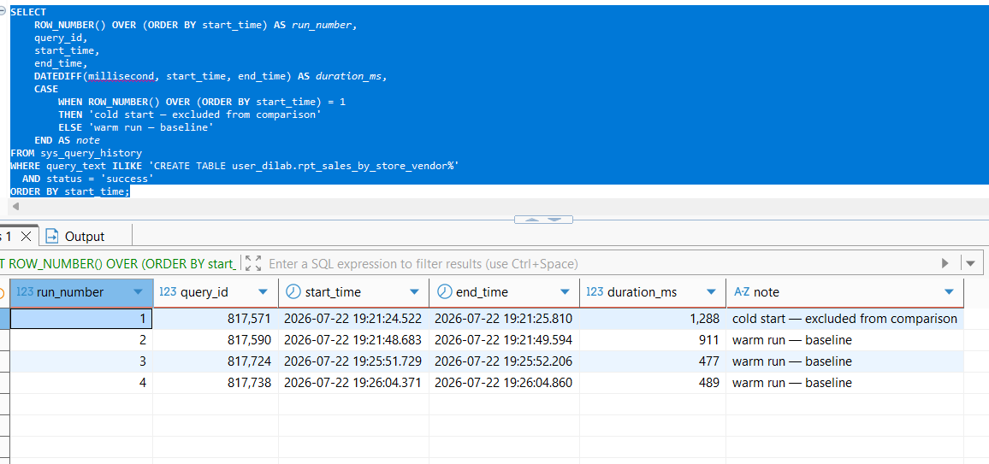
svv_table_info was queried directly for all three tables to document their pre-optimization physical layout. dim_stores and dim_vendors both showed diststyle = AUTO(ALL) — Redshift's own choice to fully replicate these small, frequently-joined dimension tables across every node. fct_sales_dd showed diststyle = AUTO(KEY(vendor_surr_id)) and sortkey1 = AUTO(SORTKEY(event_dt)) — meaning Redshift's AUTO distribution had, on its own, already settled on distributing the fact table by vendor_surr_id and sorting it by event_dt, without either being explicitly declared in the original DDL. This was an important finding going into the optimization step: it meant the baseline was not a "naive" unoptimized state, but one where Redshift's automatic heuristics had already made reasonable choices — raising the bar for what a manual optimization would need to demonstrably improve.
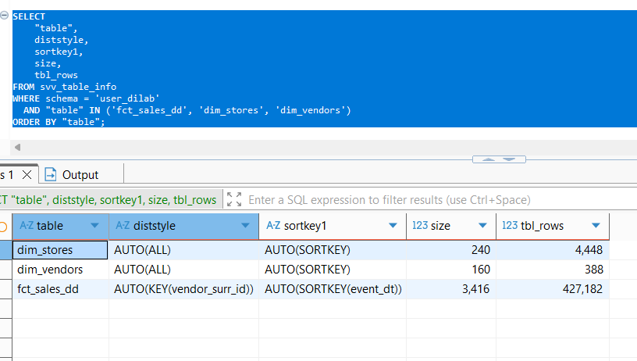
Since this three-table join is expected to run frequently, the distribution and sort keys were set manually instead of using AUTO.
The dim_stores and dim_vendors tables were changed to DISTSTYLE ALL. These tables are small, so copying them to every node removes the need to move data during joins and improves query performance.
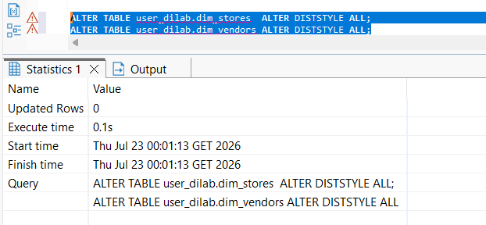
For the fact table, a new table called fct_sales_dd_opt was created because the distribution key cannot be changed on an existing table. It was defined with DISTSTYLE KEY and DISTKEY(store_surr_id). The store_surr_id column was chosen because it has many more unique values than vendor_surr_id (4,448 stores compared to 388 vendors), which distributes the data more evenly across the cluster and reduces data skew.
A compound SORTKEY(event_dt, store_surr_id) was also added. Since reporting queries are most likely to filter by date, sorting the data by event_dt allows Redshift to scan fewer data blocks and execute queries more efficiently.
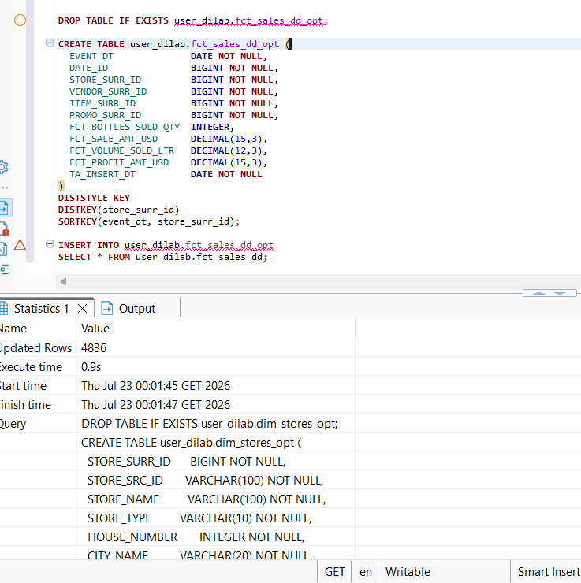
After copying the data into fct_sales_dd_opt, the ANALYZE command was run on all three optimized tables. This updated the table statistics so that the query planner could make accurate optimization decisions.

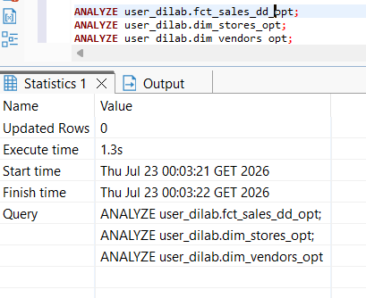
A parallel stored procedure, sp_load_sales_report_opt, was created against the _opt tables, and EXPLAIN was re-run on its underlying SELECT.
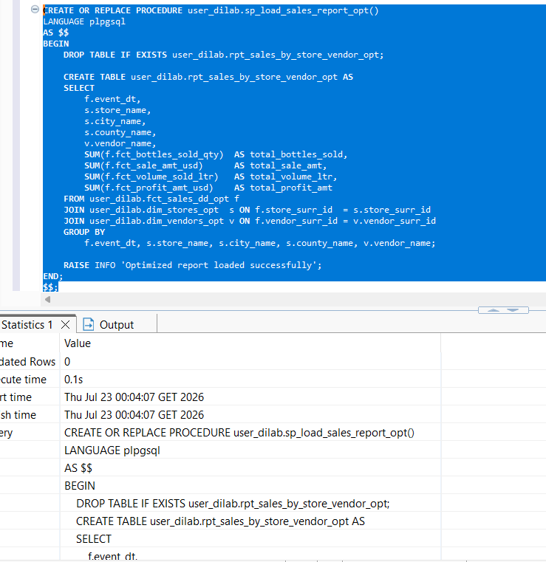
EXPLAIN was re-run on its underlying SELECT. The resulting plan was structurally almost identical to the baseline: the same two DS_DIST_ALL_NONE hash joins, the same XN Seq Scan on the fact table with cost 0.00..4271.82 (unchanged), and a marginally higher top-level HashAggregate cost (16627.14..20958.63 vs. 16489.92..20761.74) and estimated row count (433,149 vs. 427,182).
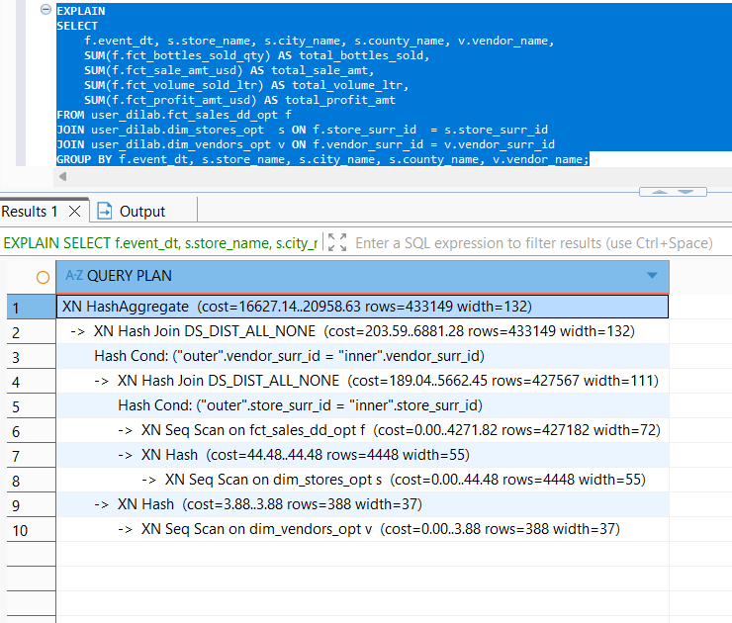
Timing, captured the same way via sys_query_history, showed 971 ms on the first (cold) run and 701 ms, 477 ms on the two warm runs that followed — stabilizing at the same 477 ms measured in the baseline. Since AUTO distribution had already selected ALL for the dimensions and a KEY/SORTKEY combination for the fact table before any manual changes were made, explicitly pinning those same choices produced no further plan change to measure. The report query itself also contains no filter on event_dt, so the new SORTKEY had no opportunity to trigger zone-map block skipping — its benefit would only become visible in a query that filters on a date range, or at a data volume large enough that the cost of not having a fixed distribution/sort strategy (versus Redshift silently changing its AUTO decision as data grows) becomes material. The explicit configuration was still considered the correct engineering choice for a join pattern described as frequent and non-shared, since it guarantees this physical layout persists rather than remaining subject to Redshift's automatic re-evaluation.
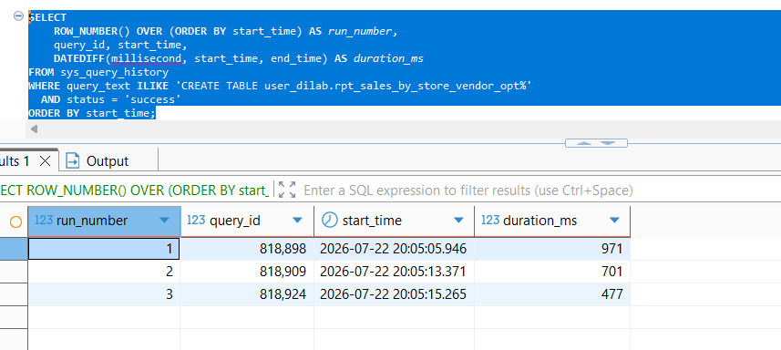
Comparison table:
Metric | BEFORE (fct_sales_dd) | AFTER (fct_sales_dd_opt)
Distribution style — fct_sales_dd | AUTO (auto-selected) | KEY, DISTKEY(store_surr_id)
Distribution style — dim_stores | AUTO (auto-selected) | ALL (explicit)
Distribution style — dim_vendors | AUTO (auto-selected) | ALL (explicit)
Sort key — fct_sales_dd | None | SORTKEY(event_dt, store_surr_id)
Sort key — dim_stores | None | SORTKEY(store_surr_id)
Sort key — dim_vendors | None | SORTKEY(vendor_surr_id)
Join type (fct ↔ dim_stores) | DS_DIST_ALL_NONE | DS_DIST_ALL_NONE
Join type (fct ↔ dim_vendors) | DS_DIST_ALL_NONE | DS_DIST_ALL_NONE
Scan method on fact table | XN Seq Scan | XN Seq Scan
Scan cost (fct_sales_dd) | 0.00..4271.82 | 0.00..4271.82
Top-level cost (HashAggregate) | 16489.92..20761.74 | 16627.14..20958.63
Estimated rows (HashAggregate) | 427,182 | 433,149
Cold start execution time | 1,288 ms | 971 ms
Stable warm-run execution time | 477–489 ms | 477 ms
Result cache | Disabled | Disabled

Manually configuring DISTKEY and SORTKEY did not improve performance for this workload because Amazon Redshift's AUTO mode had already selected the same effective distribution and sort strategy. As a result, execution time and the query plan remained almost identical before and after optimization.
This shows that Redshift's automatic optimization can already provide near-optimal performance for simple workloads. Therefore, it is important to verify the current table design and execution plan before making manual changes. In this case, the value of explicitly defining the keys is to ensure a stable physical table layout for future data growth and more complex queries, rather than to improve the performance of the current query.
2. COPY QUESTION
Since this lab is being completed independently, without a assigned group, the same underlying mechanism — comparing COPY performance from a single-file S3 source versus a multi-file S3 source — was reproduced using data already available in this account: fct_sales_dd was exported to two separate S3 locations using UNLOAD, one forced into a single file (PARALLEL OFF) and one left as Redshift's default multi-file parallel output, directly mirroring the "single file" vs. "multiple files, same data" setup the original task describes.
Two UNLOAD statements were run against identical source data (SELECT * FROM user_dilab.fct_sales_dd). The first specified PARALLEL OFF, forcing Redshift to collect and write the entire result set as one file to lineorder_singlefile/. The second omitted that flag, using Redshift's default parallel unload behavior, which writes one file per compute-node slice to lineorder_multifile/. Both used the same IAM role, region, and pipe delimiter, so the only variable between them was file count — exactly reproducing the "both files store exactly the same data" condition specified in the task.
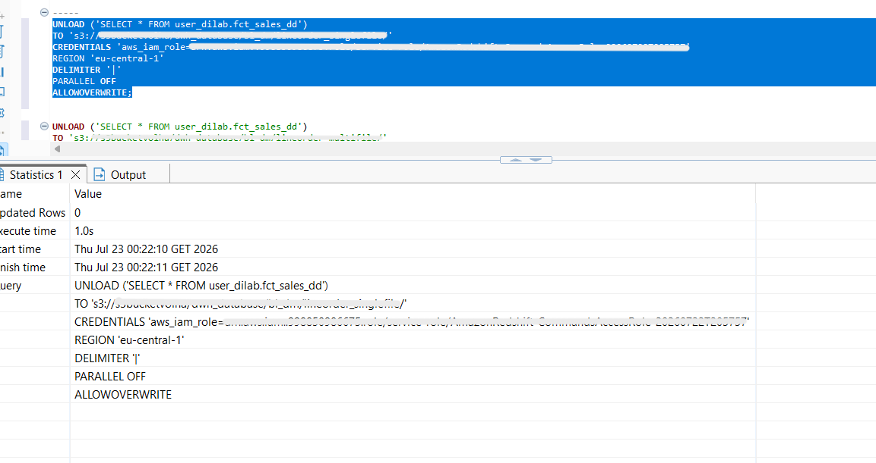
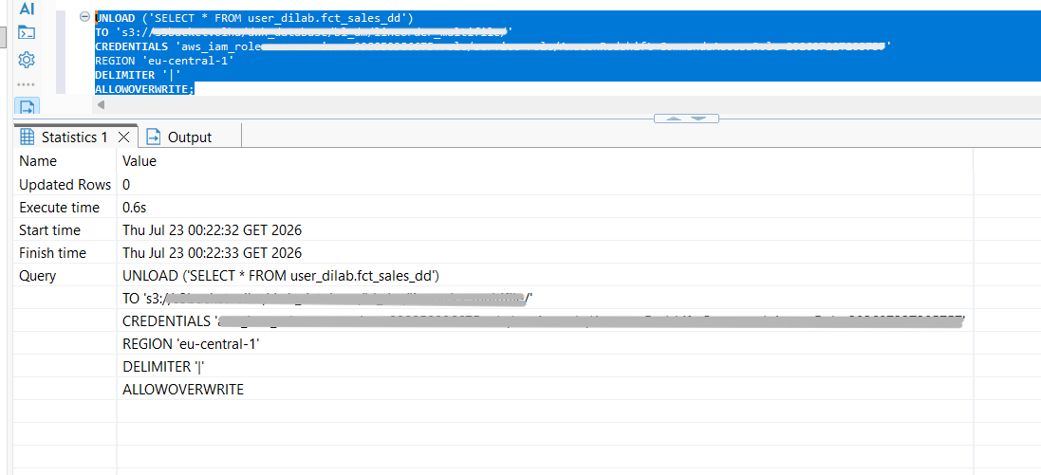

lineorder_1 and lineorder_2 were created using CREATE TABLE ... (LIKE user_dilab.fct_sales_dd), guaranteeing both tables had an identical column structure and data types:
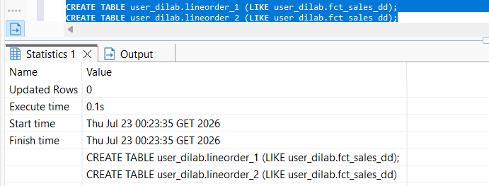
lineorder_1 was loaded from the single-file location; lineorder_2 was loaded from the multi-file location — both using the same IAM role, region, and delimiter, so file count was again the only variable.
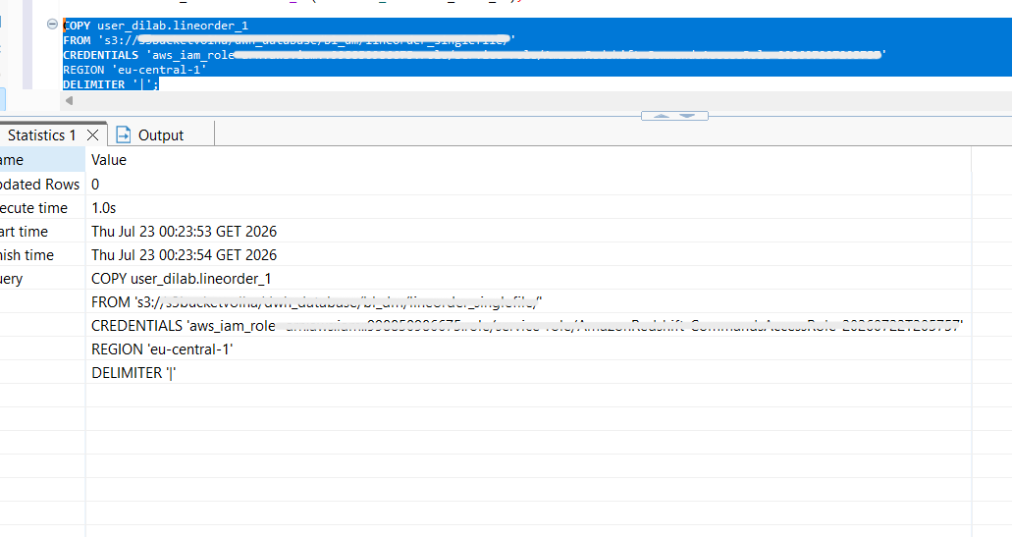
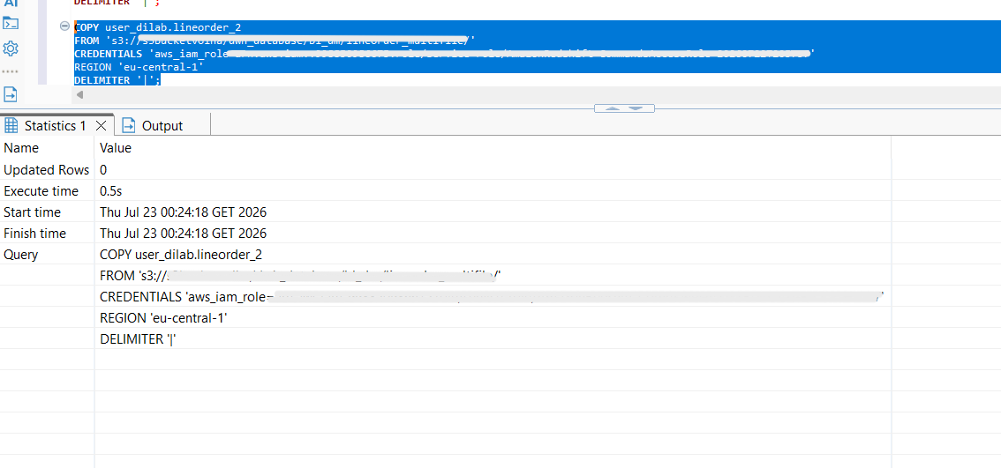

Execution time was captured via sys_query_history, filtering on the COPY statement text and computing duration_ms from start_time/end_time. The results: lineorder_1 (single file) — 980 ms, versus lineorder_2 (multi file) — 357 ms.

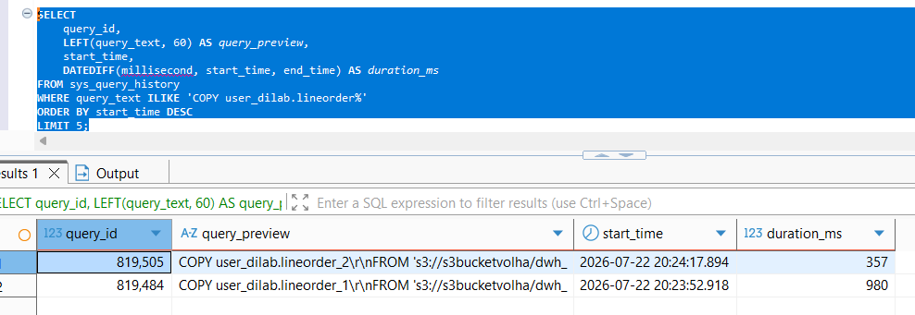
Conclusion : Loading data from multiple files was 2.7× faster than loading the same data from a single file (357 ms vs. 980 ms). This is because Amazon Redshift processes multiple files in parallel, allowing different cluster slices to load data at the same time. In contrast, a single file can only be processed by one slice, leaving the others idle. Therefore, splitting data into multiple similar-sized files is the recommended approach for achieving the best COPY performance.
- WORKING WITH EXTERNAL TABLES
Before creating the external schema, the Redshift IAM role was granted the required AWS Glue Data Catalog permissions:
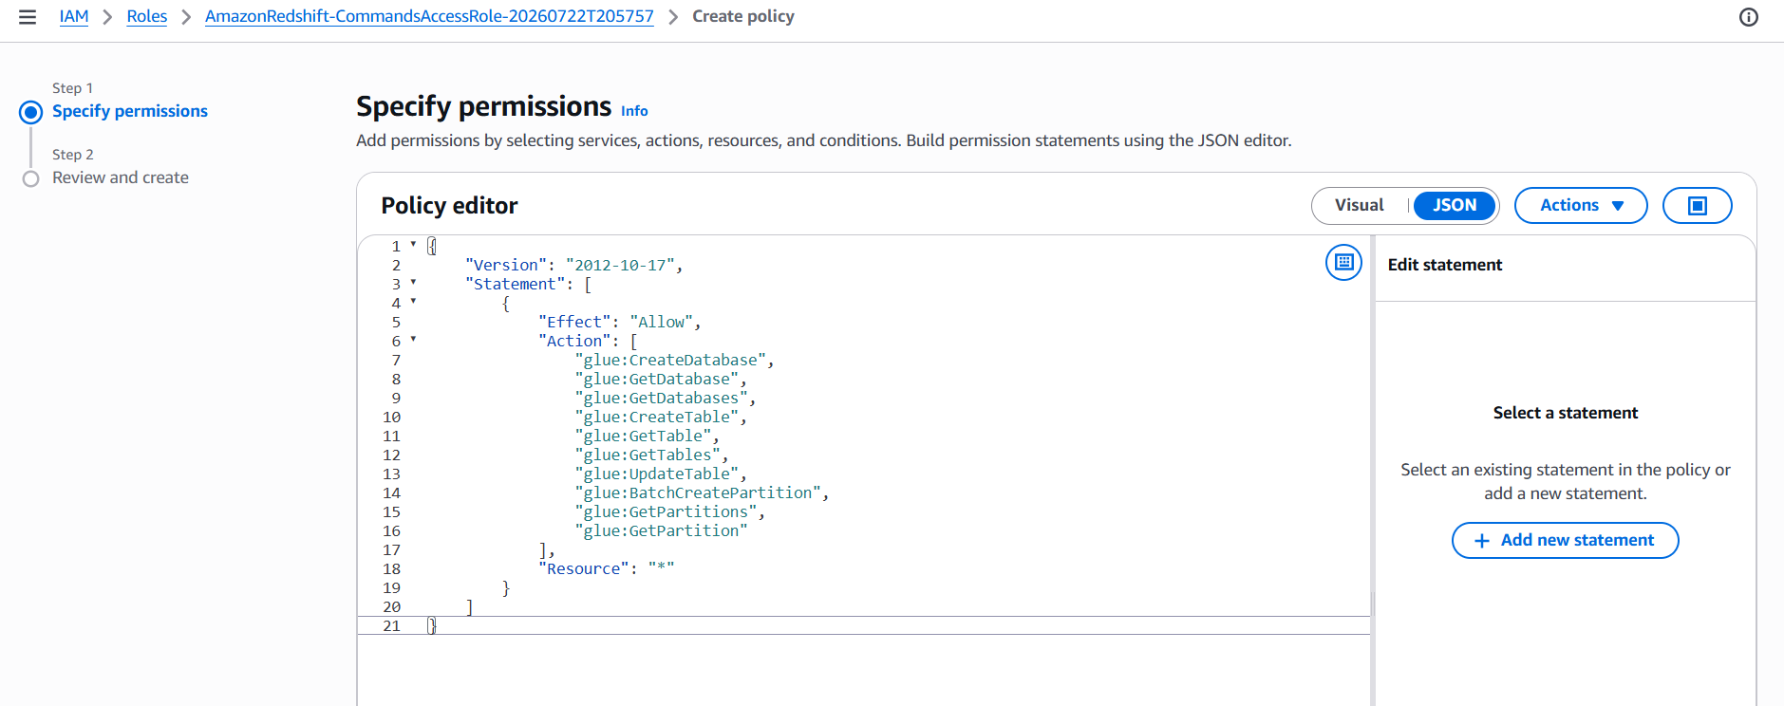
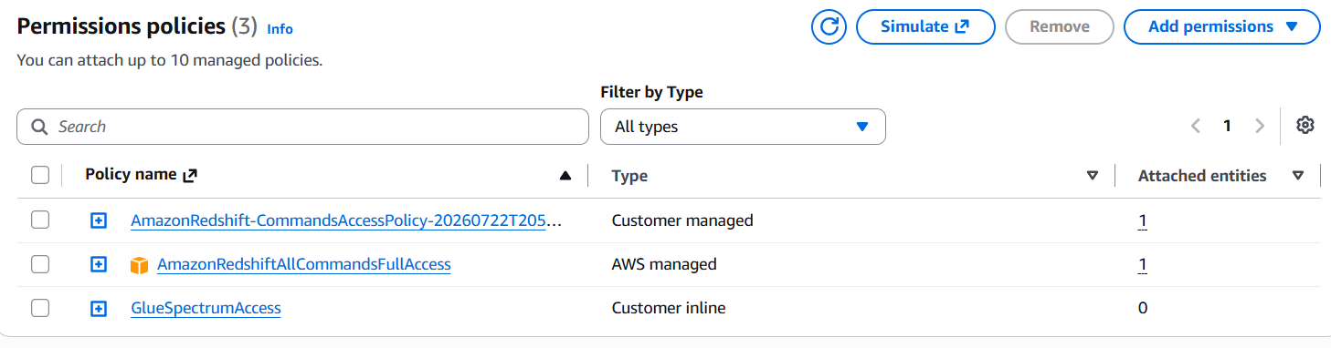
With the policy in place, CREATE EXTERNAL SCHEMA IF NOT EXISTS user_dilab_ext FROM DATA CATALOG DATABASE 'user_dilab_ext_db' IAM_ROLE '...' CREATE EXTERNAL DATABASE IF NOT EXISTS succeeded, both creating the external schema in Redshift and, in the same statement, creating the backing database in AWS Glue Data Catalog since it did not already exist. 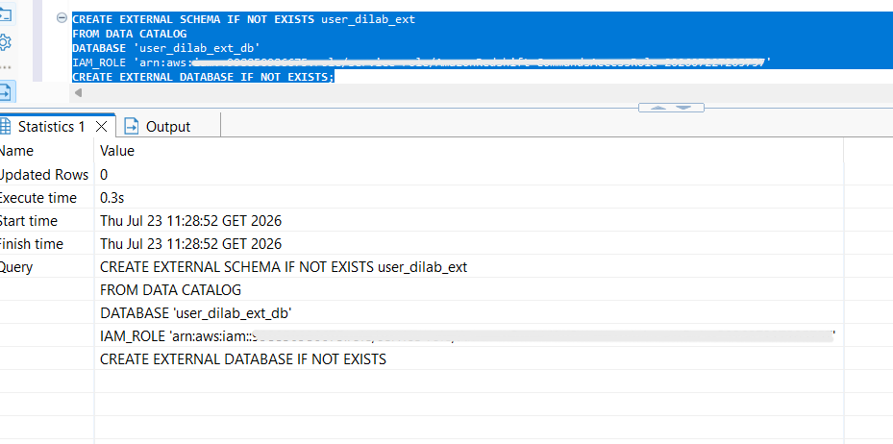
Creation of schema was verified via svv_external_schemas, which confirmed the schema was correctly registered with databasename = user_dilab_ext_db and the expected IAM role recorded in esoptions.
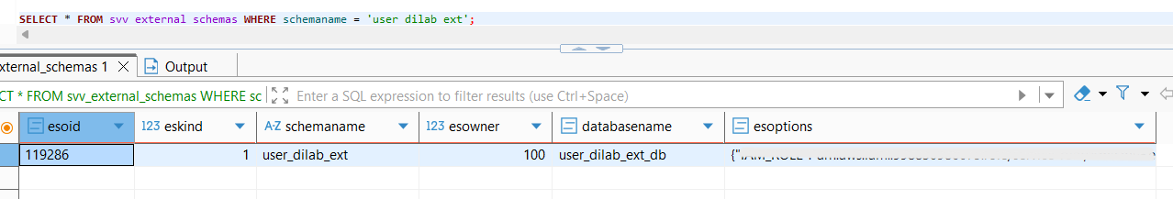
fct_sales_dd was selected as the source dataset for this step, since it already contains a date column (event_dt) suitable for monthly partitioning and had been fully validated in earlier tasks. A single UNLOAD statement selected the relevant columns along with a derived event_month column (DATE_TRUNC('month', event_dt)::DATE), writing the output to S3 in Parquet format with PARTITION BY (event_month). Redshift handled the folder structure automatically, creating one subfolder per calendar month (e.g., event_month=2024-01-01/) under the target S3 prefix — matching the required folder-per-month layout directly from the partition column's distinct values, with no need to run separate exports per month.
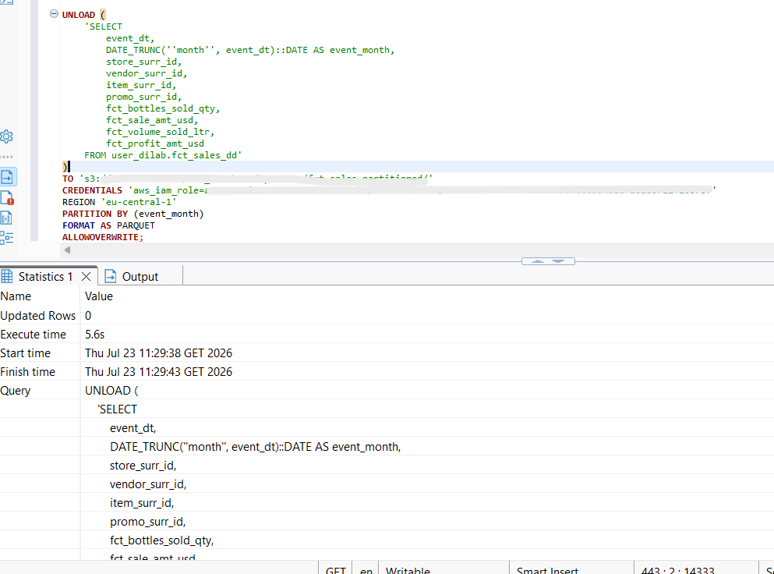
An external table, ext_student_partitioned, was created using the same columns as the exported data, with event_month defined as the partition column. The table was stored in Parquet format and linked to the S3 location where the data had been exported:
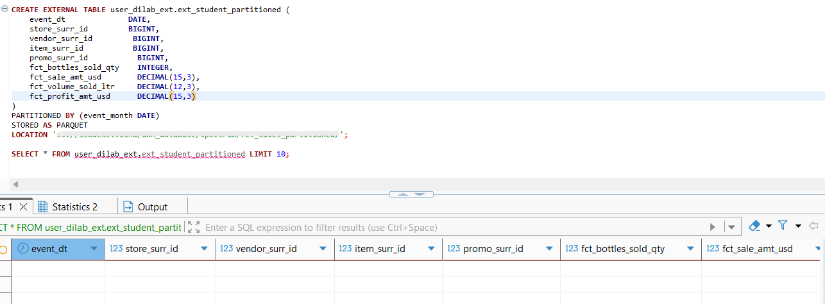
After creating the table, all 24 monthly partitions (January 2024 to December 2025) were registered using ALTER TABLE ... ADD PARTITION, because Spectrum does not detect partition folders automatically:
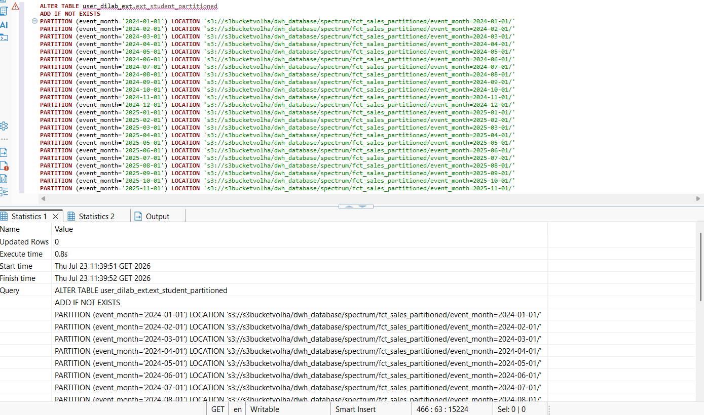
The partitions were verified in svv_external_partitions, confirming that all 24 were registered correctly:
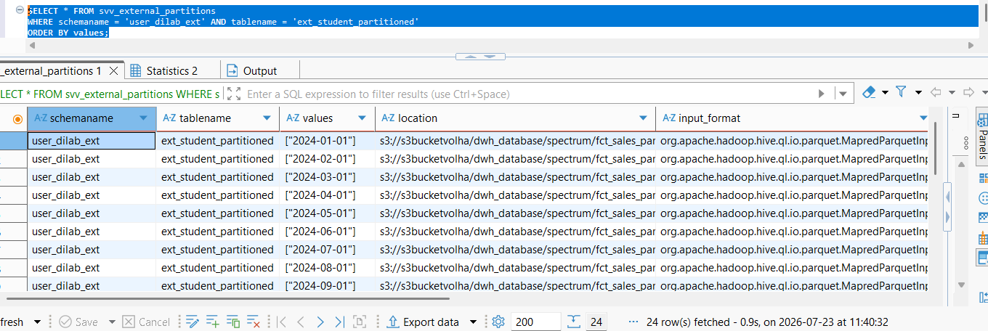
The number of rows in the original fct_sales_dd table and the external table was compared for each month. The comparison showed a difference of 0 for every month, meaning no data was lost, duplicated, or placed in the wrong partition.

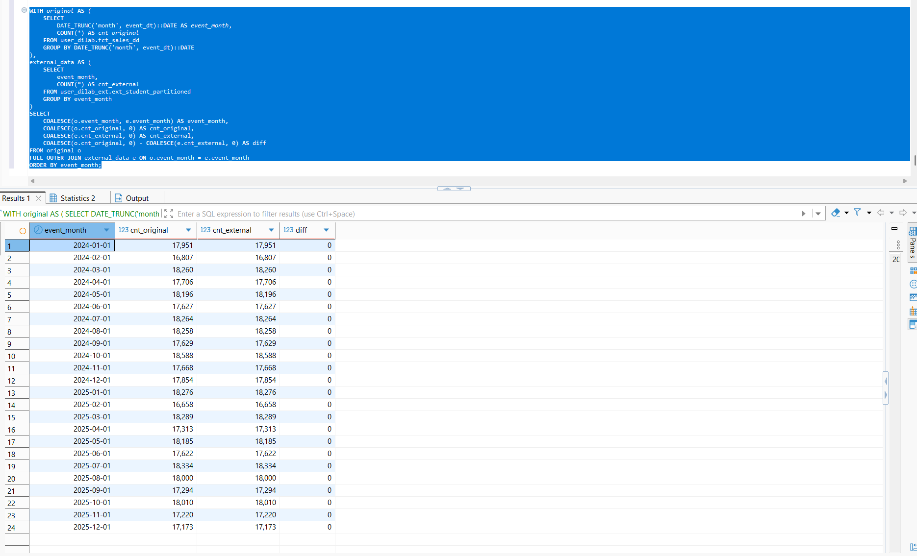
A second check using SELECT COUNT(*) also confirmed that both tables contained exactly 427,182 rows.
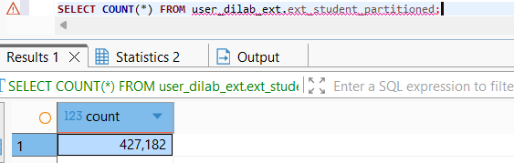
Two EXPLAIN plans were compared directly:
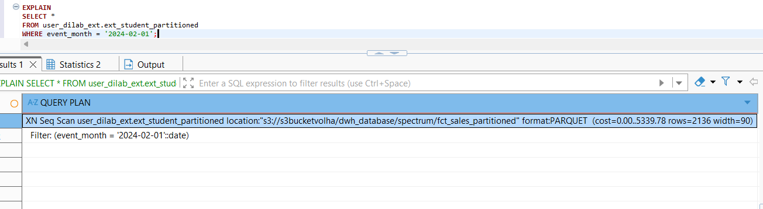
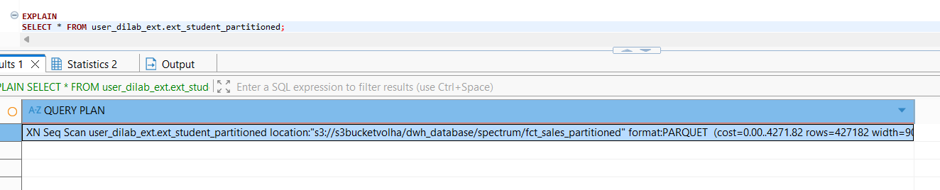
Without any filter, SELECT * FROM ext_student_partitioned produced a plan with XN Seq Scan ... rows=427182 — Spectrum scanning the full dataset across all 24 partitions. With WHERE event_month = '2024-02-01' added, the plan showed the same XN Seq Scan node but now carrying an explicit Filter: (event_month = '2024-02-01'::date) and, critically, an estimated row count reduced to just 2,136 — roughly a 200x drop, consistent with isolating one month's worth of data out of twenty-four. This is the signature of partition pruning: Spectrum used the partition metadata (registered via the earlier ALTER TABLE ADD PARTITION calls) to determine, before touching any actual file, that only the event_month=2024-02-01/ S3 subfolder could satisfy the filter — so it scanned data from that single subfolder only, rather than reading all 24 months and discarding non-matching rows afterward. This is the core cost/performance benefit partitioned external tables provide: since Spectrum bills by data volume scanned in S3, restricting the scan to one relevant partition instead of the full table directly reduces both quer y latency and the cost of running the query, without requiring any change to the query itself beyond a normal WHERE clause on the partition column.
After completing all lab tasks , all AWS services used in lab were terminated.

