2. UNDERSTANDING DATABASE AND TABLESPACES
2.1 A connection to the PostgreSQL server was established using the default postgres database. To initialize the workspace for this task, the CREATE DATABASE command was executed to create a new database named test_db. This process sets up the necessary system catalogs and the physical directory structure required for the new database instance. Following the creation of the database, an investigation of the PostgreSQL system metadata was performed:
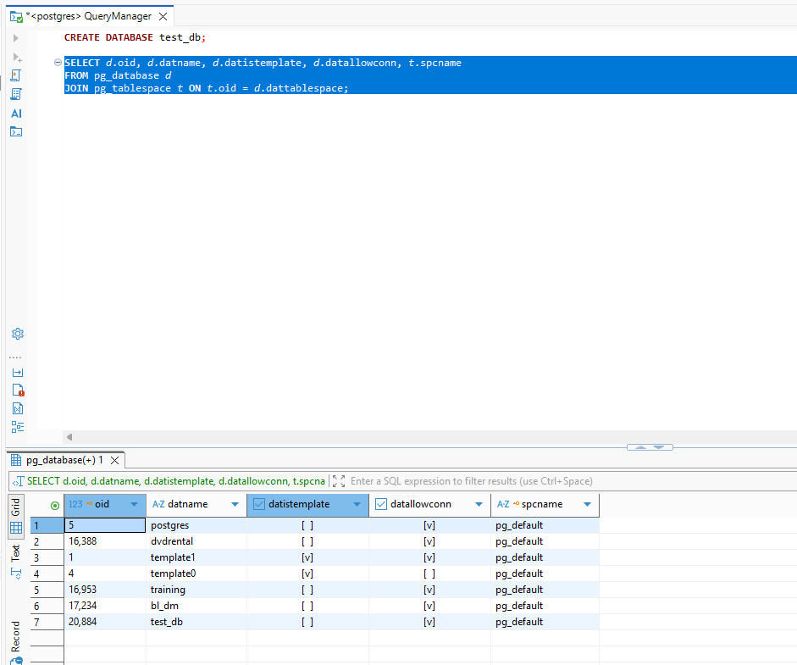
Key findings from the query results:
- oid: The unique Object Identifier assigned to test_db.
- datname: Confirms the database name in the system records.
- datistemplate: Shows whether the database is a template (False).
- datallowconn: Confirms that the database is ready to accept user connections (True).
- spcname: Identifies the physical storage location (Tablespace), which defaults to pg_default."
2.2 A new tablespace named mytablespace was created to manage physical data storage. The storage directory was established within the PostgreSQL data path at C:\Program Files\PostgreSQL\18\data\tblspc_test. This command maps a logical name to a specific physical location on the disk, allowing for optimized storage management. The existence of the new tablespace was verified:
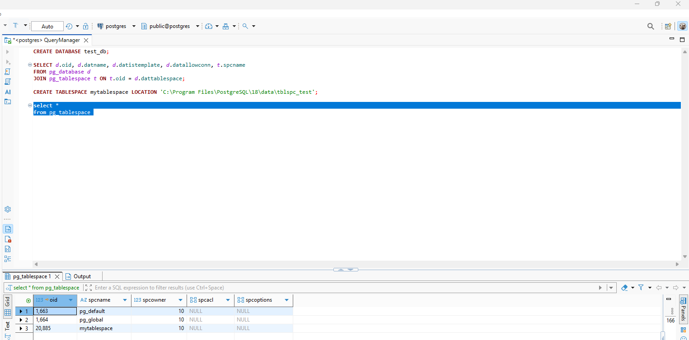

The test_db database was moved from the default storage to the newly defined tablespace using the SET TABLESPACE statement. This operation triggers the physical relocation of the database files to the mytablespace directory. The investigation query from Task 1 was re-executed to confirm that the spcname for test_db has been updated to mytablespace.
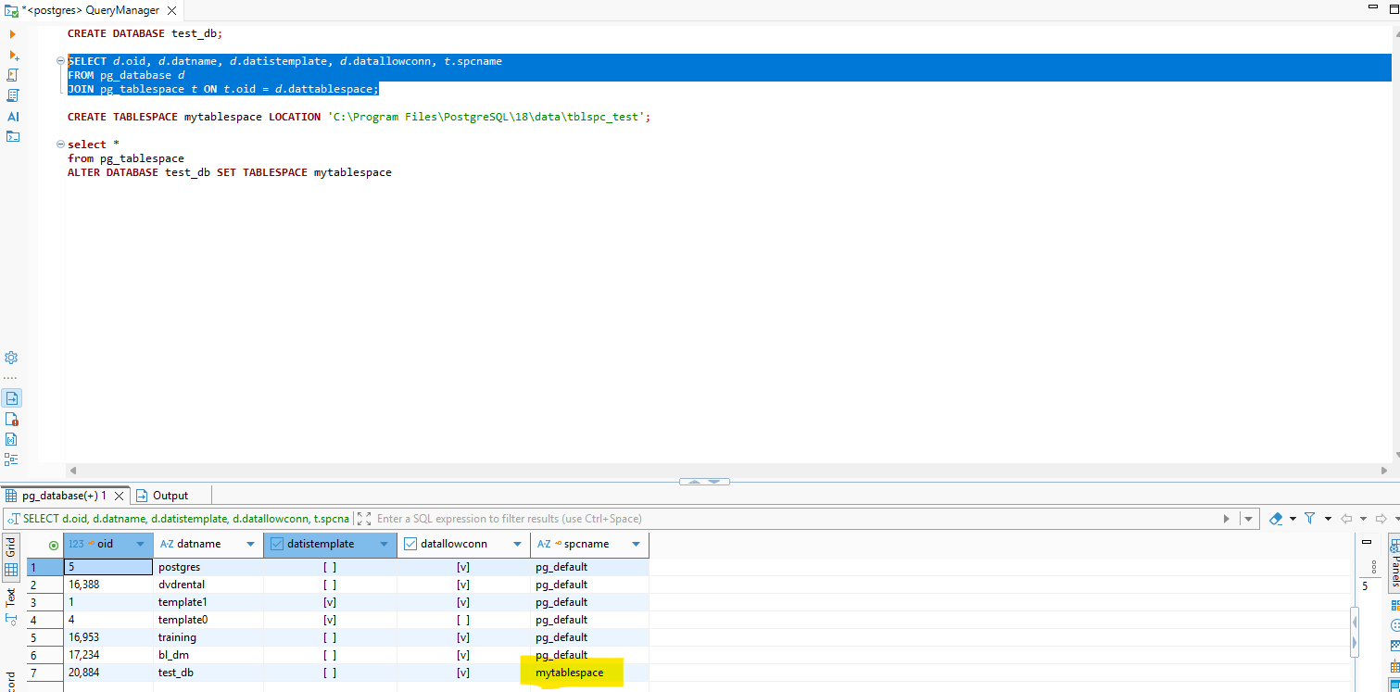

2.3 A new SQL session was established with the test_db database. Following the successful connection, the CREATE SCHEMA labs statement was executed. This command creates a logical namespace named labs, which is used to group related database objects and separate them from the system-defined public schema. The query results from pg_tables confirm that the person table was correctly created within the labs schema, verifying the successful logical isolation of the data from the default public schema:
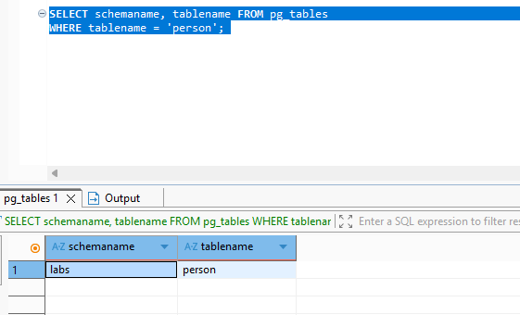
By adding labs to the search_path, the person table became accessible without a schema prefix, enabling successful data insertion and verification:
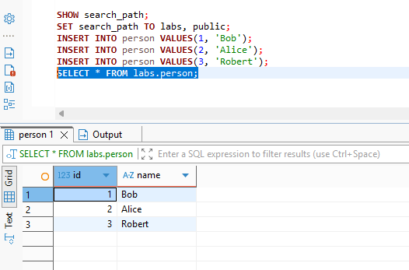
3 TRANSACTION AND VACUUMING
3.1 The extension pageinspect was successfully installed. The heap_page_items query results provide a low-level view of the table's physical storage. The t_xmin value (1913) identifies the transaction that created the records, while the t_xmax value of 0 confirms that the rows are currently active. The t_ctid column shows the physical location of each row on the disk page, illustrating how PostgreSQL manages data versions at the storage level.
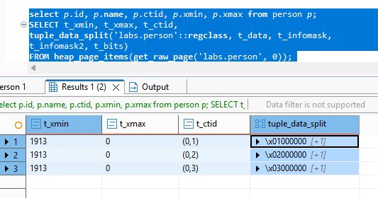

- INSERT INTO person VALUES(4, 'John')
The INSERT operation created a new physical entry in the heap with a fresh t_xmin and a t_xmax value of 0. This confirms that the record is currently active and visible: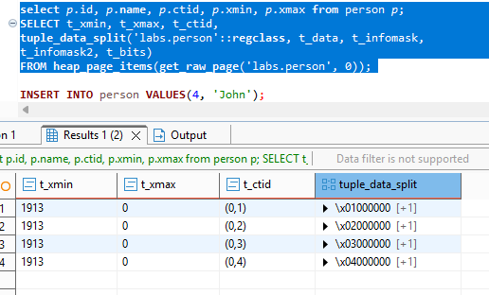
- UPDATE person set name = 'Alex' where id = 2
The UPDATE operation created a new physical row version, while the original row was assigned a t_xmax value. This transaction ID in t_xmax acts as a 'deletion mark,' signifying that the old version is no longer active and has been replaced by the new version to ensure data consistency.
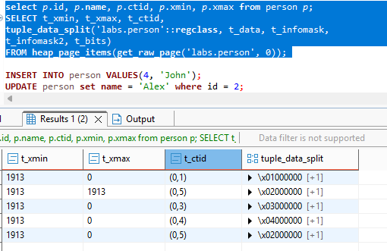
- DELETE FROM person WHERE id = 3
The DELETE operation did not physically remove the record from the storage; instead, it updated the row's t_xmax with the current transaction ID. This marks the row as logically deleted, making it invisible to future queries while keeping the data in the heap
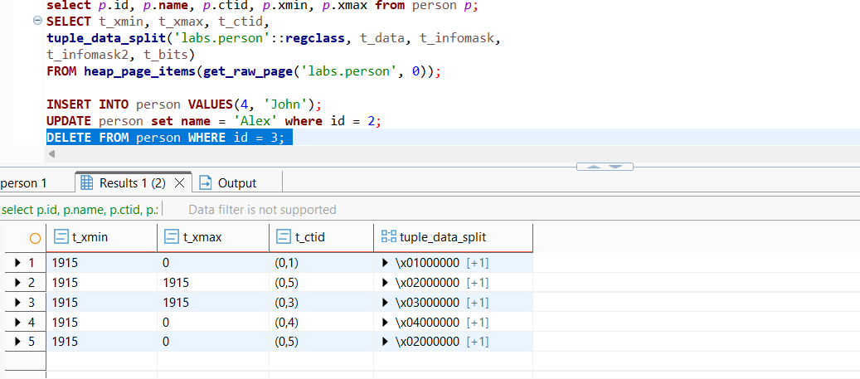
- INSERT INTO person VALUES(999, 'Test')
The INSERT operation added a new record to the heap with a t_xmax value of 0, indicating that the row is active and visible. The t_xmin reflects the current transaction ID, confirming the record was successfully created in the latest physical slot of the page
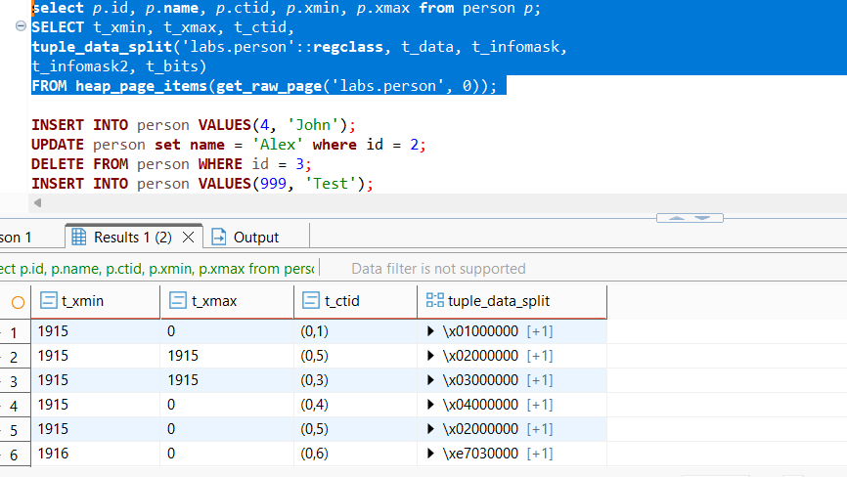

- DELETE FROM person WHERE id = 999
The DELETE operation assigned the current transaction ID to the row's t_xmax column without removing the entry from the page. This confirms that the record is now logically deleted and invisible to new transactions, although it still physically occupies space in the heap.
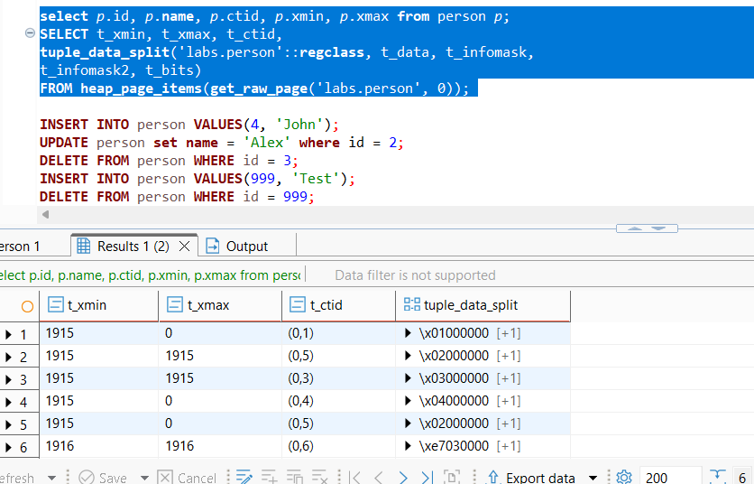
3.2. The VACUUM command cleared the dead tuples, leaving empty slots ([NULL]) available in the heap. The subsequent INSERT of 'Sarah' reused one of these free slots (0,3), proving that PostgreSQL efficiently reclaims space and reassigns physical addresses (t_ctid) for new data.
The result after vacuum command(cleared the dead tuples):
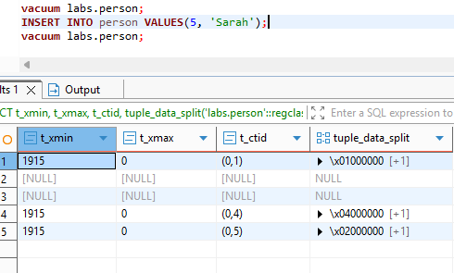
The result after insert command (INSERT of 'Sarah' reused one of free slots (0,3)):
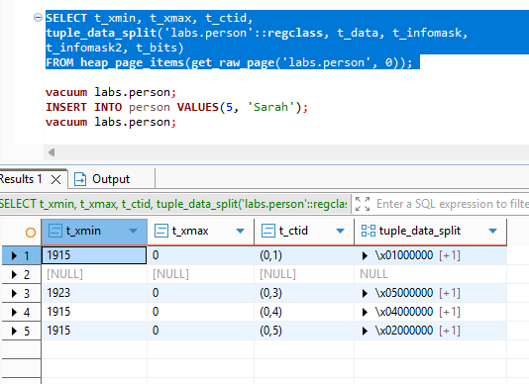
The result after vacuum full command(The VACUUM FULL operation performed a complete rewrite of the table, eliminating all internal gaps and [NULL] slots. This defragmentation compressed the remaining live records into sequential physical addresses starting from (0,1), effectively minimizing the storage footprint on disk)
