- READING THE PLAN
  - TASK 1 – TABLE WITHOUT INDEX
The table test_index_plan were created and filled in with data.
EXPLAIN
The command only shows the execution plan without running the query. Since no index exists on load_date, the database must read every row. The planner predicted 78,884 rows with a cost of 0..321,932. Because the query was never actually run, no buffer statistics, and no sort-method details. The query requires a Sort operation on the num column, which adds a significant cost.
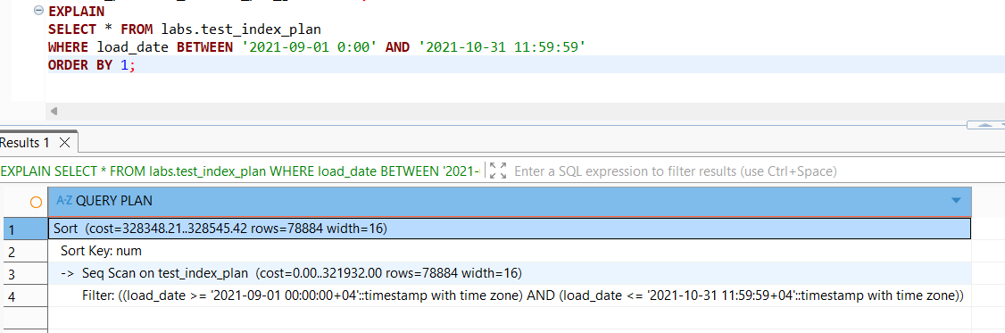
EXPLAIN ANALYZE (first run, cold-ish cache)
Now the query executes. The actual number of rows returned is 522,720, which is much higher than the initial estimate of 78,884. This happens because the table statistics were not updated yet. Execution took 28,687 ms (~28 seconds). The buffer line shows shared hit=259 read=85,024 — the vast majority of pages had to be read from disk (cold cache).
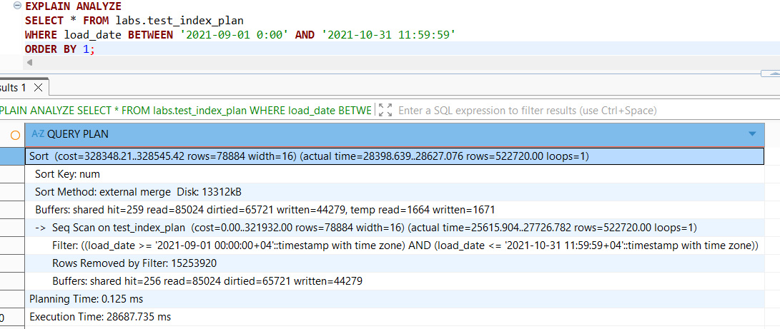
EXPLAIN ANALYZE (second run, hot cache)
The query with EXPLAIN ANALYZE run again. Execution dropped to 4,638 ms — about 6× faster. The shared hit=16,076 read=69,204 figures show that far more pages were already in the shared buffer cache this time.
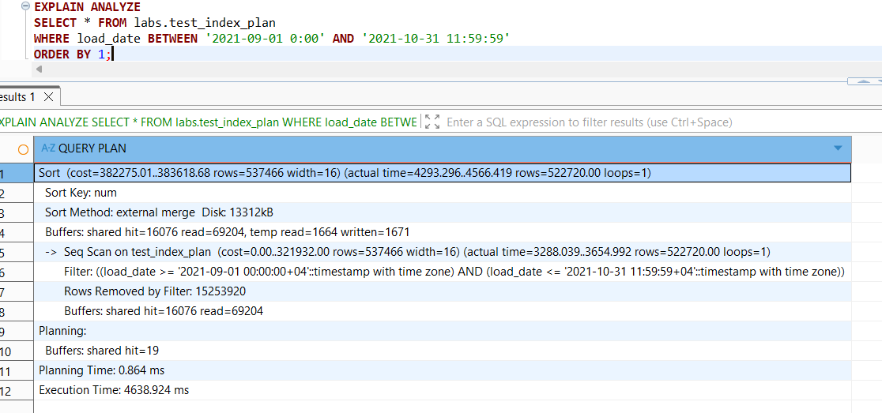
EXPLAIN (ANALYZE, BUFFERS)
This query provides the most detailed I/O statistics. The result — “shared hit=16,076 read=69,204, temp read=1,664 written=1,671”, confirming the data is taken from shared buffer cache. The result — “Rows Removed by Filter: 15,253,920” , highlights the "heavy lifting" the CPU had to do. Because there is no index, the engine had to check over 15 million rows just to find the 522k rows we needed.
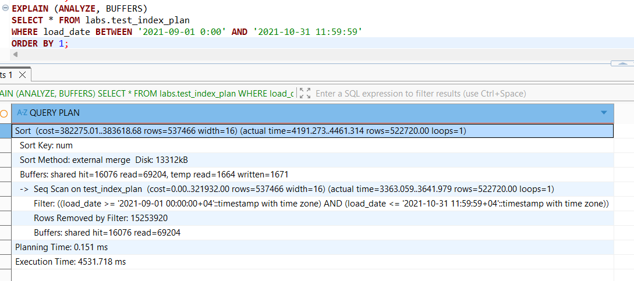
The absence of an index on load_date forced the database to perform a full sequential scan across over 15 million rows in order to retrieve the required 522,720 records, resulting in an initial execution time of approximately 28 seconds. The second execution was approximately six times faster due to the data being cached in shared buffers, which demonstrates the significant impact of disk I/O on query performance.
  - TASK 2 – ADDING INDEX
B-Tree Index was created on a test_index_plan table for load_date column.
EXPLAIN
The query planner successfully switched from a Sequential Scan to an Index Scan using the newly created idx_test_index_plan. The estimated total cost dropped significantly from 321,932 to 19,554. By leveraging the B-Tree structure, the database can now navigate directly to the requested date range instead of reading the entire table.
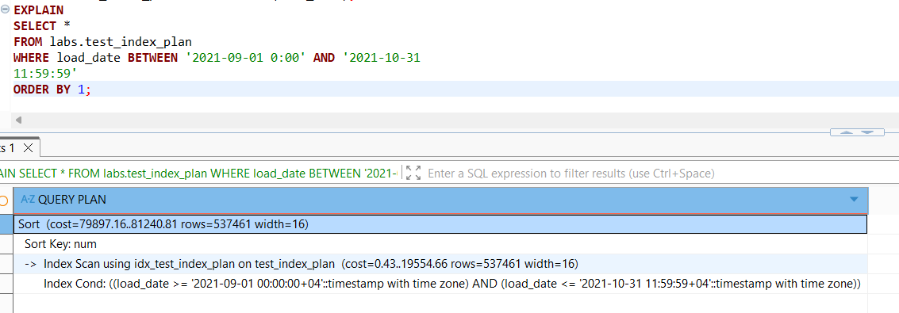
EXPLAIN ANALYZE (first run, cold-ish cache)
The execution time dropped to 1,193 ms (1.19 seconds) if to compare with EXPLAIN ANALYZE results without an index. Compared to the initial "cold" run without an index (28.6 seconds), the query is now 24x faster.
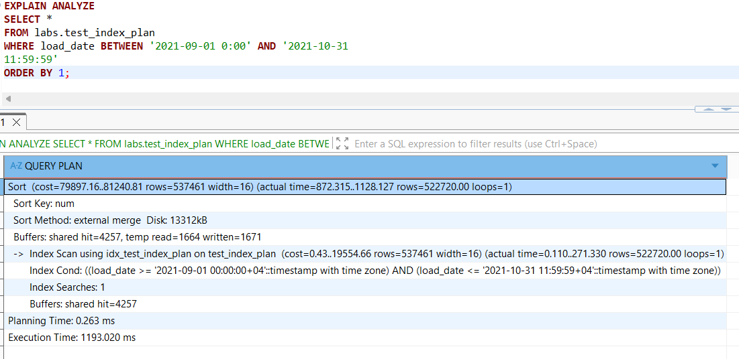
EXPLAIN ANALYZE (second run, hot cache)
The second run completed in 1,359 ms — slightly slower than the first run, which is within normal variance for a disk sort.
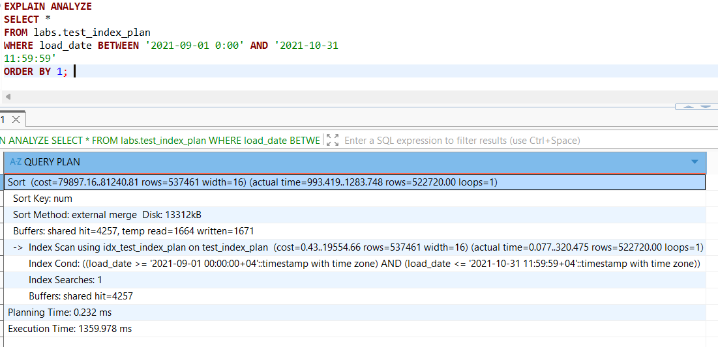
EXPLAIN (ANALYZE, BUFFERS)
Shared Hit counts dropped from over 85,000 blocks to just 4,257. This represents a massive reduction in I/O overhead.
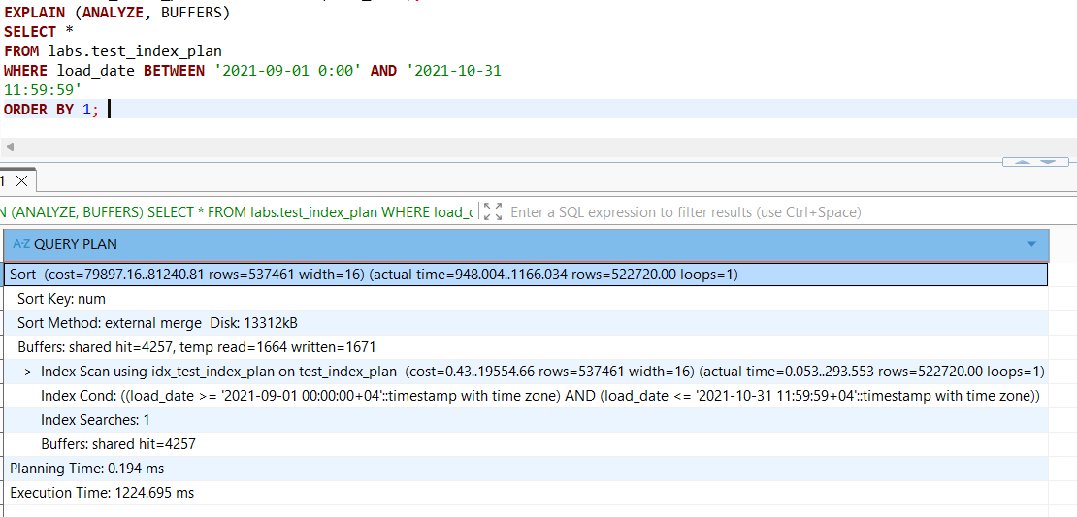
The implementation of a B-Tree index on the load_date column successfully eliminated the costly sequential scan and the "heavy lifting" of filtering 15 million rows. This change reduced I/O requirements by 95% and cut execution time from nearly half a minute to just over one second.

To use INDEX ONLY SCAN method only the column that is indexed should be included into SELECT, WHERE, and ORDER BY clauses:
SELECT load_date
FROM labs.test_index_plan
WHERE load_date BETWEEN '2021-09-01 0:00' AND '2021-10-31
11:59:59'
ORDER BY 1;

BRIN index was created on a test_index_plan table for load_date column.
EXPLAIN
The planner uses a Parallel Bitmap Heap Scan combined with a Bitmap Index Scan on idx_brin_load_date. Unlike B-Tree, BRIN doesn't point to individual rows. It identifies "ranges" of blocks. The "Bitmap" approach allows PostgreSQL to create a map of blocks that might contain the data, allowing it to skip large portions of the table while using parallel workers to speed up the scan. The estimated cost is 171,032..230,925 with 514,245 rows — notably higher than the B-Tree estimate of 79,897..81,240, which already hints that BRIN is less precise than B-Tree for this workload.

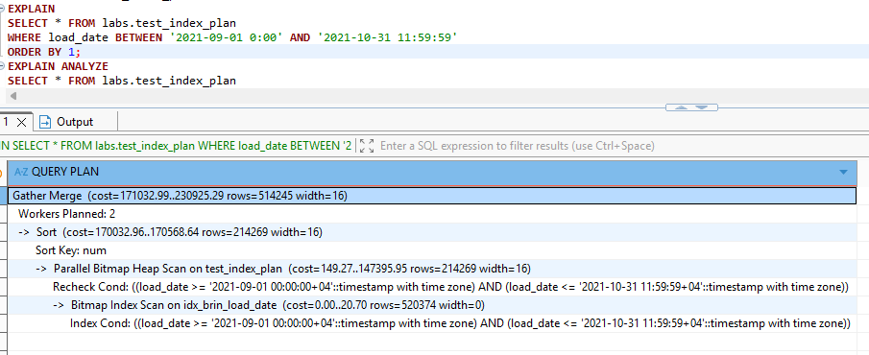
EXPLAIN ANALYZE (first run, cold-ish cache)
Execution Time: 284.378 ms. This is significantly faster than the "cold" B-Tree run. BRIN is incredibly efficient at finding data ranges.
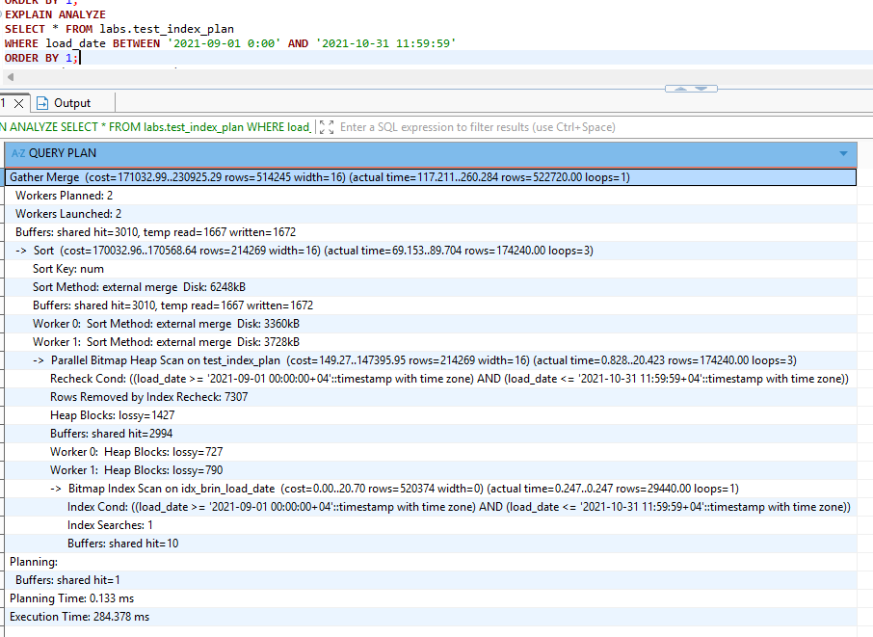
EXPLAIN ANALYZE (BRIN Second Run - Hot Cache)
Execution Time: 322.493 ms - slightly slower than the first run. Which means that the execution time is very stable. Because the BRIN index is tiny, it fits in the CPU cache. The Gather Merge node shows that the database is successfully using two parallel workers to fetch and sort the data.
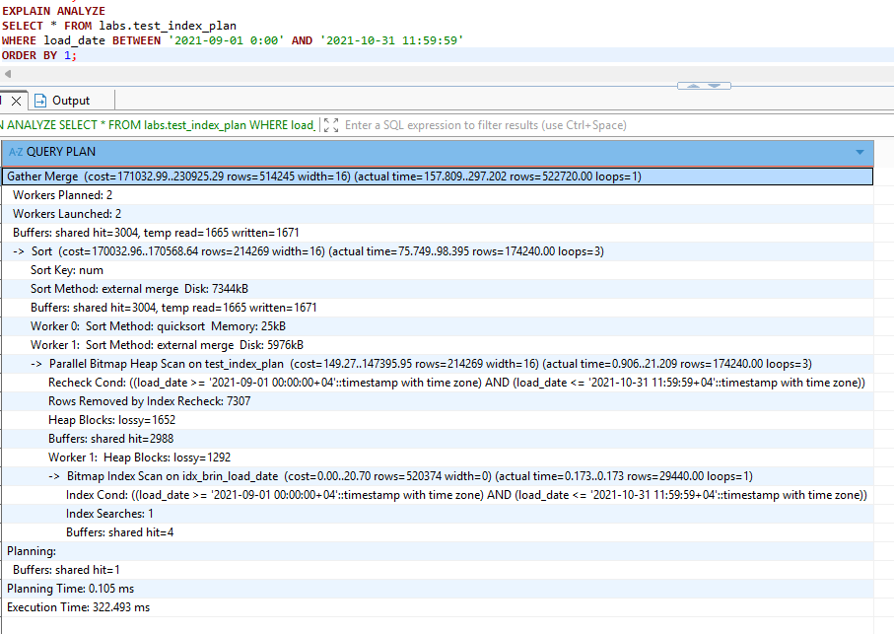
EXPLAIN (ANALYZE, BUFFERS)

The number of blocks dropped even further compared to B-Tree (shared hit=3004). Heap Blocks: lossy=1364 is meaning the bitmap became too large to track individual rows, so it tracked whole pages instead. This is the trade-off with BRIN: it uses almost zero disk space but requires a bit more "re-checking" once the data is pulled from the heap. 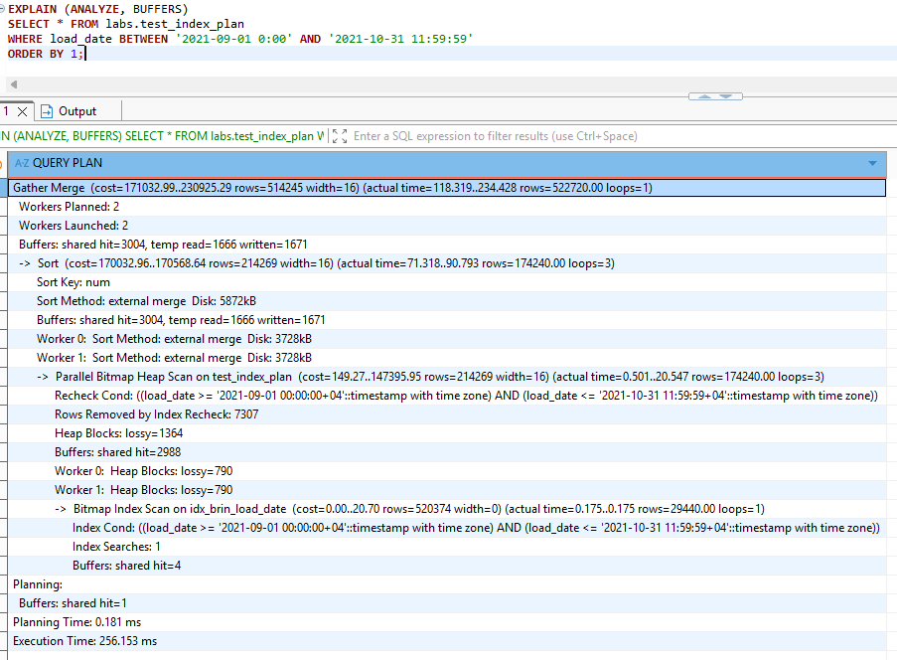
The BRIN index delivered better performance than B-Tree for this workload, reducing execution time from ~1,100–1,350 ms down to ~256–322 ms, while using only 4 shared buffer pages compared to B-Tree's 4,257 — making it significantly more memory-efficient. However, BRIN's block-level granularity required 7,307 rows to be rechecked against the heap (Heap Blocks: lossy), as it stores only min/max values per block range rather than exact row locations.
- ADDING DATA WITH INSERT AND COPY
  - TASK 3 BULK INSERT
The experimental results confirm that batch processing is key to PostgreSQL performance. Using a single INSERT INTO ... SELECT allowed for the migration of over 15.7 million rows in just 69 seconds, demonstrating high I/O throughput. It’s much more efficient than individual row inserts because it processes the data as a single transaction and minimizes logging overhead.

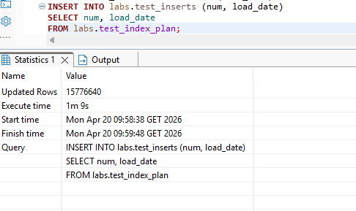
The most effective method for small-to-medium datasets in PostgreSQL is Multi-row values insertion. It reduced the overhead to nearly zero, proving that minimizing the number of distinct transactions is the most efficient way to load data
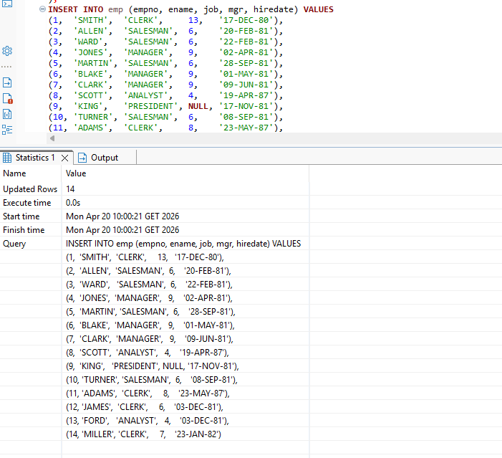
  - TASK 4 COPY COMMAND

COPY exported all 15,776,640 rows in just 10 seconds, which highlights its core advantage over INSERT — it writes data directly to a file as a stream. The FORCE_QUOTE (load_date) option demonstrates that COPY allows fine-grained control over output formatting, quoting only the specified column while leaving num unquoted.
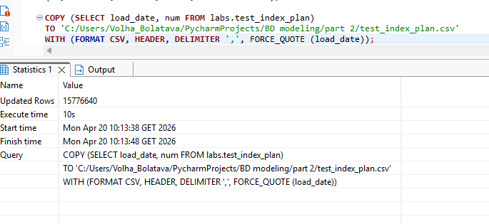
Unlike the basic COPY table TO file syntax, wrapping the command in COPY (SELECT ... WHERE ...) allows exporting a filtered subset of data — in this case only 4,320 rows, completed in 0.0s. This shows that COPY is not limited to full-table exports; it accepts any valid SELECT statement, making it flexible for partial data extractions without creating intermediate tables.
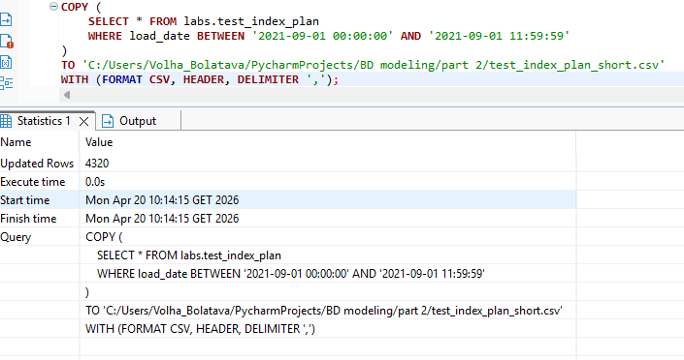
COPY FROM loaded all 15,776,640 rows in 1 minute 11 seconds — slightly slower than the export (10s) because the database had to parse, validate, and write each row to the heap while simultaneously maintaining the B-Tree index. The COPY FROM command operates much faster than a normal INSERT command because the data is read as a single transaction directly to the target table. On the other hand, it is a very strict format, and the entire COPY procedure will fail if just one line is malformed.
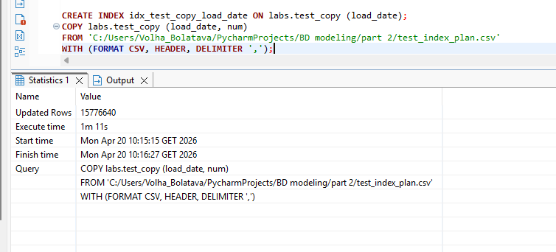

  - TASK 5 UPSERT
To insert the rows we are using UPSERT statement (INSERT ... ON CONFLICT). This is a powerful way to either add new rows or update existing ones if a conflict (like a duplicate Primary Key) occurs. Firstly, ALTER TABLE ... DROP CONSTRAINT is used as the emp table had a second unique constraint on the ename column and in the new records to add there is duplicated value 'JONES' that already already exists in a emp table.
The ON CONFLICT (empno) clause tells PostgreSQL to look at the Primary Key. Since IDs 1, 8, 11 and 14 already existed in your table from the previous task, the database identifies a "conflict." Instead of throwing an error and stopping the whole process, the DO UPDATE SET command kicks in. It takes the values from the EXCLUDED table (a temporary table containing the rows you tried to insert) and applies them to the existing rows.
Code that was executed :
ALTER TABLE emp DROP CONSTRAINT emp_ename_key;
SELECT * FROM emp;
INSERT INTO emp (empno, ename, job, mgr, hiredate) VALUES
(1, 'SMITH', 'MANAGER', 13, '2021-12-01'),
(14, 'KELLY', 'CLERK', 15, '2021-12-01'),
(11, 'ADAMS', 'SALESMAN', 4, '2021-12-01'),
(8, 'JONES', 'ANALYST', 9, '2021-12-01')
ON CONFLICT (empno)
DO UPDATE SET
ename = EXCLUDED.ename,
job = EXCLUDED.job,
mgr = EXCLUDED.mgr,
hiredate = EXCLUDED.hiredate;

The initial emp table:
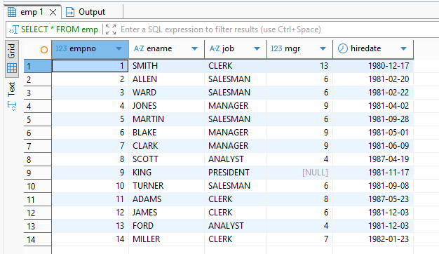
Updated emp table:
