1. PARTITIONING
Table sales_info uses PostgreSQL table inheritance: a parent table plus five child tables (2020–2024), each with a CHECK constraint on eventdate. A BEFORE INSERT trigger routes rows to the correct child.
Updating of the rows is implemented with the help of CTE. When the partition key (eventdate) is changed via a plain UPDATE, the row stays in its original child table instead of being moved to the correct one — breaking the CHECK constraint that enforces the date range for that partition. The CTE atomically deletes rows from their current child and re-inserts them through the parent, which fires the trigger and routes them to the correct partition:
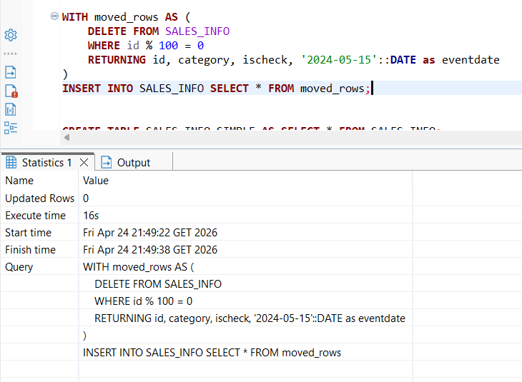
Table sales_info_simple is a plain flat copy of the same 10M rows created via CREATE TABLE AS SELECT.
- Select all
Table sales_info(inheritance) executed in 4500.839 ms, while sales_info_simple (plain) completed in 3229.034 ms. The partitioned table is slower here because PostgreSQL must open and sequentially scan all six relations (parent + 5 child tables). The flat table issues a single Seq Scan with no coordination between multiple tables.
Inheritance table result:
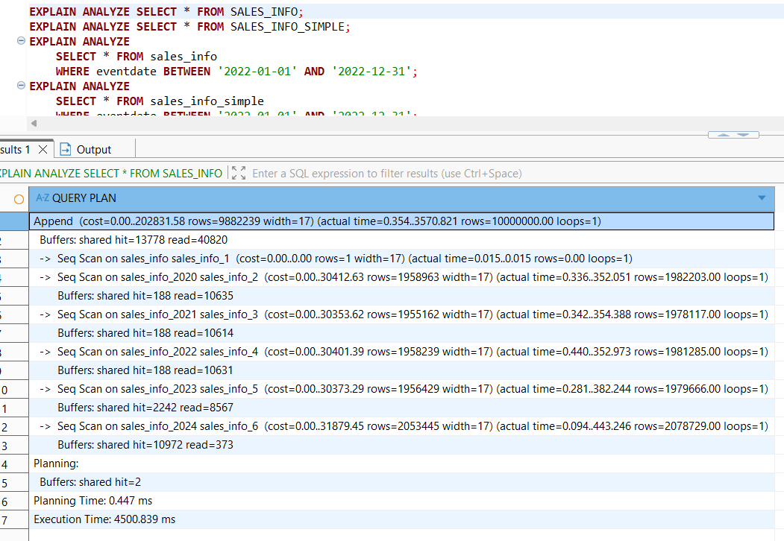
Plain table results:
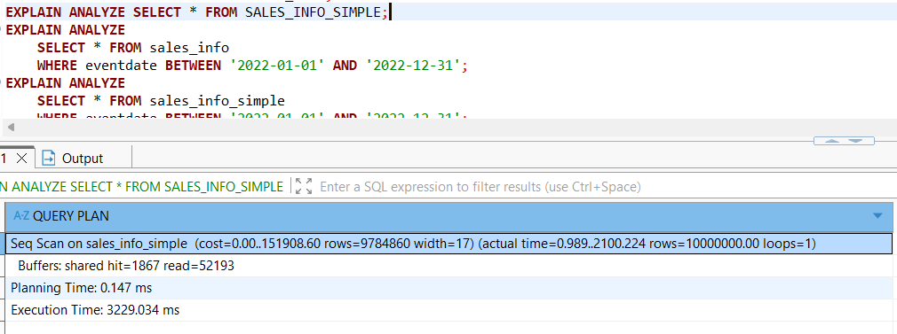
- Select with range of dates
sales_info completed in 1270.679 ms, while sales_info_simple took 1951.003 ms. The sales_info (inheritance) table is faster due to partition pruning. PostgreSQL read the CHECK constraints on each child table and determined that only sales_info_2022 could contain matching rows — all other partitions were skipped. Only 10,537 buffers were read. The flat table had no such mechanism — it performed a full parallel sequential scan across all 10M rows, removing 2,672,905 non-matching rows, reading 52,099 buffers in the process.
Inheritance table result:
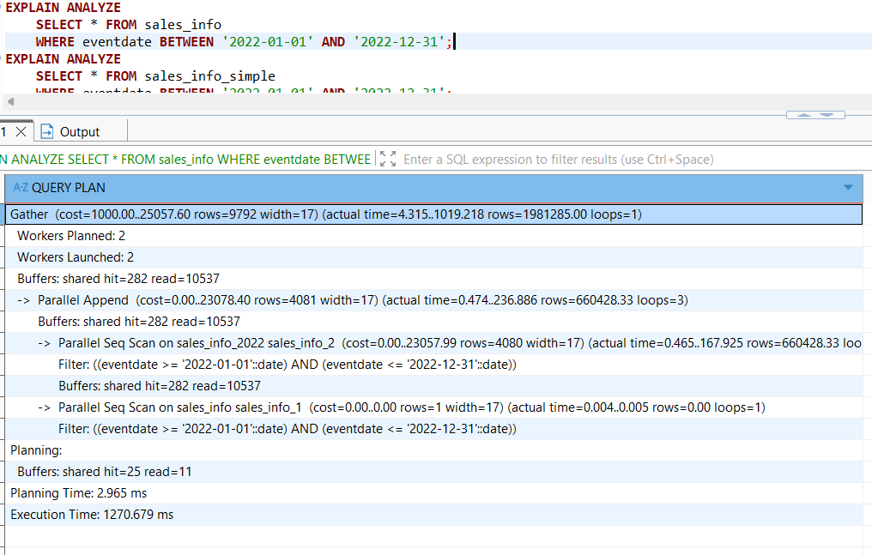
Plain table results:
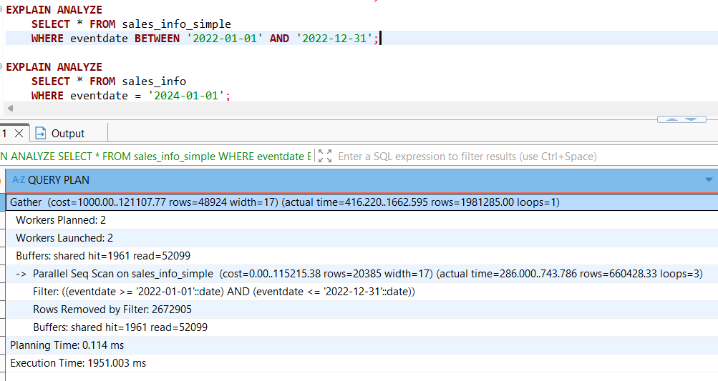
- Select exact date
sales_info completed in 357.089 ms, while sales_info_simple took 906.094 ms. The sales_info (inheritance) table is faster due to partition pruning. Partition pruning narrowed the scan exclusively to sales_info_2024, reading only 279 buffers compared to 51,817 for the flat table. The flat table removed 3,331,562 rows — scanning the entire 10M dataset across all years.

Inheritance table result:

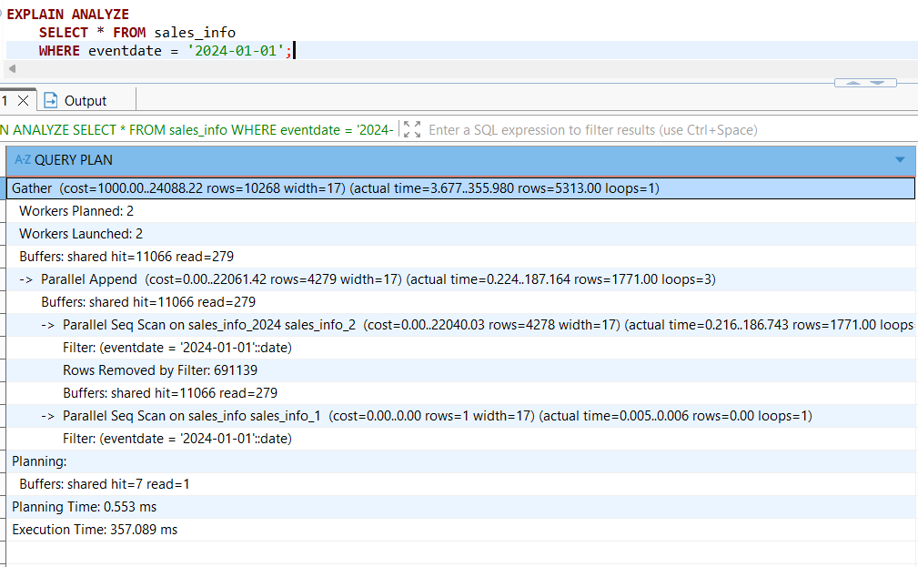
Plain table results:
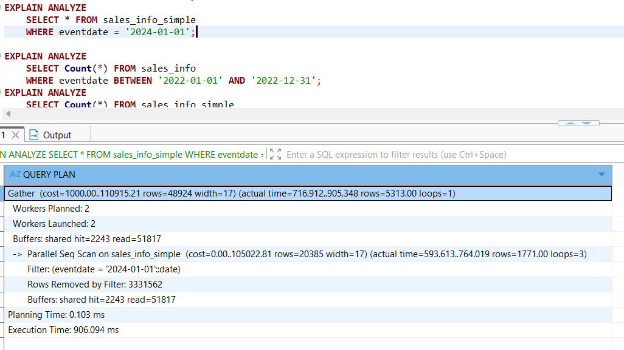
- Count of all rows
sales_info completed in 526.018 ms, while sales_info_simple took 1177.239 ms. Partition pruning applies equally to aggregates. The partitioned table's plan shows Parallel Seq Scan on sales_info_2022 only, reading just 10,255 buffers. The flat table scanned the entire dataset, removed 2,672,905 non-matching rows, and read 51,535 buffers.
Inheritance table result:

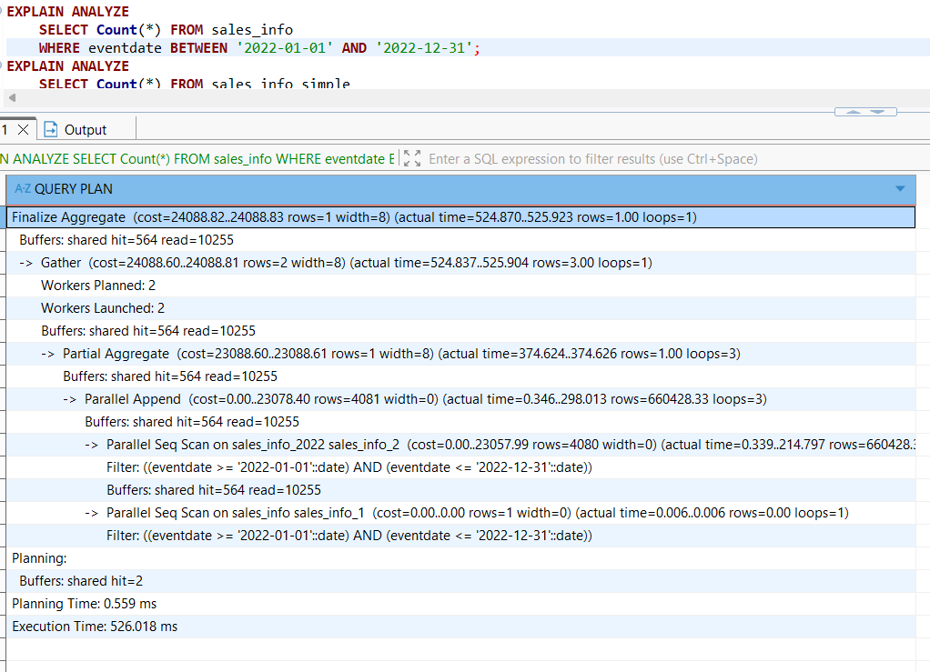
Plain table results:
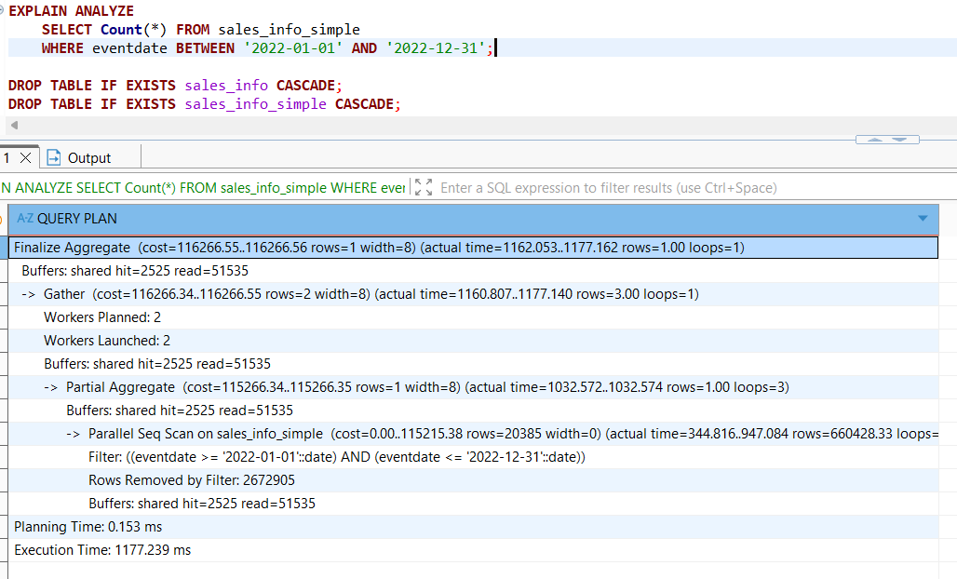
To add a new partition table the following code was executed:
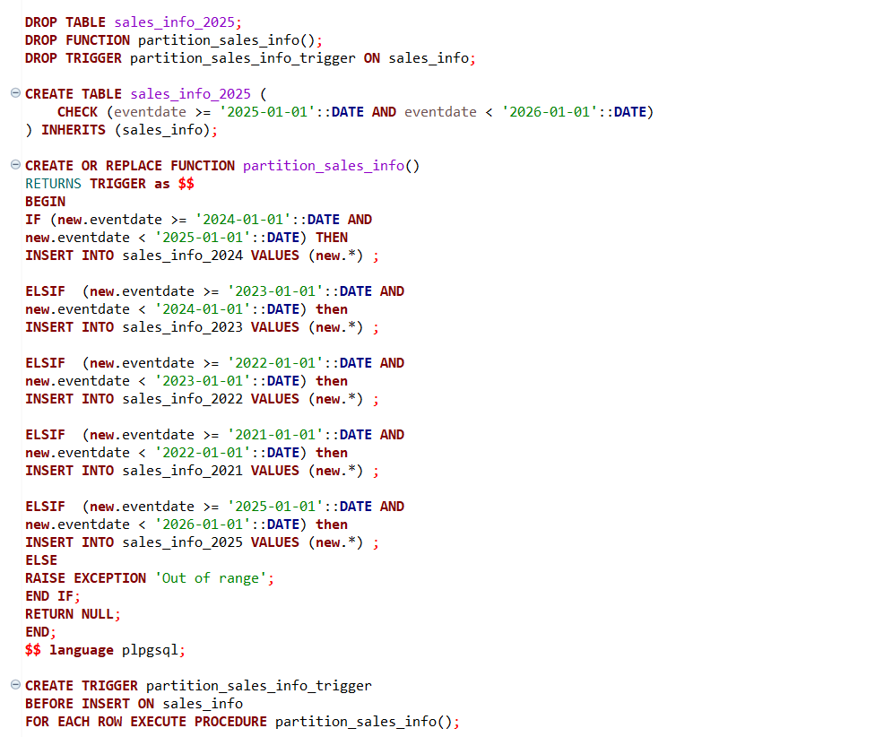
The oldest partition (sales_info_2020) was dropped and replaced with a new one (sales_info_2025). The table was recreated cleanly with the correct CHECK constraint (eventdate >= '2025-01-01' AND < '2026-01-01'). The trigger function was fully dropped and recreated from scratch to avoid leftover references to the deleted table. A new ELSIF branch for 2025 was added, routing inserts with dates in that range to sales_info_2025. The trigger was then reattached to the parent table sales_info.
The test result of insertion :
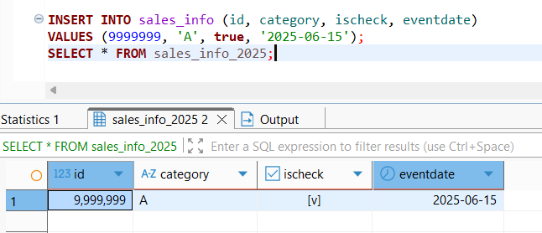
1.2 TASK2: USE DECLARATIVE PARTITIONING
Table SALES_INFO_DP uses PostgreSQL declarative partitioning: a parent table partitioned by RANGE (eventdate), with each year's partition further sub-partitioned by LIST (category). This creates a two-level hierarchy.
Unlike inheritance-based partitioning, declarative partitioning does not require a trigger — PostgreSQL automatically routes inserted rows to the correct partition based on the partition key. The UPDATE that replaces category 'J' with 'A' demonstrates this: since 'J' falls into the DEFAULT sub-partition and 'A' belongs to CAT_ABC, PostgreSQL must physically move the row between sub-partitions. In declarative partitioning this is handled transparently, unlike the inheritance approach where the CTE workaround was required. The results of update in declarative partitioning:
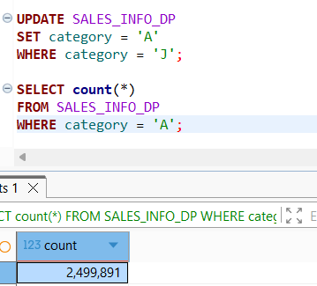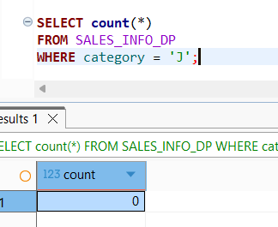
Table sales_info_simple is a plain flat copy of the same 10M rows created via CREATE TABLE AS SELECT.
- Select all
SALES_INFO_DP (declarative partitioning) executed in 4947.739 ms, while SALES_INFO_SIMPLE (plain) completed in 3616.133 ms. The partitioned table is slower here because PostgreSQL must open and sequentially scan all 15 sub-partitions across two partition levels (range by date + list by category), coordinating them via an Append node. The flat table issues a single Seq Scan with no such overhead.
Declarative partitioning table result:

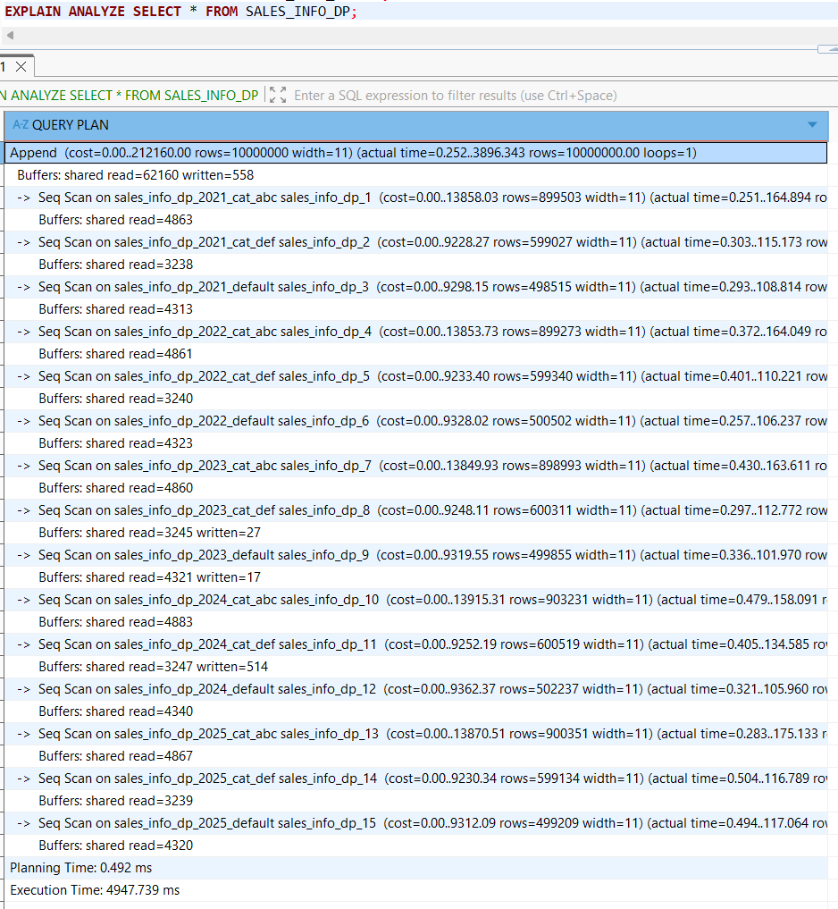
Plain table results:
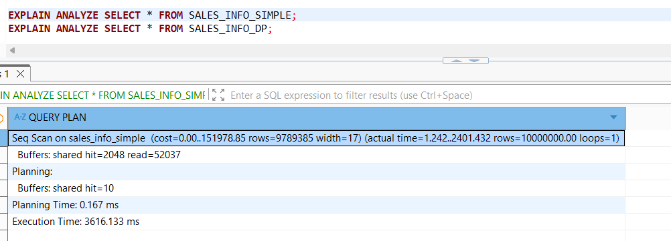
- Select with range of dates
SALES_INFO_DP executed in 1201.808 ms, while SALES_INFO_SIMPLE completed in 1459.260 ms. The partitioned table is faster because PostgreSQL scans only the 3 sub-partitions of 2022, skipping all other years entirely. The flat table must scan all 10 million rows using a Parallel Seq Scan across 2 workers, which is still slower due to the sheer volume of data filtered out.
Declarative partitioning table result:
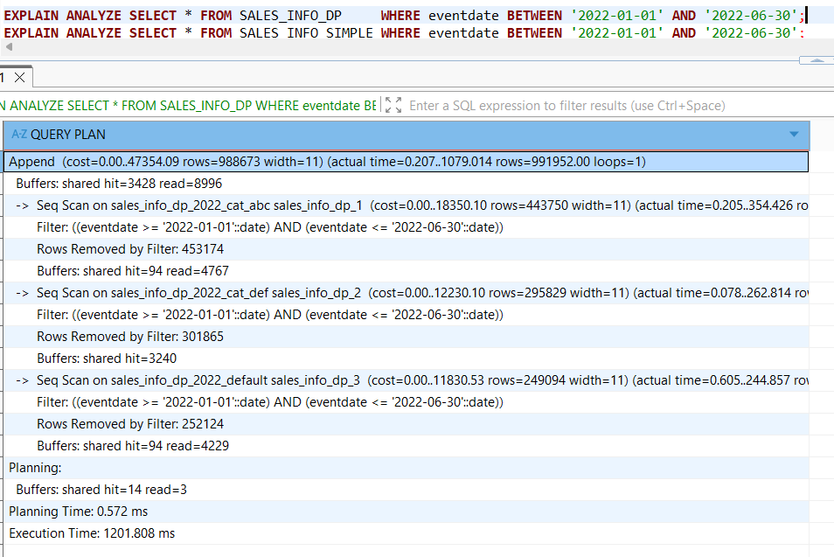
Plain table results:
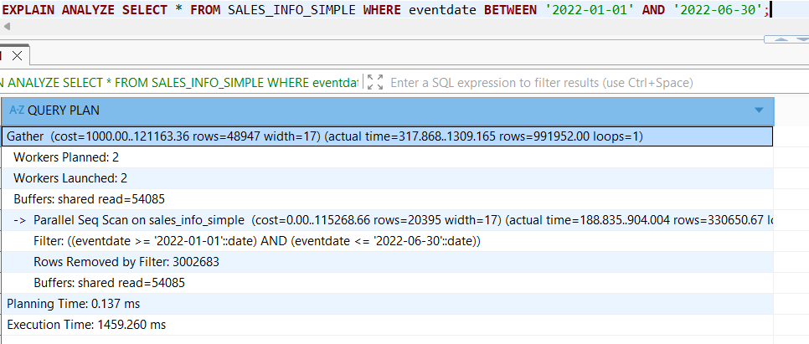
- Select exact date
SALES_INFO_DP executed in 315.024 ms, while SALES_INFO_SIMPLE completed in 902.657 ms. Because of partition pruning, PostgreSQL scans only the 3 sub-partitions of 2023, ignoring all other years entirely. The flat table has no pruning and must scan all 10 million rows even with 2 parallel workers.
Declarative partitioning table result:

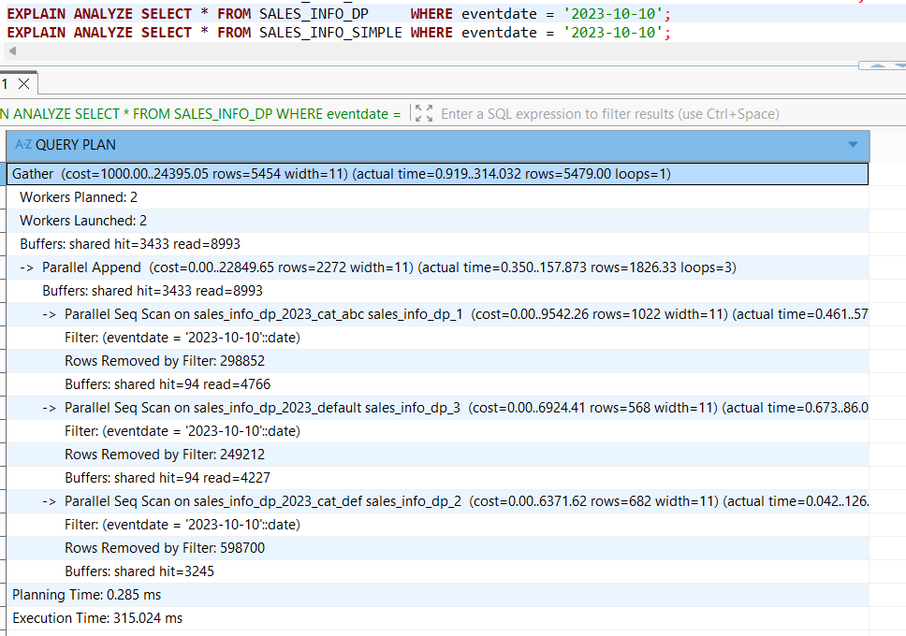
Plain table results:
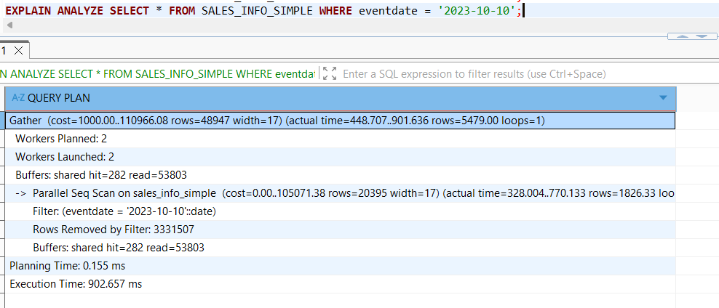
- Select exact category
SALES_INFO_DP executed in 2019.802 ms, while SALES_INFO_SIMPLE completed in 1337.130 ms. Here the partitioned table is slower because filtering by category alone provides no partition pruning on the top-level range partition (which is by eventdate). PostgreSQL must scan all 5 _cat_abc sub-partitions across every year, with an additional filter applied inside each one. The flat table benefits from parallel execution with 2 workers and wins.
Declarative partitioning table result:

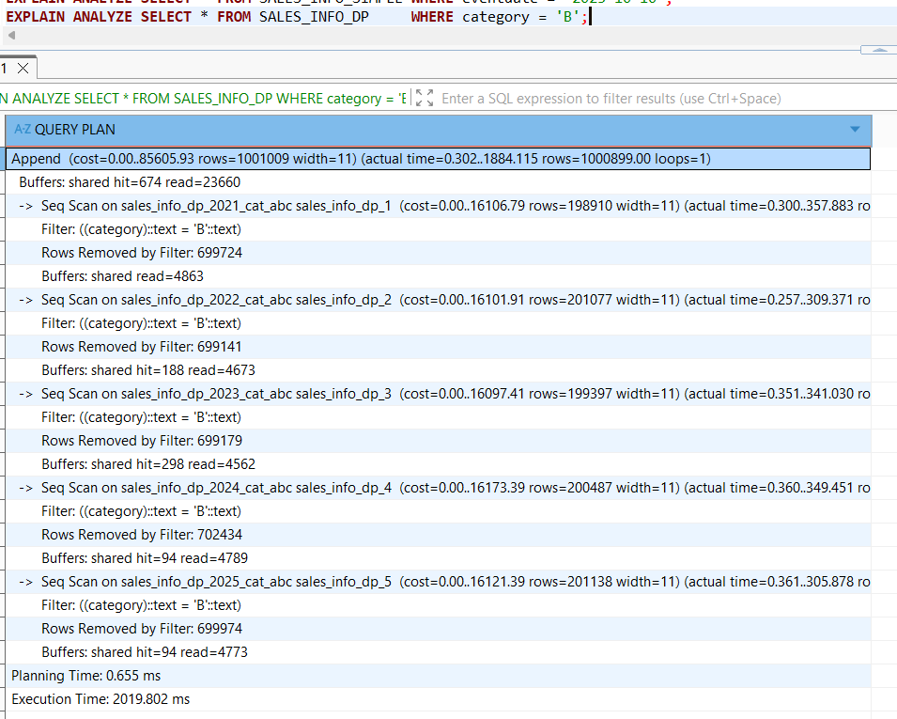
Plain table results:
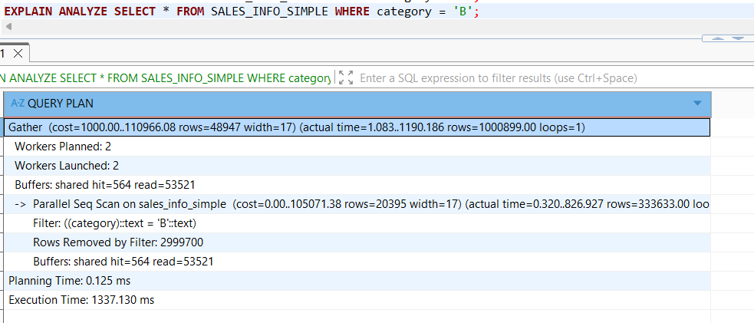
- Select a list of categories
SALES_INFO_DP executed in 4372.038 ms, while SALES_INFO_SIMPLE completed in 2751.500 ms. Similar to the previous case, filtering by category alone triggers no pruning on the top-level range partition. PostgreSQL scans 10 sub-partitions (_cat_abc and _cat_def across all 5 years) applying a filter inside each one. The flat table wins again thanks to parallel execution with 2 workers over a single table.
Declarative partitioning table result:

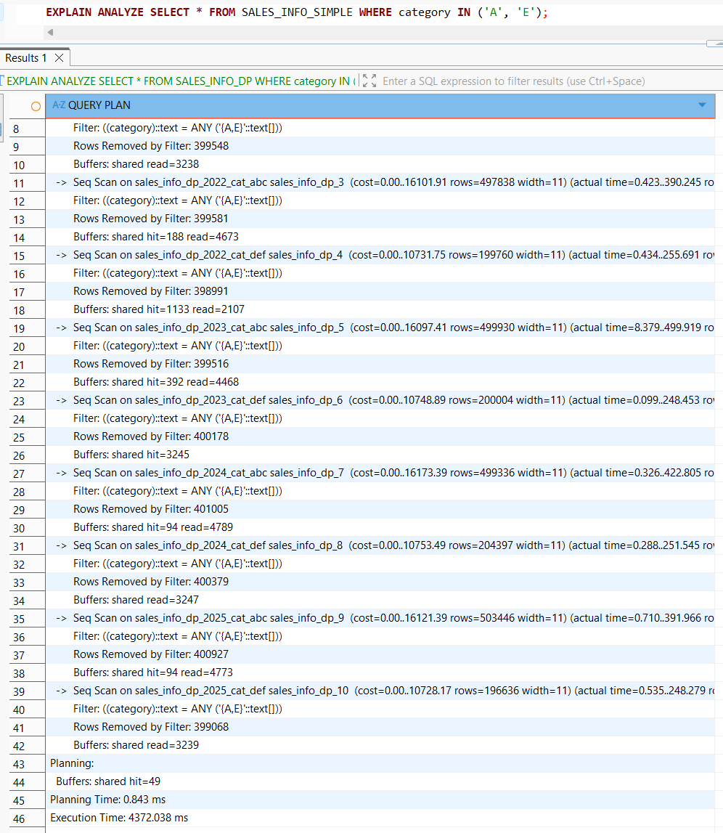
Plain table results:
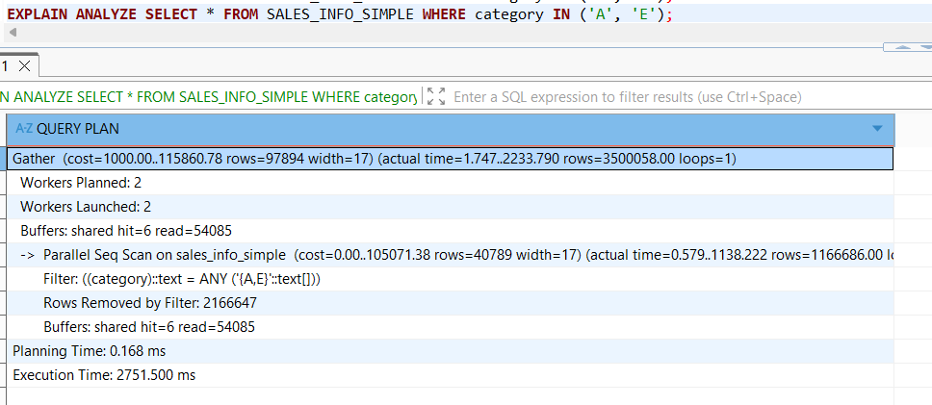
- Select a list of categories in exact date
SALES_INFO_DP executed in 233.536 ms, while SALES_INFO_SIMPLE completed in 1556.846 ms — nearly 7x faster. Filtering by both eventdate and category allows pruning on both levels, so PostgreSQL scans only 1 sub-partition (sales_info_dp_2024_cat_abc). The flat table must scan all 10 million rows with 2 parallel workers.
Declarative partitioning table result:
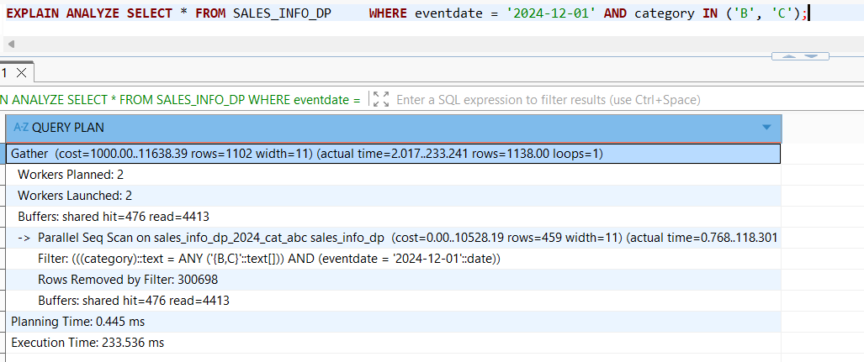
Plain table results:
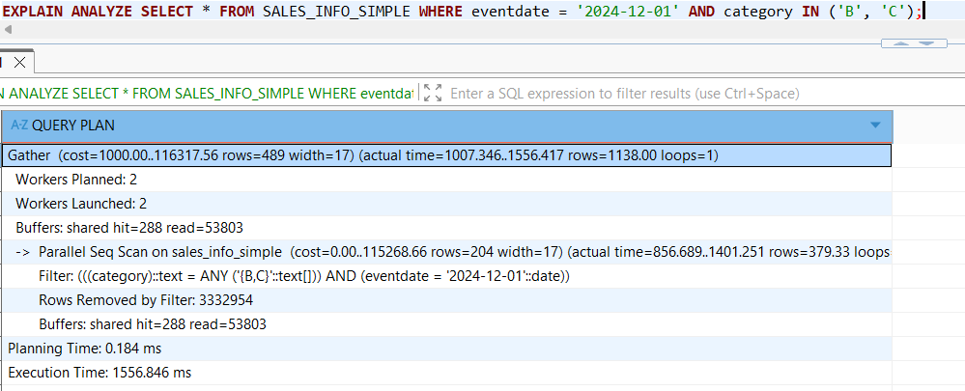
- Count of all rows
SALES_INFO_DP executed in 1754.009 ms, while SALES_INFO_SIMPLE completed in 1398.078 ms. Without any filter there is no pruning, so PostgreSQL must scan all 15 sub-partitions, which adds coordination overhead compared to the single Parallel Seq Scan on the flat table.
Declarative partitioning table result:

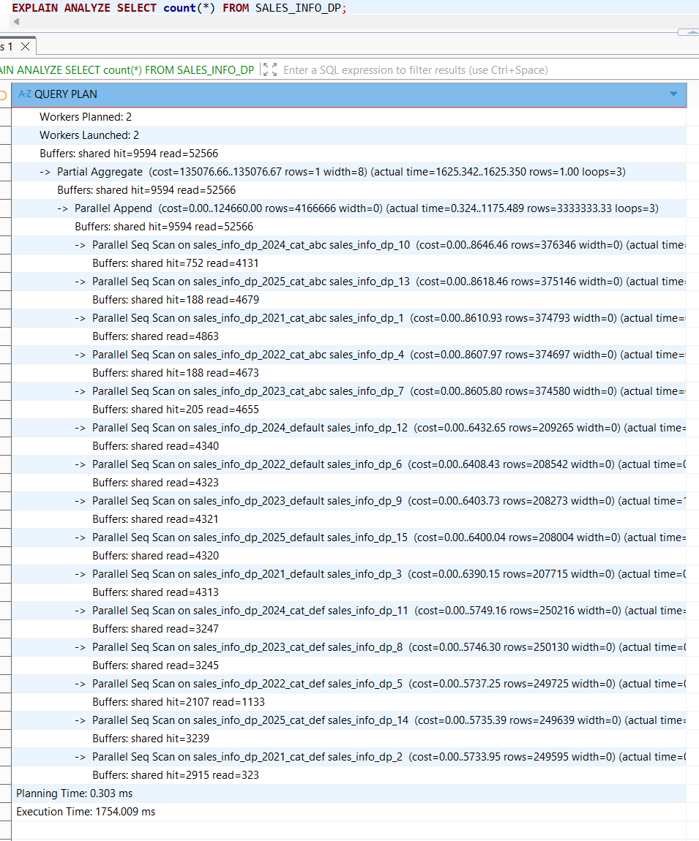
Plain table results:
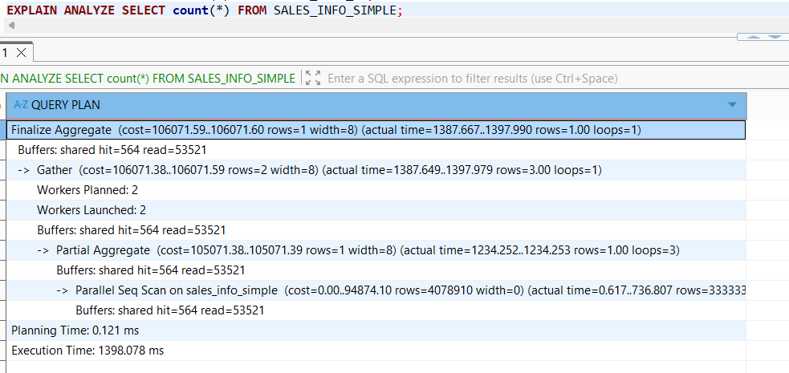
- Count of rows with range of dates
SALES_INFO_DP executed in 509.685 ms, while SALES_INFO_SIMPLE completed in 1084.048 ms — more than 2x faster. Thanks to partition pruning, PostgreSQL scans only the 3 sub-partitions of 2021, ignoring all other years. The flat table must scan all 10 million rows even with 2 parallel workers.
Declarative partitioning table result:
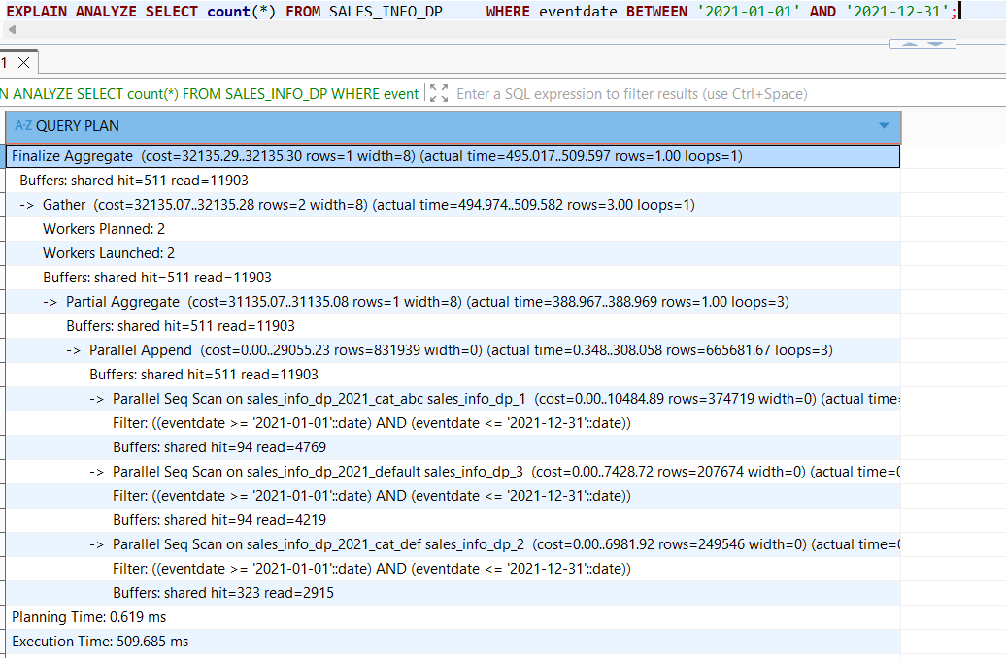
Plain table results:
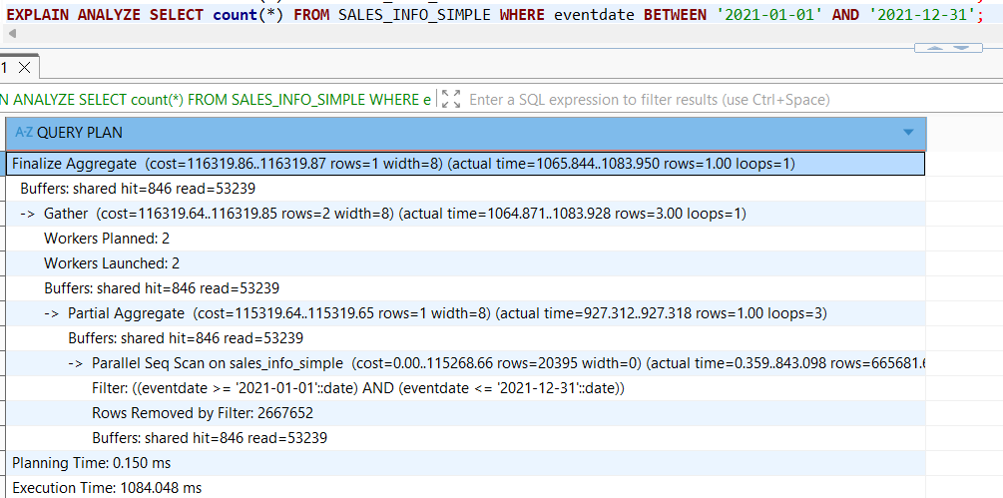
To split one list partition for two for one of the child tables with range partition the code below was executed:
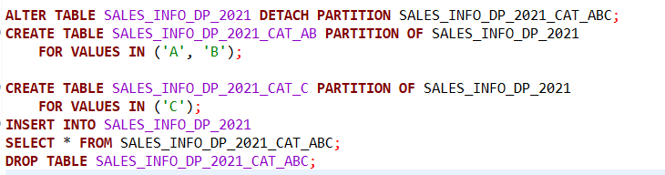
SALES_INFO_DP_2021_CAT_ABC (899,503 rows) was detached from SALES_INFO_DP_2021 and replaced with two narrower partitions — CAT_AB (698,851 rows) for values A, B and CAT_C (200,652 rows) for value C. Data was re-inserted through the parent and the old partition was dropped.
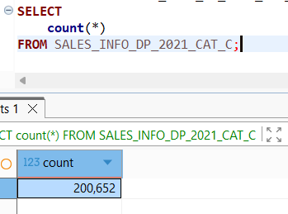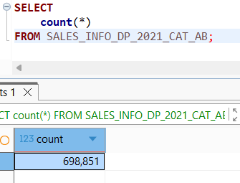
Th return partition ('A','B','C','D','E') the code below was executed:
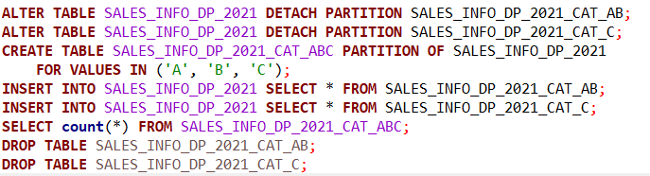
Both partitions were detached and merged back into a single SALES_INFO_DP_2021_CAT_ABC partition. The final count of 899,503 rows confirms no data was lost during the split or merge:
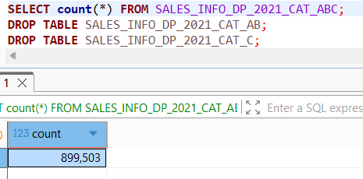

2. PARALLEL EXECUTION
2.1 TASK 3: USE PARALLEL QUERING
max_parallel_workers_per_gather = 4 was set.
1. Select all from tables
SALES_INFO (inheritance) executed in 2310.464 ms — data is spread across 6 child tables (2020–2024 + parent). PostgreSQL uses a simple Append node scanning all relations sequentially with no parallelism. No Gather node appears in the plan — the query planner decided not to use parallel workers here.
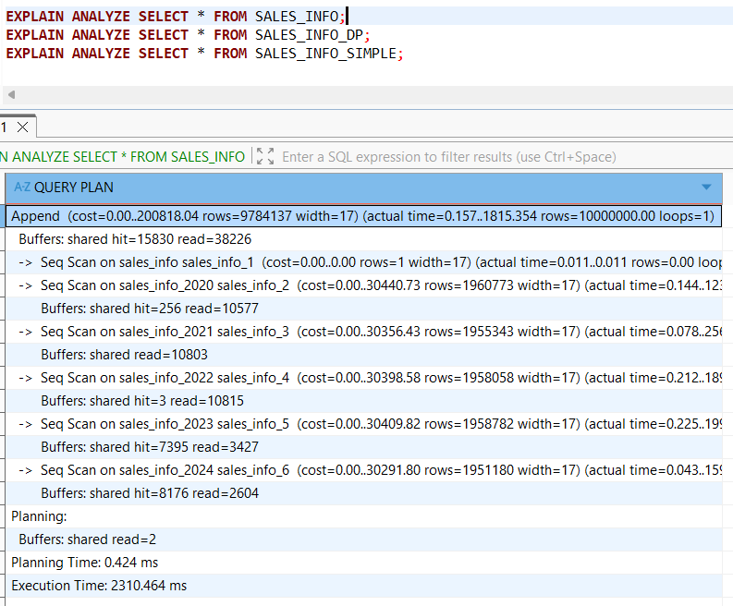
SALES_INFO_DP executed in 1733.124 ms — scans all 15 sub-partitions via a regular Append node. No parallel workers appear in the plan.
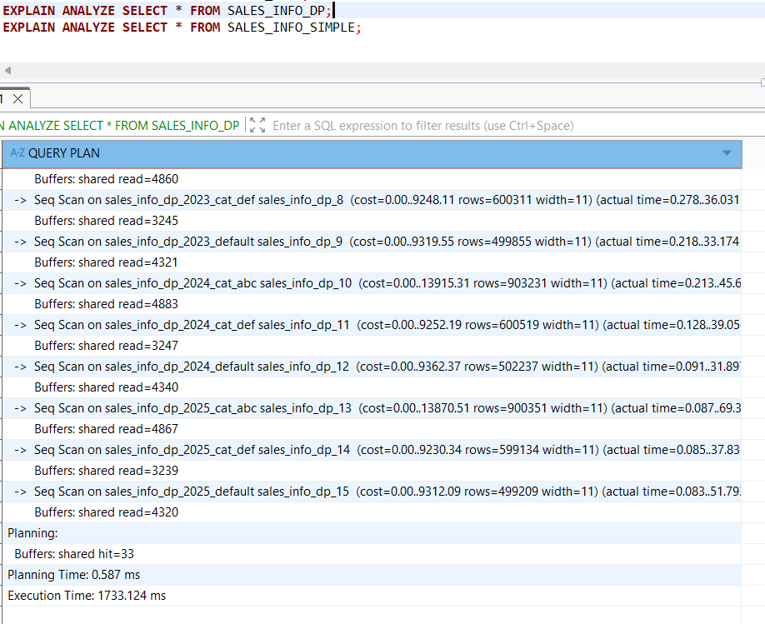
SALES_INFO_SIMPLE executed in 1249.478 ms — single Seq Scan, no parallelism.
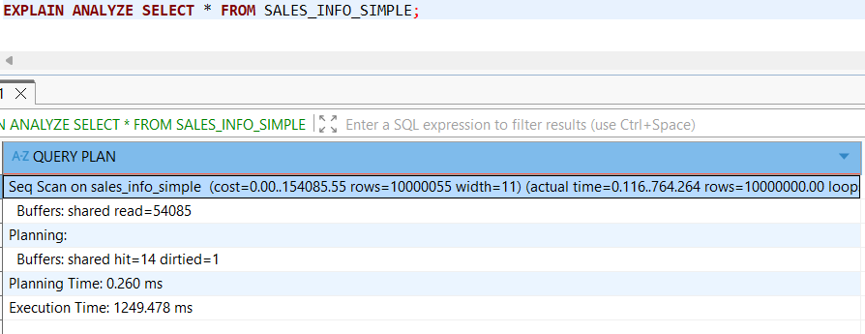
2. Add order by eventadate
SALES_INFO (inheritance) executed in 8160.550 ms — scans all 6 child tables via Append and sorts the entire 10 million row result using external merge on disk (215328kB temp space). No parallelism is used — the query planner chose a sequential plan.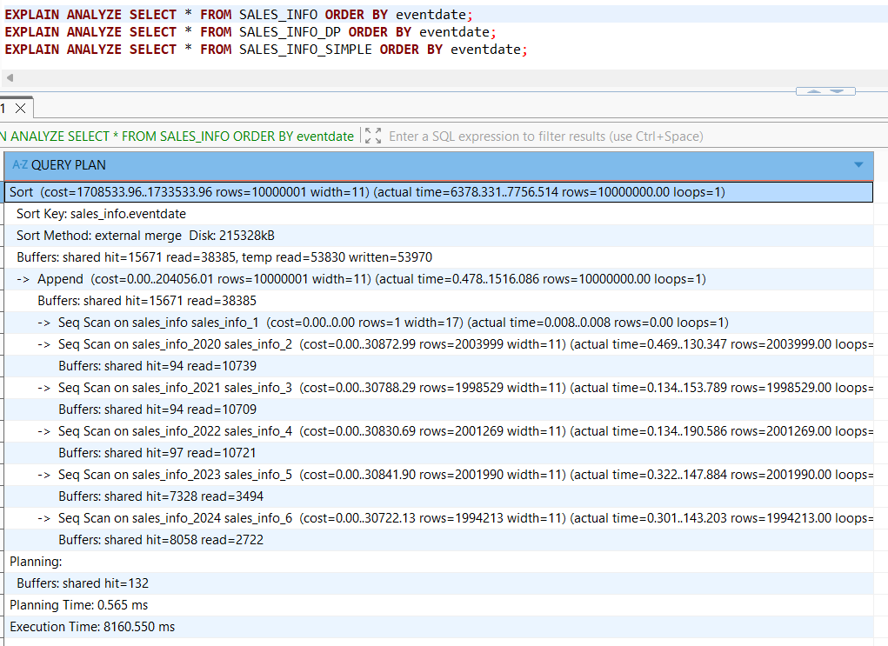
SALES_INFO_DP executed in 8499.317 ms — the slowest of the three. PostgreSQL must scan all 15 sub-partitions via Append and then sort the entire 10 million row result. No parallelism is used, making the sort extremely slow.
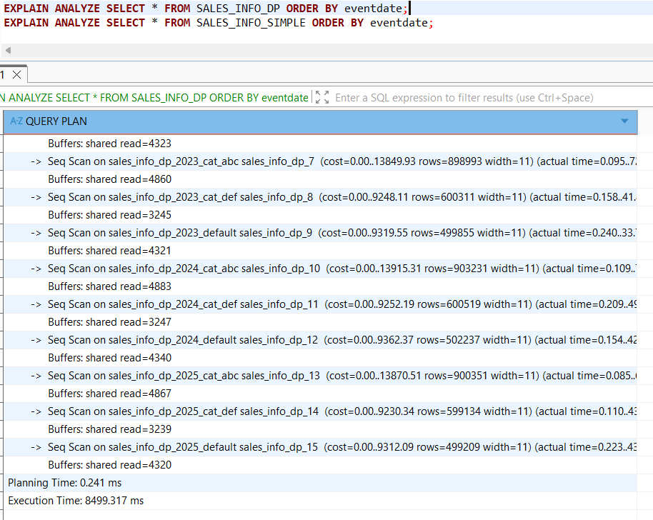
SALES_INFO_SIMPLE executed in 3647.726 ms — significantly faster than SALES_INFO_DP. Here max_parallel_workers_per_gather = 4 works: the query planner chose a Gather Merge plan with 4 workers, each sorting its own chunk using external merge on disk, then merging the results. The flat table benefits from parallelism while SALES_INFO_DP does not, because the Append node over multiple partitions prevents the query planner from choosing a parallel sort plan.
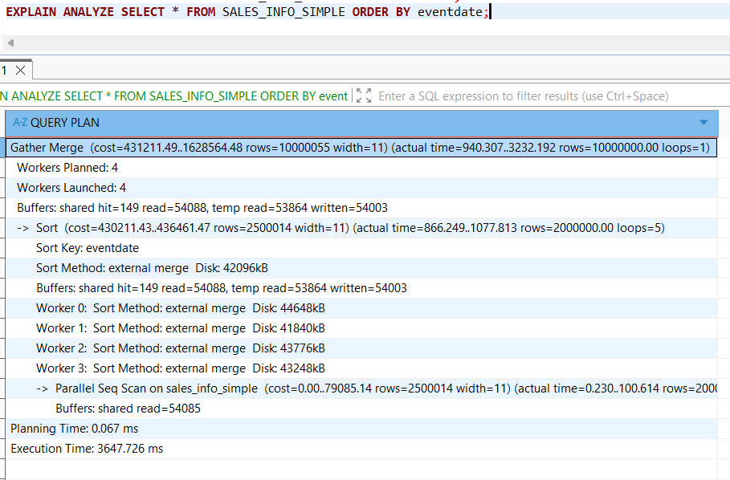
3. Select count of all rows
SALES_INFO (inheritance) executed in 439.972 ms — this time max_parallel_workers_per_gather = 4 works: the query planner chose a Parallel Append with 3 workers, scanning all 6 child tables in parallel and computing a Partial Aggregate in each worker.

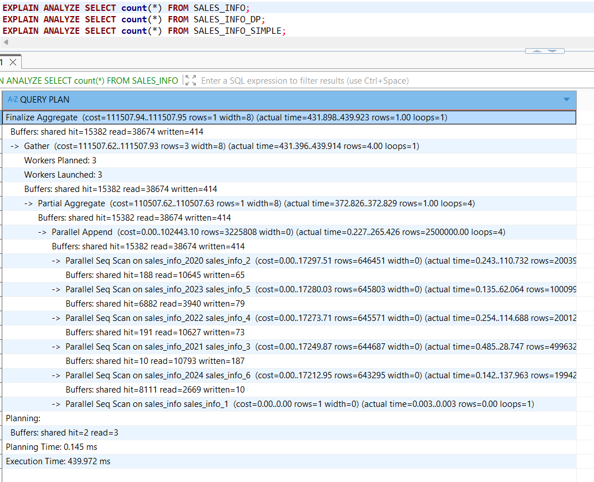
SALES_INFO_DP executed in 473.403 ms — also uses Parallel Append across all 15 sub-partitions with 4 workers. Slightly slower than SALES_INFO due to the higher number of sub-partitions to coordinate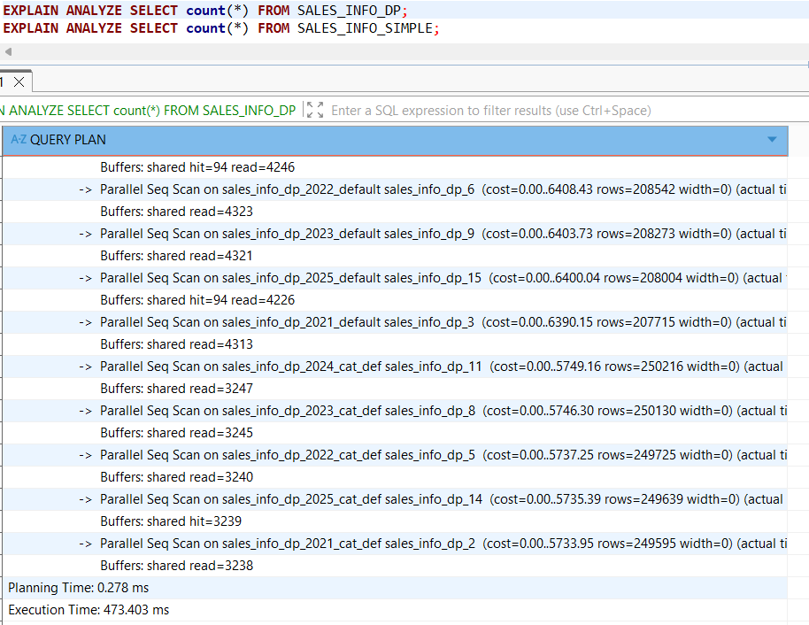
SALES_INFO_SIMPLE executed in 275.600 ms — the fastest. The query planner chose a Gather with 4 workers, each computing a Partial Aggregate over a single flat table chunk. A single table parallelizes more efficiently than multiple partitions.
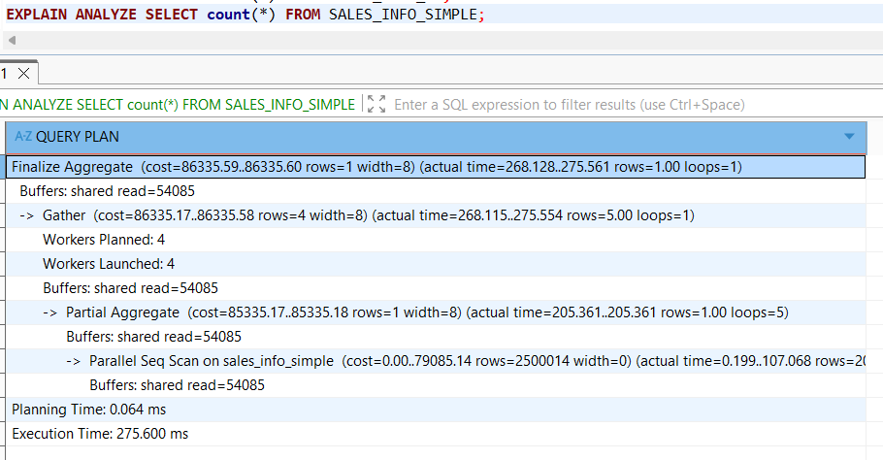
4. Add range of dates
SALES_INFO (inheritance) executed in 402.881 ms — partition pruning works: only 2 relations are scanned (parent + sales_info_2022). No parallelism, but pruning alone makes it fast.
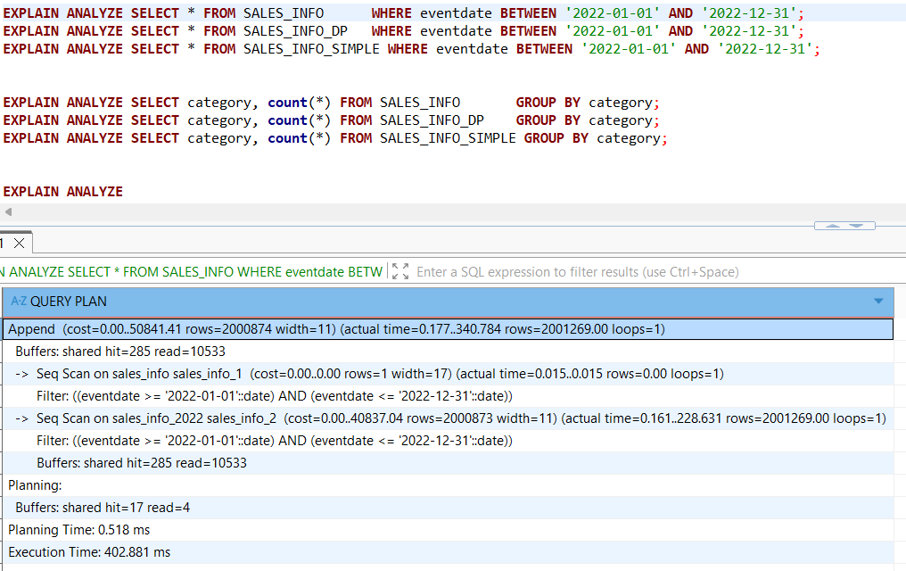
SALES_INFO_DP executed in 581.425 ms — pruning also works, scanning only the 3 sub-partitions of 2022 (cat_abc, cat_def, default). Slightly slower than SALES_INFO due to the extra sub-partition overhead, and no parallelism is used.
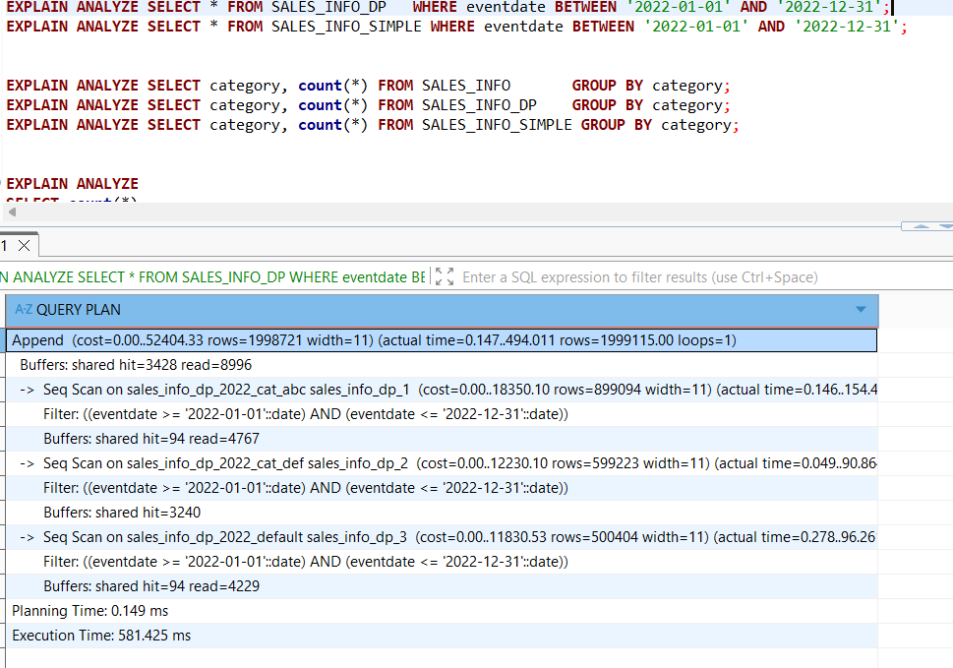
SALES_INFO_SIMPLE executed in 1256.554 ms — the slowest. No pruning possible, so PostgreSQL scans all 10 million rows with a single Seq Scan, filtering out 8 million rows. No parallel plan was chosen here either.
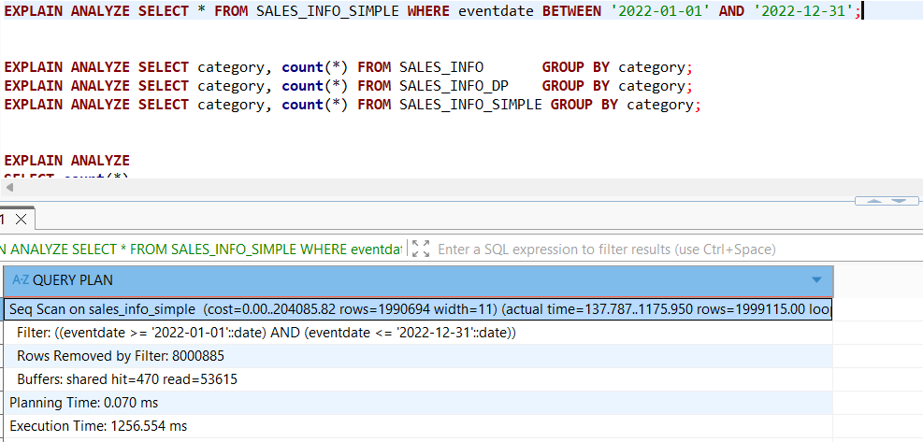
5. Add grouping by category
SALES_INFO (inheritance) executed in 694.721 ms — uses Gather Merge with 3 workers via Parallel Append scanning all 6 child tables. Each worker computes a Partial HashAggregate, then results are merged and sorted by category.
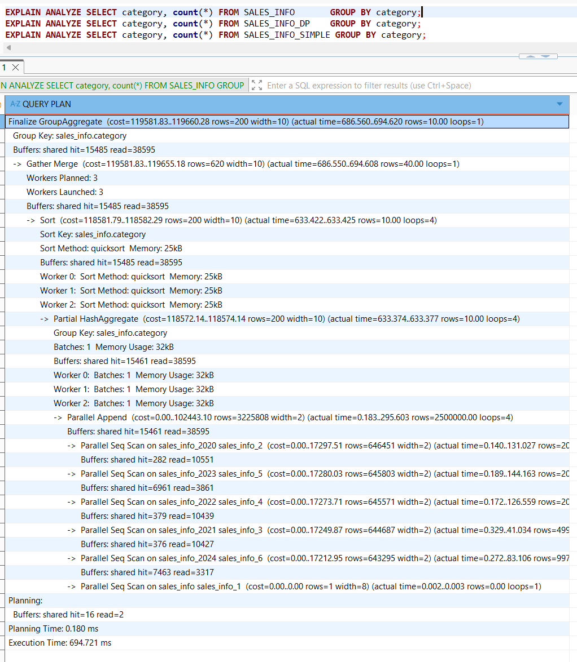
SALES_INFO_DP executed in 801.158 ms — also uses Parallel Append with 4 workers scanning all 15 sub-partitions. Slower than SALES_INFO due to higher number of sub-partitions to coordinate. No pruning is possible since category is not the top-level partition key.
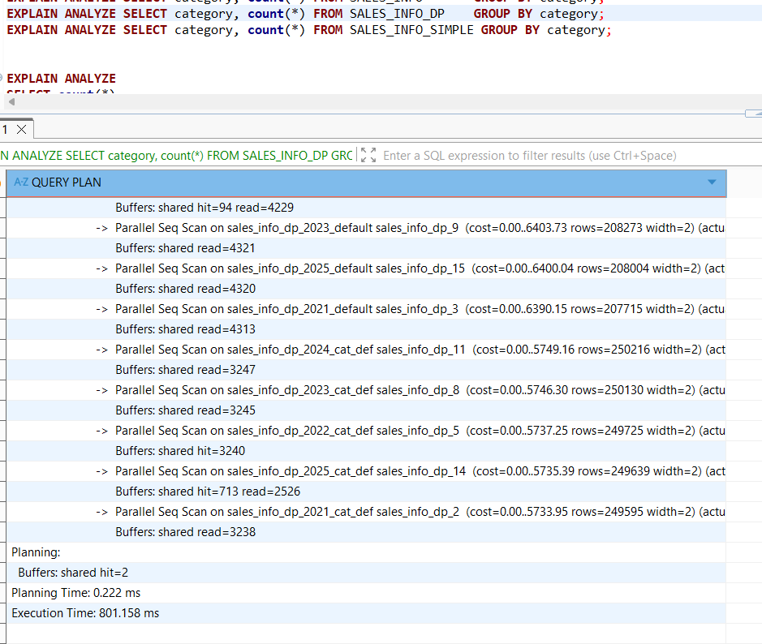
SALES_INFO_SIMPLE executed in 554.261 ms — the fastest. Uses 4 parallel workers each computing a Partial HashAggregate over the flat table, then merging results. A single table parallelizes more efficiently than multiple partitions.
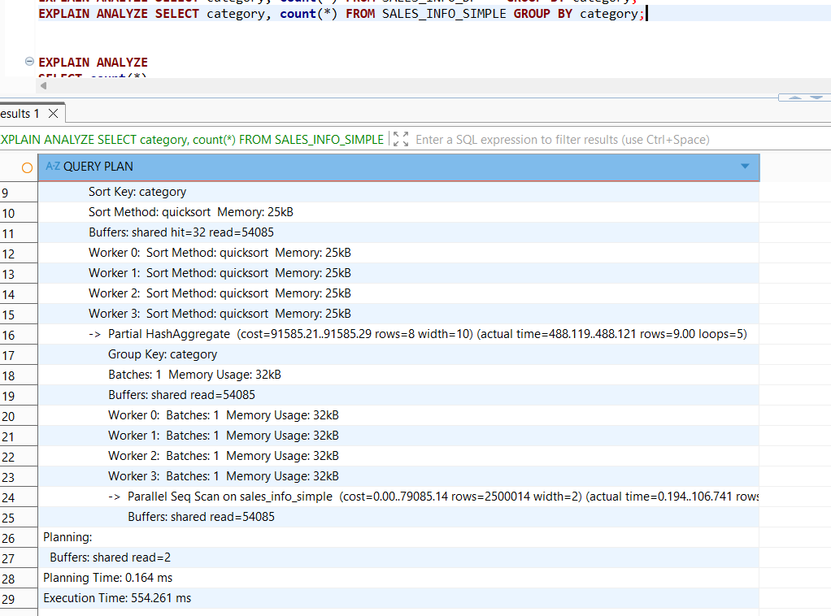
6. Join SALES_INFO and SALES_INFO_DP on id and count rows on exact date.
JOIN query executed in 722.544 ms. PostgreSQL uses a Parallel Hash Join with 4 workers. Partition pruning applies to SALES_INFO (only sales_info_2022 returns matching rows), but not to SALES_INFO_DP since the join is on id, not eventdate. This means all 10 million rows of SALES_INFO_DP must be scanned to find matching ids, which dominates the execution time.
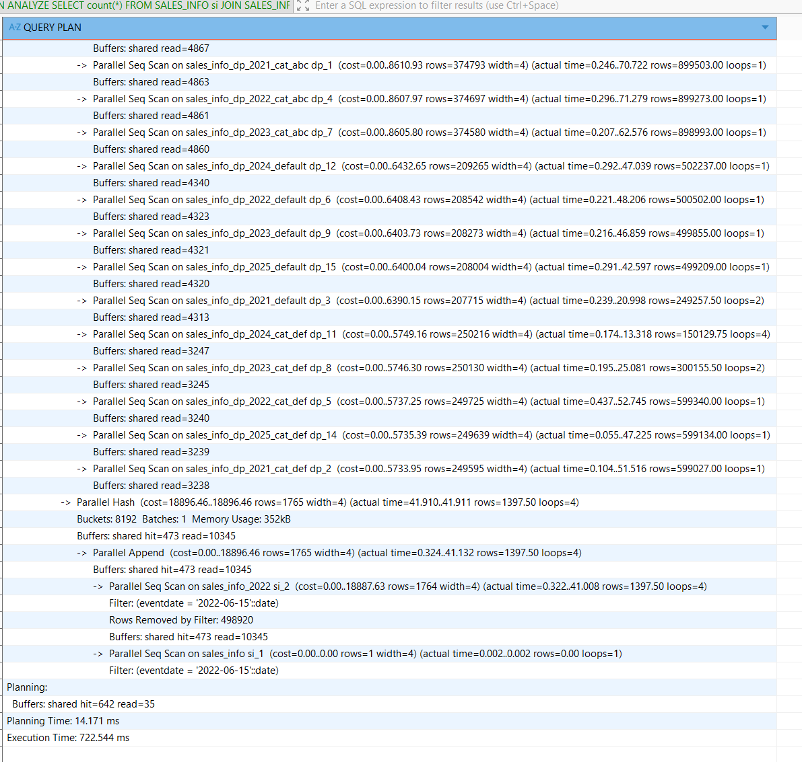
Indexes idx_sales_info_eventdate and idx_sales_info_dp_eventdate were created.
SALES_INFO executed in 372.268 ms , the index was not used. PostgreSQL chose a plain Append + Seq Scan, scanning only sales_info_2022 thanks to partition pruning. Since ~2 million rows match (the entire 2022 partition), a sequential scan is cheaper than an index scan.
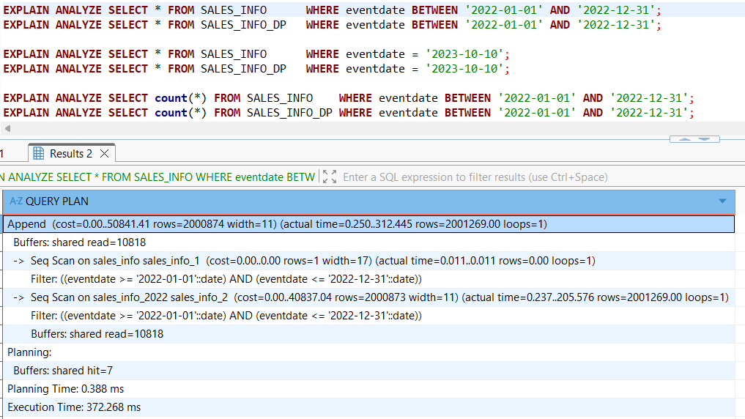
SALES_INFO_DP executed in 456.444 ms — also no index used. Same reason: partition pruning limits the scan to only the 3 sub-partitions of 2022, and since nearly all rows in those partitions match the date range, the query planner correctly prefers Seq Scan over Index Scan.
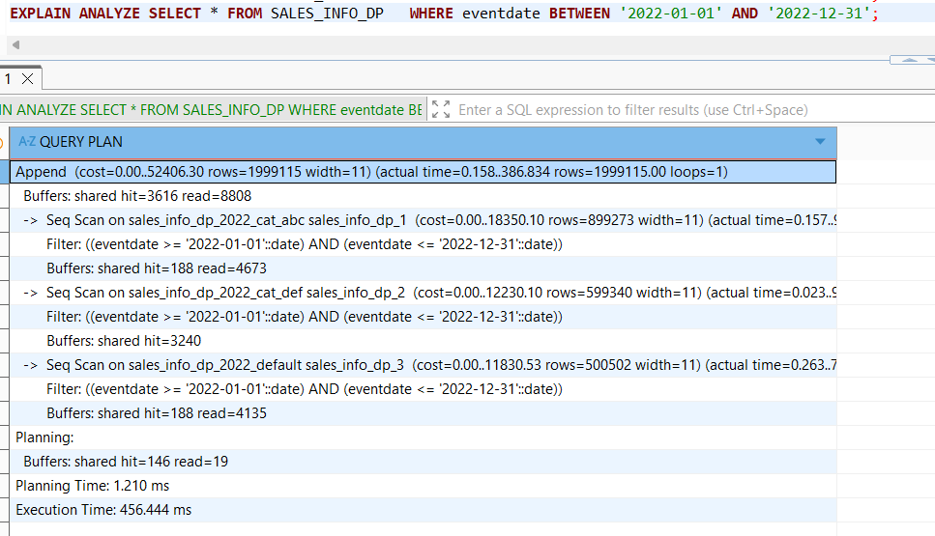
SALES_INFO executed in 97.267 ms — the index was not used. PostgreSQL chose a Parallel Append + Seq Scan with 3 workers, scanning only sales_info_2023 thanks to partition pruning. For inheritance-based partitioning the index on the parent does not automatically propagate to child tables.
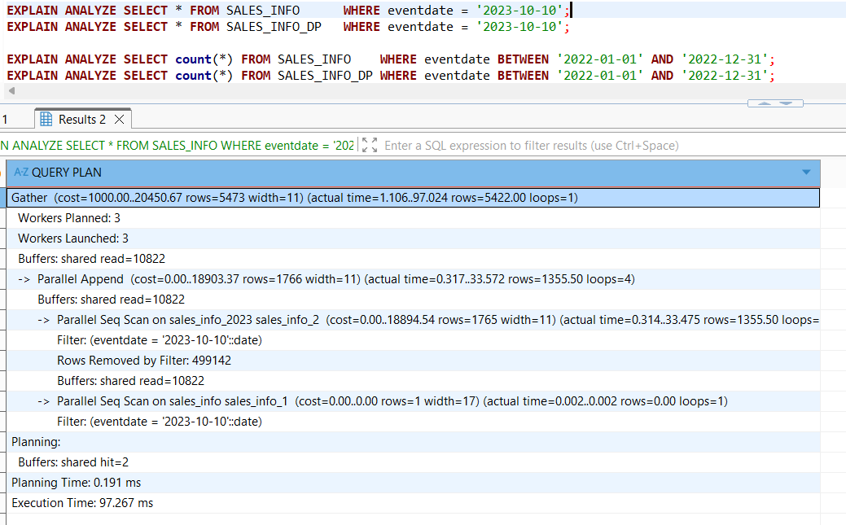
SALES_INFO_DP executed in 5.570 ms — dramatic improvement from 315 ms before indexing. The index is fully utilized: PostgreSQL performs a Bitmap Index Scan on each of the 3 sub-partitions of 2023 (cat_abc, cat_def, default), reading only the exact matching rows.
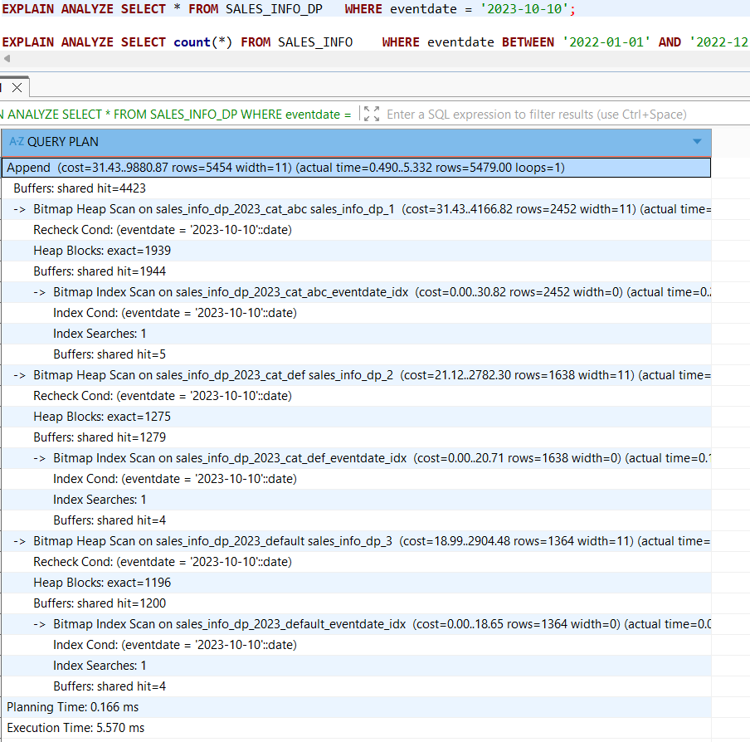
SALES_INFO executed in 182.186 ms — index was not used. PostgreSQL uses Gather with 3 workers via Parallel Append + Seq Scan on sales_info_2022 only. Since the entire 2022 partition matches the range, sequential scan remains the better choice. Parallelism helps here compared to the non-indexed run.
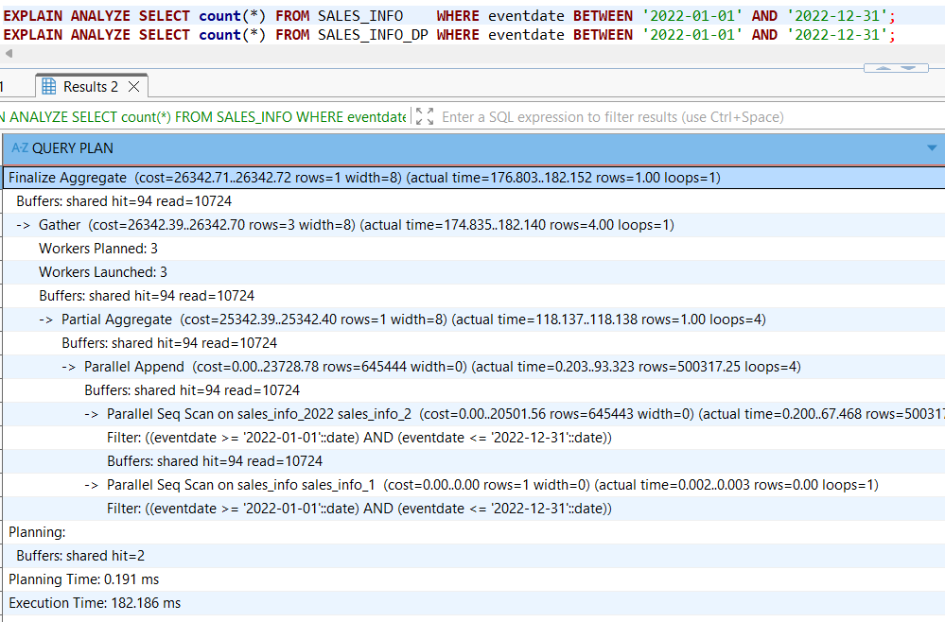
SALES_INFO_DP executed in 228.428 ms — index also not used. PostgreSQL uses Parallel Append with 2 workers scanning the 3 sub-partitions of 2022 via Seq Scan. Same reason as before — the date range matches nearly all rows in those partitions, so the query planner correctly skips the index.
