PL/pgSQL. Loading 3NF objects
BL_CL.MTA_LOGS is centralized table for logging data storing. Every executed procedure writes its name, row count, and SUCCESS/ERROR status in it.
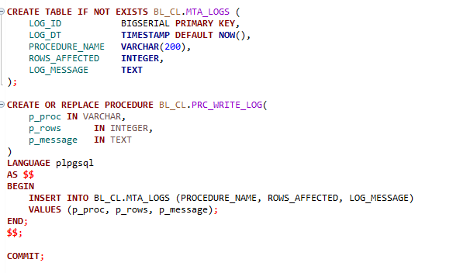
Loading to Table CE_DATES
PROCEDURE LOAD_CE_DATES loads the data to 3NF into the CE_DATES table. Consolidates unique dates from both offline and online source entities. It decomposes standard dates into day, month, quarter, and year attributes using the EXTRACT function.
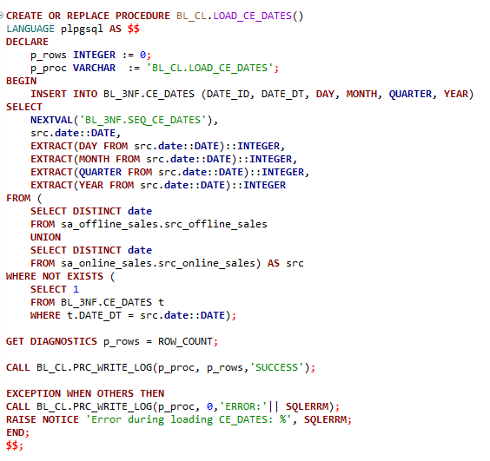
Geographic Hierarchy (COUNTIES, CITIES, STREETS, ADDRESSES) follows a strict top-down dependency chain to maintain referential integrity.
Loading to Table CE_COUNTIES
Unique regions are extracted and loaded the data to 3NF into the CE_COUNTIES table using PROCEDURE LOAD_CE_COUNTIES. Pulls from offline source only, as in online there is no location data.
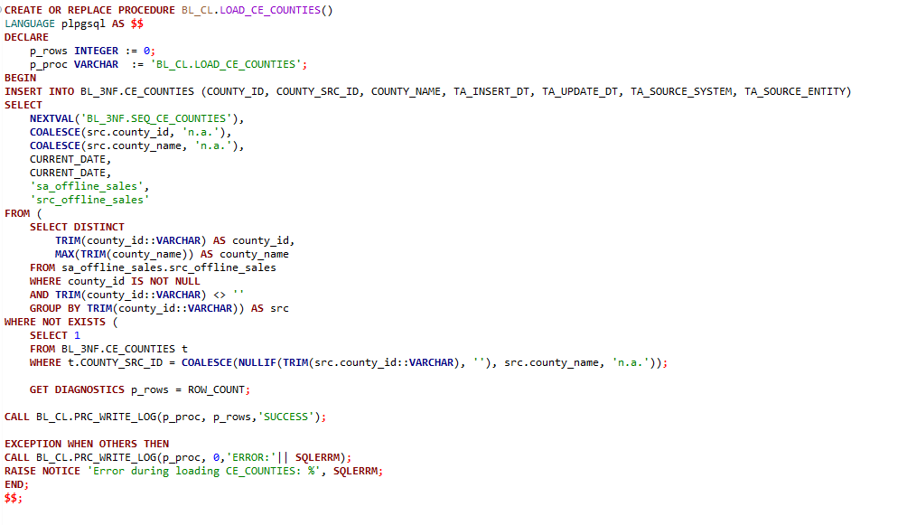
Loading to Table CE_CITIES
Unique regions are extracted and loaded the data to 3NF into the CE_CITIES table using PROCEDURE LOAD_CE_CITIES. Pulls from offline source only, as in online there is no location data.
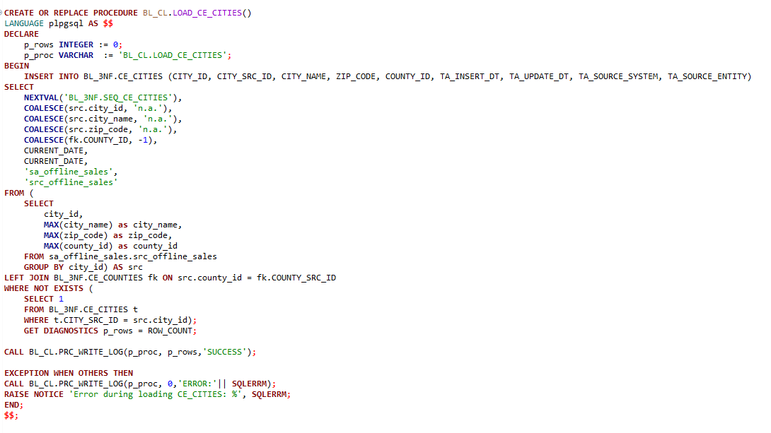
Loading to Table LOAD_CE_STREETS
Unique regions are extracted and loaded the data to 3NF into the CE_ STREETS table using PROCEDURE LOAD_CE_ STREETS. Pulls from offline source only, as in online there is no location data.
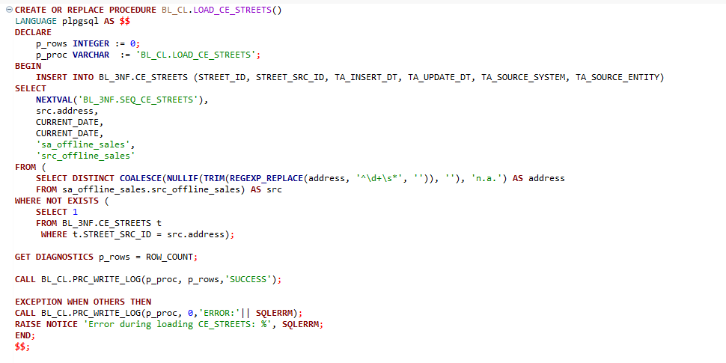
Loading to Table CE_ADDRESSES
Unique regions are extracted and loaded the data to 3NF into the CE_ ADDRESSES table using PROCEDURE LOAD_CE_ ADDRESSES. Pulls from offline source only, as in online there is no location data.
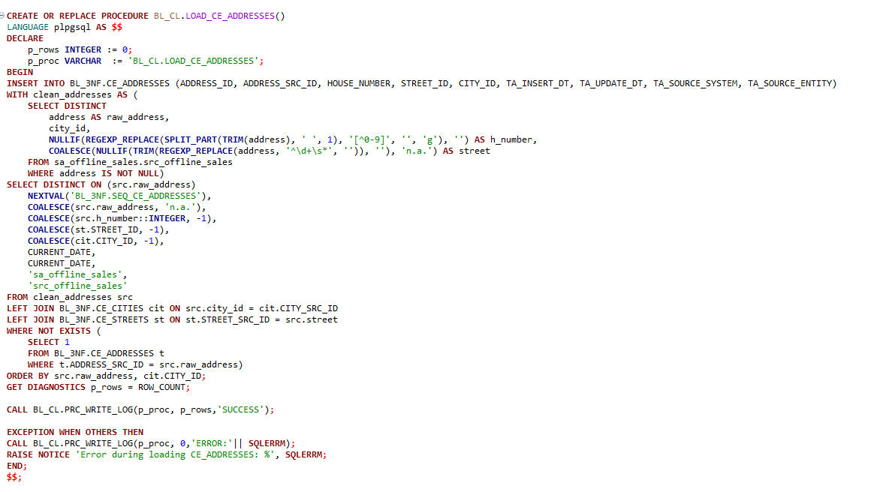
Loading to Table CE_STORES
Loading to the table CE_STORES in 3NF layer is implemented through the function returns table. Function returns table logic was chosen to isolate business logic (joins, mapping, and source unification) within the function, while the procedure focuses strictly on transaction management and logging. This design is highly scalable, making it easy to add new data sources or modify mapping rules with minimal risk to the core data warehouse. The function can be queried with a plain SELECT during development or debugging without triggering any writes.
Function BL_CL.STORES_FOR_LOAD where the data is dedublicated and joined from sources.
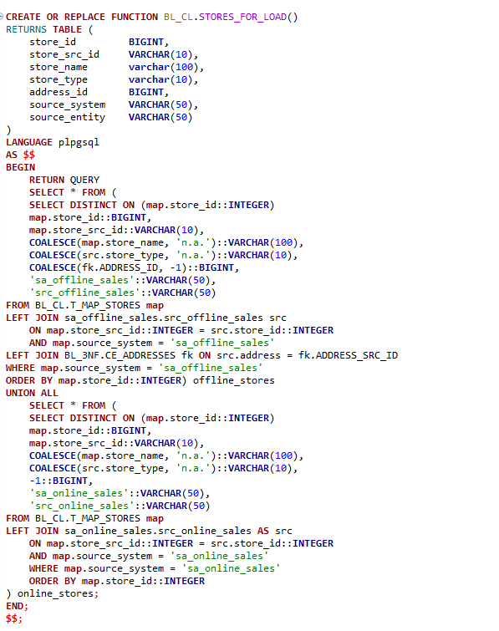
PROCEDURE BL_CL.LOAD_CE_STORES for loading the data into CE_STORES table in 3NF layer.
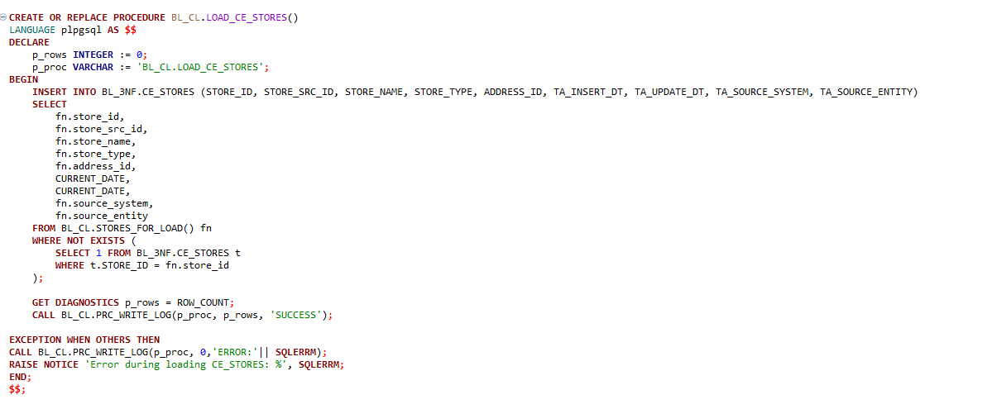

Loading to Table CE_ VENDORS
The same approach as for the table CE_STORES was applied for vendors via VENDORS_FOR_LOAD().
Function BL_VENDORS_FOR_LOAD where the data is dedublicated and joined from sources.
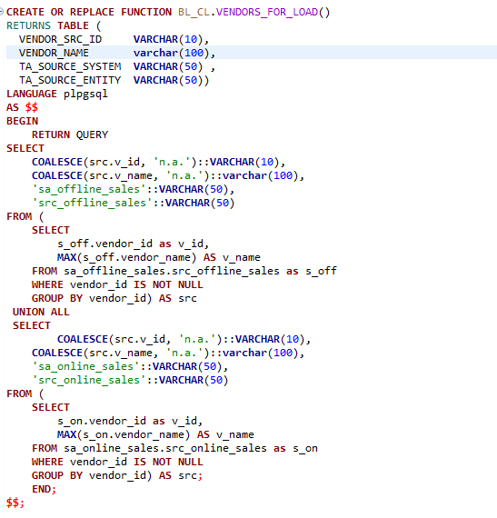
PROCEDURE BL_CL.LOAD_CE_VENDORS for loading the data into CE_ VENDORS table in 3NF layer.
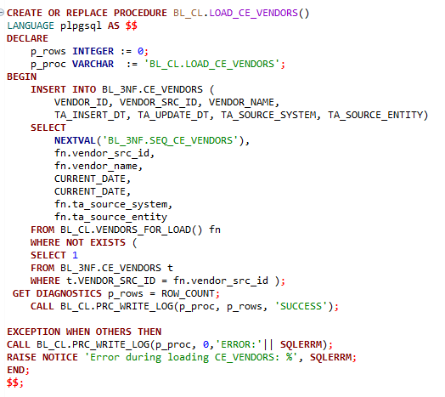
Lighter reference tables - CE_PROMOTIONS and CE_CATEGORIES was loaded to 3NF using direct procedural load to reduce overhead and increase performance optimization. Since there is no need to independently test the extraction logic (as it is straightforward), the encapsulation in a function was unnecessary.
Loading to Table CE_ CATEGORIES
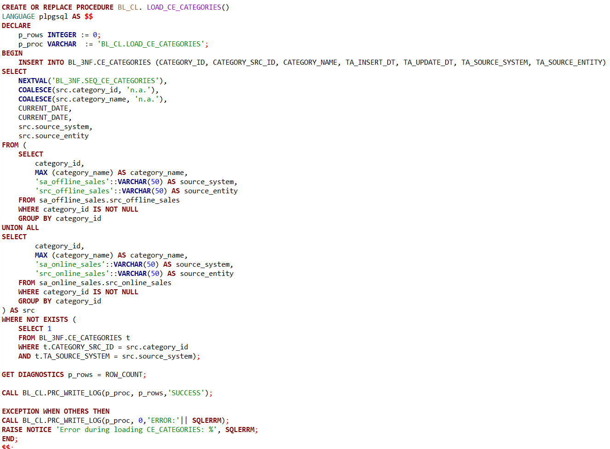
Loading to Table CE_PROMOTIONS
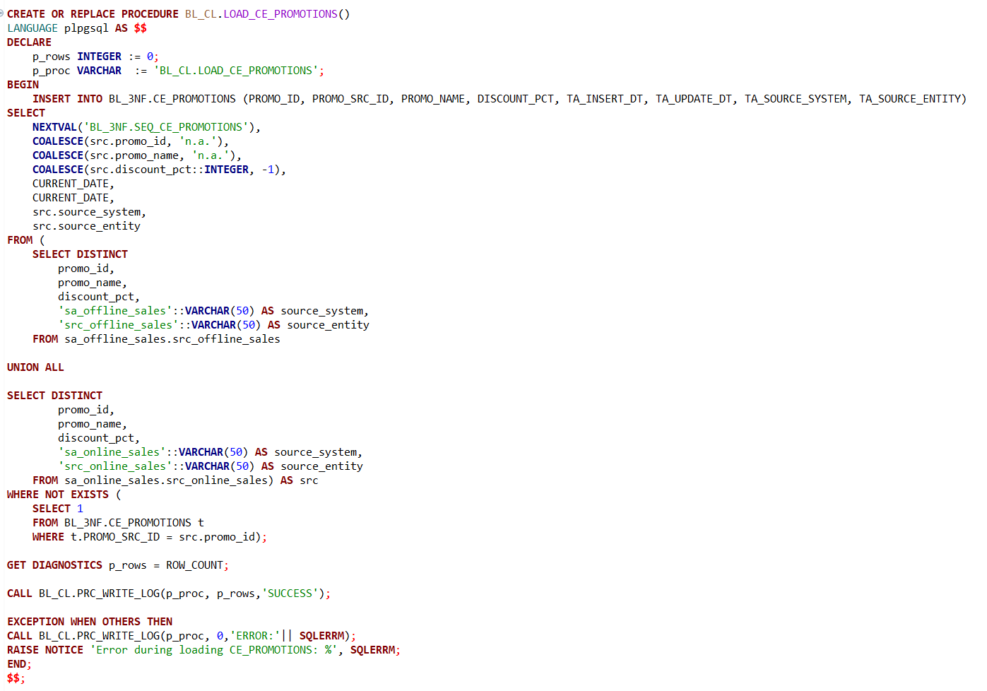
Loading to CE_ITEMS_SCD
Implementation of the LOAD_CE_ITEMS_SCD procedure using a loop was a strategic choice to manage the complexity of Slowly Changing Dimensions (SCD Type 2). SCD Type 2 logic requires a strict two-step process: closing an existing active record (setting TA_END_DT and TA_IS_ACTIVE = 'N') and inserting a new version. Using a loop ensures that this "Close-then-Open" cycle is executed atomically for each source system (sa_offline_sales and sa_online_sales) without risk of cross-contamination between different source datasets.
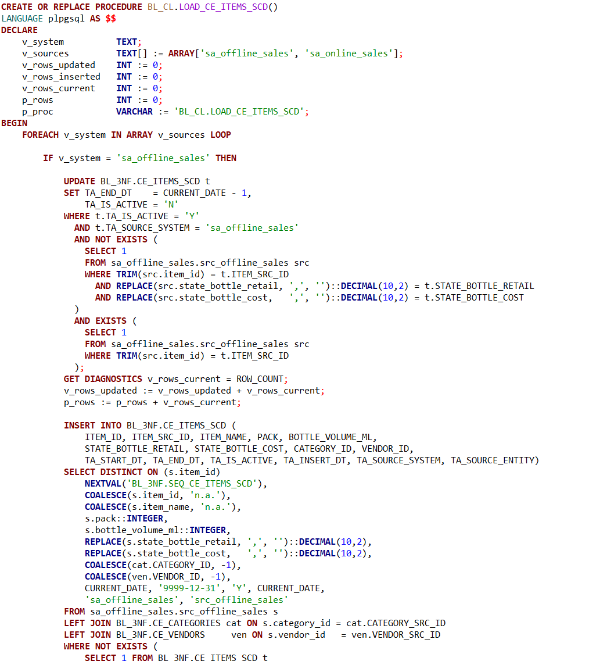
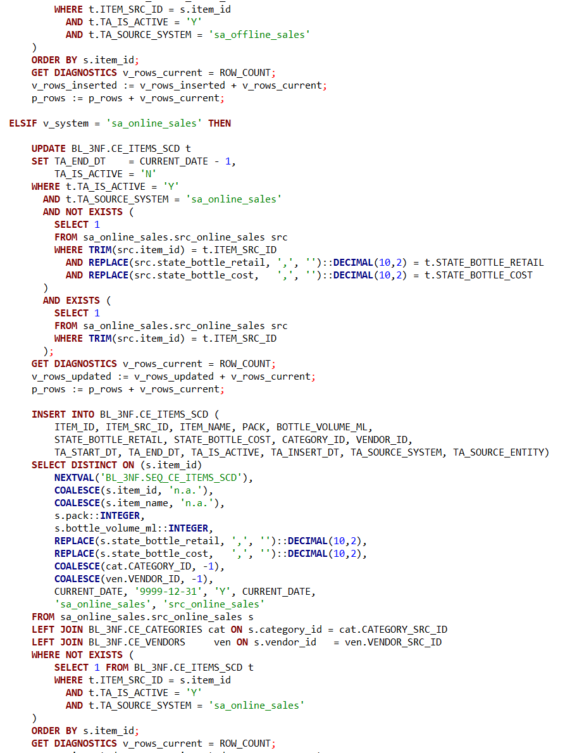
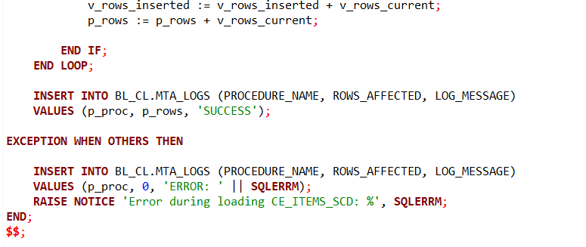
Loading to table CE_SALES
The LOAD_CE_SALES procedure loads data to Fact Table by integrating transactional data from both Online and Offline sources with the previously loaded 3NF dimensions. The procedure joining CE_DATES, T_MAP_STORES ,CE_ITEMS_SCD, and CE_PROMOTIONS, it ensures that every sale is correctly linked to the specific version of a product (SCD Type 2) from a specific vendor and the correct time period.
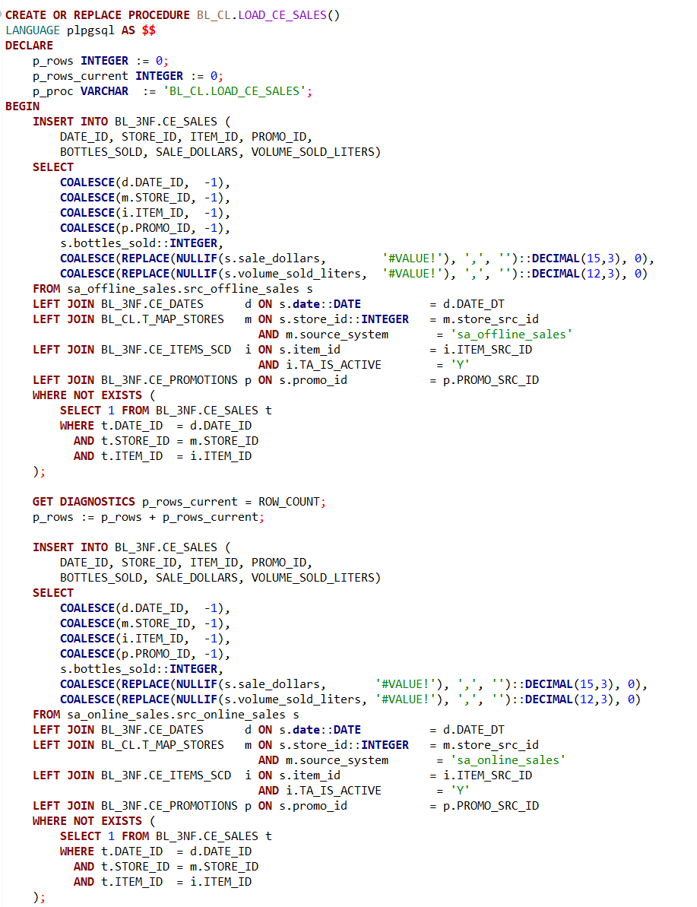
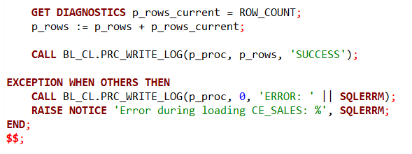
All procedures described above was collected in one main procedure LOAD_ALL_3NF_DATA. LOAD_ALL_3NF_DATA successfully automates the workflow, enforces the correct order of operations, and provides a robust layer of monitoring and error management. By consolidating all logic into one call, it ensures that the 3NF layer is consistently synchronized and ready for analytical use, making the entire ETL architecture reliable.
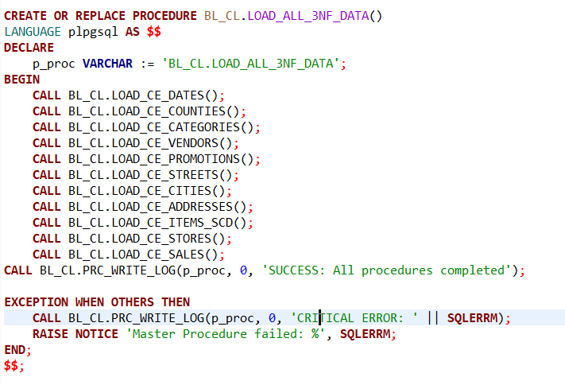

First test of LOAD_ALL_3NF_DATA procedure gives the result:
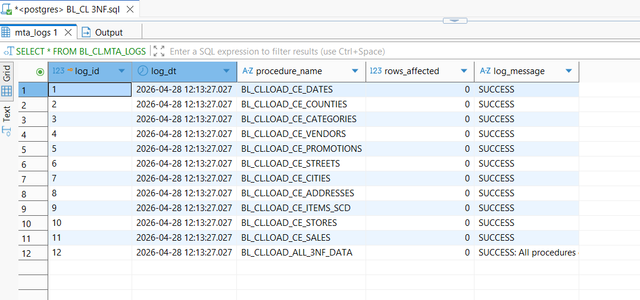
The result means that all data has been already inserted into the tables by manual not automated code. But still the new implemented procedures are successfully executed ( log_message = ‘Success’)
The second execution of LOAD_ALL_3NF_DATA procedure returns same result as the first
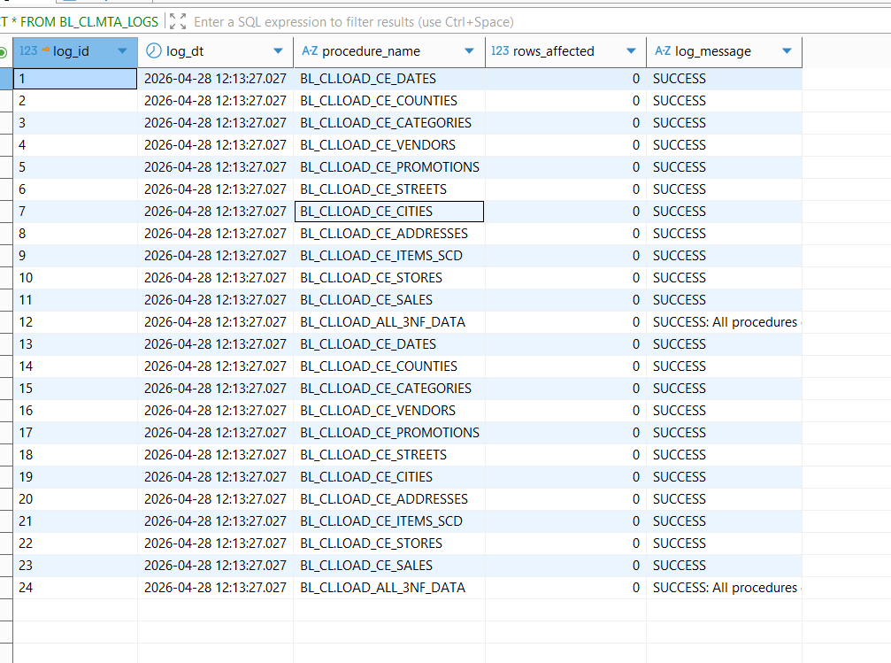
Data is loaded successfully to 3NF layer.
To check that all data is loaded tests from manual code loading was executed:
Data from Offline_source is loaded to 3Nf successfully:
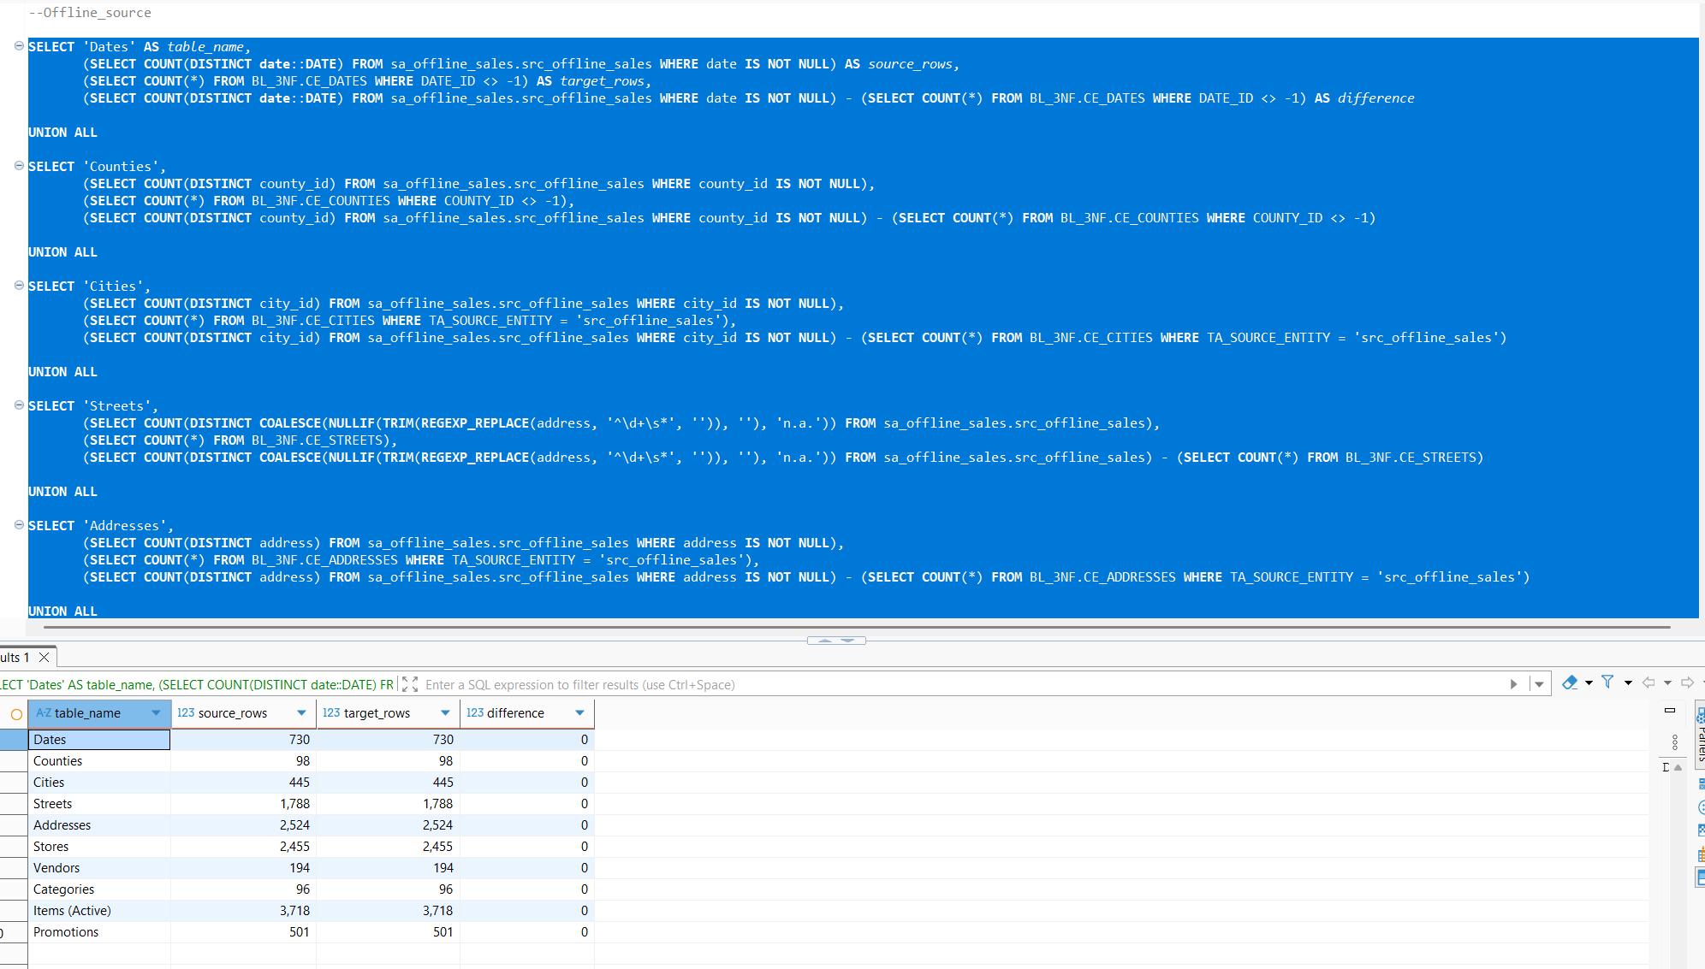
Data from Online_source is loaded to 3Nf successfully:
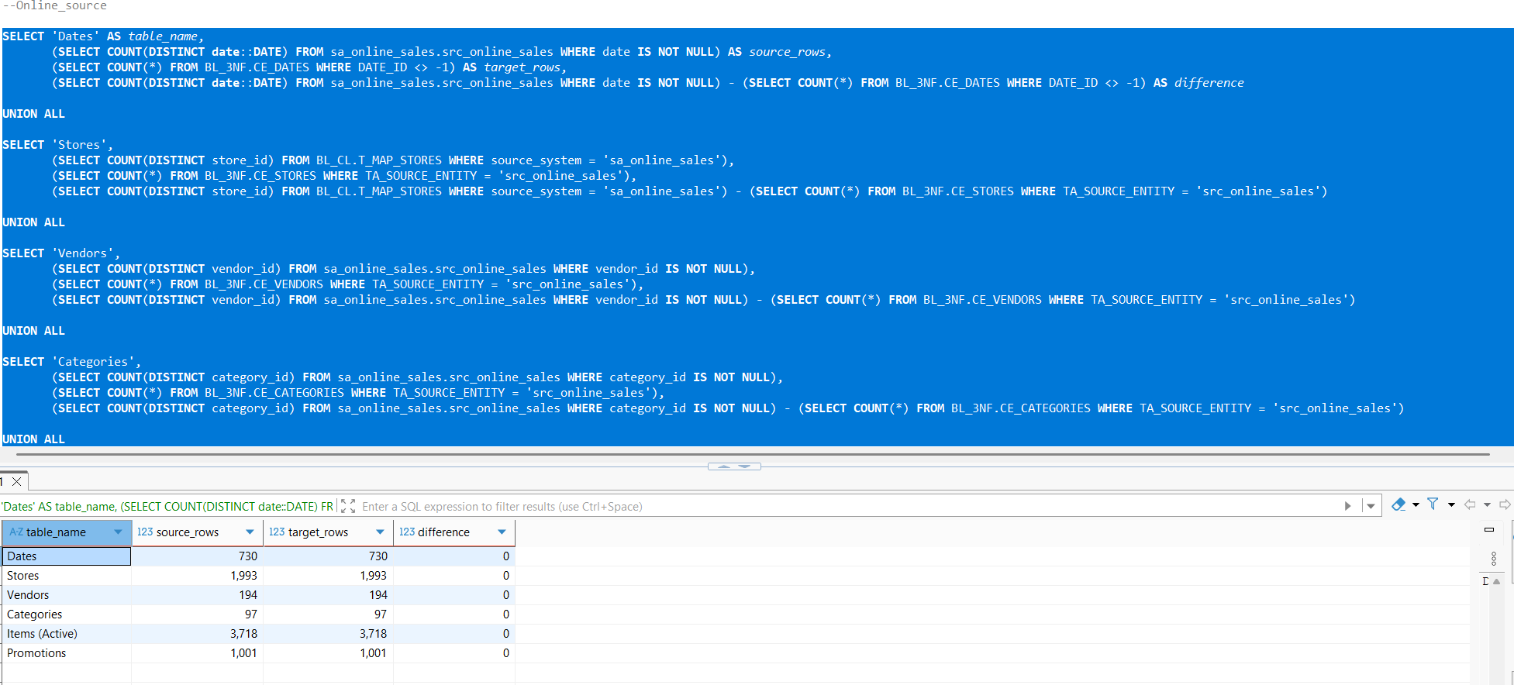
Sales table also passed the test successfully:
