Evaluation Metric Selection for LogS Prediction
Predicting aqueous solubility (LogS) is a regression task illustrated by noisy experimental measurements and heterogeneous chemical data.Differences in experimental protocols, solid-state effects, and physicochemical conditions leads to the variability in solubility datasets(Sorkun et al., 2019; Avdeef, 2019). Consequently, to ensure reasonable and significant model assessment selecting appropriate evaluation metrics is essential.
We initially considered a broad set of metrics capturing different aspects of predictive performance: Pearson correlation (r), Concordance Correlation Coefficient (CCC), distance correlation (dCor), Information Coefficient (IC), Mean Absolute Error (MAE), Median Absolute Error (MedAE), and Huber loss. This diverse set includes both correlation-based metrics, which assess association, and error-based metrics, which quantify prediction accuracy.
Correlation-based metrics such as Pearson r measure linear relation between predicted and experimental LogS values but it does not consider commonly found, systematic bias and scale shifts in solubility prediction. CCC was included to address this constraint by evaluating correlation and , as it simultaneously evaluates correlation and including or dealing with deviations from the identity line. CCC is therefore more useful for assessing predictive concordance in chemical regression tasks (Lin, 1989).
Complex solubility mechanisms may lead to non-linear relationships, distance correlation (dCor) was selected to tackle them . Unlike Pearson r, dCor can detect both linear and non-linear dependencies, making it suitable for heterogeneous chemical datasets. Although Information Coefficient (IC) was initially considered for similar reasons, it was excluded from final analysis due to redundancy with dCor and lower interpretability in this context.
To directly measure prediction accuracy Error-based metrics were selected. MAE provides an intuitive measure of average error magnitude but is sensitive to skewed residual distributions. Given that extreme outliers are often expected in solubility datasets, Median Absolute Error was favoured as a strong substitute that considers typical model performance without being dominated by large errors (Avdeef, 2019). In addition, the strengths of MAE and RMSE, combined in Huber loss, corrects small errors quadratically while decreasing sensitivity to large outliers. This balance is particularly beneficial for noisy experimental data (Oja et al., 2022).
Based on these considerations, the final set of metrics used for dataset evaluation consisted of CCC, Pearson r, dCor, Median Absolute Error, and Huber loss. Together, these metrics provide insights into predictive agreement, association, robustness, and error magnitude. This multi-metric strategy ensures a reliable and chemically meaningful assessment of solubility prediction models.

MACCS

1. Test Split: The Model Learned the Pattern
- Pearson r (0.85 - 0.87): This is a strong correlation. It means that within the chemical space of our training data, our model is excellent at ranking molecules (it knows Molecule A is more soluble than Molecule B).
- CCC (0.84 - 0.87): The CCC is almost identical to the Pearson. That is there no systematic bias here, here the predictions sit right on the line.
- MedianAE (0.54 - 0.59): Experimental error for LogS measurements is often cited around 0.5–0.7 log units. Our SVR model (0.54) is predicting almost as accurately as the lab experiments themselves for this specific type of data.
- HuberLoss (0.518 - 0.587): The SVR HuberLoss (0.518) is lower than the RF HuberLoss (0.587). This indicates that the Support Vector Machine found a "smoother" function that fits the majority of the data points better than the Random Forest, which might be overfitting slightly to noise in the training set.
- dCor (0.851 - 0.827): This implies a very strong statistical dependence. The model has successfully extracted nearly all the useful "signal" available in the MACCS keys for this specific set of molecules.
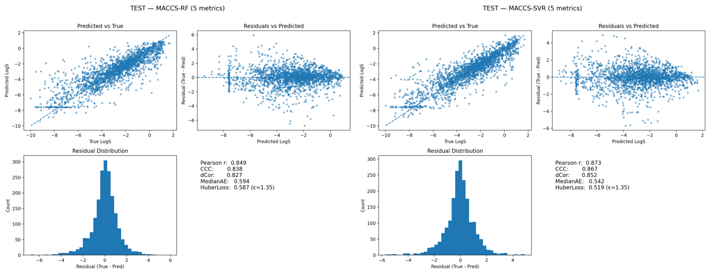

Test Split: The Success Story
The Evidence: High Pearson (0.87), low MedianAE (0.54), and a perfect diagonal alignment in the "Predicted vs True" plots. Our machine learning pipeline (SVR) and feature extraction (MACCS) successfully captured the structure-property relationship for our training distribution. The low HuberLoss (0.52) proves the model is stable and precise when the test molecules look like the training molecules.

2. Challenge Data 1: Weak Ranking, Moderate Accuracy
- Pearson r (0.21 - 0.23): This is a low correlation. It means our model is struggling to distinguish between high and low solubility molecules in this specific set. It captures very little of the variance.
- CCC (0.16 - 0.17): The Concordance Correlation Coefficient (CCC) measures both correlation and agreement (how close the points are to the diagonal). A value this low confirms that the predictions are not reliable.
- MedianAE (0.86 - 0.91): The Median Absolute Error is effectively the "average" miss. An error of ~0.9 log units means if the actual LogS is -4.0, our model predicts somewhere between -3.1 or -4.9.
- HuberLoss (0.66 - 0.78): It suggests that for many molecules, the error is within the zone of small errors. Our model is reasonably stable on this dataset. It isn't making catastrophic outliers frequently. The error is consistent, even if the correlation (Pearson) is low.
- dCor (0.20): It is very close to the Pearson score. It means there is no "hidden" non-linear relationship our model is capturing. The model simply fails to see a strong connection between the MACCS keys and the LogS values for this dataset. The features (MACCS) might just be insufficient here.

3. Challenge Data 2: The "Systematic Bias" Problem
- Pearson r (0.38 - 0.40): Interestingly, the correlation here is better than in Challenge Data 1. The model is better at knowing which molecule is more soluble than another compared to Data 1.
- CCC (0.03 - 0.04): This is the critical warning sign. A moderate Pearson (0.4) combined with a near-zero CCC (0.04) proves a massive Systematic Bias. Our model correctly identifies trends (X is more soluble than Y) but the values are shifted significantly (e.g., the model predicts -2, but the reality is -6).
- MedianAE (3.7 - 3.8): This error is extremely high for LogS. Missing solubility by nearly 4 log units (10,000x difference in concentration) usually renders our model unusable for quantitative prediction.
- HuberLoss (4.19 - 4.21): This value is much larger than (typically 1), the loss function is operating almost entirely in the "linear" region (acting like MAE). This confirms that the high error isn't just due to a few "weird" molecules. The entire set of predictions is shifted. The model is consistently missing the target by a wide margin (likely ~4 log units) for the majority of the dataset.
- dCor (0.40): Again, dCor is almost identical to Pearson. This confirms the relationship is predominantly linear (or monotonic). The model clearly "sees" a signal here (better than in Data 1), as indicated by the moderate dependence (0.40).
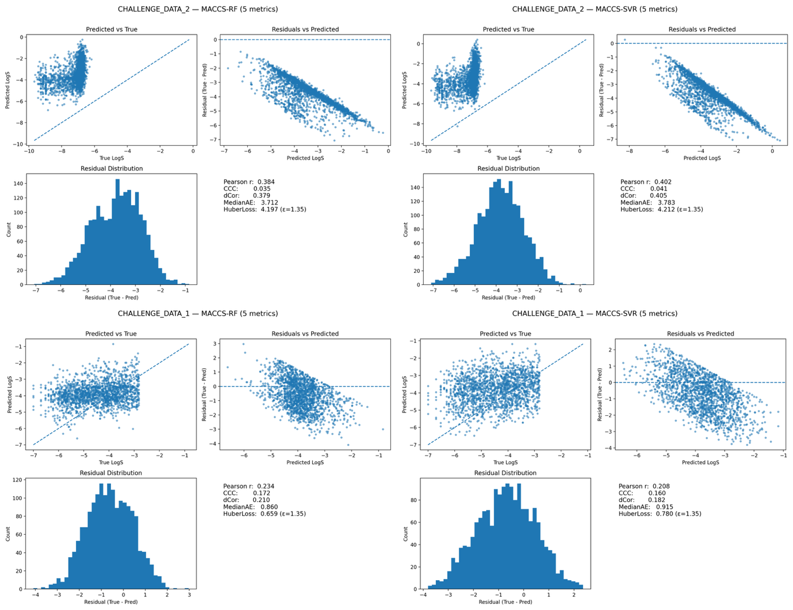

4. Diagnosis of Failures
1. Challenge Data 1 (The minor failure): Feature Limit.
- The Problem: MACCS keys are too simple. The model fails to differentiate between simple and complex versions of the same scaffold because the fingerprint does not account for the count or location of functional groups.
2. Challenge Data 2 (The major failure): Applicability Domain Failure.
- The Problem: These molecules are outside the chemical space our model understands. They are significantly more insoluble than our training data.

MORDRED

1. Challenge Data 1: Calibrated Stability
- Pearson r (0.32) & dCor (0.31): The Pearson and Distance Correlation (dCor) are nearly identical. This confirms that the relationship between the Mordred descriptors and LogS is linear. Our model is capturing a genuine moderate signal. It can roughly sort molecules from soluble to insoluble, though it lacks precision ranking.
- CCC (0.32): The Concordance Correlation Coefficient is practically equal to the Pearson . This means there is no systematic bias. The regression line aligns perfectly with the ideal diagonal. When our model predicts -3, the reality is likely around -3. It is not consistently overestimating or underestimating.
- MedianAE (0.77): It indicates that for half of the dataset, our prediction is within a very narrow margin of the truth.
- HuberLoss (0.60): The HuberLoss is exceptionally low, even lower than the MedianAE. A value this low indicates that our model's errors are normally distributed (a tight bell curve). Our model is confident and stable.

2. Challenge Data 2: The "Shift" Phenomenon
- Pearson r (0.52) & dCor (0.51): Surprisingly, the correlation is significantly higher here than in Challenge 1. The Mordred descriptors nicely capture the physical rules driving solubility for these molecules. Our model is good at determining that Molecule A is less soluble than Molecule B. The chemical "logic" is sound.
- CCC (0.06): A solid Pearson (0.52) combined with a near-zero CCC (0.06) is the definition of Systematic Bias. Our model has the correct "slope" (trend) but the wrong "intercept." It is predicting values that are likely shifted by a constant amount (e.g., predicting -4 when the truth is -8).
- MedianAE (3.53): This is a massive error. A deviation of ~3.5 log units represents a discrepancy of nearly 3,000-fold in solubility concentration. Quantitatively, the predictions are unusable.
- HuberLoss (3.77): Interpretation of the Shift: Typically, HuberLoss is smaller than average errors because it dampens outliers. Here, the HuberLoss (~3.77) is roughly equal to the MedianAE (~3.53) and is very large.This confirms that the high error isn't caused by a few "bad apples" or outliers. The entire dataset is shifted. The loss function is operating almost entirely in its linear region (treating every point as a large error). Our model is consistently missing the target by a wide margin for every single molecule.

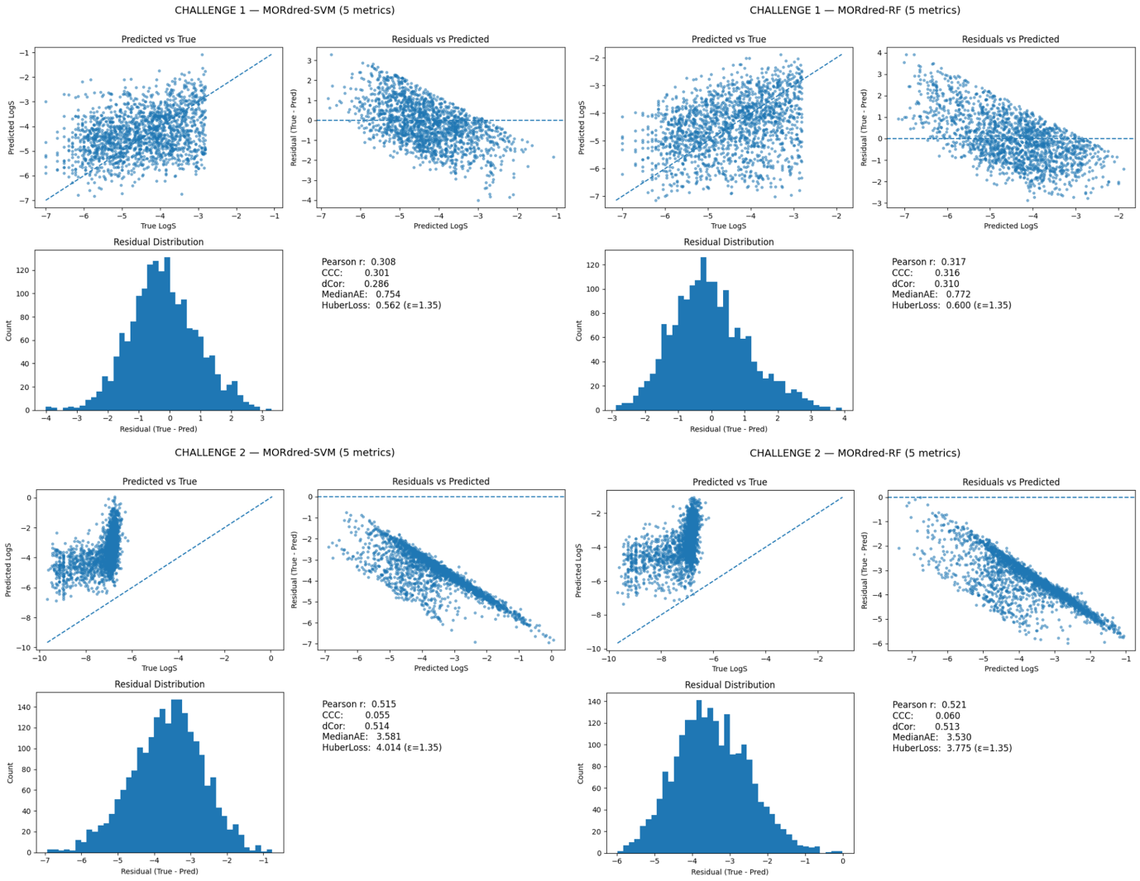

3. Diagnosis of Failures
1. Challenge Data 1 (The minor limitation): Precision Limit.
- The Problem: While the model is unbiased (centered on the truth), it suffers from high variance (noise). The Mordred descriptors capture the general chemical trend, but the model cannot pin down the exact value for specific molecules, resulting in a "cloud" of predictions rather than a tight line.
2. Challenge Data 2 (The major failure): Calibration Failure (Target Extrapolation).
- The Problem: The features successfully capture the ranking (good Pearson), but the model fails to predict the correct magnitude. Because the training data likely lacked highly insoluble molecules (LogS < -6), the model hits a "floor" and physically cannot predict the extremely low values (e.g., -9 or -10) required for this set.

References
- Avdeef, A. (2019). Solubility of ionizable drugs. ADMET & DMPK, 7(1), 13–38.
- Lin, L. I. K. (1989). A concordance correlation coefficient to evaluate reproducibility. Biometrics, 45(1), 255–268.
- Oja, M., Kontsedalov, A., Tamm, T., & Maran, U. (2022). Intrinsic aqueous solubility: Mechanistically transparent data-driven modeling of drug substances. Pharmaceutics, 14(11), 2248.
- Sorkun, M. C., Koşka, A., & Er, S. (2019). AqSolDB: A curated reference set of aqueous solubility data. Scientific Data, 6, 143.

